Business plan for “Vine romanul- Romanian Restaurant”

[Date]
Andreea Esanu (1713835)
Lecturer name: Malani Gunaratnam
University of Wales Trinity Saint David



Students name:
- Andreea Esanu-1713815-group leader
Product and services
Market Analysis and Needs
Social Responsibility and Sustainability

- Claudiu Ciobanu-1818260
Executive Summary
Business Description and History/Business Structure

- Dragos Sorica-1906082
Operations

- Corneliu Baba-1906079
Financial plan

Table of Contents
1. Executive Summary 6
2. Business Description and History 10
3. Business structure (diagram) 11
4. Product and services 13
5. Market analysis and needs 13
6. Operations 21
7. Social Responsibility and Sustainability 22
8. Financial Plan 23
9. Conclusion 31
10. References 32
11. Appendix 33

Cover Letter

Malani Gunaratnam
Winchester House, 11 Cranmer Rd, London SW9 6EJ
a.munna@uwtsd.ac.uk
Dear Madam,
We are writing to express our interest that we are a group of four romanian friends who have a passion for romanian traditional food.
We are skilled at preparing a variety of goods including sarmale and mamaliga.In addition, we enjoy the early hours of our restaurant and always arrive promptly for our shifts. We would love the chance to bring our skills to the market by introducing our own recipes to our valued customers.
We are confident that we would be able to make a real difference in the Romanian traditional taste with our talent and customer orientation. Please feel free to contact us at your earliest convenience to set up an interview and to view our business plan. We look forward to hearing from you and thank you in advance for your consideration.
Sincerely,
The “Vine Romanul- Romanian Restaurant” Team
Student name: Claudiu Ciobanu-1818260
Table of content:
- Executive Summary
  - Description of the business products and services
  - Objectives
  - Description of the market
  - High-level justification for viability
  - Growth potential
  - Overview of funding requirements
- My skills and experience
- Business Description and History
  - Objectives (short term, medium term and long-term objectives)
- Business Structure (diagram)
- Conclusion

Executive Summary
  - Description of the business products and services
Business name: The name of the restaurant it’s Romanian Restaurant and it’s a Romanian traditional food type.
Type of business structure: We decide to open a Romanian restaurant because we are a group of 4 Romanian friends who have a passion for traditional Romanian food. The business structure is a partnership between me (Claudiu Ciobanu) and my other 3 Romanian colleagues: Corneliu Baba, Dragos Sorica and Andreea Esanu.
Ownership: The restaurant will be fully owned by me and my other 3 colleagues.
Location: The restaurant will be located on Oxford Street, London and will serve a variety of food for all types of eaters.
Mission statement: “Our mission is to make and serve a high quality food that is also up to the health and safety standards”.
Vision statement: Our vision for our Romanian Restaurant is to keep gaining a lot of costumers and to keep our food ratings and hygiene up to it standards.
Product profile:
The description of the products that we are using to serve our food in the restaurant is all mentioned in the menu in both languages (Romanian and English).
  - Objectives
The primary objectives of the business plan for Restaurant are below:
- To be the premier romanian style restaurant in London, Uk
- To provide quality meals at reasonable prices with exemplary customer service for customers
- To analyse the growth potential and to achieve a sustainable growth
- To get and stay profitable
- To mantain a healthy cash flow
- To stay ahead of the competition
- To reach the right customers
  - Description of the market
The primary purpose of a business is to maximize profits for its owners or stakeholders while maintaining corporate social responsibility. Any organization has to analyze the company situation accordingly before building any strategic marketing plan.
To comprehend what clients like and don't care for inside a business, we'd need to tune in to what they need to state on specific items or focus on what they'll doubtlessly purchase inside our restaurant. An approach to do it is to apply reviews to our clients.
Our organization will direct research about the advertising channels accessible before building their vital arrangement, they will do explore about which channels will be increasingly useful for them and arrive at a bigger number of potential clients. Promoting plan improve or demolish any organization circumstance and can bring also to the association a assorted variety of choice of various exercises of showcasing comes closer from various channels accessible, for example, TV's, Newspapers, Radio, Facebook, Emails, Leaflets.
The present market in business today is in every case continually evolving. Following the patterns would draw in a great deal of clients as they're bound to go for something present day and recognizable, however we generally need be in front of our rivals. "Market patterns will in general be vigorously affected by shopper propensities and practices." (The British Library, 2019) recognizing what clients are bound to buy or what they're more pulled in to would help support our insight on what could have an incredible or negative effect on our business.
  - High-level justification for viability
In order to identify a high-level justification for viability in our business plan I have made a short analyze about our strengths and what are our abilities to work successfully to accomplish our aim, long term, middle term and long term objectives and goals for the restaurant.
The location- our first location in the centre of London, more exactly on Oxford Street 52 is a strength for our business plan and will draw us downtown visitors and customers.
Our uniqueness- we stand out as a unique alternative to fast-food, traditional Romanian food, vegan food, light food and we offer consistently high-quality food in a distinctive atmosphere with specific music.
Right products, qood quality and reliability- we need to make sure that we sell the right products to the customers, that we don’t mess up with orders that we offer quality services to our customers.
Superior product performance vs competitors- we need to analyse the market and our competitors and to make sure they will not be a threat.
Direct delivery capability- we can deliver to every customer if they wish to have this service.
Product innovations ongoing- we try to find new products and services to make our job easier and more professional.
Our management is committed and confident- our management team is like a family and goes together for achieving the same goals.
  - Overview of growth potential
Profit margins will be acceptable - The gross profit P is the difference between the expense to make an item C and the selling cost or income R and we can say that the gross profit is calculated as following:(P = R – C) so we hope to have a decent profit.
Analysing potential customers factors into demographics. “When assessing the size of the market, your approach will depend on the type of business you are selling to investors. If your business plan is for a small shop or a restaurant then you need to take a local approach and try
to assess the market around your shop” (The Business Plan Shop, 2019) according to this, we need to base our demographic around our business and analyse what people are more likely to go for. Potential customers could be factored around the area we choose to base our restaurant in or the size of our business. We do plan to start of small and then grow gradually over time, the bigger our business the more we could attract potential customers.
  - Overview of funding requirements
In our business plan we can say that we can include in funding requirements the executive summary with details about our restaurant. Also we can analyze the financial part for current financials of the business, any current or/and future loan requirements and a description about how we will use the funds.
Our business opportunities are as following:
Working families with children - this is a developing populace, both in individuals and in their decision of advantageous food. For instance, two-salary families have less time to set up a dinner and that is the way we came in their assistance.
We can grow new items - we tried the opposition market and we have the chance to grow new items which will astound both the clients and the contenders or any competition.
The local competition have poor item- all the products and services that our competitors sell are poor in quality and have significant expenses.
We could reach out to abroad - ''For any business which exist in this day and age, on the off chance that you are not growing globally is for all intents and purposes considered a sin. The extending just does such extension which give enhancement and an additional income, this likewise uncovered one of alternate techniques for working together.'' (Gording, 2011)
We can shock our competition - perhaps with our enhanced items or administrations we can astound the opposition and increase more clients.
Besides our business opportunities I can add a brief description on my team.
I am the director executive and I am responsible for analysing any management, administration or strategies for the organization.
Executive Director
Claudiu Ciobanu
Assistant Manager
Andreea Esanu
Finance Manager
Corneliu Baba
Marketing Manager
Andreea Esanu
Administration Manager
Dragos Sorica

- My skills and experience
I have been a manager at a restaurant for about 3 years; here I have obtained the necessary experience in management and on the administrative side. I consider that I have accumulated over the 3 years the necessary experience to be able to open my own business, namely to open a Romanian restaurant.
KEY Abilities AND COMPETENCIES
- Managing with and settling client complaints.
- Communicating with the kitchen staff to guarantee productive foodservice.
- Exhorting clients on wine determination.
- Overseeing client bookings & reservations.
- Purchasing stock, supplies and arranging best costs with exchange suppliers.
- Ability to make a extraordinary air & be a inspirational host.
- An eye for detail and the capacity to drive reliable brand guidelines.
- Involvement of sorting out private capacities counting parties and weddings.

Business Description and History
We want to open the restaurant in 2020 because now we are financially stabled and the location which we chosen does not have many Romanian restaurants near us. The restaurant will be open 7 days a week from 11 am to 12 pm. We also have set lunch meals for takeaway. Our lunch hours are from 12 pm to 14:30 pm. Dinner menu starts from 14:30.
We have also a bar which will be open from lunch to 1:00 am.
The aim is to provide a unique and relaxing dining experience – similar to dining at home. We will strive to achieve this goal by providing menu items incorporating quality ingredients at reasonable prices and we will be mindful of the well-being of our customers and staff– treating each and everyone with dignity and respect – just like we would at our own home.
  - Objectives:
To stabilize and to achieve the objectives of our business plan, we have created SMART GOALS which are made with the purpose of classification our objectives into smart ones for short, middle and long term goals.
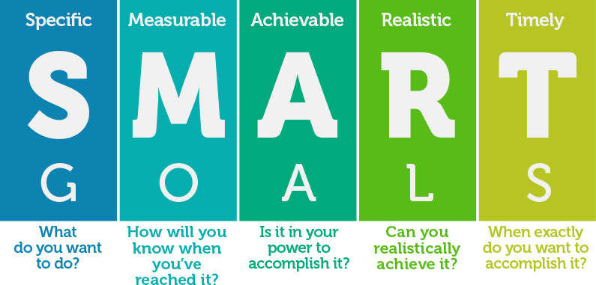
SMART GOALS needs to be specific, measurable, achievable, realistic and timely or time-based.
Short term objectives
We want to keep food costs less that 40 % of revenue. We want to promote and to expand our restaurant concept as a unique restaurant. We want to develop the marketing plan and to expand our marketing and advertising.
We want to gain customers and create relationships with them so they will become loyal.
Medium term objectives
In terms of SMART goals, the aim of our business plan is to make a profit of £ 35,000 over a period of 1 year.
We want to have a great food selection and to efficient and superior our customer service. We would like also to invest in trainings and employee welfare participation. We want to apply 10% discount to seniors or management to attract the market.
Long term objectives
We want to extend our business by opening restaurants in other location of London and to create a restaurant chain. The development of a restaurant chain is a necessary policy for achieving medium and long term goals (forming loyal and select customers, increasing the company's profit). This strategy avoids fluctuations in the general level of the company's sales, flattening the minimum and maximum levels generated by the summer periods.

Business structure (diagram)
According to Edwards (2014) the administration depends on factors such as the structure of the business and the proposed system of superising, coordinating and allocating tasks. Our restaurant choose a hierarchical structure where the board of directors, managers and all the team work together as business administrators to achieve the desired goals depending on the business plan of the restaurant.mThe business administrators work to gather towards a common goal by applying our business principles such as management, finance, marketing and accounting. The roles of the administration in the business are many as following:

Director
Claudiu Ciobanu
Assistant Manager
Andreea Esanu
Finance Manager
Corneliu Baba
Marketing Manager
Andreea Esanu
Administration Manager
Dragos Sorica

- Conclusion
Usually, small and medium business have consistently been the more mainstream sort of business since they are similarly simpler to set up, operate and work for it in orther to acomplish what we want. In any case, there is still a long way to go about this sort of business (Carpio, 2011). Significant models are utilized to structure the examinations for the business. The business plan incorporates a total strategy with a financial analyze about income and cash-flow report and statements for mission, vision and objectives. At long last, it investigates a portion of the exit and progression procedures that we as owners of the business may utilize in order to maximise what we want.
The vast majority of enteprises are working utilizing web to accomplish online item delivery So web based advertising and distributed computing has been a vital part of 21st century's enterprise. It has been demonstrated the advanced promoting technique in 21st century. In addition for the target market, showcase division and a promoting research has been practiced in this business plan so that the independent company like Romanian Restaurant can deal with their venture adapting to 21st century.

Product and services

Student name: Andreea Esanu-1713835
A Business Plan, also referred to as a marketing plan, business strategy, or business proposal, is a mission statement that sets out your vision, structure, and methods, and helps you to plan for the future.
Making a delicious food is an integral part of running a restaurant. Customers have a sense of satisfaction when they have a good meal and they will certainly feel happy about it and will want to come back to our restaurant to enjoy the same meal. “Vine romanul-Romanian Restaurant” offers a variety of Romanian traditional lunch and dinner menu, high qualities drinks and take-out prepared dishes, also a variety of tasty desserts. These dishes will be 100% Romanian, reminding each customer the taste of “home”, from childhood. There will be special menu for different occasion, such as couple anniversary, birthdays, Valentine`s day, Women`s day. In case they don’t like our already prepared menu, the customers can choose what they would like to serve for they special moment. Also, if you are not hungry and you want jut to chill out for a drink, you can go to the restaurant`s bar, to sit down and have a drink. We need to be in position to serve customers in such a way that they will come back to our restaurant (Alfa,2018).

Market analysis and needs

Marketing involves research to learn what people want to purchase (Maund et al,2017). Sometimes it’s challenging to compete in a marketplace where other businesses have more time or money to dedicate to their online marketing strategy. To get your company’s name out there, you need to make sure you promote it in the right place. It’s no secret that you need to be visible online—that’s where your customers are looking! However, creating a strong online presence need not break the bank. We believe that every business deserves the chance to be seen and heard online. Social Media Marketing is one of the most important tools for our business because we can see the feedback of the customers and what we need to improve on our services.
As we can see in diagram below, in order to create a good market analyse, we have to follow some steps to figure what we are missing or what we have to improve.
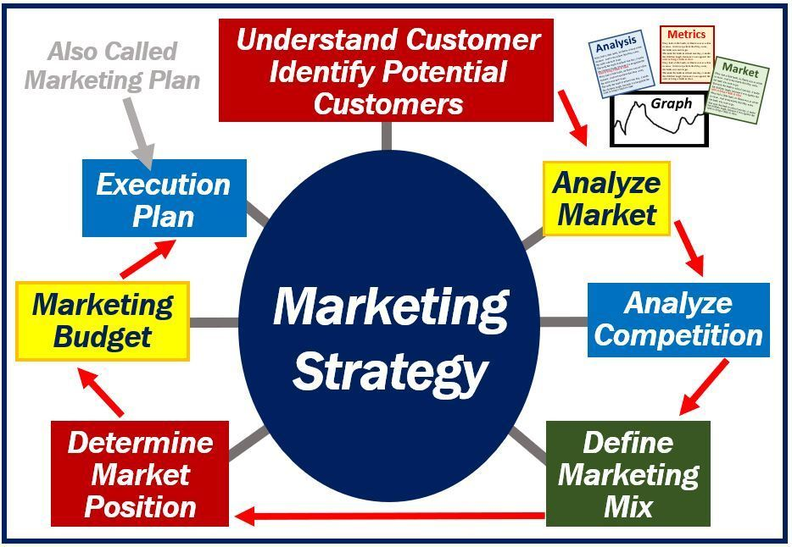

Understand customer/Identify potential customer
We will initially be located on a busy area (Oxford Street) so we can attract potential new customers (not only Romanian people), for this financial year in our target regions we estimate more than 2000 customers, monthly. It is important to know what potential customers desire are, how they would like to be treating by our staff when they are coming in.

Analyse Market
As you can see in the figure below, there is a model of analyse market, named “Porter`s Five Forces”, developed by Michael Porter in 1979, and these can help you to analyse the strengths and weaknesses of your position, and how they can impact your long-term profitability.
- The threat of entry- at this point we need figure how best can the business take care of the threat of new entrants. We must know our business competitors, who are they and if the quality of their products and services compare with ours, also we have to be careful with the suppliers because easily they can go to somewhere else if the see that our deal is not good for them.
- Supplier power- we must know how many potential suppliers we can have, and how many there are that offers uniqueness of service and how expensive would it be to switch from one supplier to another
- Buyer power-as we can see in figure, here is about price sensitivity and how they would drive down the prices, and the cost of changing from your products and services to those of a rival
- Threat of substitutes-this is about others that can substitute our product, threaten our profitability
- Competitive rivalry-as we can see all the four forces may come together to produce this force, we have to pay attention to the competition and put in all the resources at the company`s disposal to maintain market shares and sales.

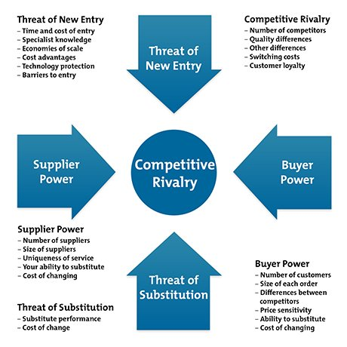
Source: https://www.mindtools.com/pages/article/newTMC_08.htm

Analyse Competition using SWOT format

Our location is a busy area with a lot of mix restaurants. Based on some research that we did, we think that our restaurant will be unique because we are going to sell Romanian traditional dishes, which you can not find in any other restaurants. Marketing strategy also includes analysis of the alternative opportunities and risks to the company with informed consideration of the competition, social environment, and company`s internal production capability (Arkebauer,1994).
In the table below, you can see our Company Swot format:

Define Market Mix
The Market Mix refers to the set of action or tactics, used by a company to promote its brand or product in the market. Marketing mix is based on the four Ps: Product, Price, Promotion and Place (see the image below).

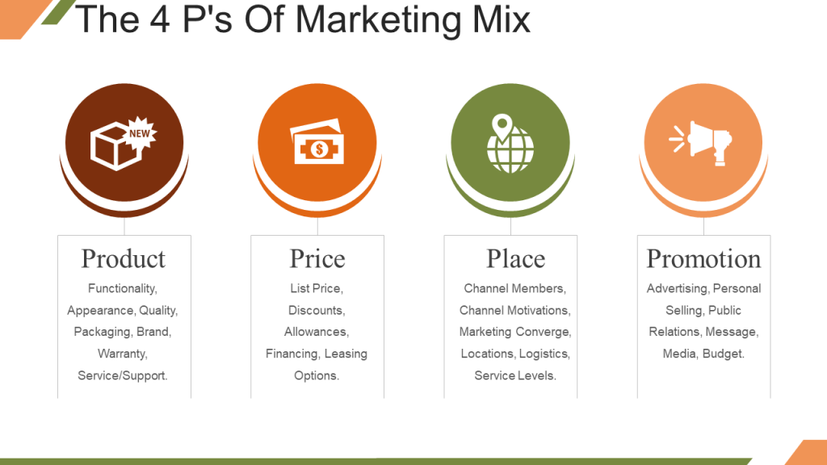
Image source: https://www.slideteam.net/blog/marketing-mix-ppt-templates-to-create-an-unbeatable-marketing-strategy

Product
The product must deliver a minimum level of performance, otherwise even the best work on the other elements of the marketing mixt won`t do any good.
As we can see in the image bellow we must have a USP-unique selling product that is satisfying the needs of the customers, our main product being traditional Romanian food.
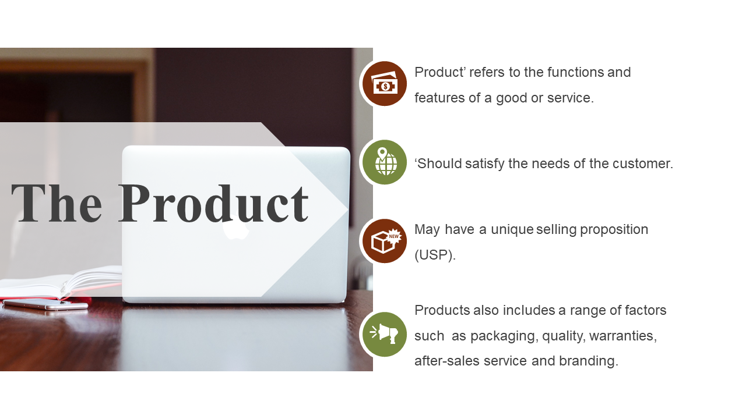Source: https://www.slideteam.net/blog/marketing-mix-ppt-templates-to-create-an-unbeatable-marketing-strategy

Price
A business can use a variety of pricing strategies when selling a product or service. The price can be set to maximize profitability for each unit sold or from the market overall. It can be used to defend an existing market from new entrants, to increase market share within a market or to enter a new market (Wikipedia). We decide that each of us we have to research study to see the price level example to our competition and ask our customers about the price level, to understand if this strategy could bring success to our business.
When we do pricing we need to consider the following factors:
- Fixed and variable costs
- Competition
- Company objectives
- Proposed positioning strategies
- Target group and willingness to pay
In the diagram below we can see some pricing strategies and tactics that we need to follow:
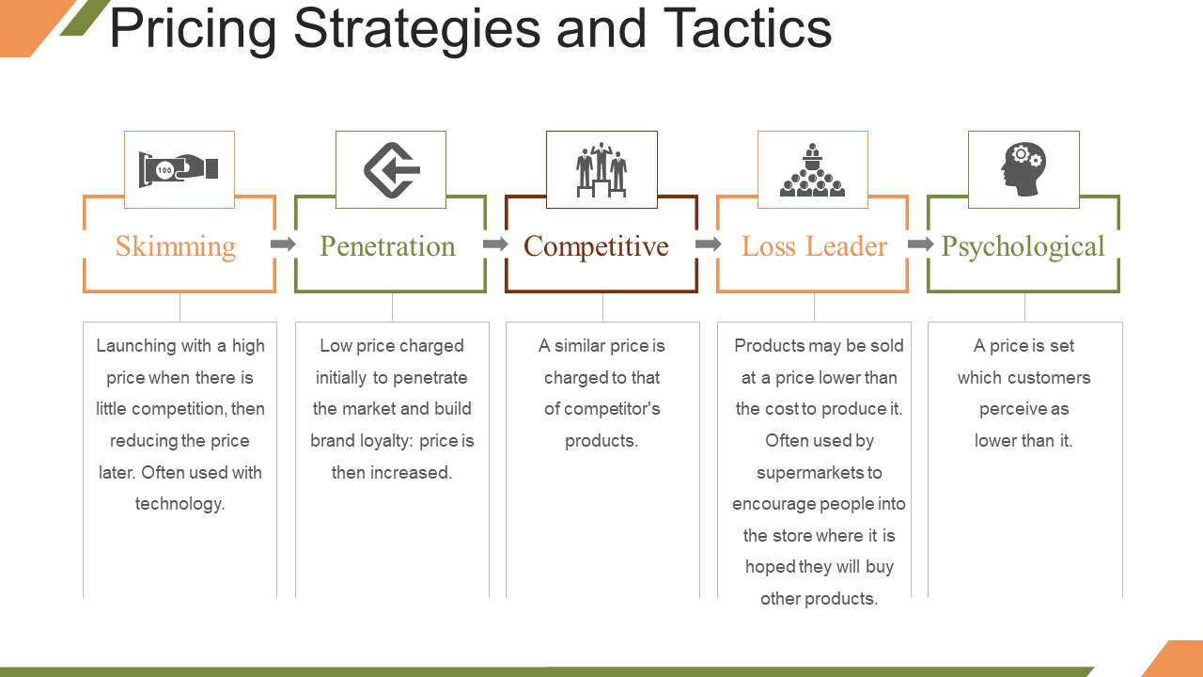
Source: https://www.slideteam.net/blog/marketing-mix-ppt-templates-to-create-an-unbeatable-marketing-strategy

Place
We must choose the right location and the right placement of products for a successful business. In order to increase the market share, we must be able to catch the eye of the consumer and find out what they like and what they will prefer to eat.
Promotion
Promotion (image bellow) refers to all actions that we need to take in order to make our product known to the consumer.
Even if in our area there are not restaurants of this kind, we thought that we promote our business considering the following:
- Social media (Facebook, Instagram)
- Website (email)
- Advertising (print, radio, tv)
Facebook and Instagram are the most used social platforms media. The key to increase our profit is to make our restaurant a popular place, posting pictures with food and even with the short video with the chef and how is preparing our food. People can also tag the name of our restaurant in their pictures spreading our name to the other potential customers.
On the website you can find the email of our business and many other information regarding the menu, the bar, opening times, and offers. Also we are trying to do tv advertising, if our business is going well.
However, the restaurant phone number will be always available for any question and information needed.
Social media marketing is a very important tool nowadays and it helps any new business to increase sales and bring in new customers.
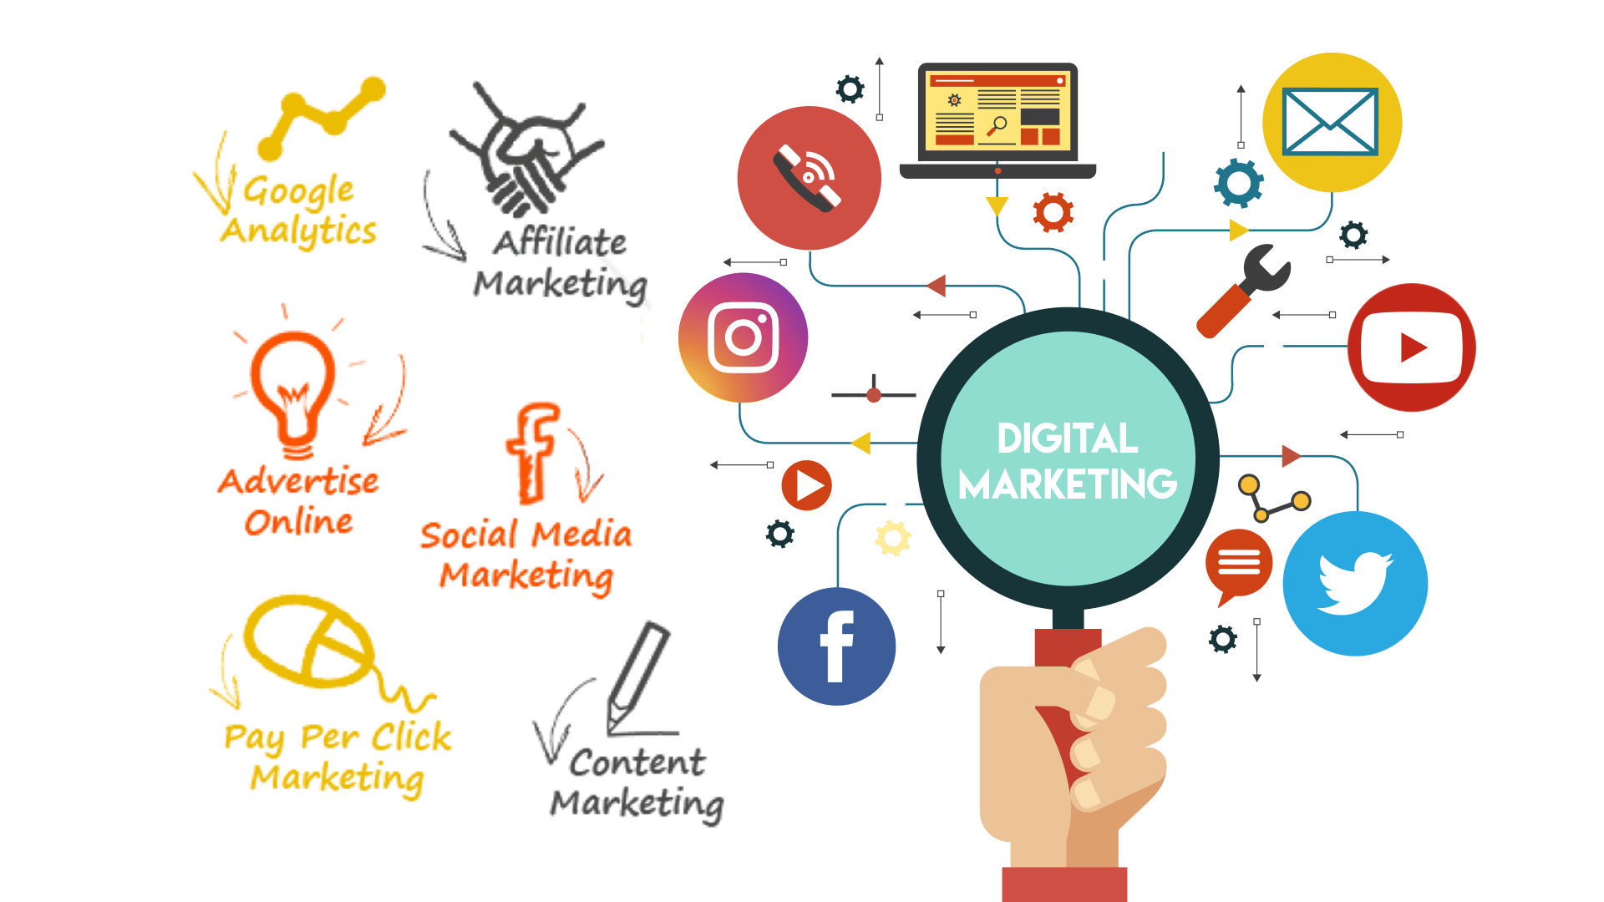
Source: http://royalgorgeatv.com/2020/01/24/user-guide-on-search-engine-optimization

Sales target and objectives
In order to set our goals and reach our objectives we must train ourselves how to watch the sales process, to be able to calculate the restaurant`s income. Being a team of 4 people with a very developed experience in sale and with customers services, we are already with a step forward. We set few objectives to follow in order to make our restaurant to work:
- One of the most important aim is to focus on making our customer service process exceptional, handling customer complaints more effectively, or incorporating customer service into your social media practices (Gregory,2019)
- Always to bring new ideas which can increase the sales
- To keep the restaurant clean and create a nice atmosphere for customers
- To set a standard for a number of daily sales and what can improve to do more
In conclusion, in order to accomplish all these objectives we need to focus on our work and everyone to do their task.

Operations

Student name: Dragos Sorica-1906082
- My skills and experience
- Operations
- Technology Plan
- Management and Organisation
- Conclusion

- My skills and experience
- Demonstrated understanding and experience as a administrative assistant for over 1 year a
- Demonstrated understanding as a clerical specialist, menial helper or office administrator colleague
- Information on office the executives frameworks and methods
- Working information on office gear, similar to printers and fax machines
- Capability in MS Office (MS Excel and MS PowerPoint, specifically)
- Fantastic time the board aptitudes and the capacity to organize work
- Tender loving care and critical thinking aptitudes
- Fantastic composed and verbal relational abilities
- Solid hierarchical aptitudes with the capacity to perform various tasks
- Secondary School degree; extra capability as an Administrative right hand or Secretary will be an or more a bakery
- Knowledge on office the executives frameworks and methods
- Working information on office gear, similar to printers and fax machines
- Capability in MS Office (MS Excel, MS Word and MS PowerPoint)
- Fantastic time management aptitudes and the capacity to organize work
- Solid hierarchical aptitudes with the capacity to perform various tasks and multi-task
- High School degree
- Secretary for 7 months at an hotel
- Problem solving and decision making skills
- Attention to detail
- Back of house" café representatives get ready and present food or clean dishes, while "front of house" labourers welcome and interface with clients. Everybody cooperates as a group to make a paramount, charming encounter for all benefactors.
- In spite of the fact that in certain regards food administration occupations are fundamentally the same as from eatery to café, every business is remarkable.
- Operations
Operations aspects of a business plan are split in three categories: strategic plan, tactical plan and operational plan. The business will operate from office from inside the restaurant.
The details of two key suppliers that are important if we want to run our business are presented below:
Supplier / Relationship 1
Organisation  Strategic alliance | Relationship Status  Dedicated personal assistance
Service provided  Asset sales | Key terms of relationship  Financial resources

Supplier / Relationship 2
Organisation | Relationship Status  Personal assistance
Service provided  Advertising | Key terms of relationship  Mass market

Other operational considerations
I am doing the administration which involves selection of the personal. I am currently employing staff for the appropriate future because our business is ready to employ people who can help our restaurant to accomplish all the goals and to help the business to develop and growth.
How many staff do you currently employ?
I want to employ waiters, chefs, delivery person and a driver.
A waiter is:
Giving great hold up benefit to guarantee satisfaction
Taking client orders and conveying nourishment and beverages
Making menu proposals, replying questions and sharing extra data with eatery supporters.
Waiter/Waitress duties incorporate welcoming and serving clients, giving data on menus, multi-tasking different front-of-the-house obligations and collecting the charge. On the off chance that you're able to perform well in fast-paced situations, we’d like to meet you. To be a fruitful Server or Server, you ought to be courteous with our clients and make beyond any doubt they appreciate their dinners. You ought to moreover be a group player and be able to successfully communicate with our Kitchen Staff to create beyond any doubt orders are precise and conveyed expeditiously.
As a chef you need to: Each restaurant’s notoriety lies with the chef of the restaurant. Hence, obligations of a chef are very noteworthy to construct or damage nourishment joint’s prestige. The term ‘CHEF’ is synonymous with delightful cooking; fragrant flavours and clearly a wonderful dish introduction that not as it were fulfils our gourmet wants but are too treat to the eyes. A chef is 90% capable for the achievements that a eatery accomplishes. Other than the restaurant’s imaginative beautification and other client appealing highlights, the nourishment it serves is the primary component that includes to its recognition. Hence the chef need to have lovely culinary aptitudes. He must have the capacities to set a unused worldview inside the nourishment joint with his insights. Thomas Keller (prevalent American chef and restaurateur) once commented exceptionally apropos “A formula has no soul. You as the cook must bring soul to the recipe.”
He is capable for planning the kitchen staff.He works in put of the head chef when he is off-duty. Additionally, Sous chef too helps the Chef de Partie (line cook) as and when needed. Sous chef is capable for the kitchen’s stock management. He looks after the organization cleanliness. He moreover trains the complete staff. A sous-chef’s obligations contain — conducting line checks and supervising the opportune turn of all food products. Sous-chef is effectively included within the ordinary operation of the kitchen.
As a delivery person you need to:
Drive vehicles to assigned goals for client item deliveries.
Drive securely and provide items inside deadlines.
Analyse conveyance address, decide suitable courses and keep up schedule.
Report any mishaps or wounds to Bosses immediately.
Load and empty items from trucks and trailers.
Perform vehicle assessment such as checking liquid level and tire pressure.
Notify administrators approximately any major repairs and maintenances.
Follow neighbourhood and state driving laws and street regulations.
Maintain the vehicle clean and safe.
Collect instalments from client at the time of item conveyance

As a driver you need to: Driver duties incorporate organizing normal cleaning and upkeep administrations for the vehicle, arranging each course based on street and activity conditions and overseeing payments. Ultimately, you may offer assistance us increment client fulfilment, making beyond any doubt clients depend on us for their transportation require:
Map out driving routes ahead of time to determine the most expedient trip
Pick up clients from the place and at the time they’ve requested
Collect payments and issue receipts
Assist clients with loading and unloading their luggage
Listen to traffic and weather reports to stay up-to-date on road conditions
Adjust the route to avoid heavy traffic or road constructions, as needed
Answer clients’ questions about the area and local places of interest
Ensure the car seats are clean and comfortable for all riders
Schedule regular car service appointments and report any issues
Book car wash and detailing services to maintain interior and exterior cleanliness of the car
Technology Plan
Organization is tied in with overseeing labourers and sorting out them in the business and successfully designating assets through the use of the miniaturized scale financial standard. The fields of organization are exceptionally wide, consolidating an assortment of the executives position with the fundamental objective to accomplish development dependability and gainfulness for our business.

The organization relies upon variables, for example, the structure of the business and the proposed arrangement of supervising, planning and designating errands. Our bread kitchen pick a hierarchical structure where the top managerial staff, directors, investors and an official committee cooperate as business executives to accomplish the ideal objectives relying upon the strategy of the bakery. The business heads work to assemble towards a shared objective by applying our business standards, for example, the board, money, advertising and bookkeeping.
- Touch screen Terminal- Within the show we have the POS advancement which exists and extend successfully. The most prominent portion almost these terminals is the truth that they are outfitted with our pastry shop modified structure with a common interface that gives new contracts a alter to start taking ask rapidly and easily. A few terminals indeed contain a connected credit card per user, so cashiers can swipe and have the client sign on screen in a matter of seconds without any squander of paper (or time).
- Receipt Printer- Indeed in the event that this proffesional innovation is truly accommodating to allow progressed receipts we still have to be offer to our clients the elective of paper receipts. Ordinarily, you may have 2 choices with respect to the receipt so fair select the one that's more viable for you. As useful to proficiency that advanced receipts can be, most eateries - particularly full-service eateries - still need to have the alternative of paper receipts. Ordinarily, you'll have two choices when it comes to receipt printers - affect and warm
3. Kitchen Display Print- A few eateries have very a frenzied kitchen, and so printed tickets might not be the foremost reasonable choice. Instep, these kitchens depend on a kitchen show framework, or a KDS.
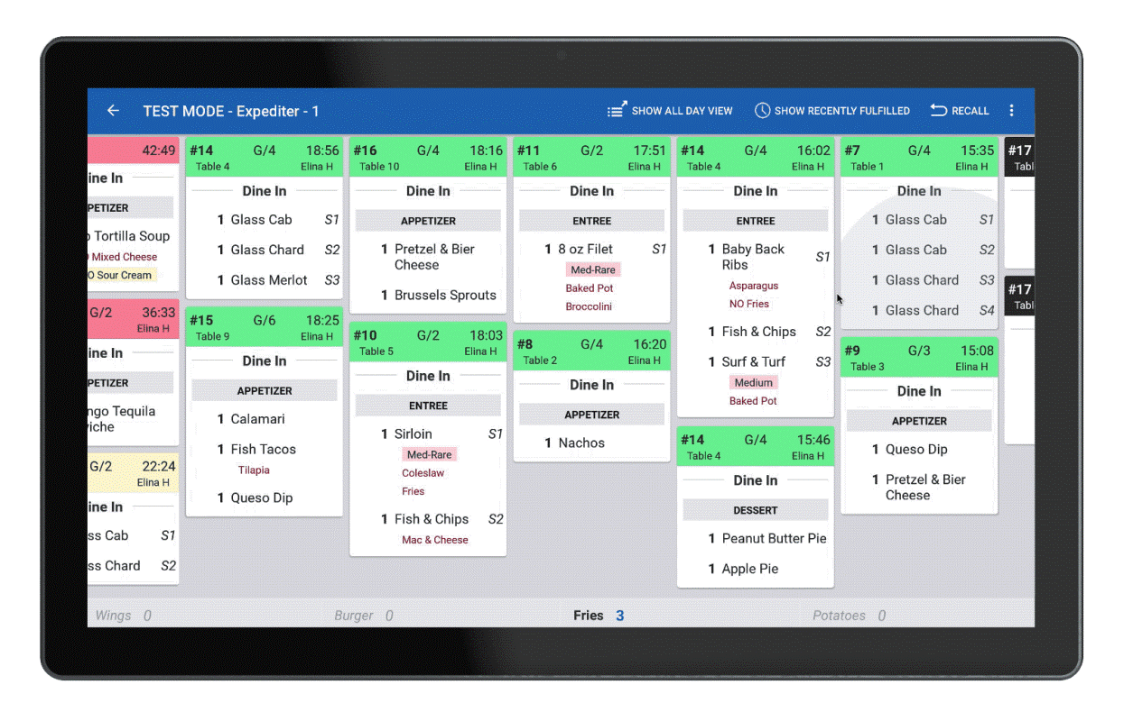
Mounted to the kitchen divider, a kitchen show will appear all open orders for the back-of-house group to see in one put. This makes it less demanding to remain organized within the back of the house, which keeps things normal within the front of the house as well.
Management and Organisation
Organization is tied in with overseeing labourers and sorting out them in the business and successfully designating assets through the use of the miniaturized scale financial standard. The fields of organization are exceptionally wide, consolidating an assortment of the executives’ position with the fundamental objective to accomplish development dependability and gainfulness for our business.
Staff wages and gross
Romanian restaurant will open 5 days a week, the reason for that is the restaurant will make more money from costumers. In addition to that if staffs
get tips then it would be a bonus for the business. In addition to that, there will be 2 staffs working from Monday to Wednesday and 3 staffs working from Thursday to Friday. The total approximate cost for 5 staff a week it will be £2500.
Extra earnings-For extra earnings we will have membership cards which will be for loyal costumers who signing up. The membership card will work for costumers who spend a maximum of £100 or more in a month they will be award with a free drink with a meal. Romanian restaurant came up with the idea for a business promotion. We have a budget to pay no more than £500 over a period of 6 months for a group of people to promote the business. the business promotion will take place with flyers promotion. We will be advertising the Romanian Restaurant on bill boards this will cost £150 for 5 weeks.
Tax-The estimated balance for the financial tax of “Vine romanul” restaurant is around 19.8%. our restaurant will save an allowance of £120 a year.
Work Scheduling
The restaurant will be open 7 days a week with hours as follows:
Day | Opening hours | Closing hours
Monday | 11:00 am | 12:00 am
Tuesday | 11:00 am | 12:00 am
Wednesday | 11:00 am | 12:00 am
Thursday | 11:00 am | 12:00 am
Friday | 11:00 am | 12:00 am
Saturday | 11:00 am | 12:00 am
Sunday | 12:00 am | 12:00 am

Here you outline who is performing what role in your organisation from the team/group
- According to Edwards (2014) the administration depends on factors such as the structure of the business and the proposed system of superising, coordinating and allocating tasks. Our restaurant chooses a hierarchical structure where the board of directors, managers and all the team work together as business administrators to achieve the desired goals depending on the business plan of the restaurant.
- The business administrators work to gather towards a common goal by applying our business principles such as management, finance, marketing and accounting.
- The roles of the administration in the business are many as following:

Director
Claudiu Ciobanu
Assistant Manager
Andreea Esanu
Finance Manager
Corneliu Baba
Marketing Manager
Andreea Esanu
Administration Manager
Dragos Sorica

Conclusion
Even if the restaurant food industry has witnessed significant demand in traditional Romanian food, in UK, most of people love to eat our traditional food. Romanian Restaurant have high quality and hygiene food with increasing tourism trends which let us to serve huge customer base. This is simply summing up what are the operations, which is the management plan and what is the structure of the business and along with my skills and experience this should be enough to achieve the main objectives and goals of the business plan.

Social Responsibility and Sustainability

Being a new in business, the corporate social responsibility main actions are that we should:
- Support and respect the protection of human rights
- Make sure that we do not introducing in our operations forms of forced labour
- Protect the environment by taking responsibility for all environmental impacts of the business
- Take anti-corruption measures
Sustainability is an essential factor for smart business today, because is the ability of a system to exist constantly at a cost, in a universe that evolves towards thermodynamic equilibrium, the state with maximum entropy (Wikipedia).
According to National Restaurant Association survey`s there are few sustainability steps that every business needs to promote and how restaurants could best promote sustainability practices to guests:
- Energy-saving equipment and practices are common
- Reducing food waste is emerging as a key activity for operators
- Many operators source packaging and supplies made from materials with a smaller environmental footprint
- A restaurant's sustainability effort can influence guests' restaurant choice

Financial Plan

Student name: Corneliu Ionut Baba - 1906079

Financial Plan Contents

- Sources of Finance………………………………………………………………………………1
- Personal Survival Budget………………………………………………………………………2
- Cash Flow Statement……………………………………………………………………………3
- Balance Sheet…………………………………………………………………………………….4
- Sales Forecast………………………………………………………………………………….5-6
- Business Ratio/Break Even Analysis……………………………………………………….6-7
- References…………………………………………………………………………………………8

In this business we are 4 partners. Andreea, Dragos, Claudiu and Corneliu.
In order to start this business and not to face financial difficulties until the moment when we considered that the business will become known and therefore profitable, all four partners met and together we considered that £ 70,000 is the amount we need, to set up this business.
Then we tried to distinguish the sources of funding. From personal savings we were able to contribute each of us with the amount of £ 7500, which from the beginning ensured us the amount of £ 30,000 enough to start the project.
For the rest of the amount we needed for £ 40,000, of course, we thought about what viable sources we could have to access that money.
We took into account several variants such as:
- Friends and family who could lend us this amount of money.
- Government funding
- Bank loans
- Angel Investors and Venture Capitalists
We came to the conclusion that being already four partners in this business it is not a good idea to involve other friends or family. Then the idea with the angel investors for the same reason we found very little attractive because we being four partners and investing almost half of the amount, we did not want to give up percentages of the business.
So we chose the option of a bank loan, which we obtained relatively easily by presenting the business plan and the amount we already had for the investment. So we ended up having enough money to implement this business plan.

- Personal Survival Budget

A personal survival budget shows the average monthly income minus all the costs and expenses I would incur in a typical month. As the name suggests, this is a not business budget - is a personal budget.

 |  | Monthly cost
A month | Rent or mortgage | £500
A month | Gas or other heatings | £50
A month | Electricity | £50
A month | Water | £60
A month | Food | £250
A month | Insurance ( life insurance ) | £120
A month | Telephons | £20
A month | Subscriptions (tv, magasine) | £20
A month | Car petrol | £100
A month | Car insurance | £80
TOTAL COSTS |  | £1250
ESTIMATED INCOME |  | £1600
 | Government benefits | 0
 | Any other benefit | 0
TOTAL INCOME |  | £1600

- Cash Flow Statement

Due to the fact that in the area where the restaurant is located there is a large community of Romanians, and based on our experience regarding the quality of the products we will offer and knowing the appetite of Romanians to consume traditional Romanian products, our expectations are quite high in terms of business success.

Cash low Forecast Expediture 2020-2021 (1 year)
Vine Romanul Restaurant

 | Jun-20 | Jul-20 | Aug-20 | Sep-20 | Oct-20 | Nov-20 | Dec-20 | Ian-21 | Feb-21 | Mar-21 | Apr-21 | Mai-21
Opening Balance | £70000
Bank Loan | £40000
Sales | £20000 | £29000 | £44000 | £55000 | £55000 | £60000 | £75000 | £45000 | £45000 | £45000 | £65000 | £65000
Others
Total money in | £20000 | £29000 | £44000 | £55000 | £55000 | £60000 | £75000 | £45000 | £45000 | £45000 | £65000 | £65000
Monthly Expenses
Rent | £2200 | £2200 | £2200 | £2200 | £2200 | £2200 | £2200 | £2200 | £2200 | £2200 | £2200 | £2200
Furniture | £12000
Equipment | £10000 |  | £800
Loan repayment |  | £600 | £600 | £600 | £600 | £600 | £600 | £600 | £600 | £600 | £600 | £600
Marketing | £200 |  |  | £100 |  |  | £100 |  |  | £100
Stationary | £100 |  | £50 |  | £50 |  | £50 |  | £50 |  | £50
Wages |  | £10800 | £10800 | £10800 | £10800 | £10800 | £10800 | £10800 | £10800 | £10800 | £10800 | £10800
Supply- Markets | £3000 | £4000 | £5000 | £5000 | £5000 | £5000 | £5500 | £3000 | £3000 | £3500 | £5000 | £5000
Insurance | £1000 | £1000 | £1000 | £1000 | £1000 | £1000 | £1000 | £1000 | £1000 | £1000 | £1000 | £1000
Others | £4000 | £4000 | £4000 | £4000 | £4000 | £4000 | £4000 | £4000 | £4000 | £4000 | £4000 | £4000
TOTAL | £32500 | £22600 | £24450 | £23700 | £23650 | £23600 | £24250 | £21800 | £21850 | £22400 | £23850 | £23800

- Balance Sheet

Balance sheet is an important part of the financial plan. Is an financial statement which shows at the time they are made the financial health of our business. we look at the balance sheet together with other financial statements to better understand the relationships between different accounts.
For us to check the liquidity, efficiency and leverage Balance Sheet is the best tool to help us to understand how we stay in the business.

LIQUIDITY
By comparing our business’s current assets to its current liabilities, we get the best feedback of the liquidity of our company, or how much cash we have available.
LEVERAGE
Balance sheet help us to understand how much leverage our business has, which tell us how much financial risk we face.
EFFICIENCY
Comparing our income statement to our balance sheet, we measure how efficiently our business uses its assets.

Balance Sheet Example

Assets  Cash and cash equivalents £25000  Accounts receivable £10000  Inventory £7000  Prepaid expense £2000  Investments £5000  Supplies £3500  Prepaid insurance £600  Total curent assets £53100  Property and equipments  Building improvements £17900  Equipments £10000  Land improvements £36000  Prop & equipements net £63900  Total assets £117000 | Liabilities and Shareholders’ Equity  Notes payable £7500  Accounts payable £3000  Wages payable £5400  Interest payable £1400  Taxes payable £1700  Accrued expenses £1900  Deferred revenue £1600  Total current liabilities £22500  Long-term liabilities  Notes payable £14500  Bonds payable £80000  Total long-term liabilities £94500  Total liabilities £117000

- Sales Forecast

Sales forecast is not about guessing the future, is about expectations, assumptions, drivers, tracking and management.
Forecast help my to do the budget and to manage, its like any other think I do in the business. The forecast is measurable by business results.
Even if the business is new this doesn’t mean I cant do the forecast. There are many ways to can have an idea about what to expect for the business.
My forecast is important for the business because give my a line to think of, a target.
To forecast the sales I just have to overlap the plans with the real results and make the corrections. This simple process will help the business a lot.
There are some steps to do e good forecast like plan your streams, forecast row by row where the method of for each row depends on the business model. But anyway almost all the forecast rows are just math.

Sales Forecast | Jun | Jul | Aug | Sep | Oct | Nov | Dec | Ian | Feb | Mar | Apr | Mai
Unit Sales
Lunches | 120 | 180 | 310 | 330 | 320 | 280 | 430 | 220 | 220 | 280 | 380 | 380
Lunch bvg | 120 | 180 | 310 | 330 | 320 | 280 | 430 | 220 | 220 | 280 | 380 | 380
Dinners | 500 | 600 | 800 | 830 | 820 | 750 | 950 | 650 | 650 | 750 | 880 | 880
Dinners bvg | 500 | 600 | 800 | 830 | 820 | 750 | 950 | 650 | 650 | 750 | 880 | 880
Others | 100 | 300 | 500 | 800 | 1000 | 1000 | 2500 | 1700 | 1700 | 1800 | 2000 | 2000
Total Unit Sales | 1300 | 1620 | 2290 | 1390 | 1340 | 2120 | 2830 | 1800 | 1800 | 2130 | 2630 | 2630
Unit prices
Lunches | 8 | 8 | 8 | 8 | 8 | 8 | 8 | 8 | 8 | 8 | 8 | 8
Lunch bvg | 3 | 3 | 3 | 3 | 3 | 3 | 3 | 3 | 3 | 3 | 3 | 3
Dinners | 18 | 18 | 18 | 18 | 18 | 18 | 18 | 18 | 18 | 18 | 18 | 18
Dinners bvg | 5 | 5 | 5 | 5 | 5 | 5 | 5 | 5 | 5 | 5 | 5 | 5
Others | 10 | 10 | 10 | 10 | 10 | 10 | 10 | 10 | 10 | 10 | 10 | 10
Sales
Lunches | 960 | 1440 | 2480 | 2640 | 2560 | 2240 | 3440 | 1760 | 1760 | 2240 | 3040 | 3040
Lunch bvg | 360 | 540 | 930 | 990 | 960 | 840 | 1290 | 660 | 660 | 840 | 1140 | 1140
Dinners | 9000 | 10800 | 14400 | 14940 | 14760 | 13500 | 17100 | 11700 | 11700 | 13500 | 15840 | 15840
Dinner bvg | 2500 | 3000 | 4000 | 4150 | 4100 | 3750 | 4750 | 3250 | 3250 | 3750 | 4400 | 4400
Others | 1000 | 3000 | 5000 | 8000 | 10000 | 10000 | 25000 | 17000 | 17000 | 18000 | 20000 | 20000
Total Sales | 13820 | 18780 | 26810 | 30740 | 32380 | 30330 | 51080 | 34370 | 34370 | 38280 | 44420 | 44420

- Business Ratio/Break Even Analysis

Acording to Michael Brown, the founder and CEO of Plan Projections (www.planprojections.com) ‘’Financial ratios are a relative measure of two or more values taken from the financial statements of a business and can be expressed as a decimal value such as 0.45 or as a percentage e.g. 45%. Financial ratios are used to analyse business trends and measure performance of both the business and the management’’
He also said ‘’The key to using financial ratios is to chose the ratios which are most critical to your business, decide on the formula to use, which should be the same as that used by comparable businesses in your industry, and consistently monitor the ratio over time relative to other ratios you have calculated’’

- We have six main categories of financial ratios

- Profitability ratios
- Liquidity ratios
- Efficiency ratios
- Leverage ratios
- Activity ratios
- Investor ratios

Profitability Ratios
Profitability ratios are used to check the ability of a business and its management to generate profit.

Liquidity Ratios
It is the ratio that helps the business to have cash to solve liabilities and debts in the short term

Efficiency Ratios
Efficiency ratios are to measure the company's ability to manage its assets to bring maximum profit

Leverage rates

A leverage ratio is about the level of debt in relation to the owners equity.

Activity ratios

Activity ratios are about the ability to convert different balance sheet accounts such as inventory, accounts receivable, and accounts payable into sales or cash.

Investor rates

Investor reports are about measuring the ability of the business to earn the best possible return for the business owners.

- Break Even Analysis

Break Even Analysis It is the tool that uses us to show when the business can become profitable, or a new product or service. It's about when revenue starts to outweigh costs. It is considered a safety margin.

In our business being all four partners of Romanian nationality and having previous experience in this field, some of us as entrepreneurs in the fast food sector and others working in the past in the restaurant in this sector of traditional Romanian products and knowing well the area where the restaurant is located, knowing that it is an area where many Romanians live, it was easy for us to be optimistic and consider that in the second month after starting the business the maximum third month income will exceed monthly expenses and in about six months we expect the initial investment to be amortized.

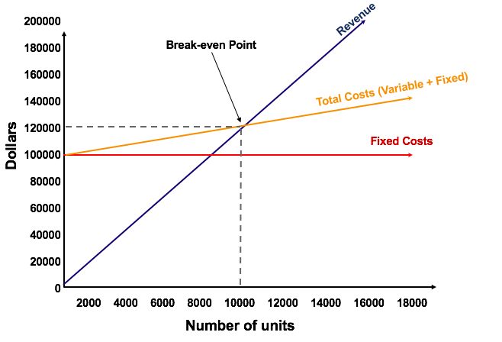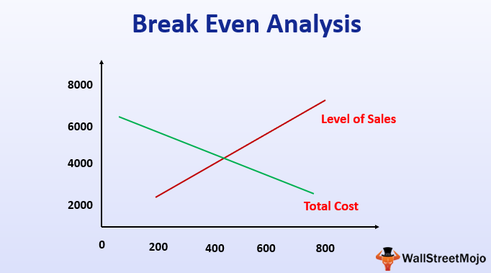

Conclusion
Business plan is a challenging and rigorous project for us, but we are very confident with our business plan idea and with all skills and knowledge that four of us we have, the company can achieve aggressive sales. The “Vine romanul- Romanian restaurant” has the potential to become a highly regarded restaurant in local markets.

References

https://www.freshbooks.com/hub/accounting/balance-sheet#whyisabalancesheetimportant
https://www.accountingcoach.com/balance-sheet/explanation/4
https://www.accountingcoach.com/cash-flow-statement/explanation
https://www.moneycanbuymehappiness.com/creating-your-survival-budget/
https://articles.bplans.com/how-to-forecast-sales/
https://articles.bplans.com/example-initial-sales-forecast-for-a-restaurant/
https://www.planprojections.com/projections/financial-ratios-analysis/
https://www.investopedia.com/terms/b/breakevenanalysis.asp
https://corporatefinanceinstitute.com/resources/knowledge/modeling/break-even-analysis/
https://en.wikipedia.org/wiki/Sustainability
https://restaurant.org/research/reports/state-of-restaurant-sustainability
https://www.slideteam.net/blog/marketing-mix-ppt-templates-to-create-an-unbeatable-marketing-strategyhttps://www.mckinsey.com/business-functions/organization/our-insights/retaining-key-employees-in-times-of-change: Accessed on 16/08/2019.
http://whartonmagazine.com/blogs/expanding-internationally-is-it-right-for-you/#sthash.AdFMCdoF.4kg5Z87J.dpbs: Accessed on 12/08/2019.

Alfa. (2018, february 2). At home. Retrieved may 10, 2020, from The Top-Five Basic Services a Customer Needs at Restaurant: http://www.athomenz.org.nz/top-five-basic-services-customer-needs-restaurant/
Arkebauer, J. (1994). The McGraw-Hill guide to writting a high-impact business plan: A proven blueprint for entrepreneurs. New York: McGraw-Hill.
Carpio. (2011). A guide to wrtie a business plan (1st ed.). England.
Edwards, J. (2014). Mastering Strategic Management (1st ed.). Victoria: B.C Campus.
Farooq, U. (2018). Reviews of Environmental Contamination and Toxicology (2nd ed.). Founding Editor.
Gordin, A. (2011). Fluent in foreign business: Grow your own company by expanding into foreign markets. USA: Princeton Council on Word Affairs.
Gregory, A. (2019). The balance small business. Retrieved May 10, 2020, from 19 small business goal you can set this year: https://www.thebalancesmb.com/small-business-goals-4126116
Keffer, S. (2014). A Guide to Developing Mission, Vission, and Value Statements (1st ed.). USA: WriteLife.
Kotler, P., & K.L, K. (2012). Marketing Management. Essex, England: Pearson Education Limited.
Maund, A., Schriek, M., & Tinkler, P. K. (2017). Certificate in Higher Education: Skills for the Workplace Student Yearbook. London: SAGE.

Appendix



