Introduction to Web Development
  - Lecture 8b Lab Tutorial Exercise

Creating a Blog Website

Objectives
In this exercise, you will set up a blog on the Drupal site you installed.

Exercise 1: Logging on to your Website
- Launch your UwAmp server.
  - Locate the folder where you installed it.
  - Right-click on the UwAmp application file and select Run as administrator.
  - It should launch a web page and your Drupal website should be listed under Virtual Host.
  - Click on the link for your Drupal website.
- To make changes to your website, you will need to login - Login.
  - Please remember that I do not know your password!
- As you will be switching between Admin Mode and Preview mode (this is what your Site Visitors see), it is a good idea to have two tabs open.
  - One tab for admin
  - One tab for Preview mode.
- To switch to Preview mode, you use the Back to site link at the top of the Admin page. If you right-click on this link, you can choose “Open link in new tab”.

Exercise 2: Customising the Site’s Appearance

Changing the Site’s Title and Slogan
- Locate the black menu bar at the top of the page and click on Manage Configuration
- Locate the System block, and click on Basic site settings
  - Change the site name and slogan if you wish
  - Save any changes by clicking the Save configuration button.

Changing the Site’s Theme
- To change the site theme, you first of need to locate a theme that you like
  - Open the following link in a new tab (so you can easily return to your website): https://www.drupal.org/project/project_theme
  - In the Search Themes text field, enter blog to filter for blog type themes and then click the Search button.
  - Look through the options and download a theme that you like.
- Return to your website
- Click on the Appearance tab in the menu
  - Click the +Install new theme button
  - Locate the Choose File button, click and browse to the theme file that you downloaded and Install it.
  - Once it is done installing, you should see your listed theme with the other themes currently installed.
  - You will need to click on the Install and set as default link to set the new theme for your site.

Configuring the New Theme

The Logo
- At the minimum, you probably want to change the logo for your website.
- Click on the Appearance tab and click on the Settings link beside your chosen theme.
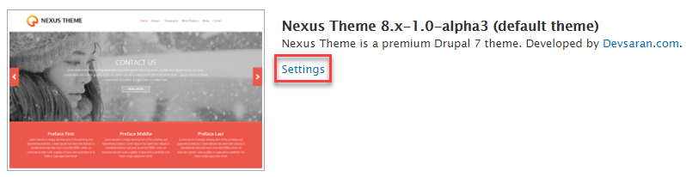
- Locate the settings for Logo Image. If you do not want to use the default logo:
  - Uncheck the “Use the logo supplied by the theme box”
  - Use the Choose File button to upload your preferred logo file.
  - Save your changes.
  - Preview your website.
  - Note: if your logo image does not display, it may be too large to fit into the space reserved for the logo in the theme template. Try resizing (making it smaller) using GIMP or Adobe, etc.

The Banner or Slideshow Images
- Your chosen theme may let you add a banner or slideshow to it. If it does, there will be settings for you to change the images and any captions.
- Make any changes that you want.

Exercise 3: Adding Users
- You can setup your blog site so that:
  - Only authenticated (logged-in) users can contribute to the blog content (to avoid spam content), but allow anyone (anonymous) users to view it.
  - You can also restrict access to certain pages to specific authenticated uses.
- From the admin menu, go to Manage People
- You probably have only one user at the moment. The admin account you set up when you installed Drupal.
- Click the Add User button and use it to add two more users of your choice.
- Click on the People menu option when you are done and you should see the new users listed. Now click on the Permissions tab at the top of the Page. This page shows you all the list of different permissions you can assign to different types of users and what they can and cannot do.
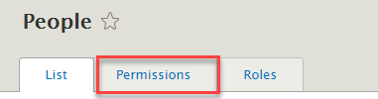
- By default, there are three types of roles: Anonymous user, Authenticated user and Administrator.
- If you want to add more roles (e.g. add a Customer role to an e-commerce site), or make changes to an existing role, click on the Roles tab.
- Click on the List tab and for the two users you created earlier, add them to roles of your choice.
  - They will belong to the Authenticated user role by default.
  - If you want to add them to the list of Administrators for the site, you can use the Action option to change the role for selected users.
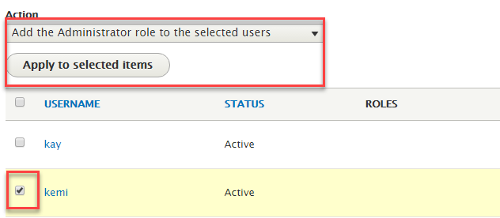
- To test the different user accounts, open a different browser. For example, copy your website’s URL from the address bar.
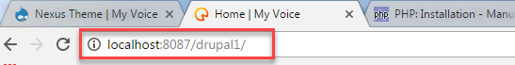
  - If you are currently using Google Chrome, open your website in Firefox and vice-versa.
  - Try logging in as one of the other user accounts that you created.
  - This allows you to simulate (pretend) being a different user.

Exercise 4: Creating a Blog
- From the Admin menu, go to Manage Content
- Click the Add content button.
- You have two choices: Article or Basic Page. You are going to use an Article as this is more suitable for content that changes, such as blog.
- Select the Article option.
- Decide what topic you want users to blog about and complete the fields. For example, say I was creating a blog to get people’s opinions on the recent Oscar nominations, I could have the following:
  - Title: 2017 Oscar Nominations (the title for the blog)
  - Body: Description to display to the user e.g.
The 89th Academy Awards telecast airs at 8 p.m. ET/5 p.m. PT, Sunday, February 26.
Nominations for this year's awards were announced on Jan. 24. What do you think of the nominations and who do you think is going to win?
  - Tag: Oscar 2017 (these are tags that can be used to find a blog if you have different blogs set up)
- Expand the Promotion Options on the right-hand side of the page.
  - Check the “Promoted to front page” option, so that this blog appears on the home page.
- Click the Save and Publish button.
- Add some more Blog Entries of your choice to your site.
- Try posting some comments to the blog(s) using the different user accounts (you will need to switch between browsers to pretend to be different users).
- That’s all for today! We will add a bit more to the site in the next class.

