Approaches to Art & Design Research and Academic Communication
Situating your research and practice
ADAD7014

Chen Wan

“let the meaning choose the word,and not the other way about.”
—— George Orwell(1954)

The discussion is based on the following epistemology：

1. I will use 'identity' as an analytical concept (R Brubaker, F Cooper, 2000). This paper intends to critically discuss what work we should do with 'identity' and how well it is being done (ibid.). As Lawrence Grossberg argues, this is not to avoid identity but to "relocate it, rearticulate it." Therefore, I will not advance a standard interpretation of 'identity' as a 'term,' hoping to facilitate individual imagination and analysis of identity while preventing unreflected 'group terms' from interfering with the discussion (e.g., the unqualified assumption that social groups are 'sharply bounded' and 'internally homogeneous'), which may lead us to over-construct boundaries and even ignore individual differences within groups.

- I believe that the concept of "identity" itself has a certain self-sameness. On a practical level, an individual's identity always retains some deep, enduring, identical parts, while other parts may be changing. On this basis, it is possible to distinguish it from more superficial, accidental, fleeting, or contingent aspects or attributes of the 'self ' (ibid.) Meanwhile, severe and practical research can proceed.

"Identity" is a constant theme in my practice-led research, and I am accustomed to discussing it using various artistic media. Society shapes our narratives, identities, and lives (Kehly, 1995). However, I am used to discussing identity with personal experience out of the social and cultural background. Most of the time, it limited the meaning of the discussion to the individual level. Gradually, I felt lost in other people's interpretations of identity and seemed guided by outside voices. I have an urgent need to use scientific methods in conducting an exploration that can accommodate my identity. From my particular raced, classed, gendered, sexed positionality, identifying the distinctions between how and why I viewed the world through my lens and what made it different from others(Robin M. Boylorn, 2020) only then will it be possible for me to understand myself and my activities, did I begin to question, challenge, and subsequently engage with these experiences (Cunliffe, 2002).

What is my standpoint? Being a lesbian of colour, as a multiple marginalised individual, I am the one lucky enough to face "triple jeopardy" (in 1996, Greene expanded Beale's work on "double jeopardy" when she introduced the concept of "triple jeopardy" to describe the challenges faced by women of colour and sexual minorities). There have been calls from scholars for the importance of focusing on the identity studies of multiply marginalised individuals(SGDPOC; Bowleg, 2008; Greene, 1996; Morales, 1989) to more accurately reflect and address the social and health needs of multiply marginalized individuals(Else-Quest & Hyde, 2016; Cole, 2009; Bowleg 2008 ). So far, in identity research, researchers have made significant strides in expanding knowledge regarding identity in the areas of race and ethnicity, sexual orientation, and gender, respectively(A Cerezo, M Cummings, M Holmes, and C Williams, 2019). scholars have also made clear the importance of expanding identity research to address intersectional lived experiences for multiply marginalized individuals（ibid.）We can see an increasing number of studies on sexual and gender-diverse persons of colour（KV Page. A Cerezo, A Ross, 2022; MA Ghabrial, LE Ross, 2018; Bowleg, 2008; Greene, 1996； Morales, 1989).

To sum up, 'identity' is my inevitable theme; at present, it remains one of the keywords in our field. What concerns me is, when we use 'identity' as an analytical concept to critically explore some of the issues which have been with us for a long time, and when we try to do practical work around 'identity,' the dominant voices do not guide our work well, it even contains a range of seriously problematic assumptions:

1, Over-intensifying identity

Existing identity research suggests that a broadly essentialist standpoint is subjecting identity to an over-emphasis on definitions and connotations.

First, let me explain what essence is. Aristotle (384–322 BC) was the first to use "essence" as a term, arguing that it refers to what is shared within each category of things, and things without a common essence cannot be included in that category. For this, Bertrand Russell already said that Aristotle's concept of essence transferred to metaphysics what was only a verbal convenience and that it confused the properties of language with the properties of the world(Russell, B., 2013).

Based on "essence," essentialism is the view that objects have a set of attributes that are necessary to their identity(Cartwright, Richard L., 1968). As critiqued in this article, it refers to any philosophy that acknowledges the primacy of essence in a broad sense. If these terms give rise to a sense of distance, let us talk briefly about identity from an essentialist perspective, grounded in the present, using sexual orientation, gender, religion, and race as examples: most gay people are pretty feminine, Women are inherently maternal, Muslims have a tendency towards terrorism, Chinese people must be good at maths. Such logic of essentialism is indeed not alien to us.

There have always been essentialist claims within identity studies. Some standard tools of essentialism, such as exaggerating intra-group homogeneity, over-modifying inter-group differences, and simplifying intra-individual diversity, continually appear in our sights. It is utilised to provide a more accessible explanatory framework for research, for a relatively easier moral judgement, or to alleviate the insecurity that identity uncertainty brings to individuals. The main ideas are, for example, that enhancing explanations of the maternal dimension of femininity can contribute to the development of the feminist theory (DiQuinzio, P., 1993); There is a need for clear boundaries between the public and the private, and we should actively construct the boundaries of gender roles and the high walls of social institutions (Elshtain, J.B., 1995). Recent gay rights movements still have many advocates who use essentialism to promote career development, declaring that "Essentialism is most commonly understood as a belief in the real, true essence of things, the invariable and fixed properties which define the 'whatness' of a given entity(Diana Fuss, 2013)."In feminist theory and gender studies, gender essentialism is the attribution of fixed essences to men and women—this idea that men and women are fundamentally different(Suzanne Kelly, Gowri Parameswaran, and Nancy Schniedewind, 2011; Fausto-Sterling, A., 2008; Elizabeth Grosz, 1995).

From an objective point of view, in the early days of human society, it would have been harder to name things and understand them further without definitions based on their 'essence.'Older social theories were often conceptually essentialist(Kurzwelly, J.; Rapport, N.; Spiegel, A. D., 2020). Some scholars have pointed out that essentialism is part of almost every philosophy(Russell, B., 2013).

However, I consider that essentialism in the field of identity seeks to place so-called science above real individuals, to design, categorise and direct them in generalised stereotypes (perhaps the term 'indoctrination' applies as well), essentialists seek homogenisation and the construction of boundaries, rejecting the differences that necessarily exist in real situations. Why should we object to the logic of essentialism? Mainly because essentialism abandons criticality and heterogeneity, once these two perspectives are obstructed, the following essentialist story usually comes with discrimination and oppression. When we over-generalise complex individuals, flatten three-dimensional realities, and describe identities in terms of a sense of hierarchy, we no longer have a reason to consider the individual differences that members within groups have and the complexity of their identities.

2, over-weakening identity

On the other side of essentialism, many researchers have also joined the camp of social constructivism and symbolic interactionism. Social Constructionism argues that nothing has an inherent, immutable quality to it, but rather the qualities of things are created through social interaction. Some social constructionists use the concept of "term" to make sophistry. They claim that since everything in reality is named by society, the quality of everything, the purpose of everything, and the information attached to everything are artificially constructed. On top of that, symbolic interactionists further believe that every symbol is inherently empty until we socially construct a meaning to fill it with (Zerubavel, 1991).

People standing on this side attempt to “soften” the term(identity), to acquit it of the charge of “essentialism” by stipulating that identities are constructed, fluid, and multiple(Brubaker, R. and Cooper, F., 2000). Jane Gallop (1982: xii) has written, ' Identity must be continually assumed and immediately called into question.' Building on his words, Jeffrey Weeks (1987) suggested that identity is temporary, unstable, dependent on social contingencies and psychological needs, and constantly challenged. This was only the beginning. Nowadays, even mentioning gender, race, nationality, or class is considered anachronistic, as the link between multiple identity dimensions can lead to inequality, so one should consider gender as a fluid and indeterminate concept (McDowell, L., 2008, 1999). A section of researchers has used intersectionality to create identity by calling for resistance to social labels (Boylorn & Orbe, 2016). Others argue that we should think, instead, of identity as a 'production,' which is never complete, always in process, and always constituted within, not outside, representation (Stuart Hall, 2015).

We must admit that some aspects of human identity derive from social constructions (Beger & Luckmann, 1967). But I do not support the idea of over-weakening identity. The horror of this assertion is, firstly, separating the internal qualities and meanings of things from themselves, assuming that everything is socially given, which is clearly at odds with objectivity; Secondly, it treats 'identity' exclusively as a fluid, superficial, contingent and transient concept, this assumption confuses the properties associated with 'self,' which lacks seriousness and guidance towards real-life. It can even lead to an 'identity crisis' - the overproduction of identity concepts and the consequent crisis of devaluation of meaning (Brubaker, R., and Cooper, F., 2000). The proliferation of 'identity' assumed by social constructionism and symbolic interactionism has made identity ubiquitous, yet nowhere to be found. It only leaves us without a rationale for talking about "identities" at all and ill-equipped to examine the "hard" dynamics and essentialist claims of contemporary identity politics(Brubaker, R. and Cooper, F., 2000).

3, Rejecting identity

In the above paragraphs, I have critically discussed two situations in which 'identity' is too heavy and too light. In fact, alongside these two mutually exclusive positions, there is also a position that rejects identity: anti-foundationalism. Fundamentally, Anti-foundationalism does not believe that there is some fundamental belief or principle which is the basic ground or foundation of inquiry and knowledge(J. Childers/G. Hentzi, 1995).

The representative anti-foundationalist, such as Foucault, dismissed the search for a return to origins as Platonic essentialism, preferring to stress the contingent nature of human practices(Gary Gutting ed., 2007). Charles Taylor has accused Foucault of having "no order of human life, or the way we are, or human nature, that one can appeal to judge or evaluate between ways of life." Foucault nevertheless insists on the need for continuing ethical inquiry without any universal system to appeal to(J. W. Bernauer/M.Mahon, 2005). Anti-foundationalist Marjorie Garber has argued that even our gender, sex, race, and class—are considered as social constructs(Adam Phillips, 1994).

To some extent, my position is partly the same as that of the anti-foundationalists, which is reflected in my desire to locate identity in concrete places and practices, rather than making generalisations that are ungrounded in the overall context, and in my tendency to be aware of subjectivity and contingency as a way of escaping generalisation and dogmatism. However, the attitude of the anti-foundationalists, who indiscriminately attack all claims other than their own, has sacrificed the relevance of research to the guidance of actual human life, enjoying the little game of scepticism with words more than the pursuit of the happiness of more people. This demonstrates anti-foundationalists overdependence on the linguistic turn(Tony Judt, 2008). Paradoxically, while opposing all certainty, even Wittgenstein, the leading anti-foundationalist, had to admit that the 'game of doubt' presupposes certainty (L Wittgenstein, 1969).

It is worth noting that once the discussion is translated into practical research, if we oppose totalising visions of social, scientific, or historical reality, considering them to lack legitimation(R. Appignanesi, C. Garratt, 2022), It is difficult to even continue with the formulation, let alone the research work. In the case of the most common social categories: gender and sexual orientation, from an anti-foundationalist standpoint, none of these keywords are allowed to be used as a basis for research, and none of them should be used to start our discussions about identity. Can someone focus on the study of 'identity' when they must fuss over new terms of reference? How can we formulate a new definitive view based on rejecting all definitive concepts? How can a critique that has wholly abandoned the necessary critical distance respond to and guide the complex human condition? (F Jameson, M Hardt, K Weeks,2001)

4, Methodological issues

When conducting empirical investigations into identity formation, there are often problems with sample selection. Over thirty years ago, Morales (1989) summarised the state of identity studies: "most of what we know about human sexuality today and the acquisition of sexual identity has been studied within the context of a White American mainstream population" (p. 218). Is this assertion outdated? In recent identity research, it is still not surprising to see that researchers are comfortable with selecting samples of middle-and high-income households, mostly from developed countries (AI Becht, SA Nelemans, SJT Branje, 2021), and also try to extend their results of studies based on these 'lucky ones.' Many practitioners and scholars apply commonly held assumptions about identity formation and mental health—rooted in the White bisexual men sample(A Cerezo, M Cummings, M Holmes, and C Williams, 2019). Unfortunately, their findings are not generalisable to people from developing countries with ordinary conditions or orintersecting identities (Phillips & Pittman, 2003). Examples include marginalized women of color, whose racial and multiple marginalized lives are deeply intertwined with economic and sociocultural influences (PH Collins, 2004).

Given the significant limitations of the sample, it is not surprising that research in the field has taken a "quantitative identity status approach"(Becht, A.I., Nelemans, S.A., Branje, S.J., Vollebergh, W.A. and Meeus, W.H., 2021; SJ Schwartz, BL Zamboanga, K Luyckx, 2013; M Watzlawik, A Born, 2007;). This research method not only fails to show that researchers have sufficient care and understanding for individuals, but also runs counter to social facts and our real life experiences.In general, the identity of the individual, at a deep level, always remains some lasting identical part. But in reality, an individual's identity comes from the intersections of the multiple dimensions of one's social life that are themselves dynamic (SR Jones, 2009)(please note that I am referring to 'dynamic' and not 'fluid') and therefore even when individuals belong to the same group, we cannot say that they are homogeneous, and it is even more challenging to maintain total constancy within individuals. Thus, quantifying identities and discussing them without regard to individual differences and development further deepens the limitations of the study.

Furthermore, some studies have excluded crucial contextual variables (e.g., AI Becht, SA Nelemans, SJT Branje, et al. 2021). Key identity development variables such as gender identity, sexual orientation, intrafamilial relationships, and external interpersonal relationships, which have been investigated to demonstrate how these variables have a significant impact on identity development (e.g., Crocetti et al. 2017), continue to be selectively ignored in pairs at the research design stage. The practical value of such studies is evident in the way they treat identity development as taking place in a social vacuum and in the disciplinary vacuum of identity research at odds with actual identity issues. In addition to this, some of these studies, because of the two limitations involved, fail to take into account the fact that important events related to the development of one's identity often have a lagging effect, and that many events that we do not consider crucial at the time they occur are often not effective in our identity development until years later when we recall and rethink them.

Through assessing existing ontology and practice on identity, the individual remains the most dominant entity in identity study. What we need to know is in which way our identity has been developed and experienced; what are the habitual, non-reflective parts of our mundane everyday lives that continue to influence our identity, but we have not really noticed and explored them yet. We should adopt a hybrid approach closer to the real (I will discuss what is 'real' in a subsequent study), for example, a narrative approach (McLean, 2016) that combines the narrative and development of identity. In this way, we could carry out practical identity research from the perspective of trying to understand and care. Fortunately, I am such a complex sample and rich in backgrounds.

Therefore, I use an autoethnographic approach to review the origins, meaning, and impact of my 'identity story' to explore how these experiences have changed over time and space. Next, I will combine identity development with several deeply personal experiences, and critically reflect on how personal experience and identity development are linked in various ways and influence each other. Autoethnography is a research method that links "autobiography and the individual to culture, society, and politics." (Ellis, 2004) Culture is made possible through lived experience (Berry, 2012), and autoethnography is inherently a cultural practice. I plunge into autoethnography to question what I had unconsciously "internalized" while growing up: avoiding identity and habitually repressing emotions.

Next, I will explore how to critically reflect and interpret selected personal experiences through an autoethnographic approach. Within my identity art projects(manga), we could try to reflect and address two issues:avoiding identity and habitually repressing emotions.

Project : ‘Mum is coming home’

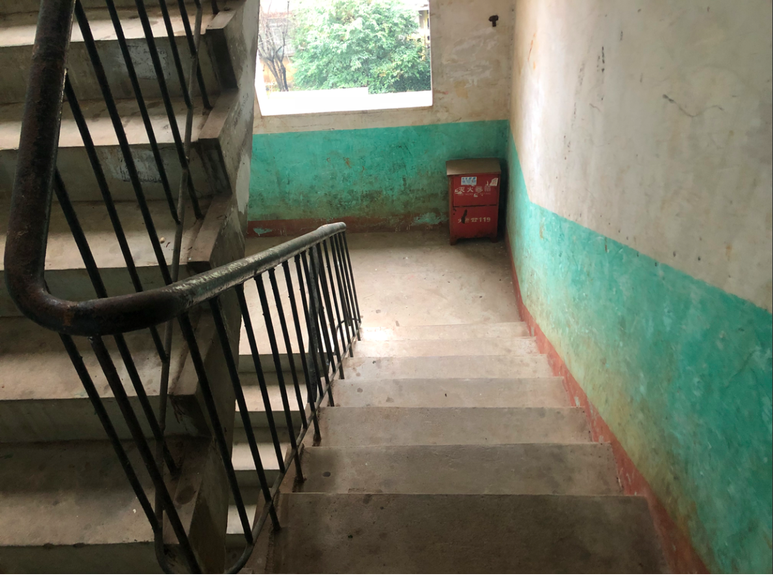

It all started with this photograph I took, which has a bit of a 'Third World' quality, and a momentum — like someone looking down retrospectively. Who is there, standing in this drab, empty, dated stairwell? Where does he/she speak from?

This is my stairwell. Behind the photo is the home I lived in for 14 years (until I entered high school), located on the edge of a small city in central China. Every day when I opened the home door, the first thing I saw was this stairwell. Throughout childhood and adolescence, I stood here, standing or running around and doing nothing. My growth environment was owed to the fact that comprehensive Chinese universities can always easily have tens of thousands of teachers and students inside. Meanwhile, almost all of our family members work in universities. Thus, there is only a wall between the home and the countryside. This unique geographical conditions create the "texture" of my stairwell. I learned to cry, walk and talk at the corner of my stairwell until I reached 14 years old.

When I stood in this stairwell, I did not choose any other angle or take a few more steps forward to take the picture, for this was the first view I had as a young child looking out of the home door. Despite it is a still photo that cannot move or speak, every time I look at it, it brings me a new unrepeatable feeling. Since our awareness of the present is always a contracted mixture of sensation and memory(Bergson, 2007). A person's memory is an undividable entity that constantly achieves new states(Bergson, 2001).

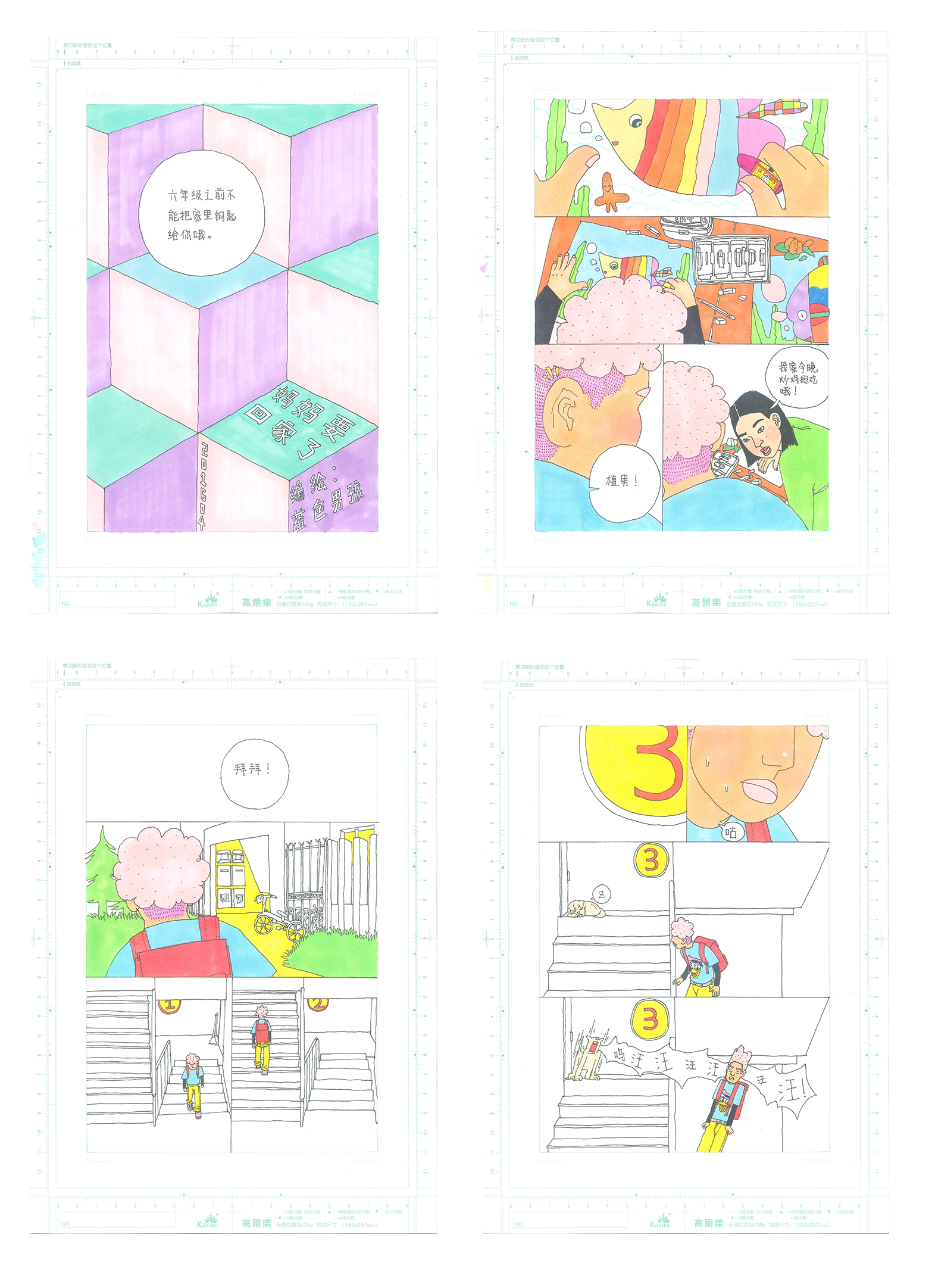

The above is an evocative 'thick description' based on personal experience (Geertz, 1973, p. 10; Goodall, 2001), which may allow individuals from different cultures to receive my perceptions from an emotional aspect. However, I was not satisfied with this, just wanted to go further and immerse the viewer in the scene from an aesthetic aspect. Hence, using the stairwell as a clue, I reconstructed the daily story with manga, creating a thematic and personal meaning to this photograph.

The 16-page comic titled 'Mum's Coming Home.' It tells the simple story of an elementary school kid sitting in the stairwell after school, waiting for mum back from work and opening the home door. In this story, I focused on portraying the main character, "Zhi Nan," who got s unknown gender, dark skin, with a face that is often expressionless except for a pout, always moves slowly, easily gets awkward or sad, and easy to be happy again.

Story begins when the bell rings. Our main character, Zhi Nan, packs their(refer to genderless Zhi Nan) school bag and heads home with a classmate, Xiao Bai, who is bragging about having fried chicken wings tonight. On the way home, they discuss a popular Japanese anime, get teased by two naughty school kids, and encounter the downstairs neighbor's watchdog, which they always feared... after all this, they finally arrive at the home door and knock knock. Unfortunately, mum is not home today either. Thus, they sit on the stairs and look out the window for a while, feeling a bit blue, then easily happy again for a banana treat from the aunt next door, and continue waiting for mum to come back home, story ends here.

This story can happen because Zhi Nan has not yet reached the sixth grade, and their parents do not feel at ease to hand over the house keys to them for safekeeping. Therefore, Zhi Nan would sit in the stairwell every day and wait for their parents to get off work. The background of this story is explained in the dialogue between characters.

In terms of characterisation, the name "Zhi Nan" is a homophonic stalk borrowing the pronunciation of "straight man" in Chinese, which is a joke that creates what Weeks calls 'ambiguity of sexual identity' (Weeks, 1987). It is a epitome of my precarious gender identity as a child. Most of the time, identity issues are associated with tension, anxiety, and even pain. However, I do not like to dwell on the pain, to discuss painful things with painful narratives. Therefore, I designed this character's name as a "joke" with a "stereotypical" overtone, using the light-hearted name to suggest the uncertainty of gender, in this way, hoping to take emotional control over the issue of "identity" at least. Objectively, this choice is also somewhat constrained by the style, theme, and length of the story. In summary, through a series of designs, I have managed to keep the story situated between 'vulnerability' and 'safety,' also 'humorous,' aimed at allowing the audience take participate in story construction。

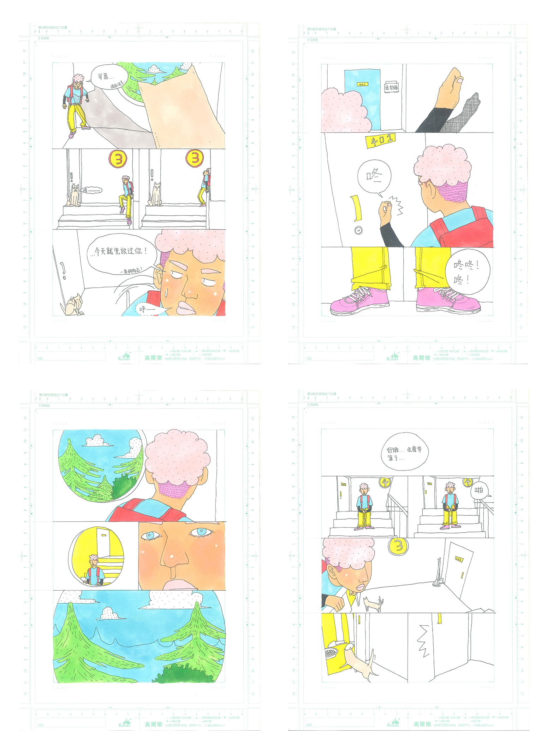
I did not directly refer to any photos when drawing this manga. The colors and descriptions were almost all placed on the characters, and the scenes were expressed with single black lines as much as possible, striving for simplicity and not highlighting any recognizability. This was done to avoid realism and to prevent giving the reader a feeling of re-presenting facts from the past. I believe that deliberate scenes are more likely to give a sense of ambiguity in the middle between past and present, field and imagination, allowing readers to gain a gap and enter an imaginary field along the blank space within my manga, thus triggering their personal experience and generating empathy and reverie.

When writing a narrative script, first, I need the audience to be able to enter my story easily. To achieve this, I designed the dialogue and narration with little use of written modifiers and complex long sentences, trying to give the audience a sense of everyday conversation, that is, the textual construction was dedicated to shaping a form of 'we-experience (MJ Kehily, 1995). To borrow Barthes' words from his'Introduction to the structural analysis of narrative,' is to pursue a form of 'it is simply there, like life itself (R Barthes, 1977); Second, I define narration as a "function," trying to make every sentence expressive of the characters' personalities and actions. Besides the above-mentioned use of the characters' questions to give context to the story, some narrative details deserve attention, for example: Zhi Nan envies Xiao Bai for having chicken wings and says, "I do not like chicken wings today." Xiao Bai responded: "You are lying again!" When faced with the invitation of a neighbor to "come in and have a sit," even though Zhi Nan does not know what time mum is getting off work today, their first reaction is to lie and decline: "but mum is coming home." These dialogues revealed Zhi Nan's habitual emotional depression, overthinking, and a strong sense of mental boundaries. These narrative details are interdependent with "function" and "action," which makes the narrative coherent and also realizes the gradual integration of characterization.

For many, art is considered an intimidating result created by a talented ‘other’ hanging on a museum or gallery wall. It exists over there rather than as an embodied, viable pathway to cognitive, emotional and cultural knowing(Michael A. Franklin, 2012).Autoethnography, a sociological research method, can have a unique connection with art practice, creating a research product that is more perceptible to the audience: an art practice project based on identity research. It is not just a personal feeling, but a detailed analysis of the individual's environment. It involves the interaction between the individual and the environment, which is the core of sociological work. Therefore, autoethnography can be combined with art due to its first-person perspective. Through the self-referential, autonomous, and egalitarian quality of images so accessible through the arts (Berry 1982; Hillman 1978; McNiff 1998), we can come to know our deepest selves and compassionately connect to the world. Providing viewers with a more overt and visual expression of identity is a feat that purely social science research cannot accomplish.

As Eakin said, autobiographical writing involves not only recalling the past, but the very act of recreating the past to discover and invent the self. Using autoethnographic reflexivity to discuss issues that are simultaneously (inter)personal and (inter)cultural (Berry & Clair, 2011). They reflect on seemingly mundane moments that become life-changing. By engaging the retrospective lens of autoethnography, they use their stories to engage their identities as evolving and vulnerable(ibid.) Reaching back into the past not merely to recapture but to repeat the psychological rhythms of identity formation(Eakin, 1985). Ultimately, identity is and should be a matter of personal choice and a positive act that opens up potential and creativity(Weeks, 1987). In this aged, empty stairwell, I consider my own story with the viewer through manga, conveying a concept of identity that is largely determined by the character, establishing a framework for interpreting personal life events, and attempting to invite a sense of 'identify' in viewers.

References

Asmussen, I.H., 2023. De-essentializing notions of self and identity in mediation. In The Routledge Handbook of Intercultural Mediation (pp. 43-50). Routledge.

Adams, T.E., Ellis, C. and Jones, S.H., 2017. Autoethnography. The international encyclopedia of communication research methods, pp.1-11.

Brubaker, R. and Cooper, F., 2000. Beyond" identity". Theory and society, 29(1), pp.1-47.

Becht, A.I., Nelemans, S.A., Branje, S.J., Vollebergh, W.A. and Meeus, W.H., 2021. Daily identity dynamics in adolescence shaping identity in emerging adulthood: An 11-year longitudinal study on continuity in development. Journal of youth and adolescence, 50(8), pp.1616-1633.

Boylorn, R.M. and Orbe, M.P. eds., 2020. Critical autoethnography: Intersecting cultural identities in everyday life. Routledge.

Cerezo, A., Cummings, M., Holmes, M. and Williams, C., 2020. Identity as resistance: Identity formation at the intersection of race, gender identity, and sexual orientation. Psychology of women quarterly, 44(1), pp.67-83.

Callagher, L.J., El Sahn, Z., Hibbert, P., Korber, S. and Siedlok, F., 2021. Early career researchers’ identity threats in the field: The shelter and shadow of collective support. Management Learning, 52(4), pp.442-465.

Collins, P.H., 2004. Black sexual politics: African Americans, gender, and the new racism. Routledge.

Elshtain, J.B., 1995. Women and war. University of Chicago Press.

Ellis, C., Adams, T.E. and Bochner, A.P., 2011. Autoethnography: an overview. Historical social research/Historische sozialforschung, pp.273-290.
Ferro, M.J., 2022. Connecting within: Digital collage as art-based research to process a pandemic. Journal of Applied Arts & Health, 13(1), pp.11-26.

Fausto-Sterling, A., 2008. Myths of gender: Biological theories about women and men. Basic Books.

Goffman, E., 2021. The presentation of self in everyday life. Anchor.

Grossberg, L., 1996. Identity and cultural studies: is that all there is?. Questions of cultural identity, pp.87-107.

Judt, T., 2008. Reappraisals: Reflections on the forgotten twentieth century. Random
House.

Kurzwelly, J., Rapport, N. and Spiegel, A.D., 2020. Encountering, explaining and refuting essentialism. Anthropology Southern Africa, 43(2), pp.65-81.

Kelly, S.M., Parameswaran, G. and Schniedewind, N., 2012. Women: Images and Realities: A Multicultural Anthology (p. 688). New York: McGraw Hill.

Lehring, G., 2020. Essentialism and the political articulation of identity. In Playing with fire: Queer politics, queer theories (pp. 173-198). Routledge.

Grossberg, L., 1996. Identity and cultural studies: is that all there is?. Questions of cultural identity, pp.87-107.

McDowell, L., 1999. Gender, identity and place: Understanding feminist geographies. U of Minnesota Press.

Orwell, G., 1954. A collection of essays (Vol. 29). New York: Doubleday.

Russell, B., 2013. History of western philosophy: Collectors edition. Routledge.

Ware, S., 2021. Irresistible Revolution: Black, Trans, and Disabled World-Making through Activist Portraiture.

Weeks, J., 2013. Questions of identity. In The cultural construction of sexuality (pp. 43-63). Routledge.

Wittgenstein, L., Anscombe, G.E.M., von Wright, G.H., Paul, D. and Anscombe, G.E.M., 1969. On certainty (Vol. 174). Oxford: Blackwell.

