ACBA6006 Building Conservation, Asset, and Facilities Management
Analysis of Built Assets – a Case Study Approach

Author: Owen Brown 1901187

Table of Contents
List of Figures 2
1 Introduction 3
2 Task One Heritage Impact Assessment 3
2.1 The Objective 3
2.2 The Significance of the Historic Asset 4
2.2.1 Evidential Value 5
2.2.2 Historical Value 5
2.2.3 Aesthetic Value 7
2.2.4 Communal Value 8
2.3 The Extension 10
2.4 The Impact of the Extension 11
2.5 Offsetting 12
2.6 Summary Table of Impact From Completed Work 14
3 Task Two. A Review of the Philosiphies and Processes Involved in Managing the Care of the Existing Building and the Extension. 15
3.1 Comparison of the Two Structures 15
3.2 Maintenance 17
3.3 Managing Maintenance 18
3.4 Authors Assessment of the Building 19
3.5 Energy Efficiency Improvements 21
3.5.1 Roof Spaces 22
3.5.2 Ground Floors 22
3.5.3 External Walls 23
3.5.4 Regular Maintenance 24
4 Conclusion 24
5 References 25
6 Appendices 29
Appendix A. Listed Building Report. School of Art 29
Appendix B. ICOMOS Guide for Assessing Value of Heritage Assets 31
Appendix C. Summary of a Detailed Inspection Process. 32

List of Figures
Figure 1. Former Central Library and School of Art Building at the beginning of the 20th Century (Swansea History Society, 2022a). 4
Figure 2. Example of ornate architectural features (Author, 2022). 5
Figure 3. Example of ornate architectural features (Author, 2022). 5
Figure 4. Drawing of the Prince of Wales and Princess Alexandra at Alexandra Road in 1881 (Swansea and Port Talbot Docks History, 2022). 6
Figure 5. Map of Alexandra Road Sweeping from Great Western Railway Station (Ordnance Survey, 1919). 7
Figure 6. Key to historic buildings in the locality. (Map adapted from Digimap, 2022) (Author, 2022). 8
Figure 7. Circular domed central reading room and reference library (Author, 2022). 9
Figure 8. Work order to adapt basement for use as public air raid shelter (West Glamorgan Archives, 2022). 9
Figure 9. Photograph of the glazed extension (Powell Dobson, 2014). 10
Figure 10. Junction of glazed extension façade and wall of existing building (Author, 2022). 11
Figure 11. Part of the historic elevation still visible through glass façade (Powell Dobson, 2014). 12
Figure 12. Central tower with reinstated pavilion dome and timber windows (Author, 2022). 13
Figure 13. Moisture and ventilation strategies for modern and historic buildings (Historic England, 2018). 15
Figure 14. Penetrating and rising damp strategies for modern buildings (left) and historic buildings (right) (Hughes, 2020). 16
Figure 15. Moisture evaporation through lime mortar (left) and unable to evaporate through cement mortar (right) (Hughes, 2020). 18
Figure 16. Area of rot to timber panelling in circular reading room (Author, 2022). 20
Figure 17. Blocked rainwater outlet to area above timber panelling (Author, 2022). 20
Figure 18. Peeling paint and modern plaster around first floor window (Author, 2022). 21
Figure 19. Displaced gasket to envelope of glazed extension (Author, 2022). 21
Figure 20. Example of insulated limecrete floor (Historic Environment Scotland, 2021). 23

1 Introduction
The Former Central Library and School of Art is a traditionally built historic listed building that was opened in 1887. In 2014 the building was extended with a glazed structure to the gable end adjacent to Pleasant Street, as part of the University of Wales Trinity Saint David’s plans to create a “new and updated seat of learning” (Wales Online, 2011).

Task one of this report will use the format of a Heritage impact statement to consider how the contemporary glazed extension has impacted on the significance of the historic Former Central Library and School of Art Building, the impact on its setting, the, impact on other heritage assets in the vicinity, and the impact on the conservation area that it is located within.

Task two of this report will review the processes and philosophies involved in managing the care and conservation of the two structures and discuss opportunities for cost effective energy efficiency improvements.

2 Task One Heritage Impact Assessment
The structure recommended in the Cadw (2017) Heritage Impact Assessment in Wales document will be used for this report, adapting the structure and headings where neccesary from that of a proposal, to facilitate the impact assessment of a completed project. Throughout this report, the Former Central Library and School of Art Building will be referred to as “the existing building”, and the modern glazed addition will be referred to as “the extension”.

2.1 The Objective
The objective of the project was to create additional design spaces and an area suitable for exhibiting the students work, which was deemed necessary to secure the long-term future of the underutilised historic asset and ensure its continued occupation in a manner that is sympathetic to its original intended use, by facilitating the creation of an accessible, fit for purpose, twenty first century seat of learning (Wales Online, 2011). The success of this objective also relied on the repair and refurbishment of the existing building, and the retention of the original façade and architectural features (Wales Online, 2011). The changes are likely to have been considered a large-scale intervention, and as such would have required detailed information to justify and assess their impact (British Standards Institution (BSI), 2013).

It is likely that ways to incorporate the design and exhibition spaces within the existing buildings footprint would have been investigated, but this would have taken away space needed for other activities, and the large amounts of glazing to provide the required natural light in the design and exhibition studios would have resulted in a loss of historic building fabric. A glazed side extension is assumed to have been deemed the best way to accommodate these spaces whilst preserving the buildings original architectural features and grandeur, and only required minor modifications to the structure to create weatherproof structural junctions and to provide improved accessibility.

2.2 The Significance of the Historic Asset
The existing building is located in the Alexandra Road conservation area and is described as one of a group of fine public buildings in a rich classical and baroque revival style to be constructed on both sides of the road (Swansea Council, 1986). It was constructed in 1886 to 1887, and was opened in 1887 as a Public Library, Art Gallery, and Schools of Science and Art (Forebears, 2022). It has two main storeys, plus an attic and basement, and its historic fabric displays many significant detailed ornate architectural features that are associated with Italiante design, constructed in the materials of the period (see listing report in appendix A) (Cadw, 1987).

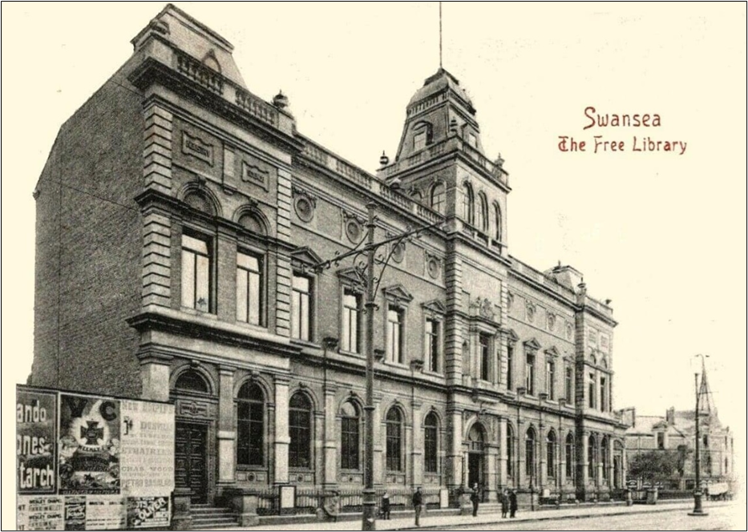
Figure 1. Former Central Library and School of Art Building at the beginning of the 20th Century (Swansea History Society, 2022a).

The significance of this historic building is expressed in the heritage values below, which requires research to be conducted to a level appropriate for the nature and history of the historic asset, to obtain a thorough understanding to a level that facilitates informed decision making relating to change (BSI, 2013).

2.2.1 Evidential Value
The building was given a Grade II listed status in 1987, and its listing (see appendix A) describes it as Italiante architecture, and “monumental, symmetrical classical design, red brick facings with pale freestone dressings” (Cadw, 1987). Italiante architecture is a style that originated in the UK in the nineteenth century, before becoming popular in many countries, and gets its inspiration from a combination of sixteenth century Italian renaissance architecture and picturesque Tuscan countryside influences, offering a less formal alternative to Victorian classical architecture (Hohenadel, 2022).

The historic fabric provides evidence of the materials used to construct buildings at the end of the nineteenth century, as well as the craftmanship required to produce the ornate architectural features (see figures 2 and 3). The fabric is a primary source of evidence in understanding peoples skills, ideas, tastes, and relationship with their surroundings, and should be protected for the appreciation of future generations (Slocombe, 2017).

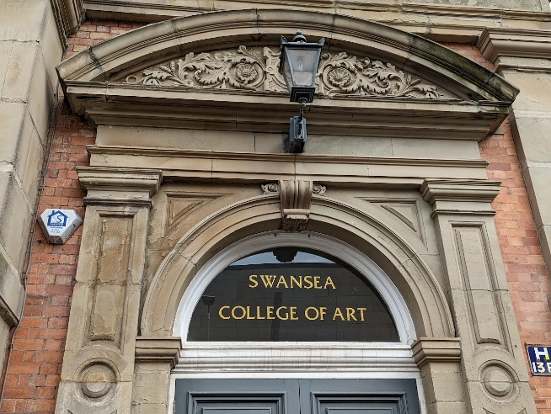  Figure 2. Example of ornate architectural features (Author, 2022). | 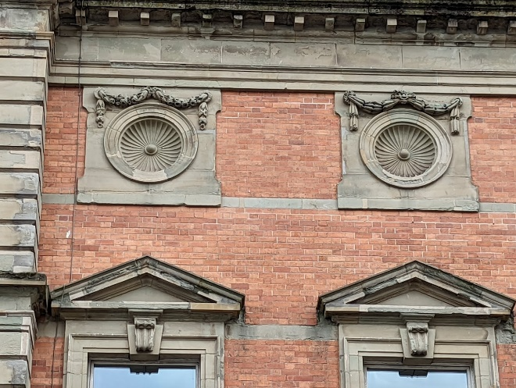  Figure 3. Example of ornate architectural features (Author, 2022).

2.2.2 Historical Value
Several Influential and famous people have been associated with Alexandra Road and with the Former Central Library and School of Art Building.

The frontage of the building forms part of the Alexandra Road streetscape. The road was originally named Yeo Street in 1879, named after Frank Ash Yeo who was a prominent councilor and the main person behind the clearance of poor quality housing to make way for Street and the public buildings that were erected along it (Swansea Council, 1986). Yeo became Mayor of Swansea in 1874, Chairman of the Swansea Harbour Trust in 1878, and Member of Parliament for Gower in 1885 (Swansea History Society, 2021).

Edward Prince of Wales and Princess Alexandra visited Swansea in October 1881 to formally open the newly constructed Prince of Wales Dock (Swansea and Port Talbot Docks History, 2022). To further commemorate this royal visit, Yeo Street was renamed Alexandra Road (Swansea Council, 1986). Figure 4 shows The Prince and Princess travelling along Alexandra Road in a horse drawn carriage.

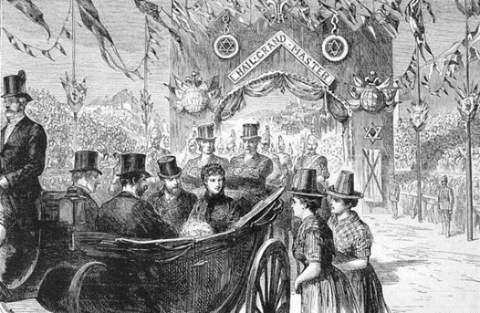
Figure 4. Drawing of the Prince of Wales and Princess Alexandra at Alexandra Road in 1881 (Swansea and Port Talbot Docks History, 2022).
The building was designed by Henry Holtom of Dewsbury (Coflein, 2021). Holtom was a well-respected and productive nineteenth century architect, and other buildings he designed in a renaissance style, including Dewsbury Town Hall and Pioneer House (former Co-operative Society building) have also been awarded Grade II listed status (Historic England, 2022).

The building was officially opened by the Right Honorable William Ewart Gladstone in June 1887 (Forebears, 2022). Gladstone was the leader of the Liberal party, and although not Prime Minister at the time of the opening, he held the office of Prime Minister four times between 1868 and 1892, and is remembered for The Representation of the People Act in 1884 which significantly increased the number of men eligible to vote, and his attempts to provide Ireland with a system of home rule (GOV.UK, 2022).

Dylan Thomas attended the nearby Swansea Grammar School and was a regular attendee of the public library (Thomas, 2018). He spent his formative years in Swansea and wrote approximately two-thirds of his poems, and many short stories and letters whilst living in the city (Swansea Council, 2022).

In 1962 the building was used as the set for a movie called Only Two Can Play, starring Peter Sellers as a bored librarian, based on a novel That Uncertain Feeling by a former Swansea University English Lecturer Kingsley Amis (Wales Online 2011).

More recently, after the closure of the library in 2007, the building has been used by the BBC as a filming location for episodes of Dr Who, staring David Tennant, Catherine Tate, and Alex Kingston (BBC, 2014a), and for Sherlock, staring Benedict Cumberbatch and Martin Freeman (Wales Online, 2011).

2.2.3 Aesthetic Value
Alexandra Road was created to be a grand sweeping boulevard that would enhance Swansea’s reputation with visiting tourists as they disembarked at the Great Western Railway station in the High Street and were swept towards the centre of the town (see figure 5) (Swansea Council, 1986).

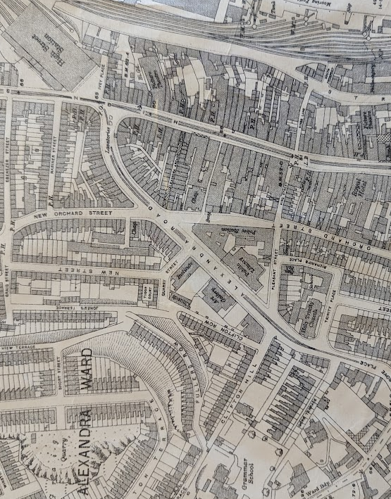
Figure 5. Map of Alexandra Road Sweeping from Great Western Railway Station (Ordnance Survey, 1919).
The reason for the existing buildings Grade II listing designation is because it forms part of a group of public buildings at the North end of Swansea city centre (Cadw, 1987). This is not surprising as it is one of many grand buildings designed in a baroque revival and rich classical style that were erected along Alexandra Road between 1885 and 1913, which created a desirable urban space and a glorious streetscape (Swansea Council, 1986). There is also an historic asset on the opposite side of Pleasant Street. A summary of the buildings is in table 1 and their locations shown in figure 6.

Alexandra road
Building |  | Year Completed | Listing Designation
1 | Working Men’s Club and Institute | 1885 | Grade II
2 | Former Central Library and School of Art Building | 1887 | Grade II
3 | BBC Building | 1889 | Not Listed
4 | Glynn Vivian Art Gallery | 1911 | Grade II*
5 | Central Police Station | 1913 | Grade II
Pleasant Street
Building |  | Year Completed | Listing Designation
6 | The Old Ragged School | 1911 | Grade II
Table 1. Summary of listed buildings in Alexandra Road and Pleasant Street (Cadw, 2022).
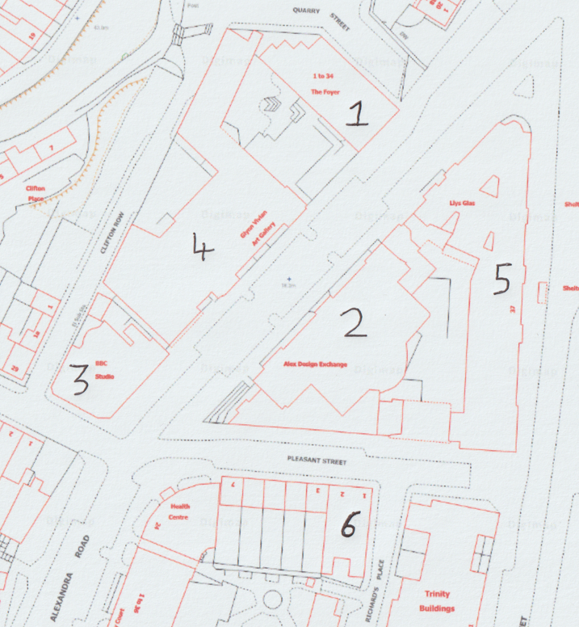
Figure 6. Key to historic buildings in the locality. (Map adapted from Digimap, 2022) (Author, 2022).
Under the International Council on Monuments and Sites (ICOMOS) guidance on heritage impact assessment (see appendix B), all of the above historic assets would be defined as having a medium significance value, as they are “Designated buildings or historic (unlisted) buildings that can be shown to have exceptional qualities or historical associations” (ICOMOS, 2011).

2.2.4 Communal Value
The building was home to the Swansea Central Library, which was a public reference and lending library, until relocation forced its closure in 2007 (Wales Online, 2011). Figure 7 shows the circular domed central reading room and reference library. A post on the Swansea History Society (2022b) reveals that many Swansea residents have fond memories of visiting the library, saying that the building is beautiful, atmospheric, and had ambience, describing how they used to visit as a child and continued to visit as an adult, recounting how they had studied there, and commenting on how sad it was that the library relocated. The circular central reading room and reference library is 86ft in diameter and 25ft tall at the centre of the glass dome (Wales Online, 2011). It is likely that this grand ornate room added to the experience of visiting the library, and the formation of fond memories.

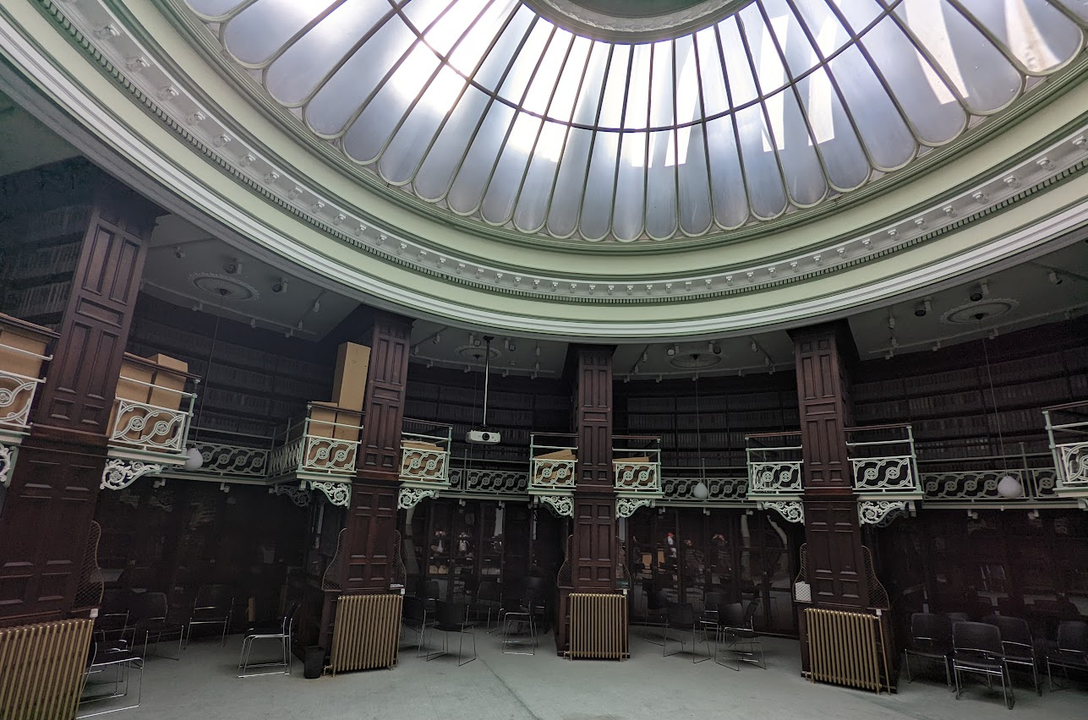
Figure 7. Circular domed central reading room and reference library (Author, 2022).
In 1939, at the outbreak of World War II, Swansea only had around 6000 Anderson shelters to protect its 167,000 residents from air raids, so cellars and basements were adapted and utilized for this purpose (Cooper, 2020). In January 1940 work began to adapt the basement of the Public Library and College of Art building, and by the seventeenth of February 1940 it was ready for use as a public air raid shelter for up to 195 persons (see figure 8) (West Glamorgan Archives, 2022).

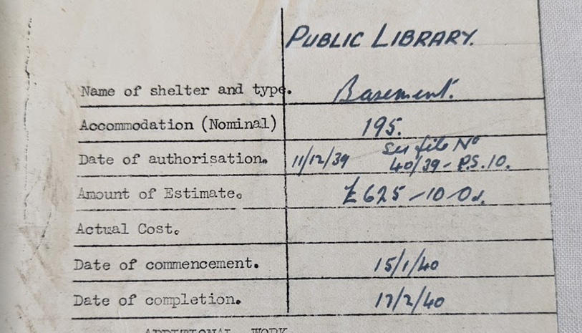
Figure 8. Work order to adapt basement for use as public air raid shelter (West Glamorgan Archives, 2022).
It is reasonable to assume that some of the older residents of Swansea will have taken shelter in the basement during the three years of air raids, which included the Three Nights Blitz in February 1941. Whilst it cannot be denied that people were sheltering from the horrors of war, interviews with persons who used air raid shelters during World War Two reveal that musical instruments were played, songs were sung, and the shared experience generally brought people closer together (BBC, 2014b). The Public Library and College of Art building is also one of the few historic buildings in Swansea city centre that survived the blitz (Prior, 2011).

2.3 The Extension
The extension (see figure 9) is a three-storey (including basement) modern glazed building to the side elevation and wrapping partially around the rear elevation, that comprises of new academic studio spaces above the existing basement which was retained and adapted as a workshop area (Swansea Council, 2012).

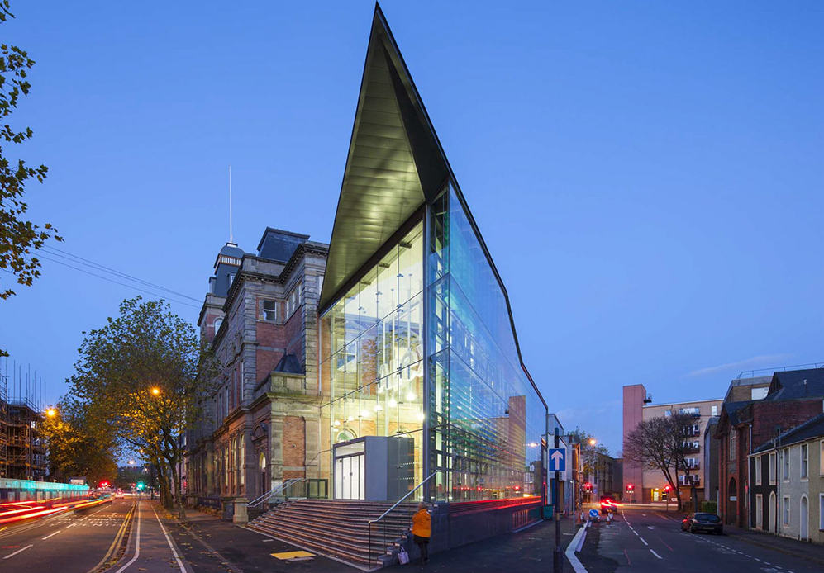
Figure 9. Photograph of the glazed extension (Powell Dobson, 2014).
The extension has a sedum roof (not visable from street level), and the extensions façade mostly has a double skin of glazing which enables acoustic protection, the regulation of glare from the sun, the provision of fresh air, and the minimisation of summer heat gains (Powell Dobson, 2014). The structural integrity is provided by a steel frame, which means the façade is not structural and serves only as a climate eliminator and modifier, which facilitates less destructive connections to the existing building through the cutting of a channel in which the glazing is inserted and sealed with a flexible sealant to allow for the differential movement between the modern and historic construction technologies (see figure 10).

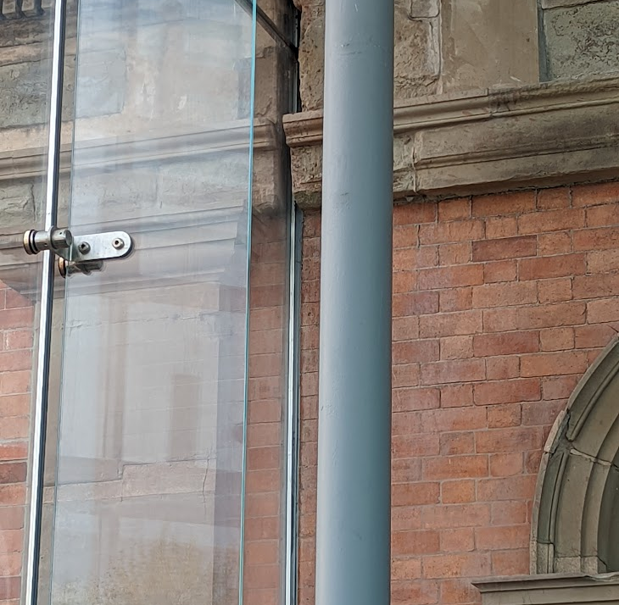
Figure 10. Junction of glazed extension façade and wall of existing building (Author, 2022).

2.4 The Impact of the Extension
Conservation is defined as:
The process of managing change to an historic asset in its setting in ways that will best sustain its heritage values, while recognizing opportunities to reveal or reinforce those values for present and future generations (Cadw, 2011).

The extension complements the existing building by following the Society for the Protection of Ancient Buildings (SPAB) conservation approach. The SPAB approach understands that extensions are sometimes necessary to ensure a building remains useful by fulfilling modern needs, but insists that any additions must contribute to the buildings story by not pretending to be historic or attempting to mimic the original fabric (Slocombe, 2017).

As discussed in 2.3 it was necessary to cut a channel into the existing building, to accommodate the weathertight connection between the existing building and the extension, which has caused a degree of harm to the historic fabric and architectural features (see figure 10). A record of the existing fabric should be created in situations where the avoidance of harm is unavoidable (BSI, 2013). Whilst necessary to connect the structures, this impact can only be viewed as negative.

Parts of an historic elevation view have been lost when viewed from pleasant street, but this has been minimised by using a glazed façade to retain a view of the historic elevation when viewed from the Alexandra Road which is the busiest street of all the buildings elevations (see figure 11). It could therefore be argued that this impact is neutral.

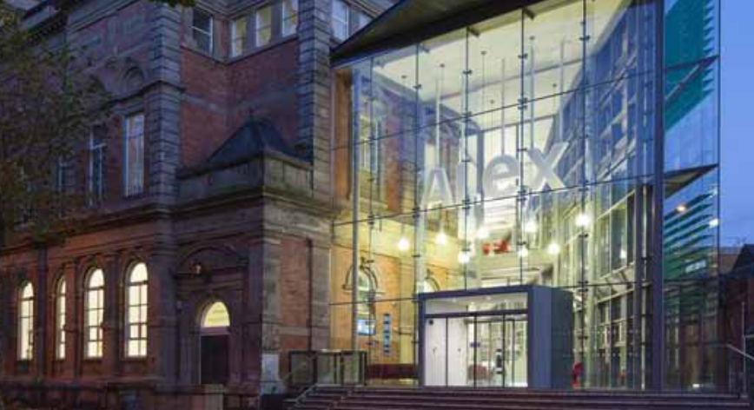
Figure 11. Part of the historic elevation still visible through glass façade (Powell Dobson, 2014).

Planning permission was granted for the demolition of three additions, including the 1936 two storey side extension to Pleasant Street (Swansea Council, 2012). This is assumed to be to make way for the new glazed extension. As the 1936 building was not part of the original building and was built prior to the building being listed in 1987, it is likely that this building did not complement the existing building and that the demolition has had a positive impact.

Planning permission was approved for new disabled access, openings to be made in the south gable, circular reading room, and rear elevation, and a new lift saft to be constructed at the rear (Swansea Council, 2012). Whilst this involves a minor loss of original fabric, it should be considered a positive impact as it improves the inclusivity and accessibility of the building.

Powell Dobson (2014) state that there is an intention for the refurbished circular reading room to be made available to the public to use as a performance venue or conferencing facility. This accessibility is a positive impact as the possibility of community use of the building is regained.

2.5 Offsetting
As discussed in 2.4, the connection of the two structures has caused a degree of harm to the historic fabric, and the creation of new openings has caused a loss of historic fabric, but it should be recognised that other measures have offset this impact.

The central tower’s pavilion dome, a feature which has been missing since bomb damage in 1941, has been reinstated (see figure 11) (Turner, 2015). This is a positive impact as combined with other measures it has returned the façade to its original appearance.

UPVC windows in the central tower have been replaced with timber windows closely matching the original design (see figure 12) (Swansea Council, 2012). It is likely that the UPVC windows were installed prior to buildings listing in 1987. This is a positive impact as combined with other measures it has returned the façade to its original appearance and original material.

Photovoltaic panels have been installed on the roofs of the existing buildings rear projections (Swansea Council, 2012). This should be considered a positive impact as they are not visible from street level. And will reduce the operational carbon footprint of buildings (Pelsmakers, 2015).

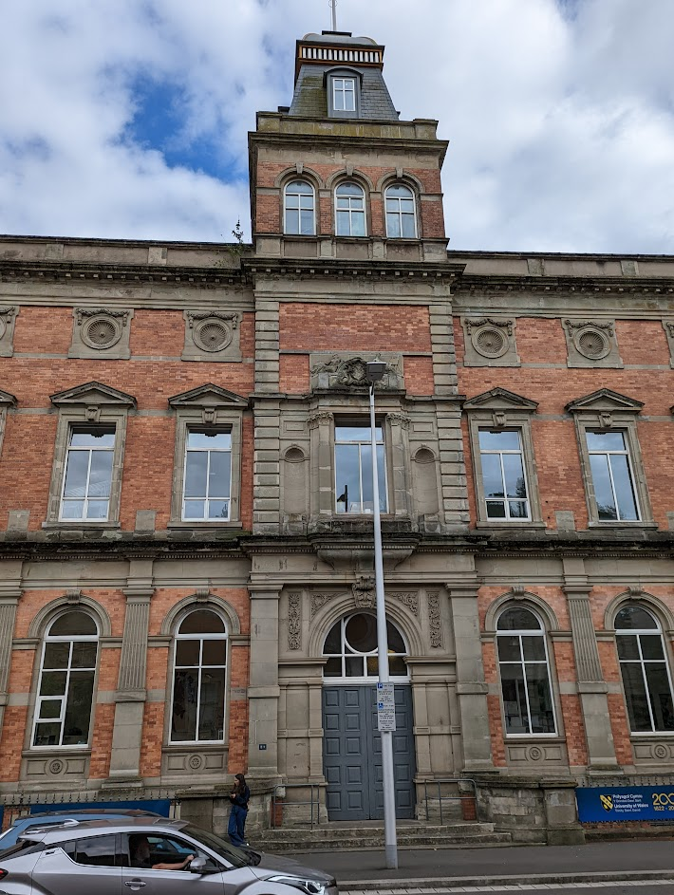
Figure 12. Central tower with reinstated pavilion dome and timber windows (Author, 2022).

2.6 Summary Table of Impact From Completed Work
Significance of Existing Building | Objective | Work Conducted | Assessment of Impact
Significance of Existing Building | Objective | Work Conducted | Positive | Neutral | Negative
Existing building is significant Grade II listed building and is part of a group of listed buildings in a conservation area to the north of Swansea City centre. | To secure the long-term future of the underutilised historic asset and ensure its continued occupation in a manner that is sympathetic to its original intended use, by facilitating the creation of an accessible, fit for purpose, twenty first century seat of learning. | Construction of a three storey (including basement) glazed extension to provide additional workshop, creative, and exhibition spaces. | Ensures the building has a viable long-term use.
 |  |  | Loss of a historic elevation. Impact reduced by glazed façade to retain a view of the historic elevation when viewed from the Alexandra Road.
 |  |  | Damage to existing fabric from cutting channels to connect the two structures.
 |  |  | Demolition of a 1936 structure that was likely detracting from the value of the historic asset and the conservation area.
 |  | Openings made in the south gable, circular reading room, and rear elevation, and new lift saft constructed at rear. | Loss of original historic fabric.
 |  |  | Improved inclusivity and accessibility of the building.
 |  | Repair and refurbishment of the existing building. | Building was brought back into a good state of repair.
 |  | Refurbishment of the circular reading room. | Improved community accessibility from room being available for public use as a performance venue or conferencing facility.
 |  | Reinstatement of the central tower’s pavilion dome. | Reinstatement of an original feature that has been missing since 1941, which as part of other measures has returned the front elevation to its original appearance.
 |  | Removal of UPVC windows in central tower, and replacement with timber windows. | Reinstatement of an original feature which as part of other measures returned the front elevation to its original appearance and original material.
 |  | Installation of Photovoltaic panels on rear roof projections. | Photovoltaic panels will reduce the carbon emissions of the building and are not intrusive as they cannot be seen from street level.
Table 2. Summary of impacts from completed work (Author, 2022)

3 Task Two. A Review of the Philosiphies and Processes Involved in Managing the Care of the Existing Building and the Extension.

3.1 Comparison of the Two Structures
To understand how to manage the care of the two structures, their construction type and materials must first be identified. The existing building is a four storey (including basement and attic) traditionally built historic building, erected between 1886 and 1887. The building has clay brick solid walls, timber windows, and slated pitched roofs, which are typical construction methods and materials from that era. The extension is a three storey (including basement workshop) modern steel framed structure that was constructed in 2014. The extension has a flat sedum roof and a glazed envelope (mostly double skin).

The way that the fabric of modern and traditional buildings deal with the movement of air and moisture is different (see figure 13), which means that the structures need to be managed in very different ways (Hughes, 2020).
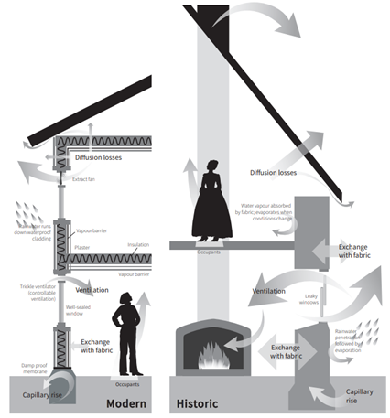
Figure 13. Moisture and ventilation strategies for modern and historic buildings (Historic England, 2018).
Modern buildings have thin thermally responsive envelopes that rely on impermeable construction materials, impermeable barriers, and moisture breaks (such as a cavity in a wall) to prevent moisture from entering the building from outside or from the ground (see figure 13), and they use impermeable membranes to prevent moisture created by the buildings inhabitants from entering the fabric (Historic England, 2018). Failure of any one of these moisture control measures will result in dampness in the fabric (Kent, 2020).

It has not been possible to access construction drawings for the extension, but it is assumed that a Vapour Control Layer (VCL) prevents moisture from inside entering the roof fabric, a waterproof layer under the sedum and the glazing of the façade prevent moisture from outside entering the building, and impermeable tanking and a Damp Proof Course (DPC) prevent moisture from the ground entering the building.

In contrast, historic buildings have thick envelopes constructed from permeable materials, which means moisture is absorbed by the fabric and later released to the surface, which can be internally or externally depending on conditions, and evaporates away (Hughes, 2020). The majority of pre-1919 buildings do not have a DPC in the walls, or a Damp Proof Membrane (DPM) under any ground bearing floors, and capillary action draws moisture from the ground into the pores of the permeable fabric, resulting in a degree of rising damp, but this is not an issue if the construction can ‘breathe’ as the moisture will evaporate away (see figure 14) (Kent, 2020). The addition of any impervious materials will prevent this moisture from evaporating and result in trapped moisture and the fabric remaining damp (Hughes, 2020).

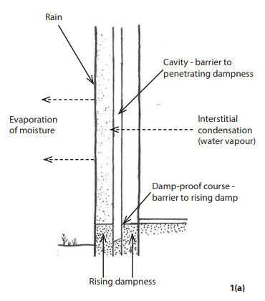 | 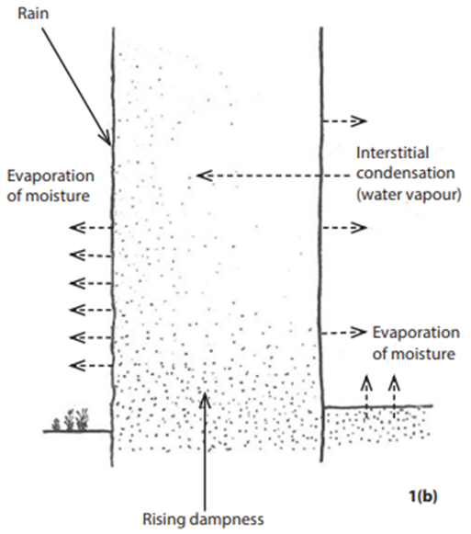
Figure 14. Penetrating and rising damp strategies for modern buildings (left) and historic buildings (right) (Hughes, 2020).

The uncontrolled ventilation from leaky elements of traditional buildings, along with the breathability of the internal partitions and ceilings, was advantageous in the removal of moisture that entered the building through the fabric. But it should be noted that these uncontrolled ventilation rates are reducing because of modern practices such as the blocking up of chimneys, suspended ground floors being changed to solid, and the improved airtightness of modern doors and windows (McMullan, 2018). And that any modern plasters, paints, or finishes will significantly reduce the ‘breathability’ of the internal fabric, or change it to become vapour closed (Weeks, 2018).

Traditional buildings also differ from modern ones as the thickness of their solid walls provides a thermal mass, which is beneficial to regulate indoor temperatures and makes them less susceptible to summertime overheating, as the mass gradually absorbs heat during the day and slowly releases it when the temperatures decrease (Historic England, 2016).

3.2 Maintenance
Maintenance can be defined as “The combination of all technical and associated administrative actions intended to retain an asset in or bring it to a state in which it can perform its required function” (Royal Institution of Chartered Surveyors (RICS), 2009).

The main methods of maintaining a facility fall into three categories:
- Planned: Avoiding failures and breakdowns through planned regular cyclical maintenance or planned for periods when the building is shutdown.
- Preventative: Using results from the monitoring of fabric or services to identify elements that require repair or replacement.
- Unplanned: Corrective maintenance after an unforeseen occurrence that is required for the facility to function safely.
(Atkin and Brooks, 2015).

The most important and common activity that ensures the preservation and conservation of an historic building, is regular maintenance (BSI, 2013). New buildings also require regular maintenance to ensure they can continue to support their design function and safeguard the owning organisations capital investment (Atkin and Brooks, 2015). It could be argued that the maintenance of the modern extension is also very important because it is connected to the existing building, and that these connection junctions should be checked regularly, because if not maintained could cause harm to the historic asset.

As described in 3.1, the existing building and the extension are very different, and as such will have different maintenance requirements and require different methods and materials to repair. For example, the glazing, assumed powder coated aluminium mullions, and cladding of the extension are all durable materials that require little maintenance during their life span, and if they do require maintenance then it can likely be conducted by recently qualified tradesperson. In contrast, the existing building is constructed from natural materials that require more regular maintenance. An example of this is the lime mortar pointing to the brickwork, which unlike cement mortar pointing, allows moisture to escape through the joints and does not result in damage to the masonry units (see figure 15). Lime pointing should be considered sacrificial as it will decay quicker than the masonry units because the majority of the salts deposits occur at the mortar joints (Hughes, 2020). Lime pointing therefore requires regular inspections of its condition, and replacement as required. Another example would be the timber windows and doors of the existing building, which require painting every five years to ensure protection, or more often to areas such as thresholds that can become bare from footfall (Edwards, 2020).

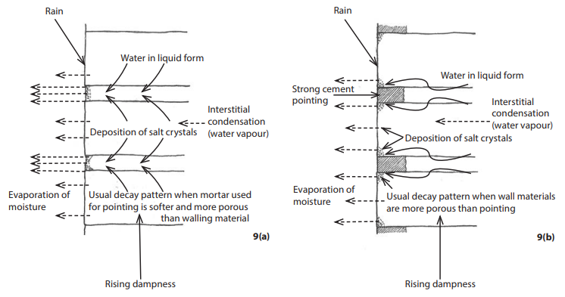
Figure 15. Moisture evaporation through lime mortar (left) and unable to evaporate through cement mortar (right) (Hughes, 2020).
It is of the upmost importance that any persons conducting maintenance repairs to historic buildings are competent in the task they are performing, as the incorrect techniques and materials can damage historic fabric (BSI, 2013).

3.3 Managing Maintenance
Reporting of issues and faults by users of the building, data monitoring, periodic inspections, and building condition surveys are all effective ways of getting the information required to produce and update a plan for managing maintenance (BSI, 2013). A maintenance management plan is an effective way of developing a maintenance strategy, and programming cyclical maintenance activities, to ensure that vulnerable areas of the building that could be subject to damage or structural problems are protected, and historic fabric is not lost (BSI, 2013). As the two structures now form one asset, it is reasonable to propose that they should be subject to the same maintenance management plan, but that the plan would need to be tailored to cater for the needs of the two very different structures.

BS 8210:2020 states that in order to manage the maintenance of facilities effectively, inspections based on industry standards and methods should be adopted and performed in a way that does not interupt an organisations core business, should be conducted as follows:
- Routine: Determine maintenance issues through regular consultation with building users, and receive feedback on previous works.
- General: Annual visual inspections of main elements, that is used to inform maintenance planning and budgeting.
- Detailed: A full inspection by a competent person of the structure, fabric, and interior fit-out, at maximum intervals of three years.
(BSI, 2020).

But it should be noted that any surveying of an historic building must be carried out by a competent person who has sufficient knowledge of traditional construction techniques, traditional materials, and their associated processes of decay, and that BS 7913:2013 asserts the need for historic assets to have a report following a detailed inspection by a competent professional at intervals of four to five years, or at an interval approriate to its significance (BSI, 2013). A summary of a detailed inspection process is available in appendix C.

3.4 Authors Assessment of the Building
This section will highlight some key issues that were identified during a one-hour assessment of the ground floor, first floor, and exterior of the building that took place on the 22 April 2022. The potential cause of the issue, and suggested remedies will also be discussed.

Figure 16 shows an area of rot to the timber panelling of the circular reading room on the ground floor of the former library and cracking to the ceiling above, which also has flaking paint in this area. Looking out of a first-floor window directly above this area revealed leadwork with debris building up, and that the rainwater outlet from this area was blocked with debris and holding water (see figure 17). It is probable that the blocked rainwater outlet has resulted in rainwater entering the reading room below, which has in turn created the optimum moisture levels in the timber panelling for rot to become established. Edwards (2020) states that rainwater goods should be inspected for leaks and cleared of debris every autumn as a minimum, but preferably more often. It is reasonable to assume that the rainwater outlet in figure 17 would not be blocked if it was inspected regularly. The timber panelling will need to be cut out, which is a loss of historic fabric, and replaced. But before replacement, the cavity behind the panelling should be inspected for dry rot, as this type of rot is a type of fungus that can thrive in damp wood, and usually spreads beyond a localised area as it searches for other damp timber to feed on (Smith and Gorse, 2021). It is also reasonably to suggest that this loss of historic fabric could have been avoided if the rainwater outlet was checked and cleared as part of a maintenance plan.

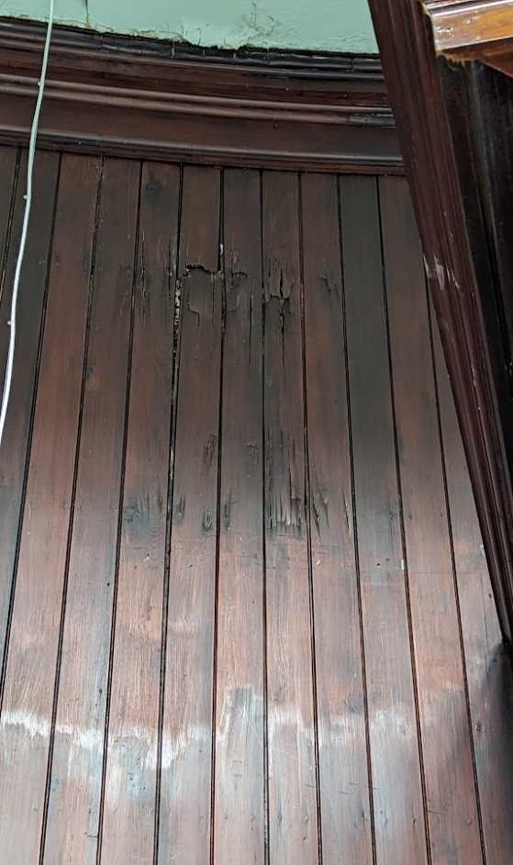  Figure 16. Area of rot to timber panelling in circular reading room (Author, 2022). | 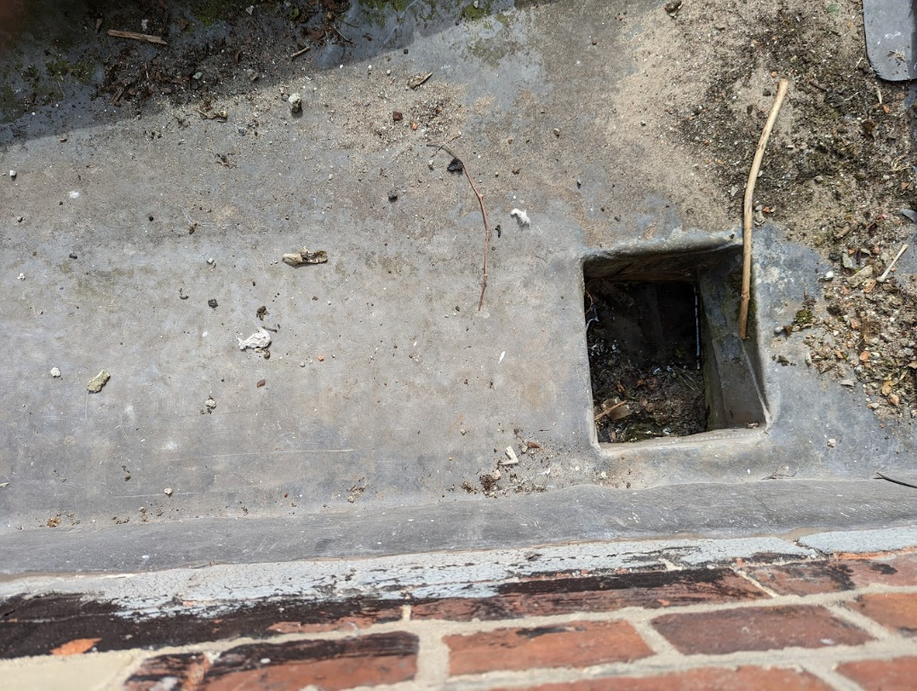  Figure 17. Blocked rainwater outlet to area above timber panelling (Author, 2022).

Figure 18 shows an area to the side and beneath a first-floor window that is damp or has been damp. It was not possible to access the area outside to diagnose the cause, but it is possible that rainwater goods above have been blocked or leaking, seals between the window and external reveal may be degraded or missing, and the external window cill may be rotten and allowing rainwater into the brickwork below. It is reasonable to suggest that all these items should be checked to diagnose the problem and as part of a condition survey and remedied as necessary. What is evident from the photograph is that this area has been repaired in the past with a modern gypsum-based plaster. Modern plasters prevent water evaporation from the internal surface of the wall, which causes salt concentrations to increase, and the deposit of salt crystals below the surface will expand when wet and cause the plaster to bulge or blow off the wall (Hughes, 2020). This appears to be a common problem as Schofield (2022) reports that the majority of historic buildings to have received the application of modern materials, which can cause damp, crumbling plaster, and peeling paint, and that the replacement of impermeable materials with permeable ones is often all that is required to remedy these issues. It is therefore recommended that any exterior issues are fixed first, followed by the removal of modern plaster, and replacement with lime plaster and breathable paint.

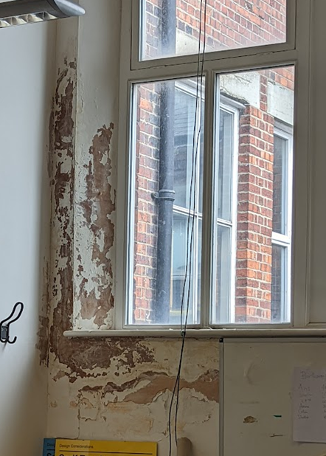  Figure 18. Peeling paint and modern plaster around first floor window (Author, 2022). | 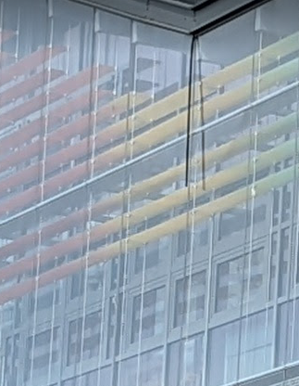  Figure 19. Displaced gasket to envelope of glazed extension (Author, 2022).
Figure 19 shows what appears to be a rubber gasket hanging from the junction of the outer skin of glazing and the steel roof beam of the extension. Whilst this issue is unlikely to be causing major problems, it is likely that additional air and moisture are now entering the cavity between the two skins of glazing, which could affect the performance of the façade. This issue highlights the need for modern buildings to be regularly inspected as they may require maintenance, no matter how new they are. It is recommended that this gasket is refitted to ensure the correct performance of the façade, and because it is somewhat unsightly.

3.5 Energy Efficiency Improvements
There is currently a drive by the UK Government to retrofit buildings with Energy Efficiency Measures (EEMs) to reduce their carbon emissions in order for the country to comply with its legally binding target of reaching carbon net zero by 2050 (Department for Business, Energy and Industrial Strategy (BEIS), 2021a). EEMs can be services based, or fabric based, but the guidance in PAS 2035 asserts that the most technically sound and cost effective method of sequencing EEMs is a fabric first approach (BSI, 2019). This report will therefore discuss the oportunities for improving the energy efficiency of the fabric.

It could be strongly argued that the extension does not require any retrofitting at this time, because its design in 2014 will have met the conservation of fuel and power requirements of the Building Regulations (2010) Approved Document L2A. However, the existing building may offer oportunities for energy efficiency improvements through ensuring it is well maintained, and potential retrofitting to the:
- Roof spaces
- Ground floors
- External walls
(Historic Environment Scotland, 2021).

3.5.1 Roof Spaces
Insulating a loft with 300mm of glass wool or stone wool insulation is one of the cheapest and easiest EEMs to install, but its return on investment is most noticeable when a small amount of loft insulation is increased. For example, increasing the insulation from 50mm to 300mm will pay back in 6.6 years, but increasing from 200mm to 300mm has a payback period of 36.9 years which is not economical in cost terms as loft insulation has an expected life expectancy of 30 years (Urquizo et al., 2019). However, it could be argued that carbon reduction is far more important than payback periods. But the carbon embodied in the insulation must be calculated against the potential operational carbon savings (Historic England, 2020). With this in mind, it is recommended that the existing building is surveyed to determine opportunities to install or increase loft insulation. Moisture open insulation, such as sheep’s wool, will increase the airtightness of the building but still allow moisture from inside to escape and dissipate via a ventilated roof space (May and Griffiths, 2015).

3.5.2 Ground Floors
In the case of the existing building, the suspended ground floor is approximately 1m above ground level, and above an assumed heated basement workshop, and as such does not offer an opportunity for EEMs. The floor of the basement workshop is assumed to be a solid floor. Adding insulation on top of the existing floor is possible but this will hide any historic floor coverings, and whilst large U-value improvements have been achieved using 30mm of breathable Aerogel insulation, this method reduces head room (particularly in doorways) and requires a loss of historic fabric from cutting the bottom of doors (Historic Environment Scotland, 2021). It is common for ground bearing floors to have been replaced with modern impermeable materials that can cause water to concentrate at the solid walls base, and if this is the case, removing and replacing with an insulated limecrete floor (see figure 20) will improve the performance of the building by allowing moisture to be absorbed and released (Historic Environment Scotland, 2021). However, the Society for the Protection of Ancient Buildings (SPAB) recommend an essential works only approach and would endorse leaving the modern floor if it is not causing any issues (Slocombe, 2017). Replacement of the floor is also likely to be expensive and disruptive, so it is reasonable to suggest that other retrofitting measures are explored first.

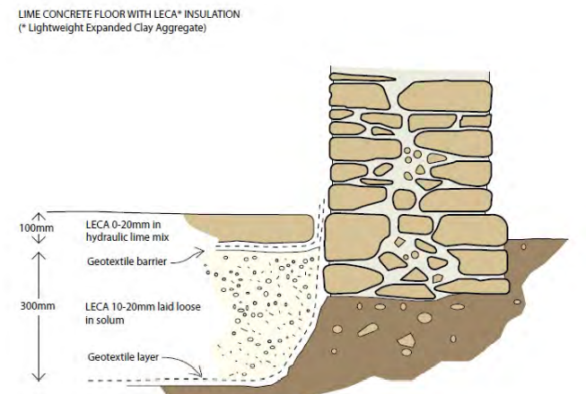
Figure 20. Example of insulated limecrete floor (Historic Environment Scotland, 2021).

3.5.3 External Walls
Solid Wall Insulation (SWI) can be applied internally or externally (Energy Saving Trust (EST), 2022). Any SWI applied to traditional buildings must be vapour open to allow moisture in the wall to evaporate (Weeks, 2018). External Wall Insulation (EWI) is the most popular of the two and is currently selected for 95% of all SWI retrofits (Glew et al., 2021). It may be more common because it presents less moisture risks than Internal Wall Insulation and because it provides the fabric with an extra layer of protection from the elements (BEIS, 2021b). However, it is almost certain that listed building consent would not be approved for EWI as it would cover the architecture that forms part of the buildings significance, and the mechanical and adhesive fixing necessary to secure the insulation would permanently harm the historic asset.

Vapour open Internal Wall insulation (IWI) is suitable for traditional buildings, but a higher risk of interstitial condensation is created because the wall is isolated from the interior warmth (BEIS, 2021b). This reduction in the walls temperature can increase humidity and the subsequent risk of embedded timbers becoming rotten (Glew et al., 2021). IWI also prevents the interior spaces from benefitting from the thermal buffering qualities of the walls thermal mass and increases the risk of summertime overheating (Morgan, 2018). IWI requires completeness, as discontinuities at areas such as window reveals would create a cold spot that increases the risk of condensation and mould growth (King and Weeks, 2016). This completeness would be very difficult to detail around some of the buildings ornate architectural features. For the same reasons as EWI, it is also unlikely that listed building consent would be granted for IWI.

3.5.4 Regular Maintenance
BS 7913 states that the energy efficiency of external walls will be over one third less if the wall is damp, and that dampness in traditional buildings is often caused by the addition of modern impermeable materials and blocked drainage and rainwater goods (BSI, 2013). It is therefore recommended that the inspection and clearing rainwater goods and underground drainage forms part of the cyclical maintenance in the management plan, and that the building is inspected to identify inappropriate modern materials, followed by testing to see if they are causing damp issues.

4 Conclusion
The existing building is a significant historic asset that has evidential, historical, aesthetic, and communal value. The addition of an extension has mostly had a positive impact on the existing building and the Alexandra Road conservation area, and when combined with repairs and renovation, this conservation has provided the foundations for the historic asset to remain in use and be able to be enjoyed by future generations.

The existing building and the extension are fundamentally different, especially in the way the structures manage moisture. Regular maintenance is required for both modern and historic buildings, but in the case of historic buildings it is key to their conservation journey and ensuring that historic fabric is not lost. The natural materials used to construct the existing building, and the need for the building to breathe, mean that it is likely to require more regular maintenance than a modern structure. The scheduling of maintenance can only be targeted when the condition of all the buildings elements are understood, and this information is best obtained from a competent professional conducting a detailed inspection at intervals approriate to assets significance. The existing building does present some opportunities for retrofitted EEMs, but the best way to improve an historic building without affecting its significance appears to be keeping it well maintained and relieving it of modern moisture trapping materials.

5 References
Atkin, B and Brooks, A. (2015) Total Facilty Management. 4th Ed. Chichester: Wiley Blackwell.

British Broadcasting Corporation (2014a) Old Swansea Central Library. Available at: https://www.bbc.co.uk/wales/arts/sites/doctor-who-wales/alllocations/swansea-library (Accessed: 17 May 2022).

British Broadcasting Corporation (2014b) WW2 People’s War. An archive of World War Two memories. Available at: https://www.bbc.co.uk/history/ww2peopleswar/stories/51/a3932651.shtml (Accessed: 17 May 2022).

British Standards Institution (2013) BS 7913:2013 Guide to the conservation of historic buildings. London: BSI Standards Limited.

British Standards Institution (2019) PAS 2035:2019 Retrofitting dwellings for improved energy efficiency – Specification and guidance. BSI Standards Limited.

British Standards Institution (2020) BS 8210:2020 Facilities maintenance management – Code of practice. London: BSI Standards Limited.

Building Regulations (2010) Approved Document L2A: Conservation of fuel and power. New buildings other than dwellings. Welsh Government.

Cadw (1987) School of Art. Full Report for Listed Buildings 11551. Available at: https://cadwpublic-api.azurewebsites.net/reports/listedbuilding/FullReport?lang=&id=11551 (Accessed: 17 May 2022).

Cadw (2011) Conservation Principles for the sustainable management of the historic environment in Wales. Cardiff: Welsh Assembly Government.

Cadw (2017) Heritage Impact Assessment in Wales. Cardiff: Welsh Government Historic Environment Service (Cadw).

Cadw (2022) Search Cadw Records. Available at: https://cadw.gov.wales/advice-support/cof-cymru/search-cadw-records (Accessed: 28 May 2022).

Coflein (2021) Site Record. Central Library and School of Art. Available at: https://coflein.gov.uk/en/site/31763/?term=swansea%20central%20library (Accessed: 23 May 2022).

Cooper, J. (2020) Find out if your Swansea street was bombed in the Second World War with our interactive map. Available at: https://www.walesonline.co.uk/news/wales-news/find-out-your-swansea-street-17668976 (Accessed: 29 May 2022).

Department for Business, Energy and Industrial Strategy (2021a) Heat and Buildings Strategy. Available at: https://assets.publishing.service.gov.uk/government/uploads/system/uploads/attachment_data/file/1032119/heat-buildings-strategy.pdf (Accessed: 02 June 2022).

Department for Business, Energy and Industrial Strategy (2021b) Guide to Best Practice: Retrofit Internal Wall Insulation. Available at: https://assets.publishing.service.gov.uk/government/uploads/system/uploads/attachment_data/file/1019707/iwi-guidance.pdf (Accessed: 02 June 2022).

Digimap (2022) Ordnance Survey Roam. Available at: https://digimap.edina.ac.uk/roam/map/os (Accessed: 30 May 2022).

Edwards, J. (2020) Technical Information Sheet. Building conservation – its meaning, understanding and implementation. Bracknell: Chartered Institute of Building (CIOB).

Energy Saving Trust (2022) Solid wall insulation. Available at: https://energysavingtrust.org.uk/advice/solid-wall-insulation/ (Accessed: 02 June 2022).

Forebears (2022) Kelly's Directory of South Wales (1895). Available at: https://forebears.io/wales/glamorganshire/swansea#sid8727 (Accessed: 23 May 2022).

Glew, D. et al. (2021) Thin Internal Wall Insulation, Measuring Energy Performance Improvements in Dwellings using Thin Internal Wall Insulation. London: Department of Business, Energy and Industrial Strategy.

GOV.UK (2022) Past Prime Ministers. William Ewart Gladstone. Available at: https://www.gov.uk/government/history/past-prime-ministers/william-ewart-gladstone
(Accessed: 23 May 2022).

Historic England (2016) Energy Efficiency and Historic Buildings. Insulating Solid Walls. Historic England.

Historic England (2018) Energy Efficiency and Historic Buildings. How to Improve Energy Efficiency. Historic England.

Historic England (2020) Know Your Home, Know Your Carbon. Reducing carbon emissions in traditional homes. Historic England.

Historic England (2022) Former Co-Operative Society Building (Pioneer House). Listed Building 1300442. Available at: https://historicengland.org.uk/listing/the-list/list-entry/1300442?section=official-list-entry (Accessed: 28 May 2022).

Historic Environment Scotland (2021) Technical Paper. Guide to Energy Retrofit of Traditional Buildings. Edinburgh: Historic Environment Scotland.

Hohenadel, K. (2022) What Is Italianate Architecture? Available at: https://www.thespruce.com/italianate-architecture-4846180 (Accessed: 28 May 2022).

International Council on Monuments and Sites (ICOMOS) (2011) Guidance on Heritage Impact Assessments for cultural World Heritage properties. ICOMOS.

Hughes, P. (2020) SPAB Technical Advice Note. The Need for Old Buildings to ‘Breathe’. 2nd Ed. London: SPAB.

Kent, D. (2020) SPAB Technical Advice Note. Control of Dampness. London: SPAB.

May, N. and Griffiths, N, (2015) Planning responsible retrofit of traditional buildings. Sustainable Traditional Buildings Alliance.

McMullan, R. (2018) Environmental Science in Building. 8th Ed. London: Red Globe Press.

Morgan, C. (2018) Sustainable Renovation improving homes for energy, health and environment. Dingwall: The Pebble Trust.

Ordnance Survey (1919) 1919 Map of Swansea. Southhampton: Ordnance Survey.

Pelsmakers, S. (2015) The Environmental Design Pocketbook. 2nd Ed. London: RIBA Publishing.

Powell Dobson (2014) Project ALEX (School of Industrial Design). Available at: https://www.powelldobson.com/en/projects/further-and-higher-education/school-of-industrial-design-project-alex (Accessed: 27 May 2022).

Prior, N. (2011) Swansea Metropolitan University buys library building. Available at: https://www.bbc.co.uk/news/uk-wales-13719371 (Accessed: 29 May 2022).

Royal Institution of Chartered Surveyors (2009) Building maintenance: strategy, planning and procurement. RICS guidance note. 2nd Ed. Coventry: RICS.

Royal Institution of Chartered Surveyors (2022) Planned preventative maintenance of commercial and residential property. RICS guidance note. Coventry: RICS.

Schofield, J. (2022) Lime in Building. A Practical Guide. 3rd Ed. Crediton: Black Dog Press.

Slocombe, M. (2017) The SPAB Approach to the conservation and care of old buildings. London: SPAB.

Smith, M. and Gorse, C. (2021) Building Surveyor’s Pocket Book. Abingdon: Routledge.

Swansea and Port Talbot Docks History (2022) Construction and Opening of the Prince of Wales Dock. Royal Opening of the Prince of Wales Dock. Available at: http://swanseadocks.co.uk/docksnewsite/powdock1.html (Accessed 24 May 2022).

Swansea Council (1986) Conservation Area Schedule. CA: 022 Alexandra Road. Available at: https://archive.swansea.gov.uk/conservationareasindex (Accessed: 23 May 2022).

Swansea Council (2012) Planning Application 2011/1268. Available at: https://property.swansea.gov.uk/online-applications/applicationDetails.do?activeTab=summary&keyVal=ZZZZRTEVXB478 (Accessed: 27 May 2022).

Swansea Council (2022) Dylan Thomas. Dylan Thomas’ Swansea. Available at: https://www.visitswanseabay.com/useful-information/dylan-thomas/ (Accessed: 28 May 2022).

Swansea History Society (2022a) [Facebook] 1 May. Available at: https://www.facebook.com/groups/580254599178060/search/?q=Alexandra%20road (Accessed: 23 May 2022)

Swansea History Society (2022b) [Facebook] 18 January. Available at: https://www.facebook.com/groups/580254599178060/search/?q=Alexandra%20road (Accessed: 23 May 2022)

Thomas, G. (2018) Soft porn and secret passageways: The fascinating past lives of Swansea's grandest buildings. Available at: https://www.walesonline.co.uk/news/wales-news/soft-porn-secret-passageways-fascinating-14547813 (Accessed: 28 May 2022).

Urquizo, J. et al. (2019) ‘Technical options for retrofitting the building stock. A case study from the United Kingdom’, 32nd International Conference on Efficiency, Cost, Optimization, Simulation and Environmental Impact of Energy Systems. Wroclaw, Poland. 23-28th June.

Wales Online (2011) New role for Swansea’s former Central Library. Available at: https://www.walesonline.co.uk/news/wales-news/new-role-swanseas-former-central-1826668 (Accessed: 23 May 2022).

Weeks, C. (2018) External Wall Insulation (EWI) Project guide. Prepared for the Welsh Government. BRE Wales & South West.

West Glamorgan Archive Service (2022) Exhibit BE 1/2/9 Public Air Raid Shelters in Swansea: Alexandra Road Public Library. West Glamorgan Archive Service

6 Appendices

Appendix A. Listed Building Report. School of Art

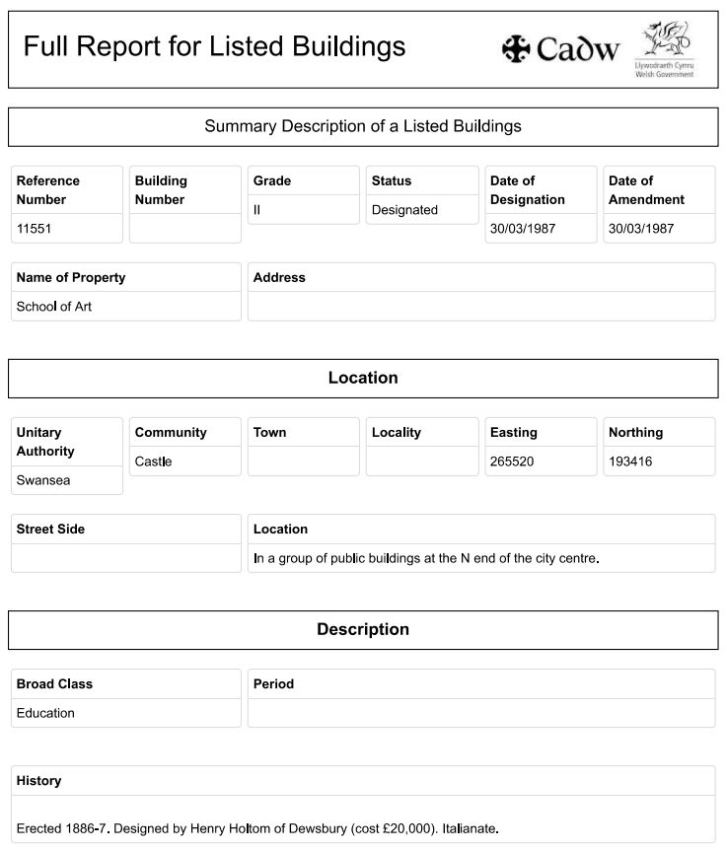

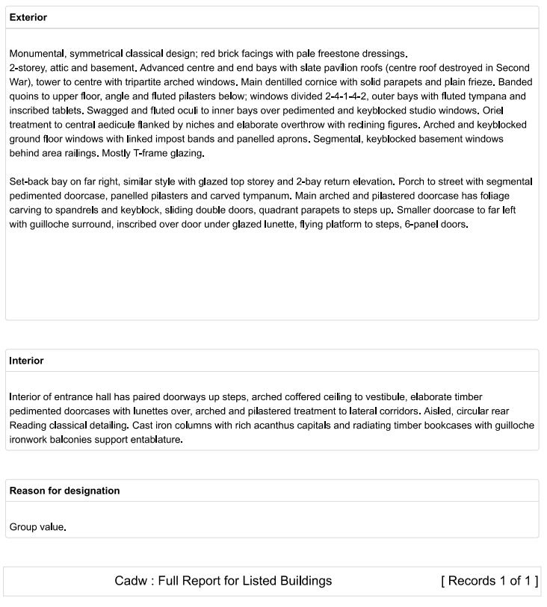

https://cadwpublic-api.azurewebsites.net/reports/listedbuilding/FullReport?lang=&id=11551

Appendix B. ICOMOS Guide for Assessing Value of Heritage Assets

Grading | Built heritage or Historic Urban Landscape | Colour
Very High | Sites or structures of acknowledged international importance inscribed as of universal importance as WH property. Individual attributes that convey OUV of the WH property. Other buildings or urban landscapes of recognised international importance. |  | Purple
High | Nationally-designated structures with standing remains. Other buildings that can be shown to have exceptional qualities in their fabric or historical associations not adequately reflected in the listing grade. Conservation Areas containing very Important buildings. Undesignated structures of clear national importance |  | Red
Medium | Designated buildings. Historic (unlisted) buildings that can be shown to have exceptional qualities or historical associations. Conservation Areas containing buildings that contribute significantly to its historic character. Historic townscapes or built-up areas with important historic integrity in their buildings, or built settings. |  | Amber
Low | “Locally Listed” buildings. Historic (unlisted) buildings of modest quality in their fabric or historical associations. Historic Townscape or built-up areas of limited historic integrity in their buildings, or built settings. |  | Green
Negligible | Buildings or urban landscapes of no architectural or historical merit; buildings of an intrusive character. |  | White
Unknown potential | Buildings with some hidden (i.e. inaccessible) potential for historic significance. |  | Yellow

Adapted from ICOMOS (2011) Guidance on Heritage Impact Assessments for cultural World Heritage properties. ICOMOS.

Appendix C. Summary of a Detailed Inspection Process.

Below is a summary of a detailed inspections process. This should be carried out to historic buildings in order to gain the information required for an organisation to produce a maintenance plan and forecast budgets accordingly.

BS 7913:2013 asserts the need for historic assets to have a report following a detailed inspection by a comprtent professional at intervals of four to five years, or at an interval approriate to its significance, and that this mostly visual inspection should identify:
- The historic buildings general condition, comparing this with earlier inspections.
- The progress of works reccomended in the previous inspection.
- The repairs or specialist investigations required.
- The importance and urgency of the required works or investigations.
(BSI, 2013).

Whilst conducting an assessment of a buildings condition, the RICS (2022) recommend that a condition rating is given to each element and sub-element, and suggests using the following following ratings:
- Good: Element is in good condition and does not require any repair or maintenance.
- Fair: Element is in an acceptable condition and servicable, but may be showing signs of wear, superficial damage, or weathering.
- Poor: Element is excesively damaged, weathered, or reaching the end of its servicable life.
- Hazardous: Element is in a condition that is dangerous, and immediate works are required to rectify.

BS 7913:2013 states that after the detailed inspection has taken place, the information should be analysised, and the work required should be given one of the four priority ratings below:
- Immediate: This work should be carried out immediately to prevent rapid deterioration or imminent damage, or to protect the safety of the public and/or employees.
- Urgent: This work should be conducted in a short time frame, never more than eighteen months, as significant additional deterioration or damage is likely without corrective measures.
- Necessary: This work is required to keep the building in a good state of repair, but is not urgent and can be scheduled for a period prior to the next detailed inspection.
- Desirable: This work is desirable to improve or enhance the historic building, but is not strictly necessary and is unlikely to cause the building harm before the next detailed inspection.
(BSI, 2013).

