Student name: Olivia Green
Student number: 1906674
Lecture Name: Molly Jack
Module Name: Effective Teamwork and Communication
Module code: BMSW4002

Table of Contents
Introduction…………………………………………………….........3/4
Types of Communication………………………………………….4
Verbal Communication……………………………………………..4/5
Non-Verbal Communication………………………………………..5
Theories of Communication……………………………………….5/6
Shannon Weaver Model Of communication…………………….6
Berlo’s Model of Communication…………………………………7
Schrammer’s Model of Communication………………………….7
Conclusion……………………………………………………………..8/9
Reference………………………………………………………………..10

INTRODUCTION
This report will be looking at the different models of communication and how these forms of communication can be expressed in the workplace. This report would also look at and explain why teamwork and communication skills are important in the workplace, the effects of good and bad communication and how it effects the working environment, and how different models work together with teamwork to create better communication.
Teamwork can be defined as people working closely together within a group to achieve a goal in a workplace or organisation, collaborating to set ideas and goals, using individual abilities to create the best outcome, through good communication skills and understanding. According to Griffiths, B.A. et al (2015) teamwork is important and its vital how indidvuals interaction with each other determines success.
Communication is the ability to express our feelings and pass on information in the workplace efficiently, effectively and successfully, whether that means through verbal, writing or nonverbal communicating. Communication is important and vital in the workplace because it creates effective productivity and positive teamwork and attitude, effective communication can be the exchange of ideas and information, the lack of communication will be the breakdown of any business. According to Kinnick and Parton (2015) communication skills is essential for any organisation, through their teamwork or individual skills to create success.
I am currently working at a hair salon as a hairstylist, Her Definition salon which is based in Streatham and we are a team of 4, we currently do men and women’s hair in the salon Afro-Caribbean and European. The form of communication that we use is mainly verbal and sometimes non-verbal communication, we use non-verbal communication if there is a serious situation that needs to be addressed quickly and we don’t want clients to know, we have a particular eye contact that only our colleagues would understand. As a hair salon communication is important because clients will explain to me what they would like done with their hair and how they would like it look, in the past I usually only went with the client description on how they would like their hair to be, but I learnt very quickly that it was best that show me a picture of what they wanted me to create so that it would not cause any miss communication which it most definitely did in the beginning of my career. Communication is also important in my workplace because we must know who is coming in and at what time, who’s client has arrived in the salon and what services they are having done. If our salon did not have good communication skills, then we would lose clientele and things would be confusing and that would create an unprofessional environment

TYPES OF COMMUNICATION
There are 2 types of communication that is known, verbal communication is where we communicate to each other and speak to people face to face or over the phone, verbal communication also is the tone and pitch of our voice when we communicate. Non-verbal communication is use of gestures and body language and writing which involves emails, letters or any form of typing.

VERBAL COMMUNICATION
Verbal communication is used to transfer information to a person or group of people through using words and listening skills. Verbal communication is messages being generated through languages, which involves good interoperation and understanding (Quintanilla, K.M. and Wahl, S.T.).
In my workplace verbal communication is very essential and used throughout the day i.e. when I finish an client or any other stylist finished a client hair we have to tell our receptionist the price of the client service so that she can take payments that is one way we use verbal communication, another way we use verbal communication in the salon our receptionist greats anyone walking through the door and they either book appointments or discuss some concerns with her. Our salon also uses verbal communication through our phone systems when booking appointments for clients. I use verbal communication when dealing with clientele discussing what they would like done and how they can go about having healthy hair.

NON-VERBAL COMMUNICATION
Non-verbal communication is the form of expressing yourself without using words to do so. Non-verbal communication is the replacement of verbal communication to express thoughts and feelings (Phutela, Deepika, 2015). Nonverbal communication is the widest form of communication understood in day to day life, more than verbal communication, which was researched by Mehrabian in1981.
- 55% of communication is non-verbal language facial expression, and eye contact and other non-verbal movements
- 7% is verbal communication (words)
- 38% para verbal communication (tone and pitch of one’s voice)

In my workplace we use non-verbal communication through eye contact, when speaking to clients you have to have good eye contact to show respect and confidence, we try not to use too much body language and facial expressions in the salon, as some clients hair state is really awful and as a stylist you must remain neutral, but that sometimes cannot be helped. In the salon we also use touch which is a non-verbal communication because as stylist we need to get up close and personal with clients and touch their hair.

THEORIES OF COMMUINCATION
There are 3 different theories of communication known which are
- Shannon Weaver model of communication
- Berlo model of communication
- Schramms model of communication

SHANNON WEAVER MODEL OF COMMUNICATON
Shannon weaver model was created by Claude Shannon and Warren Weaver in 1948, this model explains the process of communication through technology i.e. email, text messages, and radio. Within the process of sending messages through whatever channel of technology both Shannon and Weaver explains that there is a process of which communication needs to go through, where the receiver of the message has to decodes the message from the sender, but during that process the channel of which the message has been sent through technology, there might be disruptions and distorting elements, like signalling and parts of the message not received, and through these disruption it would depend on how the receiver (decoder) decodes the message and understands it. This process will determine how communication is understood by the sender and receiver (Businesstopia 2020)
At my workplace the Shannon Weaver method can be used and looking more into the Shannon Weaver method it is used through using email, clients will enquire about a hairstyle or to book an appointment, they would type a message send it via email, the computer is the channel, then received and decoded by our receptionist, then passed on to a stylist if they can do the hairstyle (destination) then that messaged is passed back to the receptionist then sends feedback to the sender (client) about the appointment or hairstyle if it can be done or not. There has been times where this form of communication has failed either pictures of what the client has sent has not come through so our receptionist would need to email the client back to confirm details, and that is how we use Shannon Weaver model without even realising it in the salon.

BERLO MODEL OF COMMUNICATION

David Berlo established his communication model Sender-Message-Channel=Receiver(SMCR) model in 1960 where he developed from the Shannon Weaver model and made it in to a more simple formula, Berlo’s model focuses on perceptions such as the depth of knowledge, social system, attitude, culture and communication skills, which is not specific to any communication skills. Berlo model only focuses on the encoding and decoding structure, the source (where the message is created) and the decoder (the person who receives the message), Berlo believed that the source and the receiver should be on the same level of communication and understanding so that the message doesn’t get lost in translation (Buisnesstopia 2020)
Berlo model of communication can be used and is used in my place of work because when clients either come in or call on the phone 80% of the time communication is understood when it comes to clients, because clients know what they want done, if they don’t sometimes their explanation of the service they want the only real barrier we have is when we get clients who don’t speak English and then there is a slight misunderstanding at times, which can be easily fixed with using our mobile phones to translate.

SCHRAMMER MODEL OF COMMUNICATION
Wilber Schramm create the Schrammer model of communication in 1954, which has significant roots to the Shannon Weaver model of communication, but with the Schrammer model he believes that communication is two way means of communication, meaning he believed in two participants taking turns sending and retrieving messages. Schrammer believed that the sender and the receiver has to have the same level of understanding to be able to communicate with each other, by sending messages back and forth this would allow both parties to give feedback to each other, essential it means the message has been encoded and decoded.
Schrammer communication can be used in my workplace by making sure each client/s that steps through the door has a level of understanding of what they want done to their hair so that communication between stylist and client can flow easily and no misunderstanding is created. In my workplace the Schrammer model of communication is used in many ways, in regards to the clients coming into the salon some clients already have some understanding of what they want or they have researched in to the process of getting whatever service they want done, so they have some knowledge beforehand so explanation of the service that they want is pretty much easy. For the clients who are not sure what they want or don’t have the knowledge of the service they want, having a consultation with them and explaining everything and the step by step procedure of what they will be doing eases their mind and relaxes the client. But most often than non the client is on the same page when it comes to their service they want done. This is how the Schrammer model can be used and is used in the salon.

Conclusion
This report was based on different methods of communication and how teamwork and good communication works together in the workplace. I looked at the different forms of communication methods, Shannon Weaver, Berlo’s, and Schrammer models of communication and a brief explanation of each models, looking at each model clearly, they are all based of the Shannon Weaver model and later advanced or simplified using a different method. It is report I discovered that no matter what, good communication is vital for a basic understanding and for things to run smoothly and effectively in the workplace, good communication is the base of any working environment. I also looked at the what method of communication might be used in the salon and unveiling these methods I realised that most of these methods are used in my workplace. This report also looked at the types of communication non-verbal and verbal communication and how it is used in my place of work, upon doing this report I also found out that non-verbal communication is used more than any other form of communication and that our non-verbal actions places a lot in how we communicate. This report has shown me so much regarding communication and how important it is to have a good level of communication in the workplace and in everyday life.

References
Griffiths, B.A. and Dunham, E.B (2015 p.47) “Communication” Certificate in Higher Education: Skills for the Workplace Student Yearbook, Sage Publications, London, Sage.

Griffiths, B.A. and Dunham, E.B (2015 p.21) “Teamwork” Certificate in Higher Education: Skills for the Workplace Student Yearbook, Sage Publications, London, Sage.
Griffiths, B.A. and Dunham, E.B (2015 p.67) “Verbal and Non-Verbal Communication” Certificate in Higher Education: Skills for the Workplace Student Yearbook, Sage Publications, London, Sage.
Griffiths, B.A. and Dunham, E.B (2015 p.50) “Verbal and Non-Verbal Communication” Certificate in Higher Education: Skills for the Workplace Student Yearbook, Sage Publications, London, Sage
Buisnesstopia, (2018) ‘Berlo’s SMCR Model of Communication’. Available from:
https://www.buisnesstopia.net/communication/berlo-model-communication [Accessed 11 December 2019]

Buisnesstopia, (2018) ‘Shannon and Weaver Model of Communication’. Available from:
https://www.buisnesstopia.net/communication/shannon-and-weaver-model-communication [Accessed 14 December 2019]
Study.com (2019) “Osgood-Schramm Model of Communication: Definition & Application”, available from
https://study.com/academy/lesson/osgood-schrammer-model-of-communication-definition-application.html [accessed 14th December 2019]

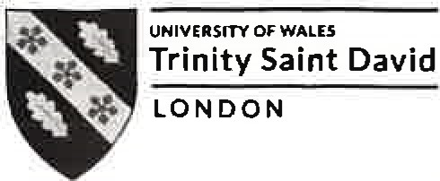
Effective Team Working and Communication — Term 1
BMSW4002
In-class exercise 1
Student Name: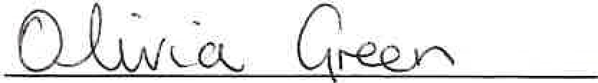 Student ID:

Time allocated: 1 hour. Please return your paper to the lecturer upon completion. It will be returned to you at the next session. You will need to include a scanned copy of this exercise in the form of an appendix together with your Task 1 (part of the Assignment for this module).
Ex.l. Read the following brief and write a business email according to the instructions.
You are the Director of Communications at your company and you would like a Supervisor, Mary December, to go on a training course in non-verbal communication because you have observed that her non-verbal skills sometimes send the wrong message. - Tell Mary why you are writing
- Say what you have observed about her communication skills
- Tell her how you think this course would improve her skills and her relationship with her fellow
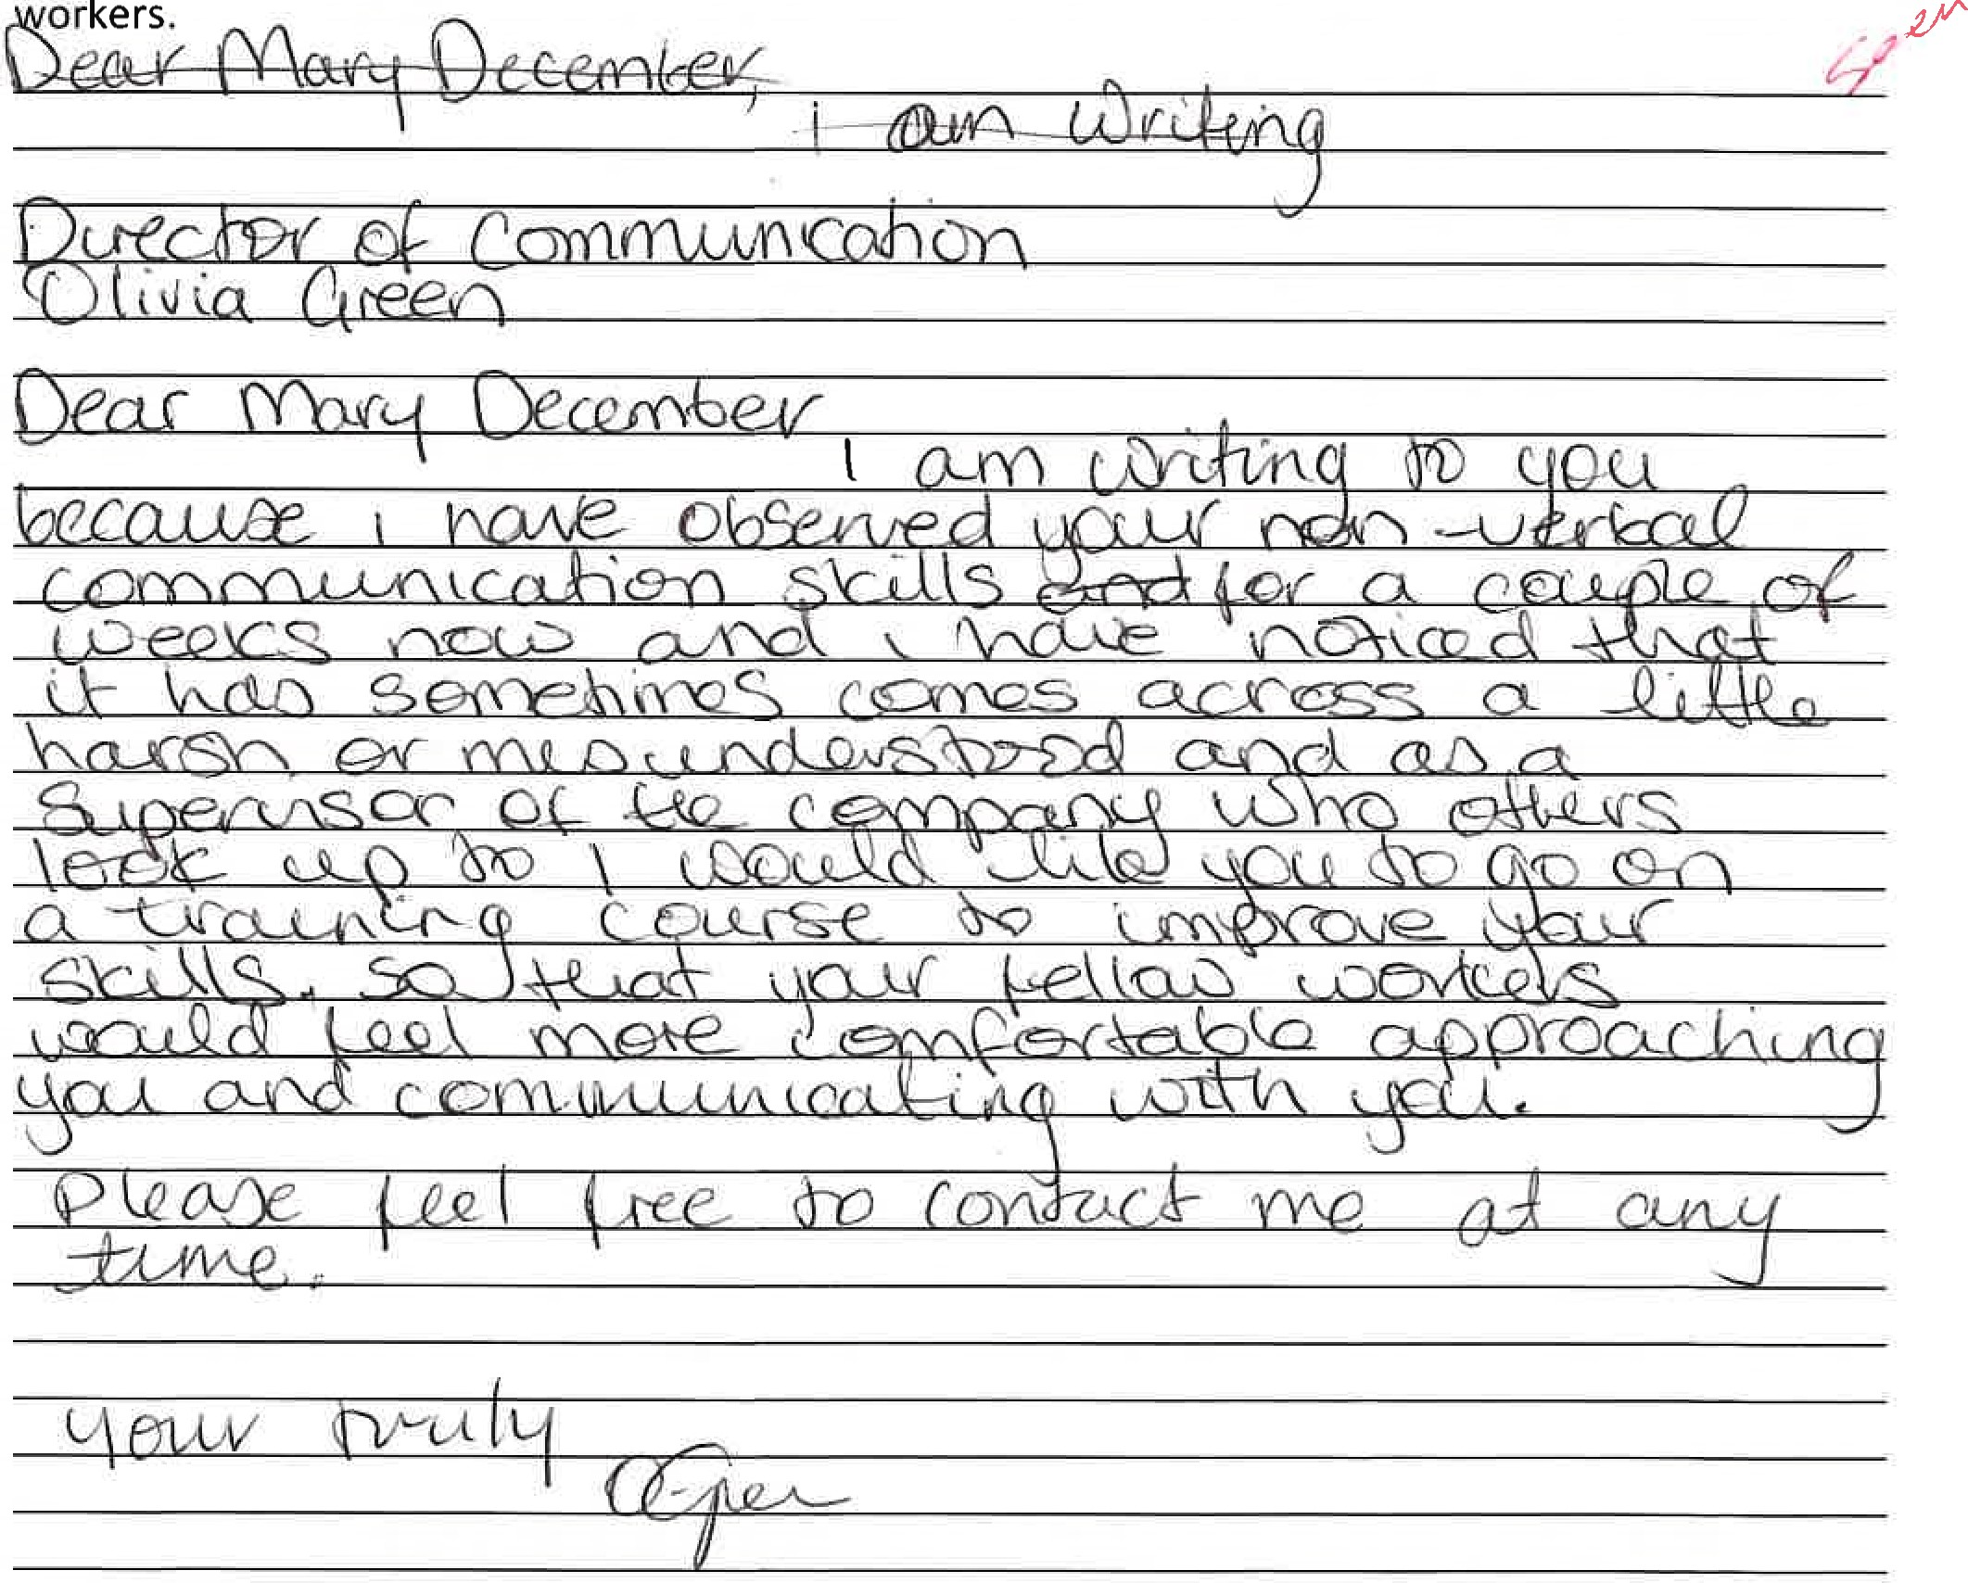
orkers.

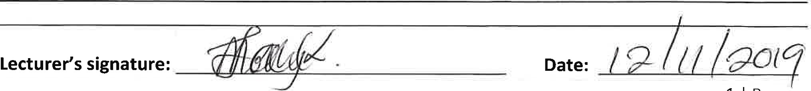

l P a g e
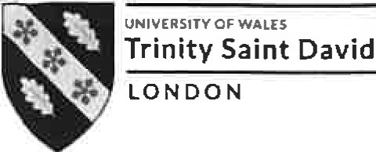
Effective Team Working and Communication - Term 1
BMSW4002
In-class exercise 1
Exercise2: COMMUNICATION: A CASE STUDY
As you read their case, think about how you might help communicate with the employee to remedy the conflict. Answer the critical thinking questions at the end of the case and, wherever possible, say whose communication model is relevant.

BARRY AND HIS STAFF
Barry is a 27-year old who is the manager of a restaurant. He is responsible for supervising and managing all employees in the kitchen. Employees working there range from 16 years old to 55 years old. In addition, the employees come from varied cultural and ethnic backgrounds. For many, English is not their primary language.
Barry has a Health and Safety (Food) Certificate and tries his best to keep up with food safety issues in the kitchen, but he admits it's not easy. Employees receive "on the job training" about food safety basics (for example, appropriate hygiene and handwashing, time/temperature, and cleaning and sanitizing). But with high turnover of employees, training is often hurried, and some new employees are put right into the job without training if it is a busy day.
One day Barry overslept because he had been working on his car until 2 a.m. He was rushing around and realized that he didn't have a clean uniform. However, he managed to find one that was not very dirty. As he dressed, he realized that he needed a haircut and a good hand scrubbing, especially after working on his car.
When he arrived at work, he dashed into the kitchen and noticed several trays of uncooked meat on the work tops. They appeared to have been sitting at room temperature overnight. He called one of the kitchen staff and asked: 'Why did you leave the chicken out when I told you to put them in the fridge?'
The man replied: 'l heard you screaming but I thought you were trying to talk to the chef above the noise of the food mixer he was using. I didn't know you were talking to me'. Barry is frustrated and doesn't know what to do. He felt like he was beating his head against a brick wall in trying to get his employees to practise food safety.
He has made many efforts to get them to learn how to handle food safely. He has put large signs all over the kitchen: KEEP HOT FOOD HOT AND COLD FOOD COLD and WASH YOUR HANDS OFTEN.
Questions:
- What are the communication challenges and obstacles that Barry faces?
- Which communication models can you use to explain Barry's problems?
- What solutions might Barry consider in addressing each of these challenges or obstacles?


Effective Team Working and Communication — Term 1
BMSW4002
In-class exercise 1
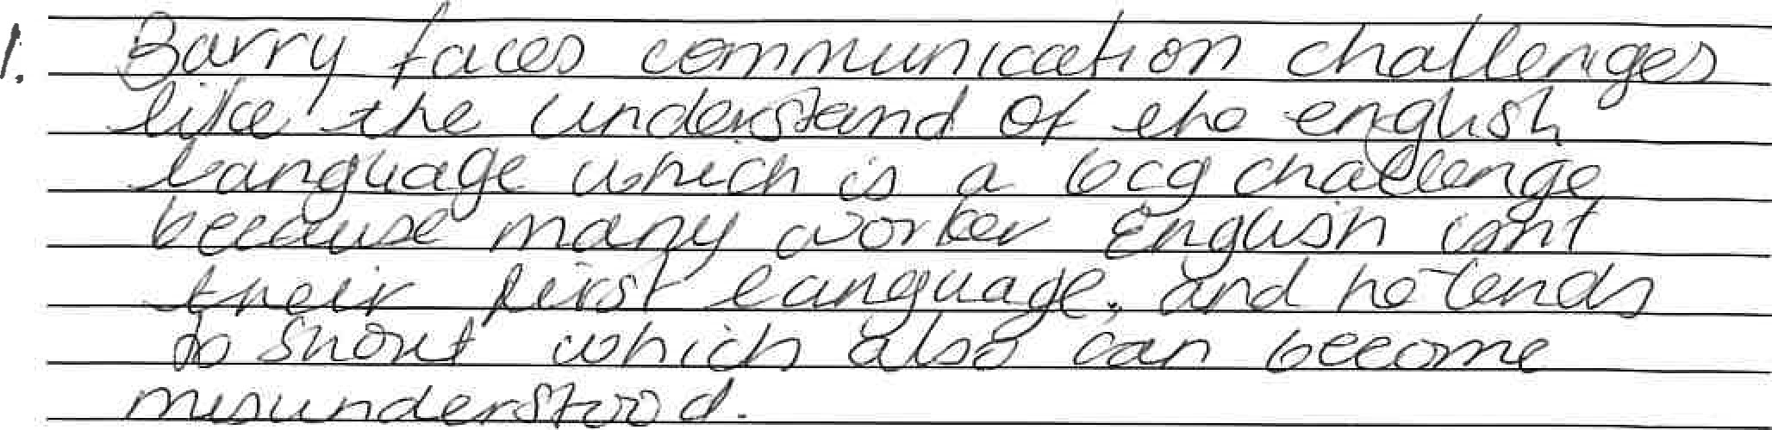
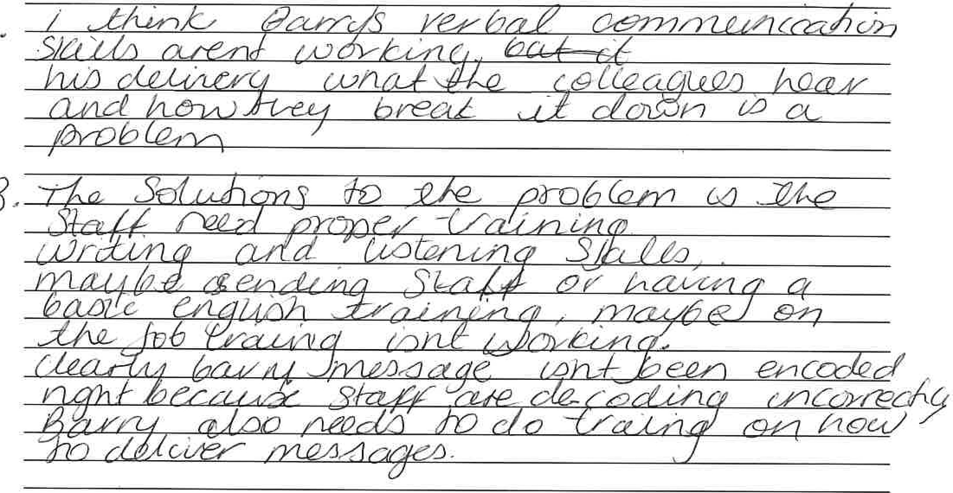
3.
-9

Lecturer's comments:

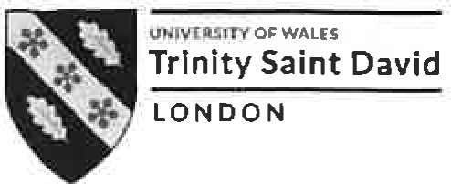
Effective Team Working and Communication — Term 1
BMSW4002
In-class exercise 1

Lecturer's comments:

Lecturer's signature: Date:

