

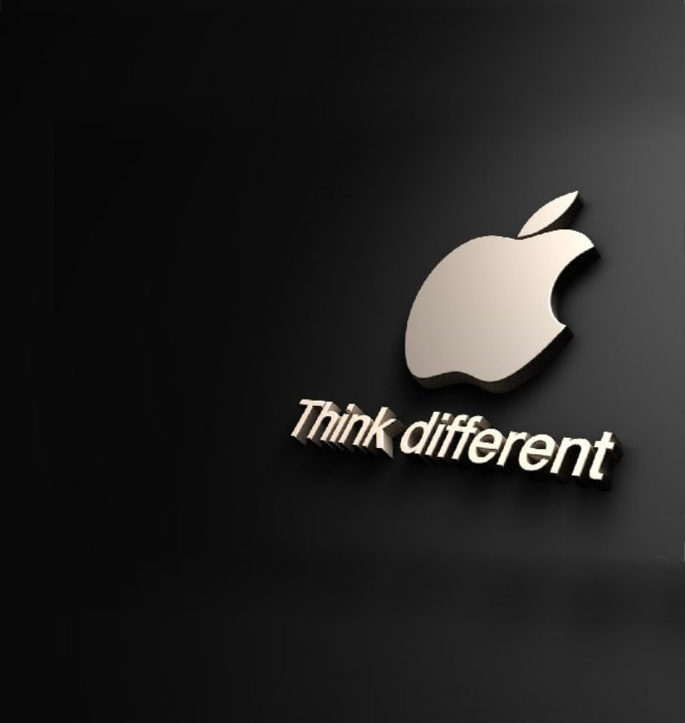
Dissertation
Dissertation Title:
Elevating the Apple Brand: Exploring Current
Trends and Future Prospects in Digital
Marketing with AI
Name: Crystal Hall
Student ID: 2237516
Module: Dissertation
Code: LCMB7020
Supervisor: Tushara Balendran
Word count: 15,000

1

2024


Master’s Degrees by Examination and Dissertation
Declaration Form.

1. This work has not previously been accepted in substance for any degree and is not being concurrently submitted in candidature for any degree.
Signed…….………………………………………………………………………...
Date …17 Jan 2024……………………………………………………………...

2. This dissertation is being submitted in partial fulfilment of the requirements for the degree of Master in Business Administration.
Signed …………………………………………………………………………….
Date …17 Jan 2024……………………………………………………………...
3. This dissertation is the result of my own independent work/investigation, except where otherwise stated.
Other sources are acknowledged by footnotes giving explicit references.
A bibliography is appended.
Signed candidate: ……………………………………………….……………….
Date …17 Jan 2024……………………………………………………………...

4. I hereby give consent for my dissertation, if accepted, to be available for photocopying, inter- library loan, and for deposit in the University’s digital repository
Signed (candidate)……………………………………….………….…………...
Date …17 Jan 2024……………………………………………………………...
Supervisor’s Declaration.
I am satisfied that this work is the result of the student’s own efforts.
Signed: …Tushara Balendran……………………………………..
Date: ……16/02/2024…………………………………………………………...

Acknowledgement
I am incredibly grateful to my supervisor, Tushara Balendran, for her invaluable guidance, support, and expertise throughout this dissertation process. Tushara's unwavering encouragement, insightful feedback, and constructive criticism have truly shaped the outcome of this work. She is a pillar and her excellent teaching methods and passion have allowed me to reach my goal.

I am grateful to my friends A.J.F and J.C.W, and my one and only sister for their mental and emotional support, assistance, invaluable insights, encouragement, and willingness to share their knowledge, which enriched my research journey and contributed significantly to the completion of this dissertation. Not forgetting my boys, who are my world, and, I’d like to thank my family for their support and love.

Thank you all for your contributions and unwavering support.
Your Signature: Crystal Hall
Date: 19 Feb. 24

Table of Contents
1. Chapter 1: Introduction 7
1.1. Background 8
1.2. Justification of the research 8
1.3. Rationale 9
1.4. Aims of the study 10
1.5. Research objectives. 10
1.6. Research Questions 11
1.7. Dissertation outline 11
2. Chapter 2: Literature Review 13
2.1. Understanding the Brand 14
I. Brand image 14
II. Brand position 16
III. Brand value 18
The impact of AI on Apple's brand image. 19
2.2. Current Trends in Digital Marketing 20
I. Social media marketing 20
II. Content marketing 22
III. SEO Marketing 23
Digital marketing strategies employed by Apple. 24
2.3. The Role of Artificial Intelligence (AI) in Digital Marketing 25
I. AI-Powered Customer Segmentation 26
II. AI-Driven Personalisation 27
AI-driven marketing strategies influence consumer views of the Apple brand 28
Identifying areas for innovation in integrating AI into Apple's marketing strategies. 29
2.4. Literature Gap 30
2.5. Objectives and Models 32
I. R.A.C.E Framework 32
II. The Honeycomb Model 34
III. Keller's Brand Equity Model 37
IV. Maslow Model 39
3. Chapter 3: Methodology 42
3.1. Introduction to methodology 42
3.2. Research Design – Onion method 42
3.3. Philosophies 43
3.4. Approaches 44
3.5. Strategies 44
3.5.1. Investigation 45
3.6. Choices 47
3.7. Time horizons 48
3.8. Techniques and Procedures 49
3.9. Research Ethics 51
4. Chapter 4: Analysis of Data 53
4.1. Introduction to Data Analysis 53
4.2. Results, Presentation, and Interpretation 53
5. Chapter 5: Survey Discussion 69
6. Chapter 6: Conclusion 71
6.1. Recommendations 72
6.2. Limitations 74
7. Chapter 7: Appendices 76
8. Chapter 8: References 82

List of Figures and tables
Figure 1: Dissertation outline | 12
Figure 2: R.A.C.E Framework | 33
Figure 3: The Honeycomb Model | 35
Figure 4: Keller's Brand Equity Model | 38
Figure 4: Maslow Model | 41
Table 1: Primary Research (Quantitative Survey) | 46
Table 2: Secondary Research (Literature Review) | 46
Table 3: User interaction use of AI-powered features or services | 55
Graph 1: User interaction use of AI-powered features or services | 55
Table 4: User satisfaction of the AI interactions of the Apple Brand | 56
Graph 2: User satisfaction of the AI interactions of the Apple Brand | 57
Table 5: Use of Apple AI-powered Features for Purchases | 58
Graph 3: Use of Apple AI-powered Features for Purchases | 59
Table 6: Influence of Apple AI Recommendations on Purchases | 60
Graph 4: Influence of Apple AI Recommendations on Purchases | 60
Table 7: Likelihood of Recommending Apple Products Based on AI Features | 61
Graph 5: Likelihood of Recommending Apple Products Based on AI Features | 62
Table 8: Perception of Apple's Innovation through AI in Marketing | 63
Graph 6: Perception of Apple's Innovation through AI in Marketing | 63
Table 9: Privacy Concerns Regarding Apple's AI-Driven Marketing | 64
Graph 7: Privacy Concerns Regarding Apple's AI-Driven Marketing | 65
Table 10: User Perception of Apple's Explanations for AI Ethics in Marketing | 65
Graph 8: User Perception of Apple's Explanations for AI Ethics in Marketing | 66
Table 11: User Perception of AI's Impact on Apple Brand Experience | 67
Graph 9: User Perception of AI's Impact on Apple Brand Experience | 67
Table 12: Apple as the "Go-to Brand" | 68
Graph 10: Apple as the "Go-to Brand" | 69

Chapter 1: Introduction
This research examines the implications of AI-driven digital marketing trends on Apple's market leadership and future potential. The digitalisation of marketing is undergoing a transformational shift, with trends that are impacting industries. The increase in technological devices is revolutionising the way companies interact with customers (Verhoef et al., 2021). Artificial intelligence is a major contributor to these changes. Apple needs to improve its marketing, user experience, and brand appeal in the constantly evolving technological industry. Understanding the latest trends is not enough; it's important to comprehend what customers want, what makes them happy, and the best way to deliver products and services to them. This study analyses the impact of AI on Apple's brand, digital marketing, and the innovative ways in which AI can be integrated, including machine learning, natural language processing, and computer vision (Rosário & Dias 2023).
Apple's brand is widely recognised as a key driver of customer loyalty. This study examines the effects of Apple's use of AI in marketing, including personalised marketing, chatbots, predictive analytics, and other AI-driven technologies, on consumer engagement, loyalty, and marketing performance. Using tools such as the Honeycomb Model, RACE, Keller's, and Maslow's models to investigate AI social media, content, and influencer marketing in AI. (Hiremath and Gupta, 2022).
The literature review objectively evaluates brand authenticity, image, and equity to fill research gaps. The onion technique and a mono-method quantitative inquiry with a predetermined sample approach are used in the research to gain insights into AI-powered marketing, Apple's brand dynamics, and customer views. The dissertation examines AI's role in Apple's digital marketing, including present and future effects, the definition of digital marketing, and its development. AI-operated bots, predictive analytics, and voice SEO marketing are discussed in the report, along with industry trends, audience segmentation, brand communication, and future problems. The topics of privacy, ethics, competitiveness, and global reach will be discussed. (Kopalle et al., 2022).

Background
Since 1976, Apple Inc. has spearheaded consumer electronics innovation, setting new industry benchmarks with products like the Macintosh, iPod, iPhone, and iPad (Levy, 2023). These innovations have earned a dedicated customer base and established Apple as a global leader in the consumer electronics sector. (Verma & Sambhav, 2020). Key moments in Apple's evolution from a modest garage startup to a tech behemoth include the introduction of the Macintosh in the 1980s and the resurgence under Steve Jobs' leadership in 1997 (Levy, 2023).
The advent of the iPhone in 2007 solidified Apple's dominance, reshaping the smartphone landscape and leading to further diversification with products like the iPad and Apple Watch (Levy, 2023). However, Apple faces criticism for its premium pricing and closed ecosystem practices, despite its global success (Verma & Sambhav, 2020). With a workforce exceeding 154,000 employees and a market capitalization surpassing $3 trillion, Apple faces challenges in innovation and market appeal (Levy, 2023).
To address these challenges, Apple has turned to artificial intelligence (AI) in its marketing strategies, aiming to enhance brand awareness, personalise user experiences, and improve targeting and performance tracking (Chintalapati and Pandey, 2021). By embracing AI and other emerging technologies, Apple remains steadfast in its commitment to excellence and user experience while navigating the complexities of an evolving marketplace (Stone et al., 2020).

Justification of the research
This dissertation examines AI-driven digital marketing trends to increase Apple's market leadership and understanding of the future of technology. In the ever-changing tech business, Apple requires good marketing, user experience, and brand growth. To support Apple's success, the research examines AI's marketing applications, including chatbots and customised marketing, to support Apple's success. It discusses AI-powered marketing's influence on Apple's brand dynamics and consumer views, digital marketing trends, AI's position in Apple's strategies, benefits, problems, and future possibilities. The research recognises Apple's innovation and highlights the necessity of a strong brand image in the digital age, exploring AI's role in redefining brand identities and helping firms create engaging digital footprints (Primavesi, 2022).

Rationale
The purpose of this research is to look at current digital marketing trends driven by AI and determine future opportunities in the rapidly changing technology industry. Apple will use the study's results to create marketing tactics that will shape industry trends, keep market dominance, and increase user engagement and brand attractiveness (Yau, Saad, and Chong, 2021).
This research will give a thorough examination of AI-driven digital marketing trends, their influence on Apple's brand image, and potential areas for innovative AI integration. To accomplish these goals, the study will use the Honeycomb Model, RACE, Keller's Model, and Maslow's Model. The findings of this study explore an increasingly complex interaction between digital marketing and consumer culture. (Jones, 2019).
In this literature review, brand authenticity, image, and equity will be analysed while also addressing knowledge gaps. The critical assessment will examine various viewpoints, highlighting literature gaps and research issues. The onion technique will guide the philosophical approach, enabling a single-method quantitative study.
The research will provide valuable insights into AI-powered marketing, potentially impacting Apple's brand image and consumer perceptions. The study will examine various AI-driven marketing tactics, including social media, influencer marketing, content marketing, natural language processing, and smart assistants (Mariani, Perez-Vega, & Wirtz, 2021).
The study will thoroughly examine AI-driven digital marketing trends, their impact on Apple's brand image, and areas for innovative AI integration (Kopalle et al., 2021). This will help Apple develop new marketing strategies to maintain its market leadership while also improving user engagement and brand appeal (Rosário and Dias, 2023).

Aims of the study
This extensive research project examines the effects of AI-enabled digital marketing trends on Apple brand growth. The project explores how Artificial Intelligence (AI) impacts digital marketing and how it may help Apple meet its goals. It also examines Apple's brand and identity over time to find ways to use AI in digital marketing. The research analyses the latest digital marketing methods, tools, and platforms and how AI can improve them (Wang et al., 2023).
While using AI in digital marketing presents ethical issues, the study aims to generate customised and targeted marketing efforts that meet customer preferences and improve customer interactions. The findings will help digital marketers, corporate leaders, and other professionals use AI to enhance their digital marketing tactics (Ding et al., 2020).

Research objectives.
The research objectives that will guide this study are as follows.
- Examine current digital marketing strategies employed by Apple
- Identify areas for innovation in the integration of AI in Apple's marketing strategies.
- Analyse the impact of AI on Apple's brand image.
- Assess how AI-driven marketing strategies influence consumer views of the Apple brand.

Research Questions
By addressing these research questions, this study will provide a comprehensive understanding of the current state and future prospects of digital marketing with AI, specifically in the context of the Apple brand. The research questions that will guide this study are as follows:
- What are the current digital marketing strategies employed by Apple?
- What are the areas for innovation in the integration of AI in Apple's marketing strategies?
- How does the impact of AI affect Apple's brand image?
- How do AI-driven marketing strategies influence consumer views of the Apple brand?

Dissertation outline
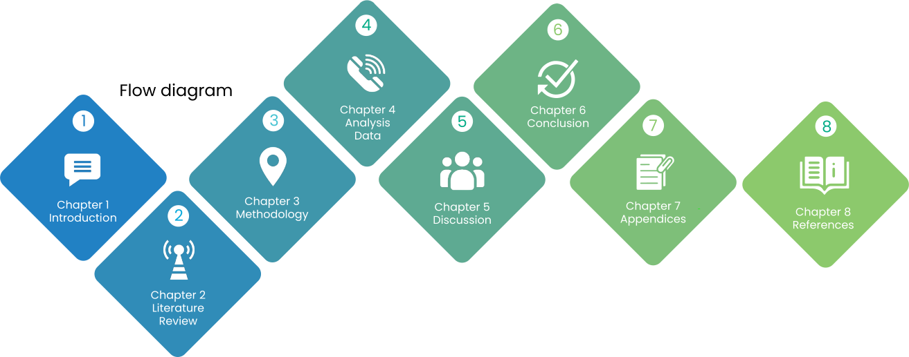
(Figure 1: Source created by learner, 2024)
- Chapter1: Introduction
The study is guided by a summary of its goals, purpose, and direction, along with information on Apple, digital marketing, and AI. The research aims demonstrate its significance in aligning with the study's goals.

- Chapter2: Literature Review
To understand digital marketing, evaluate academic works & research. Honeycomb Model, RACE, Keller's & Maslow's models are useful for studying AI-based social media, content & social media marketing. Examine secondary data to improve the models & identify shortcomings.

- Chapter 3: Methodology
The methodology section outlines the study strategy, data collection, and analysis methods. It helps readers understand the chosen approaches and their connection with study objectives.

- Chapter4: Analysis Data
This study explores how factors like purchase decisions, digital marketing, and customer relationship management affect the preferences and habits of Apple owners. It will analyse survey results with reference to literature and methodological constraints.
- Chapter5: Discussion
A discussion on AI in brand and digital marketing involves integrating AI technologies into marketing strategies to enhance brand awareness, personalize user experiences, improve targeting and tracking, and increase consumer engagement and market share as well as noting the limitations.

- Chapter6: Conclusion
The dissertation concludes with an analysis of Apple's brand, AI, and digital marketing based on previous chapters. It includes corporate recommendations, future research proposals, and acknowledges research limitations.

Chapter 2: Literature Review
The digital marketing industry is well-established as a way for businesses to reach their target audience and increase revenue (Neslin and Shankar, 2009). However, integrating AI into digital marketing has the potential to revolutionise the industry by providing consumer behaviour insights, automating processes, and personalising customer experiences (Krafft, Sajtos and Haenlein, 2020). This integration, however, raises concerns about privacy and security (Mani and Chouk, 2019).
To gain a comprehensive understanding of the potential of AI in digital marketing, this literature study analyses AI research from various sources, such as ProQuest, Science Direct, Harvard Business Review, and Sage Journals, to identify trends and potential (Kietzmann, Paschen, and Treen, 2018). The study begins with an overview of existing knowledge and explores basic AI capabilities, such as data-driven insights and automated tasks (Seymen, 2023). Additionally, the study covers applications of AI in advertising, social media, content marketing, and CRM.
One of the most pressing ethical issues related to the use of AI in digital marketing is data privacy (Mogaji, Soetan, and Kieu, 2020). Addressing algorithmic prejudice and marketing job displacement is crucial from an ethical standpoint (Wachter, 2022). To ensure the responsible use of AI in digital marketing, it is critical to establish ethical frameworks for AI and promote human-AI engagement (Wang, Xiong, and Olya, 2020).
The paper examines prospective advances in natural language processing, virtual assistants, and the "sentient web" (Larry Catá Backer, 2023). By examining expert forecasts, we show how AI helps companies understand and engage customers more effectively than ever before (Guha et al., 2021).
This comprehensive literature review delves into the current state of AI in digital marketing and its potential for the future (Vlačić et al., 2021). By assessing its strengths, weaknesses, and future opportunities, this study equips marketers with the knowledge and foresight necessary to develop effective, sustainable, and customer-focused digital marketing strategies. The paper investigates how AI has enhanced the Apple brand and its potential for digital marketing (Thilagavathy and Praveen Kumar, 2021).

Understanding the Brand
- Brand image
Authenticity in digital marketing is crucial for building and retaining customer trust. Businesses must adopt a careful approach, urged Eslami et al. (2022). Social media campaigns should move beyond mere visibility and engage target audiences for increased acquisition and interaction, according to Mukherjee (2019). To achieve success, targeted content creation based on online behaviour, interests, and demographics is key. Even with automated tools, genuine human interactions remain crucial for building audience trust through sincere engagement, true personalities, and prompt responses.
Influencer marketing is ever-changing. According to Mukherjee (2019), influencers can significantly enhance a company's reach and integrity. Companies must navigate potential drawbacks carefully. Eslami et al. (2022) and Jahng et al. (2020) suggest that a thorough vetting process and ongoing monitoring are crucial for successful collaborations.
In today's digital age, social media has become an indispensable tool for businesses to effectively engage with their audiences and establish meaningful connections, thereby promoting brand awareness and driving customer engagement. Eslami et al. (2022) underscore the numerous advantages of social media, but caution that businesses must also skillfully navigate potential pitfalls such as maintaining authenticity, addressing social media fatigue, and counteracting misinformation, as noted by Dollwet (2020) and Jahng et al. (2020).
According to Eslami et al. (2022), social media marketing requires a strategic understanding of its potential pitfalls and effective utilization. Content marketing, on the other hand, combines engagement, brand authority building, and conversion strategies, and profoundly impacts brand growth. Dollwet (2020) highlights that businesses can benefit from social media's transformative impact by improving strategies, encouraging meaningful connections, and ensuring long-term growth. The careful consideration and implementation of such strategies can significantly impact a brand's success in the digital world.
Successful companies prioritise corporate social responsibility, diversity, communication, and innovative ecosystems to maintain agile and strategic brand positioning. Through brand positioning and customer loyalty, companies can influence customer opinions and purchases. Apple's unique and innovative products have enabled it to establish a distinct brand identity, position itself in the market, and create significant brand value, as noted by Razak et al. (2020).
The establishment of a successful brand identity is contingent upon a variety of factors. These include strategic marketing, goal planning, audience definitions, and design choices. According to Wong (2023) and White et al. (2023), consistent branding is essential for enhancing sales, cultivating trust, and ensuring long-term success.
According to Ray (2023), the integration of chatbots and virtual assistants can enhance operational efficiency and provide individualised experiences. However, it is imperative to prioritise privacy and transparency to avoid negative perceptions. Additionally, Shaily and Emma (2021) suggest that AI can assist social enterprises in managing finances.
Several scholars have explored different aspects of retail brand recognition. Roggeveen et al. (2021) suggest that creative merchandising techniques and AI technology can help align brand identities. Jones (2021) advocates for analysing branding strategies, while Bachmann (2023) examines personal branding. Keller (2019) emphasises the importance of consumer emotions, while Visscher et al. (2021) criticise innovation ecosystems, and Akbari (2019) examines the role of corporate social responsibility in brand positioning. These perspectives highlight the complexity of the subject matter (Keller, 2019; Visscher, 2021; Akbari, 2019).
Das et al. (2020) explored brand equity from emotional, logical, and operational marketing perspectives. Meanwhile, Hayes (2023) argues that a strong brand image increases market lifetime, value, and trust, while Jones et al. (2019) note that managing AI algorithm errors, privacy, and biases is challenging.
Researchers are studying AI's role in branding, positioning, and value to understand consumer psychology, ethics, and digital marketing trends. The literature highlights diverse views on brand image, identity awareness, positioning, and value, emphasising the need for a holistic understanding. As research evolves, it's important to study new trends and challenges for lasting performance.

- Brand position
The unique selling proposition (USP) of a brand constitutes a crucial element in setting it apart from its competitors. This strategic position not only enhances brand recognition, equity, and loyalty but also serves as a guiding principle for product development, advertising campaigns, and audience targeting. Consequently, it occupies a valuable space in the minds of consumers and plays a crucial role in shaping a brand's identity (Keller, 2019).
Keller's 2019 study explores the relationship between consumer emotions, brand attachment, and loyalty. Brands face challenges in simplifying experiences and reducing physical discomfort in a dynamic market. Managers play a crucial role in brand development, measurement, and management, shaping consumer views and encouraging brand success (Keller, 2019).
Visscher and colleagues (2021) conducted a recent study on brand positioning within innovation ecosystems. The research highlights the significance of active engagement, planned behaviour, and deliberate attitudes in connecting partners and making strategic decisions in these self-reproducing environments. T Within ecosystems, the internal structure and competition embed innovation source control and strategic value appropriation. Overall, the findings underscore the importance of aligned explorative and exploitative innovation ecosystem methods for achieving purposeful and coherent outcomes (Visscher et al., 2021).
Akbari et al. (2019) conducted a meticulous study that scrutinised the influence of Corporate Social Responsibility (CSR) on brand positioning and customer loyalty. The research findings reveal that environmental CSR initiatives have several benefits, such as financial gains, increased brand recognition, and legitimacy. Moreover, the study highlights the versatility of successful companies in integrating both online and offline strategies to establish effective brand placement. Research emphasises the positive impact of CSR initiatives on customer value, satisfaction, trust, and loyalty. This study underscores the significance of CSR as a crucial factor in driving brand success in the contemporary business landscape.
Keller (2019), Visscher et al. (2021), and Akbari et al. (2019) proffer varying viewpoints on brand positioning. While Keller illuminates the challenges brands encounter in fostering customer-brand connections and differentiation in a dynamic marketplace, Visscher et al. challenge the notion of self-replicating positioning and emphasise the need for strategic, purposeful action. Akbari et al. delve into the ethical dimensions of brand positioning by studying the influence of corporate social responsibility on consumer trust, satisfaction, and loyalty.
Researchers have explored the intricate correlation between brand positioning, consumer psychology, innovation ecosystems, and CSR research from diverse perspectives, including psychological, strategic, and ethical. For instance, Keller's brand-consumer psychology research intersects with Visscher et al.'s (2021) strategic approach to innovation ecosystems. Furthermore, Akbari et al.'s CSR research highlights the ethical factors that influence consumer loyalty across sectors, adding to the differentiation mix.
Brand value significantly influences various business activities such as mergers, acquisitions, licencing, and overall success (Brown et al., 2018, p. 102). A strong brand value is a result of a combination of emotional and tangible factors, which leads to increased customer loyalty and competitiveness. To achieve this, brands must align their values with their target demographic, which consequently expands their clientele and boosts their revenue. Brand equity and value are complex concepts that require a multifaceted approach to understand (Das, 2020; Quan et al., 2020; Gupta et al., 2020). Gupta et al. (2020) provide a detailed overview of brand value, highlighting its emotional and tangible aspects and emphasising the importance of a holistic approach to brand management.
- Brand value
It is important to highlight the emotional and tangible aspects of a brand, as well as the need for a comprehensive approach to brand management. Another company may find the brand's equity, which includes its financial and perceived value, name, logo, and identity, valuable enough for acquisition (Keller, 2013).
In the realm of mergers, acquisitions, and licencing, establishing a strong brand value is paramount. This is because brand value comprises both intangible and tangible factors that can significantly increase customer loyalty and competitiveness. It encompasses brand loyalty, trust, consumer perception, and alignment of brand values with the target demographic, among other things. As noted by Cachero-Martínez and Vázquez-Casielles (2021), brands possess both perceived and monetary value, while Brown et al. (2018, p. 102) underscore the pivotal role of brand value in these business strategies.
Several scholars, including Das (2020), Quan et al. (2020), and Gupta et al. (2020), have acknowledged the importance of understanding brand equity and value. Gupta et al. (2020) provide a comprehensive overview of brand value, discussing its emotional, rational, and operational dimensions and their impact on demand generation and competitiveness, highlighting the need for real-world examples, and addressing potential challenges to enhance practical relevance. Quan et al. (2020), on the other hand, focus on website brand equity and propose components while empirically testing its relationship with customer satisfaction and loyalty, acknowledging that there is a lack of empirical research. Practical examples or case studies could improve clarity.
The works of Gupta et al. (2020), Quan et al. (2020), and Das (2020) offer an in-depth analysis of brand value, website brand equity, and cognitive, economic, and financial dimensions, respectively. By synthesising these studies, we can achieve a more comprehensive understanding of brand management.
The studies mentioned demonstrate the complex nature of brand relationships and the various components of brand equity. Gupta et al. (2020) extensively explore brand value, Quan et al. (2020) address website brand equity, and Das (2020) offers a broader perspective on cognitive, economic, and financial dimensions. By integrating insights from these studies, professionals in digital marketing can gain a more comprehensive understanding of brand equity in the current dynamic landscape.
In their research, Gupta et al. (2020) discuss the various dimensions of brand value, emphasising the importance of brand managers in aligning activities with promises. Quan et al. (2020) examine website brand equity and propose components while recognising the need for empirical research. Meanwhile, Das (2020) considers cognitive, economic, and financial perspectives but does not focus specifically on digital marketing trends.
In his research, Hayes (2023) highlights the correlation between a brand's monetary value and its overall strength. He emphasises the importance of a positive brand image in shaping consumer perspectives and trust, which is a key factor in purchasing decisions, building loyalty, and inspiring advocacy.
- The impact of AI on Apple's brand image.
Apple's use of AI in their products and services has been instrumental in enhancing the consumer experience (Marr, 2020). The integration of Siri voice commands and natural language processing in the 2011 iPhone 4s marked a significant milestone in smartphone technology and demonstrated Apple's dedication to AI (Alrashdan, 2022). Additionally, the use of machine learning algorithms in Face ID, camera, and digital personalisation has improved device efficiency and provided personalised recommendations, further cementing Apple's reputation for innovation.
Apple's advanced AI technology, such as Siri and other AI-powered systems, enhances the user experience by personalising voice recognition, natural language processing, and predictive analytics (Ahmed et al., 2022). Strengthening Apple's technical prowess and reputation ensures consumers feel secure about AI-driven product security and privacy (Puntoni et al., 2021).
Apple faces challenges with integrating AI into its products and services. While AI can enhance customisation and usefulness, it may also harm support. To maintain its ethical AI image, Apple needs to balance AI integration with considerations for data privacy, security, and discrimination (Guha et al., 2021). Venkatraman et al. (2021) found that machine learning-based virtual assistants and personalised experiences increase customer loyalty towards the Apple brand. Despite potential threats to personalisation, ethics, and data security, Apple continues to innovate user experiences, maintain trustworthiness, and disrupt the market. In order to prosper online, Apple must combine ethical considerations with the promises of AI.

Current Trends in Digital Marketing
Social media has revolutionised the way we interact with each other, allowing us to easily share our own content, ideas, and information. Platforms like Facebook, Twitter, Instagram, and LinkedIn offer a variety of features that allow us to build communities and connect with others. By facilitating communication and collaboration, social media has had a profound impact on digital culture, fostering discussions, and promoting the spread of knowledge..
- Social media marketing
Social media has undergone a significant transformation, evolving from being just a communication channel to becoming a pivotal marketing tool that is revolutionising business strategy for customer attraction and brand awareness (Mukherjee, 2019). This transformation warrants analytical scrutiny, placing emphasis on the influence of social media on customer acquisition. Today, the success of social media marketing depends on strategic engagement, metrics, narratives, targeted content, and storytelling, all aimed at strengthening audience connections (Mukherjee, 2019). Therefore, it is crucial to focus on cultivating enduring relationships and building passionate supporters through human interaction, targeted content, and strategic engagement.
The influence of social media goes beyond just being visible, with a focus on nuanced engagement metrics such as likes, comments, shares, and sentiment analysis (Eslami et al., 2022). Measurable metrics, including lead generation, conversion rates, and click-through rates, allow firms to fine-tune strategies based on performance data (Mukherjee, 2019). It's essential to comprehend the social media customer journey to optimise content and engagement, promoting enduring bonds through authentic alignment with audience values (Eslami et al., 2022).
Maintaining authenticity in brand communication can be challenging in the landscape of social media marketing (Mukherjee, 2019). Consumers can discern genuine interactions from promotional content, and businesses risk social media fatigue as they strive to balance engagement and overexposure (Eslami et al., 2022). To navigate issues of misinformation, caution is necessary to mitigate potential pitfalls (Mukherjee, 2019; Allcott & Gentzkow, 2017). Authenticity is crucial for building and retaining customer trust, so businesses must adopt a careful approach (Eslami et al., 2022).
In increase acquisition and interaction, social media campaigns must engage target audiences by creating targeted content based on online behaviour, interests, and demographics (Mukherjee, 2019). Building audience trust through genuine human interactions, even with automated tools, is crucial for success. Sincere engagement, displaying true personalities, and providing prompt responses facilitate this achievement (Eslami et al., 2022).

In the domain of influencer marketing, the scene is constantly changing, stressing the importance of selecting the appropriate influencers with care (Mukherjee, 2019). Influencers have a significant impact on expanding a company's influence and credibility, but organisations must navigate possible challenges. The research provides insight into the complexities of influencer marketing, advocating for a rigorous screening process and continuous monitoring for fruitful partnerships (Eslami et al., 2022; Jahng et al., 2020).
In today's digital age, businesses utilise social media digital spaces to engage with their audiences and establish meaningful connections, which can encourage brand awareness and drive customer engagement (Eslami et al., 2022). However, businesses must also be aware of potential pitfalls. Critical aspects include maintaining authenticity, addressing social media fatigue, and countering misinformation (Dollwet, 2020; Jahng et al., 2020).
Social media marketing is a complex and ever-evolving field that requires careful consideration of potential challenges and effective use of resources (Eslami et al., 2022). To maximise benefits, businesses can leverage social media's power to boost brand recognition and attract new customers by refining their approach, building meaningful relationships, and fostering sustainable growth (Dollwet, 2020)..
- Content marketing
Content marketing powers the digital landscape, combining engagement, brand authority building, and conversion strategies to profoundly impact brand awareness and consumer engagement. This approach emphasizes quality, relevance, and strategic keyword use, enriching it with SEO integration, audience segmentation, and diverse content formats. A subset of content marketing, information marketing caters to audience needs through blogs, infographics, videos, podcasts, eBooks, and whitepapers, encouraging engagement across channels (Deepa and Geeta, 2021).
Brand storytelling, user-generated content, and KPIs guide tailored strategies, acknowledging the importance of narrative, information overload management, and visual content. Visual content, such as infographics and videos, emerges as a powerful force in platform-wide engagement, altering user engagement and brand impressions (Deepa and Geeta, 2021).
According to Ho et al. (2020), there are different perspectives and buzzwords surrounding the landscape of content marketing, leading to definitional challenges. Content marketing aims to create and distribute valuable, consistent, and relevant content to attract and retain customers. Ho et al. (2020) provide insight into content marketing nuances and identify engaging practices, that contribute to an analytical content marketing capability framework.
The strategic importance of content marketing is evident as marketing shifts towards engagement, responding to consumer cynicism towards traditional advertising. To address challenges in definition and perception, we need differentiation and clarity. Ho et al. (2020) identify six content marketing elements that contribute to a clearer understanding and emphasise its strategic role in brand storytelling.
Recent studies by Kozinets (2021) and Dwivedi et al. (2021) have highlighted the importance of narrative-driven content and social media marketing in digital marketing. Kozinets emphasises how storytelling in content marketing can help capture audience attention and build emotional connections. Meanwhile, Dwivedi et al. discuss how social media marketing can help businesses connect with customers, raise brand awareness, and improve sales.
The literature review by Dwivedi et al. (2021) explores four key themes in digital and social media marketing: Environment, Marketing Strategies, Company, and Outcomes. The themes delve into different aspects of digital marketing, such as changes in consumer attitudes, the impact of mobile channels, platform effectiveness, and the influence of emerging technologies. These themes provide a comprehensive overview of the dynamic nature of digital marketing.
Leading experts contribute diverse perspectives to the literature, addressing challenges, limitations, and proposing future research avenues. It is clear that digital marketing is constantly evolving, and businesses need to be adaptive in their approach to keep up with consumer power and cultural norms.
- SEO Marketing
In the world of digital marketing, content marketing and SEO are closely related elements that play a significant role in shaping the digital landscape. Content marketing engages audiences and builds brand authority by creating valuable content in various formats, like blog articles, videos, podcasts, and whitepapers. Meanwhile, SEO integration optimises keywords for improved discoverability. To guide impactful strategies, brand storytelling, user-generated content, and key performance indicators are essential (Das, 2021). However, new algorithms question the sustainability of old SEO strategies, emphasising a comprehensive approach that prioritises user experience and content relevancy (Panchal et al., 2021). Quality, relevance, engagement, and data-driven insights are crucial for content marketing, which remains a driving force. The future of content marketing is influenced by technological advancements and changing consumer behaviours, requiring continuous learning and experimentation (Das, 2021).
Recent research has highlighted the importance of adapting SEO strategies to evolving search engine algorithms, which can significantly impact website traffic and conversion rates (Panchal et al., 2021). Voice search optimisation has emerged as a transformative approach, urging businesses to tailor their strategies to meet the needs of conversational queries (Das, 2021; Terho et al., 2022).
To reach customers through various digital channels, including the internet, social media, search engines, and mobile devices, businesses can benefit from understanding the different types of content management systems (CMS) available (Das, 2021). Social media advertisements (SMAs) and Search Engine Marketing (SEM) can be efficient tools to target specific audiences, and native advertising on social media provides flexible options for showcasing content (Das, 2021).
Search engines, particularly Google, dominate the internet services market, with SEO improving web page rankings and influencing web traffic. User trust in search engines and complex interdependencies among stakeholders underscore SEO challenges (Schultheiß and Lewandowski, 2020). Contrasting views highlight the symbiotic relationship between SEO and content marketing (Das, 2021). The evolving landscape emphasises adapting SEO strategies for user intent and content quality (Panchal et al., 2021). Continuous learning and experimentation are crucial in the dynamic world of content marketing (Das, 2021). Recent research explores the impact of well-executed SEO strategies on website traffic and conversion rates, underscoring the need for businesses to adapt to evolving search engine algorithms (Terho et al., 2022).
- Digital marketing strategies employed by Apple.
Apple employs various digital marketing techniques to connect with its audience, increase sales, and create loyalty (Puthussery, 2020). By using various channels such as its website, blogs, podcasts, and videos, Apple delivers informative and engaging content, emphasising simplicity and elegance to maintain its position as a digital technology leader (Pandey et al., 2020). Through authentic content marketing, Apple effectively conveys its unique selling proposition (USP) and ensures success (Pandey et al., 2020).
Apple also engages directly with its audience through social media platforms like Facebook, Instagram, Twitter, and YouTube. This allows them to share product information, behind-the-scenes operations, and inspirational anecdotes, completing their brand narrative. By using strategic hashtags and geotagging, Apple builds focused marketing communities, encouraging brand loyalty and real-time connections with millions of followers (Gleiss et al., 2021).
To improve its digital presence and organic search rankings, Apple employs a multifaceted approach to search engine optimisation (SEO). They craft high-quality content with carefully selected keywords, meta tags, and descriptions, ensure mobile optimisation, responsive design, and quick website loading for an improved user experience. Engaging with industry leaders and securing backlinks from renowned bloggers strengthens Apple's virtual reputation and search engine results. The use of structured data and schema markup further increases organic traffic and digital visibility (Mashiah, 2021).
Influencer marketing plays a crucial role in Apple's online campaigns, where collaboration with tech, music, and fashion icons sparks conversations and shares innovative ideas (McGruer, 2020). By incorporating celebrities, Apple effectively promotes its products and brand, reaching its target audience through extensive fan bases (McGruer, 2020). Special event invites and influencer engagements solidify Apple's connection with its audience and sustain its marketing success.

The Role of Artificial Intelligence (AI) in Digital Marketing
In the new technology sector, the rise of Artificial Intelligence (AI) is revolutionising digital marketing with AI-driven customer segmentation, personalisation, and improved customer experiences. This exploration delves into the complexities of brand image, the impact of the digital landscape, and the transformative role of AI. Understanding these dynamics, allows can guide brands towards a compelling digital presence that resonates with their audience. (Hiremath & Gupta, 2022).
- AI-Powered Customer Segmentation
The integration of Artificial Intelligence (AI) algorithms has transformed the field of digital marketing. With sophisticated algorithms, AI-driven segmentation offers precise, efficient, and personalised customer segmentation (Terho et al., 2022). By improving targeting precision, navigating vast datasets, and providing real-time personalisation based on customer preferences (Panchal et al., 2021), companies can proactively adjust their marketing strategies, resulting in greater efficiency and effectiveness (Terho et al., 2022).
AI-driven segmentation also offers scalability and efficiency, automating processes and providing companies with a competitive edge to adapt to changing customer dynamics (Terho et al., 2022). However, ethical considerations arise, emphasising the need for transparency and guidelines for responsible AI use (Panchal et al., 2021). Integration with Customer Relationship Management (CRM) systems can further improve effectiveness by encouraging synergy and allowing customisable AI models (Das, 2021).
The integration of AI algorithms can have a significant impact on marketing metrics by offering insights into customer behaviours, preferences, and trends, resulting in more effective and targeted marketing (Schultheiß and Lewandowski, 2020). However, integrating AI with predictive analytics poses challenges that require successful integration frameworks and continuous refinement (Das, 2021). Research has highlighted AI's potential benefits in identifying distinct customer segments with precision surpassing traditional methods (Gawer, 2021). Despite the promises of AI-driven segmentation, ethical concerns regarding biases and privacy necessitate a cautious and transparent approach (Panchal et al., 2021). Furthermore, integration challenges underscore the need for strategic approaches and continuous refinement of AI models (Das, 2021)..
- AI-Driven Personalisation
AI innovations in the consumer electronics industry are driving a rise in personalization, enabling companies to attract potential customers with tailored content that meets specific requirements (Nalluri & Rao, 2023). The benefits of AI-driven personalisation include acquiring new users, deepening user insights, and increasing user engagement (Sage Journals). Companies must implement these methods authentically to be perceived as genuine efforts to serve customers better (Nalluri & Rao, 2023). A study emphasised the importance of minimising perceived risk and addressing the impact of time pressure on ad avoidance in consumers to tailor strategies effectively (Cao, Isa, and Perumal, 2023).
Mobile advertising literature has shifted from text-based SMS advertisements to smartphone-based banner advertisements, with an emphasis on understanding their impact on the effectiveness of mobile advertising campaigns (Jebarajakirthy et al., 2021). AI has emerged as a transformative force in the consumer electronics industry, enhancing user interfaces, creating personalised smart homes, and revolutionising customer support through chatbots and virtual assistants (Editorial, 2023). The integration of AI is crucial for understanding consumer motivations and preferences in online retail (Nalluri and Rao, 2023).
Personalization driven by AI is crucial in the consumer electronics industry because it allows companies to attract potential customers and gain deeper user insights. Advertisers must tailor strategies to minimise perceived risk (Cao, Isa, and Perumal, 2023) and address the impact of time pressure on ad avoidance in consumers. With AI emerging as a transformative force in the industry, mobile advertising literature has evolved from text-based SMS advertisements to smartphone-based banner advertisements.
- AI-driven marketing strategies influence consumer views of the Apple brand
Apple's brand reputation and profits are heavily reliant on how customers perceive the brand. The company has successfully established a brand identity of exclusivity, quality, and innovation that appeals to discerning customers who value premium products. Apple's emphasis on customer experience and exceeding expectations has led to improved customer satisfaction. The company is known for its innovation and premium pricing, reflected in its emotive marketing campaigns, such as "Think Different" and narrative-driven advertising. Huang & Rust (2021) note that Apple's emotive marketing has further enhanced its brand image.
To improve customer engagement and personalisation, Apple employs AI-powered marketing, starting with an AI-backed marketing strategy. The company uses AI-driven chatbots and virtual assistants that interpret customer requests and provide relevant information, leading to an enhanced customer experience (Soofastaei, 2021). By analysing customer data and purchases, Apple can tailor advertising to specific customers and generate dynamic pricing models that reflect user preferences and market fluctuations (Nair & Gupta, 2021). By leveraging AI-powered marketing, Apple can better understand and engage with its customers, thereby improving its brand image and customer satisfaction.
The use of AI-powered marketing has shifted customer perceptions of Apple positively. Nair & Gupta (2021) note that by using Natural Language Processing and Machine Learning to personalise marketing messages and recommendations, Apple can tailor advertisements and product suggestions to user data, such as browsing habits, purchase patterns, and preferences, thereby enhancing engagement and satisfaction. Apple's use of AI technology in marketing has helped build consumer trust, ease, and innovation, thereby improving its brand image. AI-powered chatbots and Siri have also improved Apple's customer service and brand experience.
Research has shown that Apple's AI-based marketing has a positive public perception, with many valuing the company for its innovation, brilliance, and elegance. Apple is a digital pioneer that designs cutting-edge products for its customers. By leveraging AI-backed marketing, Apple has demonstrated its commitment to using cutting-edge technology to improve customer experiences, by leveraging AI-backed marketing (Nair & Gupta, 2021).

- Identifying areas for innovation in integrating AI into Apple's marketing strategies.
Apple uses AI in a variety of marketing strategies, including AI-targeted advertising, which customises ads based on advanced AI algorithms that assess people's surfing and purchasing habits. This AI-centric approach helps Apple engage and convert customers. Additionally, Apple's email marketing uses AI algorithms to segment client information and deliver emails based on Apple interactions and preferences. Personalising marketing communications increases brand loyalty and engagement, as cited by Rosário & Dias in 2023. For customer care, Apple utilises AI-powered chatbots on its website and other messaging channels. These chatbots, utilising natural language processing, answer inquiries rapidly, enhancing the customer experience. Apple's AI marketing illustrates their dedication to employing cutting-edge technology to improve customer experiences, as cited by George, George, and Martin in 2023.
Apple has several marketing opportunities to employ AI to increase customer engagement and personalisation. AI-powered virtual shopping may customise shopping, recommend items, propose complementary goods, or develop tailored promotions, as cited by Ameen et al. in 2021. AI has the potential to improve customer service by understanding and answering inquiries using natural language processing. AI-generated content helps Apple improve its marketing across platforms and devices, as cited by Dwivedi et al. in 2021. Other AI applications include customer behaviour and preference prediction. Apple can better understand its target demographics and alter its marketing strategy by using AI algorithms to analyse social media, internet surfing, and purchasing habits. Apple's marketing strategy should increase user experience, marketing efficacy, and corporate growth via AI, as cited by Guha et al. in 2021.
AI in Apple's advertising has perks and downsides. AI improves advertisement personalisation, evaluates enormous data sets to discover customer preferences and habits, and allows Apple to target certain customer groups to improve marketing. Apple's advertising personnel may concentrate on more useful tasks when AI automates uninteresting tasks, as cited by Marr in 2020. Apple improves marketing and data-driven decisions. However, AI implementation has issues, including data security and privacy challenges, that Apple must preserve customer trust and data protection for. Algorithm prejudice may cause AI systems to mistakenly disclose or encourage bias in marketing, and for justice and inclusiveness, Apple must carefully design and manage AI systems, as cited by Yu in 2020. Finally, AI integration involves technological infrastructure, experience, training, and model development. Despite these challenges, Apple may use AI to improve marketing efforts and tailor its marketing efforts.
Apple's AI branding stimulates creativity. AI integration areas include predicted customer behaviour analysis, augmented reality, and voice-activated assistants. AI has improved targeted advertising, client recommendation systems, and consumer data analytics, as cited by Zulaikha et al. in 2020. However, data confidentiality and AI skills remain issues despite the advantages, as cited by Vimalkumar et al. in 2021. By solving these difficulties and inventing new AI applications, Apple can retain its tech supremacy and increase its marketing. AI in Apple's advertising might transform consumer interactions and uncover fascinating future potential..

Literature Gap
The existing literature on branding provides profound insights into brand identity, position, and value, as exemplified by Apple's successful integration (Razak et al., 2020). However, there is a critical gap in exploring contemporary trends, particularly the integration of AI in branding, with a lack of focus on ethical concerns. The literature emphasises brand identity, awareness, and positioning, but fails to delve into AI's nuanced impact on brand consistency, voice unification, and consumer connections (Ray, 2023; Jones et al., 2019). Furthermore, there is a noticeable gap in empirical evidence supporting brand identification perspectives in the retail sector, revealing contrasting views that necessitate further research (Roggeveen et al., 2021; Jones, 2021; Bachmann, 2023).
This research underscores the imperative for organisations to examine the intricate relationship between a positive brand image and consumer views, trust, and market lifetime, highlighting the need for further exploration of the ethical dimensions of AI in brand value (Hayes, 2023). Examining brand value reveals a gap in addressing AI challenges, including algorithm errors, privacy concerns, and biases (Jones et al., 2019). A holistic examination combining psychological connections with ethical considerations is lacking, leaving questions about the self-reproducing nature of innovation ecosystems (Visscher et al., 2021).
The literature on social media marketing acknowledges its transformative evolution, but lacks a nuanced exploration of contemporary trends, particularly in influencer marketing (Mukherjee, 2019; Eslami et al., 2022; Jahng et al., 2020). Content marketing is underexplored, presenting a clear gap in the literature regarding its current state, contrasting views, or perspectives. Similarly, the SEO marketing section lacks specific information on the current state of research, contrasting views, or perspectives.
To address these gaps, the dissertation aims to provide valuable insights by focusing on the intricacies of influencer marketing within social media, offering detailed insights into identification, challenges, and ongoing monitoring. Additionally, it offers specific information on the current state of research, contrasting views, and perspectives in content marketing and SEO marketing. The comprehensive review highlights the dynamic interplay between content marketing and SEO, emphasising holistic SEO practices for user experience and content relevance. The study will provide valuable insights into AI-powered marketing, potentially impacting Apple's brand image and consumer perceptions.

Objectives and Models
- R.A.C.E Framework
R.A.C.E. is a popular marketing model that guides the customer journey with four stages: Reach, Act, Convert, and Engage. It integrates digital marketing and improves the effectiveness of online marketing with a structured approach (Huang & Rust, 2021)

(Figure 2: Source created by learner, 2024)
Reach: Apple's social media strategy is effective because it uses engaging content and targeted advertising, such as stylish product launches, viral campaigns, and influential partnerships, allowing them to reach a broad audience. The company can further expand through paid social media and targeted SEO for specific product lines. AI sharpens targeting precision on social media, identifying potential customers ahead of traditional methods using predictive analytics. This shift facilitates hyper-personalised campaigns, which increase relevance and conversion rates. Apple leverages traditional advertising, social media, and partnerships to achieve a massive global reach, competing with Samsung, Google, and Microsoft (Gil, 2021).
Act: In the digital media and AI landscape, Apple strategically utilises App Store campaigns and personalised content, driven by AI-powered recommendations led by Siri (Xie & Lou, 2020). This transcends standard product suggestions, tailoring experiences with podcasts, and curating App Store lists based on user preferences. The heightened personalisation transforms interactions into experiential journeys, creating exploration and trust through AI-driven chatbots in alignment with brand values and customer data. Amid fierce competition, Samsung challenges Apple in the smartphone market with continuous innovation and top-tier marketing. Apple prioritizes user experience over flashy technology with its AI approach, giving it a competitive edge in a market contested by rivals such as Samsung, Huawei, and Google.
Convert: Apple's conversion prowess, anchored in a user-centric approach, streamlined purchasing, and personalised recommendations, defines its success in driving engagement and conversions without compromising its premium image (Shen, 2023). AI plays a critical role in enhancing the conversion funnel, addressing pain points, and increasing success rates. Dynamic pricing adjustments based on market trends ensure competitiveness while maintaining Apple's premium brand integrity. Voice assistants like Siri further contribute to seamless conversions, offering frictionless, hands-free checkouts. Apple is facing increasing competition from companies like Samsung, Huawei, and Google in the digital media and AI space, which is driving their focus on user experience and innovation.
Engage: Apple prioritises the customer experience, encouraging loyalty through ongoing communication and exclusive events. AI-driven CRM systems facilitate personalised interactions, while sentiment analysis predicts customer feedback. By creating personalised forums and chatrooms, AI creates a loyal community, leveraging sentiment analysis to proactively address potential issues (Figure Ueiredo et al., 2014). It goes beyond transactions, building a united tribe based on shared values and experiences, and cementing Apple's identity as more than just a brand—a community hub. Apple's innovative use of AI creates a holistic and immersive brand experience, positioning the company at the forefront of technological and relational innovation. (Tom Dieck & Han, 2022; Ricci 2020)..
- The Honeycomb Model
In 2011, the Social Media Honeycomb Model was developed by Kietzmann, Hermkens, and McCarthy as a structured framework for digital marketing. Its seven essential components guide businesses in tailoring effective social media strategies, emphasizing key building blocks for success.
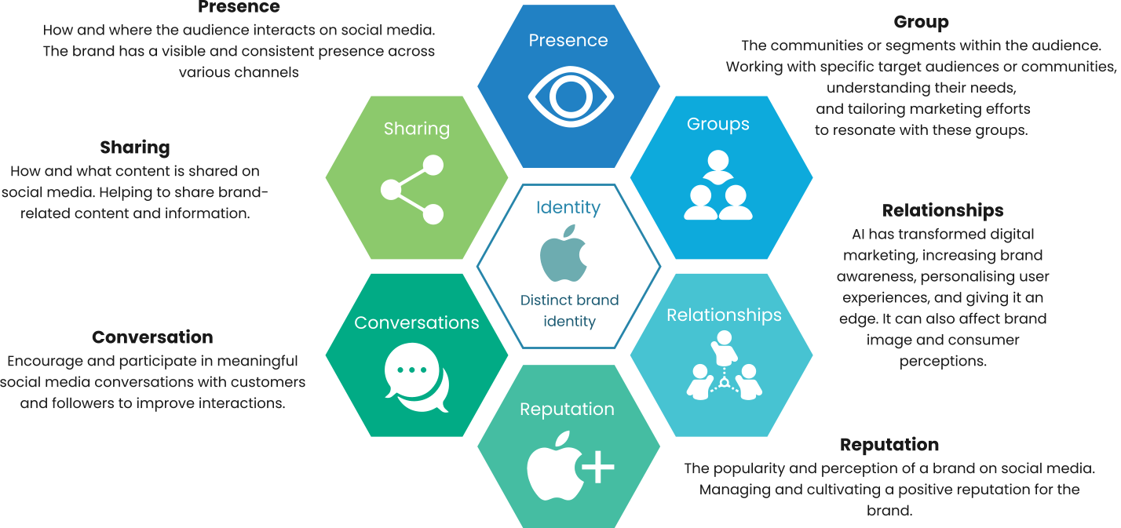
(Figure 3: Source created by learner, 2024)
Apple integrates its social media strategy with the Honeycomb Model, ensuring a consistent digital presence across identity, presence, connections, reputation, groups, discussions, and sharing. Apple has successfully presented a story that reflects its commitment to innovation, user focus, and brand loyalty.
1. Identity: Apple's digital brand embodies sleek design and innovation (Fernandez, 2023). Apple uses AI to adapt online experiences, assuring a user-centric approach while protecting privacy (Turow, 2021). This extends beyond products to exhibit ethos and lifestyle on channels like as Instagram and Twitter, with the goal of constantly developing its digital identity.
2. Presence: Apple's online presence goes beyond SEO and content marketing. Social media sites such as Facebook, Twitter, and YouTube provide dynamic engagement opportunities. An omnichannel strategy smoothly integrates online and offline touchpoints to ensure a consistent brand experience (Huang & Rust, 2021). Influencer marketing expands this visibility by connecting with a wide range of audiences.
3. Relationships: Apple prioritises consumer relationships and uses AI-driven CRM systems to analyse interactions, preferences, and behaviours (Rosário & ias, 2003). Community-building around Apple products promotes loyalty and peer-to-peer support. Interactive customer service, enabled by AI chatbots, strengthens connections by improving communication and increasing satisfaction.
4. Reputation Management: Apple uses AI algorithms to monitor social media and manage its reputation (Huang & Rust, 2021). Transparent communication regarding product development and obstacles creates trust, reducing potential reputational risks. Crisis management, aided by social listening techniques, ensures timely detection and resolution.
5. Groups: Apple's community participation strategy relies heavily on social media groups (Kopalle et al., 2022). Participating in debates, resolving issues, and giving insights within relevant communities strengthens Apple's reputation as a recognised authority. User-generated content amplification improves social proof and legitimacy.
6. Conversations: Apple prioritises meaningful conversations. Sharing thought leadership and important insights promotes an active online discourse (Venkatesan & Lecinski, 2021). Real-time participation on social media shows responsiveness, which contributes to positive brand sentiment.
7. Sharing: Apple's approach focuses on encouraging content sharing throughout groups (Kopalle et al., 2022). Aside from self-promotion, Apple promotes a culture of sharing expertise. Educational information, lessons, and creative instructions let users feel empowered and participate more deeply. Collaborative content creation through challenges or contests builds interest and increases organic reach.
RACE and The Honeycomb Model: Similarities and Differences
Similarities:
Apple uses AI in both the Honeycomb and RACE models to improve various areas of their digital marketing approach. The Honeycomb Model targets AI-driven personalisation to personalise online experiences, offering a user-centric approach while protecting privacy (Turow, 2021). Similarly, the RACE model extends this by incorporating AI into audience targeting, dynamic advertisements, and personalised consumer experiences (Grewal et al., 2020). Including AI in both models shows Apple's dedication to using technology for enhanced and focused interactions.
Both versions help to strengthen Apple's brand visibility and reach. The RACE concept helps to expand reach by using AI-driven audience targeting and dynamic ads (Huang & Rust, 2021). The Honeycomb Model maintains a consistent digital presence across multiple dimensions, including identity, presence, relationships, and more. The combination of both approaches demonstrates Apple's strategic approach to digital marketing, which encompasses a wide range of methods to maximise impact.
Both methods promote proactive reputation management. Apple tries to maintain a positive brand image, handle issues quickly, and limit any risks, whether through AI algorithms monitoring social media in the Honeycomb Model or the strategic use of the RACE model to develop dynamic commercials (Huang & Rust, 2021; Gupta & Madan, 2022). This commonality indicates Apple's dedication to protecting its reputation through integrated digital marketing techniques.
Differences:
Both models contribute to Apple's digital marketing strategy, but they serve separate purposes. The Honeycomb Model offers a comprehensive framework for evaluating and improving a company's social media strategy, with an emphasis on user involvement and interaction across multiple dimensions (Turow, 2021). The RACE model, on the other hand, focuses on the overall digital marketing funnel, which includes Reach, Act, Convert, and Engage (Grewal et al., 2020). The RACE model goes beyond social media and includes several touchpoints in the customer experience.
The Honeycomb Model encourages community engagement, meaningful conversations, and content exchange in social media groups (Kopalle et al., 2022). In contrast, the RACE model, although taking engagement into account, focuses on converting leads and driving specific actions via the digital marketing funnel (Gupta & Madan, 2022). The Honeycomb Model's emphasis on community development is more closely connected with developing relationships and trust.
- Keller's Brand Equity Model
Apple leverages Keller's powerful Keller's Customer-Based Brand Equity (CBBE) model to dominate digital brand equity. This AI-fuelled framework, with its key stages, unlocks customer insights and strengthens Apple's online presence (Keller, 2016)
(Figure 4: Source created by learner, 2024)
Brand Salience: Apple's iconic logo, sleek design, and minimalist aesthetic are synonymous with innovation. AI plays an essential role in targeted advertising campaigns, ensuring Apple stands out in a crowded digital landscape. (Huang & Rust, 2021)
Performance: Apple's products are known for their superior functionality and cutting-edge technology. To maintain trust and improve user experiences, the company leverages AI-driven performance analysis, such as A/B testing and predictive maintenance. (Yau, Saad and Chong, 2021)
Imagery: Apple aligns itself with creativity, individuality, and innovation. AI adds a personalized touch by analysing user data, recommending relevant content, and encouraging user-generated content through social media campaigns. (Hajarian et al., 2021)
Feelings: Apple's advertising campaigns and brand messaging evoke positive emotions in its customers. By leveraging AI-driven sentiment analysis and personalized customer service, the company ensures a continuous positive emotional experience, enhancing overall satisfaction. (Roggeveen et al., 2021)
Resonance: By incorporating AI into its digital marketing strategy, Apple establishes personalized connections, generates valuable insights, and optimizes campaigns. AI-powered chatbots provide 24/7 support, encouraging a thriving online community of brand advocates. Loyalty programs and community building, facilitated by AI, contribute to achieving brand resonance. (Ghorbani, 2023)
Advantage/disadvantage.
Despite the benefits of AI in digital marketing, there are some challenges. Over-reliance on data may overlook emotional nuances, and a static framework may hinder quick adaptation to shifts. Additionally, negative brand equity demands significant investment in reputation management. However, by proactively managing brand equity, Apple can position itself for sustainable growth in the digital age. (Kopalle et al., 2022)
Keller's model provides a structured approach to optimizing Apple's marketing campaigns across several dimensions. The model comprehensively assesses Apple's digital brand health and evaluates the effectiveness of Apple's current marketing strategies. Guiding targeted digital strategies through salience, performance, imagery, feelings, and resonance, Keller's model provides a structured approach to optimizing Apple's marketing campaigns by analysing these key dimensions. AI integration improves effectiveness, contributing to customer retention, reduced marketing needs, and higher profit margins. Recognition and trust, created by brand equity, position Apple for sustainable growth in the digital age. (Hawker, 2019; McKinsey, 2023)
Advantages: Keller's model comprehensively assesses Apple's digital brand health. The model is particularly effective in evaluating Apple's online presence and identifying areas for improvement in their digital marketing efforts. Guiding targeted digital strategies through salience, performance, imagery, feelings, and resonance (Hawker, 2019). Keller's model provides a structured approach to optimising Apple's marketing campaigns by analysing these key dimensions. It evaluates the effectiveness of Apple's current marketing strategies and suggests areas for innovation and improvement in integrating AI technology. AI integrations improves effectiveness, contributing to customer retention, reduced marketing needs, and higher profit margins. Recognition and trust, created by brand equity, position Apple for sustainable growth in the digital age (Mckinsey, 2023).
Disadvantages: Implementing Keller's model, particularly in brand feelings and imagery, may pose challenges, requiring skilled professionals and robust data analysis. Potential subjectivity introduces a margin of error, and the costly implementation of AI and specialists poses challenges for smaller brands. Over-reliance on data may overlook emotional nuances, and a static framework may hinder quick adaptation to shifts. (Grewal et al., 2020) Market saturation challenges differentiation, and negative brand equity demands significant investment in reputation management. (Kopalle et al., 2022). The ongoing cost of maintaining brand equity underscores the need for proactive management in a dynamic digital landscape (Porath, 2023).
- Maslow Model
(Figure 5: Source created by learner, 2024)
Physiological: Meeting physiological needs is the first step in Maslow's Hierarchy of Needs. This is in line with Apple's digital marketing strategy, which emphasises product features that tend to meet customers' basic physiological demands (Legun & Burch, 2021). Apple's smartphones have extended battery lives, efficient processors, and user-friendly interfaces that make it simple to access key features. Features like sleep tracking and fitness apps emphasise health and well-being, creating a reliable, convenient, and efficient user experience from the outset (Alghamdi et al., 2022).
Safety: Safety needs are central to human nature, and Apple's digital marketing effectively addresses them. Prioritising secure and reliable user experiences, Apple instills trust and peace of mind (Alghamdi et al., 2022). Privacy and security features like Face ID, Touch ID, encrypted messaging, and robust security measures demonstrate Apple's commitment to user data protection (Stolojescu-Crisan et al., 2022). Emphasising product quality and durability further assures customers, establishing Apple as a brand that prioritises safety and well-being.
Social: Recognising the importance of social needs, Apple's digital marketing creates a sense of community and belonging (Alghamdi et al., 2022). By emphasising user-generated content and incorporating social media features, Apple encourages users to share experiences, encouraging a larger Apple community. Leveraging social influence through testimonials and customer stories, Apple successfully fulfils the social needs of its customers, deepening emotional connections and building brand loyalty (Abrash 2021).
Self-Actualization: Apple's digital marketing plays a crucial role in helping users achieve self-actualization, the highest level in Maslow's hierarchy. Empowering individuals to express creativity and pursue passions, Apple's innovative products, simplicity, and beautiful design encourage users to explore their full potential. With a range of devices supporting creation, learning, and personal growth, Apple's emphasis on user experience facilitates the realisation of users' goals and aspirations. By promoting self-expression and personal growth, Apple's digital marketing appeals to individuals seeking to actualize their unique talents and capabilities. (Abrash, 2021).
Conclusion to Literature review
The literature review sheds light on the dynamic landscape of digital marketing and its intersection with artificial intelligence (AI) in elevating the Apple brand. The exploration of current trends reveals a paradigm shift towards personalised and immersive customer experiences. Leveraging AI technologies, such as machine learning and data analytics, has become imperative for enhancing consumer engagement and creating brand loyalty.
The reviewed literature underscores the significance of AI-driven strategies in optimising digital marketing campaigns. Apple's commitment to innovation and seamless integration of AI in its marketing endeavours is evident from the success stories highlighted in the literature. As the digital marketing landscape continues to evolve, the future prospects for AI in brand elevation appear promising. The synthesis of insights from various studies emphasises the potential of AI to not only streamline marketing processes but also to anticipate and respond to consumer needs in real-time.

Chapter 3: Methodology

Introduction to methodology
The methodology outlines the key steps in the research process, beginning with an in-depth literature review to understand current trends. The study uses a quantitative poll to assess Apple's brand impression and AI's involvement in digital marketing among UK and US adults over 18. The survey ensures a representative sample and ethical conduct, following industry norms. It examines Apple customers' AI-driven digital marketing views, attitudes, and behaviours, ensuring a complete picture. This method reveals Apple's customers' complex interactions. In the evolving digital ecosystem, the quantitative survey helps unravel intricate linkages and inform strategic decisions (Hossain et al.2024). This methodological framework aims to deliver credible and valuable insights, contributing to the strategic improvement of the Apple brand in the evolving digital marketing landscape.

Research Design – Onion method
The "onion method" proves to be a versatile metaphorical approach employed across diverse domains, notably marketing and research. In the marketing field, it serves as a representation of the layers inherent in a comprehensive marketing strategy, delineating aspects like target market, differentiation, and communication channels. In research, the "research onion" model, introduced by Saunders et al.,(Sinha, Clarke and Farquharson, 2018) systematically guides the development of research methodology, organizing the study, and designing the research process. The layers in this model include philosophy, approach, strategy, choices, and time horizon, providing a structured framework for researchers (Melnikovas, 2018). Beyond this, the term "onion method" extends to AI applications, employing a layered approach for tasks like keyword research (Smullen, 2023). Therefore, the "onion method" emerges as a cohesive and structured concept, offering a layered approach in various processes across different domains (Dissanayake, 2023).
Path
Philosophy | Approach | Design | Type of Study
Positivism | Deductive | Quantitative | Survey, Experiment, mono-method quantitative study
s(Figure 6: Source created by learner, 2024)

Philosophies
The research onion model, developed by Saunders et al. (2019), is based on the positivist approach which prioritizes empirical observation and analysis through scientific methods, rejecting subjective speculation. Objectivity, devoid of biases, is pivotal in uncovering universal principles (Engward, 2012), prioritizing empirical thinking and dependable outcomes. This framework underscores the importance of value-free research, drawing conclusions based on logic and facts. Comprising layers such as research philosophy, approach, strategy, time horizons, and data collection methods, the model ensures thorough and well-structured research (Saunders et al., 2019). Positivism, crucial for objectivity and reliability in data collection (Haig, 2018), forms the cornerstone for making informed generalizations.

Approaches
The deductive approach is a commonly used research method that moves from general to specific by developing specific predictions or hypotheses for empirical testing based on established theories or concepts. Marketing research often benefits from this approach, as it enables researchers to develop hypotheses about consumer behaviour and market trends (Vakratsas and Ambler, 1999). For instance, a researcher may develop a hypothesis about the impact of celebrity endorsements on brand loyalty and design an experiment to test it using a sample of consumers and statistical analysis (Keller, 2016).

Strategies
Online surveys are a valuable tool for collecting data objectively and methodically. By using checklists and rating scale questions, numerical and consistent responses can be obtained for increased data objectivity. To standardise data collection, Google Form surveys were delivered through WhatsApp and mail distribution was also used. This enabled reaching a wider audience and improving response rates, which in turn enhanced data reliability. Google Forms surveys are a fast, efficient, and accessible way to reach diverse audiences (Ilieva, Healey and Baron, 2002). WhatsApp simplifies survey distribution, particularly for those who may have limited access to the internet. However, personal messaging platforms may raise privacy concerns. Mail distribution, on the other hand, is a dependable method for a range of demographics, but junk mail and firewall restrictions can impede delivery and lower response rates (Shih and Fan, 2009).
It's important to note that online surveys may fatigue respondents and lead to lower response rates due to request overload. Therefore, it's crucial to strike a balance and use various distribution methods to obtain an accurate representation of the data. By using a combination of distribution methods, response rates can be increased, data reliability can be improved, and a diverse range of responses can be obtained (Sammut, Griscti and Norman, 2021).

Investigation
The investigation will involve both primary and secondary research. The primary research will focus on a quantitative survey to collect data from participants, while the secondary research will involve a literature review of existing research studies. The results of both research methods will be integrated to provide a comprehensive understanding of the research topic. This mixed-methods approach aims to provide recommendations for optimising Apple's use of AI to improve its marketing effectiveness and consumer engagement.

Table 1: Primary Research (Quantitative Survey)
Advantages | Disadvantages
Engaging directly with the subject matter in primary research allows for a more nuanced understanding of the phenomena being investigated (Castleberry, 2001). | According to Chivaka (2018), investing in AI-powered digital marketing requires significant investments in time, financial resources, and expertise.
According to Johnson et al. (2020), surveys provide precise data for empirical scrutiny, and customization ensures relevance, thus increasing reliability. | Conducting data analysis requires specific knowledge and technical resources, which may raise research costs and complexity (Chivaka, 2018).
By customizing data collection processes in primary research, the obtained data can be more relevant and specific, which enhances the reliability of the findings. | Sample size limitations may hinder the generalizability of research outcomes, impacting the broader applicability of results.
Bespoke research designs in primary research help mitigate confounding variables and methodological biases, thereby bolstering the credibility of research outcomes. | Closed-ended survey questions may restrict the depth of inquiry by limiting respondents' ability to provide nuanced or complex responses.
 | Despite the challenges, diligent execution of primary research can lead to profound insights, enriching the academic and professional discourse (Castleberry, 2001).

Table 2: Secondary Research (Literature Review)
Advantages | Disadvantages
Secondary research offers cost-effectiveness and efficiency, facilitating access to a wealth of information without extensive data collection efforts (Cheong et al., 2023). | The reliability of secondary data may fluctuate, necessitating critical evaluation of credibility, given that it was not specifically collected for the current study (Castleberry, 2001).
Secondary research enables exploration of existing knowledge and historical trends, developing comprehensive understanding and facilitating comparison of findings across various contexts (Cheong et al., 2023). | Limited availability and scope of existing data may restrict the depth and breadth of analysis, potentially constraining the richness of insights derived (Cheong et al., 2023).
It allows researchers to examine multiple perspectives and insights on a topic, enriching the understanding of the subject matter and promoting interdisciplinary discourse (Cheong et al., 2023). | Researchers must rigorously evaluate the quality and relevance of sources to ensure the validity and applicability of findings, which requires additional time and effort (Castleberry, 2001).
Secondary research is particularly useful for studying historical trends or comparing findings across different studies or datasets, facilitating longitudinal analyses and meta-analyses (Cheong et al., 2023). | Despite limitations, secondary research remains a valuable tool for generating insights and informing research in various fields, contributing to knowledge advancement and evidence-based decision-making (Cheong et al., 2023).

Choices
Mono-method quantitative
According to the research onion model developed by Saunders et al. (2019), mono-method quantitative research depends on a single strategy for gathering and analysing data. The model divides research into three categories: mono-method, mixed-method, and multi-method. It recommends using the mono-method approach for some types of questions, such as examining how social media affects consumer behaviour, for which surveys are particularly useful for exploratory research (Phair and Warren, 2021).
Quantitative data, such as height in feet, age in years, and weight in pounds, allows exact mean estimates. (Soetewey, 2019).
Qualitative data includes observations, diaries, and interviews are qualitative data. Text, images, and descriptions are included. (Soetewey, 2019).
Quantitative Advantage: The subject of digital marketing has seen tremendous transformations in recent years. To better understand these changes, it is necessary to collect numerical data and conduct statistical analyses. Statistical accuracy is critical for reaching objective findings in digital marketing. By collecting numerical data, statistical analysis may be done, providing a solid foundation for making informed judgements (Chaffey and Ellis-Chadwick, 2019). Furthermore, bigger sample sizes improve the findings' generalizability to a larger population, making it easier to identify changing patterns in digital marketing methods. Larger sample sizes improve the ability to apply the results (Ibrahim, 2022). Additionally, quantitative data allows for comparisons and trend detection across time, which aids in analysing the evolution of digital marketing initiatives and their impact on the Apple brand. Quantitative data is essential for recognising and comparing patterns throughout time (Rosário & Dias 2023). Finally, surveys are an effective approach to reaching a broad and diverse population participating in digital marketing, making them an attractive option for data collection (Chaffey and Ellis-Chadwick, 2019).
Quantitative Disadvantage: Quantitative surveys, while valuable for data collection, have limitations that may compromise the depth of insights. Firstly, they may not capture the full spectrum of consumer perspectives, unlike qualitative methods. Furthermore, surveys often lack contextual details to explain specific behavioural patterns (Wang et al., 2023), hindering understanding in the digital marketing landscapes. Respondent biases or socially desired responses can also impact data accuracy (Birjali et al., 2021), though careful survey design and anonymity can mitigate this issue.
Additionally, the systematic nature of quantitative surveys may impede the investigation of unexpected results or unanticipated patterns. Success is highly contingent on well-designed questions, as poorly formulated ones can yield biased or unreliable outcomes (Couper, 2008).

Time horizons
Due to time constraints, a cross-sectional approach was used to select the time horizon (Haleem et al., 2022). AI-based customer segmentation analyzes data within specific time frames to comprehend customer behaviour, preferences, and trends (Zhang and Zhang, 2023). By leveraging AI algorithms, companies can devise targeted campaigns that resonate more effectively with their audience (Morgan and Anokhin, 2019). AI-based segmentation provides accurate insights into customer behaviour, improves marketing performance, and enables personalized marketing messages (Deloitte, 2022).

Techniques and Procedures
- Sample size: The reliability and precision of statistics are greatly affected by the size of the sample (Littler, 2015). I will target 50 and above diverse participants through my clients, friends, and family contacts for my research.
- Sample type: It is important to use probability sampling to randomly select participants in order to generalize the findings to the population. Non-probability sampling, on the other hand, may introduce bias and limit the applicability of the results (Mcleod, 2019). It is also important to collect demographic and geographic data to ensure that participants of different ages, genders, and generations are included in the study, thus representing different segments of the population.
- Sample method: There are different types of sample techniques, including simple random sampling, stratified sampling, cluster sampling, and convenience sampling (Fleetwood, 2018). Convenience sampling is a method of selecting participants based on their availability, which helps to optimize research efficiency. To get diverse participant opinions, one can leverage personal and professional connections.
Advantages: When conducting statistical studies, it is crucial to select an appropriate sample size to ensure precise and reliable results. Increasing the sample size enhances the precision and accuracy of estimates, resulting in a reduction in the error margin. It also improves external validity by increasing the likelihood that the findings will be typical of the larger population (Littler, 2015). Random sampling is an effective method of selecting participants as it helps to identify individuals who reflect the characteristics of the entire population. This method results in findings that are more likely to apply to a larger population, increasing generalisability (Mcleod, 2019). Although random sampling offers advantages, it is important not to ignore the efficiency and practicality of convenience sampling, especially in situations where reaching a varied participant pool is difficult. Convenience sampling is both time- and cost-effective, especially when leveraging personal and professional relationships (Fleetwood, 2018).
Disadvantages: However, using these sample procedures is not without challenges. As Littler (2015) points out, recruiting and managing a bigger sample size can be time-consuming and resource intensive. Mcleod (2019) also cautions against the possibility of participant heterogeneity in bigger samples, highlighting the importance of carefully considering multiple views that may create variability.
Non-probability sampling, on the other hand, is resource-efficient but has restricted applicability outside of the given sample. McLeod (2019) highlights this restriction, stating that results from non-probability sampling may not be easily generalised to the larger population. Similarly, Fleetwood (2018) emphasises that the non-random nature of convenience selection might affect sample representativeness. The danger of selection bias in convenience sampling complicates matters further, as participants may share characteristics that differ from the general population (Fleetwood, 2018).
Data collection method
The study primarily used a quantitative data collection strategy within a specific timeframe, citing time constraints and a desire to efficiently reach a large audience. Quantitative methods were chosen as th most efficient and effective way to collect information about consumer perceptions, behaviours, and preferences for the Apple brand. This decision enabled a structured framework for collecting numerical data, with closed-ended questions such as dichotomous, multiple choice, and Likert scale questions used to capture and analyse respondents' attitudes and opinions cohesively (Saunders et al., 2019; Wang et al., 2023).
Aligned with the research onion model, the study used a single quantitative strategy, questionnaires, to ensure statistical precision and credible results, which is especially important in digital marketing research (Ding et al., 2020). The study aimed to effectively engage a diverse range of participants by using surveys that reflected a positive view of the research onion. Despite potential limitations, such as a lack of depth in the data collected, the study's strategic alignment provides quantitative insights that influence decision-making, making it the best approach for comprehensively addressing the research question and objectives.
The data collection process included recruiting participants aged 18 to 65 from the United Kingdom and the United States via personal networks and administering an online survey using Google Forms. The survey was designed with specific closed-ended questions and lasted 2–5 minutes, ensuring anonymity and ethical behaviour. Despite the effectiveness of quantitative methods, limitations arose during data collection. The survey's brevity and time constraints may have limited the depth of responses, particularly on complex topics like artificial intelligence and digital marketing. Despite using various participant recruitment methods and pilot-testing the survey instrument for clarity and relevance, challenges remained in ensuring comprehension of AI concepts, potentially affecting response accuracy and consistency.

Research Ethics
Effective digital marketing in the tech industry relies on understanding trends and data collection for informed decisions. Ethics by design integrates ethical values into AI system design from inception, emphasizing ethical considerations like transparency, perception, accountability, and bias and discrimination (Jobin, Ienca, & Vayena, 2019; Brynjolfsson and McAfee, 2017).
Confidential data safety is vital for business success, yet the absence of efforts to segregate or anonymize data may expose secuity inconsistencies across business areas. Transparency and perception are crucial in AI-based digital marketing, as transparency creates customer trust (Bharti and Park, 2023), though AI strategies are often perceived as manipulative, eroding trust (Brynjolfsson and McAfee, 2017). Hence, maintaining transparency is imperative, ensuring customers are informed about data collection and analysis (Hall, 2019).
In the rapidly advancing tech landscape, ethical considerations are expanding, requiring continuous vigilance to uphold standards. Accountability is key in AI-based digital marketing, with both the system and its creators responsible for outcomes (Jobin et al., 2019). Despite innovations, AI marketing can lead to unintended discrimination, risking brand reputation (Bharti and Park, 2023). Thus, ensuring accountability in AI strategies is critical, holding creators liable for any unintended consequences (Hall, 2019).
AI-based digital marketing presents unique ethical considerations, including ethics by design, transparency and perception, accountability, and bias and discrimination. While these concerns have implications across various AI-powered fields, it's crucial to recognize the distinct ethical challenges digital marketing may encounter due to AI integration. Bias and discrimination in AI-based digital marketing stem from the biased data used to train AI systems (Brynjolfsson and McAfee, 2017). These systems can inadvertently perpetuate existing biases and discrimination, resulting in harm to certain groups (Jobin et al., 2019). Therefore, ensuring AI systems in digital marketing are trained on unbiased data and do not perpetuate biases or discrimination is paramount (Bharti and Park, 2023).
Data privacy stands as a paramount ethical consideration in AI-based digital marketing, with unauthorized third-party access posing a significant concern as AI gathers and retains proprietary user demographic and behavioural data (Bharti and Park, 2023). Improper data management can severely tarnish brand identity, underscoring the importance of prioritizing data privacy (Hall, 2019). Safeguarding confidential data is imperative for business success, yet the absence of efforts to segregate or anonymize data can expose vulnerabilities in security measures across different business segments (Brynjolfsson and McAfee, 2017).
Ethical considerations in AI-based digital marketing are crucial, and businesses must ensure that transparency, accountability, and unbiased data training are part of their AI implementation strategy. Additionally, safeguarding confidential data is paramount, and brands must prioritize data privacy to avoid reputational risks.

Chapter 4: Analysis of Data

Introduction to Data Analysis
Data analysis consists of a methodical study of information in order to discover important trends and draw sound conclusions. This process uses statistical tools to convert raw data into meaningful knowledge that guides decision-making across multiple industries. The ongoing research process, which includes goal identification, data collection, cleaning, and analysis, is critical. This enables decision-makers in our data-rich world to identify patterns and forecast future demands. Also, research ethics, which highlights the moral conduct of research, is critical in designing, carrying out, and reporting research projects (Kalichman, 2010).

Results, Presentation, and Interpretation
For the quantitative survey aspect of this research, the analytical tool of choice will be combination of Google Forms and Microsoft Excel will be employed in this research.
Google Forms for user-friendly survey creation and administration, facilitating seamless data collection adding images to keep the users engaged. Subsequently, the gathered data will be transferred to Microsoft Excel for detailed analysis, utilizing its analytical capabilities to generate graphs and tables for a visual representation of quantitative findings. This dual-tool approach streamlines the process from data collection to analysis, ensuring efficiency and accuracy. The synergy between Google Forms and Excel contributes to a robust understanding of the survey outcomes, allowing the research team to derive meaningful insights and effectively communicate the quantitative aspects of the study.
Question 1: Have you interacted with any AI-powered features or services (eg Translate app, Handwriting recognition app etc) offered by Apple in the last six months?
The study surveyed 93 respondents and examined the impact of AI-powered digital marketing on Apple product recommendations. The accompanying graphic displays groups' likelihood of recommending Apple products or services.
Table 3: User interaction use of AI-powered features or services
Response Category | Number of Responses | Percentage
Yes | 44 | 47.30%
No | 49 | 52.70%
Total | 93 | 100%
Graph 1: User interaction use of AI-powered features or services
Out of 93 polled respondents, 47.3% had used AI in the previous six months, indicating a high level of openness to AI adoption among Apple users. In contrast, 52.7% refrained from using AI, highlighting the importance of diversifying AI marketing techniques. The poll aimed to obtain customer insights regarding Apple's AI-powered services and collect comments to improve user engagement and experiences. Apple may use these discoveries to improve and elevate its AI products and services, potentially reaching new user bases.
The equal distribution of user replies to highlights Apple's superior AI marketing research. Active participation indicates a customer base that is open to future advancements, whereas non-engagement allows Apple to focus on instructional features, highlight value propositions, and handle potential difficulties.

Question 2: How would you rate your overall satisfaction with Apple's AI-driven services, such as Siri or recommendations suggested by Apple?
The survey of 93 participants delves into the impact of AI-driven marketing on Apple product recommendations. This graph illustrates respondents' satisfaction levels, influencing the exploration of AI in Apple's strategies.
Table 4: User satisfaction of the AI interactions of the Apple Brand
Recommendation Source | Number of Responses | Percentage
Very Satisfied | 30 | 32.60%
Satisfied | 9 | 9.70%
Neutral | 5 | 5.40%
Dissatisfied | 24 | 25.80%
Very Dissatisfied | 11 | 11.90%
Total | 14 | 15.10%
Total | 93 | 100%
Graph 2: User satisfaction of the AI interactions of the Apple Brand

Apple's AI services have gained significant acceptance among customers, and the company's focus on providing a seamless and intuitive AI experience has helped improve user satisfaction. According to the survey, 58.1% of respondents were satisfied with Apple's AI-driven services, demonstrating that Siri and other recommendations are useful to a large number of customers.
According to the study's results, user happiness, quality assurance, and brand loyalty all contribute to users' positive satisfaction. Users liked Apple's effort on creating a fluid and intuitive experience with features such as Siri's voice recognition and personalised recommendations, resulting in satisfaction. Also, satisfied users are more likely to stay loyal to Apple products, resulting in long-term customer relationships. A sizable proportion of respondents (35.5%) revealed a neutral view. While not displeased, they may not see substantial differences in Apple's AI services. Apple could look into ways to better engage this sector by conveying the benefits of AI and making continual improvements to the service. This may cause neutrals to feel satisfied, leading to a more positive opinion of the brand (Wang et al., 2023).
A small minority of respondents (6.5%) were dissatisfied with Siri's accuracy, responsiveness, and recommendations. Apple might improve user experiences by upgrading AI systems to better understand individual preferences. Addressing difficulties in speech recognition, e.g., accents or disabilities in speech and natural language processing, can also help improve user interactions.
Question 3: Do you use recommendations from Apple (using AI data collection) when you buy something?
The poll examines Apple product/service recommendations based on AI-driven digital marketing features. With 93 replies, the chart displays recommendation tendencies. On how AI-informed recommendations affect consumer behaviour helps the larger study of Apple's marketing plans' innovative AI integration and consumer opinions.
Table 5: Use of Apple AI-powered Features for Purchases
Recommendation Source | Number of Responses | Percentage
Siri | 30 | 32.60%
Personalised Recommendations | 9 | 9.70%
Chatbot (e.g., Apple support) | 5 | 5.40%
Face, Finger Print, and Voice ID | 24 | 25.80%
Other | 11 | 11.90%
None | 14 | 15.10%
Total | 93 | 100%

Table 3: Use of Apple AI-powered Features for Purchases

According to a recent survey conducted to assess user sentiments regarding Apple's AI-driven services, approximately half of the respondents (47.3%) acknowledged interacting with Apple's AI features, indicating a favourable perception of these offerings. Users likely recognized the value of AI-powered services, appreciating benefits such as enhanced productivity, convenience, and personalized experiences. The study identified two potential areas of innovation for Apple to enhance user experiences: firstly, a more seamless integration of AI across its ecosystem, embedding features into apps like Siri, Photos, and Maps; and secondly, utilizing AI to predict user preferences and tailor recommendations, thereby increasing engagement through personalized app suggestions, content, or notifications based on individual choices.
Question 4: Do you use personalised recommendations from Apple (with the use of AI data collection) when you buy something?
This survey question examines how AI-driven recommendations affect Apple goods purchases. Based on 93 replies, the graphic shows influence levels. This supports the research goal of studying how AI affects Apple's brand image and customer feedback.
Table 6: Influence of Apple AI Recommendations on Purchases
Influence Level | Number of Responses | Percentage
Always | 10 | 10.80%
Very Often | 11 | 11.80%
Occasionally | 24 | 25.80%
Rarely | 14 | 15.10%
Never | 35 | 37.60%
Total | 93 | 100%
Graph 4: Influence of Apple AI Recommendations on Purchases

The survey on AI-powered recommendations and Apple product purchases produced some interesting results. The study consists of three components and includes feedback from 93 Apple product users.
According to the survey, a significant number of Apple users (22.6%) consider AI recommendations to be crucial in their purchasing decisions. They perceive AI recommendations as personalized and trustworthy. However, another group (24.7%) values discretion over convenience, while some (15.1%) rely on reviews and independent research instead of AI assistance. Interestingly, 37.6% of iPhone users disregard AI recommendations altogether.
Question 5: How likely are you to recommend Apple products or services to others based on your experiences with their AI-driven features in digital marketing?
The information is about a survey question that asks people if they would recommend Apple products or services to others based on their experiences with AI-driven features in digital marketing. The answers are separated into different groups based on how likely they are to recommend Apple's products or services. The chart shows these groups visually. The survey had 93 people answer it, and the percentages show how many people were in each group. Essentially, the chart shows how many people would recommend Apple's products or services after experiencing AI-driven features in digital marketing.
Table 7: Likelihood of Recommending Apple Products Based on AI Features
Likelihood of Recommendation | Number of Responses | Percentage
Very Likely | 11 | 11.80%
Likely | 32 | 34.40%
Neutral | 37 | 39.80%
Unlikely | 4 | 4.30%
Very Unlikely | 9 | 9.70%
Total | 93 | 100%

Graph 5: Likelihood of Recommending Apple Products Based on AI Features

This table categorises respondents' likelihoods, providing insight into their distribution across various categories. The total number of 93 responses represents the whole sample for this question. The majority of respondents, 39.8%, fell into the "neutral" category, indicating a moderate position towards recommending Apple products or services based on AI-driven features in digital marketing.
The poll sought to identify the impact of AI on Apple's brand image. According to the findings, 46.2% of respondents strongly supported Apple because of its AI-driven features, which align with the company's image as a market leader. However, 39.8% remained neutral, creating a potential for Apple to use AI for personalised experiences that could persuade neutrals to support. The remaining 14% expressed cautious reservations, indicating that Apple should address unfavourable opinions on AI, privacy, and user experience.
Question 6: Do you think that AI has helped you to see that Apple is good at coming up with new ideas and keeping up with changes in digital marketing?
The survey conducted on AI-powered recommendations and its impact on Apple product purchases produced some informative results. The study encompasses three parts and contains feedback from 93 Apple product users.
Likelihood of Recommending Apple Products Based on AI Features
Table 8: Perception of Apple's Innovation through AI in Marketing
Agreement Level | Number of Responses | Percentage
Strongly Agree | 13 | 14.00%
Agree | 23 | 24.70%
Neutral | 31 | 33.30%
Disagree | 12 | 12.90%
Strongly Disagree | 14 | 15.10%
Total | 93 | 100%
Graph 6: Perception of Apple's Innovation through AI in Marketing

The purpose of an online poll of 93 randomly selected consumers was to learn about their thoughts on artificial intelligence (AI) and its impact on Apple innovation. The findings show that around 38.7% of respondents strongly agree or agree that AI significantly adds to Apple's ability to produce new ideas and adapt to digital marketing changes. This good opinion reinforces Apple's position as an innovative industry leader.
Approximately 33.3% of respondents took a neutral attitude, neither strongly supporting nor denying AI's impact on Apple innovation. This provides a chance for Apple to positively influence neutrals by emphasising its AI-driven technologies, highlighting specific breakthroughs, and increasing brand credibility.
A lower proportion (28.0%) of respondents disagreed with AI's impact on Apple innovation. To counteract scepticism, Apple might provide real-world examples of AI-driven accomplishments, providing tangible evidence of its impact on innovation.
Question 7: Are you worried about Apple using AI in their digital marketing and how it could affect your privacy?
This analysis investigates participants' concerns about Apple's use of AI in digital marketing and its potential impact on privacy. With 93 respondents, it provides insights into diverse consumer apprehensions and attitudes toward the intersection of AI and privacy within Apple's digital marketing strategies.
Table 9: Privacy Concerns Regarding Apple's AI-Driven Marketing
Concern Level | Number of Responses | Percentage
Very Concerned | 21 | 22.60%
Concerned | 29 | 31.20%
Neutral | 29 | 31.20%
Unconcerned | 9 | 9.70%
Total | 93 | 100%
Graph 7: Privacy Concerns Regarding Apple's AI-Driven Marketing

The survey, which wanted to understand consumers' attitudes towards Apple's AI-driven marketing practices and how they affect their privacy concerns, revealed that more than half of respondents, or 53.8%, were very concerned or concerned about the privacy implications of Apple's AI-driven marketing practices. These respondents are concerned about potential data exploitation, surveillance, and unauthorised use of personal information.
Although a small minority of respondents (15.1%) were worried about the privacy impact of AI, Apple needs to integrate privacy considerations into AI-driven efforts to build consumer trust. Monitoring appropriate data usage can help Apple maintain its reputation as a responsible and user-centric firm.
Question 8: Can you tell me how good Apple is at explaining the moral issues that come with using AI in digital marketing, according to you?
Table 10: User Perception of Apple's Explanations for AI Ethics in Marketing
Explanation Quality | Number of Responses | Percentage
Very Well | 8 | 8.60%
Well | 17 | 18.30%
Neutral | 39 | 41.90%
Poorly | 12 | 12.90%
Very Poorly | 17 | 18.30%
Total | 93 | 100%
Graph 8: User Perception of Apple's Explanations for AI Ethics in Marketing

Apple, one of the world's leading technological corporations, has invested heavily in artificial intelligence (AI) technologies. However, these investments raised questions regarding the ethical implications of their application. To address these issues, Apple has announced its AI ethics policy to its customers. A recent study, based on survey data from 93 respondents, looked at the effectiveness of Apple's communication on AI ethics.
According to the study results, 41.9% of respondents said Apple's explanation of AI moral issues was neutral, implying that Apple's communication may not have had a significant impact on perceptions. However, 26.9% of respondents appreciated Apple's efforts to explain AI ethics, demonstrating that effective communication about AI ethics elevates Apple's brand image as a responsible tech leader.
On the other side, a total of 31.2% of respondents regarded Apple's explanations as poor or lacking, underlining the necessity for complete communication emphasising openness and user rights in order to address AI ethical concerns. Educating users about AI's limitations and protections promotes comprehension.
Question 9: To what extent do you believe Apple's use of AI improves your overall brand experience?
Participants' thoughts on how Apple's AI affects their brand experience are examined. The different beliefs of 93 respondents illustrate the potential beneficial impact of AI and provide areas for improvement in AI-driven marketing techniques to increase Apple's brand image.
Table 11: User Perception of AI's Impact on Apple Brand Experience
Impact Level | Number of Responses | Percentage
Significantly | 6 | 6.50%
Moderately | 24 | 25.80%
Somewhat | 28 | 30.10%
Slightly | 17 | 18.30%
Not at all | 18 | 19.40%
Total | 93 | 100%

Graph 9: User Perception of AI's Impact on Apple Brand Experience

The poll sought to evaluate how Apple's deployment of AI affects the customer experience and brand impression. A representative sample of Apple consumers from various demographics took part in the study. The data show that around 32.3% of respondents believe Apple's usage of AI greatly or moderately improves their brand experience. These users are likely to value AI-powered features like personalised recommendations, frictionless interactions, and efficient services.
However, a sizable proportion (19.4%) say that AI does not enhance their brand experience. These users are critical, arguing that Apple should study why some users see limited impact and rectify any problems. Addressing privacy concerns is critical to preserving a brand's reputation. Apple must ensure that AI continually provides excellent experiences in order to avoid the risks associated with limited improvement.
48.4% of respondents believe AI's impact improves their brand experience slightly or minimally. These consumers have a balanced viewpoint and believe that Apple can improve AI algorithms to provide more consistent and meaningful experiences. Educating users on the benefits of AI promotes understanding. Apple may improve by fine-tuning AI and improving user education. Communicating AI's role and benefits can persuade sceptics.
Question 10: Is Apple your "go to brand?"
The chart provided show the responses to Question 10 of a survey, which investigates whether Apple is considered the "go-to brand" by respondents. This analysis aims to provide insights into how Apple's digital marketing strategies influence consumer perceptions and brand loyalty.

Table 12: Apple as the "Go-to Brand"
Go-To Brand | Number of Responses | Percentage
Yes | 55 | 59.10%
No | 37 | 39.80%
Neutral | 1 | 1.10%
Total | 93 | 100%
Graph 10: Apple as the "Go-to Brand"

According to a survey performed to assess Apple's brand loyalty, 59.1% of respondents regard Apple as their go-to brand, suggesting the company's strong user preference. This loyalty is due to Apple's excellent digital marketing methods and users' faith in its products, services, and overall brand experience.
However, the survey indicated that 39.8% of respondents do not consider Apple their primary brand, posing a risk to the corporation. However, this provides an opportunity for Apple to determine which brands users prefer over Apple and enhance its products and services to maintain brand loyalty and encourage repeat purchases.
In addition, only 1.1% of respondents were neutral about Apple as their preferred brand, indicating an opportunity for Apple to attract neutrals through personalised marketing and excellent user experiences. Communicating Apple's distinct value proposition can help sway neutrals to the brand.

Chapter 5: Survey Discussion
The survey results provide critical insights into consumer involvement with Apple's AI-powered solutions, which improves our understanding of consumer behaviour and opinions. This analysis is critical for determining the impact of Apple's continuous digital marketing campaigns on consumer perceptions and brand image. (Guha et al., 2021).

The study's findings show that Apple uses a variety of AI-powered features to assist with the success of its marketing initiatives. This result is closely tied to continuing study into Apple's current digital marketing methods. However, there is an opportunity for development because not all customers use these functionalities, indicating potential target markets for Apple via customised marketing approaches. While the majority of users are satisfied with Apple's AI services, others are uncertain, indicating room for improvement. Addressing feedback and preferences can result in functional adjustments and specialised interactions that improve satisfaction, promote the brand, and change consumer views of Apple. The research also emphasises Siri's appeal as an AI suggestion tool among customers, which aligns with Apple's objective of infusing AI into its marketing efforts in new ways.

The survey shows that Apple's AI-powered services are generally well-received, with some respondents remaining hesitant. This shows that there is room for improvement in these programmes. This suggests there is an opportunity for improvement in these services. Apple has the chance to improve the user experience and personalisation by carefully listening to input and adjusting to consumer wishes, resulting in increased satisfaction and brand loyalty. These upgrades have the potential to improve consumer views of the Apple brand (Thilagavathy and Praveen Kumar, 2021).

The study looks into Apple's usage of AI-generated ideas, with a particular emphasis on Siri as a valuable resource for customers. This is consistent with Apple's ongoing study of new methods to incorporate AI into its marketing initiatives. However, some users do not use AI-powered recommendations, providing potential for Apple to raise awareness and educate consumers about the benefits of these capabilities. (Ahmed et al., 2022).

The study investigates the impact of AI-generated recommendations on purchasing decisions. However, personal preferences and brand loyalty also play an important part in moulding consumer behaviour; therefore, AI recommendations are not always conclusive. This highlights the need for a comprehensive marketing strategy that takes into account individual preferences. The study emphasises the need to understand individual preferences when developing marketing tactics, which sheds light on the complexities of consumer behaviour. The survey results also reflect privacy issues with Apple's AI-powered digital marketing initiatives, emphasising the importance of addressing these concerns in order to build consumer trust. Consumer trust and loyalty, which are directly related to the Apple brand reputation, can be significantly influenced by perceptions of privacy and data security. (Mani and Chouk, 2019).

According to the survey results, there are differing perspectives on Apple's competence in dealing with moral issues surrounding AI in digital marketing. Some respondents regard Apple's efforts positively, while others are neutral or negative. This shows that there is a need for more effective communication and engagement tactics on ethical concerns. The findings emphasise the importance of ethical issues in determining customer impressions of brands, especially in the context of AI-powered marketing techniques (Wang, Xiong, and Olya, 2020).

This shows how AI influences how consumers see Apple's brand and marketing strategies. By efficiently using AI, Apple can improve their brand, engage with customers, and remain ahead of the tech curve. However, Apple must address privacy concerns, ethical challenges, and user preferences in order to ensure that their AI-based marketing initiatives succeed and maintain their brand's positive reputation.

Chapter 6: Conclusion
In conclusion, this dissertation has undertaken a thorough examination of Apple's current digital marketing strategies, focusing particularly on the integration of artificial intelligence (AI). Through meticulous analysis of AI-driven trends and their implications for Apple's market leadership, this study has shed light on the dynamic nature of the digital landscape and the transformative potential of AI technology. By leveraging AI-powered tools such as personalized marketing, chatbots, predictive analytics, and influencer collaborations, Apple has effectively engaged its audience, created brand loyalty, and enhanced marketing performance.

Exploring the intricate interplay between digital marketing, AI, and Apple's brand dynamics, we have identified areas where AI integration can drive innovation within Apple's marketing strategies. Apple's diverse range of digital marketing approaches demonstrates a commitment to upholding market leadership and amplifying brand resonance. Furthermore, AI's transformative role in revolutionizing digital marketing underscores the need for strategic frameworks like Keller's model to assess Apple's digital brand health and identify avenues for enhancement.

AI-powered customer segmentation and personalization have emerged as key drivers of Apple's success in targeting precise customer segments, personalizing experiences, and optimizing marketing campaigns. However, challenges such as ethical considerations, integration complexities, and potential biases necessitate a cautious and transparent approach to AI implementation. Nonetheless, AI-driven marketing initiatives, including personalized recommendations and chatbots, have bolstered Apple's brand resonance and cultivated loyalty among consumers.

This research emphasizes the pivotal role of AI in shaping consumer perceptions of the Apple brand. By prioritizing innovation, addressing consumer concerns, and maintaining transparency and user-centricity, Apple can harness AI to fortify its brand image, drive engagement, and sustain its competitive edge in the digital landscape. As AI technology evolves, Apple must remain adaptable and innovative to uphold its market relevance and success.

The investigation into Apple's digital marketing strategies, AI integration, and consumer perceptions underscores the importance of transparency, accountability, and user-centricity in AI-driven marketing approaches. By prioritizing consumer trust, satisfaction, and engagement, Apple can solidify its brand image as a provider of premium experiences, thereby maintaining its market leadership position.

In summary, this research highlights the significant impact of AI-driven marketing strategies on consumer perceptions of the Apple brand. Through responsible innovation and a commitment to consumer-centric practices, Apple can continue to leverage AI effectively to reinforce its brand image, enhance engagement, and sustain its competitive advantage in the digital landscape.

Recommendations
The digital marketing landscape presents a vast potential for artificial intelligence (AI), which remains largely untapped, heralding a burgeoning trend as companies refine their AI processes. Real-time personalization through AI is gaining momentum, with industry giants such as Apple positioned to fully exploit its capabilities. Swift integration of AI-driven digital marketing procedures is crucial for Apple's sustained success, with their long-term strategy relying on training machine learning algorithms to deeply understand customer behaviour and preferences, thus enabling the creation of highly targeted marketing campaigns.

Through leveraging AI, Apple can meticulously analyse vast datasets to refine strategies and deliver tailored content to diverse customer segments, thereby enhancing satisfaction, developing loyalty, and driving sales. Additionally, AI-powered chatbots offer real-time support, personalized recommendations, and swift issue resolution, elevating the overall customer experience.

Maintaining competitiveness in digital marketing necessitates embracing AI, making it indispensable for Apple as a market leader to invest in AI to retain its position and attract new users, especially the younger demographic entrenched in platforms like Snapchat and Instagram. Ensuring a pervasive presence on these platforms is crucial for catering to existing users and enticing new ones, thereby securing Apple's market dominance.

To achieve this, Apple must prioritize investment in AI integration across its digital marketing platforms, aiming to augment personalization, enhance customer engagement, and bolster overall marketing efficiency. Continued emphasis should be placed on training machine learning algorithms to understand the customer behaviour better, enabling the creation of more precise and impactful marketing campaigns. Furthermore, Apple must ensure a pervasive presence on platforms like Snapchat and Instagram and tailor engagement strategies accordingly to effectively captivate the younger demographic.

In the rapidly evolving landscape characterized by technological advancements, Apple must remain vigilant in monitoring and adapting to emerging trends and technologies in AI and digital marketing to sustain its competitive edge and market dominance. Ethical considerations regarding data usage must also take precedence, with Apple prioritizing consumer privacy and trust. Transparency and accountability in AI-driven marketing practices are imperative for maintaining consumer confidence and brand integrity.

Limitations
The study faces several limitations and obstacles that warrant consideration. Firstly, the survey's limited scope and time constraints may have restricted the breadth of data collected, particularly regarding the demographics of respondents. A more extensive and diverse sample, encompassing both qualitative and quantitative measures, could provide a more comprehensive understanding of consumer behaviour and preferences regarding AI-powered features in Apple's ecosystem.

Furthermore, while the survey revealed a significant split among respondents in their interaction with AI-powered functionalities, it also highlighted potential areas for improvement or untapped market segments. However, the study did not delve deeper into the reasons behind these trends, limiting the depth of insights into consumer perceptions and behaviours. The varying degrees of satisfaction among respondents also present challenges in interpreting the data effectively. While a majority expressed positive sentiments, a notable portion remained neutral, suggesting the need for further investigation into the factors influencing consumer satisfaction with AI-driven features. Additionally, the survey's reliance on self-reported data may introduce bias and inaccuracies, potentially impacting the validity of the findings.

Moreover, the study's focus on AI-generated recommendations and consumer concerns about privacy and moral issues associated with AI in digital marketing may not capture the full range of challenges faced by Apple in implementing AI integration strategies. Other obstacles, such as technological limitations, regulatory constraints, and competition, could also impact the effectiveness of Apple's AI initiatives. While the survey provides valuable insights into consumer perceptions and behaviours regarding AI-powered features in Apple's ecosystem, it is essential to acknowledge its limitations. Future research endeavours should aim to address these constraints by adopting a more comprehensive approach, encompassing a wider range of demographics and utilizing both qualitative and quantitative methods to gain a deeper understanding of consumer attitudes and behaviours towards AI integration in digital digital marketing.

Chapter 7: Appendices
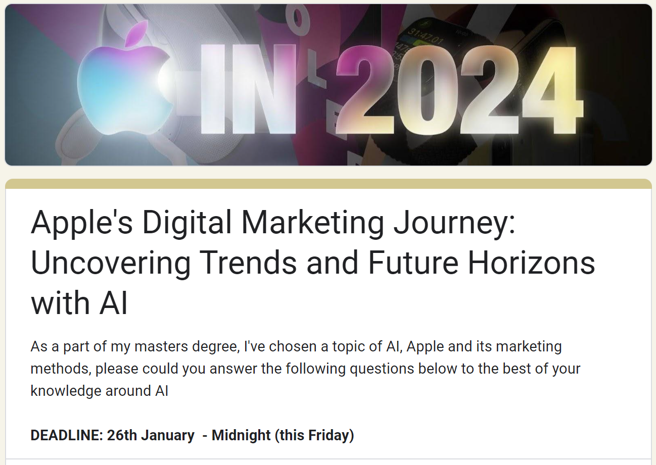
Appendix 1: Question 1 of 10
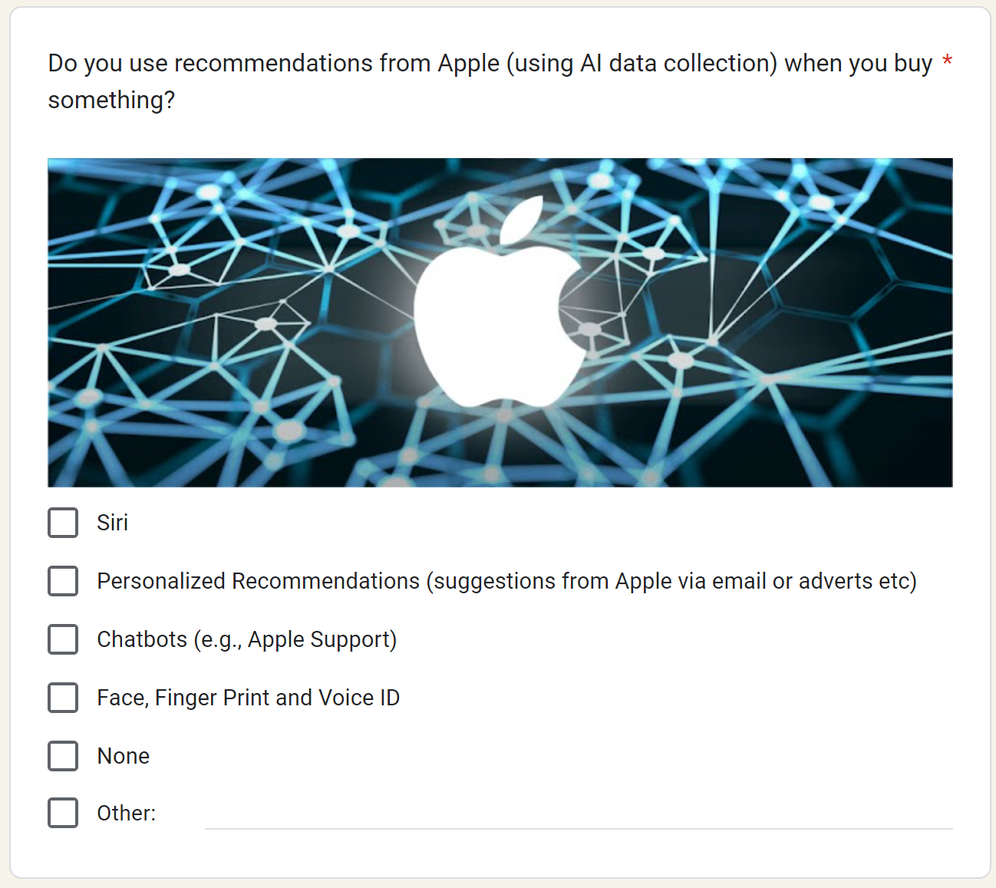
Appendix 2: Question 2 of 10
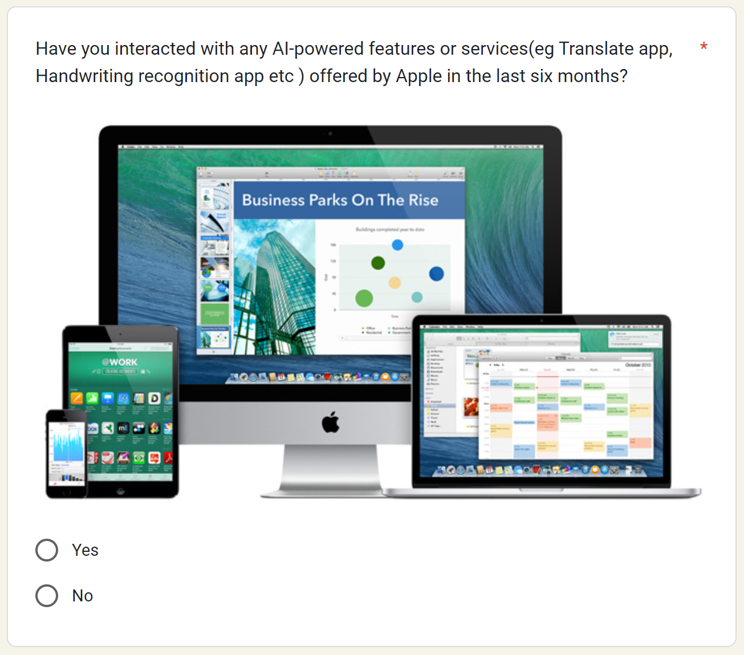
Appendix 3: Question 3 of 10
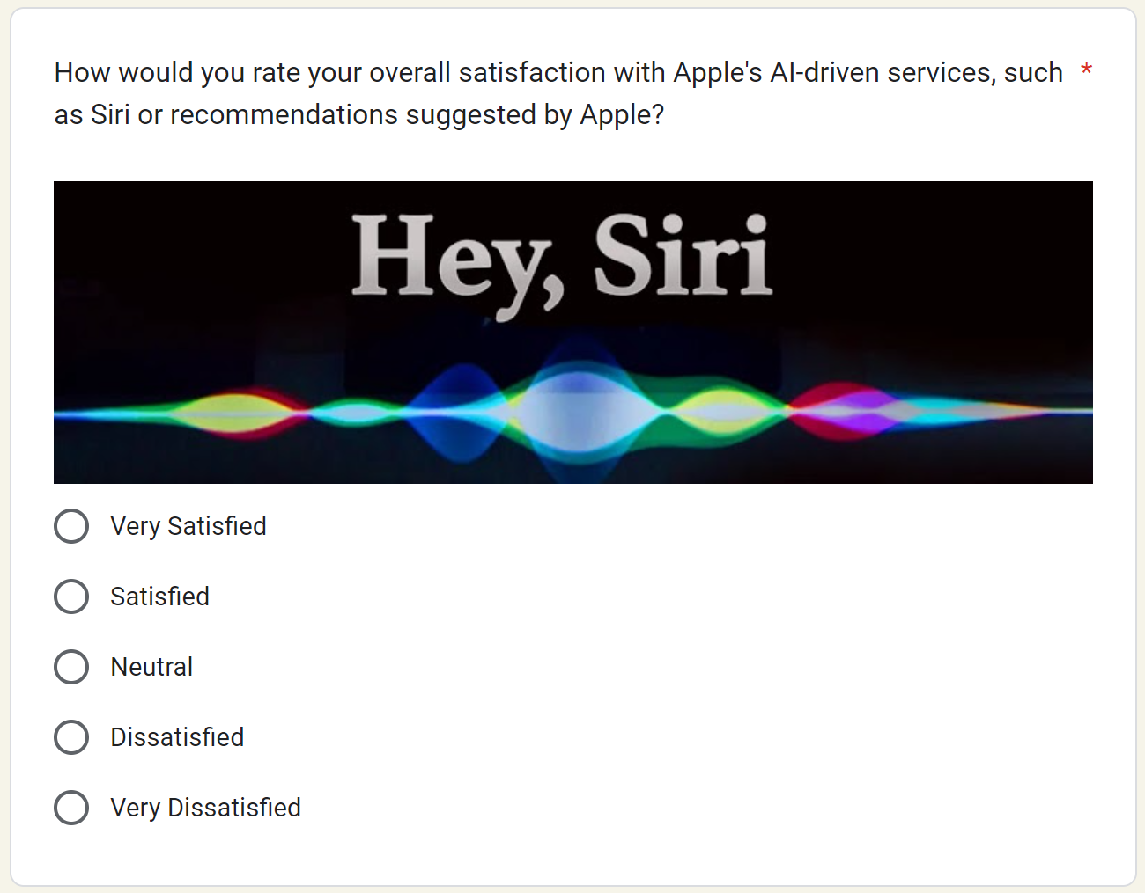
Appendix 4: Question 4 of 10
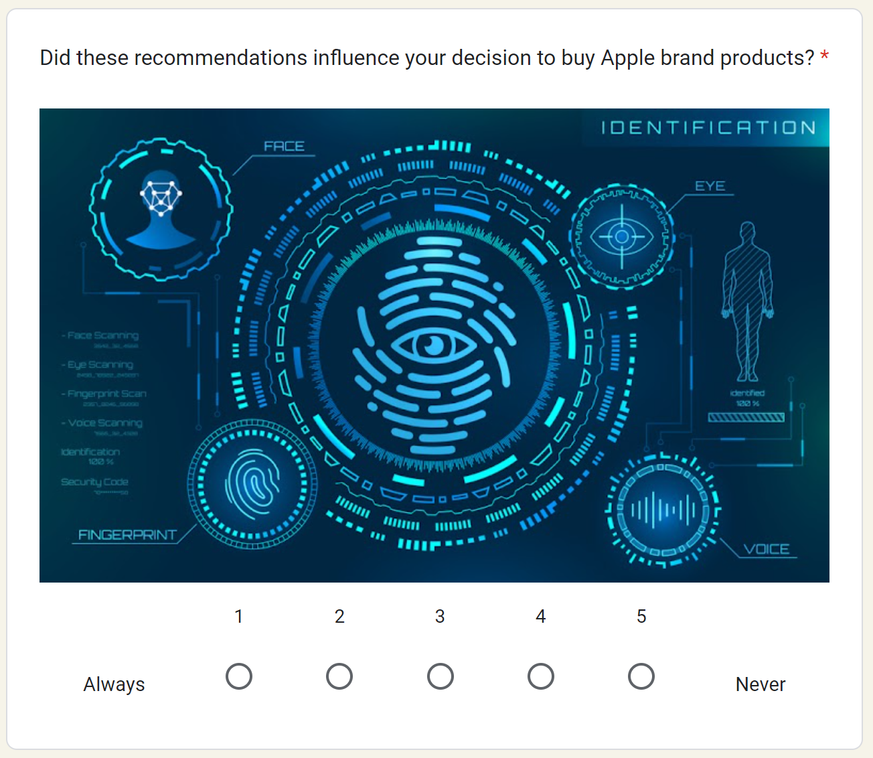
Appendix 5: Question 5 of 10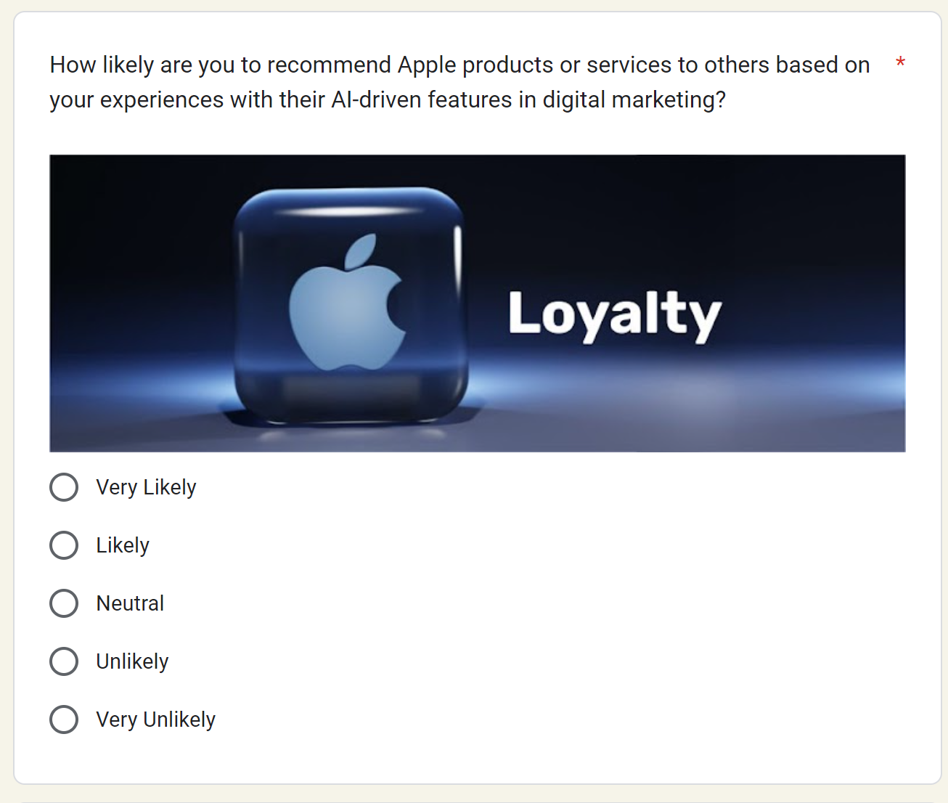
Appendix 6: Question 6 of 10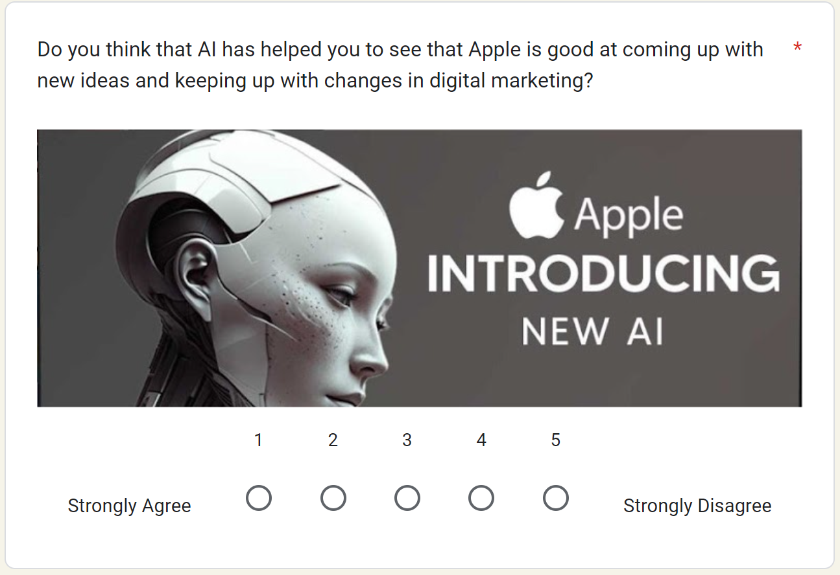
Appendix 7: Question 7 of 10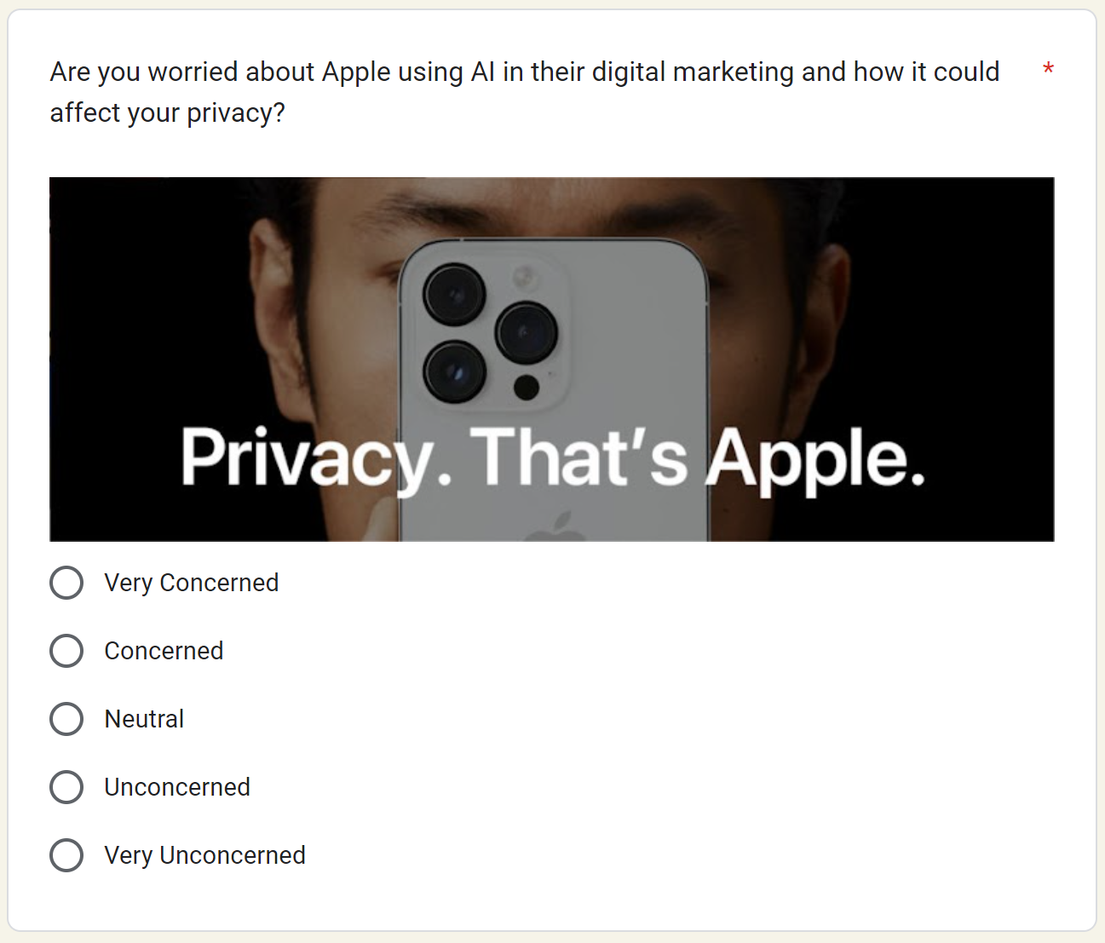
Appendix 8: Question 8 of 10
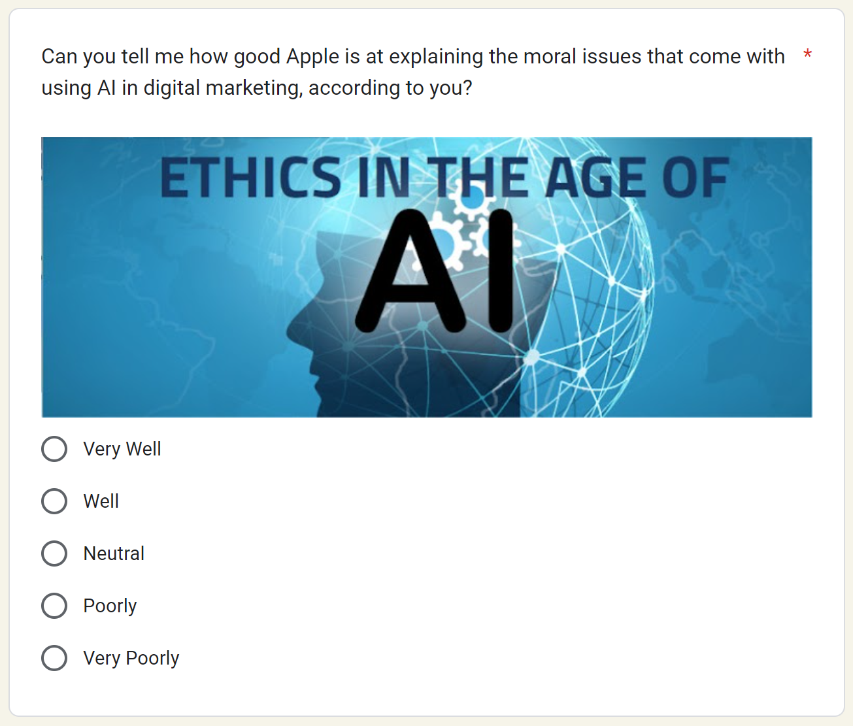
Appendix 9: Question 9 of 10
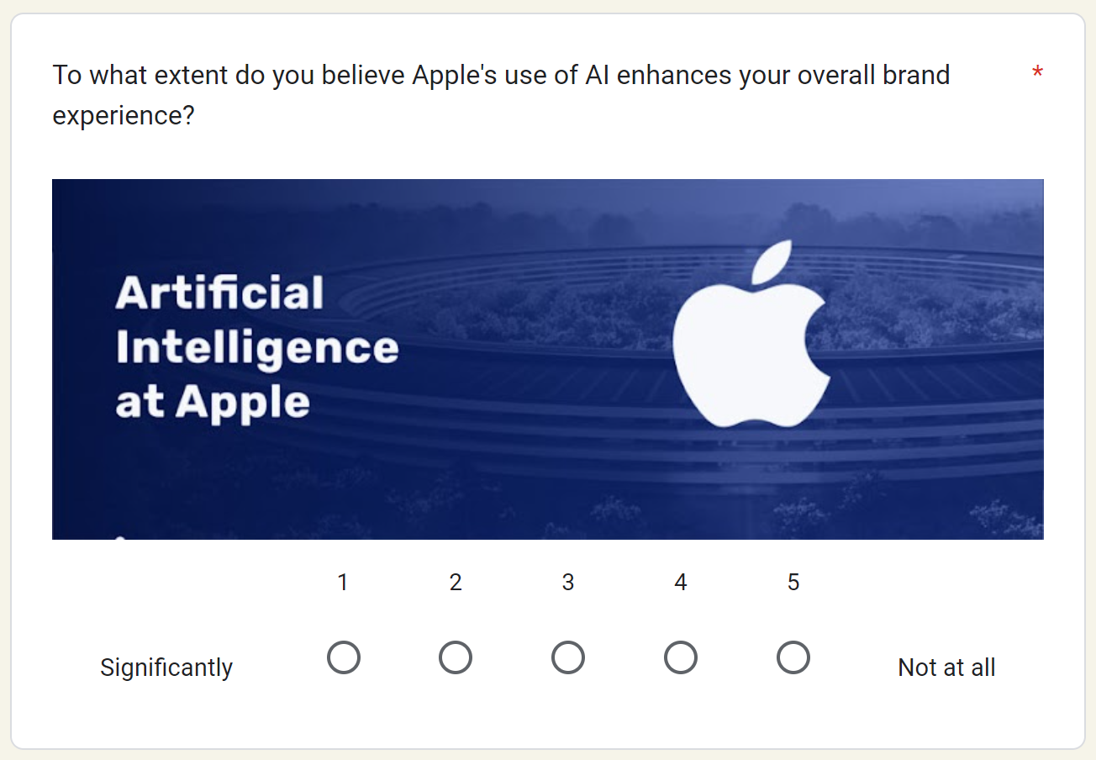
Appendix 10: Question 10 of 10

Appendix 11: End survey

Chapter 8: References
Abrash, M. (2021). Creating the Future: Augmented Reality, the next Human-Machine Interface. [online] IEEE Xplore. doi:https://doi.org/10.1109/IEDM19574.2021.9720526.
Achrol, R.S. and Kotler, P. (2022). Distributed marketing networks: The fourth industrial revolution. Journal of Business Research, 150, pp.515–527. doi:https://doi.org/10.1016/j.jbusres.2022.06.029.
Ahmed, A.A.A., Agarwal, S., Kurniawan, Im.G.A., Anantadjaya, S.P.D. and Krishnan, C. (2022). Business boosting through sentiment analysis using Artificial Intelligence approach. International Journal of System Assurance Engineering and Management, 13(S1), pp.699–709. doi:https://doi.org/10.1007/s13198-021-01594-x.
Akbari, M., Mehrali, M., SeyyedAmiri, N., Rezaei, N. and Pourjam, A. (2019). Corporate social responsibility, customer loyalty and brand positioning. Social Responsibility Journal, 16(5), pp.671–689. doi:https://doi.org/10.1108/srj-01-2019-0008.
Akilkhanov, A. (2024). Council Post: AI And Personalization In Marketing. [online] Forbes. Available at: https://www.forbes.com/sites/forbescommunicationscouncil/2024/01/05/ai-and-personalization-in-marketing/?sh=319322806856 [Accessed 5 Feb. 2024].
Akter, S. and Wamba, S.F. (2023). Handbook of Big Data Research Methods. [online] Google Books. Edward Elgar Publishing. Available at: https://books.google.co.uk/books?hl=en&lr=&id=9gPEEAAAQBAJ&oi=fnd&pg=PA279&dq=AI-driven+CRM+systems+facilitate+personalised+interactions+in+Apple%27s+marketing+strategies.&ots=il8D7158rP&sig=96nf_xncGffe2uCoOrfPxaXbAjI&redir_esc=y#v=onepage&q&f=false [Accessed 26 Jan. 2024].
Aldoseri, A., Al-Khalifa, K. and Hamouda, A. (2023). A Roadmap for Integrating Automation with Process Optimization for AI-powered Digital Transformation. preprints. [online] doi:https://doi.org/10.20944/preprints202310.1055.v1.
Alghamdi, A.M., Riasat, H., Iqbal, M.W., Ashraf, M.U., Alshahrani , A. and Alshamran, A. (2022). Intelligence and Usability Empowerment of Smartphone Adaptive Features. ProQuest, [online] 12(23), p.12245. doi:https://doi.org/10.3390/app122312245.
Almeida Costa, L. (2021). Analyzing the Sustainability of Apple’s Competitive Advantage Chiara Primavesi. [online] Available at: https://run.unl.pt/bitstream/10362/144880/1/2021-22_fall_44388_chiara-primavesi.pdf [Accessed 9 Jan. 2024].
Alrashdan, M. (2022). An enhanced user’s speech recognition data analysis and expectation in intelligent personal assistant. International Journal of Data and Network Science, 6(4), pp.1169–1174. doi:https://doi.org/10.5267/j.ijdns.2022.7.003.
Ameen, N., Tarhini, A., Reppel, A. and Anand, A. (2021). Customer Experiences in the Age of Artificial Intelligence. Computers in Human Behavior, [online] 114(106548), p.106548. Available at: https://www.sciencedirect.com/science/article/pii/S0747563220302983 [Accessed 18 Jan. 2024].
Andrivet, M. (2023). What Is Brand Identity? [online] The Branding Journal. Available at: https://www.thebrandingjournal.com/2023/03/brand-identity/ [Accessed 12 Jan. 2024].
Bachmann, P. (2023). Council Post: the Power of Personal Branding for Credibility and Trust. [online] Forbes. Available at: https://www.forbes.com/sites/forbescoachescouncil/2023/07/24/the-power-of-personal-branding-for-credibility-and-trust/?sh=41bd765b5645 [Accessed 12 Jan. 2024].
Baisakhi Mitra Mustaphi (2020). Digital Marketing Strategies for Effective Customer Relationship Management. Journal of Modern Accounting and Auditing, 16(8). doi:https://doi.org/10.17265/1548-6583/2020.08.004.
Berman, R. and Katona, Z. (2020). Curation Algorithms and Filter Bubbles in Social Networks. Marketing Science, 39(2), pp.296–316. doi:https://doi.org/10.1287/mksc.2019.1208.
Birjali, M., Kasri, M. and Beni-Hssane, A. (2021). A Comprehensive Survey on Sentiment analysis: Approaches, Challenges and Trends. Knowledge-Based Systems, 226(1), p.107134. doi:https://doi.org/10.1016/j.knosys.2021.107134.
Cachero-Martínez, S. and Vázquez-Casielles, R. (2021). Building consumer loyalty through e-shopping experiences: The mediating role of emotions. Journal of Retailing and Consumer Services, 60, p.102481. doi:https://doi.org/10.1016/j.jretconser.2021.102481.
Camilleri, M.A. (2020). The use of data-driven technologies for customer-centric marketing. International Journal of Big Data Management, [online] 1(1), p.50. doi:https://doi.org/10.1504/ijbdm.2020.106876.
Campbell, C., Sands, S., Ferraro, C., Tsao, H.-Y. (Jody) and Mavrommatis, A. (2020). From data to action: How marketers can leverage AI. Business Horizons, 63(2), pp.227–243. doi:https://doi.org/10.1016/j.bushor.2019.12.002.
Cao, N., Isa, N.M. and Perumal, S. (2023). Effects of Risk Attitude and Time Pressure on the Perceived Risk and Avoidance of Mobile App Advertising among Chinese Generation Z Consumers. Sustainability, 15(15), p.11547. doi:https://doi.org/10.3390/su151511547.
Castleberry, S.B. (2001). Using Secondary Data in Marketing Research: A Project That Melds Web and Off-Web Sources. Journal of Marketing Education, 23(3), pp.195–203. doi:https://doi.org/10.1177/0273475301233005.
Chaffey, D. and Ellis-Chadwick, F. (2019). Digital Marketing. 7th ed. Pearson UK.
Chaffey, D. and Smith, P.R. (2013). Emarketing excellence : Planning and Optimizing Your Digital Marketing . Routledge, 4th Edition.
Cheong, H., Lyons, A., Houghton, R. and Majumdar, A. (2023). Secondary Qualitative Research Methodology Using Online Data within the Context of Social Sciences. International Journal of Qualitative Methods, [online] 22(1). doi:https://doi.org/10.1177/16094069231180160.
Chintalapati, S. and Pandey, S.K. (2021). Artificial intelligence in marketing: A systematic literature review. International Journal of Market Research, 64(1), pp.38–68. doi:https://doi.org/10.1177/14707853211018428.
Chivaka, R. (2018). Secondary Data Analysis. [online] ResearchGate. Available at: https://www.researchgate.net/publication/327060808_secondary_data_analysis [Accessed 14 Feb. 2024].
Couper, M.P. (2008). Designing Effective Web Surveys. [online] Cambridge University Press. Cambridge: Cambridge University Press. Available at: https://www.cambridge.org/core/books/designing-effective-web-surveys/C709B3E307CF5F462F8267078C3A0E02 [Accessed 29 Jan. 2024].
Crick, J.M. (2020). Qualitative research in marketing: what can academics do better? Journal of Strategic Marketing, 29(5), pp.390–429. doi:https://doi.org/10.1080/0965254x.2020.1743738.
Das, S. (2020). Innovations in Digital Banking Service Brand Equity and Millennial Consumerism. Digital Transformation and Innovative Services for Business and Learning, pp.62–79. doi:https://doi.org/10.4018/978-1-7998-5175-2.ch004.
Das, S. (2021). A Systematic Study of Integrated Marketing Communication and Content Management System for Millennial Consumers. Innovations in Digital Branding and Content Marketing, pp.91–112. doi:https://doi.org/10.4018/978-1-7998-4420-4.ch005.
Deepa, E. and Geeta, M. (2021). DIGITAL MARKETING A CATALYST IN CREATING BRAND IMAGE THROUGH CUSTOMER. Turkish Journal of Computer and Mathematics Education, 12(4), pp.1308–1315.
Deloitte (2022). Connecting Meaningfully in the New Reality. [online] Available at: https://www2.deloitte.com/content/dam/Deloitte/ca/Documents/deloitte-analytics/ca-en-omnia-ai-marketing-pov-fin-jun24-aoda.pdf [Accessed 8 Feb. 2024].
Dieck, M.C.T. and Han, D.D. (2021). The Role of Immersive Technology in Customer Experience Management. Journal of Marketing Theory and Practice, [online] 30(1), pp.1–12. doi:https://doi.org/10.1080/10696679.2021.1891939.
Ding, Y., DeSarbo, W.S., Hanssens, D.M., Jedidi, K., Lynch, J.G. and Lehmann, D.R. (2020). The past, present, and future of measurement and methods in marketing analysis. Marketing Letters, 31(2-3), pp.175–186. doi:https://doi.org/10.1007/s11002-020-09527-7.
Dissanayake, E. (2023). Research Onion: A Systematic Approach for Designing Research Methodology. Part One Research Onion: A Systematic Approach for Designing Research Methodology. doi:https://doi.org/10.13140/RG.2.2.24466.12489.
Dollwet, S. (2020). Social Media Marketing 2019: How to Reach Millions of Customers Without Wasting Your Time and Money - Proven Ways to Grow Your Business on Instagram, YouTube, Twitter, and Facebook. [online] Google Books. Alakai Publishing LLC. Available at: https://books.google.co.uk/books?hl=en&lr=&id=cTXsDwAAQBAJ&oi=fnd&pg=PA4&dq=Effective+social+media+campaigns+in+the+era+of+digital+saturation+engage+target+audiences.&ots=uYBafZdWvT&sig=LYR0GEupPTTTzSanWlqpwh-Zsmk&redir_esc=y#v=onepage&q&f=false [Accessed 20 Jan. 2024].
Drummond, C., O’Toole, T. and McGrath, H. (2020). Digital Engagement Strategies and Tactics in Social Media Marketing. European Journal of Marketing, [online] 54(6), pp.1247–1280. doi:https://doi.org/10.1108/ejm-02-2019-0183.
Dudovskiy, J. (2023). Apple Segmentation, Targeting and Positioning . [online] Business Research Methodology. Available at: https://research-methodology.net/apple-segmentation-targeting-and-positioning/ [Accessed 6 Oct. 2024].
Dwivedi, Y.K., Ismagilova, E., Hughes, D.L. and Carlson, J. (2021). Setting the Future of Digital and Social Media Marketing research: Perspectives and Research Propositions. International Journal of Information Management, [online] 59(1), pp.1–37. doi:https://doi.org/10.1016/j.ijinfomgt.2020.102168.
Editorial (2023). The Rise of Artificial Intelligence in Consumer Electronics: What it Means for You. [online] Electronics Era. Available at: https://electronicsera.in/the-rise-of-artificial-intelligence-in-consumer-electronics-what-it-means-for-you/ [Accessed 6 Feb. 2024].
Engward, H. (2012). Research methodology: a step by step guide for beginners Ranjit Kumar Research methodology: a step by step guide for beginners Sage £26.99 440pp 9781849203012 1849203016. Nurse Researcher, 19(3), pp.45–45. doi:https://doi.org/10.7748/nr.19.3.45.s5.
Eslami, S.P., Ghasemaghaei, M. and Hassanein, K. (2021). Understanding consumer engagement in social media: The role of product lifecycle. Decision Support Systems, [online] 162(0167-9236), p.113707. doi:https://doi.org/10.1016/j.dss.2021.113707.
Farris, P.W. (2010). Marketing Metrics: The Definitive Guide to Measuring Marketing Performance. [online] Google Books. Pearson Education. Available at: https://books.google.co.uk/books?id=jpphBAAAQBAJ&printsec=frontcover&source=gbs_ge_summary_r&cad=0#v=onepage&q&f=false [Accessed 29 Jan. 2024].
Fernandez, L.J. (2023). The Art of Business Origami: Folding Your Way to Success. [online] Google Books. Lloyd Jose Fernandez. Available at: https://books.google.co.uk/books?hl=en&lr=&id=nC3oEAAAQBAJ&oi=fnd&pg=PA93&dq=Apple+has+meticulously+crafted+its+digital+identity [Accessed 25 Jan. 2024].
Figueiredo, J., Oliveira, I., Silva, S., Pocinho, M., Cardoso, A. and Pereira, M. (2023). Artificial Intelligence in Relational Marketing Practice. Advances in Marketing, Customer Relationship Management, and E-Services, pp.73–96. doi:https://doi.org/10.4018/978-1-6684-9324-3.ch003.
Gawer, A. (2021). Digital Platforms and ecosystems: Remarks on the Dominant Organizational Forms of the Digital Age. Innovation, [online] 24(1), pp.1–15. doi:https://doi.org/10.1080/14479338.2021.1965888.
George, A.S., George, H. and Martin, A.S.Gabrio. (2023). Partners Universal International Innovation Journal (PUIIJ) A Review of ChatGPT AI’s Impact on Several Business Sectors. A Review of ChatGPT AI’s Impact on Several Business Sectors. doi:https://doi.org/10.5281/zenodo.7644359.
Ghorbani, M. (2024). Thesis AI tools to support Design activities and Innovation processes Students Name Institution Politecnico di Torino Course Engineering and Management Date.
Gil, C. (2021). The End of Marketing: Humanizing Your Brand in the Age of Social Media. [online] Google Books. Kogan Page Publishers. Available at: https://books.google.co.uk/books?hl=en&lr=&id=wEJFEAAAQBAJ&oi=fnd&pg=PP1&dq=Apple+leverages+innovative+products+for+organic+reach+through+social+media.&ots=tQ2i8yQMdX&sig=Yd6D0s83kgIwrz39ni2J4R7cxvs&redir_esc=y#v=onepage&q&f=false [Accessed 22 Jan. 2024].
Gleiss, A., Kohlhagen, M. and Pousttchi, K. (2021). An Apple a Day – How the Platform Economy Impacts Value Creation in the Healthcare Market. Electronic Markets. doi:https://doi.org/10.1007/s12525-021-00467-2.
Grewal, D., Hulland, J., Kopalle, P.K. and Karahanna, E. (2020). The future of technology and marketing: A multidisciplinary perspective. Journal of the Academy of Marketing Science, [online] 48(1), pp.1–8. doi:https://doi.org/10.1007/s11747-019-00711-4.
Guha, A., Grewal, D., Kopalle, P.K., Haenlein, M., Schneider, M.J., Jung, H., Moustafa, R., Hegde, D.R. and Hawkins, G. (2021). How Artificial Intelligence Will Affect the Future of Retailing. Journal of Retailing, 97(1).
Gupta, R. and Madan, S. (2022). Digital Marketing: The Science and Magic of Digital Marketing Can Help You Become a Successful Marketing Professional (English Edition). [online] Google Books. BPB Publications. Available at: https://books.google.co.uk/books?hl=en&lr=&id=e5KGEAAAQBAJ&oi=fnd&pg=PP24&dq=+the+realm+of+digital+marketing [Accessed 25 Jan. 2024].
Gupta, S., Gallear, D., Rudd, J.M. and Foroudi, P. (2020). (PDF) the Impact of Brand Value on Brand Competitiveness. [online] ResearchGate. Available at: https://www.researchgate.net/publication/340206406_The_impact_of_brand_value_on_brand_competitiveness [Accessed 13 Jan. 2024].
Hadlington, L., Harkin, L.J., Kuss, D., Newman, K. and Ryding, F.C. (2022). Perceptions of fake news, misinformation, and disinformation amid the COVID-19 pandemic: A qualitative exploration. Psychology of Popular Media, 12(1). doi:https://doi.org/10.1037/ppm0000387.
Haig, B.D. (2018). https://librarysearch.uwtsd.ac.uk/discovery/fulldisplay?&context=L&vid=44WHELF_UWTSD:44WHELF_UWTSD_VU1&search_scope=Search_ELEC&tab=Everything&docid=alma99100178950802421. [online] librarysearch.uwtsd.ac.uk. Available at: https://librarysearch.uwtsd.ac.uk/permalink/44WHELF_UWTSD/upgrip/alma99100178950802421 [Accessed 14 Feb. 2024].
Hajarian, M., Camilleri, M., Díaz, P. and Aedo, I. (2021). A Taxonomy of Online Marketing Methods. [online] Available at: https://www.um.edu.mt/library/oar/bitstream/123456789/60424/1/online%20marketing%20methods.pdf [Accessed 25 Jan. 2024].
Haleem, A., Javaid, M., Qadri, M.A., Singh, R.P. and Suman, R. (2022). Artificial Intelligence (AI) Applications for marketing: a literature-based Study. International Journal of Intelligent Networks, [online] 3(3), pp.119–132. doi:https://doi.org/10.1016/j.ijin.2022.08.005.
Hall, J. (2019). Council Post: How Artificial Intelligence Is Transforming Digital Marketing. [online] Forbes. Available at: https://www.forbes.com/sites/forbesagencycouncil/2019/08/21/how-artificial-intelligence-is-transforming-digital-marketing/ [Accessed 15 Feb. 2024].
Hawker, K. (2019). Keller’s Brand Equity Model — What It Is & How to Use It. [online] Medium. Available at: https://medium.com/@keatonhawker/kellers-brand-equity-model-what-it-is-how-to-use-it-84e42d562299 [Accessed 25 Jan. 2024].
Hayes, A. (2023). Brand Equity: Definition, Meaning, Effect on Profit Margin, and Examples. [online] Investopedia. Available at: https://www.investopedia.com/terms/b/brandequity.asp [Accessed 14 Jan. 2024].
Helberger, N., Sax, M., Strycharz, J. and Micklitz, H.-W. . (2021). Choice Architectures in the Digital Economy: Towards a New Understanding of Digital Vulnerability. Journal of Consumer Policy. doi:https://doi.org/10.1007/s10603-021-09500-5.
Hiremath, N. and Gupta, N. (2022). Marketing Strategies used by Apple to Increase Customer Base. International Journal of Innovative Science and Research Technology, [online] 7(7). Available at: https://ijisrt.com/assets/upload/files/IJISRT22JUL940.pdf [Accessed 22 Dec. 2024].
Ho, J., Pang, C. and Choy, C. (2020). Content marketing capability building: a conceptual framework. Journal of Research in Interactive Marketing, 14(1), pp.133–151. doi:https://doi.org/10.1108/jrim-06-2018-0082.
Hossain, M.A., Akter, S., Yanamandram, V. and Strong, C. (2024). Navigating the platform economy: Crafting a customer analytics capability instrument. Journal of Business Research, [online] 170, p.114260. doi:https://doi.org/10.1016/j.jbusres.2023.114260.
Hristova, D. and Lieberoth, A. (2021). How Socially Sustainable Is Social Media Gamification? A Look into Snapchat, Facebook, Twitter and Instagram. Transforming Society and Organizations through Gamification, pp.225–245. doi:https://doi.org/10.1007/978-3-030-68207-1_12.
Huang, M.-H. and Rust, R.T. (2020). A Strategic Framework for Artificial Intelligence in Marketing. Journal of the Academy of Marketing Science, [online] 49(1), pp.30–50. doi:https://doi.org/10.1007/s11747-020-00749-9.
Ibrahim, B. (2021). Social Media Marketing Activities and Brand Loyalty: A Meta-Analysis Examination. Journal of Promotion Management, [online] 28(1), pp.1–31. doi:https://doi.org/10.1080/10496491.2021.1955080.
Ilieva, J., Healey , N.M. and Baron, S. (2002). (PDF) Online Surveys in Marketing research: Pros and Cons. [online] ResearchGate. Available at: https://www.researchgate.net/publication/292105149_Online_surveys_in_marketing_research_Pros_and_cons [Accessed 8 Feb. 2024].
Jebarajakirthy, C., Maseeh, H.I., Morshed, Z., Shankar, A., Arli, D. and Pentecost, R. (2021). Mobile advertising: A systematic literature review and future research agenda. International Journal of Consumer Studies, 45(6), pp.1258–1291. doi:https://doi.org/10.1111/ijcs.12728.
Jobin, A., Ienca, M. and Vayena, E. (2019). The Global Landscape of AI Ethics Guidelines. Nature Machine Intelligence, [online] 1(9), pp.389–399. Available at: https://www.nature.com/articles/s42256-019-0088-2 [Accessed 15 Feb. 2024].
Jones, K. (2021). Council Post: the Importance of Branding in Business. [online] Forbes. Available at: https://www.forbes.com/sites/forbesagencycouncil/2021/03/24/the-importance-of-branding-in-business/?sh=4dd598b267f7 [Accessed 12 Jan. 2024].
Kalichman, M. (2020). Introduction: What is Research Ethics? | Online Ethics. [online] onlineethics.org. Available at: https://onlineethics.org/cases/resources-research-ethics-education/introduction-what-research-ethics [Accessed 5 Feb. 2024].
Kataria, S. and Saini, V. (2019). The mediating impact of customer satisfaction in relation of brand equity and brand loyalty. South Asian Journal of Business Studies, 9(1), pp.62–87. doi:https://doi.org/10.1108/sajbs-03-2019-0046.
Keller, K.L. (1993). Conceptualizing, Measuring, and Managing Customer-Based Brand Equity. Journal of Marketing, [online] 57(1), pp.1–22. doi:https://doi.org/10.1177/002224299305700101.
Keller, K.L. (2016). Reflections on customer-based brand equity: perspectives, progress, and priorities. AMS Review, [online] 6(1-2), pp.1–16. doi:https://doi.org/10.1007/s13162-016-0078-z.
Kietzmann, J., Paschen, J. and Treen, E. (2018). Artificial Intelligence in Advertising. Journal of Advertising Research, 58(3), pp.263–267. doi:https://doi.org/10.2501/jar-2018-035.
Kopalle, P.K., Gangwar, M., Kaplan, A., Ramachandran, D., Reinartz, W. and Rindfleisch, A. (2021). Examining artificial intelligence (AI) technologies in marketing via a global lens: Current trends and future research opportunities. International Journal of Research in Marketing, [online] 39(2). doi:https://doi.org/10.1016/j.ijresmar.2021.11.002.
Kopalle, P.K., Kumar, V. and Subramaniam, M. (2019). How legacy firms can embrace the digital ecosystem via digital customer orientation. Journal of the Academy of Marketing Science, [online] 48(1), pp.114–131. doi:https://doi.org/10.1007/s11747-019-00694-2.
Kozinets, R.V. (2021). Algorithmic branding through platform assemblages: core conceptions and research directions for a new era of marketing and service management. Journal of Service Management, 33(3), pp.437–452. doi:https://doi.org/10.1108/josm-07-2021-0263.
Krafft, M., Sajtos, L. and Haenlein, M. (2020). Challenges and Opportunities for Marketing Scholars in Times of the Fourth Industrial Revolution. Journal of Interactive Marketing, 51(1), pp.1–8. doi:https://doi.org/10.1016/j.intmar.2020.06.001.
Kumar, P. and Singh, G. (2020). Using Social Media and Digital Marketing Tools and Techniques for Developing Brand Equity With Connected Consumers. [online] Handbook of Research on Innovations in Technology and Marketing for the Connected Consumer. Available at: https://www.igi-global.com/chapter/using-social-media-and-digital-marketing-tools-and-techniques-for-developing-brand-equity-with-connected-consumers/239509 [Accessed 22 Jan. 2024].
Kyamko, M. (2022). 7 Strategies to Help You Build a Strong Retail Brand. [online] crowdspring Blog. Available at: https://www.crowdspring.com/blog/retail-branding-strategies/ [Accessed 12 Jan. 2024].
Lane Keller, K. (2019). Consumer Research Insights on Brands and Branding: A JCR Curation. Journal of Consumer Research, [online] 46(5), pp.995–1001. doi:https://doi.org/10.1093/jcr/ucz058.
Larry Catá Backer (2023). The Soulful Machine, the Virtual Person, the ‘Human’ Condition, and its Social Constitution --An Encounter with Jan M. Broekman, Knowledge in Change: The Semiotics of Cognition and Conversation (Cham, Switzerland: Springer Nature, 2023). Social Science Research Network. [online] doi:https://doi.org/10.2139/ssrn.4605405.
Legun, K. and Burch, K. (2021). Robot-ready: How apple producers are assembling in anticipation of new AI robotics. Journal of Rural Studies, 82, pp.380–390. doi:https://doi.org/10.1016/j.jrurstud.2021.01.032.
Levy, S. (2023). Apple Inc. In: Encyclopedia Britannica. [online] Available at: https://www.britannica.com/topic/Apple-Inc [Accessed 11 Feb. 2024].
Lewandowski, D. and Schultheiß, S. (2022). Public awareness and attitudes towards search engine optimization. Behaviour & Information Technology, pp.1–20. doi:https://doi.org/10.1080/0144929x.2022.2056507.
Makrides, A., Vrontis, D. and Christofi, M. (2020). The Gold Rush of Digital Marketing: Assessing Prospects of Building Brand Awareness Overseas. Business Perspectives and Research, [online] 8(1), p.227853371986001. doi:https://doi.org/10.1177/2278533719860016.
Mandapuram, M., Gutlapalli, S.S., Reddy, M. and Bodepudi, A. (2020). Application of Artificial Intelligence (AI) Technologies to Accelerate Market Segmentation. Global Disclosure of Economics and Business, 9(2), pp.141–150. doi:https://doi.org/10.18034/gdeb.v9i2.662.
Mani, Z. and Chouk, I. (2019). Impact of Privacy Concerns on Resistance to Smart services: Does the ‘Big Brother Effect’ matter?. Journal of Marketing Management, 35(15-16), pp.1–20. doi:https://doi.org/10.1080/0267257x.2019.1667856.
Mao, Y., Lai, Y., Luo, Y., Liu, S., Du, Y., Zhou, J., Ma, J., Bonaiuto, F. and Bonaiuto, M. (2020a). Apple or Huawei: Understanding Flow, Brand Image, Brand Identity, Brand Personality and Purchase Intention of Smartphone. Sustainability, 12(8), p.3391. doi:https://doi.org/10.3390/su12083391.
Mao, Y., Lai, Y., Luo, Y., Liu, S., Du, Y., Zhou, J., Ma, J., Bonaiuto, F. and Bonaiuto, M. (2020b). Apple or huawei: Understanding flow, brand image, brand identity, brand personality and purchase intention of smartphone. Sustainability, 12, p.3391. doi:https://doi.org/10.3390/su12083391.
Marcus, J. (2021). Digital Strategy for Consumer Products. [online] Available at: https://dspace.mit.edu/bitstream/handle/1721.1/139478/marcus-jbmarcus-sm-idm-2021-thesis.pdf?sequence=1&isAllowed=y [Accessed 14 Jan. 2024].
Mariani, M.M., Perez‐Vega, R. and Wirtz, J. (2021). AI in marketing, Consumer Research and psychology: a Systematic Literature Review and Research Agenda. Psychology & Marketing, 39(4). doi:https://doi.org/10.1002/mar.21619.
Marr, B. (2020). The Intelligence Revolution: Transforming Your Business with AI. [online] Google Books. Kogan Page Publishers. Available at: https://books.google.co.uk/books?hl=en&lr=&id=fhn0DwAAQBAJ&oi=fnd&pg=PR1&dq=Siri+transformed+Apple%27s+AI+journey [Accessed 18 Jan. 2024].
Mashiah, I. (2021). ‘Come and join us’: How tech brands use source, message, and target audience strategies to attract employees. The Journal of High Technology Management Research, 32(2), p.100418.
McGruer, D. (2020). Dynamic Digital Marketing: Master the World of Online and Social Media Marketing to Grow Your Business. [online] Google Books. John Wiley & Sons. Available at: https://books.google.co.uk/books?hl=en&lr=&id=sPm4DwAAQBAJ&oi=fnd&pg=PR9&dq=Apple+encourages+industry+leaders+and+external+experts+to+collaborate+with+them+in+order+to+improve+their+search+rankings.&ots=f-AyXmmgfj&sig=18PV93feUjrnM05dQCsnkIL4Sc8&redir_esc=y#v=onepage&q&f=false [Accessed 18 Jan. 2024].
Mckinsey (2023). AI customer service for higher customer engagement | McKinsey. [online] www.mckinsey.com. Available at: https://www.mckinsey.com/capabilities/operations/our-insights/the-next-frontier-of-customer-engagement-ai-enabled-customer-service [Accessed 25 Jan. 2024].
McLean, G., Osei-Frimpong, K. and Barhorst, J. (2021a). Alexa, Do Voice Assistants Influence Consumer Brand engagement? – Examining the Role of AI Powered Voice Assistants in Influencing Consumer Brand Engagement. Journal of Business Research, 124, pp.312–328. doi:https://doi.org/10.1016/j.jbusres.2020.11.045.
McLean, G., Osei-Frimpong, K. and Barhorst, J. (2021b). Alexa, do voice assistants influence consumer brand engagement? – examining the role of AI powered voice assistants in influencing consumer brand engagement. Journal of Business Research, 124, pp.312–328. doi:https://doi.org/10.1016/j.jbusres.2020.11.045.
McLeod, S. (2023). Qualitative Vs Quantitative Research Methods & Data Analysis. [online] Simply Psychology. Available at: https://www.simplypsychology.org/qualitative-quantitative.html [Accessed 9 Nov. 2023].
Mcleod, S. (2019). Sampling Methods | Simply Psychology. [online] Simplypsychology.org. Available at: https://www.simplypsychology.org/sampling.html [Accessed 16 Nov. 2023].
Melnikovas, A. (2018). Towards an Explicit Research Methodology: Adapting Research Onion Model for Futures Studies * Journal of Futures Studies. [online] Journal of Futures Studies. Available at: doi:10.6531/JFS.201812_23(2).0003 [Accessed 27 Jan. 2024].
Melović, B., Jocović, M., Dabić, M., Vulić, T.B. and Dudic, B. (2020). The impact of digital transformation and digital marketing on the brand promotion, positioning and electronic business in Montenegro. Technology in Society, 63(1), p.101425. doi:https://doi.org/10.1016/j.techsoc.2020.101425.
Migdadi, M. (2020). Knowledge management, customer relationship management and innovation capabilities. Journal of Business & Industrial Marketing. doi:https://doi.org/10.1108/JBIM-12-2019-0504%5D.
Mogaji, E., Soetan, T.O. and Kieu, T.A. (2020). The Implications of Artificial Intelligence on the Digital Marketing of Financial Services to Vulnerable Customers. Australasian Marketing Journal (AMJ), 29(3).
Morgan, T. and Anokhin, S.A. (2019). The joint impact of entrepreneurial orientation and market orientation in new product development: Studying firm and environmental contingencies. Journal of Business Research, 113. doi:https://doi.org/10.1016/j.jbusres.2019.06.019.
Mukherjee, K. (2019). Social media marketing and customers’ passion for brands. Marketing Intelligence & Planning, 38(4), pp.509–522. doi:https://doi.org/10.1108/mip-10-2018-0440.
Munsch, A. (2021). Millennial and Generation Z Digital Marketing Communication and Advertising effectiveness: a Qualitative Exploration. Journal of Global Scholars of Marketing Science, [online] 31(1), pp.10–29. doi:https://doi.org/10.1080/21639159.2020.1808812.
Nair, K. and Gupta, R. (2021). Application of AI Technology in Modern Digital Marketing Environment. World Journal of Entrepreneurship, Management and Sustainable Development, ahead-of-print(ahead-of-print). doi:https://doi.org/10.1108/wjemsd-08-2020-0099.
Nalluri, P. and Rao, R.S. (2023). Impact of Product Line on Shopping Motivations of Consumers in E-commerce—A Correspondence Analysis. Global Business Review. doi:https://doi.org/10.1177/09721509231170469.
Neslin, S.A. and Shankar, V. (2009). Key Issues in Multichannel Customer Management: Current Knowledge and Future Directions. Journal of Interactive Marketing, 23(1), pp.70–81. doi:https://doi.org/10.1016/j.intmar.2008.10.005.
Panchal, A., Shah, A., Kansara, K., Student, S., Bhagubhai, M., Polytechnic and Ids, E. (2021). Digital marketing-search Engine Optimization (SEO) and Search Engine Marketing (SEM). International Research Journal of Innovations in Engineering and Technology (IRJIET), 5(12), pp.17–21. doi:https://doi.org/10.47001/IRJIET/2021.512004.
Panda, M. and Mishra, A. (2022). DIGITAL MARKETING. ResearchGate. [online] Available at: https://www.researchgate.net/publication/358646409_DIGITAL_MARKETING [Accessed 9 Jan. 2024].
Pandey, N. (2020). Digital Marketing for B2B organizations: Structured Literature Review and Future Research Directions. Journal of Business & Industrial Marketing.
Papagiannis, N. (2020). Effective SEO and Content Marketing: The Ultimate Guide for Maximizing Free Web Traffic. [online] Google Books. John Wiley & Sons. Available at: https://books.google.co.uk/books?hl=en&lr=&id=B4TLDwAAQBAJ&oi=fnd&pg=PR15&dq=Apple+uses+many+SEO+strategies+to+boost+its+digital+presence+and+organic+search+ranks.&ots=Q1VvDy2Ukd&sig=ULk4uInA6DHKjs2fB0Mam83X5zY&redir_esc=y#v=onepage&q&f=false [Accessed 18 Jan. 2024].
Paschen, U., Pitt, C. and Kietzmann, J. (2020). Artificial intelligence: Building blocks and an innovation typology. Business Horizons, 63(2), pp.147–155. doi:https://doi.org/10.1016/j.bushor.2019.10.004.
Paul, J. and Criado, A.R. (2020). The art of writing literature review: What do we know and what do we need to know? International Business Review, 29(4), p.101717. doi:https://doi.org/10.1016/j.ibusrev.2020.101717.
Phair, D. and Warren, K. (2021). Saunders’ Research Onion: Explained Simply. [online] Grad Coach. Available at: https://gradcoach.com/saunders-research-onion/ [Accessed 27 Jan. 2024].
Pina, R. and Dias, Á. (2020). The influence of brand experiences on consumer-based brand equity. Journal of Brand Management, 28, pp.99–115. doi:https://doi.org/10.1057/s41262-020-00215-5.
Plangger, K., Grewal, D., de Ruyter, K. and Tucker, C. (2022). The future of digital technologies in marketing: A conceptual framework and an overview. Journal of the Academy of Marketing Science, 50, pp.1125–1134. doi:https://doi.org/10.1007/s11747-022-00906-2.
Porath, U. (2023). Advancing Managerial Evolution and Resource Management in Contemporary Business Landscapes. Modern Economy, [online] 14(10), pp.1404–1420. doi:https://doi.org/10.4236/me.2023.1410072.
Puntoni, S., Reczek, R.W., Giesler, M. and Botti, S. (2020). Consumers and Artificial Intelligence: an Experiential Perspective. Journal of Marketing, [online] 85(1), p.002224292095384. doi:https://doi.org/10.1177/0022242920953847.
Purnomo, Y.J. (2023). Digital Marketing Strategy to Increase Sales Conversion on E-commerce Platforms. Journal of Contemporary Administration and Management (ADMAN), 1(2), pp.54–62. doi:https://doi.org/10.61100/adman.v1i2.23.
Puthussery, D.A. (2020). Digital Marketing: An Overview. [online] Google Books. Notion Press. Available at: https://books.google.co.uk/books?hl=en&lr=&id=wFjTDwAAQBAJ&oi=fnd&pg=PT3&dq=Apple+employs+digital+marketing+strategies+like+social+media [Accessed 9 Jan. 2024].
Quan, N.H., Chi, N.T.K., Nhung, D.T.H., Ngan, N.T.K. and Phong, L.T. (2020). The influence of website brand equity, e-brand experience on e-loyalty: The mediating role of e-satisfaction. Management Science Letters, [online] pp.63–76. doi:https://doi.org/10.5267/j.msl.2019.8.015.
Rane, N., Choudhary, S. and Rane, J. (2023). Metaverse for enhancing customer loyalty: effective strategies to improve customer relationship, service, engagement, satisfaction, and experience. [online] Social Science Research Network. Available at: https://papers.ssrn.com/sol3/papers.cfm?abstract_id=4624197 [Accessed 22 Jan. 2024].
Rathore, B. (2020). Personalization and Profits: The Impact of AI on Targeted Digital Marketing. International Journal of Transcontinental Discoveries (IJTD), ISSN: XXXX-XXXX, 7(1).
Ray, P.P. (2023). ChatGPT: a Comprehensive Review on background, applications, Key challenges, bias, ethics, Limitations and Future Scope. Internet of Things and Cyber-Physical Systems, [online] 3(1), pp.121–154. doi:https://doi.org/10.1016/j.iotcps.2023.04.003.
Razak, M., Hidayat, M., Launtu, A., Kusuma Putra, A.H.P.A. and Bahasoan, S. (2020). Antecedents and consequence of brand management: empirical study of Apple’s brand product. Journal of Asia Business Studies, [online] 14(3), pp.307–322. doi:https://doi.org/10.1108/jabs-01-2019-0030.
Ricci, L. (2020). Immersive Media and Branding: How Being a Brand Will Change and Expand in the Age of True Immersion. [online] www.igi-global.com. Available at: https://igi-global.com/chapter/immersive-media-and-branding/248230 [Accessed 26 Jan. 2024].
Rivera, R. (2023). Creating a Robust Brand Identity: Key to Retail Marketing Success. [online] Marketing 360® Blog. Available at: https://blog.marketing360.com/design-and-branding/creating-a-brand-identity-the-cornerstone-of-retail-marketing/ [Accessed 12 Jan. 2024].
Roetzer, P. and Kaput, M. (2022). Marketing Artificial Intelligence: AI, Marketing, and the Future of Business. [online] Google Books. BenBella Books. Available at: https://books.google.co.uk/books?hl=en&lr=&id=FVRFEAAAQBAJ&oi=fnd&pg=PT11&dq=Visual+content+marketing+is+a+driving+force+in+platform-wide+engagement.&ots=Y_wkAv_Plm&sig=ptRWeQ62GDp-IpmpkBZMpyVlAKs&redir_esc=y#v=onepage&q&f=false [Accessed 23 Jan. 2024].
Roggeveen, A.L., Grewal, D., Karsberg, J., Noble, S.M., Nordfält, J., Patrick, V.M., Schweiger, E., Soysal, G., Dillard, A., Cooper, N. and Olson, R. (2020a). Forging meaningful consumer-brand relationships through creative merchandise offerings and innovative merchandising strategies. Journal of Retailing, [online] 97(1). doi:https://doi.org/10.1016/j.jretai.2020.11.006.
Roggeveen, A.L., Grewal, D., Karsberg, J., Noble, S.M., Nordfält, J., Patrick, V.M., Schweiger, E., Soysal, G., Dillard, A., Cooper, N. and Olson, R. (2020b). Forging meaningful consumer-brand relationships through creative merchandise offerings and innovative merchandising strategies. Journal of Retailing, [online] 97(1). doi:https://doi.org/10.1016/j.jretai.2020.11.006.
Roggeveen, A.L., Grewal, D., Karsberg, J., Noble, S.M., Nordfält, J., Patrick, V.M., Schweiger, E., Soysal, G., Dillard, A., Cooper, N. and Olson, R. (2020c). Forging meaningful consumer-brand relationships through creative merchandise offerings and innovative merchandising strategies. Journal of Retailing, [online] 97. doi:https://doi.org/10.1016/j.jretai.2020.11.006.
Rosário, A.T. and Dias, J.C. (2023). How Has data-driven Marketing evolved: Challenges and Opportunities with Emerging Technologies. International Journal of Information Management Data Insights, 3(2), p.100203.
Rosie Jahng, M., Lee, H. and Rochadiat, A. (2020). Public relations practitioners’ management of fake news: Exploring key elements and acts of information authentication. Public Relations Review, 46(2), p.101907. doi:https://doi.org/10.1016/j.pubrev.2020.101907.
Roy, S., Sural, S., Chhaya, N., Natarajan, A. and Ganguly, N. (2021). An Integrated Approach for Improving Brand Consistency of Web Content. ACM Transactions on the Web, 15(2), pp.1–25.
Sammut, R., Griscti, O. and Norman, I.J. (2021). Strategies to improve response rates to web surveys: A literature review. International Journal of Nursing Studies, [online] 123, p.104058. doi:https://doi.org/10.1016/j.ijnurstu.2021.104058.
Saunders, M.N.K., Lewis, P. and Thornhill, A. (2019). https://librarysearch.uwtsd.ac.uk/discovery/fulldisplay?&context=L&vid=44WHELF_UWTSD:44WHELF_UWTSD_VU1&search_scope=Search_ELEC&tab=Everything&docid=alma99100313060202421. [online] librarysearch.uwtsd.ac.uk. Available at: https://librarysearch.uwtsd.ac.uk/permalink/44WHELF_UWTSD/upgrip/alma99100313060202421 [Accessed 14 Feb. 2024].
Schultheiß, S. and Lewandowski, D. (2020). ‘Outside the industry, nobody knows what we do’ SEO as seen by search engine optimizers and content providers. Journal of Documentation, 77(2), pp.542–557. doi:https://doi.org/10.1108/jd-07-2020-0127.
Seymen, O.F. ed., (2023). A Customer-centric Analytics Framework and Insights of Digital Transformation. [online] login.microsoftonline.com. Available at: https://www.proquest.com/docview/1763784180?parentSessionId=pVbxgRjlMs%2BLXad3I7ZxURxX05%2BGT1eMfkl%2FbhGPb5w%3D&pq-origsite=primo&accountid=130472&sourcetype=Magazines [Accessed 15 Feb. 2024].
Shah, D. and Murthi, B.P.S. (2020). Marketing in a data-driven Digital world: Implications for the Role and Scope of Marketing. Journal of Business Research, [online] 125, pp.772–779. doi:https://doi.org/10.1016/j.jbusres.2020.06.062.
Shaily, Sharjana Alam and Emma, N.N. (2021). INTEGRATION OF ARTIFICIAL INTELLIGENCE MARKETING TO GET BRAND RECOGNITION FOR SOCIAL BUSINESS. International Review of Management and Marketing, 11, pp.29–37. doi:https://doi.org/10.32479/irmm.11542.
Shen, Z. (2023). Research on the Current Development and Optimization of TikTok’s Digital Marketing Strategies. Business, Economics and Management EDMS, 2023(23), p.142.
Shih, T.-H. and Fan, X. (2009). Comparing response rates in e-mail and paper surveys: A meta-analysis. Educational Research Review, 4(1), pp.26–40. doi:https://doi.org/10.1016/j.edurev.2008.01.003.
Shokouhyar, S., Dehkhodaei, A. and Amiri, B. (2021). Toward customer-centric mobile phone reverse logistics: using the DEMATEL approach and social media data. Kybernetes, 51(11), pp.3236–3279. doi:https://doi.org/10.1108/k-11-2020-0831.
Sinha, T., Clarke, S. and Farquharson, L. (2018). Shrek, Saunders and the Onion Myth: Using Myths, Metaphors and Storytelling. [online] ProQuest. Available at: https://www.proquest.com/docview/2088049934/fulltext/78540F6AC1CB446CPQ/1?accountid=130472&sourcetype=Conference%20Papers%20&%20Proceedings [Accessed 27 Jan. 2024].
Smullen, D. (2023). How To Use ChatGPT For Keyword Research. [online] Search Engine Journal. Available at: https://www.searchenginejournal.com/chatgpt-for-keyword-research/483848/ [Accessed 27 Jan. 2024].
Soetewey, A. (2019). Variable types and examples. [online] Stats and R. Available at: https://statsandr.com/blog/variable-types-and-examples/ [Accessed 5 Feb. 2024].
Soofastaei, A. (2021). Introductory Chapter: Virtual Assistants. [online] www.intechopen.com. IntechOpen. Available at: https://www.intechopen.com/chapters/78670 [Accessed 18 Jan. 2024].
Steenkamp, J.-B.E.M. (2020). Global Brand Building and Management in the Digital Age. Journal of International Marketing, 28(1), pp.13–27. doi:https://doi.org/10.1177/1069031x19894946.
Stolojescu-Crisan, C., Crisan, C. and Butunoi, B.-P. (2021). Access Control and Surveillance in a Smart Home. High-Confidence Computing, p.100036. doi:https://doi.org/10.1016/j.hcc.2021.100036.
Stone, M., Aravopoulou, E., Ekinci, Y., Evans, G., Hobbs, M., Labib, A., Laughlin, P., Machtynger, J. and Machtynger, L. (2020). Artificial intelligence (AI) in strategic marketing decision-making: a research agenda. The Bottom Line, 33(2), pp.183–200. doi:https://doi.org/10.1108/bl-03-2020-0022.
Tahir, I., Md, N. and Khan (2021). FACULTY OF EDUCATION AND BUSINESS STUDIES The Impact of Artificial Intelligence (AI) on CRM and Role of Marketing Managers. [online] Available at: https://www.diva-portal.org/smash/get/diva2:1526230/FULLTEXT01.pdf [Accessed 24 Jan. 2024].
Terho, H., Mero, J., Siutla, L. and Jaakkola, E. (2022). Digital content marketing in business markets: Activities, consequences, and contingencies along the customer journey. Industrial Marketing Management, [online] (105), pp.294–310. doi:https://doi.org/10.1016/j.indmarman.2022.06.006.
Thilagavathy, N. and Praveen Kumar, E. (2021). Artificial Intelligence on digital Marketing-An overview. Volatiles & Essent. Oils, 8(5), pp.9895–9908.
Trattner, C., Jannach, D., Motta, E., Costera Meijer, I., Diakopoulos, N., Elahi, M., Opdahl, A.L., Tessem, B., Borch, N., Fjeld, M., Øvrelid, L., De Smedt, K. and Moe, H. (2021). Responsible media technology and AI: challenges and research directions. AI and Ethics, 2, pp.585–594. doi:https://doi.org/10.1007/s43681-021-00126-4.
Turow, J. (2021). The Voice Catchers: How Marketers Listen in to Exploit Your Feelings, Your Privacy, and Your Wallet. [online] Google Books. Yale University Press. Available at: https://books.google.co.uk/books?hl=en&lr=&id=QPQqEAAAQBAJ&oi=fnd&pg=PP1&dq=AI+can+analyse+user+preferences+and+behaviours+to+tailor+marketing+strategies [Accessed 25 Jan. 2024].
Vakratsas, D. and Ambler, T. (1999). How Advertising Works: What Do We Really Know? Journal of Marketing, 63(1), p.26. doi:https://doi.org/10.2307/1251999.
Venkatesan, R. and Lecinski, J. (2021). The AI Marketing Canvas: A Five-Stage Road Map to Implementing Artificial Intelligence in Marketing. [online] Google Books. Stanford University Press. Available at: https://books.google.co.uk/books?hl=en&lr=&id=clMlEAAAQBAJ&oi=fnd&pg=PT12&dq=Areas+for+innovation+in+integrating+AI+in+Apple%27s+marketing+strategies.&ots=WuICM9cmqn&sig=hUIi_iw8J50-hxjQ4K7KuShwq7s&redir_esc=y#v=onepage&q&f=false [Accessed 24 Jan. 2024].
Venkatraman, S., Overmars, A. and Thong, M. (2021). Smart Home Automation—Use Cases of a Secure and Integrated Voice-Control System. Systems, [online] 9(4), p.77. doi:https://doi.org/10.3390/systems9040077.
Verhoef, P.C., Broekhuizen, T., Bart, Y., Bhattacharya, A., Qi Dong, J., Fabian, N. and Haenlein, M. (2021). Digital transformation: a Multidisciplinary Reflection and Research Agenda. Journal of Business Research, [online] 122(122), pp.889–901. Available at: https://www.sciencedirect.com/science/article/pii/S0148296319305478 [Accessed 22 Dec. 2023].
Vimalkumar, M., Sharma, S.K., Singh, J.B. and Dwivedi, Y.K. (2021). ‘Okay google, what about my privacy?’: User’s privacy perceptions and acceptance of voice based digital assistants. Computers in Human Behavior, 120, p.106763. doi:https://doi.org/10.1016/j.chb.2021.106763.
Visscher, K., Hahn, K. and Konrad, K. (2021). Innovation Ecosystem Strategies of Industrial firms: a Multilayered Approach to Alignment and Strategic Positioning. Creativity and Innovation Management. doi:https://doi.org/10.1111/caim.12429.
Vlačić, B., Corbo, L., Costa e Silva, S. and Dabić, M. (2021). The Evolving Role of Artificial Intelligence in marketing: a Review and Research Agenda. Journal of Business Research, [online] 128, pp.187–203. doi:https://doi.org/10.1016/j.jbusres.2021.01.055.
Wachter, S. (2022). The Theory of Artificial Immutability: Protecting Algorithmic Groups under Anti-Discrimination Law. SSRN Electronic Journal. [online] doi:https://doi.org/10.2139/ssrn.4099100.
Wang, R., Bush-Evans, R., Arden-Close, E., Bolat, E., McAlaney, J., Hodge, S., Thomas, S. and Phalp, K. (2023). Transparency in persuasive technology, immersive technology, and online marketing: Facilitating users’ informed decision making and practical implications. Computers in Human Behavior, [online] 139, p.107545. doi:https://doi.org/10.1016/j.chb.2022.107545.
Wang, Y., Xiong, M. and Olya, H. (2020). Toward an Understanding of Responsible Artificial Intelligence Practices. Proceedings of the 53rd Hawaii International Conference on System Sciences. doi:https://doi.org/10.24251/hicss.2020.610.
Wellman, M.L., Stoldt, R., Tully, M. and Ekdale, B. (2020). Ethics of Authenticity: Social Media Influencers and the Production of Sponsored Content. Journal of Media Ethics, 35(2), pp.68–82. doi:https://doi.org/10.1080/23736992.2020.1736078.
White, A., CEO, Founder and Relations, T. (2023). How Credible Is Your Brand? Five Tips To Build Trust. [online] Newsweek. Available at: https://www.newsweek.com/how-credible-your-brand-five-tips-build-trust-1772654 [Accessed 12 Jan. 2024].
Wong, J. (2023). Council Post: Building Brand Trust In The Digital Era: Strategies For Establishing Credibility And Authenticity. [online] Forbes. Available at: https://www.forbes.com/sites/forbescommunicationscouncil/2023/07/05/building-brand-trust-in-the-digital-era-strategies-for-establishing-credibility-and-authenticity/?sh=55a2392132d2 [Accessed 12 Jan. 2024].
Xie, Q. and Lou, C. (2020). Curating Luxe Experiences Online? Explicating the Mechanisms of Luxury Content Marketing in Cultivating Brand Loyalty. Journal of Interactive Advertising, 20(3), pp.209–224. doi:https://doi.org/10.1080/15252019.2020.1811177.
Yaghtin, S., Zand, M.K. and Safarzadeh, H. (202AD). (PDF) Planning a goal-oriented B2B content marketing strategy. ResearchGate. [online] May. Available at: https://www.researchgate.net/profile/Shahrzad-Yaghtin/publication/341491675_Planning_a_goal-oriented_B2B_content_marketing_strategy/links/6215082aba15e05e2ea06fa9/Planning-a-goal-oriented-B2B-content-marketing-strategy.pdf [Accessed 9 Jan. 2024].
Yau, K.-L.A., Saad, N.M. and Chong, Y.-W. (2021). Artificial Intelligence Marketing (AIM) for Enhancing Customer Relationships. Applied Sciences, [online] 11(18), p.8562. doi:https://doi.org/10.3390/app11188562.
Yu, P. (2020). Florida Law Review Florida Law Review The Algorithmic Divide and Equality in the Age of Artificial The Algorithmic Divide and Equality in the Age of Artificial Intelligence Intelligence Recommended Citation Recommended Citation. [online] Available at: https://scholarship.law.ufl.edu/cgi/viewcontent.cgi?article=1593&context=flr [Accessed 18 Jan. 2024].
Zeng, L. (2021). An Analysis of Apple’s Internationalization Strategy. International Journal of Frontiers in Sociology, [online] 3(17). doi:https://doi.org/10.25236/IJFS.2021.031716.
Zhang, S. and Zhang, L. (2023). The Influence of Brand Social Interaction on Purchase Intention: A Perspective of Social Capital. Sage Open, 13(2), p.215824402311699-215824402311699. doi:https://doi.org/10.1177/21582440231169933.
Zhang, W. and Wilson, A. (2023). From self-regulated learning to computer-delivered integrated speaking testing: Does monitoring always monitor? Frontiers in Psychology, 14. doi:https://doi.org/10.3389/fpsyg.2023.1028754.
ZULAIKHA, S., MOHAMED, H., KURNIAWATI, M., RUSGIANTO, S. and RUSMITA, S.A. (2020). Customer Predictive Analytics Using Artificial Intelligence. The Singapore Economic Review, [online] pp.1–12. doi:https://doi.org/10.1142/s0217590820480021

