
Programme: Master of Business Administration
Module: International Marketing: Principles and Practices
Module code: LCMB7026
Lecturer: Dian Mayasari
Student Name: MD. Nuruzzaman
Student ID: 2438310
Word Count: 5370

Table of Contents
Introduction 3
PESTEL Analysis of KFC in the United States and Japan 4
Political Factors 4
Economic Factors 5
Social and Cultural Factors 7
Technological Factors 8
Environmental Factors 9
Legal Factors 10
STP Strategy 10
Segmentation 11
Targeting 12
Positioning 13
Marketing Mix of KFC in both Countries 13
Product Strategy 14
Pricing Strategy 14
Place Strategy 15
Promotional Strategy 15
People, Process and Physical Evidence 17
Directional Development Strategy 18
Ethical Issues 18
Recommendations 19
Reflective Part: The KFC International Marketing Report 20
References 24

Introduction
KFC is counted among the most established brands in the world of quick-service restaurants. Harland David Sanders established the company in 1952 in the United States. It is founded on the road side restaurant of Sanders in Kentucky where he came up with a unique fried chicken recipe which he made using a secret combination of eleven herbs and spices. This special recipe is what the brand has built its identity and differentiation in the fast-food industry. KFC through franchising and constant international growth and expansion slowly evolved itself to be one of the biggest fast-food chains in the world as compared to a small local restaurant. The brand has thousands of restaurants in over 140 countries and territories today and they are owned by Yum! Brands.
KFC has succeeded internationally with a specific specialisation in its products and brand identity that has focused on fried chicken. The mission statement of the company focuses on providing high quality food and giving the customer an unforgettable experience by offering consistent services, innovation and brand heritage. Colonel Sanders image continues to be a significant element of the company brand positioning, as an image of credibility, tradition and product knowledge. In the course of time, KFC concentrated on the expansion of its menu and the enhancement of customer interaction also to be competitive on the fast-food market worldwide (Kotler and Keller, 2016). Although KFC was founded in the United States, its long term growth policy has extensively depended on the international markets. Consumer tastes, cultural aspects and economic beliefs vary among the countries, as a result the company tends to adjust certain features of their marketing approach to fit the local conditions without giving up the essence of its brand. This is the necessity of maintaining consistency in the global market or adapting to the specifics of the local business, and this is well known as one of the main challenges of international marketing management (Hollensen, 2020).
Japan is one of the leading foreign markets of KFC, which began its market penetration in the early 1970s and rose to popularity very fast. KFC has also been able to build a good relationship with the Japanese consumers unlike other Western fast-food brands that would be facing a challenge in dealing with culture. The brand has been well identified with eating out especially at Christmas time and it proves that a global brand, with the help of innovative marketing and positioning, can easily fit in the local culture.
This report thus compares the international marketing strategies of KFC in the United States where the brand started its operations and Japan as the host country. The purpose of the analysis is to discover how KFC can preserve its international brand name and modify its marketing strategies to suit various market conditions.

PESTEL Analysis of KFC in the United States and Japan
The macro-environment plays a significant role in the international marketing decisions especially in the multinationals food service brand. The PESTEL model enables the companies to examine the ways in which political, economic, social, technological, environmental and legal environments influence strategic opportunities and threats in the various markets (Kotler and Keller, 2016).

Political Factors
Political environment is significant in terms of determining the conditions under which multinationals can be operated. The political system in the United States is stable and has a well-established regulatory environment, which favor international operations of the business and franchising. In the United States, the fast-food industry enjoys comparatively free competition and a robust intellectual property protection that favors the brand-based corporations like KFC. Nevertheless, the labour laws and minimum wages have added to the costs of doing business within the restaurant industry. Indicatively, minimum wages in some states in the U.S. have been increased above USD 15 per hour, which has raised the cost of labour to fast-food chains. Japan’s CPI index shows stronger institutional transparency than USA comparatively, imposing better regulatory environment for KFC. Lower corruption risk supports stable competition and market confidence.
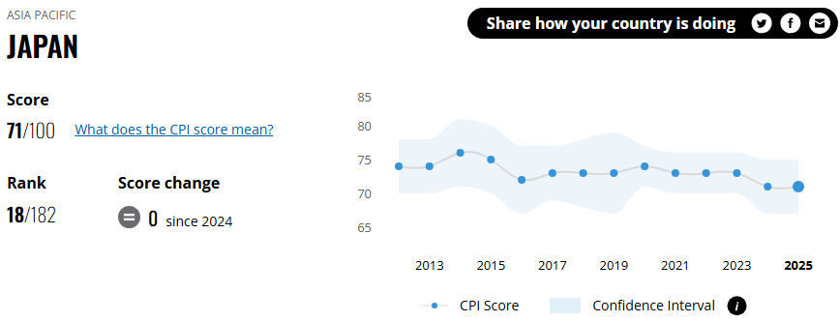
Figure 1: Corruption Perceptions Index of Japan (Transparency International, 2026).
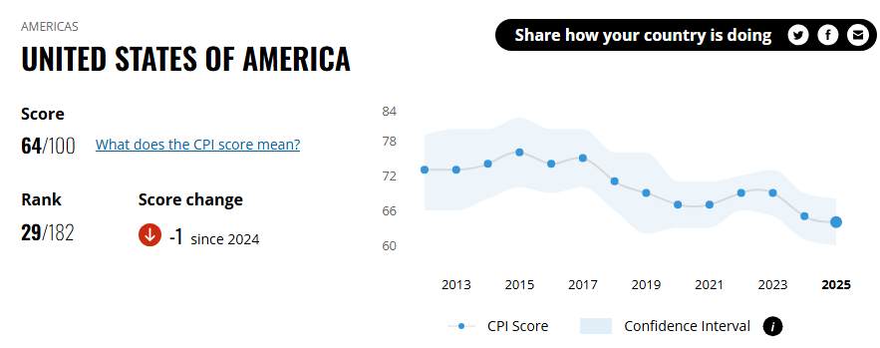
Figure 2: Corruption Perceptions Index of USA (Transparency Index, 2026).
Conversely, Japan has a stable political and regulatory environment that fosters foreign investment. Historically, the government of Japan has been in favor of the international brands entering the market by providing transparent franchise legislation and trade liberalization. Nevertheless, food safety laws and supply chain quality raise the cost of operation compliance in the food companies (Keegan & Green, 2020).
The political stability in both countries has been an opportunity to long term business growth. Nonetheless, the increased labour expenses in the United States pose a hazard to profitability. Strict food safety standards in Japan are costly to the operations, but they also enhance consumer confidence in the business, which is favorable to the established international brands such as KFC.

Economic Factors
Consumer purchasing power and food consumption patterns are directly affected by the economic conditions. The United States is the biggest economy in the world, and its GDP is estimated to be USD 29 trillion in 2024 and GDP per capita is USD 85,000 and above (World Bank, 2025). Consumers have high income levels and high consumer spending, which produce favourable conditions to the quick-service restaurant industry. The US market is however a mature and competitive product where long term competitors like McDonald, Popeyes and Chick-fil-A are strong.
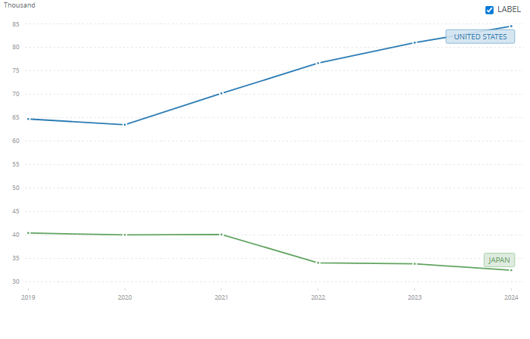
Figure 3: GDP per Capita Comparison between USA and Japan (World Bank, 2025).
In 2025, Japan has the fourth-largest economy in the world with a GDP of a bit less than USD 4.28 trillion and a GDP per capita of about USD 34,700. Even though the level of income is low compared with the United States, Japan is a high-income developed market. The slow economic growth and ageing population in Japan may however impact the long-term demand in the fast-food industry.
USA has higher unemployment rate than Japan, and this shows consistent difference over years. This also impacts the demand and affordability of the target audience of fast food chains like KFC.
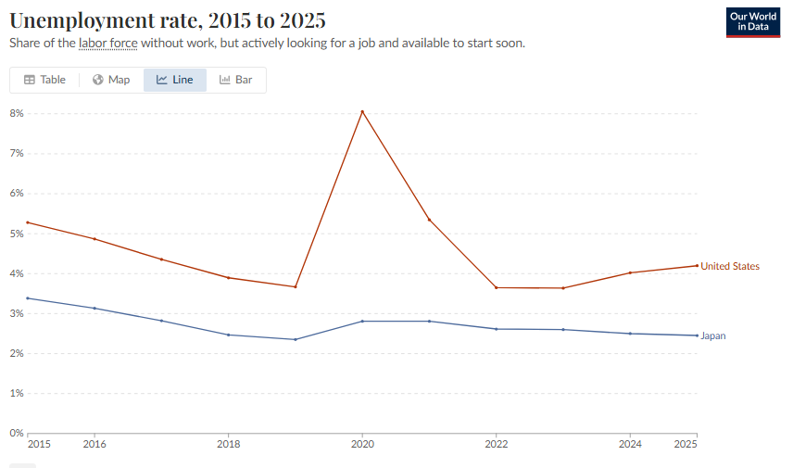
Figure 4: Unemployment Rate Comparison between USA and Japan (World Bank, 2026)
KFC also has a different presence in the market of the two countries. In the United States, there are estimated 3,900 KFC restaurants, and there are also 1,200 outlets in Japan (Yum Brands, 2026).
The purchasing power is high in the United States which presents a chance in the development of premium menus and the value meals that will target various consumer segmentations. Nonetheless, the presence of intense competition in the U.S. fast-food market is a major threat to the company. The moderate level of income and the high density of population in Japan gives the fast-food brands a chance to tap into the urban customers who desire convenience.

Social and Cultural Factors
The social aspects are especially relevant to food brands since consumer behaviour, eating habits and cultural traditions are crucially different in countries (Hollensen, 2020). The fast food in the United States is entrenched in American consumerism culture, as people have hectic schedules and like consuming foods that are convenient. Fast-food industry in America is highly competitive in terms of price and promotional offers. Nevertheless, the growing health awareness among the customers has placed a strain on the fast-food companies to make healthier choices in their menus (Usunier and Lee, 2013).
Japan has another cultural setting. Japanese customers are usually picky when it comes to food quality, cleanliness and portions. Although this is different, KFC has been able to integrate into Japanese culture. The best-known of them is the campaign that KFC launched in the 1970s and called KFC for Christmas: it made fried chicken a Christmas meal. Nowadays, there are a great number of Japanese families who pre-order KFC and celebrate Christmas. Japanese people are very old-gun demographically speaking, with the median age of over 50 years old (the United States has about 39 years of median age).
Long-term orientation and uncertainty avoidance are high in Japan hence KFC stands a chance to establish good brand loyalty by ensuring that there is consistency in quality and trusted seasonal promotions such as Christmas meals. However, the presence of good traditional food habits may pose a challenge on accepting new menu changes.
High individualism and indulgence in the United States also favor the demand of convenient and inexpensive fast food which is favorable to KFC. Simultaneously, these characteristics contribute to the competition, too, since consumers often change fast-food brands.
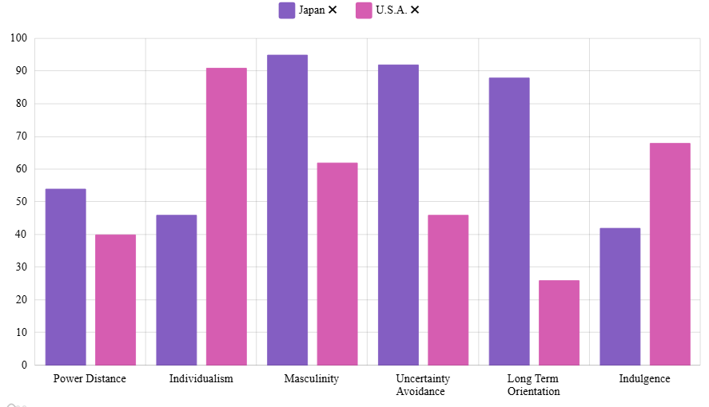
Figure 5: Hofstede Score Comparison between USA and Japan (Geert Hofstede, 2026).
Health awareness is a threat and an opportunity in the United States. Although the traditional fried food demand might decrease, KFC can launch alternatives of menu options that are healthier. There is also high cultural acceptance of KFC as a festive food in Japan and this aspect gives the brand a distinct competitive edge.

Technological Factors
The US is one of the most developed digital economies, and the population has a high rate of internet access and depends on food delivery apps like Uber Eats and DoorDash. Japan is highly technologically developed and has a well-developed digital infrastructure. Mobile payment systems and online food delivery platforms are considered by consumers. However, Japanese buyers tend to appreciate the quality of in-store food and service and this implies that technology should only supplement and not substitute conventional service (Jones et al., 2013).
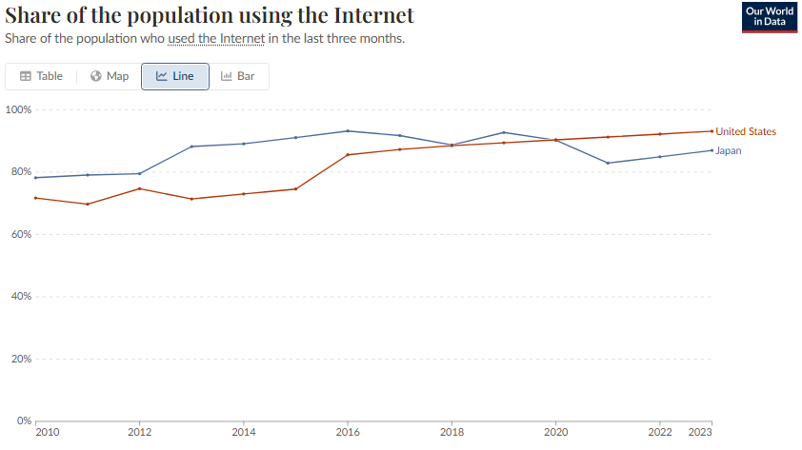
Figure 6: Internet Penetration Rate in Japan vs USA (Our World in Data, 2024).
As the internet population in the two countries reaches over 85 percent, KFC should focus more on high-tech integration, including AI-based loyalty apps and hassle-free third-party delivery of their products to win the native customer base digitally (Our World in Data, 2024). In the US, this supports aggressive mobile marketing, whereas in Japan, it supports critical digital engagement of seasonal traditions of KFC Christmas and kiosks to overcome local labor shortages.
In both markets, the digital technology provides KFC with a chance to enhance its level of operational efficiency and customer interactions. Mobile ordering and delivery services have the potential to add convenience to the consumer..

Environmental Factors
Global food companies are becoming increasingly concerned about environmental sustainability. Over the last several years, the environmental consciousness grew among the United States residents, which is why a lot of fast-food corporations started to use recyclable packages and try to minimize the usage of plastics. Japan has gone a step further to adopt viable waste management policies and recycling systems (Lusk and Schuetz, 2012).
The amount of plastic waste per person is larger in the U.S. (around 74 kg) compared to Japan (around 47 kg), which means greater consumption of packaged goods and takeaway meals. In the case of KFC, this implies that the packaging of convenience food will experience increased demand in the U.S., but also significant pressure to decrease single-use plastics in terms of regulations and environmental policies. Lower waste rates and high standards of recycling in Japan imply that KFC should focus on sustainable waste management and practices of packing.
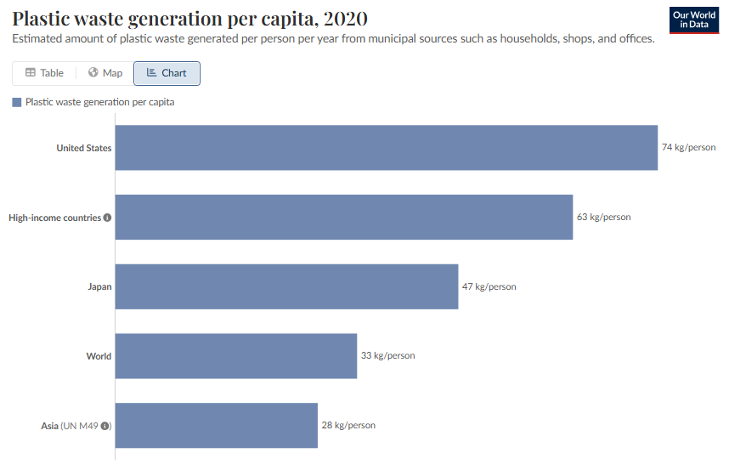
Figure 7: Plastic Waste Generation in both Countries per Capita (Cottom et al., 2024).

Legal Factors
The US has stringent laws governing food safety, labour laws and advertising laws. Further, there is the issue of escalating legal review over employee working conditions in the fast-food sector which has impacted on the operational expenses.
Japanese also have strong food safety standards and regulations. The food companies are under strict regulations on the source of ingredients, labelling and hygienic practices.
The presence of strict legal requirements makes the operations costly, but at the same time, it safeguards the health of the consumer and builds stronger brand credibility. These regulations must be adhered to ensure that both markets have the trust of the consumer.

STP Strategy
The United States is the homeland market of KFC and is characterised by the high rivalry among the quick-service restaurants, whereas Japan is a culturally different host country where consumer behaviour and dining cultures vastly differ.
In the USA, KFC is established as a middle-income family value brand, focusing on the speed and price as the main competitor to such giants as McDonalds.
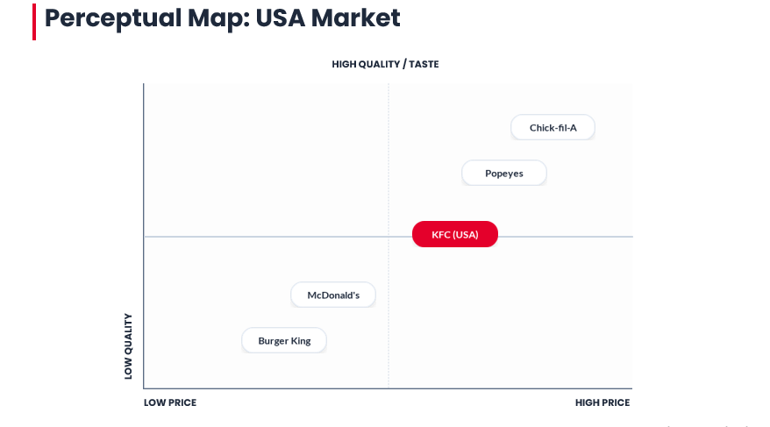
Figure 8: Perceptual Map of USA (Source: Author).
KFC Japan, in contrast, is a luxury Occasion Brand that enjoys superior prices due to its superior quality perceptions and advanced cultural practices such as the Kentucky for Christmas feast.
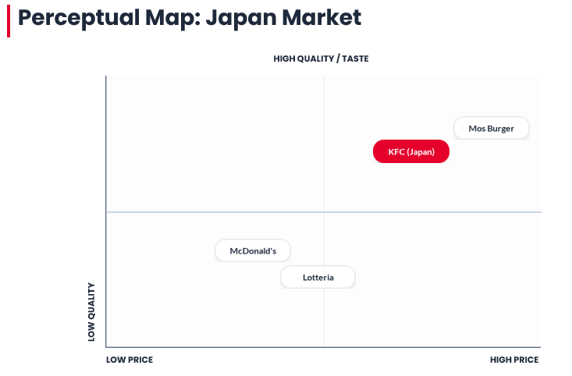
Figure 9: Perceptual Map of Japan (Source: Author).

Segmentation
KFC uses behavioural and demographic variables as its key market segmentation variables in the United States. Families are one of the largest consumer groups since the menu of the company includes a variety of sharing options like bucket meals and family packages that can be used to share with a group of people. Such products are in line with the American consumption patterns. Another significant group is that of young adults and students since they are the ones who usually want convenient and affordable food. As in 2023, USA shows higher percentages in youth age groups than Japan (Data Commons, 2026). Demographic segmentation is rather applicable to the fast-food market due to the strong impact of age groups and household structures on buying behaviour (Jobber and Ellis-Chadwick, 2019).
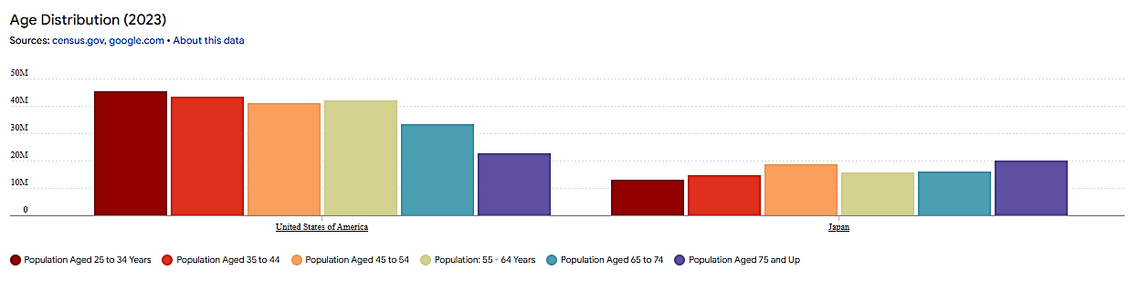
Figure 10: Population Distribution Age Groups Japan Vs USA (Data Commons, 2026).
In the United States, behavioural segmentation is also significant because people are in great need of fast-food restaurants. The busy urban lifestyle and work schedules stimulate consumers to put more emphasis on the convenient restaurant foods. Segmentation based on behaviour is especially applicable to the consumer markets that are highly competitive and where the purchase decisions are frequently determined by the lifestyle patterns (Keegan and Green, 2020).
Segmentation is based on various culture and social aspects in Japan. The restaurants that are situated around good transported areas usually have the commuters as their target market who need to have quick meals either before or after work. The families are another significant segment. Japanese consumers are usually keen on the presentation and standards of service and quality of food. The cultural values play a significant role that determines the expectation of the consumer in terms of food intake and service experience (Usunier and Lee, 2013).
The use of seasonal segmentation is especially prominent in Japan since KFC has effectively associated its brand with the celebrations of the festive period. The most notable one is the Christmas marketing campaign that has been launched back in 1970s and promotes families to buy fried chicken meals during the holiday season. This marketing campaign nowadays has evolved into a national holiday and about 3.5 to 3.6 million Japanese families buy KFC meals during Christmas annually (Steenkamp, 2019).

Targeting
The KFC targeting strategies indicate variations in the purchasing power and culture of the two countries, United States and Japan. Basically, KFC follows differentiated targeting strategies to cater different purchasing powers and cultural dimensions. KFC also uses localized targeting as they adapt different product and marketing strategies to attract specific cultural or regional preferences, KFC adapt localized targeting strategies in Japan to follow up with their cultural preferences. The company mostly focuses on the middle-income consumers in the United States who want to have an affordable meal that is fast. Families and young professionals are some of the key target markets due to their high preference of the quick-service restaurants. In the American market, promotional activities tend to be like meal bundles, and temporary promotional prices to appeal to price sensitive people. A good targeting needs firms to target segments in which they can add more value than their competitors (Kotler, 2010).
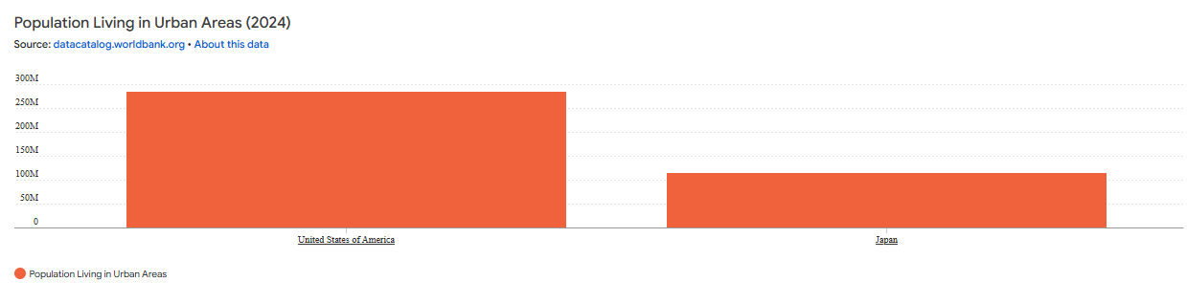
Figure 11: Urbanization in USA vs Japan (Data Commons, 2026).
In Japan, KFC is also aimed at urban consumers and families that are interested in the Western-style food and convenient dining. Also, the families observing the festive events will be a valuable target market. MNCs often readjust their targeting strategy to suit cultural distinctions and consumption culture in new markets (Hollensen, 2020).

Positioning
The positioning strategy used by KFC in the two markets is also different because of the differences in terms of cultural expectations and competitive environments. The brand in the United States is marketed as an old-fashioned fast-food restaurant that is linked to its initial recipe of fried chicken and the heritage of Colonel Sanders. This positioning focuses on being authentic and traditional, which builds on the historical role of the brand in American food culture (Baker and Hart, 2008).
Positioning in Japan is more inclined towards cultural experiences and seasonal traditions as opposed to historical heritage. The brand has developed an intimate identity with the festal occasions especially Christmas meals and this has enhanced its emotional attachment to the Japanese consumers. The triumph of the Kentucky to Christmas campaign shows how multinational organizations can incorporate local cultural aspects into the positioning of their brands, yet retain a similar global identity. Global brands that succeed in the international market usually create a balance between international brand consistency and local market orientation to be competitive in a variety of cultures (Czinkota et al., 2021).

Marketing Mix of KFC in both Countries
Companies in the international markets tend to localize marketing mix dimensions in accordance with the local consumer preferences, competition situations and economic factors. In the case of multinational brands like KFC, standardisation globally and localisation is critical in protecting the brand identity without losing its relevance to the local markets (Kotler, 2010).

Product Strategy
The main business line of KFC is based on the theme of fried chicken cooked in accordance with the original recipe developed by Colonel Harland Sanders. This is the recipe that the brand is built on and the consistency in the international markets. Having a familiar product on the core enables multinational firms to create a high brand recognition and customer loyalty in various countries (Keller, 2016).
The menu in the United States is more dominated about the conventional fried chicken, chicken sandwich and family bucket meals that are meant to be consumed by a group. The competition in the fast-food sector in the United States is very stiff and firms often offer limited-time menu products in order to gain customers and stimulate repurchases. Innovation of the products is hence a significant move towards sustaining consumer interest in the mature markets (Porter, 2008).
KFC in Japan shapes its product strategy around the local preferences and expectations of the food in Japan. Japanese consumer tends to consume lighter food and flavours that are local. Consequently, the company provides menu items that include ingredients and flavor including teriyaki and rice-based food items
Japan has also a role of seasonal menu items. KFC has managed to relate its products to the seasonal festivities, especially during the Christmas season during which the fried chicken is in high demand. This case illustrates the way in which global corporations can use the local culture in product development to enhance cultural sensitivity (Hofstede, 2011).

Pricing Strategy
The price policies in the United States and Japan vary due to the differences in competition, operation expenses and consumer buying behaviour. Competition among the large restaurant chains is very high in the fast-food market in the United States, brands often use value pricing. The most widely used strategies to encourage the demand and preserve market share are promotional pricing, bundled meals and limited time offers (Armstrong, 2020).
The convenience and affordability is another aspect that American consumers consider when choosing quick-service restaurants. These tastes are promoting the provision of middle-income priced menu meals by companies that are targeting to attract the younger customers (Jobber, 2019).
The menu prices in Japan are also more costly due to the cost of operation and the higher pricing of rentals in the urban areas.
Table 1: Pricing Example in Different Locations (Source: Author).
Country | Pricing Strategy | Example
USA | Value based and competitive pricing, promotional pricing is also popular | $5 meal deals, $20–$35 family buckets
Japan | Premium and seasonal pricing | ¥1030 combo meals, ¥4580 Christmas box

Place Strategy
Place is the means of distribution channels where the company avails its products to the target consumers in such a manner that it is convenient and available in the market (Kotler and Keller, 2016). KFC stores in the United States are very common both in the suburbs and the city. Drive-through restaurants are also widespread due to the fact that a lot of consumers have access to personal vehicles as their mode of transport (Cateora, 2020).
The associated restaurant locations in the United States are retail parks, highway locations and shopping centres. These spaces are readily accessible by the families, commuters and travellers. Fast-food companies need to have efficient distribution strategies since the purchasing behaviour is highly dependent on the accessibility (Baker, 2014).
Location strategies vary in Japan due to the transportation patterns. Consequently, the KFC stores tend to be situated in the vicinity of the train stations, business zones and areas with heavy traffic in the cities where people walk regularly. The establishments enable the restaurants to get a continuous flow of customers during the day (Euromonitor, 2023).

Promotional Strategy
The two markets also vary in promotional strategies because of the differences in culture and behaviour. The marketing campaigns often revolve around product innovation, value meals and promotional offers in the United States. Television, digital and social media advertising is largely popular in reaching younger consumers and families (Baker, 2014).
Another significant element of promotional messages used by KFC in the United States is brand heritage. In advertisement campaigns, the face of Colonel Sanders is often featured to underline authenticity and the many years of the brand history on the fried chicken market (Levitt, 1983). Value-based promotion is a common strategy KFC employs to acquire customers in the United States. As an example, the company introduced a promotion campaign of a free bucket, during which a client who made a purchase of some amount via the KFC app was given a free bucket of chicken. Another strategy used by KFC is to advertise limited-time offers, including $7 Fill Ups meals and seasonal menu items, through the resources of digital ads and social media campaigns (KFC Global, 2021).
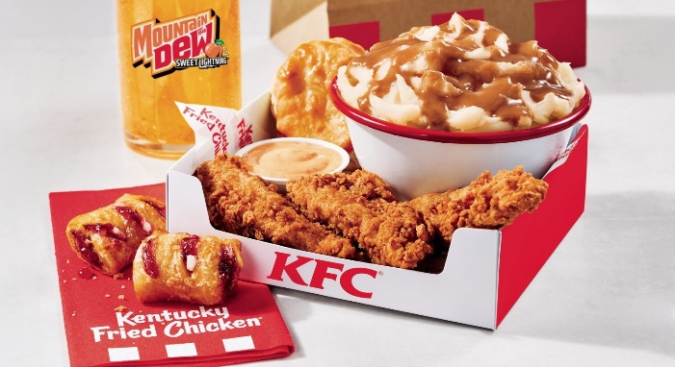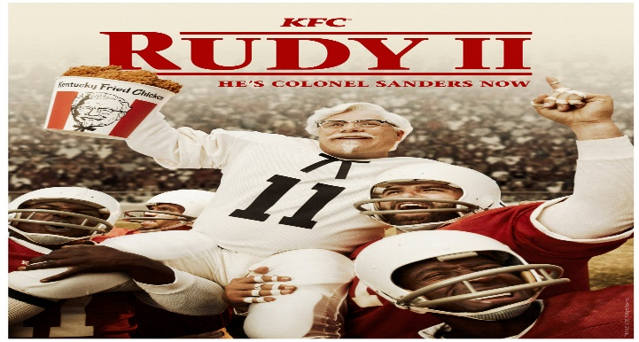
KFC USA Campaign Posters (Relaunch of $7 fill-up and football kick off season campaigns)
In 1974, Kentucky for Christmas campaign by KFC Japan invited families to celebrate Christmas with fried chicken of KFC. The promotion came up with Party Barrels (family meal of chicken in big buckets) and displayed festive ads of families having a Christmas dinner at KFC. With time, the campaign has become a tradition in the country. It has resulted in millions of Japanese families pre-ordering buckets of Christmas weeks earlier and the Christmas week is the busiest week of the year to the company in Japan in terms of sales. Advertisements at this time focus on family dinners and communal meals (Mintel, 2023).
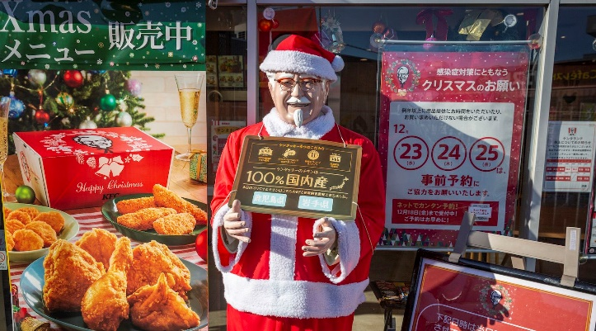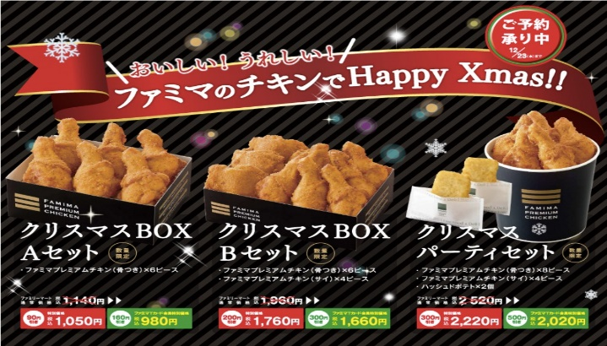
KFC Japan Christmas Day Promotional Campaigns

People, Process and Physical Evidence
Employees are important in influencing customer experiences in fast-food restaurants. The perceptions of a consumer to a brand can be greatly affected by service quality. Customer service in Japan is also one of the most distinctive areas and employees are supposed to be polite and efficient when dealing with customers (Deloitte, 2024).
Quick service restaurants also need efficient service processes. Other factors that help in creating good customer experiences include clean dining areas and clean restaurant facilities (Yum Brands, 2023).
Table 2: Comparison of Marketing Mix of Japan and USA (Source: Author).
Element | United States | Japan | Implication
Product | Fried chicken, sandwiches, large bucket meals | Local flavors, rice meals, seasonal products | Menu adaptation to local tastes
Price | Value meals, frequent offers, and aggressive discounts | Tiered pricing; generally higher | Pricing strategy mirrors market standards
Place | Urban, suburban, drive-through, and street outlets | Urban centers, transport hubs, and high-footfall streets | Regional crowd and transportation area
Promotion | High-frequency value deals and digital app offers | Culture-based campaigns (e.g., Christmas-specific promos) | Promotional patterns are localized
People | Fast, efficiency-oriented service | Courteous, high-service culture features | Different service culture
Process | Drive-through and delivery app use | Efficient in-store service | Convenience driven
Physical Evidence | Impactful branding, standard stores | Seasonal organizing, clean stores | Physical brand experience is maintained

Directional Development Strategy
The expansion of KFC in Japan is reactionary to an Ansoff Matrix market development strategy that is entering the new markets with the existing products (Ansoff, 1957).
In entering Japan, KFC brought its main product which was fried chicken and changed marketing and distribution strategies which matched the local behaviour. This strategy maintained international brand recognition but was attractive to the local taste (Hollensen, 2020).
One of such is the Christmas campaign. KFC advertised fried chicken in the 1970s as a meal to have during celebrations and a seasonal ritual has become common in Japan. This shows how marketing is able to influence consumer habits.
KFC considers the strategic location of stores in busy locations like train stations and shopping centers, which appeal to urban customers who want to have convenient meals. Rice-based and teriyaki items as menu localisation help KFC to attain a balance between maintaining its core brand and appealing to the local taste (Cateora, 2020).

Ethical Issues
Ethical issues in the fast-food industry include public health, labour practices, and environmental sustainability. Health issues are crucial. Most fast-food products are full of calories, fat, sodium which are associated with obesity and heart diseases. Customers are now requiring nutritious food and more transparent nutritional information (WHO, 2022).
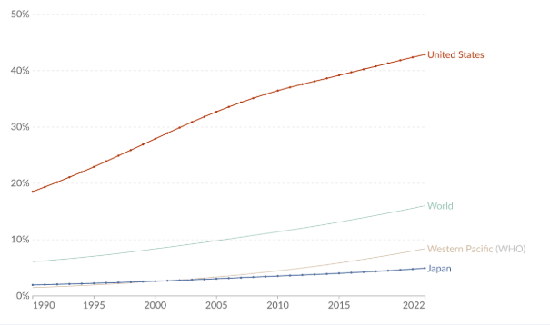
Figure 12: Adult Obesity Rates in Japan vs USA (Ritchie and Roser, 2017).
The other issue is labour practice. Most of the workers in fast-food restaurants are entry-level employees and they can be poorly paid and not secured in their jobs. The enhancement of wages and working conditions is becoming more and more important (OECD, 2023).
There is an increasing concern of environmental sustainability. Packaging waste is produced in bulk by fast-food restaurants. Firms are reacting to the demands with recyclable packaging, responsible sourcing and waste-cutting efforts to enhance reputation and lessen the environmental footprint (UN Environment, 2022).
There are concerns over the sale of high fat, calorie and sodium content in their food by fast-food chains in America, including KFC, which are leading causes of obesity as well as heart disease. Health promotion campaigns and nutrition advocacy organizations often raise these issues and promote healthier diets (Ahmad et al., 2024). Due to large seasonal promotions like the KFC Christmas Party Barrel in Japan, packaging wastes like disposable buckets, boxes and plastic containers are produced in large amounts.

Recommendations
In order to reinforce the international strategy of KFC, a number of measures can be proposed.
To begin with, KFC should extend healthier menu items. Health-conscious consumers might be interested in grilled products, in the plant-based meals, and alternatives that are not so high-calorie.
Second, they must invest in online ordering and delivery services. Convenience and operational efficiency are enhanced with mobile applications, self-service kiosks and having partnerships with delivery services (Deloitte, 2024).
Third, KFC must adjust and change marketing strategies to the local cultures without losing a global identity. When KFC conducted its Christmas campaign in Japan, it also enhanced consumer interaction which is caused by cultural integration (Hollensen, 2020).
Fourth, KFC can plan to enhance sustainability initiatives. Increasing the recyclable packaging and enhancing the sustainability of the supply chains improve the reputation and meet the environmental anticipations (UN Environment, 2022).
Lastly, the company should be constantly innovative in products. The addition of new flavours, seasonal products, and specials is a way of keeping the interest and competitiveness alive particularly in the mature markets such as the United States (Kotler, 2010).

Reflective Part: The KFC International Marketing Report
I decided to use the reflective cycle developed by Gibbs (1988) to stucture my reflection since this approach is well-organised and enables me to think of the whole process of learning and research. The cycle of Gibbs encompasses six steps that are description, feelings, evaluation, analysis, conclusion, and action plan (Gibbs, 1988). This framework has enabled me to critically reflect on my experience on preparing the KFC report, which focuses on research, analysis, and writing of the STP and Marketing Mix sections, as well as strategic recommendations and ethics.
Description
This assignment was about forming a comparative international marketing report on KFC, with reference to its activities in the country of origin (United States) and in the country of destination (Japan). The report needed an analysis of the market environment based on the PESTEL and STP and 7Ps of the marketing mix, directional development strategy, ethical issues, and recommendations.
The initial one was the collection of secondary data. I had been browsing the academic journals and marketing textbooks as well as, online industry reports to gain the insight of the company specifics in its operations.
After data was gathered, I have drawn up the report structure and determined the number of words to allocate to each area: PESTEL analysis, STP strategy, marketing mix, directional development, ethical issues, and recommendations. I then started writing the sections keeping in mind that they had to be analytical, evidence-based, and comparative between the two countries. As an example, in developing the STP section, I contrasted the demographic and behavioural segments in the United States and Japan and related this information to the KFC targeting and positioning strategies.
Feelings
My first emotions were excitement and apprehension. I was thrilled since KFC is a familiar international brand with intriguing cultural adjustments especially in Japan. Simultaneously, I was afraid of making my report analytical and evidence-based instead of descriptive.
I became more confident as I went on. I was able to find data in reports and academic sources in the industry which assisted me in offering accurate evidence to back up the analysis. Comparative marketing strategies in two different markets have also become an interesting intellectual experience that made me take into account cultural, economic, and social peculiarities of consumer behaviour.
Nonetheless, I was sometimes overwhelmed by the amount of data that was there. As an illustration, the fast-food industry in the United States and Japan is highly researched, and it needed critical consideration to choose the appropriate, up-to-date, and reliable data. I had to ensure the depth of the research along with requirements of the task.
Evaluation
The process had a number of positive sides. The fact that I used not only academic sources but also reliable reports on the industry also enabled me to improve the level of analysis of my work. By using the theoretical perspectives of STP, marketing mix and Ansoff growth strategies, I made sure that my analysis was anchored on the marketing theory. The comparison of the two markets assisted me in determining such strategic lessons as the significance of the seasonal marketing campaigns in Japan and the emphasis on the value pricing in the United States.
Analysis
The reflection identified some of the important learning points. To begin with, the proper research must have a breadth and depth. Although a great amount of information exists, it is essential to choose the most applicable evidence to make sure that the report will be focused and minimized. As an example, I have preferred data concerning consumer behaviour, market size, and seasonal trends instead of general economic indicators that were not as directly applicable to the marketing strategy.
Second, comparative analysis increases the knowledge on international marketing strategies. Through the systematic comparison of the United States and Japan I was in a position to understand differences in the strategy of KFC in product adaptation, pricing, promotion and distribution. This solidified my idea of the necessity of cultural adaptation in international marketing without the need to change the brand identity
Third, academic reports would require an organized writing and planning to come up with coherent reports. Splitting the number of words per section, making tables and thinking about where to put figures guided me in organising my arguments and presenting the information in the most lucid way possible. Applying the Gibbs framework in retrospect also helped to realise the importance of reflection on every step of the research and writing process.
Conclusion
On the whole, the research and report writing process of the KFC was very educative. I gained the further insight into the international marketing strategies, especially how a global brand becomes globalized in the local markets without losing its original identity. I also learned to combine both theory and multiple sources of evidence with the help of which I created a comparative, analytical report.
The problems of dealing with large volumes of data and striking a balance between brevity and depth assisted me in becoming more critical and analytical, as well as writing academic papers. The reflective practice also strengthened the role of planning, organised writing, and referencing, which are essential skills in writing quality academic papers.
Action Plan
In future, I will use analytical frameworks that were used in this assessment such as PESTEL, STP, and marketing mix to assess the market situation and create effective strategies in professional business environments. The skills acquired in terms of research and critical analysis will assist me in interpreting the market data and strategic decisions in the job positions. Also, the skills will enhance my capability to evaluate the consumer trends and business environments in the workplace and in daily life.
To conduct future research and write a report, I will:
- Begin work sooner to provide avail the opportunity to use accurate sources and to choose the most appropriate data.
- Write in a structured note taking system that will help in sorting the data in frameworks and make writing easier.
- Pay attention to analytical writing by continuously connecting facts with theory and concepts.
- Use figures and tables to enhance the visual comprehension and analysis.
- Take time to get feedbacks on drafts periodically especially on the clarity, readability, and citation uniformity in order to prevent significant changes in the future.
Through these measures, I hope to enhance the quality of my academic writing and research productivity, thus coming up with reports that are rigorous and interesting.

References
Ahmad, M.T., Zaman, S.U., Hussain, R., Ijaz, H., Khan, A.A., Kalsoom, F. and Javaid, S., 2024. Fast food intake and the risk of obesity and chronic diseases. Multidisciplinary Surgical Research Annals. Available at: https://msrajournalreview.com/index.php/Journal/article/view/322 (Accessed: 16 March 2026).
Ansoff, H.I., 1957. Strategies for diversification. Harvard Business Review, 35(5), pp.113-124.
Armstrong, G., 2020. Principles of Marketing. 8th ed. London: Pearson.
Baker, M., 2014. Marketing Strategy and Management. 5th ed. London: Palgrave Macmillan.
Cateora, P.R., Gilly, M.C. and Graham, J.L., 2020. International Marketing. 18th ed. New York: McGraw-Hill Education.
Cottom, J., Lau, W., Sherrington, C. and others (2024) Plastic waste generation per capita. Our World in Data. Available at: https://ourworldindata.org/grapher/plastic-waste-generation (Accessed: 19 March 2026).
Data Commons, 2026. Population distribution in Japan vs United States. [online] Data Commons. Available at: https://datacommons.org.
Deloitte, 2024. Global Quick Service Restaurant Trends 2024. [online] Deloitte Insights.
Euromonitor International, 2023. Fast Food in Japan. [online].
FAO, 2021. Nutrition and Food Systems. Rome: Food and Agriculture Organization.
Geert Hofstede., 2026. Country comparison bar charts. [online] Geert Hofstede. Available at: https://geerthofstede.com/country-comparison-bar-charts/ [Accessed 15 March 2026].
Gibbs, G., 1988. Learning by Doing: A Guide to Teaching and Learning Methods. Oxford: Oxford Polytechnic.
Hofstede, G., 2011. Dimensionalizing Cultures: The Hofstede Model in Context. Online Readings in Psychology and Culture, 2(1), pp.1-26.
Hollensen, S., 2020. Global Marketing. 8th ed. London: Pearson Education.
Jobber, D., 2019. Principles and Practice of Marketing. 8th ed. London: McGraw-Hill Education.
Keller, K.L., 2016. Strategic Brand Management: Building, Measuring, and Managing Brand Equity. 4th ed. London: Pearson.
KFC Global, 2021. How “Kentucky for Christmas” began in Japan. Available at: https://global.kfc.com/stories/how-kentucky-for-christmas-began-in-japan (Accessed: 16 March 2026).
Kotler, P., 2010. Marketing Management. 14th ed. Upper Saddle River, NJ: Pearson Education.
Levitt, T., 1983. The globalization of markets. Harvard Business Review, 61(3), pp.92-102.
Mintel, 2023. Fast Food in Japan: Trends and Insights. [online].
OECD, 2023. Food and Consumer Insights: Fast Food Sector. Paris: Organisation for Economic Co-operation and Development.
Our World in Data (2024). Share of the population using the Internet, United States and Japan, 2010 to 2023. Available at: https://ourworldindata.org/grapher/share-of-individuals-using-the-internet?tab=line&time=2010..2023&country=USA~JPN (Accessed: 24 May 2024).
Porter, M.E., 2008. Competitive Strategy: Techniques for Analyzing Industries and Competitors. New York: Free Press.
Ritchie, H. and Roser, M. (2017) Obesity. Our World in Data..
Transparency International, 2026. Corruption Perceptions Index 2025. Available at: https://www.transparency.org/en/cpi/2025/index [Accessed 15 March 2026].
UN Environment, 2022. Sustainable Packaging in Food Services. Nairobi: United Nations Environment Programme.
WHO, 2022. Global Health Risks: Mortality and Burden of Disease Attributable to Selected Major Risks. Geneva: World Health Organization.
World Bank, 2025. GDP per capita (current US$) – United States and Japan (2019–2024). World Development Indicators.
Yum! Brands, 2023. Annual Report: KFC Operations and Strategy. [online].

