Mariusz Kalasz (1805456)

Lecturer: Sue Maw

Managing a Hardware/Software Project Integrated with Enterprise and Innovation Group Project
Module

Table of Contents
Introduction 2
Risk Management 2
Code of Practice 4
Quality Assurance 10
References 13
Appendix 13

Introduction
This report will go over the aspects of the project which were left out from the project initiation document. The report will include a risk management assessment, code of practice (which in includes the sustainability of the project, and the ethical and legal issues of it) and the quality assurance issues.

Risk Management
There is a large list of risk associated with this project, however most of them are minor, so in the following list are the main risks. The risks will follow these ranges in probability and impact level.
Probability Level | Range
High | >50% chance of happening
Significant | 30-50% chance of happening
Moderate | 10-29% chance of happening
Low | Less than 10% chance of happening

Impact level | Range
High | >30% above budgeted expenditure
Significant | 20-29% above budgeted expenditure
Moderate | 10-19% above budgeted expenditure
Low | Within 10% of budgeted expenditure

  - Health and Safety Risks
- Illness (R1) - there is a risk of one or more team members falling ill, depending on the severity of the illness it can affect the work efficiency of the whole team, which in turn will make the team be behind deadlines. Probability: Significant. Impact: Low. There is not much that can be done to reduce this risk as it is a random chance.
- Electrocution (R2) – when building the scale there is a risk of the builders to have an electric shock, even though they will be working with low voltages the risk is still there and it could result in death or permanent damage. This would also damage the parts. Probability: Low. Impact: High. To decrease the chance of this happening the team in charge of building the scale will be wearing rubber gloves so they have insulation between them and the electrical parts, also the team will be supervised by an experienced member of staff.
- Fire Hazard (R3) – this is risk is very unlikely, but it is still possible. If the battery fails, it can leak a highly flammable electrolyte, however there is a very low chance of the battery failing (1 in 10 million [1]). Probability: Low. Impact: High. To decrease the chance of this happening it would be to follow the safety instructions which were provided with the battery.

  - Development Risks
- Gold Plating (R4)– this risk is more about adding unneeded features to the original design, this can affect the time and cost of the development by adding those new features. Probability: Significant. Impact: Moderate. To decrease the chance of this risk happening by design the product to cost, so it will not go over budget.
- Shortfalls in externally supplied components (R5)– this can happen if the shipping was not handled correctly which in turn damaged the parts or the parts themselves had a producer error which makes them work incorrectly, this can waste time and money by getting replacement parts. Probability: Low. Impact: Significant. To reduce this risk the parts can be ordered from respectable places and read up on any reviews left by previous users.
- Short circuiting the parts (R6) – this can happen when in making the product, like electrostatic on one members hands can damage the parts. This was already considered as the Arduino can have its microprocessor replaced, but this still will cost and waste time. Probability: Moderate. Impact: Significant. To reduce this risk the people who are building the scale will wear earth bracelets which prevents electrostatic to build up and discharge on the parts.

  - Risk Management Matrix
Probability
High
Significant | R1 | R4
Moderate |  |  | R6
Low |  |  | R5 | R2, R3
 | Low | Moderate | Significant | High  Impact

As seen on the risk matrix none of the risks listed are in the red area so there are not any risks which have to be acted on immediately however there are risks which are close to that area should still be acted on to reduce them ever happening.

Code of Practice
In this section the sustainability, ethical and legal issues for the project will be discussed.

  - Sustainability
The project will have effects on the environment and potentially on the society. The following are the potential results of the project.
First Order: The first order effects are the direct affects of the project to the environment. So, one of the first order affects is the emission of green house gasses, this is due to powering the equipment which is used to develop the project, this ranges from using the PCs to program the app and the function of the scale but also green house gasses are emitted when the parts for the weighing scale were delivered, furthermore the creation of the parts themselves would emit green house gasses. Another first order effect of the project is that there will be e-waste, this is due to the battery not being able to be recycled additionally some parts of the weighing scale parts will not be able to be fully recycled. So, there will be always some E-waste left over.
Second Order: The second order effects are the effects of the project which reduce the other impacts of it. So, the body of the scale and majority of parts can be recycled, for example the plastic used can be recycled and same as the wires and any metal which is in the weighing scale. This reduces the amount of pollution which is current in today’s world and the materials can be reused, like the wires can be melted down to create new wires or other electronic parts. Another second order is that the app promotes making food yourself, so by buying groceries there is less packaging involved unlike in readymade meals, so in turn that reduces the pollution, as there is less foil’s or plastic which are harder to recycle.
Third Order: The third order effects are the long-term socioeconomic effects of the project. So one of them will be higher power usage, but not too great, as the scale will be running on a battery so the only time that it will use the mains power is when it has to be charged but that still will uses more energy on average. Another third order would be the overall population would become healthier as the app encourages healthy eating, so if it succeeds and enough people will use it, it will decrease the obesity in the UK (which is around 28.7% of adults in England currently [2]).

  - Legal and Ethical Issues
In this subsection the legal and ethical issues will be discussed using the IET (The Institution of Engineering and Technology) and the BCS (British Computer Society) codes of conduct, with reference to the General Data Protection Legislation. More concentration in this section will be for the BCS code of conduct.
IET
Firstly, the IET “promotes and encourages ethical behaviour in the practice of science, engineering and technology by all stakeholders” [3] this project falls in the technology part of the IET therefore it is a good idea to follow these rules so the project is fair for all stakeholders. The IET is used to guide members (members are referenced to people who joined the IET) to meet the professional conduct which was specified in the Byelaws.
The Rules of Conduct from the IET also “aim to support members to take an ethical stance” [3] when the need of balancing often conflicts in interests and demands of employees, society and the environment.
The following rules are extracts from the Byelaws where the IET based their Rules of Conduct, the full Rules of Conduct are in the Appendix:
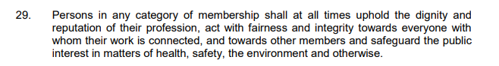 [3]
This excerpt of the byelaws speaks that the company needs to be fair to all parties and safeguard the public interests in matters of health, safety and the environment. The company in question, Tsunami Soft is already following this excerpt as the company is fair to all parties and the project will have specific accessibility features which will include more groups of parties for example the disabled or partially disabled. Also Tsunami Soft has taken the health, safety and environment when in the design and development stages, the scale will have airflow vents so the risk of the battery overheating is decreased and the scale will be recyclable and if there is anyway to reduce pollution or the negative effects on the environment they will be followed.
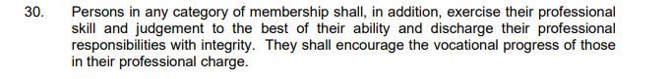 [3]
This excerpt of the byelaws speaks of how the company needs to take their responsibilities with using their professional skills and judgement to the best ability. Tsunami Soft has followed this when in following the Gantt chart of the project, so each responsibility or task to be completed by the deadline and to the highest possible standard.

BCS
The BCS has a responsibility to set rules and professional standards to direct the behaviour of its members in professional matters. [4] And the following rules are expected to be higher than those established by the general law and that they will be enforced by disciplinary action.
The following conduct governs the conduct of individual and not the nature of the business or ethics of any “Relevant Authority”:
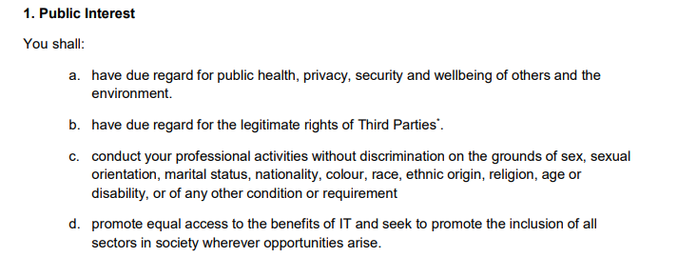 [4]
The following section of rules is part of the ethics for the public. Point “A.” speaks about that the company has a regard to the public health, privacy, security and wellbeing of others and the environment. This has been already discussed in the IET section, however about the privacy and security, the project will store the login information for social media of the user and this also will allow the app to post to those social medias, therefore the company needs to follow the Data Protection Act 2018, so the data stored needs to be:
- Used fairly, lawfully and transparently.
- Used for specified, explicit purpose.
- Used in a way that is adequate, relevant, and limited to only what is necessary.
- Accurate and, where necessary, kept up to date.
- Kept for no longer than necessary.
- Handled in a way that ensures appropriate security, including protection against unlawful or unauthorised processing, access, loss, destruction or damage.
[5]
The data protection act also covers the security part of point A.
Point “B” speaks about respecting other legislations for example the data protection act, copyright, patents and other intellectual property. The company has followed these legislations.
Point “C” has been discussed in the IET section, but in short, there can not be any discrimination to any parties. The company follows this closely to heart as the team has members of other nationalities and sexual orientation and believes.
Point “D” has also been discussed in the IET section; the company will provide additional accessibility options for the project in future developments.
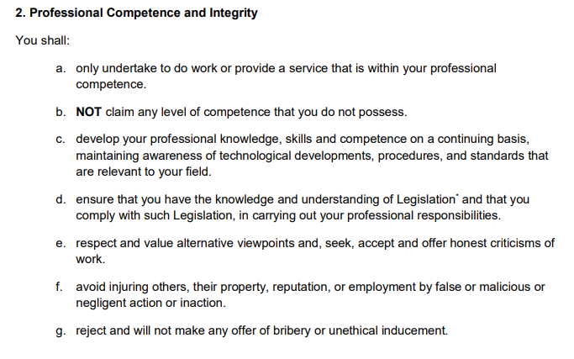
[4]
This section of rules from the BCS is about to keep everything professional and to keep up to date with any new technology which is relevant to the field of work.
Point A and B, both have been followed by the company, none of the members claimed high levels of competence regarding the project, the only claims were of small background knowledge on specific subjects. The project is within the team’s professional competence.
Point C, the team during this project has developed new knowledge with new technical skills also being developed, and this knowledge has been kept up to date. Also, the team has been maintaining awareness on technological developments, procedures and standards.
Point D, the company is aware of any legislation which affects it, any of those legislation have been read through and understood. The actions of the company have been following with them.
Point E, F and G, these three points are short therefore they will be discussed together. The company respects any and all alternative viewpoints, Tsunami Soft also seeks any productive and honest criticisms. The company will not put anyone or anything in danger, it has followed any possible health and safety regulations and employee legislations. The company will not accept nor offer any bribery or unethical inducement.
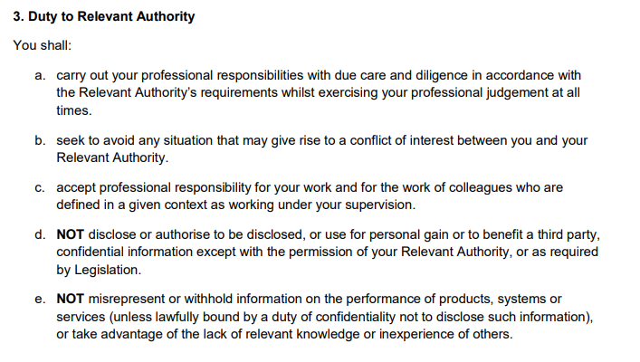
[4]
Point A, the company will complete its responsibilities in a lawful way, while keeping its professional judgement.
Point B, the company will try and avoid any possible rise of conflict between the company and the authorities.
Point C, if the current team had any supervisors, professional responsibility would be followed.
Point D and E, the team members will not disclose any information for their person gain or a third party’s gain. Unless it is required by legislation or the relevant authority’s permission. The company will include all information needed for the consumer about the project and will not take advantage of parties with limited experience.
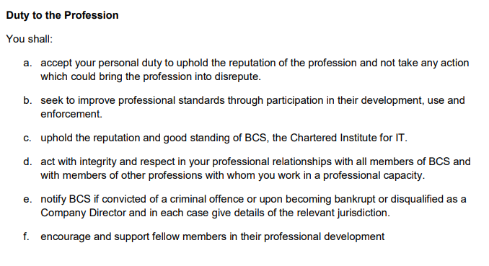
[4]
This section will apply to the company when it decides to be a member of the BCS this also works the same with the IET when the company decides to become the member of one of those two then the company will follow these.

Quality Assurance
The quality assurance will use the SMART criteria to assess these following points which were taken from the ISO 9126:
- Functionality
- Reliability
- Usability
- Efficiency
- Maintainability
- Portability
[6]
Functionality
Specific | The specifics of functionality, is to check if the prototype is; suitable, accurate, interpolate, compliant and secure.
Measurable | This would be measured in tests of the final prototype, by testing each sub-characteristic, so for example to check if the prototype is suitable for the project there would be test including testing of recipes and if the scale works with the app.
Achievable | This could be achievable if enough test were made.
Realistic | Realistically the tests will at least give the MVP of results.
Timely | This would take approximately a week.

Reliability
Specific | The specifics of Reliability will be tested including; Maturity, fault tolerance and recoverability.
Measurable | This will be measured by tests.
Achievable | This could be achievable if enough test were made, however some test will be omitted due to the limit of having one prototype.
Realistic | Realistically the tests will at least give the MVP of results.
Timely | This would take approximately a week.

Usability
Specific | In specifics this will test the usability of the prototype and its understandability, learnability and operability.
Measurable | This will be measured via tests, for example to test operability the app and scale will be given to a tester and they will record their experience.
Achievable | This could be achievable if enough test were made.
Realistic | Realistically the tests will at least give the MVP of results.
Timely | This would take approximately a week.

Efficiency
Specific | This will test the prototype’s efficiency this including the time behaviour of it and resource behaviour.
Measurable | This will be measured by the amount of time it takes to boot up and how much memory, CPU, disk and network usage the prototype uses.
Achievable | This can be achievable the tests will take place during other tests to see how well the prototype runs.
Realistic | Realistically the tests will give a good idea of the resource usage, but it will not be the most efficient.
Timely | This will take place during other tests to have different environments to see how well it preforms, so it will take approximately a week

Maintainability
Specific | The specific tests will check on how maintainable the prototype is, this includes the analysability, changeability, stability and testability.
Measurable | This will not be exactly measured via tests; this is more of how the app and scale can change depending their software and the only changes that will be allowed to the software will be updates sent by the company.
Achievable | This will be achievable if the scope of the project is kept in mind.
Realistic | The user will not be able to change the software themselves they will be able to change the options of it however the code will not be open sourced.
Timely | This will be kept in scope until the development ends.

Portability
Specific | The specifics of this is that it will test the portability of the prototype this includes, adaptability, instability, conformance, replicability.
Measurable | This will be measurable via tests like for example the adaptability can be tested by the prototype being used in different environments.
Achievable | This could be achievable if enough test were made.
Realistic | Realistically the tests will at least give the MVP of results.
Timely | This would take approximately a week.

References

[1] | Battery University, “BU-304a: Safty Concerns with Li-ion,” Battery University, [Online]. Available: https://batteryuniversity.com/learn/article/safety_concerns_with_li_ion. [Accessed 31 January 2020].
[2] | House of Commons Library, “Obesity Statistics,” Parliment, 6 August 2019. [Online]. Available: https://researchbriefings.parliament.uk/ResearchBriefing/Summary/SN03336. [Accessed 31 January 2020].
[3] | IET, “IET Rules of Conduct,” IET, 3 October 2019. [Online]. Available: https://www.theiet.org/media/4618/rules-of-conduct-oct-2019.pdf. [Accessed 31 January 2020].
[4] | BCS, “Code of Conduct for BCS Members,” BCS, 5 June 2019. [Online]. Available: https://cdn.bcs.org/bcs-org-media/2211/bcs-code-of-conduct.pdf. [Accessed 31 January 2020].
[5] | The British Goverment, “Data Protection,” Gov.uk, 2018. [Online]. Available: https://www.gov.uk/data-protection. [Accessed 31 January 2020].
[6] | SQA, “ISO 9126 Software Quality Characteristics,” SQA, [Online]. Available: http://www.sqa.net/iso9126.html. [Accessed 31 January 2020].

Appendix

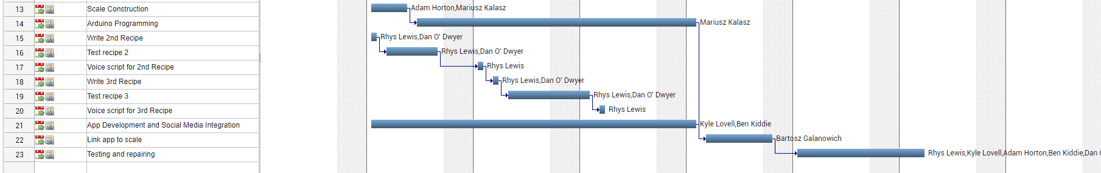
The Updated Gantt Chart

Team Picture after the informal demo
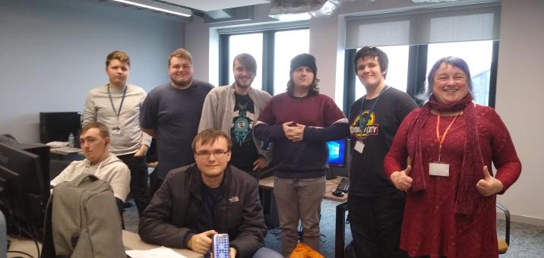
The mark for the informal demo
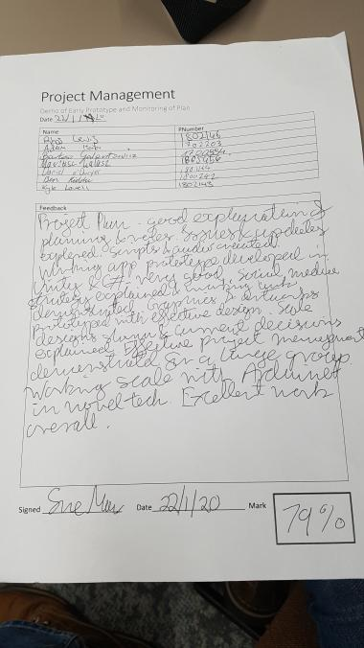

The Rules of Conduct for IET
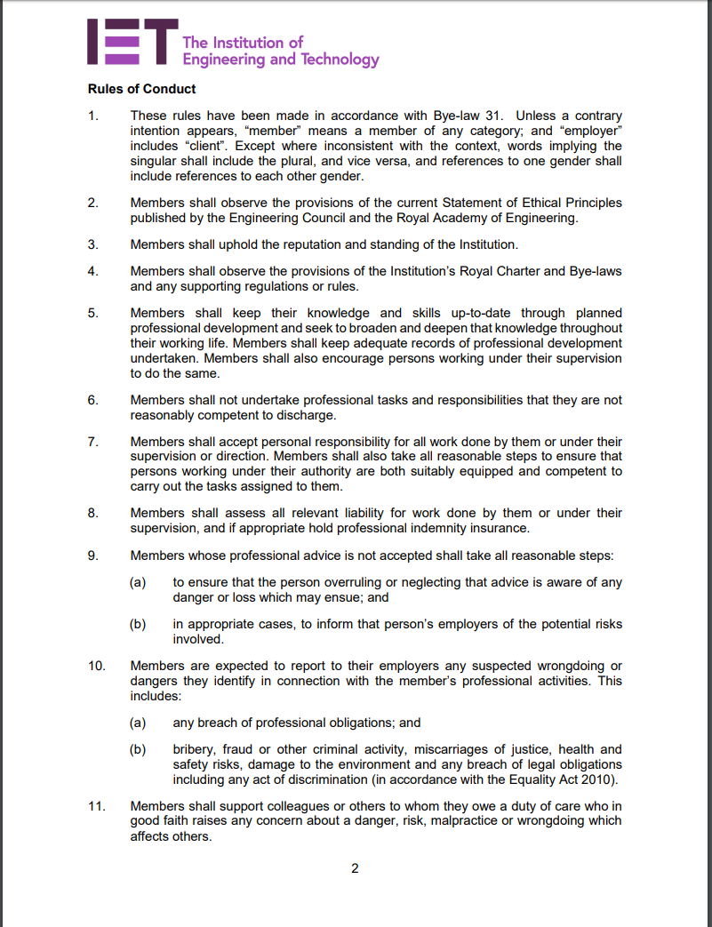

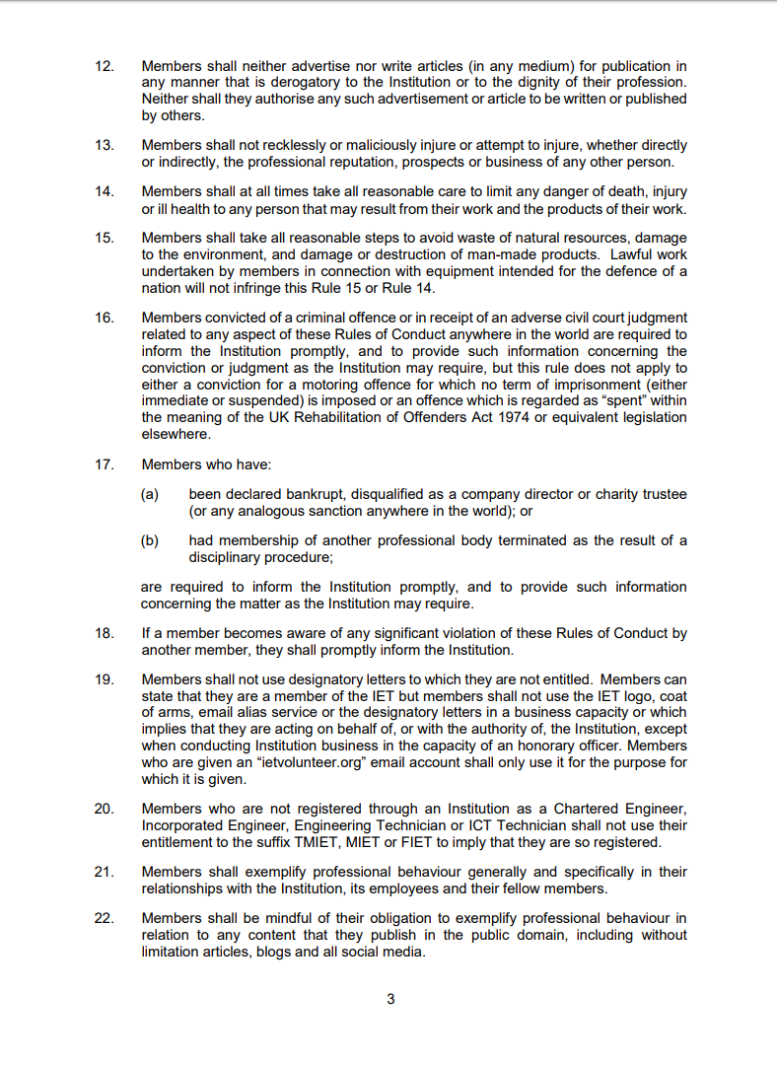

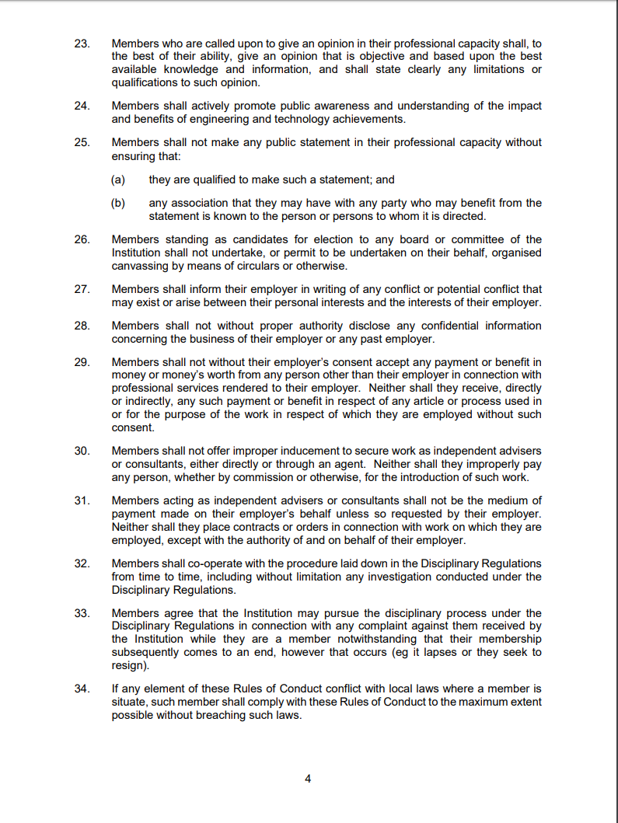

The Appendix for the rules of conduct from BCS


