BMIH5001 Entrepreneurship
Student ID: 2206723
Student Name: Andreea Marin
Lecturer name: Chris Wilkin

Introduction
The following essay will examine the modern concept of Sweet Dreams Boutique, a boutique lodge that has been cautiously deliberate using the Business Model Canvas (BMC). Situated in the principal location of the United Kingdom more precisely in the center of London, the inn units a new widespread for opulence with the aid of prioritizing environmental sustainability. The BMC examines the distinct characteristics of Sweet Dreams Boutique, highlighting its commitment to environmentally sustainable methods, collaborations with local organizations, and tailor-made guest studies. Backed by using marketplace traits, Similar web records, and successful assignment examples, the boutique motel emerges as an innovator in the hospitality zone, geared up to set up new benchmarks in luxury with a focal point on ethics. Finally, the reflection will be evaluated here.

Discussion
Sweet Heaven Boutique is a pioneering idea in the hospitality enterprise that effectively combines luxurious and environmental sustainability. Expressed through the utilisation of the Business Model Canvas (BMC), this boutique hotel located inside the central vicinity of the UK targets to redefine luxury even as last dedicated to environmentally sustainable practices. The BMC is intricately crafted to emphasize the specific traits that set Sweet Heaven Boutique aside from its competition in the marketplace (Canestrino et al., 2020). The centre of Sweet Haven Boutique's appeal lies in its steadfast dedication to environmentally accountable strategies, which result in a mixture of the world of luxury (Martins and Perez, 2020). The inn's determination to sustainability is evident from its very beginning because it prioritises the utilisation of locally obtained materials during the development technique so one can lessen its ecological footprint. This dedication is also evident in the status quo of strategic alliances with home suppliers around the United Kingdom, which not only strengthens the local economic system but also ensures a supply chain that adheres to sustainable principles (Gabrielsson et al., 2020). The Customer Segments part of the Business Model Canvas (BMC) provides a strategic definition of the particular market that Sweet Haven Boutique ambitions to goal. The lodge incorporates sophisticated travellers who actively pursue an engaging and environmentally aware luxury experience. Sweet Haven Boutique capitalises on the growing fashion of green tourism by embracing the standards valued by cutting-edge purchasers (Champenois et al., 2020). The motel positions itself as the top choice for folks who prioritise sustainability while nevertheless taking part in the high stage of comfort and beauty related to luxurious hospitality.
Sweet Haven Boutique's dedication to sustainability isn't always beauty, however alternatively thoroughly included into its fundamental operations, positioning it as a pioneer in the ever-changing realm of boutique inns (Haltiwanger, 2022). This pledge aligns with the developing worldwide recognition of the ecological consequences of the hospitality quarter, as customers regularly call for environmentally aware alternatives (Secundo et al., 2021). Regarding the Business Model Canvas, the price proposition is apparent now not simply inside the environmentally pleasant operations but also inside the deliberate acquisition of local sources and cooperation with nearby providers (Alford and Jones, 2020). This now not best aids in diminishing the lodge's environmental effect but additionally positions Sweet Haven Boutique as an engaged participant in the local economic system, cultivating network connections and endorsing sustainable techniques. With the hospitality industry's present process, a massive transformation closer to sustainability, Sweet Haven Boutique carefully positions itself to attract a selective consumer (Canestrino et al., 2020). The growing phenomenon of sustainable tourism demonstrates that cutting-edge customers aren't best pursuing lavish reviews however also are turning more aware of the ecological consequences of their choices (Dana, 2021). Sweet Haven Boutique sticks out as a pioneer in the hotel quarter, skillfully combining opulence with ecological sustainability.
The Channels and Customer Relationship additives of the Business Model Canvas (BMC) are crucial in defining the wonderful identity of Sweet Haven Boutique and ensuring a clean guest experience in the ever-converting hospitality industry (Armuña et al., 2020). Channels, as designated within the Business Model Canvas (BMC), emphasise the vital want of green distribution and verbal exchange channels. Sweet Haven Boutique utilises virtual media strategically to construct a sturdy online presence for marketing and reservation offerings. The most important traces of touch for potential visitors are a person-pleasant internet site and a committed cell application, which provide a simplified and handy manner to make bookings (Gabrielsson et al., 2020). The importance of having a strong virtual presence is supported by Similarweb records, highlighting the need for an intensive online method in navigating the competitive panorama of the hospitality enterprise (Martins and Perez, 2020). The net structures serve as transactional channels and communicative tools, enabling Sweet Haven Boutique to correctly communicate with its target market. By utilising various communication systems, the resort can successfully show its dedication to sustainability, offering a clear attitude toward its environmentally pleasant tasks (Molina, 2020). This method is in line with the tastes of contemporary travellers who prioritise environmental awareness.
Sweet Haven Boutique places enormous emphasis on Customer Relationships, prioritising customized career and energetic interaction (Alford and Jones, 2020). The lodge pursues to create a long-lasting bond with its customers by presenting a personalised concierge provider, deviating from conventional hospitality practices. This carrier is going beyond the everyday hospitality offers by using imparting facts on sustainable practices and neighbourhood points of interest (Martins and Perez, 2020). The objective is to enhance the entire visitor revel by presenting greater than simply accommodation, but instead a comprehensive and culturally absorbing voyage. This willpower to customise assistance harmonises results easily with modern industry patterns and successful instances, emphasising the want of cultivating visitor allegiance via different and good-sized engagements (Armuña et al., 2020). Transitioning to the Revenue Streams segment, Sweet Haven Boutique implements a numerous method for producing income. In addition to the traditional profits generated from room reservations, the resort carefully decided on environmentally pleasant sports. These alternatives embody a whole lot of activities, which include guided excursions of neighbourhood sustainable establishments and wellness packages that consist of green services (Canestrino et al., 2020). The primary objective of this strategic diversification is to now not only cater to the changing needs of the marketplace but also protect the lodge towards any volatility in its conventional revenue streams. Through diversifying its sources of earnings, Sweet Haven Boutique not only strengthens its monetary stability but also reaffirms its dedication to imparting various and enriching revelations for its customers (Dana, 2021). Sweet Haven Boutique's use of resilient Channels, emphasis on Customer Relationships, and numerous methods to Revenue Streams establishes it as a pioneering and progressive player in the motel area. The boutique motel distinguishes itself by presenting a smooth online revel, customised carrier options, and a clever method to generate earnings from many assets (Armuña et al., 2020). It caters to the needs of present-day guests and ensures its lengthy-term viability in an aggressive market (Santos and Liguori, 2020). The inn's complete technique demonstrates its dedication to surpassing the expectations of its visitors within the ever-converting realm of opulence and environmental duty.
The resort's success is based on the critical elements of Key Resources and Key Activities. Sweet Haven Boutique allocates sources towards the use of renewable energy sources, the utilisation of eco-friendly construction substances, and the availability of a team of workers training on sustainable practices (Cardella et al., 2020). Partnerships with nearby artists and providers not only decorate the extraordinary visible appeal but additionally uphold the hotel's determination to sustainability, taking suggestions from boutique hotels that have efficiently incorporated those ideas. The significance of Key Partnerships is apparent inside the alliances formed with close-by organisations and enterprises that possess a shared willpower toward sustainability (Alford and Jones, 2020). The lodge can in addition to its social obligation create at the same time useful collaborations by way of interacting with environmental non-governmental companies, operating with eco-aware brands, and taking elements in community initiatives. Sweet Haven Boutique represents a modern concept that correctly combines opulence and environmental focus (Dana, 2021). The Business Model Canvas offers a holistic perspective on the resort's dedication to environmental sustainability, neighbourhood collaborations, and tailor-made guest experiences. Based on market developments, Similarweb records, and previous instances, Sweet Haven Boutique is placed to revolutionise boutique resort requirements within the UK, making it an exclusive and charming endeavour.
Reflection
Participating inside the in-class non-public entrepreneurial/managerial test enabled me to discover a greater profound comprehension of my motivations and characteristics as an entrepreneur and manager. The utilisation of the Gibbs reflective cycle in analysing this occasion has been important in uncovering the various tiers of acquired insights from the assessment. The preliminary phase of the Gibbs reflective cycle entails presenting a detailed account of the enjoyment. The in-magnificence surveys served as a methodical basis for self-assessment and also advocated for me to mirror my entrepreneurial and managerial tendencies. The questions have been intellectually stimulating, encompassing subjects starting from hazard fear to leadership styles, resulting in a full evaluation of my entrepreneurial profile. Transitioning to the second phase, emotions have been stirred up using the assessment, resulting in a combination of feelings (Gabrielsson et al., 2020). Certain disclosures aligned with my insecurity, at the same time as others faced my preconceived assumptions. Realising my inclination closer to a collaborative leadership fashion become validating because it coincides with my conviction in the efficacy of teamwork. Yet, the recognition that my willingness to take dangers may be still low like I anticipated, because of the heightened precaution it motivates me to research the underlying elements contributing to this disposition. The final segment, assessment, calls for a meticulous examination of the occasion. Utilising educational models and frameworks, I evaluated my motives as an entrepreneur and manager. The Entrepreneurial Orientation (EO) model, which encompasses the factors of innovativeness, hazard-taking, and proactiveness, allowed me to assess my entrepreneurial inclinations.

Although I take into consideration myself as non- revolutionary and unambitious person, the tendency to avoid taking risks required me to have interaction in investigation for help me increase my self-confidence. Did it stem from a worry of failure or a predilection for strategic selection-making? These questions became crucial for similar self-reflection.
In the fourth step, the process of analysis entailed a greater profound investigation into my motivations and features. Contemplating my aversion to not taking dangers, I pondered whether it sprang from a desire for balance or a necessity for meticulous planning. The inclusion of the Management Styles model, which distinguishes between autocratic, democratic, and laissez-faire strategies, furnished similar insight for my investigation. Recognising my tendency closer to a cooperative method has in addition emphasised the importance I attribute to the interactions and relationships within a group. In the final level, the belief, I became able to combine my mind and observations into sensible and useful understandings. Recognising my inclination to keep away from risks drove me to make a company decision to expand a greater planned method of taking risks. Embracing this variation is in line with selling a greater flexible and responsive entrepreneurial attitude. Moreover, acknowledging the significance of collaboration has reinforced my dedication to establishing an inclusive and communicative environment. The final segment, the movement plan, includes delineating the sequential measures for subsequent development. To boom my willingness to take risks, I intend to take part in situations that take a look at this inclination, actively looking for probabilities to take calculated risks and gain understanding from the consequences. Additionally, selling a transparent and inclusive communication amongst team individuals will enhance the cooperative atmosphere, helping a wide variety of viewpoints and innovative hassle-solving. Ultimately, the utilisation of the Gibbs reflective cycle allowed for an intensive exam of my drive and aspirations in entrepreneurship and control. Utilising academic fashions facilitated a rigorous assessment, leading me to realistic observations and a proactive strategy for personal and professional boom. Adopting trade and fostering a more proactive entrepreneurial mind-set will virtually decorate my development as a talented entrepreneur and supervisor.

Conclusion
Sweet Haven Boutique is a pioneering instance inside the resort quarter, skillfully combining opulence with ecological sustainability. The boutique hotel establishes itself as a frontrunner in responsible hospitality by adopting an all-encompassing Business Model Canvas this is based totally on green methods and neighborhood partnerships. Sweet Haven Boutique prioritises customised visitor stories and the improvement of several sales assets to satisfy the converting demands of the industry and ensure long-term monetary stability. This modern layout embodies the future of one-of-a-kind accommodation, where opulence blends seamlessly with a profound dedication to sustainability, establishing a brand new benchmark for incredible nice inside the United Kingdom. Hence, the reflection of this topic using Gibbs model has been also discussed the above essay.

Appendix
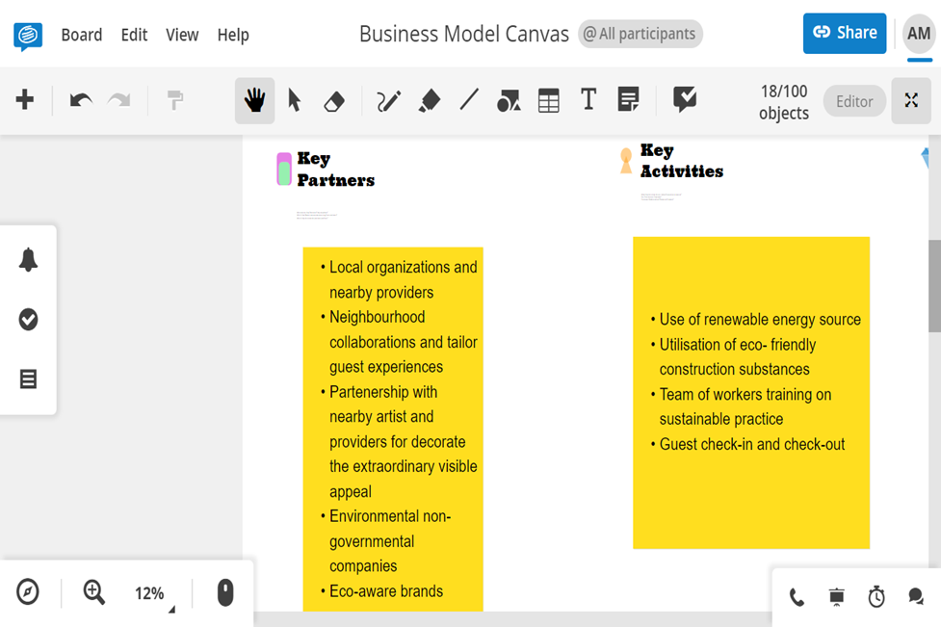

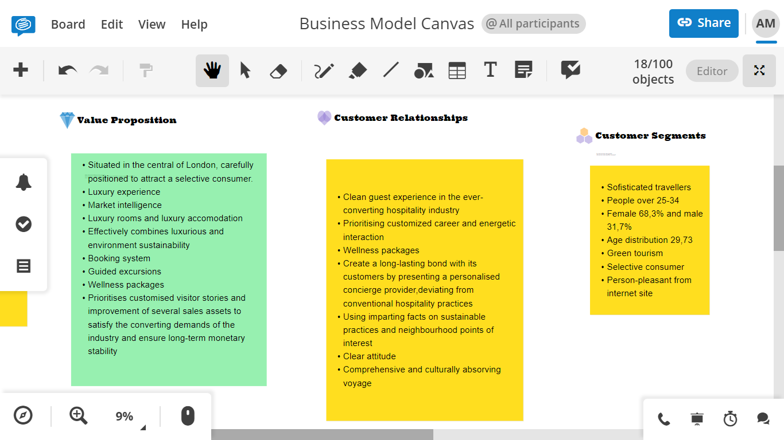

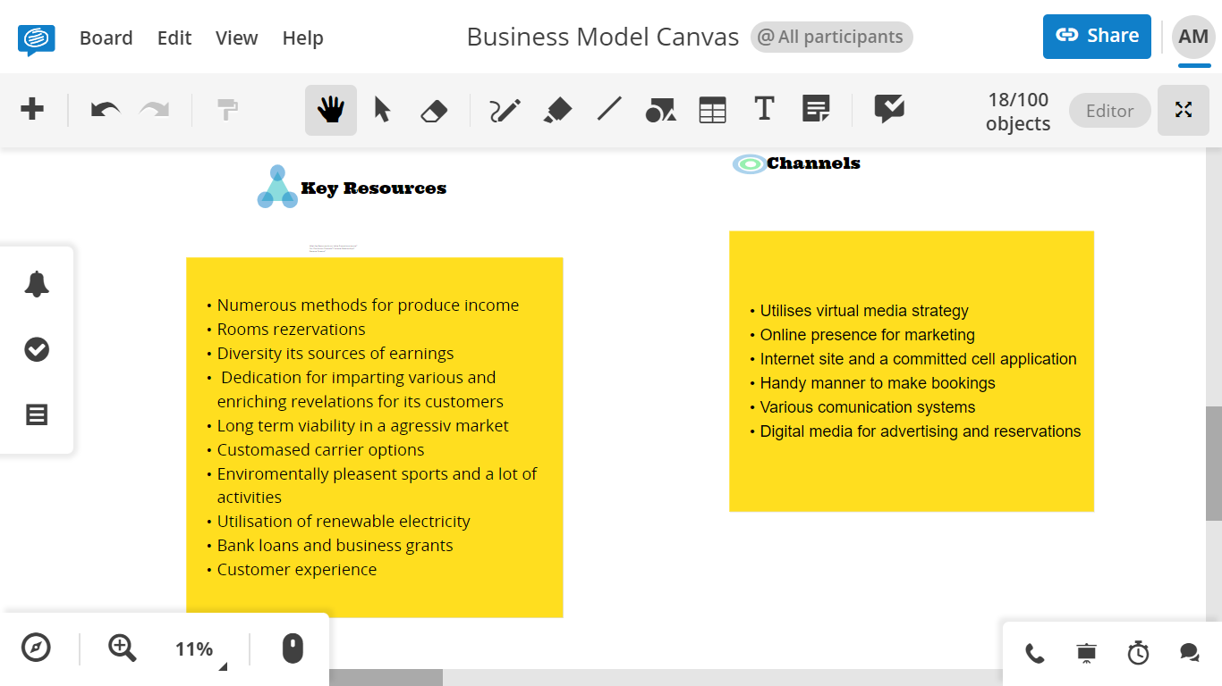

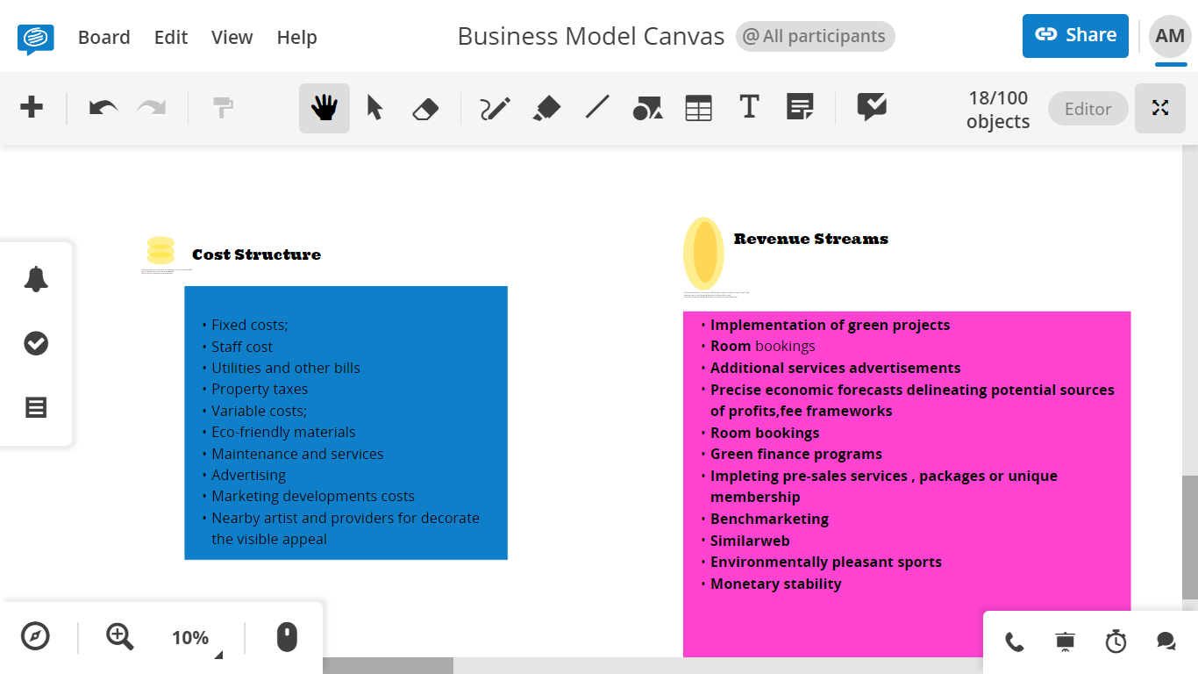

Analysis and Audience Demographics Comparison

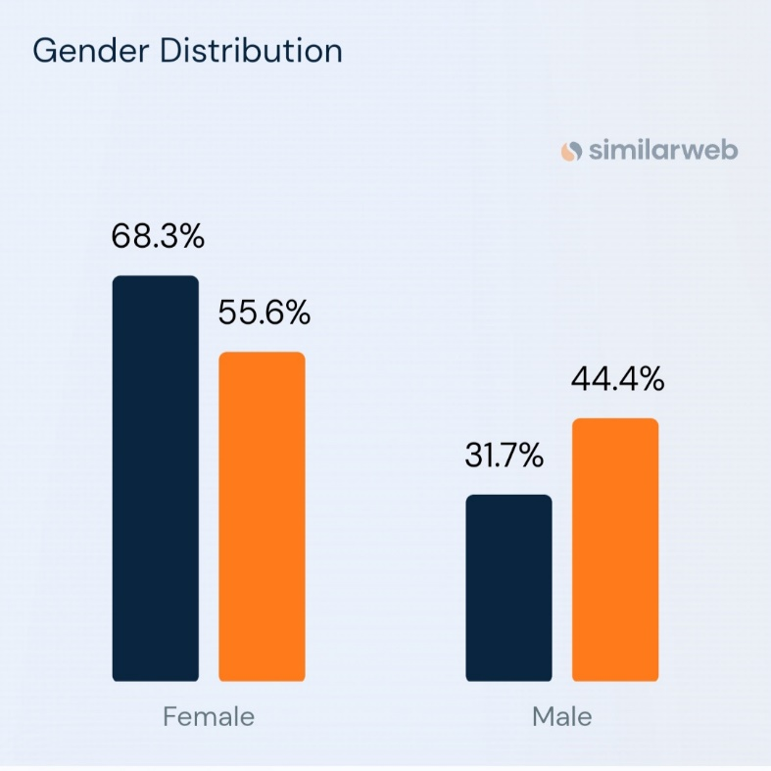

Sources: (Boutiquehotel.me Website Traffic Demographics)
Audience composition can reveal a site’s current market share across various audiences. boutiquehotel.me’s audience is 31,7% male and 68.3% female. The largest age group of visitors are 25-34 year olds.

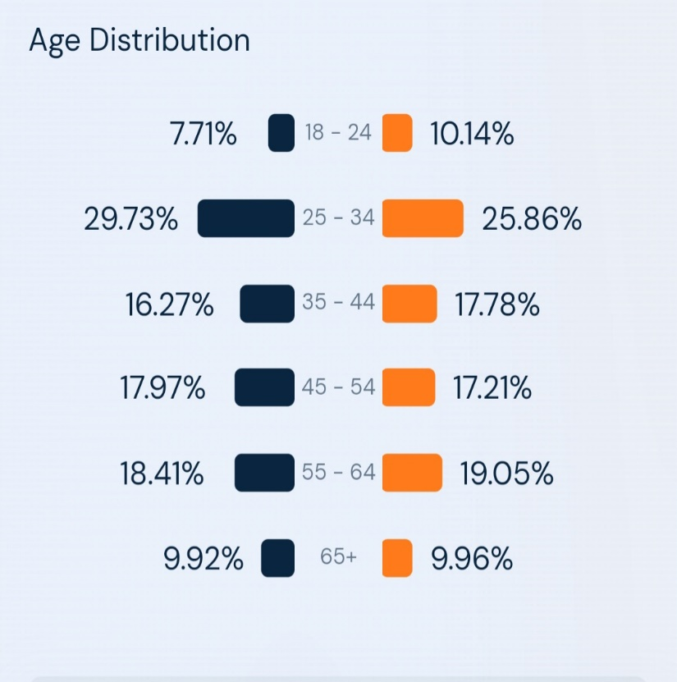

Source:(similarweb.com) Analysis and Audience Demographics Comparison

References
Alford, P. and Jones, R., (2020). The lone digital tourism entrepreneur: Knowledge acquisition and collaborative transfer. Tourism Management, 81, p.104139.
Armuña, C., Ramos, S., Juan, J., Feijóo, C. and Arenal, A., (2020). From stand-up to start-up: exploring entrepreneurship competences and STEM women’s intention. International Entrepreneurship and Management Journal, 16, pp.69-92.
Canestrino, R., Ćwiklicki, M., Magliocca, P. and Pawełek, B., (2020). Understanding social entrepreneurship: A cultural perspective in business research. Journal of Business Research, 110, pp.132-143.
Cardella, G.M., Hernández-Sánchez, B.R. and Sánchez-García, J.C., (2020). Women entrepreneurship: A systematic review to outline the boundaries of scientific literature. Frontiers in psychology, 11, p.1557.
Champenois, C., Lefebvre, V. and Ronteau, S., (2020). Entrepreneurship as practice: systematic literature review of a nascent field. Entrepreneurship & Regional Development, 32(3-4), pp.281-312.
Dana, L.P. ed., (2021). World encyclopedia of entrepreneurship. Edward Elgar Publishing.
Gabrielsson, J., Hägg, G., Landström, H. and Politis, D., (2020). Connecting the past with the present: the development of research on pedagogy in entrepreneurial education. Education+ Training, 62(9), pp.1061-1086.
Haltiwanger, J.C., (2022). Entrepreneurship during the COVID-19 pandemic: Evidence from the business formation statistics. Entrepreneurship and Innovation Policy and the Economy, 1(1), pp.9-42.
Martins, I. and Perez, J.P., (2020). Testing mediating effects of individual entrepreneurial orientation on the relation between close environmental factors and entrepreneurial intention. International Journal of Entrepreneurial Behavior & Research, 26(4), pp.771-791.
Molina, J.A., (2020). Family and entrepreneurship: New empirical and theoretical results. Journal of Family and Economic Issues, 41, pp.1-3.
Santos, S.C. and Liguori, E.W., (2020). Entrepreneurial self-efficacy and intentions: Outcome expectations as mediator and subjective norms as moderator. International Journal of Entrepreneurial Behavior & Research, 26(3), pp.400-415.
Secundo, G., Del Vecchio, P. and Mele, G., (2021). Social media for entrepreneurship: myth or reality? A structured literature review and a future research agenda. International Journal of Entrepreneurial Behavior & Research, 27(1), pp.149-177.
Similarweb(boutiquehotel.me vs myboutiquehotel.com visitors comparison by gender and age distribution)https://www.similarweb.com/website/search.com/
Similarweb(boutique.me Website Traffic Demographics)www.similarweb.com

