Graduate Diploma in Professional Learning- SLD/PMLD

Module Title: Communication
Module no: M6X02189

Title: Communication

1811104

Eirian Griffiths

Introduction
In this research project the intervention of using a communication board to support a learner’s communication skills is assessed over a four-week period. To ensure anonymity, the learner will be referred to as ‘Max’. Max’s disabilities and the impact they have on his ability to communicate will be reflected upon. Following on from this, the efficacy of the intervention put in place will be analysed and improvements will be discussed.
When examining communication, it is imperative to follow the development of early communication and languages skills. There are two key theoretical approaches when looking at the acquisition of language. Firstly, the sociolinguistic approach – a socio-cultural theory that focuses on social interaction between an infant and adult on the development of communication, in which language is acquired when the child has reason to communicate. Secondly, the psycholinguistic approach - a semantic cognitive theory, in which the impact of cognitive development of play and thinking skills are essential to learning how to communicate. Piaget’s theory supports the psycholinguistic approach (Coupe O’Kane and Goldbart 1998). In a trust group session, the integration of social and cognition developments in the acquisition of early communication skills was examined (Appendix 1).
Communication involves how we interact with others. Communication includes smiling, eye contact, gesture and language, with the aim being to share feelings, wants and needs with other people. The Oxford Learner’s Dictionary defines communication as ‘the activity or process of expressing ideas and feelings or of giving people information’ (Oxford University Press 2019, p.1). The development of early communication can be categorised into distinct stages: pre-intentional, anticipatory, intentional, words and ideas, joining words and ideas and abstract words and reasoning (McLachlan and Elks 2017, p.2). In the United Nations Convention on the Rights of the Child, the forty two rights include a child’s right to communicate, such as in Article 12: Your right to say what you think should happen and be listened to (Children’s Commissioner for Wales 2019).
Over fifty percent of communication messages conveyed are nonverbal (McLachlan and Elks 2017). The body language we use, facial expressions, gestures and movements are all forms of communicating. Nonverbal communication encompasses ‘the sending and receiving of information through appearance, objects, the environment and behavior’ (Manusov and Patterson 2006, p. xi). Social communication skills are developed through nonverbal experiences. Nonverbal communication supports a learner convey messages that cannot be expressed verbally. Nonverbal communication is imperative as it can be used to support a pupil’s understanding of situations and events. For pupils with severe learning difficulties (SLD) or profound and multiple learning difficulties (PMLD) nonverbal communication is important because pupils rely on the cues provided by the way in which people use their bodies and voices. Although it is important to recognise that nonverbal communication can also mask someone’s ability to understand spoken language (McLachlan and Elks 2017, p.112).

Behaviour as a form of communication
Behaviour is a form of nonverbal communication. Clements and Zarkowska (2000, pg. 4) note that most behaviours reflect an attempt to satisfy desires, cope with frustrations, high levels of emotion and meet our general needs. The term ‘challenging behaviour’ is used when referring to a collection of behaviours that interfere with a person’s learning skills are disproportionate in severity, could cause danger and or significant stress to the person or others and are contrary to social norms (Zarkowska & Clements, 1994). Pupils with SLD or PMLD communicate through a limited repertoire of challenging behaviours because of significant communication difficulties. A pupil with SLD or PMLD learns to use challenging behaviour to indicate a need, desire, anxiety or discomfort (McLachlan and Elks 2017, p.90). When utilising the term ‘challenging behaviour’ it is imperative to focus on how the behaviour impacts a person, as opposed to emphasising the behaviour as a problem. The Iceberg Model (Haygroup 2015) in Appendix 2, as discussed in a trust group session, shows the observable aspects of behaviour (what) and the hidden aspects of behaviour (why). Therefore, instead of focusing on the behaviour itself, it is important to find out what is going on below the surface.

An important step in reducing challenging behaviours is to determine the communicative function of behaviour. There are possible reasons as to why a pupil may present challenging behaviour, for example, to escape or avoid something unpleasant, to gain attention, due to sensory needs, if in pain or to gain access to something tangible. Therefore, in order to support a pupil with SLD or PMLD who may display such behaviours, it is important to use strategies that prevent or reduce the pupil reaching crisis point, for example, setting consistent, realistic and clearly defined boundaries. It is also important to consider the organisation of a classroom when implementing strategies to reduce challenging behaviours, for example, ensuring an organised and clutter-free environment and providing a daily schedule so pupils know what is going to happen. In addition, it is essential to remember to give attention to and show encouragement when a pupil is engaging in an activity appropriately as this reinforces positive behaviour (Klein et. al 2001).

Despite putting the above strategies in place, a pupil with SLD or PMLD’s behaviour can still escalate to a crisis point if they lose the ability to communicate effectively. Therefore, it is also important to examine the neurobiology of behaviours of concern. The Polyvagal Theory proposed by Stephen Porges proposes that the physiological state limits the range of behaviour and psychological experience and ‘the evolution of the nervous system determines the range of emotional expression, quality of communication and ability to regulate bodily and behavioral state’ (Porges 2003, p.505). An escalation of behaviours of concern is a manifestation of a nervous system that has become dysregulated. American neuroscientist Paul MacLean formulated the ‘Truine Brain’ model (Appendix 3), which is based on the division of the human brain into three regions; the basal ganglia, which is in charge of primal instincts; the limbic system, which is in charge of emotions or affective system and the neocortex, which is responsible for rational or objective thought (Komninos 2019, p.1). Most pupils with SLD or PMLD are hypervigilant and have an overactive stress response system. When the brain perceives a danger or threat in the environment it loses access to the social engagement system. The stress response ‘fight, flight or freeze’ is the emergency physiological reaction system of the body that occurs in response to a perceived harmful event, attack, or threat.
It is difficult to learn in a state of hyper or hypo arousal. If a pupil with SLD or PMLD is experiencing stress or anxiety it is important to recognise the behaviours displayed are similar to those shown in anger; defiance, verbal/physical aggression, hyper vigilance, anxiety, panic, running away, avoidance/physiological flight, withdrawal, rhythmic self-soothing behaviours or extreme-fainting.

When attempting to understand the reasoning behind challenging behaviours being displayed, it is crucial to observe and identify behaviour patterns. The details which are important to focus on are the times, frequency and setting in which the behaviours occur. There are different templates and methods for recording behaviour patterns, for example, A.B.C (Antecedent, Behaviour, Consequence) (Cumine, Dunlop and Stevenson 2010, p. 79-80; T.O.A.D. (Talking out of turn, Out of seat, Attention seeking, Disruptive) (Wragg, 1994 cited in O’Brien, 1998, p.75); S.T.A.R. model (Setting, Trigger, Action, Result) (Zarkowska & Clements, 1994); and Whitaker’s 8 Step Plan: deciding where to start, pinpointing the settings, looking for triggers, results, meaning, prevention, new skills and behaviour and changing the results (Whitaker 2001, p.16).

Within the trust group sessions, the different ways special schools record and analyse behaviours were discussed. Most special schools use behaviour watch, which is an online recording system that helps track progress and highlights possible barriers to learning alongside an annual Behavioural Needs Assessment Matrix, in which a pupil’s behaviour rating is assigned (Appendix 4). In addition, schools have a behaviour policy and within this the Team Teach approach is included, which is used to support staff develop the necessary knowledge and skills in managing a range of challenging behaviours. Integral to this approach is the emphasis placed on using de-escalation techniques and ensuring the safety of the pupils.

It is crucial to establish what stage a learner is communicating at to support them to acquire appropriate communication skills. When a person can communicate effectively, the likelihood of challenging behaviours is reduced. It is important to examine the typical development of communication to identify activities, situations and strategies for promoting development in learners with SLD or PMLD. There are seven main stages in the development of communications skills set out within the communication matrix; pre-intentional behaviour; intentional behaviour; unconventional communication; conventional communication; concrete symbols; abstract symbols; language (Design to Learn 2019). Within special schools, there are a variety of communication assessments available to measure the different stages of communication, such as The South Tyneside Assessment of Syntactic Structures (STASS); The Affective Communication Assessment (ACA); The Preverbal Communication Schedule (PVCS); Routes for Learning; Communication Matrix and the Derbyshire Language Scheme. When discussing communication assessments in the trust group sessions, it was noted that within each special school a range of communication assessments were used, depending on the needs of the learners.

When examining the assessment of communication within the trust group discussions, it was found that what is available in terms multi-agency collaboration in each school varies greatly and there is a lack of Speech and Language Therapy (SALT) input between and within authorities. Within my school, there are two specialist communication teaching assistants that provide help, guidance and support to class teams. A teacher will complete a referral form if they have concerns regarding an individual, which is then discussed in communication forum meetings (consisting of the specialist teaching assistants, the deputy head – the total communication manager and Speech and Language therapist from the authority), held termly at the school. Feedback is then provided concerning the outcomes of the forum meetings. Most referrals are dealt with by the communication assistants who support pupils individually or in a group once a week. Once the level of communication for a pupil is established, a personalised programme is made and Alternative or Augmentative Communication (AAC) or Information Communication Technology (ICT) interventions are put in place to support communication.

AAC
There is a reason behind any behaviour displayed and it is imperative to place emphasis on what an individual is aiming to communicate. AAC systems can be hugely beneficial for individuals with SLD or PMLD to support understanding language. In reference to the previous discussion of behaviour as a form of communication, AAC use may also reduce challenging behaviour as it gives ‘a learner a means of expression that is more easily understood’ (Lacey et.al 2005, p. 286). AAC strategies are categorised as either unaided (relying on the individual’s body) or aided (requiring the use of tools or equipment in addition to the individual’s body) (Glennen 1997, p.60). A pupil will benefit more from early use of AAC. At a pre-intentional level, switches with motivating sensory equipment (lights, fans, music) can be introduced and at an intentional level, single message communication aids (Big Mac’s) can be used (Latham and Miles 2001, p.28). Augmentative communication is used to aid communication and alternative communication is used as an alternative to speech. As previously emphasised, communication can take many forms such as speech, eye-pointing, gestures, facial expressions, touch, sign language, symbols, pictures, objects of reference, text, spelling charts and speech-generating devices (International Society for Augmentative and Alternative Communication 2010).

Low Tech AAC systems include equipment that is not battery powered, such as objects of reference, drawing, writing, printed word boards, alphabet charts, picture/symbol exchanging, now and next cards, communication boards or books and sign language. High-Tech AAC systems include voice output communication aids, amplifiers and recorded devices such as, portable computerised devices, software computers, text-based devices and switches. High-Tech AAC devices rely on mains power and re-chargeable battery packs as they use lighted dynamic displays and synthesised voices. High-Tech AAC systems run sophisticated software vocabularies, multiple voices and can be customised. Liberator specialise in high-end AAC devices (Liberator Pty Ltd 2018, p.1). There is no ‘best’ AAC system; what suits a person will depend on their abilities and needs, such as, physical functioning, sensory skills and personal preference. Individuals can use more than one AAC system and choose what to use depending on the situation.
In addition, there is a wide variety of ICT devices available that aid communication, such as, iPads, eye gaze and specialised computer packages and software. When supporting someone use any form of AAC it is imperative to have an awareness of the pathway of progression to enhance communication skills for that individual. For example, a learner may be introduced to using objects of reference as a start point and as they progress move onto using colour photographs, to using symbols, to black and white symbols, followed by words over time.

Within special schools there are different systems available so staff are aware of an individual’s communication needs to ensure consistency when working with a pupil, for example, ‘all about me’ booklets that contain a communication portfolio, one page profiles, Individual Education Plans and any applicable Individual Behaviour Plans, Positive Handling Plans, Health Care Plans and therapy programmes. In the trust group sessions, it was found that other schools use different systems, such as communication dictionaries or communication passports. Though schools may use a different format, the main aim is to ensure staff members know how to effectively support a pupil with their communication needs. In addition, annual person-centred reviews take place, in which parents are involved in discussing the support individuals need, what is working and outcomes and actions for change are agreed. These multi agency meetings ensure that individuals are receiving relevant and up to date support regarding their communication skills.
After examining systems available to support communication as a whole school, it is also important to place focus on how a communication system can be used to support an individual. In this case study support put in place for Max, a seven year old pupil with speech and language difficulties and hearing problems, as identified on his statement of special educational needs, will be examined in more detail and how Max’s disabilities present themselves will be reflected upon. Firstly, the term ‘speech and language difficulty’ covers a wide range of speech, langage and communciation delays and disorders, which may include a difficulty with using certain sounds in words, understanding words, grammar, or the order of words and language difficulties can also affect a individual’s ability to read and write (Hull Learning Services 2004). Martin and Miller (2003, p.38) note that ‘the most obvious manifestation of a speech difficulty will be lack of intelligibility’ as sounds are ‘omitted, substituted or distorted’; pointing out that a speech difficulty may be articulatory; inadequate motor skills in speech sound production or phonological; an individual’s speech sound use is idiosyncratic.
Secondly, as identified in his statement, Max’s also has hearing problems. Max’s speech and language difficulties and hearing problems are linked because communication through spoken language is learnt by imitating what is heard. Hodges and McLinden (2015p.154) note that ‘somewhere between 40 and 89 per cent of people with learning disabilities may have hearing outside normal limits’. In Max’s case, his speech and language difficulties and hearing problems and the subsequent effect this has on his communication skills are highlighted when Max displays tantrum like behaviour such as shouting, hitting out, throwing items and lying on the floor. When Max is not understood, is anxious or feels out of control in a situation, he communicates this through displaying these behaviours, therefore, it seems the behaviours have been learnt from previous experiences and events.
Max is working at level P5 for speaking when assessed using PIVATS assessment tool (Lancashire County Council 2019). Appendix 5 shows the targets that Max is working on and has achieved, which McLachlan & Elks (2007) would categorise as the words and ideas stage of communication. In class, Max uses a photograph schedule, which supports Max during times of transition, and he knows what will be happening during a day. Although the use of a schedule is encompassed within the TEACCH programme for learners with ASD, the use of photographs or symbols can also be used as a communication aid to enhance understanding.

Intervention
Max displays challenging behaviour when he is not understood and cannot verbally express his needs. Therefore, after discussions with the school communication assistants, it was determined that the AAC system of a communication board would be the best intervention to implement to enhance Max’s communication skills. The introduction of a communication board is a powerful tool as children learn to get what they want expeditiously. The function of communication is taught using a communication board, as Siegel (1996, p. 258) points out by using language alongside the communication board, children can ‘adopt a visual mnemonic (the picture) to aid in retention of the word, thus improving receptive vocabulary.’ What is also useful is that communication boards can be adapted as a child’s skills develop over time (Reynolds and Fletcher-Janzen 2007, p. 498). The week before introducing the communication board incidences of challenging behaviours displayed by Max were recorded (Appendix 6). From this, the times where Max displayed his most challenging behaviours were highlighted. Based on this data, three opportunities were identified during the day in class where communication board was used to support Max’s communication skills; 9.30 am, 11.30 am and 1.00pm. During these three set times over a four-week period the communication board was used to as a choice option on Max’s now and next card. The communication board was also used if challenging behaviour arose at any other points throughout the day. Based on a similar template to the A.B.C recording system for challenging behaviour (Cumine, Dunlop and Stevenson 2010, p. 79-80), Max’s observed behaviours were recorded a week before the intervention took place; the environment, context, trigger, behaviours observed and the duration of events were detailed in a table (Appendix 6). This table was then completed a week after the intervention to determine the effectiveness of the intervention of the communication board (Appendix 7). After recording the challenging behaviours observed over a week, the communication board was introduced on the following Monday morning at 9.30 am. On Max’s now and next card (Appendix 8) a photograph of circle time area was placed first and then a choice symbol as the next activity. The choice symbol represents the communication board (Appendix 9), in which Max is given the opportunity to make a choice. When planning the intervention, Max’s likes and interests were considered because Max is more likely to learn and participate in activities he enjoys. This is evident within the Leuven Well Being and Involvement Scales (2011) and in Carpenter et al. (2011) theory that engagement is the key predictor of learning for individuals with learning disabilities.

As Max has poor auditory processing skills, he may not understand instructions initially, therefore, he uses a now and next card to provide additional visual support. Max is familiar with using photographs to represent activities on his now and next card and using photographs on his daily schedule, so the introduction of the communication board operates as an additional step of support for what is already in place. Staff supported Max by modelling taking the choice symbol and placing it on the communication board to indicate this was taking place. Following the advice of Siegel (1996, p.258) Max was initially given one object to ask for: bubbles. Staff modelled taking the photograph of the bubbles from the communication board to another staff member and reinforced the word bubbles. The other staff member then followed the request and was given the bubbles so that Max understood the function of picture exchange communication. The communication board was then used again at 11.30 to indicate a choice. This time, a photograph of unfix cubes was placed on the communication board and the process of modelling the picture exchange communication was repeated. Lastly, the communication board was used to indicate outdoor play. This time, with verbal and physical support from staff, Max was encouraged to use the communication board himself – taking off the photograph of outside and giving it to staff. After the first two days of staff modelling the communication board with Max, he was able to use it with no physical prompting and by the Friday afternoon of the first week he was able to use the communication board with no verbal prompting. For week 2 of the intervention, following the advice of Siegel (1996, p.258) Max was given two choices as he mastered asking for one object. The first time Max was offered two choices on his communication board, he took them both off and put them on the corresponding card. Staff reset the communication board and modelled choosing one choice. Max was then given another turn to choose an activity. He again chose both activities. Staff modelled choosing one option again, giving Max time to process the change of instruction. Max again picked up two choices and started to become frustrated. Staff waited for Max to regain his focus and modelled use of the communication board. With physical prompting and verbal support Max then chose one option and was given the item. The next time the card was used that day (Monday week 2) Max was given two choices on his communication board and with verbal prompting only, he chose one option. By the end of week 2 Max was independently choosing between two options on his communication board.
In week three Max was given one extra choice on his communication board. The first time Max was given three choices he only required verbal, not physical support to choose one of the options on his communication board. Following on from this, he was able to choose from three options without any verbal support. During week three the communication board was used in a different environment as it was used outside. Different activity stations outside were set up: painting, stacking blocks and a book box. Pictures representing the three choices of activity were placed on Max’s communication board. Max was then asked to choose one option, in which he chose painting.
By the end of week four, Max was able to choose between four options placed on the communication board. During week four, the communication board was used in addition to the set times to support his communication when displaying challenging behaviour. During snack time Max became frustrated as he was asking for ‘fra fra’ for snack but the member of staff supporting him didn’t know what he was asking for.

The member of staff placed photographs of the two types of crisps available for snack (quavers and frazzles) on his communication board. Max chose the picture he wanted, gave it to the member of staff and verbalised ‘fra’. In this instance, Max used the communication board in another context as prior to this he had only used it for activity choices. Throughout the rest of week four the communication board was also used for making choices at snack and dinner time.

Results
In the table in which Max’s challenging behaviours were documented the week before the intervention (Appendix 6) there were fourteen recorded incidents with a mean average duration of five minutes per incident. On average, there were three times in each day where challenging behaviours were observed and there were nine different types of challenging behaviour observed over the week. In the table in which Max’s challenging behaviours were documented the week after the four-week communication intervention (Appendix 7) there were ten recorded incidents with a mean average duration of two minutes per incident. On average, there were two times in each day where challenging behaviours were observed and there were six different types of challenging behaviours were observed over the week. From the information recorded after using the communication board at least three times a day within the four week intervention, the data reveals that the frequency of challenging behaviours throughout the day decreased, the duration that the challenging behaviours were observed for reduced and the types of challenging behaviours lessened over the week.
The results from the tables provide evidence that the intervention facilitated communication for Max and because of this, the frequency of challenging behaviours displayed reduced. The notion that the intervention had a positive influence on his behaviour could be focused upon further in an additional study. Within the results there was one instance where the communication board was used outside. This could be assessed more extensively and be retested to include different areas in school. However, in this study it is also important to detail other factors that came into consideration when examining the usefulness of the communication board as a communication tool. Whilst an improvement was seen in the frequency of when Max used the communication board, he did not consistently use it to communicate every time. To ensure the validity of the study, independent variables were kept as constant as possible; where the intervention took place stayed the same, the times in which the intervention was used were not changed, the task itself was unaltered and the instructions and resources used were consistent.
It is important to recognise that the results could also be influenced by other variables, such as Max’s general wellbeing. Lacey et al. (2005, p.386) stress it is imperative for all learners that the physical, social and emotional environments are conducive to learning as demonstrated by Maslow’s hierarchy of needs shown in Appendix 10 (Maslow 1970, pp. 56-61). Therefore, it is important to consider how the knowledge of hierarchy of needs can affect learning and how in turn, an individual’s wellbeing can affect their behaviour. As Pollard et al. (2014, pp. 21-22) points out ‘if a pupil is hungry or distressed, teaching and learning is unlikely to be effective’.

Conclusion
On reflection, the assessment could have been improved to provide stronger evidence that the communication board was a useful tool in supporting Max’s communication skills. For example, evidence of Max using the board to communicate could have been recorded. By watching the video, the observations could have been reviewed, analysed and evaluated in more detail. However, the decision was made not to video due to the ethical implications. Max would have also been aware he was being filmed, which could have changed his response to using the communication board. In addition, the opportunity for Max to use the communication board could be increased and the acquired skills could be transferred in different contexts. As a result of carrying out this study, it has highlighted the importance of being a reflective practitioner. Ghaye and Ghaye (1998, p. vii) support that ‘one of the fundamental purposes of reflecting-on-practice is to improve teaching and learning’. Pollard et al. (2014) also agree it is important for teachers to learn continuously to develop their knowledge and skills. The key focus being to learn from experiences to improve future practice. Following on from this study, the delivery and assessment of the use of the communication board on Max’s communication skills and behaviour will be continued to develop his skills in a variety of contexts.

References

Carpenter, B., Rose, S., Rawson, H. & Egerton, J. (2011). The rules of engagement. SEN Magazine, September / October 2011, issue 54, 34-37.
Children’s Commissioner for Wales (2019) Know your rights! [Online] Available at: https://www.childcomwales.org.uk/wp-content/uploads/2016/04/ccfw_rights_poster_eng.pdf (Accessed: 9th December 2019).
Clements, J. and Zarkowska, E. (2000). Behavioural Concerns & Autistic Spectrum Disorders Explanations and Strategies for Change. London: Jessica Kingsley Publishers.
Coupe O’Kane, J. and Goldbart, J. (1998) Communication Before Speech Development and Assessment. 2nd edn. London: David Fulton Publishers.
Cumine, V., Dunlop, J., & Stevenson, G. (2010). Autism in the Early Years. A Practical Guide. 2nd edn. Oxon: Routledge.
Design to Learn (2019) COMMUNICATION MATRIX [Online] Available at: https://legacy.communicationmatrix.org/sevenlevels.aspx (Accessed: 11th December 2019).
Ghaye, A. & Ghaye, K. (1998). Teaching and Learning through Critical Reflective Practice. Oxon: David Fulton Publishers.
Glennen, S.L. (1997) ‘Augmentative and Alternative Communication System’, in Glennen, S.L and DeCoste, D.C. Handbook of Augmentative and Alternative Communication. Delmar: Singular Publishing Group.
Haygroup (2015) THE ICEBERG MODEL EXPLAINED [Online] Available at: https://www.londonleadershipacademy.nhs.uk/sites/default/files/uploaded/Introduction%20to%20the%20Iceberg%20model_FINAL_25%2003%202015.pdf (Accessed: 9th December 2019).
Hodges, L. and McLinden, M. (2015) ‘Learners with severe and profound learning difficulties and sensory impairments’, in Lacey, P., Ashdown, R., Jones, P., Lawson, H. and Pipe, M. (eds.) The Routledge Companion to Severe, Profound and Multiple Learning Difficulties. London and New York: Routledge
Hull Learning Services (2004) Supporting Children with Speech and Language Difficulties. London: David Fulton Publishers Ltd.
International Society for Augmentative and Alternative Communication (2010) What is AAC? [Online] Available at: https://www.isaac-online.org/english/what-is-aac/aspx (Accessed: 11th December 2019).
Klein, M.D., Cook, R.E. and Richardson-Gibbs, A.M. (2001) Strategies for Including Children with Special Needs in Early Childhood Settings. United States: Delmar.
Komninos, A. (2019) The Concept of the "Triune Brain" [Online] Available at: https://www.interaction-design.org/literature/article/the-concept-of-the-triune-brain (Accessed: 13th December 2019).
Lacey, P., Dunn, J., McCall, Y. and Wilson, L. (2005) ‘The learning environment’, in Lacey, P., Ashdown, R., Jones, P., Lawson, H. and Pipe, M. (eds.) The Routledge Companion to Severe, Profound and Multiple Learning Difficulties. London and New York: Routledge.
Lancashire County Council (2019) PIVATS [Online] Available at: https://www.lancashire.gov.uk/pupiltracker/pivats/pivats-news/ (Accessed: 17th December 2019).
Latham, C. and Miles, A. (2001) Communication, Curriculum and Classroom Practice. London: David Fulton Publishers.
Leuven Well Being and Involvement Scales. (2011). Observing, Learning, Playing and Interacting in the EYFS. Plymouth: Plymouth City Council.
Liberator Pty Ltd (2018) Low-Tech & High-Tech AAC [Online] Available at: https://liberator.net.au/support/education/aac/low-tech-vs-high-tech (Accessed: 11th December 2019).
Martin, D. and Miller, C. (2003) Speech and Language Difficulties in the Classroom. 2nd edn. Oxon: David Fulton Publishers.
McLachlan, H. and Elks, L. (2017) Communication Builders for Complex Needs. Cornwall: Elklan.
Manusov, V. and Patterson, M, L. (ed.) (2006) The SAGE Handbook of Nonverbal Communication. London: SAGE Publications.
Maslow, A.H. (1970). Motivation and Personality. 3rd edn. New York: Harper & Row.
O’Brien, T. (1998). Promoting Positive Behaviour. London: David Fulton.
Oxford University Press (2019) Oxford Learner’s Dictionaries [Online] Available at: https://www.oxfordlearnersdictionaries.com/definition/american_english/communication (Accessed: 9th December 2019).
Pollard, A., Black-Hawkins, K., Hodges, G.C., Dudley, P., James, M., Linklater, H., Swaffield, S., Swann, M., Tumer, F., Warwick, P., Winterbottom, M. and Wolpert, MA.(2014) reflective teaching in schools. 4th edn. London: Bloomsbury Publishing Plc.
Porges, S.W. (2003) ‘The Polyvagal Theory: phylogenetic contributions to social behavior’, Physiology & Behavior, 79, pp. 503 – 513.
Reynolds, C.R. and Fletcher-Janzen, E. (ed.) (2007) Encyclopedia of Special Education A Reference for the Education of Children, Adolescents, and Adults with Disabilities and Other Exceptional Individuals. 3rd edn. New Jersey: John Wiley & Sons, Inc.
Siegel, B. (1996) The World of the Autistic Child Understanding and Treating Autistic Spectrum Disorders. Oxford: Oxford University Press.
Whitaker, P. (2001). Challenging Behaviour and Autism. Making Sense – Making Progress. London: The National Autistic Society.
Zarkowska, E. & Clements, J. (1994). Problem Behaviour and People with Severe Learning Disabilities: The S.T.A.R. Approach. Oxon: Routledge.

Appendix 1
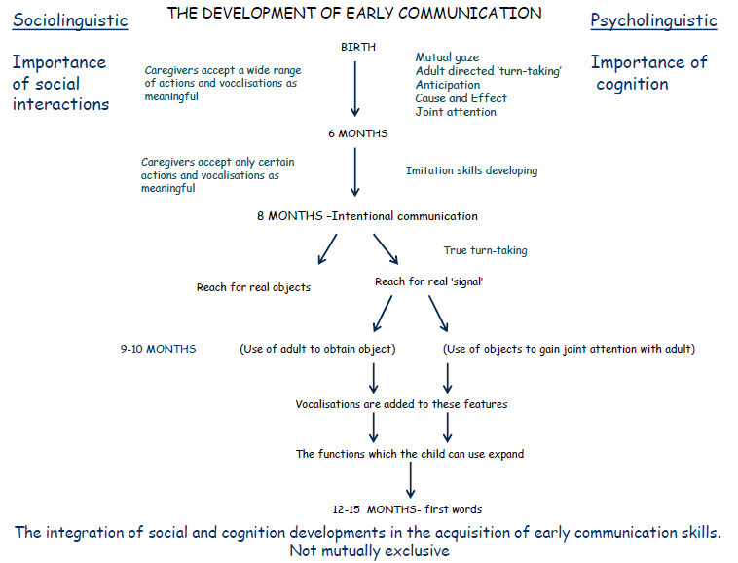

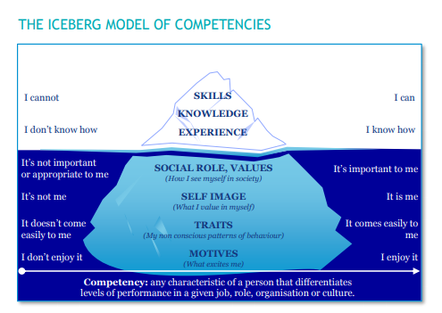
Appendix 2

Appendix 3
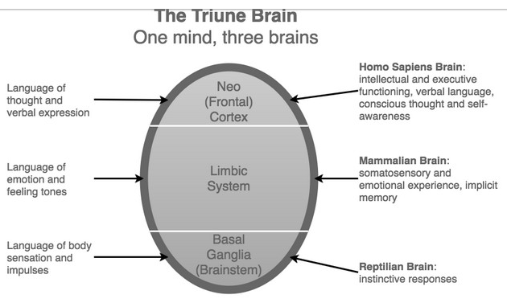

Appendix 4
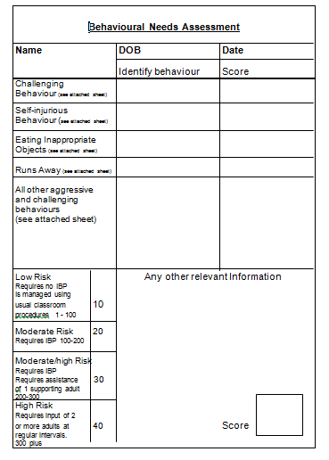

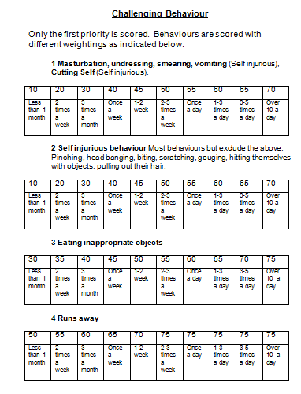
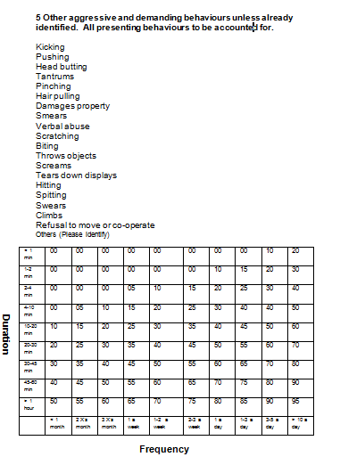

Appendix 5
PIVATS Speaking P5
Green – target achieved
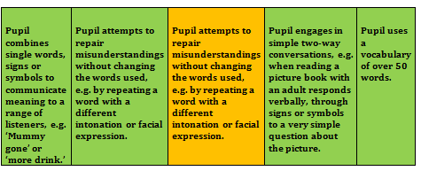
Orange- target not achieved
McLachlan & Elks (2007) Communication Steps – Words and Ideas stage:
Level of communication | What is communicated? | How is it communicated? | Interaction skills | Play skills
Words and Ideas (12-18 months) | Simple words/ signs/ symbols/ objects to: name things, request, ask for more and expand on purposeful ‘messages’ without words, e.g.:  I want  (requesting)  No  (rejecting)  Dog  (naming)  It’s gone  (disappearance)  Mine  (possession) | Initially uses non-verbal communication but gradually may use words/signs./symbols. Communication is approximate at first. | Needs adult to respond to his communication and provide models of language. Can initiate. Interactions- may have 1 or 2 turns. | Can explore several objects at once. Enjoys sorting, Can play with large doll objects and relate these to self/another person.

Appendix 6
Challenging behaviours recorded – one week prior to the intervention.

Day | Time | Behaviours  Observed | Duration | Trigger
Monday | 09.35  11.30  1.30 | Throwing objects  Shouting  Lying on floor with head down  Pulling on door to try and open- hitting door | 6 mins  2 mins  5 mins | Refusing to go to assembly.  Getting pack lunch out of bag  before lunch time and being told it was too early.  Trying to go outside straight after circle time when an activity was first.
Tuesday | 09.30  11.45  1.15 | Ignoring instruction– carrying on with activity  Opened class door and went out into corridor, lay on floor and hitting fists on floor  Threw toothbrush on the floor | 3 mins  4 mins  1 min | Wanted to continue to play with choice item and refused to join circle time.  Wanted to go to dinner– too early.  Refused to brush teeth after circle time.
Wednesday | 9.35  10.30  12.30 | Shouting  Throwing objects  Hitting out  Threw crisps on the floor, knocked over a drink  Shouted and hit out at staff | 8 mins  6 mins  9 mins | Asking for bubbles ‘bubu’- instructed circle time first, then bubbles.  Wanted an extra packet of crisps.  Took item off another child. When item given back to child he reacted.
Thursday | 09.00  10.15  12.30 | Put head on table  Threw food on floor and stamped on it  Threw toy up onto the roof  Shouting  Hitting out | 2 mins  4 mins  9 mins | Refused to go outside.  Took another pupils snack and staff gave item back to pupil.  Did not want to share item with another child.
Friday | 10.00  1.00 | Tipped chair over and kicked table  Pushed another child | 7 mins  5 mins | Wanted to take choice item to assembly.  Refused to come from outside back in for circle time.

Appendix 7
Challenging behaviours recorded – one week after the intervention

Day | Time | Behaviours  Observed | Duration | Trigger
Monday | 09.35  11.30 | Head down on table  Picked up dinner box and tried to leave class | 1 min  3 mins | Refusing to go to assembly.  Wanted to go to dinner– too early.
Tuesday | 11.30  1.15 | Picked up lunch box and showed staff  Threw toothbrush on floor | 3 mins  1 min | Wanted to go to dinner– too early.  Refused to brush teeth.
Wednesday | 12.30  1.00 | Pulling on door handle  Head down on table | 5 mins  1 min | Wanted to go in from outside early.  Refusing to join circle time.
Thursday | 10.15  1.15 | Knocked a bowl off the table  Ignoring instruction– carrying on with activity | 2 mins  1 min | Wanted another bowl of crisps.  Wanted to carry on playing with preferred activity
Friday | 10.00  1.00 | Head down on table  Snatched toy from another child | 1 min  6 mins | Refusing to go to assembly.  Did not want to share toy.

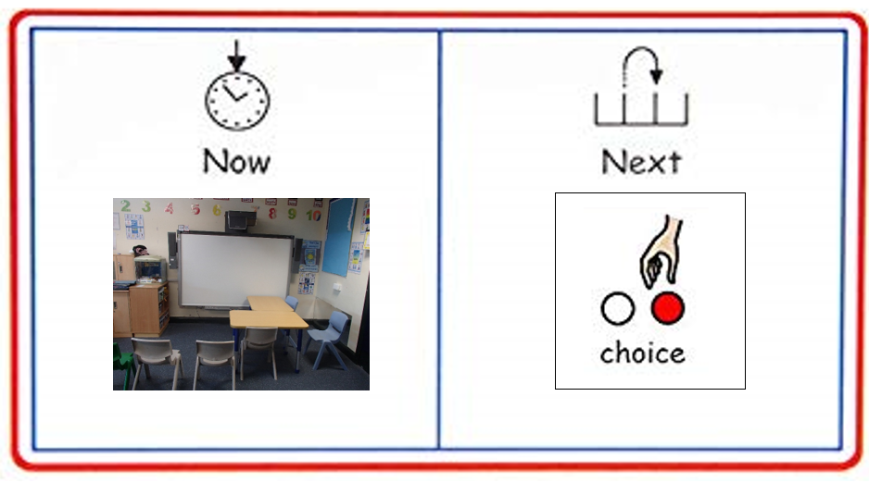
Appendix 8

Appendix 9
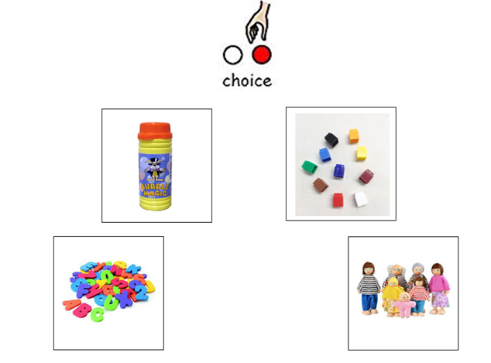
Communication board

Appendix 10

Maslow’s Hierarchy of Needs


