Postgraduate/Distance Learning
Assignment coversheet & feedback form

THIS SHEET MUST BE THE FIRST PAGE OF THE ASSIGNMENT YOU ARE SUBMITTING (DO NOT SEND AS A SEPARATE FILE)

For completion by the student:
Student Name: Debbie Lear

Student University Email: 2406411@student.uwtsd.ac.uk
Module code: HPCA7031  Module title: Astrology, History, Spirit and Soul | Student ID number:  2406411 |  |  | Educational support needs:  /No
Assignment title: A Critical Review of three primary source documents.
Assignment 1

Assignment due date: 18th November, 2024
This assignment is for the 2nd module of the degree
I confirm that this is my original work and that I have adhered to the University policy on plagiarism.
Signed ……………………………………………………………
Email submission:if you are submitting this form via email, please tick this box 
(as a substitute for your signature) to confirm that you agree to the above declaration.
Assignment Mark
1st Marker’s Provisional mark
2nd Marker’s/Moderator’s provisional mark
External Examiner’s mark (if relevant)
Final Mark

NB. All marks are provisional until confirmed by the Final Examination Board.

For completion by Marker 1 :
Comments:

Marker’s signature: |  |  | Date:
For completion by Marker 2/Moderator:

Comments:

Marker’s Signature: |  | Date:
External Examiner’s comments (if relevant)

External Examiner’s Signature: |  | Date:

Debbie Lear - 2406411

Astrology, History, Spirit and Soul

HPCA7031

Word Count: 2901

18 November 2024

A Critical Comparison of Mercury in three primary source documents.

This paper will compare the astrological treatment of Mercury in the following three sources: Ptolemy, Tetrabiblos, Translated by F. E. Robbins. Loeb Classical Library 435. Cambridge, MA: Harvard University Press, 1940, Lilly, William, Christian Astrology, 1647. Retyped and annotated by Deborah Houlding. Bel Air, MD: Ascella Publications, 1999, and Greene, Liz, and Howard Sasportas, The Inner Planets: Building Blocks of Personal Reality. York Beach, ME: Weiser Books, 1993.

In this essay, I will briefly introduce each astrologer and their cosmologies and continue to develop and synthesise their astrologies concerning the behaviour of Mercury. I will break this process into themes: Mercury’s planetary qualities, astrological methods, character and behaviour, and lightly touch on psyche, soul and myth.

The authors and their cosmologies.

Ptolemy
Ptolemy was an Egyptian astronomer thought to have lived around 100 – 178 CE. His Tetrabiblos (Mathematical Treatise) is a crucial Greek/Hellenistic astrological text. Ptolemy adopts Aristotle’s natural philosophical model of the cosmos, a scientific, mechanical system in which planets are under the divine control of a ‘prime mover’. As the planets interact in their movements, they influence each other, positively or negatively, relative to each other and their placement in the zodiac. According to Aristotle and Ptolemy, the planets are divinely ‘moved’ and directly correspond to our earthly life. We can ‘observe’ and experience these ‘physical’ occurrences as the ‘heat of the sun’ or the ‘moistening of the moon.’ In other words, in-line with Aristotle’s thinking, we have empirical knowledge of the luminaries through our sense perception. By observing the physical movements of the planets, the skilled astrologer can ‘rationally’ predict future events, just as we can predict the seasons. In the Tetrabiblos, Ptolemy introduces his methodology and proceeds to illustrate how the planets’ behaviours and interactions can denote mundane events on Earth and how natal horoscopes can provide insights into a subject's health and nature.

William Lilly (1602–1681) was a 17th-century Christian astrologer. Like Ptolemy, in his book, Lilly’s Christian Astrology, he also adopts Aristotle’s model of the cosmos; however, he includes the work of other astrologers, sometimes intervening with alternative methods if he sees significant patterns emerging in his work as an astrologer. Aristotle’s natural philosophy allows astrology to be accepted within Christianity because the ‘prime mover’ is essentially God. Lilly’s Christian Astrology has three chapters: the first describes his methodology; the second, judicial or horary (of the hour) astrology, whereby a chart is cast according to the exact date and time a question is asked. An example question would be. ‘Whether a woman is honest.’ Lilly p.151 and finally, natal astrology, using the time and place of birth. Lilly’s book illustrates how astrology can answer questions about health, sickness, riches, marriage, and life expectancy.
Lilly’s astrological methods vary from Ptolemy's. Although Ptolemy talks of planetary aspects: ‘oppositions’ of 180 degrees, trines at 120 degrees, Squares at 90 degrees and sextiles at 30 degrees, he does not speak of houses but of ‘places’ or positions, as we may observe them in the night sky. Lilly includes details of a house system, divided at 30-degree intervals, which contain each of the twelve zodiac signs, beginning with Aries and concluding with Pisces. Additionally, he assigns parts of the body to each sign of the zodiac, each house of the zodiac and each planet. Mercury correlates to diseases of the brain, spirit, imagination, speech, tongue, fingers, hands, speech, coughs, falling evil and madness.

Howard Sasportas
Howard Sasportas (1948–1992) was an American-English psychological astrologer and co-founder of the Centre for Psychological Astrology along with Liz Greene. Contrary to Ptolemy and Lilly, who both saw a physical correlation between the cosmos and life on Earth, Sasportas focuses on how the planets can symbolise aspects of our psyche and personality, how we think and behave. Astrology can help us identify areas in our lives where we may have hidden, unconscious issues that we can work to transform. There is no mention of technical methodology in Sasportas’s Inner Planets; the reader is assumed to be familiar with the zodiac and houses. The archetypal qualities of Mercury are made apparent, primarily by a lecture where examples of character traits are linked to Hermes’s behaviour in Greek mythology. Sasportas proceeds to guide us through Mercury’s placement in each zodiacal sign, giving examples of how planetary placements and their aspects to other planets may provide insights into a subject’s psyche: When Mercury is in the sign of Leo, the subject may be prone to ‘embellishing the truth’ or in Sagittarius, ‘turn a minor incident to a matter of great significance.’

A significant distinction between Ptolemy, Lilly and Sasportas’s treatment of Mercury is that both Ptolemy and Lilly adhere to a framework of rigid, mathematical rules that allow them to make ‘rational’ judgements relating to our ‘physical’ life on earth. For example, Ptolemy may ask how a subject’s marriage may play out. Lilly may ask whether a disease will be long or short. Sasportas adopts a looser, interpretative modality based on Jungian archetypal qualities, ‘Jungian archetypes serve as templates for human experiences and are expressed through symbols and images’ We can identify mercurial qualities in the archetypes of the trickster, the magician, the messenger, the guide and the hero. According to Richard Tarnas in his book Cosmos and Psyche, Jungian archetypes are essentially the psychological equivalent of Plato’s Forms; he writes, ‘The original Jungian archetypes were primarily considered to be the basic formal principles of the human psyche, the original Platonic [and Aristotelian] archetypes were regarded as the essential principles of reality itself, rooted in the very nature of the cosmos.’ .

Mercury’s planetary qualities
According to Ptolemy, Mercury's inconsistencies are expressed in its physical behaviour. He focuses on the planet’s elemental properties and how it is affected by the luminaries. He also comments that on its swift obit, it is in constant flux, between hot and cold, day and night, male and female:

‘Mercury in general is found at certain times alike to be drying and absorptive of moisture, because he never is far removed in longitude from the heat of the sun; and again humidifying, because he is next above the sphere of the moon, which is closest to the earth; and to change quickly from one to the other, inspired as it were by the speed of his motion in the neighbourhood of the sun itself.’

Mercury is androgynous since he produces the dry [sun, male] and the moist [moon, female] alike.’ He is the only planet that Ptolemy lists as being both beneficent and maleficent, male and female, diurnal and nocturnal, both the morning and evening stars. Lilly, too, writes that Mercury cannot be considered masculine or feminine because the planet becomes the gender of whichever other planet ‘joins’ it. Similarly, regarding a planet’s malevolence or benevolence, it acts as ‘good’ or ‘ill’. For Sasportas, Mercury can temporarily ‘mimic’ any archetypal qualities of the other planets; he is all of them, yet he is none. Sasportas also implies that having a ‘strongly emphasised’ Mercury placement or Mercury-ruled sign in the natal chart can suggest confusion regarding a person’s sexual identity because they often have an attraction to both men and women.

Astrological methods
Lilly uses Ptolemy’s table of planetary dignities in his methodology (See Fig.1). The luminaries rule over one planet each; the sun rules over Leo, and the moon, Cancer. All other planets rule two portions of the zodiac. Mercury rules Gemini by diurnal expression and Virgo by nocturnal expression. A diurnal expression denotes a planet in a chart where the sun is above the horizon and a nocturnal expression when the sun is below the horizon. When a planet is found to be in one of the houses it rules, it is in its Domicile, where it is in its most robust expression; however, at 15 degrees of these houses, it is in the most potent form of its expression. Mercury is in Domicile in Virgo in a night chart and Gemini in a day chart, as noted above. When Mercury is found in unfavourable signs of the zodiac, its strength can be weakened, depending on the elemental properties of the sign it finds itself in. In his explanations of Mercury and planetary placements, Ptolemy consistently refers to the elemental changes planets exchange in their interactions. Lilly, on the other hand, relates to the potential outcome. Lilly’s descriptions are far more precise than Ptolemy's and more instructional for the reader; the judgements are implicitly laid out.

Mercury rules Gemini and Virgo; He is exalted at fifteen degrees of Virgo and in detriment in Sagittarius and Pisces; his fall is in Pisces. He rules the first and eighth hour of Wednesday and the whole day. His allies are Jupiter, Venus, and Saturn, and his enemies are all other planets. (Lilly) p.31

According to Lilly, a well-placed Mercury can gift intellect, eloquence, wit, ambition, curiosity, a talent for divination, a curiosity for occult knowledge, and a successful entrepreneur. When ill-placed, deceptive, a gossiper, a liar, ‘given to wicked arts, as necromancy and such like ungodly knowledges.’ Sasportas’s descriptions echo this: Mercury is an ‘outrageous liar’, ‘brat’, and ‘a child that would do anything to get attention, even if it means behaving badly.’ ‘A thief, trickster and magician.’ Sasportas suggests what behaviours could be displayed: ‘Mercury’s house position could be an area of life where we are prone to distorting the truth, or where we can be very persuasive, to the point of resorting to devious tactics to win over others.’

Triplicities
The Aristotelian elements, Earth, Air, Fire and Water, are grouped into triplicities. Mercury is the only planet that rules both the Earth and Air triplicities. During a daytime chart, Mercury rules the triplicity of air – Gemini, Aquarius and Libra; in a nighttime chart, the triplicity of Earth, Virgo, Taurus and Capricorn. Mercury loses its potency when it finds itself in an elemental triplicity with which it doesn’t participate (fire or water). For example, its qualities are weakened in Cancer, Scorpio and Pisces. According to Sasportas, someone ‘with Mercury in any water sign may have a secretive mind and quite a bit of caution about what they reveal to you about themselves, as if their instincts tell them it is safer not to give too much away.’ Here, we see an example of Mercury’s ability to absorb the elements of the planets or signs he interacts with. He loses his speed and focus in a water sign, and clarity becomes subdued. As Ptolemy describes, Mercury can be both master creator and destroyer as he interacts with other celestial bodies.

‘Mercury, if he gains the rulership, is generally speaking, in nature like whatever of the other planets may be associated with him. In particular, he is above all stimulating, and in predictions concerning men is keen and very practical, ingenious in any situation; but he causes robbery, theft, piracy, and assault, and furthermore, brings about unsuccessful voyaging when he is in aspect with the maleficent planets, and occasions of disease and dryness, quotidian agues, coughs, raising, and consumption. He is the cause of events taking place which concern the priestly code, the worship of the gods, the royal revenues, and change in customs or laws, from time to time, in consistency with his association with the other planets on each occasion. With reference to the air, since he is very dry and swift on account of his nearness to the sun, and the speed of his revolution, he is particularly apt to arouse irregular, fierce, and unchangeable winds, and as might be expected, thunder, hurricanes, chasms in the earth, earthquakes and lightening; sometimes by these means he causes the destruction of useful animals and plants. At setting he diminishes waters and rivers, at rising fills them.’

Mercury: Character and behaviour
In Ptolemy’s table of planetary dignities, the water houses are ruled by Mars, which we might expect would result in Mercury becoming more ‘fiery’ or passionate and impulsive in communication. In Lilly’s astrology, the water triplicity is ruled by Saturn during the day and Mercury during the night. In this placement, we could consider Mercury in aspect to Saturn being favourable; Saturn can give structure to the conceptual qualities of Mercury. Contrarily, Mercury can ‘assist’ in Saturn's negative attributes for Ptolemy, especially in health matters, where it is inclined to ‘Prolong evil effects.’ When unaspected or ‘alone’, Ptolemy claims Mercury makes one toothless, deaf and dumb, though clever and cunning. Ptolemy

We can understand character traits, appearance and behaviour through Mercury’s placement in the natal chart. For Ptolemy, the placement of a planet on the eastern horizon at birth gives us insight into a person’s bodily form and temperament’ He maintains that a person with Mercury here will have ‘a sallow appearance, be of moderate height, graceful, with small eyes and moderately curling hair, and be warm in temperament.’, however, when placed in the west they are ‘not of good colouring, with straight hair and olive complexion, lean and spare, with glancing, brilliant eyes and somewhat ruddy; in temperament they exceed in the dry.’ For Lilly, Mercury takes on the influence of any planet it is in aspect with; Saturn makes for ‘heavy, Jupiter more temperate, Mars is rasher, Sun more gentle, Venus more jesting, Moon more shiftier.’ Sasportas speaks more about behaviours than appearance: If Mercury rises before the sun, you think first and then act; but if the sun rises ahead of Mercury, you act first and then later seek a justification for your actions.’. Sasportas also believes that Mercury is ultimately our capacity to conceptualise, order, rationalise, and, in this respect, decide action. In some ways, it is an intermediary between the inner and outer worlds. Mercury’s ability to transform from male to female, hot to cold, allows us to check out situations and ‘decide whether to approach them from a ‘yang place or yin place’, whether we act in a masculine or feminine capacity.

Mercury: psyche and soul.

For Ptolemy, Mercury is one of the two planets that govern the soul, the other being the moon. In Book III, Chapter 14 of the Tetrabiblos, he addresses the diseases of the soul. He maintains that the positions of Mercury (thought and intellect) and the moon (emotions), and their relationship to each other and the angles (the cusp of the first, fourth, seventh and tenth houses), and to the planets, can reveal the qualities of the soul:

When in addition, the governors of the soul, [Mercury and the moon] … are in their own or familiar houses or sects, they make the characters of the soul open, unimpeded, spontaneous, and effective, especially when the same planets rule the two places at once, that is, when they are configurated to Mercury in any aspect whatever and hold the separation or application of the moon; if they are not so disposed, however, but are in places alien to them, it renders the properties of their own natures obscure, indistinct, imperfect, and ineffective with respect to the active qualities of the soul.’

In this sense, we see Mercury and the Moon creating tension. An ‘open soul’ would have planetary placements in their ‘correct’ position, in harmony within its operating system. When planets are in unfavourable positions, as in the moon in a day chart or Mercury in a water sign, the elemental balance is off-kilter, the soul or spirit becomes weaker, driven by too much emotion and not enough rationality, or vice versa. The ideal soul would be in complete balance with the cosmos. This way of thinking points to a cosmos governed by universal laws, a divine system whereby our natal chart can illuminate the hand that fate has dealt us, our natural talents or gifts and areas where we may find difficulties.

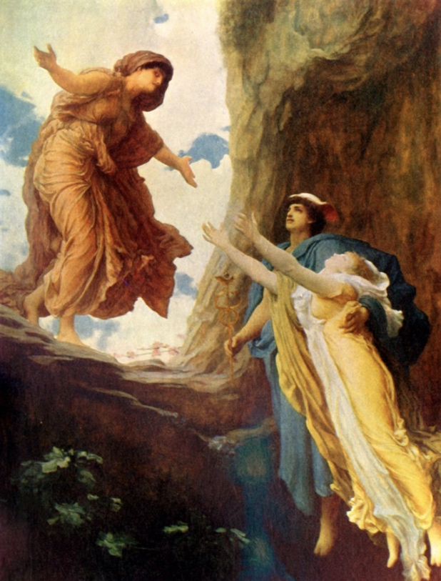
The Return of Persephone
Frederic Leighton

Mercury, the messenger
Sasportas doesn’t talk about the soul; his focus is on the Underworld, which he considers a metaphor for the ‘unconscious, where unintegrated positive and negative psychic contents are buried and repressed.’ Hermes (Mercury) was tasked with negotiating Persephone’s release from Hades and the Underworld in Greek mythology because of his communication and negotiating skills. Mercury, in aspect to Pluto, symbolises ‘Pluto, calling Mercury into the Underworld – we can benefit by exploring the unconscious to discover deep complexes and ‘untapped potentials.’ Mercury is called upon for reflective, analytical skills in ourselves; what areas in life can we transform and innovate? It is Mercury that guides us through this symbolic journey into the Underworld. At these moments, Mercury is the rescuer, the hero, triumphant; at others, he is the petty thief, the gossiper, and the manipulator. In The Astrology of Fate, Liz Greene sees Hermes’s talent for synthesising diametrically opposite themes, perhaps because of his dualistic nature: ‘Hermes fosters relationships even through quarrelling and separateness and brings things together through their differences and vice versa. Additionally, Sasportas observes that Mercury tends to appear strongly in clients’ charts when they are going through a transition in their lives. For Sasportas, Mercury is the rescuer of the divine child within us all; wherever we find Mercury in our natal chart, we are asked to stay open and curious about life.

Conclusion

This comparison of Ptolemy’s Lilly’s and Sasportas’s astrology shows that Mercury is swift, malleable, Machiavellian, and consistently inconsistent. All three astrologers refer to his ability to absorb the qualities of other planets, culminating in a positive or negative expression. We have observed that regardless of each astrologer’s cosmology, the qualities and archetypes associated with Mercury can show up physically and psychologically. While both Ptolemy and Lilly adhere to the Aristotelian view of the cosmos, in the sense that the physicality of the cosmos essentially reflects life on earth, they both address questions regarding the soul or temperament of a subject, which is in line with Sasportas’s psychological astrology. Ptolemy’s writing reinforces the planet's elemental aspects, allowing for a deep understanding of its changeable nature under certain conditions. He is the magician, wandering between worlds, the messenger, the rescuer, the governor of the soul, a cunning thief, and a master craftsman. He can woo us with poetry or cut us with the sharpest of tongues; he can be everything and nothing, depending on which planets he ‘plays’ with and where they interact. Essentially, As Dane Rudhyar observes, Mercury is a moveable feast:

Mercury is the hand that weaves the many patterns of the living. It is a servant; at times, a treacherous one. It is synthetising agency, which has little to say as to what it synthezises. It relates everything there is. It co-ordinates. It fashions. It combines the quintessence of all relationships, of all life-functions. It is the Master-Workman, the Master of Works.

Appendix 1.

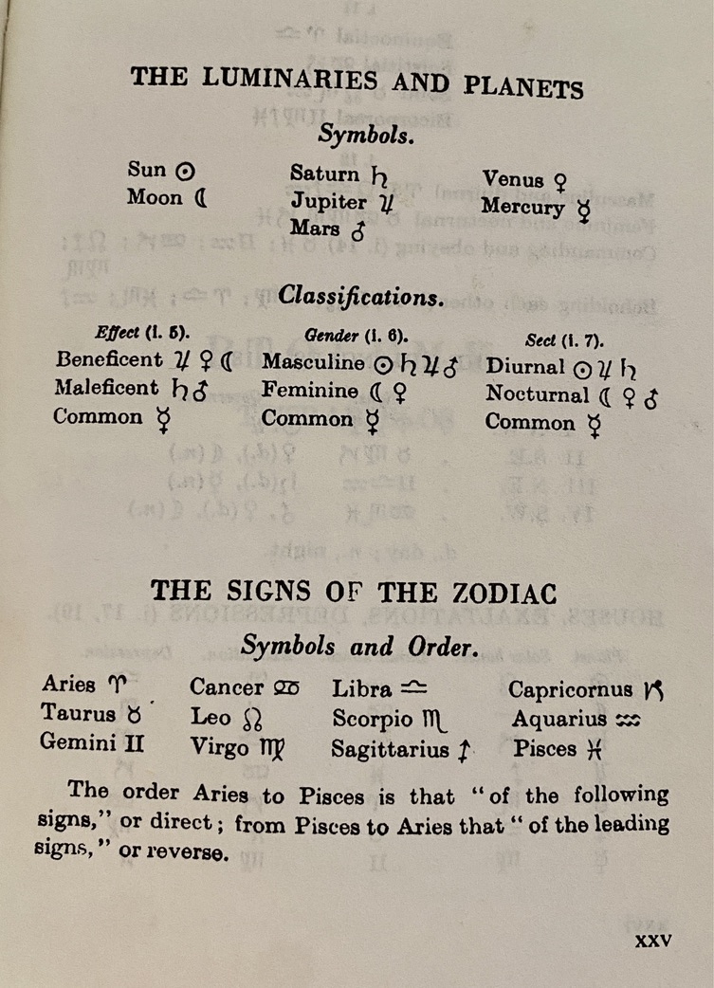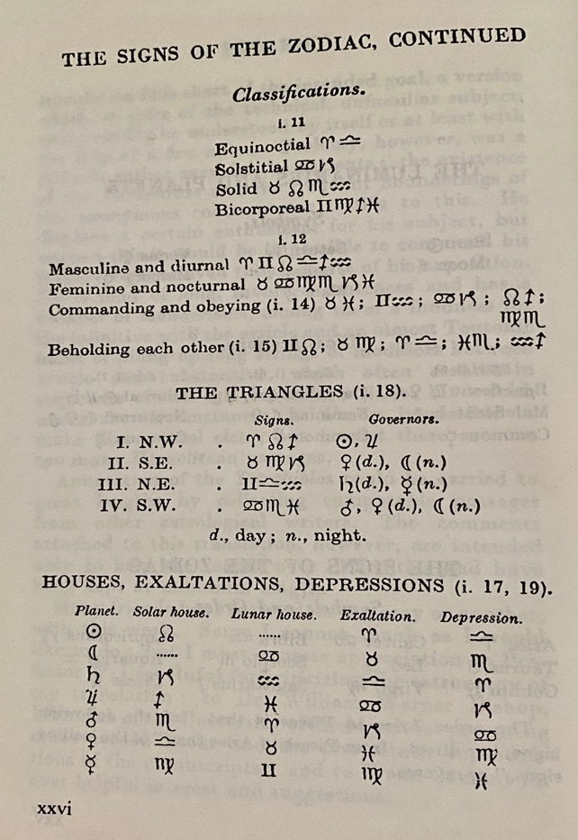
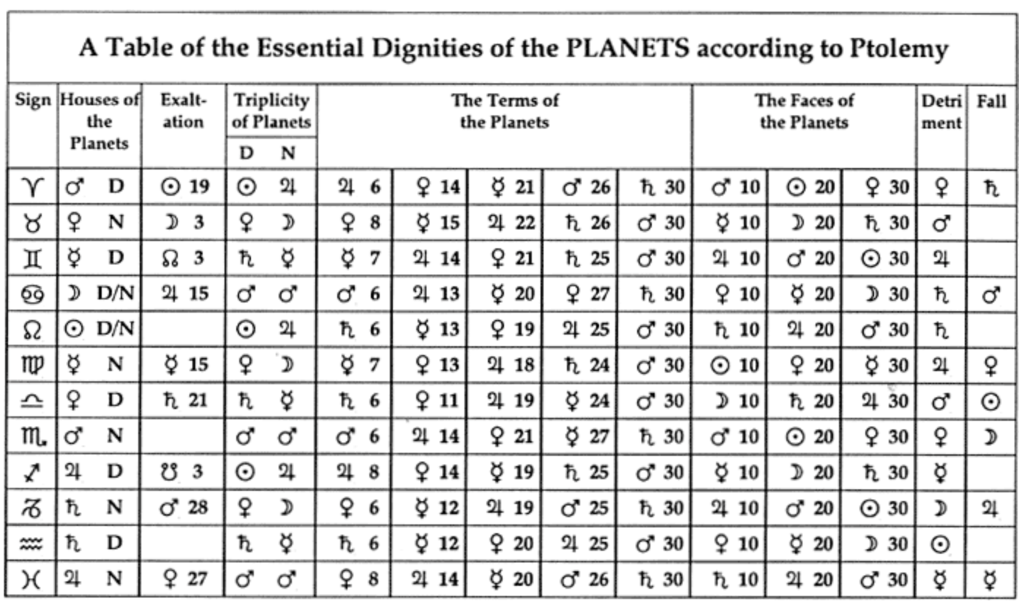

Appendix 2. William Lilly’s Planetary Tables
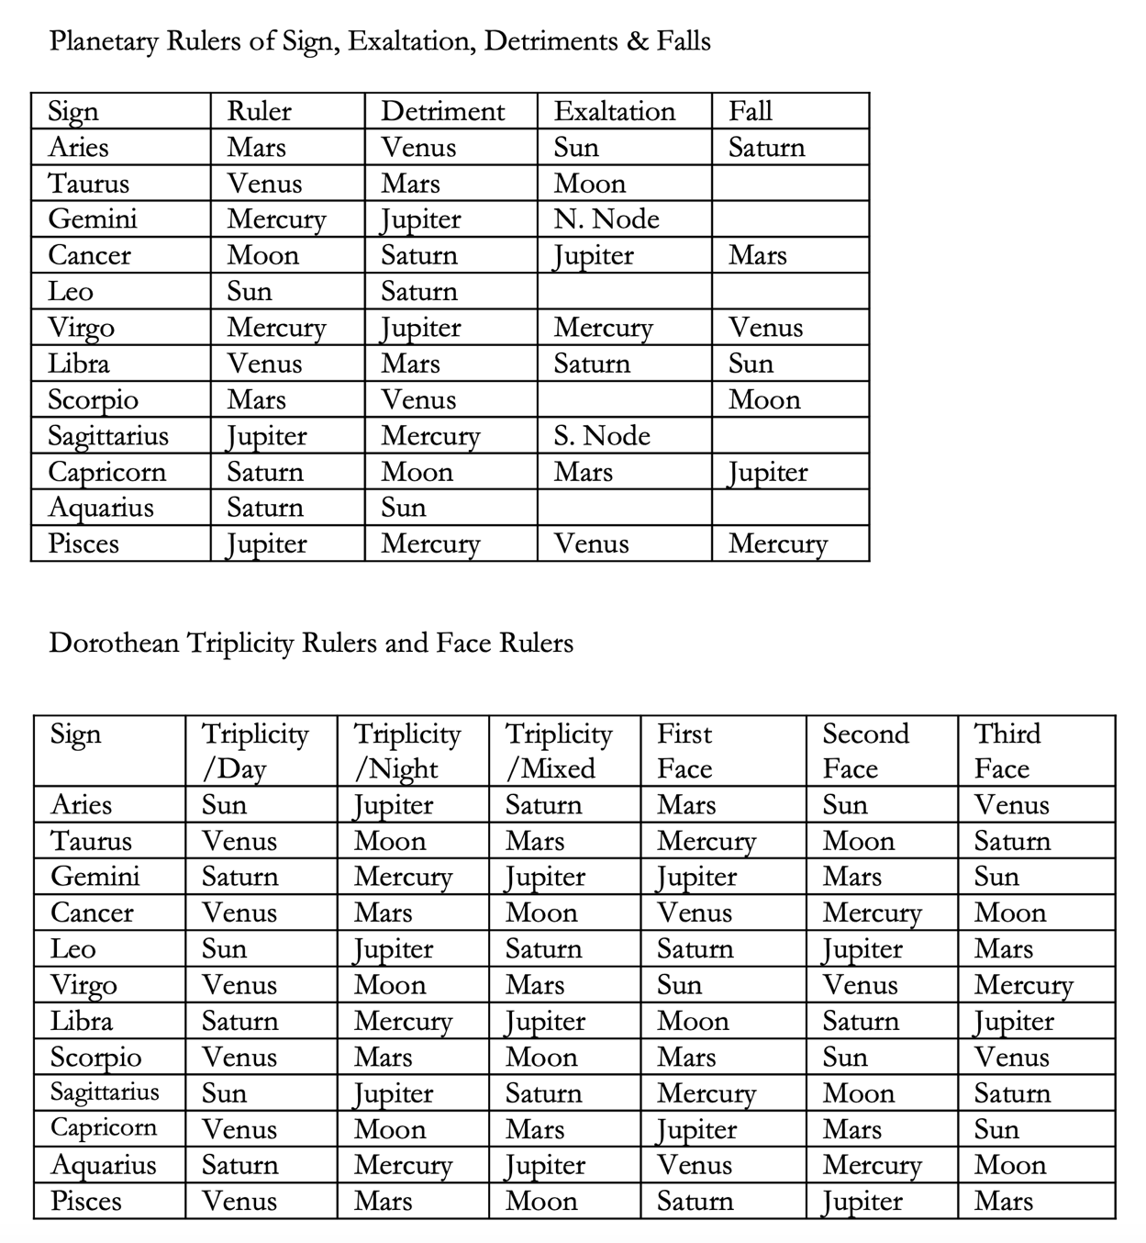

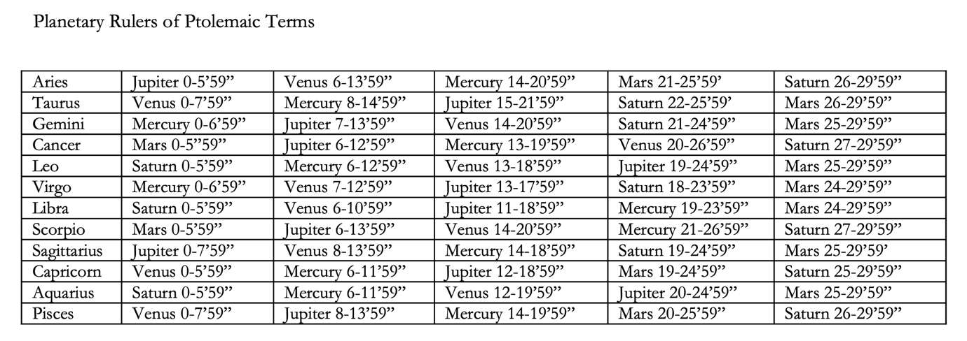

https://www.renaissanceastrology.com/essentialdignitytables.pdf
Accessed 21 November 2024
Lilly's Table to Examine the Strength & Debility of Each Planet

Essential Dignities |  |  | Essential Debilities
In own sign or in mutual reception with another planet by sign [1] | +5 |  | In Detriment | -5
In exaltation, or mutual reception by exaltation | +4 |  | In Fall | -4
In own triplicity | +3 |  | Peregrine | -5
In own terms | +2
In own face | +1
Accidental Dignities |  |  | Accidental Debilities
In the 10th or 1st house | +5 |  | In the 12th house | -5
In 7th, 4th, or 11th house | +4 |  | In the 8th or 6th house | -2
In the 2nd or 5th house | +3
In the 9th house | +2
In the 3rd House | +1
Direct in Motion [2] | +4 |  | Retrograde | -5
Swift in Motion | +2 |  | Slow in Motion | -2
Saturn, Jupiter, Mars when oriental [3] | +2 |  | Saturn, Jupiter, Mars when occidental | -2
Mercury, Venus when Occidental | +2 |  | Mercury, Venus when oriental | -2
Moon increasing in light (waxing) | +2 |  | Moon decreasing in light (waning) | -2
Free from combustion and sun's beams [4] | +5 |  | Combust (within 8°30' of sun) | -5
Cazimi (within 0°17' of the sun) | +5 |  | Under sun's beams (within 17° of the sun) | -4
Partile conjunction with Jupiter or Venus [5] | +5 |  | Partile conjunction with Saturn or Mars | -5
Partile conjunction with North Node | +4 |  | Paritle Conjunction with South Node | -4
Partile trine with Jupiter or Venus | +4 |  | Beseiged of Saturn and Mars [6] | -4
Partile sextile with Jupiter or Venus | +3 |  | Partile opposition with Saturn or Mars | -4
Conjunct the fixed star Regulus (29°40 Leo) | +6 |  | Partile square with Saturn or Mars | -4
Conjunct the fixed Spica (23°40 Libra) | +5 |  | Conjunct the fixed Algol or within 5° (26°04 Taurus) | -4

https://www.skyscript.co.uk/dig5.html Accessed 20 November 2024

Ptolemy, Tetrabiblos. Translated by F. E. Robbins. Loeb Classical Library 435. Cambridge, MA: Harvard University Press, 1940, Intro, p.viii.
Campion, Nicholas, Astrology and Cosmology in the World’s Religions. New York University Press, 2012, p.155.
Ptolemy, Tetrabiblos, p. 39.
Ptolemy, Tetrabiblos, p.73.
Lilly, William, Christian Astrology, Ascella, London, 1999, pp.119 - 132
Astrodienst, Howard Sasportas <https://www.astro.com/astrowiki/en/Howard_Sasportas> [accessed 13 November, 2024].
Sasportas, Howard, & Greene, Liz, Inner Planets: Building Blocks of Personal Reality, Samuel Weiser, Maine, 1993, pp.39-40.
Ptolemy, Tetrabiblos, pp.393-409
Lilly, William, Christian Astrology, p.119
Schaffner, Anna Katharina, Jungian Psychology: Unravelling the Unconscious Mind, 12 September 2024. <https://positivepsychology.com/jungian-psychology/#:~:text=Jung%20believed%20that%20the%20unconscious,conflicts%20(Jung%2C%201964).> [Accessed 22 November 2024].
Ibid.
Tarnas, Richard, Cosmos and Psyche: Intimations of a New World View, Plume, New York, 2007, p.85.
Ibid. p. 39.
Ptolemy, Tetrabiblos, p. 41.
Ibid Tetrabiblos p. 43
Lilly, Christian Astrology, p.3.
Sasportas, Inner Planets, p8.
Ibid. p
Lilly, Christian Astrology, p. 32.
Sasportas, Inner Planets, p.11
Ibid. p.11.
Ibid. p.42.
Ptolemy, Tetrabiblos, pp.187-188
Ptolemy, Tetrabiblos, p.329.
Ibid. 265.
Ibid. p.307.
Ptolemy, Tetrabiblos, p. 311.
Lilly, Christian Astrology, p.31
Sasportas, Howard, Inner Planets, p.53
Ptolemy, Tetrabiblos, p. 337.
Frederic Leighton, The return of Persephone, < https://artuk.org/discover/artworks/the-return-of-persephone-37738> [accessed 14 November 2024]
Sasportas, Inner Planets, p.12
Ibid. p. 20
Liz Greene, The Astrology of Fate, Weiser, Boston, 1984, p.195.
Sasportas, Inner Planets, p.13.
Rudhyar, Dane, New Mansions for New Men, Lucis, New York, 1938, p.147

