Dissertation:

Challenges in making US manufacturers
less dependent from the China supply chain

Student: Philipp Mahrenholtz
Student ID number: 1906345

Date: 8th of March 2022
Total number of pages: 124

Declarations

This work has not previously been accepted in substance for any degree and is not being concurrently submitted in candidature for any degree
Signed:
Date: 8th of March 2022

Statement 1
This dissertation is the result of my own independent work/investigation, except where otherwise stated.
Other sources are acknowledged by footnotes giving explicit references. A bibliography is appended.
Signed:
Date: 8th of March 2022

Statement 2
I hereby give consent for my dissertation, if accepted, to be available for photocopying and for interlibrary loan, and for the title and summary to be made available to outside organisations.
Signed:
Date: 8th of March 2022

Acknowledgements
After an exciting safari through six modules, this dissertation aims for the trophy of my MBA studies at the University of Wales, Trinity Saint David. The ride was fuelled on what I have learnt during two course years, and I am looking forward to using the acquired experience and knowledge in my future work. Many thanks to the tutors of the courses I attended for helping me exploring new territories: Anthony Burns, Roisin Mullins, Davina Wyn Evans, Glenn Behenna, Richard Dunstan, and Felicity Healey-Benson – all of them experts in their fields. Special thanks also to Alex Bell, the programme director. I am especially grateful to Anthony Burns for supervising my dissertation.

Summary / Abstract
Many US manufacturers are dependent on their supply chains in China. Prompted by various factors including the US-China trade war and the Covid-19 pandemic, global manufacturers strive to reduce this dependency. Despite some sincere intention, however, many of them failed to relocate substantial portions of their supply chain away from China that remains the dominant manufacturing superpower. This dissertation investigates the challenges in making US manufacturers less dependent from the Chain supply chain. The broader context is exemplarily concretised for global manufacturers of power tools that form the background of the research.
Reducing the US dependency by diversifying the supply chain away from China does not only touch several currently hotly debated themes of economics and politics. It has also practical relevance for many global manufacturers entangled in the Chinese supply chain. The presented research revealed several findings of high interest:
- The diversification strategy depends on the specific situation. For global manufacturers of power tools, China is primarily a production location but not a sales market. These companies are ready to reduce their investment in the China supply chain by not further extending their local production capacities. However, their engagement in contracted manufacturing and sourcing of finished goods has not substantially been reduced yet.
- China with its heavily subsidised and state backed industry remains a very attractive supply location, in view of costs and convenience. Areas where the China supply chain fells short, i.e. environmental protection and human rights, are not that relevant in business to date.
- The US with its free politico-economic system failed to adapt to contemporary China and its command enterprises. The global manufacturers with their typically short-term profit orientation are reluctant to develop and maintain a long-term strategy to overcome the challenges of supply change diversification.
Based on these findings strategical recommendations are given:
- The diversification away from China must be financially valid, i.e. cost-effective. Tariffs and anti-dumping-duties will unfortunately be required to compete against China’s subsidised and state backed economy. On the other hand, US manufacturers must get more competitive and increase productivity by digitalisation and automation.
- The diversification away from China must be convenient enough. US manufacturers tend to fall back on old habits and stick to the China supply chain which has been trimmed for attractiveness by the West for decades. At the same time, it must be prevented that for convenience the Chinese suppliers are just asked to move their factories to e.g. Mexico.
- The diversification away from China can be supported by a mandatory declaration of the country of origin on the products and in online shops. This gives purpose to employee of the US manufacturer and the customer who is then prepared to pay more for products that are not made in China.
These are politically charged matters and, therefore, future research should investigate meaningful governmental tools to support US manufacturers in reducing the dependency on the China supply chain.

Table of content

1 Introduction 8
1.1 Aims and objectives 10
1.2 Further background 11
1.3 PESTLEE factors and Porter’s 5 forces 13

2 Literature review 20
2.1 Global supply situation, current economic policy, and trends 21
2.2 Particular situation of manufacturers in the context of US-China trade war 24
2.3 Diversification of the supply base, nearshoring and homeshoring 30
2.4 Environmental and ethical considerations and implications on marketing 35

3 Methodology 38
3.1 Research process 38
3.2 Assumptions, limitations, and scope 42
3.3 Ethical considerations 42

4 Research data 43
4.1 Company reports of power tool manufacturers 43
4.2 Interview of business people 45

5 Results: Analysis of the research data 49
5.1 Company reports of power tool manufacturers 49
5.2 Interview of business people 53

6 Discussion of the research results 59
6.1 Supply chain diversification? It depends… 59
6.2 Costs, costs, costs – then convenience 61
6.3 China drives the new world order 65
6.4 The ball is in the West, US 70

7 Conclusions and recommendations 76
7.1 Conclusions 76
7.2 Recommendations 78

8 Appendices 81
8.1 Appendix A: Summary of company reports 81
8.2 Appendix B: Parsed interview protocols 85
8.3 Appendix C: Completed ethics form 95

9 References 106

Introduction
Many manufacturers in the United States (US) have outsourced their production to China. A trend that started after China was officially recognized by the US in 1972 under President Richard Nixon and opened up under the leadership of Deng Xiaoping with his Open Door Policy introducing far-reaching market reforms. What started as a mutually beneficial utilisation of competitive advantage for labour intensive production in the sense of Adam Smith and liberal trading (Smith, 1776), ended in a total dependency of US manufacturers on the China supply chain. Today, China’s factories produce nearly everything and there is hardly a way around Made-in-China products for enterprises or customers. China enabled many multi national enterprises (MNE) to produce profitably and to scale up their business quickly (Ismail et al., 2014).
Power tools used in the construction and Do-It-Yourself (DIY) industry is an archetypical example of a product that US manufacturers have China made for the global market. However, over the last few years, this business model got under pressure and its sustainability in the long term became questionable (Hille, 2020). The cumulation of global tensions in the US-China war under Donald Trump’s presidency was the most prominent, however, neither the first nor the only visible phenomenon of this development in a new era of protectionism (Fahrion et al., 2021). The growth of revenue and profit is put at risk as tariffs make products imported from China more expensive and impair margins of the US enterprises. The supply chain instability hampered production in China due to energy and material shortage, further aggravated by the Covid-19 pandemic and a shortage of containers, resulting in all-low fill rates of Western warehouses. Moreover, production costs have been rising in China already for some time because of increasing wages (Fig. 1). At the same time, customers are getting increasingly aware of the China problem from an environmental and ethical standpoint including human rights, coercion of neighbouring countries and exertion of influence stretching as far as to the heart of the European Union (EU) (Tartar et al., 2018).
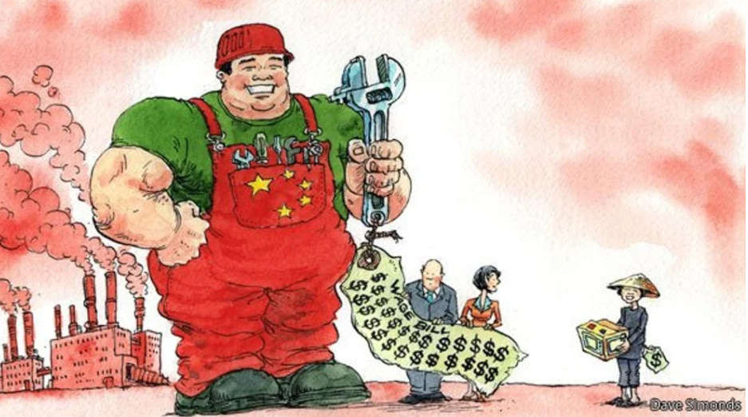
Figure 1: Manufacturing: The end of cheap China (The Economist, 2012)

In this environment, many MNEs plan to divert their foreign direct investments (FDI) to other countries and seek to diversify their supply chain currently concentrated on China. Also small and medium enterprises (SME) are forced to rethink their supply chain for components etc. Other low-cost countries are shifting into focus as a potential replacement for China, mostly in Asia but also nearer to the domestic markets (‘nearshoring’). In the extreme case, the production is brought back to the home country (‘homeshoring’) to make the products directly where they are sold, often coming along with a sentiment of patriotism. These activities have started already some years ago with however limited success (Goodman et al., 2021; Fang, 2020; Shih, 2020a; Doyle, 2000). Despite these activities, however, the trade deficit of the US towards China is still rising (Goldman, 2021), and China overtook US as the world’s leading FDI destination (Hannon and Jeong, 2021): Is the West inapt to overcome the challenges of reducing the dependency on the Chinese supply chain?
The key purpose of the dissertation is to investigate the problems underlying the efforts to diversifying the production in the attempt to reduce the dependency from Chinese suppliers. This topic is not only of high interest from an academic point of view as it contributes to the theoretical discourse of several hotly debated themes of economics and politics. It has also practical relevance for many manufacturers and their management entangled in the Chinese supply chain.

Aims and objectives
The primary aim of the dissertation is to understand the challenges in making US manufacturers less dependent on the China supply chain. Taking global manufacturers of power tools as an example, the problems are investigated in depth. Possible solutions are developed to overcome the dependency and, at the same time, to get the supply chain ecologically more sustainable and ethically less questionable. To achieve these aims, the following objectives are defined:

- Objective 1: Critically analyse the competitive environment of manufacturers to understand the challenges and their implications on the business within a macro and micro environmental framework.
- Objective 2: Analyse data collected from interviews with business people and from company reports of power tool manufacturers, and compare with information from reviewing critical literature.
- Objective 3: Draw conclusions to identify possible strategies for overcoming current roadblocks in the route to diversifying the supply chain.
- Objective 4: Give recommendations to foster US manufacturers in reducing the over-dependency on their China supply chain.
The subject of the dissertation deals with a typical challenge in a global business environment (Morrison, 2011). The environment will be analysed after some further background of the problem is given in the following section.

Further background
The supply of products from foreign countries to home markets can take various forms: It can be sourcing of a (potentially private labelled) off-the-shelf product from a local manufacturer, or contract manufacturing of a company’s own product, or supplying directly from a factory that is solely owned by the manufacturer or run by a joint venture (JV) as a result of an FDI. The diversification of the supply chain away from China is driven by various factors (Kalish, 2021). For US manufacturers, the main reasons and goals of diversifying the supply chain and getting less dependent on China are (MB, 2021):

- Reduce the dependency on just one country
  - More flexible supply chains can better respond to regional crises and are therefore more resilient while less at the mercy of a particular country (Villena and Gioia, 2020).
- Particularly, reduce the dependency on China:
  - China is getting increasingly costly, relocating away from China to low cost countries potentially helps to regain cost competitiveness (The Economist, 2012).
  - China-US trade war but also anti-dumping duties from the EU are adding further costs (Abnett, 2020); reducing imports from China help to decrease the costs (Harrison, 2019).
  - China is increasingly disadvantageous for FDI and problematic regarding intellectual property (IP) because China has the least level playing field (Chimits, 2021).
  - China’s standards are questionable from environmental and ethical standpoints, e.g. regarding pollution and human rights; moving out of China allows to live up to corporate social responsibility (CSR) (Kastner, 2021).
- Reduce the transportation distance by moving production closer to the consumer markets:
  - Shorter transportation distances help to reduce time and costs, but also to reduce the carbon footprint (Frans and Ruf, 2021).
  - By eliminating long distances or contested waters, transportation time shortens and the transportation gets more reliable (Yi, 2021).
- Improve marketing and customer targeting:
  - Increase sales by marketing products for customers environmentally and/or ethically concerned about environment pollution, human right abuses etc. taking place in countries like China (Carlile, 2021; Newman, 2020).
  - Increase sales by targeting customers with Not-made-in-China or Made-in-the-USA products (Tita, 2019).

These are a number of unambiguous incentives for Western companies to diversify away from China. The Covid-19 pandemic has made the urgency for a change even clearer (Patel, 2020). However, less so unambiguous are the results achieved to date. Though new data shows that US companies are leaving China (Rapoza, 2021), China has passed the US as No. 1 destination for foreign investment (Hansen, 2021a).

PESTLEE factors and Porter’s 5 forces
The points listed in the background section touched various micro and macro environmental aspects global manufacturers of power tools are facing in relation to supply chains and their diversification. Before a comprehensive literature review is presented in the following section, the environment is briefly outlined to further introduce and frame the situation this kind of companies are operating in. The environment on the macro level will be investigated by the PESTLEE factors, and on the micro level by the Porter’s 5 Forces model.

The PESTLEE analysis, an extended version of the PESTEL analysis (Aguilar, 1967), considers seven aspects describing the macro-economic framework an organisation is set in: Political, Economical, Social, Technological , Legal, Environmental, and Ethical. The arguments for a diversification of the supply chain away from China are arranged to these seven aspects:

Political – Looking at the list of reasons for diversifying the supply chain away from China, it becomes clear that many of these points are highly political, epitomized by the US-China trade war. Whether FDI, IP or tariffs, all these economical aspects have a political dimension, too. The same goes for environmental and ethical aspects. This is because China is a one-party authoritarian state, with an economic system generally described as state capitalism, without any rule-of-law principles or a free civil society (Qin and Hernandez, 2018). Everything in and with China is political (Kinder and Wiggins, 2021). The assumption by the West that political freedom would follow the economic development and prosperity proved wrong (Mitter and Johnson, 2021), rendering the hope for depoliticising any macro-economic aspects unsustainable. On the other hand, the US became politically polarised and protectionist, particularly during the Trump era (Anderton, 2021). This again, however, is partly due to the imbalance of the US-China trade and the economic impact this has on job and wealth prospects.

Economical – The economy in North America, parts of Europe, South and East Asia is still booming despite the Covid-19 pandemic (TWB, 2021a), thanks to a relaxed monetary policy around the world and historically low interest rates in the US and Europe (OECD, 2019a). Manufacturers of professional power tools are especially benefitting from a growing construction industry with the US, China and India accounting for 57% of all global growth in that sector (GCP, 2019). Moreover, the disposable income in the private sector is high and still growing (OECD, 2019b) creating demand for consumer products of the DIY industry. While the global economy is generally growing, its centre of gravity shifts gradually to the east as China has the largest growth rates (Kemp, 2021). In parallel, the formerly to a large extent liberal global economy gets increasingly politicised and weaponised due to the increasing political and military might of China.

Social – The social macro trend is that the impact of women on the economy is growing (Brennan, 2015). They represent an opportunity bigger than India and China combined already for some time (Silverstein and Sayre, 2009), they are the most powerful consumers and are proliferating professional areas that have previously been domains of men like construction and engineering (Voria, 2018). Women show a more ethical behaviour and are more environmentally sensitive than men (Hunt, 2020). They also feel more socially responsible and take CSR more seriously (Heyward, 2020). This has implication on the buying behaviour and how companies are run. The importance of online shopping increases, further boosted by the Covid-19 pandemic and social distancing rules preventing shopping in brick-and-mortar shops (Bhattarai, 2021). Another social phenomenon gaining importance is the complain about the shortage of talents and skilled workers in the US in general (Ellyatt, 2021), and in the manufacturing and construction industry in particular (Sisson, 2021). This will boost automated production and digitalisation (Tanzi, 2021).

Technological – Technological innovation plays an important role in the business strategy for any company manufacturing technical products (Schilling, 2008). In the power tool industry, one megatrend is the battery technology proliferating ever more categories of the power tool range. Prices are soaring due to high demand, further exacerbated by the US-China tensions on rare earths (Cheng and Li, 2021). Another hot topic is the 5G technology: Politically because of concerns in democratic countries about the data security of 5G components supplied by Chinese manufacturers like Huawei (Ofek and Masko, 2019) and technically because of its broad influence on global manufacturers as it is not only built into tools and equipment but also helps to speed production and to run complex supply chains (Gautam, 2020).

Legal – The 1 trillion USD infrastructure law signed by President Biden on November 15, 2021, is a huge stimulus for the construction and DIY business (Pramuk, 2021). Tariffs imposed by the US government on China but also on the EU and a number of other countries in Asia as well as Mexico, are not based on laws but on presidential decrees. The tariffs on several products including steel, all-important for hardware manufacturers, were first introduced by the Trump administration as part of the ‘America first’ policy. They were then further elaborated by the Biden administration and the revival of the ‘Buy American’ Act (A. Smith, 2021), making clear that US’ stance on China will by no means soften (Drago, 2021). The import of products which are assumed being made by Uighurs in forced labour camps into the US is restricted, e.g. cotton apparel but also tech products (Swanson, 2020). Similar, the EU is working on a due diligence initiative to strengthen CSR. Though not explicitly mentioned in the text, it clearly aims at authoritarian states like China (EUPD, 2021). It is inspired by the German supply chain act that holds companies to account and has a strong emphasis on environmental and ethical obligations (Siddique, 2021), certainly a thorn in China’s side (Kliem, 2021).

Environmental – Environment is Generation Z No. 1 concern (Jahns, 2021), but also Generation Y, aka the millennials, increasingly care about environmental impact (Butler, 2021). Manufacturers are well consulted if they are aware of this and take advantage. Manufacturing in China enjoys the bad reputation of being particularly harmful to the environment. In China, the water you drink is as dangerous as the air you breathe (Deng, 2021). Though improving, the Chinese environmental standards are still relatively low and production costs are easily externalised, at the expense of nature and people but to the advantage of the economy. Another effect of mass production in China including heavy or hardware industries is a high carbon footprint responsible for global warming. While the carbon output of the production is arguably not higher than it would be in the US, the situation is exacerbated by additional emissions due to long transportation distances, calling for the approach to make where you sell, i.e. bring the production of goods back home (Jagger, 2021).

Ethical – Ethics is a delicate topic when doing business with China. Not so because of the Confucian philosophy but because of the human rights situation under the authoritarian regime of the Chinese Communist Party (CCP). Low human rights standards affect many aspects of personal and business life; it is a domestic issue with global dimensions (HRW, 2021). In his UN speech on February 22, 2021, China foreign minister Wang presented China’s concept about human rights which according to him is primarily defined by the economic prosperity (Tiezzi, 2021). Others might say it is a triumph of economic growth over human rights. Another ethical subject is climate justice: China is by far the biggest carbon emitter worldwide with carbon emissions double that of the US. However, the per capita emission is still well below that one of the US. Moreover, the US is the biggest historical carbon emitter, and a significant portion of China’s emission can be accounted on products produced for the US (Regan and Dotto, 2021). Clearly, China has a huge stake in climate justice, however, US’s is even bigger, and both countries are key to change.

In conclusion, US manufacturers with a China supply chain operate in a global stress field of macro-economic factors. The factors are highly topical, largely intertwined and politically charged. Some of them require particular attention and form business chances to be taken by informed decisions and with a sense of urgency.

Porter’s 5 Forces model (Porter, 1979) describe the five major competitive forces acting on a company on a micro level. By considering the threat of new entrants and of substitutes, the bargaining power of customers and of suppliers, and the industry rivalry, the business situation is analysed from the perspective of US manufacturers:

Threat of new entrants – Manufacturers of power tools are facing a stiff competition as ever more companies are flocking in an already saturated market. Many of them are from China, often these are former contracted manufacturers that have been nurtured over many years by their contracting clients. China has just recently overtaken Germany as the world’s top machinery exporter (Wang, 2021). This trend will continue as the technical workforce is steadily increasing in China while it is decreasing in the West (McCarthy, 2017). US manufacturers are particularly threatened by new entrants as they have lost competitiveness over past decades, prompting the US administration to take countermeasures by providing financial aid to enhance technical and manufacturing capabilities (Franck, 2021).

Threat of substitutes – From a practical standpoint, power tools can hardly be replaced by another technology or solution. Quite the opposite, more and more activities historically executed by means of manual tools are now supported by power tools (Bachute, 2019). This holds for professionals but also for DIY weekend warriors (Layton, 2020). In the construction industry, the next level of powered tools is crested by sophisticated automation tools like drilling robots or power driven exoskeletons (Thilmany, 2019). These make the work physically easier to the benefit of occupational health and increase competitiveness in countries with labour shortage and high wages like the US.

Bargaining power of customers – The cost of switching from one brand to another is low and the customer can chose from an ever increasing variety of brands, particularly in the DIY sector (Fiskars, 2021). Customer preferences regarding product quality and emotions the product is sold with (e.g. perception of sustainability) are key for a horizontal differentiation strategy. The trend towards e-commerce received another push by the Covid-19 pandemic, pressuring pricing and margins (Wood, 2021). Online shopping empowers customers to easily compare products and brands (Jain and Kaitwade, 2020), not only in price but also how the manufacturers stack in regard to CSR etc.

Bargaining power of suppliers – Low-tech hardware components are relatively easy to source and to switch from one supplier to another. The power of the suppliers for power tools is low and decreasing as huge excess capacities have been build up in China for quite some time (Badkar, 2013) while the supply base elsewhere relentlessly went out of business as it could not compete with China’s price dumping or was closed out from the Chinese market (Kratz and Oertel, 2021). In 2021, the supply of many items became short, due to supply chain disruption, material and energy shortage, and also transportation issues. The effects can be felt anywhere (Goodman and Bradsher, 2021), highlighting yet again the unidirectional dependency on Chinese suppliers and the associated risks. Suppliers from other countries get the chance for taking over business to date handled by China.

Industry rivalry – The rivalry in the power tool industry is relatively high due to the competing market actors. The power tool market is still growing (GNW, 2021) and as long as construction and DIY business are doing fine in the key markets of the manufacturers, the situation offers opportunities. However, the situation can get rough when these markets are cooling down. This will inevitably result in a decline of achievable sales volumes and margins.

In summary, high threat of new entrants and bargaining power of customers meets low threat of substitutes and bargaining power of suppliers. Manufacturers of power tools are subject of strong competitive forces acting from competitors and customers. The abundance of suppliers and production capacities brings some relief; however, these are currently concentrated in China. This circumstance is potentially threatening but a manufacturer with a sustainable strategy can seize it as an opportunity (Fig. 2).

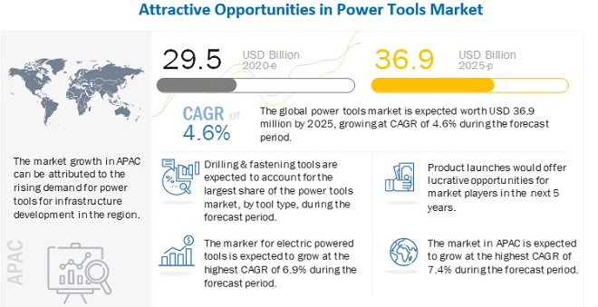
Figure 2: Power tool market size (2020 estimated vs. 2025 projected) and growth impulses (M&M, 2020)

Literature review
The literature review presented in the following was conducted to investigate the current situation from a micro and macro perspective. This part of the research is based on data from publications, reports, or other sources freely available in the internet.

Global supply situation, current economic policy, and trends
The global economy has been very much in Covid-19 mode for the last two years already. Despite the turbulences, however, the current world economic outlook shows that the global economy is generally recovering (IMF, 2021). The gross domestic product (GDP) is forecast to grow by 6% in 2021. The economy is booming in China (+8.9%) but also in the US (+6.7%) while it is lagging in the European economic zone (+3.6%). In the World Economic Forum’s global competitiveness report (Schwab and Zahidi, 2020), it is stressed that the international supply chains have to better balance with local prosperity and strategic resilience. However, it warns that the resilience may not improve if companies just replace a supplier from one location with a new one from another location and that reshoring may lead to less employment opportunities if combined with a higher degree of automation.
According to the world business outlook 2021 (AHK, 2021) of the German Chamber of Commerce Abroad (Auslandshandelskammer – AHK), 71% of companies with supply difficulties are making changes in their supply chains, thereof 44% are looking for additional suppliers for their products, 20% are planning to distribute their suppliers in several countries and 6% to relocate some of the production back to their own company (Fig. 3). This is a lot of intention but not much of execution yet (Beattie, 2021). Moreover, only a minority of companies plans for a regional diversification or homeshoring. Most of the supply chain remains in the country where it is currently and that is China in the first place. On the other hand, supply security issues are one of the most mentioned impact of the Covid-19 crisis.

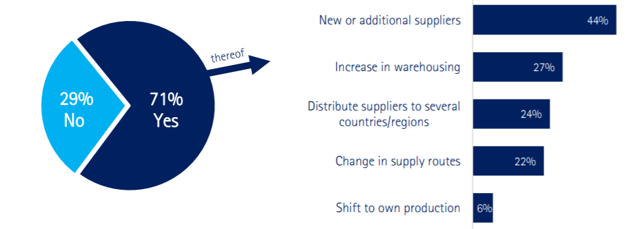
Figure 3: Survey result on the question: Do you plan to diversify your supply chain? (AHK, 2021)

The Covid-19 pandemic has shown the flaws in over-reliance on a single source supply chain. Countries rush to improve their economy and production by reducing supply chain dependence on a single source or country (US COC, 2020). The European Commission has identified the over-dependency on a single source, i.e. primarily China, as one of the main reason for the late recovery (EC, 2020), and promotes building up domestic manufacturing capacities, what basically leads to homeshoring. How risky the dependency on a single supply base can be, Korea’s recent ‘Urea crisis’ has shown (Lee, 2021). Nearly 98% of the urea solution needed to run modern diesel engines Korea used to get imported from China. When China banned the export of urea following its own ban of Australia’s coal needed for the urea production, Korea literally went dry with serious effects on its domestic transport business, afflicting its entire economy.
In the rivalry of production capacities and investments, the latest global manufacturing competitiveness index from Deloitte (Giffi et al., 2020) ranks the US as first and China as second in manufacturing competitiveness. In the US, factors helping to create competitive advantage centre on sustainability, science and innovation, and IP protection. In China, factors like policies encouraging FDI in science and technology, as well as infrastructure development help manufacturers to create a competitive advantage. Out of the top 10 manufacturing competitive countries, all three North American countries (US, Canada and Mexico), five Asia Pacific countries (China, Japan, South Korea, Taiwan and India), and two European countries (Germany and the United Kingdom) are listed (Fig. 4). Another four South East Asia countries (Malaysia, Indonesia, Vietnam and Thailand) are following swiftly to form with India a group of five emerging manufacturing powers, the ‘Mighty Five’ (MITI-V). Manufacturers rank talent as the most critical driver of global manufacturing competitiveness. Other drivers are cost competitiveness, productivity, and supplier network.

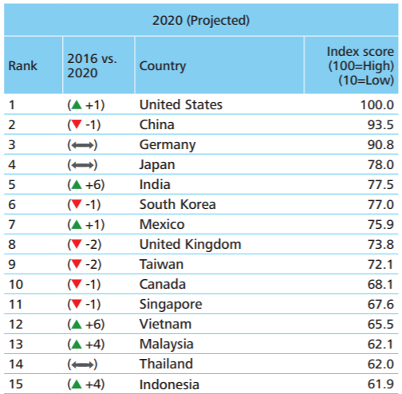
Figure 4: Manufacturing competitive ranking, the top 6 countries (US, China, Germany, Japan, India, and South Korea) account for 60% of world’s manufacturing GDP (Giffi et al., 2020)

While individual countries are competing globally for jobs and investments, globalisation seems to have reached a turning point. The global trade volume as a percentage of GDP is stagnating at 60% since 2008 (Richter, 2020a). Along the transition of global trade, the value chains are changing: While the value of exported (knowledge-intensive) services is still rising, that of exported (labour-intensive) goods is declining, e.g. the export of electrical machinery like power tools fell globally by -8.3% between 2008 and 2018 (Lund et al., 2019). The World Trade Organization (WTO) expects a sustained reduction of global trade over the coming years and a more domestic approach to production and sourcing, because of the Covid-19 crisis but also because of the US-China trade war. In parallel, the global FDI is shrinking by trend (Fig. 5), further accelerated by the Covid-19 crisis with -42% alone in 2020 (TWB, 2020). Note that FDI figures comprise investments not only in manufacturing but also in all kind of services as well as financing and housing.

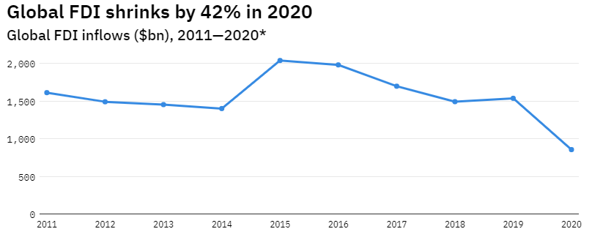
Figure 5: Global FDI inflows in billion USD (Davies, 2021)

Particular situation of manufacturers in the context of US-China trade war
The pandemic revealed the vulnerability of far-flung supply networks as containment measures obstructed the movement of manufactured goods (EIU, 2021). US-China tensions turned supply chains into geopolitical instruments and brought to attention the danger of depending on a rival state for supplies. Looming already for some time, the US-China conflict most evidently surfaced in 2017, the year Donald Trump was elected to the President of the US as well as Xi Jinping re-elected to the General Secretary of the CCP. With a polarising and mercantilist Trump and an increasingly authoritarian and assertive Xi, the relation of the world’s two biggest powers went sour and the US-China trade war broke out, affecting the whole world (Lippert and Perthes, 2020). Some three years later, Western arrogance paired with Chinese disguise allowed Covid-19 to become a full-scale pandemic (Stelter, 2020).
While Trump’s arguments and form are certainly debatable, the US trade with China has undeniably been developing for the last three decades to a massive trade deficit (Fig. 6) with an all-time high of 400 billion USD in 2018 (Ma, 2021a). A structural deficit of that magnitude is not sustainable in the long run (Amadeo, 2019). China can manufacture low-priced consumer goods like power tools because of several comparative advantages. Some of them, like low wages or value-quality production, might have gone over time. Other advantages, like pegged exchange rates and state subsidised overcapacities in certain industries, still remain (Amadeo, 2021; Jia, 2019). Primary target of the tariffs were hardware products made of aluminium and steel. – Despite the imposed tariffs, however, jobs and capital continue to flow out. Statistics show that the FDI from the US to China has stagnated over the past decade but is higher than that from China to the US (BEA, 2021). The main cause of the declining manufacturing in the US is a low productivity (Rose, 2021).

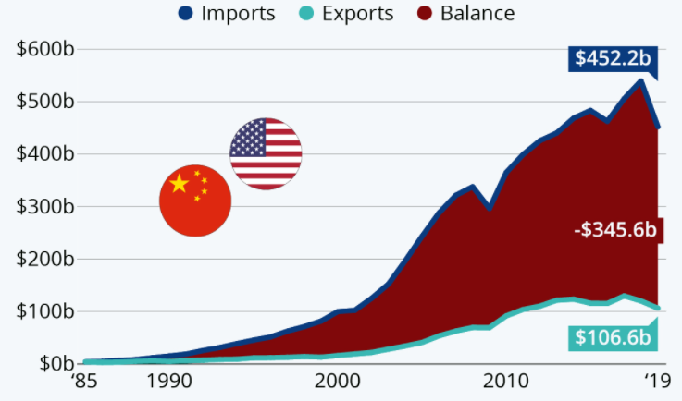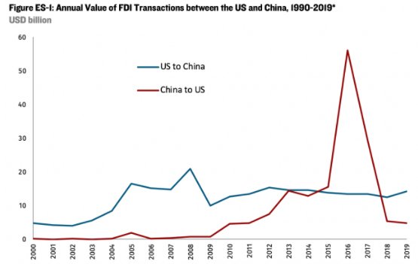
Figure 6: US trade in goods with China since 1985 (Richter, 2020b) (left) and annual value of FDI between the US and China (Hanemann et al., 2021) (right)
Further, the extra tariff costs are not paid by China as postulated by Trump, but by the US importers at first (Singh, 2019). The importers are then mitigating the higher burden in several ways that hurt US companies and customers. Such strategies include accepting lower profit margins or cutting wages and jobs (Harrison, 2019). On the other end, Chinese suppliers cover some of the cost of US tariffs by offering a discount to not lose too much of their business as US companies are scouting for alternatives outside China. China retaliates US tariffs by imposing tariffs on imported US goods, the average duty for goods from the other are roughly 21% now, while the rates on goods from other countries are about 6% in China and 3% in the US, respectively (Fig. 7). Further, China strikes back with denying access to the China market for companies following any (US or European) sanctions placed on Chinese companies e.g. because of violating human rights in Xinjiang and supply chain laws. New rules even allow Chinese companies to sue international companies for compensation in Chinese courts if their interest or business are damaged (Mayger et al., 2021).

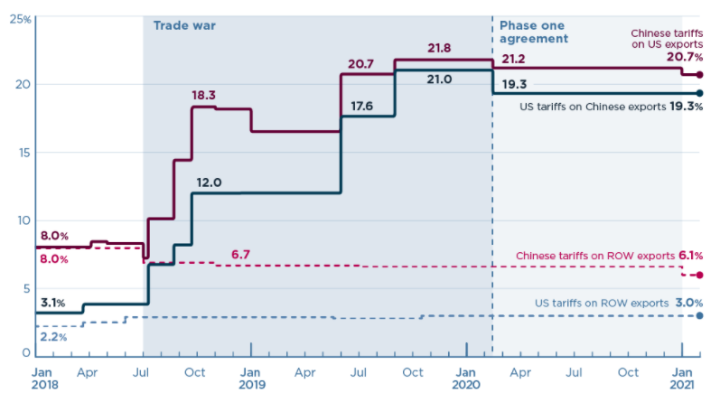
Figure 7: US-China tariff rates towards each other and rest of world (ROW) (Bown, 2021)

On January 15, 2020, both sides reached the so-called phase one agreement to prevent further escalation; however, the deal still did not address issues like China’s theft of IP, forced technology transfer and subsidies for domestic industries, and China still did not reach the agreed target imports of US manufactured goods of 110 billion USD (Martin, 2021). Meanwhile, the Trump-era US-EU tariff war over steel and aluminium products has been settled in October 2021 (Lawder and Shalal, 2021), making products from European power tool suppliers more price-competitive in the US market. The high tariffs on goods traded between the US and China remain in place as the policy towards China does not change very much under Biden though Trump’s trade war is generally considered as a failure. Meanwhile, the EU imposed anti-dumping duties on imports of certain steel products from China in February 2022 due to ongoing unfair trade practices (Blenkinsop, 2022), as high as 86.5% depending on the product category.
Nevertheless, shortages of masks and other medical equipment at the beginning of the Covid-19 crisis demonstrated how dependent the West and in particular the US had become on supply from China, arguably supporting Trump’s move to decouple from China (Black and Morrison, 2021). Xi likes to publicly defend globalisation and advocate free trade as famously pictured during the World Economic Forum (WEF) in Davos 2017 and recently repeated at the Asian pendant, the Boao Business Forum (BBF) (McMorrow, 2021). This is not without some irony and chutzpa, as Xi’s China practices free trade only to the extent it benefits Chinese interests and China is further dropping in the ranking of free market access from place 68 in 2017 to 78 in 2020 (Otte, 2021). Xi understands globalisation as cooperation at China’s terms (Myers and Bradsher, 2021) with limited market access and selective coupling only where it is needed, while the Chinese command economy is protected and subsidised (EU COC, 2021). Moreover, China administration demonstrates its growing coercion influencing local politics of any country, making very clear what happens if a country or company is not aligning with China, e.g. in the Lithuania dispute erupting 2021 which China claims is controlled by the US (Nevett, 2022). The Minister Xia Xiang of the Chinese Mission to the EU bluntly warns that it is unwise for any company to move away from China's industrial chains (Xiang, 2021).
China shows decoupling tendencies on its own rights as Xi thinks it can take the risks while it gradually rotates from an export driven economy towards an economy carried by domestic consumption (TWB, 2021b). The ‘China first’ or ‘Dual circulation’ strategy prioritises domestic trade while maintaining international trade only if directly beneficial. In 2010, exports accounted for more than 26% of China’s GDP, in 2020 for just a little bit more than 17% (Ma, 2021b). Over the past two decades, the Chinese middle class grew by 700 million (Textor, 2021a) with enough disposable income to support domestic demand (Fig. 8), and Chinese products have reached a level of quality and prestige that is acceptable for Chinese previously preferring Western goods (Dusharme, 2018). Moreover, self-reliance is explicitly defined as a target in the recently published 14th Five-Year plan (Buck and Du Chenne, 2021) e.g. for computer chips as they are also used in power tools. The China Manufacturing 2025 (CM2025) aims to ban global competitors in 10 strategic technologies and to decouple from international technical standards, by this avoiding to be trapped in the middle-income trap (LSE, 2021). With these measures, Beijing is today self-confident enough to not converge with Organisation for Economic Cooperation and Development (OECD) norms and principles, and to regularly infringe trade practices of the WTO it agreed to when joining (Bacchus et al., 2018). The US, on the other hand has lost much of its historic manufacturing capabilities and is addictive to cheap supply from China. US manufacturers are therefore much more vulnerable and well advised to regain lost competences and to put fewer eggs in the Chinese market as its importance for Western companies is significantly declining already now (Glunz, 2022).

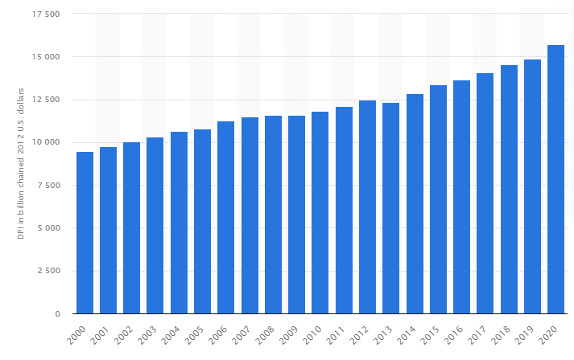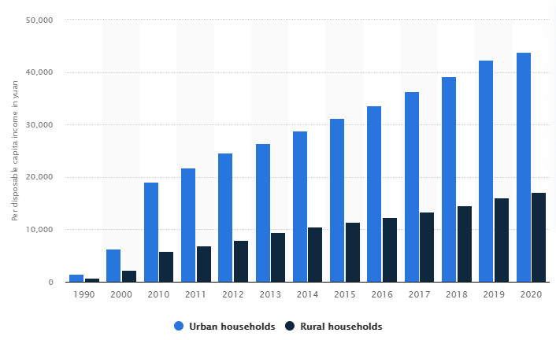
Figure 8: Annual per capita disposable income from 2000 to 2020, US (left) and China, urban versus rural households (right), 1000 Yuan ≈ 155 US Dollars (Textor, 2021b)

After 40 years of ever deeper economic integration between the US and China, decoupling tendencies continue to spread and in time will affect all multinationals in all industries, from manufacturing to consumer goods (Rachman, 2020). China was one of the top three sourcing countries for 96% of the US companies in 2017, but only 77% in 2020. Despite this decline, China is still by far the dominant sourcing location, and its position is not likely to change (Kalish, 2021). Most companies do not intend to cut China completely out of the supply chain but to strategically hedge their supply chain and diversify into other countries (Shih, 2020b), at least as a China-plus-One (China+1) business strategy. 84% of the US manufacturers wish to diversify their sources of production away from China (Mukherjee and Norland, 2021). According to the American Chamber of Commerce, 30% of US manufacturers have decreased their investment in China due to the US-China trade policy (AmCham, 2021); however, others have increased theirs or are newly entering China’s supply orbit. Meanwhile, the danger of decoupling is evolving rather from China where the leadership wants the economy being ready for decoupling to form “deterrent capabilities based on artificially cutting off supply to foreigners” (Xi, 2020).

Diversification of the supply base, nearshoring and homeshoring
A 2020 survey conducted by the EY consultancy found that 83% of all of MNEs were contemplating nearshoring or even homeshoring (The Economist, 2020a). The advantage of outsourcing manufacturing to China, once the panacea for companies looking to scale manufacturing and profit, has eroded over time. Other countries in Asia and elsewhere have developed competitive manufacturing capabilities and issues e.g. with IP theft have further caused companies to rethink the strategy of contracting manufacturing to Chinese companies (Donahue, 2021). US manufacturers are shifting to other countries to get the products they need (Laskowski, 2020), though US imports from China has picked up again during the pandemic and is now at level with that at 2017. The two biggest losers from the conflict in terms of trading volumes are the US and China with suffering GDP and employment (Gentile et al., 2020), the winners from the US-China trade dispute are some Asian countries and Mexico (Fig. 9). The Asian countries are the Asian Tigers South Korea and Taiwan as well as the MITI-V countries.

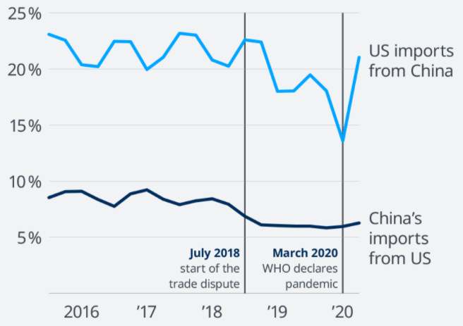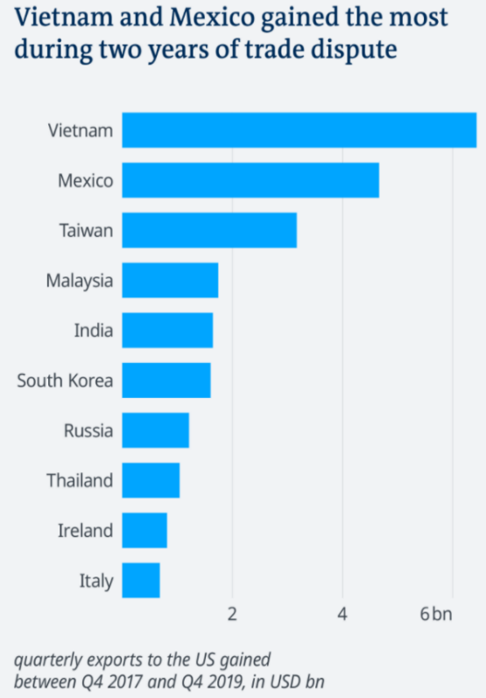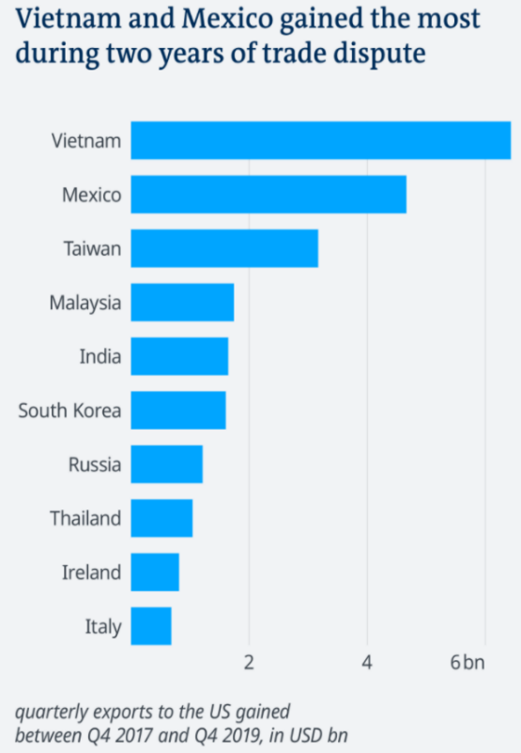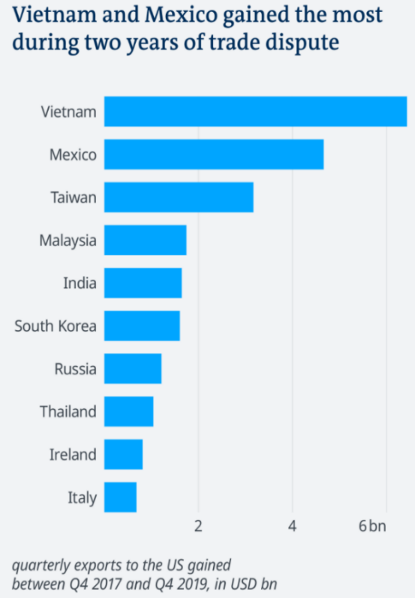
Figure 9: US imports from China (left), and quarterly exports of manufactured goods to the US (right), increase between 2017 and 2019 (Laskowski, 2020)

Taiwan and South Korea are high-cost countries with a mature tech industry and local talent, and therefore the prime position for high-quality products. Both belong to the China-influenced East Asian sphere and are largely integrated in one supply chain with China, making them the natural replacement for China. However, labour costs in South Korea, driven by their Chaebol (big industrial conglomerates) economy, are significantly higher than in Taiwan, soon to outpace even those in Japan (Fig. 10). Therefore, Taiwan gained the most business plus in machinery including tech hardware and power tools, making just over 2.8 billion USD (Jennings, 2019). Taiwan contract manufacturers are relocating parts of their formerly China based production back home, other parts they are shifting to Southeast Asia or India to supply the US from there (Hille, 2021).

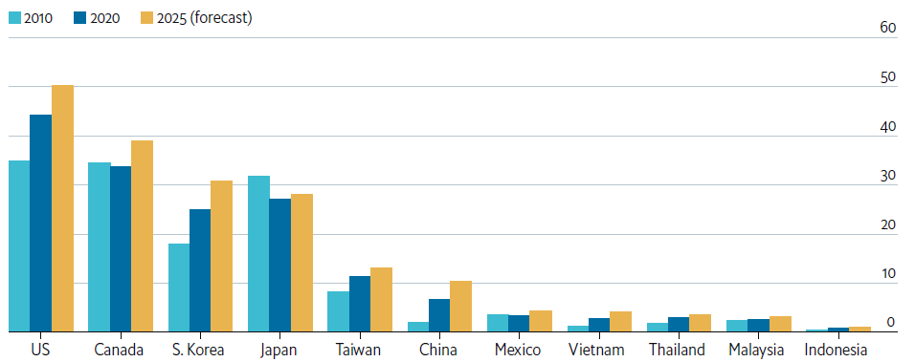
Figure 10: Average manufacturing labour cost (USD/hour) for selected countries (EIU, 2021)

For low-tech products, Vietnam is the big winner. Exports from Vietnam to the US jumped by 33% in the first half of 2019 alone (Harding, 2019). Close vicinity to China, regionally and culturally, and partly shared supply chains are the main reasons for this success. However, a mere relocating of cheap production from China to Vietnam is not what Trump’s US intended by the tariff war, and the US International Trade Commission (ITC) imposed in turn anti-dumping duties on specific product categories to incentivise bringing production back to the US. Also Malaysia and Thailand have picked up some business from manufacturers shifting their supply chain with an increase of FDI in these countries of 80% in 2020 (Hsu, 2021). Interestingly to note however, Indonesia failed to do so likewise yet but it is catching up (Sim, 2019). Same goes for Mongolia which is also close to China but landlocked and short of material supply and skilled workforce (Pesek, 2019).
Less clear is the situation for India, the business gain is small in relative terms, given its economic size (India’s GDP in 2020 was nearly 10 times that of Vietnam (King, 2021)). Experts predicted that India will massively benefit from the US-China war (Chris, 2019) and wondered whether New Delhi failed to take advantage because of its own manufacturing weaknesses and disputes with the US (Islam, 2019). Its huge market, low labour costs, high engineering skills, and English speaking workforce are strong points for manufacturers to choose India for the China+1 strategy (Maddineni and Yao, 2019). However, 9 out of 10 US MNEs consider India as very challenging, mainly because of red tape bureaucracy that has even worsened against foreign investors after waves of cheap Chinese goods have put many local producers out of business (Sharma, 2021). The US State Department, otherwise benevolent on India for their political rapprochement, complains that Indian requirements are not aligned with international standards, effectively closing out local manufacturers from global supply chains and restricting the expansion of bilateral trade (USDS, 2021).
Mexico is the nearshoring location for the US with some history in manufacturing for the US and Canada, the two countries with which it signed the North American Free Trade Agreement (NAFTA). Many industries including power tool makers for metal and wood working moved to Mexico after they have experienced a labour crisis in the US due to employees retiring from these industries and younger generations not interested in factory work (Tagliapietra, 2020). Now Mexican factories are extended, or new ones are founded to take up production from China or to facilitate capacity extensions. Often, the factories are located just south of the border for shortest transportation distance to the US consumer market, also diminishing the dead capital in transition (Atrill, 2019). Further advantages like no time difference between Mexico and the US, and a high number of graduates in the field of science, technology, engineering, and mathematics (STEM) makes nearshoring interesting not only for blue collar but also for white collar jobs e.g. in development centres (Diaz, 2021). On the other hand, Mexico had one of the world’s worst Covid-19 response still affecting factory production, a symptom of its lack of governance and not really a recommendation of a reliable supply chain during a pandemic crisis (Staff, 2020).
Homeshoring, also known i.a. as insourcing, reshoring or repatriating manufacturing, is the ultima ratio to move production to where people buy it. However, companies must overcome some hurdles when doing so: Firstly, the difference in labour costs is high (Fig. 11) and homeshoring manufacturers have to figure out how to stay competitive economically (Stonnington, 2020). But also the shortage of workers with the right skill set and education is seen as another problem since the US lacks more than three million graduates in the technical field now and for the coming decade (Wegner, 2019). The US, like many other OECD countries, has turned into a country of consultants, lawyers, and doctors, while the labour market is challenged by changes brought by digitisation and innovation (N. Smith, 2021). Most of the manufacturing companies that reshored business to the US from 2010 to 2018 have been from the low to medium technology level and only 14% from the high-tech sector (N.N., 2021a). Overall, however, the number of manufacturing jobs in the US is in a long-term decline (Hernandez, 2020). A strategic policy for rebuilding a modern manufacturing industry and much needed investments in climate and infrastructure could change this and increase manufacturing jobs in the US (Scott, 2020).
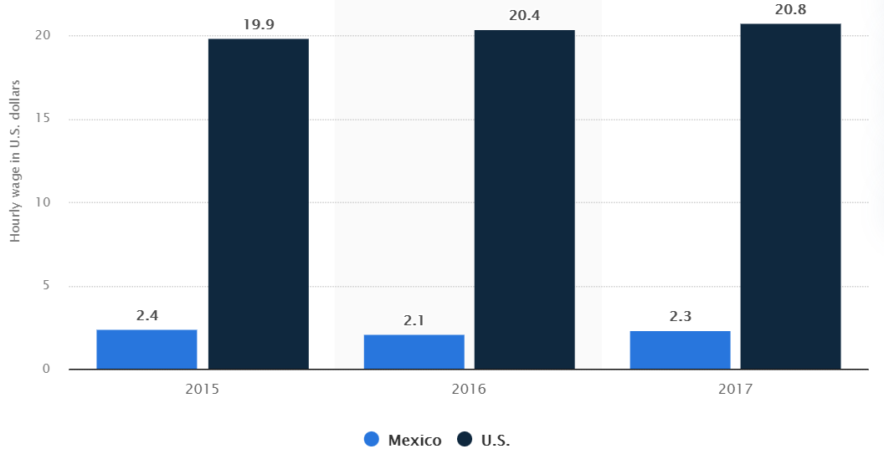
Figure 11: Average wage in the manufacturing sector in Mexico and the US (Romero, 2021)

Reshoring can be financially viable by means of advanced manufacturing automation using AI, robotics technology, 3D printing etc. to overcome the high labour costs. Incumbent manufacturing leaders collaborate with newcomers versed in IT to innovate strategically products and production, either in JVs or strategic alliances (Tidd and Bessant, 2014). Investments are required in new plants and production dedicated technology centres to enhance their manufacturing capacities and capabilities (Brotherton-Bunch, 2019).
Repatriating manufacturing has some mercantilist and nationalistic, even patriotic aspects; this also suggests the ‘Buy American’ act to support local suppliers by contracting them for the annual 600 million USD of federal procurements (Hansen, 2021b). Originally signed by Trump’s as part of his ‘America First’ policy in 2017, the contracts awarded directly to foreign companies went up by another 30% until Biden established more effective rules in January 2021. This together with the infrastructure law signed in November of the same year, is a huge incentive for power tool manufacturers producing in the US. While this works for public spend, patriotism will stop private consumers from buying Chinese products only if products made in the US are not significantly more expensive or if intelligent marketing manages to change the customer’s mindset (Karp, 2021).

Environmental and ethical considerations and implications on marketing
Ethics and environment (E2) play an increasingly important role in corporate governance. The outsourcing of labour overseas is a natural result of the globalisation of markets and free trade. Less regulations, particularly regarding environmental protection and workers’ rights, has always been a key driver for outsourcing manufacturing to less developed countries to cut costs and maximise profits (Hayes, 2021). The list of environmentally or ethically deficits China is accused of is long: Air, land and water pollution, deforestation, lack of animal welfare as well as missing freedom of speech, press, and assembly, missing religious and political freedom, torture and missing rule of law, suppression of ethnic minorities and extinction of their culture, forced biometric data collection and mass surveillance, unfair Hukou discrimination (dividing population in 1st class citizens and 2nd class peasants) and Social Credit systems. Democratic governments address these deficits only halfheartedly, since an estimated 37 trillion USD, equivalent to about 26% of the global GDP, is at stake by the year 2040 from less engagement between China and the world (Woetzel et al., 2019). Western consumers are good in turning a blind eye to the exploitation of workers and environment in China (Chamberlain, 2017). To date, particularly Americans are reluctant to spend extra money for the sake of avoiding products made in China, though 40% are saying they would do so (McDaniel, 2020). People often say one thing and do another, and admittedly it is not easy to avoid Chinese products and find alternatives. Moreover, the country of origin (COO) might be marked on the product but is generally not stated in online shops.
Moreover, in recent decades offshoring has not only been seen as beneficial to the global economy and economic growth; it was also believed to promote peace and democracy in China. In Germany, this belief still prevails (Karnitsching and Vela, 2020), coined by the proverb ‘Wandel durch Handel’ (‘change through trade’), though China’s increasingly assertive behaviour has proven this assumption wrong for some time already. Moreover, the importance of China for the homeland labour market is generally overestimated; even in Germany, by far the European country with the highest export volume to China, only 1 – 2% of the jobs are directly or indirectly dependent on the China trade (The Economist, 2020b) (compare to 2 – 5% of jobs that are dependent on German combustion-engine car manufacturers which inevitable change-or-die fate is generally accepted). – It is the profit of the corporations invested in China that is at stake. The new German government inaugurated in December 2021 will be more value based and open for a strategic alignment of the EU with the US (Alvarez, 2021). In the US, there is a bipartisan support for foreign trade (Fig. 12) while manufacturers are urged by Beijing to lobby against China-related bills in the US Congress to avoid facing economic consequences (N.N., 2021b). Xi’s weaponisation of trade by means of export bans and consumer boycotts warns Western firms that they have to align with the CCP if they want to continue business in China (The Economist, 2021); and the red line on China human rights makes companies pick sides (N.N., 2021c). It is difficult for companies to live up to their own standard and take CSR seriously. CSR could mean for manufacturers to reduce business ties in China and to invest and trade more with China’s democratic targets like Taiwan, Japan or South Korea (Ortagus, 2021).

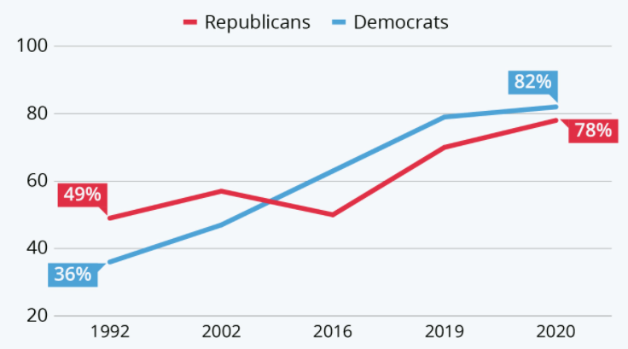
Figure 12: Percentage of US Americans who see foreign trade as positive (N.N., 2021d)
Business ethics is important for corporate sustainability (Hansen et al., 2014), and social responsibility is important in marketing (Fernando, 2020). The social pressure on companies operating in China will potentially grow similar to the pressure on 1980s firms doing business in South Africa (Magnus, 2021); however, the giant China will not be as much impressed. While the consumer perception of products, measured by the Made-In-Country-Index (MICI), does not differ much for China, India, or Mexico, the quality perception of products made in the US is substantially higher (Fig. 13). The marketing potential of products made in the US has been used successfully by various manufactures already years before the revival of protectionism or US-China rivalry (Weinswig, 2016; Regole, 2015; Mannes, 2011). Made-in-the-USA labelling is beneficial but requirements have to be met before the product can be accordingly labelled (L. Smith, 2021). – Again, China is leading the way to more protectionism and ‘patriotic marketing’, forcing with more proudly Made-in-China products world brands to find other markets rather sooner than later (Kim, 2022).

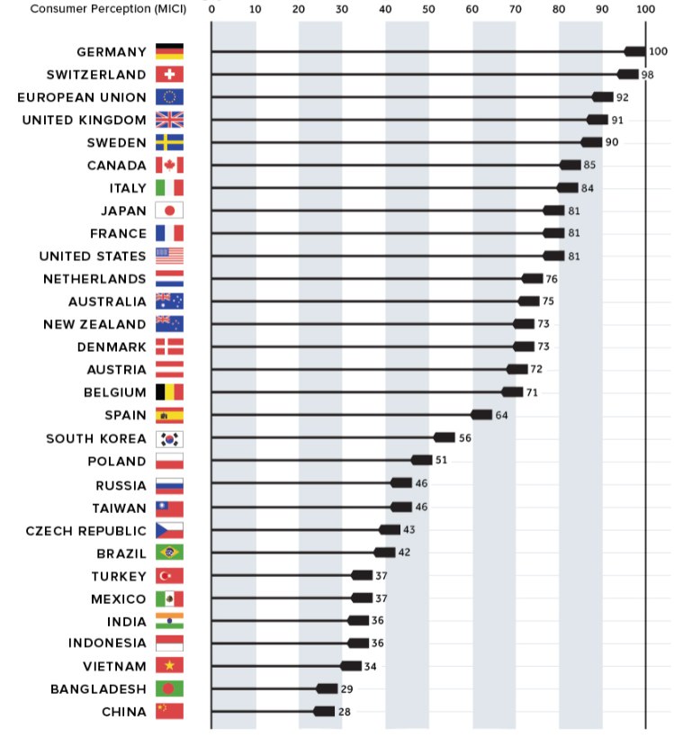
Figure 13: Made-In-Country-Index (MICI) for selected countries (Desjardins, 2017)
Despite Made-in-the-USA being not a recent marketing phenomenon, it is difficult to research references that are significant in number or quality, despite all the abundance of literature on the tensed political landscape, changing economic situation, diversification of supply bases. If global manufacturers refresh their brand identity around Made-in-America etc., then they do not make much noise about it. Maybe this is simply because there are currently not many products that are not made in China, as also the scarce online presence around the Not-made-in-China theme suggests. US manufacturers are better off when not over-emphasizing the few products made in the US they offer. Made-in-the-USA will remain scarce for some more time, and for customers it will remain an ordeal to find Not-made-in-China products.

Methodology

Research process
Following the literature review, further research is conducted to investigate the reasons why many US manufacturers have not succeeded more in reducing the dependency on their current China supply chain to date, and to depict strategic options to overcome the challenges. After a brief review of company reports published by relevant power tool manufacturers, information is collected by interviewing business people at critical positions. The gained primary data is then analysed and compared to the data from the literature review, using primarily qualitative methods. The relatively limited data set and the widely absent hard data, e.g. in form of specific financial information, prohibits extensive quantitative evaluations.
Assuming the role of a practitioner-researcher, the research strategy has mostly characteristics of an exploratory study (Saunders et al., 2019): Aspects of the researched problem are explored and described, however, qualified attempts are made to explain some of the causes. The subject will be approached by Saunder’s research onion model (Fig. 14):


Figure 14: Research onion model after Saunders (Crossley and Jansen, 2021)

Research philosophy
The presented research the philosophy of interpretivism as it aims to provide insights into a complex business problem that cannot be reduced entirely to a series of law-like generalisations. It is necessary to explore the subjective meaning underlying people’s actions in order to understand these (Remenyi et al., 1998). The knowledge is not fixed but questioned, and the gained information is interpreted by the researcher.

Research approach
Based on the literature review, critical research questions are developed used as a basis for reviews of company reports and interviews with business people. The themes of the reports and interviews are compared against the findings of the literature review. The qualitative data collected by various methods establishes different views of the phenomena (Easterby-Smith et al., 2002), resulting in the formulation of a theory in an inductive way where the theory follows the raised information.

Research strategy
The research based on interviews and company reports is basically a case study with several survey elements. The case is investigated to gain contextual, in-depth knowledge about the real-world subject (McCombes, 2019). This research design allows to explore the matter with the aim to formulate a theory that explains some of the underlying reasons and that allows to give recommendations to the reader.

Choices
This additional layer is differentiating between three options, namely mono, mixed and multi-method. It is about how many data types, qualitative or quantitative, are used for the research (Creswell and Plano Clark, 2017). Since the research is primarily based on qualitative data from different sources (company reports and interviews), it is a mono method with mixed types of data sources.

Time horizon
The described method will lead to a cross-sectional data set collected as a snap-shot of a development over time (Crossley and Jansen, 2021). The research subject describes a particular situation of US manufacturers seeking to lessen the dependency on their current China supply chain, as it has progressed till the end of the year 2021.
Techniques and procedures
Techniques and procedures employed for data collection and analysis align with the other layers of the research onion and are chosen to suit the given research task best (Wilson, 2014). As mentioned, the research consists of two parts using different methods:
- Company reports published by global manufacturers of power tools are reviewed for critical information. In particular, statements regarding supply chain issues experienced lately and future sourcing strategies are extracted.
- Interviews are conducted to gain information from business people relevant for the considered case. These semi-structured interviews are conducted as one-on-one conversations with open-ended questions.
The interviews loosely follow a set of open-ended questions to make sure that most of the critical subjects are covered during all interviews. After some leading sentences to set the context, the questions are asked using interrogative words, e.g.: ‘Reducing the dependency form the China supply chain is desirable yet not very much progressed – What are critical challenges for being competitive with Chinese suppliers?’. This technique of asking questions is crucial in information gathering and problem solving (Brooks and Leslie, 2018). The interviews do not necessarily follow the same order of questions to allow a conversation as natural as possible. The questions are asked clearly and in a neutral tone of voice to avoid bias (Saunders et al., 2019). The collected data is analysed by means of a thematic approach (Caulfield, 2019). The data is further examined to identify common themes that are then compared to the results of the literature review.

Assumptions, limitations, and scope
Assumptions are made that the statements in the company reports are truthfully and that the interview participants answered without personal preference on the matter. The sample size is relatively limited; however, the research results may be taken as reliable and valid when the considered companies and interviewed participants are representative (Robson, 2002). Therefore, the participant error and bias are assumed small, as are the observer error and bias because the researcher is experienced and free of any conflicts of interest. The research scope is specific to the case considered and does not allow a generalisation of the research results.

Ethical considerations
Ethical considerations have an impact on the research method and particularly if people get involved by interviews. By conducting semi-structured interviews with open-ended questions it is ensured that the interviewee does not feel urged to talk about anything he or she is uncomfortable with. No confidential information will be revealed in the dissertation and the data will be used in anonymous form. The identity of the interview participants is not disclosed.
The dissertation work followed the ‘UWTSD Research Ethics & Integrity Code of Practice, 2017 – 2020’. All investigations have been carried out independently. Only published sources were used for the literature review and analysis of the company report. Before any interviews with business people were held, the ‘PG2-E1 Ethics Forms’ was completed and approved by the supervisor. This safeguards the data collection and is in line with common practise to have research proposals reviewed also regarding ethical aspects (Bhandari, 2021).

Research data
The literature research brought up many relevant publications dealing with China’s changing role as the US’s workbench. Before the challenges of global US manufacturers in getting less dependent from the China supply chain are investigated further by interviews with business people, company reports of power tool manufacturers are reviewed to deepen the understanding of their current situation in this game.

Company reports of power tool manufacturers
For the secondary data research, the most recent reports published by global power tool manufacturers have been analysed to gain insight in their supply chain strategy and diversification activities.

Investigated companies
The total sample size of investigated manufacturers is six. These are the biggest global players in the considered industry with a strong US focus, either as companies headquartered in the US or as foreign companies with substantial sales in the US. The selection can therefore be deemed representative. The reviewed company reports were published in 2021 for the fiscal year of 2020:

- C1: Illinois Tool Works Inc. (ITW) is a US company that manufactures engineered components and power tools for the global market.
- C2: Stanley Black & Decker (SBD) is a public Fortune 500 manufacturer of industrial tools headquartered in the US.
- C3: Techtronic Industries Company Limited (TTI) Hong Kong designs, produces, and markets power tools and other power equipment and hand tools for the global market.
- C4: Makita is a public manufacturer of power tools; based in Japan, that is globally recognized as leader of innovation.
- C5: Hilti is a global company based in Liechtenstein that develops, manufactures, and markets products for the construction sector, including power tools.
- C6: Bosch is a German multinational engineering and technology company that also produces power tools.

Themes reviewed and aspects analysed
Company reports contain a lot of information; not all information is of any interest for the presented research and not all information of interest is given. The literature review revealed four themes which are of interest for the presented dissertation and for which information can be found in the company reports for further research. These themes and related aspects are:

T1: Supply chain – How do the supply chains of global power tool manufacturers look like?
  - Manufacturing or sourcing from international suppliers?
  - Working with Chinese suppliers or having own factories in China?
T2: US-China conflict – How did the conflict impact the supply chain of the manufacturers?
  - Was the supply chain affected by the tariff war?
  - Is developing or manufacturing of products in China considered as a risk?
T3: Diversification activities – How are the manufacturers’ supply chains currently changing?
  - Moving supply away from China, if so which strategy?
  - Moving production closer to the US, either nearshoring or homeshoring?
T4: E2 and CSR – How is any decision making on supply chains influenced by these aspects?
  - Do environmental considerations (e.g. carbon footprint) play a role?
  - Do ethical considerations (e.g. human right situation) play a role?

Interview of business people
The interviews delivered primary data from people involved in the global manufacturing business. During the interviews, particular aspects where addressed directly; a complex analysis of what has been said was therefore not necessary. Critical points were noted in parsed protocols which can be found in the Appendix of this thesis.

Interview participants
In total, nine interviews were conducted with diverse interview partners. These included business people from industry and commerce organisations. All of them were professionally involved in one or several aspects of manufacturing, sourcing, supply chain, or investment strategy. The interview participants were known to the researcher or were identified by internet research. All interviewees had senior level positions in their organisations with a professional experience of 20 years or more. About as many of them were female as male. The ¾ to 1-½ hour long interviews were arranged upfront and took place between December 21, 2021 and January 31, 2022:

- P1 is an expert for the China region in one of the German chambers of commerce that supports German manufacturers in the global market.
- P2 is a former leader of a China competence centre in one of the German chambers of commerce now consulting German companies for their US business.
- P3 is a sourcing specialist working for one of the global power tool manufacturers with profound experience in South Asia, South East Asia and East Asia as well as in Mexico.
- P4 is a member of a council for investment promotion and trade development in Taiwan focusing i.a. on local hardware suppliers.
- P5 is a member of a trade and invest agency in Vietnam consulting Western manufacturers and Vietnamese suppliers.
- P6 is a leading member of a German Indian chamber of commerce with profound experience in Asian manufacturing business.
- P7 is a manager of a leading Taiwanese manufacturer supplying finished hardware products for the international market.
- P8 is a manager of a Vietnamese hardware supplier for global power tool manufacturers for many years.
- P9 is a manager of an Indian contract manufacturer of hardware components for global manufacturers.

Subjects and aspects addressed
The phone interviews were held as informal conversations to foster open answers. The findings of the literature review and the insight gained from the analysis of the company reports led to open-ended questions. These can be structured to the following subjects and related aspects:
S1: Supply chain diversification is a hotly debated subject in the media and business communities – What is the current status of supply chain diversification away from China?
  - Onset of activities
  - Latest developments
S2: There are several possible reasons why global manufacturers feel prompted to reorganise their supply chains – What has triggered the relocation activities?
  - Tariffs or (anti-dumping) duties
  - Legal and IP issues
  - Covid19 – supply chain security
  - Regional China tensions
  - Increasing production costs from Chinese suppliers
S3: Different types of supply chains are differently affected and vary geographically – What types of supply chain reshuffle experiences the respective country?
  - Reshuffle contract manufacturing or sourcing of finished goods
  - Reshuffle own facilities (FDI)
S4: Ultimately, supply chain diversification leads to a decoupling of the US and China – To what extent do global manufacturers move away from China?
  - Complete withdrawal (decoupling)
  - Limited relocation (diversification)
S5: Supply chains do not get reorganized on their own and require stimulus – What is required to relocate the supply chain e.g. for power tools?
  - Strategic commitment to leave convenient tracks
  - Monetary incentives to achieve cost improvement
  - Building supply structures and people skills
S6: Reorganizing supply chains is challenging for many manufacturers – What are frequent challenges to overcome in countries other than China?
  - Lack of digitalisation
  - Insufficient capacities
  - Insufficient capabilities
S7: Shortage of qualified personnel in manufacturing is an often made complaint globally –What kind of qualification is needed if lack of qualified personnel is an issue?
  - Skilled and trained workers
  - Technically versed graduates
S8: The European supply chain law epitomise the ambition of the West to protect human rights and environment in supplier countries – What impact does the European supply chain law have?
  - Challenge for global manufacturers
  - Challenge for Chinese suppliers
S9: The ethical and environmental standards do not necessarily improve when relocating supply chains – How are the E2 standards in the respective country, compared to China?
  - Ethical standards
  - Environmental standards
S10: Reducing the dependency form the China supply chain is desirable yet not very much progressed – What are critical challenges for being competitive with Chinese suppliers?
  - Costs
  - Convenience
  - Competence

Results: Analysis of the research data
This section presents the summary of the information gathered by reviewing company reports and the interviewing business people.

Company reports of power tool manufacturers
The information extracted from the company reports, amended by company-specific references, is presented for the companies C1 to C6 to understand their current and future positioning regarding supply chain strategy and diversification activities. A summary with diagrams visualising the key results by binning the findings in qualitative categories is given in Appendix A.

ITW (C1)
According to ITW’s annual report (ITW, 2021) they use raw materials, i.a. steel, that are sourced from numerous countries. They have only one factory outside of the US (where they sell the sub-brand Ramset as Made-in-the-USA) and Europe (where they sell by their Spit brand) and that is in Suzhou, China. On their website they state that the long-term strategy is to deeply root in China (ITW Asia, 2021). The report does not reveal any intention in regard to diversifying the supply chain and they claim that they are suffering supply chain disruptions which are however not significant to the business due to the company's decentralized operating structure and a large number of storage facilities. Still, the annual report lists business activities in China in the risk evaluation section. A separate CSR report (ITW, 2022) underlines that ITW is not only having high standards for their own entities but also high expectations towards their suppliers in that purchased products are evaluated thoroughly. Attention is paid to all kind of aspects including environmental protection and sustainability, forced labour and child labour, LGBTQ+ rights. High-risk suppliers are asked to obtain certification of their compliance with these requirements.

SBD (C2)
SBD publishes an annual report with some strategic information and an extensive discussion of business risks (SBD, 2021). The company imports large quantities of finished goods, component parts and raw materials from various countries including China. Changes in the US policy regarding international trade have negatively impacted the company’s business, resulting in an increase in supply chain costs. It is mentioned that trade protection measures related to the US-China relationship bear risks and that assets including IP rights are difficult to protect. To maintain operations excellence, an adaptable and technology enabled supply chain is promoted to manufacture closer to its customers. Their ‘Make where we sell’ strategy improves customer responsiveness, lowers lead times, reduces costs and mitigates geopolitical and currency risk while facilitating major improvements in carbon footprint. The report does not mention diversification of supply chains or relocation away from China where substantial portion of the company’s manufacturing takes place (Muraski, 2020). However, recent capacity extensions required to meet sales increase have been allocated to their two Mexican factories in Monterrey and Reynosa. Moreover, a greenfield plant in Fort Worth, Texas, has been put in operation in 2020 and the company recently posted that they aim to reduce its manufacturing in China by 60% over the next several years (SBD, 2022). The report underlines that sustainability, i.a. by becoming carbon positive, is integral to their business strategy. The company recognises that they must invest in reskilling and upskilling its employees.

TTI (C3)
TTI's brand portfolio includes more than 10 entities including renowned brands like Milwaukee, AEG, and Hoover. TTI is a public company headquartered in Hong Kong with manufacturing locations in China, Vietnam, Germany, Mexico and several in the US cities (FII, 2019). It is aggressively growing, and more than half of its revenue is made in the US. TTI is expanding new sites at their factories in Saigon, Vietnam, and Torreon, Mexico, but also in the United States (TTI, 2021), demonstrating that capacity increases are made outside of China. The environmental, social and governance section represents the better part of the annual report covering CSR topics in detail. TTI claims to foster human rights, environment protection and to overcome potential ethical supply chain challenges, and in doing so has joined initiatives and partnerships with a non-governmental organisation (NGO). Responsible sourcing of raw materials and products along their supply chain aims to maintain a sustainable sourcing strategy with suppliers that comply with all ethical, social and environmental standards. The report does not reveal any supply chain details, however, given its background and history tied to Hong Kong the dependency on China may be assumed high, any activities to change this is not reported. In light of its Chinese legacy and the importance of the US market it is interestingly to note that they plan to launch a Made-in-the-USA tool line (Stuart, 2020).

Makita (C4)
Makita generates over 60% of its sales in Europe and North America, and less than 5% in China. Its iconic one-brand product portfolio is known and produced around the world at eight different locations. Including a facility that commenced operations in the US (near Atlanta) in 1985, Makita has expanded its global manufacturing base and approximately 80% of its products are manufactured overseas with big plants in Mexico (near Mexico City) and in China (near Shanghai) (Makita, 2022). The tools produced in the US are not specifically advertised as such, and there are no known plans to launch any Made-in-the-USA product lines (DeBoer, 2021). According to their annual report (Makita, 2021), they are specifically increasing the capacities of the plants in China. The report does not mention any issues regarding Covid-19 disruptions or planned supply chain diversification. However, to address the notorious labour shortage in Japan and also to improve convenience for customers, Makita plans to accelerate the digital transformation in production and for customers. The report addresses environment and ethics in separate sections, particularly emphasizing the importance of respecting human rights along the entire supply chain. Makita follows a ‘CSR procurement’ scheme so that the “customer can enjoy peace-of-mind when using Makita tools”.

Hilti (C5)
Hilti is a privately owned company; publicly available information is scarce, and their annual company report does not reveal many details, let alone details about their supply chain strategy (Hilti, 2021a). Apparently, Hilti responded to the supply chain disturbances by just increasing storage space, as Hilti is known for that they are not afraid about higher inventory levels and for that they have a deep in-house production, meaning that the percentage of finished products sourced e.g. in China is relatively low. Hilti is invested in China as they own factories in Shanghai and in Zhanjiang, Guangdong province, that primarily produce for the Asian market (FTV, 2021) which they do not plan to disengage. Hilti North America serves one of their core markets where they also used to have a production line. In 2009, the production for the Americas moved to Matomoros, Mexico, just across the US border. This move is rather an outsourcing than a nearshoring for the US. Hilti, located in Liechtenstein, is generally perceived as a European company. CSR is a big issue, with high environmental and ethics standards (Hilti, 2021b), committed to respecting human rights.

Bosch (C6)
The 135 year old company Bosch is privately owned by a charitable institution. According to their annual report, more than half of the revenues are made in Europe, and some 20% in the US (Bosch, 2021). Many of the power tools and components are today manufactured in China as well as in Taiwan and Mexico (Ortiz, 2021). Some Bosch tools are made in the US, something even some traditional American brands cannot claim. However, the company does not advertise them specifically as Made-in-the-USA products, maybe also because the perception of a Made-in-Germany brand is generally equivalent or even superior to that of Made-in-the-USA. The annual report does not cover any details like supply chains or Covid-19 disruptions, let alone diversification strategies. Elsewhere, Bosch stresses the importance of a responsible corporate governance in particular for a charitable institution as Bosch with a supply chain based on a common understanding of ethical and environmental action (Bosch, 2022). On this basis, Bosch demands that their suppliers comply with generally applicable labour standards including the freedom of association, as well as environmental protection along the complete supply chain.

Interview of business people
The nine interviews can be grouped into three subsets of similar peers: Participants P1 to P3 form a group of specialists involved in US-China business interrelated with Europe. Their views represent the situation of global manufacturers in a traditional supply relation with China. Participants P4 to P6 are members of local agencies promoting investment and trade in Asian countries, and consult global manufacturers, namely in Taiwan, Vietnam, and India. These three countries are favoured alternatives for hardware manufacturing. Participants P7 to P9 are managers of companies in the same three countries already supplying for global manufacturers. The perspective of these suppliers, which are ready to acquire more business relocating away from China, form a control group particularly for the peer group of promoting agencies. The following figures (Fig. 15 to 23) compile the key findings from all interviews per aspect addressed and relate the findings to the themes brought up by the literature review. Identifiers in parenthesis (e.g. P1) reference to the participant supporting the respective statement or result.

Triggers for reconsidering the China supply chain
Consolidated results | Explication and themes
Important triggers:  - Production costs (P1, 3, 5, 6, 8)  - Tariffs or duties (P3, 4, 7, 9)  - Covid-19 and supply chain  insecurities. (P2, 5, 7)  Less important triggers:  - Legal and IP issues (P3)  - Regional China tensions (P7)  - Market access barriers (P1) | There is a general consensus about the primary triggers across the participants: Next to increasing production costs due to rising wages in China and tariffs or anti-dumping duties, Covid-19 pandemic and supply disruptions are the reasons why global manufacturers are reconsidering the China supply chain. Other reasons like lacking rules of law in China or tensions between China and Taiwan also exist; however, these are currently not driving the discourse. Market access barriers is only an issue for manufacturers for which China is an important sales market. The touched themes coincide well with those brought up by the literature research.
Figure 15: Key results – Triggers for reconsidering the China supply chain
Types of supply chain reshuffle primarily taking place
Consolidated results | Explication and themes
Prevalent type:  - Reshuffle factories owned by the  global manufacturer  (P2, 3, 4, 5, 6, 7)  Rare type:  - Reshuffle contract manufacturing  or sourcing of finished goods  (P1, 3, 4, 5, 6, 8) | Reshuffling of supply chain is to date clearly limited to a reduction of investments in factories in China. Production capacities, however, are not moved out from China. Instead, additional capacities are built elsewhere. Moreover, contract manufacturing or sourcing of finished goods are to date not very much affected by this supply chain relocations. This is an interesting finding as published literature does not reveal this differentiation.
Figure 16: Key results – Types of supply chain reshuffle primarily taking place

Extent of global manufacturers moving away from China
Consolidated results | Explication and themes
Extent of relocation of production:  - Only limited relocation by  diversifying supply chains (P1-9)  - No complete withdrawal by  decoupling supply chains (P1-9) | Decoupling and withdrawing supply chains completely from China is currently not considered by global manufacturers or experienced by suppliers. Instead supply chains are relocated to a limited extent by diversifying them. Most global manufacturers are looking for reducing the dependency by a China+1 supply model. This observation aligns well with the general economic trends presented in the literature review. A decoupling forced by China does not seem to be an issue yet, or at least there is no awareness in that regard.
Figure 17: Key results – Extent of global manufacturers moving away from China
Requisites for relocating the supply chain e.g. of power tools
Consolidated results | Explication and themes
Requisites in the order of importance:  - Financial incentives to achieve cost  competitiveness (P1, 2, 4, 5, 6, 7)  - Building supply structures and  people skills (P2, 3, 5, 7, 8)  - Strategic commitment to leave  comfort zone (P1, 2, 9) | There is general consensus that several preconditions have to be met: First, there must be an cost advantage or at least the relocation must be financially viable. Then, the supply chain structures and people competency skills must be developed as they have been earlier developed in China. In addition, there must be a clear strategic commitment to leave the convenient traces of the China supply universe. – While the first requisite is self-explanatory and companies are outspoken about it, the other two points are less brought up in publications; particularly the importance of strategic commitment.
Figure 18: Key results – Requisites for relocating the supply chain e.g. of power tools
Frequent challenges to overcome in countries other than China
Consolidated results | Explication and themes
Challenges and their respective specifics:  - Lack of digitalisation in authorities  and administration (P1, 2, 5, 6, 9)  - Lacking capacities and capabilities  at suppliers, at least perceived by  global manufacturers (P1, 2, 3, 6) | Retarded digitalisation is often a problem of authorities in India or Vietnam, but not so in Taiwan. This is an interesting point the literature research did not deliver. Insufficient capacities and capabilities are often mentioned in publications; however, it is interesting to note that global manufacturers generally perceived this as a problem while the suppliers are positive that these can be developed over relatively short time as the local employment markets are flexible and responsive to the demand.
Figure 19: Key results – Frequent challenges to overcome in countries other than China
Qualification needed if lack of qualified personnel is an issue
Consolidated results | Explication and themes
Primary lack in the West:  - Technically versed graduates  (P2, 3, 6)  Primary lack in Asia:  - Skilled and trained workers  (P1, 3, 7) | In the US as in Europe, a lack of STEM graduates is generally complained, at least in specific areas. Moreover, in the US there is a potential lack of skilled workers which, however, is less critical. In Asia, skilled and trained workers are occasionally short in supply due to high demand with inflating production capacities. Both aspects are addressed in the reviewed literature. It is important to note, however, that the short supply of qualified personnel is globally a disputed topic and that no interviewee mentioned the lack of qualified personnel as a real business problem.
Figure 20: Key results – Qualification needed if lack of qualified personnel is an issue
Impact of European supply chain law
Consolidated results | Explication and themes
General consensus:  - No impact (P1, 3, 4, 5, 6, 7, 8, 9) | The European supply chain law epitomise the ambition of the West to protect human rights and environment in supplier countries like China. However, it is consensus that it might be taken seriously but difficult to employ its requirement effectively. It will therefore largely remain a formality and not help to lift the standard in general. In India and Vietnam, the suppliers working with global manufacturers will generally meet the requirements. For Taiwan it is not an issue anyway.
Figure 21: Key results – Impact of European supply chain law
E2 standards in the respective country compared to China
Consolidated results | Explication and themes
Environmental standards:  - Can be problematic as in China,  depending on the country (P5, 6)  Ethical standards:  - Can be problematic as in China,  depending on the country (P5, 6) | The E2 standards in Taiwan are comparable to those in the West. The environmental standards in countries like India and Vietnam can be worse than in China but not at suppliers working for global manufacturers. Also the ethical standards there can be problematic as Vietnam is an authoritarian state and India has occasionally issues with child labour, though not at suppliers of global manufacturers. These findings resonate environmental and ethical themes discussed in the researched literature but demonstrate that the E2 standards are not per se improved when moving production away from China.
Figure 22: Key results – E2 standards in the respective country compared to China
Critical challenges for being competitive with Chinese suppliers
Consolidated results | Explication and themes
Challenges in the order of importance:  - Costs (P2, 3, 4, 5, 6, 7, 8, 9)  - Convenience (P3, 5, 6, 9)  - Competence (P4) | The sentiments of global manufacturers are similar to those of end-customers: Two main aspects are considered for supply (chains), namely costs and convenience, and in that regard it is hard to avoid China. In contrast, competing in manufacturing competencies is not the critical challenge. While the aspects of costs and competencies are frequently substantiated in the reviewed literature, the importance of convenience in this competition is only anecdotally mentioned for the end-customer experience, and not at all for the manufacturers.
Figure 23: Key results – Critical challenges for being competitive with Chinese suppliers

Discussion of the research results
The research results shed light to the challenges US manufacturers have when they want to reduce the dependency on China to diversify their supply chain. In the following, these challenges are discussed by several topics.

Supply chain diversification? It depends…
One of the eye-opening result of the review of company reports and the interviews of business people is that the situation is more complex than the researched literature suggested at first glance. The supply chain situation depends on the industry and product category, and what role China plays for the specific manufacturer which can be categorised accordingly:

→ Manufacturers for which China is an important sales market
do not want to lose the business, rather they have to adjust by localisation production in China leading to even more investments in China.

→ Manufacturers for which China is not a sales market but a production location
with own factories in China. They are ready to reduce their engagement by redirecting some investments; however, they mostly do not reduce their production capacity in China.

The bottom line is that FDI from the US in China continues and is bigger than the other way around; however, by trend the FDI is stagnating as the plus and minus from both categories balance:
P2: “Activities depend very much on the industry and, most importantly, whether the company is only producing in China or also selling their products. In the latter case, even an increase in FDI can be observed, as Wall Street and Silicon Valley increase their investments in China…”

For global power tool manufacturers, however, China is not a sales market and therefore they focus new investments on countries other than China. The production output of their factories in China is, overall, not changing much.

Not decoupling of supply but diversification of investments
Global manufacturers like those of power tools are far from decoupling from China and moving out their production capacities. However, at least they divert some of the FDI capital away from China to other countries. With their already existing factories remaining in China, this is a diversification towards a China+1 supply chain model. Their motivation might be the strategic reduction of the dependency on China; however, at the same time it is certainly also a matter of an optimised return of investment (ROI) for production in countries other than China. This is relevant for manufacturers with own factories only. But not all manufacturers invest in own production, there is also the possibility to have products made externally in China.

→ Manufacturers that contract manufacture or source finished products in China
do not need own production facilities in China. Often manufacturers have a mix of own and external production in China, or they source primarily components externally to feed the production in their own factories.
The interviews revealed that Global manufacturers have not shown much interest yet in moving production away from China:

P6: “Trade and investment promotion agencies in India are strongly promoting Indian companies as a strategic alternative to Chinese contract manufacturers; with very limited success, however. Western companies are rather looking for new investment opportunities to build own production facilities.”

The analysed company reports do not reason investments outside of China by strategic terms as to reduce the dependency on the China supply chain. It is rather an investment or financial decision, certainly also taking the production costs at the location of investment into account. Moving already existing factories out of China and rebuilding them elsewhere is an investment with a long payback period requiring strategic foresight (Atrill, 2019). Particularly sourcing of finished goods can be quickly relocated and for now, China is still in many cases easier and cheaper to source from than most other countries.

Costs, costs, costs – then convenience
Companies are profit-based, not value-based; and public US companies are shareholder value based, meaning that other stakeholders, let alone the general public is not considered in their decision-making (Mendelow, 1983). Metaphorically speaking, if sourcing from China remains most profitable for the next years to come, US manufacturers will continue to source there for now even if by this Americans pay for the ICBMs currently deployed in China to direct at the US:

P2: “Investment decisions are primarily based on financial considerations, and the US leaders are double-faced: political will to diversify but economically hard-nosed and prosaic.”

The number at the bottom line matters, taking into account increasing production costs in China, tariffs and/or anti-dumping duties, but also, though to a lesser extent, legal/IP issues and looming tensions in China’s sphere of interests as well as supply chain insecurities – risks that have to be translated to costs in this context. The paramount importance of short-term financial gains is further aggravated by a lack of a coherent strategy among the individual departments in an MNE, and the potential lack of strategic understanding of the individual managers:

P3: “The fragmentation of responsibilities and globally dispersed business units often lead to a lack of the bigger strategical picture. Many departments do not realise the consequences of their action in the long run. There are sometimes situations where one department responsible for strategic supply chain diversification outsource production from China to Taiwan, and another department responsible for sourcing in Asia is moving the production back to China shortly thereafter to meet their annual target for immediate cost reduction.”

MNEs, particularly in the US, are known for being myopic. They are focused on the next quarterly financial report like democratic governments are focused on the election for the next quadrennial legislative period:

P1: “Many MNEs are short-sighted. Even if there are very clear advantages, also in regard to profit in the long-term, it is difficult for them to change their strategy. This holds particularly for typical US companies with their supply base in China.”

Focusing on costs and short-term profit prevents a long-term strategy. If not forced by other means, there must be a clear financial incentive for the global manufacturer to move production away from China, and it must materialise in the short run.

Convenience matters for manufacturers like for end-customers
The importance of convenience is recognized anecdotally in the literature for end-customers looking for products online. In most cases they eventually give up finding anything explicitly not made in China. For global manufacturers, however, the importance of convenience is not even mentioned. Quite surprisingly, however, many interviewees made this point. The MNE staff tends to stick to China as a matter of convenience or even habit. Supply structures, capacities and capabilities are also important, but these can be built if not existing yet. However, it is often forgotten that also in China these had to be developed over decades:

P3: “It requires time to build up capacities and capabilities, as it took time to do so in China. Chinese suppliers are good because Western manufacturers developed them. Same we would have to do at new production facilities elsewhere but are generally not patient enough. Because of short-term savings is most important; and when it comes to involving engineering to help sourcing, things get inconvenient and costs are increasing.”

Back in the 1980s and 1990s the West was apparently patient enough, presumably because of the huge cost savings to make. Now the cost savings are not so ample, and it takes more commitment to spend extra effort to develop new supply chains and to leave the convenient China supply chain universe. This is another fine example demonstrating that big companies change slowly and resist innovations (Ismail et al., 2014).

Competence and skilled personnel: Important but not a problem
Along the transition of global trade, the value chains as described by Porter (Porter, 1985) are changing from resource-intensive goods to knowledge-intensive services, leading from a resource based view (RBV – (Wernerfelt, 1984)) to a knowledge based view (KBV – (Foss, 1996)). Competence and skilled personnel are certainly more important than ever, even more so in economies experiencing disruptions (Henderson, 2008).
While this is certainly true, as it is true that the demand for qualified personnel rises, a potential shortage was not mentioned by any interviewee as a reason for not moving supply chains away from China. Taiwan with its relatively high wages and technic-focused educational system does not call for labour intensive but knowledge intensive manufacturing. In Vietnam and India, there is a young population eager for knowledge and ready to work hard. In the US as in the West in general, there might be a shortage of skilled workers in some areas, which however is to some degree a myth anyway (Weller, 2021). Similar to Taiwan, the US is a country where automated production, AI and production on demand leads the way into the production future, tapping the opportunity to create online value proposition (OVP – (Chaffey, 2015)). – Anyway, the critical point here is that the demographic decline and socio-economic development in China should indeed push production away from China (Ke and Li, Y., 2021), however, apparently it does not.
CSR and E2: Soft aspects remain soft
CSR is a form of soft law. It is not required by US, EU or other state statute or regulations, i.e., hard law, but is nonetheless seen as obligatory by most organisations because of consumer expectations and internal norms. Consumer preferences for social and E2 accountability is still low but growing in the US, and some major companies are taking note (George, 2019). Business models taking this into account assume that ultimately only that business is sustainable and profitable that engages CSR and by this the customer (Hansen et al., 2014).
The company reports pay full attention to CSR. One may assume that if there was a real desire for improving E2 standards, the manufacturers should move production away from China and to countries like the US or Taiwan (not so to countries like Vietnam and India where environmental and ethical standards are not always higher than in China). The interviews made clear, however, that E2 is still primarily a mean of marketing and subordinate to hard goals like profitability. This statement is in line with a study concluding that CSR is mostly a matter of greenwashing and marketing (NCI, 2022) and therefore generally not decisive for supply chain policies.

China drives the new world order
China is the ascending superpower and the undisputed No. 1 in manufacturing (Fig. 24). It knows how to play the game to its advantage, and the presented research confirmed this. China is ahead of many developments, setting the pattern for the future economic world order. It benefits from its command economy and state capitalism but is not shy to reference market economy where appropriate. Other than the West, China has a plan, thinks strategically, and looks at distance horizons.

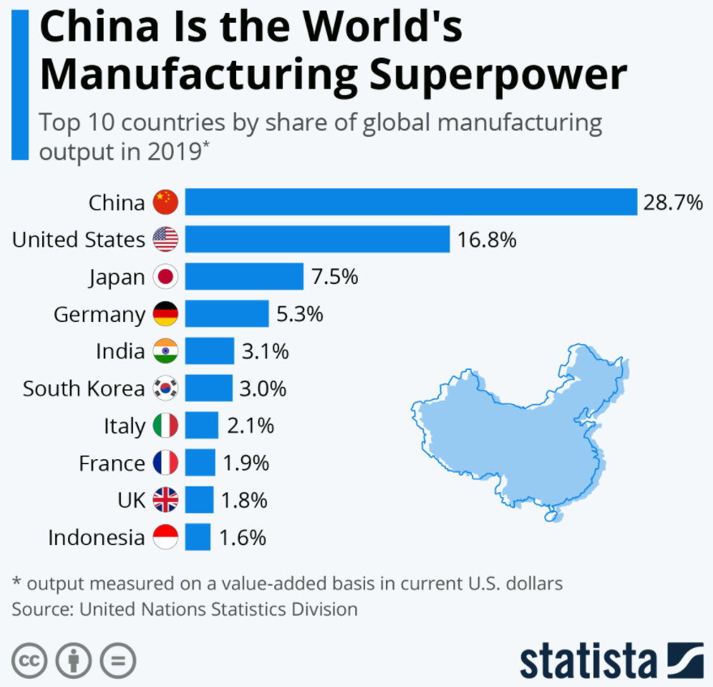
Figure 24: China is leading the world’s manufacturers (Richter, 2021)

In Beijing’s official stance, the trade surplus and the attractiveness to FDI are merely a result of China’s comparative advantage in manufacturing certain products, in the tradition of liberal trading. However, it is more the result of the CCP controlling everything. In this sense, the party even promotes relocation of production away from China:

P3: “Mexico is interesting for building own factories, typically twin factories across borders, but not for building a supply chain. Currently MNEs have not a huge appetite to manufacture things in own factories that are currently sourced from Chinese suppliers; what you do see, however, Chinese suppliers moving their factories to other low-cost countries like Vietnam, India, not Taiwan of course, but also Mexico.”

The interesting point, reiterated also by other interviewees, is that often Chinese suppliers are behind supply chain relocations. Prompted by global manufacturer’s request to mitigate soaring costs in China but then also encouraged by the Chinese government, Chinese suppliers are moving to countries like Vietnam or India, but also even Mexico. Fed by subsidised raw materials and components from China, the West continues to receive cheap supply, and China still receives the revenue, without pollution and land consumption, as well as regional influence by increasing trades. The CCP is happy to move the low-paid manufacturing jobs out of China while keeping the Chinese businesses on the growth path, by this steering out of the middle-income trap where it currently abides (Fig. 25).

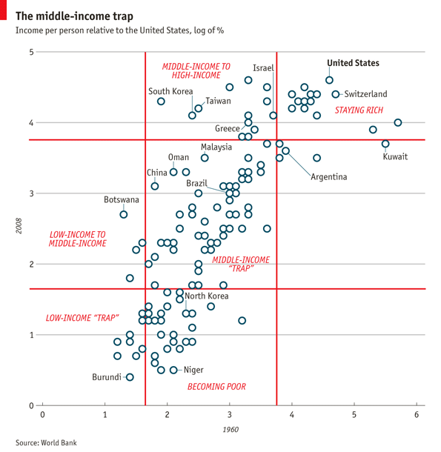
Figure 25: China in the middle-income trap (The Economist, 2019)

Chinese chutzpa meeting Western arrogance
While historically there is some common cultural background between China and its neighbouring countries like Vietnam and Taiwan, the US and China culture and mindset are quite opposite to each other (Hofstede et al., 2010), particularly regarding long-term orientation and individualism. Culture eats strategy for breakfast (Drucker, 1954). – This is certainly one reason for the unbalanced trade and the increasing rift of clashing civilisations (Huntington, 1996). China is very advanced and far-sighted while the self-confident West did not realise that it was overtaken by China:

P5: “The Vietnamese companies are quite advanced but the administration like the customs authority is not. Can you imagine that it takes sometimes three weeks before the authority completes the document handling as they still do everything manually? These are the kind of hurdles to deal with when you want to resource away from China to Vietnam.”

Yes, as a European you can easily imagine as we have similar problems regarding digitalisation. Global manufacturers reason their reluctance to relocate away from China by referencing to the backwardness of authorities in developing countries regarding digitalisation while Western authorities and large portion of the economy are lagging as well, by this missing the potential of underdeveloped countries like India.

Weaponisation / politisation of economy
The literature research made already obvious that policy and economy cannot be considered separately. In an ideal world, there is free trade, globally integrated with shared supply chains, and every country benefitting from its own specific competitive advantage: Growing prosperity and peace for all of us. The reality is, however, that this idea is currently dematerialising and the economy itself is turning into a weapon as recently shown in the Lithuania dispute with China (Nevett, 2022). The West still struggles to adapt to Xi’s China, and many decisionmakers have not realised to date how much they are influenced by China and its narrative. This naivety has been very clearly depicted by a closing remark of one of the interviewees, herself a Western expert in international business:

P5: “The West often talks badly about China these days. Sure, there are conflicts which come by nature when a new superpower arises, and China’s economic success and success in lifting so many people out of poverty is indeed enviable. But it is wrong to see China as a threat, or as imperialistic or even as a nation with hegemonic ambitions. The Chinese language does not even know the term ‘hegemonic’.”

This is a view interviewees from all other places, particularly Taiwan, Vietnam, and India would certainly not share – let alone Mongolia, Xinjiang, or Tibet. Western societies and economies have probably not fully grasped the situation and implications yet. Global manufacturers focussing on short-term profit fail to develop a long-term strategy if not guided by the government. Yet the geopolitical situation makes every manager to a policymaker of his country, responsible for the goodwill of his company (Müller, 2022).

Value-based versus interest-based economic policy
The primary interest of companies is to maximise profit, e.g. by reducing costs as demonstrated by the interviews discussed in prior sections. Companies are not guided by values, i.e. they do what is not forbidden or enforced by hard laws. CSR is a form of value-based soft law, but the reality is that even the United Nation Principles (UNGP) on Business and Human rights (UN, 2011) have not succeeded to move it to more enforceable hard law. Strictly speaking it is more than questionable whether any business with China can be in line with the UNGP (HRW, 2017). Notwithstanding, the interviews showed clearly that this will not change for now:

P4: “The environmental and ethical standards in Taiwan are on par with those in Europe, so it really does not have to fear the European Supply Chain Law. But we are realistic enough to not expect any business transitioning from risk countries like China as the effectiveness of this law is considered across the business community as low.”

A change towards a more value-based business behaviour can be induced either by more ethic-guided governments or by the consumer. This requires manufacturers to build value through brand and not pricing, and a new product positioning through emotion marketing (Fahy and Jobber, 2019).

The ball is in the West, US
The US is economically highly dependent on China, suffering most from supply chain disruption caused by the Covid-19 pandemic (Fig. 26). Also Europe suffers from global supply chain disruptions, however, at a much lesser extent as it is less dependent on China. In contrast, China and other emergent economies suffer virtually not at all from supply chain disruptions as they are not dependent on global supply chains.

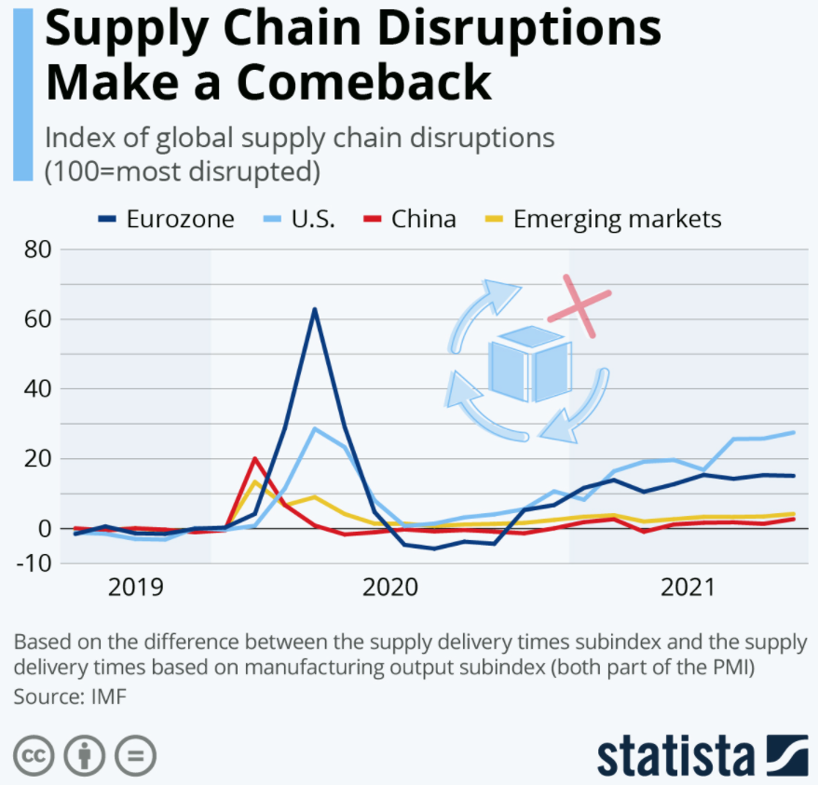
Figure 26: US is suffering most from supply chain disruptions (Buchholz, 2021)

It is up to the US to reduce the dependency by diversifying the supply chain. This is however easier said than done and will come at some costs. As the research has shown, the tariffs made products more expensive, and extra costs are born by the US customers. But even with the 25% tariff, the subsidized production in China is still cheaper than in other countries, in particular when duties are imposed also on these:

P5: “Vietnam is strong in manufacturing and has lower labour costs [than China]. It is similarly convenient and diligent. […] However, anti-dumping duties by the US on some hardware product categories are increasingly a problem, ironically pushing some of the production back to China because it is now cheaper again to produce in China even with 25% tariff.”

If some of the production is diversified away from China, it does not mean it ends up in the US. Followers in the cost-chain are countries like Vietnam, India or Mexico. On the way to these countries, the production is bypassing the US that are still avoided as a manufacturing location (Fig. 27). Not bringing the factory jobs back to the US is from Trump’s point of view a failure; however, not-made-in-China is a step towards diversification and reduction of dependency from the China supply chain.

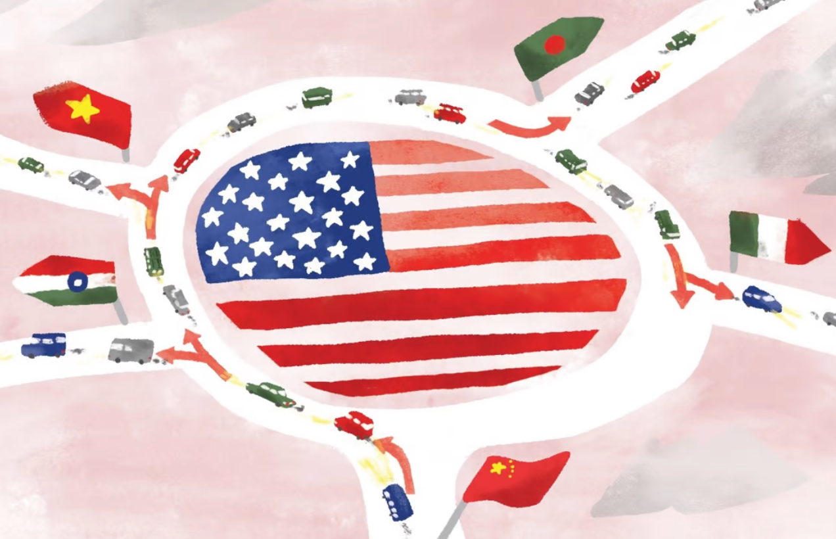
Figure 27: Tariffs on Chinese imports did not bring manufacturing back to the US (Klein, 2019)

Made-in-America great again
The research has shown that in the first place the factories and jobs moved away from the US because of low productivity. By manufacturing in China, the US was spared from the need to innovate for productivity improvements – only a temporary benefit that has turned into a curse and addiction over time. The interviews made clear that, if the US wants to change the current situation, they have to change:

P2: “Products made in the US can only be competitive if their production is highly automated, and/or if customers are willing to pay extra, what however is hardly the case to date. The US companies, like the consumers, arranged themselves with the supplies out of China. Maybe the pandemic-triggered supply delays, annoying companies as consumers, will lead to a rethinking.”

For more US production, the US manufacturers have to innovate, and the consumers have to pay more. The nuisance with disruptions caused by the Covid-19 pandemic may support the willingness to produce in the US and to pay extra, but to what extent? This will only have a sustainable success if not only the supply chain diversifies but diversification becomes also a part of the corporate strategy (Ansoff, 1988), and Made-in-the-USA becomes a relevant marketing feature. Without doubt, such value-based marketing could have some impact with the right marketing mix (product, price, place, promotion: the 4P (McCarthy, 1960)) and a comprehensive strategy (plan, pattern, position, perspective, and ploy: the 5Ps (Mintzberg, 1987)). ‘Buy American’ calls on the basic needs for job security and social belonging in a Maslow sense (Maslow, 1943), motivating the customer as he feels he is spending money for a good cause, his own and that of his community or nation. The employee, now more purpose driven, is motivated beyond the hygiene factors, making him more productive, creative and committed (Herzberg et al., 1959). – So much for the theory… However, maybe now the moment for change has come at last, after the US capitalism has manoeuvred into a Schumpeter’s ‘creative destruction’ (Schumpeter, 1912). Actions taken now to mitigate impacts on supply chains from Covid-19 can build resilience against future shocks (Alicke et al., 2020).

Localisation, supply chain triangle, end of globalisation
Localisation is another interesting yet important aspect of global changes in supply chains. As an extensive subject on its own it was only lightly touched by the presented research, but several statements from interviewees give some insight:

P2: “Supply chain problems related to Covid-19 and shutdowns revealed the vulnerability of the supply chains, prompting some manufacturers to localise.”

P4: “[…] Taiwanese companies are bringing back their production from China to Taiwan, at least some of it. The West is then supplied from Taiwan, and China from the factories there.”

Forming a dual-track manufacturing structure is helpful to manoeuvre around US and Chinese adversities, making it less vulnerable. The former globalised economies degrade to a patchwork arrangement, possibly developing towards to three mayor supply chain clusters aligned around the US, China, and Europe (Fig. 28), where particularly the US and China are mostly decoupled (EU COC, 2021). The West is not the driver of this development as to date the desire for decoupling or even an effective diversification is generally low for discussed reasons.

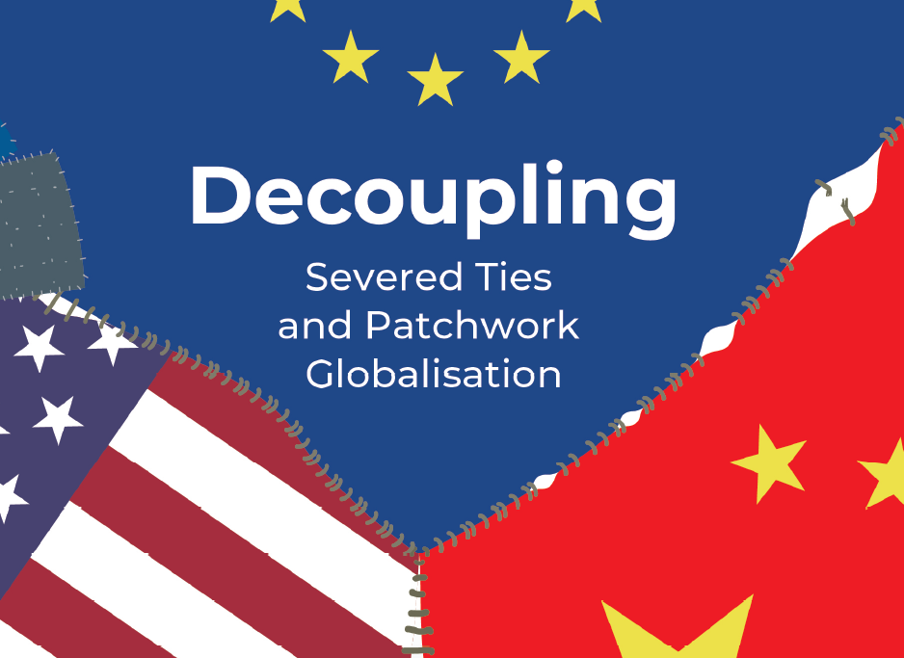
Figure 28: Decoupling towards tri-polar supply chains US-Europe-China (EU COC, 2021)

Decoupling is easier said than done while China's attractiveness is unbroken (Riecke, 2021). However, China is getting ready for a full-scale decoupling, threatening the West with its heavy reliance on China as an export market and the world’s factory. 30 years after Fukuyama’s proclamation of the end of rivalling political systems (Fukuyama, 1992), marking the beginning of turbo globalisation, the globalisation has passed the zenith (Fig. 29). Cooperating with allies of like-minded countries can help US manufacturers to reduce dependencies on the China supply chain without sliding in protectionism when descending the peak (Schneider-Petsinger, 2021).

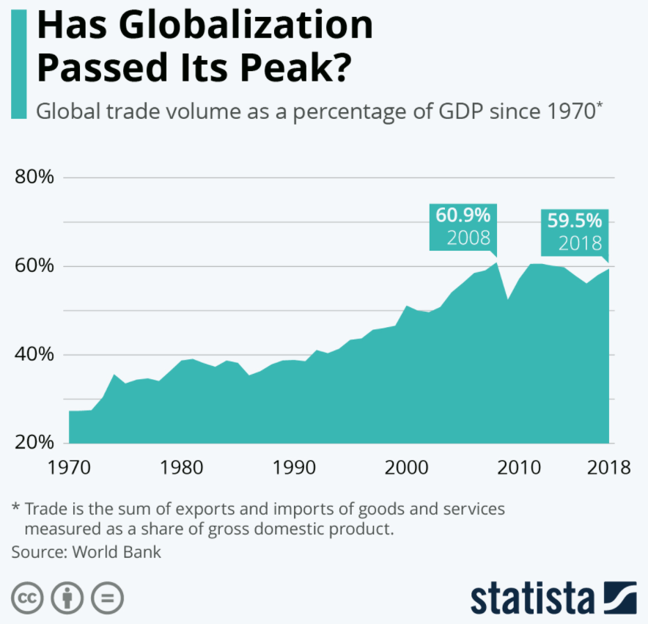
Figure 29: The end of globalisation? (Richter, 2020a)

Conclusions and recommendations

Conclusions
Based on the presented research results, the following key conclusions can be drawn:
- Since China is for global manufacturers of power tools typically a location for production but not for sales, they are ready to reduce their supply chain engagement in China. Generally, however, the investment in own factories is merely not further extended while contract manufacturing and sourcing of finished parts have not yet been relocated.
- Costs are the driving factor for supply chain diversification. For finance driven MNEs, investments are primarily diverted for investment optimisation, and contract manufacturing and sourcing, which could be reshuffled quickly, remain mostly where they are currently for maximum profit. – Diversification happens only if it is profitable.
- Convenience or habit within MNE organisations is another important factor responsible for resisting supply chain diversification away from China. This conduct is similar to the purchasing behaviour of customers. – Reducing the dependency from China would have been further progressed if it is easier and less resource intensive to execute.
- While costs and convenience take the front seats, aspects like CSR and the availability of qualified personnel take the back seats. Companies do not always live up to their standard and consumers do not either. Finding skilled personnel might be occasionally difficult but it is elsewhere not more difficult than in China and does not prevent relocation.
- China is technologically advanced and with its state capitalism and command economy at an advantage when shaping supply chains. It is the uncontested manufacturing superpower, yet it controls some of the diversification away from China to its own benefit. – Without leadership, the liberal economy of the West falls behind e.g. regarding digitalisation and automation of production, giving China further gain in manufacturing competitiveness.
- Global trade and supply chains are highly politicised and weaponised, this holds also for the supply chain organisation. The West with its MNEs is generally short-sighted; political leadership is needed to urge manufacturers towards a long-term supply chain strategy. Politics have to enforce supply chain laws more effectively if they really mean them to shape a more value-based business conduct.
- Global manufacturers do not have a coherent strategy across their organisations. Some of the supply chain is diversified away from China, but this does not necessarily improve the E2 situation. US manufacturers did shore some production capacity near to Mexico; however, nothing substantial back home. Made-in-USA production requires a purpose driven and farsighted strategy that includes i.a. manufacturing innovations and marketing plans, creating value for the customer and willingness to pay extra.
- The overall dependency on the China supply chain remains high for now. However, whether they want to or not, global manufacturers of e.g. power tools must get prepared for reducing the dependency on the China supply chain before they are decoupled at China’s initiative. Globalisation is at a turning point and manufacturers must align their supply chains along the new geopolitical and economic reality.
Some US manufacturers take steps towards a diversification away from their current China supply chain (Lynch, 2021), and even localise some of their production calling for a ‘make where sell and buy where you make’ strategy (Trebilcock, 2022). However, some of these programs involve Chinese suppliers that relocate their factories from China to Mexico. Setting up a China supply chain outside of China but controlled by China is not a sustainable solution since this setup does not reduce the dependency fundamentally and keeps on supporting an imbalanced system and inhuman regime.

Recommendations
The presented research has clearly shown that reducing the dependency from the China supply chain is more than a mere economic issue. Focusing on actions that can be addressed and controlled by companies and their managers, the following recommendations are made:
- Diversifying supply chains away from China must be financially valid. For this, tariffs and duties are justified but only if they are well coordinated by the governments. US manufacturers have to define a coherent strategy that includes a more long-term perspective considering all indirect costs of a dependency from China but that also includes action to improve productivity in factories outside of China where the factories have been trimmed for effectiveness during last three decades. Strategic leadership is required to push digitalisation and automation of production.
- Reducing dependency must be convenient, or any inconvenience must be overcome. US manufacturers should understand the goal of reducing the dependency as a major change management task. The operation and sourcing departments of MNEs should not be left handling this on their own, potentially jeopardising other department’s strategies or those of the corporate management. This endeavour must get more priority and resources, and stakeholders must understand better the gain over the long run. Just moving the Chinese supplier from China to Vietnam or Mexico might appear convenient at first sight but does not reduce the dependency and will not solve any issues fundamentally.
- Resolute promoting and marking the COO on the product but also in the increasingly important online shops would enable the customer to understand where the product is coming from and to make informed decisions. (Contrary to common belief, marking of the COO is not mandatory to date, neither in the US nor in Europe (EC, 2022; USCBP, 2022).) The purchase behaviour of the consumer can support Not-made-in-China products and by this help to diversify the supply chain. One step further, Made-in-USA products give the customer and the employee purpose and incentive to pay higher prices, also for the sake of environmental protection and human rights, incentivising China to improve in those fields, too. Companies can push this further with value-based marketing.
These measures require long-term strategies to correct the imbalance after the US made China big while it failed to keep up. 50 years after the historic meeting of Nixon and Mao in Beijing in February 1972 (Fig. 30), where the idea was promoted that a prosperous China will be peaceful and a huge market for American exports (The Washington Post, 2022), we have to admit that China’s politics and strategic perseverance let the opposite come true.

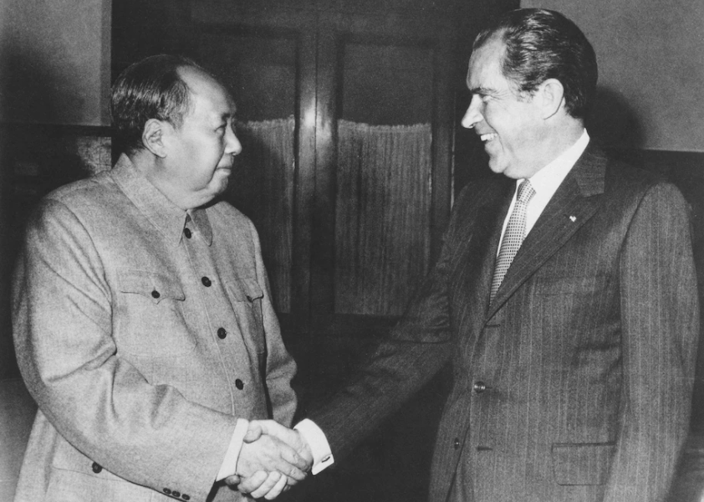
Figure 30: The meeting of the US President and the CCP Chairman in Beijing on February 21, 1972 that over time would transform the US-China relations in ways that were unimaginable and unintended at the time (The Washington Post, 2022)

The present humanitarian catastrophe in the Ukraine, which has been largely foreseeable, and the terror regime of Russian President Putin clearly demonstrate where refusing to see China’s ambitions and Chinese Leader Xi’s true face may ultimately lead to. As the West has to ask itself whether it wants to finance Putin by buying Russian oil and gas, the West has to ask itself whether it wants to finance Xi by spending money on all the imports from China (The Washington Post, 2022). There is no point in doing so only after the next catastrophe happens. The currently imposed sanctions hit those Western companies hardest which are dependent on Russian supply chains or market. It is in the core interest of global manufacturers to reduce the dependency on the China supply chain. It is a hard process requiring political leadership, but independence does not come for free.
It is the nature of manufacturers and consumers to pursue short-term profits and cheapest products, respectively. Politics plays a key role in incentivising long-term business strategies and value-based behaviour. Waiting to see mechanisms of the free economy and society remedying the situation will not suffice to overcome the challenges with authoritarian regimes like China. Future research should therefore investigate meaningful governmental tools other than protectionist tariffs or debt-financed Made-in-USA infrastructure programs to support US manufacturers in reducing the dependency on the China supply chain. Mandatory marking and direct visibility of the COO of every product particularly for online shops could be one such measure worthwhile to investigate regarding its effectiveness in motivating consumers to deal with higher costs and less convenience. However, having products for the US manufactures made in Mexico but by Chinese suppliers is not a sustainable solution. Research should investigate the extent of this latest trend and possible means to prevent it.

Appendices

Appendix A: Summary of company reports
All six companies considered are strongly engaged in China and have international supply chains that include China (Fig. A.1). One of them, ITW, even states that it has a strong focus on supply from China. This frank emphasis is remarkable for a traditional US company like ITW. All companies source finished goods from Chinese suppliers and most of them also have own factories. Only one of them, Makita, is not invested in own assets in China. This surprises since China may be taken as a natural location to produce goods for the Japanese home market. The reports do not reveal whether the companies continue to invest in China. However, they mention examples of further FDI in production facilities. None of them mentioned China, so at least further expansion of production capacities in China does not seem to be significant.

Figure A.1: Key results – Supply chain

Makita, without own factories in China, was therefore also the only company not significantly affected by the US-China conflict and their tariff war (Fig. A.2). The other companies were affected, SBD even strongly. SBD and ITW consider developing or manufacturing products in China as a risk which as US public companies they are obliged to mitigate and to notify in their annual reports. Supply chain diversification is one possibility for risk mitigation that was used by those companies. ITW even considers manufacturing in China as a particularly high risk, not surprisingly given that they are heavily supplied form there. Makita, Hilti, and Bosch are private companies which do not have to indicate risks, and which naturally have little incentive to list China as a risk even if this is the case. TTI on the other hand is a public company but located in Hong Kong, Special Administration Region of China. They hardly can call supply engagement in China as a risk. Note that risk in this context are not only tariffs and other costs e.g. related to sanctions in the course of the US-China trade war. Further risks are long transportation routes or Covid-19 lockdowns of factories and harbours.

Figure A.2: Key results – US-China conflict

Despite the risk, no company intends to move completely away from China resulting in a decoupling of supply chains (Fig. A.3). Only two of them, SBD and TTI, report plans for moving away some of the production to diversify their supply chains. (This is particularly noteworthy for the China based company TTI.) The other companies, including ITW with its risk prone focus on China, do not plan any diversification activity. However, one thing is what companies write in their reports, another thing is what they are really getting ready for. Regarding nearshoring or homeshoring, only two companies, SBD and Bosch, take a stance. SBD, the company that reportedly suffered severely by supply insecurities from China, explicitly name China as the country they aim to reduce the supplies from. Bosch does not reveal any details about these activities, as a private owned company it does not have to do so. However, one may assume that the current extension of the production close to its European home market is not relocated from China but additional capacity. Bosch sells high-end hardware (e.g. white goods) to the Asian upper class, and automotive components to Chinese car manufacturers, and therefore moving away from China is an unlikely scenario.

Figure A.3: Key results – Diversification activities

The company reports keep silent on the role of E2 on potential supply chain relocations (Fig. A.4). This is in stark contrast to the prominent and wordy place CSR occupies in dedicated sections of the reports or even in separate CSR reports. The reports discuss in length aspects like the reduction of the carbon footprint for better environmental and climate protection, or the observance of human rights to meet global ethical standards. However, these aspects are not linked to the situation in specific countries and the supply chain located there. Instead, the companies stress that all necessary actions are taken to ensure environmental and ethical standards are met in all business processes, and that all suppliers are screened for compliance. Paper does not blush.

Figure A.4: Key results – E2 and supply chain relocation

The analysed company reports do not provide a comprehensive breakdown of the sales by region. In particular, the sales share allotted to China are not substantiated, with the exception of Makita company proposing that less than 5% of the turnover was generated in China. It may be reasonably assumed, however, that this number will not be much exceeded in case of the other five companies considered. Given the enormous size of the Chinese market with an over-sized construction sector and steadily growing DIY business, 5% is a very small revenue portion. China is simply not a market for Western power tools designed for professionals and high-end home improvers. For global power tool manufacturers, China is clearly a manufacturing location, not a sales market.

Appendix B: Parsed interview protocols
S1 | Supply chain diversification is a hotly debated subject in the media and business communities – What is the current status of supply chain diversification away from China?
P1 | Currently there is not a massive relocation activity to the US. Colleagues in China do not report of any significant movement of supply chains away from China; maybe some movement can be observed for electronics not so much for hardware manufacturing. The matter however is subject of strategic considerations in many global companies.
P2 | Activities depend very much on the industry and, most importantly, whether the company is only producing in China or also selling their products. In the latter case, even an increase in FDI can be observed. Investment decisions are primarily based on financial considerations, and the US leaders are double-faced: political will to diversify but economically hard-nosed and prosaic.
P3 | Supply chain diversification is extensively investigated already for some time, however, not much has been materialized yet. Re-sourcing supply of finished goods or contracted manufacturing is only slowly progressing. Further investments in China factories are mostly stopped, however. Investment are made in factory extensions in Asian countries and Mexico but to a lesser extent in the US.
P4 | Activities depend largely on the industry and type of company. Semi-conductors/chip industry is presumably the industry Taiwan is most known for as being the leading manufacturing country. But also manufacturing capacities of other electronics and high-tech products are streaming in, even strategical low tech products.
P5 | Vietnam is a very active place with booming industry for the past decade in general. There might be some movement of production, however, primarily it is about investments extending capacities that are diverted away from China to Vietnam. Moreover, Chinese low-tech/dirty manufacturers are encouraged by the Chinese government to move factories/low-paid work out of the urban areas in China.
P6 | No substantial relocation of production from China to India, despite strongly promoting his. Western companies are rather looking for new investment opportunities in production facilities.
P7 | Taiwan experiences a lot of relocation activity from Taiwanese companies shifting production from their factories from China to Taiwan. Less movement is from global manufacturers.
P8 | In Vietnam, there are today an increasing number of Chinese companies producing for the global market. The production has shifted from China to Vietnam to bypass US tariffs or EU duties, and to make use of lower wages compared to China.
P9 | India suppliers are engaged to acquire new business out from China but there are several pushbacks: Different standards, different material specifications compared to China. And the Indian administration is not very quick.

S2 | There are several possible reasons why global manufacturers feel prompted to reorganise their supply chains – What has triggered these relocation activities?
P1 | The tensions with China are certainly the main reason for increased activities, after increasing production costs have been around already for some time. Also, Western companies are expressing concerns that the indirect pressure from China will increase.
P2 | US-China tensions has stirred up the US economy particularly during the Trump term. However, at the same time Chinese economy has been booming, attracting more business. Supply chain problems related to Covid-19 and shutdowns revealed the vulnerability of the supply chains, leading to localisation of supply chains rather than to relocating of supply chains out of China.
P3 | US-China conflict, particularly Trump’s trade war and the tariffs as well as European anti-dumping duties initiated any relocation activities. So these are financial aspects; Covid-19 supply chain security issues added to this further. In contrast, issues like IP protection in China or E2 considerations do not really matter.
P4 | Mounting tensions with China, and US sanctions for sensitive electronic parts plays a major role in the relocation. Further, re-installed anti-dumping duties supports production by Taiwanese factories.
P5 | Rising costs in China has prompted investment in Vietnam for some time, but the US-China trade etc. accelerated this trend further. However, Covid-19 has actually hampered this development a bit as setting up new production facility during lockdowns is difficult.
P6 | Risk-aware companies looking for FDI opportunities think that India could be a good location to replace China that is getting increasingly expensive and adverse with the US-China tensions and all that.
P7 | Increasing risk awareness triggered by tariff war, Covid-19 pandemic, as well as tensions between China and Taiwan. Improving relative competitiveness against China’s rising wages supports the move of production from China back to Taiwan.
P8 | Already before the tensions with China started Vietnam experienced an inflow of production from China, especially for hardware products, because of cheaper production costs.
P9 | India contract manufacturers shifted into the focus for the last 5 years since things in China aggravated particularly towards the US.

S3 | Different types of supply chains are differently affected and vary geographically – What type of supply chain reshuffle experiences the respective country?
P1 | To date, there is no massive swing of manufacturing capacities from China to the US; neither are there plans to relocate production facilities, nor to re-source supply of finished goods away from China.
P2 | Companies producing for the Chinese market are extending their production capacities in China, companies for which the Chinese market is not important are not further investing in China and are trying to diversify the supply chain away from China.
P3 | Manufacturers are looking for alternatives to China for investments in new production capacities. The US however is not the primary aim of these investments yet. Relocating supply of finished goods is not so much on the radar as it is assumed that these can be quickly relocated if the US-China situation is deteriorating further; and for now China is simply still the cheapest and easiest. There are even cases where sourcing relocated e.g. to Taiwan or Vietnam is now brought back to China again. – This is very volatile, shifting around supply from one country to another is dependent on the current tariffs and duties which are changing so often, hampering a long-term strategy.
P4 | Taiwan benefitted from supply chain diversification away from China, by global manufacturers but the more so by Taiwanese companies. This holds primarily for direct investments in production facilities and research centres, not so much for contract manufacturing or sourcing of finished goods.
P5 | There are definitely investments of MNEs in manufacturing of automotive components, electronics, but also hardware components in Vietnam, e.g. TTI building a new factory. Activities for contracted manufacturing or finish goods sourcing is not really visible.
P6 | The limited activity has been primarily for own production facilities for which manufacturers moved capacities from Chinese to Indian factories. Diversifying supply of sourced products from China to India is difficult because of reduced availability of required quality.
P7 | The production capacities of Taiwanese factories in China are reduced. Primarily the electronic industry (computer, chips etc.) but also other industries including power tools manufacturer are reshuffling their production.
P8 | Many of the new factory capacities are built by Chinese manufacturers in designated industrial areas. These then supply finished goods Western companies source, partly as contracted manufacturing.
P9 | Many manufacturers in the automotive industry have moved the production and supply from China to India. Power tool and hardware manufacturers are slower and as latecomers face capacity shortage.

S4 | Ultimately, supply chain diversification leads to a decoupling of the US and China – To what extent do global manufacturers move away from China?
P1 | There is no massive swing of manufacturing capacities from China to the US, more so to other countries including Vietnam, India and Taiwan, from where some US manufactured are now supplied from. But this is all diversification, by no means decoupling.
P2 | This cannot be stated for specific industries; however, generally speaking, China is not an important selling market for US companies as it is for e.g. German companies. So there is more readiness in US companies to diversify some of their business away from China.
P3 | It is generally a China+1 strategy; often Chinese suppliers are asked to move their production to countries like India, building up capacities and capabilities on their own expense.
P4 | In particular, Taiwanese companies are bringing back some of their production from China to Taiwan. The West is then supplied from the factories in Taiwan, and China from the factories in China. Also some Western companies with a long-term strategy are moving some production from China to Taiwan; however, these are rather SMEs than MNEs.
P5 | Western manufacturers are relocating production from China to Vietnam, but only some. Also Chinese manufacturers are relocating to Vietnam to build up a second supply basis to diversify source and risk.
P6 | India will never replace China completely, neither is it ready yet nor do global manufacturer want this as India is having its own peculiarities.
P7 | Manufacturers reshuffle the production in their factories to diversify. Neither global manufacturers nor Taiwanese will completely go away from China, the toes are strong and the supply chains are often too intertwined.
P8 | Vietnam manufacturers have certainly benefitted from relocating activities like no other Asian country. Still it is a battle against strong Chinese competition and far from easy money.
P9 | India’s manufacturers are hoping for more business from China but only particular industries have benefitted to date. This is not decoupling from China, rather limited diversification activities.

S5 | Supply chains do not get reorganized on their own and require stimulus – What is required to relocate the supply chain e.g. for power tools?
P1 | It is hard to compete against the Chinese supply chain, it is simply the best worldwide in view of costs and but also agility. Any activity is primarily driven by the financial benefit that can be generated in the short term. Western companies like US manufacturers have to learn to think strategically beyond the current horizon.
P2 | It takes a lot to shift production away from China to the US. In the first place financial viability i.e. price competitiveness, building new supply chains and competencies. However, in the end it mostly boils down to costs, and then a solid commitment with a strategic plan is needed to go through all this.
P3 | It requires time to build up capacities and capabilities, as it took time to do so in China. Chinese suppliers are good because Western manufacturers developed them. Same has to be done at new production facilities elsewhere, but they are generally not patient enough because short-term savings is most important.
P4 | In Taiwan, the government supports reshoring of production from China to Taiwan by several programs. Incentives are given e.g. to close the gap to competitive salaries, and funds for are provided for investments in facilities.
P5 | It takes money and time to develop suppliers, requiring engagement and stamina. With this, capacity and capability are no limiting factors. Vietnamese are born entrepreneurs, but the right partner have to be found, potentially with the support of consulting chambers of commerce.
P6 | Indian entrepreneurship is high but China has been easier because of the strong backup by the government with funding and subsidies as well as administrative support. This would also be needed for India for more success in relocating the supply chain from India to China.
P7 | Relocation of production to Taiwan is either cost driven or driven by legal considerations. The US tariffs on Chinese goods help to reduce costs and there are also financial incentives by the Taiwanese government for bringing home production. US sanctions also supported relocation activities. The Taiwan industry is very well set up for taking on manufacturing jobs, from a capacity as well as capability standpoint as they have excellent infrastructure and workforce. – It were primarily Taiwanese companies that helped to develop manufacturing in China.
P8 | There are already good supply china structures in Vietnam since Vietnam has been developing as an alternative production location already for some time. Vietnamese are also as quick as Chinese; however, it is difficult to compete against the superpower China.
P9 | The Indian are a manufacturing people with a sense for business. These are good prerequisites; however, it takes time and patience is needed. Global manufacturers also have to adopt to the Indian culture which is different to the Chinese.

S6 | Reorganizing supply chains is challenging for many manufacturers – What are the challenges to overcome in countries other than China?
P1 | Companies are aware of the manifold risk of over-dependence on China (trade war, Covid-19, political tensions, IP protection), still the management decisions of MNEs are generally short-sighted. Even if there are very clear advantages in the long-term, it is difficult to change their strategy. This holds particularly for US companies with their supply base in China. Companies that sell in China do not want to lose the market; on the other hand, however, business in China is becoming increasingly difficult because of increasingly restricted market entrance (decoupling standardisation, exclusion from tenders etc.). Further, companies struggle to find alternatives, China is still most convenient for sourcing due to costs (even anti-dumping duties do not outweigh the effects of subsidised manufacturing in China e.g. for cheap raw material and energy). Other countries are not on the same level of expertise and are less digitalised. Building up capacities and capabilities requires time most companies are not willing to spend.
P2 | China still has a cost benefit e.g. due to subsidies that even tariffs do not outweigh. Moreover, China is the easiest place to make business today. Alternatives (capacities, capabilities) have to be developed first. This holds also for the US which lags considerably in regard to productivity, linked also to a notoriously backwardness in digitalisation.
P3 | Compared to China, many countries a left far behind in view of expertise. Both, capabilities and capacities need to be extended. The real challenge is to have the endurance till any activities come to an effect.
P4 | Taiwan is a very advanced country well integrated in the global supply chain. Technically, there is no challenge to overcome. The real or only challenge are manufacturing costs. But again, there is an awareness that due to wage lowering effects from China the Taiwanese wages are relatively low compared to other developed countries.
P5 | Vietnamese are tech-savvy and the companies are digitalised. Vietnamese companies are advanced but the administration is not; e.g. customs authority and trade office are lagging with a low digitalisation rate, hampering many processes. The infrastructure (transportation, communication) in remote areas can be challenging but it is developing very quickly.
P6 | Degree of digitalisation in India is high, capabilities are generally not an issue or can be developed, same goes for capacity. One big challenge is the availability of raw material grades equivalent to the grades manufacturers have been used in China for decades. So a simple switch is not possible.
P7 | There are no other manufacturing challenges than costs in Taiwan, and the willingness of Western procurement.
P8 | The biggest problem has been extensive shut down periods due to Covid, bringing all manufacturing to hold.
P9 | Indians with higher education are very literate in digital application but the infrastructure is not always there.

S7 | Shortage of qualified personnel in manufacturing is an often made complaint globally – What kind of qualification is needed if lack of qualified personnel is an issue?
P1 | China has a huge pool of graduates and skilled workers. On the other hand, demographics makes it more difficult to meet demand on workforce.
P2 | The lack of qualified STEM personnel is indeed a problem if someone tries to bring manufacturing home to the US.
P3 | Asian countries other than China generally lack skilled workers. In the West, employees are less tech savvy and less versed in digital working, this is a severe miss.
P4 | The lack of vocational training (as available e.g. in Germany to non-university graduates) has been identified as a gap in the past that has been successfully addressed by the government. There are today governmental sponsorships to incentivise this kind of education.
P5 | Vietnamese workers and engineers are extremely diligent and ready to learn. The pool is big, so any shortages are filled up quickly.
P6 | Skilled workers are generally rare in India. Generally sufficient engineers are available which are well educated and good in English.
P7 | Qualified engineers and skilled blue-collar workers can be short as in many other Western countries, also because these jobs all flowed out to China over past decades. This shortage, however, can be filled up quickly once the right incentive is given.
P8 | To date, there is no lack of qualified personnel in general. In specific areas, however, there might be a temporary shortage.
P9 | Skilled workers are maybe rare in India but can be trained on the job. Graduate colleges have a long tradition in India; their output is maybe not as massive as in China but steadily and reasonably increasing.

S8 | The European supply chain law epitomise the ambition of the West to protect human rights and environment in supplier countries – What impact does the European supply chain law have?
P1 | This remains to be seen but it is generally believed that it will not have any effects. It is considered as a formality since it cannot be controlled anyway in countries like China.
P2 | US as EU companies get prepared for increasingly stringent requirements e.g. by defining code of conducts to stay compliant and out of trouble. The issue is taken very seriously, as it is by the Chinese supplier (who feels this law being a Lex China anyway). The big corporations try to pass on the responsibilities to their (Western) suppliers if possible. It will however have no effect on the supply chain or the actual situation in China regarding human rights. China does simply not care very much these days.
P3 | The European law will not have an impact on the US-China supply chain as it is not applicable then and is not the right measure to lift standard in general.
P4 | The supply chain law certainly does not play a role in Taiwan as the standards are on par with Europe. On the other hand, no positive effect like from additional business transitioning from risk countries is expected as the effectiveness of this law is considered being low.
P5 | Vietnamese suppliers that Western manufacturers are working with should generally meet the requirements.
P6 | This is not on the radar yet and therefore remains to be seen. Human rights are generally not an issue as exploitation of workers and child labour are not an issue in the manufacturing industry.
P7 | This is not an issue at all as the requirements will be easily met in Taiwan.
P8 | This is not really on the agenda yet. However, any supply chain regulations will generally not be a big problem to meet.
P9 | The law is not expected to have any effect on the supply streams between China and India or globally.

S9 | The ethical and environmental standards do not necessarily improve when relocating supply chains – How are E2 standards in the respective country, compared to China?
P1 | N/A
P2 | Needless to say, the E2 standards in the US are high, though maybe somewhat lower than in Europe…
P3 | When it comes to production in or supply from China, there is always some risk of greenwashing.
P4 | The environmental and ethics standards are very high in Taiwan which regularly owns the top ranks of global indices for democracy, open society, anti-corruption, sustainability etc.
P5 | Though an authoritarian government, things like exploitation of workers, child work, etc. are generally not an issue in Vietnam, with maybe some exceptions within minority tribe communities. Environmental standards are high by law and generally followed by suppliers having business with Western companies (to a lesser degree however by other suppliers).
P6 | India is a free and democratic state, however, with cases of child labour and environmental protection is not always of highest priority.
P7 | Ethical and environmental standards are very high, comparable to Europe but not to China.
P8 | No comment.
P9 | No comment.

S10 | Reducing the dependency form the China supply chain is desirable yet not very much progressed – What are critical challenges for being competitive with Chinese suppliers?
P1 | N/A
P2 | Products made in the US can only be competitive if their production is highly automated, and/or if customers are willing to pay extra, what however is hardly the case to date. The US companies, like the consumers, arranged themselves with the supplies out of China.
P3 | When it comes to sourcing, convenience is also a matter next to costs: Managers of Western manufacturers are simply used to the established supply chain in China. This thinking is very deep rooted and have to overcome to give competitors a chance.
P4 | Taiwan is certainly competitive against China: It has tech savvy, highly educated work force that is significantly cheaper than in other developed countries like Japan or South Korea as the wages have been stagnated for quite a while now while those in China skyrocketed. The job and talent markets are flexible, the country is highly digitalised. Cost, convenience, competence is all no challenge, at least from the supplier’s perspective. However, China’s coercion is looming over Taiwan’s business and there are some companies who are afraid enough to leave China without considering Taiwan as an option.
P5 | Vietnam is strong in manufacturing and has lower labour costs. It is similarly diligent and convenient, though the client might feel differently. It can or will be the next China. However, anti-dumping duties by the US on some hardware product categories are increasingly a problem, ironically pushing some of the acquired production back to China because it is now cheaper again to produce in China even with 25% tariff.
P6 | India is absolutely competitive particularly regarding wages; and it has a huge potential to be the next super manufacturers. Unfortunately, the anti-dumping duties on China still does not make good the huge subsidies existing in some industries including hardware and power tool production as there are virtually no subsidies in India. Indian bureaucracy can be an issue e.g. when Chinese manufacturers intend to move to India or Western companies want to make direct investments. This requires some extra efforts.
P7 | Many industries in Taiwan are competitive compared to China. Some Taiwanese companies fail to emphasise their strengths as Taiwanese are generally modest people.
P8 | Chinese suppliers are still more experienced with Western preferences but Vietnamese factories are learning and catching up quickly. Dumping prices from Chinese factories are still a problem, though.
P9 | Things are done differently in India compared to China. This might be inconvenient for the customer at the beginning.

Appendix C: Completed ethics form
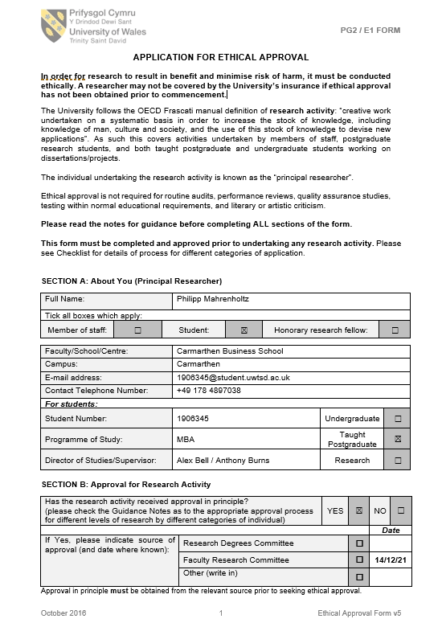
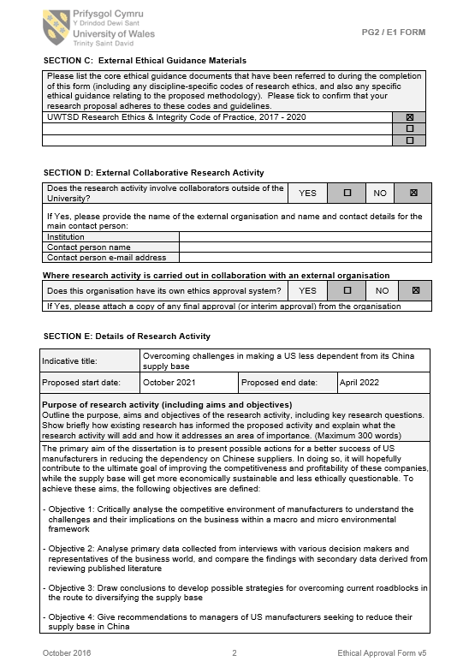
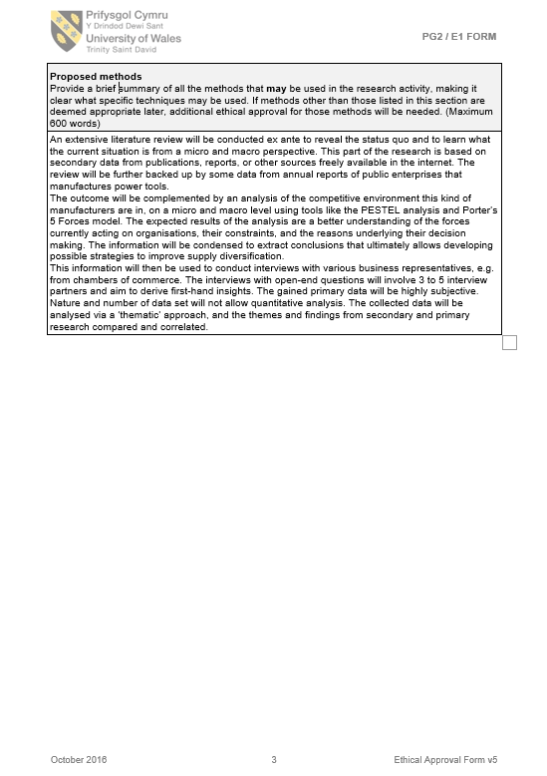
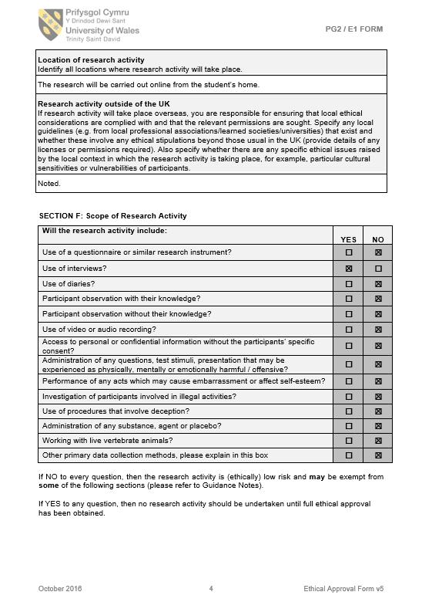
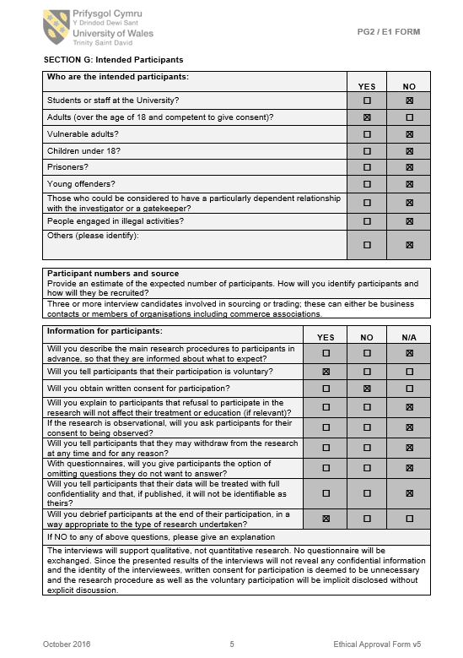
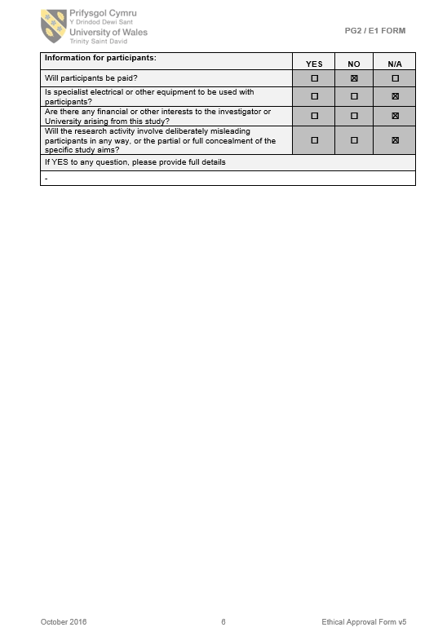
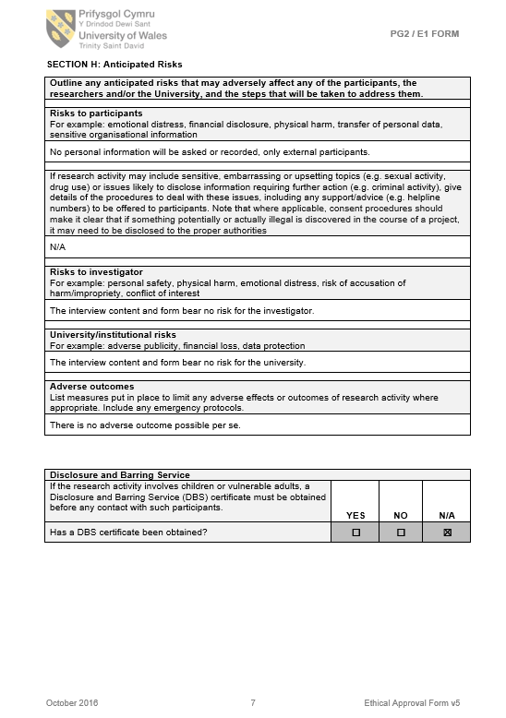
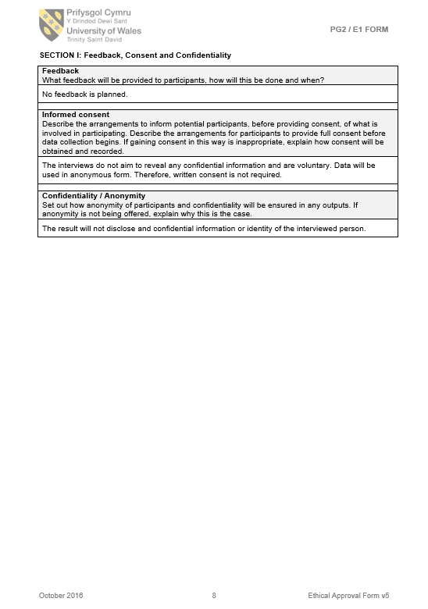
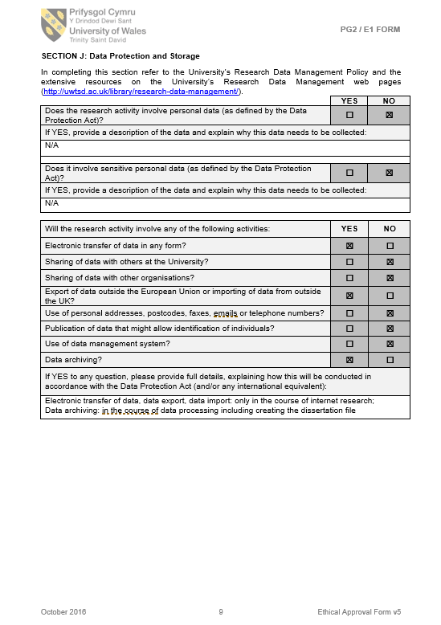
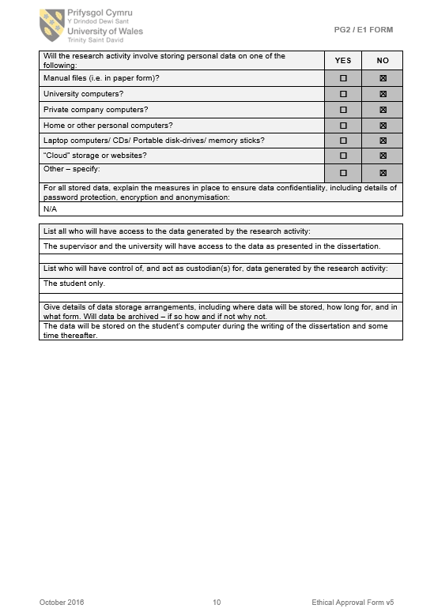
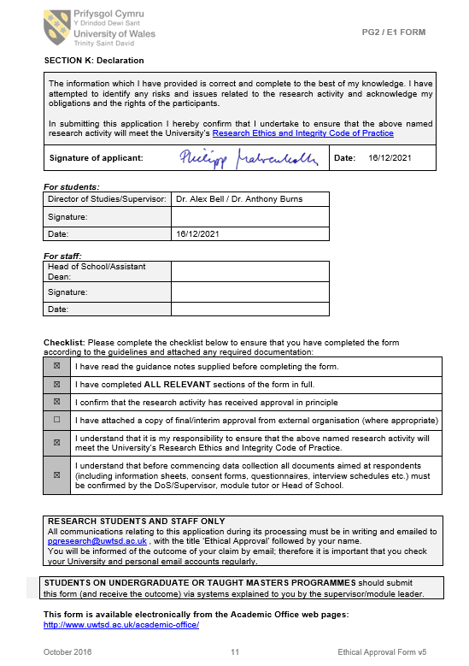

References
Abnett, K. (2020) ‘EU extends anti-dumping duties on Chinese steel’, Reuters [Online]. Available at https://www.reuters.com/article/us-eu-steel-anti-dumping-idUSKCN2511NZ (Accessed 15 November 2021).
Aguilar, F. (1967) ‘Scanning the business environment’, Macmillan New York.
AHK (2021) ‘AHK world business outlook 2021’, Network of German Chambers of Commerce Abroad (AHKs) [Online]. Available at https://www.dihk.de/resource/blob/55520/cfc21a22a651745c6b33155100e1fcfc/ahk-world-business-outlook-spring-2021-data.pdf (Accessed 21 October 2021).
Alicke, K., Azcue, X. and Barriball, E. (2020) ‘Supply-chain recovery in coronavirus times - plan for now and the future’, McKinsey & Company Operations [Online]. Available at https://www.mckinsey.com/business-functions/operations/our-insights/supply-chain-recovery-in-coronavirus-times-plan-for-now-and-the-future (Accessed 14 November 2021).
Alvarez, S. (2021) ‘China and Germany’s new traffic-light coalition’, Wirtschaftswoche [Online]. Available at https://www.wiwo.de/politik/deutschland/china-und-die-neue-ampel-koalition-ich-wuerde-die-china-frage-nicht-zu-sehr-an-den-gruenen-festmachen-/27859928.html (Accessed 9 December 2021).
Amadeo, K. (2019) ‘US trade deficit and how it hurts the economy’, The Balance [Online]. Available at https://www.thebalance.com/u-s-trade-deficit-causes-effects-trade-partners-3306276 (Accessed 26 December 2019).
Amadeo, K. (2021) ‘U.S. trade deficit with China and why it’s so high’, The Balance [Online]. Available at https://www.thebalance.com/u-s-china-trade-deficit-causes-effects-and-solutions-3306277 (Accessed 29 November 2021).
AmCham (2021) ‘2021 American business in China, White Paper’:, American Chamber of Commerce China [Online]. Available at https://www.amchamchina.org/white_paper/2021-american-business-in-china-white-paper/ (Accessed 2 December 2021).
Anderton, K. (2021) ‘This is the reason American politics are so polarized’, Forbes [Online]. Available at https://www.forbes.com/sites/kevinanderton/2020/10/27/this-is-the-reason-american-politics-are-so-polarized-infographic/ (Accessed 20 November 2021).
Ansoff, H. (1988) ‘The new corporate strategy’, Penguin Books.
Atrill, P. (2019) ‘Financial management for decision makers’, Financial Times Prentice Hall.
Bacchus, J., Lester, S. and Zhu, H. (2018) ‘Disciplining China’s trade practices at the WTO: How WTO complaints can help make China more market‐​oriented’, CATO Institute [Online]. Available at https://www.cato.org/policy-analysis/disciplining-chinas-trade-practices-wto-how-wto-complaints-can-help-make-china-more (Accessed 15 December 2020).
Bachute, S. (2019) ‘Reasons why power tools have become more popular over hand tools’, Medium Technology [Online]. Available at https://medium.com/@sanketbachute9576/reasons-why-power-tools-have-become-more-popular-over-hand-tools-4dc5a5c41641 (Accessed 25 November 2021).
Badkar, M. (2013) ‘China’s excess capacity problem - China stimulated its economy like crazy after the financial crisis ... and now the nightmare is beginning’, Business Insider [Online]. Available at https://www.businessinsider.com/chinas-excess-capacity-problem-2013-6 (Accessed 25 November 2021).
BEA (2021) ‘U.S. direct investment abroad: Country detail China’, Bureau of Economic Analysis [Online]. Available at https://www.bea.gov/international/di1usdbal (Accessed 15 December 2021).
Beattie, A. (2021) ‘Why supply chain diversification isn’t all that easy’, Financial Times [Online]. Available at https://www.ft.com/content/0e34387f-2a52-47f7-837d-a429ff555ea6 (Accessed 2 December 2021).
Bhandari, P. (2021) ‘A guide to ethical considerations in research’, Scribbr [Online]. Available at https://www.scribbr.com/methodology/research-ethics/ (Accessed 13 December 2021).
Bhattarai, A. (2021) ‘Baby boomers, to retailers’ surprise, are dominating online shopping’, The Washington Post [Online]. Available at https://www.washingtonpost.com/road-to-recovery/2021/01/21/baby-boombers-online-shopping-pandemic/ (Accessed 16 March 2021).
Black, S. and Morrison, A. (2021) ‘The strategic challenges of decoupling’, Harvard Business Review, May-June 2021 Issue [Online]. Available at https://hbr.org/2021/05/the-strategic-challenges-of-decoupling (Accessed 29 November 2021).
Blenkinsop (2022) ‘EU imposes anti-dumping tariffs on Chinese steel fasteners’, Reuters [Online]. Available at https://www.reuters.com/business/eu-imposes-anti-dumping-tariffs-chinese-steel-fasteners-2022-02-17/ (Accessed 19 February 2022).
Bosch (2021) ‘Bosch annual report 2020’, [Online]. Available at https://assets.bosch.com/media/global/bosch_group/our_figures/pdf/bosch-annual-report-2020.pdf (Accessed 27 December 2021).
Bosch (2022) ‘Bosch’s responsible corporate governance’, [Online]. Available at https://www.bosch.com/sustainability/responsibility/ (Accessed 22 January 2022).
Bown, C. (2021) ‘US-China trade war tariffs: An up-to-date chart’, Peterson Institute for International Economic (PIIE) [Online]. Available at https://www.piie.com/research/piie-charts/us-china-trade-war-tariffs-date-chart (Accessed 29 November 2021).
Brennan, B. (2015) ‘Top 10 things everyone should know about women consumers’, Forbes [Online]. Available at https://www.forbes.com/sites/bridgetbrennan/2015/01/21/top-10-things-everyone-should-know-about-women-consumers/ (Accessed 20 November 2021).
Brooks, A. and Leslie, J. (2018) ‘How to ask great questions’, The Economist [Online]. Available at https://hbr.org/2018/05/the-surprising-power-of-questions (Accessed 6 March 2022).
Brotherton-Bunch, E. (2019) ‘Stanley Black & Decker is reshoring more production of Craftsman Tools’, [Online]. Available at https://www.americanmanufacturing.org/blog/stanley-black-decker-is-reshoring-more-production-of-craftsman-tools/.
Buchholz, K. (2021) ‘Supply chain disruptions make a comeback’, Statista [Online]. Available at https://www.statista.com/chart/25960/supply-chain-disruption-index/ (Accessed 10 January 2022).
Buck, G. and Du Chenne, J. (2021) ‘China aims for self-sufficiency’, Deutsche Bank [Online]. Available at https://flow.db.com/more/macro-and-markets/china-aims-for-self-sufficiency (Accessed 28 November 2021).
Butler, A. (2021) ‘Do customers really care about your environmental impact?’, Forbes [Online]. Available at https://www.forbes.com/sites/forbesnycouncil/2018/11/21/do-customers-really-care-about-your-environmental-impact/ (Accessed 24 November 2021).
Carlile, C. (2021) ‘Should we boycott “made in China”?’, Ethical Consumer [Online]. Available at https://www.ethicalconsumer.org/fashion-clothing/should-we-boycott-made-china (Accessed 29 October 2021).
Caulfield, J. (2019) ‘How to do thematic analysis’, [Online]. Available at https://www.scribbr.com/methodology/thematic-analysis/ (Accessed 11 July 2021).
Chaffey, D. (2015) ‘Digital business and e-commerce management, 6th editon’, Pearson Education.
Chamberlain, G. (2017) ‘The grim truth of Chinese factories producing the west’s Christmas toys’, The Guardian [Online]. Available at https://www.theguardian.com/business/2016/dec/04/the-grim-truth-of-chinese-factories-producing-the-wests-christmas-toys (Accessed 5 December 2021).
Cheng, T.-F. and Li, L. (2021) ‘Tech industry braces for skyrocketing rare earth prices: Surging demand and U.S.-China tensions make life tough for hardware makers’, Nikkei Asia [Online]. Available at https://asia.nikkei.com/Business/Technology/Tech-industry-braces-for-skyrocketing-rare-earth-prices (Accessed 22 November 2021).
Chimits, F. (2021) ‘Chasing the ghost of transatlantic cooperation to level the playing field with China: time for action’, China Monitor - Picture Alliance / Associated Press [Online]. Available at https://merics.org/en/report/chasing-ghost-transatlantic-cooperation-level-playing-field-china-time-action (Accessed 25 October 2021).
Chris, M. (2019) ‘India to benefit from US-China trade war: Experts’, Economic Times India, Issue May 16, 2019 [Online]. Available at https://economictimes.indiatimes.com/news/economy/foreign-trade/india-to-benefit-from-us-china-trade-war-experts/articleshow/69357900.cms?from=mdr (Accessed 2 November 2021).
Creswell, J. and Plano Clark, V. (2017) ‘Designing and conducting mixed methods research, 3rd edition’, SAGE Publications Ltd.
Crossley, J. and Jansen, D. (2021) ‘Saunders’ research onion: Explained simply’, Grad Coach [Online]. Available at https://gradcoach.com/saunders-research-onion/ (Accessed 28 December 2021).
Davies, N. (2021) ‘The Covid collapse: Surveying the damage to global investment flows’, Investment Monitor [Online]. Available at https://www.investmentmonitor.ai/analysis/covid-decimated-fdi-in-developed-countries (Accessed 30 November 2021).
DeBoer, C. (2021) ‘What tools are made in the USA?’, [Online]. Available at https://www.protoolreviews.com/what-tools-are-made-in-the-usa/ (Accessed 22 December 2021).
Deng, T. (2021) ‘In China, the water you drink is as dangerous as the air you breathe’, The Guardian [Online]. Available at https://www.theguardian.com/global-development-professionals-network/2017/jun/02/china-water-dangerous-pollution-greenpeace (Accessed 24 November 2021).
Desjardins, J. (2017) ‘The world’s most respected “Made in” labels’, Visual Capitalist, based on survey by Statista [Online]. Available at https://www.visualcapitalist.com/respected-made-in-labels-country/ (Accessed 9 December 2021).
Diaz, M. (2021) ‘Beyond outsourcing: How to get started with nearshoring’, Forbes [Online]. Available at https://www.forbes.com/sites/forbestechcouncil/2021/05/27/beyond-outsourcing-how-to-get-started-with-nearshoring/ (Accessed 4 December 2021).
Donahue, D. (2021) ‘Subcontract manufacturing in China: The risks and alternative options’, Forbes [Online]. Available at https://www.forbes.com/sites/forbesbusinesscouncil/2021/06/18/subcontract-manufacturing-in-china-the-risks-and-alternative-options/ (Accessed 8 November 2021).
Doyle, P. (2000) ‘Value-based marketing’, Chichester: John Wiley & Sons.
Drago, A. (2021) ‘Next China: Is Trump still in the White House?’, Bloomberg [Online]. Available at https://www.bloomberg.com/news/newsletters/2021-04-02/as-biden-keeps-trump-s-china-policies-no-reset-yet-in-relations (Accessed 23 November 2021).
Drucker, P. (1954) ‘The practice of management’, Harper & Row New York.
Dusharme, D. (2018) ‘Made in China: from scary bad to scary good’, Quality Digest Journal May 2018 [Online]. Available at https://www.qualitydigest.com/inside/management-article/made-china-scary-bad-scary-good-052918.html (Accessed 29 October 2021).
Easterby-Smith, M., Thorpe, R. and Lowe, A. (2002) ‘Management research: An introduction’, Sage London.
EC (2020) ‘Strategic dependencies and capacities: Reducing single source dependency for Europe’s recovery’, European Commission [Online]. Available at https://ec.europa.eu/info/sites/default/files/swd-strategic-dependencies-capacities_en.pdf (Accessed 14 November 2021).
EC (2022) ‘Rules of origin for EU imports’, European Commission - Taxation and Customs Union [Online]. Available at https://ec.europa.eu/taxation_customs/customs-4/international-affairs/origin-goods_en (Accessed 18 January 2022).
EIU (2021) ‘North American supply chains - Will reshoring actually happen?’, A report by The Economist Intelligence Unit [Online]. Available at https://www.eiu.com/public/topical_report.aspx?campaignid=jun21nareshoring (Accessed 21 July 2021).
Ellyatt, H. (2021) ‘There are millions of jobs, but a shortage of workers: Economists explain why that’s worrying’, CNBC [Online]. Available at https://www.cnbc.com/2021/10/20/global-shortage-of-workers-whats-going-on-experts-explain.html (Accessed 22 November 2021).
EU COC (2021) ‘Decoupling - Severed ties and patchwork globalisation’, EU Chamber of Commerce in China & MERICS.
EUPD (2021) ‘Corporate social responsibility (CSR) and its implementation into EU Company law’, EU Policy Department for Citizens’ Rights and Consitutional Affairs [Online]. Available at https://www.europarl.europa.eu/RegData/etudes/STUD/2020/658541/IPOL_STU(2020)658541_EN.pdf (Accessed 21 November 2021).
Fahrion, G., Graca Peters, K., Sarovic, A. and Zand, B. (2021) ‘The U.S. and China Face Off in the Far East’, Der Spiegel [Online]. Available at https://www.spiegel.de/international/world/indo-pacific-arms-race-the-u-s-and-china-face-off-in-the-far-east-a-6032d1c3-2fb5-4896-a9e4-15c89ea16825.
Fahy, J. and Jobber, D. (2019) ‘Foundations of marketing’, McGraw-Hill.
Fang, A. (2020) ‘“China exit” limited to some American sectors -- and not for home’, Nikkei Asia, September 12, 2020 [Online]. Available at https://asia.nikkei.com/Economy/Trade-war/China-exit-limited-to-some-American-sectors-and-not-for-home.
Fernando, J. (2020) ‘Why is social responsibility important in marketing?’, Investopedia [Online]. Available at https://www.investopedia.com/terms/c/corp-social-responsibility.asp (Accessed 7 December 2021).
FII, M. (2019) ‘3 highlights from Techtronic Industries Co Ltd’s’, Fool Investing International [Online]. Available at https://www.fool.com/investing/international/2019/09/03/3-highlights-from-techtronic-industries-co-ltds-h1.aspx (Accessed 22 December 2021).
Fiskars, A. (2021) ‘Manufacturers offering precision tools for DIY tasks’, Verified Market Research [Online]. Available at https://www.verifiedmarketresearch.com/blog/top-power-tool-manufacturers/ (Accessed 25 November 2021).
Foss, N. (1996) ‘More critical comments on knowledge-based theories of the firm’, Organization Science, (7:5), 1996, pp. 519–523.
Franck, T. (2021) ‘Senate passes $250 billion bipartisan tech and manufacturing bill aimed at countering China’, CNBC [Online]. Available at https://www.cnbc.com/2021/06/08/senate-passes-bipartisan-tech-and-manufacturing-bill-aimed-at-china.html (Accessed 25 November 2021).
Frans, D. and Ruf, Y. (2021) ‘Decarbonizing transportation: Emission reduction pathways for transportation and logistics operations’, Roland Berger [Online]. Available at https://www.rolandberger.com/en/Insights/Publications/Decarbonizing-transportation.html (Accessed 5 November 2021).
FTV (2021) ‘Hilti factories’, Fastener TV [Online]. Available at https://fastener.tv/hilti-factory-in-thuringen-austria/ (Accessed 22 December 2021).
Fukuyama, F. (1992) ‘The end of history and the last man’, Free Press New York.
Gautam, A. (2020) ‘How will 5G shape the next generation of supply chains?’, Forbes [Online]. Available at https://www.forbes.com/sites/forbestechcouncil/2020/10/22/how-will-5g-shape-the-next-generation-of-supply-chains/ (Accessed 14 November 2021).
GCP (2019) ‘Global Construction 2030: A global forecast for the construction industry to 2030. PwC sponsored report from Global Construction Perspectives, Oxfor Economics’, Loddon House.
Gentile, E., Li, G. and Mariasingham, M. (2020) ‘Assessing the impact of the United States-People’s Republic of China trade dispute using a multiregional computable general equilibrium model - ADB Economic Working Paper No. 620’, Asia Development Bank [Online]. Available at https://www.adb.org/sites/default/files/publication/640651/ewp-620-impact-us-prc-trade-dispute.pdf (Accessed 3 December 2021).
George, E. (2019) ‘Can corporate social responsibility be legally enforced?’, Forbes [Online]. Available at https://www.forbes.com/sites/uhenergy/2019/10/11/can-corporate-social-responsibility-be-legally-enforced/ (Accessed 10 February 2022).
Giffi, C., Rodriguez, M., Gangula, B., Roth, A. and Hanley, t: (2020) ‘Global manufacturing competitiveness index’, Deloitte and Council on Competiveness [Online]. Available at https://www2.deloitte.com/global/en/pages/manufacturing/articles/global-manufacturing-competitiveness-index.html (Accessed 18 October 2021).
Glunz, A. (2022) ‘Business confidence survey China 2021/2022’, KPMG Survey.
GNW (2021) ‘Power tools market to reach USD 33.05 billion by 2028; rising demand for energy-efficient products to accelerate growth’, GlobeNewsWire [Online]. Available at https://www.globenewswire.com/news-release/2021/09/22/2301136/0/en/Power-Tools-Market-to-Reach-USD-33-05-Billion-by-2028-Rising-Demand-for-Energy-efficient-Products-to-Accelerate-Growth-Fortune-Business-Insights.html (Accessed 25 November 2021).
Goldman, D. (2021) ‘Gobbling China’s exports, US sinks into dependency’, Asia Times [Online]. Available at https://asiatimes.com/2021/10/gobbling-chinas-exports-us-sinks-into-dependency/ (Accessed 25 October 2021).
Goodman, P. and Bradsher, K. (2021) ‘The world is still short of everything. Get used to it.’, The New York Times [Online]. Available at https://www.nytimes.com/2021/08/30/business/supply-chain-shortages.html (Accessed 25 November 2021).
Goodman, P., Wang, V. and Paton, E. (2021) ‘Global brands find it hard to untangle themselves from Xinjiang cotton’, The New York Times [Online]. Available at https://www.nytimes.com/2021/04/06/business/xinjiang-china-cotton-brands.html (Accessed 26 October 2021).
Hanemann, T., Rosen, D., Gao, C. and Lysenko, A. (2021) ‘Two-way street – US-China investment trends – 2020 update’, Rhodium Group [Online]. Available at https://rhg.com/research/two-way-street-us-china-investment-trends-2020-update/ (Accessed 15 December 2021).
Hannon, P. and Jeong, E.-Y. (2021) ‘China overtakes U.S. as world’s leading destination for foreign direct investment’, The Wall Street Journal, Jan 24, 2021 [Online]. Available at https://www.wsj.com/articles/china-overtakes-u-s-as-worlds-leading-destination-for-foreign-direct-investment-11611511200 (Accessed 7 October 2021).
Hansen, E., Zvezdov, D., Harms, D. and Lenssen, G. (2014) ‘Advancing corporate sustainability, CSR, and business ethics’, Philosophy Documentation Center, Business & Professional Ethics Journal, 2014, 33 (4), 287-297.
Hansen, S. (2021a) ‘China passes U.S. as No. 1 destination for foreign investment as Coronavirus upends global economy’, Forbes [Online]. Available at https://www.forbes.com/sites/sarahhansen/2021/01/24/china-passes-us-as-no-1-destination-for-foreign-investment-as-coronavirus-upends-global-economy/.
Hansen, S. (2021b) ‘Biden signs “Buy American” executive order—Here’s what it means for businesses’, Forbes [Online]. Available at https://www.forbes.com/sites/sarahhansen/2021/01/25/biden-signs-buy-american-executive-order-heres-what-it-means-for-businesses/?sh=158dd8662e4d (Accessed 17 October 2021).
Harding, R. (2019) ‘Asia’s emerging economies are winning US-China trade war’, Financial Times [Online]. Available at https://www.ft.com/content/b01d048c-df59-11e9-9743-db5a370481bc (Accessed 23 November 2019).
Harrison, V. (2019) ‘US-China trade war: “We’re all paying for this”’, BBC [Online]. Available at https://www.bbc.com/news/business-49122849 (Accessed 29 December 2019).
Hayes, A. (2021) ‘The unintended consequences of outsourcing’, Investopedia [Online]. Available at https://www.investopedia.com/articles/personal-finance/082815/unintended-consequences-outsourcing.asp (Accessed 5 December 2021).
Henderson, I. (2008) ‘People management: personnel management and human resource management’, Chapter 1, HRM for MBA Students, Chartered Institute of Personnel and Development (CIPD).
Hernandez, R. (2020) ‘US manufacturing jobs are in long-term decline’, US Bureau of Labour Statistics [Online]. Available at https://www.bls.gov/opub/mlr/2018/beyond-bls/the-fall-of-employment-in-the-manufacturing-sector.htm (Accessed 4 December 2021).
Herzberg, F., Mausner, B. and Bloch Snyderman, B. (1959) ‘The motivation to work’, Wiley, New York 1959, 2nd Ed.
Heyward, C. (2020) ‘The growing importance of social responsibility in business’, Forbes [Online]. Available at https://www.forbes.com/sites/forbesbusinesscouncil/2020/11/18/the-growing-importance-of-social-responsibility-in-business/ (Accessed 19 November 2021).
Hille, K. (2020) ‘The great uncoupling: one supply chain for China, one for everywhere else’, Financial Times.
Hille, K. (2021) ‘Taiwan manufacturers quit China over trade tensions and rising costs’, Financial Times [Online]. Available at https://www.ft.com/content/5b78a04d-e51d-45d8-b276-2bbf9b11bed2 (Accessed 7 December 2021).
Hilti (2021a) ‘Hilti company report 2020’, [Online]. Available at https://www.hilti-companyreport.com/en (Accessed 13 December 2021).
Hilti (2021b) ‘Hilti’s social commitment and business ethics’, [Online]. Available at https://www.hilti.group/content/hilti/CP/XX/en/company/Sustainability/society.html (Accessed 22 January 2022).
Hofstede, G., Hofstede, G. J. and Minkov, M. (2010) ‘Cultures and organizations: Software of the mind’, McGraw-Hill Education.
HRW (2017) ‘The costs of international advocacy’, Human Rights Watch [Online]. Available at https://www.hrw.org/report/2017/09/05/costs-international-advocacy/chinas-interference-united-nations-human-rights (Accessed 28 January 2022).
HRW (2021) ‘China’s global threat to human rights’, Human Rights Watch [Online]. Available at https://www.hrw.org/world-report/2020/country-chapters/global# (Accessed 24 November 2021).
Hsu, S. (2021) ‘Which Asian nations can benefit from the “China Plus One” strategy?’, The Diplomat [Online]. Available at https://thediplomat.com/2021/06/which-asian-nations-can-benefit-from-the-china-plus-one-strategy/ (Accessed 28 November 2021).
Hunt, E. (2020) ‘The eco gender gap: why is saving the planet seen as women’s work?’, The Guardian [Online]. Available at https://www.theguardian.com/environment/2020/feb/06/eco-gender-gap-why-saving-planet-seen-womens-work (Accessed 19 November 2021).
Huntington, S. (1996) ‘The clash of civilizations and the remaking of world order’, Simon & Schuster, New York.
IMF (2021) ‘World economic outlook (WEO Report)’, International Monetary Fund [Online]. Available at https://www.imf.org/external/datamapper/NGDP_RPCH@WEO/OEMDC/ADVEC/WEOWORLD (Accessed 30 October 2021).
Islam, F. (2019) ‘Why the US-China trade war has not helped India’, Hindustan Times, Issue Oct 30, 2019 [Online]. Available at https://www.hindustantimes.com/analysis/why-the-us-china-trade-war-has-not-helped-india-analysis/story-bQ74UotjHLBpHmRsoZc2xJ.html (Accessed 2 November 2021).
Ismail, S., Malone, M. and van Geest, Y. (2014) ‘Exponential organizations: Why new organizations are ten times better, faster, and cheaper than yours (and what to do about it)’, Diversion Publishing Corp.
ITW (2021) ‘ITW - Illinois Tool Works Inc. 2020 annual report’, [Online]. Available at https://www.annualreports.com/HostedData/AnnualReports/PDF/NYSE_ITW_2020.pdf (Accessed 27 December 2021).
ITW (2022) ‘ITW: Our shared values’, [Online]. Available at https://www.itw.com/media/y4ffzbuq/itw_2020corporatesocialresponsibilityreport_final.pdf (Accessed 22 January 2022).
ITW Asia (2021) ‘Welcome to ITW Asia’, N.N. [Online]. Available at http://www.itwppfasia.com/en/page-aboutus.html (Accessed 22 December 2021).
Jagger, A. (2021) ‘Reshoring: Is manufacturing coming home?’, The Manufacturer Journal [Online]. Available at https://www.themanufacturer.com/articles/reshoring-manufacturing-coming-home/ (Accessed 30 November 2021).
Jahns, K. (2021) ‘The environment is Gen Z’s No. 1 concern – and some companies are taking advantage of that’, CNBC [Online]. Available at https://www.cnbc.com/2021/08/10/the-environment-is-gen-zs-no-1-concern-but-beware-of-greenwashing.html (Accessed 24 November 2021).
Jain, V. and Kaitwade, N. (2020) ‘Power tool suppliers feeling the economic pressure amid pandemic’, Industrial Distrinution Magazine [Online]. Available at https://www.inddist.com/economy/article/21135238/power-tool-suppliers-feeling-the-economic-pressure-amid-pandemic.
Jennings, R. (2019) ‘Why Taiwan is benefiting the most from the U.S.-China trade war’, Forbes [Online]. Available at https://www.forbes.com/sites/ralphjennings/2019/11/29/why-taiwan-is-benefiting-the-most-from-the-us-china-trade-war/#37151fb11743 (Accessed 29 November 2019).
Jia, Y. (2019) ‘China paid record $22bn in corporate subsidies in 2018’, Financial Times [Online]. Available at https://www.ft.com/content/e2916586-8048-11e9-b592-5fe435b57a3b (Accessed 29 December 2019).
Kalish, I. (2021) ‘Economic Brief: Supply chains diversify amid disruptions’, The Wall Street Journal, May 5, 2021 [Online]. Available at https://deloitte.wsj.com/articles/economic-brief-supply-chains-diversify-amid-disruption-01620241328 (Accessed 3 November 2021).
Karnitsching, M. and Vela, J. (2020) ‘Germany’s Altmaier defends Berlin’s muted response to China’s crackdown in Hong Kong’, Politico [Online]. Available at https://www.politico.eu/article/peter-altmaier-defends-berlins-muted-response-to-chinas-crackdown-in-hong-kong-germany/ (Accessed 5 December 2021).
Karp, E. (2021) ‘US manufacturers can’t stop Americans from buying chinese-made goods. Here’s what they can do’, Forbes [Online]. Available at https://www.forbes.com/sites/ethankarp/2021/05/05/us-manufacturers-cant-stop-americans-from-buying-chinese-made-goods-heres-what-they-can-do/ (Accessed 3 December 2021).
Kastner, J. (2021) ‘Germany passes supply chain law to curb exploitation in Asia’, Nikkei Asia, June 11, 2021 [Online]. Available at https://asia.nikkei.com/Politics/Germany-passes-supply-chain-law-to-curb-exploitation-in-Asia (Accessed 26 October 2021).
Ke, M. and Li, Y. (2021) ‘China needs 11.8m workers. Here’s how to close its labour gap’, World Economic Forum [Online]. Available at https://www.weforum.org/agenda/2021/07/how-to-fix-china-labour-shortage/.
Kemp, J. (2021) ‘Column: Asia and the great reconvergence’, Reuters [Online]. Available at https://www.reuters.com/business/energy/asia-great-reconvergence-kemp-2021-04-13/ (Accessed 21 November 2021).
Kim, J.-H. (2022) ‘Cosmetics firms struggle with waning popularity of Korean products in China’, The Korea Times [Online]. Available at https://m.koreatimes.co.kr/pages/article.asp?newsIdx=322105 (Accessed 12 January 2022).
Kinder, T. and Wiggins, K. (2021) ‘Collapsed Blackstone deal shows that “everything is political” in China’, Financial Times [Online]. Available at https://www.ft.com/content/19e5002a-7ac8-45c8-ae7c-e33bcf731939 (Accessed 21 November 2021).
King, R. (2021) ‘Gross domestic product (GDP) in the Asia-Pacific region in 2020, by country’, Statista [Online]. Available at https://www.statista.com/statistics/632149/asia-pacific-gross-domestic-product-by-country/ (Accessed 3 December 2021).
Klein, J. (2019) ‘Donald Trump said his tariffs on Chinese imports would bring factory jobs back to the US, but that’s not happening’, South China Morning Post [Online]. Available at https://www.scmp.com/news/china/diplomacy/article/3021007/donald-trump-said-his-tariffs-chinese-imports-would-bring (Accessed 4 February 2022).
Kliem, F. (2021) ‘Germany’s supply chain law will further complicate China relations’, [Online]. Available at https://asia.nikkei.com/Opinion/Germany-s-supply-chain-law-will-further-complicate-China-relations (Accessed 21 November 2021).
Kratz, A. and Oertel, J. (2021) ‘Home advantage: How China’s protected market threatens Europe’s economic power’, European Council On Foreign Relations [Online]. Available at https://ecfr.eu/publication/home-advantage-how-chinas-protected-market-threatens-europes-economic-power/.
Laskowski, C. (2020) ‘The real winners of the US-China trade dispute’, Deutsche Welle [Online]. Available at https://www.dw.com/en/the-real-winners-of-the-us-china-trade-dispute/a-55420269 (Accessed 1 November 2021).
Lawder, D. and Shalal, A. (2021) ‘U.S., EU end Trump-era tariff war over steel and aluminum’, Reuters [Online]. Available at https://www.reuters.com/world/us-eu-expected-announce-deal-ending-steel-aluminum-tariff-dispute-sources-say-2021-10-30/ (Accessed 29 November 2021).
Layton, J. (2020) ‘The essential power tools you need for home upkeep and DIY projects’, The Seattle Times [Online]. Available at https://www.seattletimes.com/explore/at-home/the-10-essential-power-tools-for-home-upkeep-improvement-and-diy-projects/ (Accessed 25 November 2021).
Lee, L. (2021) ‘Urea crisis reveals risks of Korea’s supply chain’, The Korea Times [Online]. Available at https://m.koreatimes.co.kr/pages/article.asp?newsIdx=318737 (Accessed 14 November 2021).
Lippert, B. and Perthes, V. (2020) ‘Strategic rivalry between United States and China’, Stiftung Wissenschaft und Politik (SWP) [Online]. Available at https://www.swp-berlin.org/10.18449/2020RP04/ (Accessed 28 November 2021).
LSE (2021) ‘Made in China 2025: avoiding the middle-income trap’, The London School of Economics and Political Science [Online]. Available at https://www.lse.ac.uk/ideas/podcasts/made-in-china-2025 (Accessed 26 January 2022).
Lund, S., Manyika, J., Woetzel, J., Bughin, J., Krishnan, M., Seong, J. and Muir, M. (2019) ‘Globalization in transition: The future of trade and value chains’, McKinsey Global Institute [Online]. Available at https://www.mckinsey.com/featured-insights/innovation-and-growth/globalization-in-transition-the-future-of-trade-and-value-chains (Accessed 1 December 2021).
Lynch, D. (2021) ‘As supply lines strain, some corporations rewrite production playbook’, The Washington Post [Online]. Available at https://www.washingtonpost.com/business/2021/11/15/supply-chains-companies-strategy/ (Accessed 19 November 2021).
Ma, Y. (2021a) ‘United States goods trade deficit with China from 2013 to 2020’, Statista [Online]. Available at https://www.statista.com/statistics/939402/us-china-trade-deficit/.
Ma, Y. (2021b) ‘Share of exports in gross domestic product (GDP) in China from 2010 to 2020’, Statista [Online]. Available at https://www.statista.com/statistics/256591/share-of-chinas-exports-in-gross-domestic-product/ (Accessed 30 November 2021).
Maddineni, N. and Yao, R. (2019) ‘Should India be your China Plus One?’, [Online]. Available at https://www.india-briefing.com/news/india-china-10664.html/ (Accessed 27 November 2021).
Magnus, G. (2021) ‘Profit or principle is the hard choice for foreign companies in China’, Financial Times [Online]. Available at https://www.ft.com/content/d3806cc5-8233-4488-95ca-f35c502f5cbb (Accessed 13 December 2021).
Makita (2021) ‘Makita report 2021 (fiscal year ended March 31, 2021)’, [Online]. Available at https://www.makita.biz/ir/upload_file/m005-m005_05/makita_report2021e.pdf (Accessed 27 December 2021).
Makita (2022) ‘Makita - A global brand’, [Online]. Available at https://www.makita.biz/company/abroad.html (Accessed 22 January 2022).
Mannes, T. (2011) ‘“Made in U.S.A.” as a marketing strategy’, The San Diego Union-Tribune [Online]. Available at https://www.sandiegouniontribune.com/sdut-made-in-usa-as-a-marketing-strategy-2011apr22-story.html (Accessed 5 December 2021).
Martin, E. (2021) ‘China decoupling would cost U.S. billions, chamber says’, Bloomberg [Online]. Available at https://www.bloomberg.com/news/articles/2021-02-17/china-decoupling-would-cost-u-s-economy-billions-chamber-says (Accessed 1 December 2021).
Maslow, A. (1943) ‘A theory of human motivation’, Psychological Review, 1943, Vol. 50 No. 4, p.370–396.
Mayger, J., Zhang, D.-M. and Murphy, C. (2021) ‘China pushes back against U.S. sanctions with new rules’, Bloomberg [Online]. Available at https://www.bloomberg.com/news/articles/2021-01-09/china-issues-rules-to-protect-firms-citizens-from-foreign-laws (Accessed 18 October 2021).
MB (2021) ‘Darum verlassen diese westlichen Firmen China (That is why these Western companies are leaving China)’, Money Blog [Online]. Available at https://www.msn.com/de-de/finanzen/top-stories/darum-verlassen-diese-westlichen-firmen-china/ss-AAPmpxG?ocid=msedgntp#image=14 (Accessed 11 October 2021).
McCarthy (1960) ‘Basic marketing. A managerial approach’, Richard D. Irwin, Inc., Homewood.
McCarthy, N. (2017) ‘The countries with the most STEM graduates’, Forbes [Online]. Available at https://www.forbes.com/sites/niallmccarthy/2017/02/02/the-countries-with-the-most-stem-graduates-infographic/ (Accessed 25 November 2021).
McCombes, S. (2019) ‘The main types of research compared’, Scribbr [Online]. Available at https://www.scribbr.com/methodology/types-of-research/ (Accessed 28 December 2021).
McDaniel, C. (2020) ‘40% of Americans say they won’t buy “Made in China” but do they mean it?’, Forbes [Online]. Available at https://www.forbes.com/sites/christinemcdaniel/2020/05/28/40-of-americans-say-they-wont-buy-made-in-china-but-do-they-mean-it/ (Accessed 5 December 2021).
McMorrow, R. (2021) ‘Xi warns against economic decoupling and calls for new world order’, Financial Times [Online]. Available at https://www.ft.com/content/096dd554-499b-468c-b5fa-38b0352941a0 (Accessed 29 November 2021).
Mendelow, A. (1983) ‘Setting corporate goals and measuring organizational effectiveness - A practical approach’, Elsevier B.V. Long Range Planning, 1983, Vol.16 (1), p.70-77.
Mintzberg, H. (1987) ‘The strategy concept I: Five Ps for strategy’, California Management Review, 30(1), 11-25.
Mitter, R. and Johnson, E. (2021) ‘What the West gets wrong about China’, Havard Business Review, May-June 2021 [Online]. Available at https://hbr.org/2021/05/what-the-west-gets-wrong-about-china (Accessed 21 November 2021).
M&M (2020) ‘Power tools market with COVID-19 impact analysis - Global forecast to 2025’, Markets and Markets [Online]. Available at https://www.marketsandmarkets.com/Market-Reports/power-tools-market-50744034.html (Accessed 25 November 2021).
Morrison, J. (2011) ‘The global business environment – Meeting the challenges, 3rd edition’, Palgrave Macmillan New York.
Mukherjee, A. and Norland, E. (2021) ‘China-Plus-One strategy’, CME Group [Online]. Available at https://www.cmegroup.com/education/featured-reports/china-plus-one-strategy.html (Accessed 27 November 2021).
Müller, H. (2022) ‘Wie Manager mit Russland und China umgehen sollten (How managers should deal with Russia and China), in German’, Manager Magazin [Online]. Available at https://www.manager-magazin.de/politik/weltwirtschaft/henrik-mueller-wie-manager-mit-russland-und-china-umgehen-sollten-a-2c7c8787-5303-4514-9b26-3dd29318af31 (Accessed 12 February 2022).
Muraski, G. (2020) ‘SBD’s China dilemma’, [Online]. Available at https://www.rhsmith.umd.edu/news/stanley-black-deckers-china-dilemma (Accessed 22 December 2021).
Myers, S. and Bradsher, K. (2021) ‘China says it remains open to the world, but wants to dictate terms’, The New York Times [Online]. Available at https://www.nytimes.com/2020/11/23/world/asia/china-xi-jinping-globalization.html (Accessed 29 November 2021).
NCI (2022) ‘Corporate climate responsibility monitor’, New Climate Institute [Online]. Available at https://newclimate.org/wp-content/uploads/2022/02/CorporateClimateResponsibilityMonitor2022.pdf (Accessed 7 February 2022).
Nevett, J. (2022) ‘Lithuania: The European state that dared to defy China then wobbled’, BBC [Online]. Available at https://www.bbc.com/news/world-europe-59879762 (Accessed 11 January 2022).
Newman, D. (2020) ‘How leading global companies are using sustainability as a market sifferentiator’, Forbes [Online]. Available at https://www.forbes.com/sites/danielnewman/2020/07/24/how-leading-global-companies-are-using-sustainability-as-a-market-differentiator/ (Accessed 30 November 2021).
N.N. (2021a) ‘Percentage of manufacturing companies that reshored business to the United States from 2010 to 2018, by product technology level’, Statista [Online]. Available at https://www.statista.com/statistics/749921/share-of-manufacturing-companies-engaged-in-reshoring-by-product-technology-level-us/ (Accessed 4 December 2021).
N.N. (2021b) ‘Beijing urges US businesses to lobby against China-related bills in Congress’, Reuters [Online]. Available at https://www.theguardian.com/world/2021/nov/12/us-businesses-lobby-china-related-bills-congress (Accessed 15 November 2021).
N.N. (2021c) ‘Xi’s red line on China human rights makes companies pick sides’, Bloomberg [Online]. Available at https://www.bloomberg.com/news/articles/2021-03-26/xi-s-red-line-on-china-human-rights-makes-companies-pick-sides.
N.N. (2021d) ‘Americans see foreign trade as positive’, Statista [Online]. Available at https://www.statista.com/chart/20968/americans-foreign-trade-economic-opportunity/ (Accessed 1 December 2021).
OECD (2019a) ‘Long term interest rates. Main Econmoic Indicators (Report), Volume 2019, Issue 12’, Organisation for Economic Cooperation and Development.
OECD (2019b) ‘Household disposable income. National Accounts of OECD Countries (Report), Volume 2019, Issue 2, Detailed Tables’, Organisation for Economic Cooperation and Development.
Ofek, E. and Masko, J. (2019) ‘Huawei’s 5G and the U.S.-China trade war’, Harvard Business School Press [Online]. Available at https://www.hbs.edu/faculty/Pages/item.aspx?num=56564 (Accessed 22 November 2021).
Ortagus, M. (2021) ‘Corporate social responsibility should mean offsetting business ties in China’, The Hill [Online]. Available at https://thehill.com/opinion/international/558270-corporate-social-responsibility-should-mean-offsetting-business-ties-in (Accessed 5 December 2021).
Ortiz, P. (2021) ‘Which power tool brand is better in 2021?’, [Online]. Available at https://housegrail.com/bosch-vs-dewalt/ (Accessed 22 December 2021).
Otte, C. (2021) ‘Wirtschaftsdaten kompakt: China - Report November 2021’, GTAI (German Trade & Invest) [Online]. Available at https://www.gtai.de/resource/blob/21314/3bb177af64c971583cb268b82ea68237/GTAI-Wirtschaftsdaten_November_2021_China.pdf (Accessed 2 December 2021).
Patel, N. (2020) ‘COVID proves that companies need to reduce their dependence on China’, Fortune Magazine, September 11, 2020 [Online]. Available at https://fortune.com/2020/09/11/covid-19-us-china-business-supply-chain-diversification/ (Accessed 3 November 2021).
Pesek, W. (2019) ‘Mongolia’s economy is stuck between China, Russia and US’, Nikkei Asia [Online]. Available at https://asia.nikkei.com/Opinion/Mongolia-s-economy-is-stuck-between-China-Russia-and-US (Accessed 3 December 2021).
Porter, M. (1979) ‘How competitive forces shape strategy’, Harvard Business Review, March-April 1979 Issue.
Porter, M. (1985) ‘Competitive advantage’, New York Free Press.
Pramuk, J. (2021) ‘Biden signs $1 trillion bipartisan infrastructure bill into law, unlocking funds for transportation, broadband, utilities’, CNBC [Online]. Available at https://www.cnbc.com/2021/11/15/biden-signing-1-trillion-bipartisan-infrastructure-bill-into-law.html (Accessed 23 November 2021).
Qin, A. and Hernandez, J. (2018) ‘How China’s rulers control Society: opportunity, nationalism, fear’, The New York Times [Online]. Available at https://www.nytimes.com/interactive/2018/11/25/world/asia/china-freedoms-control.html (Accessed 21 November 2021).
Rachman, G. (2020) ‘The decoupling of the US and China has only just begun’, Financial Times [Online]. Available at https://www.ft.com/content/9000d2b0-460f-4380-b5de-cd7fdb9416c8 (Accessed 2 December 2021).
Rapoza, K. (2021) ‘New data shows U.S. companies are definitely leaving China’, Forbes [Online]. Available at https://www.forbes.com/sites/kenrapoza/2020/04/07/new-data-shows-us-companies-are-definitely-leaving-china/.
Regan, H. and Dotto, C. (2021) ‘US vs. China: How the world’s two biggest emitters stack up on climate’, [Online]. Available at https://edition.cnn.com/2021/10/28/world/china-us-climate-cop26-intl-hnk/index.html (Accessed 24 November 2021).
Regole, R. (2015) ‘The power of manufacturers using “Made in the USA” in marketing’, Industry Week Journal [Online]. Available at https://www.industryweek.com/leadership/article/21966360/the-power-of-manufacturers-using-made-in-the-usa-in-marketing (Accessed 7 December 2021).
Remenyi, D., Williams, B., Money, B. and Swartz, E. (1998) ‘Doing research in business and management: An introduction to process and method’, Chapman & Hall, London.
Richter, F. (2020a) ‘Has Globalization Passed Its Peak?’, Statista [Online]. Available at https://www.statista.com/chart/21821/global-trade-volume-as-a-percentage-of-gdp/ (Accessed 1 December 2021).
Richter, F. (2020b) ‘A longterm view on U.S. trade with China’, Statista [Online]. Available at https://www.statista.com/chart/17982/us-trade-in-goods-with-china-since-1985/ (Accessed 29 November 2021).
Richter, F. (2021) ‘China is the world’s manufacturing superpower’, Statista [Online]. Available at https://www.statista.com/chart/20858/top-10-countries-by-share-of-global-manufacturing-output/ (Accessed 2 December 2021).
Riecke, T. (2021) ‘Decoupling ist leichter gesagt als getan: Chinas Anziehungskraft ist ungebrochen (Decoupling is easier said than done: China’s attractiveness is unbroken), in German’, Handelsblatt [Online]. Available at https://www.handelsblatt.com/meinung/kolumnen/globale-trends/globale-trends-auslaendische-direktinvestitionen-decoupling-ist-leichter-gesagt-als-getan-chinas-anziehungskraft-ist-ungebrochen/27367814.html?ticket=ST-10551536-ciGWTbKgpnJBJssetgtM-cas01.example.org (Accessed 2 January 2022).
Robson, C. (2002) ‘Real world research, 2nd edition’, Blackwell Publishers.
Romero, T. (2021) ‘Average wage in the manufacturing sector in Mexico compared to the United States from 2015 to 2017’, Statista [Online]. Available at https://www.statista.com/statistics/882757/mexico-average-wage-manufacturing-sector-compared-us/ (Accessed 4 December 2021).
Rose, S. (2021) ‘Do not blame trade for the decline in manufacturing jobs’, Center For Strategic & International Studies (CSIS) [Online]. Available at https://www.csis.org/analysis/do-not-blame-trade-decline-manufacturing-jobs (Accessed 29 November 2021).
Saunders, M., Lewis, P. and Thornhill, A. (2019) ‘Research method for business students, 8th edition’, Prentice Hall.
SBD (2021) ‘Stanley Black & Decker Annual Report 2020’, Stanley Black & Decker [Online]. Available at https://ir.stanleyblackanddecker.com/static-files/6082f7a0-6298-47f6-9e60-032145c1cf20 (Accessed 27 December 2021).
SBD (2022) ‘SBD’s U.S. manufacturing and trade’, [Online]. Available at https://stanleyblackanddeckerintheus.com/issue/u-s-manufacturing-and-trade/ (Accessed 22 January 2022).
Schilling, M. (2008) ‘Strategic management of technological innovation’, McGraw-Hill.
Schneider-Petsinger, M. (2021) ‘US and European strategies for resilient supply chains - Balancing globalization and sovereignty’, Chatham House [Online]. Available at https://www.chathamhouse.org/sites/default/files/2021-09/2021-09-10-us-european-supply-chains-schneider-petsinger.pdf (Accessed 20 February 2022).
Schumpeter, J. (1912) ‘The theory of economic development’, Duncker & Humblot.
Schwab, K. and Zahidi, S. (2020) ‘The Global Competitiveness Report (GCR)’, World Economic Forum [Online]. Available at https://www3.weforum.org/docs/WEF_TheGlobalCompetitivenessReport2020.pdf (Accessed 20 October 2021).
Scott, R. (2020) ‘We can reshore manufacturing jobs, but Trump hasn’t done it’, Economic Policy Institute [Online]. Available at https://www.epi.org/publication/reshoring-manufacturing-jobs/ (Accessed 9 December 2021).
Sharma, A. (2021) ‘US still sees India as “challenging” forbusiness’, Asia Times [Online]. (Accessed 24 October 2021).
Shih, W. (2020a) ‘Bringing manufacturing back to the U.S. is easier said than done’, Harvard Business Review, April 2020 Issue.
Shih, W. (2020b) ‘Global supply chains in a post-pandemic world’, Havard Business Review, September-October 2020 [Online]. Available at https://hbr.org/2020/09/global-supply-chains-in-a-post-pandemic-world.
Siddique, H. (2021) ‘Rights groups join forces to call for UK corporate accountability laws’, [Online]. Available at https://www.theguardian.com/environment/2021/jul/04/rights-groups-join-forces-to-call-for-uk-corporate-accountability-laws (Accessed 21 November 2021).
Silverstein, M. and Sayre, K. (2009) ‘The female economy’, Harvard Business Review, September 2009 Issue [Online]. Available at https://hbr.org/2009/09/the-female-economy (Accessed 20 November 2021).
Sim, D. (2019) ‘Indonesia is “only loser” as US-China trade war provides Asean investment boon’, South China Morning Post [Online]. Available at https://www.scmp.com/news/asia/southeast-asia/article/3031618/indonesia-only-loser-us-china-trade-war-provides-asean (Accessed 3 December 2021).
Singh, R. (2019) ‘Explainer: Trump’s China tariffs - Paid by U.S. importers, not by China’, Reuters [Online]. Available at https://www.reuters.com/article/us-usa-trade-china-tariffs-explainer/explainer-trumps-china-tariffs-paid-by-u-s-importers-not-by-china-idUSKCN1UR5YZ (Accessed 29 December 2019).
Sisson, P. (2021) ‘One solution to a shortage of skilled workers? Diversify the construction industry.’, The New York Times [Online]. Available at https://www.nytimes.com/2021/09/25/business/dealbook/labor-shortage-diversity.html (Accessed 22 November 2021).
Smith, A. (1776) ‘The wealth of nations’, W. Strahan and T. Cadell, London.
Smith, A. (2021) ‘Biden signs “Buy American” executive order’, NBC [Online]. Available at https://www.nbcnews.com/politics/white-house/biden-sign-buy-american-executive-order-monday-n1255487 (Accessed 23 November 2021).
Smith, L. (2021) ‘What it takes to be “Made in the USA”’, Investopedia [Online]. Available at https://www.investopedia.com/articles/economics/12/made-in-the-usa.asp (Accessed 5 December 2021).
Smith, N. (2021) ‘America is pumping out too many Ph.D.s – The U.S. does not need more humanities doctorates but the opposite is true for STEM graduates’, Bloomberg [Online]. Available at https://www.bloomberg.com/opinion/articles/2021-01-04/america-is-pumping-out-too-many-ph-d-s (Accessed 5 December 2021).
Staff, R. (2020) ‘Mexico’s factories still hurting from coronavirus’, Reuters [Online]. Available at https://www.reuters.com/article/us-mexico-economy-pmi-idUKKCN24Z22A (Accessed 7 December 2021).
Stelter, D. (2020) ‘The coronavirus crisis and western cultural arrogance’, The Globalist [Online]. Available at https://www.theglobalist.com/coronavirus-covid19-pandemic-global-health-asia-the-west/ (Accessed 28 November 2021).
Stonnington, N. (2020) ‘Why reshoring U.S. manufacturing could be the wave of the future’, Forbes [Online]. Available at https://www.forbes.com/sites/forbesbusinesscouncil/2020/09/09/why-reshoring-us-manufacturing-could-be-the-wave-of-the-future/ (Accessed 4 December 2021).
Stuart, L. (2020) ‘Coming soon: Milwaukee Made-in-USA hand tools planned for 2021’, [Online]. Available at https://toolguyd.com/milwaukee-made-in-usa-hand-tools-announcement/). (Accessed 22 December 2021).
Swanson, A. (2020) ‘U.S. restricts Chinese apparel and tech products, citing forced labor’, The New York Times [Online]. Available at https://www.nytimes.com/2020/09/14/business/economy/us-china-forced-labor-imports.html (Accessed 21 November 2021).
Tagliapietra, S. (2020) ‘Why more manufacturing industries are nearshoring to Mexico’, Manufacturing Global Journal [Online]. Available at https://manufacturingglobal.com/smart-manufacturing/why-more-manufacturing-industries-are-nearshoring-mexico (Accessed 4 December 2021).
Tanzi, A. (2021) ‘Rise of the robots speeds up in pandemic with U.S. labor scarce’, Time [Online]. Available at https://time.com/6114724/pandemic-robotos/ (Accessed 21 November 2021).
Tartar, A., Rojanasakul, M. and Diamond, S. (2018) ‘How China is buying its way into Europe’, Bloomberg [Online]. Available at https://www.bloomberg.com/graphics/2018-china-business-in-europe/ (Accessed 5 November 2021).
Textor, C. (2021a) ‘Number of the middle class population in China in 2002 and 2020’, Statista [Online]. Available at https://www.statista.com/statistics/875874/middle-class-population-in-china/ (Accessed 30 November 2021).
Textor, C. (2021b) ‘Annual per capita disposable income from 2000 to 2020’, Statista [Online]. Available at https://www.statista.com/statistics/259451/annual-per-capita-disposable-income-of-rural-and-urban-households-in-china/ (Accessed 2 December 2021).
The Economist (2012) ‘Manufacturing; The end of cheap China’, The Economist (London), 2021-03-10, Vol. 402 (8775), p.75.
The Economist (2019) ‘The middle-income trap’, The Economist (London), March 27th 2012 [Online]. Available at https://www.economist.com/graphic-detail/2012/03/27/the-middle-income-trap (Accessed 13 February 2022).
The Economist (2020a) ‘Free exchange: Location, location, location - Is a wave of reshoring around the corner?’, The Economist (London), December 19th 2020, p.108.
The Economist (2020b) ‘Germany’s China policy: Out of date’, The Economist [Online]. Available at https://www.economist.com/europe/2020/07/16/angela-merkels-soft-china-stance-is-challenged-at-home (Accessed 13 December 2021).
The Economist (2021) ‘Consumer boycotts warn of trouble ahead for Western firms in China’, The Economist, May 31st edition [Online]. Available at https://www.economist.com/business/2021/03/31/consumer-boycotts-warn-of-trouble-ahead-for-western-firms-in-china.
The Washington Post (2022) ‘50 years after Nixon visit, US-China ties as fraught as ever’, The Washington Post, February 21, 2022 [Online]. Available at https://www.washingtonpost.com/politics/50-years-after-nixon-visit-us-china-ties-as-fraught-as-ever/2022/02/21/69cc3c0e-92db-11ec-bb31-74fc06c0a3a5_story.html (Accessed 21 February 2022).
The Washington Post (2022) ‘“We cannot blink”: Eastern Europe tells the West it is time to stand up to Putin’, The Washington Post, March 8, 2022 [Online]. Available at https://www.washingtonpost.com/world/2022/03/08/latvia-defense-baltics-eastern-europe-putin/ (Accessed 8 March 2022).
Thilmany, J. (2019) ‘Exoskeletons for construction workers are marching on-site’, Trimble Constructable Magazin [Online]. Available at https://constructible.trimble.com/construction-industry/exoskeletons-for-construction-workers-are-marching-on-site (Accessed 25 November 2021).
Tidd, J. and Bessant, J. (2014) ‘Strategic innovation management’, Wiley.
Tiezzi, S. (2021) ‘Can China change the definition of human rights?’, The Diplomat [Online]. Available at https://thediplomat.com/2021/02/can-china-change-the-definition-of-human-rights/ (Accessed 24 November 2021).
Tita, B. (2019) ‘Stanley to make more Craftsman tools in U.S.’, The Wall Street Journal [Online]. Available at https://www.wsj.com/articles/stanley-to-make-more-craftsman-tools-in-u-s-11557919800 (Accessed 7 December 2021).
Trebilcock, B. (2022) ‘Stanley Black & Decker: Make where you sell, buy where you make’, Supply Chain Manager Review [Online]. Available at https://www.scmr.com/article/stanley_black_decker_make_where_you_sell_buy_where_you_make (Accessed 21 February 2022).
TTI (2021) ‘TTI Techtronic Industries annual report 2020’, [Online]. Available at https://ir.ttigroup.com/en/ir/annual/2020/ar2020.pdf (Accessed 27 December 2021).
TWB (2020) ‘Foreign direct investment, net inflows’, The World Bank [Online]. Available at https://data.worldbank.org/indicator/BX.KLT.DINV.CD.WD (Accessed 30 November 2021).
TWB (2021a) ‘Global economic prospects’, The World Bank [Online]. Available at https://www.worldbank.org/en/region/eca/brief/global-economic-prospects-europe-and-central-asia (Accessed 21 November 2021).
TWB (2021b) ‘China economic update - June 2021’, The World Bank [Online]. Available at https://www.worldbank.org/en/country/china/publication/china-economic-update-june-2021.
UN (2011) ‘Guiding principles on business and human rights’, United Nations [Online]. Available at https://www.ohchr.org/documents/publications/guidingprinciplesbusinesshr_en.pdf (Accessed 26 January 2022).
US COC (2020) ‘Reducing supply chain dependence on single source’, U.S. Chamber of Commerce [Online]. Available at Strategic dependencies and capacities: Reducing single source dependency for Europe's recovery (Accessed 14 November 2021).
USCBP (2022) ‘Marking of Country of Origin on U.S. Imports’, U.S. Customs and Border Protection [Online]. Available at https://www.cbp.gov/trade/rulings/informed-compliance-publications/marking-country-origin-us-imports#:~:text=The%20phrase%20“made%20in”%20is,or%20deceive%20the%20ultimate%20purchaser. (Accessed 18 January 2022).
USDS (2021) ‘2021 investment climate statements: India’, U.S. Department of State [Online]. Available at https://www.state.gov/reports/2021-investment-climate-statements/india (Accessed 23 October 2021).
Villena, V. and Gioia, D. (2020) ‘A More Sustainable Supply Chain’, Harvard Business Review, March-April 2020 Issue [Online]. Available at https://hbr.org/2020/03/a-more-sustainable-supply-chain.
Voria, R. (2018) ‘Why we need more women in sales’, Forbes [Online]. Available at https://www.forbes.com/sites/forbesbusinessdevelopmentcouncil/2018/01/17/why-we-need-more-women-in-sales/ (Accessed 20 November 2021).
Wang, A. (2021) ‘China overhauls Germany to become world’s top machinery exporter’, [Online]. Available at https://www.scmp.com/news/china/diplomacy/article/3140489/china-overhauls-germany-become-worlds-top-machinery-exporter (Accessed 25 November 2021).
Wegner, P. (2019) ‘Labor shortage: Workers with a higher education’, Statista [Online]. Available at https://www.statista.com/study/69261/labor-shortage/ (Accessed 5 December 2021).
Weinswig, D. (2016) ‘Made In America is making waves, bringing branding and versatility’, Forbes [Online]. Available at https://www.forbes.com/sites/deborahweinswig/2016/10/18/made-in-america-movement-making-waves/ (Accessed 5 December 2021).
Weller, C. (2021) ‘The fairy tale of labor shortages just got proven wrong’, Forbes [Online]. Available at https://www.forbes.com/sites/christianweller/2021/05/07/the-fairy-tale-of-labor-shortages-just-got-proven-wrong/ (Accessed 10 February 2022).
Wernerfelt, B. (1984) ‘A resourced-based view of the firm’, Strategic Management Journal, 5(2), 171-180.
Wilson, J. (2014) ‘Essentials of business research: A guide to doing your research project’, SAGE Publications Ltd.
Woetzel, J., Seong, J., Leung, N., Ngai, J., Manyik, J., Madgavkar, A., Lund, S. and Mironenko, A. (2019) ‘China and the world: Inside the dynamics of a changing relationship’, McKinsey Global Institute [Online]. Available at https://www.mckinsey.com/~/media/mckinsey/featured%20insights/china/china%20and%20the%20world%20inside%20the%20dynamics%20of%20a%20changing%20relationship/mgi-china-and-the-world-full-report-june-2019-vf.ashx (Accessed 6 December 2021).
Wood, L. (2021) ‘Global power tools & accessories B2B e-commerce marketplaces 2021: COVID-19 is prompting buyers and sellers to consider third-party digital channels’, PR Newswire [Online]. Available at https://www.prnewswire.com/news-releases/global-power-tools--accessories-b2b-e-commerce-marketplaces-2021-covid-19-is-prompting-buyers-and-sellers-to-consider-third-party-digital-channels---forecast-to-2028-301412885.html (Accessed 25 November 2021).
Xi, J. (2020) ‘Certain major issues for our national medium- to long-term economic and social development strategy’, Center for security and emerging technology [Online]. Available at https://cset.georgetown.edu/wp-content/uploads/t0235_Qiushi_Xi_economy_EN-1.pdf (Accessed 19 January 2022).
Xiang, X. (2021) ‘China’s supply chains and “re-shoring” under Covid-19?’, EU-Observer [Online]. Available at https://euobserver.com/opinion/150165 (Accessed 10 January 2022).
Yi, W.-W. (2021) ‘Businesses push to be self-sufficient amid global supply chain disruptions’, The Korea Times [Online]. Available at https://m.koreatimes.co.kr/pages/article.asp?newsIdx=317696 (Accessed 31 October 2021).

