Course: BA (Hons) Leadership and management Level 5 – Term 2

Student Name: | Peace Kakaire
Student Number: | 1708266
Module No: | BMSK5006
Group: | 1
Module Title: | Knowledge and information Management Skills for The Workplace
Tutor Name: | DR Olusoyi Ashye
Word Count: | 4000-5000 Words
Submission Date: | 13/05/2019

Table of Contents
Introduction 3
Company background: 4
Connections among data, information, knowledge, and wisdom: 4
Data definition and management: 5
Information by definition and its management: 6
Information sources: 6
Information Lifecycle: 7
Valuable information: 8
Defining Knowledge management: 8
Importance of knowledge management: 9
The relationship between individual knowledge and organizational knowledge with respect to Fordway Solutions Limited: 10
Techniques to identify knowledge assets: 11
Rationales for capturing and managing knowledge: 11
Wisdom in Fordway: 12
Knowledge types: 14
Functional levels of knowledge management in Fordway: 14
Knowledge management process required for the organizational development of Fordway 15
Strategies for creating a knowledge management culture: 18
Approaches to managing information risk: 21
External factors and sustainability within knowledge and information management: 22
Conclusion 23
References 24

Introduction
This report has been prepared to address the significance of necessary information and knowledge management skills that are highly required for the employees in any workplace culture. For every organization, information and data are one of the most valuable assets and proper transformation of these into decision-making process mandatorily seeks the wisdom of employees and employers both. Otherwise, information will not be considered as one of the biggest intellectual property. As we know, information itself can bring money for anyone if people know how to use and manage it for the betterment of the society, culture, community, country and mostly for everything. Employees without sufficient skills in information management can turn the most important skills of the company to be destructive rather are helpful for its success. I have selected Fordway Solution Company Limited and it’s a computer consultancy service provider in the United Kingdom. This report will review data, knowledge and information management of Fordway Solution.

Company background: Fordway solutions limited was created in the year 1991 in the UK as a private company limited for computer consultancy, IT solutions, IT transformation and software solutions services. It has below 100 employees and turnover is below one million pound that categorizes it as a middle size company. The importance of knowledge and information management skills is so much vital in this company for bringing efficiency in the workplace and among its employees (Hill and Hill, 2012). All the employees in the company are both technically savvy and handle their information systems cautiously that has helped the Fordway to achieve its overall goals more easily.

Connections among data, information, knowledge, and wisdom:
In the following diagram, the DIKW model has been explained as a hierarchy and every step of the model is important for adding value to the upper steps of the pyramid. This is uniquely important for every organization as data and inputs will vary from organization to organization (Blackstone and Lewis, 2007). In my selected IT company Fordway, this relationship is highly consistent as it ensures the knowledge management to be effective enabling the company to chive efficiency and effectiveness in workplace culture and structure.

Figure 1 below defines and illustrates the relationship between Data, Information, Knowledge and Wisdom.
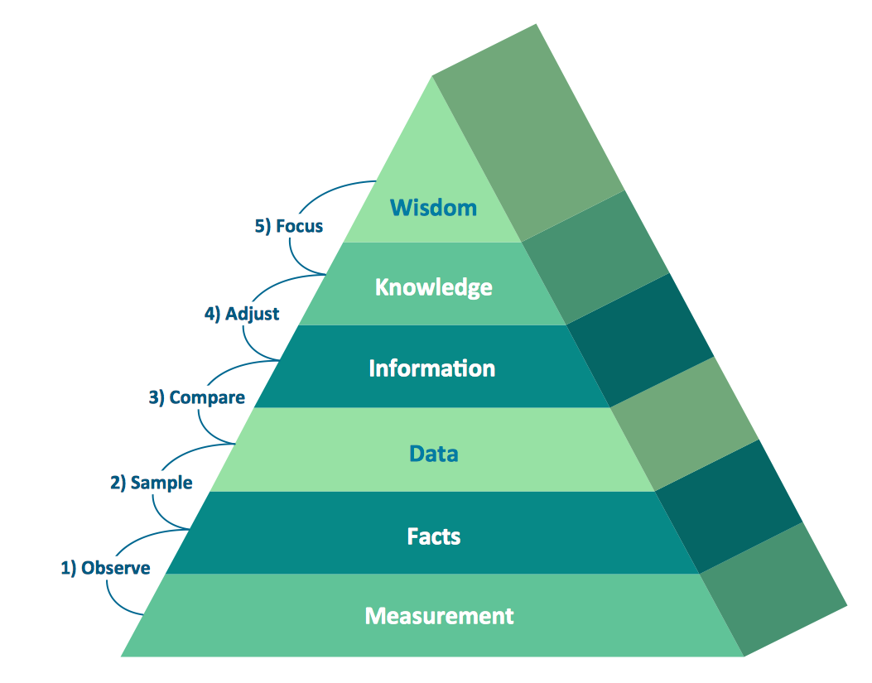
Source: (Knowledge Management Systems, 2010)
Data definition and management: Data is referred to as anything having no useful meaning as a record of anything, random variables, random comments, and facts on any observation, numerical or non-numerical number series implying no applied sense of the event or fact. Without processing, data cannot be used for any useful purpose of the organization. Data is considered to be the root of all other management of information (Lilley, Lightfoot and Amaral, 2004). So, organizations are required to collect, store, maintain and monitor data properly for making other functions effective and fruitful.
In Fordway, data is managed considering its significances to the company like confidential data are kept with essential software and privacy protection but information that are routine-wise and not confidential are maintained for regular storing purposes. The following example of raw data doesn’t individually mean anything useful unless it is processed for further use as shown in table 1 below.

Table 1: Example of raw data (Kumar and Suresh, 2009).

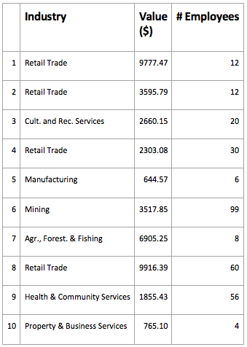
Information by definition and its management: Raw data when becomes processed through interpretation, contextualized under certain events, and represented to people for a particular purpose, it is called information (Hill and Hill, 2012). As it becomes meaningful for evaluating certain events, information is considered to be the actual output of raw data. There are several ways to process information like classifying, selecting with priorities, sorting, reordering, cumulating, etc.
Information sources: From two major sources information is gathered by Fordway by;
- Formal way: formal information is gathered from annual reports, meeting agendas and results, periodical performance outputs of employees in the company, etc. which presented by formal presentation and announcement (Peel, 2012).
- Informal way: when employees talk within themselves or to outsiders about the organization-oriented issues informally many information is generated like oral conversations, e-mails, informal messages, group talking, etc.
Information Lifecycle: It is meant as the overall process through which information from its very first collection and storage pass several steps of formatting, transformation, modification and reaches to archiving or wastes as per managers’ discretion.
The information lifecycle has been diagrammed below in figure 2:
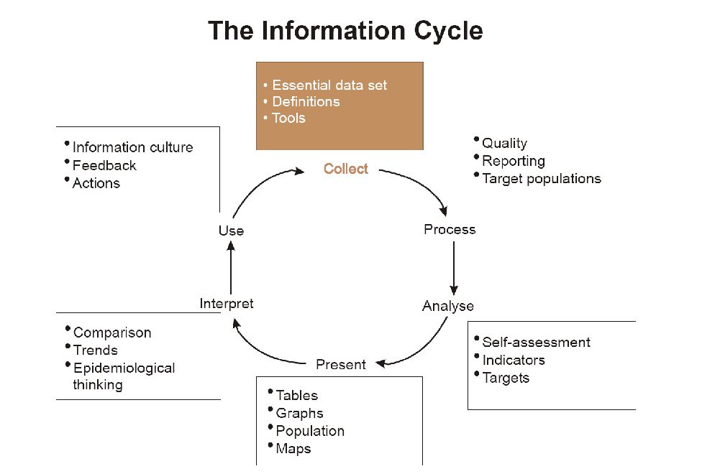
Figure 2: Information lifecycle flow from collecting to usage
Source: (Blackstone and Lewis, 2007)
In Fordway, information regarding employees’ salary, competency, entry positions, businesses’ incomes, expenses, assets, liabilities and turnover and other monetary and non-monetary sources of information are collected, stored and represented wisely considering the importance of it to the stakeholders of the company (Lilley, Lightfoot and Amaral, 2004). Proper interpretation of the collected data increases companies’ understandings about the incurred events and it also reduces uncertainties, complexities of the company.
Valuable information: To Fordway information is valuable in two perspectives such as-
- Tangible value of information: information helps Fordway to manage and control its inventory, to reduce the cost of operations, to improve sales in different regions and other monetary value addition goals that are identifiable in eyes to the stakeholders (O'Brien and Marakas, 2011).
- The intangible value of information: Information management also helps the company to achieve customer loyalty, maintain services’ quality, and increase the efficiency of the employees.
Defining Knowledge management: Knowledge is gained in terms of information being analyzed. After studying the information and experiencing particular facts or events an understanding is built up on that case which is defined as knowledge (Kumar and Suresh, 2009). From the relationship of information, we try to find some designated patterns of it in knowledge level, for example in figure 3 below.
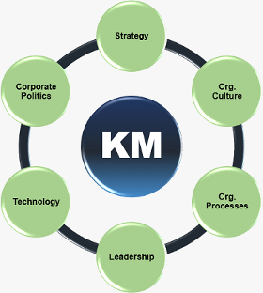
Figure 3: Knowledge management in an organization (Hill and Hill, 2012)
Importance of knowledge management: In Fordway, employees are encouraged to gather knowledge from their everyday operations so that this knowledge can be turned into a valuable asset for the company as a whole (Campling, 2008). The biggest reasons telling why knowledge management is fruitful in light of my selected company Fordway Solutions are given below-
- Easy access to information and knowledge: with the help of proper and efficient handling of information and resources, Fordway can be able to speed up the process of availing any information whenever necessary.
- Improve decision-making process: when managers make decisions they can collaborate with all the important resources and information easily and its impact is huge for better decision-making.
- Facilitate innovation and cultural change: it encourages employees to share and view new ideas among them and no ideas are set hidden or beyond reviewing and it helps them to be innovative.
- Increase efficiency: as it makes access to information easier, wastage of time and other valuable resources become less and employees don’t have to sit idle for lack of information resources or for time lapse in communicating among different departments (Greasley, 2013).
- Improve satisfaction of customer: Speed of response to customer requirements is high for knowledge management in Fordway. So, customers’ satisfaction level has been accelerated for knowledge management (Lilley, Lightfoot and Amaral, 2004).
- Avoiding redundancy and making the same mistakes again: In Fordway, it helps to save time, money, and employees’ energy levels of working by reducing the duplication of any work. As result, employees don’t make the same blunders for having an automatic system.
The relationship between individual knowledge and organizational knowledge with respect to Fordway Solutions Limited: Individual knowledge means people’s own experience on some events and facts that they face and the conclusions of patterns, relations or understanding that they draw from those facts. This knowledge fosters the individuals giving him better insights, providing best strategies and new ideas further enable the individuals to gather more tacit knowledge. All the employees of Fordway are encouraged to be individually knowledgeable and thereby contribute to an organization’s overall knowledge (O'Brien and Marakas, 2011).
Figure 4 below shows how individual and corporate knowledge contribute together to establish an organization enriched with knowledge, wisdom, and intellectuals thriving to implement the best decision for the company.
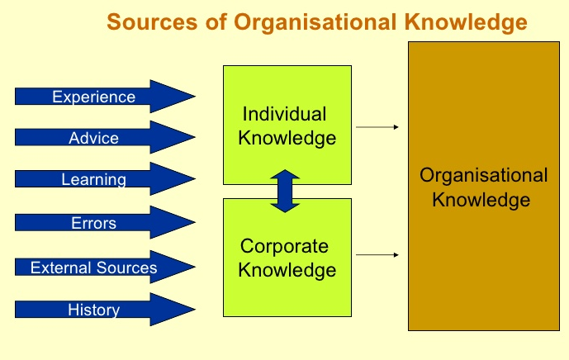
Figure 4: Relating individual and organizational knowledge
Source: (Campling, 2008)
Techniques to identify knowledge assets: to identify gaps in knowledge assets the most important thing is to draw knowledge for that distinct organization. Sometimes line managers, department officials don’t want to coordinate and distribute the knowledge that they hold or experience (Kumar and Suresh, 2009). Because they think that sharing knowledge by filling the gaps among all employees might reduce the control of their knowledge. In Fordway, managers are designated to find out in which sections of the company, knowledge is accumulated, who acquire the most important knowledge and thereby they try to introduce newer ways of training, rewards, performance appraisal so that employees don’t think themselves individually owner of the knowledge (Lilley, Lightfoot and Amaral, 2004). Rather employees are motivated to be part of organizational knowledge participants by sharing their own knowledge with whoever it seems appropriate and beneficiary for Fordway.

Rationales for capturing and managing knowledge:
Capturing knowledge is very crucial but only the most valuable with long-term effects possibility, having broad application in the organization must be captured (Campling, 2008). While capturing knowledge Fordway maintains some critical issues. Some of the most important to keep in mind are-
- Capturing knowledge must be efficient enough.
- It must be available for re-use otherwise further functions of knowledge won’t be easier.
- It must be refreshed with ownership and responsibilities.
- Captured knowledge must match with the solutions of the Fordway company.

Wisdom in Fordway: it is viewed like judgments and valuable decisions that are made from the knowledge being experienced in any incident, event or from any information. Knowledge only is not enough for wise decision making rather the company requires sufficient teachings of good or bad to make wise results (Peel, 2012). Fordway focuses on learning knowledge and focusing on reflection of the knowledge so that sound judgments and recommendations can be made by the company.
Organizational or corporate knowledge is the combination of all the strategies, practices, decisions, business or non-business events’ most important information and resources and many other intellectual assets comprising employees’ individual knowledge that take place within or out of the company but highly affects the value of the organization (Greasley, 2013). The more organizational knowledge a company has, the more it becomes well-off in terms of making the best decision with the increased collaboration of necessary information and resources. Fordway tries to gain organizational knowledge with the combination of both individual and corporate knowledge and these two parts of organizational knowledge comprising contribute the company to achieve its broad goal of efficiency, innovation, world-class management team, and customer satisfaction goals. See figure 5 below (Peel, 2012).

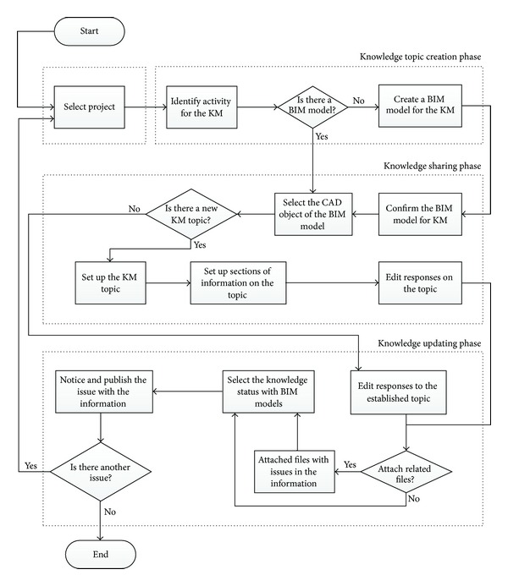
Figure: Knowledge management process workflow
Source: (Peel, 2012)

Knowledge types: Knowledge management helps Fordway’s top-level managers like decision makers of every level to make decisions about any changes, procedures, new idea selection and research of new statistics easily (O'Dell and Hubert, 2011). The above example presents two types of knowledge in Fordway-
- Explicit knowledge is that the divisional leaders learn from articulation, recording in company books, codes, etc and these can be stored easily.
- Implicit knowledge is mostly tacit in terms of information which is generated by intuition, perception and not well-structured or organized in written format.
Functional levels of knowledge management in Fordway: For different functions knowledge management is operated differently. In the lower levels management of the company, like in TPS basic data level related knowledge is required. In upper levels of the management, information management and knowledge both tacit, explicit is required for MIS, DSS, and EIS.
Figure 6 below shows different functional levels of knowledge management in an organization.
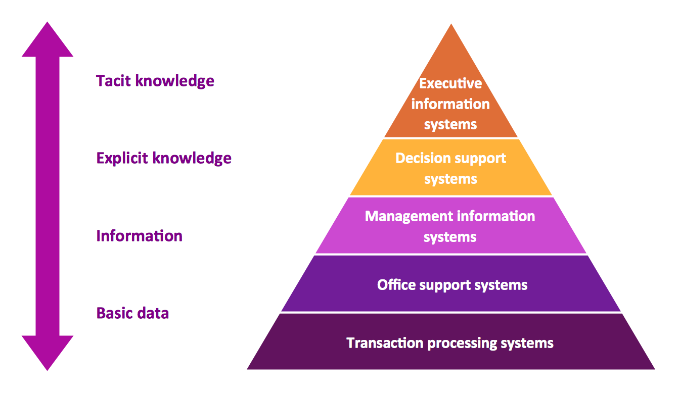
Figure 6: Knowledge Management in functional levels
Source: (O'Brien and Marakas, 2011)

To ensure the continuous knowledge management program Fordway organizes employee development training, technological logistics seminars take place in the company frequently so that employees can convert information into knowledge (Kumar and Suresh, 2009). it is knowledge management that helps Fordway company to make decisions about production, sales, inventory, distribution channels, investment, borrowing and almost in every department.
Knowledge management process required for the organizational development of Fordway: the knowledge management can be processed in light of the steps followed in knowledge management lifecycle. Figure 7 below mentions cycling knowledge management starts from the first one step and ends with the last one of applocation.

Figure 7: Knowledge management process
Source: (Greasley, 2013)
Knowledge acquisition: first of all knowledge should be acquired through encouraging innovation and idea development process among the employees and other stakeholders of the Fordway. There many ways of acquiring knowledge like employees both new and existing bringing knowledge from external parties of the company, merger and acquisitions with other strategically famous companies, outsourcing research and development of new products, consultancy program, training and new machinery equipment etc (Campling, 2008). From all the resources of Fordway knowledge gathering is motivated otherwise company won’t have sufficient knowledge and information skills when it becomes a must.
Knowledge retention: Fordway attempts to retain its knowledge through proper storing, care and preservation to prevent it from being stolen or widespread. Otherwise valuable knowledge, if it is accessible to competitors, company won’t get any first-mover advantage from acquisition (O'Brien and Marakas, 2011). From ancient times, we find that knowledge has been retained in many ways that explain how much flourish was each century of the world. In fordway, knowledge is retained through several ways like-
- Database management systems offer flat file, hypertext, free-form and relational databases where data of structured, unstructured, picture, video, and also data from combined sources can be stored.
- Business Intelligence is important as business deals with huge amount of information everyday. From this sea of resources to find and present the most valuable ones to the decision makers BI works for Fordway.
- Data warehouse stores all the information of Forday on weekly basis and pile this up after presenting the most meaningful ones to organizational decision-making.
- Data marts are maintained so that department-oriented information only can be stored in smaller scale.
Knowledge transfer: Fordway distributes, disseminates, shares and exchanges knowledge in formal and informal ways within or outside the organization with the hope that the transmutted knowledge will be used and will bring great benefits for the overall organization (Peel, 2012). Knowledge movement or mostly technology movements are commonly done through royalty payment or license fees among partners. In terms of knowledge transfer among two or more organizations not only it turns out to be a one-way activity rather it encompasses feedback, mutual adjustment through several trials and error processes.
For transmutting of knowledge both receivers who admits applying received knowledge in practical events and who provides knowledge with full interest of sharing are most important componenets for successful transfer. There are several ways through which knowledge can be transferred in Fordway. Some of these most used transfering mechanisms available in Fordway are given below-
- Electronic mail for day to day transactions
- SMS for sending short messages
- Instant messaging services of Messenger
- Videoconferancing for distant comunicators to have virtually face to face discussion
- Teleconferancing among many people through telephone
- Voicemail for transmutting one by one audio message
- Social media like facebook twitter, instagram, tumblr etc.
- Blogs of one or many post givers
- Virtual world through computer generated simulated environment that can be treated as second life
- Information database comprising all the project data.
While transferring knowledge on of the most important factors to be kept in mind is having trust among knowledge giver and receiver on the fact that the shared knowledge won’t be used in destructive ways rather both parties will get advantages from it (Reid and Sanders, 2015). If the trust issue is not confirmed, knowledge transfer will not be a matter of peace. For ensuring the trust to prevail, the Fordway introduces safe code of conducts and trustee agreement for avoiding future uncertainties among stakehholders and competitors.
Knowledge application: The last task of knowledge management life cycle or knowledge management process is to successfully apply the knowledge in practical areas or for where it is most suitable and beneficiary. Mostly in times of decision making or to establish any changes in the organization, knowledge is acquired dknowledge is used. There are several knowledge application systems being used in Fordway solutions limited for sending directions and routines of knowledge technologies and these are mentioned below-
- Expert systems like human consultant with lot of artificial intelligence are set for providing answers and solutions to any problem or any difficulty being raised in IT services of Fordway. It can be used through a software tool too where the software application is provided with all the necessary setups and scenerios and also with replies for any challanges.
- Another most used knowledge application system is DSS or decision support system where for making any type of decision goes to the information system and stored resources of DSS representing comparisons, analysis, past incidents, forecasting approaches and most important area to focus or having critical issues (Campling, 2008).
- Advisor system is one way where Fordway gets advises in any comlexity through well-equipped, multi-factes advisory support
- Fault diagnosis systems help the company to find out critical areas, analyse the reasons behind, look over best solutions and support the Fordway when any of the fault arises in the company.
Fordway solution Limited does every little thing to encourage and empower employees so that they can highly focus on establishing such an organizational culture where knowledge can be managed properly. It also refers all the necessary strategies required for planning, researching, executing, controlling and monitoring knowledge based activities and also making it a major principle of the company (O'Dell and Hubert, 2011). To develop its framework, Fordway has a mission of building a workplace culture where knowledge management and information management skills are most important set objectives to be achieved for employees (Kumar and Suresh, 2009).
Strategies for creating a knowledge management culture: To get the most benefits from knowledge it is important to know that idle knowledge has nothing specialty. Rather it must be updated and used on a time-to-time basis and without a cultural background of satisfying knowledge and skills orientation it is not possible to get facilities. The following strategies can help Fordway to develop such a framework and culture:
- Showing employees how knowledge benefits them: The managers of Fordway need to make the employees understand that getting new knowledge like a new product or service idea or introducing some ideas to others is so valuable for increasing their performance level and improving their ideas too.
- Knowledge based reward and recognition system: The workplace culture will be changed dramatically if employees’ compensation packages are backed by knowledge acquisition and sharing incentives (O'Brien and Marakas, 2011). So, they must be rewarded for introducing new ideas, for re-using the knowledge and recognition for both contributor and user of the ideas. Team working for generating innovative thoughts need to be rewarded for both team leader and team members. As a result, they will feel empowered and enriched. See Figure 8 below shows the framework of K
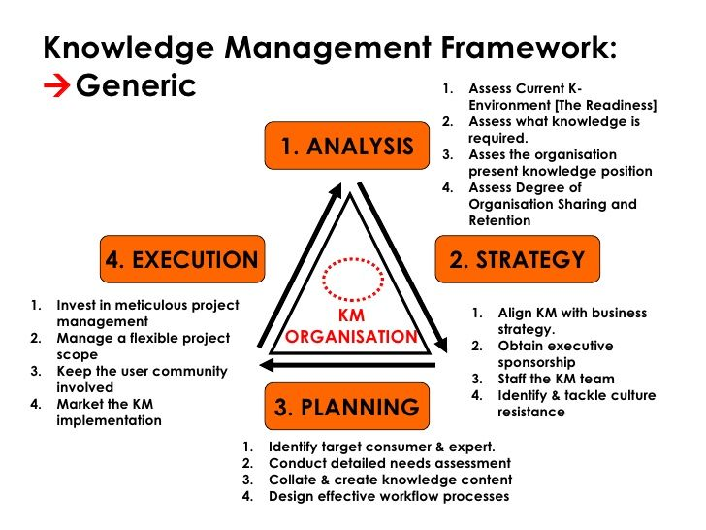
Figure 8: Framework for knowledge management culture
Source: (Greasley, 2013)
- Showing people some role-model of successful knowledge-sharing: The top managers need to show role-model companies as example and motivating factor so that they can understand the value of true knowledge management skills and work on achieving those. Walmart is the best example to Fordway that managing billion sales and million customers each week and storing that information is one of its valuable resources. Following such kind of big companies can pave the way of successfulness easily (Peel, 2012).
- Letting employees make errors: In almost every organization employees are not allowed to make any mistakes or it turns out to be rude to their job safety. As a result, employees feel afraid of sharing any new ideas or addressing new approaches practically and ultimately the organizational culture demotivated them to be knowledgeable (O'Dell and Hubert, 2011). But it shouldn’t be the scenario and the employees of Fordway must feel free that their initiatives will be highly valued no matter either it becomes a successful attempt or not.
- Recruiting employees through meeting requirements of knowledge sharing: Knowledge sharing skills and capabilities must be checked even before recruiting employees to the Fordway. So, the HRM of the company must be careful about recruitment processes that the new employees should match with the requirements of making the culture knowledge inspired and knowledge intensive.
- Educating and training people: Fordway has taken many employee developments and training programs so that existing and newly recruited employees can learn about knowledge strategies and information skills to generate innovative ideas for the company. Updated ICT programs, business and enterprise systems and also trainer must be well-enough to educate employees’ proper knowledge.
- Ensuring that technology works for employees and not the opposite: employees must get some assurance that technology works for their betterment rather that not they be worked for technology (O'Brien and Marakas, 2011). Most employees feel reluctance about sharing their knowledge for thinking about their individual gains only but we see knowledge management is a function of human resources, technological resources, and processes of any organization. Here, the most important component is human resources and they must cooperate to establish a cultural framework. There shouldn’t be any if and if nots to motivate people.

Approaches to managing information risk: when data or information of the organization is not protected, it causes severe problems of losing valuable data, stealing, misshaping, misrepresentation or destruction of other valuable sources. That is why it is obligatory that Forday maintains procedures, technologies, strategies and several codes of rules and regulations to manage and reduce this information risk. Some of the most important methods to reduce risk of Fordway Solutions have been explained in figure 8 below;
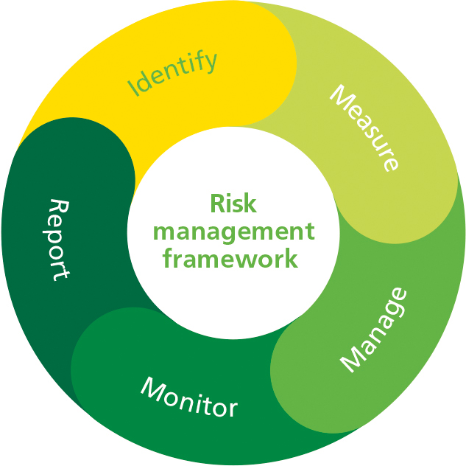
Figure 9: ways to manage information risk
Source: (O'Brien and Marakas, 2011)
- First of all, the risks must be identified considering the source, reasons of risk arising
- Then the identified risks are assessed that what will be and has been the consequences or loss from the risk occurrence
- Next, the risk is mitigated by using remedy solutions so that the bigger the risks might seem before mitigation; its impact is lessened after mitigation.
- Then the response plans for further risk arising is developed so that Fordway can easily approach any way when they go through some technological difficulties arising from software malware functions (Reid and Sanders, 2015).
- There must be sufficient and developed software platforms to backup the risky consequences.
- An above all way is to review risk management procedures and standards frequently to ensure that these comply with Fordway’s safety issues.
External factors and sustainability within knowledge and information management: It is needless to say that organizations need to process knowledge and enhance technological sides very effectively. But businesses also need to look up over the benefits of stakeholders beyond the business environment, the society, environment, the climate; to other vulnerable groups etc. if knowledge and information are managedto keepthe mind of all these external factors and macro-economic components, then the organizations will be sustainable in the long-term viewpoint. Fordway solutions to achieve this goal of sustainability, they do more extra for adding value to the lives of people and environment. For example, Fordway’s top leaders and responsible parties demonstrate the key speech on sustainability to make employees remember their business goals continuously (Greasley, 2013). The company thinks of people, ecological and economical viewpoints together to make profits by adopting several CSR or corporate social responsibilities such as re-using knowledgeable approaches even after establishment of it once in the company with required adjustments and updates. They maintain environment and employee-friendly code of ethics for the company and software solutions are provided to customers keeping mind of their contribution to future potentiality.

Conclusion
Although investments to human capital for improving employees’ information skills and capabilities are seemed to be costlier, it has huge impacts on efficient and effective knowledge management for the company and for making employees asset of the company. Information management is of huge benefits for the company as it provides all the valuable informational resources for making better decisions of the company’s management. I’ve made this assignment based on the analysis of Fordway Solutions’ cultural setups designated for its cultural framework encouraging knowledge and information skills among employees. To ensure proper management and resourceful decision making bringing best results for the company, Fordway must follow the knowledge management establishing framework guidelines and also make the importance of it realizable to its employees as we know employees are the actual practitioner of this process. Without making them motivated, it won’t be possible to gain such kind of objectives easily.

References
- About us - Fordway - Managed Cloud Services, IT .... [online] Available at: https://www.fordway.com/about-us/ [Accessed 16 April 2019].
- Blackstone, W. and Lewis, W. (2007). Commentaries on the laws of England. Clark, NJ: Lawbook Exchange.
- Campling, J. (2008). Management. Milton, Qld.: John Wiley & Sons Australia.
- Davenport, T. and Prusak, L. (2014). Working knowledge. Boston, Mass.: Harvard Business School Press.
- Fordway - Managed Cloud Services, IT Infrastructure & IT .... [online] Available at: https://www.fordway.com/ [Accessed 24 April 2019].
- Greasley, A. (2013). Operations management. Hoboken, N.J.: Wiley.
- Hill, A. and Hill, T. (2012). Operations management. Houndmills, Basingstoke, Hampshire: Palgrave Macmillan.
- Ichijō, K. and Nonaka, I. (2007). knowledge creation and management new challenges for managers. Oxford: Oxford university press
- Knowledge Management Systems. (2010). Gardners Books.
- Kumar, S. and Suresh, N. (2009). Operations management. New Delhi: New Age International.
- Lilley, S., Lightfoot, G. and Amaral, P. (2004). Representing organisation. Oxford: Oxford University Press.
- O'Brien, J. and Marakas, G. (2011). Management information systems. New York [u.a.]: McGraw-Hill.
- O'Dell, C. and Hubert, C. (2011). The New Edge in Knowledge. EBL - LIBRARY ORDERS ONLY.
- Peel, J. (2012). Knowledge Management. Delhi: Orange Apple.
- Reid, R. and Sanders, N. (2015). Operations Management. New York: Wiley.
- Sanchez R, (2003). knowledge management and organizational competency.

