Tristan Budenis (2428021)
2428021@student.uwtsd.ac.uk
ACCA5026 – SQL Report
Databases and Application Development

Table of Contents
Introduction 2
Database Design 3
Implementation Documentation 4
Database creation 4
Create Tables 4
Populating tables 6
Validation Tests 9
Stored procedures for CRUD 10
Key Queries to business performance 14
Triggers 16
Stored Procedure and Transactional Scenario 17
Transactional Scenario 17
Performance Tuning Enhancement 18
Literature Support for Design and Implementation Choices 19
Conclusion and reflection 20
References 21

Introduction
The student’s union has requested a club management system be built to manage all the different societies and clubs within the university. The student’s union play a pivotal role in student life, through a wide array of clubs and societies – these include and not limited to sports clubs, cultural groups and intellectual societies. At the moment, the student’s union entirely use a paper-based system to hold records and other related data. This outdated practice creates many headaches when it comes to tracking memberships, create events, relay official announcements, and understand current position of the student’s union.
Paper records are highly susceptible to physical damage from fire, water, or decay, often leading to the permanent loss of critical information without a backup[1]. Additionally, they are inefficient to manage, as manual filing and searching consume significant time and physical space compared to instant digital retrieval.
To solve this current system, the student’s union has requested a club management system be created to help manage a wide array of records. The aims of the project include ensuring club records remain accurate by updating names, classifications, and founding dates for all active organizations.
- Maintain up-to-date records of all clubs, societies, and groups within the Students’ Union.
- Register and manage student memberships, including scenarios where students belong to multiple clubs.
- Organise and record club events such as meetings, activities, and trips.
- Monitor member participation to support analysis of engagement and activity levels.
- Track official communications and announcements for audit purposes and future reference.
The project must ensure data validity and integrity, normalisation and consistency. Vital concepts like primary keys (PK) and foreign keys (FK), constraints, triggers, and procedures are used to ensure data validity [2]. The project will be built using MySQL and validated using test data to demonstrate functionality and full usability in line with the project’s requirements.

Database Design
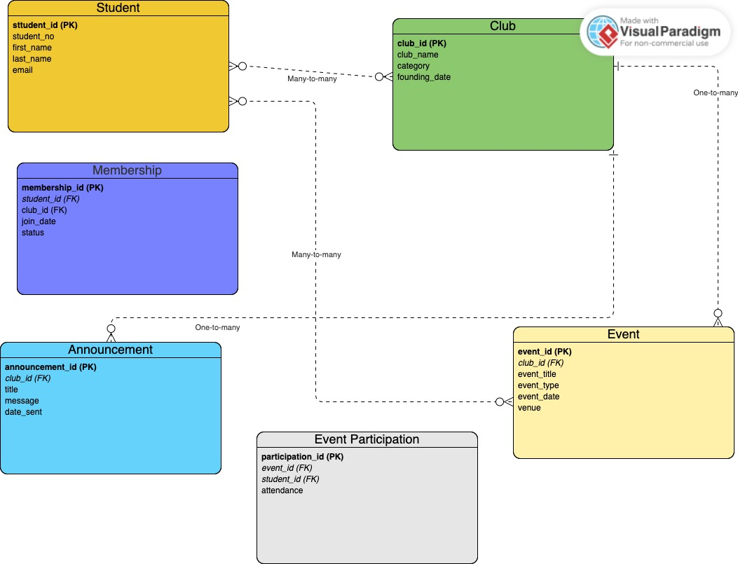
This section outlines the relational database design for the Campus Club Management System (CCMS). The first phase of the project focused on designing a database structure that accurately reflects system requirements while ensuring data integrity, minimal redundancy, and scalability. An Entity Relationship Diagram (ERD) was created using Visual Paradigm to model the entities, attributes, relationships, and cardinalities within the system.
The entities identified in the design were used directly from the project requirements. These include Student, Club, Event, and Announcement, which represent the core components of the system. In addition, the Membership and Event Participation associative entities were introduced to resolve many-to-many relationships between students and clubs, and between students and events, while supporting the storage of relationship-specific attributes.
The student entity stores academic and personal identifiers such as student number, name, and email address. The Club entity maintains information about student-run organisations, including club name, category, and founding date. As student involvement in clubs is a central requirement of the system, these two entities form the foundation of the database design.
Students may join multiple clubs, and each club may have many student members. This many-to-many relationship is resolved using the Membership associative entity, which links students to clubs through foreign keys. This design removes the need for data duplication and allows membership details to be managed efficiently.
Similarly, students may attend multiple events, and each event may be attended by multiple students. To represent this many-to-many relationship, the Event Participation entity was introduced. This entity links students to events and includes an attendance attribute, enabling the system to monitor participation and analyse engagement levels.
The ERD was normalised to Third Normal Form (3NF) to eliminate redundancy and prevent data inconsistency. As defined by Connolly and Begg, “a relation is in Third Normal Form (3NF) if it is in Second Normal Form and no non-key attribute is transitively dependent on the primary key” [3]. By ensuring that all non-key attributes are fully functionally dependent on the primary key and that no transitive dependencies exist, the database achieves improved scalability, integrity, and maintainability.
Finally, the use of primary keys and foreign keys ensures that each record is uniquely identifiable and that valid relationships are enforced between entities. These constraints prevent duplication, maintain referential integrity, and provide a robust foundation for the implementation of the Campus Club Management System.

Implementation Documentation

Database creation
The below image shows me creating the database. Additionally, I set the database as the default schema as ccms.
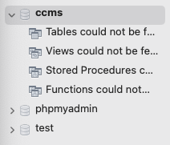

Create Tables
Student
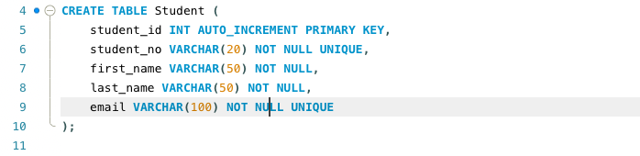
Club
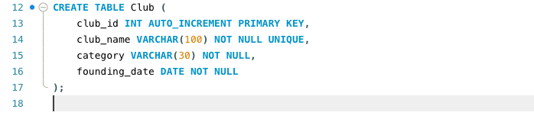
Membership
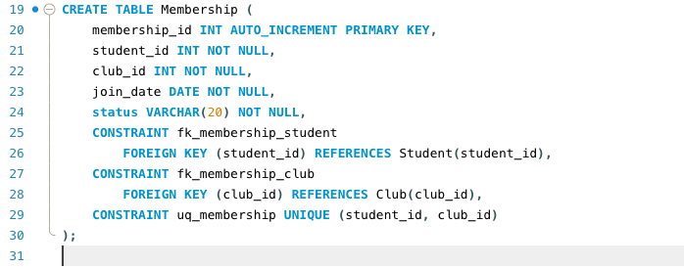
Event
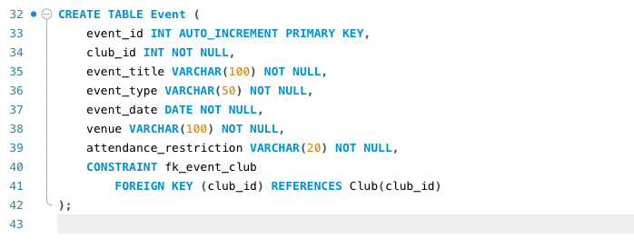
Announcement
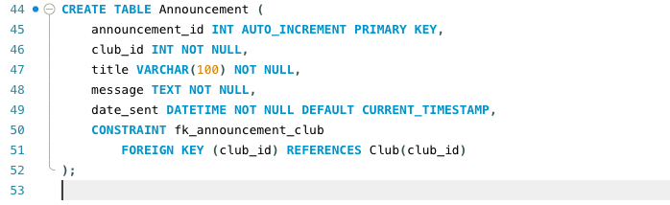
Event Participation
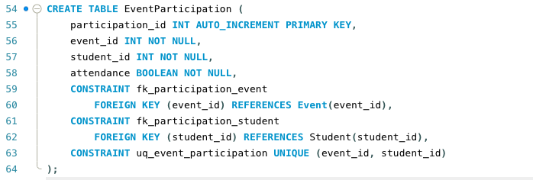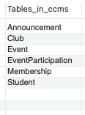

SQL Data Definition Language (DDL) statements were used to define the database tables, each of which was intended to represent a unique Campus Club system entity. Auto-incrementing integer values were used to define primary keys in order to facilitate effective indexing and uniquely identify records. While UNIQUE constraints were added to attributes like student numbers, email addresses, and club names to prevent duplicate records, appropriate data types and NOT NULL constraints were utilised to maintain domain integrity. In order to ensure referential integrity throughout the database, foreign key constraints were applied when relationships exist between entities. This methodical technique offers a solid basis for dependable data storage and retrieval and facilitates normalisation to Third Normal Form (3NF).

Populating tables
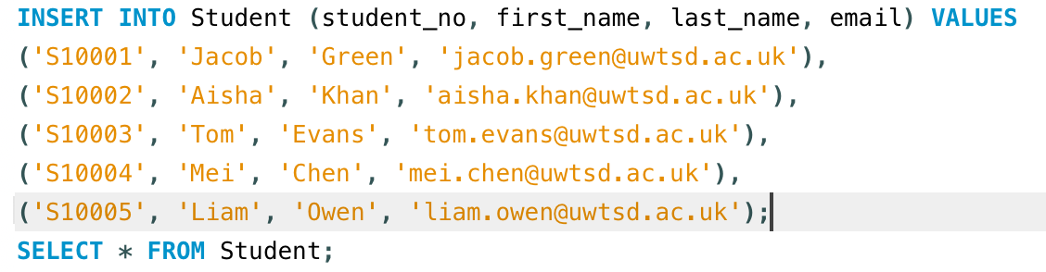
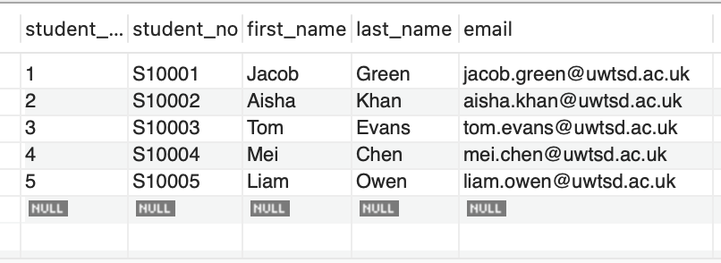
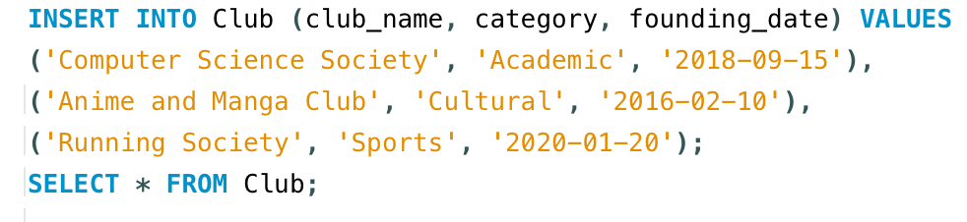
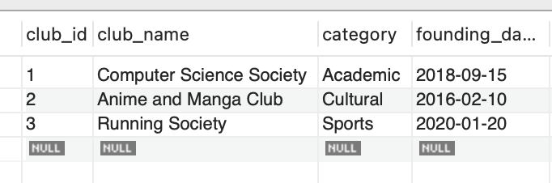
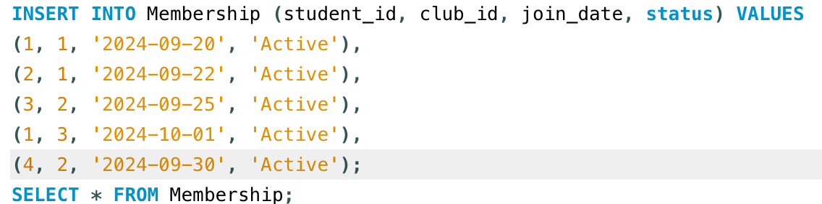
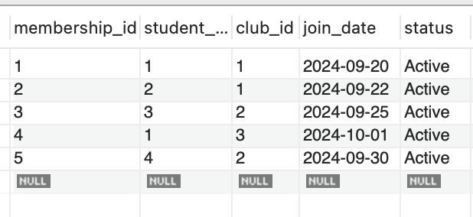
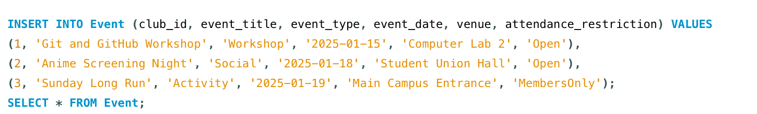
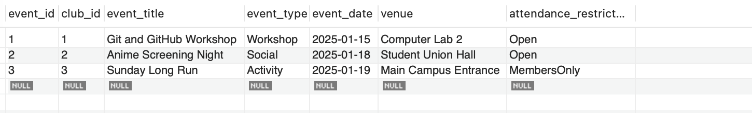

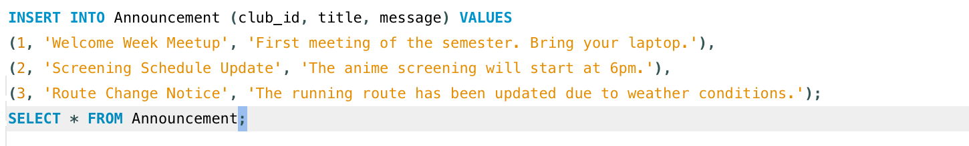
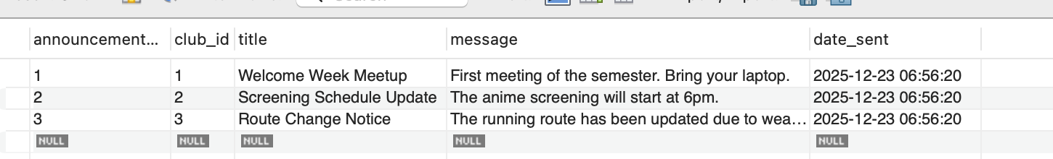

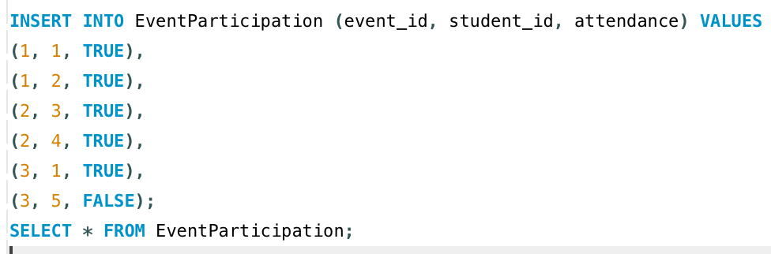
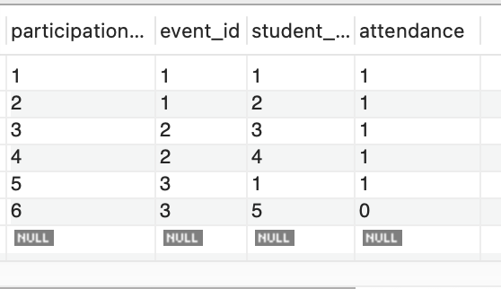
To determine whether the inserted values were successfully entered into the database, I also filled up all of my tables using the SELECT * FROM procedure.

Validation Tests
Test 1: Duplicate Entry
This test is to see if it’s possible to enter duplicate entries into student_id & event_id. This prevents any duplicate entry into the database. As you can see below the test was successful as I received an error returning duplicate entry.

10:20:29 INSERT INTO EventParticipation (event_id, student_id, attendance) VALUES (1, 1, TRUE) Error Code: 1062. Duplicate entry '1-1' for key 'uq_event_participation' 0.0058 sec
Test 2: Invalid Foreign Key
This test looks to insert/update an existing row. This test should fail to show foreign key’s are set up correctly as restraints. As you can see below the test was successful as I received an error trying to update an existing foreign key.
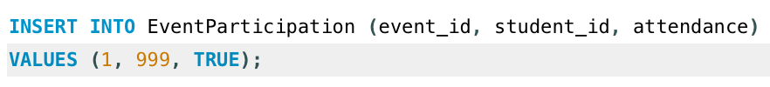
10:33:18 INSERT INTO EventParticipation (event_id, student_id, attendance) VALUES (1, 999, TRUE) Error Code: 1452. Cannot add or update a child row: a foreign key constraint fails (`ccms`.`eventparticipation`, CONSTRAINT `fk_participation_student` FOREIGN KEY (`student_id`) REFERENCES `Student` (`student_id`)) 0.020 sec
Test 3: Join validation
This test is to join the student table, to events and event participation. This again was successful demonstrating that the foreign keys are linked as the correct result returned a joined table.
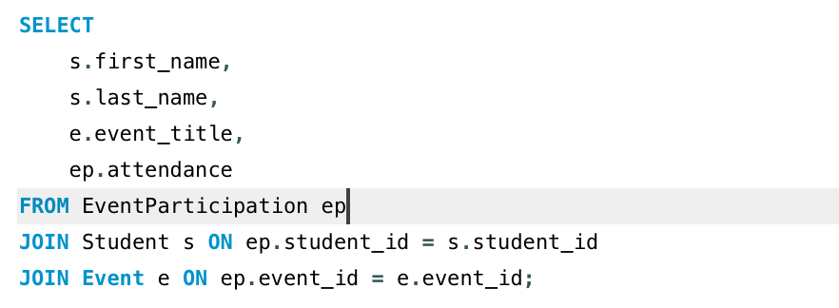
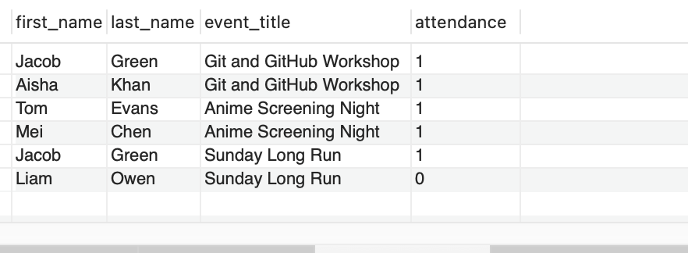
To verify that relationships between entities work properly, join queries were run using sample data to test the database design. Additionally, constraint testing was carried out by trying to insert faulty and duplicate records, which the database appropriately rejected. These tests show that data integrity and consistency are ensured by enforcing primary key, foreign key, and uniqueness constraints.

Stored procedures for CRUD
Create
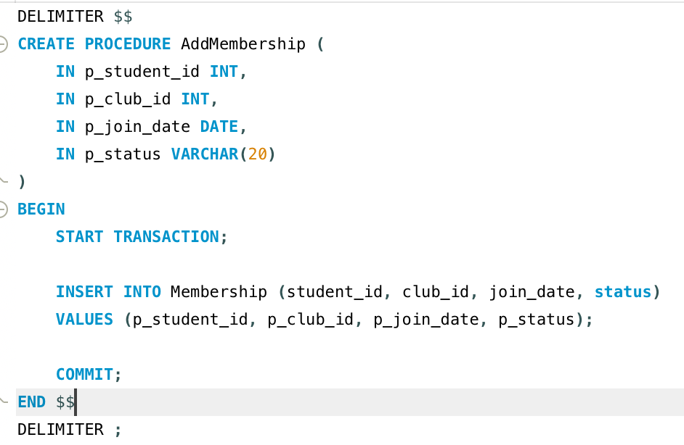
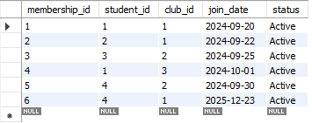

Update
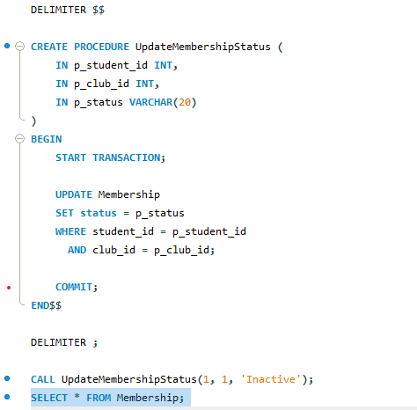
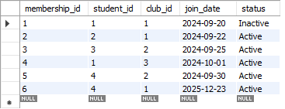

Delete

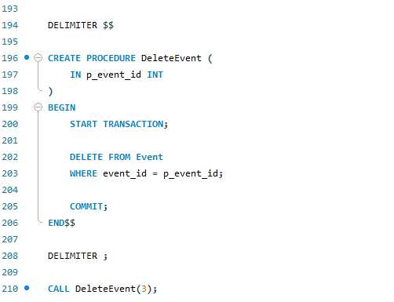

16:39:35 CALL DeleteEvent(3) Error Code: 1451. Cannot delete or update a parent row: a foreign key constraint fails (`ccms`.`eventparticipation`, CONSTRAINT `fk_participation_event` FOREIGN KEY (`event_id`) REFERENCES `event` (`event_id`)) 0.000 sec
Rollback
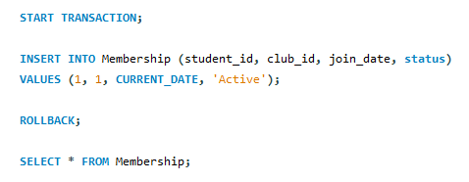

The Campus Club Management System's fundamental Create, Read, Update, and Delete (CRUD) functions were supported by stored procedures, each of which had explicit transaction control to guarantee data integrity [7]. An INSERT procedure used to register students as club members served as an example of the Create operation; a transaction is started and committed only when the membership record has been successfully added. Join queries across several tables were used to validate read operations, ensuring that relational links operate as intended and that stored data can be reliably retrieved. A process that updates current membership records, such as updating a student's membership status, was used to implement the Update operation. Changes are only committed when the transaction is successfully completed. An attempt to delete an event was used to illustrate the Delete procedure. Foreign key restrictions appropriately prevented the operation, leading to a rollback that maintained referential integrity. When taken as a whole, these processes show regulated data manipulation through transactions, guaranteeing that every database activity is carried out consistently and atomically.

Key Queries to business performance
View members of a club (using Club_id)
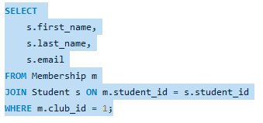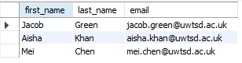
Track event attendance
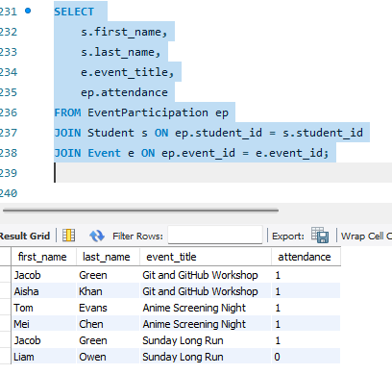
List upcoming events by club
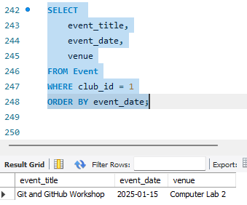
Due to their frequent use and significance to the Campus Club Management System's operating requirements, several queries were designated as performance critical. These queries are used to present future events and announcements, track event participation, and collect membership information. They mostly include join operations across many tables.
For instance, queries that obtain club membership information depend on joins between the Student and Membership tables, and staff members of the Students' Union are expected to do these queries on a frequent basis. To assess engagement levels, event attendance queries also link Student, Event, and EventParticipation databases. Retrieving announcements for clubs and filtering events by club and date are two more performance-critical queries.
Secondary indexes were added to foreign key and filtering columns to speed up query execution and minimise entire table scans because these queries rely on relational joins and expanding datasets.

Triggers
A trigger is a piece of SQL code that runs automatically when another event occurs within the database. A trigger is an automatic command. Within my project I will use triggers to audit the database to ensure that everything is valid.

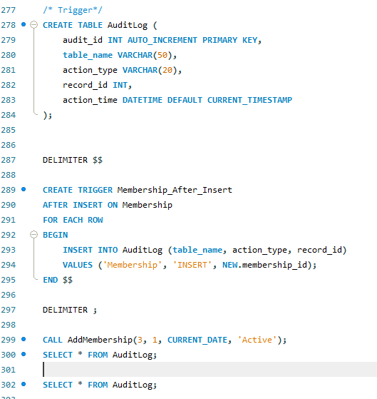

Above you see the automatic auditing tigger. This process automatically records insert operations on the Membership table, due to the trigger in place. The trigger adds a matching entry to the AuditLog table whenever a new membership record is created. This guarantees that auditing is managed at the database level without the need for human interaction, guaranteeing data change traceability. This ensures that all membership records are linked to valid students, preserving consistency and correctness across related tables.
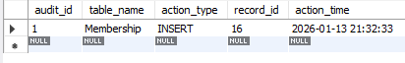

Stored Procedure and Transactional Scenario
Stored procedures are pieces of precompiled SQL code that are saved in the database and can be run multiple times [4]. This helps with speed, security, and maintainability by minimising code repetition, network traffic, and allowing controlled data access. Stored procedures were implemented to perform common operations within the Campus Club Management System. Procedures were created to handle insert, update, and delete operations.
Insert operations were implemented using stored procedures to safely add new records, such as registering a student as a club member or recording participation in an event. Each insert procedure begins a transaction to ensure that all related changes are applied together. If the operation completes successfully, the transaction is committed. Otherwise, it is rolled back to prevent incomplete or inconsistent data from being stored [5].
Update operations is another stored procedure used to modify existing records, such as making changes to the status of a student’s membership. These procedures use transactions to ensure that updates are only committed when valid conditions are met, preventing partial updates that could compromise data accuracy.
Delete operations were also used using a stored procedure, for example when removing a record or deleting a membership. This procedure method allows for the database to remain in a consistent state post deletion.

Transactional Scenario
A transactional scenario was implemented to illustrate a commit in theory and rollback capability. In this scenario, a transactional scenario is initiated by creating a data modification to the database. If the change that is initiated and successfully meets the constraints set once the database was created, the changes will be committed to the database. If the event fails, such as deleting an event that is being referenced by another table, an error will be returned. This then rollbacks to the state the database was in prior to the transaction. This ensures that no partial or invalid changes are applied and that referential integrity is preserved at all times [8].

Performance Tuning Enhancement
As the database grows, the queries will eventually get slower as the database will have to search through more records as the database grows. This is known as databases scalability [9]. To improve this performance, I used an index function to allow the database to jump right to the correct index instead of scanning every record.
Indexes were created on membership and participation tables to optimise joins between students, clubs, and events. Additional indexes were applied to event attributes, such as club identifiers and event dates, to improve the efficiency of queries used to retrieve upcoming events or filter events by club. Indexing was also applied to announcement records to support efficient retrieval of club communications.
The use of indexing significantly reduces the need for full table scans by allowing the database engine to locate records more efficiently. Subsequently, query execution is run faster and can accommodate larger data queries as the database grows.
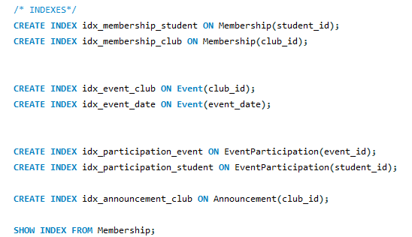
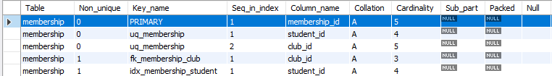
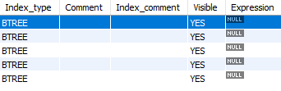
The ‘show index from membership’ displays all indexes that have been created with the membership table [10]. The output confirms the presence of secondary indexes on foreign key columns used in join operations, as well as primary and unique key constraints. The result displayed above demonstrates correct execution of the indexing.

Literature Support for Design and Implementation Choices
The Campus Club Management System's database design and implementation choices were supported by scholarly and professional literature as well as well-established database theory. In accordance with the guidelines provided by Connolly and Begg [3], who highlight that normalisation lowers update, insertion, and deletion anomalies in relational databases, the database was normalised to Third Normal Form (3NF) in order to eliminate redundancy and preserve data integrity.
The use of primary keys, foreign keys, and integrity constraints was guided by standard relational database practices, ensuring integrity and consistency across related tables [2], [6]. These restrictions establish links between entities like students, clubs, and events and stop incorrect data entry.
By centralising database logic, stored procedures were used to demonstrate Create, Update, and Delete processes, enhancing maintainability and security [4]. In accordance with Grey and Reuter's description of the ACID characteristics of transaction processing systems, transaction control utilising commit and rollback was implemented to guarantee atomic execution of database operations [8]. While rollback functionality enables the database to return to a consistent state in the event that operations fail, commit operations guarantee that legitimate changes are applied permanently [5].
To automatically monitor data changes without depending on application-level logic, triggers were used to build auditing capability. This strategy is in line with recommended principles for preserving traceability and accountability in database systems [3]. Secondary indexes on performance-critical columns were used to improve query efficiency by lowering entire table scans [9], [10].
Overall, the design and implementation choices are based on well-established relational database theory and backed by scholarly and professional literature, guaranteeing that the system is reliable, scalable, and appropriate for practical application.

Conclusion and reflection
This project successfully delivered the requirements of a relational database for the Campus Club Management System. The final database design supports the management of student memberships, club information, events, participation tracking, and official announcements. By normalising the database to 3NF, data integrity and redundancy was minimised. In addition, the use of primary & foreign keys and constraints to maintain integrity.
Using realistic sample data, validation queries, and stored procedures to allow Create, Update, and Delete operations, the implementation phase illustrated useful database capabilities. When operations failed, the database was kept in a consistent state and data alterations were implemented atomically thanks to transaction processing that used commit and rollback functions. Additionally, auditing triggers were implemented to automatically track changes to key tables, supporting accountability and future auditing requirements. Performance tuning was addressed through the application of secondary indexes on performance-critical columns, improving query efficiency and scalability.
During the project, there were problems with transactional behaviour and constraint enforcement, especially when deleting records that depend on each other. Addressing these challenges reinforced the importance of referential integrity and careful database design. The project also showed how important testing and validation are to make sure that database designs work the way they are supposed to in real life.
If I were to enhance the database further I would add advanced reporting and analytical capabilities to the report. In addition, I would add capabilities for roles within the database. For instance, a public user could only view the tables, while an administrator could make modifications. In retrospect, this project has helped me improve my MySQL and ERD design abilities.

References
[1] N. Toersen, “Paper Care Records - 10 Risks Associated With Them,” Theaccessgroup.com, 2025. Available: https://www.theaccessgroup.com/en-gb/health-social-care/care-management-software/electronic-care-plans/10-risks-of-using-paper-care-records/. [Accessed: Dec. 22, 2025]
[2] V. Yadav, “MySQL Constraints - Scaler Topics,” Scaler Topics, Oct. 27, 2023. Available: https://www.scaler.com/topics/mysql-tutorial/constraints-in-mysql/?utm_source=chatgpt.com. [Accessed: Dec. 22, 2025]
[3] T. M. Connolly and C. Begg, Database systems : a practical approach to design, implementation and management. Harlow: Pearson Education Limited, 2015.
[4] A. Chia, “What Are Stored Procedures? | Splunk,” Splunk, Aug. 06, 2024. Available: https://www.splunk.com/en_us/blog/learn/stored-procedures.html
[5] M. Gangwar, “SQL commit and rollback | digitalocean,” www.digitalocean.com, Aug. 03, 2022. Available: https://www.digitalocean.com/community/tutorials/sql-commit-sql-rollback
[6] W3Schools, “SQL Constraints,” W3schools.com, 2019. Available: https://www.w3schools.com/sql/sql_constraints.asp
[7] Codecademy, “What is CRUD? Explained,” Codecademy, 2025. Available: https://www.codecademy.com/article/what-is-crud-explained
[8] A Reuter and J. Gray, Transaction processing : concepts and techniques. San Mateo, Calif: Morgan Kaufmann Publishers, 1993. Available: https://books.google.co.uk/books?id=VFKbCgAAQBAJ&printsec=frontcover&redir_esc=y#v=onepage&q&f=false. [Accessed: Dec. 23, 2025]
[9] TechTarget, “What Is Scalability? - Definition from SearchDataCenter.com,” SearchDataCenter, Jul. 10, 2024. Available: https://www.techtarget.com/searchdatacenter/definition/scalability
[10] sensys, “List all indexes in MySQL Database - Softbuilder Blog,” Softbuilder, Mar. 05, 2023. Available: https://soft-builder.com/how-to-list-all-indexes-in-mysql-database/. [Accessed: Dec. 23, 2025]

