
effective team-working and communication
BMSW4002

December 1, 2021
University of Wales Trinity Saint David

Name and Student ID: Kudhaja Khanum 2026878

Name of host Organisation (UWTSD)
Date of report publication: 10 December 2021
Word count (excluding executive summary, references and appendices)

Executive Summary

Case study of Andrea Jones business situated in Swansea, is a medium sized retail store, after pandemic they had served customers through online and doing home deliveries. She employs 27 people varying ages and experiences, with one sales assistant on long term sickness. From investigation of the case study lack of communications and teamwork has been seen. No team structure, regular communication or any procedures of standard of work. Recommendation of Tuckman, Belbin and Kilmann theories was given to improve the teamwork and produce more efficiency in working together as a team. For communication the three model was given the Berlo, Schramm, Shannon and weaver to improve communications and productivity in workplace,
A brief overview of the areas you are addressing and investigating together with the main conclusions you have drawn. Typically half – 1 page

Table of Contents
Executive Summary 1
Terms of Reference 3
Procedure 4
Introduction 5
Findings 6
Conclusion (average of 10% of word count) 7
Recommendations 8
Bibliography 9
Appendices 10
Acknowledgements 11
UPDATE TABLE FREQUENTLY – CHECK IT HAS BEEN UPDATED PRIOR TO SUBMISSION

Terms of Reference
A report was requested by Andrea Jones, purpose of the report is to help her medium retail business that is rapidly growing and needs help with teamwork and good communication within their business to achieve their full potential. Khanum has complied this report to address issues and investigated on teamwork, reorganising and communication

Procedure
To compile, the report researched been done on various areas to gather information on websites, books and articles.

Introduction
Andrea Jones business is rapidly growing without any good communication and teamwork, 27 staff are currently working at the retail business but with lack of teamwork and communication. Having good communication and teamwork is a key to success. Verbal and non-verbal communication is needed in any business, verbally speaking is in leadership and having mutual understanding to work together as a team. Non-verbal is through email, message and written letter of conformation and written documentation of standard of work required.

Findings
Teamwork
After assessing the case study of Andrea’s retail business here is the report of findings that would benefit the business. Many businesses benefited from the Tuckman and Belbin theories, these two would be ideal team development processes and help understand team dynamics better. This will bring out the full potential of a person. Dr. W. Bruce. Tuckman an educational psychologist and researcher, published his four-stage model theory in 1965, forming, storming, norming, and performing. This model is widely used in businesses as start-up training for quality improvement in teams to achieve better goals. Bruce Tuckman said, “These phases are necessary and inevitable for a team to grow, face up to challenges, tackle” problems, find solutions, plan work and deliver results” (Boneright, D.A 2010). The Tuckman model will help the team to perform well in the business, each phase will identify the common problem and overcome it, and process to the next stage. The outcome of this model will make the team work better together and overcome conflicts. These can be done through activities within the work placement or organised outdoor activities.
The first stage is forming where the team has questions, getting to know each other and their interpersonal skills are tested. This is the stage where they form a relationship with the leader and other team members. Main guidance comes from the leader, the individual of team members’ roles or duties can be unclear in this phase.
The second phase is storming, where conflict happens between the team members. The lack of trust issues or agreements happens here. The leader coaches and may receive challenges from other team members. The team focuses on its goal or target and tries to avoid any distractions from relationships or emotions.
The third phase is norming where agreements happen, and teams are formed and respond well to the leader and follow instructions. Team members accept each other’s characteristics and express personal opinions. Roles and responsibilities are established, decisions are made with the agreement of team members. The team may engage in social activities and have commitment and unity among the team. The leader is respected, and leadership responsibilities are now shared amongst the teams.
The fourth phase is the performing stage where the team can solve problems, the team members look out for each other, and they don’t need to be instructed or need assistance unless if needed from the leader. If disagreements happen, they are now resolved within the team positively and necessary changes to process and structure are made by the team. The leader d delegating tasks and projects to team members and oversees.
Dr.M. Belbin studied teamwork for many years and in 1981 he came up with a theory that identify nine team roles used to find behavioural strengths and weaknesses in the workplace. The most successful team is to have a diverse team role, it’s how you behave in a situation and not a personality. “Belbin’s research revealed that the difference between the successful and unsuccessful team was not dependent on factors such as intellect and experience but primarily on behaviour, the way team members make decisions, interact with one another and apply their capabilities to reach the team results” (Batenburg et al 2013). An effective team requires all nine team roles.
These are action-oriented roles that focus on team improvement and putting plans in action, the role of a shaper is challenging, dynamic, and works well under pressure. The implementer role is the one who is practical thinking, reliable, and works efficiently. Completer-finisher who shows care and has consideration for their duties.
The second is thinking oriented role that focuses on providing technical expertise and analysing, the plant role is creative, thinking of ideas, and problem-solving. The one with the light bulb comes up with great solutions or innovative ideas. The monitor evaluator can identify the long-term aims and is objectives. Tries to see what other options are available and judges fairly. The role of a specialist is who knows, expertise in certain areas or special skills. The last is the socially oriented roles that bring ideas and people together. Like the coordinator role who is good at task delegation and visualise the goals. Teamwork role is where they are cooperative, insightful, diplomatic, try to listen, and prevent conflicts. The resource investigator role is the one who is very enthusiastic, positive, and explores opportunities.
Finding out the role is important for the person to know their team roles and create better interactions. “It is only by making use of complementary and collective strengths that individuals and teams can achieve their full potential – in short nobody’s perfect, but a team can be” (Belbin 2015)
The first step is to find out their team role is by doing the Belbin questionnaire which is included in the appendix. There are no right or wrong answers, you chose the one that you feel suits your thought. Find the result which will show which two roles are you and from here you can dedicate the duties according to the roles and the team would perform better knowing their role.
Following the Tuckman and Belbin theory would help to reorganise the team, to assign tasks and duties to the right person, the manager will find it easy to interact with the team well, also improving communication is very important, have regular meetings, if possible, in person or at using Microsoft Teams. As consists of instruction

Communication models
It’s very important for any business to have two-way communication for information flow better and get feedback. This helps to solve problems better and faster, gathering information and willing to make changes to work together. Here are three theories of communication models that is a two-way communication and helps business to communicate with team members and be up to date with information.
Berlo’s SMRC model communication is a process of communication in the simplest form. SMRC stands for Sender, Message, Channel and Receiver. The importance of this communication is the coding and decoding of the message it can be used more efficiently. This form of communication is from social media, ATM and online shopping. Which is needed in Andrea’s business as their sales online has increased. This model of communication can be very effective, generating mores sales through online shopping, but another advantage would be to use the social media for advertisements and promote the business furthermore. Get customers feedback or reviews of their service and learn from customers what can be improved or added to make their service better.
Shannon and Weaver communication of model is a mathematical theory of communication that argues human communication can be broken down into six concepts
Sender – Encoder- Channel – Noise – Decoder- Receiver. This where the communication has occurred when the message is received. Andrea can use this model of communication to send message managers but sometimes noise can cause interference. The message could be not in the full and read differently. Also using the telephone can be a two-way communication and can get feedback. But dynamic of face-to-face communication would be missing.

Schramm communication model is a two-way process where both sender and receiver take turns to communicate.

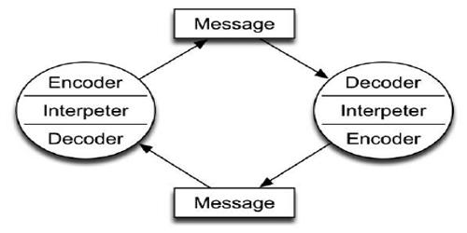
A two-way communication is important to be able to solve problems better and getting a solution quicker. Both sender and receiver listen to each other, collect information from each other and face obstacle of future changes that need to be made, which makes working together easier and information flows better. This is in form of video calls, phone calls, face to face conversations and group discussion.

For Andrea the two-way communication of having phones calls, video calls, group discussion and face to face conversation would help to improve their business effectively. As the case study specify there no formal teams and only have some meeting through Microsoft Teams. Recommendation would be that a face-to-face meeting held with the three managers and discuss the growth of the online orders, take feedback from the manager on what can be improved and what needs to be changed. Then follow on with regular emails to staff’s pf update, then have regular meetings through Microsoft Teams and detailed emails to managers with targets and expectations.
One other theory that would help Andrea’s business is the Kilmann theory model where it is used as a tool to measure an individual’s response to conflicts. This shows how much an individual team member focus on their own concerns or satisfy other individual’ concerns. Conflict happens when a disagreement happens but how you resolved as an individual. Thomas Kilmann conflict mode was created in early 1971, the theory lays out five different modes of how people handle conflict on axes of assertiveness and cooperativeness. Here is a example of the model.
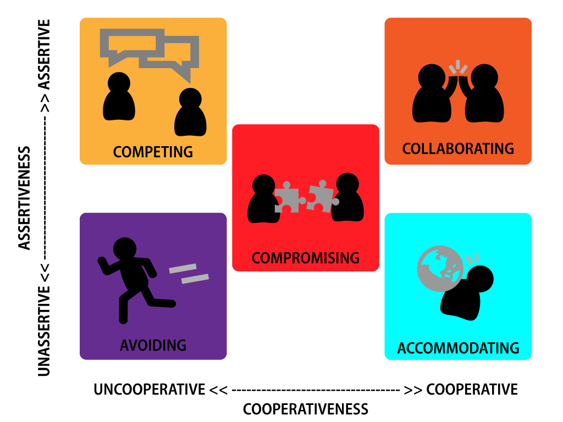
This Photo by Unknown Author is licensed under CC BY
Assertiveness means having a confident and forceful behaviour, you have respect for yourself, able to express your feelings clearly. Willing to work on resolving conflicts and know you rights.
Cooperativeness mean working together for common goal, very cooperative. You try to please others, put others’ views first and avoid creating conflict.
Using the Kilmann theory you can learn how an individual handles conflict and how the other team members handle conflict when it happens. “Thomas Kilmann model is widely used to help evaluate how someone might react in a conflictual situation” (Tripple & Buamoel 2015). A questionnaire is included in the appendix, by completing this questionnaire you can find out your character of behaviour. Conflicts happened during the storming phase in Tuckman theory, or it can happen anytime, but it is a very important for a team development. Working together in a team they can resolve the conflict with a good leadership.
From Covid-19 new way of working has been developed, the virtual communication has more important than ever to communicate. This effective as it’s the fastest way to communicate and share information to team members. It improves productivity, you get instant response which can solves problems quicker through messaging, group chats on WhatsApp, video conferencing on skype or Microsoft Teams which Andrea already does but not regularly. Because of this there are more misunderstandings and confusions. Meetings should be consistent to increased productivity and awareness of each team member’s duties.
The element of communication comes in many forms, the common ones are the speech, body language, tone voice, active listening, feelings and emotions from this you can process and make a effective decision toward the business. Team members perform better when the is a bond and trust with the managers. They full potential comes out, which would lead to success in the business. Andrea’s business lacks a lot of trust, not structure with too many people employed it can cause confusions
Having an effective communication in Andrea’s business is important key to success and having a good constant communication will maintain the success and will provide a better understanding of standard of work required from the staff. As their communication now is very poor, no regular meetings held, or any teamwork seen. Working as a team is also important aspect for the business as it will increase effectiveness in productivity. Promotes better performance at work, teams willing to work better and meet their goals.
“Communication makes meanings that range between an individual's idiosyncratic ideas and the co-constructions people share about their experiences together. Idiosyncratic meanings are one person's views or ideas that are not shared by others” (Burtis, J.O. and Turman, P.D. 2010).

It’s very important for any business to have two-way communication for information flow better and get feedback. This helps to solve problems better and faster, gathering information and willing to make changes to work together.
For Andrea the two-way communication of having phones calls, video calls, group discussion and face to face conversation would help to improve their business effectively. As the case study specify there no formal teams and only have some meeting through Microsoft Teams. Recommendation would be that a face-to-face meeting held with the three managers and discuss the growth of the online orders, take feedback from the manager on what can be improved and what needs to be changed. Then follow on with regular emails to staff’s pf update, then have regular meetings through Microsoft Teams and detailed emails to managers with targets and expectations.

Conclusion
Andrea Jones business had rapidly grown from going online, but their team structure was very stable and a lot of miscommunications. Very limited meeting held for a business that employs 27 people, not organised and or controlled well. From the findings theories can be applied to help the business increase its productivity and better communication within the teams. Belbin, Tuckman theory would be ideal here, to find the characteristic and apply to their duties and bring out the better. Using Kilmann questionnaire where they would identify conflicts and how individual deal with a situation.
Usually written in paragraphs or sections.
You are summarising the information from your findings – do not introduce anything new in this section. Include the main points and link these to the terms of reference.

Recommendations (If appropriate)
Meeting held with the manager to inform to apply the theories of Belbin, Tuckman and Kilmann to improve better communication and find out the characteristic of each team member to assign the role according to the results of the questionnaire. As they would be able to perform to their full potential. The model of communication of Berlo’s, Schramm, Shannon and Weaver to be used to have effective way of communication in the business. After analysing these results from the theories, it will help to re-organise the team and designate manager to specific areas, take on a new manager for night shifts to be responsible for that area, manager for the working from home, stock room manager and a floor manager would be ideal thing to do. Using Microsoft Teams weekly to discuss and analysis any issue that needs to be delt with. Constant emails with information sent to team members regarding updates or changes made to the system. Maybe also have WhatsApp group for instant responses to questions or ideas that needs to be shared. Making the whole staff aware of standard of work required and provide a monthly recognition for good input in work for an employee.

Bibliography/References

Busse, W.W. (2021) ‘Mentoring: A lifetime cycle and key to successful career development’, Journal of allergy and clinical immunology, 147(5), pp. 1634–1637. doi:10.1016/j.jaci.2021.02.036.
Burtis, J.O. and Turman, P.D. (2010) Leadership communication as citizenship give direction to your team, organization, or community as a doer, follower, guide, manager, or leader. Thousand Oaks, Calif. ;: SAGE.
Bonebright, D.A. (2010) ‘40 years of storming: a historical review of Tuckman’s model of small group development’, Human resource development international
Businesstopia www.businesstopis.net/communication/shannon-and-weaver-model-communication online
Communication Theory www.communicationtheory.org/berlos-smcr-model-of=communication online
Cohen, S.G. and Bailey, D.E. (1997) ‘What Makes Teams Work: Group Effectiveness Research from the Shop Floor to the Executive Suite’, Journal of management
Dawn R Utley, Stephanie E Brown and Michael P J Benfield (2009) ‘Working Group or Team: Characteristic Differences’, IIE Annual Conference. Proceedings, p. 415–.
Griffiths, A. and Wall, S. (2011) Economics for business and management. Third edition. Harlow, England: Pearson Education Limited.
Giovanni De.D (2019) The secrets of effective communication
Leydesdorff, L., Petersen, A. and Ivanova, I. (2017) ‘Self-organization of meaning and the reflexive communication of information’, Social Science Information
Pugalis, L. and Bentley, G. (2013) ‘Storming or performing? Local Enterprise Partnerships two years on’, Local economy, 28(7-8), pp. 863–874. doi:10.1177/0269094213503066.
Stead, B.A. (1972) ‘Berlo’s Communication Process Model as Applied to the Behavioral Theories of Maslow, Herzberg, and McGregor’, Academy of Management journal,
The Schramm Model of Communication (2009) Key Concepts in Marketing.
Trippel & Baumoel. D 2015 Beyond the Thomas Kilmann model: into extreme conflict negotiation
QS STUDY www.qssstudy.com/business-studies/schramms-model-communication online

Appendices

Acknowledgements

