BA Business Management
Blogging to communicate - Assessment 1

Name: Moisiu Maria-Alexandra
ID:1921355

Introductory line
Marketing Communications is the most essential part of promoting brand awareness to a large group of customers. Blogs are a creative way to communicate with the target audience. The chosen project deals with the promotion of Anti-Age Eye Concealer launched by Maybelline in the UK.
Blog Post 1: Price-Sensitive Strategy for the Anti-Age Eye Concealer for an Edge in the UK Cosmetic Market
Among the leading cosmetic brands in the UK such as MAC, Benefit Cosmetics, L’Oreal Paris, The Body Shop, Maybelline offers a reasonable offer for its products. The female population in the UK, ranging from 14-30 years of age are prone to buying makeup and not everyone can afford bombarding prices set up by the companies. The cosmetics market in the UK contributes to a large portion of the revenue generated in the country. However, the competitive forces are high in the industry, making it imperative for newly launched products to consider the needs and demands of price-sensitive customers. Rimmel and Max Factor lead the market with 48% and 41% users respectively. However, Maybelline New York dominates 38% of the market (Maybelline, 2020). Increasing the share and surpassing that of the leaders will require additional efforts.
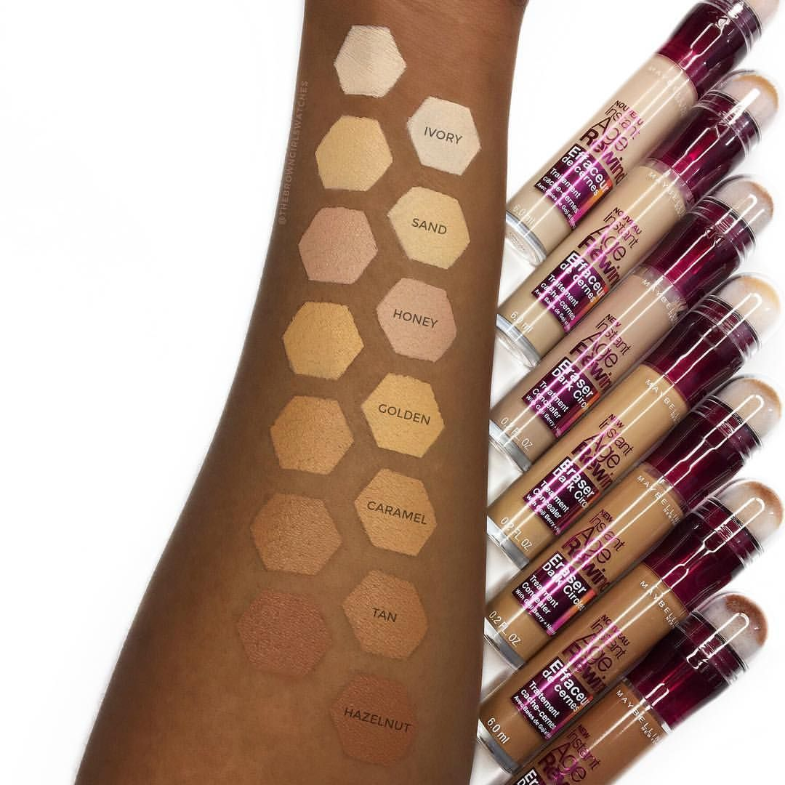
Figure 1: Concealer Shades
(Source: Maybelline, 2020)
The first step to launching a new product with proper pricing strategies includes an overall survey of the newly launched products of other brands. The next step includes probing into the pricing strategies of those brands and their market prices. It is followed by customer feedback on how convenient procuring the products of the company has been. The price set for the Anti-Age Eye Concealer is 20 pounds, a reasonable price and an exciting offer for the shoppers. It is suitable for people aged from 25-32 because that is the target audience for this product and they have a reasonably steady income by the age of 25. Selection of the cheapest suppliers and establishing proper policies to assure correct deliverables help at a reasonable price drop of the product (Sarkar et al., 2020). Comparing and contrasting other anti-ageing concealers with the product can help in setting a price that is 10 pounds lower than the other product. It makes the product attractive to price-sensitive consumers. They can now go ahead and avail their pocket-friendly product from e-commerce platforms with attractive discounts on the product.
Blog Post 2: Sustainable Product Development to Spread Awareness against Product Testing on Animals
The rising awareness among consumers has led to a global decline of usage of Maybelline Products for they have been accused of testing their products on animals. Skincare products and personal products have been tested on animals leading to a degrading brand reputation for the organisation because of rising protests. The Anti-Age Eye Concealer targets audience ranging from 25-32 years and they are aware of the importance of environmental sustainability. The outbreak of the pandemic, COVID-19 has increased the consciousness and sensitivity towards the environment, as it has been reported that pollution and degrading quality of the environment have increased the death rates globally (Reid et al., 2020). The product has been launched keeping in mind that the target audience also includes vegans, environment conservationists and social workers. Brand awareness with a special message on no animal testing of the product is an innovative idea to redeem the lost reputation of Maybelline New York among a certain community of the customers.

Figure 2: Awareness against Animal Testing
(Source: Reid et al., 2020)
Technological development, investment in equipment that assures that there is no need to test the product on animals can be mentioned in a social media post for the launch of the brand to spread awareness among customers. The scientific and organic development of the product, careful packaging and reduced use of synthetic materials can help in incurring more number of customers for the brand. Maintaining proper relations with the various suppliers is a strong force determining how authentic the procured raw materials are. The HRM needs to develop special policies to deal with the suppliers for a regular inflow of raw materials to curate the concealer as safely as possible (Nilashi et al., 2020). The efforts made by the company at sustainable product development can be incorporated into Facebook pages, Instagram Reels can be used to post snippets from the factory to make the customers aware of the real-time production. The key to developing a product successfully is to invest in the right places at the right time. Investing in suitable technology and weighing the bargaining power of the suppliers help the sustainable development of products without the need to test the product on animals and lose a handful of customers in the process.
Blog Post 3: Social Media Marketing Tools for Promotion for Effective Brand Value and Sales
Technological development and rising usage of social media have made it an effective tool for marketing. Digital marketing not only increases a customer base but also reaches out to a wide scope of people at a global forefront. Maybelline New York has 10.6 million followers on Instagram, 35 million followers on Facebook, 305K subscribers on YouTube and 674.21K brand fans on Twitter. Presence on social media is an effective tool for promoting the Anti-Age Eye Concealer among customers as it has already reached a wide base. The Facebook page can be used to conduct a poll to have an overall customer survey of how many of them would like to test the free sample test kit of the product. The top 10 respondents to the poll can be offered a free sample test kit as it is an effective tool for brand promotion. Word of mouth can act as a driving force for the promotion of the brand (Chatterjee and Kar, 2020). The top 10 respondents could reach out to their immediate friends and family and give their feedback. The next step could be a launch of live feedback from the top 10 respondents on the official page of Maybelline New York on Facebook. It will reach out to millions of viewers about the USP of the product, as they intend to go ahead and by it for 20 pounds.

Figure 3: Social Media Marketing Tools
(Source: Chatterjee and Kar, 2020)
Instagram Reels with effects and attractive music is the new promotion tool being adopted by many companies and local stores. The target audience aged between 25 and 30 are hefty users of social media for various purposes. Instagram Reels could include real-time factory snippets from the production of the cosmetic to various tutorials that include the process of applying the product (Capatina et al., 2020). The number of viewers increases by seconds, resulting in an increasing number of followers of the brand. Interactive Vlogs and celebrity endorsements of the product are some of the popular advertising strategies, influencing the target audience to go ahead and make their purchase.
Blog Post 4: Attractive packaging for target audience for an edge in the cosmetic market in the UK
It is popularly claimed that beauty lies in the eye of the beholder. Cosmetic brands must consider the aesthetics of their standard beauty products for sales among a wider base of customers. The most important determinant of packaging is the preferences of the target audience. It is mandatory to survey how many of the customers' judges a book by its cover. Psychologically stimulating packaging can attract attention from a wide range of customers who opt to take a detailed glance at the product, price and directions of use. However, with the rising use of e-commerce platforms like Amazon, eBay and Alibaba, it can be understood that a picture with proper dimensions of the product has become mandatory for product promotion (Karimi et al., 2020). Packaging also falls under the funds being invested by the company, and the raw materials procured by the company to package the product must not be synthetic or harmful to health in the long run to avoid further complaints.
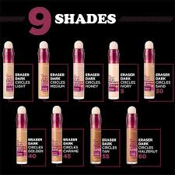
Figure 4: Packaging of Maybelline Anti-Aging Eye Concealer
(Source: Maybelline, 2020)
The packaging must include an analysis of the colour combinations to be used, the total built of the product and witness whether or not it has any drawbacks. Damaged packaging can cause returns and refunds leading to an additional loss for the company itself. The Anti-Age Eye Concealer has a colour combination of magenta and nude making it attractive to the customers by giving away the nature of the product. The roll-on on top is easy to apply and convenient for the target audience to carry around. Pocketsize products fit customer trends of modern times, as they would prefer carrying the products and applying them wherever and whenever. The packaging must be attractive to be launched and promoted on social media, including detailed directions for use to increase the convenience of the customers (Garritty et al., 2020). The packaging must include the expiry date, price and warnings to make it authentic. The sales can be boosted if the company incorporates the increasing awareness of the ban on animal testing for its products.
Blog Post 5: Surveys and Sales at Sheffield and London for Kiosks and Promotion
Sheffield is located in South Yorkshire in the UK and has a lesser population compared to the other parts of the UK. The total population of Sheffield is 730,000 and that makes it a prominent hub to launch and market the Anti-Age Eye Concealer. The geographical location of the town stands for the cold weather it characterises. The weather is suitable for sales of the product as the chilly weather roots for increased usage of skincare products. The number of office goers and university students is conscious about the health of their skin, making it mandatory for cosmetic brands to devote considerable efforts to launching and promoting products in the city. The Sheffield Cultural Hub organises several cultural events in the city making it imperative for the company to conduct live surveys and carrying out free sampling there (Lahtinen et al., 2020). The cultural shows are populated during an event and it is rather profitable for Maybelline New York to sponsor the shows, as there is an increased footfall. The first 10 samples are given out free in small pouches to make it cost-effective and attractive process for a wider reach to customers.

Figure 5: Sheffield Cultural Hub
(Source: Lahtinen et al., 2020)
London is a large metro area in the UK with a population of 9,304,000. The demographics include a wider variety of cultures from various parts of the world. There are several office-goers and daily commuters within the sphere of the city, including a large proportion of tourists at all times of the year. This provides a greater chance to conduct face-to-face surveys at frequented places like Trafalgar Square, Tower Bridge and Buckingham Palace of London. Approaching target audiences with a list of questions about the brand of cosmetics they use, their needs and demands as well as a provision of a sample pouch of the customers (Dörnyei, 2020). The weather is relatively warmer than Sheffield, but the customer trends suit the sale of greater amounts of skin care products among the population ranging from 25-32. Broadway and metro stations is a hub of a population where sponsoring booths can be set up for feedback and sales boost.

Figure 6: Broadway London
(Source: Broadway, 2020)
Blog Post 6: Effective Positioning among Select Audience and Cosmetic Users of Age 25-32
The intended audience of the product aged between 25 and 32 are mostly office-goers and are concerned about the health of their skin. Production and promotion of an Anti-Aging Eye Concealer show some striking benefits for its customers. The 20-pound price range is an effective offer compared to the other cosmetic brands existing in the UK market. The beneficial value of the product includes an effective roll-on, which is easy to use and showing effective results almost immediately. The blending qualities of the eye concealer do not exhibit creases (Hornikx et al., 2020). The blend is smooth enough to erase dark circles and not leave behind any cakey look or creases. The concealer to be applied directly to the under-eye area has a Micro-Corrector Applicator with arrows on a sponge making it convenient for the customers to use. The benefits can be communicated to the customers through vending booths and kiosks set up at frequented public spaces and social media marketing to correctly position the product. The brand value is ingrained in the organic materials used to curate the product and its long-lasting effects. The product is consistent compared to the other brands and suits the instant need of the office-goers in the UK.
Concluding Line
Marketing Communications blog posts have dealt with 6 themes about the Marketing Mix to assure the creation of an edge of Maybelline New York Anti-Age Eye Concealer over other brands in the UK market.

References
Broadway, 2020. London Theatre Guide | Broadway.Org. [online] Broadway.org. Available at: <https://www.broadway.org/info/london> [Accessed 18 November 2020].
Capatina, A., Kachour, M., Lichy, J., Micu, A., Micu, A.E. and Codignola, F., 2020. Matching the future capabilities of an artificial intelligence-based software for social media marketing with potential users’ expectations. Technological Forecasting and Social Change, 151, p.119794.
Chatterjee, S. and Kar, A.K., 2020. Why do small and medium enterprises use social media marketing and what is the impact: Empirical insights from India. International Journal of Information Management, 53, p.102103.
Dörnyei, K.R., 2020. Limited edition packaging: objectives, implementations and related marketing mix decisions of a scarcity product tactic. Journal of Consumer Marketing, pp. 1-5.
Garritty, C., Hamel, C., Hersi, M., Butler, C., Monfaredi, Z., Stevens, A., Nussbaumer-Streit, B., Cheng, W. and Moher, D., 2020. Assessing how information is packaged in rapid reviews for policy-makers and other stakeholders: a cross-sectional study. Health research policy and systems, 18(1), pp.1-17.
Hornikx, J., van Meurs, F., van den Heuvel, J. and Janssen, A., 2020. How brands highlight country of origin in magazine advertising: A content analysis. Journal of Global Marketing, 33(1), pp.34-45.
Karimi, M., Kaveh, M.H. and Morowatisharifabad, M.A., 2020. The Viewpoints of Urban High School Male Students, Parents and Teachers About Cigarette Smoking by Adolescents: A Social Marketing-Based Qualitative Study, Shiraz, Iran. Shiraz E-Medical Journal, 21(10).
Lahtinen, V., Dietrich, T. and Rundle-Thiele, S., 2020. Long live the marketing mix. Testing the effectiveness of the commercial marketing mix in a social marketing context. Journal of Social Marketing, pp. 1-15.
Maybelline, 2020. Maybelline New York Official Site | Makeup Products & Tutorials. [online] Maybelline.com. Available at: <https://www.maybelline.com/> [Accessed 18 November 2020].
Nilashi, M., Yadegaridehkordi, E., Samad, S., Mardani, A., Ahani, A., Aljojo, N., Razali, N.S. and Tajuddin, T., 2020. Decision to Adopt Neuromarketing Techniques for Sustainable Product Marketing: A Fuzzy Decision-Making Approach. Symmetry, 12(2), p.305.
Reid, L.F., Vignali, G., Barker, K., Chrimes, C. and Vieira, R., 2020. Three-dimensional Body Scanning in Sustainable Product Development: An exploration of the use of body scanning in the production and consumption of female apparel. In Technology-Driven Sustainability (pp. 173-194). Palgrave Macmillan, Cham.
Sarkar, S., Tiwari, S., Wee, H.M. and Giri, B.C., 2020. Channel coordination with price discount mechanism under price‐sensitive market demand. International Transactions in Operational Research, 27(5), pp.2509-2533.

