Marius-Catalin
Bobitiu
Cloud Computing
Database
Management Systems
ACCC5004

Table of Contents
Introduction 3
What is a Database Management System (DBMS)? 3
Characteristics of Database Management System 3
1. Data stored into tables 4
2. Reduced Redundancy 4
3. Data Consistency 4
4. Support multi-user and concurrent access 4
5. Query Language 4
6. Security 4
7. Transactions 5
Summary 5
Database 5
Mission 5
Tables 5
Advantages 14
Abstract 15
Introduction 15
Database 15
Bibliography 15

Introduction

What is a Database Management System (DBMS)?

A Database Management System is a set of software programs that controls the organization, storage, management, and retrieval of data in a database. DBMS are sorted according to their information structures or types. It is a set of pre-composed projects that are utilized to store, update and retrieve a database. The SQL query processing requires that the DBMS identify and execute a procedure for retrieving the results of the query. The SQL query determines what data is to be found, but does not define the method by which the data manager searches the database. (Aparajitha.R.S.V, 2010)

Characteristics of Database Management System

A DBMS system has the following characteristics:

- Data stored into tables
- Reduced Redundancy
- Data Consistency
- Support multi-user and concurrent access
- Query Language
- Security
- Transactions

Data stored into tables

The information is never directly stored into the database. It is stored into tables, created inside the database. DBMS also permits to have connections between tables which makes the information more significant and associated. You can easily understand what sort of information is stored where, by checking the tables created in the database.

Reduced Redundancy

The DBMS follow Normalization which divides the information in such a way that repetition is at minimum.

Data Consistency

The DBMS software can update and add data by itself, maintaining the consistency of data without making it a challenge for the user.

Support multi-user and concurrent access

DBMS allows multiple users to work on it at the same time and still manages to maintain the data consistency.

Query Language

DBMS provides users with a simple Query language. Data can be easily got, inserted, updated or deleted in a database.

Security

In a DBMS we can create logins and users, with different access permissions, which makes it very useful and secure. It protects the data from unauthorized access.

Transactions

DBMS supports transactions, making it better to handle and manage data integrity in real world applications where multi-threading is extensively used.

Summary

Database Management System (DBMS) is a software for storing and retrieving users' data while considering appropriate security measures. It consists of a group of programs which manipulate the database.

It has a lot of good characteristics which makes it very good to be used, some of them are data stored in tables, data consistency, multi-user access, security. It is a very good system to store your data in, extremely easy to use, access to the data anytime from anywhere, and with the login system your data is protected.

Database

Mission

To provide a database for their new range of clinics that will open.

Tables

The database consists of 8 tables. The tables are as follows:

- Region: It contains a list of the geographical regions.

- City: Contains a list of cities organized by the geographical regions

- VetClinic: Contains details of the clinic.

- Customer: Contains details of customer

- Pet: Contains details of all the pets

- Visits: Contains the visit details

- Treatment_Detail: Contains the details of the treatments received during a particular visit.

- Treatment: Contains the details of different types of treatment offered by the clinic.

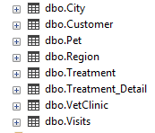

Each table has several fields to enter data, and all fields have several field proprieties.

Region

RegionID | INT | Primary key  Not null
RegionName | Varchar(100) | Not Null

The region table in design view:

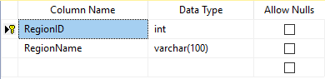

The Region table in view mode:

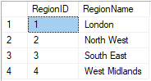

City

CityID | INT | Primary key  Not null
CityName | Varchar(100) | Not null
RegionID | INT | Foreign key  Not null

The city table in design view:

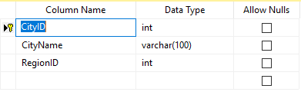

The city table in view mode:

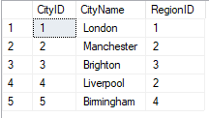

VetClinic

ClinicNo | INT | Primary key  Not null
ClinicName | Varchar(100) | Not null
ClinicAddress | Varchar(200) | Not null
CityID | INT | Not null  Foreign key
Postcode | Varchar(10) | Not null
TelNo | Varchar(15) | Not null
openMonFri | Time | Not null
openSat | Time | Not null
openSun | Time | Not null
openBankHolidays | Time | Not null

The VetClinic table in design view :

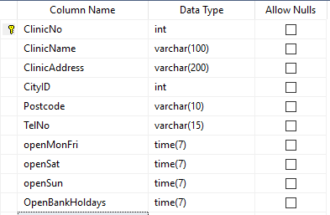

The VetClinic table in view mode:



Customer

CustomerID | INT | Primary key  Not null
Customer Name | Varchar(30) | Not null
CustomerStreet | Varchar(100) | Not null
CustomerCityID | INT | Not null  Foreign key
Postcode | Varchar(10) | Not null
PhoneNumber | Varchar(15) | Not null

Customer Table in design view:

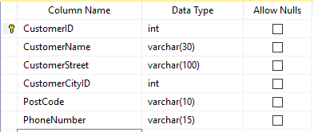

Customer Table in view mode:

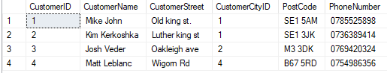

Pet

PetID | INT | Primary key  Not null
CustomerID | INT | Foreign key  Not null
PetName | Varchar(20) | Not null
AnimalType | Varchar(30) | Not null
PetGender | Varchar(6) | Not null
PetDOB | Date | Not null
PetColour | Varchar(20) | Not null
PetLength | Varchar(40) | Not null
PetWeight | Varchar(40) | Not null

The Pet table in design view:

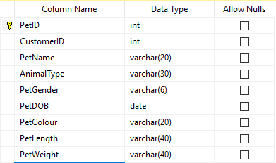

The Pet table in view mode:

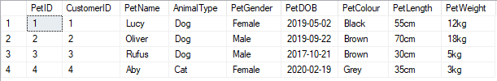

Visits

VisitID | INT | Primary key  Not null
PetID | INT | Foreign key  Not null
ClinicNo | INT | Foreign key  Not null
VisitDate | Date | Not null
AmountPaid | Money | Not null

The Visits Table in design view:

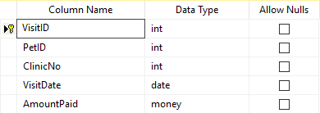

The Visits table in view mode:

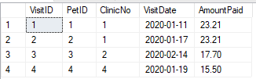

Treatment_Detail

TreatmentsID | INT | Primary key  Not null
VisitID | INT | Foreign key  Not null
TreatmentCode | INT | Foreign key  Not null
TreatmentDetail | Varchar(100) | Not null

The Treatment_Detail table in design view:

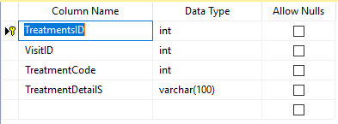

The Treatment_Detail table in view mode:

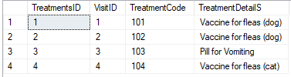

Treatment

TreatmentCode | INT | Primary key  Not null
TreatmentName | Varchar(50) | Not null
TreatmentDesc | Varchar(200) | Not null
TreatmentPrice | Money | Not null

The Treatment table in design view:

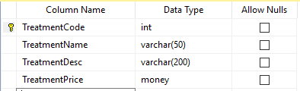

The Treatment table in view mode:

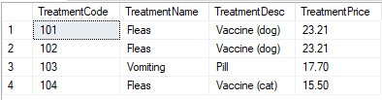

Advantages

- Everything is stored in his own table.

- The relationships will help the user to easily introduce new data inside the tables.

- User-friendly. It is very easy to use by anyone.

- Everything is secured, since there is a login system created. At the moment they are only 2 users, which are admin and staff. It can be added later on more users by the admin.

Abstract

Introduction

In the introduction section we find out what is a database management system and also some characteristics of it.

As a summary, a DBMS is defined as the software system that allows users to define, create, maintain and control access the database. Some important characteristics are the Data Integrity, Security and the multi-user access.

Database

In the Database section we look forward in our designed database solution for the Pet Care.
We take a look at the tables structures, with some examples from the real database. And, in the final, we try to find out what advantages of using this database.

Bibliography

Aparajitha.R.S.V, K. M. M. T. P. T. V. R. P., 2010. Database Management Systems. International Journal Of Computer Applications, pp. 73-76.

Kristi Castro(2018). Advantages of Database Management System. -https://www.tutorialspoint.com/Advantages-of-Database-Management-System

Oracle - Database/What is a database? - https://www.oracle.com/database/what-is-database.html

Thank You!

