

Component: Apply the principles and practices of Data security, Governance and Compliance based on a given scenario
Program: MSC Data and Artificial Intelligence
Student ID: 2432187
Student Name: Kandarp Mukeshkumar Sharda
Module Code: ACCA7028
Module: Data Security, Governance and Compliance
Lecturer: Dr Muhammad A. Abbas

Contents
Abstract 4
1. Introduction 5
2. Case Context 5
3. Literature Review on various information security frameworks 5
3.1 Information Technology Infrastructure Library (ITIL) 5
3.2 International Organisation for Standardization: ISO/IEC 27001 8
4. Security, Governance, and Compliance Design for NG 10
4.1 Compliance (Laws and Ethics) 10
4.2 Governance and Strategic Planning for Security 11
4.3 Security Policies 12
4.4 Risk Management 13
4.5 Protection Mechanisms 14
4.6 Service Level Agreement 16
5. Importance of Constantly Updating Standards 16
6. NG Security Implementation Plan 16
7. Conclusion 17
References 17

Table of Figure

Figure 1: ITIL Framework [1] 6
Figure 2: ITIL life cycle [10] 7
Figure 3: Process to implement ISO/IEC 27001:20013 [12] 8
Figure 4: ISO 27001 ISMS Lifecycle Diagram [18] 9
Figure 5: Vulnerability × Threat Table 10
Figure 5: Compliance Rules for Different User Groups at NG 11
Figure 6: Information Security Governance Structure 12
Figure 7: Information Security Policy Table 13
Figure 8: Risk Register for NG 14
Figure 9: Layered Protection Mechanisms 15
Figure 10: Gantt chart outlining the six-phase schedule for NG’s security improvement plan. 17

Abstract
This report outlines how NatureGreen(NG) can improve its information security by using recognised frameworks and a clearer governance structure. The company currently going through several issue including missing security policies, unclear responsibility and growing risk caused by staff and customer using personal device. Using research carried out on ISO 27001, ITIL and my own knowledge, I have developed complete security model is proposed which include new governance structure led by CISO, updated compliance measures, a clear risk-management process, and technical controls such as access control, intrusion detection, encryption, and BYOD security. This report also explains why organisations must regularly update their standards and regulations as cyber threats continue to evolve. Overall, the proposed approach gives NG a practical and strategic way to build a secure, compliant, and resilient security environment.

1. Introduction
NatureGreen (NG) works across different countries and depends heavily on wireless networks and cloud services, using Wi-Fi for almost everything and relying on cloud systems to support staff and customers. As the company grows internationally, it is facing increasing pressure to let employees and clients use their own devices to access NG’s systems, which creates serious risks to customer data, staff information, and the company’s important intellectual property. Right now, NG has no implemented security framework, governance setup or policies to manage the risk. Using knowledge gained from recognised frameworks like ISO/IEC 27001 and ITIL, along with my own understanding of the NG situation, I have created this compliance structure that suits the organisation’s needs. It also explains why organisations like NG compulsorily update their rules and security controls to stay protected in this fast-changing technology world.

2. Case Context
NG is a global health-product company with a large international customer base and a heavily digital environment. Nearly 95% of its network relies on wireless connectivity, and most services are delivered through cloud platforms. NG also has a strong online and social media presence, increasing its digital exposure. As the company grows, it faces pressure to allow its staff and customers to use their own devices to access its network and cloud systems. However, NG currently lacks a formal security framework, defined roles, governance structure, and clear policies, leaving customer data, staff information, cloud assets, and valuable intellectual property at significant risk.

3. Literature Review on various information security frameworks

This literature review examines two major information security frameworks ITIL and ISO/IEC 27001. Each framework is presented with an overview, a critical review, and its relevance to NG.

3.1 Information Technology Infrastructure Library (ITIL)
A lot of organisations use ITIL as a framework for managing IT services, as it gives them a structured and standard way to plan, deliver, and improve their IT activities. It helps companies organise their IT work in a clear and consistent way so that services properly support business goals, strengthen governance, improve reliability, and create more stable day-to-day operations [1]. ITIL works by guiding organisations through a set of defined processes that help them manage incidents, changes, and service requests in a consistent and controlled way. Reason being ITIL sets out clear processes, roles, and responsibilities, it allows organisations to coordinate their IT service activities more effectively and maintain steady performance across different areas of IT. One of its main benefits is its focus on repeatable and measurable processes, such as handling incidents, managing service requests, carrying out changes, and keeping accurate configuration information which eventually helps IT teams work in a more controlled, predictable, and collaborative way with the rest of the organisation [2]. ITIL also pushes for continuous improvement by pushing for regular reviews of IT practices, making sure services keep up with business needs as the organisation grows or introduces new technologies. Research also shows that ITIL supports more professional IT operations by using structured tools such as service desks, incident logging systems, and configuration management databases (CMDBs), which significantly improves visibility of IT assets and can help to increases coordination between technical teams and business units [3].

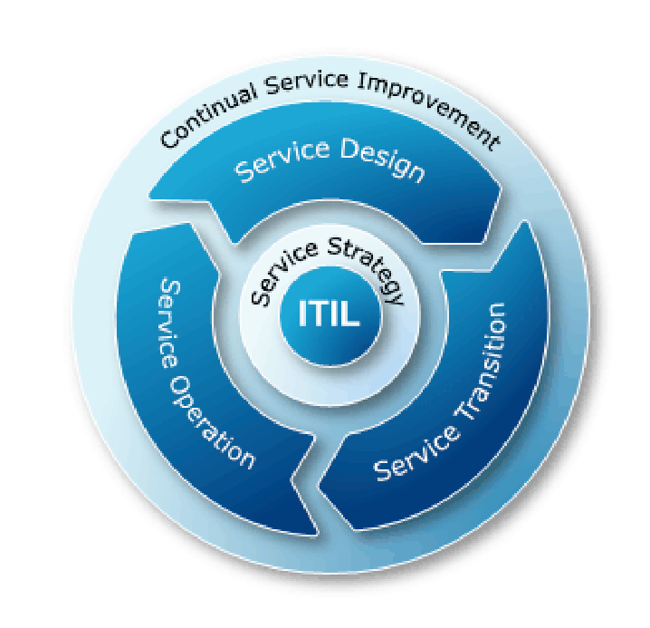
Figure 1: ITIL Framework [1]
Even though it is a widely used framework, research shows that many organisations find it difficult to put it into practice because of non-technical issues such as workplace culture, staff attitudes, and the level of management support [4]. Employees often see ITIL processes as restrictive or time-consuming, especially when communication and training are poor, which leads to resistance and uneven adoption [5]. Many organisations also underestimate how much leadership involvement, coordination, and resources are needed, which results in ITIL being applied only on the surface and failing to bring real improvements [4]. Financial pressures make things harder as well, because training, new tools, and changes to processes require upfront investment before any benefits can be seen, causing management to hesitate [5]. I strongly believe that financial pressure becomes a real problem because organisations must spend money upfront on staff training and IT tools like service-desk systems, incident-logging software, monitoring tools, as well as updating their internal processes. Since the benefits only appear later, I can see why management often easily approves this investment. Research also shows that trying to introduce too many processes at once creates confusion and poor alignment, highlighting the importance of a clear and prioritised approach. The key success factors are good training, strong awareness, and committed management, which are often missing in practice, which creates a gap between how ITIL is meant to work and how it is actually used [6]. I also believe that many organisations struggle because they treat ITIL as a checklist rather than a long-term cultural change, which makes it harder for staff to understand its real purpose.
Lots of findings from ITIL research match closely with the challenges NG is facing, suggesting that the framework could help the company build the structure and governance it currently lacks. NG is struggling with unorganised IT practices, limited documentation, and poor alignment between IT operations and business goals problems that ITIL aims to fix by promoting clear processes, defined roles, and stronger service governance [1]. For example, ITIL would require NG to document procedures properly and assign clear responsibilities, such as who approves changes or who handles incidents. ITIL improves Business-IT alignment by strengthening communication, decision-making, and clarity around IT responsibilities. This would help NG reduce confusion between departments and create a more coordinated way of managing IT services [7]. For instance, both the network team and support team would follow the same process for logging and escalating incidents. The company’s issues with incident handling, ad-hoc responses, and limited monitoring could also be improved through ITIL’s structured service-support processes, which are known to enhance service quality, shorten incident-resolution times, and give better visibility of day-to-day operations [8]. In addition, NG’s lack of consistent change management and weak control over configuration information exposes the organisation to mistakes that could be avoided. ITIL helps reduce these risks by encouraging disciplined change handling and accurate tracking of IT assets and how they are connected [9].

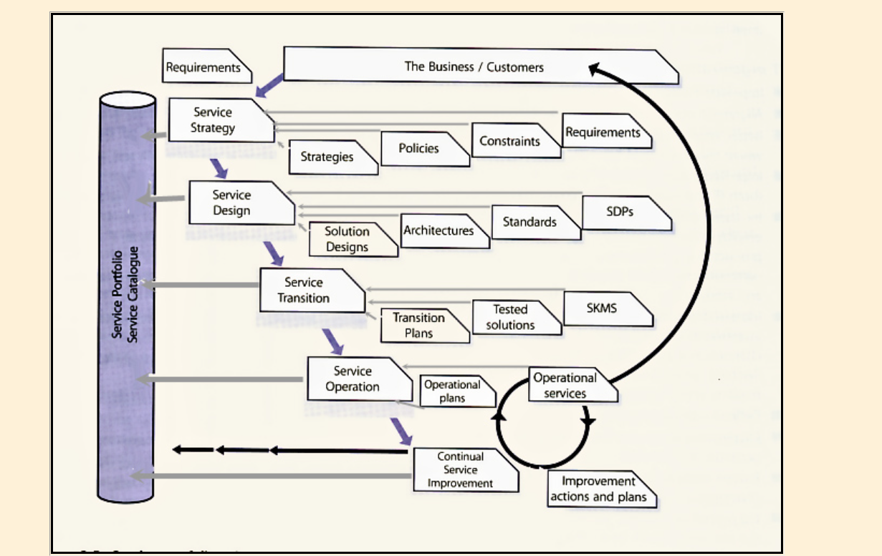
Figure 2: ITIL life cycle [10]

3.2 International Organisation for Standardization: ISO/IEC 27001
For many organisations, ISO/IEC 27001 has become a key guide for creating and maintaining a proper Information Security Management System (ISMS). In simple terms, I would explain it as giving companies a clear and organised way to keep their information safe. It is now the third most commonly used ISO certification in the world, which shows how important it has become for managing information security [11]. Research also shows that the standard acts as a full framework that helps organisations understand their risks, put the right security measures in place, and work towards formal certification [11]. It works by following a step-by-step cycle where organisations identify risks, apply suitable controls, review their performance, and keep improving their security practices over time [12]. This framework also offers a structured method for keeping information safe, mainly through very strong risk assessments, well-defined security measures, and good governance [12].
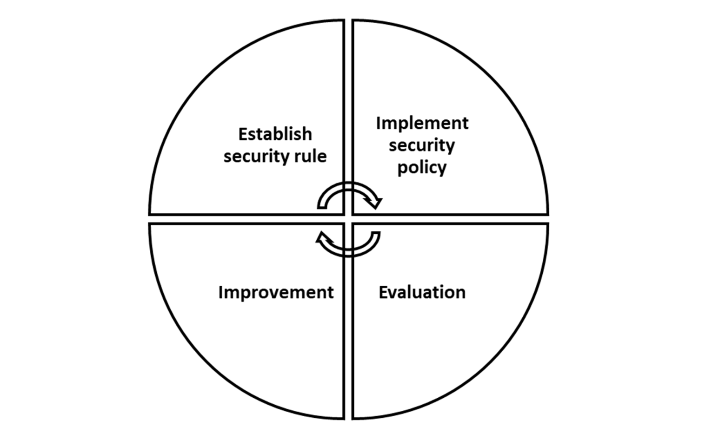
Figure 3: Process to implement ISO/IEC 27001:20013 [12]

Even though ISO/IEC 27001 is being widely used but there is still a lot of debate about how useful and practical it is in real organisations. The 15-year review of ISO/IEC 27001 showed that it still faces several problems, such as limited real-world evidence, difficulties in linking it with other standards, and challenges in risk analysis because the guidelines are quite flexible [11]. Other studies also point out that ISO 27001 spread more slowly than similar management standards, partly because certification does not give companies an immediate business benefit and because it takes a lot of time and effort to implement [13]. I believe reason is straightforward because there are lot of heavy documentation and audit requirements, which can discourage organisations that lack enough staff or resources. It still focuses mostly on “Protect” controls, meaning it is more about prevention than responding to new and fast-changing cyber threats, which may limit its usefulness today [14]. Case studies have showed that many organisations face long implementation times, complicated risk assessments, and resistance from staff and I think this shows that success depends more on the organisation’s ability and culture than on the standard itself [12]. Even though ISO 27001 is strong in theory, it has many real-world limitations, and its success depends heavily on the organisation’s context, resources, and willingness to adopt it properly.
Many of the issues reported by organisations that have implemented ISO 27001 are very similar to the challenges which is being faced by Natural green, particularly around managing fast growth, keeping documentation consistent, and meeting rising customer expectations for data security [12]. As NG continues to expand its wireless setup and cloud-based services, these problems become harder to manage, which shows that a structured ISMS (Information Security Management System) could help bring more clarity to its security practices. Research also highlights that organisations often struggle when staff are not properly prepared for new security responsibilities, leading to confusion, inconsistent compliance, and resistance to new procedures [15]. NG may face the same situation because of its growing BYOD usage and the absence of well-defined security guidelines, which can make employees unsure of what they need to do. This makes communication and staff involvement essential when introducing ISO 27001 controls. Improvements in training, security awareness, and asset management are crucial for building a mature and reliable security posture [16]. These points are especially important for NG because it has a diverse workforce and relies heavily on personal devices, which increases the risk of uneven security practices if proper guidance is not provided. ISO 27001 works best when an organisation has enough resources, committed management, and the right internal skills to support the process [17]. Implementing the standard takes time, effort, and investment, so it is unlikely to succeed without strong organisational commitment. For NG, this means ISO 27001 can help create clearer governance, strengthen cloud and wireless security, and reduce BYOD-related risks, but only if the company prepares well and involves staff throughout the process.

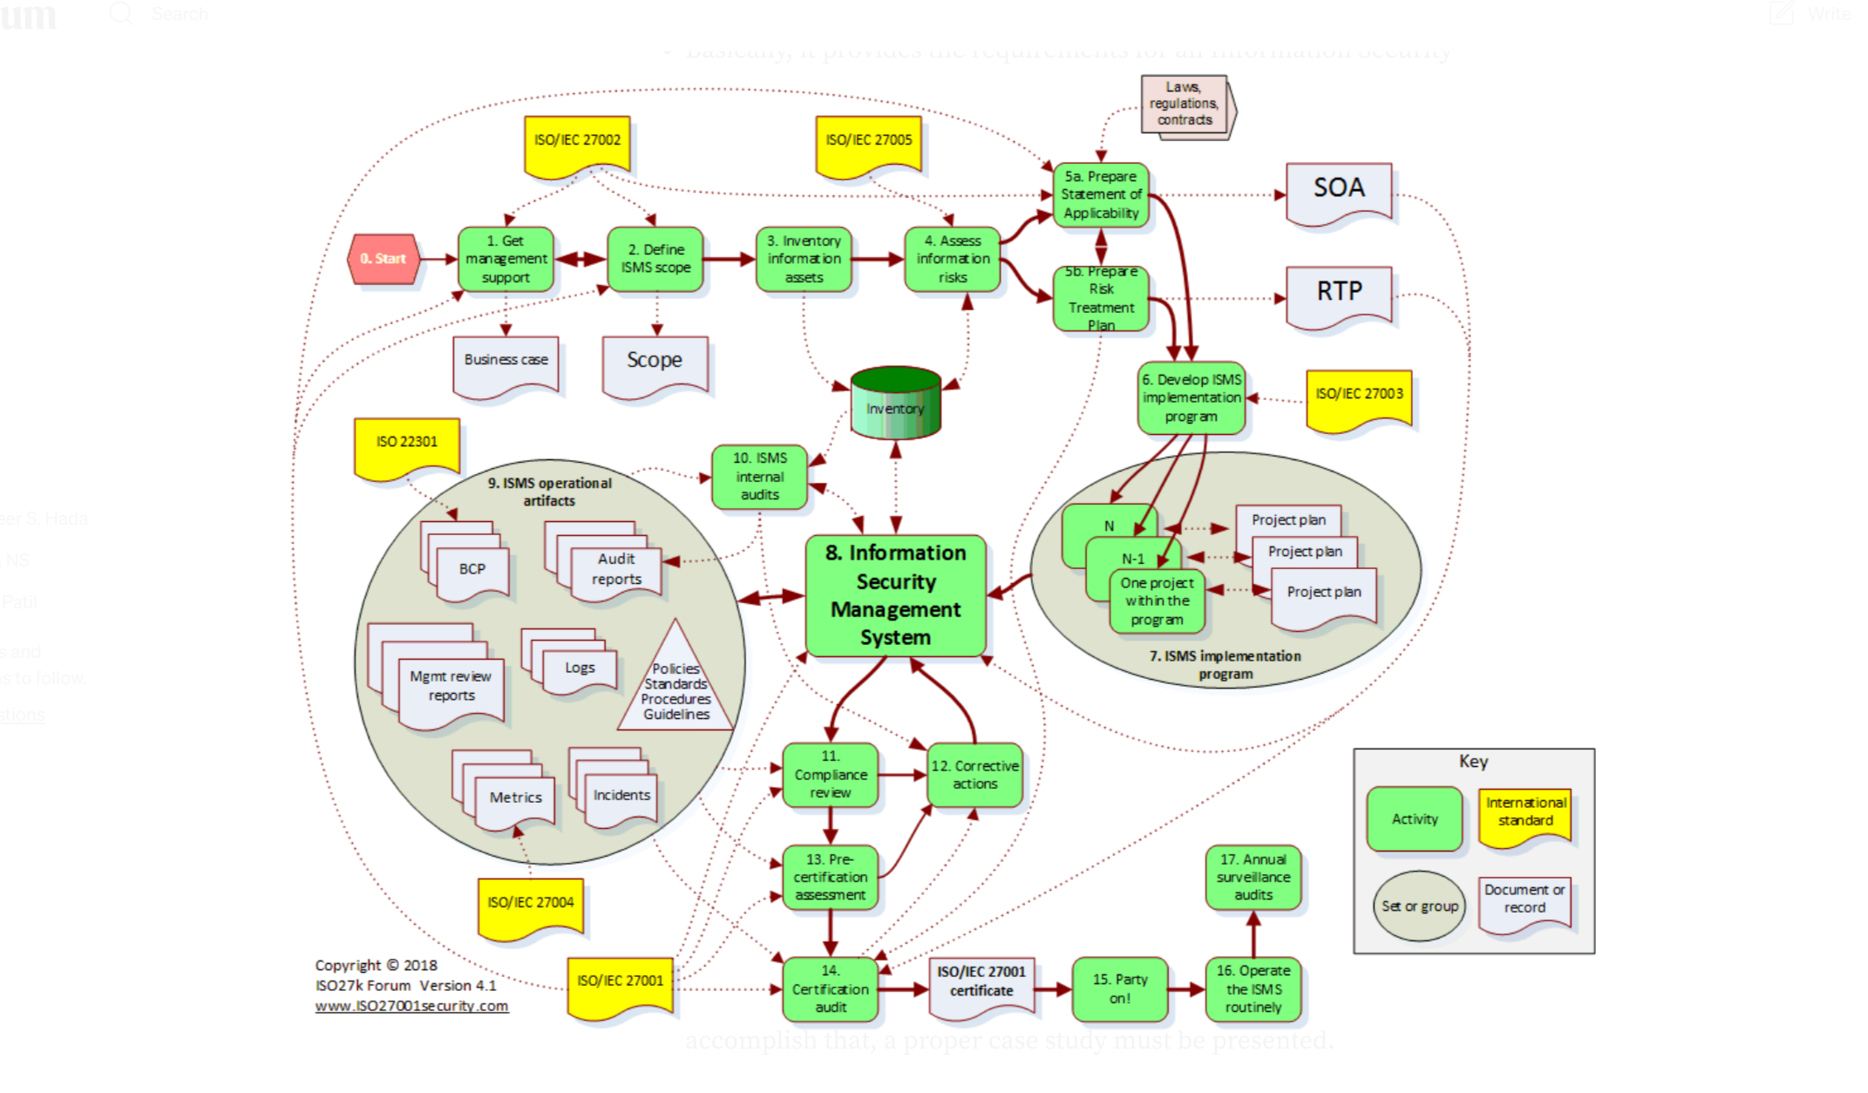
Figure 4: ISO 27001 ISMS Lifecycle Diagram [18]

4. Security, Governance, and Compliance Design for NG
Several assumptions have been made while designing NG's security framework. It is assumed that NG currently don’t have a dedicated security leadership role, so a CISO will be introduced to provide direction. The Risk Management Team, Compliance Officer, and Security Governance Lead are assumed to be absent. NG is assumed to have no dedicated policies for BYOD, cloud access, wireless use, or data handling, and limited documentation. It is also assumed that NG must comply with GDPR, intends to adopt ISO 27001, and currently has no risk register, blueprint, or SLA system in place. One more assumption that they have enough funding to implement this policies requirement.
Before developing the security framework, I have identified major threats and vulnerabilities before working on it so I can get clear about it.

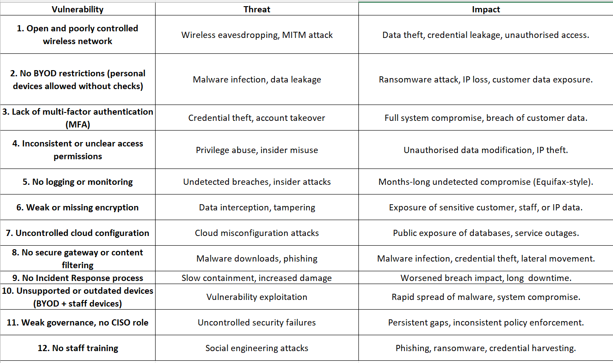
Figure 5: Vulnerability × Threat Table

4.1 Compliance (Laws and Ethics)
Compliance means an organisation follows all the laws, rules, standards, and ethical guidelines for handling information. It makes sure that any data the company collects, stores, or uses is managed safely, legally, and fairly, including protecting people’s privacy, keeping data accurate, and processing information securely. Compliance is important because failing to follow these rules can lead to fines, reputational damage, and loss of customer trust. It also includes acting ethically by being honest about how data is used, avoiding unnecessary data collection, and treating customers fairly.
The first thing I will do is to ensure that the organisation meets the requirements of regulatory laws like GDPR and the Data Protection Act. This law is being made to dictate how you must collect, store, access, and protect personal and business information. NG is currently operating through cloud service, wireless networks, and employee-owned devices without any contract or documentation; this puts the company at risk of breaching these regulations. To address this issue, I have created a certain set of compliance requirements that will bind different user groups with different compliance requirements and also explain how it will enforce it. If any set of users breaches the law, they will be either heavily penalised or held accountable through disciplinary sanctions, contract termination, or legal proceedings, as required under the organisation’s compliance framework

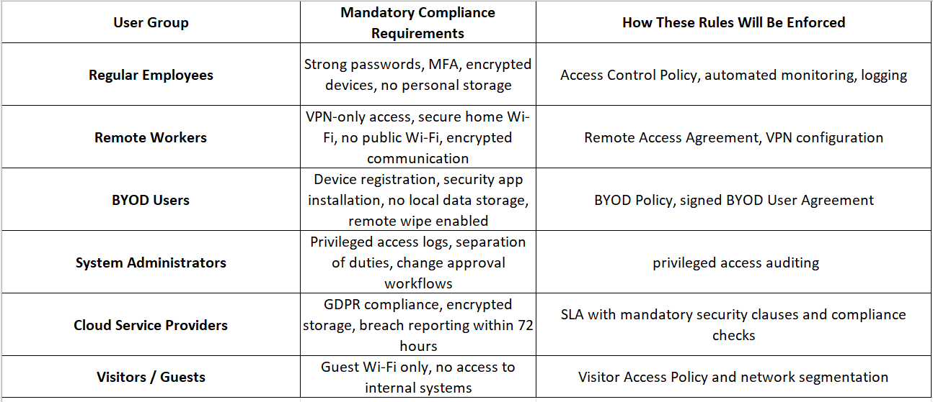
Figure 5: Compliance Rules for Different User Groups at NG

4.2 Governance and Strategic Planning for Security
Governance and strategic security explain how to control and manage the organisation's direction by setting direction and assigning responsibility, and most importantly, its information and systems. Governance defines who is responsible and how securities decisions, policies and controls are managed, whereas strategic planning sets long-term goals, identifies improvements, and decides what actions and resources are needed.
As the maker of this, first, I will create a proper governance structure for the organisation, which is backed by ISO 27001 for security while ITIL for process governance. Right now, the company don’t have any defined security roles, consistent processes, or proper documentation. After doing research on ISO 27001, a clear pattern emerges that tells when management participation is weak and risks are not clearly assessed, then security controls become poorly implemented. To solve this, I will introduce a Chief Security Officer (assuming CIO already exist) who will handle a leadership role and take responsibility for major security decisions. I have talked about the establishment of the Risk Management team and the Compliance Officer in the Risk Management section. Under CISO, there will be a security governance lead who will be handling different sector managers, like IT, Information security, etc, to set priorities, manage resources, and track progress. To strengthen day-to-day control, the governance model will also follow ITIL practices, especially Incident Management (e.g., handling issues like malware infection), Change Management (e.g., reviewing and approving system changes), and Service Documentation (e.g., keeping clear written procedures), so that NG adopts repeatable, standardised processes instead of the inconsistent methods currently used. I will also add a GAP analysis mandatory procedure that needs to be done every 12 months to compare the company’s current situation with ISO 27001 requirements and use the findings to create a security blueprint. This blueprint will contain future security design, stronger BYOD and cloud controls, better documentation, and a step-by-step timeline for implementation. By doing this company will have a well-organised, accountable, and ISO-aligned security programme.

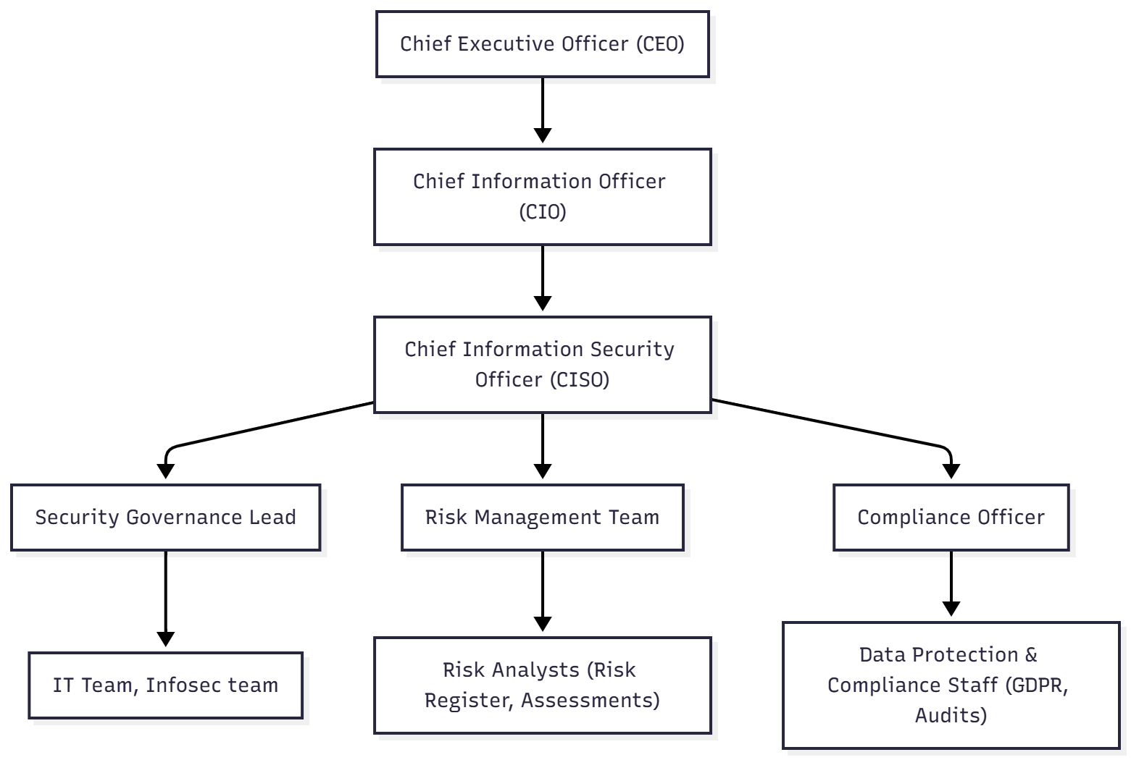
Figure 6: Information Security Governance Structure

4.3 Security Policies
A security policy is a high-level statement that defines an organisation’s rules, responsibilities, and expectations for protecting its information and technology resources. It establishes what behaviour is acceptable, what actions are prohibited, and how systems and data must be handled to maintain confidentiality, integrity, and availability. A strong policy supports legal and organisational requirements, provides clear guidance for all users, and must be written in a way that is clear, enforceable, and capable of standing up to legal or regulatory review. It also acts as the foundation from which more detailed standards, procedures, and guidelines are created.
As a designer of policy, I will firstly introduce a formal security policy that can help in preventing the organisation's main risk and helps prevent incidents like where an employee accidentally downloaded malware from an unsafe link, which can lead to a data breach of customer and company data. These policies will be clearly written and reviewed by the legal team. This policy will clearly set rules for email use, internet browsing, device security, and cloud practices so that everyone follows a safe and consistent method. This policy will be available on the security policy portal in different languages and fonts, even with sound, so that it can serve the NG's diverse staff. Staff have to log in on the portal, where they have to read it and do a mandatory sign-off, supported by automatic reminders and short awareness modules. The policy will be reviewed every 12 months, or sooner if a major incident or technology change occurs, and employees will be able to submit suggestions through the portal, with useful feedback added by the Risk Management Team. Breaching any of the policy will have severe consequences and penalties; by this we ensure that employees or customers have fear about breaching it. Below is the security policy table for it.

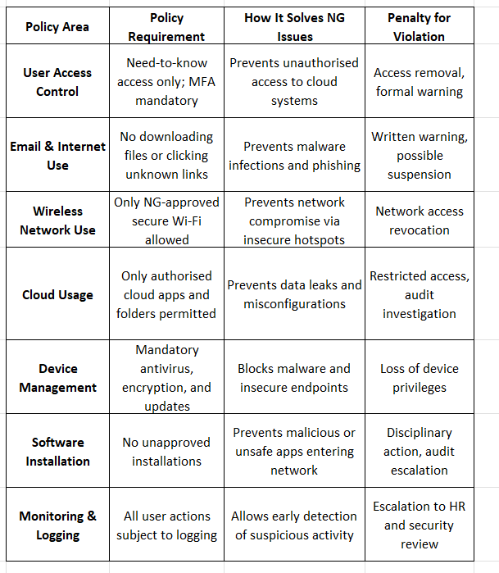
Figure 7: Information Security Policy Table

4.4 Risk Management
Risk management is all about knowing what could go wrong and taking sensible steps to keep the organisation safe. It starts by understanding what important assets need protection and identifying the threats or weaknesses that could put them at risk. The organisation then looks at how likely each risk is and how much damage it could cause. Based on this, it chooses practical controls, such as security tools, clear policies, or regular monitoring, to reduce the risks to a safe level. Good risk management is ongoing, with risks reviewed regularly so the organisation stays protected as new threats or technologies appear.
To increase the NG’s security, I will introduce a clear risk assessment plan which includes identifying risks, analysing them and evaluating how risky they are then and finally choosing the right treatment. It is important because the company uses cloud service, wireless networks and staff-owned devices, which eventually lead to some risks like phishing, misconfigurations, and unauthorised access. I will assign the Risk Management team, which will list all important assets, record related threats and weaknesses in a risk register, and judge each risk by likelihood and impact. I will also assign the compliance team so that they can make sure the Risk Management Team are following the law like GDPR. One of the biggest risks for NG is the use of personal BYOD devices to access cloud platforms without sufficient controls. Under the new process, this risk would be formally entered into the risk register, assessed as high due to weak device security, and assigned to a risk owner. The team would then establish needed controls like Mobile Device Management, Limited access permissions, and BYOD agreements. Later on, this risk will be reviewed to ensure it has been reduced. The figure below shows Risk Register for NG.
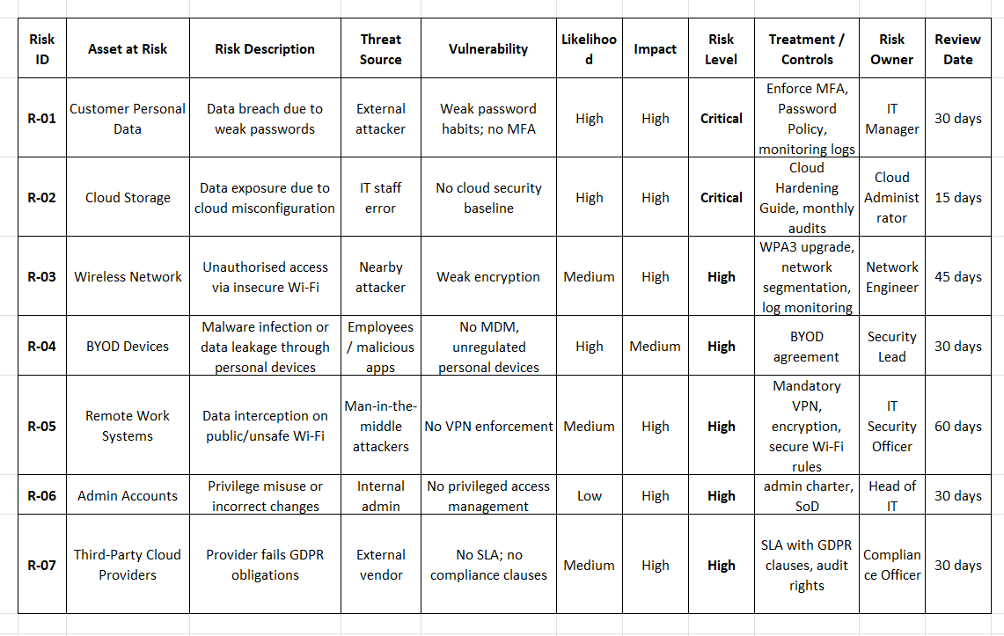
Figure 8: Risk Register for NG

4.5 Protection Mechanisms
Protection mechanisms are the technical controls an organisation whose work is to make systems, data, and networks remain same from unauthorised access or cyberattacks. These include access controls such as identification, authentication, authorisation, and accountability (IAAA), which make sure only approved users can reach sensitive information. Other technical measures like firewalls, intrusion detection and prevention systems, encryption, and secure gateways monitor network traffic, block harmful activity, and protect data both when it is stored and when it is being sent are part of it.
For securing NG’s wireless and cloud-based systems, I will bring a layered set of security controls that can directly address the weaknesses found in the company. As most of NG’s network runs on Wi-Fi and staff also try to access cloud-based services using personal devices, therefore here strong identification, authentication, authorisation and accountability (IAAA) controls will be applied using unique user identities, multi-factor authentication, role-based access control, and detailed logging. These controls will be supported by firewalls, secure gateways, and content-filtering tools to block harmful sites and prevent malware from intruding into the company's private network. This is important because NG is under pressure to allow staff and customers to use their own personal devices, which increases the risk of malware. A hybrid Intrusion Detection and Prevention setup will be established where network-based IDPS will be deployed on cloud and wireless network, whereas Host-Based IDPS will be deployed on individual devices and servers. Encryption will be applied using AES-256 for stored data and TLS for data in transit to protect sensitive information from interception. To decrease BYOD risks, I will introduce device management and limited cloud permissions. Below layered protection diagram show how these controls work together as multiple defensive layers.

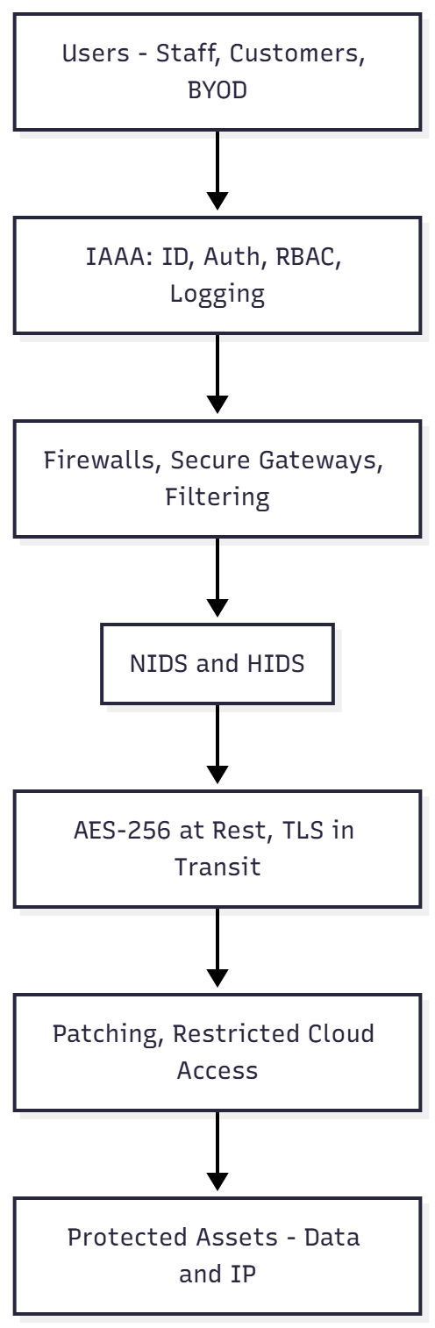
Figure 9: Layered Protection Mechanisms

4.6 Service Level Agreement
A Service Level Agreement (SLA) is a formal contract that defines the expected level of service between an organisation and its internal teams or external providers, including clear metrics such as availability, response times, recovery times, performance thresholds, and responsibilities.
For NG, SLA are very important because it is heavily reliant on cloud services, wireless networks, and third-party systems, but right now, they don’t have a defined expectation or measurable commitment, which can cause issue such as slow response during outages, delays in handling the security incidents, and confusion over who is responsible when cloud settings or data access go wrong. To solve this, I will introduce formal SLAs to all important service-providers that include cloud vendors, managed security services, and internal IT teams. These SLA will contain required uptime levels, expected incident-response times, data-protection duties, and recovery procedures. For example, SLA with a cloud provider will contain minimum uptime guarantees, maximum incident-response times, and clear rules for protecting customer data in line with GDPR. Internally also SLA will also ensure that the IT and security team responds to the alerts, investigates incidents, and manages access requests within agreed time frames. By doing this, NG will benefit in their service performance, stronger accountability and better protection against any service failure.

5. Importance of Constantly Updating Standards
Regularly updating security standards is very important because technology, threats, and legal requirements change quickly. If a company keeps using old controls or outdated processes, it becomes an easy target for new types of attacks. A clear example is the Equifax breach in 2017, where criminals used a known software flaw that had not been patched. Investigations showed that weak procedures and poor oversight stopped Equifax from applying the update in time, allowing attackers to access personal data for months [19]. From this, we can learn what happens when security standards are not kept up to date: old controls cannot protect against modern threats, which can lead to serious financial, legal, and reputational damage. For NG, which uses cloud systems, wireless networks, and BYOD, updating standards regularly is essential to stay compliant, reduce risks, and keep its security framework aligned with today’s fast-changing digital environment.

6. NG Security Implementation Plan

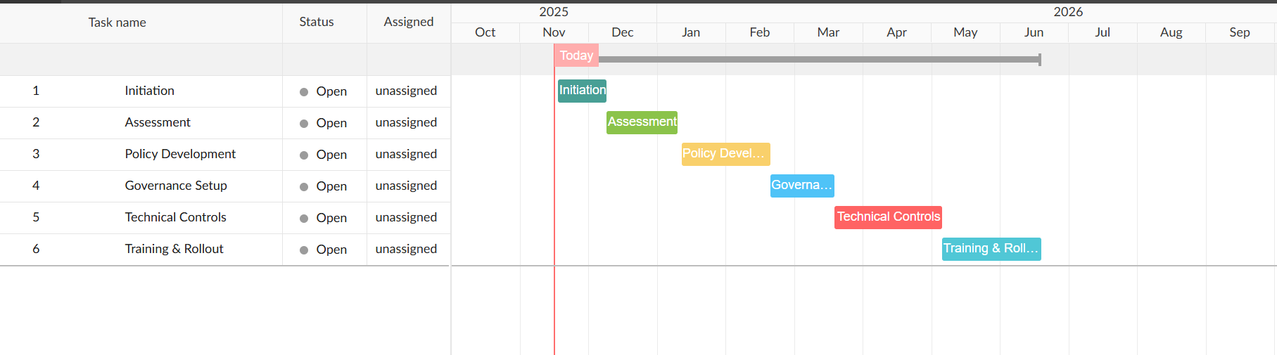
Figure 10: Gantt chart outlining the six-phase schedule for NG’s security improvement plan.
This timeline shows a six-phase plan for improving NG’s security, starting with initiation and assessment in late 2025 and ending with training and rollout in mid-2026 nearly 180 days plan. Each phase builds on the previous one, ensuring a smooth and structured implementation of new policies, governance, and technical controls.

7. Conclusion
In conclusion, NG requires a structured and well-managed security approach to safeguard its wireless network, cloud service, personal device usage, and sensitive data. By using a well-recognised framework such as ISO 27001/ ITIL and putting strong governance, clear policies and regular risk management in place, the company can replace their current inconsistent practices with a more secure and accountable system. Updating standards, improving documents and defining a clear role will help NG stay compliant, lower risks, and respond better to new threats. Overall, this approach gives NG a practical way to build a stronger and more resilient security environment.

References
[1] M. Gërvalla, N. Preniqi, and P. Kopacek, “IT Infrastructure Library (ITIL) framework approach to IT Governance,” IFAC-Pap., vol. 51, no. 30, pp. 181–185, 2018, doi: 10.1016/j.ifacol.2018.11.283.
[2] Y. Al-Ashmoery, H. Haider, A. Haider, N. Nasser, and M. Al-Sarem, “Impact of IT Service Management and ITIL Framework on the Businesses,” in 2021 International Conference of Modern Trends in Information and Communication Technology Industry (MTICTI), Sana’a, Yemen: IEEE, Dec. 2021, pp. 1–5. doi: 10.1109/MTICTI53925.2021.9664763.
[3] K. P. Duffy and B. B. Denison, “Using ITIL to Improve IT Services”.
[4] N. Ahmad and Z. M. Shamsudin, “Systematic Approach to Successful Implementation of ITIL,” Procedia Comput. Sci., vol. 17, pp. 237–244, 2013, doi: 10.1016/j.procs.2013.05.032.
[5] S. S. C. Shang and S.-F. Lin, “Barriers to Implementing ITIL-A Multi-Case Study on the Service-based Industry,” Contemp. Manag. Res., vol. 6, no. 1, May 2010, doi: 10.7903/cmr.1131.
[6] S. Sebaaoui, M. Lamrini, A. Bouayad, and L. E. Abbadi, “Design of an ITIL Implementation Model in a Company”.
[7] N. Zeinolabedin, M. Khademi, and N. Rahbar, “Assessing Efficiency of ITIL Framework to Align Business And IT”.
[8] M. Spremic, Z. Zmirak, and K. Kraljevic, “IT and Business Process Performance Management: Case Study of ITIL Implementation in Finance Service Industry,” in ITI 2008 - 30th International Conference on Information Technology Interfaces, Cavtat, Croatia: IEEE, June 2008, pp. 243–250. doi: 10.1109/ITI.2008.4588415.
[9] Z. Yao and X. Wang, “An ITIL based ITSM practice: A case study of steel manufacturing enterprise,” in 2010 7th International Conference on Service Systems and Service Management, Tokyo, Japan: IEEE, June 2010, pp. 1–5. doi: 10.1109/ICSSSM.2010.5530204.
[10] “ITIL Version 3 Chapters.” Accessed: Nov. 14, 2025. [Online]. Available: https://www.hci-itil.com/ITIL_v3/books/5_service_improvement/service_improvement_ch2.html
[11] G. Culot, G. Nassimbeni, M. Podrecca, and M. Sartor, “The ISO/IEC 27001 information security management standard: literature review and theory-based research agenda,” TQM J., vol. 33, no. 7, pp. 76–105, Dec. 2021, doi: 10.1108/TQM-09-2020-0202.
[12] F. Kitsios, E. Chatzidimitriou, and M. Kamariotou, “The ISO/IEC 27001 Information Security Management Standard: How to Extract Value from Data in the IT Sector,” Sustainability, vol. 15, no. 7, p. 5828, Mar. 2023, doi: 10.3390/su15075828.
[13] Y. Barlette, “410 PUBLICATIONS 3,614 CITATIONS SEE PROFILE”.
[14] M. Malatji, “Management of enterprise cyber security: A review of ISO/IEC 27001:2022,” in 2023 International Conference On Cyber Management And Engineering (CyMaEn), Bangkok, Thailand: IEEE, Jan. 2023, pp. 117–122. doi: 10.1109/CyMaEn57228.2023.10051114.
[15] A. Ojalainen, “ISO 27001 INFORMATION SECURITY MANAGEMENT STANDARD’S IMPLEMENTATION IN SOFTWARE DE- VELOPMENT ENVIRONMENT: A CASE STUDY”.
[16] H. Setiawan and M. D. Fauzi, “Hospital Information System Audit Using The ISO 27001 Standard,” vol. 3, no. 1, 2014.
[17] M. Shohoud, “Study the Effectiveness of ISO 27001 to Mitigate the Cyber Security Threats in the Egyptian Downstream Oil and Gas Industry,” J. Inf. Secur., vol. 14, no. 02, pp. 152–180, 2023, doi: 10.4236/jis.2023.142010.
[18] R. Iddagoda, “Practical Approach to Implementing ISO 27001 — summary,” Medium. Accessed: Nov. 13, 2025. [Online]. Available: https://medium.com/@ruween/practical-approach-to-implementing-iso-27001-summary-452e99cad00d
[19] I. Kabanov and S. E. Madnick, “A Systematic Study of the Control Failures in the Equifax Cybersecurity Incident,” SSRN Electron. J., 2020, doi: 10.2139/ssrn.3957272.

