A Comparison of the Marketing Methods Analysis of two multinational hotel brands: Six Sense and Holiday Inn

Name: Irina Diana Buture
Student no: 2239006
Marketing Essentials BMIH4005
Lecturer’s Name: Dale Clarke
Word count: 1415

Marketing strategies and online presence play a crucial role in the success of hotels in today's highly competitive hospitality industry. This essay aims to compare the marketing strategies and online presence of Six Sense and Holiday Inn, two multinational hotel brands, in order to provide insights into their approaches and tactics. By examining various aspects such as brand identity, target audience, digital marketing efforts, and online customer engagement, this analysis will shed light on the distinct strategies employed by these brands.

Six Senses and Holiday Inn are two prominent hotel brands that cater to different segments of the market. While both brands operate in the hospitality industry, they differ in terms of their target audience, brand positioning, and overall experience.

Six Senses is a luxury hotel brand that is renowned for its focus on wellness, sustainability, and unique experiences. The brand takes pride in providing guests with an opulent and holistic approach to travel. Six Senses properties are often located in breathtaking and secluded locations, offering guests a sense of exclusivity and tranquillity. The brand has a portfolio of properties in stunning destinations across different continents. Some of the notable global locations where Six Senses properties can be found include:

1. Asia: Six Senses has a significant presence in Asia, with properties in countries such as Thailand, Vietnam, Maldives, Cambodia, and China. In Thailand, you can find Six Senses resorts in destinations like Phuket, Koh Yao Noi, and Krabey Island.

2. Europe: Six Senses has expanded its footprint in Europe with properties in countries like Portugal, Spain, Greece, and Austria. For example, you can find Six Senses resorts in locations such as Douro Valley in Portugal and Kaplankaya in Turkey.

3. Middle East: The brand has established a presence in the Middle East with properties in countries like the United Arab Emirates (UAE), Oman, and Jordan. In the UAE, Six Senses operates properties in Dubai, Abu Dhabi, and the stunning Zighy Bay.

4. North America: Six Senses has also ventured into North America, with properties in the Caribbean. For instance, the brand operates resorts in the Dominican Republic and St. Kitts and Nevis.

5. Other Regions: Six Senses has expanded beyond these regions as well, with properties in destinations like Fiji, Seychelles, and the African country of Rwanda.

The brand's commitment to sustainability is reflected in their eco-friendly practices and emphasis on wellness activities such as spa treatments, yoga, and healthy dining options. Six Senses caters to travellers who prioritise luxurious experiences, wellness, and sustainability. Their brand identity revolves around creating a unique and memorable stay that goes beyond traditional luxury accommodations.

On the other hand, Holiday Inn is an established mid-range hotel chain that focuses on comfort, affordability, and accessibility. The brand positions itself as a global mid-scale hotel brand that provides reliable accommodations at an affordable price. Holiday Inn properties are strategically located in urban centres, business districts, and popular tourist destinations, offering convenience to their guests. Some notable global locations where Holiday Inn properties can be found include:

1. North America: Holiday Inn has a strong presence in its home market of the United States, with properties scattered across major cities and popular tourist destinations. The brand also operates hotels in Canada and Mexico.

2. Europe: Holiday Inn has a significant presence in Europe, with properties in countries like the United Kingdom, Germany, France, Spain, Italy, and many others. You can find Holiday Inn hotels in major European cities, airport locations, and tourist hotspots.

3. Asia-Pacific: Holiday Inn has expanded extensively in the Asia-Pacific region, with properties in countries such as China, Japan, India, Australia, and Thailand. Major cities in these countries often feature multiple Holiday Inn hotels catering to both business and leisure travellers.

4. Middle East: The brand has established a presence in the Middle East, with properties in countries such as the UAE, Saudi Arabia, Qatar, and Kuwait. Cities like Dubai and Abu Dhabi boast several Holiday Inn hotels.

5. Other Regions: Holiday Inn has also expanded into other regions, including Africa and South America, with properties in countries like South Africa, Brazil, and Argentina.

Holiday Inn caters to a broader audience, including families, budget-conscious travellers, and business professionals. They strive to create a consistent and reliable experience for their guests, ensuring that they receive value for their money.

Despite their differences, Six Senses and Holiday Inn also share some similarities. Both brands understand the importance of maintaining a strong online presence and engaging with customers through various digital marketing channels. They utilise platforms like Instagram, Facebook, Twitter, and YouTube to showcase their properties, amenities, and special offers. By leveraging these digital platforms, both brands aim to connect with their target audience, build brand awareness, and drive bookings.

Branding plays a pivotal role in marketing, creating distinct identities and differentiation in the market. Six Sense and Holiday Inn employ different branding strategies to appeal to their target audiences. Six Sense positions itself as a high-end brand in the hospitality sector, focusing on creating unique experiences and emphasising wellness and sustainability. On the other hand, Holiday Inn positions itself as a global mid-scale hotel brand, aiming to provide affordable accommodations while emphasising consistency and value for money.

In the digital era, a strong online presence is essential for hotels to connect with their target audience and drive bookings. Six Sense adopts a comprehensive digital marketing approach, utilising platforms like Instagram, Facebook, and Twitter to showcase stunning visuals, highlight unique experiences, and engage with followers. Their content revolves around wellness, sustainability, and breathtaking locations, appealing to the luxury travel market.

Holiday Inn also utilises various digital marketing channels, with a focus on Facebook, Instagram, and Twitter. Their content aims to highlight family-friendly amenities, comfortable accommodations, and special offers to attract leisure and business travellers seeking affordable yet reliable options. Notably, Holiday Inn's Instagram presence tends to focus on a limited demographic, with an emphasis on the US market.

A brief analysis of their Instagram profiles reveals that Six Senses showcases a variety of locations and emphasises wellness and sustainability, indicating a high-end experience, while Holiday Inn has a more localised focus, fostering a sense of community by inviting users to become members. (screenshots added in appendix)

Engaging with customers online is crucial in the hospitality industry. Six Sense prioritises personalised interactions through its website and social media channels, offering user-friendly online booking capabilities and additional services. They encourage customers to share their experiences through user-generated content campaigns and promptly respond to inquiries and feedback, fostering a sense of engagement.

Holiday Inn focuses on providing seamless online experiences, offering an intuitive booking system and special promotions on their website. They leverage positive customer reviews and testimonials to build trust and employ chatbot systems and online customer support to address queries.

Comparing customer reviews between Six Senses and Holiday Inn can provide insights into the experiences and satisfaction levels of guests who have stayed at their respective properties. Six Senses is often highly regarded for its luxurious and unique experiences. The customer reviews of Six Senses properties mostly reflect admiration for the stunning locations, natural surroundings and a great appreciation of the sense of privacy that these locations provide. Many guests praise the wellness facilities and programs offered by Six Senses, including spa treatments, yoga sessions, and wellness retreats. They highlight the high-quality services, the friendly and resourceful staff, the brand's eco-friendly initiatives and much more.

Customer reviews of Holiday Inn properties commonly show that the guests often appreciate the affordable pricing, the strategic locations (ideal for both business and leisure travellers), they also praise the friendly and helpful staff and the family-friendly amenities.

It's important to note that customer reviews vary based on individual experiences and preferences. While these positive aspects are commonly mentioned, there are some negative reviews as well, highlighting areas for improvement.

In summary, Six Senses and Holiday Inn are two hotel brands that operate in different segments of the market. Six Senses caters to luxury and wellness-seeking travellers, offering unique experiences and emphasising sustainability. Holiday Inn, on the other hand, adopts a more mainstream approach, and targets a broader audience looking for affordable and reliable accommodations. The brands differ in brand positioning, target audience, and unique selling points but both brands recognize the significance of a strong online presence and providing convenient online booking experiences to enhance customer satisfaction. By understanding the strategies employed by these brands, hoteliers can gain valuable insights into effective marketing techniques and tailor their own approaches accordingly in the highly competitive hospitality industry.

Appendix and sources:

- Wikipedia: https://www.wikipedia.org/
- Six Senses Official Website: https://www.sixsenses.com/
- Six Senses Brand Story: https://www.sixsenses.com/en/about-us/our-story
- Holiday Inn Official Website: https://www.holidayinn.com/
- Holiday Inn Brand Overview: https://www.ihg.com/holidayinn/content/us/en/about
- Six Senses Instagram: https://www.instagram.com/sixsenseshotelsresortsspas/
- Six Senses Facebook: https://www.facebook.com/SixSensesHotelsResortsSpas/
- Six Senses Twitter: https://twitter.com/sixsenses_
- Holiday Inn Instagram: https://www.instagram.com/holidayinn/
- Holiday Inn Facebook: https://www.facebook.com/holidayinn/
- Holiday Inn Twitter: https://twitter.com/HolidayInn
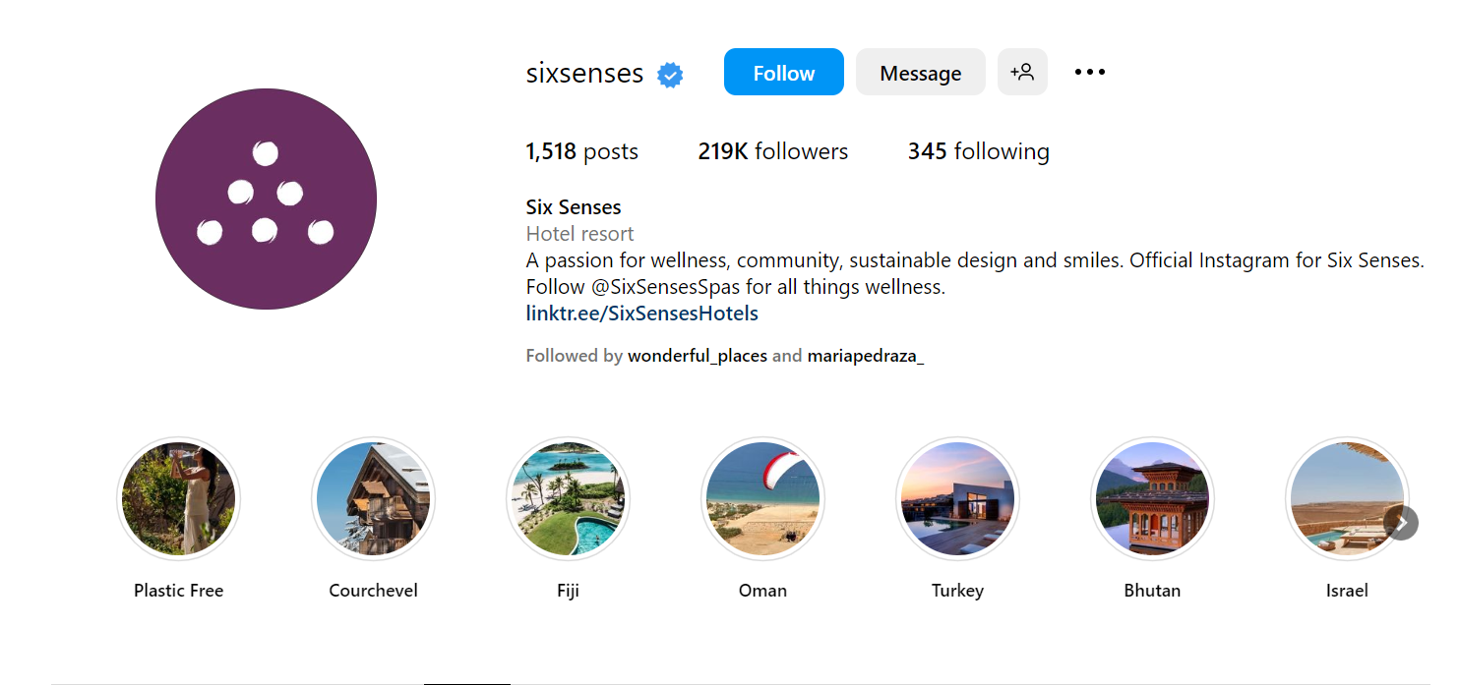
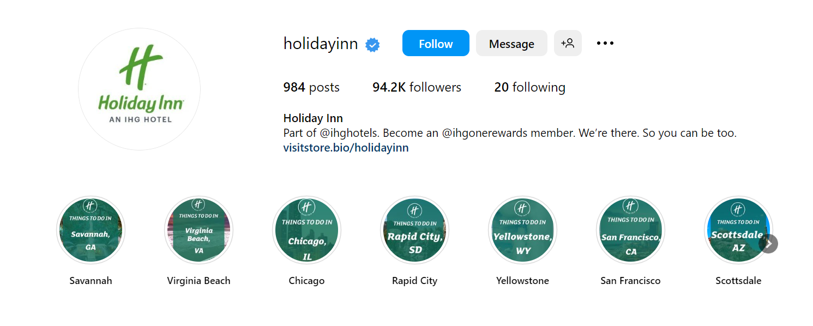

A Comparative Analysis of Six Sense and Holiday Inn: Marketing Strategies

Marketing strategies and online presence are pivotal for success in the highly competitive hospitality industry. This essay aims to compare the marketing strategies and online presence of Six Sense and Holiday Inn, two multinational hotel brands, to provide insights into their approaches and tactics. The analysis will consider various aspects, including brand identity, target audience, digital marketing efforts, and online customer engagement.

Six Senses is a luxury hotel brand renowned for its focus on wellness, sustainability, and unique experiences. In contrast, Holiday Inn is an established mid-range hotel chain that emphasises comfort, affordability, and accessibility. Six Senses caters to travellers who prioritise luxurious experiences, sustainability, and wellbeing. On the other hand, Holiday Inn targets a broader audience, including families, budget-conscious travellers, and business professionals, offering comfortable and affordable accommodations without compromising quality.

Branding is a crucial element of marketing, creating distinct identities and differentiation in the market. Six Sense and Holiday Inn employ different branding strategies to appeal to their target audiences. Six Sense positions itself as a high-end brand in the hospitality sector, focusing on creating unique experiences and emphasising wellness and sustainability. In contrast, Holiday Inn positions itself as a global mid-scale hotel brand, aiming to provide affordable accommodations while emphasising consistency, reliability, and value for money.

In the digital era, a strong online presence is essential for hotels to connect with their target audience and drive bookings. Six Sense adopts a comprehensive digital marketing approach, utilising platforms like Instagram, Facebook, and Twitter to showcase stunning visuals, highlight unique experiences, and engage with followers. Their content revolves around wellness, sustainability, and breathtaking locations, appealing to the luxury travel market. Holiday Inn also utilises various digital marketing channels, with a focus on Facebook, Instagram, and Twitter. Their content aims to highlight family-friendly amenities, comfortable accommodations, and special offers to attract leisure and business travellers seeking affordable yet reliable options. Notably, Holiday Inn's Instagram presence tends to focus on a limited demographic, with an emphasis on the US market.

A brief analysis of their Instagram profiles reveals that Six Senses showcases a variety of locations and emphasises wellness and sustainability, indicating a high-end experience, while Holiday Inn has a more localised focus, fostering a sense of community by inviting users to become members.

Engaging with customers online is crucial in the hospitality industry. Six Sense prioritises personalised interactions through its website and social media channels, offering user-friendly online booking capabilities and additional services. They encourage customers to share their experiences through user-generated content campaigns and promptly respond to inquiries and feedback, fostering a sense of engagement. Holiday Inn focuses on providing seamless online experiences, offering an intuitive booking system and special promotions on their website. They leverage positive customer reviews and testimonials to build trust and employ chatbot systems and online customer support to address queries.

In conclusion, while the digital channels mix used by both brands may seem similar, Six Sense and Holiday Inn have distinct marketing strategies and online presence to attract their respective target audiences. Six Senses targets luxury and wellness-seeking travellers, emphasising personalised communication and sustainability. In contrast, Holiday Inn adopts a more mainstream approach, targeting a broader audience looking for comfortable and affordable accommodations. The brands differ in brand positioning, target audience, marketing channels, and unique selling points.

Appendix and sources:

- Wikipedia: https://www.wikipedia.org/
- Six Senses Official Website: https://www.sixsenses.com/
- Six Senses Brand Story: https://www.sixsenses.com/en/about-us/our-story
- Holiday Inn Official Website: https://www.holidayinn.com/
- Holiday Inn Brand Overview: https://www.ihg.com/holidayinn/content/us/en/about
- Six Senses Instagram: https://www.instagram.com/sixsenseshotelsresortsspas/
- Six Senses Facebook: https://www.facebook.com/SixSensesHotelsResortsSpas/
- Six Senses Twitter: https://twitter.com/sixsenses_
- Holiday Inn Instagram: https://www.instagram.com/holidayinn/
- Holiday Inn Facebook: https://www.facebook.com/holidayinn/
- Holiday Inn Twitter: https://twitter.com/HolidayInn

