



Managing enterprise in the 21st Century
BMSW4006

Group members: Bode Williams (1913013),
Diana B. Fernandes (1912499) & Shahed Ahmed-noor (1916535)
Submitted by Diana B. Fernandes (1912499) – Group leader
Lecturer name: Ze Zook
Date: 3rd September 2020
Word count: 6226

Business plan for Green Greatness

(Section completed by student 1912499)

Executive summary

Green greatness is a vegan and vegetarian take away restaurant located in Bricks Lane, central London. At green greatness customers will be provided with a variety of options of food, a differentiated service and many facilities related to effectiveness and readiness of their orders. The restaurant will be providing a versatile menu with many options of creative and delicious vegetarian and vegan meals and also an adapted version of dishes according to customers order description. In addition to this, the restaurant will bring into practice the preparation of lunch boxes of healthy meals for school which can be picked in the morning before the children attend their classes. in order to bring creativity. Our services will be operating through Uber eats and the personal website of the restaurant. This way, costumers will be able to make orders from their locations by simply accessing Uber eats or the original website from their mobile devices. This business takes into consideration the dietary need of the customers and their busy routines that can drive them to unhealthy habits.

The business objectives in short term (period of 6-12 months) will be focusing arranging premises, adapting to the market in order to understand more about the potential customers and existing competitors. This period will also focus on the maximization of customers satisfaction in order to become more attractive and increase our clientele and 10% of annual revenue. The medium-term objectives of business (period of 2-3 years) will be focused on hiring employees in order to cope with the increase in orders, the achievement of 20% increase in annual revenue and the implementation of more technology to improve efficiency of the service. As long-term objectives the business will be focusing of expanding to more areas of the UK. Subsequently there will be another increase in full time staff, implementation of more technology and a development and diversification of services. as a consequence of the investment and rise of customers one of the long-term objectives of the business is the achievement of a significant increase of 30% of annual turnover.
The potential competitors for this business are Abe and Cole and All green. Both competitors are experienced in the market and pursue a significant number of loyal customers. Both businesses are targeting vegetarian and vegan customers. However, what differentiates Green greatness from those competitors are the innovative ideas existing within the menu and dish elaboration which are not included in their restaurants. An example are the bamboo utensils to reduce the use of plastic and lunch boxes. These innovative ideas brought to this business will attract clients as it will fully address their needs as it will contribute to the main cause of the business which is cruelty free food and a bigger awareness of ecosystem protection.

Analysing the demographic target, the restaurant is suitable for all ages, genders and social classes because our food price margins fit into any budget. As for the psychographic analysis of the target customers, there are the vegan and vegetarian. However, there is also the other potential customers which are transitioning from to the meat-free lifestyle due to health issues, the ones who have awareness of animal cruelty and many other reasons related to change of lifestyle. These customers are potential targets for this business as they will seek for the benefits to their health that the restaurant will be providing through enjoyable food.

In a period of 5 years this business is expected to have generated more than 100000 pounds and have reached 10000 customers. It is expected that the annual turnover presents a growth of 60% in annual revenue.

As for the funding requirements the business will require the loan of 10000 pounds.
The investment granted will be used to cover expenditures related to premise arrangement, supplies, equipment, and others costs that will l be accounted in the cashflow and sheet balance. In addition to this, the investor supporting the funding will be pursuing the value of 25% share hold of the business.

Table of Contents
Introduction 5
Business history 6
Business Description 6
Business objectives 7
Business structure 9
Staff employment 10
Team roles 11
Suppliers 12
Legality 14
Insurance for business operation 15
Estimated potential customer 16
Customer description 17
The customers’ need that our products and services address 17
Pricing 17
SWOT Analysis 21
Online Advertising 24
Technology Centegra plus 25
Technology vision soft 26
Technology Bizimply 26
Social responsibility of the business 26
Finances 27
References 30
Appendix 32

Introduction

There is nothing new about the fact that that nowadays everything becomes a Trend. Things that in previous years were not popular ended up becoming centres of attention and major revolutions. One of the biggest changes that has been happening on our planet is related to the number of people that have become vegetarian and vegan on the world over the years. A research conducted by the vegan society in 2018 has found out that there are more than half a million vegans in the UK. (BBC News, 2020)

The reason behind the creation of this business plan does not only centre in the gathering of a loan. One of the main reasons for the creation of this business, is to raise awareness of others about how a healthy lifestyle can be adopted by anyone by stopping the consumption of meat. Throughout the business plan, the different aspects and requirements for opening the restaurant will be covered. The focus will go from the history of business; the description of the service provided; objectives, the market analysis carried out, legal aspects, technology and financial plan.

Business history

Green Greatness was an idea thought by us a few years ago when the vegan \ vegetarian world still did not have as much repercussions as today. However, the idea in our business has always had a long-term vision with a view to a prosperous future and prone to the practice of cleaner eating habits by good part of the population in the world.

Despite our idea having arisen in times when the practice of meat free meals was not a trend, we always had the futuristic mindset that this movement would develop and consequently become more popular. Along the years we have been studying the market and paying special attention to statistics relating to meat free lifestyle.

The biggest motivation for the creation of our business was the awareness that we obtained through assisted documentaries about the meat industry that performs several cruelties to animals. In addition to this, the exaggerated manipulation and stimulation to product in mass to meet the needs of the population damages not only the environment but also the health of those who consume these meats.

Business Description

Green Greatness is a takeaway/delivery restaurant of vegan/vegetarian meals, drinks and deserts. We are located in central London precisely in Bricks Lane. Our business is structured as LLC (limited liability company) and operates under the entrepreneurs Bode Brown, Diana Fernandes and Shahed Ahmed.

This business is based in takeaway and delivery service of vegan and vegetarian food. Green Greatness offers a wide range of cruelty free (free from animals) foods and drinks confectioned with natural and healthy ingredients. The options of meals are endless as the customers have the option the choose the best combination according to their taste and desire. Moreover, in order to bring more creativity for the customers, our restaurant provides a choice of utensils. When ordering, the customers have the option of receiving their order in plastic utensils or they can receive their orders in naturally made bamboo utensils for a small additional charge.

Our service is based truly and purely in the satisfaction of the needs of our customers and that is the reason why we pursue a high versatility of options. We take into account the daily dietary needs of our consumers who face a busy routine and do not have time to prepare their meals. This service brings to customers the facility to have their healthy meals throughout the day, whether they are at work, home or school.

Our target customers are the vegans and vegetarians of all ages and social classes but also in the group of people who are transitioning from the consumption of meat to the cruelty free lifestyle. On the other hand, there is also the group of people who are changing their lifestyle because of health purposes. According to Lora Jones, a BBC News business reporter “A total of 49% of those interested in cutting down on their meat consumption said they would do so for health reasons, according to a survey of more than 1,000 adults in Great Britain by Mintel.”.

Our goal is to work intelligently to bring maximum satisfaction to the needs of our customers so that they become loyal to our work and recommend to others as well. We have decided to be part of this elite that aims to improve the quality of life on our planet and live with the conscience of a clean business that does not sacrifice animals to earn profits.

Business objectives

As a future successful business, our restaurant has clear and direct objectives that concern the attraction of more and more customers, profit gain and also our largest cause that advocates clean food and a sustainable environment for our planet without sacrificing animals.

Short term objectives

The short-term goal for our business focuses on a period of 6 to 12 months. this period represents the period of adaptation of our business to the market, as well as the acquisition of new customers through our advertisements. during this time, we also intend to focus significantly on the criticisms received by customers in order to improve our service.

- Arrange a permanent premise with costs under 600£ a week that could fit approximately five to six members of staff by November 2020.

- The generation of three hundred new customers by March 2021.

- The increase of four hundred to five hundred new customers by September 2021.

- A rise of 10% in annual revenue by December 2021.

Medium term objectives

In the later 2 to 3 years of the business will represent the period of development of our business and therefore there will be a focus on hiring more staff in order to support the increase of orders. During this period, the business will already have the capacity to pay for the new labour costs which will consequently result in a better and efficient service for the customers and the company.

- Hiring a new full-time staff by February 2021.

- The achievement of 20% increase in our annual revenue by September 2022.

- The acquisition and investment in new technologies in order to optimize the service by January 2023.

Long term objectives

On the next 3 to 5 years we aim to invest in the expansion of the business. During this time the focus of our business will be on expanding into other parts of the UK. with this we will increase our clientele, and the resulting profits. Later, the business will open the way for other investments that diversify the service and bring greater innovation.

- By August 2023, the expansion of the business, reaching other parts of the UK like Essex, Manchester and Birmingham

- A significant increase in full-time staff members by September 2024

- The increase on annual turnover by 30% by September 2025.

- Implementation of new modern technologies to optimise the efficiency and delivery of services by January 2026.
- Development of new functionalities and diversification of services by June 2026

Business structure

As represented on the diagram above, this business is divided in different categories and function roles. On the top of the hierarchy is represented the CEOs Diana B. Fernandes, Bode Williams and Shahed Ahmed which are the owners of the business and creators of the business idea.

Staff employment

Restaurant businesses usually involve a team of employees whose tasks are delegated to each other according to their skills and qualifications. Therefore, we decided to employ a team of five people to join the owners of the company in order to make the business work. However, even though people are being employed, the CEOs of the company will also participate in all stages of the business, from production to deliver to our customers.

Team roles

Regarding the other subdivisions of the diagram, the responsible for orders management and online customer service will be the CEO Shahed Ahmed as he pursues the experience in dealing with different costumers. Besides that, Shahed Ahmed will also be controlling the flow in orders and tracking the progress of growth of customers and the progress of orders each day.

The marketing direction and product advertisement will be on account of one of the staff employed labelled as staff member 1 who is qualified and has experience to fit in this role.
Note: The owners of the company will also have a large participation in the promotion of the restaurant.

The legality/human resources of the business are under the responsibility of a staff member labelled as staff member 2 who is also qualified and experienced in law and human resources.

The production management is on account of one of the CEOs Diana B. Fernandes. As one of the owners and creator of the business, pursues a strong interest in bringing the creativity and innovation regarding the food making.

Regarding kitchen diligences two of the new staff employed labelled as chef 1 and chef 2 are going to be responsible for preparing and packing orders. These two employees will be working together under the management of the CEO Diana B. Fernandes

The finances of the business will be on account of the financial advisor labelled as staff member 3 will be responsible for the administration and application of the capital on investments for the restaurant.

The innovation and technological development will also be managed by one of the CEOs Bode Williams as he is highly inclined towards innovation and technological development. This role will be of extreme importance as it will allow the maximization of efficiency in the business.

Important note: As the business grows, more workforce will be implemented in order to cope with the accomplishment of tasks.

Suppliers

Supplier / Relationship 1
Organisation  Breaks Food Service  Breaks is a company responsible for providing green groceries that works 365 days a year and delivers the best quality and fresh groceries of green foods.  The organisation has been producing for more than 50 years and it is considered as the number one greengrocer in the UK. (Breaks, 2020)  It is a safe supplier company with recognition in the British Market and an important an ally for food supply of many restaurants in the country. | Relationship status  Supply management  The relationship between Green Greatness and Breaks Food Service is a supply management relation. This relation is based in the identification, acquisition, and management of resources that are essential to the activities of the business. (Kenton, 2020)
Service provided  - Supply of provisions for the preparation of meals  - Guarantee of on time delivery of supplies  - Tracking of product quality and technical standards before from point of production to the restaurant kitchen.  - Assistance in addressing challenges and exploitation of advantages related to consumer profile, location and resources.  - Nutritionist approach on products condition guaranteeing safety for consumers. | Key terms of relation  Breaks Food Service as one of the key suppliers of groceries for Green Greatness restaurant will be providing the business with goods, assistance and other resources necessary for the business to progress.  The fundamental objective of this relation is the cost control; the adequate distribution and an effective gathering of relevant information for the business’s growth purpose.

Supplier / Relationship 2
Organisation  Sysco  Known globally as one of the largest distributors and seller of food and non-food products Sysco provides its services for restaurants and other institutions like educational facilities and healthcare. The company also establishes relations with other customers around the world and serves more than 650,000 customer locations. (Sysco, 2020)  Sysco is a company committed to the satisfaction of their customers and represents one of the safest supplier company with great recognition in the UK and worldwide (Sysco, 2020). | Relationship status  Supply chain management  The relationship existing between Green Greatness and Sysco is supply chain management relation. This relation is based in by keeping regulation of internal inventories, production, distribution, sales, and the inventories of company vendors. (Hayes, 2020)
Service provided  - Supply of provisions for the preparation of meals  - Assistance and analysis of menu creation  - Marketing support  - Assistance in culinary and recipe creation  - Assistance and guide in matters of standards, cleaning, conservation and food preparation. | Key terms of relation  Sysco will be assisting Green Greatness the supply of goods and services the company will also be supporting the restaurant in the management of raw materials and other guides to fulfil the restaurant’s goals in order to reach maximum effectiveness of the service provided to customers. Thus, the company Sysco will also be supporting the business in gaining competitive advantages in the marketplace.

Legality

In order to create this business, laws and regulations were taken in consideration as important keys to keep the business running under all the legal conditions. Our business will be registered 28 days before operating.

Food hygiene scheme
As the business is related to food making, one of the regulations being taken in consideration is the Food Hygiene Rating Scheme. This scheme aims to help the business in questions related to hygiene standards that need to be maintained in order to keep within the proper hygiene standards stipulated by legal food industry supervisory organizations. (Food Standards Agency, 2020)

Health and safety
The business will be operating with five or more people; therefore, the restaurant will be following the Health and Safety Executive (HSE) guide developed to assist small and medium business in keeping up with security standards. The objective of the HSE is to guarantee the safety of all staff and at the same time keep the restaurant within the health and safety laws and regulations. (Food Standards Agency,2020)

Fire safety
As an operating food business, the fire and safety regulation scheme were also taken in consideration for this business. In order to adapt the premises and acquire safety advice it is important to get advice from local fire authorities. (Food Standards Agency, 2020). A fire risk assessment will be carried out in the premise in order to analyse the place and take all precautions to protect all staff members and keep the team safe and within the law.

Insurance for business operation

In order to keep this restaurant working within all laws and regulations, business insurances will be implemented.

Business insurances will assist in protection to the owners of the business against inconveniences susceptible to happen in daily basis such as stock damage; premise damage; stock supply chain breakdown and other questions related to employees.

Liability insurance
The liability insurance is a backup up of costs for business owners in cases of compensations claims due to negligence susceptible of happening in the business. The compensation claims could come from employees, customers, shareholders or clients. The liability insurance also covers expenditures related to loss or damage of property and personal injuries that may occur. (Association of British Insurers, 2020)

Employer’s liability insurance: This insurance is responsible for covering expenditures of compensation for employees in case of injuries or illness during wok.

Commercial property insurance: This insurance will be implemented with the objective to cover expenditures related to premise or stock loss or damage and equipment substitution if needed.

Cyber insurance: As the business will be operating though a digital platform and will make use of technology to store data, a cyber insurance will be implemented with the aim to cover the costs of possible losses or damage of data from IT system.

(Section completed by student 1913013)

Estimated potential customer

The percentage of the people that patronise vegan stores is on the increase because of the increase in awareness and by nature majority of human being are vegetarian. The company meticulously considered the following to get the average numbers of customers for patronage, high volume passage area for example city centre, major train stations, high street, highly populated residential areas and commercial areas. The company also analysed the competitors, identify the customers, what do they consider to be important in our product, the language they speak, current level of information about the product. Base on the above analysis the company potentially expect about 750 customers to patronise various types of our products.
According to the secondary research “sales of meat-free are expected to rise after a dip”.

Fig.1 – Vegan population growth along the years

According to BBC business news “interest in vegetarian and vegan products shows no sign of slowing down, as retail sales are expected to increase to £658m by 2021”.

Our potential customers can be described as people who are well informed about veganism in terms of the benefits and importance of been a vegan.

Customer description

All customers are important to our business plan, but the fact is some are more important than others, and only few are most important of all. Our primary customers are the ones who understand the products and services and satisfy with the way we patiently listen to and respond to their needs. These are well informed customers and the people who their desire aligns with our resolution offer rather than business script, habit or policy. These set of people do one-on-one advert to the potential customers unknowingly, but this happen as a result of the wealth of information and knowledge they have about the products and services. Secondly, our other customers can be described as occasional customers. These are people who patronise the product due to the information and advert they get online but not necessarily know much about it. Thirdly, these are customers that buy on basis of satisfying their taste and getting to know what the product is all about. Lastly, people who want to take the product for medical reason as an alternative to drugs.

The customers’ need that our products and services address

- Environmentally, it helps to avoid climate change
- It keeps old people metabolism like they are young.
- It helps keep normal body size (weight lost).
- Vegan diet help protect the brain.
- It can help reduce diabetic in the body system.
- Vegan could help reduce premature mortality.
- It will reduce the money spent on health-related issues.
- Setting up this business will help government reduce unemployment increase the employment rate in the United Kingdom.

Pricing
Price is the amount that customer will pay for the product and services.
First and foremost, the company would like to consider the cost, labour, profit and competitors’ price.
Cost comprises of overhead that is rent, utility bill, maintenance and tax.
Materials these are variable expense meaning increase or decrease corresponding in the numbers of products the company offer.
Labour cost is mandatory for all employer to pay their employee according to constitutional minimum wage.
For our propose business plan we chose to use the formula below for the pricing (two mark-up steps).
Mark-up is usually 2 upward
Materials + labour = cost
0.49 + 8.21 = £8.70
First mark-up formula is cost + mark-up = wholesales price
Then, £8.70 x 2 = £17.40
Second mark-up formula is wholesales + mark-up = retail price
£17.40 x 2 = £34.80
Mark-up is the profit one makes on each piece.
Overhead cost is money spent on maintenance, bills, taxes, new materials, tools, supplies and legal service.
Overhead cost – profit = income.
Income is what is left after everything (take home).

Market, Region, Industry and Competitor conducted research (Questionnaires)
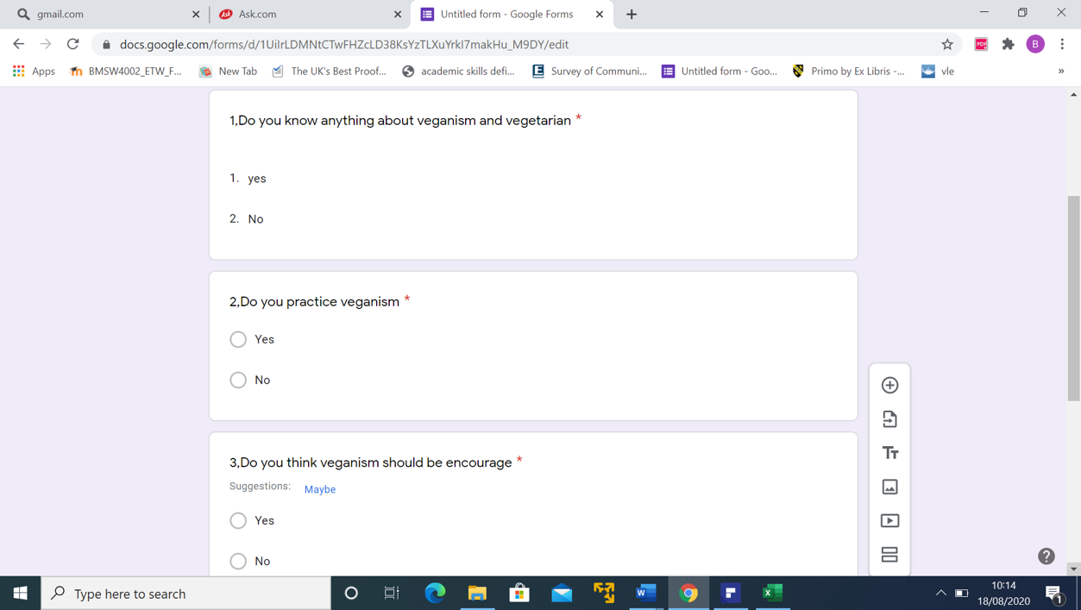

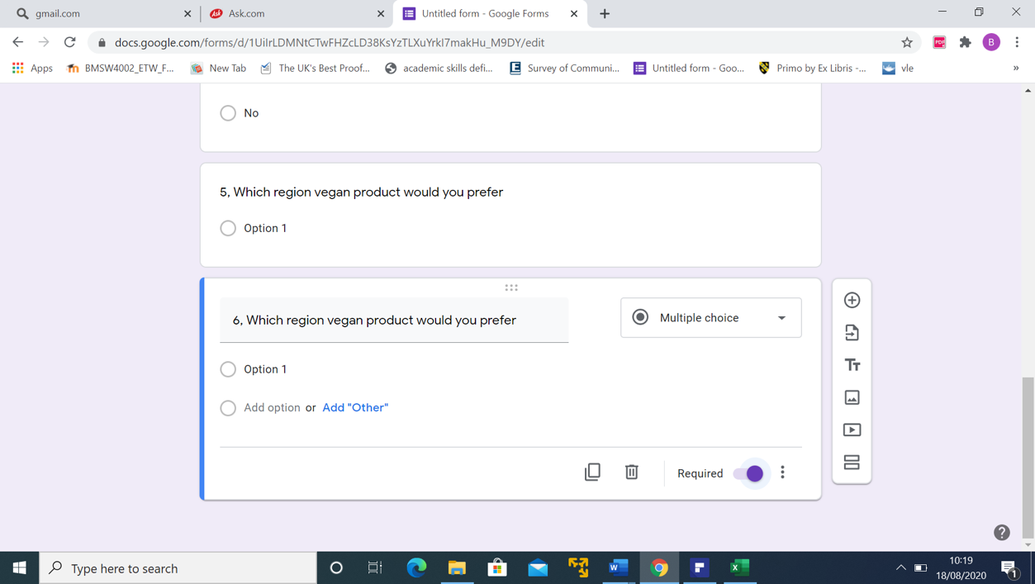

Response 1, 2, 3 and 4
Questions | Yes | No
Question 1 | 243 | 57
Question 2 | 193 | 107
Question 3 | 201 | 39
Question  4 | 267

Graphical analysis our market research

Question 5 response detail

Question | UK | China | Japan
Question 5 | 76 | 72 | 128

Response 6 details

Question | All green | Abel & Cole
Question 6 | 128 | 119

SWOT Analysis

(All green)
Strength | Weakness
Packaging of their product is one of the things they do to attract the customers to patronise the product. This are done in such a way that it will more new customers and not only attract the existing customers alone.  Recycling the packs is one of the priorities in their company. Most of the customers commended this aspect of their services because It take good care of the environment. | They do not offer price reduction for their customers at any time.  They do not give priority to old, pregnant, physically challenged and sick customers in the queue.
Opportunity | Threat
Varieties of taste on a product is an opportunity if considered in our plan.  Good customer service is another opportunity because products like this need good attention to attract more customers. | They are efficient online when order for their product they deliver on time at customers’ doorstep.

(Abel & Cole)
Strength | Weakness
They allow long week shopping in advance. This means the customer can order for each week in advance.  They also allow cancellation any time before they supply the customer. They are flexible in order and supply policy of their company.  They have good commercial online advert and good articles about vegan diet. | Their product does not meet the taste of the customers. Meaning, the variety of products they have is not finger licking products.  No price reduction for any of their product. Student, little children and old people are not considered their pricing policy.
Opportunity | Threat
Making provision for price reduction for little children and old people will be an opportunity for our business to grow.  Employing experience chef who understand the customers’ taste will also be an opportunity to keep our customers order to take the business to the next level. | Cancellation of order at any time and long week order.  Their quick response to delivery is incomparable.  Their articles and online advert give them edge in vegan industry.

(Green Greatness)
Strength | Weakness
Good customer service both online and in our outlet.  Catching and standard advert for the customers.  Favourable pricing policy for the children, old and new customers.  Active social media communication with the customers.  Educative articles on veganism. | Lack of enough capital to do multimedia print adverts.  Lack of capital to roll out multiple outlets.
Opportunity | Threat
We would consider price reduction policy for children and old customers.  We would give priority to pregnant women, physically challenged and old people in our services.  We would use the social media to interact with customer in order to get feedback.  We would consider vegan products from other part world to satisfy other nationalities in UK. | Multiple outlet of other competitors in the industry.  High number of customer base of other competitors.  The rate at which another competitor does advert.

The idea of the SWOT analysis is to use the organization’s strengths to take advantage of the opportunities in the industry, and to also convert internal weaknesses to strengths and external threats into opportunities.
From the analysis above, we see that the business has a decent strength level to take advantage of the opportunities in the market. What we have is a growing market, and we believe that with the capabilities and experience of the promoters alongside its access to financial and technical resources, we are well positioned to exploit this fast-growing market. The business will however need to deploy superior marketing and sales efforts to overcome too build some market awareness.
The outcome of the SWOT analysis also indicates that Green Greatness would have to play on cost as a means of achieving competitive advantage. This should be done through overhaul of the entire value-chain of the business without compromising quality of its product offerings. In addition, the result could be combined with excellent customer service and on-time after sales service that guarantees order fulfilment for customers.

Online Advertising

We will aggressively use social media platforms (Twitter, Facebook, LinkedIn, Instagram, and Google), online advertising platforms (Google, Facebook, Bing, Yahoo! etc.) to promote Green Greatness

Using these platforms we can drive:
- Brand awareness and engagement
- Lead generation or customer acquisition
- Share a mix of relevant links, blog posts, and engaging content
- Promote upcoming events
- Engage with influencers
The ultimate goal is to build and ensure customers visit the platform and place orders.

Leaflets–We will design and distribute leaflets promoting Green Greatness as the one-stop online store where customers can attach our flyers with 15% Off Your product purchase and distribute within key cities in the UK. We would make very colourful and captivating coupons and it will be distributed at strategic places such as
- Homes
- Schools
- Hospitals
- Small business such as barbing and hair saloons
- Companies
- Churches
- Shopping malls
- Newspaper stands

We will place the discount coupon across several business outlets within our primary market for potential customers to pick. We hope to run this discount service for about three months in other to build a solid customer base. We will regularly send SMS to customers living within London promoting not only the physical store location but encouraging them to shop online on our online store.
(Section completed by student 1916535)
In My part of the business plan I will be discussing the technology we will be using we will be using numerous technologies. I will be also discussing our social responsibility and what we plan to give back to the community and finally how much we will be asking for and how we plan to invest in the money.

Technology Centegra plus

Centegra Plus is a service best used in the hospitality industry with an advanced and real time system it helps control all elements of our bossiness. The benefits of using Centegra Plus. The benefits are amazing you can control all your stock adjust what you need to also stock takes and wastage which is very important as this all a cost and with Centegra it will automatically adjust your stock when we automatically waste it off at the end of the day it is also very easy to use when it comes to stock ordering with Centegra it will take no more than 10 minutes to stock order it all done by email so our delivery companies will receive it straight away. One of the main reasons we have decided to use this company is because recently Centegra have signed up with uber eats and just eats so it will be perfect to use specially knowing we will be using both uber eats and just eat to provide our services online to maximize are sales.

Technology vision soft

Vision Soft is a very advanced Epos system and is specially created for Hospitality industry for £550 one off payment you can have two 16inch touch screen also cash up drawer two till printers and also you get to have app for android and iOS this also can merge into our Centegra plus software we will using. The Vision soft epos system is also very good on terms as it will also be very compatible with our own online web ordering. Me and my whole team will have our own login code so we can pay close attention who is using the till and when and we will ask our customers to give feedback on the service they have received on the day as all my teams name will be printed on the bottom of the receipt and this for us is very important as we plan to give the best service possible so our customers come back. Vision soft also comes with the promotion app food hub which will promote our business on their social platform.

Technology Bizimply

Bizimply is a software created for all business if they choose to use it is a software that will help with our staff rots controlling labor costs and predicting sales and labor for the future weeks and months. It will help us create rotes and with all my teams’ email address they will be receiving all their Rota. Just like vision soft with Bizimply you can merge it with Centegra and that will help my predictive sales for future weeks and months. Bizimply will come with a touch screen I pad where my team will need to sign in with their given login in details and sign out when we go on break and at the end of the day this will help me and my partners for payroll at the end of the month and help us control our labor cost specially as we our new business opening up and still learning our trade. Bizimply has Constance upgrades and helps everyone using is with any problems they may accrue. Bizimply has a fee of twenty-five pounds a week for us to use its service and after discussing with my partners we have decided that this software will be idea for our business.

Social responsibility of the business

Me and both my business partners have taken a lot of thought care in our social responsibilities. As you are aware that to help the younger generation we must promote and make them understand the importance of healthy eating so that been said we have decided to go in to local schools and trying to explain what we do and best way to promote our business we have decided that we will be doing a pack lunch meal deal for all school student on week days also with a ten percent discount so they our encourage to eat healthy and also help promote our business as we all know that word and mouth still to this date is the best way to promote our business and what better way to do it then get the younger generation involved.
We have also decided to help out our elderly customers by giving them twenty five percent discount on a weekday we shall call the pensioner day this will help our elderly customer eat healthy boost our sales and help them out on these tough times.
As we our very sporty partners we have all agreed to sponsor to local sports teams. We all understand the importance of sports as it helps us stay fit and healthy and in this difficult time, we want to give back to our local community to help keep children off the streets we will fully fund our local sports teams of our choosing to give special care back to the younger generation.
Finally as our food will be made fresh every day we understand their will be wastage at the end of the day although the food will be fine to eat the next day we want to keep it fresh so we shall sign up with local charities and the wastage food at the end of the day will all go the homeless to help not starve the night. We are grateful for what we have so it’s only fair that the food we don’t want should go to good cause and what best way to do that than giving back to the community that will help us succeed as in we all want to see people happy see part of our social reasonability is nothing to do with promoting but given back to people that struggle on a day to day life.

Finances
So now I will be discussing our finances and how much it will roughly cost to start up our business I will be showing a breakdown of the costs and also offer you a share in to our company. The startup cost is in a table down below.

Initial rent | £500 Per Week
Improvement and renovation | £15,000
Equipment | £20,000
Furniture | £8000
Computer /Epos/ System/ Software | £2500
Cash Register | £100
Telephone / Internet | £55 per month
Brochures/ Menu Board | £1500
Licenses/Permits | £250 a year
Accountants | £1500 a month
Solicitor | £2500
Marketing and Advertisement | £2500
Wages | £4500 per month
Petty cash | £500
Till Float | £100
Insurance | £3000
Total Cost | £62,005

As you can see the startup cost for our business will cost is sixty-five thousand and five pound what we asking for is one hundred thousand this will cover the costs of all our startup costs and also help with any problem we may incur all the way the rest of the money will stay in the bank just for emergency us only for example if COVID 19 lockdown would happen again we have the money to cover the costs and rent until we reopen this we make sure our new business can survive, also if the business is a success we can employ more staff in the first few weeks and that will help cover the costs. We have to expect the unexpected at any time so if any breaks or we need to boost promotion we have the money left over to cover any cost.

In return me and my business partners will offer you a equal share in our business this will be a twenty five percent share in our business and you will receive the profit at the end of the month. I hope you will invest in our business as we all believe that going vegan isn’t just a Nish but something that people feel strongly about and that eating healthy and feeling healthy is the new way in life

Conclusion
This business plan was produced with the intention of presenting to investors the brilliant idea of a business on the food industry, particularly in the vegan and vegetarian field. The main purpose of this business plan is to convince the investors that this restaurant is capable of attracting the attention of those who are already non consumers of meat, but also for those who are still in the process but are inclined to switch to a healthier lifestyle. This business has a significant potential of growth and the investment granted will be well distributed to fund all the necessary equipment and supplies to operate the business.

References

Abi.org.uk (2020) Business insurance: How to buy insurance ABI [Online]. Available at: https://www.abi.org.uk/products-and-issues/choosing-the-right-insurance/business-insurance/ (Accessed at: 13 August 2020).

Brake.co.uk (2020) Why Brakes: Brakes foodservice [Online]. Available at: https://www.brake.co.uk/why-brakes (Accessed at: 9 August 2020).

Cantor, B. (2015) 5 words that describe best customer service, [Online] Available at: https://www.customercontactweekdigital.com/customer-insights-analytics/articles/5-words-that-describe-the-best-customer-service (Accessed at: 23 August 2020)

Food Standards Agency (2020) Food Hygiene Rating Scheme [Online]. Available at: https://www.food.gov.uk/safety-hygiene/food-hygiene-rating-scheme (Accessed at:12 August 2020).

Hayes, A. (2020) Supply Chain Management (SCM): What you need to know Investopedia [Online] Available at: https://www.investopedia.com/terms/s/scm.asp (Accessed at: 9 August 2020).

Jones, L. (2020) Veganism: Why are vegan diets on the rise? BBC News [Online]. Available at: https://www.bbc.co.uk/news/business-44488051 (Accessed at: 9 August 2020).

Kenton, W. (2020) Supply Management: An overview Investopedia [Online]. Available at: https://www.investopedia.com/terms/s/supplymanagement.asp (Accessed at: 9 August 2020).

Maund, A. Schriek, M. Tinkler, P. K. (2017) Certificate in higher Education: Skills for the Workplace Student Yearbook. Sage Publication LTD. London. P488

Morgan, P. (2017) The Business Student Guide to Study §and Employability. Sage Publications LTD. London.

Peterson S. D. et al [Online] Available at: https://www.dummies.com/business/start-a-business/business-plans/10-questions-your-business-plan-should-answer/ (Accessed at: 12 August 2020)

Pricing formula (2016) [Online] Available at: https://www.youtube.com/watch?v=H3r9M3QhnNQ&feature=emb_rel_end (Assessed at: 21 august 2020)

Sysco.com (2020) The Sysco Story [Online]. Available at: https://www.sysco.com/About/Company-Profile/The-Sysco-Story.html (Accessed at: 9 August 2020).

Appendix

