Entrepreneurship
Assessment 2

Nicholas Batty
Student number: 1706986
University of Wales Trinity St David
Module: SBMA7111D Entrepreneurship
Date: 7th January 2018

Contents
Abstract 2
Background 3
Enterprise opportunity 3
Background 3
Opportunity 3
Rationale 4
Infinera Value 5
Further research 6
Economic change in region 7
Telecom Provider Stock 7
Unemployment in region 7
Timing 8
Telecoms crash 8
11th September impact 9
Infinera today 9
Social impact in region 10
Students Matters 10
Reference List 12

Abstract

This paper provides my understanding of how Dr. Welch Ph.D. Identified an enterprise opportunity, the economic change, and how he impacted social change in the region. I look at what his rationale was for some of the decisions and directions. I draw upon academic research to support my reason. I also undertook a questionnaire with Dr. Welch, using Microsoft Forms. This enabled me to better strengthen my reason, as it was challenging to find academic research information pertaining to him directly.

Background
Dr. Welch is the co-founder of Infinera Corporation. He, Jagdeep Singh and Drew Perkins initially established a company called Zepton Networks in January 2000, the name was changed to Infinera (NASDAQ: INFN) soon after.
The rationale and primary goal of the enterprise, was to positively disrupt the telecommunications industry ‘creative destruction’, this trait is also explained by Schumpeter (1947). Dr. Welch explained in an interview undertaken with Kinnane OSA (2011), that with the Photonic Integrated Circuit (PIC) technology he was developing, coupled with a systems integration platform, he could make a positive impact in the way telecommunication providers offered services. This trait was mainly present in ‘innovative entrepreneurs’.
Naude (2010) detailed in his paper, that he believed scholars with innovative entrepreneurship traits, did not really consider economic development during the start-up phase of an entrepreneurial adventure. This is a trait, I believe that Dr. Welch possessed.

Enterprise opportunity

Background

Dr. Welch completed his thesis and was awarded a Ph.D. In Electrical engineering in 1985 from Cornell University.

He then took on a role as a research scientist at Spectra Diode Labs (SDL,) moving into Chief Technology Officer and Vice President of Corporate Development. After seventeen years, SDL was acquired by JDS Uniphase (JDSU) in 2001, as explained in his interview with Kinnane OSA (2011).

Opportunity

I undertook a questionnaire using Microsoft Forms, with Dr. Welch on 26th October 2017 – spelling and grammar corrected. (Batty & Welch 2017 referenced).

I asked in my questionnaire with Dr. Welch on 26th October 2017;

Q. When you built up seventeen years of service at Spectra Diode Labs, what was the compelling factor for you to decide to move on to new ventures?’

A. “When SDL was acquired by JDSU, the company was spread in 32 different locations. I couldn't see myself trying to create the authority necessary to convince everyone to pursue a particular direction. It was the perfect time to go out and start my own venture.”

After the acquisition of SDL, Dr. Welch felt the timing was right to venture into a new opportunity, he felt he couldn’t have as much impact in SDL due to its now considerable size once JDSU took control. He met with Jagdeep Singh and Drew Perkins at a Kleiner Perkins Christmas party in 2000, where they talked about a new venture, as explained in his interview with Kinnane OSA (2011).

Dr. Welch saw an opportunity in the way telecommunications was transported, he felt that by combining discrete components, he could reduce the power, space, operational expenditure required, and increase the bandwidth. By combining multiple components into single chip technology, coupled with system integration, there are also savings to be made in material, space, size and reliability concerns.

I asked in my questionnaire with Dr. Welch on 26th October 2017;

Q. Do you take risks, if so how do you calculate the level of risk, and what considerations do you make? (Batty & Welch 2017)

A. “I like to take risks, and am comfortable taking them. The strategy needs to strong. The opportunity needs to be well identified. I am confident in the ability to solve the engineering issues along the way.”

Rationale

There was a lot of focus in the telecommunications industry about the amount of electricity consumption.

Research undertaken by Sofie Lambert, Ward Van Heddeghem, Willem Vereecken, Bart Lannoo, Didier Colle, and Mario Pickavet in 2012, estimated that in 2012, more than 350Twh would be consumed by communication networks, which is 1.8% of the worldwide total consumed electricity.
Another research paper conducted by US Department of Energy in 2011, stated that, Information technology and telecommunications facilities account for approximately 120 billion kilowatt hours of electricity annually, or 3% of all U.S. electricity use.

Several papers were written covering the increase in electricity consumption in the telecommunications sector. An example; Power Consumption in Telecommunication Networks: Overview and Reduction Strategies 2011 (Willem Vereecken, Ward Van Heddeghem, Margot Deruyck, Bart Puype, Bart Lannoo, Wout Joseph, Member, IEEE, Didier Colle, Member, IEEE, Luc Martens, Member, IEEE and Mario Pickavet, Member, IEEE). The research found that an estimated amount of the Information and communications technology (ICT) equipment, accounted for 2-4 percent of worldwide carbon emissions, and that the power consumed by the hardware equipment accounted for 40-60 percent. By 2020 this was expected to double.

Infinera value

Infinera’s white paper in 2015 explained that, using a PIC had a great effect on long -haul DWDM (Dens Wavelength Division Multiplexing) networks. Infinera also believed that the PIC came with the added advantages in lower power, smaller space and added reliability. Infinera also believed that by deploying the PIC it enabled service providers (carriers) to use time as a selling point to enable network turnup faster, enabling revenue generation quicker high Return of Investment (ROI) time.

Telecommunications providers found that power, cost and space reduction, along with an increased bandwidth were very marketable to their customers. Anything that could save them money, enabled them to activate equipment faster will give them a faster return of investment, was of great value to them. With the shift in technology, telecommunication providers will require more and more bandwidth, as Nordrum (2017 IEEE) explained.

Infinera’s (formerly named as Zepton Networks) venture capital funding, came from several investors, including Juniper Networks (NASDAQ: JNPR), Applied Materials Ventures, Benchmark Capital, Accel Partners, Kleiner Perkins Caufield & Byers, Sprout Group, Venrock Associates, and WorldView Technology Partners. They managed to gain $86m USD in funding to get things moving as explained by Lightreading.com. The management team of Infinera had a history in start-ups, Jagdeep Singh and Drew Perkins both ran Lightera Networks which was acquired by Ciena (NASDAQ: CIEN) in 1999 for $552m as detailed by CNN (1999).

In 2001 Infinera (NASDAQ: INFN) was established to disrupt the market with a PIC innovative solution. Dr. Welch wished to pioneer photonic integrated circuit technology, which would transform the field of optical telecommunication networks.

I asked in my questionnaire with Dr. Welch on 26th October 2017;

Q. What type of entrepreneur do you see yourself as, and why? (Batty & Welch 2017)

A. "I like disruptive ideas. trying to take an industry in a direction it hasn't gone before and hopefully being successful at it. We have done several versions of that in Infinera, PICs, instant bandwidth, are a couple of examples.
Sometimes we have had to play catch up like our DSP development. It is very fun to create and execute on a strategy that the rest of the world has overlooked."

Further research

Research showed in the extract below which Joseph L. BowerClayton M. Christensen (1995) undertook, was high-end technology, was most profitable, and that customers would pay a premium for, as shown in Figure 1 ‘The Disruptive Innovation Model’. I see the enterprise solution that Dr. Welch was planning to bring to market, followed a similar trait, that customers would pay for the technology shift.

Disruptive Technologies: Catching the Wave
Joseph L. BowerClayton M. Christensen 1995

Figure 1

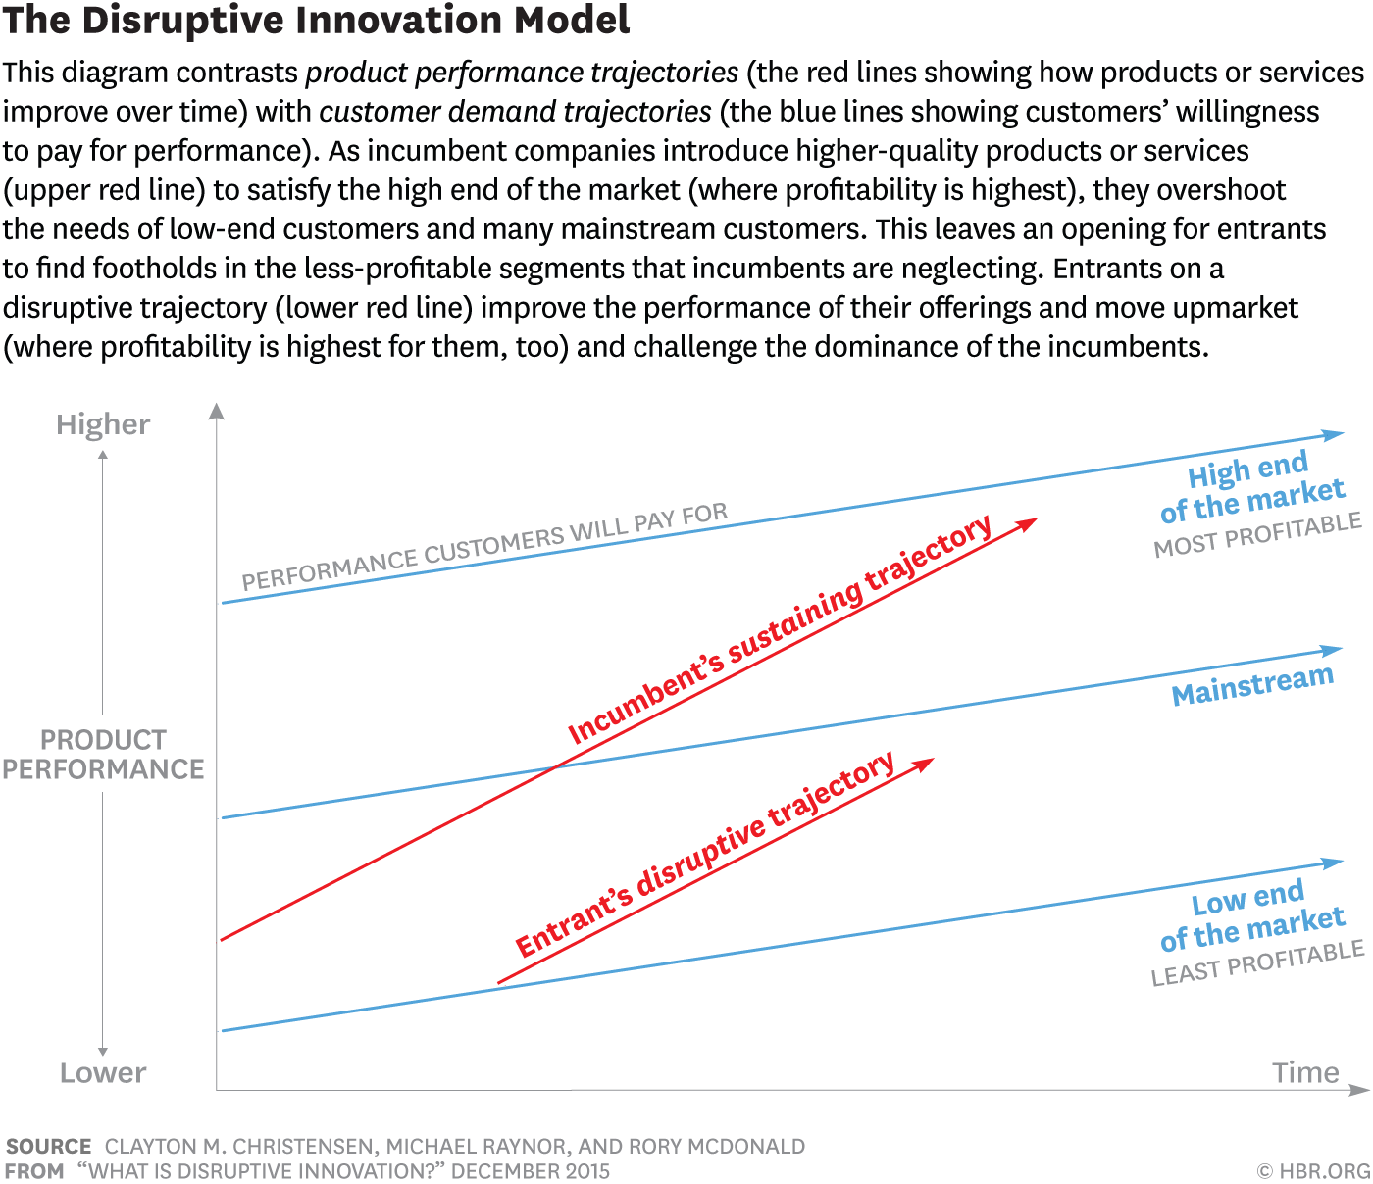

I asked in my questionnaire with Dr. Welch on 26th October 2017;

Q. What motivates, challenges and excites you? (Batty & Welch 2017)

A. "The opportunity to create positive social change through innovative leadership."

With the response from this question I asked Dr. Welch in October, I drew the same conclusion in my initial assessment 1 paper.
Innovative entrepreneurship – Dr. Welch’s father had a lot of influence on his path, his technical acumen and the mechanical mind he possesses today. In my view this helped with the pathway to his success. It is very clear based on my research that Dr. Welch is an academic, reaching a Ph.D. in Engineering, he specialised in crystal growth, optics and harnessed this skill during his time in Cornell. It takes the right sort of individual to have the drive, passion and goals to become an entrepreneur. The motivation and drive to make change in the telecommunication sector was clear.
Opportunity entrepreneurship – Dr. Welch had an opportunity to make a change. Based on the research and reviewing his interview notes, he didn’t seem to be looking for a new opportunity. He spent seventeen years at SDL as a senior executive. However, following the acquisition by JDSU, (Kevin K. Boeh, Paul W. Beamish; Mergers and Acquisitions (2002) he felt the timing was right to start looking at other things that would challenge and excite him.

Economic change in region

Telecom provider stock

The economic situation in the telecommunications industry in the late 90’s was a boom; however, the bust was coming, and in 2001 it hit hard.

Sprint (NYSE: S) for example went from $74.5 in October 1999 to $20.0 in October 2001, a decrease of 73% in this period. A similar trend in UK with British Telecom (NYSE: BT) with stock at $90.0 in October 1999 to $25.4 in October 2001, a decrease of 72% (data researched from New York Stock Exchange (NYSE). The economic situation at the time wasn’t great.

With the boom behind them in the 90’s and the bust slowly taking its reign 2001, was this a good time to start a new enterprise? Dr. Welch, Jagdeep Singh and Drew Perkins, thought so. They saw an opportunity to start something new. The Economist ( www.economist.com ) also wrote an article called ‘The great telecoms crash’ in 2001 which references the demise of telecom providers.

I asked in my questionnaire with Dr. Welch on 26th October 2017;

Q. Are you an optimist, a realist, or a mix of both? (Batty & Welch 2017)

A. “65% optimist, 35% realist”.

Unemployment in region

In 2001 unemployment levels in Sunnyvale California (CA) the location of Infinera’s corporate headquarters, were at 3.1% however, this number increased within one year to 8.2%. Data was researched by Federal Reserve Economic Data (FRED).

Timing

Not great timing for establishing something disruptive, still Dr. Welch proceeded.

They went out and hired excellent skilled staff to develop the PIC and supporting products. I took a quote from Kinnane’s interview with Welch in 2011.

“all the big companies were laying people off. You could hire anybody you wanted.”

Infinera now employs more than 2300 employees worldwide (as of Dec 2016), and has offices in United States or America, India, Canada, China, Hong Kong, Singapore, Japan, Sweden, Russia and United Kingdom.

Telecoms crash

With several of the key telecommunications companies entering chapter 11 (North American equivalent of bankruptcy) like Worldcom (Now Verzion), 360Networks (now Zayo) and Global Crossing (now Century Link), as explained by The Economist article in 2001, laying off staff and cutting back. Dr. Welch found this a great opportunity to go and hire exceptional skilled individuals to support his new venture.

As David S. Langdon, Terence M. McMenamin, and Thomas J. Krolik explained in their article ‘United States labor market in 2001: economy enters a recession’, there was a decrease in IT manufacturing (Dr. Welch’s start-up was in this industry), and that the recession was with America in 2001. The chart below shows in Figure 2 the decline in employment in the IT Manufacturing industry.

Figure 2

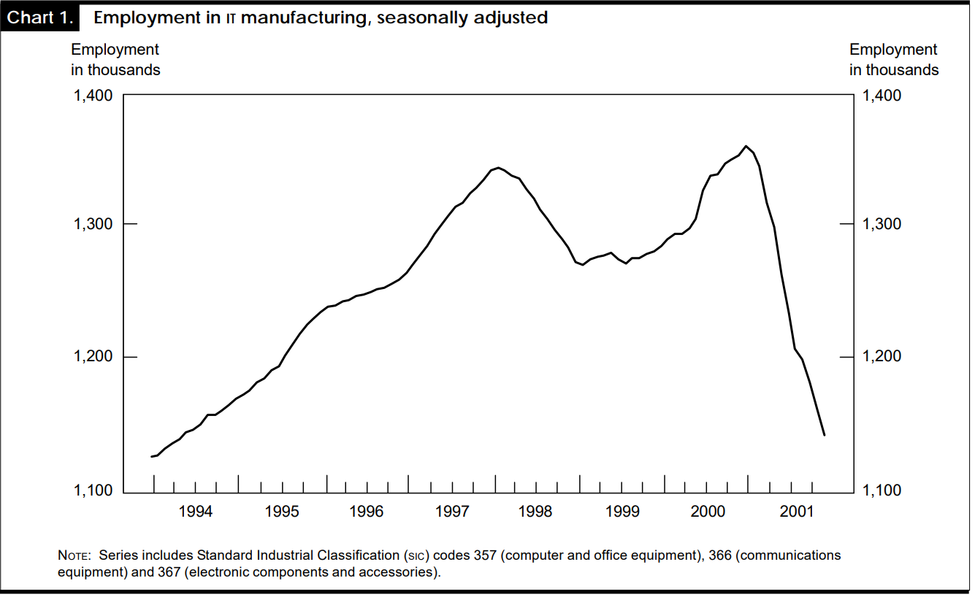

11th September impact

There was also uncertainty after the 11th September 2001 terror attacks in North America. Airlines shutdown for four days following the attacks, it has been estimated that there was a 2-billion-dollar loss for the tourism industry in United States. The travel industry declined with tourism and with business class passengers. I summarized this from two documents, one by IATA report by Antony Tyler, and one by Veronika Bysyuk (2010).

As explained by Dr. Welch when he was interviewed by Kinnane (2011), Infinera was established around the time of the 11th September terror attacks, it didn’t have too much of a business effect, but it affected everyone individually.

Infinera today

Infinera's major direct competitors are Ciena, Huawei, Cisco, Fujitsu, as shown in Figure 3 by Infonetics research (2014)

Figure 3

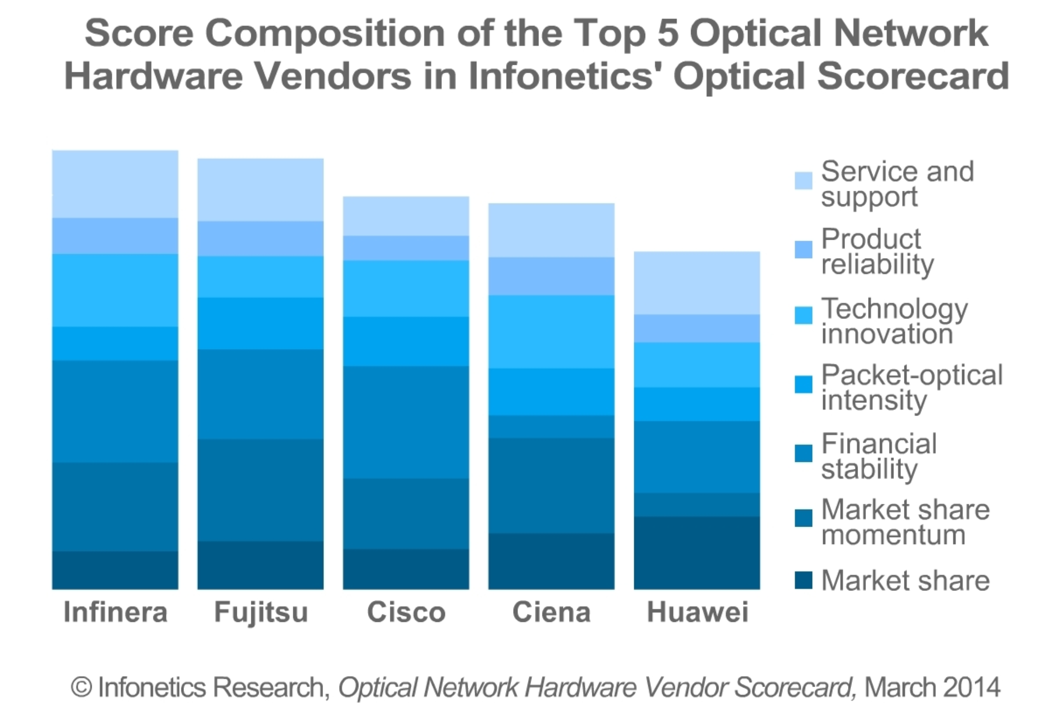

In 2015 Infinera acquired Transmode, (a Swedish manufacturer of telecommunications equipment), which enabled them to tackle another industry sector, Metro Networks.

Infinera’s 2017 portfolio of products. ( https://www.infinera.com/wp-content/uploads/infinera-br-product-overview-transport-networks.pdf - Page 2 ) as shown in Figure 4.

Figure 4

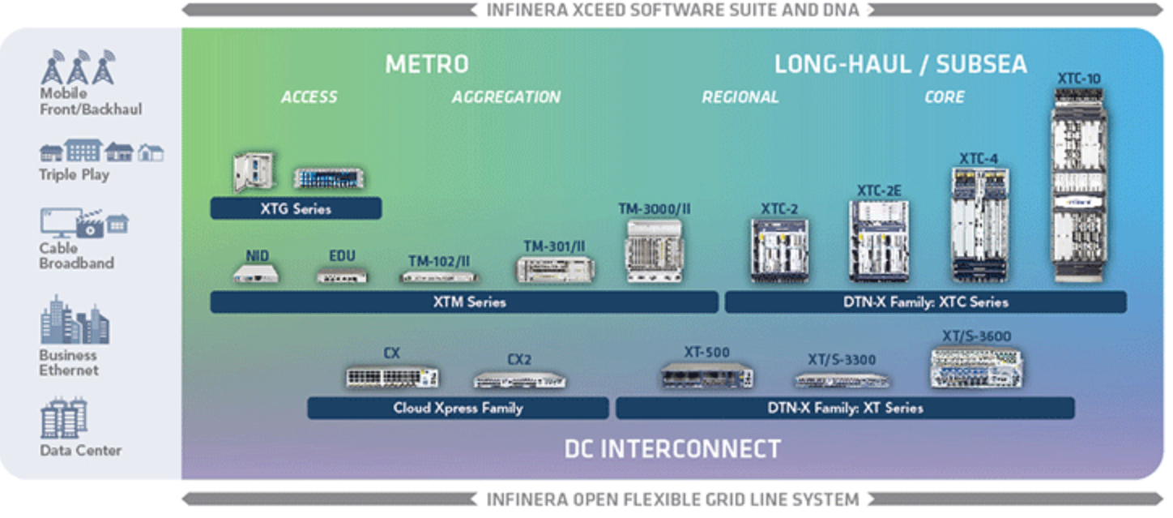

Social impact in region

In 1999 Dr. Welch and his wife Heidi setup a foundation called The David and Heidi Welch Foundation. Focusing on education, rights for teachers and students.

Dr. Welch is also a trustee of Natural Resources Defense Council (NRDC) a non-profit environmental organization.

Whilst Dr. Welch has been working at Infinera driving technology and innovation forward, he has also established a non-profit organization, contributing more than $500 thousand dollars from personals funds called ‘Student Matters’ (http://studentsmatter.org/).

I found several social entrepreneurs with similar traits.

Blake Mycoskie founder of TOMS – in 2006 he setup a company called TOMS, his model is simple. He calls it ‘ONE FOR ONE’, whereby with every product purchased (mainly shoes, apparel, and eye wear at present), he will help a person in need by giving back a one for one financial contribution ( http://www.toms.co.uk/improving-lives ).

Jeff Skoll former President of eBay - in 1999 he setup a foundation called SKOLL whereby he has contributed more than $1Billion from person funds. The Skoll foundation, helps drive social entrepreneurship and support them to success. Jeff’s vision is ‘to live in a sustainable world of peace & prosperity’ ( http://www.skoll.org/ ).

Hulgard (2010) also described similar traits in his paper ‘Discourses of Social Entrepreneurship’.

Students Matters

Student Matters, is a national non-profit organization founded in 2011 by Dr. Welch. Students Matters supports access to public education, through communications and litigation. The organization pushes for education equality through the courts, and permits students to have a right and a voice in their education in North America.

Dr. Welch has been engaged in several court cases fighting for student rights in public education sector. In 2016 Students Matter also helped bring a successful lawsuit against teacher tenure in California (Vergara v. California).

I asked in my questionnaire with Dr. Welch on 26th October 2017;

Q. What enterprise opportunities have you been engaged in that have led to economic and/or social change? (Batty & Welch 2017)

A. “I founded an organization, Students Matter that has pursued public education reform. We filed a lawsuit (Vergara v. California) where we challenged the system that the tenure laws were in conflict with the constitutional rights of the child in that the laws did not reflect quality as a measure of success. We have made a significant impact in the perspective of many as it comes to children’s rights to an equal access to quality education in California and across the country.”

Q. What inspired you to become the founder of 'Students Matter'? (Batty & Welch 2017)

A. “Children are the future of our society and education is the foundation of which they develop. Our system does not value the education of the child, especially those from low income areas. Students Matter was designed to address some of these inhibitions to a quality education.”

Reference list

451 Research
Intel’s Silicon Photonics Products Could Change the World of IT Paper 2016 Peter Christy Research Director 451 Networks https://www.intel.com/content/dam/www/public/us/en/documents/white-papers/451-research-silicon-photonics-paper.pdf
Last accessed: 02/12/17

Batty & Welch 2017
Questionnaire undertaken via Microsoft Forms with Dr. Welch on 26th October 2017 – spelling and grammar corrected from Dr. Welch’s response. This will form part of my Turnitin submittal.

CenturyLink (formerly Global Crossing)
http://www.centurylink.com
Last accessed: 07/12/17

Ciena Corporation (CIEN)
https://www.nyse.com/quote/XNYS:CIEN
www.ciena.com
Last accessed: 06/12/17

Cisco
https://www.cisco.com/
Last accessed: 16/12/17

CNN
Lightera acquired by Ciena
http://money.cnn.com/1999/03/15/deals/ciena/
Last accessed: 06/12/17

Discourses of Social Entrepreneurship
Lars Hulgard (2010)
Pages 8-10
https://emes.net/content/uploads/publications/WP_10-01_Hulgaard__web_.pdf
Last accessed: 16/12/17

The Economist
Online article ‘The great telecoms crash’ 2002
http://www.economist.com/node/1234886
Last accessed: 06/12/17

Everything You Need to Know About 5G
Amy Nordrum 2017 IEEE
https://spectrum.ieee.org/video/telecom/wireless/everything-you-need-to-know-about-5g
Last accessed: 06/12/17

FRED (Federal Reserve Economic Data)
Unemployment Rate in San Jose-Sunnyvale
https://fred.stlouisfed.org/series/SANJ906URN
Last accessed: 02/12/17

Fujitsu
http://www.fujitsu.com/uk/
Last accessed: 16/12/17

Steve Gedeon
What is Entrepreneurship? (2010) Ted Rogers School of Management, Ryerson University Toronto, Ontario, Canada M5B 2K3 pages 16-30

THE GREAT TELECOM IMPLOSION
article by Paul Star (2002)
https://www.princeton.edu/~starr/articles/articles02/Starr-TelecomImplosion-9-02.htm
Last accessed: 07/12/17

Huawei
http://www.huawei.com/en/
Last accessed: 07/12/17

Impact of 9/11 Terrorist Attacks on US and International Tourism Development
Veronika Bysyuk May 2010
https://www.modul.ac.at/uploads/files/Theses/Bachelor/BYSYUK_Impact_of_9_11_on_US_and_International_Tourism_Development.pdf
Last accessed: 07/12/17

The Impact of September 11 2001 on Aviation
Antony Tyler
http://www.iata.org/pressroom/Documents/impact-9-11-aviation.pdf
Last accessed: 07/12/17

Infonetic Research
Vendors scorecard 2014
By Andrew Schmidt
http://www.businesswire.com/news/home/20140326006386/en/Infinera-Fujitsu-Cisco-Ciena-Huawei-Top-Infonetics%E2%80%99
Last accessed: 07/12/17

Infinera Corporation
www.infinera.com
Last accessed: 07/12/17
Infinera Photonic integration circuit white Paper 2015
Document: WP-PIC-8-2015
https://www.infinera.com/wp-content/uploads/2015/08/Infinera-WP-Photonic_Integration.pdf
Last accessed: 30/11/17

Joseph A. Schumpeter
The Journal of Economic History, (1947), Vol. 7, No. 2 pp. 149-159

Joseph L. BowerClayton M. Christensen (1995)
Disruptive Technologies: Catching the Wave
FROM THE JANUARY–FEBRUARY 1995 ISSUE Harvard Business review
https://hbr.org/1995/01/disruptive-technologies-catching-the-wave
Last accessed: 02/12/17

Kleiner
Kleiner Perkins
http://www.kpcb.com/companies
Last accessed: 30/11/17

Kinnane OSA 2011
Optical Society of America
Oral History Project Interview with David F. Welch Conducted on (March 7, 2011), by Adrian Kinnane
http://www.osa.org/osaorg/media/osa.history/Transcripts/Welch,_David_Interview_(final)_2011-03.pdf
Last accessed: 07/12/17

Lightreading
Zepton Has an $86M War Chest
http://www.lightreading.com/zepton-has-an-$86m-war-chest/d/d-id/577345
Last accessed: 07/12/17

Mergers and Acquisitions
Kevin K. Boeh, Paul W. Beamish
Mergers and Acquisitions (2002): Text and Cases pages 168 -170

Nasdaq (INFN)
Infinera Stock details
http://www.nasdaq.com/markets/ipos/company/infinera-corp-106988-53506
Last accessed: 6/12/17

New York Stock Exchange (NYSE: S)
Sprint stock details
https://www.nyse.com/quote/XXXX:S
Last accessed: 31/11/17

New York Stock Exchange (NYSE: BT)
British Telecom stock details
https://www.nyse.com/quote/XXXX:BT/QUOTE
Last accessed: 16/12/17
Naude 2010
Chapter 18 of Naudé, W. A. (Ed.). (2010)
Entrepreneurship and economic development.
Palgrave Macmillan, Page 6

NRDC
Natural Resources Defense Council
https://www.nrdc.org/
Last accessed: 16/12/17

TOMS
founder Blake Mycoskie
ONE FOR ONE
http://www.toms.co.uk/improving-lives
Last accessed: 11/12/17

Power consumption in telecommunication networks: overview and reduction strategies
IEEE Communications Magazine ( Volume: 49, Issue: 6, 7th June 2011 )
(Willem Vereecken, Ward Van Heddeghem, Margot Deruyck, Bart Puype, Bart Lannoo, Wout Joseph, Member, IEEE, Didier Colle, Member, IEEE, Luc Martens, Member, IEEE and Mario Pickavet, Member, IEEE)
http://ieeexplore.ieee.org/document/5783986/
Last Accessed: 6/12/17

Student Matters
http://studentsmatter.org
Last accessed: 16/12/17

Skoll
http://skoll.org/about/about-skoll/
Last accessed: 16/12/17

Telecommunications energy and greenhouse gas emissions management for future network growth
Chien Aun Chan, André F. Gygax, Christopher Leckie, Elaine Wong, Ampalavanapillai Nirmalathas, Kerry Hinton.
Applied Energy, 15 March 2016, Vol.166, pp.174-185 [Peer Reviewed Journal]
https://ac-els-cdn-com.ezproxy.uwtsd.ac.uk/S0306261916000180/1-s2.0-S0306261916000180-main.pdf?_tid=8de9cb9c-d9d0-11e7-931a-00000aacb35d&acdnat=1512487722_d23c10c0373b988c72268bf8f937a3c1
Last accessed: 05/12/17

United States Department of Energy
Energy efficiency and renewable energy
Information and communication technology portfolio –DOE/EE-0390 – March 2011
https://www1.eere.energy.gov/manufacturing/pdfs/ict_brochure.pdf
Last accessed: 16/12/17

United States labor market in 2001
David S. Langdon, Terence M. McMenamin, and Thomas J. Krolik (Local Area Unemployment Statistics, Bureau of Labor Statistics https://stats.bls.gov/opub/mlr/2002/02/art1full.pdf
Last accessed: 30/11/17

Understanding Motivations for Entrepreneurship A Review of Recent Research
Evidence
Ute Stephan, Mark Hart and Cord-Christian Drews 2015 pages 1-54
https://www.enterpriseresearch.ac.uk/wp-content/uploads/2015/02/Understanding-Motivations-for-Entrepreneurship-Rapid-evidence-assessment-paper..pdf
Last accessed: 12/12/17

Vergara v. State of California
Court case 2016
https://scholar.google.co.uk/scholar_case?case=4910371724480037363&q=Vergara+v.+California&hl=en&as_sdt=2006&as_vis=1
Last accessed: 11/12/17

Verizon Business (formerly Worldcom)
https://www.verizonwireless.com/homepage/
Last accessed: 07/12/17

Worldwide electricity consumption of communication networks
Sofie Lambert, Ward Van Heddeghem, Willem Vereecken, Bart
Lannoo, Didier Colle, and Mario Pickavet 2012
Department of Information Technology, Ghent University - iMinds, Gent, Belgium
http://www.internet-science.eu/sites/eins/files/biblio/oe-20-26-B513.pdf
Last accessed 05/12/17

Zayo (formerly 360networks)
https://www.zayo.com/news/zayo-acquires-360networks-2/
Last accessed: 07/12/17

