Assessment component: Individual report

Student Name : Krishna Lakhu Khunti
Student ID : 2515605
Module Name: Strategic Management
Module Code: LCMB7003
Lecturere’s Name: Amare Desta
Zulf Khan
Word Count : 5000 words (± 10%)
Term 2

Table of contents
Section 0: Introduction to the report ………………………………………………..….. 3
Section 1: Organisational Context and Overview …………………………………….... 4
Section 2: External and Internal Analysis …………………………………………….... 7
Macro Environmental Analysis (PESTLE) ...………………………………………... 7
Internal Capabilities VRIO Analysis ...……………………………….……………. 10
SWOT Analysis …………………………………….………………………….…... 12
Section 3: Comprehensive and Holistic View of the Organisation .………………….... 13
Alignment of Business and CSR Objectives ………………………………………... 13
Balanced Scorecard Application ...………..………………………….……………. 4
Section 4: Strategic Choices and Implementation ..………………………………….... 4
Business Level Choices ……………………………………………………………... 4
Strategic Recommendations(Ansoff’s Matrix) ……………………….……………. 4
Implementation Challenges and Solutions …………….……………………….…... 6
Section 5: Reflection …………………………………………………………..……... 2
References …………………………………………………………………………..… 8

0.0. Introduction
Prepared from the perspective of a strategic management consultant, this report contains a comprehensive strategic evaluation of Marks and Spencer Group plc (M&S) within the UK retail market to advise the Board of Directors. The primary objective of the report is to critically analyze M&S's current strategic positioning, evaluate the suitability of its overarching "Reshape for Growth" strategy and define its core value proposition. To achieve this, the report has used established strategic management frameworks, including PESTEL, VRIO, and SWOT analyses with a critical evaluation of the organization’s Corporate Social Responsibility (CSR) alignment and a Balanced Scorecard assessment. At the end, this report synthesizes these findings to propose robust, actionable business-level recommendations designed to mitigate implementation challenges and sustain M&S's competitive advantage in a volatile macroeconomic environment

1.0. Organisational Context and Overview
M&S History, Mission, Vision, and Business Model
Marks and Spencer Group plc (M&S) is a heritage British retailer founded in 1884. M&S operates across the food, clothing, and home sectors under a vertically integrated, own-label business model with rigorous control over everything from product design and quality to supply chain ethics (Marks and Spencer, 2026a). The organization’s mission statement is “to bring the magic of M&S through exceptional quality, value, service and innovation to every customer, whenever, wherever and however they want to shop with us” (Marks and Spencer, 2026a). Its long-term vision is to remain the United Kingdom’s most trusted brand by delivering outstanding value and maintaining a customer-first approach (Marks and Spencer, 2026a).
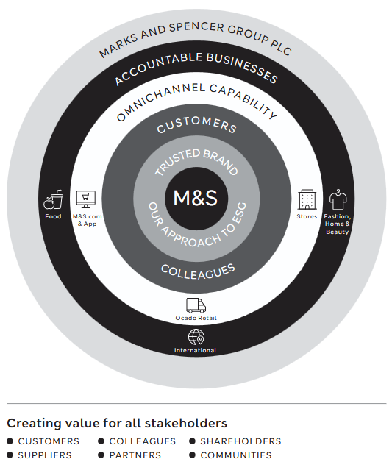
(Source: https://corporate.marksandspencer.com/sites/marksandspencer/files/marksandspencer/annual-report/m-and-s-annual-report-and-financial-statements-2026.pdf )
Currently, the company is shifting from legacy retail operations to a modern, omnichannel infrastructure under it’s "Reshape for Growth" corporate strategy for 2026 (Marks and Spencer, 2026b). This transformation includes renewal of the physical store estate, the aggressive expansion of the food division, the optimization of supply chain logistics and recent acquisition of a fully automated distribution site in Lichfield. Supported by its environmental, social, and governance (ESG) framework; M&S aims to achieve sustainable and profitable growth while protecting its premium brand positioning.
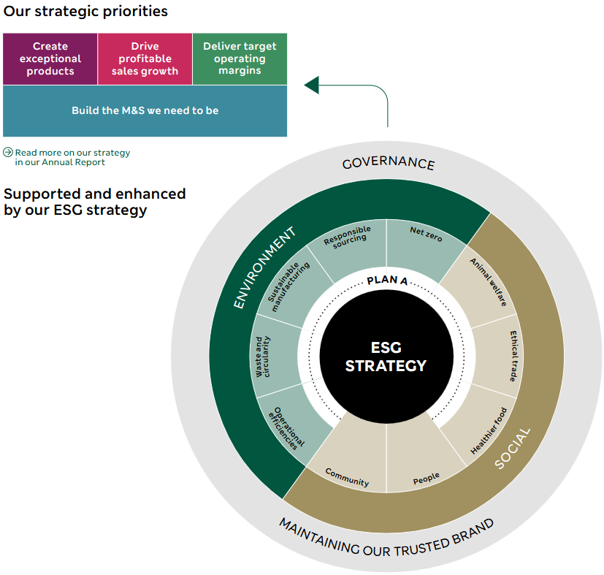
(Source: https://corporate.marksandspencer.com/sites/marksandspencer/files/2025-05/Marks-and-Spencer-Group-plc-ESG-Report-2025.pdf )

UK Market : Industry, Competitors and Market Position
UK retail is highly saturated and competitive industry with significant regulatory burdens. Market is currently facing economic volatility and slowly transitioning towards digital-first shopping (Machin, 2026). In such market M&S competes with fast-fashion retailers(Primark), e-commerce giants(Shein, Temu) and established high-street apparel brands (Next) in their clothing, home and beauty division. M&S Food division competes with premium supermarkets (Waitrose and Sainsbury's) and aggressively priced discounters (Aldi and Lidl) simultaneously to defend its market share.
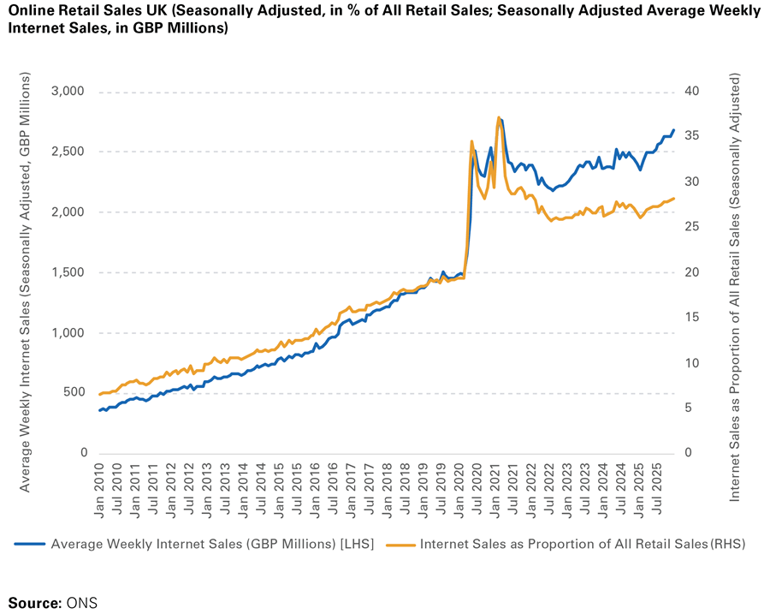
(Source: https://www.tmhcc.com/en/news-and-articles/thought-leadership/uk-retail-sector-report-february-2026 )

2. External and Internal Environment Analysis
The Macro-Environment and PESTEL Factors
External factors create threats and opportunities for retails players. PESTEL provides systemetic framework to analyze these factors and it’s impact on M&S.
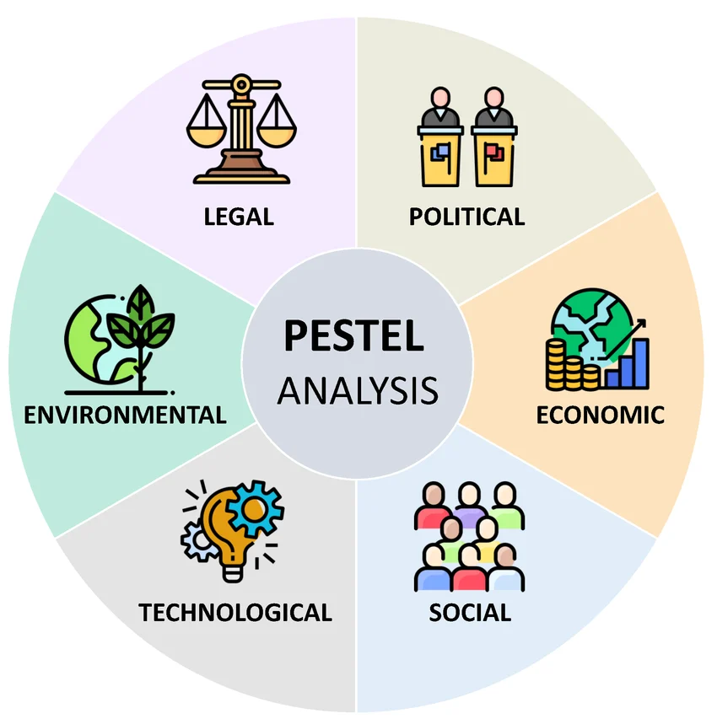
(Source: https://www.researchgate.net/figure/PESTEL-analysis-Source-the-authors_fig2_373122171 )

Political Factors: The pilical landscape of UK 2026 imposes significant regulatory burdens for retailers like M&S. Post-Brexit trading regulations (phytosanitary checks) increase import costs and full custom controls due to UK government’s Border Target Operating Model requires additional administrative work and IT integration requirements for vertically integrated retailers (DCF Analysis, 2026).
Assessment (Threat): Threat to M&S profit margins due to higher administrative costs for imports and potential delays can threaten supply chains of perishable goods.

Economic Factors: Overall sales volumes in 2025 and early 2026 are struggling to surpass pre-pandemic levels and persistent inflation continues to erode household purchasing power and consumer confidence (Tokio Marine HCC, 2026). UK government’s 2025 National Living Wage increase to £12.21 per hourand recent autumn budgets will Increase borrowing costs and employer National Insurance contributions for large employers (DCF Analysis, 2026; Tokio Marine HCC, 2026).
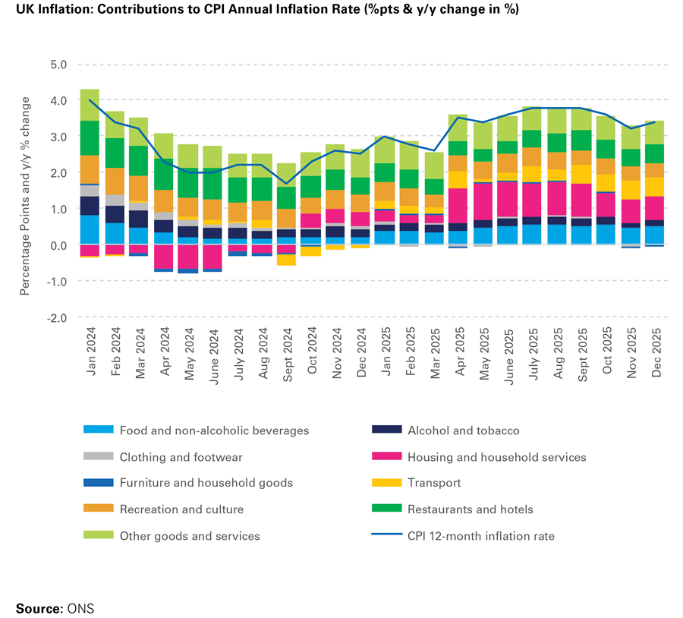
(Source: https://www.tmhcc.com/en/news-and-articles/thought-leadership/uk-retail-sector-report-february-2026 )
Assessment (Threat): While the erosion of discretionary income poses a risk to M&S’s Clothing and Home divisions; It is partially mitigated by it’s resilient and inelastic premium food channel.

Sociocultural Factors: Circular shopping behaviours are gaining traction with consumers seeking both ethical and value-driven purchases while simultaneously expecting more corporate ethical responsibility and fair labor compensation amidst the ongoing cost-of-living crisis. Data also shows more polarising behaviours : While 43% of consumers are shopping around more frequently for food and essentials; Increasing number of consumers prefer spending on in-store experiences, community events and leisure rather than purely transactional goods (UK Parliament, 2026; CBRE, 2026).
Assessment (Opportunity): This presents a distinct opportunity to capture affluent, resilient shoppers through M&S ongoing physical space upgrades and drive long-term brand loyalty through it’s “Sparks” loyalty program.

Technological Factors: UK retail market is going throuhg digital transformation where online retail is no longer just an alternative channel but an important channel. ONS data of June, 2026 indicate that online sales represent 29.4% of retail sales. Retailers are adopting Artificial-Intelligence for supplychain, inventory optimization,real-time pricing and personalization (Shoosmiths, 2026).
Assessment (Opportunity): Technological factors directly favour M&S's strategic strengths. M&S can leverage it’s data ecosystem and newly automated supply chain infrastructure for AI powered hyper-personalised marketing to increase digital sales conversions and algorithmic inventory management to reduce waste.

Environmental Factors: Environmental regulation and stakeholder expectations are pushing UK retailers toward more ambitious decarbonisation and circularity commitments. UK’s newly introduced Extended Producer Responsibility (2025) for packaging regulations require packaging producers to fund the full cost of packaging waste management process including collection, sorting and treatment.
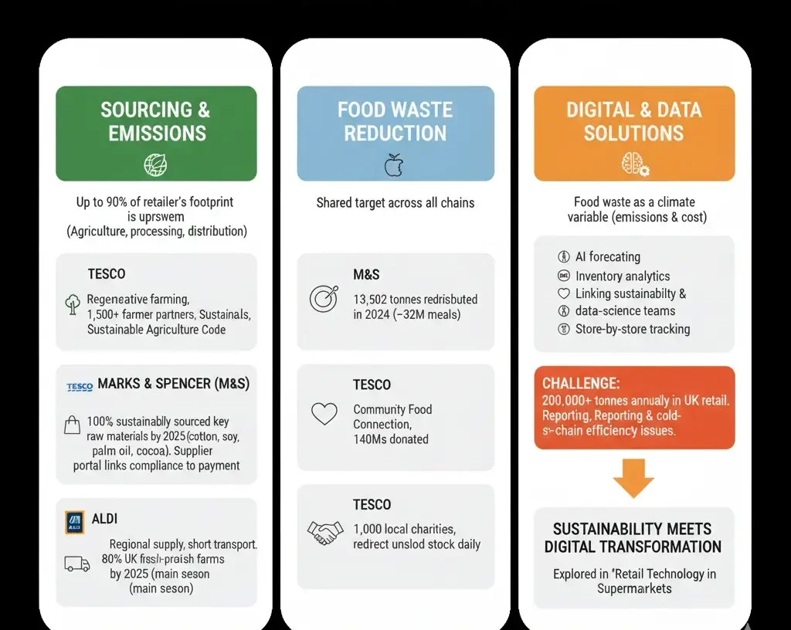
(Source: https://www.grocerytradenews.com/supermarket-sustainability-strategy/ )
Assessment (Threat): While environmental factors raise compliance costs across the sector, it also rewards retailers like M&S. M&S targets a net-zero value chain by 2040, a decade ahead of the UK government's 2050 target under its ‘Plan A strategy’ and covers both direct operations and the supply chain emissions (Marks & Spencer, 2026a).

Legal Factors: The Employment Rights Act 2025 is effective from 2026 and introduces new duties on employers, including guaranteed work hours protections and a proactive duty to prevent sexual and third-party harassment (The Retail Bulletin, 2026). Data protection law increases the risk of potential regulatory investigation and litigation under UK GDPR. Environmental compliance is no-longer a voluntary commitments but core legal obligations under EPR legislation for packaging (Grocery Trade News, 2025).
Assessment (Threat): New labour laws and employment rights increase compliance risk to a customer-facing retailer with a large flexible workforce. Moreover, GDPR regulations and EPR mendates require capital investments and potential fines if failed to oblige.

Internal Capabilities and VRIO Analysis
Any company's internal capabilities and resources determine it’s market performance.VRIO framework is used to systemetically evaluate whether Marks and Spencer’s (M&S) internal capabilities and resources are valuable, rare, inimitable and organised to identify internal strengths and weakesses based on the evaluation.
1.1 Heritage Brand Equity and Trust
Value | UK’s most trusted grocery brand and it’s Heritage status allows M&S to maintain a premium pricing across its Food and Clothing segments.
Rarity | M&S Heritage brand status immense value as it is supported by centuries of operational history, excellent quality control and responsible sourcing policies.
Inimitability | New competitors cannot rapidly replicate a century of brand heritage, generational consumer trust or deeply integrated supplier relationships.
Organisation | M&S continually reinforces this premium and ethical brand identity via its marketing expenditure and 'Plan A' sustainability framework.
Strategic Implication | This is M&S’s most vital internal strength and a sustained competitive advantage

1.2 The 'Sparks' Ecosystem & AI-Powered Digital Infrastructure
Value | M&S heavily transformed its Sparks loyalty programme in April, 2026 by pivoting from traditional points to a digital wallet offering real monetary rewards to increase customer retention and collect actionable behavioural data.
Rarity | While retails apps are not rare, M&S’s advance Machine Learning models integration for hyper-personalised pricing and product discovery is a rare capability.
Inimitability | Competitors can build applications but M&S has decades old, highly specific, vertically integrated omnichannel data to train it’s proprietary algorithms; which is complex and capital-intensive venture for others.
Organisation | M&S’s digital ecosystem is highly organised and CEO Stuart Machin considers AI-driven infrastructure - a central growth lever for "Reshape for Growth" strategy.
Strategic Implication | This capability symbolizes a core modern strength for M&S.

1.3 Physical Store Estate and Supply Chain Scalability
Value | The physical footprint of M&S provides brand visibility and serves as a valuable network for click-and-collect fulfilment.
Rarity | Physical store networks is not rarity among major UK retailers.
Inimitability | Competitors such as Next or Waitrose can easily build this infrastructure.
Organisation | Historically, M&S’s poor supply chain scalability and legacy stores resulting in unsold stock and costly end-of-season sales. Hence, company is actively modernizing it’s supply chain using advanced automated food distribution infrastructure and aggressive capital expenditure.
Strategic Implication | Legacy physical infrastructure acts as a weakness and M&S is attempting to mitigate this through capital restructuring.

SWOT Analysis
Short desc about SWOT and its importance
Strength | Opportunity
- Trust as UK's strongest brand for a fourth consecutive year, allows customer loyalty and premium pricing against discounters  - Well-organised, highly resilient food sourcing and supplier network with market-leading sales growth; Hard to replicate for competitors  - The AI-driven digital ecosystem providing granular first-party data for hyper-personalised marketing and algorithmic inventory management. | - Shifting consumer demand toward premiumisation and functional nutrition closely aligns with M&S Food's existing positioning and prospective UK–EU sanitary and phytosanitary agreement would reduce border friction and cost for fresh food imports  - Growth in AI-driven personalisation and online retail, with M&S targeting 50% online share of clothing, home and beauty sales by 2028  - Using AI to reduce operating costs and increase fulfilment speeds  - Increasing consumer demand for sustainable, ethically sourced and durable products; M&S can leverage brand trust to capture it
Weakness | Threat
- A legacy store estate with high operational overhead and yet converted to the larger, renewed full-line and food-led formats  - Reliance on outsourced third-party IT providers and risk of attacks through legacy IT vulnerabilities  - Reliance on complex, global apparel freight and higher price points in the clothing and home divisions compared to ultra-fast fashion competitors | - High UK inflation and fragile consumer confidence, limiting discretionary spend in non-food categories  - Cost inflation due to higher business rates multipliers, minimum wage mandates and higher employer National Insurance contributions directly threatening operating margins  - Intense competition from Tesco and Sainsbury's in food; and from Next, Primark and ASOS in clothing, home and beauty

Strategic Synthesis and implications for M&S
M&S’s primary challenge is to covert its hard to replicate brand trust into further growth while facing external risks from UK market environment (Inflation, cost increases, regulatory burden). M&S possesses robust strengths with three consecutive years of sales, profit and market-share growth, with a strong balance sheet to defend against threats and capture emerging opportunities. The brand has to urgently close the technology and third-party risk gap. The store rotation programme and a prospective easing of UK–EU border friction offer a route to convert external opportunities into lower-cost, higher-quality trading, but M&S has to manage external pressure without eroding the value proposition and brand's premium positioning to sustain these opportunities.

3. CSR and Sustainability Objectives
Critical Evaluation of CSR Strategy and Business Alignment
CSR is nolonger viewed as peripheral philanthropy but as a core driver of competitive advantage. M&S approaches corporate social responsibility under "Plan A 2030" and integrated into it’s overarching "Reshape for Growth" business strategy. M&S ensures that its ethical pursuits simultaneously drive operational efficiency and risk mitigation by linking environmental and social targets with commercial profitability.
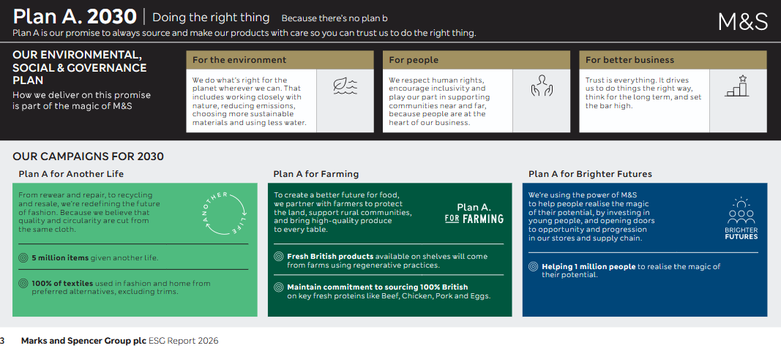
(Source: https://corporate.marksandspencer.com/sites/marksandspencer/files/marksandspencer/annual-report/marks-and-spencer-group-plc-esg-report-2026.pdf )

On the environmental dimension, this includes the Plan A Accelerator Fund, which approved twelve new circularity and decarbonisation projects in 2025/26, including the SOJO in-store repair service that has grown from a pilot into a permanent part of the group's "Another Life" circular-fashion programme (Marks and Spencer Group plc, 2026b). M&S has committed to becoming a Net Zero business across its entire value chain by 2040, supported by Science Based Targets initiative (SBTi) validations. M&S recently deployed 85 lower-emission vehicles (including electric HGVs and trucks powered by biomethane) within its logistics network, which not only reduces transport carbon emissions by up to 85% (compared to diesel) but also safeguards the company's supply chain against future fossil-fuel price volatility and UK carbon taxes.
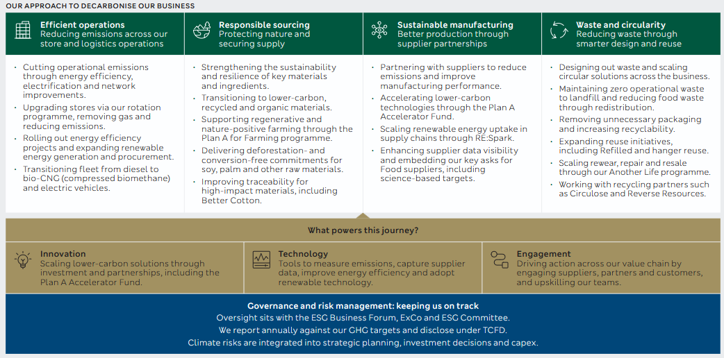
(Source: https://corporate.marksandspencer.com/sites/marksandspencer/files/marksandspencer/annual-report/marks-and-spencer-group-plc-esg-report-2026.pdf)
M&S enforces Global Sourcing Principles across its entire supplychain, restricts cotton sourcing from high-risk regions, secures 99% RSPO-certified segregated palm oil for its food products and operates a "Fortress factories" programme to mitigate the legal and reputational risks and build long-term, closely audited relationships with strategic manufacturing partners (Marks & Spencer, 2026e; Marks and Spencer Group plc, 2026a)
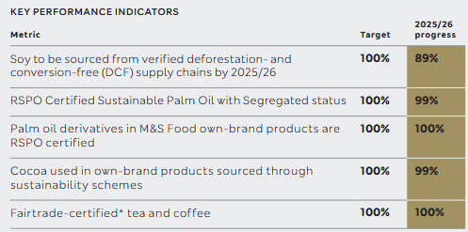
(Source: https://corporate.marksandspencer.com/sites/marksandspencer/files/marksandspencer/annual-report/marks-and-spencer-group-plc-esg-report-2026.pdf)
M&S aligns its community and workforce investments with its objective to remain UK's most trusted brand. For instance, It’s partnership with YoungMinds raises substantial funds to addresses youth mental health, Neighbourly partnership redistributes surplus food and "Eat Well" programme supports healthier eating across the M&S Food range (Marks & Spencer, 2026d). Internally, aligning wages with the Real Living Wage is a calculated business objective to reduce staff turnover costs and improve in-store customer service productivity rather than a mere social stance.
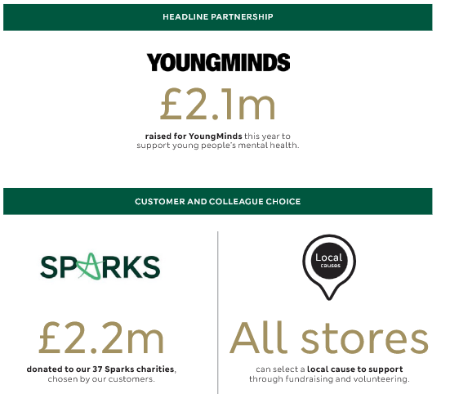
(Source: https://corporate.marksandspencer.com/sites/marksandspencer/files/marksandspencer/annual-report/marks-and-spencer-group-plc-esg-report-2026.pdf)

4. Comprehensive View via Balanced Scorecard
Strategic Alignment through the Balanced Scorecard
Kaplan and Norton’s (1992) Balanced Scorecard provides a holistic view of the organisation’s performance across four core perspectives. It translates M&S's mission into actionable and measurable operational goals.
Perspective | Objective | Key Performance Indicators | Targets | Initiatives
Financial | Sustain self-funded, profitable growth | - Group operating and pre-tax profit  - free cash flow  - dividend cover | Extend the run of consecutive annual profit growth achieved in FY2024/25 (£875.5m PBT); maintain a progressive, covered dividend | Disciplined capital allocation of £650–750m in FY2026/27 across store rotation, supply chain and technology under "Reshaping for Growth"
Customer | Deepen customer trust, loyalty and relevance across a broader demographic | Sparks active membership and engagement; brand ranking | Grow engaged Sparks membership and personalisation reach; defend the UK's strongest-brand ranking for a fifth consecutive year | AI-powered Sparks relaunch and Virgin Red partnership; continued investment in the "Love That" brand campaign
Internal Business Process | Build a resilient, quality-assured supply chain and secure digital operations | Fortress factories audit coverage; cybersecurity incident recovery time; online order availability | Zero repeat critical security incidents; expanded Fortress factories coverage across strategic suppliers | Post-breach technology and identity-management investment; Global Sourcing Principles and Fortress factories programme
Learning & Growth | Develop colleague capability and an inclusive culture to support transformation | Colleague engagement survey scores; training hours per colleague; internal promotion rate | Improve year-on-year engagement scores across the ~65,000-strong workforce during the technology transition | Colleague wellbeing, development and inclusion programmes under the Plan A "people" pillar

5. Strategic Choices and Implementation
5.1 Evaluating Business and Corporate-Level Strategic Choices
Fundamentally, Business-level strategy determines how M&S competes within retail market to achieve a competitive advantage by strategically choosing between cost leadership (competing on price), differentiation(unique value) and focus (Porter, 1980).
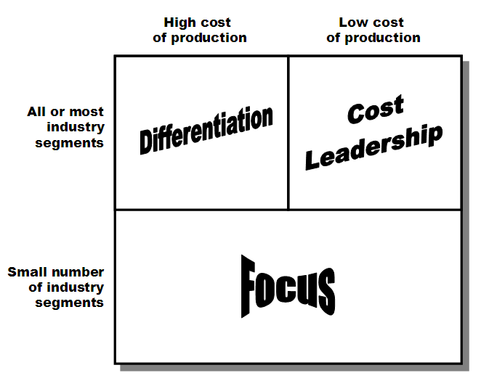
(Source: https://www.mbaknol.com/marketing-management/porters-generic-competitive-strategies/ )
Pursuing cost leadership is structurally unattractive for M&S as that position is already occupied by discounters and ultra-low-cost fashion importers. UK grocery sector is dominated by discounters like Aldi and Lidl, with lean operating models and limited stock keeping units (SKUs) granting them insurmountable cost advantages. Similarly in Clothing and Home divisions, competing on price against ultra-low-cost fashion importers(Shein and Temu) or high-volume retailers (like Primark) would completely erode M&S's margins and destroy its heritage brand equity. particularly while e-commerce giants like Shein and Temu have further price advantage as apparel imports valued under £135 remain exempt from UK customs duty (CityAM, 2026). Furthermore, A narrow focus strategy is undesirable at M&S's national scale as it would also under-exploit brand’s broad food, clothing, home & beauty portfolio.
A broad differentiation strategy that positions M&S on quality, provenance and trusted service is most defensible business-level choice rather than price. This choice allows M&S to directly leverage it’s rare and difficult to imitate resources identified in the VRIO analysis: sustained brand trust, quality-led food sourcing, and a loyalty-driven customer relationship. M&S must compete by offering superior, distinguishable value and ensure that customers perceive M&S products as "affordable luxuries" that cannot be perfectly replicated by cheaper competitors.

5.2 Strategic Recommendation and Choice Validation
This Broad Differentiation strategy is further evaluated and validated through the lenses of Porter’s Five Forces and Ansoff’s Matrix.
Evaluation via Porter’s Five Forces: Porter's Five Forces framework supports this conclusion. Competitive rivalry in the UK retail landscape is intense and a threat of substitutes is very real and sever as hoppers have negligible switching costs. While the threat of new entrants is low for full-range grocery, because of the capital and logistics requirements but established omnichannel grocers such as Tesco and Sainsbury's make it effortless to abandon one supermarket for another. while meal-delivery services substitute for traditional grocery shopping altogether. In value-fashion, retailers such as Next and Primark, and fast-growing online entrants and Shein and Temu have expanded aggressively through app-led, low-price models (Yahoo Finance, 2026). Hence, the threat of substitutes is significant on both sides of the business. Buyer power is high and still rising, as cost-of-living crisis make even loyal M&S shoppers more price-sensitive and loyalty schemes across the sector make switching easier (Retail Insight Network, 2026; Tokio Marine HCC, 2026). Because precisely the price-competitive segment of the market has high rivalry, substitute threat and buyer power; competing on differentiation avoids this disadvantaged competition and favours M&S’s relative strengths.
Validation via Ansoff’s Matrix: M&S's "Reshape for Growth" strategy aligns with the lower-risk quadrants of Ansoff’s Matrix: Market Penetration and Product Development. Market penetration through AI-personalised Sparks scheme(relaunched) to penetrate deeper among it’s existing UK customers by increasing the frequency of purchases. M&S is pursuing Product Development by continually introducing premium food lines and carefully curated third-party clothing brands on its digital platform; which further enhances the differentiated value of its ecosystem. Simultaneously, M&S builds immense brand loyalty by heavily investing in unique private-label goods (which account for roughly 60% of M&S's revenue) and stringent quality certifications,. This loyalty directly reduces the bargaining power of buyers, making them less price-sensitive and far less likely to defect to low-cost substitutes.
This commitment to a Broad Differentiation strategy supported by targeted Market Penetration allows M&S to deliver optimum operational performance and secure a sustained competitive advantage. While consumers are cutting costs on basic commodities due to inflation, they continue to spend on high-quality, experiential purchases. M&S is actively exploiting this by accelerating its physical store renewal programme. By closing legacy, multi-floor high-street shops and opening highly experiential, visually appealing retail park destinations(with integrated food halls and frictionless click-and-collect capabilities), M&S creates a physical differentiation that digital-only rivals cannot match. M&S can use AI & predictive data to offer hyper personalized promotions to increase conversion rates. M&S captures a higher share of consumer spending, ensure higher operating margins and long-term market dominance through this combination of premium physical experiences and digital convenience.

Implementation Challenges and Proposed Mitigation Solutions
M&S must navigate three anticipated challenges and operational risks to ensure succcessful execusion of the strategy and long-term viability.
Challenge 1 : Capital Expenditure and Margin Pressure
Transitioning the legacy store estate to modern formats, alongside building automated supply chain infrastructure (like the Lichfield facility), requires massive upfront capital expenditure. Store rotation program reduces full-line estate from 229 to 180 stores by 2028, and carries significant restructuring costs(including an £84.4 million charge). These costs can deplete free cash flow and reduce short-term shareholder dividends.
Mitigating requires rigorous capital discipline and the board must prioritise investments that offer immediate cost reductions and highest-return initiatives. Store renewals must be executed through a strictly phased rollout, ensuring that the revenue generated from early successful renewals directly funds subsequent project phases.
Challenge 2 : Technological Integration and Cyber Vulnerability
Shifting from legacy IT systems to modern, AI-driven infrastructure introduces the risk of operational disruptions. Furthermore, Sparks ecosystem possesses the risk of targeted cyber-attacks because of it’s vast and highly valuable consumer data.
M&S should roll out new digital infrastructure in isolated regional clusters first, to identify bugs and fix them before full deployment; a "Test and React" agile methodology. Additional capital must be diverted toward AI deployment and cyber-security capabilities.
Challenge 3: Brand Consistency
M&S has carefully constructed its reputation for quality and ethical sourcing. As the platform expands to include third-party clothing and beauty brands (Product Development), If a partner brand violates labour or environmental standards, the reputational damage will fall directly on M&S.
This can be mitigated by M&S's selective choice of partners and zero-tolerance Service Level Agreements (SLAs). Any third-party brand hosted on the M&S platform must be contractually forced to undergo independent audits verifying compliance with M&S’s internal "Plan A" ESG standards.
Section 2 : Reflective Account
I have applied Gibbs’ Reflective Cycle (1988) to critically evaluate my personal and academic development throughtout preparing the strategic analysis of Marks & Spencer (M&S). This systematic, six-stage approach(Description, Feelings, Evaluation, Analysis, Conclusion, and Action Plan) helped me examine my research phase, evaluate my analytical decisions and reconsile my learning outcomes.

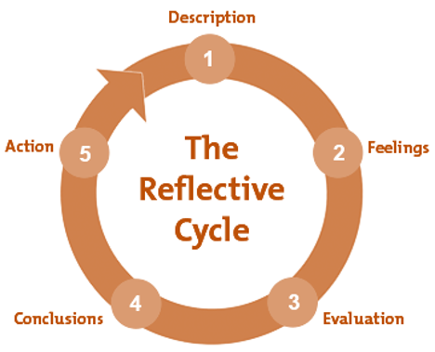
(Source: https://www.open.edu/openlearncreate/mod/page/view.php?id=165770 )

1. Description
The task required me to assume the role of a strategic management consultant, select an organisation in a specific market focus and producing a consultant-style evaluation of its strategic position for the Board of Directors. I chose M&S in the UK market, applied a sequence of frameworks, such as PESTEL to assess the external and VRIO to assess the internal environment and used SWOT to synthesise both. Then i worked through CSR and balanced scorecard review for a holistic view of performance, and finally apllied Porter's Five Forces and Ansoff's Matrix to recommend and validate a business-level strategy. I applied each framework using primary and credible sources in the UK retail sector, including M&S's own annual reports and results announcements, trade press and specialist industry commentary.
2. Feelings
The assignment required multiple frameworks and the amount of corporate data got me worried as I was unsure about best approach to demonstrate my key findings. I wanted to produce a master's level critical evaluation rather than a descriptive assignment. During the PESTEL and VRIO analyses, I could see the same issues such as M&S's April 2025 cyberattack, legacy IT infrastructure, intense rivalry, inflation. So, I mapped M&S's "Reshape for Growth" initiatives against provided academic frameworks and that gave me confidence because i was successfully able to use these frameworks to audit M&S’s internal and external environment.
3. Evaluation
I could see that mentioned frameworks were connected and depended on eachother, applying them in this manner turned out highly effective. I was able to measure and turn abstract concepts (such as M&S's "Plan A" ESG targets and supplychain automations) into concrete, strategic arguments. At the same time, I was mixing macro-environmental threats with internal organizational weaknesses during the early drafts. Balancing the theoretical depth with concise and impactful evaluation was a challenge as certain sections requied details.
4. Analysis
This reflection made me realize that strategic management is fundamentally an iterative, non-linear discipline. Initially, I was struggling because I did not realize that PESTEL strictly audits the external macro-climate to identify market opportunities and threats, whereas VRIO judges firm’s internal capabilities. I was able to synthesize SWOT matrix effortlessly after this understanding. Furthermore, evaluating M&S's strategic choices introduced real-world implementation barriers such as capital expenditure constraints, cyber security risks and inflations; which helped me move beyond theoretical idealism and develop cohesive understanding.
5. Conclusion
While executing high-level strategic audit as a supposed consultant, I had to act as optimist as well as skeptic and validate M&S's strategic choices while anticipating potential failure points. This research process enhanced my critical thinking, data synthesis and strategic reasoning skills. I learned that having a rigid analytical outline and word count checkpoints are essential for maintaining structure and avoiding descriptive narration in long-form academic reports.
6. Action Plan
I will implement the following improvements, if I am presented with a similar strategic management project in my future career :
1) Filter high credibility and primary sources in the beginning rather than later.
2) Not treating the application of strategic frameworks as sequential, disconnected tasks and apply them iteratively to check each new analysis against earlier findings.
3) Even use incomplete or still-developing information to synthesize my findings and make recommendations grounded in real-world data and examples.

References
1. Machin, S. (2026) Full Year Results for the 52 Weeks Ended 28 March 2026. https://corporate.marksandspencer.com/newsroom/press-releases/full-year-results-52-weeks-ended-28-march-2026 (Accessed: 29 June 2026)
2. Marks and Spencer (2026a) M&S Vision, Purpose and Behaviours. https://corporate.marksandspencer.com/sites/marksandspencer/files/2026-04/m-and-s-vision-purpose-and-behaviours.pdf (Accessed: 29 June 2026)
3. Marks and Spencer (2026b) Marks and Spencer Group plc Annual Report and Financial Statements 2026. https://corporate.marksandspencer.com/sites/marksandspencer/files/marksandspencer/annual-report/m-and-s-annual-report-and-financial-statements-2026.pdf (Accessed: 2 July 2026)
4. DCF Analysis (2026) Marks and Spencer Group plc (MKS.L): PESTLE Analysis [Apr-2026 Updated]. https://dcf-analysis.com/products/mksl-pestel-analysis (Accessed: 2 July 2026).
5. Tokio Marine HCC (2026) UK Retail Sector Report February 2026. https://www.tmhcc.com/en/news-and-articles/thought-leadership/uk-retail-sector-report-february-2026 (Accessed: 10 July 2026).
6. UK Parliament (2026) Retail sector in the UK: Economic Contribution and Trends. https://researchbriefings.files.parliament.uk/documents/SN06186/SN06186.pdf (Accessed: 10 July 2026)
7. CBRE (2026) UK Real Estate Market Outlook 2026: Retail. https://www.cbre.co.uk/insights/books/uk-real-estate-market-outlook-2026/retail (Accessed: 13 July 2026)
8. CBRE (2026) UK Real Estate Market Outlook 2026: Retail. https://www.cbre.co.uk/insights/books/uk-real-estate-market-outlook-2026/retail (Accessed: 14 July 2026)
9. Shoosmiths (2026) Trends reshaping consumer & retail in 2026. https://www.shoosmiths.com/perspectives/stories/articles/trends-reshaping-consumer-retail-in-2026 (Accessed: 14 July 2026)
10. Grocery Trade News (2025) Supermarket Sustainability Strategy: Reducing Carbon and Waste. https://www.grocerytradenews.com/supermarket-sustainability-strategy/ (Accessed: 16 July 2026)
11. The Retail Bulletin (2026) Rising costs, new rights: The challenge facing retail employers. Available at: https://www.theretailbulletin.com/newsletter/rising-costs-new-rights-the-challenge-facing-retail-employers-27-07-2026/ (Accessed: 16 July 2026)
12. CityAM (2026) UK risks becoming 'dumping ground' for Temu and Shein, retailers warn. https://www.cityam.com/retailers-fear-fresh-competition-from-temu-and-shein-following-eu-crackdown/ (Accessed: 20 July 2026).
13. Porter, M.E. (1979) 'How competitive forces shape strategy', Harvard Business Review, 57(2), pp. 137–145.
14.

