
APPENDIX GA36c

LEVEL 6 ASSESSMENT SPECIFICATION

Student name: | Nathan Goodman | Student ID number: | 1800134
Programme: | PGCE Primary
Module: | Principles of Pedagogy
Module code: | M6X01438/C | Contribution to Overall Module Assessment (%): | 100%
Lecturer: | Siân Brooks | Internal Verifier: | Siân Brooks
Assignment Title: | ‘Describe a learning event which has happened during your recent school experience. Reflect upon what took place, connecting events to theories of learning and teaching. Make recommendations about how you could improve your own practice in the light of this. Produce a poster to illustrate how you would develop the elements of an effective learning environment.’ | My Word count (or equivalent): 4914 | 5,000 or equivalent.
Submission deadline: | 17/10/18 (23.59) | Return date of provisional marks & written feedback: | 14/11/18
Submission method: | All written assessments, where practical and possible, must be submitted via Turnitin unless otherwise instructed by the Lecturer. (Please DO NOT put this assessment specification into Turnitin or it will match many similarities with other students’ submissions.)  Alternative submission method (if applicable):  Late submission of the assessment will result in a late penalty mark. Penalties for late submission: Up to one week late, maximum mark of 40%. Over one week late, 0%. Only the Extenuating Circumstances Panel may approve a change to submission dates.
Academic honesty / referencing: | Academic honesty is required. In the main body of your submission you must give credit to authors on whose research and ideas your work is based. Append to your submission a reference list that indicates the books, articles, etc. that you have used, cited or quoted in order to complete this assessment.

Module Learning Outcomes
(from module syllabus)
1. understand, synthesise and evaluate the main theories that underpinning learning, behaviour and assessment in the primary school
2. reflect critically on how learning theories inform the planning and provision of high quality learning environments, demonstrating a clear understanding of how theory and practice are interrelated
3. organise knowledge and learning through the use of a range of information sources, and present work appropriately.

‘Describe a learning event which has happened during your recent school experience. Reflect upon what took place, connecting events to theories of learning and teaching. Make recommendations about how you could improve your own practice in the light of this. Produce a poster to illustrate how you would develop the elements of an effective learning environment.’

Introduction
This assignment will talk about a classroom learning event I recently witnessed i.e. the use of questioning in the classroom. It will describe the learning environment and outline the process of observation which I undertook. Part 2 will link to key theorists who have all had an impact on education in their own way. The last section will show a plan of my own ideal learning environment within a classroom setting. The learning event I witnessed took place within a Primary School in South Wales, which had 384 pupils on roll, 33.6% of the pupils on roll were eligible for free school meals. The schools latest Estyn report (2015) showed the school was graded as good. Throughout my assignment, for safeguarding reasons, I will refer to the school itself as School X and any pupils as Child A, B,C etc. For this assignment my ethical considerations are in guidance with BERA (2018).
The class observed was a year 4 class of 28 students, normally 30, two students were absent on the day of the observation. There were two adults in the classroom, the teacher and a teaching assistant. The teacher in the classroom, had decided to spit the class into 3 groups and adopted a carousel approach to the tasks she set. Each of the groups would ultimately complete each of the tasks. She had a focus group, that she was going to work with, there was an independent writing group and an independent ICT group who would use Bee-bot robots. The teaching assistant was going to work with a specific child with special educational needs on a different writing task, they were located near the writing group. Prior to entering the classroom, I decided that I would focus my observation on the quality of questioning the teacher would use throughout the lesson, checking how this impacted on the children, their responses and ultimately their learning. I also decided to look at the learning environment to see whether this enhanced or distracted from the learning and finally I wanted to gauge whether the children could be independent learners had resilience i.e. their mindset/self-esteem as they were undertaking their task.

Part 1- Observation
I initially decided to observe from the side lines all three groups simultaneously, making notes of all I was seeing, I undertook this observation for the first 10 minutes. I felt this would give me an overview of the classroom routines the teacher had instilled in the children.; it would allow me to view the impact of the learning environment, the mindset and the attitude to learning of the children involved. I wanted to know whether anything would change, depending on the groupings, on the task given or would attitudes change if they were working on their own. I then planned to observe all 3 groups separately to get a better understanding of the learning environment of the whole classroom and see if it differed with each group. I spent approximately 15 minutes with each group making hand written notes, this allowed me to see how children within the same class interacted with each other and the task given. According to Devers and Frankel (2000) the use of groups within research can provide the greatest insight into answering the research question. By observing a group, you can witness how children interact with others and share ideas. Miles and Huberman (1994) mention that there are three important types of group samples these are – “typical cases, deviant or extreme cases and negative or disconfirming cases.” By choosing 3 groups to observe I felt I had a greater chance of finding one of the 3 samples from the above list, which in effect I did. Nevertheless, there were negatives with the approach I choose, firstly, during the first 10 minutes it was difficult to ensure that I had collated all the relevant information given that I became distracted by the amazing positive attitude the children had as they engaged in their tasks, especially the ICT group which I will outline later. Secondly, perhaps a more formal observation record sheet with key sections highlighting my focus would have been better as it meant I could quickly record what I had seen. I am aware that utilising an audio recording may have helped capture those key moments in the interaction between teacher and child, child and child, and then transcribed those notes, however I didn’t think this approach would be suitable for the classroom environment. The number of children within the class, the movement of the children in the class and the noise from the class next door. I believe this could have interfered with the quality of the audio recording. The audio recording would have been conducted using my personal mobile phone, this raises a potential safeguarding issue. On the other hand, using an audio recording might have picked up information which I may have missed or not seen as important at the time, but on further reflection may have added beneficial insight to the observation conclusion. Filming the lesson would have been difficult as three cameras would have been needed, this could have caused the children to behave in a different way unless they were used to this happening on a regular basis. It could also raise a potential safeguarding issue.
The focus group were reading a book with the class teacher. This group had the support of the teacher throughout, with a variety of questions being put to them to test their understanding and knowledge. The style of questioning followed the Blooms’ taxonomy structure, questions started out at the remembering stage then slowly progressed to the creating section (Forehand 2010). However not all of the stages were used for each child, it was obvious from watching the interactions that the questions were tailored specifically to the ability of each child. The teacher utilised the higher order questions to draw out full responses from each child, often following up with a supplementary scaffolded question to elicit that fuller response, always allowing thinking time. There was a great deal of ‘what’ type of questions, ‘why do you think that happened,’ ‘how do you know’ to check their understanding. Praise was consistently used by the teacher. It was obvious from the children’s responses that they were used to this approach, one child, child A clearly got an answer totally wrong, yet wasn’t phased by that, he continued to smile and engaged in answering further questions. It was obvious that the learning culture within the classroom was one were effort was rewarded through praise and failure was part of learning process with support given to address mis- conceptions. Support was observed as mis-understandings were quickly dealt with both from a peer to peer perspective and a teacher child view point. There was a positive relationship between teacher and pupils in all of the interactions observed.
The independent writing group had to write a diary entry from the perspective of the main character in the book they had recently read as a class. On the table were prompts, one relating to the senses i.e. touch, feel, smell, hearing and taste. The second prompt was a word bank which had keywords from the story which the pupils could use to help them. A scaffolding approach. I observed this group quickly get down to the task with a great deal of discussion taking place as to the character they were choosing to be. This seems to support Vygotsky’s view that the process of discussing helps children make sense of the task and so helped them to get started. The children were very insightful, describing what that character had felt in the book, what they had experienced. They had obviously had exposure to the skills required to be independent learners. Utilising support from each other as they tackled the task. Approximately half of the group appeared to be using the word bank prompt to help them write the task.
The ICT group were split into smaller groups of three i.e. group A, B and C each had a ‘Bee-Bot’ robot which could be programmed to move, the aim of the task was to programme the robot, so that it reached different points around the room. The group were given the opportunity to work independently at their own pace; Cremin and Burnett (2018) in their research state that “children should be free to work at different speeds and in different ways, learning from first hand experiences through active exploration and personal discovery.”
I only focused on Group A and did not witness Groups B and C. Group A seemed to enjoy the task, they stayed on task throughout the lesson. Once they managed to reach all the points they would then re-arrange the points trying to make it harder for themselves each time, they were learning by doing. What was interesting to observe was how the children organised themselves, as they set about achieving the task, the teamwork observed as they supported each other, helping that person to improve their own performance before passing the task and responsibility onto the next person. It was true collaboration in action. Everyone had a turn at programming the Bee-Bot, when they weren’t programming they would try to work out the correct number of moves and turns needed. There was no power struggle within this group each person was happy for everyone to take it in turns but still participated fully. Each of the groups would discuss their thoughts and ideas about which route was best and how many steps and turns they all thought it would take. This really highlighted Vygotsky’s view that children solve practical problems with the help of speech. I was very surprised at the level of engagement and the way the children listened to each other and would try out each other’s ideas without any adult enforcing them to do so. Obviously only watching group A has meant that I may not have the full picture on how the pupils engaged in ICT tasks, and this is something I would change in the future. I think it would have been more effective for me to undertake a second observation of this ICT task, by focussing only on the ICT task so I could watch all three groups After approximately 45 minutes the teacher stopped the lesson, and the groups rotated. Behaviour was excellent with only minor interruptions which were stopped by the teacher using one command which did not allow any response from the children.
Their resilience when faced with a challenge was very good utilising their peers to support them once they had tried the task several times.

Part 2- Literature
It is important that children feel safe, so they are confident to participate within the learning environment. A child cannot learn when their mind is in turmoil, they need to feel secure so that they can engage in the learning process. The quality of the classroom environment in schools has a large effect on student learning (Pickett and Fraser 2010). In the Successful Futures report Donaldson (2015), mentions children being able to have the “confidence to participate in performance and being able to explain their ideas which they are learning about.” If the child doesn’t have a positive learning environment, then they are less likely to share their ideas and less likely to be as confident to participate in discussions or volunteer answers. A child with low self- esteem, can feel intimated by their peers, become anxious as they do not want to look, in their terms, ’stupid’ in front of their peers or their teacher; consequently, they are not willing to raise their hand and answer questions in front of others? For learning to happen the teacher needs to create the right climate, one which is supportive and non- threatening, where the children feel comfortable, happy and safe, a place where they have positive relationships with their teachers. The focus group showed this throughout, they were confident and although the questions being asked by the teacher were directed in the main to specific individuals, each child was prepared to answer. At the end of the lesson I asked child A who had got a question completely wrong how he had felt? He shrugged his shoulders and said “don’t’ mind, not worried, Miss didn’t mind, my friend helped me! I’ll get it right next time”. This really echoed Carol Dweck’s work on creating a positive mindset in the classroom, encouraging children to become resilient learners. Creating a positive mindset means that the child will try harder as they believe they can learn and can attain that skill (Yeager and Dweck 2012).
Creating a climate where children feel confident to answer means that they know it is okay if they get something wrong, it’s the trying that’s important, they are trying to understand what the problem is asking and using their previous knowledge and the scaffolded questioning asked by the teacher to support their response. Thus, creating positive mindsets in a positive learning environment. “Both learning and self-esteem are things that students achieve as they tackle challenges and work to master new material” (Dweck 1999). Resilience is essential for a child to achieve in school and be successful in later life.
It was evident from the observation I undertook. that the teacher had high expectations of the children in her group, she had created that positive learning environment, where they were confident and comfortable to answer those questions. “Questions are an integral part of classroom life and essential to every teacher’s pedagogical repertoire” (Doherty 2018). Research has shown that a teacher with high expectations of their classes “asked more open questions” (Rubie-Davies 2007). “The skilful use of well- chosen questions to engage and challenge learners and to consolidate understanding is an important feature of teaching” (Ko and Sammons 2013). It is important to check understanding through the questioning process to identify and deal with any mis-conceptions the child may have. Questioning invites discussion and gives the opportunity for the child to develop an inquiring mind. “They are also one of the elements of effective formative assessment” (Black et al 2003). Hattie and Timperley 2007 discuss “A deep understanding of learning involves the construction of meaning/ understanding and relates more to the relationships, cognitive processes, and transference to other more difficult or untried tasks.” The teacher used a lot of praise; praise when “used correctly can help students become adults who delight in intellectual challenge, understanding the value of effort and are able to deal with set- backs.” (Dweck 1999). This was seen in child A’s comments to me when I asked about him getting that question wrong; he wasn’t put off by answering the question wrongly and was quite prepared to volunteer and answer again. Stipek (2010, cited in Coe et al 2014) argued that praise that is meant at encouraging and protective of low attaining students actually conveys a message of the teacher’s low expectations...” pupils are” likely to attribute their failure to a lack of ability” (Coe et al 2014).
Encouraging children to think is a vital component of teaching, John Dewey believed that ‘questioning is thinking’ a teacher has a responsibility to help their pupils assimilate information, interpret that information for themselves and use that information. Rosenshine (2012) states “Questions allow a teacher to determine how well the material has been learned and whether there is need for additional instruction. The most effective teachers also ask students to explain the process they used to answer the question, to explain how the answer was found.” The Sutton trust found from their research that effective questioning was one part of quality instruction that teachers needed to use if they were to have a strong impact on student outcomes (Coe et al 2014). Effective questioning i.e. higher order questioning can be an effective tool in a teacher’s repertoire for ensuring learning takes place within the classroom; it can have three main purposes
- To test, develop or deepen understanding, i.e. assessment
- To form and maintain an inquisitive classroom environment
- To adjust teaching as a result of what has been said.
I certainly observed all three happening in the focus group. Creemers and Kyriakides (2006) highlighted that an effective teacher prioritised asking both process and product type questions to an appropriate degree of difficulty stepping in at the appropriate level of Blooms’ taxonomy. Using their own knowledge and understanding of the individual child within the classroom to determine how they would begin questioning the child; and from the response received they would then determine whether the child was ready to move on with their learning. However, whenever a question is given the teacher must ensure that the children have enough time to respond i.e. the teacher must not jump in too quickly, allowing for thinking time, coupled with appropriate feedback is essential (Coe et al 2014). The teacher in the classroom exhibited high expectations in everything she did both in her verbal and non- verbal communication with the groups, Davies’ (2007) research has found that a teacher with high expectations asks far more questions than a teacher with low expectations, which means that the children in that class would be dis-advantaged as they would have fewer opportunities to recall information or think beyond the facts in the lessons. Feedback from the teacher is crucial if that child is to approach the next question with a positive attitude; feedback determines the next steps in a pupils’ learning. It can be an effective tool, of up to 8 months additional progress, when the “teacher redirects the learners’ actions to achieve a goal by aligning effort and activity with an outcome” (Higgins et al 2014). This is what the classroom teacher did.
Children need to practise skills in order to master them. “The teacher’s questions and student discussion are a major way of providing this necessary practice” (Rosenshine 2012). The ICT group are a good example of this process, “The most effective teachers ensued that students efficiently acquired rehearsed, and connected knowledge” (Rosenshine 2012). This is supported by research from Ong et al (2016) who looked at learning in Singapore classrooms, they felt that teachers could create life- long learners through questioning. As Bodrova and Leong (2007) said of Vygotsky, “for certain knowledge or content and for certain ages, one step in learning may mean two steps in development… learning and development proceed at a more even pace.” This is in contradiction to Piaget who felt that a child’s ability to learn was dependent on their chronological age of development. My observation showed that the teacher did not cap her pupils’ learning, she set them tasks which were challenging but not too complex to make them unattainable for the groups to achieve. The pupils utilised their prior knowledge and through dialogue and cooperation with their peers they achieved the tasks and moved the problem on, this is a clear indication of Vygotsky’s zone of proximal development ZPD (as seen in figure 1), though it has elements of constructivism in that it builds on prior knowledge. The teacher created and organised a learning environment where the ICT group was involved in the process of negotiation and co-constructing their knowledge whilst the independent writers, utilised their time to communicate with each other, interacting so that the task became clearer as they talked it through thus making them much more confident, giving them a feeling of self-belief, it was Vygotsky (cited in Dillon 1982) who said “Thought undergoes many changes as it turns into speech. It does not merely find expression in speech; it finds reality and form.”

Figure 1: Zone of Proximal Development- (ZPD)
(Vygotsky’s model taken from Jonathan Toews- Modern Education and ZPD)

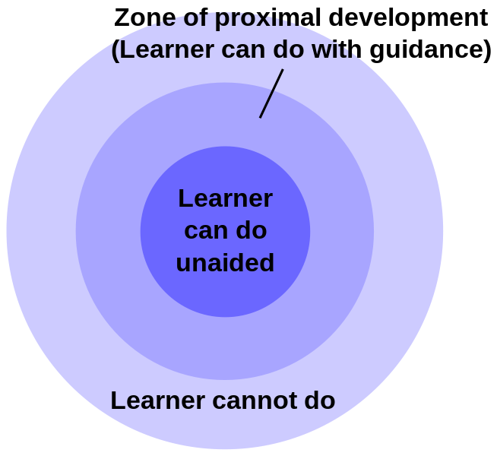

The power of socialisation was evident across the learning environment, children cooperated and communicated with each other. I believe learning happened because the teacher had ensured that the learning environment was correct, the tasks given were challenging yet not too complex they allowed the children to utilise their previous knowledge. The teacher provided the necessary scaffolding required to help the children achieve that task so that they could make those connections. Making those connections between prior knowledge and the new task ensures learning can take place.

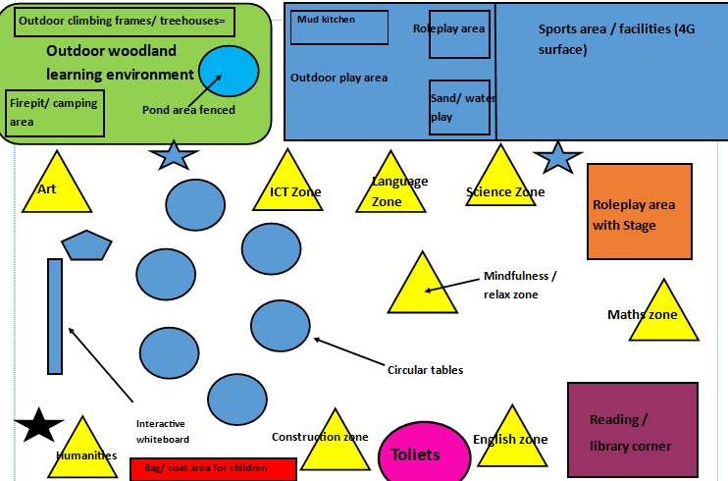
Part 3- Reflect and Innovate
Figure 2- My Classroom learning environment and key
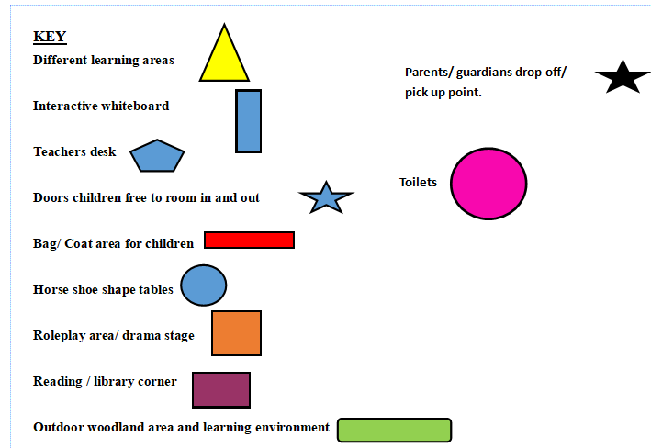

My classroom design is aimed for the foundation phase; however, it could easily be used for KS2. The classroom has separate areas of learning and experiences which are based on the Successful Futures Report (Donaldson, 2015). Donaldson’s recommended that the new curriculum should incorporate six key areas of learning; I have used this idea and adapted it further to create my ideal classroom (see figure 3). My classroom will incorporate the following:
• Art Zone
• ICT Zone
• English Zone
• Humanities Zone
• Construction Zone
• Science Zone
• Mathematics Zone
• Reading corner
• Language Zone
• Mindfulness & relaxation zone
• Sports area -with different facilities
• Outdoor woodland- firepit/ camping area & outdoor climbing frame/treehouse
• Outdoor play area- mud kitchen, roleplay area & sand/water play area
There is no music area within my classroom, due to the amount of space the instruments would take up, also the noise may be very overpowering for some students, music would be explored through a specific music room within the school.
The aim of my design is to create an active learning environment where children can have the freedom to explore, learn through play and most importantly have fun. Ginsburg (2007) talks about the benefits of play, it allows children to explore the world through a variety of different roles and overcome fears. He also mentions that “Undirected play allows children to learn how to work in groups, to share, to negotiate and to resolve conflicts.” The importance of play is also mentioned by Lester and Russell (2010) who argue that play is creating a world where children are in control and can think outside of the box, where their imagination can run wild. My classroom design allows children the freedom to select a variety of activities they wish to engage in and explore those activities in the different areas of the classroom through play. Kozulin, et al. (2003) suggest that “Students develop their independent learning processes through their own activities.” It allows the children to either work independently or within a group dynamic of their own choice. The areas themselves would stay the same but the activities in each area would regularly change, to constantly challenge the child and engage them. My design (Figure 2) illustrates two doors leading to the outside areas, the children would be allowed to roam freely inside and outside of the classroom. If the children wished to go outside, then they must put on a high-visibility vest and a teacher or Teaching Assistant (TA) must be outside to supervise them for health and safety reasons. My classroom would always have two teaching assistants attached to the class. If funding allowed, ideally the class would be taught by two teachers, allowing team teaching to take place. The children would be assessed through observation and their progress monitored through regular questioning. This would allow the teacher to ensure the children were encouraged to tackle the activities in all areas of the room. This is very much an (AFL) Assessment for Learning approach. Brown (2005) talks about how assessments need to be “fit for purpose” to allow the children to demonstrate what they have learnt. Brown and Knight (1994) agree with this they believe that assessment does not need to be testing, rather it can be achieved in a variety of ways by reviewing the children’s’ interactions with other students, observing their role play etc.

My classroom has a large outdoor space which has a sports area where the children can engage in a variety of different sporting activities; an outdoor play area where they can play in the mud kitchen, sand/ water play and a second roleplay area. It also has an outdoor woodland learning environment where children can explore the outdoors, through activities such as low ropes, trim trails, a tree house and a firepit/camping area. The reason why I have included all of these is to provide a variety of opportunities for children to learn in. It provides a completely different environment that many children have never experienced before, especially when placed within a city school. Clements (2004) talks about how children can “grow emotionally and academically by developing an appreciation for the environment.” The outdoor environment allows children to explore their surroundings but also learn outdoor survival skills such as making a fire and cooking. It provides many opportunities to incorporate cross curriculum teaching, for example when learning how to make a fire you could link it to ‘The Great Fire of London’ and really get the children to understand how and why it spread so quickly.
Considering what the outdoor experience means to the child is important (Ord and Leather 2011), as it is something so unique to each individual child.

Television programmes such as Blue Planet highlight the need for communities to act upon the environmental issues raised, from my personal experience, children were shocked with what they witnessed and wanted to question why this was happening? The teacher then allowed children to suggest ideas and debate how they could make positive changes to the environment. This links to Grigg (2015) where he mentions how "governments, employers and educators’ acknowledge that schools are struggling to keep pace with major social and economic changes, such as digital lifestyles and environmental challenges.” Educating children to understand and respect the environment in which they live is surely a fundamental goal in tackling the environmental issues. Outdoor education is one area in which children can explore and gain an understanding of the effects man can have on the environment. Brown (2010) explains how outdoor learning can “develop skills of enquiry, critical thinking … to meet the social economic and environmental challenges in the 21st century.” He also talks about how outdoor learning can help children value and appreciate the environment, it allows them to build a connection with the country’s natural heritage. Cremin and Burnet (2018) maintains that children being outdoors allows their learning to be “Engaging practically, cognitively and affectively and in its experiential nature” as they are more physically active.

Some of the aspects in my classroom are based on constructivism theory. Ültanır (2012) talks about the teacher in constructivism as a “Guide, facilitator and co-explorer.” I have included this within my classroom by allowing for different areas of learning where children are guided to go and explore and learn through different experiences. Ültanır (2012) also discusses Montessori’s approach and how the role of the teacher is to be the “facilitator” and allow children to have a choice in what they wish to learn. However, my classroom is not just constructivism, part of my classroom learning environment is also based on social constructivism from Vygotsky’s ideas of social interaction. Whereas a Montessori approach is based more on independent work, my classroom allows for the choice of group or independent work; placing the responsibility of choosing in the hands of the child. This again links back to Vygotsky’s ideas of social interaction, children learning from each other.
All of this only works if a child is confident and comfortable in a positive learning environment which has been established by the teacher with routines that the child understands. Children need to be ‘happy’ in their learning if they are to be successful, creative and develop that imagination and curiosity; Noddings (2003) talks about how happiness is essential to an individual’s well-being. This is even more important today given the pressures the children in our schools’ face from modern society e.g. split families, fitting in, social media, bullying, body image etc. Teachers’ need to understand a child’s social and emotional development if that child is to be successful in the classroom, providing a mindfulness/ relaxation zone as I have done in my classroom will ensure that the child who is upset, needs time out, or just needs a quiet place to reflect has somewhere to go. Research suggests that for a learner centred teaching approach to have a positive outcome the environment in which the children learn must be supportive, creating a climate where children feel safe, they need to become resilient, learning from their mistakes as they adjust their knowledge and understanding (Kyriacou 2014). A teacher needs to be approachable, a resource for support, guidance and encouragement. Using each of the learning zones within my ideal classroom will ensure that their problem- solving skills are developed as the teacher will provide activities which encourages meta-cognition so that the children can structure their answers and build on those answers; they are ‘learning to learn’ (Donaldson, 2015).

Conclusion
During my observation of the classroom learning event I witnessed the teacher using a ‘social constructivist ‘approach to her lesson. The children were in groups and communicated socially with each other discussing how to achieve the tasks they had been given. However, I also witnessed another pedagogical theory being used in the classroom, a ‘constructivist’ approach where the teacher acted as a facilitator’, she provided an activity for the children to explore and complete their work independently, she also used questioning and feedback to scaffold the learning with her focus group. Interestingly you could argue that there was a third approach evident throughout the observation which has not been discussed ‘operant conditioning with positive reinforcement.’ It is difficult to tell whether the children had been trained using this approach to work in the learning environment created, but they had certainly learned from her one word/small sentence commands that brought them back to focus on the task, should they lose focus. This showed that the classroom routines were already established. This observation allowed me to question my own thoughts as to which approach I would like to implement in my classroom. This led me to decide on using both a social constructivist approach and a constructivist approach in the design of my learning environment and in the planning of the activities my children would experience. The question remains is one approach on its own enough? This essay has leaned towards a mixed method approach of different learning theories, which in the context of the learning observed in the classroom appeared to be very effective; rather than relying on just one approach.

References
- Black P, Harrison C, Lee C, Marshall B and William D (2003) Assessment for Learning: Putting it into Practice. Maidenhead: Open University Press.
- Bodrova, E. & Leong, D, (2007). Tools of the Mind: The Vygotskian Approach to Early Childhood Education, New Jersey, Pearson.
- British Educational Research Association, 2018. BERA Ethical Guidelines for Educational Research 2018. Fourth edition.
- Brown, K., 2010. Curriculum for excellence through outdoor learning. Learning and Teaching Scotland.
- Brown, S., 2005. Assessment for learning. Learning and teaching in higher education, (1), pp.81-89.
- Brown, S. & Knight, P. (1994) Assessing Learners in Higher Education, London: Kogan Page.
- Child, D (1981). Psychology and the Teacher. 3rd ed. London: Holt, Rinehart and Winston. p136-154
- Clements, R., 2004. An investigation of the status of outdoor play. Contemporary issues in early childhood, 5(1), pp.68-80.
- Coe, R., Aloisi, C., Higgins, S. and Major, L.E., 2014. What makes great teaching? The Sutton Trust- Review of the underpinning research. Durham University.
- Creemers, B.P. and Kyriakides, L., 2006. Critical analysis of the current approaches to modelling educational effectiveness: The importance of establishing a dynamic model. School Effectiveness and School Improvement, 17(3), pp.347-366.
- Cremin, T. and Burnet, C. (2018). Learning To Teach In The Primary School. Abingdon: Routledge.
- Devers, K. and Frankel, R. (2000) Study design in Qualitative Research-2 sampling and data collection strategies. Education for health. Vol 13, No 2, 263-271
- Dillon, J.T. (1982) ‘The effect of questions in education and other enterprises’, Journal of Curriculum Studies, 14:2, 127-152
- Doherty, J., 2018. Skilful questioning: The beating heart of good pedagogy. Profession, 18(19), p.19.
- Donaldson, G., 2015. Successful futures: Independent review of curriculum and assessment arrangements in Wales. Welsh Government.p21-63
- Dweck, C.S., 1999. Caution--Praise Can Be Dangerous. American Educator, 23(1), pp.4-9.
- Forehand, M., 2010. Bloom’s taxonomy. Emerging perspectives on learning, teaching, and technology, 41, p.47.
- Ginsburg, K.R., 2007. The importance of play in promoting healthy child development and maintaining strong parent-child bonds. Paediatrics, 119(1), pp.182-191.
- Grigg, R., 2015. Becoming an Outstanding Primary School Teacher: Routledge.
- Hattie, J. and Timperley, H., 2007. The power of feedback. Review of educational research, 77(1), pp.81-112.
- Higgins. S, Katsipataki, D., Coleman ,R., Major, L.E., & Coe, R. (2014). The Sutton Trust- Education Endowment Foundation Teaching and Learning Toolkit. London: Education Endowment Foundation.
- Ko, J. and Sammons, P., 2013. Effective Teaching: A Review of Research and Evidence. CfBT Education Trust. 60 Queens Road, Reading, RG1 4BS, England
- Kozulin, A., Gindis, B., Ageyev, V.S. and Miller, S.M. eds., 2003. Vygotsky's educational theory in cultural context. Cambridge University Press.
- Kyriacou, C., 2014. Essential teaching skills. 4th edition. Oxford university Press.
- Lester, S. and Russell, W., 2010. Children's Right to Play: An Examination of the Importance of Play in the Lives of Children Worldwide. Working Papers in Early Childhood Development, No. 57. Bernard van Leer Foundation. The Hague, The Netherlands.
- Miles, M.B. & Huberman, M.A. (1994). Qualitative data analysis: an expanded sourcebook, 2nd edn. Thousand Oaks, CA: Sage.
- Noddings, N., 2003. Happiness and education. Cambridge University Press.
- Ong, K.K.A., Hart, C.E. and Chen, P.K., 2016. Promoting higher-order thinking through teacher questioning: A case study of a Singapore science classroom. New Waves, 19(1).
- Ord, J. and Leather, M., 2011. The substance beneath the labels of experiential learning: The importance of John Dewey for outdoor educators. Australian journal of outdoor education, 15(2), pp.13-23.
- Pickett, Linda; Fraser, Barry. Childhood Education, suppl. annual theme 2010; Olney Vol. 86, Iss. 5, (2010): 321-326.
- Rosenshine, B., 2012. Principles of instruction. American Educator, 36(1), pp.12-19.
- Rubie‐Davies, C.M., 2007. Classroom interactions: Exploring the practices of high‐and low‐expectation teachers. British Journal of Educational Psychology, 77(2), pp.289-306.
- Toews, J. (2012). Modern Education and ZPD. Available: https://talonsphilosophy.wordpress.com/2012/09/21/jonathan-toews-modern-education-and-zpd/ Last accessed 12/10/2018
- Ültanir, E., 2012. An Epistemologic Glance at the Constructivist Approach: Constructivist Learning in Dewey, Piaget, and Montessori. International Journal of Instruction. Vol, 5 No 2.
- Vygotsky, L.S. (1981). The genesis of higher mental functions. In J. V. Wertsch (ED.), The concept of activity in Soviet psychology (pp. 144-188). Armonk, NY: M. E. Sharpe.
- Yeager, D.S. and Dweck, C.S., 2012. Mindsets that promote resilience: When students believe that personal characteristics can be developed. Educational psychologist, 47(4), pp.302-314.

