Foreign Languages & Cultural Awareness

Executive Summary
The intercultural dynamics in the hospitality industry, especially Southern Asia requires sensitivity and cultural awareness that is exercised tactfully. The paper discusses the differences in culture of England and Southern Asia based on the results from a study made by GLOBE Project about cultures and leadership. One of the challenges highlighted includes communication styles, hierarchy and decision-making processes offered with resolutions such as cultural sensitivity training, clear channel of communications alongside cross-cultural collaboration. It is through the promotion of diversity and development toward inclusivity that guest services at Inclusively Hotel & Spa can be enhanced as well as to ensure sustainable business success in an increasingly globalized market.

Table of Contents
Executive Summary 2
Introduction 4
Discussion 4
Conclusion 5
Recommendations 6
Side Note 7
India 7
References 8

Introduction
Managing cultural diversity is an important factor for better service in the hospitality industry where everything changes quickly (Armstrong et al., 2022). As such, the recommended Asian location from cultural clusters is Southern Asia with dynamic country of India is an ethnically diverse region, which presents both opportunities and difficulties for the hospitality management. The cultural heritage of Southern Asia is quite rich hence a great opportunity to explore intercultural dynamics which should be discussed using the terms leadership style and teamwork (Baker and Ishikawa, 2021). Assessment of the Southern Asian culture and its need for getting into its cultural core is necessary if an employee works as an Assistant General Manager in London’s Inclusivity Hotel & Spa. Critical differences, cultural dimensions to analyse issues and recommendations for developing intercultural leadership in the hospitality industry discussed in this paper.

Discussion
Key Differences between England and Southern Asia
In countries such as England and Southern Asia especially India the cultural differences are so visible. As for England, they have a predominantly Western culture that praises punctuality and cares about individuals; their communication style lacks splendour (Bharadwaj and Jammulamadaka, 2023). Alternatively, collectivism is a key component of Southern Asian cultures where familial and societal relationships are paramount. On the matter of communication, England is characterised by directness and assertion but Southern Asians communicate indirectly to preserve harmony as well respect. In addition to this, the hierarchies are visible in Southern Asian cultures more than in England whereby they do not have such a flatter organizational structure arrangement (Bolton et al., 2020). The cuisine also immensely shines as England is a type of meat and potato country while the Southern Asian one offer flavour, varieties in spices so vegetarian dishes. Moreover, the religious pluralism is more significant in Southern Asia since Hinduism Islam Buddhism and Christianity are all present influencing different domains of everyday life while England presents a Christian fan (Wake, 2024). These differences emphasize the significance of subtle translation and flexibility in any type of cross-cultural hospitality management (Cherfan and Allen, 2022).

Analysing and comparing the two countries using a GLOBE Project Culture and Leadership Study
Several aspects of the culture and leadership study in The GLOBE Project can be used to compare England with Southern Asia (Globe Project, 2024). On the P-D dimension, there is a perception that England has lower power distance as compared to southern Asian countries like India because hierarchical structure in these states south of Asia are considered acceptable. Another related concept is individualism and collectivism (Egitim, 2022). England is much more fancied towards individualism, but there are Southern Asian cultures that favour collectivism having group solidarity and interdependence. Third, there is high level of uncertainty avoidance since people in England live organized under clear rules and structures unlike the Southern Asia region that embraces ambiguity (Klyukanov, 2020). Furthermore, relationships and harmony have a deep cultural significance within Southern Asian societies which is often associated with high in-group collectivism. Lastly, communication assertions are highly respected in England while indirect types of modes are preferred by Southern Asian countries for the sake of dignity and ensuring harmony (Weinland, 2023). These cultural differences emphasize the need for adaptable leadership styles and cross-cultural competence in hospitality (Mogea, 2023).
Discussing the Challenges of Intercultural Leadership in the Hospitality Industry
The most important problem that intercultural leadership in the hospitality industry is related to managing teams coming from countries like England and Southern Asia. Other sources of conflict can be communication patterns. However, in southern Asia indirect patterns are adopted to prevent imbalance while direct and explicit communication is promoted in UK. This difference may result in miscommunication and frustrations among the members of team. Second structural, are pertaining to the criticism of incompatibility with hierarchical structure can arise considering that England has flat organizational structures while other South Asian countries such as India have higher levels hierarchy forms. Furthermore, the perception differences pertaining to authority and decision making may cause conflict. The situation in England is different: while employee democracy is common within the decision-making processes, respect for authority and seniority remain a hallmark of Southern Asia (Rosado-May et al., 2020).

Conclusion
This is to conclude that the application of intercultural teams in a hospitality setting especially where cultural differences are prominent like England and Southern Asia reveals culturally sophisticated techniques involving culture consciousness active communication coordination across cultures. Nevertheless, a correctly structured team of such nature can be borrowing diversity in communication and decision structure from the fringes as principles to togetherness. Cultural sensitivity training; cross-cultural communication lines including networking helps to eliminate potential threats associated with intracultural conflicts or the use diversity for improved quality of guest care.

Recommendations
1. Understanding of Cultural Training: In terms of workforce cultural sensitivity training programs, it is believed that these should focus on communication styles principles decision-making processes agenda beliefs (Thompson and Matkin, 2020). The use case study, role-playing games and interactive discussions enables the demonstration of empathy and awareness in training.
2. Establish Clear Communication Channels: Settle for formal communication in the preferred style and pattern of individual. For instance, team members may report on concerns or clarifications without ridicule (Trisasanti et al., 2020). Use different technologies to facilitate communication by digital updates, replies and orders such as cultural confusion.
3. Promote Cross-Cultural Collaboration: Favour a culture where team members of different cultures learn how to complement each other and use the diversity as an opportunity for creative problem solving. Promote intercultural mentorship programs, team building and multi-racial activities with the aim of developing coordinal relationships between employees (Tuleja, 2021). Emphasize the importance of developing cultural diversity within a team, its function as an organizational practice aimed at promoting inclusivity and respect.

Side Note
Illustrations of the country scores

India
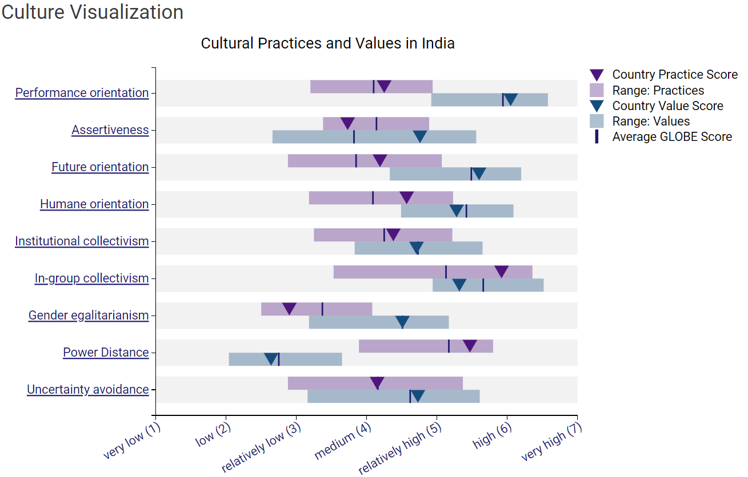
Figure 1: India Cultural Visualisation Map
(Source: India results, 2024)
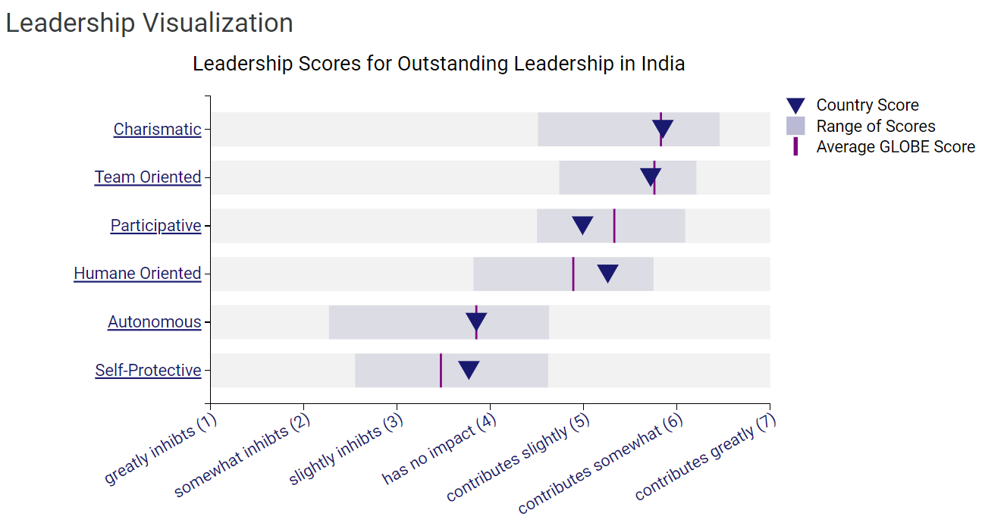
Figure 2: India Leadership Visualisation Map
(Source: India results, 2024)

References
Armstrong, E., Yin, X., Razee, H., Pham, C.V., Sa-Ngasoongsong, P., Tabu, I., Jagnoor, J., Cameron, I.D., Yang, M., Sharma, V. and Zhang, J., 2022. Exploring barriers to, and enablers of, evidence-informed hip fracture care in five low-middle-income countries: China, India, Thailand, the Philippines and Vietnam. Health Policy and Planning, 37(8), pp.1000-1011.
Baker, W. and Ishikawa, T., 2021. Transcultural communication through Global Englishes: An advanced textbook for students. Routledge.
Bharadwaj, A. and Jammulamadaka, N., 2023. Politics of colonialism in intercultural communication: Case of Indian managers. International Journal of Cross Cultural Management, 23(1), pp.169-191.
Bolton, K., Botha, W. and Kirkpatrick, A. eds., 2020. The Handbook of Asian Englishes. John Wiley & Sons.
Cherfan, J. and Allen, M., 2022. Preferred leadership communication styles across cultures. Journal of Intercultural Communication Research, 51(2), pp.134-152.
Egitim, S., 2022. Challenges of adapting to organizational culture: Internationalization through inclusive leadership and mutuality. Social Sciences & Humanities Open, 5(1), p.100242.
Globe Project, 2024. GLOBE Project. Available at: https://globeproject.com/ (Accessed: 29 January 2024).
India results, 2024. GLOBE Project. Available at: https://globeproject.com/results/countries/IND%3Fmenu=list.html#list (Accessed: 29 January 2024).
Klyukanov, I.E., 2020. Principles of intercultural communication. Routledge.
Mogea, T., 2023. Cross-Cultural Communication Barriers in Organizations. CENDEKIA: Jurnal Ilmu Sosial, Bahasa dan Pendidikan, 3(2), pp.20-33.
Rosado-May, F.J., Cuevas-Albarrán, V.B. and Jimenez Pat, N.F., 2020. Intercultural Leadership: An Indigenous Perspective in a Multicultural World. New Horizons in Positive Leadership and Change: A Practical Guide for Workplace Transformation, pp.285-311.
Thompson, H. and Matkin, G., 2020. The Evolution of Inclusive Leadership Studies: A literature review. Journal of Leadership Education, 19(3).
Trisasanti, H., Dhammasaccakarn, W., Rinthaisong, I. and Limpradit, B., 2020. Intercultural communication apprehension as a mediator between generational differences and conflict. The Journal of Behavioral Science, 15(3), pp.66-84.
Tuleja, E.A., 2021. Intercultural Communication for Global Business: How leaders communicate for success. Routledge.
Wake, A., 2024. The Indo-Pacific’s Broadcast Landscape, Strategic and Military Value. In Transnational Broadcasting in the Indo Pacific: The Battle for Trusted News and Information (pp. 7-35). Cham: Springer International Publishing.
Weinland, K., 2023. 1.4 Beliefs, Values, and Cultural Universals. Intercultural Communication.

