Title page

Name: Rashida Morton
Student Number:2112665
Module: Problem Solving and Decision-Making BMSW4004
Lecturer: Chijioke Uba

Table of content

Contents
Title page 1
Introduction: 2
Understanding the nature and impact of staff shortage on Proper Care and its employees 2
Identifying the causes of Staff Shortage 3
The alternative solutions to solve the problem (Staff Shortage) 5
Evaluation of the solution using PMI 6
Plan for implementing the solution, Monitoring and Reviewing XYZ 6
Conclusion: 6
References: 7

Introduction:
The thinking of an individual begins with the awareness of the problematic situation. In this case, the difficult situation has the potential to grow into a problem that deserves a solution. Every issue is bound to be a tough situation. However, not every problematic situation becomes a problem because this reality depends on the individual. A person, who finds themself in a challenging situation and is aware of its existence, does not have to "see" the problem until the ability of the problem awareness is developed. The individual, who is aware of the problem, can specify the difficulty or source of the conflict which causes the problematic situation and can deal with the problem. Contrary to that, the individual who cannot be aware of the problem is albeit experiencing the feeling superimposed by curiosity. However, he does not realise what causes the difficulty.
Decision-making (reference) is the study of identifying and choosing alternatives based on the values and preferences of the decision maker. Making a decision implies that there are choices to be considered. In such a case, we want to identify as many of these alternatives as possible and choose the one that best fits our goals, objectives, desires, and values. (Harris (1980)) According to Baker et al. (2001), decision-making should start with the identification of the decision maker(s) and stakeholder(s) in the decision, reducing the possible disagreement about the problem definition, requirements, goals, and criteria. Decisions must be made when you face a problem.

Applying logic, fundamental problem solving and decision-making is essential to solve problems effectively. This process starts with identifying the problem and its causes. Subsequently, proposing alternative solutions that target the leading causes previously identified. An evaluation to choose the appropriate one is the next step. Finally, there is a need to develop a plan that outlines how the chosen solution will be implemented.
This report will apply the logic of problem-solving and decision-making to solve the problem of staff shortage in Proper Care.

Understanding the nature and impact of staff shortage on Proper Care and its employees
The first step to solving any workplace problem is to clearly understand the problem and its nature and impact. Staff shortage (reference) is a UK-wide and long-term problem, and if it continues to go the way it is, it will not only affect proper care. It will continue to affect the NHS and other adult and care organisations. It affects the organisations, leading to a further deterioration in care quality and potentially undermining the future sustainability of services and the waiting lists continue to grow. Patients will have longer wait and will become more ill as they are not treated quickly enough. Staff shortage is having a significant impact on employees and employers. The mental health of staff working is at risk as they are being overworked and underpaid, causing stress, so staff are choosing to leave the profession leading to staff shortage.

Following a detailed understanding of the nature and impact of staff shortage on proper care and its employees and patients, the next step was to identify the causes of the problem.

Identifying the causes of Staff Shortage

To solve any problem effectively, the first and perhaps, most crucial step is to identify the causes of the problem. Numerous tools of analysis could be used to achieve this. For this report, the PESTLE and Fishbone model of analysis have been employed
Over the past 20 years, the phrase PESTLE has been often utilised. Francis J. Aguilar (1967) may have made the first mention of the methods and instruments for "Scanning the Business Environment" when he discussed the "ETPS" prompt, which stands for "Economic, Technical, Political, and Social," one of the four categories he used to categorise the environment. Political, Economic, Sociocultural and Social, Technological, Environmental, and Legal, or PESTEL, is an abbreviation (L). The framework helps identify external influences on an organisation. Since all organisations are impacted by several external circumstances, starting without such a structure would be challenging. At the business level, strategists employ it.
The PESTLE analysis conducted to identify the external environmental factors underpinning staff shortage uncovered three main factors. These are discussed below:
Political – Brexit regulations on immigration caused lots of EU nurses and doctors to leave the UK, leading to staff shortage in care homes like Proper Care ….....(Milner et al, 2021) According to Milner (2021), European doctors and nurses left the UK for several reasons. Specifically, they felt unwelcome and considered Brexit to lead to instances of racism. ...

Economical – low salary and costs of living crisis leading to staff shortage as nurses leave for alternative professions according to (Barbara Stilwell, 2004) Of the 175 million people (2.9% of the world’s population) living outside their country of birth in 2000, 65 million were economically active. The rise in people migrating is significant for many developing countries because they are losing their better-educated nationals to more affluent countries. Medical practitioners and nurses represent a small proportion of the highly skilled workers who migrate. Still, the loss for developing countries of human resources in the health sector may mean that the capacity of the health system to deliver health care equitably is significantly compromised. It is unlikely that migration will stop, given the advances in global communications and the development of global labour markets in some fields, including nursing.

Sociological – careers attitudes do not favour training to be carers/nurses. The workforce at care homes, which totals more than 500,000 in the UK, is crucial to the calibre of care given to residents. Much of the care provided in this setting is insufficient, person-centred, and disregards people’s dignity. Burnout affects nurses working in nursing homes for various reasons, which lowers the standard of care. According to recent findings, the growth of nurse leadership and the clarification of professional principles can improve the quality of care for older adults. Cultures of care need to be addressed through training, better workforce support, and oversight. Through an educational intervention, burnout should be addressed, enhancing patient care and the nursing staff's experiences.

Environmental – staff shortage may be caused (temporarily) by weather. Recent talks and prior research frequently suggest that the labour market for healthcare professionals in Germany is a problem for hospitals there. However, research has only provided a few clues about how environmental and organisational factors explain variations in staff shortages, how staffing ratios are affected by staff shortage measures, and how essential staff shortages are for patients. Hospital staff shortages, as determined by self-reports, vacancies, and turnover, are significantly correlated with several environmental and organisational factors, according to regression analyses based on survey data from 104 German hospitals from 2015 to 2016. These analyses also included information on the labour market and patient satisfaction.

Another helpful tool is cause and effect analysis for concentrating on causes rather than symptoms taking note of a group's combined knowledge and experience, giving a picture of the cause of an effect or problem and establishing a solid foundation for future data collection and action. The areas that need to be addressed to produce a good effect can all be found through cause and effect analysis.
A cause and effect diagram, commonly referred to as a fishbone or an Ishikawa diagram, is a step-by-step diagram that graphically displays the analysis findings. Prof. Kaoru Ishikawa was the one who created it. It establishes systematic links between "effect" and "cause(s)" The fishbone (Ishikawa) diagram is primarily an example of a suggestive presentation model for the relationships between an event (effect) and its several underlying causes. The diagram's structure enables team members to think very organised manner. The advantages of creating a Fishbone diagram include that it employs an organised technique to help identify the underlying causes of an issue or quality attribute, stimulates group engagement, makes use of the process knowledge of the group, and detects data gaps that should be gathered for more research (Basic Tools for Process Improvement, 2009).
Using the fishbone diagram, I was able to identify other causes not covered by PESTLE analysis
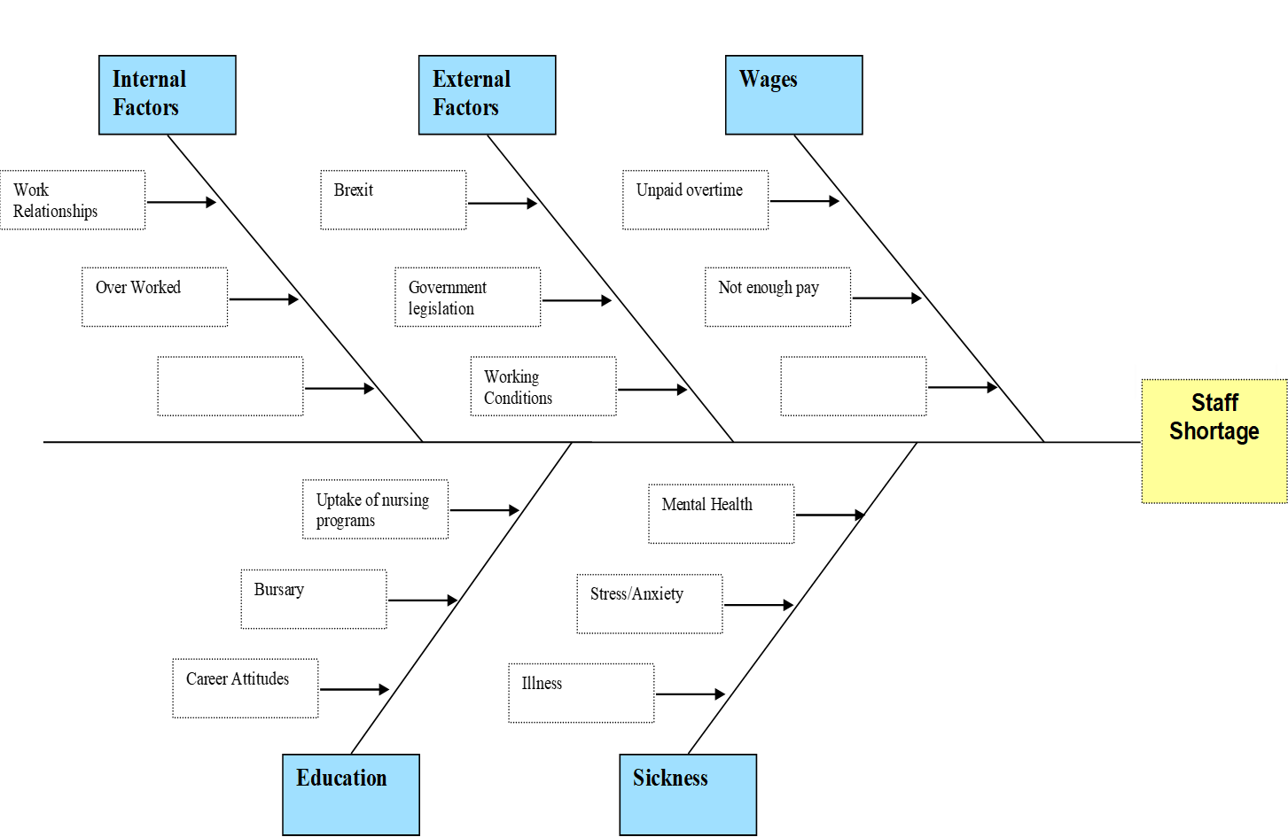
The PESTLE and Fishbone enable the identification of the cause of staff shortage. Drawing from these, the possible solutions that target the leading causes were subsequently identified.

The alternative solutions to solve the problem (Staff Shortage)

The leading Solutions to staff shortage from my PESTLE and Fishbone are agency staff for sick staff work practice for poor working conditions and job fairs for careers attitude. All of these solutions will help improve staff shortage
Agency staff or cover system will help cover staff who need time off instead of just not turning up for work without cover, so patients will still be able to be cared for
Work practice for all staff to follow to ensure the best working conditions for both employees and patients, which will, in turn creates a better work environment for all
Job fairs to give those interested in nursing a better understanding of what they will be required to do, it is essential to let people know the hard side of nursing but also the rewarding and positive effects it also has.
The next step was to evaluate the solutions to choose the most appropriate one

Evaluation of the solution using PMI
using the PMI, the main solution was identified as work practices/training to help improve staff shortage
The PMI highlighted that Agency staff/cover system is the most appropriate. In the next section, the plan on how to implement work practices/training will be discussed

Plan for implementing a solution, Monitoring and Reviewing XYZ
Implementing work practices in proper care by having regularly staff meetings followed by monthly staff training and also giving incentive/bonuses. Nurses are crucial to delivering high-quality patient care. The way it works and is organised and the way information is used needs to be improved to draw in top nurses, provide them with the tools they need to do their best work, and keep them as long-term workers.

Conclusion:

Inadequate numbers of new nurses are being educated (mainly due to a lack of nursing school faculty), but to a greater extent, the current shortage is caused by freshly graduated nurses' reluctance to pursue positions in hospitals/adult care. The major reasons given by nurses for feeling unsatisfied with their work are stress-related burnout and the significant amount of time they must spend on non-nursing chores; 43 per cent of nurses say they intend to quit their positions within the next three years. As a result, the mid-forties is the average age of hospital nurses.
Every year, nurses put in an additional eight and a half weeks of work. Recent research has shown that taking care of too many patients, Leads to errors and poor quality of care. More practices and programs need to be put in place for a better quality of care.

References:

Buchan, J., Charlesworth, A., Gershlick, B. and Seccombe, I., 2019. A critical moment: NHS staffing trends, retention and attrition. London: The Health Foundation.
Hassmiller, S.B. and Cozine, M., 2006. Addressing the nurse shortage to improve the quality of patient care. Health Affairs, 25(1), pp.268-274.
Ilie, G. and Ciocoiu, C.N., 2010. Application of fishbone diagram to determine the risk of an event with multiple causes. Management research and practice, 2(1), pp.1-20.
Milner, A., Nielsen, R. and Norris, E., 2021. Brexit and European doctors’ decisions to leave the United Kingdom: a qualitative analysis of free-text questionnaire comments. BMC health services research, 21(1), pp.1-8
Rastogi, N.I.T.A.N.K. and Trivedi, M.K., 2016. PESTLE technique–a tool to identify external risks in construction projects. International Research Journal of Engineering and Technology (IRJET), 3(1), pp.384-388.
Smythe, A., Jenkins, C., Galant-Miecznikowska, M., Bentham, P. and Oyebode, J., 2017. A qualitative study investigating training requirements of nurses working with people with dementia in nursing homes. Nurse education today, 50, pp.119-123.
Stilwell, B., Diallo, K., Zurn, P., Vujicic, M., Adams, O. and Dal Poz, M., 2004. Migration of health-care workers from developing countries: strategic approaches to its management. Bulletin of the World health Organization, 82, pp.595-600.
Winter, V., Schreyögg, J. and Thiel, A., 2020. Hospital staff shortages: environmental and organizational determinants and implications for patient satisfaction. Health Policy, 124(4), pp.380-388.

