

Student Name: Estela Peralta
Student ID: 2527558
Module Name: Introduction to Health and Social Care
Module Code: LCHS4003
Lecturer: Umma Suleiman

Poster
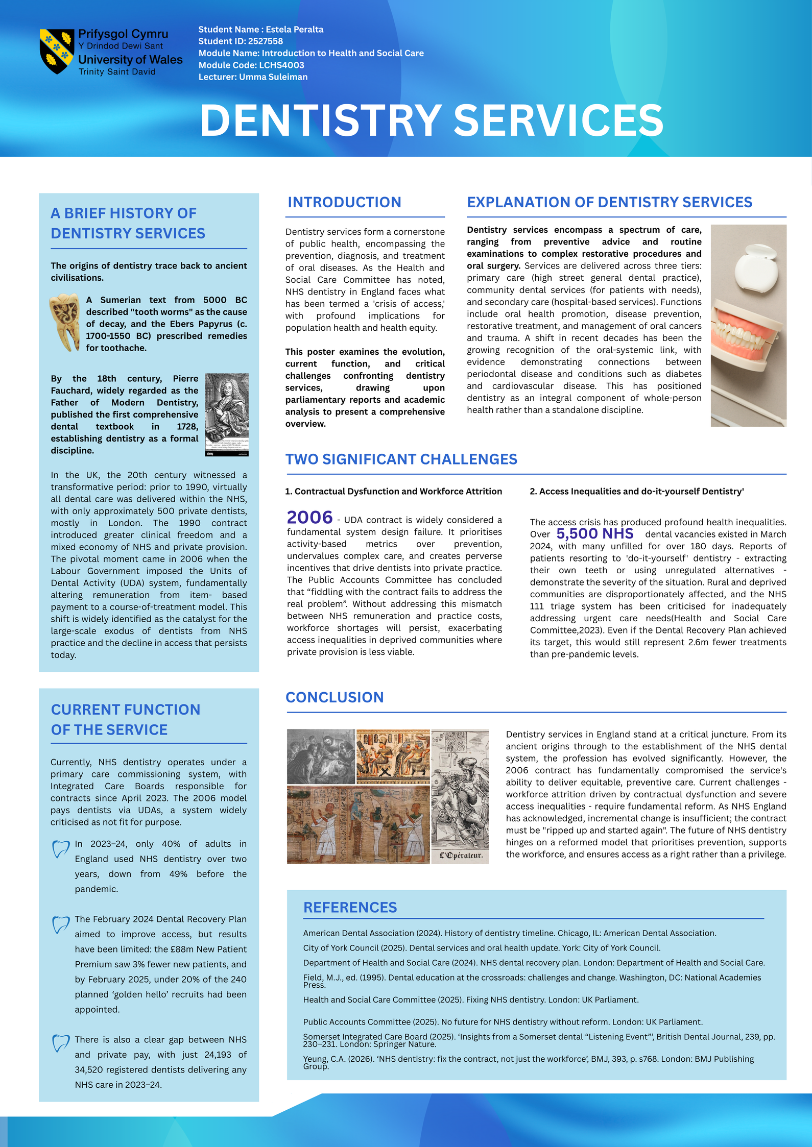

Essay
Introduction
Community disability services represent a fundamental shift from institutional segregation towards supporting disabled people to live as equal citizens. This essay investigates the origins of these services, explores their historical context, critically evaluates current functioning, and discusses their significance in enhancing service users' quality of life.
Origins and Historical Context
The roots of community disability services lie in a long tradition of institutionalisation rooted in the Old Poor Law of 1601. This legislation established what disabled people have characterised as the "administrative model," viewing them as a problem requiring officials "to define, classify, register, administer and control". Disability was interpreted through the individual or 'medical model'—as a problem of the body or mind rather than a socially created issue.
The 1960s and 1970s saw the emergence of community service systems based on the "continuum model," offering services ranging from restrictive residential care to supported independent living. However, this approach proved limited; many people became "stuck at the restrictive end of the continuum" and experienced a "very little genuine community".
A transformative shift occurred with the rise of the disabled people's movement. In 1976, the Union of the Physically Impaired against Segregation (UPIAS) redefined disability through the social model: "the disadvantage or restriction of ability caused by a contemporary social organisation which takes little or no account of people who have physical impairments". This paradigm shifts fundamentally challenged the notion that disabled people's bodies were the source of their problems, paving the way for civil rights campaigns and a new approach to community supports.
Current Function
Contemporary community disability services function through a complex framework. In the UK, specialist teams provide multidisciplinary care, and person-centered planning is considered a cornerstone of practice. The integration of health and social care has been identified as a "significant strength," with co-located models enhancing access, reducing delays, and ensuring care is better aligned to needs.
Despite these advances, significant challenges remain. Services now operate within the context of individualised planning and direct funding. However, quality of life outcomes remain variable; a recent study of over 5,800 service recipients found participants had only 48.4% of quality-of-life outcomes present in their lives. Disparities exist based on age, race, disability type, and support needs, with people of colour and those with more complex needs experiencing poorer outcomes.
Critical Evaluation and Significance
The significance of community disability services in enhancing quality of life is profound, yet contingent on effective implementation. Research demonstrates that person-centered care models produce meaningful improvements: reported outcomes include "greater autonomy, independence and emotional stability, fewer crises, stronger social belonging, and reduced staff burnout".
Quality of life is enhanced through several mechanisms. Community-based services facilitate participation in employment, education, and social activities. People receiving services emphasize the importance of choice, dignity, and being seen as "someone else living in society." However, the quality of support matters significantly; when services fail, the consequences are severe.
Conclusion
Community disability services have evolved from a history of institutional control towards a rights-based, person-centered paradigm. While significant progress has been made in shifting from segregated care to community inclusion, persistent disparities and quality challenges remain. The significance of these services ultimately lies in their capacity to enable citizenship, autonomy, and belonging—but this potential is only realized when services are genuinely person-centered, properly resourced, and held accountable to the people they support.

References
Care Inspectorate Wales (2025) Assurance Check of Torfaen Learning Disability Services. Cardiff: CIW.
Community Living Algoma (2026) 'Transitioning to a Person-Centered Care Model', Health Management, 26(1).
Davis, K. (1998) The Disabled People's Movement: Putting the Power in Empowerment. Sheffield University.
Friedman, C. and Rizzolo, M.C. (2025) 'Disparities in Quality-of-Life Outcomes and Quality of Supports among People with Disabilities Who Receive Home- and Community-Based Services', Journal of Developmental and Physical Disabilities.
Shankar, R. et al. (2026) 'Organising care for complexity: a pathways model for adult community intellectual disability services', International Review of Psychiatry.

