
AWD Torque Vectoring

Combined Advance Vehicle Dynamics

ACHA6003/6011

Lecturer: Mark Sandford

BEng Automotive Engineering

Duke Asamoah

1706143

Contents
1 Table of figures 3
Abstract 4
2 Introduction 5
3 Investigation 5
3.1 Base Vehicle data 5
3.1.1 Background research 5
3.1.2 Mass distribution 7
3.1.3 Drive line layout 7
3.1.4 Control strategy 8
3.2 Torque Vectoring Systems 8
3.3 Lumped mass of the vehicle 9
3.4 Longitudinal Centre of Gravity 10
3.5 Vehicle’s moment of inertia 11
3.6 Inertia conjugate 11
3.7 Dynamic Index 12
3.8 Vehicle specifications 13
3.9 Front wheels mechanical torque path 13
3.10 Clutch pack torques 14
3.11 Potential longitudinal acceleration on different surfaces 14
3.12 Yaw rates increase relative to hand wheel position 14
3.13 Controller sensors required and potential vehicle dynamic improvements 14
4 Conclusions and summary 14

Table of figures
Figure 1 The Ferrari FF driving on sand with ease (Ireson, 2011) 5
Figure 2 Ferrari FF layout (Glucker, 2011) 7
Figure 3 longitudinal force and slip ratio connections under various wheel slip angles, lateral force and slip ratio relationships under various slip angles (Li, 2009) 8
Figure 4 Longitudinal force vs slip ratio (Wang et al., 2021) 9
Figure 5 Calculation in excel to obtain the longitudinal Centre of Gravity 10
Figure 6 Calculation in excel to achieve the moment of inertia 11
Figure 7 Calculation in excel to obtain the Inertia conjugate 12

Abstract
This report analysis the key feature of the Ferrari FF, this includes research about its important feature, torque vectoring. To better understand how the torque vectoring front wheel drive system affects vehicle dynamics and possible management options.

Introduction
Ferrari released their first all-wheel drive vehicle in March 2011; this vehicle is known as the Ferrari FF. The purpose of this report is to analyse the FF in a way to the methods used by a rival car manufacturer (in order to gain a competitive edge). In order to achieve this, aim several areas of investigation including theoretical research and calculation based of vehicle data must be carried out. The key points of focus will be:
- Base Vehicle data
- Torque Vectoring Systems
- Lumped mass model
- Longitudinal Centre of Gravity position
- Vehicle moment of inertia
- Position conjugate
- Dynamic Index
- Vehicle specifications
- Front wheels mechanical torque path
- Clutch pack torques
- Potential longitudinal acceleration on different surfaces
- Yaw rates increase relative to hand wheel position
- Controller sensors required and potential vehicle dynamic improvements
The report will end with a summary of the findings and any further recommendations for future development.

Investigation
As mentioned in the introduction above, this section will be divided into multiple sub sections.

Base Vehicle data

Background research
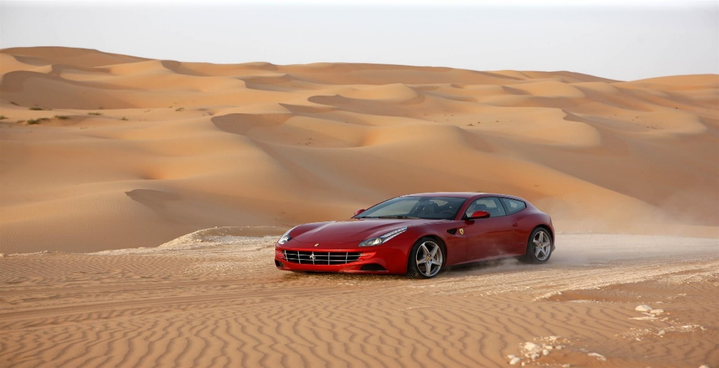
When Ferrari unveiled their all-wheel drive shooting brake vehicle, the automotive community divided into three camps: those who loved it, those who despised it, and those who were ambivalent. However, fresh facts on FF's All wheel drive (AWD) system may not alter that reality, but it's guaranteed to excite all parties and cause unending discussion, especially among Lamborghini Aventador enthusiasts. Despite the existence of seven forward speeds in the main gearbox, it only has all-wheel drive in first through fourth ratios. For the first four gears of the main box, the forward transmission is powered by a conical gear located at the front of the engine. As a result of gear multiplication/reduction, in fifth through seventh gears, the rear wheels can handle the torque. There are two primary purposes for the system: improving the vehicle's poor-surface (mud, snow, gravel, ice and sand) grip and reducing the vehicle's speed and gearing on these types of terrain. Starting from a standstill and scrabbling out of low-speed bends, when forward bite is at its most valuable, help from the front wheels will offer both more acceleration and traction, easing some of the weight from the rear tyres (Ireson, 2011).
Figure 1 The Ferrari FF driving on sand with ease (Ireson, 2011)
The following section down below will discuss all-wheel drive in more detail and the advantages and disadvantages that come with it.
AWD is a relatively new type of vehicle drive system that distributes power to the wheels with the best grip. Through three 'differentials': central, front, and rear, power can be distributed between the front and rear wheel axles or between individual wheels. A differential is a mix of the AWD gearbox and advanced engineering that transfers power from the transmission to the correct axles of an automobile. AWD is available in two configurations: mechanical and electronic. Mechanical AWD employs the differential-based method described above, but SUVs from 2015 and 2016 also feature digitalised 'electronic' AWD. Each wheel of the car is equipped with sensors that accurately monitor traction, wheel speed, and more. An ECU (Electrical Computer Unit) uses this data to determine which wheel has the most grip. Electronic AWD is frequently referred to as 'torque vectoring’ (which will later be elaborated on). (Sandicliffe, 2016).
All-Wheel Drive (AWD) is indeed a difficult system, but that is a very important advancement in current automobiles that may significantly increase road safety and driving skills.
Key advantages for an All-wheel drive vehicle:
- Increased traction in icy or wet conditions - All-wheel drive systems distribute traction swiftly and skilfully to the proper wheels when the road is wet, ice, or otherwise treacherous. This aids with the stability of your vehicle when driving in inclement weather.
- Enhances all-round manoeuvrability - Intelligent torque vectoring is used in the newest AWD systems, from ordinary crossovers to supercars. It is simpler to drive on uneven roads because to the ECU's ability to adjust the grip and speed within each wheel.
- AWD is always activated - In contrast to All-Wheel Drive, which kicks in automatically when the engine starts, 4-Wheel Drive must be engaged by the driver.
- Improves the control and grip of a variety of vehicles - The SUV's handling and other areas of sports car performance can be improved with all-wheel drive (AWD). For dynamic everyday driving, several popular cars have updated from 4x4 to AWD (Hartman, 2022).
The disadvantages of AWD must also be considered:
- Pricing - Although the resale value may be better than a two-wheel drive, the original purchase price is more. Different systems might cost as much as $5,000 for the same car. The complexity of AWD means that it costs more to maintain than conventional two-wheel drive vehicles. If there is an issue with the vehicle, buyers who are thinking about buying a used automobile without a guarantee might be on the hook for a significant sum of money.
- Low fuel economy - Apart from the additional expense of the car, these AWD systems have a much worse fuel economy. Due to the increased weight of AWD cars and the engine's requirement to supply power to all wheels, vehicles consume four to ten percent more fuel than two-wheel-drive vehicles.
- Preconceived choices - When purchasing a new car, most customers pick AWD over two-wheel drive without hesitation, believing they will have an advantage on icy conditions. What people do not realise is that AWD systems boost traction to aid acceleration; it has no influence on the car's braking or handling in treacherous circumstances. The braking and handling characteristics are identical to that of a two-wheel drive.
- Advanced technology for 2-wheel drive - While new and improved technology has not yet (Wan, 2017)achieved the performance of an AWD car in a two-wheel drive vehicle, it is near. Many two-wheel-drive vehicles now have traction and stability control, which allows the driver to direct more power to one wheel while decreasing power to another.
If required, the driver can even entirely remove power to one wheel to avoid the car spinning out of control. On the other hand, ABS improves a vehicle's stopping ability and is not restricted to AWD cars (Pande, 2020).

Mass distribution
The all-wheel drive system is 50% lighter in mass than a conventional four-wheel drive arrangement in comparison. Weight-to-power ratio and performance of the FF are considerably enhanced as a result. This configuration allows for the preservation of a low centre of gravity as well as the preservation of Ferrari's performance car weight distribution, with more than 50% of the car's weight distributed over the rear axle since it is a front engine vehicle (Edmunds, 2020; Ferrari, 2011).
The FF's front-mid-mounted engine and rear-mounted transmission result in an ideal front-to-rear weight distribution of 47:53 (Wan, 2017).

Drive line layout
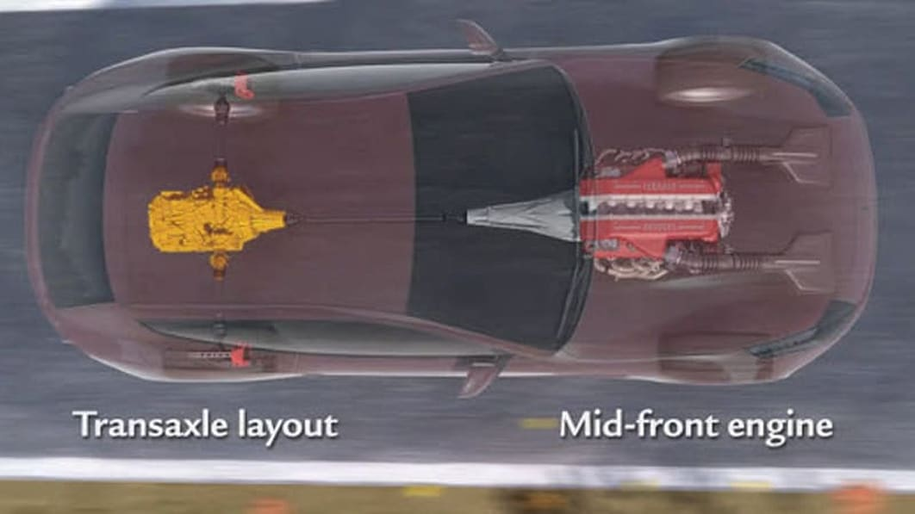
With a seven-speed dual clutch gearbox in the back between the rear wheels, this automobile features a mid-front positioned engine with a driveshaft that connects directly to its engine's rear end (Whyhighend? ,2010).
Figure 2 Ferrari FF layout (Glucker, 2011)

Control strategy
The first precaution is a panic response that may be triggered by the driver using the steering wheel. The Ferrari FF has a swivelling rear end to deal with understeer, most drivers do not open the steering wheel when the understeer occurs. In addition, the driver just must softly push the brake to avoid ABS from stepping in, which is considerably simpler than with the Italia's firm pressure point, and the Ferrari FF transforms a severe understeer into an exhilarating oversteer. As the Ferrari FF slides, the driver must exert a fair amount of effort in order to get it back on track (Davis, 2022).

Torque Vectoring Systems
Torque vectoring mechanisms primarily intend to increase a vehicle's traction, particularly while travelling in wet, muddy or icy conditions. Torque vectoring is a computer-controlled technology that regulates the amount of power sent to each wheel by the car's engine or motors. By more efficiently managing power, a vehicle equipped with torque vectoring will have even more traction on treacherous terrain and will accelerate more swiftly. In order to disperse such power, an electronic torque vectoring system is used. By controlling how much torque is transmitted to each wheel and how much slack is permitted, the differential uses many clutches to do this. This will depend on how much traction the wheels have and what the driver wants them to do (Hirons, 2022).
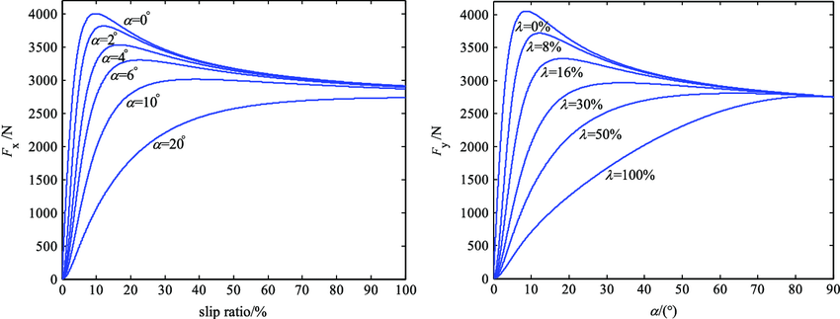
While cornering, a vehicle with a rear-wheel independent-drive (RWID) system may benefit from a torque vectoring control method. Initially, the longitudinal linear stiffness of each driving wheel is calculated using the recursive least squares method. Initial differential torque is then computed to reduce the total tyre slippage energy dissipation of the vehicles involved. An acceleration slip regulation (ASR) is inserted into overall control plan before differential torque is provided to the two driving wheels to prevent approaching the tyre adhesion saturation area and causing excessive slip. The torque vectoring control method and tyre longitudinal linear stiffness are tested in a variety of manoeuvre scenarios to ensure the accuracy of the estimates. It has been shown that a 17 percent decrease in slip power consumption may be achieved by using the suggested torque vectoring control (Wang et al., 2021).
Figure 3 longitudinal force and slip ratio connections under various wheel slip angles, lateral force and slip ratio relationships under various slip angles (Li, 2009)
During cornering, the lateral transfer of normal force from one side of the wheels to the other during vehicle body roll causes the slip of the outer-wheel to result in a lower slip of the inner-wheel. Therefore, if the driving torque is evenly split between the two wheels, the outer-wheel cannot fully use the sticky state, even if it still has adhesion margin, and the inner-wheel may also easily slide owing to the comparative large traction force need (Wang et al., 2021).
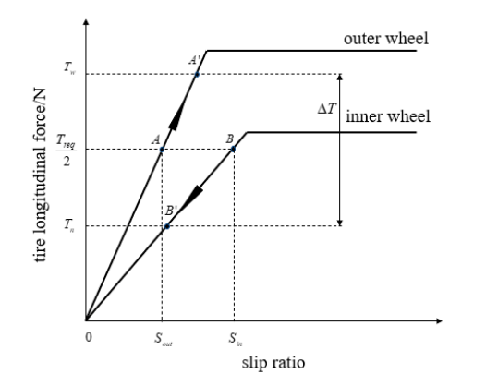
Figure 4 Longitudinal force vs slip ratio (Wang et al., 2021)

Lumped mass of the vehicle
In a lumped mass model, all the components are treated as if they were one big mass in space (Lobontiu, 2018).
The mass components for the Ferrari FF that will be investigated are:
- Gearboxes (front and rear)
- Engine (V12)
- Driver
The masses of these parts will be split into 3 individual masses: the engine at the front being mass 1 (m1), the driver at the front centre being mass 2 (m2), and the gearbox at the rear being mass 3 (m3).
The front gearbox which will be included with mass 1 being the engine. The front gearbox will weigh 60kg and the engine will weigh 340kg,this will make m1 a total of 400kg.
The Driver of the Ferrari FF would weigh 100kg. This mass will be considered as mass 2.
The rear gearbox at the back of the vehicle weighs 90kg. this mass will be considered mass 3.
This is a spreadsheet made in excel to show the values discussed above:
 | Length (m) | Mass (Kg)
Mass 1 (Engine) |  | 400
Mass 2 (Driver) |  | 100
Mass 3 (Gearbox) |  | 90

Longitudinal Centre of Gravity
It is theorised that a vehicle's centre of gravity (CG) is the point at which the total mass of all its constituent parts acts as a single unit. The vehicle acts as if its whole weight is concentrated in this one location, since that is the way, it is in terms of physics (Car and Driver, 2018).
In order to find the centre of gravity, the following formula is required -
$$F=\frac{M2L1*M3L2}{M1+M2+M3}$$
- F being the longitudinal centre of gravity
- L1 length from mid point of the vehicle to the front wheelbase
- L2 length between wheelbases
- M1 frontal mass
- M2 mid-vehicle mass
- M3 rear mass
Using this formula in excel give the following calculation and result
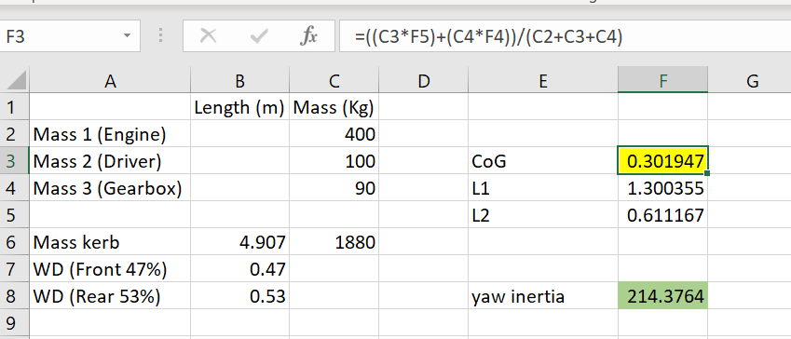
Figure 5 Calculation in excel to obtain the longitudinal Centre of Gravity
The table above shows the workings of how the longitudinal Centre of Gravity position was obtained. L1 was achieved by multiplying the length of the Ferrari ff (4 metres) and the frontal weight distribution (53%) together and dividing it by 2. L2 was achieved by multiplying the length of the Ferrari ff and the rear weight distribution (47%). By summing up the formula as seen above, the centre of gravity equates to 0.301947 m. This value will be used as an asset to find the vehicle’s moment of inertia.

Vehicle’s moment of inertia
The moment in this concept is dictated by the centre of gravity's front-to-rear placement. During cornering, the automobile rotates (changes direction) around its centre of gravity, and the farther apart the centres of weight concentration are from the centre of gravity (which serves as their common centre), the greater the moment (Webmaster, 2009).
In order to find the moment of inertia, the following formula is used –
I = (M₁ x r²) + (M₂ x (1-r)²) + (M₃ x (1-r+0.5)²)
In the formula above the following variables are used –
- I: this is the moment of inertia
- M₁: mass 1
- M₂: mass 2
- M₃: mass 3
- r: Centre of gravity
This formula can be calculated in Microsoft Excel as seen below
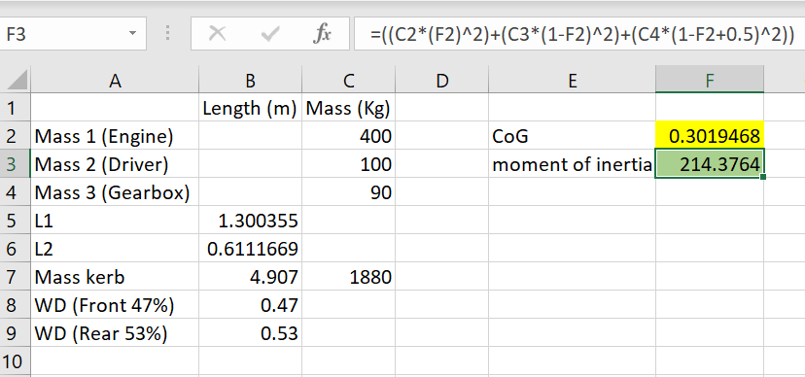
Figure 6 Calculation in excel to achieve the moment of inertia
The moment inertia was calculated by taking the total mass of the vehicles (m) and multiplying it by the longitudinal centre of gravity (r). The value received as shown above is 214.3764 kg/m². This figure will be used to find the Inertia conjugate.

Inertia conjugate
An inertial conjugate is a position where no translation occurs when a free entity with finite mass and inertia qualities is loaded at an angle that does not pass through its centre of gravity. While loading, no translation takes place, regardless of whether it is a percussion-based load or not. A characteristic of 'stiff' bats in several sports, notably baseball and its ilk, is their tendency to find their ‘sweet spot’. Contrary to popular belief, this is not the same thing as a stringed racket. This is the 'centre of percussion' or the inertial conjugate. It's the same concept applied to an automobile. The application of force is at the front wheels, which resolves to the force and moment at the centre of gravity. The mass, moment of inertia, and distance from the centre of gravity to the front and rear axles all contribute to the lateral acceleration, lateral force, direction, and magnitude at the rear wheels. (Blundell & Harty, 2004).
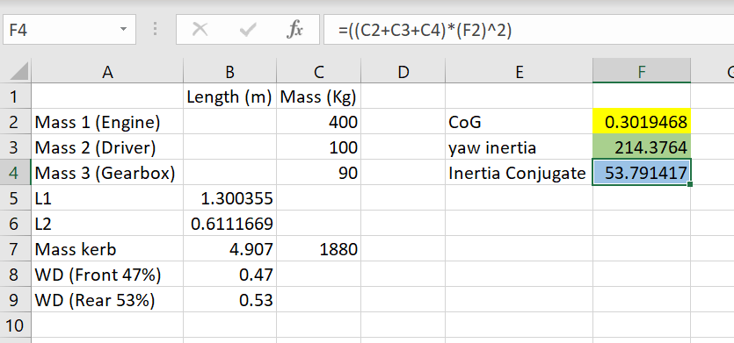
Figure 7 Calculation in excel to obtain the Inertia conjugate
Seen from above is a table of how the inertia conjugate is calculated. The inertia conjugate (I_{zz}) was obtained by using all 3 masses (m) and multiplying them by the centre of gravity distance and squaring it. The value attained as shown above is 53.791417 Kg/m². This figure will be used to find the dynamic index.

Dynamic Index
The dynamics of the real vehicle are significantly impacted by the whole vehicle's yaw moment of inertia, which is dominated by the body and accompanying masses. An often-debated metric is the ratio k²/ab, also referred to as the 'Dynamic Index,' where k denotes the radius of gyration associated with Izz and a and b denote the longitudinal location of the vehicle mass centre relative to the front and rear axles, respectively (Blundell & Harty, 2004).
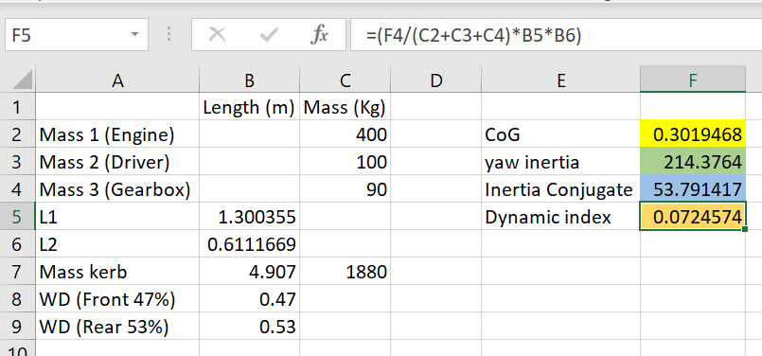
As seen in the table above, the dynamic index was calculated by taking the inertia conjugate (I_{zz}) and dividing it by the masses and multiply it by a and b. The value obtain was 0.0724574. The figure obtain is below 1. This means the rear of the car moves outwards and the inertial effects add to rear tyre slip angle.

Vehicle specifications
Here is the Ferrari ff specifications:
Powertrain
- Engine 6.3 engine (V12)
- Power 651 horsepower at 8000rpm
- Torque 683Nm at 6000rpm
- Induction atmospheric
- Fuel type premium
- Transmission 7 speed automatic
- Drive train all-wheel drive
Vehicle Type
- Hatchback
- Category sports car
Fuel efficiency
- City 21.4 L/100km
- Highway 14.7L/ 100km
- Combined 15.4 l/100km
- Autonomy 590km
- CO2 emissions 423 g/km
Steering/Suspension/brakes/tires
- Steering Rack and pinion with assist
- Front suspension independent (double wishbones)
- Rear suspension independent multilink
- Front brakes disc
- Rear brakes disc
- Front tires 245/35ZR20
- Rear tires 295/35/ZR20
Safety
- Seatbelts 4
Dimensions and weight
- Length 4907mm
- Width 1953mm
- Height 1379mm
- Wheelbase 2990mm
- Front track 1676mm
- Rear track 1661 mm
- Weight 1884kg (The Car Guide, 2022)

Front wheels mechanical torque path

Clutch pack torques

Potential longitudinal acceleration on different surfaces

Yaw rates increase relative to hand wheel position

Controller sensors required and potential vehicle dynamic improvements

Conclusions and summary

References
Blundell, M., & Harty, D. (2004). The Mutlibody systems approach to vehicle dynamics.
Car and Driver. (2018). Explained: How To Measure a Vehicle’s Center-of-Gravity Height. https://www.caranddriver.com/news/a18201745/explained-how-to-measure-center-of-gravity-height/
Davis, J. (2022). Ferrari FF in the driving report: 660 PS four-wheel drive on test drive | CAR ENGINE AND SPORT. https://topgear-autoguide.com/category/sports-car/ferrari-ff-in-the-driving-report-660-hp-all-wheel-drive-on-test-drive1607335326
Edmunds, D. (2020). Ferrari FF info scan 2020.pdf.
Ferrari, S. p. A. (2011). Ferrari_int FF_2011.pdf.
Glucker, J. (2011). Video: Ferrari FF 4RM drivetrain explained. https://www.autoblog.com/2011/03/08/video-ferrari-ff-4rm-drivetrain-explained/
Hartman, D. (2022). What are the Benefits of All Wheel Drive? https://itstillruns.com/benefits-wheel-drive-5463557.html
Hirons, R. (2022). Torque vectoring explained | carwow. https://www.carwow.co.uk/guides/glossary/what-is-torque-vectoring#gref
Ireson, N. (2011). Yet More Details On Ferrari’s FF All-Wheel Drive System. https://www.motorauthority.com/news/1056494_yet-more-details-on-ferraris-ff-all-wheel-drive-system
Li, L. (2009). The relationships of the longitudinal force and the slip ratio under... | Download Scientific Diagram. https://www.researchgate.net/figure/The-relationships-of-the-longitudinal-force-and-the-slip-ratio-under-different-wheel-slip_fig2_245391030
Lobontiu, N. (2018). Mechanical Systems. System Dynamics for Engineering Students, 77–148. https://doi.org/10.1016/B978-0-12-804559-6.00003-8
Pande, S. (2020). 8 Advantages and Disadvantages of All-Wheel Drive. https://honestproscons.com/advantages-and-disadvantages-of-all-wheel-drive/
Sandicliffe. (2016). All You Need To Know About All-Wheel Drive (AWD). https://www.sandicliffe.co.uk/blog/all-you-need-to-know-about-all-wheel-drive-awd
The Car Guide. (2022). 2016 Ferrari FF Base Specifications - The Car Guide. https://www.guideautoweb.com/en/makes/ferrari/ff/2016/specifications/base/
Wan, M. (2017). Ferrari FF. https://www.autozine.org/Archive/Ferrari/old/FF.html
Wang, J., Lv, S., Sun, N., Gao, S., Sun, W., & Zhou, Z. (2021). Torque vectoring control of rwid electric vehicle for reducing driving-wheel slippage energy dissipation in cornering. Energies, 14(23). https://doi.org/10.3390/en14238143
Webmaster. (2009). VEHICLE DYNAMICS. https://ritzel.siu.edu/courses/302s/vehicle/vehicledynamics.htm
Whyhighend? (2010). Ferrari 4RM or 4 Ruote Motrici explained - Why High End. http://www.whyhighend.com/ferrari-4rm.html

