Presentation

Sustainability within the Hotel and Hospitality Sector

Module: Contemporary Themes
Module Code: BMIH6001
Lecturer: Lola Villard
Student name: Dumitru Cauni
Student ID: 2015734

Power Point slides for the presentation
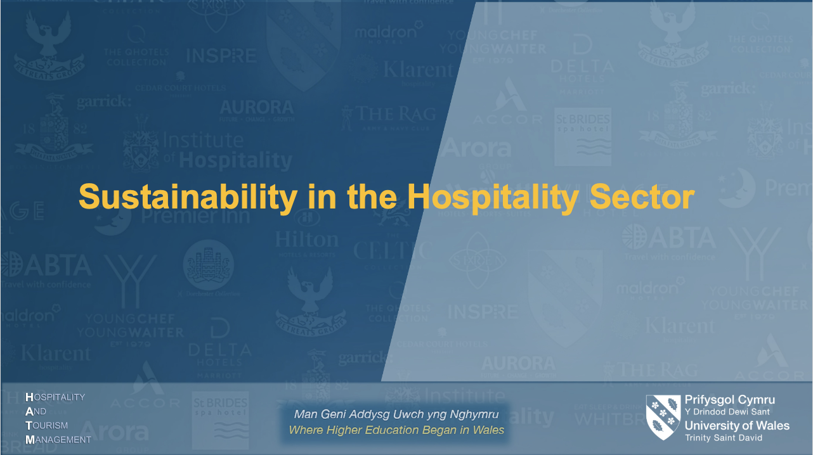
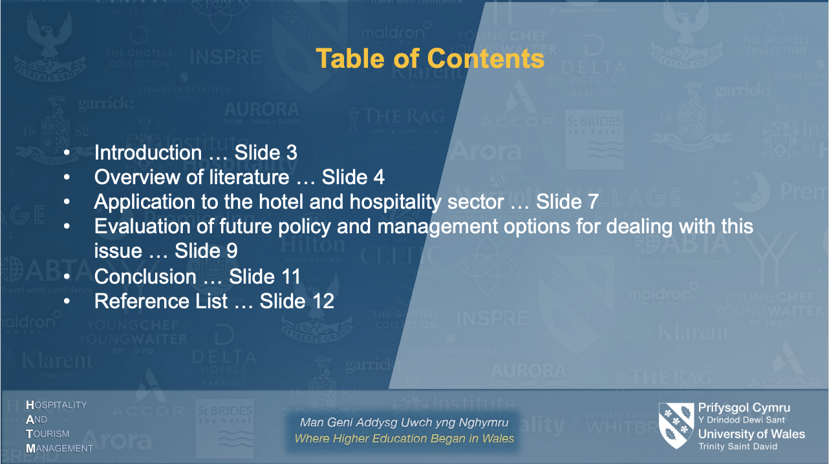

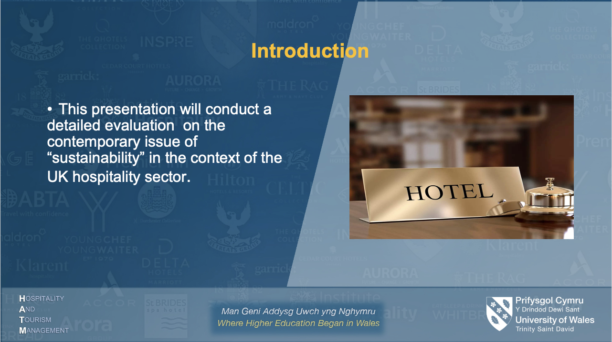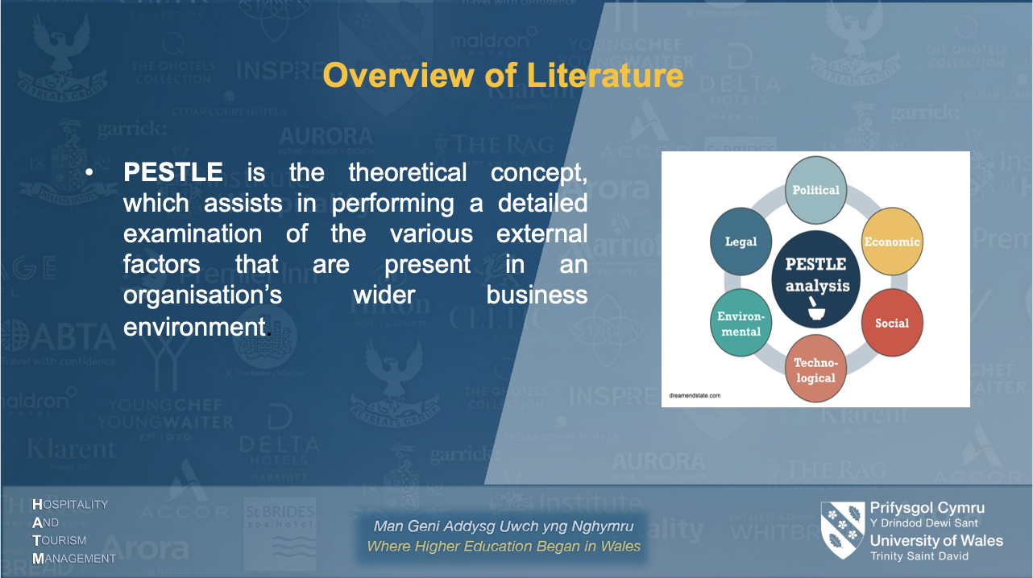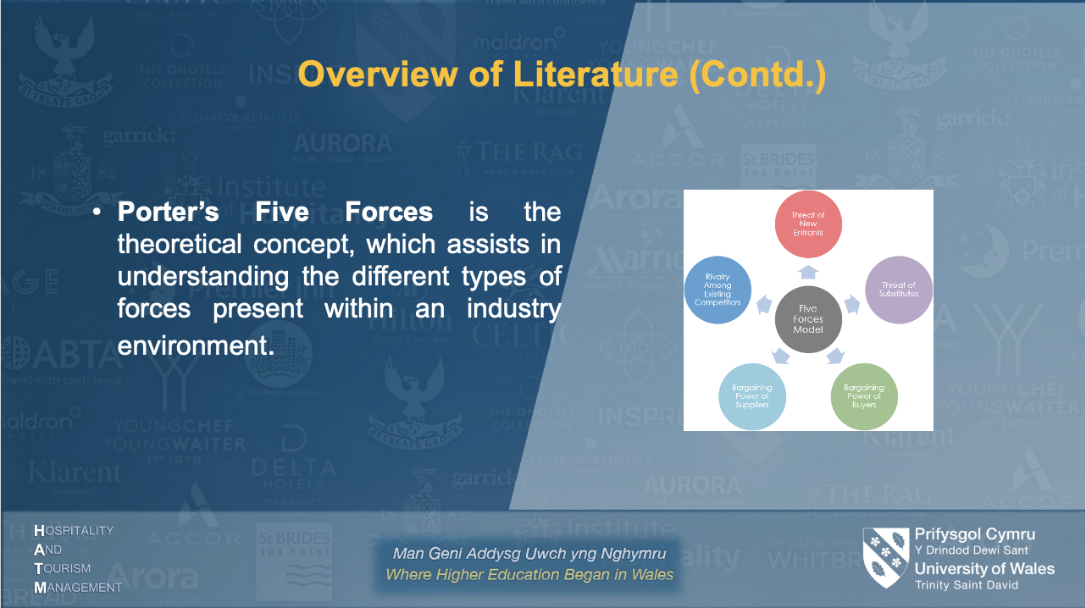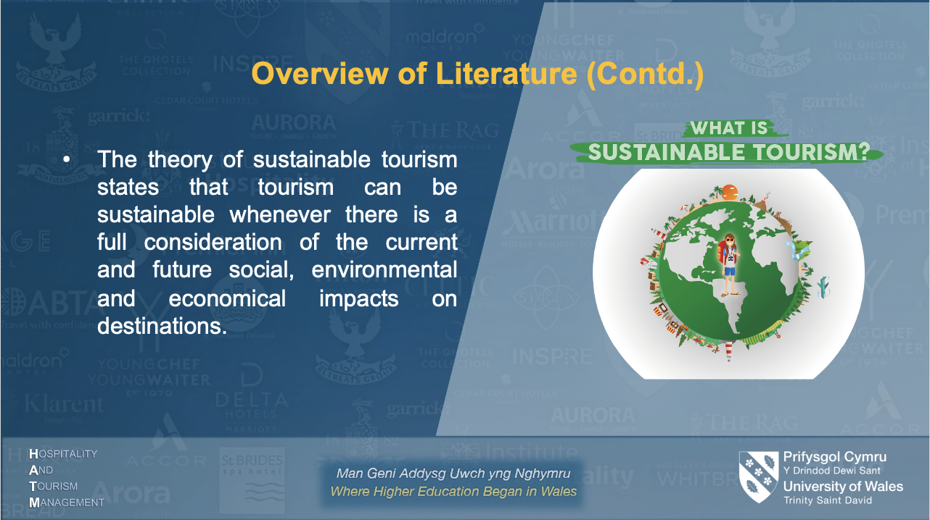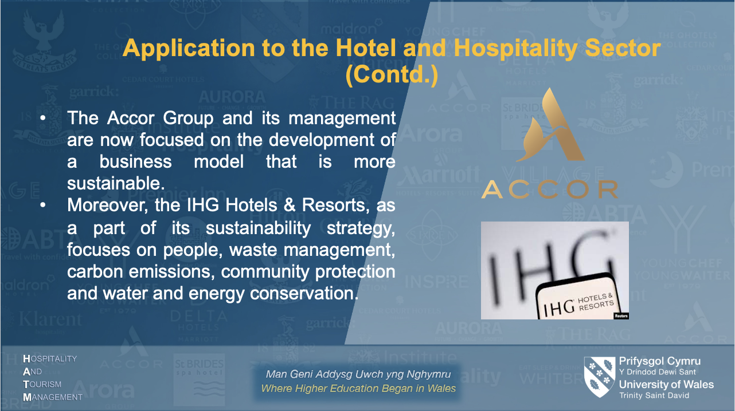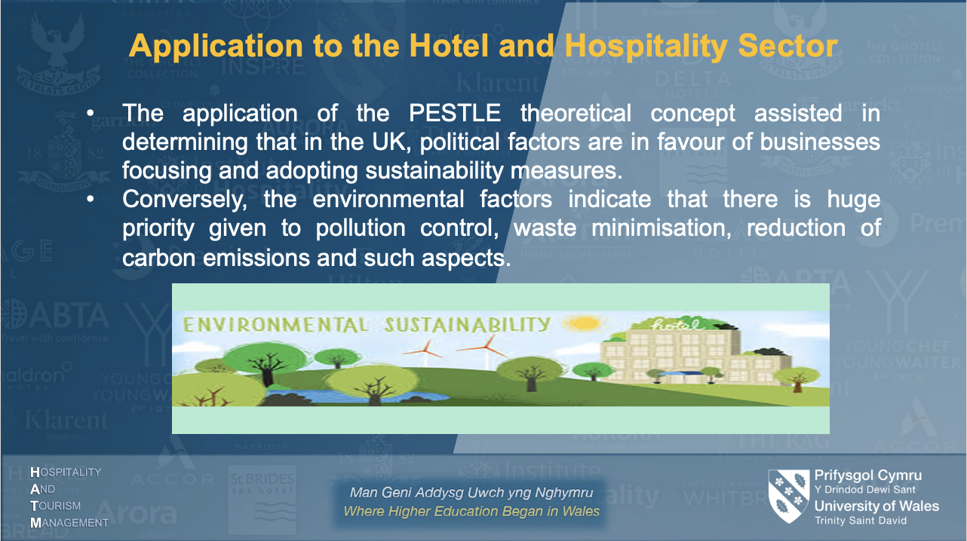
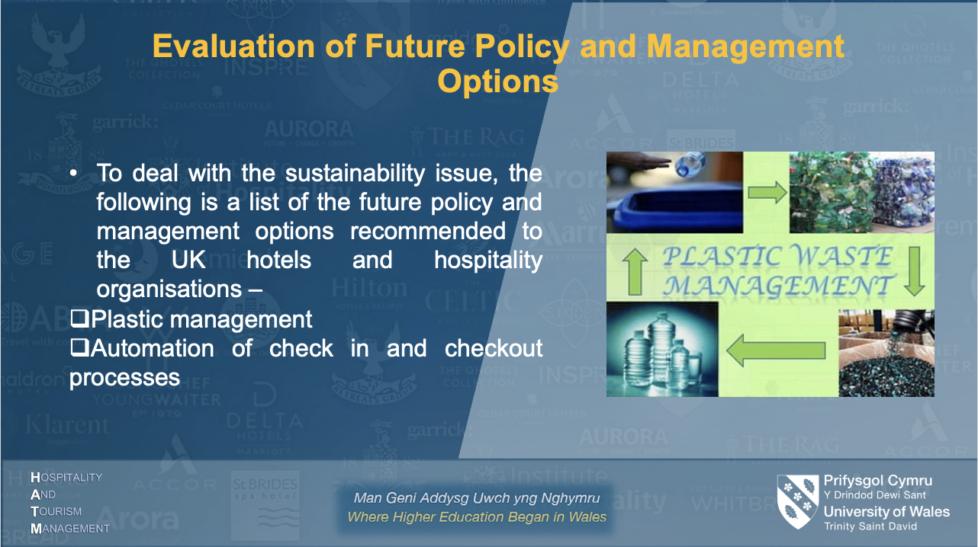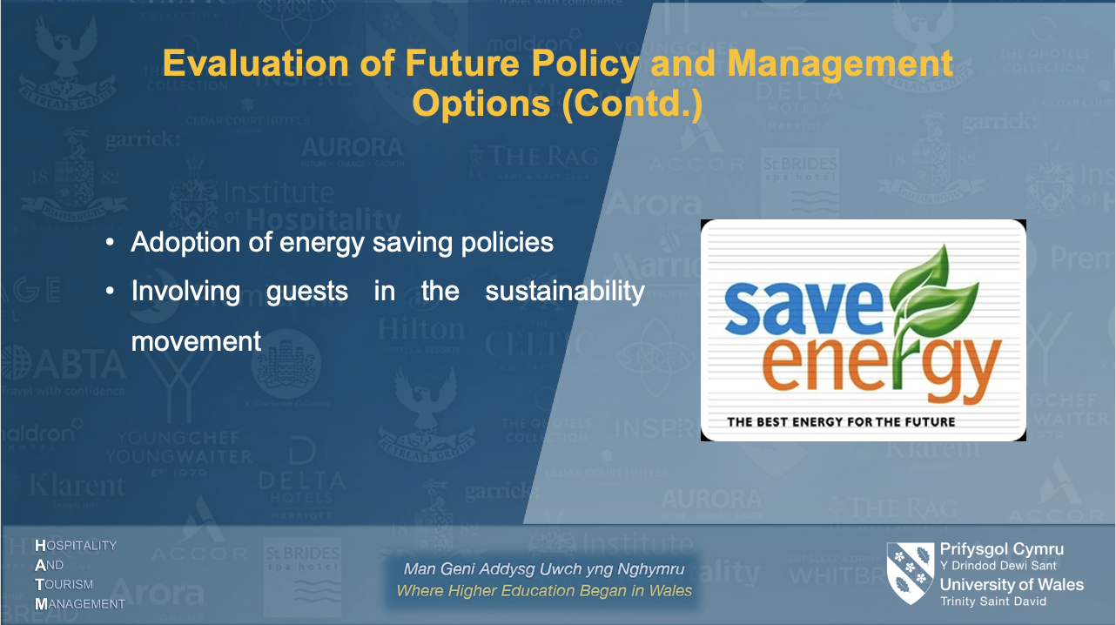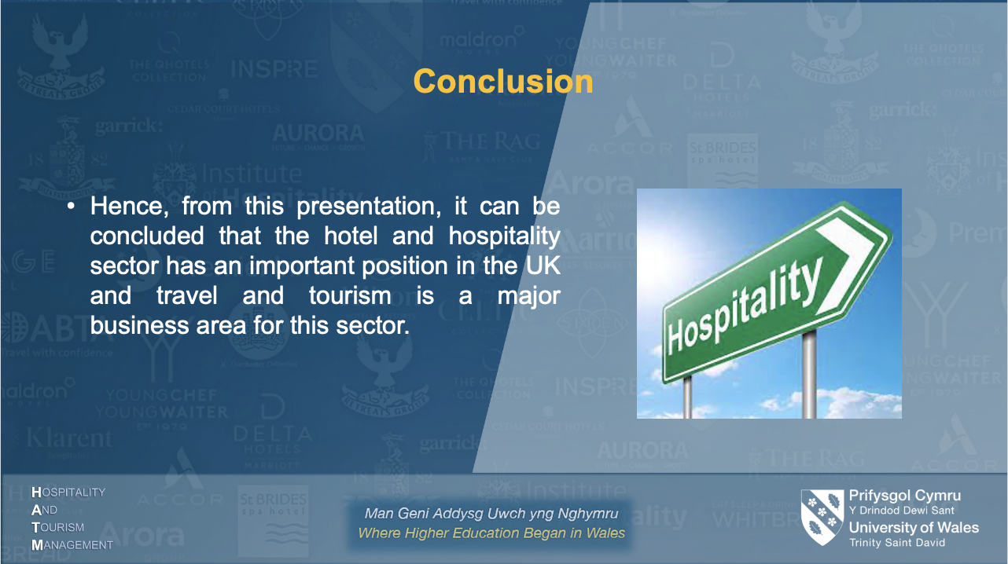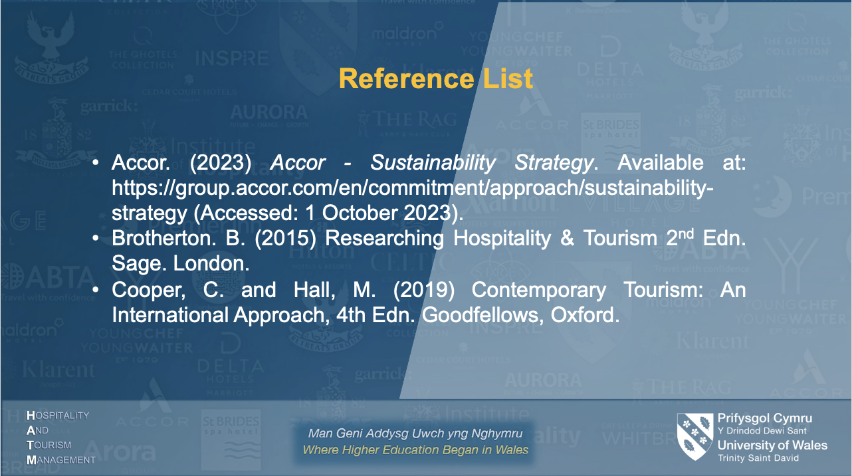

Reference List
- culture.gov.uk. (2023) Department for Culture, media, and sport, GOV.UK. Available at: https://www.gov.uk/government/organisations/department-for-culture-media-and-sport (Accessed: 18 October 2023).
- Ford, R.C., and Sturman, M.C. (2020) Managing Hospitality Organizations 2nd Edn. Sage, London.
- IHG Plc. (2022) Our approach to - InterContinental Hotels Group plc, RESPONSIBLE BUSINESS REPORT 2022. Available at: https://www.ihgplc.com/en/-/media/ihg/files/responsible-business/2021-responsible-business-report/rbr-2022-our-approach-to-responsible-business-7-16.pdf?la=en&hash=8DA8D21F36EE2D2C0E2FADF0A241EA79 (Accessed: 10 October 2023).
- Khalid, L.S. and Rahman, I.A. (2019) Measuring the effect of the external factors on Iraqi construction projects performance using PESTLE technique. Journal of Xi’an University of Architecture & Technology, 12(6), pp.671-680.
- ONS. (2023) Gross domestic product (GDP), Gross Domestic Product (GDP) - Office for National Statistics. Available at: https://www.ons.gov.uk/economy/grossdomesticproductgdp#:~:text=GDP%20monthly%20estimate%2C%20UK%3A%20December%202022&text=Monthly%20real%20gross%20domestic%20product,growth%20of%207.4%25%20in%202021. (Accessed: 13 October 2023).
- Rahman, M.S. (2019) An Analysis of Smart-Phone Industry in Bangladesh Using Porter’s Five Forces Model. Open Access Library Journal, 6(09), p.1.
- Sustainable Tourism World. (2023) Sustainable tourism: The theory, Sustainable Tourism World. Available at: https://www.sustainabletourismworld.com/sustainable-tourism-the-theory/ (Accessed: 14 October 2023).

