Natasha John
1351144
MANAGING BEHAVIOR AND SUPPORTING LEARNER ENGAGEMNT
ECPT5003 & ECPT6005

Introduction

This essay explores the current thinking and guidance on behaviour management and effective learner engagement within the post 16 sector. I will be looking at the effectiveness of different strategies from models and theories. There are some guidance/reports from Unison and UCU (2013) and internal institution polices such as University of Wales Trinity Saint David’s (UWTSD) Student Code of Conduct (UWTSD, 2021). I will look at how these link in with the UK Professional Standards Framework (UKPSF, 2011).

Main body

“There is an assumption that just because teaching takes place, learning follows.” (Lebor, 2017, p. 4) This is frequently debated. It can be said that students, for the most part do partake and act appropriately in lessons than other occurrences where they disobey. Considering the difference in personal ambitions, idiosyncrasies, it is questionable as to why students partake in learning as a shared or collaborative activity. (Lebor, 2017)

In a study of challenging behaviour in provision for unemployed adults, the following were outlined as examples of what might be regarded as challenging:

- Behaviour that disrupts routine teaching to an extent that challenges the teachers’ resources and concentration of other learners; this may not be violent, offensive or dangerous, simply disruptive
- Behaviour that is offensive or violent, interfering with routine activity
- Offending behaviour, including offending in the criminal sense, which bullies or ridicules fellow learners and creates an intimidating environment
- Extreme passivity or non-engagement in learning
- Intermittent patterns of attendance. (Niace 2012: 12)
(Avis et al, 2019, p. 159)

As stated by Curwin et al., “Our observations and experiences tell us that somewhere between 70 and 90 percent of discipline problems have their root causes in places outside school.” (Curwin et al, 2008, p. 8) These problems can have different internal and external factors for the students such as a troubled home life, mental or physical disabilities, drug or alcohol abuse. For teachers, it is crucial that they try to understand the impact of these factors even though they might not be in a position to change them. By focusing on what they can control in the classroom, they are able to have a positive influence on these factors (Curwin et al., 2008). This aligns with ‘respect individual learners and diverse learning communities’ from the Professional Standards Framework (UKPSF, 2011).
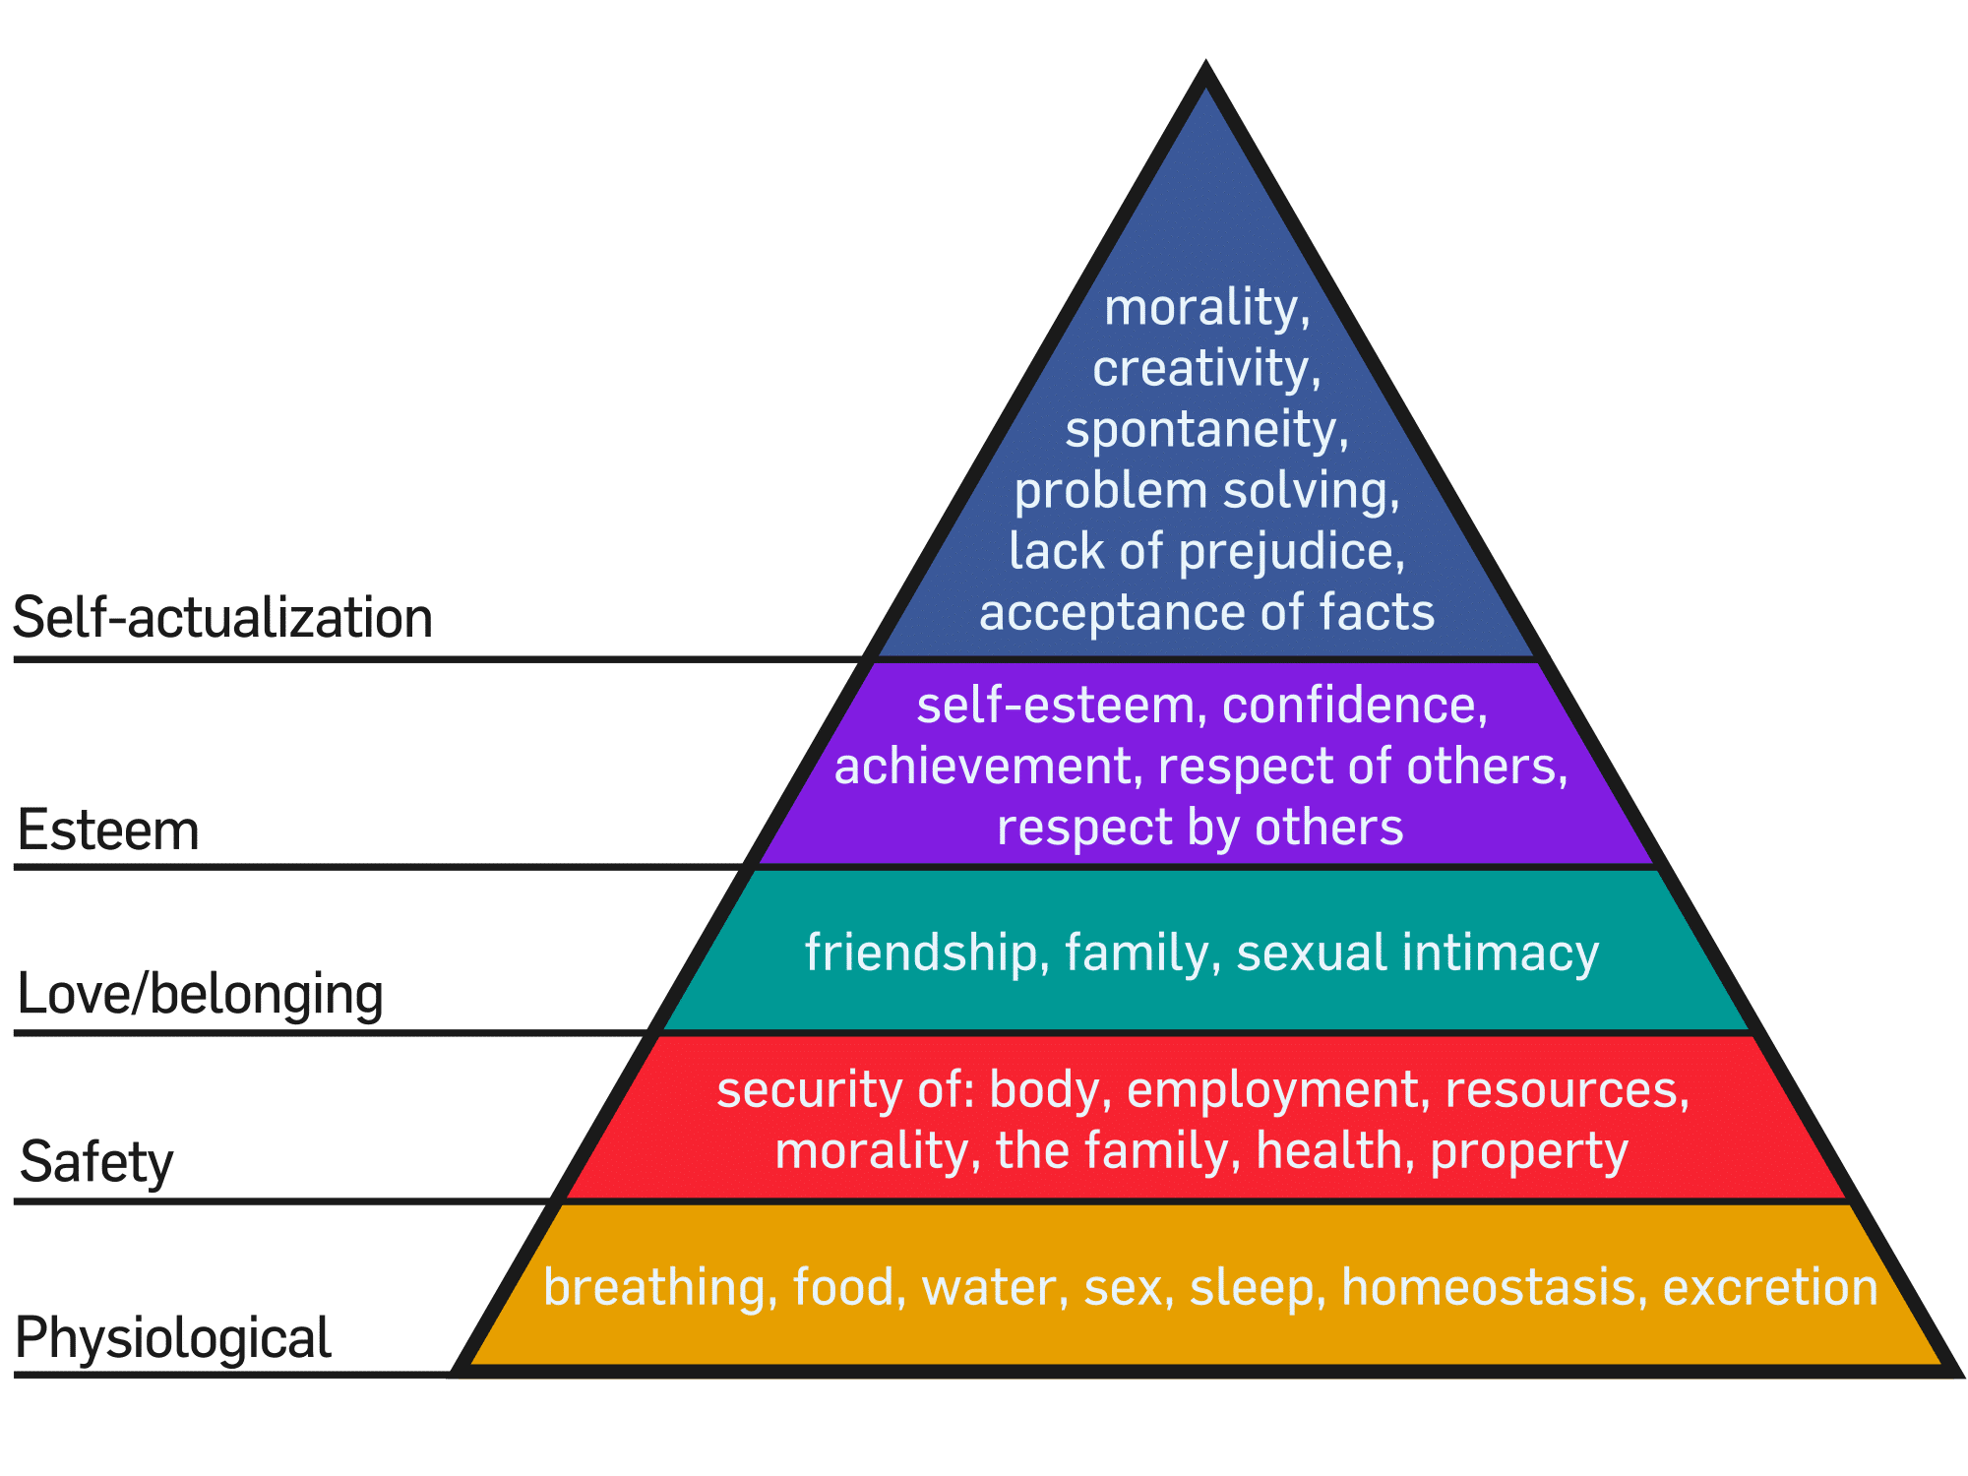
According to Maslow’s Hierarchy of Needs (1987) we can see the levels of need that should be addressed to ensure learning can happen successfully. Only when all other levels have been achieved will it be possible to reach the highest level of need. This is an appropriate way for teachers to be aware how motivation and the basic psychological and physical needs of students can affect their behaviour before any teaching has been undertaken. Frequently, poorer students might not have their physiological needs met therefore result in them being unable to concentrate. It’s very important that institutions have support in place for students experiencing these situations. It can be said that the inflexibility of the hierarchy can be problematic due to higher level needs being met before lower ones.
(Lebor, 2017)

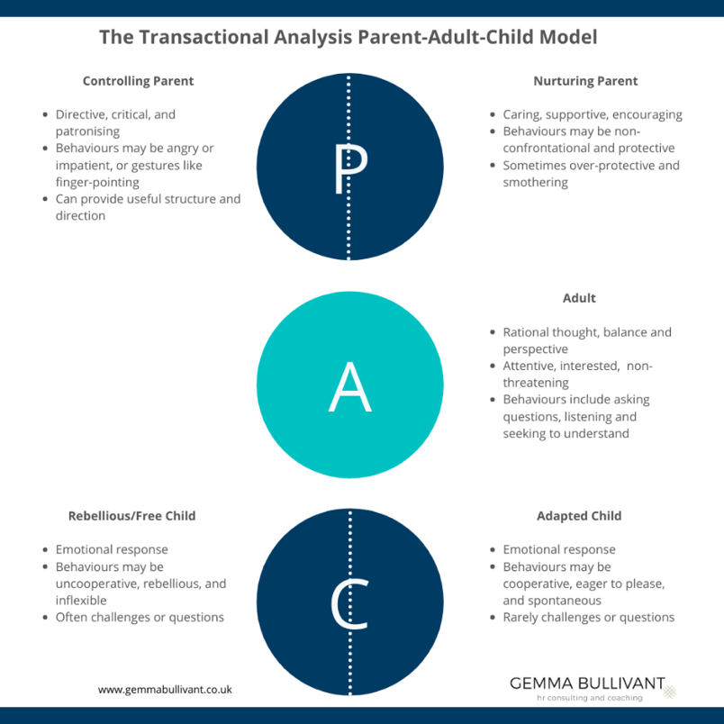

By looking at the Transactional Analysis (TA) approach we can see the different ego states that can occur during different encounters.

Much teaching may be classified to be in the parent ego state. The danger of this is that transactions will be directed at the child ego state which produces a corresponding childlike response in our students which perpetuates the parent ego state, If the child ego state produces a passive, teacher-centred approach, we need to change. (Reece et al., 2009, p. 290)

Here are a range of classic theories and models of class management:

Fred Jones (2007) believed in teaching students ‘responsibility, independence and co-operation’ in order to help them gain self-control. By creating a positive classroom environment, Jones believed that this would restrict misbehaviour. The teachers should create physical closeness by navigating amongst the learners within the classroom paying attention to their ‘body language, proximity, correct breathing and posture’. He made up a ‘say, see, do cycle’ which earned students ‘Positive Activity Time’ and in turn motivate them to learn in class (Lebor, 2017). This aligns with ‘develop effective learning environments and approaches to student support and guidance’ from the Professional Standards Framework (UKPSF, 2011).
Harry Wong (2009) states that behaviour problems are not due to discipline but a matter of ‘lack of class facilitation’. Wong offers methodologies to structure lessons via the organisation in order to create a safe, positive and inclusive environment for all learners. The main focus is a need for teachers to be flexible, but lesson preparation is crucial. It’s important to note that this is not a theory of teaching but a ‘series of suggestions’. This view is based on experience of relationships between the teacher and the learners rather than research. (Lebor, 2017) This aligns with ‘Design and plan learning activities and/or programmes of study’ and ‘Develop effective learning environments and approaches to student support and guidance’ from the Professional Standards Framework (UKPSF, 2011).

Jean Gibbs (2001) projected a two-stage strategy as a method of training parents and staff to enhance ‘small group engagement and co-operative learning’. It is a school-based initiative focusing on increasing student self-esteem and reduces student behavioural issues dramatically. The first strategy is to teach in small groups which will engage all learners. The second strategy is to construct long-term memberships groups which will encourage peer support and group skills helping students with their personal development. (Lebor, 2017) This aligns with ‘Develop effective learning environments and approaches to student support and guidance’ from the Professional Standards Framework (UKPSF, 2011).
Jere Brophy (2010) suggests the importance of ‘goal orientation and intrinsic motivation in learning and students’ engagement in cognitive skills’ so that they are able to obtain rewards. It’s fundamental that there are strategies that compensate for those disaffected by previous educational experiences. This aligns with ‘appropriate methods for teaching, learning and assessing in the subject area and at the level of the academic programme’ the Professional Standards Framework (UKPSF, 2011).

Mendler and Curwin’s (2008) ‘discipline with dignity’ approach focuses on three dimensions, prevention, action and resolution. It can be said that this is strategy is helpful in acquiring control in the classroom. The purpose of disciplining students should be to teach rational lessons to the learners. Consequences for students that are displaying disruptive behaviour should never be humiliating in a manner that influences the learners motivation (Lebor, 2017). This aligns with ‘respect individual learners and diverse learning communities’ from the Professional Standards Framework (UKPSF, 2011).

William Glasser’s (1986) control theory is an adaptation on Maslow’s hierarchy of needs but focusing on love, freedom and power. He believes that if students see the work as not connected to their needs, then this will result in them not being motivated in the task. Teachers’ ought to focus on the essential needs of the learners by setting work that improves their personal development. Outlook relies on the potential of learners to be included in shaping the curriculum which can be problematic as the curriculum is set by government/academic authorities (Lebor, 2017). This aligns with ‘The implications of quality assurance and quality enhancement for academic and professional practice with a particular focus on teaching’ from the Professional Standards Framework (UKPSF, 2011).

If a teacher plans their lesson to the best of their ability, then this should encourage a high level of motivation. It can be argued that some post-16 students do not have the maturity to acknowledge this. If this occurs, teachers will require a ‘code of practice’ (Reece et al, 2009).
This aligns with ‘Design and plan learning activities and/or programmes of study’ from the Professional Standards Framework (UKPSF, 2011).

The following guidelines have been found to be useful:
Set acceptable standards for work.
Set high standards of behaviour and apply rules firmly and fairly.
Give respect and accept respect.
Treat everyone as an individual.
Relationships are important so take the initiative and for everyone:
Greet and be greeted
Speak son be spoken to
Smile and relate
Communicate
(Reece et al., 2009, pp. 292-3)

These guidelines align with ‘Develop effective learning environments and approaches to student support and guidance’ and ‘Appropriate methods for teaching, learning and assessing in the subject area and at the level of the academic programme’ from the Professional Standards Framework (UKPSF, 2011).

The way that teachers communicate with students is vital. Being assertive can help teachers take control if need be. This should be done in a mature and sensitive way by understanding students’ responses and modify their approach accordingly. The main focus should be on developing strategies that practise the way teachers use verbal and non-verbal language. Albeit, this does not mean that teachers won’t be tested by students behaviour (Avis et al, 2019). After all, assertion allows us to communicate our feelings, opinions and thoughts, while simultaneously letting others do the same. Assertiveness can preserve and enhance our self-esteem and self-respect which ought to enhance respect amongst students (Reece et al, 2009). This aligns with ‘respect individual learners and diverse learning communities’ and ‘develop effective learning environments and approaches to student support and guidance’ from the Professional Standards Framework (UKPSF, 2011).

Motivated students cause fewer discipline problems. Enthusiastic teachers who present their material in stimulating, meaningful ways and treat students with respect and dignity almost always have fewer behaviour problems than those who do not. When students are actively learning content that they can personally relate to, they usually have neither the time nor energy to create discipline problems. Conversely, when students feel that they are passive receptacles for irrelevant knowledge, they become bored, turn off, and ﬁnd satisfaction in acting out.
(Curwin et al., 2008, p. 168)

This aligns with the following dimensions from the Professional Standards Framework (UKPSF, 2011):

- Design and plan learning activities and/or programmes of study
- Teach and/or support learning
- How students learn, both generally and within their subject/disciplinary area(s)
- Respect individual learners and diverse learning communities

Parry and Taubman (2013) suggest that ‘individual teacher strategies are most effective when reflected across the whole institution’ and further that organizational policies and practices on classroom management should be aimed at creating a ‘positive workplace’, for example by helping to ensure consistency in how staff deal with classroom situations and encouraging students to take responsibility for their behaviour as well as their learning. (Avis et al., 2019, p. 158)
UWTSD have their own policy which is called the Student Code of Conduct. If a student does not meet the standards that are outlined, then the University Non-Academic Misconduct Policy may be enforced. Students who study at UWTSD are expected behave in an appropriate way which will not dishonour the reputation of the University. Breaches of this code of conduct are taken very seriously. UWTSD strives to enable an inclusive and safe environment for staff and students. (UWTSD, SCC, 2021)
The following standards are:
- Professionalism
- Representing the University
- Respect for Others
- Respect for the community
- Caring for each other
- Respect for the University Environment
This policy aligns with the following dimensions from the Professional Standards Framework (UKPSF, 2011):

- Respect individual learners and diverse learning communities,
- Promote participation in higher education and equality of opportunity for learner,
- Use evidence-informed approaches and the outcomes from research, scholarship and continuing professional development

Conclusion

As stated in the UCU report (2013), the main focus on classroom behaviour management is based on children. While this can be adapted to post 16 learners, the FE sector needs to have their own guidance and polices on how to manage challenging behaviour in the classroom. The ‘culture of the organisation’ has a huge impact on how students learn. By having more guidance and polices in place this will be beneficial for the teachers and learners involved.
(Avis et al, 2019)

Reflection Essay

Introduction

In this essay I am going to be reflecting on two observations that I took part in and one of my own lessons. Throughout this essay, I am going to be looking at behaviour management and learner engagement. I am going to be using the Gibbs reflective style.

- Description

All of these lessons observed were a part of the Cert HE Art & Design Foundation Course at Swansea College of Art, UWTSD. The first lesson I observed was Kath’s group critique consisting of 8 students. Their project was based on Communities. Individually, they all had to speak about what they have currently been working on. They were all sat around a table so that they could see and hear each other clearly. The second lesson that I observed was Martin’s lecture on exhibition planning. For the first part of the session, we went to visit galleries for the workers to explain what they do in the lead up to an exhibition. This included, marketing, technician support, curating, installing of the exhibition etc. The second part of the session was a presentation-based Martin’s recent trip to London which showcased different artists and how they exhibited their work. This was followed by a task where the students had to create their own space. My own lesson that I am reflecting on was a typography workshop where the students were instructed to create their own typeface design. Working with the title of Neostagia. There was a class size of 6. I started off the lesson with a PowerPoint of artists, instructions and some examples of previous students work. I gave the students handouts which had this information on and sheets for them to create their typeface. I ended the lesson with a group discussion so I could get feedback from how the lesson went.

- Feelings

Before the lesson started, I was intrigued to see how Kath’s lesson was going to unfold as it was in a form of a critique. I have never written a reflection on a critique so I was excited to see what I would learn. For Martin’s lesson, I know a few of the students have Additional Learning Needs (ALN) so I was curious as to what the behaviour management may look like.
I was a bit apprehensive for my lesson as I know this group of students rather well. It can be very difficult to motivate them and get them engaged in activity. I was confident with my lesson plan and delivery of the lesson as I had already delivered this lesson three times. I found it challenging to get them motivated at first, but after having one on one conversations, I seen an improvement in their confidence. When my lesson was over, I felt very positive as the students listened very well, showed signs of positive engagement and produced great outcomes of work.

- Evaluation

Kath was encouraging students by asking them questions on how they would expand their work which was keeping students motivated and engaged. This aligns with the ‘develop effective learning environments and approaches to student support and guidance’ from the Professional Standards Framework (UKPSF, 2011).
There were a couple of students that didn’t have much work and couldn’t really talk about it. I noticed that many of the students were giving peer feedback to each other which was very encouraging. There was a point where some students were having their own conversation and talking over another student. Kath give some feedback to one student about their organisation skills and their response was “Other artists are so unorganised, so why do I have to be?” Kath’s response was “You are at the start of your journey so this needs to make sense.” At the end of the crit, Kath encouraged the students for their next project.

Martins session was very well planned with an itinerary of what was going to be happening for the day. Whilst in the gallery, students showed that they were engaged by nodding and making eye contact with the person talking. During the presentation I noticed that some students were doodling but I am aware that this might be how some people show engagement if they have ALN. I saw that some students were on their phones, some were staring into space and I noticed that one just got up and left, but I presume that was to go to the toilet as she shortly returned.

As I had already delivered this lesson three times, I knew the structure quite well and felt prepared for the lesson. This aligns with the ‘develop effective learning environments and approaches to student support and guidance’ from the Professional Standards Framework (UKPSF, 2011). I gave students handouts of the PowerPoint slides so that they could re-read these if need be. I understand that with certain tasks, students work at different paces so I was willing to individually go through the next steps with students when they were ready. I was continuously checking in on the students to see what stage they were at and where there thought process was in creating these typefaces. I was trying to encourage the students to work with their theme and see where they could develop their ideas further. This aligns with the ‘teach and/or support learning’ from the Professional Standards Framework (UKPSF, 2011).

- Analysis

The taught lessons were both prepared to a good standard which should have encouraged students’ motivation. This relates to Wong’s outlook on lesson preparation being a crucial part in behaviour management (Lebor, 2017). For all the sessions they were in small groups which links in with Gibbs strategy that focuses on increasing student self-esteem by working in small groups to engage learners. This in turn should decrease behavioural issues (Lebor, 2017). This aligns with the ‘develop effective learning environments and approaches to student support and guidance’ from the Professional Standards Framework (UKPSF, 2011). As Kath’s lesson was in a form of a critique, this encouraged students to give each other feedback which created a positive learning environment for the students ‘when students have similar tasks a small group approach can generate valuable discussion and peer support.’ Reece, et al. 2008 p132). By Kath asking students about how they could expand on their work, she was keeping them motivated and engaged. This aligns with the ‘appropriate methods for teaching, learning and assessing in the subject area and at the level of the academic programme’ from the Professional Standards Framework (UKPSF, 2011).Even though some student’s couldn’t speak about their work as they didn’t have much research or sketchbook work, Kath encouraged the importance of research. When the students started talking over Kath, she was assertive but politely asked them to listen to the other students who were talking about their work. When Kath responded to the student about their organisation skills, she done this in mature and sensitive manner (Avis et al, 2019).

Within Martin’s lecture I noticed that some students were showing signs of non-verbal engagement, but some were also disengaged. They were doodling, starting into space and on their phones etc. A lot of these students have ALN and these might well be adaptions to that. However, Martin should be aware of this prior to the lesson starting. *QUOTE*
Martin continually tried to engage to students by asking them questions and at the end of the lesson asked them if they understood what the task was.
As I had already delivered this lesson three times, I knew the structure quite well. I gave students handouts of the PowerPoint slides to ensure that I met different learning styles. As the students worked through the task at their own pace, I was able to individually help students and encourage them with their designs. This give me an ‘opportunity to see the quality of learning’ and an ‘opportunity to establish a rapport with students and improve communication’ (Reece, et al. 2008 p132). To end the lesson, I gathered the students around the table to have a discussion about the lesson and what they achieved. They all gave positive feedback and could see how they could develop this project further in the future.
- Conclusion
From observing and reflecting on these sessions it’s apparent how lesson planning is vital in keeping the students engaged from the start of the lesson. Having good relationship with the students is vital in managing behavioural issues in the classroom and building positive strategies that help this.

Positive, preventative strategies might be seen to be more useful than reactive and unrehearsed responses in establishing and maintaining good relationships with and between learners. (Avis et al, 2019: P159)
It’s very important to encourage students and how this has an impact on getting them motivated and keeping them engaged in the lesson. I have learned that small groups help with behaviour management issues as they are more focused on the individuals, and this helps build their self-esteem.

- Action plan – See Appendices

Appendices

Action Plan

Specific:
I want to keep building good relationships with students and plan lessons to the best of my ability.

Measurable:
By monitoring my relationship with the students and continuing reflecting on my practice after each lesson.

Attainable:
Creative positive, preventative strategies.

Relevant:
This is very relevant to my practice as a teacher as you want to make sure that the students have a positive, safe, inclusive environment to learn.

Time-bound:
As this will come with experience and will be continual professional development, I hope to have improved on this by the next academic year.

This aligns with the following professional standards:

- Design and plan learning activities and/or programmes of study
- Teach and/or support learning
- Develop effective learning environments and approaches to student support and guidance
- Engage in continuing professional development in subjects/disciplines and their pedagogy, incorporating research, scholarship and the evaluation of professional practices
- Appropriate methods for teaching, learning and assessing in the subject area and at the level of the academic programme
- Respect individual learners and diverse learning communities

Teacher Observation Form



Teacher | Kath Clewett
Date | 16th March 2023
Group | Cert HE Art & Design Foundation students (3D)
Topic/Context | Critique on their Communities project
Notes on the lesson:
- Writing notes for student feedback
- Asking questions on artists
- Student peer feedback
- Individual feedback – question on responses
- Importance of different disciplines
- Encouraging students to expand on work, how to develop
- Encouraging collaboration for FMP
- Mentioning relevant artists and research
- Challenging students to see how to expand on current work
- Artist research need more research for project
- Health and safety when using lighter on plastic
- Students talking over - Kath disciplined
- Documenting work professionally
- Students helping each other
- Community - learning from each other
- Picking up on previous criticism
- “other artists are so unorganised so why do I have to be?
- “you are at the start of your journey- it needs to make sense”
- Encouraging students at end of crit for the next project

What I have learned:
- Engage students by asking questions
- If addressing behavioral issues, do so in a calm and sensitive manner
- Importance of group size in class

Targets to improve my own practice (mapped to professional standards):
Build good relationships with students – links with ‘Respect individual learners and
diverse learning communities’ and ‘Teach and/or support learning’ from the Professional Standards Framework (UKPSF, 2011)

Work on positive strategies to tackle challenging behavior – aligns with the ‘Appropriate methods for teaching,
learning and assessing in the subject area and at the level of the academic programme’ from the Professional Standards Framework (UKPSF, 2011)

Teacher Observation Form

Teacher | Martin Bush
Date | 23rd March 2023
Group | Cert HE Art & Design Foundation Students (Vis Comm)
Topic/Context | Exhibition planning
Notes on the lesson:
- Martin – Exhibitions
- Glynn Vivian and Elysium
- Nodding, paying attention, engaged
- Presentation – Mike Nelson
- Pictures from London exhibition
- Sounds, experience, scenesm objects, narrative
- History that doesn’t exist
- Tableau vivant – presentation of artists
- Students doodling, on phone, staring into space, getting up- toilet?
- Set task – break for lunch
- “Everyone know what they are doing? One thumbs up and one head. Nod.

What I have learned:
- The importance of planning a lesson to keep students engaged
- How internal and external factors can effect a students motivation/engagement

Targets to improve my own practice (mapped to professional standards):
- Learn more about the individual needs of the students. This links in with the ‘Respect individual learners and diverse learning communities’ from the Professional Standards Framework (UKPSF, 2011).
- Make sure my lessons are well planned to discourage negative behavior where possible. This aligns with the ‘Design and plan learning activities’ and/or programmes of study from the Professional Standards Framework (UKPSF, 2011).



Lesson Plan

Topic: Typography - Creating own typeface/font |  | Class: Art & Design Foundation CertHE (Level 4)
Date: 17/03/23 | Length of lesson: 2 hours |  | Number of students: 8
Resources required:
Pens/drawing materials, paper, a computer or iPad.

Aim of Lesson

For students to design their own typeface and turn it in to a .ttf file.

Learning Outcomes – The Learners Should Be Able To:

- Produce evidence of engagement by participating in the workshop.
- Gain basic knowledge in the process of creating a typeface.

Previous student knowledge required for the session:

None

Anticipated difficulties (if applicable):

- Students might not have their own devices.
- Some students might have dyslexia.

Professional Standards (where are these being met within the session)

- A1 Design and plan learning activities and/or programmes of study – This is evident in the lesson plan and handout.
- A2 Teach and/or support learning - This will happen during the physical section of the lesson by promoting positive attitudes to learning. I will support learners to achieve their potential by setting them a physical task and offering support throughout.
- A3 Assess and give feedback to learners – This will happen during the lesson and at the end of the lesson by a formative assessment. They will all show their typefaces to each other and engage in conversation.
- A4 Develop effective learning environments and approaches to student support and guidance – I will ensure that learners are supported and taught in a safe learning environment, taking appropriate action where required using relevant policies and guidance.

- K1 The subject material – This is evident on the handout.
- K2 Appropriate methods for teaching, learning and assessing in the subject area and at the level of the academic programme – I will be using a handout to deliver the content of the lesson. A formative assessment will take place during and at the end of the session where the students will present their final outcomes to the other groups.
- K4 The use and value of appropriate learning technologies – Use of digital programmes to create informative handouts and online software.

- V1 Respect individual learners and diverse learning communities – I will treat all students and colleagues equally and fairly, ensuring all have an equal opportunity to be heard. I will listen respond positively to others’ views. I will behave in a professional manner. I am always reviewing my own professional and personal attitudes and beliefs.

Lesson Detail:

Stage | Focus | Strategy | Time
Introduction  Development  Plenary/conclusion | Firstly, I’ll talk through the PDF handout showing students examples of typefaces and some artists. I will then explain the process of creating a typeface. To finish the introduction, I’ll show some examples of previous students work.  Students will be encouraged to create a typeface based on their current project title: Neo-stalgia. They can do this using any materials they wish eg. pen, ink, collage or digitally.  I will hand out alphabet templates for them to develop their typeface. These will then be scanned in and uploaded onto the website which creates the downloadable .ttf file. This will then be downloaded and installed on the students device for them to use as a typable font. If the student doesn’t have their own device, I will show them the process on my laptop, download the file and send it to them via email.  As each student works at a different pace, I will go through creating the .ttf file separately.  Students will reflect on what they have created and show the group their typefaces. | PDF handouts - digital  Physical – workshop  Verbal presentations of typefaces – formative assessment. | 10 mins  1 hour 40mins  (10 min break)  10 mins

Assessment Strategies: when and how are they included within the lesson?

Formative assessment included at the end of the lesson for feedback. This will be a group discussion with the students for them to show and talk about developing their typefaces.

Informal reflection (to be completed after the session)

Reference List

Curwin, Richard L., et al. Discipline with Dignity : New Challenges, New Solutions, Association for Supervision & Curriculum Development, 2008. ProQuest Ebook Central, http://ebookcentral.proquest.com/lib/trinity/detail.action?docID=368212.
Created from trinity on 2023-04-17 20:53:01.

James Avis, Roy Fisher and Ron Thompson (2019) Teaching in Lifelong Learning 3e A Guide to Theory and Practice. London, England: Open University Press (UK Higher Education Humanities & Social Sciences Study Skills). Available at: https://search-ebscohost-com.ezproxy.uwtsd.ac.uk/login.aspx?direct=true&db=nlebk&AN=2753446&site=ehost-live (Accessed: 18 April 2023).

Lebor, Mervyn. Classroom Behaviour Management in the Post-School Sector : Student and Teacher Perspectives on the Battle Against Being Educated, Springer International Publishing AG, 2017. ProQuest Ebook Central, https://ebookcentral.proquest.com/lib/trinity/detail.action?docID=4931611.

Reece, I. and Walker, S. (2009) Teaching, training and learning: A practical guide. Tyne and Wear: Business Education Publ.
Student Code of Conduct (2021). University of Wales Trinity Saint David. Available at: https://www.uwtsd.ac.uk/media/uwtsd-website/content-assets/documents/student-experience/UWTSD-Student-Code-of-conduct-2021.pdf
(Accessed: April 18, 2023).

Whole College Behaviour Management Final Report (2013). Univeristy and College Union. Available at: https://www.ucu.org.uk/media/5693/UCU-whole-college-behaviour-policy-project-report/pdf/UCU_Whole_College_Behaviour_Management_Final_Report_June_2013.pdf
(Accessed: April 18, 2023).

Managing difficult behaviour in colleges. Unison. Available at: https://www.unison.org.uk/content/uploads/2018/04/24890.pdf
(Accessed: April 18, 2023).

Non-Academic Misconduct Policy (2022-23). University of Wales Trinity Saint David. Available at: https://www.uwtsd.ac.uk/media/uwtsd-website/content-assets/documents/academic-office/misc-forms/Non-Academic_Misconduct_Policy_2022-23.pdf
(Accessed: April 18, 2023).

