Menu Engineering 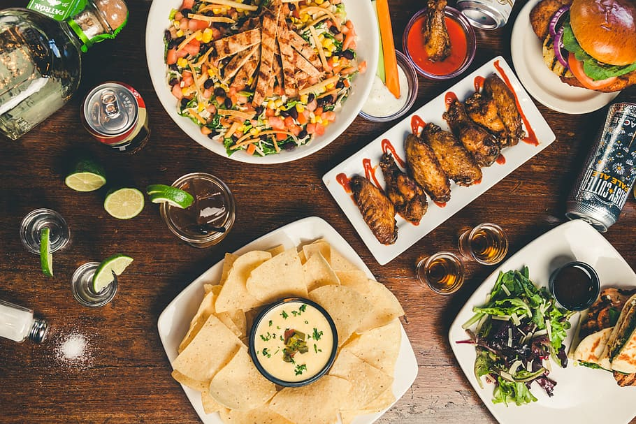

Module Name :Food and Beverage Operations
Module Number :BMIH4002
Student Number: 2226454
Lecture Name :Muhammad Cassamo
Word Count : 550

PART 1: Restaurant Concept
Fusion Delights is a unique restaurant concept that adapts to the changing tastes and preferences of the current eating scene and serves as the basis for the menu. Fusion Delights was inspired by fusion cuisine, which mixes ingredients from many culinary traditions to produce distinctive flavor profiles (Davis et al., 2018). The restaurant seeks to give a variety of clients an unforgettable eating experience. The adventurous food aficionados looking for creative and unorthodox eating experiences—driven by their quest for new and interesting flavors—are the target market for Fusion Delights. A harmonic fusion of tastes, textures, and ethnic influences may be found on Fusion Delights' menu. The menu has a variety of appetizers, entrées, sides, desserts, and drinks that represent the restaurant's ethos and aesthetic by fusing ingredients from many cuisines. According to Davis et al. (2018), this strategy guarantees that the menu design and products are distinctive and alluring in the fiercely competitive hospitality sector. Starters at Fusion Delights include sushi rolls with an Asian flair that combine Mexican, Indian, or Mediterranean tastes. Customers may enjoy well-known foods with novel taste combinations thanks to this. The main course menu has dishes like Moroccan-spiced grilled chicken with coconut-infused quinoa, fusing the exotic flavors of Southeast Asia with the fragrant spices of Morocco. Fusion Delights seeks to surprise and excite its clients by delivering imaginative combinations, creating a unique dining experience (Walker, 2017).
Fusion Delights offers solutions for clients with particular dietary restrictions in order to satisfy a variety of dietary preferences and follow health and wellness trends. The abundance of vegetarian, vegan, gluten-free, and lactose-free alternatives guarantees that every visitor may take advantage of the fusion experience without having to compromise their dietary requirements. This method, which is backed up by Motarjemi and Lelieveld (2014), acknowledges the significance of accommodating various dietary preferences in the hospitality sector. Fusion Delights' menu layout and design are meticulously created to produce a visually attractive and unified brand image. To represent the fusion idea and improve the eating experience, colors, typefaces, and graphics have been carefully chosen. Customers can easily traverse the menu and make informed decisions because to its logical organization and simple yet alluring food descriptions, which were inspired by the concepts of hospitality management (Foskett et al., 2021). The menu options at Fusion Delights are fundamentally based on seasonality and sustainability. In order to help regional farmers and lessen its carbon impact, the restaurant emphasizes seasonal vegetables and gets its components locally. According to Boussard (2021), this dedication to sustainability is in line with current environmental trends and laws.

PART 2: Menu Design.

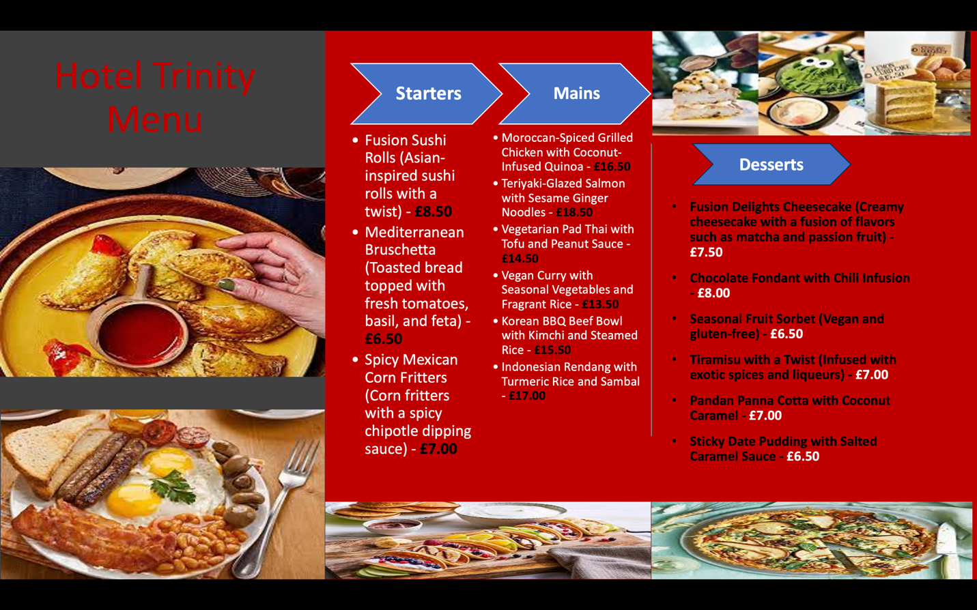

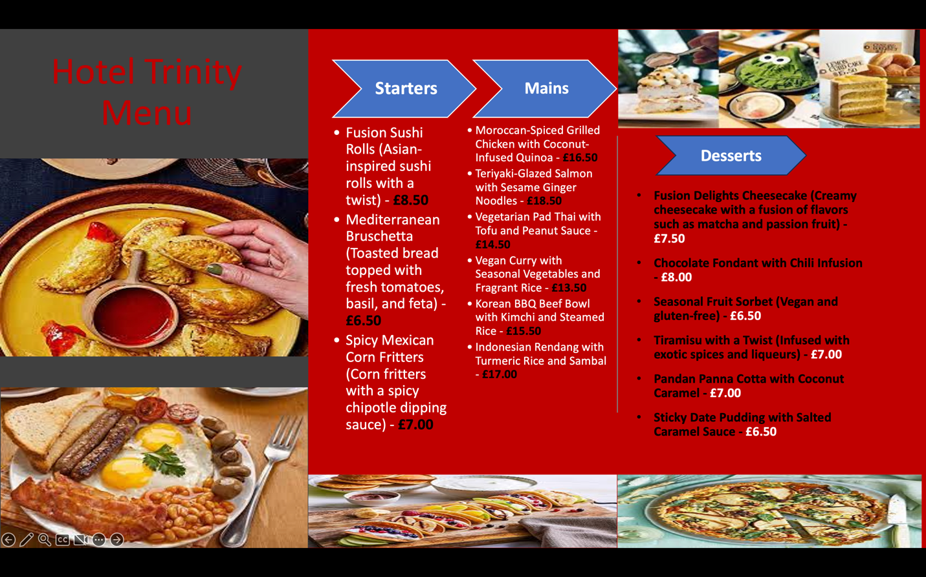

References
- Boussard, S (2021) Food and Beverage Management in the Luxury Hotel Industry. New York: Business Expert Press.
- Cousins, J. (2020) Food and beverage service. 9th ed. London: Hodder Education Group.
- Davis, B et al. (2018) Food and Beverage Management. 6th edn London: Routledge.
- Foskett, D. et al. (2021) The Theory of Hospitality and Catering. 14th Edition. London: Hodder Education Group.
- Motarjemi, Y and Lelieveld, H (2014) Service operations management: improving service delivery. Illustrated edition. Amsterdam: Academic Press.
- Walker, J. (2017). Introduction to Hospitality. Harlow: Pearson Education Limited. (Chapter on Culinary Concepts and Trends)

