Module: LCHS4003
Introduction to Health and social care
June Kelly Ring
Student Number: 2505639
Portfoloio-2 tasks (Poster and essay)
Lecturer: Daniel Haruna
Community Mental Health Services
23rd February 2026

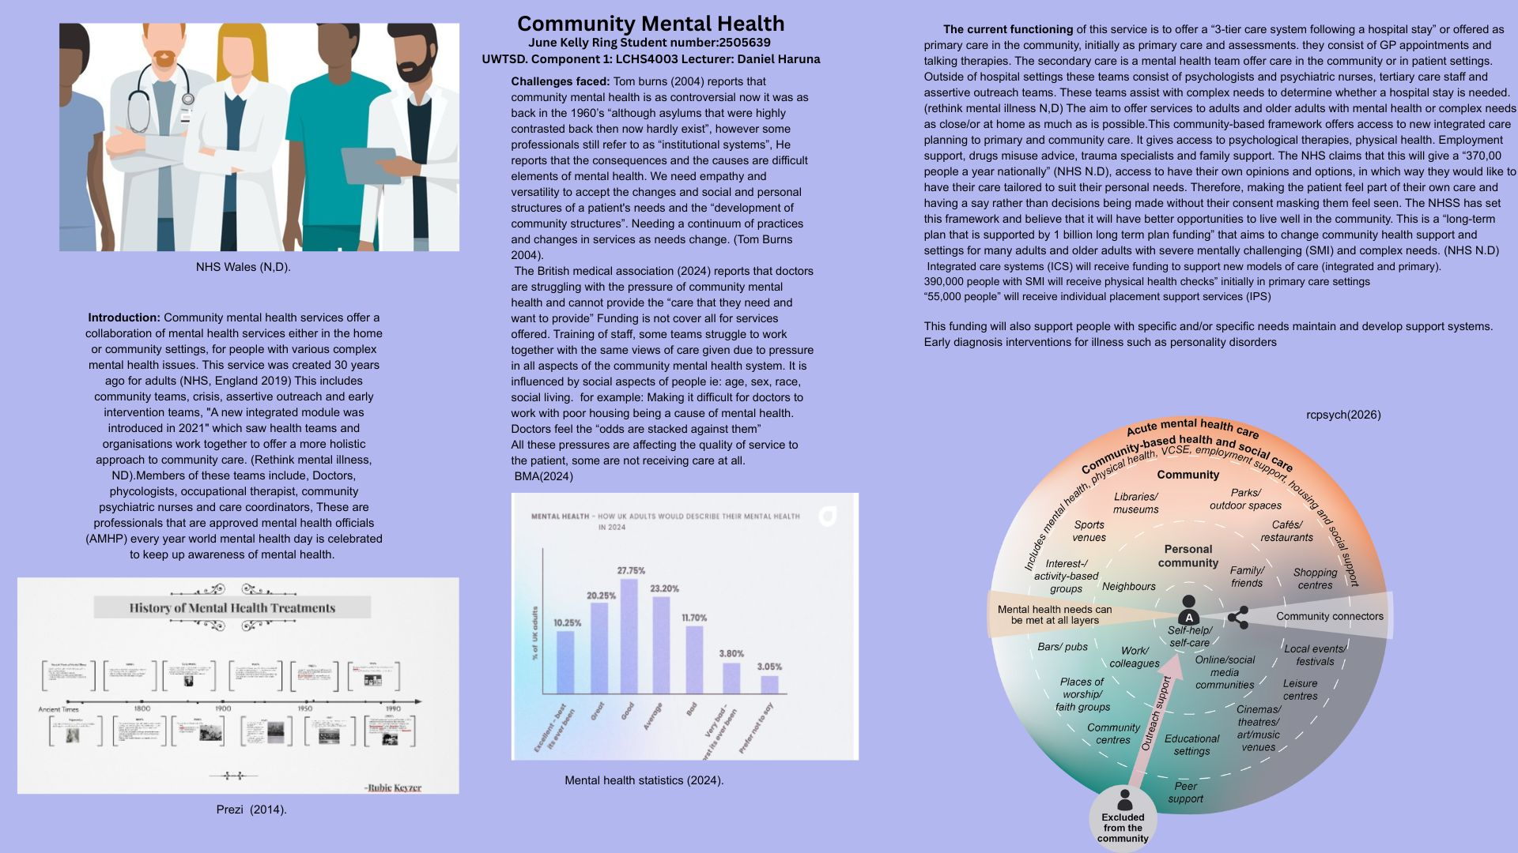

Ambulance Services

Origins of the service
The 1st ambulance was introduced in 1904. It was the 1st petrol vehicle introduced and could “carry a single stretcher and could travel up to 15mph” before that in the 1890’s if you needed medical assistance, it was up to the police, firefighters and taxi drivers to assist with “fleet” wheeled stretchers. These fleets were horse driven.
In the approach to the second world war an “Auxiliary ambulance service” was introduced by the “government civil defence service”. The auxiliary service was predominantly run by women. “In 1948, a post war restructure” was imposed and made it a requirement that all ambulances should be available to all that required one. In the 1950’s “headquarters moved to waterloo road in London, but was clearly not big enough for the service”, however in the 1960’s headquarters was moved a further up the same road and the services newsletter referred to it as “the promise land” this remains headquarters in London to the present day. NHS Ambulance service (NHS London n.d).
How the service runs today
Statista reports that there are “21,300” members of staff in the ambulance service (Statista 2026). To meet the high demands of the service an updated “structure of standards was implemented in 2017”. This structure set a standard of how Ambulances worked for example assessing the need to go to hospital, and to improve time response. Also using the “Lord Carter recommendations” implementing a structured framework setting. (NHS England n.d). Many ambulance services are required when 999 and 111 is called, “increasing the demand of the service. ”the NHS confederation reports that “since the Covid pandemic (Feb 21-Aug 21) systems saw a rise of “60% in calls”
The teams consist of “highly skilled practitioners” Offering services also for mental health and community assistance, for example falls, car accidents. As well as assessing in the home. Often a call would result in telephone consultations to ease the pressure of call out and response. So that priority is given to life threating emergencies (NHS Confederation 2021-2026).
Ambulance service staff are first responders on the front line, they enhance the quality of life by offering “timely medical care” so that care is prioritised. Timing is key to the right pathway of care and if any medicines or equipment are needed. They provide “quick and safe transportation” to hospital giving first aid/lifesaving care if needed along the journey to the hospital for admission. Using equipment on board like defibrillators, giving oxygen, CPR and many more emergency needs, so that the patient is as stable as possible when arriving to hospital. “The service is available 24/7” so if in any emergency they can respond day or night. Mortality is reduced as they respond rapidly and offer crucial lifesaving care (Next Digital Health n.d).

There are 4 types of first responder ambulances.
Air ambulances offer care over large distances, this is an “Airbourne intensive care system”, transferring lifesaving transplants.
Advanced life support, (ALS) for patients with serious conditions that need equipment like oxygen, defibrillation ect.
Neonatal specific for babies and young children as they carry incubators, ventilators and other equipment
Basic life support ambulances. (BLS) they provide basic first aid and transportation for patients needing a “screen level of care” (Next Digital Health n.d).
There daily challenges are lack of awareness form drivers on roads, funding, staffing and limited resources. They are under pressure for the unprecedented demand of the service,

So i conclude that although this service is always in high demand, they offer the best complex service that they can and without the ambulance service the mortality levels would be higher.

References [LHCS4003) CMHS Component 1 (Poster, Essay and pictures)
British medical association (2024) Failing mental health system , Available at: Failing mental healthcare system (Accessed on 1st February 2026).
London Ambulance service (n.d) Our History- a timeline- London ambulance services Available at: Our history - a timeline - London Ambulance Service NHS Trust (Accessed on 4th February 2026).
NHS England and NHS Improvement and the National Collaborating Central for Mental Health, (September 2019). The Community Mental Health Framework for Adults and Older Adults. Version 1.0, Available at: https://www.england.nhs.uk/wp-content/uploads/2019/09/community-mental-health-framework-for-adults-and-older-adults.pdf (Accessed on 24th January 2026)
National health service, England (n.d) Community Mental Health. Available at:NHS England » Community mental health services (Accessed on 1st February 2026)
National Health Service Wales (n.d) Challenges for today's mental health services Available at: https://ctmuhb.nhs.wales/services/service-changes-for-covid-19-adult-mental-health-services/ (Accessed on 29th January 2026).

NHS England (No date) Ambulance services are at the heart of the urgent and emergency care system Available at:NHS England » Ambulance (Accessed on 4th February 2026)
National health service confederation (2021-2026) Ambulance service pressures need a whole system response. Available at:Ambulance service pressures need a whole-system response | NHS Confederation (Accessed on 4th February2026)
NHS Confederation (n.d) The importance of ambulance services in society Available at :The Importance of Ambulance Services in Society9 (Accessed on 4th February 2026)

Mental health statistics (2024) What percentage of adults struggle with mental health Available at: Mental Health Statistics UK 2024 - Forth (Accessed on 29th January 2026)
O, Goodwin (2024) Challenges for today's mental health services Available at: Challenges for today’s Mental Health Services - CF (Accessed on 1st February2026)
Prezi. (2014) History of mental health Available at: History of Mental Health by Rubie Keyzer on Prezi (Accessed on 04th February 2026).
Royal college of psychiatrists (2026) Community mental health system functions for adults and older adults Available at:The Community Mental Health Framework for Adults and Older Adults | Royal College of Psychiatrists (Accessed on 03rd February 2026)
Rethink mental illness (n.d) NHS mental health teams Community, crisis, and early intervention support. Available at: NHS mental health teams - Community, crisis, and early intervention support (Accessed on 24th January 2026)
Statista (2026) Total number of ambulance staff in the NHS Hospitals and Community Health Service (HCHS) workforce in England from 2009 to 2024.Available at: Ambulance staff in NHS workforce England 2009-2024| Statista (Accessed on 4th February 2026)

Tom Burns (2004) Community Mental Health Teams : A Guide to Current Practices. Oxford: OUP Oxford. Available at: https://research-ebsco-com.uwtsd.idm.oclc.org/linkprocessor/plink?id=79a5df86-335b-319e-bb01-7db1fe1fadf8 (Accessed: 1 February 2026)

