April 23
Effective Teaching and Assessment in Higher Education
UNHE7007
Junior Richard (1605599)

Table of Contents
A Statement of Teaching and Learning 2
Reference 3
10-Minute Micro-Teaching Session – (Video) 4
10-Minute Micro-Teaching Session Reflection 5
Reference 5
Reflective Report of a teaching intervention cycle 6
Introduction 6
Present Situation 6
Description of What You Wish to Change and Why 9
How? 10
Description and Evaluation of Change Undertaken 12
What Next? 13
Conclusion 13
Reference 13
Observations 15
PGCert tHE Observation Form (1) 15
Reflective report 19
Reference 20
PGCert tHE Observation Form (2) 20
Reflective report 23
Reference 24
PGCert tHE Observation Form (3) 31
Reflective report 33
Reference 34
CPD Event Reflection 35
Digital Pedagogy Series: Getting the Most out of Moodle 35
Understanding the Extenuating Circumstances Policy and Procedure 37
Digital Pedagogy Series: Building an online community 39
Appendix A 41
PG Cert tHE -TEACHING LOG 41

A Statement of Teaching and Learning
As a dedicated and passionate higher education professional with a background in student services, I am passionate about providing an inclusive and supportive learning environment for students. My experiences working closely with students, faculty, and other university stakeholders have honed my understanding of the importance of effective teaching and learning support methods. In this statement, I will discuss my approach to promoting student success and fostering a positive learning experience, drawing from my experiences as a student services officer in higher education.

I believe that supporting student learning extends beyond the lecture hall and that a holistic approach is essential for success. As a higher education professional, I strive to create an inclusive and supportive environment for all students (V1) by addressing their unique needs and challenges, promoting equal access to higher education (V2), and facilitating open communication between students, faculty, and staff.

To accommodate the diverse needs of students, I tailor my support and guidance by considering cultural differences, supporting students with disabilities, and providing targeted resources for specific student populations, such as international students and home/EU students (A1, A4). This personalised approach ensures that all students receive the necessary support to succeed in their academic endeavours.

In my role, I actively collaborate with faculty members and other university support teams to better support student learning. For instance, I once worked closely with the disability, programme, and finance team to help a student who needed to interrupt their studies due to health concerns. By coordinating with the faculty and other university support teams, we were able to ensure that the student received the necessary support to successfully transition back into their studies upon their return. This collaborative approach not only facilitated a smooth and seamless process for the student but also contributed to their improved academic outcomes and overall well-being (A2, A4). Such collaborations foster a cohesive learning environment that empowers students to reach their full potential.

I continuously assess the effectiveness of my support strategies and seek to improve my practices based on outcomes. This includes gathering feedback from students, tracking student success metrics, and conducting regular reviews of support services and resources (A5, V3). For example, I have organised and evaluated enrolment workshops designed to streamline the enrolment process for new and returning students. By gathering feedback from attendees and analysing the impact of these workshops on enrolment efficiency, I was able to identify areas for improvement and implement changes that further enhanced the enrolment experience for students. By staying committed to data-driven decision-making, I ensure that my efforts remain aligned with the evolving needs of students.

Throughout my tenure as a Student Services Officer, I have maintained professional memberships and affiliations, such as my membership with the Association of University Administrators (AUA) and the Higher Education Academy (HEA), to stay informed about best practices and trends in higher education and student support. These affiliations demonstrate my commitment to ongoing professional development and growth in my role (A5, V3).

As a higher education professional, I have encountered various challenges. One challenge I have faced is addressing the diverse needs of students from different cultural backgrounds (V1). For instance, international students often face unique challenges, such as adjusting to a new academic environment or overcoming language barriers. To address these issues, I collaborated with colleagues to develop tailored support resources, such as English language support services (A1, A2).

Another challenge I encountered is assisting students with personal problems, which can significantly impact their academic performance and overall well-being. In response to this challenge, I worked closely with the counselling, disability, finance, and programme team to ensure students receive comprehensive and appropriate support. Additionally, I utilised online one-to-one sessions to provide advice and guidance tailored to individual student needs. These targeted efforts aim to create a supportive environment in which students can succeed academically while addressing their challenges (A3, A4).

In conclusion, my experiences as a Student Services Officer in higher education have not only equipped me with a deep understanding of the importance of effective teaching and learning support methods but also instilled in me a passion for empowering students and fostering success. Through aligning my practices with the UKPSF framework and staying informed by drawing on relevant literature (Higher Education Academy, 2023; K1, K2), I have consistently demonstrated my dedication to nurturing student success and cultivating a comprehensive, supportive learning environment that enables all students to thrive.

Reference
Higher Education Academy. (2023). Professional Standards Framework for Teaching and supporting learning in higher education 2023. Retrieved from https://www.advance-he.ac.uk/knowledge-hub/uk-professional-standards-framework-ukpsf

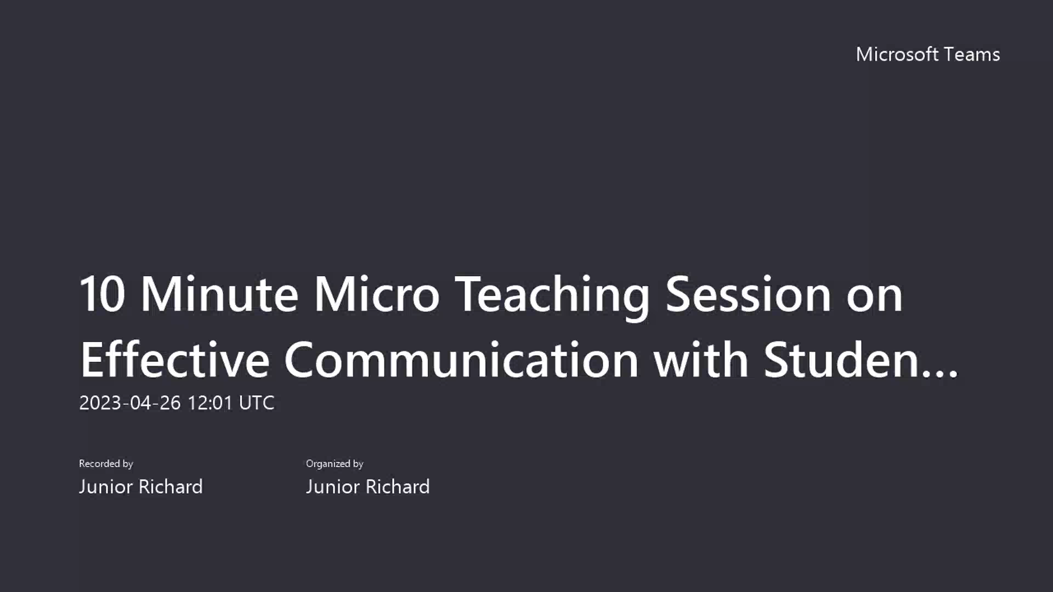
10-Minute Micro-Teaching Session – (Video)

Link to video: https://uowtsd-my.sharepoint.com/:v:/g/personal/j_richard_uwtsd_ac_uk/EQ-cQMjAbF9KoKzVWfDM5G8BrF4mSKxyd4Jk197oRS9PoQ

10-Minute Micro-Teaching Session Reflection
In my micro-teaching session on effective communication with students in higher education, I aimed to demonstrate professionalism and respect for individual learners and diverse groups (V1) by ensuring inclusive content. To cater to diverse learning preferences and promote engagement in learning and equity of opportunity (V2), I employed a variety of teaching strategies, such as using a poll to gather input on common communication challenges.

I incorporated relevant literature to support the communication strategies discussed (V3) and emphasised the importance of effective communication in the diverse, globalized higher education landscape (V4). I fostered a supportive learning environment, promoting collaboration with others (V5).

Despite technical difficulties, I received constructive feedback from participants through a feedback form and verbal communication. This feedback allowed me to assess and identify areas for improvement in teaching and supporting learning (A2). I provided practical information on effective communication strategies, such as active listening and empathy, and addressed common communication challenges, including language barriers, to support and guide learners (A4).

By incorporating UKPSF values into my micro-teaching session, I demonstrated my commitment to effective communication in higher education. I will continue to reflect on my practice and seek feedback to improve my teaching and design more effective learning activities (V5). The observations and feedback from this session have informed my teaching practice, allowing me to better address the needs of my learners and continuously improve my methods.

Reference
Higher Education Academy. (2023). Professional Standards Framework for Teaching and supporting learning in higher education 2023. Retrieved from https://www.advance-he.ac.uk/knowledge-hub/uk-professional-standards-framework-ukpsf

Reflective Report of a teaching intervention cycle

Introduction
In this reflective report, I will reflect on a teaching intervention cycle I implemented as a Student Services Officer in higher education. As higher education professionals, it is important to engage in reflection to continuously improve and learn from our experiences. To guide this report, I will be using the Gibbs (1998) Reflective Cycle as a framework for structured reflection.

This report discusses a teaching intervention cycle that helps students connect their values and goals with their academic pursuits. The cycle aims to overcome practical barriers that students may face, such as balancing coursework with family responsibilities or financial constraints. By providing access to resources and support, the intervention aims to improve student retention and success, in alignment with the United Kingdom Professional Standards Framework (UKPSF) (Higher Education Academy, 2023). The cycle is based on the idea that student well-being and personal development are closely tied to academic achievement and engagement (Thomas, 2012).

In the following sections, I will describe the present situation of the teaching intervention cycle, identify areas for improvement, discuss the steps taken to implement changes, evaluate the impact of these changes, and outline plans for further development. I will also reference relevant literature to provide support for the analysis and evaluation of the teaching intervention cycle.

Present Situation
My goal is to assist students in overcoming obstacles to their success or personal growth, as a Student Services Officer. I provide tailored support to address specific challenges they are facing.

Firstly, I start by identifying students who may be facing challenges in their academics, including financial constraints, and personal or emotional well-being. This is done by keeping in touch with academic staff, monitoring student performance, and encouraging students to seek support when necessary. Early intervention is crucial to prevent issues from escalating and leading to student disengagement or dropouts (Tinto, 2006).

Secondly, once a student is identified as needing support, a tailored plan is developed in collaboration with the student to address their specific needs. This may involve connecting them with relevant resources such as academic skills workshops, financial aid, and counselling services. By adopting a student-centred approach, the intervention cycle aims to empower students to take ownership of their learning and well-being, in line with the principles of self-regulated learning (Zimmerman, 2002).

Thirdly, it involves regular follow-ups with students to monitor their progress and provide ongoing support, including revising action plans, offering additional resources, or simply providing a listening ear. The follow-up component is crucial, as it enables the continuous assessment of the effectiveness of the intervention and ensures that students receive the support they need to succeed (Kuh et al., 2008).

Lastly, it involves collaboration with various stakeholders within the institution, such as academic staff, counselling, and finance departments. This collaborative approach allows for a more holistic support system that addresses the complex and interconnected challenges faced by students in higher education (Bronfenbrenner, 2005).

The teaching intervention cycle took place in a higher education institution with a diverse student population, including both undergraduate and postgraduate students from various socio-economic backgrounds and age groups. The institution prioritises creating an inclusive and supportive learning environment that meets the unique needs of each student while fostering a sense of belonging and community. This approach is in line with Thomas (2012) ideas on the importance of such an environment.

The intervention cycle is designed to help students who are experiencing difficulties in their academic pursuits or personal lives, which could negatively affect their education. These challenges may include financial difficulties, family responsibilities and mental health issues. It's essential to note that this cycle is not limited to students who are already struggling but is also proactive in preventing and supporting those who may be at risk of encountering difficulties in the future (Tinto, 2006).

There has been an increasing emphasis on student retention and success in higher education, as institutions are held accountable for the outcomes and experiences of their students (HESA, 2020). This has led to a growing body of research on effective strategies to support student well-being and engagement, with the understanding that these factors are closely linked to academic achievement (Astin, 1984; Kuh et al., 2008). Additionally, the widening participation agenda in higher education has resulted in a more diverse student population, necessitating the development of targeted support services that cater to the specific needs of different student groups (HEFCE, 2015).

Research has shown that the teaching intervention cycle is important in improving student retention and success. Many studies support this idea, including Tinto's (1993) theory that institutional support, like academic and social integration, is crucial for student persistence. Astin (1984) theory also emphasises the importance of student engagement in both academic and extracurricular activities, which can be achieved through targeted support services. Recent research has even demonstrated that proactive and holistic support interventions can have a positive impact on student well-being, academic performance, and retention rates (Cuseo, 2016; Thomas, 2012).

I felt that the teaching intervention cycle is closely connected to the UKPSF, which is a set of standards that help guide the professional development of higher education educators.

In the context of the teaching intervention cycle, the following alignments with the UKPSF can be observed:

- Respect for individual learners and diverse groups (V1): The teaching intervention cycle recognised the importance of respecting individual learners and their diverse backgrounds. The interventions are designed to cater to different learning needs, considering the variety of student experiences.
- Engagement in learning and equity of opportunity (V2): The intervention cycle aimed to promote student engagement and ensure equitable opportunities for all learners. This is achieved through a range of support services and teaching strategies that encourage active participation and foster a sense of belonging among students.
- Evidence-informed approaches to practice (V3): The teaching intervention cycle was informed by research, scholarship, and professional learning. Interventions are based on current best practices and are continuously refined in response to new evidence and insights.
- Responding to the wider context of higher education (V4): The intervention cycle considered the broader context of higher education, including changes in student demographics, technological advancements, and evolving expectations from employers and society. This responsiveness ensures that the cycle remains relevant and effective in meeting the needs of students and stakeholders.
- Collaboration to enhance practice (V5): The teaching intervention cycle involved collaboration among academic staff, support service providers, and students themselves. This collaborative approach enables the sharing of expertise, resources, and insights to improve the overall quality of the interventions and enhance student outcomes.
- Knowledge of how learners learn and teaching approaches (K1, K2): The intervention cycle was underpinned by an understanding of how students learn, both generally and within specific subject areas. This knowledge informs the selection of appropriate teaching and support strategies that cater to the diverse learning needs of students.
- Critical evaluation for effective practice (K3): The teaching intervention cycle incorporated mechanisms for self-evaluation and feedback from students and colleagues. This ongoing reflection and critical evaluation enable continuous improvement in the quality and effectiveness of the interventions.
- Use of digital and other technologies for learning (K4): The intervention cycle harnessed the potential of digital and other technologies to enhance teaching and learning. This included the use of learning management systems, online resources, and multimedia content to support student engagement and success.
- Quality assurance and enhancement (K5): The teaching intervention cycle was aligned with institutional quality assurance and enhancement processes. Interventions are subject to regular review and evaluation to ensure they meet the needs of students and contribute to the achievement of desired learning outcomes.
- Designing, planning, and supporting learning (A1, A2, A4): The intervention cycle involved designing and planning learning activities, as well as supporting and guiding learners throughout their educational journey. This encompasses a range of teaching approaches and environments that cater to different learning preferences and needs.
- Assessment and feedback for learning (A3): The teaching intervention cycle included mechanisms for assessing student progress and providing constructive feedback. This enables students to understand their strengths and areas for improvement and to take responsibility for their learning.
- Enhancing practice through continuing professional development (A5): The intervention cycle recognised the importance of ongoing professional development for academic and support staff. This commitment to continuous improvement ensures that interventions remain current and effective in supporting student success.

Description of What You Wish to Change and Why
Upon reflecting on the current teaching intervention cycle and its alignment with the UKPSF, several aspects were identified that could benefit from an improvement to enhance its effectiveness in supporting students.

- Early identification and intervention (A1, A3, V2): Although the intervention cycle emphasised the importance of early identification and support, there is room for improvement in the methods used for detecting students at risk. For example, the existing system relies heavily on academic staff referrals and self-reporting by students, which may not capture all students who could benefit from the intervention. Enhancing the early identification process is crucial, as research has shown that timely support can significantly impact student retention and success (Tinto, 2006). By improving early identification, the intervention cycle would better align with the UKPSF's focus on designing and planning learning activities (A1) as well as assessing and providing constructive feedback on students' progress (A3). Moreover, emphasises promoting engagement in learning and equity of opportunity for all to reach their potential (V2).
- Personalised support (A1, A4, K1, K2, V1): While the intervention cycle approach is student-centred, it is essential to further tailor support services to the unique needs and backgrounds of individual students. This may involve gathering more in-depth information about students' personal circumstances, learning styles, and cultural backgrounds, which can inform the development of customised support strategies (Kuh et al., 2008). Enhancing personalisation aligns with the UKPSF's values of respecting individual learners (V1), understanding how students learn (K1), the knowledge of approaches to teaching and supporting learning (K2), the activity areas of designing learning activities (A1) and fostering inclusive environments (A4).
- Inclusivity and accessibility (A4, K4, V5): The intervention cycle could benefit from a more explicit focus on inclusivity and accessibility, ensuring that all students, regardless of their background or abilities, can access and benefit from the support services provided. This may involve incorporating principles of universal design for learning (UDL) in the development of support resources, as well as providing training to staff on inclusive practices (CAST, 2018). A commitment to inclusivity and accessibility is in line with the UKPSF's emphasis on promoting an inclusive learning environment for all students (A4), appropriate use of digital and/or other technologies and resources for learning (K4) and collaborating with others to enhance practice (V5).
- Evaluation and feedback (A3, A5, K3, V3): Although the intervention cycle involved some degree of self-evaluation and feedback from colleagues and students, there is an opportunity to strengthen these processes to better inform future improvements. This may include implementing more systematic and rigorous evaluation methods, such as surveys, focus groups, or learning analytics, to gather feedback on the effectiveness of the intervention from multiple perspectives (Boud & Molloy, 2013). Continuous evaluation and feedback are essential for evidence-based practice and ongoing improvement (Schön, 1983). Aligning with the UKPSF's values of using evidence-informed approaches as a basis for effective practice (V3), knowledge of critical evaluation (K3), the activity areas of assessing and providing feedback (A3) and engaging in continuing professional development (A5).

How?
To implement the identified changes to the teaching intervention cycle, the following steps were undertaken:

- Enhancing early identification and intervention:
  - Collaborated with academic staff and relevant departments to develop a more comprehensive early-warning system that includes data on students' attendance, engagement, and academic performance.
  - Implemented a system to periodically review the early-warning data, identifying students who may be at risk of facing challenges and requiring support.
  - Developed a communication plan to reach out to identified at-risk students, offering tailored support and resources to address their needs.
- Personalising support:
  - Conducted in-depth needs assessments for each student accessing the support services, gathering information on their personal circumstances, learning styles, and cultural backgrounds.
  - Developed individualised support plans based on the needs assessment data, outlining targeted strategies and resources to address the specific challenges faced by each student.
  - Established regular check-ins with students to monitor their progress and adjust their support plans as needed, ensuring ongoing personalisation of the intervention.
- Promoting inclusivity and accessibility:
  - Reviewed existing support resources and materials to identify areas for improvement in terms of inclusivity and accessibility by following the principles of universal design for learning (UDL).
  - Provided training to staff on inclusive practices, promoting awareness and understanding of the diverse needs of students along with strategies to address them.
  - Ensured that all newly developed resources and materials adhered to UDL principles, making them accessible and inclusive for all students.
- Strengthening evaluation and feedback processes:
- Designed and implemented a systematic evaluation plan that included multiple methods of data collection, such as surveys, focus groups, and learning analytics.
- Engaged colleagues and students in providing feedback on the effectiveness of the intervention, using the data gathered through the evaluation plan to inform ongoing improvements.
- Scheduled regular reflection sessions to review the evaluation data and identify areas for improvement, fostering a culture of continuous professional development and evidence-based practice.

While implementing the changes to the teaching intervention cycle, several challenges were encountered. These challenges were addressed using evidence-based strategies, drawing on relevant literature and best practices.

- Resistance to change (Cawsey et al., 2016): Some staff members initially expressed concerns about the proposed changes, fearing that they might add to their workload or disrupt existing processes. To address this challenge, regular communication and consultation sessions were held to involve staff in the decision-making process, ensuring their concerns were heard and addressed. By fostering a culture of collaboration and shared ownership, resistance to change was minimised, and the changes were more readily accepted.

- Data privacy and ethical considerations (Drachsler & Greller, 2016): The enhanced early identification system required collecting and analysing sensitive data about students, raising concerns about data privacy and ethical implications. To address this challenge, a comprehensive data management plan was developed in line with institutional policies and GDPR, ensuring that data privacy was maintained, and the ethical use of data was prioritised.

- Time and resource constraints (Bolman & Deal, 2017): Implementing the changes required considerable time and resources, which were often limited. To overcome this challenge, a phased approach was adopted, prioritising the most critical changes, and gradually implementing the others over time. Additionally, external funding sources were explored to secure additional resources to support the changes.

- Ensuring consistency in inclusive practices (Stefani, 2010): Ensuring that all staff members consistently applied the principles of UDL, and inclusive practices were a challenge. To address this, regular training sessions and workshops were organised, focusing on the practical application of inclusivity principles. A system of peer observations and feedback was also implemented, promoting the sharing of best practices, and fostering a community of continuous learning.

- Evaluating the effectiveness of changes (Boud & Molloy, 2013): Assessing the impact of the changes on student outcomes and experiences poses a challenge, as it required the development of appropriate evaluation methods and the interpretation of complex data. To overcome this challenge, consultation with experts in evaluation and learning analytics was sought, and relevant literature was reviewed to inform the development of a robust evaluation plan.

Description and Evaluation of Change Undertaken

The changes implemented in the teaching intervention cycle included enhancing early identification and intervention, promoting inclusivity and accessibility, strengthening evaluation and feedback processes as well as personalised support.

Initially, there was a mix of excitement and apprehension about implementing these changes, as they presented opportunities for growth and improvement but also required considerable effort and adaptation.

Overall, the changes made to the teaching intervention cycle have been positive, resulting in more effective and inclusive support for students. Early identification of at-risk students has improved, leading to timely and targeted interventions (Tinto, 2006). The increased focus on personalisation has allowed for a better alignment of support services with individual students' needs (Kuh et al., 2008). Inclusivity and accessibility have been enhanced, ensuring that all students can benefit from the support provided (CAST, 2018). Finally, the strengthened evaluation and feedback processes have enabled data-driven improvements and fostered a culture of continuous professional development (Boud & Molloy, 2013).

Feedback from colleagues and students has been largely positive, with many reporting that the changes have led to more responsive and personalised support services. Some challenges, such as resistance to change and resource constraints, have been identified and addressed throughout the implementation process (Cawsey et al., 2016; Bolman & Deal, 2017). The alignment of the intervention cycle with the UKPSF has ensured that the changes are grounded in best practices and professional standards (Higher Education Academy, 2023).

The changes made to the teaching intervention cycle have resulted in significant improvements in student support, addressing the diverse needs of students and contributing to their academic success and personal development. These changes have also reinforced the commitment to ongoing reflection and professional development.

To continue building on the progress made, it is essential to maintain the focus on early identification and intervention, personalisation, inclusivity, and ongoing evaluation. Regular reviews of the intervention cycle should be conducted, engaging in continuous professional development, and incorporating feedback from colleagues and students. Further research and collaboration with colleagues and experts in the field can help identify new strategies and approaches to enhance the effectiveness of the teaching intervention cycle.

What Next?
The following next steps in the teaching intervention cycle will build upon the progress made thus far and address any areas requiring further improvement:

- Enhance collaboration and communication with academic staff: Strengthen the connections between the student services and academic departments to facilitate better information sharing and collaboration in supporting students (Tinto, 2017). This will ensure that the interventions are well-coordinated and that students receive consistent and timely support across their academic experience.
- Explore technological solutions to support students: Investigate and implement appropriate technology tools and platforms, such as learning analytics, adaptive learning systems, and communication tools, to further personalise support and enhance student engagement (Picciano, 2015). This will provide additional resources to help students navigate their academic journey and overcome challenges more effectively.
- Implement a mentorship program: Develop a peer mentorship program that connects experienced students with incoming students, providing additional support and guidance throughout their academic journey (Crisp & Cruz, 2009). This will enhance the sense of belonging and community among students and support their transition into higher education.
- Evaluate the long-term impact of the interventions: Conduct longitudinal studies to assess the long-term effects of the teaching intervention cycle on student retention, academic success, and overall well-being (Astin, 1993). This will provide valuable insights into the sustainability and effectiveness of the interventions and inform future improvements.
- Expand professional development opportunities for staff: Offer ongoing training and development opportunities for staff in the areas of inclusive practices, student support strategies, and evidence-based interventions (Darling-Hammond et al., 2017). This will ensure that staff members continue to develop their skills and knowledge in line with best practices and professional standards, such as the UKPSF.

Conclusion
The changes made to the teaching intervention cycle in higher education have proven to be effective in improving student success and personal growth. Through early identification and intervention, personalised support, inclusivity, and accessibility, and strengthened evaluation and feedback processes, students are receiving the necessary resources to thrive in their academic journeys. These changes were implemented following professional standards and best practices which have been positively evaluated by colleagues and students alike. As I continue to engage in reflective practice, I can further identify areas for improvement through feedback and ensure that we are providing the best possible support for our students. Ultimately, these changes serve to enhance the overall quality of higher education and pave the way for a brighter future.

Reference
Astin, A. W. (1993). What matters in college? Four critical years revisited. Jossey-Bass.
Bolman, L. G., & Deal, T. E. (2017). Reframing organizations: Artistry, choice, and leadership. Jossey-Bass.
Boud, D., Keogh, R., & Walker, D. (1985). Reflection: Turning experience into learning. Kogan Page.
Boud, D., & Molloy, E. (2013). Rethinking models of feedback for learning: The challenge of design. Assessment & Evaluation in Higher Education, 38(6), 698-712.
Brookfield, S. D. (1995). Becoming a critically reflective teacher. Jossey-Bass.
CAST (2018). Universal Design for Learning Guidelines version 2.2. [graphic organizer]. Wakefield, MA: Author. Retrieved from http://udlguidelines.cast.org
Cawsey, T. F., Deszca, G., & Ingols, C. (2016). Organizational change: An action-oriented toolkit. Sage Publications.
Crisp, G., & Cruz, I. (2009). Mentoring college students: A critical review of the literature between 1990 and 2007. Research in Higher Education, 50(6), 525-545.
Darling-Hammond, L., Hyler, M. E., & Gardner, M. (2017). Effective teacher professional development. Learning Policy Institute.
Drachsler, H., & Greller, W. (2016). Privacy and analytics: It's a DELICATE issue: A checklist for trusted learning analytics. In Proceedings of the Sixth International Conference on Learning Analytics & Knowledge (pp. 89-98).
Gibbs, G. (1998). Learning by doing: A guide to teaching and learning methods. Further Education Unit. Oxford Polytechnic: Oxford.
Higher Education Academy (2023). Professional Standards Framework for Teaching and supporting learning in higher education 2023. Retrieved from https://www.advance-he.ac.uk/knowledge-hub/uk-professional-standards-framework-ukpsf
Kuh, G. D., Kinzie, J., Schuh, J. H., & Whitt, E. J. (2008). Student success in college: Creating conditions that matter. Jossey-Bass.
Picciano, A. G. (2015). Theories and frameworks for online education: Seeking an integrated model. Online Learning, 19(2), 1-21.
Schön, D. A. (1983). The reflective practitioner: How professionals think in action. Basic Books.
Stefani, L. (2010). Planning teaching and learning: Curriculum design and development. In H. Fry, S. Ketteridge, & S. Marshall (Eds.), A handbook for teaching and learning in higher education: Enhancing academic practice (pp. 35-52). Routledge.
Tinto, V. (2006). Research and practice of student retention: What next? Journal of College Student Retention: Research, Theory & Practice, 8(1), 1-19.
Tinto, V. (2017). Reflections on student persistence. Student Success, 8(2), 1-8.

Observations

PGCert tHE Observation Form (1)
Professional Observed | Piyumika Gamage | Date |  | 03/04/23
Observer | Junior Richard | Attendees No. |  | 9
Programme Title | Managing people | Programme level |  | 7
Venue | Salisbury House (London campus) | Duration |  | 2 hours
Module aims /Learning outcomes
- Identify and critically appraise the Human Resource Management role in employee recruitment, development and engagement in a competitive and international context.
- Develop a critical appreciation of the issues involved in managing a complex and diverse workforce for both organisational success and workforce wellbeing.

Teaching Characteristics [Preparation, selection and organisation of content. Choice of teaching/learning strategies/ methods]
- The instructor used a coaching style of teaching during the class.
- The instructor engaged with the students and provided guidance and support as they worked through the material.
- A variety of techniques were used to demonstrate the concepts, including examples.
- Students were encouraged to ask questions and the instructor was patient in answering them.
- The instructor created a supportive learning environment where students felt comfortable sharing their opinions and perspectives.

Presentation [Beginning class, introduction, continuity with other sessions, students’ prior knowledge. Clarity of presentation. Pace. Attitude to subject matter. Use of appropriate reinforcement. Ending the session – summary, future work etc.]

- The presentation was clear and well-organised, with appropriate pacing.
- Visual aids such as slides and diagrams were used to illustrate key points.
- Examples and case studies were used to bring the concepts to life and provide practical applications.
- Interactive elements, such as group discussions and activities, allowed for practical application and engagement.

Technique and Aids [General apparatus – board, data projector, use of handouts. Question and answer technique. Other evaluation procedures, class management, instructions to students.]

- The instructor used a computer to display PowerPoint slides.
- A YouTube video was used to illustrate key points.
- Verbal instructions were given to supplement the visual aids.
- The instructor politely asked students to remain quiet to manage the class.
- The use of the whiteboard, PowerPoint slides, and YouTube videos were effective aids to support student learning.
- The verbal instructions were clear and provided additional context for the material.
- The instructor's class management techniques created a supportive and focused learning environment.

Student Responses [ General class atmosphere, level of participation, attention and interest. Student attitude and ability to carry out classwork. Were learning problems identified and overcome? Awareness of individual needs. Attitude to students.]

- The class atmosphere was generally positive and supportive.
- A small number of students didn’t seem to be actively participated in the class, by asking questions and contributing to discussions.
- However, most students appeared to be attentive and interested in the material.
- Student attitudes were positive toward the topic.
- Most students were able to carry out the classwork with ease.
- No significant learning problems were identified during the class.
- The instructor demonstrated a positive attitude towards students, encouraging their participation and providing constructive feedback.

General [ Was effective communication achieved? Was there good student – teacher rapport? Were the aims/outcomes achieved? Appropriateness of teaching/learning method]
- Effective communication was achieved between the instructor and students.
- There was good student-teacher rapport, with the instructor demonstrating a friendly and approachable demeanour.
- The module aims/outcomes were achieved, with the class covering the intended material and providing students with a clear understanding of the topic.
- The teaching/learning methods were appropriate for the material and helped to engage students in the learning process.
- The instructor was able to create a positive and supportive learning environment, fostering engagement and participation from students.
- The pace of the class was appropriate and allowed students to follow along with the material.
- Overall, the class was effective in achieving the intended learning outcomes and provided students with an engaging and informative learning experience.

Examples of good practice
- The instructor used a variety of teaching methods and aids to engage students and illustrate key concepts.
- The instructor created a positive and supportive learning environment, encouraging students to ask questions and share their perspectives.
- Clear and concise instructions were provided to students, making it easy for them to follow along with the material.
- The instructor was able to manage the class effectively, creating a focused and engaging learning experience for students.
- Overall, the instructor demonstrated a strong understanding of effective teaching practices, incorporating a variety of techniques and strategies to create an engaging and informative learning environment.

Development areas/action points
- Incorporate more opportunities for student-led discussions and peer-to-peer learning, as this can help to promote active engagement and critical thinking.
- Explore additional teaching aids and methods, such as interactive simulations or case-based learning, to help students better understand complex concepts.
- Seek feedback from students on the teaching methods and content covered in the class, to identify areas for improvement and ensure that the material is relevant and engaging.
- Continuously assess and adapt teaching methods and content to meet the needs of diverse learners, and to ensure that the material remains current and relevant.
- Consider incorporating more opportunities for student feedback and self-assessment, as this can help to promote student ownership of the learning process and improve engagement.

Observer (Name ) Junior Richard |  |  | Date 3/4/23
Oberservee (Name) Piyumika Gamage |  |  | Date 5/4/23

Reflective report
On completion of the peer observation reports for each module, compose a short reflective paragraph on your observation experiences. refer to models such as Gibbs (1999).
This reflective report discusses my observation experiences of Piyumika's teaching session I attended on "Managing People" and its impact on my teaching practice. Using Gibbs' (1999) reflective cycle as a framework, I will analyse my observations and explore how they have informed my teaching practice. I will also incorporate relevant literature to support my reflections, using the Harvard referencing style.

During the observation, I focused on Piyumika's teaching characteristics, presentation skills, techniques, and aids used in the session, as well as student responses and general aspects of the class. Piyumika employed a coaching style of teaching and used various techniques, such as examples, case studies, and group activities, to illustrate the concepts. The atmosphere was generally positive and supportive, with most students actively participating in discussions and showing interest in the material.

Throughout the observation, I felt inspired by Piyumika's teaching approach, which fostered an engaging learning environment. I was particularly impressed using real-life examples and case studies to bring the material to life, as well as the interactive elements that encouraged student participation. I was also struck by the importance of creating a supportive learning environment, which was achieved through Piyumika's patient and approachable demeanour.

Piyumika's teaching style proved to be effective in achieving the intended learning outcomes and engaging students in the learning process. The combination of coaching, the use of varied teaching methods, and the creation of a supportive learning environment contributed to a positive and engaging classroom atmosphere. However, I noted that a small number of students did not actively participate in discussions or ask questions, indicating that there might be room for improvement in terms of fostering greater engagement.

According to Race (2014), effective teaching involves engaging students in active learning, which requires a blend of different teaching methods and techniques. Piyumika's teaching approach exemplifies this principle, as she effectively utilised a variety of methods, including coaching, case studies, and group activities, to engage students in the learning process. However, it is also essential to address the needs of all students, including those who may be less engaged (Biggs and Tang, 2011). This observation experience highlighted the importance of continuously refining and adapting teaching methods to meet the diverse needs of learners.

Observing Piyumika's teaching session provided valuable insights into effective teaching practices, which have informed my teaching approach. The combination of coaching, varied teaching methods, and a supportive learning environment fostered a positive and engaging classroom atmosphere. However, there is always room for improvement, particularly in terms of addressing the needs of less engaged students.

To enhance my teaching practice, I will:
- Incorporate a variety of teaching methods and techniques, such as coaching, case studies, and group activities, to engage students in active learning.
- Create a supportive learning environment by being approachable, patient, and responsive to students' needs.
- Continuously refine and adapt my teaching methods to meet the diverse needs of learners, ensuring that all students are engaged and supported.
By implementing these changes, I aim to enhance my teaching practice and create a more engaging and inclusive learning environment for my students.

Reference
Biggs, J., and Tang, C. (2011). Teaching for quality learning at university. 4th ed. Maidenhead: Open University Press.
Gibbs, G. (1999). Learning by doing: A guide to teaching and learning methods. London: Further Education Unit.
Race, P. (2014). The lecturer's toolkit: A practical guide to assessment, learning and teaching.

PGCert tHE Observation Form (2)
Professional Observed | Junior Richard | Date |  | 26/04/23
Observer | Diola Bijlhout | Attendees No. |  | 17
Programme Title | Effective communication skills | Programme level |  | 4/5/6/7
Venue | Online Teams | Duration |  | 10 minutes
Module aims /Learning outcomes
- To provide participants with an understanding of the importance of effective communication strategies for engaging with students in higher education.
- To develop participants’ knowledge of the key components of effective communication, including active listening, empathy, and clarity
- To enable participants to practice these skills through a role-play activity.
Teaching Characteristics [Preparation, selection and organisation of content. Choice of teaching/learning strategies/ methods]
- The instructor used a facilitator teaching style during the online micro teaching session.
- The instructor engaged with the participants by providing relevant information and guidance while working through the session material.
- A variety of techniques were used to explain the concepts, including providing examples and questioning and whole group activities.
- The instructor used prompting, open-ended questions.
- Students were encouraged to answer the presented questions by using written text responses.
- The instructor facilitated a supportive online learning environment where participants felt comfortable to share their opinions and perspectives.
Presentation [Beginning class, introduction, continuity with other sessions, students’ prior knowledge. Clarity of presentation. Pace. Attitude to subject matter. Use of appropriate reinforcement. Ending the session – summary, future work etc.]

- The presentation followed an appropriate pacing and was clear and well-organised.
- PowerPoints presentation slides were used as visual aids, and appropriate text size was used, images were used as an illustration to support the key points.
- Questions and interactive activities were used to keep the participants in the virtual classroom engaged and attentive.

Technique and Aids [General apparatus – board, data projector, use of handouts. Question and answer technique. Other evaluation procedures, class management, instructions to students.]

- Various tools were used to support the questioning and answering, such as taking a group poll task, provide a definition moment and a let’s share moment.
- The use of the various techniques and aids were well introduced, definition (at the beginning of the session), a group poll (midway the session), let’s share at the end to facilitate learning.
Student Responses [ General class atmosphere, level of participation, attention and interest. Student attitude and ability to carry out classwork. Were learning problems identified and overcome? Awareness of individual needs. Attitude to students.]

- In general, a positive online class atmosphere and high level of participation, as well as attention and interest from participants. Participants engaged following prompts by providing their views.

General [ Was effective communication achieved? Was there good student – teacher rapport? Were the aims/outcomes achieved? Appropriateness of teaching/learning method]
- The pace in which the instructor taught the session allowed participants to develop an understanding on the key elements of effective communication.

Examples of good practice
- The instructor made good use of using words of encouragement, such as “good”, “that is a great one”, “that one too”.
- Consider based on the nature of the session and appropriate method to check or ensure learning has occurred. For example, used sharing moment in the chat.

Development areas/action points
- Make sure to position yourself clearly (in front of the camera) so that all your participants/students will see you clearly, especially when teaching online. Look intentionally at the camera (your participants).
- Make sure you will have clarity on how to assess that your objectives were achieved. For example, this group of participants did not share or discuss their best practices in the chat. Also, there was no role-play activity.
- Also in an online environment make sure when going through your slides to explain the text.
- Avoid using too much text in slides, using bullet points can better help structure the text for your participants.

Observer (Name ) Diola Bijlhout |  |  | Date 26/04/2023
Oberservee (Name)  Junior Richard |  |  | Date  26/04/23

Reflective report
On completion of the peer observation reports for each module, compose a short reflective paragraph on your observation experiences. refer to models such as Gibbs (1999).
This reflective report discusses the observation experience of my teaching session on "Effective Communication Skills" and its impact on my teaching practice. Using Gibbs' (1998) reflective cycle as a framework, I will analyse the observations made by Diola Bijlhout and explore how they have informed my teaching practice. Relevant literature will be incorporated to support my reflections, using the Harvard referencing style.

During the observation, Diola focused on my teaching characteristics, presentation skills, techniques, and aids used in the session, as well as student responses and general aspects of the class. I used a facilitator teaching style, engaging with participants, and incorporating a variety of techniques to explain concepts. The session was conducted online and aimed to provide participants with an understanding of effective communication strategies, develop their knowledge of key components, and enable them to practice these skills through a role-play activity.

While delivering the session, I felt confident in my ability to present the material and engage participants. However, I was aware of some areas that needed improvement, such as positioning myself clearly in front of the camera and using less text on the PowerPoint slides. I also recognised that I could improve the assessment of learning outcomes and the incorporation of the planned role-play activity.

Overall, my teaching approach was effective in creating a positive online learning environment and engaging participants in the session. However, Diola's observation highlighted areas for improvement, such as camera positioning, slide design, and assessment of learning outcomes.

According to Salmon (2011), effective online teaching involves engaging learners through a variety of methods and adapting traditional teaching techniques to the digital environment. My teaching approach exemplifies this principle, as I effectively utilised different techniques to engage participants in the online session. However, Anderson and Dron (2011) emphasize the importance of addressing the unique challenges of online teaching, such as the need for clear camera positioning and adapting slide design for digital presentations. My observation experience highlighted the need to further refine my online teaching skills in these areas.

Observing my teaching session provided valuable insights into my strengths and areas for improvement. While my teaching style and use of various techniques contributed to a positive online learning environment, I need to address specific challenges related to online teaching to enhance the overall learning experience for participants.

To improve my teaching practice, I will:
- Position myself clearly in front of the camera and maintain eye contact with participants during online sessions.
- Adapt my slide design by using bullet points and less text to enhance the clarity and readability of the material.
- Develop clear methods for assessing the achievement of learning outcomes, such as incorporating interactive activities or quizzes to gauge participant understanding.
- Implement the planned role-play activity and other interactive elements to further engage participants and provide practice opportunities.
By implementing these changes, I aim to enhance my teaching practice and create a more engaging and effective online learning environment for my participants.

Reference
Anderson, T., & Dron, J. (2011). Three generations of distance education pedagogy. The International Review of Research in Open and Distributed Learning, 12(3), 80-97.
Gibbs, G. (1998). Learning by doing: A guide to teaching and learning methods. London: Further Education Unit. Oxford Polytechnic: Oxford.
Salmon, G. (2011). E-moderating: The key to teaching and learning online. 3rd ed. New York: Routledge.



Ask students input

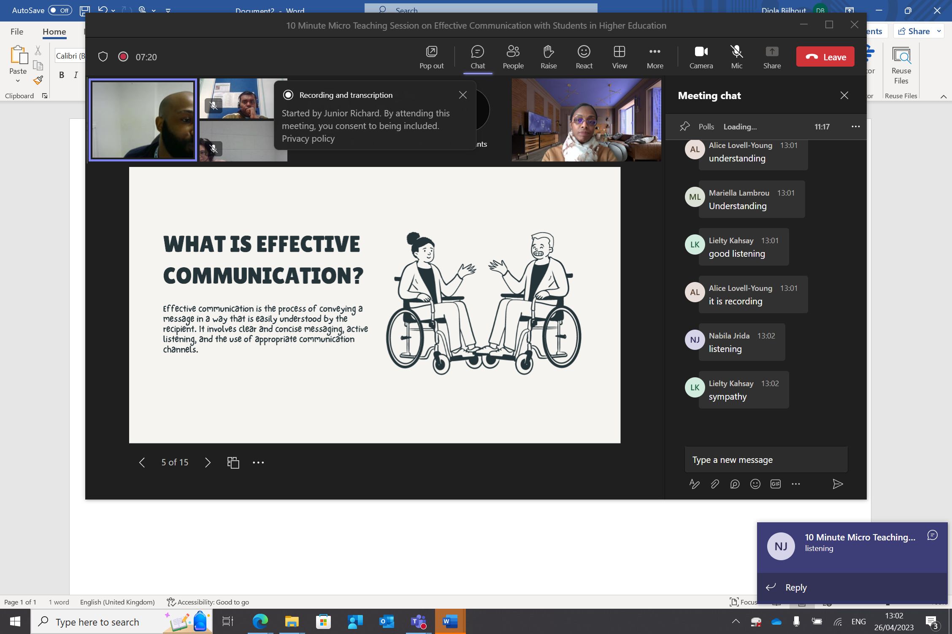

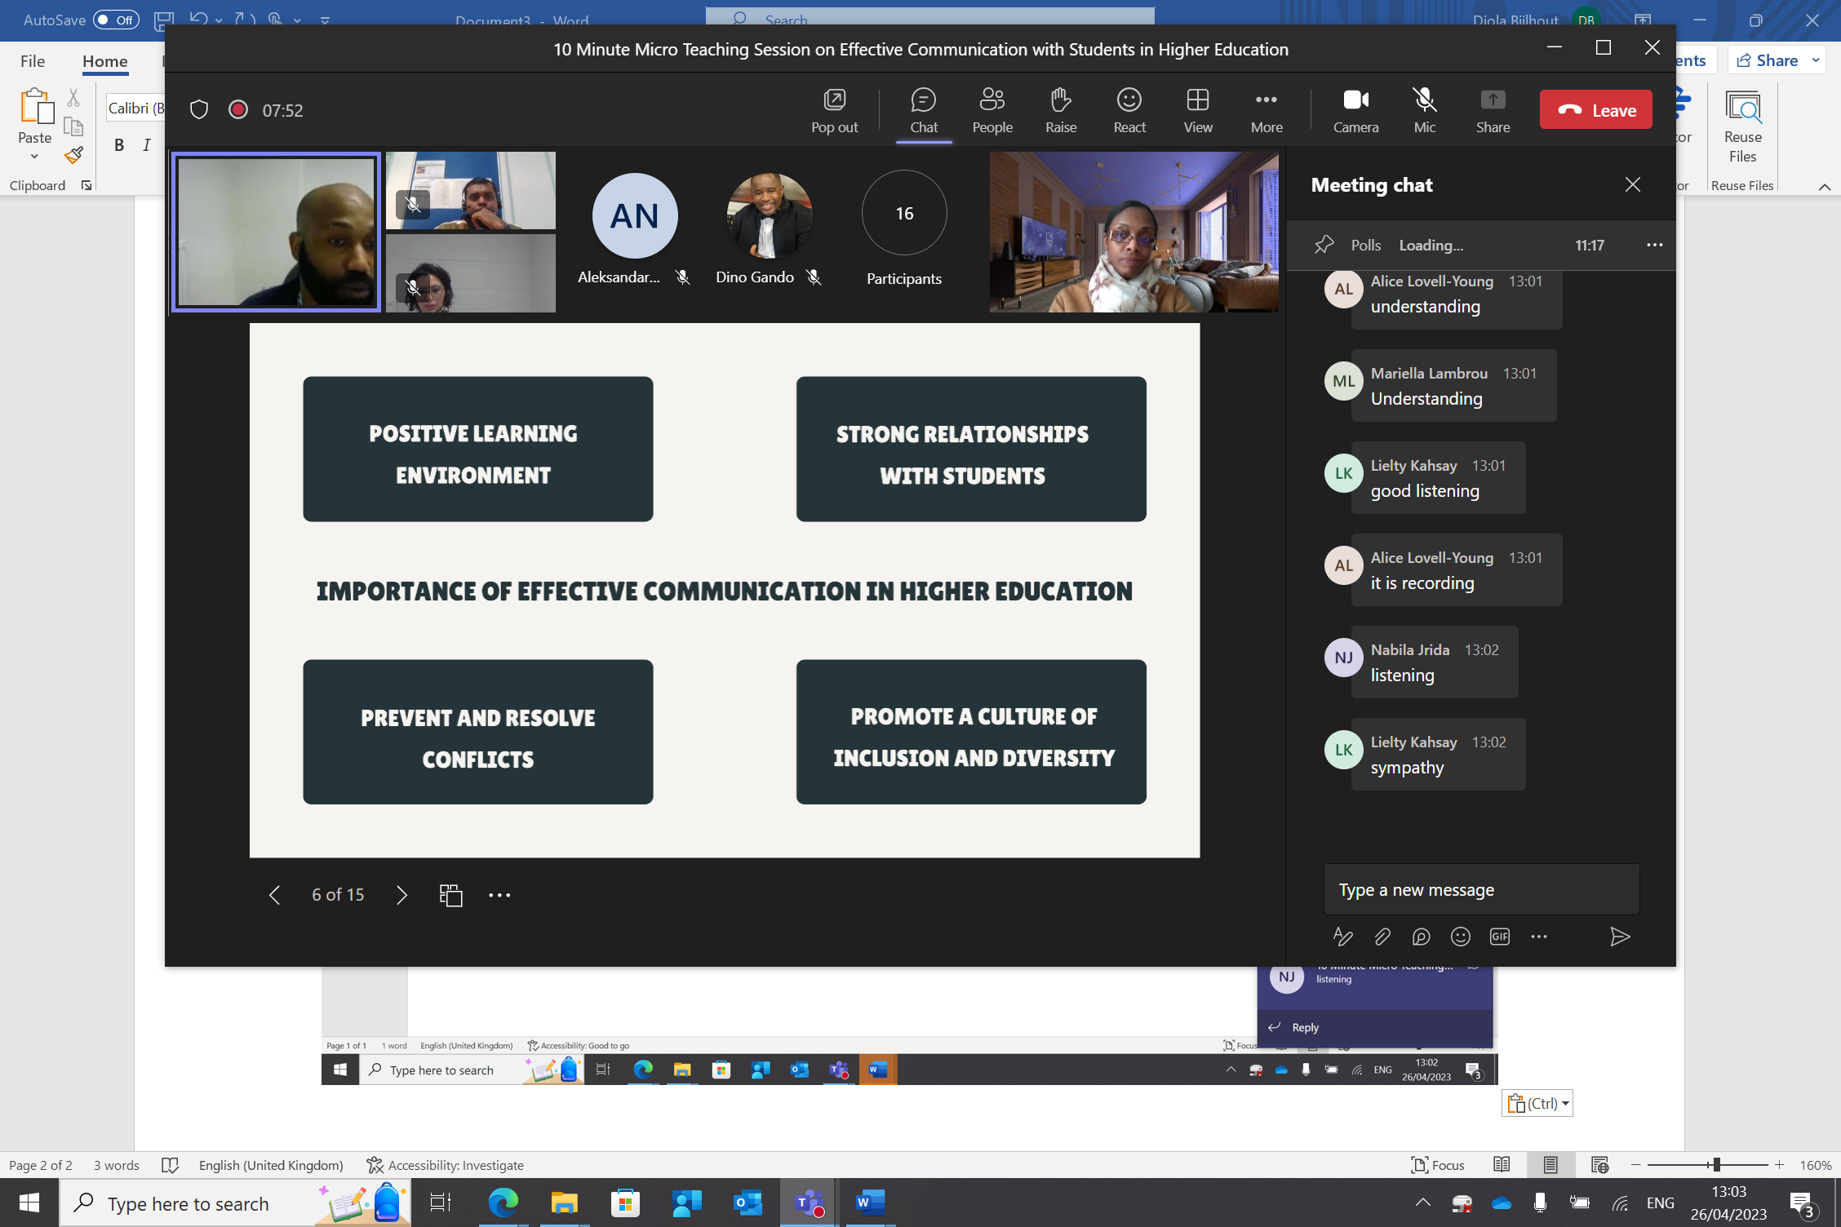

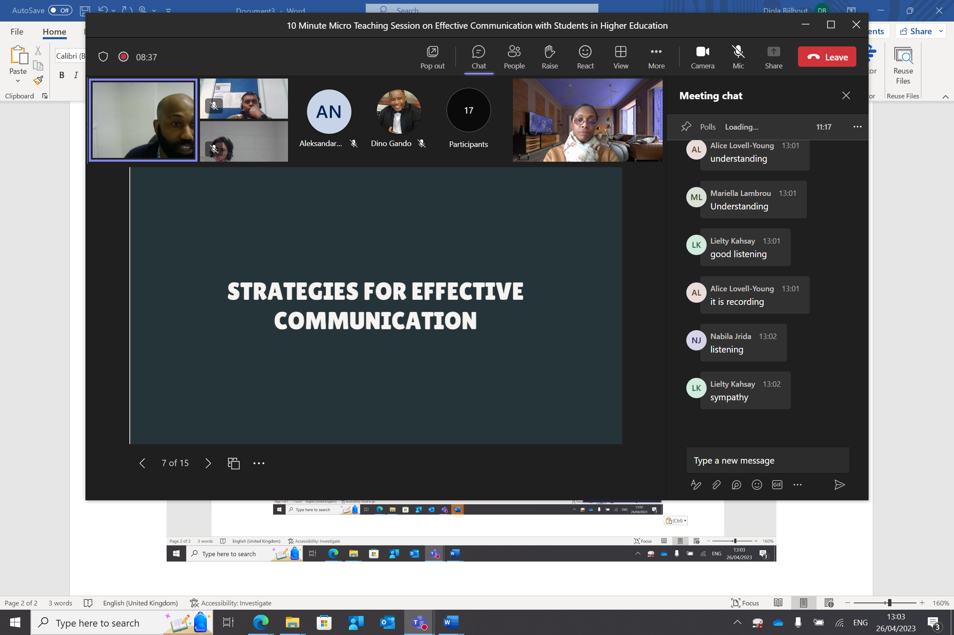



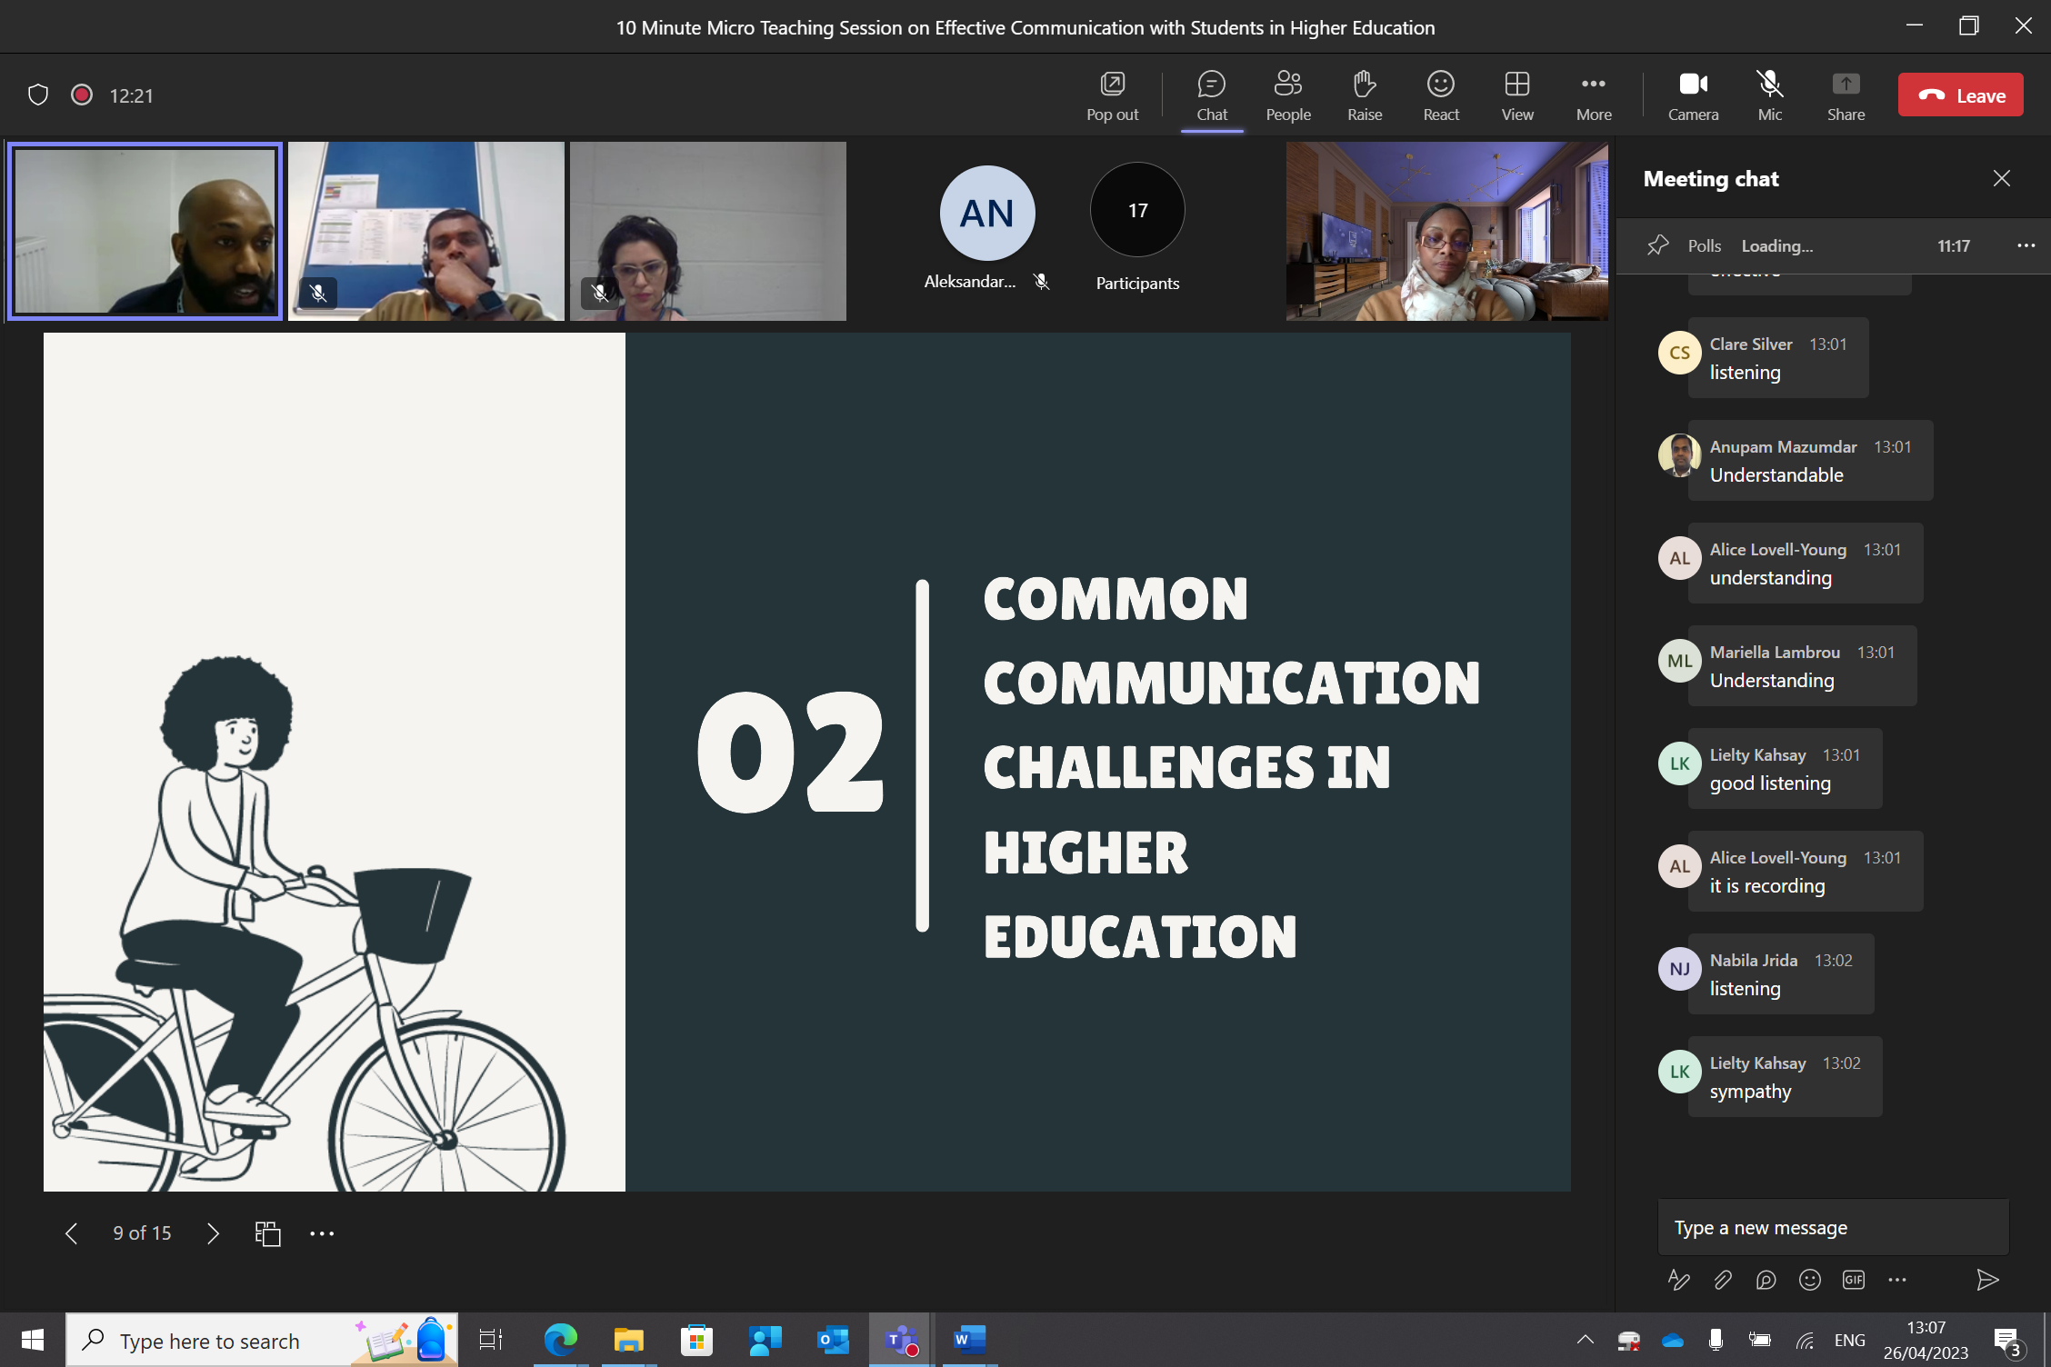

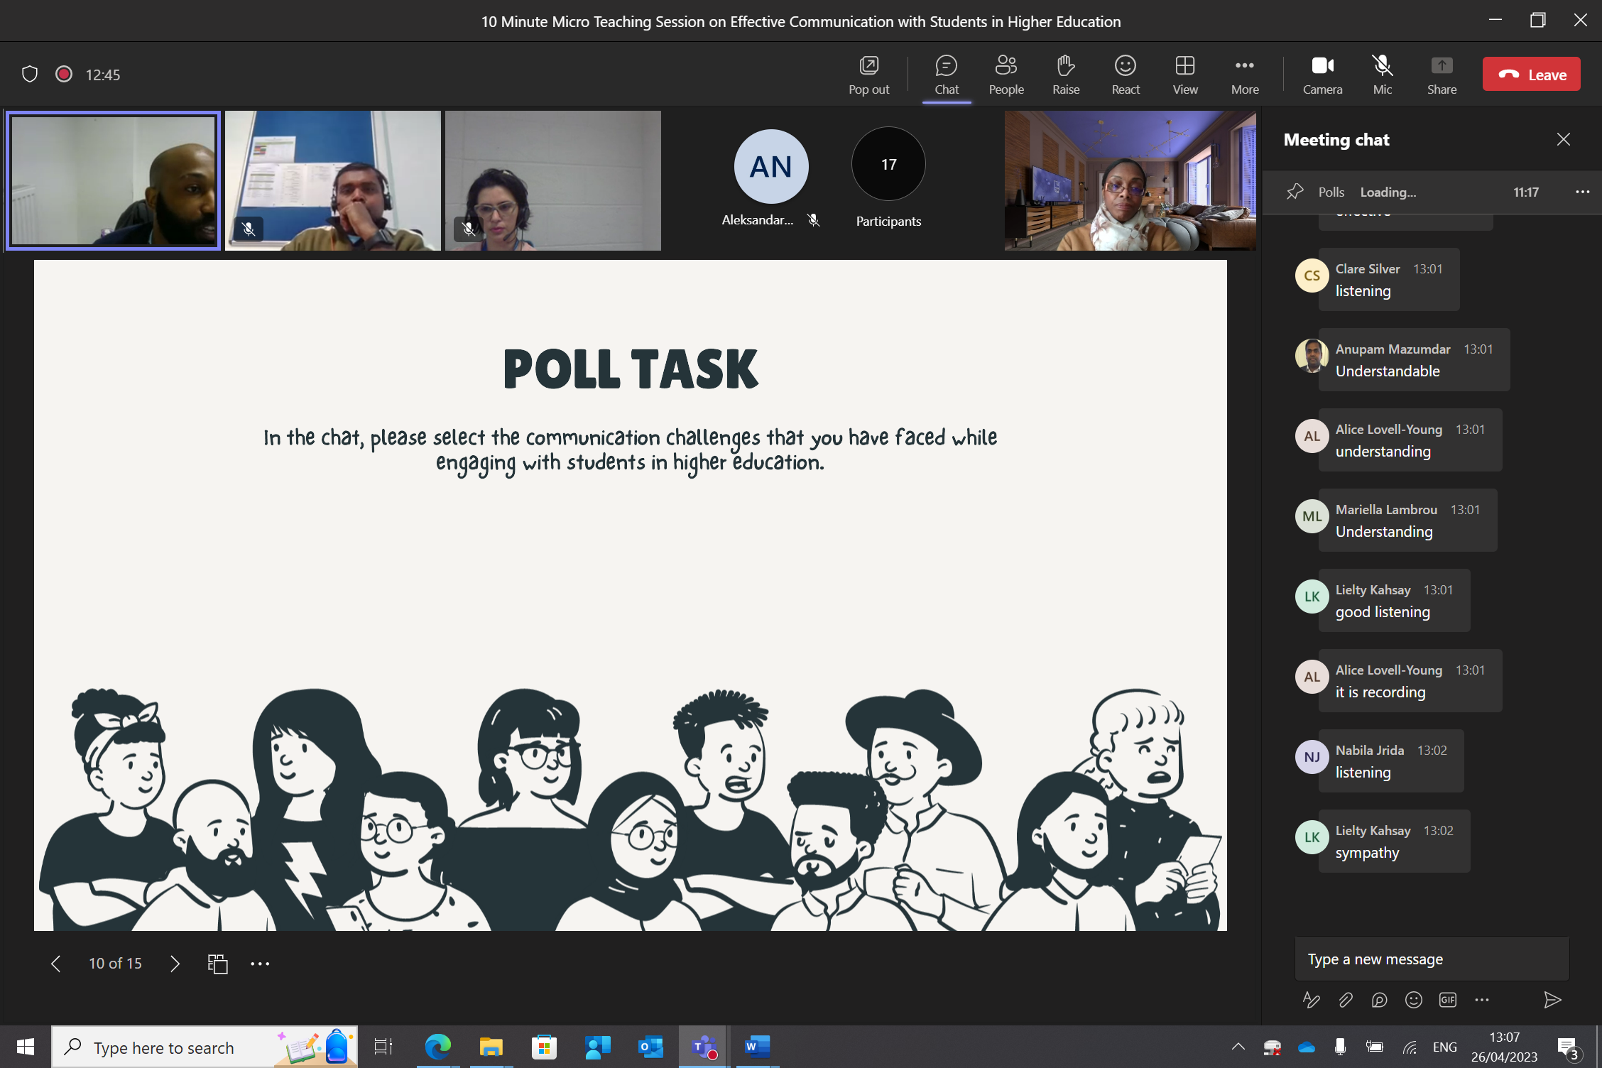

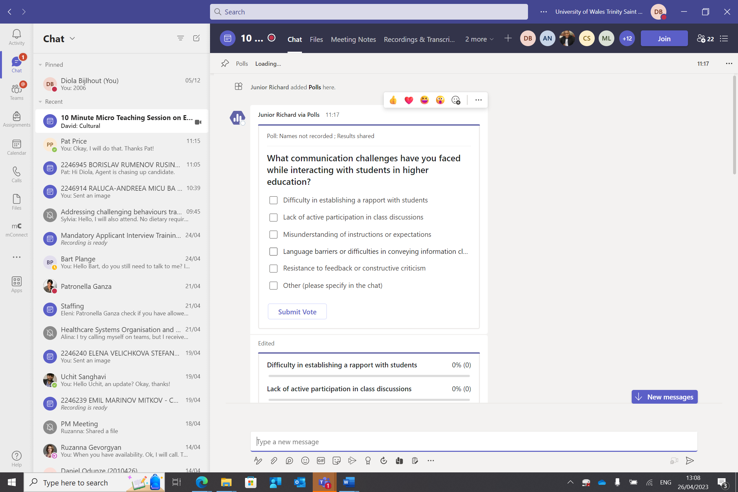

Responds saying good, yes that is a great one, too, etc.

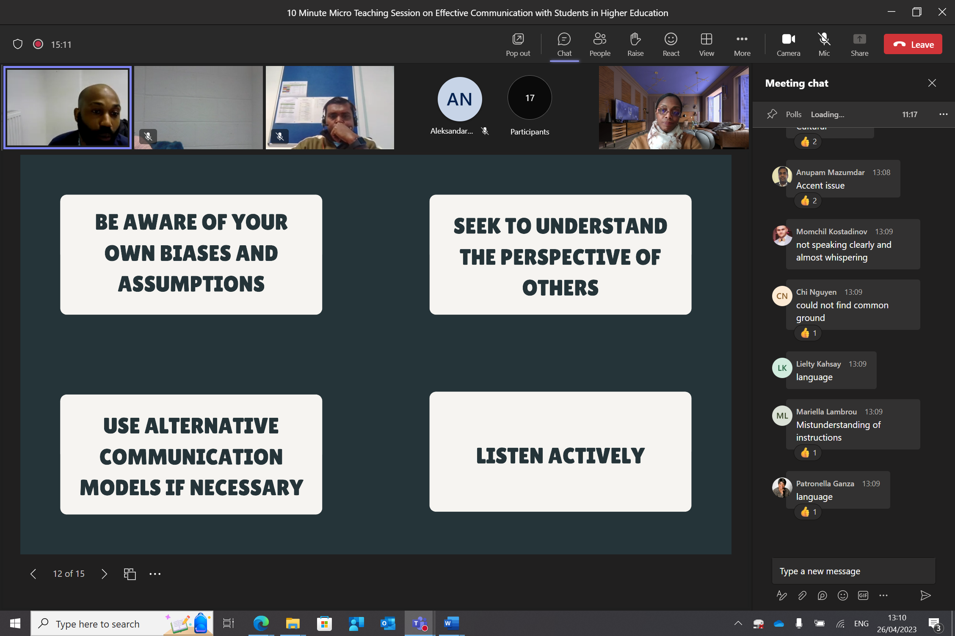

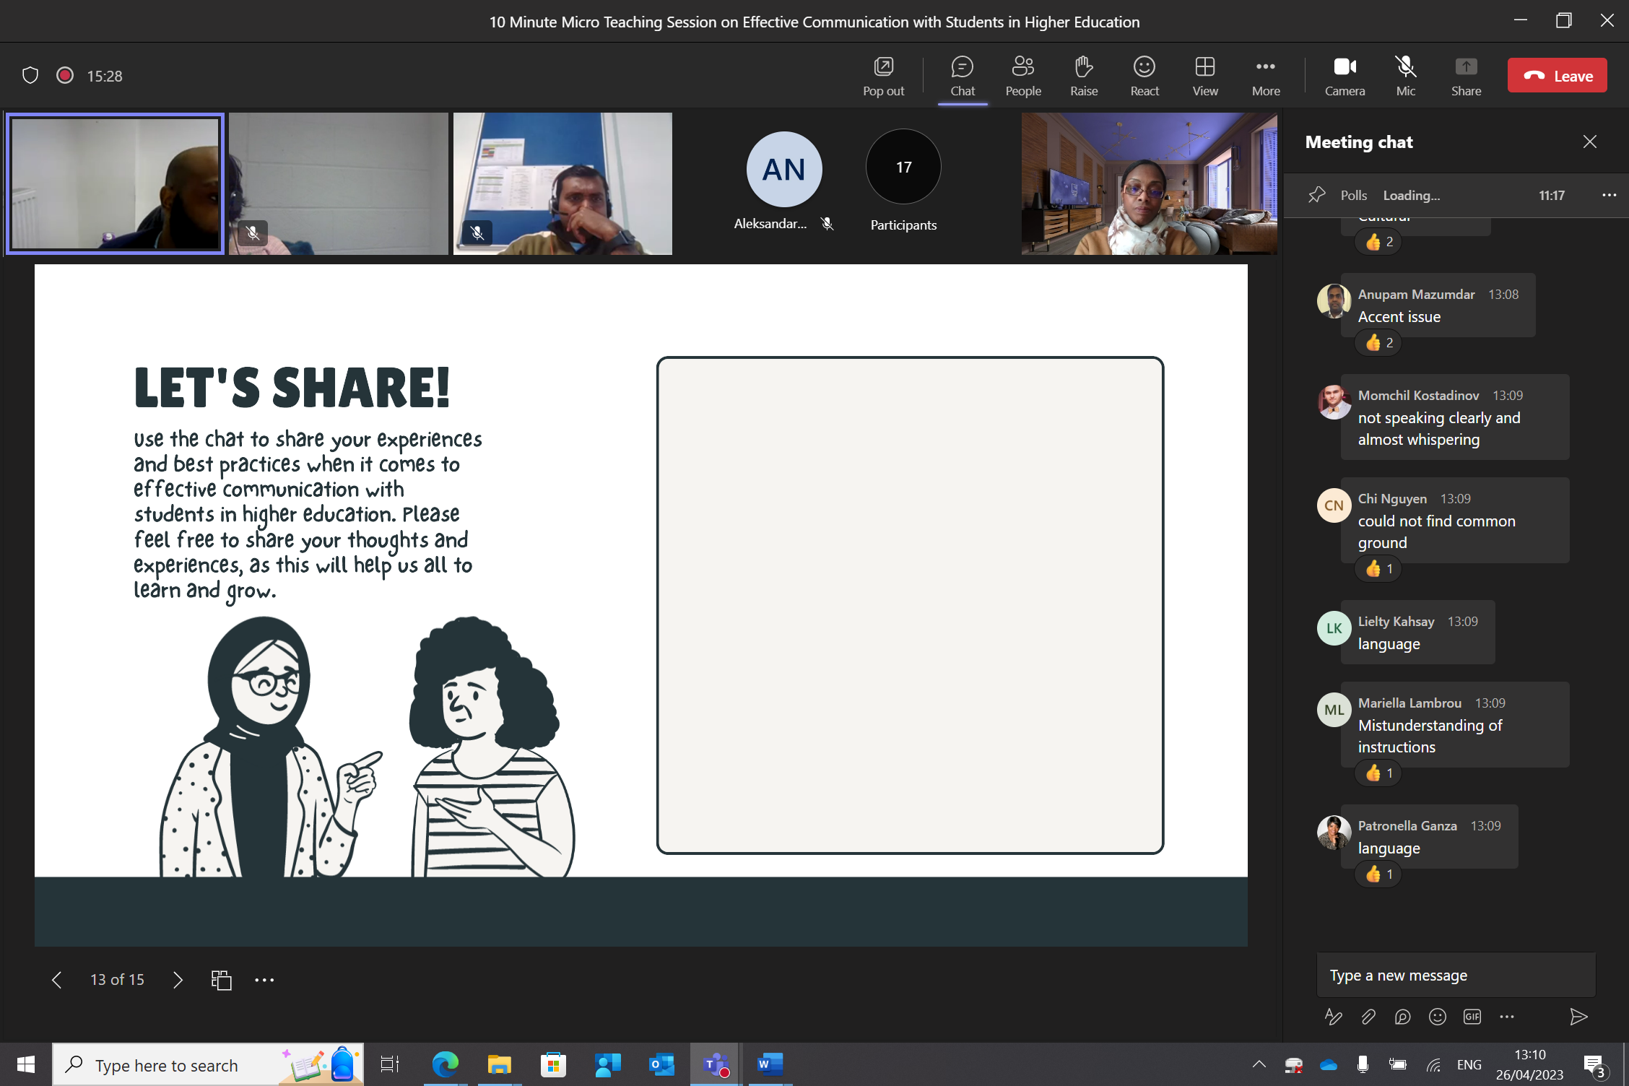

Check if the objectives were reached, learning took place

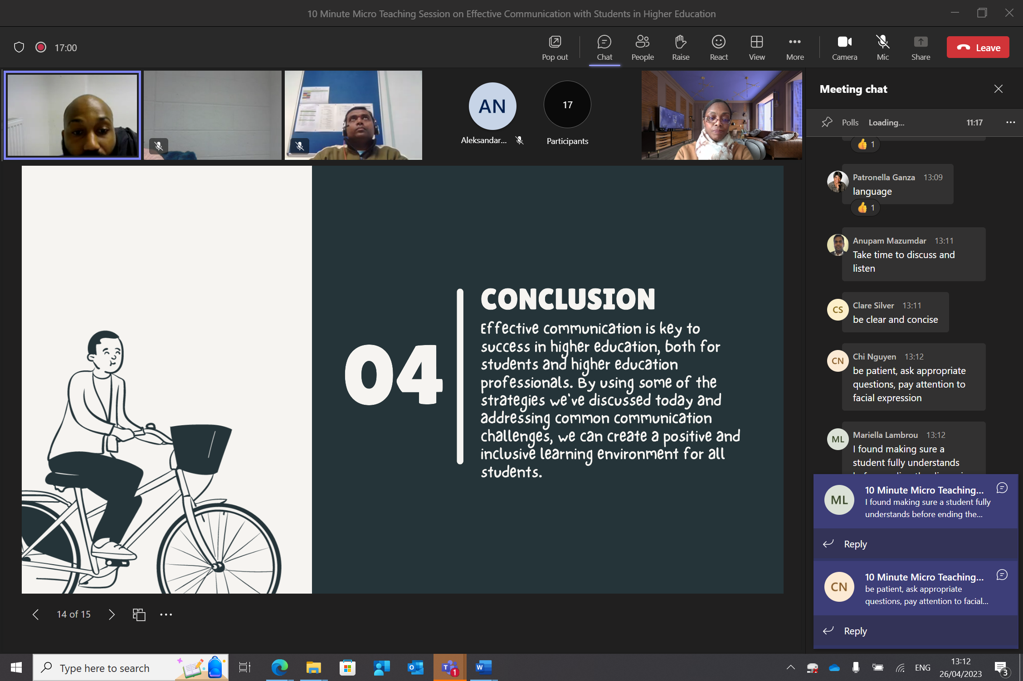

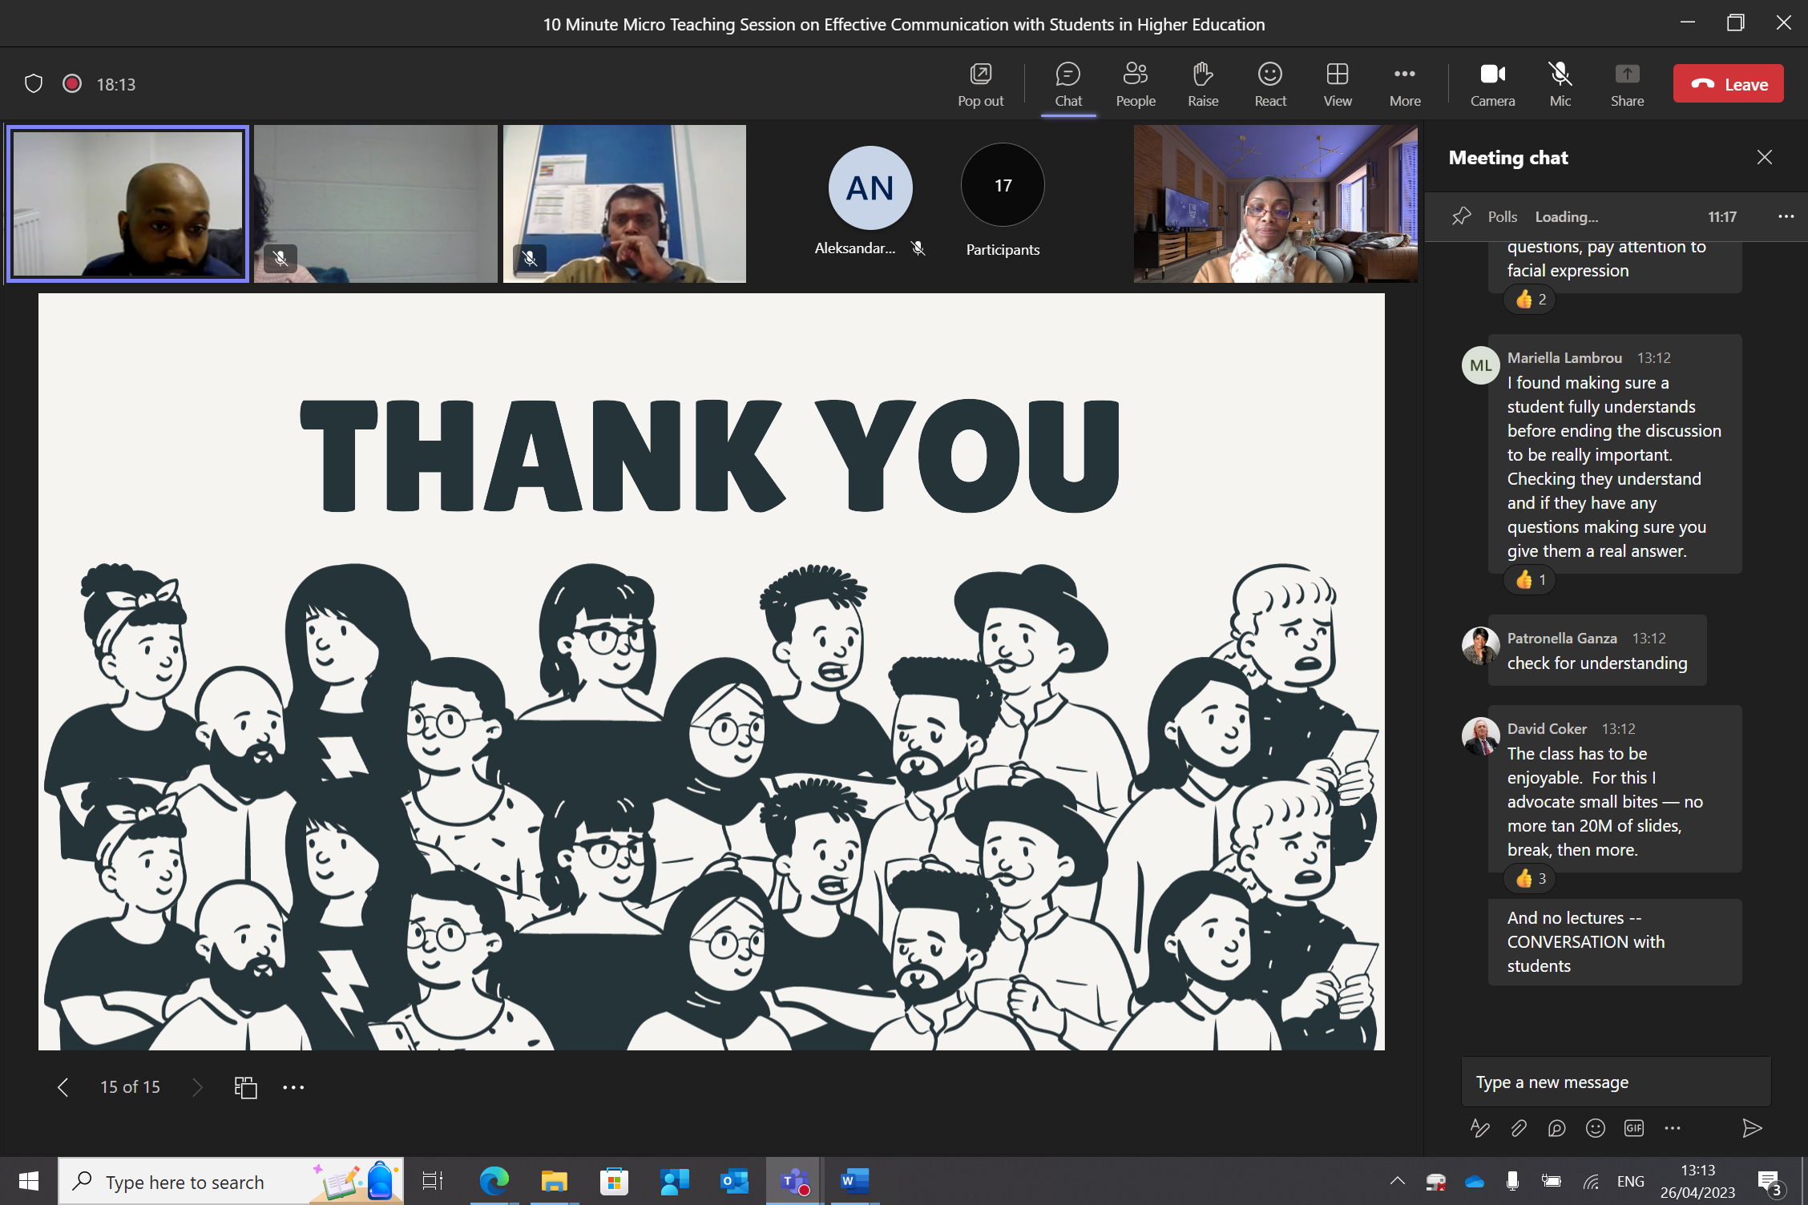
Reflect on what you have learned and how to integrate it in your practice

PGCert tHE Observation Form (3)

Professional Observed | Junior Richard | Date |  | 08/02/23
Observer | David Coker | Attendees No. |  | 7
Programme Title | Interruption of Studies Procedure & Policy | Programme level |  | 4/5/6/7
Venue | UWTSD London Campus | Duration |  | 30 minutes
Module aims /Learning outcomes
- To provide staff with an understanding of the interruption of studies procedure and policy.
- To enable staff to support students who may need to interrupt their studies for personal or professional reasons.
- To ensure that staff are equipped to navigate the administrative process of handling interruption of studies requests.
Teaching Characteristics [Preparation, selection and organisation of content. Choice of teaching/learning strategies/ methods]
- Junior used a lecture-style teaching approach, presenting the material in a clear and organised manner.
- He engaged with the attendees through Q&A sessions, ensuring that the material was well understood.
- Junior provided clear explanations and examples of the interruption of the studies process and policy.

Presentation [Beginning class, introduction, continuity with other sessions, students’ prior knowledge. Clarity of presentation. Pace. Attitude to subject matter. Use of appropriate reinforcement. Ending the session – summary, future work etc.]

- The class began with a clear introduction that outlined the goals and objectives of the session.
- Junior assessed students' prior knowledge by asking questions and encouraging discussion.
- The presentation was clear and easy to follow, with appropriate use of visual aids and examples to support understanding.
- The pace of the presentation was appropriate, with sufficient time allowed for students to take notes and ask questions.
- Junior demonstrated a positive attitude towards the subject matter, conveying enthusiasm and passion for the topic.

Technique and Aids [General apparatus – board, data projector, use of handouts. Question and answer technique. Other evaluation procedures, class management, instructions to students.]

- Junior used a PowerPoint presentation to provide an overview of the interruption of studies procedure and policy.
- Handouts of the academic policy were provided to students to support their learning.
- Real-life examples were used to illustrate the interruption of studies process and policy.
Student Responses [ General class atmosphere, level of participation, attention and interest. Student attitude and ability to carry out classwork. Were learning problems identified and overcome? Awareness of individual needs. Attitude to students.]

- Students were attentive and engaged during the class.
- Questions were asked and answered, indicating that the students had a good understanding of the material.

General [ Was effective communication achieved? Was there good student – teacher rapport? Were the aims/outcomes achieved? Appropriateness of teaching/learning method]
- Effective communication and a good rapport was achieved between the Junior and students.
- The aims and outcomes of the module were achieved.
- The teaching/learning method was appropriate for the material.

Examples of good practice
- Provided clear explanations and examples of the interruption of studies procedure and policy.
- Real-life examples were used to illustrate the interruption of studies process and policy.

Development areas/action points
- Encourage more interaction and engagement through group work and discussions.
- Consider providing additional resources, such as online guides or video tutorials, to supplement the learning experience.
- Explore additional teaching aids and methods, such as case-based learning or role-playing scenarios, to help staff better understand and support students through the interruption of studies process.

Observer (Name ) David Coker |  |  | Date 08/02/23
Oberservee (Name)Junior Richard |  |  | Date  12/02/23

Reflective report
On completion of the peer observation reports for each module, compose a short reflective paragraph on your observation experiences. refer to models such as Gibbs (1999).
Reflecting on my observation experience while teaching the "Interruption of Studies Procedure & Policy" session at UWTSD London Campus, I will utilise Gibbs' (1998) reflective cycle to guide my analysis and draw on appropriate literature to support my reflection.

The session aimed to provide staff with an understanding of the interruption of studies procedure and policy, equipping them to support students who may need to interrupt their studies for personal or professional reasons. I employed a lecture-style teaching approach, engaging attendees through Q&A sessions and using visual aids such as PowerPoint slides and handouts.

I felt confident in my ability to convey the material in a clear and organised manner, and I appreciated the positive feedback from the observer, David Coker. However, I also recognised that there might be room for improvement in terms of encouraging interaction and engagement among attendees.

The feedback from the observer indicated that my presentation was clear and easy to follow, with effective communication and a good rapport between myself and the attendees. However, there were suggestions for improvement, such as encouraging more interaction and engagement through group work and discussions, providing additional resources, and exploring alternative teaching aids and methods.

Although the lecture-style teaching approach effectively communicated the information, it is important to consider alternative methods that foster more active learning and engagement. Brame (2016) highlights that active learning methods can lead to improved retention of information and better application of knowledge in real-life situations. Therefore, incorporating group work, discussions, or case-based learning could be beneficial for the attendees.

The session achieved its aims and outcomes, and the teaching method was appropriate for the material. However, there are opportunities to improve the learning experience by incorporating additional resources, fostering more interaction and engagement, and exploring alternative teaching aids and methods.

To enhance future sessions, I plan to:

- Encourage interaction and engagement among attendees through group work, discussions, or case-based learning.
- Provide additional resources, such as online guides or video tutorials, to supplement the learning experience.
- Explore alternative teaching aids and methods, such as role-playing scenarios, to help staff better understand and support students through the interruption of studies process.
By implementing these changes, I aim to create a more engaging and interactive learning experience for attendees, ultimately improving their understanding and application of the interruption of studies procedure and policy. Reflecting on this observation experience has provided valuable insights into my teaching practices, highlighting areas for improvement, and reinforcing the importance of continuous professional development.

Reference
Brame, C.J. (2016). Active learning. Vanderbilt University Center for Teaching. Retrieved from https://cft.vanderbilt.edu/guides-sub-pages/active-learning/
Gibbs, G. (1998). Learning by doing: a guide to teaching and learning methods. London: Further Education Unit. Oxford Polytechnic: Oxford.

CPD Event Reflection

Digital Pedagogy Series: Getting the Most out of Moodle

CPD event: Digital Pedagogy Series: Getting the most out of Moodle.
Organiser: UWTSD
Time &. Date: Wed, Mar 22, 2023, 1:00 PM – 3:00 PM
Location: Microsoft Teams

I participated in a CPD event called "Digital Pedagogy Series: Getting the Most out of Moodle" which was organized by UWTSD. The event took place on Wednesday, March 22, 2023, from 1 pm to 3 pm, and was held online via Microsoft Teams. The session was facilitated by Dominique Northeast, a digital technologist from the Digital Learning and Creativity team at UWTSD, and covered various topics such as page design, content planning, accessibility, user and content management, and activity tracking and reporting.

I was eager to attend the CPD event to expand my knowledge of Moodle's features and functions. At first, I was unsure if the content would be beneficial to me. However, as the session went on, I became more interested and engaged in the topics. I felt confident and empowered as I learned new ways to enhance my Moodle courses.

The CPD event was well-structured and covered essential aspects of using Moodle effectively. I appreciated how the event was organised into different sections, each focusing on a different aspect of Moodle. The session provided practical tips and strategies for designing and managing Moodle courses, and the activities were designed to help me engage with the material in a meaningful way. I enjoyed learning about the different features of Moodle and how I could use them to improve the learning experience for my students.

Attending the CPD event has enhanced my skills relevant to the UKPSF in various ways. Firstly, it has improved my ability to manage Moodle courses, which is crucial for my teaching practice. I have gained knowledge about essential principles of page design, content planning, and user management, which will be valuable in creating effective Moodle courses. This aligns with A1 of the UKPSF as it demonstrates my capability to design and plan learning activities and programs.

During the CPD event, I gained valuable knowledge and skills to improve my teaching practice. Specifically, I learned new strategies for enhancing accessibility and tracking student progress in Moodle. The session emphasized the importance of accessibility and guided me on how to make Moodle courses more accessible to students with diverse needs. Additionally, I gained insight into activity tracking and reporting, which will enable me to monitor student progress and provide timely feedback. I see this as a positive step towards achieving the UKPSF's A3 criteria for assessing and giving feedback for learning.

The CPD event I attended was beneficial in teaching me how to effectively use technology and resources for learning purposes. Specifically, I was able to learn about the various features of Moodle and how they can be utilised to improve the learning experience of my students. This aligns with K4 of the UKPSF, which demonstrates my capability to use relevant digital and/or other technologies and resources for enhancing learning.

Attending the CPD event "Digital Pedagogy Series: Getting the Most out of Moodle" was a great chance for me to enhance my abilities in efficiently managing Moodle courses and utilising technology and resources for effective learning. The event equipped me with practical insights and techniques for designing and administering Moodle courses, enhancing accessibility, and monitoring student progress. Consequently, I am confident that participating in this CPD event has significantly advanced my professional development as per the UKPSF.

Understanding the Extenuating Circumstances Policy and Procedure

CPD event: Understanding the Extenuating Circumstances Policy and Procedure
Organiser: UWTSD
Time &. Date: Mon, Jan 30, 2023, 3:00 PM – 4:00 PM
Location: Microsoft Teams

I attended a CPD event titled "Understanding the Extenuating Circumstances Policy and Procedure," held by Andrew Gough, a senior academic officer from the Academic Office at UWTSD. The event was held online via Microsoft Teams on Monday, January 30, 2023, from 3:00 PM to 4:00 PM. The CPD event covered the Extenuating Circumstances Policy and Procedure at UWTSD a higher education institution, which is a policy that allows students to request additional support or extensions due to unforeseen circumstances.

At first, I was unsure if the event would benefit me as I had some knowledge about the policy already. But as the session went on, I became more interested and engaged in the topic. I felt empowered learning about the various procedures and how to help students in difficult situations.

The CPD event was informative and covered the essential aspects of the Extenuating Circumstances Policy and Procedure at UWTSD. The session was well-structured, and Andrew Gough provided practical examples and tips on how to handle different scenarios related to extenuating circumstances. The event was highly relevant to my professional development, as it gave me an in-depth understanding of the policy and how to apply it effectively.

Attending the CPD event has positively impacted my development regarding the UKPSF in multiple ways. Specifically, it enhanced my understanding of the Extenuating Circumstances Policy and Procedure, which plays a crucial role in my teaching practice. The event covered various situations where students may require additional support or deadline extensions due to unexpected circumstances. This aligns with K3 of the UKPSF, showcasing my capacity to use critical evaluation to improve my teaching approach.

Through the CPD event, I gained new strategies to better support students facing extenuating circumstances, which has helped me enhance my teaching practice. I learned effective procedures and communication techniques when working with students who may be facing challenges. This aligns with A4 of the UKPSF, demonstrating my ability to guide and support learners.

The CPD event provided me with valuable knowledge on how to address the broader environment in which higher education functions. Specifically, I gained insight into UWTSD's policies and procedures regarding extenuating circumstances, which I can apply in my future teaching endeavours. This aligns with V4 of the UKPSF, demonstrating my capacity to adapt to the wider context of higher education and consider the implications for my professional practice.

In conclusion, the CPD event on "Understanding the Extenuating Circumstances Policy and Procedure" was an excellent opportunity for me to develop my knowledge and skills related to supporting students who may need additional support due to unforeseen circumstances. The event provided me with practical tips and strategies for handling different scenarios and communicating effectively with students. As a result, I believe that attending this CPD event has contributed significantly to my professional development relevant to the UKPSF.

Digital Pedagogy Series: Building an online community

CPD event: Digital Pedagogy Series: Building an online community.
Organiser: UWTSD
Time &. Date: Wed, Mar 1, 2023, 1:00 PM – 2:00 PM
Location: Microsoft Teams

I recently attended a Continuing Professional Development (CPD) event titled "Digital Pedagogy Series: Building an online community" by Emily Jones, a digital technologist from the Digital Learning and Creativity team at UWTSD. The event was conducted online via Microsoft Teams on Wednesday, 1st March 2023, from 1 pm to 2 pm. The CPD event covered the topics of good practice for community building, different ways to help students get to know you, tone of voice when writing content, and the communication tools available to build an online community. The session was hands-on, and there were several activities to participate in.

I was eager to attend the CPD event to gain knowledge on creating an online community. However, at the start, I found the amount of information overwhelming. As the session progressed, I became more engaged and interested in the activities provided. Completing the tasks gave me a sense of accomplishment, and I could see how they helped me develop new skills.

The CPD event was highly informative and provided practical insights into how to build an online community effectively. I appreciated how the event was designed to be interactive, with hands-on activities that helped me to engage with the material in a more meaningful way. The event also covered different communication tools that can be used to build an online community. The activities focused on tone of voice, various communication tools, and ways to help students get to know you better. These topics were all relevant to my development as an educator, and I can see how the skills I learned will be helpful in my future teaching practice.

Attending the CPD event boosted my skills related to the UKPSF in various ways. Firstly, I improved my communication skills, particularly in an online learning setting. I learned to use different communication tools efficiently and maintain a professional and respectful tone while interacting with students. This aligns with V1 of the UKPSF, highlighting my ability to value and accommodate diverse groups of learners.

Secondly, the CPD event helped me to enhance my teaching practice by teaching me new strategies for engaging students and building an online community. This is in line with A1 and A2 of the UKPSF as it shows that I can design and plan learning activities and teach and support learning through appropriate approaches and environments.

Lastly, the CPD event helped me to use scholarship or professional learning as a basis for effective practice. The event provided me with evidence-informed approaches that I can use to build an online community effectively. This is in line with V3 of the UKPSF as it shows my ability to use scholarship or professional learning as a basis for effective practice.

Attending the CPD event was very beneficial for me as it helped me enhance my skills in online teaching and communication. I gained valuable practical knowledge and learned new techniques to effectively engage students and create an online community. The event also improved my communication skills, and teaching methods, and showed me the importance of utilising scholarship and professional learning for effective teaching practice. Overall, I feel that attending this CPD event has greatly contributed to my professional development according to the UKPSF standards.

Appendix A

PG Cert tHE -TEACHING LOG

Candidate: Junior Richard | Campus: London Campus
Date | Session Details | No of Hours | Practice Advisor’s Signature
06/10/2022 | Offering advice on how to transition back to studies after an interruption break, such as providing study tips or recommendations on how to prioritise tasks. | 1 | David Coker
07/10/2022 | Advising a student on how to appeal a grade, including providing information on the appeals process and the documentation required. | 0.5 | David Coker
07/10/2022 | Providing guidance to a student on the process for requesting an interruption of studies, including explaining the documentation required and the deadline for submitting the request. Including providing guidance on how to identify funding implications of interrupting studies and its impact on studies. | 1 | David Coker
07/10/2022 | Assisting a student with resolving a scheduling conflict, including identifying alternative course options and providing guidance on the process for changing programme. | 1 | David Coker
10/10/2022 | Providing guidance on the process for withdrawing from a programme. | 0.5 | David Coker
10/10/2022 | Assisting a student with resolving an issue related to their enrolment status, including providing guidance on the process for withdrawing from a programme. | 1 | David Coker
10/10/2022 | Providing guidance to a student on the process for registering for classes, including explaining the deadlines and the steps required to complete the process. | 0.5 | David Coker
10/10/2022 | Advising a student on how to appeal a grade, including providing information on the appeals process and the documentation required. | 0.5 | David Coker
10/10/2022 | Offering advice on how to transition back to studies after an interruption break, such as providing study tips or recommendations on how to prioritise tasks. | 1 | David Coker
11/10/2022 | Providing guidance to a student on the process for requesting an interruption of studies, including explaining the documentation required and the deadline for submitting the request. Including providing guidance on how to identify funding implications of interrupting studies and its impact on studies. | 1 | David Coker
11/10/2022 | Offering advice on how to transition back to studies after an interruption break, such as providing study tips or recommendations on how to prioritise tasks. | 1 | David Coker
13/10/2022 | Assisting a student with resolving an issue related to their student account, including providing information on the status of their payments and the steps required to resolve any outstanding issues | 0.5 | David Coker
13/10/2022 | Offering advice on how to transition back to studies after an interruption break, such as providing study tips or recommendations on how to prioritise tasks. | 1 | David Coker
14/10/2022 | Providing guidance to a student on the process for requesting an interruption of studies, including explaining the documentation required and the deadline for submitting the request. Including providing guidance on how to identify funding implications of interrupting studies and its impact on studies. | 1 | David Coker
14/10/2022 | Advising a student on the impact of changing modules on their programme progression. | 1 | David Coker
17/10/2022 | Providing guidance on the process for withdrawing from a programme. | 0.5 | David Coker
17/10/2022 | Assisting a student with resolving an issue related to their student account, including providing information on the status of their payments and the steps required to resolve any outstanding issues | 0.5 | David Coker
17/10/2022 | Assisting a student with their student finance application. | 2 | David Coker
18/10/2022 | Providing guidance to a student on the process for requesting an interruption of studies, including explaining the documentation required and the deadline for submitting the request. Including providing guidance on how to identify funding implications of interrupting studies and its impact on studies. | 1 | David Coker
18/10/2022 | Providing guidance to a student on the process for requesting an interruption of studies, including explaining the documentation required and the deadline for submitting the request. Including providing guidance on how to identify funding implications of interrupting studies and its impact on studies. | 1 | David Coker
19/10/2022 | Providing guidance to students on the process for completing an interruption of studies, including explaining the documentation required and the deadline for submitting the request | 0.5 | David Coker
19/10/2022 | Providing guidance to a student on the process for requesting an interruption of studies, including explaining the documentation required and the deadline for submitting the request. Including providing guidance on how to identify funding implications of interrupting studies and its impact on studies. | 1 | David Coker
20/10/2022 | Advising a student on the process for changing their programme, including providing information on the requirements and the documentation required. | 1 | David Coker
21/10/2022 | Advising a student on the process for changing their programme, including providing information on the requirements and the documentation required. | 1 | David Coker
21/10/2022 | Advising a student on the process for changing their programme, including providing information on the requirements and the documentation required. | 1 | David Coker
27/10/2022 | Advising a student on the process for changing their programme, including providing information on the requirements and the documentation required. | 1 | David Coker
01/11/2022 | Advising a student on the process for changing their programme, including providing information on the requirements and the documentation required. | 1 | David Coker
03/11/2022 | Providing guidance to a student on the process for requesting an interruption of studies, including explaining the documentation required and the deadline for submitting the request. Including providing guidance on how to identify funding implications of interrupting studies and its impact on studies. | 1 | David Coker
03/11/2022 | Providing guidance to a student on the process for requesting an interruption of studies, including explaining the documentation required and the deadline for submitting the request. Including providing guidance on how to identify funding implications of interrupting studies and its impact on studies. | 1 | David Coker
07/11/2022 | Providing guidance on the process for withdrawing from a programme. Including providing guidance on how to identify funding implications of withdrawing from programme and its impact. | 1 | David Coker
11/11/2022 | Advising a student on the process for changing their programme, including providing information on the requirements and the documentation required. | 1 | David Coker
18/11/2022 | Advising a student on the process for changing their programme, including providing information on the requirements and the documentation required. | 1 | David Coker
21/11/2022 | Advising a student on the process for changing their programme, including providing information on the requirements and the documentation required. | 2 | David Coker
22/11/2022 | Providing guidance to a student on the process for requesting an interruption of studies, including explaining the documentation required and the deadline for submitting the request. Including providing guidance on how to identify funding implications of interrupting studies and its impact on studies. | 1 | David Coker
22/11/2022 | Advising a student on the process for changing their programme, including providing information on the requirements and the documentation required. | 1 | David Coker
22/11/2022 | Advising a student on the process for changing their programme, including providing information on the requirements and the documentation required. | 1 | David Coker
22/11/2022 | Advising a student on the process for changing their programme, including providing information on the requirements and the documentation required. | 1 | David Coker
23/11/2022 | Providing guidance on the process for withdrawing from a programme. Including providing guidance on how to identify funding implications of withdrawing from programme and its impact. | 1 | David Coker
25/11/2022 | Providing guidance to students on the process for completing an interruption of studies, including explaining the documentation required and the deadline for submitting the request | 0.5 | David Coker
25/11/2022 | Providing guidance on the process for withdrawing from a programme. | 0.5 | David Coker
01/12/2022 | Providing guidance to a student on the process for requesting an interruption of studies, including explaining the documentation required and the deadline for submitting the request. Including providing guidance on how to identify funding implications of interrupting studies and its impact on studies. | 1 | David Coker
01/12/2022 | Providing guidance to students on the process for completing an interruption of studies, including explaining the documentation required and the deadline for submitting the request | 0.5 | David Coker
05/12/2022 | Providing guidance to students on the process for completing an interruption of studies, including explaining the documentation required and the deadline for submitting the request | 0.5 | David Coker
06/12/2022 | Providing guidance on the process for withdrawing from a programme. Including providing guidance on how to identify funding implications of withdrawing from programme and its impact. | 1 | David Coker
03/01/2023 | Advising a student on the process for changing their programme, including providing information on the requirements and the documentation required. | 1 | David Coker
10/01/2023 | Providing guidance to a student on the process for requesting an extension on an assignment deadline, including explaining the documentation required and the deadline for submitting the request. | 0.5 | David Coker
13/01/2023 | Providing guidance to a student on the process for requesting an extension on an assignment deadline, including explaining the documentation required and the deadline for submitting the request. | 0.5 | David Coker
13/01/2023 | Providing guidance on the process for withdrawing from a programme. | 0.5 | David Coker
16/01/2023 | Providing guidance to a student on the process for requesting an interruption of studies, including explaining the documentation required and the deadline for submitting the request. Including providing guidance on how to identify funding implications of interrupting studies and its impact on studies. | 1 | David Coker
19/01/2023 | Providing guidance to a student on the process for requesting an interruption of studies, including explaining the documentation required and the deadline for submitting the request. Including providing guidance on how to identify funding implications of interrupting studies and its impact on studies. | 1 | David Coker
20/01/2023 | Advising a student on the process for changing their programme, including providing information on the requirements and the documentation required. | 1 | David Coker
26/01/2023 | Providing guidance on the process for withdrawing from a programme. Including providing guidance on how to identify funding implications of withdrawing from programme and its impact. | 1 | David Coker
31/01/2023 | Advising a student on the process for changing their programme, including providing information on the requirements and the documentation required. | 1 | David Coker
01/02/2023 | Providing guidance to a student on the process for requesting an interruption of studies, including explaining the documentation required and the deadline for submitting the request. Including providing guidance on how to identify funding implications of interrupting studies and its impact on studies. | 1 | David Coker
03/02/2023 | Providing guidance to students on the process for completing an interruption of studies, including explaining the documentation required and the deadline for submitting the request | 0.5 | David Coker
08/02/2023 | Advising a student on the process for changing their programme, including providing information on the requirements and the documentation required. | 1 | David Coker
08/02/2023 | Providing guidance on the process for withdrawing from a programme. | 0.5 | David Coker
08/02/2023 | Assisting a student with their student finance application. | 2 | David Coker
09/02/2023 | Assisting a student with resolving an issue related to their enrolment status, including providing guidance on the process for withdrawing from a programme. | 1 | David Coker
09/02/2023 | Assisting a student with resolving an issue related to their enrolment status, including providing guidance on the process for withdrawing from a programme. | 1 | David Coker
10/02/2023 | Offering advice on how to transition back to studies after an interruption break, such as providing study tips or recommendations on how to prioritise tasks. | 1 | David Coker
10/02/2023 | Advising a student on how to appeal a grade, including providing information on the appeals process and the documentation required. | 0.5 | David Coker
10/02/2023 | Offering advice on how to transition back to studies after an interruption break, such as providing study tips or recommendations on how to prioritise tasks. | 1 | David Coker
10/02/2023 | Offering advice on how to transition back to studies after an interruption break, such as providing study tips or recommendations on how to prioritise tasks. | 1 | David Coker
11/02/2023 | Offering advice on how to transition back to studies after an interruption break, such as providing study tips or recommendations on how to prioritise tasks. | 1 | David Coker
13/02/2023 | Assisting a student with resolving an issue related to their enrolment status, including providing guidance on the process for withdrawing from a programme. | 1 | David Coker
13/02/2023 | Advising a student on how to appeal a grade, including providing information on the appeals process and the documentation required. | 0.5 | David Coker
13/02/2023 | Assisting a student with resolving an issue related to their enrolment status, including providing guidance on the process for withdrawing from a programme. | 1 | David Coker
14/02/2023 | Advising a student on the process for changing their programme, including providing information on the requirements and the documentation required. | 1 | David Coker
15/02/2023 | Assisting a student with resolving an issue related to their enrolment status, including providing guidance on the process for withdrawing from a programme. | 1 | David Coker
16/02/2023 | Assisting a student with resolving an issue related to their enrolment status, including providing guidance on the process for withdrawing from a programme. | 1 | David Coker
27/02/2023 | Providing guidance to a student on the process for requesting an interruption of studies, including explaining the documentation required and the deadline for submitting the request. Including providing guidance on how to identify funding implications of interrupting studies and its impact on studies. | 1 | David Coker
01/03/2023 | Providing guidance to students on the process for completing an interruption of studies, including explaining the documentation required and the deadline for submitting the request | 0.5 | David Coker
02/03/2023 | Providing guidance to a student on the process for requesting an interruption of studies, including explaining the documentation required and the deadline for submitting the request. Including providing guidance on how to identify funding implications of interrupting studies and its impact on studies. | 1 | David Coker
03/03/2023 | Providing guidance to a student on the process for requesting an interruption of studies, including explaining the documentation required and the deadline for submitting the request. Including providing guidance on how to identify funding implications of interrupting studies and its impact on studies. | 1 | David Coker
08/03/2023 | Providing guidance on the process for withdrawing from a programme. | 0.5 | David Coker
08/03/2023 | Providing guidance to a student on the process for requesting an interruption of studies, including explaining the documentation required and the deadline for submitting the request. Including providing guidance on how to identify funding implications of interrupting studies and its impact on studies. | 1 | David Coker
21/03/2023 | Providing guidance on the process for withdrawing from a programme. Including providing guidance on how to identify funding implications of withdrawing from programme and its impact. | 1 | David Coker
23/03/2023 | Providing guidance on the process for withdrawing from a programme. Including providing guidance on how to identify funding implications of withdrawing from programme and its impact. | 2 | David Coker
24/03/2023 | Providing guidance to a student on the process for requesting an interruption of studies, including explaining the documentation required and the deadline for submitting the request. Including providing guidance on how to identify funding implications of interrupting studies and its impact on studies. | 1 | David Coker
14/04/2023 | Providing guidance to a student on the process for requesting an interruption of studies, including explaining the documentation required and the deadline for submitting the request. Including providing guidance on how to identify funding implications of interrupting studies and its impact on studies. | 1 | David Coker
19/04/2023 | Assisting a student with resolving an issue related to their student account, including providing information on the status of their payments and the steps required to resolve any outstanding issues | 0.5 | David Coker
20/04/2023 | Providing guidance to a student on the process for requesting an interruption of studies, including explaining the documentation required and the deadline for submitting the request. Including providing guidance on how to identify funding implications of interrupting studies and its impact on studies. | 1 | David Coker
26/04/2023 | Providing guidance to students on effectively communicating in higher education. | 0.1  0.5  Total  Hours = 76.6 | David Coker  David Coker
25/04/2023 | Providing guidance on the process for withdrawin from a ro amme. | 0.1  0.5  Total  Hours = 76.6
Hours = | Hours Carried Over= | 0.1  0.5  Total  Hours = 76.6

j.richard

Participant's signature
Practice Advisor's signature

