Ceri Dacey (2415538)
UWTSD
Introduction to Web and database concepts

Table of Contents
Introduction 2
Requirements 2
Implementation 2
Validation 5
Evaluation 7
Comparison of 2 live websites: 10
Conclusion 12
References 12
Appendices 13

Introduction
This report will look to evaluate a website that has been created for the purpose of the ‘Introduction to Web and Database Concepts’ module. Design decisions will be discussed, as will the implementation process. The report will include screenshots of the website and its validation results. A further evaluation will take place which will touch upon website accessibility, usefulness, functionality, content, usability and search engine optimisation. Finally, two websites will then be compared and evaluated using the criteria previously mentioned.

Requirements
The website that has been created is very specific and targeted. It is aimed at people who play the game Kingshot and who play on server number 821. Kingshot is a mobile strategy game with over 1000 servers where players become a Governor of their own Medieval-style town. Players manage resources, build up their town and battle other towns and servers. There is also the option to join alliances and to chat to and co-operate with other players. The website created hasinformation relevant to players gaming experience including alliance information, current news and tutorials.

Implementation
Figure 1 shows the homepage of the website. It has a Kingshot themed background, a black navigation bar at the top with white writing, a centralised title and a small paragraph. When hovering over one of the options in the navigation bar, it will be highlighted in green as shown.
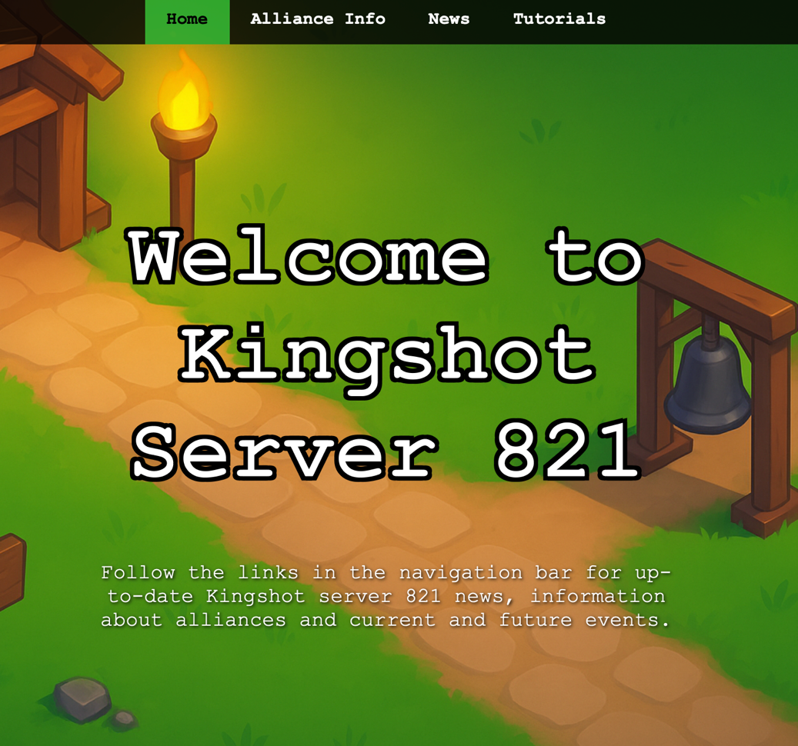
Fig.1 - A screen grab of the homepage of the created website.
Figure 2 shows the 2nd page of the website titled ‘Alliance Info.’ Again, the page has a Kingshot themed background and a black navigation bar with white writing. There is a large heading followed by a white line and a small paragraph. Next, there are 6 white boxes with a black outline. These boxes contain information about each alliance in the game.
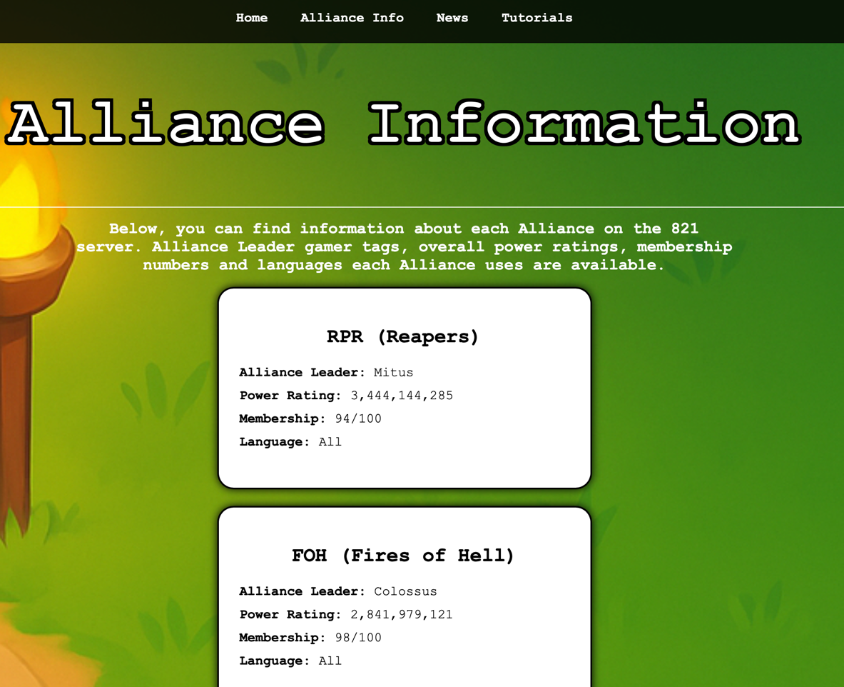
Fig.2 - A screengrab of the 2nd page of the website titled ‘Alliance Information.’
Figure 3 shows the 3rd page of the website titled ‘News.’ It has the same design as the previous page with one difference; the boxes are wider as there is a higher quantity of text.
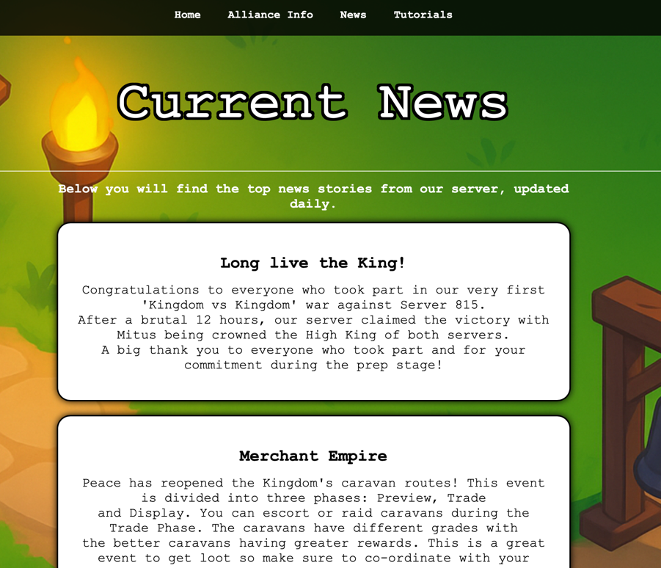
Fig. 3 – A screengrab of the 3rd page of the website titled ‘Current News.’
Figure 4 shows the 4th page of the website titled ‘Tutorials.’ It has the same design as the previous pages however, there are hyperlinks in each box too.
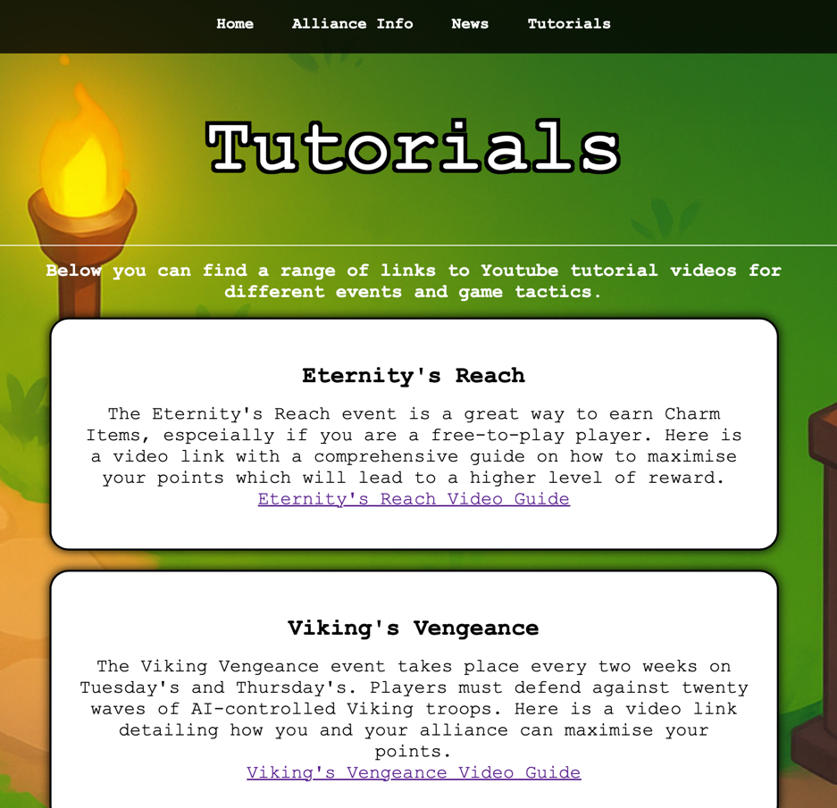
Fig.4 - A screengrab of the 4th page of the website titled ‘Tutorials.’

Validation
The HTML code was validated using http://validator.w3.org. Figure 5 is a screengrab showing the initial errors that were present in the code at the time. Figure 6 is a continuation of the list of errors.
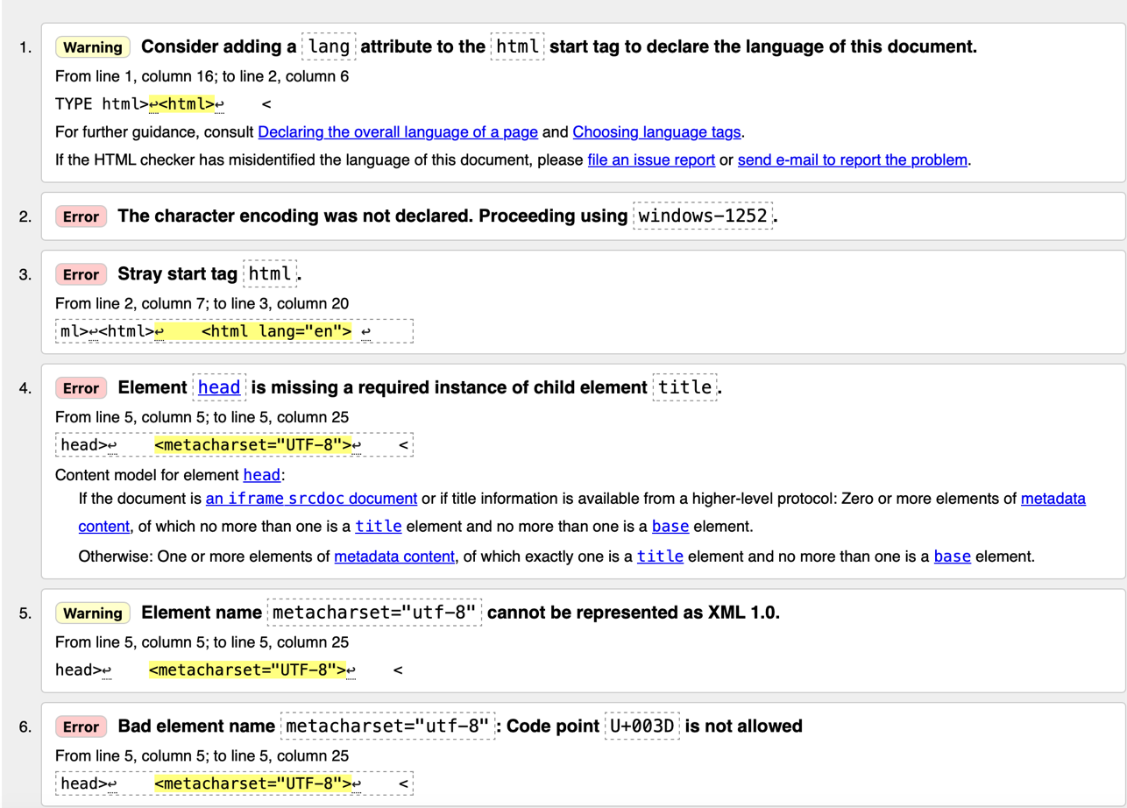
Fig. 5 – A screengrab of the first 6 errors and/or warnings of the HTML code
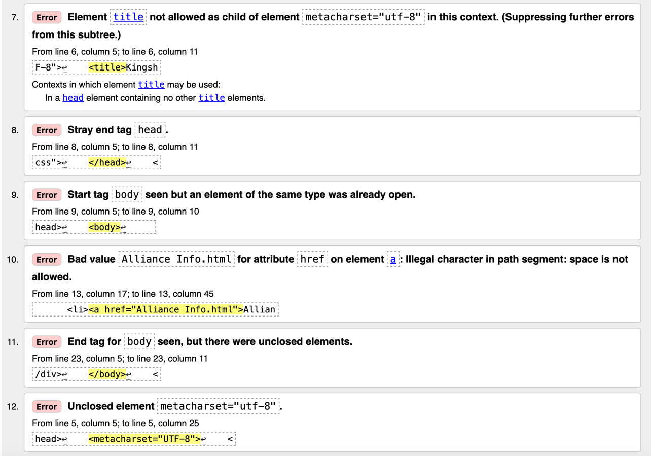
Fig.6 – A screengrab of errors 7-12 of the HTML code.
The list of errors was easily rectified with solutions such as, getting rid of the duplicate <html> tag and correcting the meta charset=”UTF-8” tag. The process was repeated after the corrections were made and no errors were then detected.
The CSS code was validated using http://jigsaw.w3.org/css-validator/. No errors were detected in the code however, one warning was listed. Figure 7 shows this.
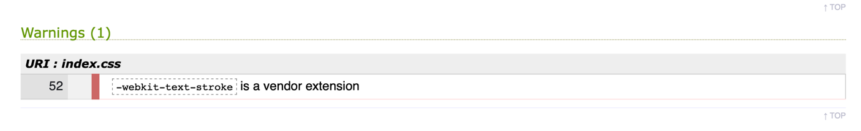
Fig.7 – A screengrab of the results from the CSS validator tool.
The reason for this warning is because it is not a standard CSS property. It was decided not to correct the issue at this time as it works well on Chrome, Edge and Safari. Further reflection may be required.

Evaluation
Before focusing on evaluating the website created for this assignment, this section will look to describe and discuss the importance of website usability, accessibility and search engine optimisation.
Usability:
Web usability refers to how efficient and easy a website is to use. The clarity of the information, the simplicity of the usage, the ease of navigation and how in control the user feels all play a part in the overall usability of a website [1]. Best practices include, introducing usability early in the web design process, making sure there is a visual hierarchy (large, clear headings, subheadings etc.), legible text, branding and good navigation such as including a navigation bar and menus [2]. In 2022, a study conducted by Jongmans, Jeannot, Liang & Dampérat looked into how the visual design of a website affects users’ opinions regarding the usability of the site and how positive an experience it was. They assigned 1 group of participants fictional websites with differing quality levels of visual designs and another group with real e-commerce webpages also with differing quality levels of visual design. They, then measured the users’ perceptions of the websites usability and how pleasing they found it. The study found that the better the visual design was, the better the evaluations were of the websites. They also found that a better visual design helps to improve perceived website usability [3].

Accessibility:
With so many people using the internet in the modern-day world and the UN saying that internet access is ‘The New Human Right’, website accessibility has rightfully gained huge traction in recent years. ‘Web accessibility refers to the practice of making websites usable by people of all abilities and disabilities’ [4]. There are multiple examples of how someone with a disability could need certain tools to access the Web. This can include screen readers or alternative text for those who are blind for example. A study in 2007 assessed the homepages of the 100 top-ranked international universities to evaluate how accessible they were to people with disabilities. They used multiple methods to analysis the accessibility including testing sites against formal web accessibility standards (WCAG 1.0), whether images had appropriate alternative text, language alternatives and accessibility statements. They found that many top universities had significant accessibility problem including poor image accessibility, poor policy and lack of text-only versions of content. This implies that many university websites are potentially excluding people with disabilities [4].

SEO:
SEO stands for Search Engine Optimisation and involves structuring your content so search engines can understand it clearly, while also ensuring users can easily find your website. There are over 1.5 billion websites on the Web today [5] and therefore, making sure a website appears in the first page of search engine results can give a significant advantage when it comes to user and site traffic. A study in 2022 by Mersid Poturak, Dino Kečo & Eldar Tutnić looked to examine how SEO would affect the business performance of the International Burch University in Sarajevo. They conducted interviews with Marketing and PR teams and studied Google Analytics data. They found that better SEO rankings correlated positively with an increase in visits to their website, an increase in engagement and more enrolments which in turn resulted in higher annual revenue. The implications of this is that investing in SEO can produce measurble, long-term benefits for a business [6].

Evaluation of website:
The Kingshot Server 821 website produced for this assignment has a simple homepage to reduce cognitive load. The background is a picture from the game itself which should build an atmosphere of familiarity for the target audience. The title and paragraph have both been centralised and are in the same font for the purpose of consistency. There is a clear hierarchy or importance with the title being significantly larger than the paragraph below. White font was used so that there was a high contrast against the background. There is a simple navigation at the top of the screen so that users can move around the site easily. The navigation bar is black with white writing and when the user hovers over each page title it is highlighted in green. This is also for contrast purposes so that the user can see clearly what they are doing. The format is very similar on the other 3 pages with the same background, font type and colour and navigation bar used. This decision was made so that consistency was maintained and therefore hopefully making it memorable. The 3 pages all contain boxes with information in them relevant to the title at the top of the page. Information is clear and concise so that users are not bombarded with too much which could cause cognitive overload. The links to the video tutorials on the last page are all functional and add supplement information for users if they wish. Keywords that users would typically search for have been used as titles and have been used throughout the website as a whole to improve SEO. Accessibility has been checked using Safari’s own accessibility testing tool which can be seen in Figure 9.

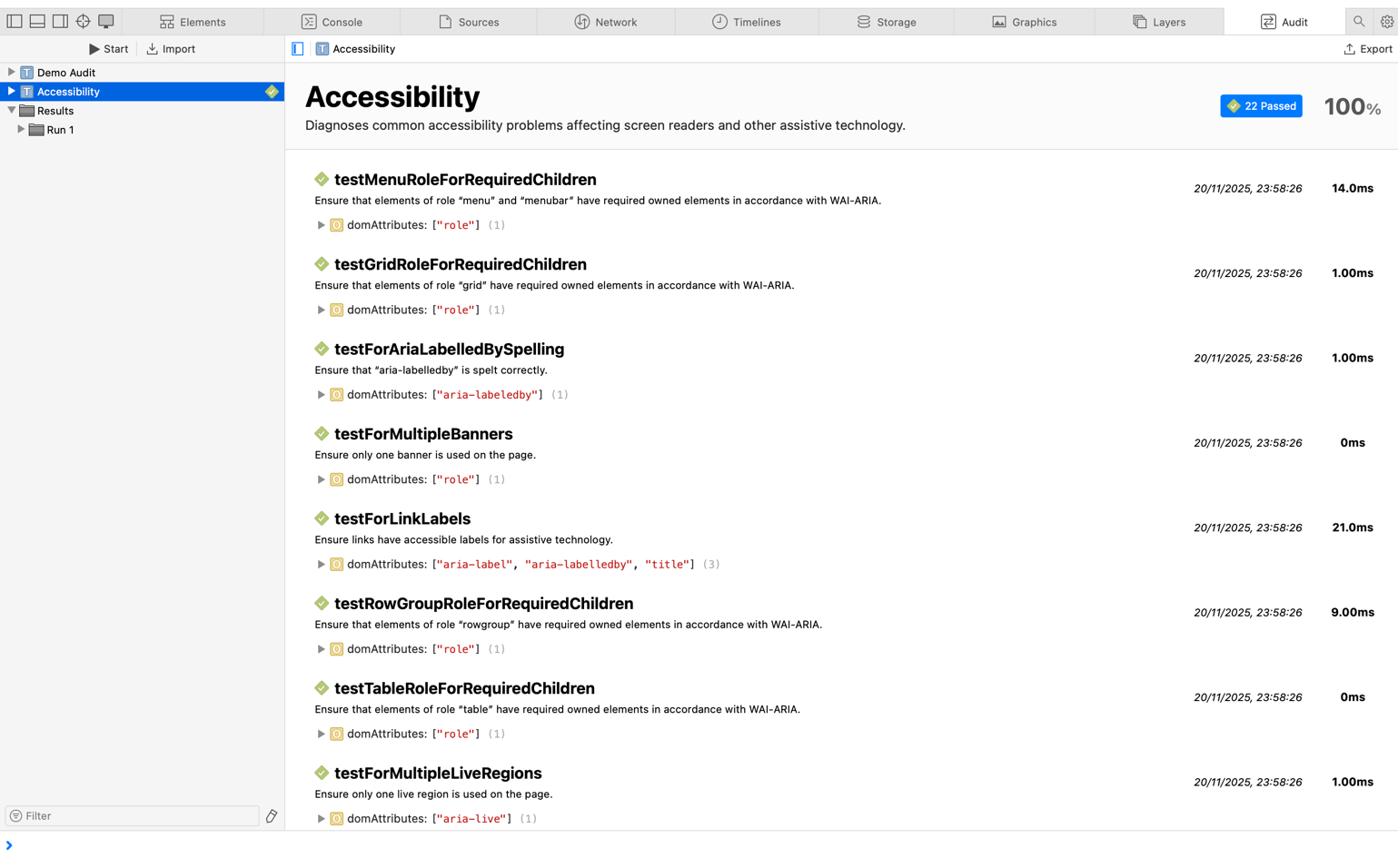
Fig.8 – A screengrab of the Accessibility testing tool.

The website scored 100% in its accessibility test however. This will be due to high contrast background between the background and text and the reliance on text instead of images. To enhance accessibility further ARIA labels could be used. With regards to improvements, the layout could be enhanced on the “Alliance Info” page. Instead of the boxes running in a vertical line, it would perhaps look better if it had a grid style layout.

Comparison of 2 live websites:
This section of the report will look to compare 2 live websites. The first being Apple.com and the second being Arngren.net.
The Apple.com website has a very clean, modern look to it. The white background with the black header makes the products stand out. This is especially true for the contrasting product colours such as the orange phone at the top. The webpage doesn’t feel cluttered but also has enough information to engage users. The font style is consistent and there is a good use of headings and sub-headings to show the user the hierarchy of information importance. There is a neat navigation bar at the top of the page which helps to create a logical flow. It also acts as a grounding mechanism making sure users have a place they can go back to if they want to search for something specific. Each product section on the homepage has clear boundaries and simple ‘Learn More’ or ‘Buy’ buttons. This particularly helps the user avoid sensory overload. In stark contrast, the arngren.net homepage has a high level of cognitive overload due to the amount of information, lack of consistent spacing and the high volume of pictures. There are multiple font colours and styles and the page doesn’t follow a clear logical path. This gives the page an amateur feel to it which is a disadvantage when products are being sold. The user needs to feel a sense of trust when ordering products online. The Apple website gave a feeling of professionalism and trust that the Arngren website doesn’t.
Navigation of the Apple website feels very intuitive. At the very top there is the option to choose the country you are purchasing from followed by a navigation bar with clear titles and drop-down menus. The user can then scroll down the page to see the latest products. When attempting to find a product such as a MAC using the navigation bar redirects you to a section of the website that has a lot of information about that type of product. The information is easy to access and visually appealing due to the pictures and animations used. There is also the option to take part in a multiple-choice quiz so that Apple can recommend certain products for the user based on the information given. This makes the whole process more streamlined and easier for the user.
Being tasked to find a specific product on the Arngren website on the other hand, is difficult. The navigation bar is situated on the left side of the page and its multiple font colours, sizes and styles make it visually overwhelming. Many of the product titles don’t fit into the navigation tool bar so the user cannot read the full title. This could lead to users clicking the wrong links and prolonging the process of their search. As there are so many product photographs scattered throughout the homepage haphazardly, the users’ eyes dart around the page instead of following a logical order. This makes it difficult for the user to focus and leads to cognitive overload. When searching for a specific product using the small search bar at the top of the page, the required page was not found, and an error message was shown. Similarly, some of the links to products in the navigation tool bar either did not work or transferred you to a different webpage saying the product was no longer available or had been archived.
On the Apple website there is a good use of font size and boldness to convey more important information regarding specs, prices and further information. Figure 9. shows an example of what a user first sees when looking at a specific product.
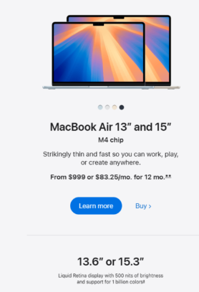
Fig. 9 – Screengrab taken from the Apple.com website showing product information.
Using Figure 9 as an example, the title of the product and their sizes are in a bold, large font. This information is crucial to let the user know what exactly it is they are buying and to differentiate from other products. Also in a bold font, the chip type and the price are displayed however, this font is smaller. This lets the user know that this information is important but perhaps secondary in nature to the name and size of the product. There are also two verbal statements which are more descriptive about the product however, these are not in bold font. Although short and concise, the two statements give the user additional information but do not feel overwhelming thanks in part to the standard font used. When the user clicks to ‘Learn more’ or ‘Buy’ the product they are taken to a page with more information. Although, most of the information was readily available and well presented, it was not straight forward to find out warranty information.
The Arngren site is, on the other hand very cluttered and so, finding information is a difficult task. Due to the products overlapping each other, it is sometimes hard to distinguish which price is for which product. Although, the site uses the colour red for most of the prices, it is not consistent enough as further down the page other colours are used. This makes it easy to miss some of the prices. There is also, no option to change the language of the page and therefore the user is reliant on in browser translator tools.
The overall experience of the Apple site was smooth. From loading the page, to browsing, to searching for a specific product, to research, it was an easy and efficient process. Using the page felt intuitive and a level of trust was built due to its professionalism. On the other hand, the Arngren site provoked the opposite feeling. The inconsistency of the layout, the font and the photos made for a frustrating shopping experience. The amateur nature of the design also creates an atmosphere of mistrust for the user. The Arngren site needs a complete over-haul with consistency being key. The products need to be well spaced out and not overlapping, the menu needs to be more prominent with one font style and colour. There needs to be more of a logical flow and an option to view the site in other languages.

Conclusion
The Kingshot Server 821 website successfully applies key web design principles, including usability, accessibility, and SEO. Clear navigation, consistent layout, and high-contrast text make it user-friendly, while targeted keywords support search engine visibility. Comparisons with Apple.com and Arngren.net further highlight the importance of visual hierarchy, intuitive navigation, and clear content. While the Kingshot Server 821 site performs well overall, improvements such as a grid layout for the Alliance Info page could enhance usability further. This project shows that even a small, niche-focused website can provide a high-quality user experience when design decisions are carefully considered.

References
[1] ChatGPT. (GPT-4). OpenAI. Accessed: Sep. 26, 2023. [Online]. Available: https://chatgpt.com

[2] Usability & Web Accessibility, “Site Hierarchy and Navigation,” Yale University, accessed Nov. 7, 2025. [Online]. Available: https://usability.yale.edu/usability-best-practices/site-hierarchy-and-navigation

[3] E. Jongmans, F. Jeannot, L. Liang, and M. Dampérat, “Impact of website visual design on user experience and website evaluation: The sequential mediating roles of usability and pleasure,” Journal of Marketing Management, vol. 38, no. 17–18, pp. 2078–2113, Jul. 2022.

[4] S. K. Kane, J. A. Shulman, T. J. Shockley, and R. E. Ladner, “A Web Accessibility Report Card for Top International University Web Sites,” in Proc. 2007 Int. Cross-Disciplinary Conf. Web Accessibility (W4A ’07), Banff, AB, Canada, May 2007, pp. 148–156.
[5] “Total Number of Websites,” Internet Live Stats, accessed Nov. 7, 2025. [Online]. Available: https://www.internetlivestats.com/total-number-of-websites/
[6] M. Poturak, D. Kečo, and E. Tutnić, “Influence of Search Engine Optimization (SEO) on Business Performance: Case Study of Private University in Sarajevo,” Int. J. Res. Business Soc. Sci., vol. 11, no. 4, pp. 59–68, Jun. 2022.

Appendices
Homepage html:
<!DOCTYPE html>
<html lang="en">
<head>
<meta charset="UTF-8">
<title>Kingshot Server 821</title>
<link rel="stylesheet" href="index.css">
</head>
<body>
<nav>
<ul>
<li><a href="Index.html">Home</a></li> <!--Navigation Bar-->
<li><a href="Alliance Info.html">Alliance Info</a></li>
<li><a href="News.html">News</a></li>
<li><a href="Tutorial.html">Tutorials</a></li>
</ul>
</nav>
<div class="center-content">
<h1> Welcome to Kingshot Server 821</h1>
<p>Follow the links in the navigation bar for up-to-date Kingshot server 821 news,
information about alliances and current and future events. </p>
</div>
</body>
</html>

Homepage css:
body {
margin: 0;
padding: 0;
height: 100vh;
background-image:url(A4EE90F9-FA52-4381-9FDC-D816E6722812.jpeg);
background-position: center;
background-size: cover;
position: relative;

}
ul {
list-style-type: none;
margin: 0;
padding: 0;
background-color: rgba(0, 0, 0, 0.8);
display: flex;
justify-content: center;
top: 0;
left: 0;
width: 100%;
z-index:1000;
}

ul li a {
display: block;
color: white;
padding: 14px 20px;
text-decoration: none;
font-family: "Lucida Console", "Courier New", monospace;
font-weight: bold;
}

ul li a:hover {
background-color: #33ff449c;
color: black;

}
.center-content {
position: absolute;
top: 50%;
left: 50%;
transform: translate(-50%, -50%);
text-align: center;
color: white;
}
h1 {
color: white;
font-size: 5em;
font-weight: bold;
font-family: "Lucida Console" , "Courier New" , monospace;
text-align: center;
-webkit-text-stroke: 2px black;
text-shadow:
-2px -2px 0 black,
2px -2px 0 black,
-2px 2px 0 black,
2px 2px 0 black;

}
p {
font-size: 1.2em;
font-family: "Lucida Console" , "Courier New" , monospace;
margin-top: 15px;
color: white;
text-shadow: 1px 1px 3px black;
}

Alliance Info html:
<!DOCTYPE html>
<html lang="en">
<head>
<meta charset="UTF-8">
<link rel="stylesheet" href="alliance info.css">
<title>Alliance Info</title>
</head>
<body>
<nav>
<ul>
<li><a href="Index.html">Home</a></li>
<li><a href="Alliance Info.html">Alliance Info</a></li>
<li><a href="News.html">News</a></li>
<li><a href="Tutorial.html">Tutorials</a></li>
</ul>
</nav>
<header>
<h1>Alliance Information</h1>
<hr>
<p class="intro">
<b>Below, you can find information about each Alliance
on the 821 server. Alliance Leader gamer tags, overall
power ratings, membership numbers and languages each Alliance uses are
available.</b>
</p>
</header>
<main>
<section class="alliance">
<h2>RPR (Reapers)</h2>
<ul>
<li><strong>Alliance Leader:</strong> Mitus</li>
<li><strong>Power Rating:</strong> 3,444,144,285</li>
<li><strong>Membership:</strong> 94/100</li>
<li><strong>Language:</strong> All</li>
</ul>
</section>

<section class="alliance">
<h2>FOH (Fires of Hell)</h2>
<ul>
<li><strong>Alliance Leader:</strong> Colossus</li>
<li><strong>Power Rating:</strong> 2,841,979,121</li>
<li><strong>Membership:</strong> 98/100</li>
<li><strong>Language:</strong> All</li>
</ul>
</section>

<section class="alliance">
<h2>MOB (Savage)</h2>
<ul>
<li><strong>Alliance Leader:</strong> Lick</li>
<li><strong>Power Rating:</strong> 2,760,383,778</li>
<li><strong>Membership:</strong> 97/100</li>
<li><strong>Language:</strong> English</li>
</ul>
</section>

<section class="alliance">
<h2>ToG (The Old Guard)</h2>
<ul>
<li><strong>Alliance Leader:</strong> Generalron44</li>
<li><strong>Power Rating:</strong> 2,628,327,754</li>
<li><strong>Membership:</strong> 99/100</li>
<li><strong>Language:</strong> All</li>
</ul>
</section>

<section class="alliance">
<h2>KOR (Korea)</h2>
<ul>
<li><strong>Alliance Leader:</strong> TaTa</li>
<li><strong>Power Rating:</strong> 2,323,493,715</li>
<li><strong>Membership:</strong> 100/100</li>
<li><strong>Language:</strong> Korean</li>
</ul>
</section>

<section class="alliance">
<h2>NEW (New Bayblon)</h2>
<ul>
<li><strong>Alliance Leader:</strong> Mickey Lange</li>
<li><strong>Power Rating:</strong> 1,978,367,338</li>
<li><strong>Membership:</strong> 95/100</li>
<li><strong>Language:</strong> All</li>
</ul>
</section>
</main>

</body>
</html>

Alliance info CSS:
body {
margin: 0;
padding-top: 60px;
background-image:url(A4EE90F9-FA52-4381-9FDC-D816E6722812.jpeg);
background-position: center;
background-size: cover;
position: relative;

}
nav ul{
list-style-type: none;
margin: 0;
padding: 0;
background-color: rgba(0, 0, 0, 0.8);
display: flex;
justify-content: center;
align-items: center;
position: fixed;
top: 0;
left: 0;
width: 100%;
height: 60px;
z-index:1000;
}

ul li a {
display: block;
color: white;
padding: 14px 20px;
text-decoration: none;
font-family: "Lucida Console", "Courier New", monospace;
font-weight: bold;
}

ul li a:hover {
background-color: #33ff449c;
color: black;

}
h1 {
color: white;
font-size: 5em;
font-weight: bold;
font-family: "Lucida Console" , "Courier New" , monospace;
text-align: center;
-webkit-text-stroke: 2px black;
text-shadow:
-2px -2px 0 black,
2px -2px 0 black,
-2px 2px 0 black,
2px 2px 0 black;

}
p {
font-size: 1.2em;
text-align: center;
max-width: 800px;
margin: 15px auto;
font-family: "Lucida Console" , "Courier New" , monospace;
margin-top: 15px;
color: white;
}
hr {
border:none;
height: 1px;
background-color: #ffffff;
margin: 10px 0;
}
.alliance li strong {
color: #000000;

}

main
{
display: grid;
grid-template-columns: 1fr;
gap: 20px;
justify-items: center;
}
.alliance
{
background-color: #ffffff;
border: 2px solid #010101;
border-radius: 20px;
padding: 25px;
width: 70%;
max-width: 400px;
box-shadow: 0 0 10px #000000;
transition: transform 0.3s ease, box-shadow 0.3s ease, border-color 0.3s ease;
}
.alliance h2 {
color: #000000;
font-family: "Lucida Console" , "Courier New" , monospace;
margin-bottom: 10px;
text-align: center;
}

.alliance ul {
list-style: none;
padding-left: 0;
}

.alliance li {
padding: 5px 0;
color: #000000;
font-family: "Lucida Console" , "Courier New" , monospace;
}

News html:
<!DOCTYPE html>
<html lang="en">
<head>
<meta charset="UTF-8">
<link rel="stylesheet" href="News.css">
<title>News</title>
</head>
<body>
<nav>
<ul>
<li><a href="Index.html">Home</a></li>
<li><a href="Alliance Info.html">Alliance Info</a></li>
<li><a href="News.html">News</a></li>
<li><a href="Tutorial.html">Tutorials</a></li>
</ul>
</nav>
<header>
<h1>Current News</h1>
<hr>
<p class="intro"><b>Below you will find the top news stories from our server, updated daily.</b>
</p>
</header>

<main>
<section class="News">
<h2>Long live the King!</h2>
<p>Congratulations to everyone who took part in our very first 'Kingdom vs Kingdom' war against Server 815. <br>
After a brutal 12 hours, our server claimed the victory with Mitus being crowned the High King of both servers. <br>
A big thank you to everyone who took part and for your commitment during the prep stage! </p>
</section>
<section class="News">
<h2>Merchant Empire</h2>
<p>Peace has reopened the Kingdom's caravan routes! This event is divided into three phases: Preview, Trade<br>
and Display. You can escort or raid caravans during the Trade Phase. The caravans have different grades with <br>
the better caravans having greater rewards. This is a great event to get loot so make sure to co-ordinate with your alliance.</p>
</section>
<section class="News">
<h2>Alliance Exchange Scheme</h2>
<p>A new scheme has been proposed by the NAP8 leaders where 4 people from each alliance gets to spend one week at <br>
another alliance. This will hopefully, build trust and unity and also give players an insight into how other <br>
alliances work.</p>
</section>
<section class="News">
<h2>A Panda Wedding?!</h2>
<p>A BIG 821 Congratulations to Angry Panda and Queen Panda on their recent engagement! We are all very happy <br>
for you both and can't wait for the wedding invite!</p>
</section>
</main>
</body>

News CSS:
body {
margin: 0;
padding-top: 60px;
background-image:url(A4EE90F9-FA52-4381-9FDC-D816E6722812.jpeg);
background-position: center;
background-size: cover;
position: relative;

}
nav ul{
list-style-type: none;
margin: 0;
padding: 0;
background-color: rgba(0, 0, 0, 0.8);
display: flex;
justify-content: center;
align-items: center;
position: fixed;
top: 0;
left: 0;
width: 100%;
height: 60px;
z-index:1000;
}
ul li a {
display: block;
color: white;
padding: 14px 20px;
text-decoration: none;
font-family: "Lucida Console", "Courier New", monospace;
font-weight: bold;
}

ul li a:hover {
background-color: #33ff449c;
color: black;

}
h1 {
color: white;
font-size: 5em;
font-weight: bold;
font-family: "Lucida Console" , "Courier New" , monospace;
text-align: center;
-webkit-text-stroke: 2px black;
text-shadow:
-2px -2px 0 black,
2px -2px 0 black,
-2px 2px 0 black,
2px 2px 0 black;

}
p {
font-size: 1.2em;
text-align: center;
max-width: 800px;
margin: 15px auto;
font-family: "Lucida Console" , "Courier New" , monospace;
margin-top: 15px;
color: white;

}
hr {
border:none;
height: 1px;
background-color: #ffffff;
margin: 10px 0;
}
main
{
display: grid;
grid-template-columns: 1fr;
gap: 20px;
justify-items: center;
}
.News {
background-color: #ffffff;
border: 2px solid #000000;
border-radius: 20px;
padding: 25px;
width: 80%;
max-width: 700px;
box-shadow: 0 0 10px #000000;
transition: transform 0.3s ease, box-shadow 0.3s ease, border-color 0.3s ease;
}
.News h2 {
color: #000000;
font-family: "Lucida Console" , "Courier New" , monospace;
text-align: center;
margin-bottom: 10px;
}
.News p {
color: #000000;
font-family: "Lucida Console" , "Courier New" , monospace;
text-align: center;
}

Tutorials html:
<!DOCTYPE html>
<html lang="en">
<head>
<meta charset="UTC-8">
<link rel="stylesheet" href="Tutorial.css">
<title>Tutorials</title>
</head>
<body>
<nav>
<ul>
<li><a href="Index.html">Home</a></li>
<li><a href="Alliance Info.html">Alliance Info</a></li>
<li><a href="News.html">News</a></li>
<li><a href="Tutorial.html">Tutorials</a></li>
</ul>
</nav>
<header>
<h1>Tutorials</h1>
<hr>
<p class="intro"><b>Below you can find a range of links to Youtube tutorial videos for different events and game tactics. </b>
</p>
</header>
<main>
<section class="Tutorials">
<h2>Eternity's Reach</h2>
<p>The Eternity's Reach event is a great way to earn Charm Items, espceially if you are a free-to-play player. Here is a video link
with a comprehensive guide on how to maximise your points which will lead to a higher level of reward.<br>
<a href="https://www.youtube.com/watch?v=-9K5qE2tbU8">Eternity's Reach Video Guide</a> </p>
</section>

<section class="Tutorials">
<h2>Viking's Vengeance</h2>
<p>The Viking Vengeance event takes place every two weeks on Tuesday's and Thursday's. Players must defend against twenty waves of
AI-controlled Viking troops. Here is a video link detailing how you and your alliance can maximise your points.<br>
<a href="https://www.youtube.com/watch?v=k8FCM8XrWtk">Viking's Vengeance Video Guide</a> </p>
</section>

<section class="Tutorials">
<h2>Kingdom of Power</h2>
<p>The Kingdom of Power event is a major event where two kingdoms (servers) fight against each other through several phases. There is
a Preparation Phase, a Battle Phase and a Triage Phase. Here is a video link explaining the process in full.<br>
<a href="https://www.youtube.com/watch?v=5OxkEQX14to">Kingdom of Power Video Guide</a> </p>
</section>

<section class="Tutorials">
<h2>Governor Gear</h2>
<p>Governor Gear and Charms can drastically increase your combat power if you know which items to upgrade first. Here is a video link
furhter exploring this topic.<br>
<a href="https://www.youtube.com/watch?v=7dB1FJxkTCI">Governor Gear and Charms Video Guide</a> </p>
</section>

</main>
</body>
</html>

Tutorials CSS:
body {
margin: 0;
padding-top: 60px;
background-image:url(A4EE90F9-FA52-4381-9FDC-D816E6722812.jpeg);
background-position: center;
background-size: cover;
position: relative;

}
nav ul{
list-style-type: none;
margin: 0;
padding: 0;
background-color: rgba(0, 0, 0, 0.8);
display: flex;
justify-content: center;
align-items: center;
position: fixed;
top: 0;
left: 0;
width: 100%;
height: 60px;
z-index:1000;
}

ul li a {
display: block;
color: white;
padding: 14px 20px;
text-decoration: none;
font-family: "Lucida Console", "Courier New", monospace;
font-weight: bold;
}

ul li a:hover {
background-color: #33ff449c;
color: black;

}
h1 {
color: white;
font-size: 5em;
font-weight: bold;
font-family: "Lucida Console" , "Courier New" , monospace;
text-align: center;
-webkit-text-stroke: 2px black;
text-shadow:
-2px -2px 0 black,
2px -2px 0 black,
-2px 2px 0 black,
2px 2px 0 black;

}
p {
font-size: 1.2em;
text-align: center;
max-width: 800px;
margin: 15px auto;
font-family: "Lucida Console" , "Courier New" , monospace;
margin-top: 15px;
color: white;
}
hr {
border:none;
height: 1px;
background-color: #ffffff;
margin: 10px 0;
}
main
{
display: grid;
grid-template-columns: 1fr;
gap: 20px;
justify-items: center;
}
.Tutorials {
background-color: #ffffff;
border: 2px solid #000000;
border-radius: 20px;
padding: 25px;
width: 80%;
max-width: 700px;
box-shadow: 0 0 10px #000000;
transition: transform 0.3s ease, box-shadow 0.3s ease, border-color 0.3s ease;
}
.Tutorials h2 {
color: #000000;
font-family: "Lucida Console" , "Courier New" , monospace;
text-align: center;
margin-bottom: 10px;
}
.Tutorials p {
color: #000000;
font-family: "Lucida Console" , "Courier New" , monospace;
text-align: center;
}

