Qualification: CIPD Diploma in Applied Human Resources

Module Name: Developing Professional Practice

Word Count Assignment 2: 952
Word Count Assignment 4: 939

Student Name: Jade Bowen
Student Number: 2014437
CIPD Membership Number: 57385937

By signing below, I confirm that the work/evidence presented is my own, unaided work. I understand the regulations pertaining to candidate malpractice and the action that may be taken as a result.

Signed: J.Bowen
Date: 03/01/2021
Contents Page

Page | Assignment
3-7 | Evidence Matrix
8-10 | Assignment 1
11-19 | Assignment 1 Evidence
20-22 | Assignment 2
23 | Assignment 2 References
24-28 | Assignment 3
29-45 | Assignment 3 Evidence
46-48 | Assignment 4
49 | Assignment 4 References
50-52 | Assignment 5
53 | Assignment 5 Evidence
54-56 | My PDP

Candidate name: Jade Bowen |  |  |  | CIPD Membership/registration No.:  57385937
Qualification title: CIPD Level 5 Diploma in Applied HR |  |  |  | Unique Learner No. (ULN):
Unit code | Unit title | Assessment criteria no. | Evidence description | Evidence reference number | Assessor  initials | I/V initials if sampled
5CDPP | Developing Professional Practice in Human Resources | 1.1, 1,2, 1.3 | Screenshot – CIPD L5 Diploma in Applied Human Resources – Programme of Study Handbook – course description | Doc1.1
5CDPP | Developing Professional Practice in Human Resources | 1.1, 1,2, 1.3 | Screenshot – CIPD L5 Diploma in Applied Human Resources – timetable | Doc1.2
5CDPP | Developing Professional Practice in Human Resources | 1.1, 1,2, 1.3 | CIPD L5 Diploma in Applied Human Resources - Programme of Study Handbook – detail of course | Doc1.3
5CDPP | Developing Professional Practice in Human Resources | 1.1, 1,2, 1.3 | Screenshot – CIPD L5 Diploma in Applied Human Resources – Programme of Study Handbook – detail of course | Doc1.4
5CDPP | Developing Professional Practice in Human Resources | 1.1, 1,2, 1.3 | Screenshot – CIPD L5 Diploma in Applied Human Resources – Programme of Study Handbook – guided learning hours | Doc1.5
5CDPP | Developing Professional Practice in Human Resources | 1.1, 1,2, 1.3 | Screenshot – CIPD L5 Diploma in Applied Human Resources – Programme of Study Handbook – Harvard referencing | Doc1.6
5CDPP | Developing Professional Practice in Human Resources | 1.1, 1,2, 1.3 | Screenshot – CIPD L5 Diploma in Applied Human Resources – Programme of Study Handbook – CIPD membership | Doc1.7
5CDPP | Developing Professional Practice in Human Resources | 1.1, 1,2, 1.3 | Apprenticeship contract between employer and B-WBL | Doc1.8
5CDPP | Developing Professional Practice in Human Resources | 1.1, 1,2, 1.3 | Apprenticeship Learning Agreement | Doc1.9
5CDPP | Developing Professional Practice in Human Resources | 1.1, 1,2, 1.3 | Screenshot of outlook calendar – review | Doc1.10
5CDPP | Developing Professional Practice in Human Resources | 1.1, 1,2, 1.3 | CIPD Code of Professional Conduct | Doc 1.11
5CDPP | Developing Professional Practice in Human Resources | 1.1, 1,2, 1.3 | Screenshot – UWTSD Student Code of Conduct | Doc1.12
5CDPP | Developing Professional Practice in Human Resources | 1.1, 1,2, 1.3 | Screenshot – Plagiarism – Programme of Study Handbook | Doc1.13
5CDPP | Developing Professional Practice in Human Resources | 1.1, 1,2, 1.3 | Welcome to the CIPD – Student brochure | Doc1.14
5CDPP | Developing Professional Practice in Human Resources | 1.1, 1,2, 1.3 | Screenshot from Moodle – Recommended Core Textbooks | Doc1.15
5CDPP | Developing Professional Practice in Human Resources | 1.1, 1,2, 1.3 | Screenshot – UWTSD quick links - Moodle | Doc1.16
5CDPP | Developing Professional Practice in Human Resources | 1.1, 1,2, 1.3 | Screenshot – Programme of Study Handbook – Student services | Doc1.17
5CDPP | Developing Professional Practice in Human Resources | 1.1, 1,2, 1.3 | Induction Questionnaire | Doc1.18
5CDPP | Developing Professional Practice in Human Resources | 3.1, 3.2, 3.3 | Gantt chart | Doc 3.1
5CDPP | Developing Professional Practice in Human Resources | 3.1, 3.2, 3.3 | Brainstorm/ business case – training on the job/in-stores | Doc 3.2
5CDPP | Developing Professional Practice in Human Resources | 3.1, 3.2, 3.3 | Excel spreadsheet – original budget plan | Doc 3.3
5CDPP | Developing Professional Practice in Human Resources | 3.1, 3.2, 3.3 | Email discussing venue costs | Doc 3.4
5CDPP | Developing Professional Practice in Human Resources | 3.1, 3.2, 3.3 | Venue invoice | Doc 3.5
5CDPP | Developing Professional Practice in Human Resources | 3.1, 3.2, 3.3 | Excel spreadsheet. - New budget plan | Doc 3.6
5CDPP | Developing Professional Practice in Human Resources | 3.1, 3.2, 3.3 | Diary invite - Call with project manager | Doc 3.7
5CDPP | Developing Professional Practice in Human Resources | 3.1, 3.2, 3.3 | Colleague availability form | Doc 3.8
5CDPP | Developing Professional Practice in Human Resources | 3.1, 3.2, 3.3 | Training schedule | Doc 3.9
5CDPP | Developing Professional Practice in Human Resources | 3.1, 3.2, 3.3 | 3 day classroom department training – colleague copy | Doc 3.10
5CDPP | Developing Professional Practice in Human Resources | 3.1, 3.2, 3.3 | Department 10 day in-store training | Doc 3.11
5CDPP | Developing Professional Practice in Human Resources | 3.1, 3.2, 3.3 | Training sign-off card | Doc 3.12
5CDPP | Developing Professional Practice in Human Resources | 3.1, 3.2, 3.3 | Colleague contact details form | Doc 3.13
5CDPP | Developing Professional Practice in Human Resources | 3.1, 3.2, 3.3 | Diary invites with SM to discuss training plan | Doc 3.14
5CDPP | Developing Professional Practice in Human Resources | 3.1, 3.2, 3.3 | Diary invites with SM to discuss training progress | Doc 3.15
5CDPP | Developing Professional Practice in Human Resources | 3.1, 3.2, 3.3 | Hire car invoice | Doc 3.16

5CDPP | Developing Professional Practice in Human Resources |  | 3.1, 3.2, 3.3 | Manager Roles/Responsibility Rota | Doc 3.17
5CDPP | Developing Professional Practice in Human Resources |  | 3.1, 3.2, 3.3 | Colleague training plan | Doc 3.18
5CDPP | Developing Professional Practice in Human Resources |  | 3.1, 3.2, 3.3 | Counter’s training plan showing specialist training course planned in | Doc 3.19
5CDPP | Developing Professional Practice in Human Resources |  | 3.1, 3.2, 3.3 | Training progress email | Doc 3.20
5CDPP | Developing Professional Practice in Human Resources |  | 3.1, 3.2, 3.3 | Copy of Company absence tracker | Doc 3.21
5CDPP | Developing Professional Practice in Human Resources |  | 3.1, 3.2, 3.3 | Follow up emails | Doc 3.22
5CDPP | Developing Professional Practice in Human Resources |  | 3.1, 3.2, 3.3 | Comminication effectiveness questionnaire | Doc 3.23
5CDPP | Developing Professional Practice in Human Resources |  | 3.1, 3.2, 3.3 | Colleague feedback questionnaire | Doc 3.24
5CDPP | Developing Professional Practice in Human Resources |  | 3.1, 3.2, 3.3 | Manager feedback questionnaire | Doc 3.25
5CDPP | Developing Professional Practice in Human Resources |  | 5.1, 5.2, 5.3 | Snapshot of CIPD 2013 My CPD self-assessment | Doc 5.1
5CDPP | Developing Professional Practice in Human Resources |  | 5.1, 5.2, 5.3 | Honey and Mumford 1986 – Learning style questionnaire | Doc 5.2
Candidate declaration:
- I confirm that the work/evidence presented for assessment is my own unaided work.
- I have read the assessment regulations and understand that if I am found to have ‘copied’ from published work without acknowledgement, or from other candidate’s work, this may be regarded as plagiarism which is an offence against the assessment regulations and leads to failure in the relevant unit and formal disciplinary action.
- I agree to this work being subjected to scrutiny by textual analysis software if required.
- I understand that my work may be used for future academic/quality assurance purposes in accordance with the provisions of the Data Protection Act 1998.
- I understand that the work/evidence submitted for assessment may not be returned to me and that I have retained a copy for my records.
- I understand that until such time as the assessment grade has been ratified through internal and external quality assurance processes it is not final.
Signature: |  | J. Bowen |  |  |  | Date: | 03.01.2020

Activity 1
- Interpret the key components of the HR development programme.

The key components of the HR development programme require the completion of the Level 5 CIPD Diploma in Applied Human Resource Management (Doc1.1). This is a higher apprenticeship qualification with Coleg Sir Gar, in conjunction with University of Wales Trinity Saint David, located at Carmarthen Campus. This course will enable the learner to develop their skills and knowledge within the HR profession.

Being a student member of both institutions will allow access to a wide range of resources, including both institutions' on-line libraries and physical libraries and access to student services.

The course runs across 2 years; starting September 2020 ending in May 2022 and graduating in July (Doc1.2) To achieve the CIPD qualification; 16 modules; equal to 90 credits need to be completed. These modules are found on Moodle, and consist of core units, knowledge-based and competence-based units. (Doc1.3)

The learner will undergo a mix of on the job, online and in-class learning; this allows experience to be gained whilst studying (Doc1.4) The programme provides 450 hours of guided learning and 450 hours of self-studying, to prepare assessments and build portfolios. (Doc1.5) These assignments should be completed using Harvard referencing (Doc1.6) and uploaded via TurnItIn for validation.

Achieving a CIPD qualification is globally recognised and not only helps the learner increase earning potentials, but also allows for the use of ‘AssocCIPD’ following their name. Being a CIPD student member also increases credibility with employers, provides members with exclusive access to HR and L&D resources’, and allows for an array of networking. (Doc1.7)

A key aspect of the course is to providing evidence of personal growth and achievements; working on an active PDP will enable the student to display how they have continuingly developed their knowledge and skills across the 2 years.

1.2 Explain organisational arrangements and codes of practice which underpin the programme.

As this HR development course forms part of an apprenticeship, Employers must sign a contract with Coleg Sir Gar agreeing to follow the detail outlines. (Doc1.8) Both employers and Coleg Sir Gar have a duty of care for the learner; to ensure they can learn and develop on the job and are making good progress with the programme.

Employers will need to support the learner by allowing them to be released from work to attend monthly workshops at University. As some assignments are required to be done ‘on the job’ and ‘in role’, the learners’ Line Manager should carry out regular check-ins to review performance, arrange experience opportunities and to offer additional support. This supports the student to use their online/ in-class learnings and apply it in work-related situations, building their HR knowledge and experience. (Doc1.9)

Studying whilst gaining experience enables the learner to use and share their knowledge to better their organisation, reflect on what works well and what can be done differently and provides networking with other HR professionals inside and outside of work.

A learning tutor from Coleg Sir Gar will stay in contact with the learner, conducting regular reviews, either via the phone or at their place of work to discuss overall progress and concerns. (Doc1.10)

Whilst studying this programme, students must comply with the CIPD Code of Professional conduct (Doc 1.11), as well as the UWTSD Student Code of Conduct (Doc1.12). This includes full attendance to lectures; either in-class or via Skype/Teams. Continuously failing to comply could result in disciplinary action.

Work from every component of a module must be attempted and submitted in accordance with the required format and by the deadline via TurnItIn, conducted with integrity and referenced correctly to avoid plagiarism. (Doc1.13)

1.3 Identify key sources of programme - related information and advice for learners.

To gain the most valuable and reliable information whilst studying this course, it is important to use a range of trustworthy sources.
Being a CIPD member provides access to the CIPD website, offering a wide range of valuable information which is incredibly useful when studying this development programme. (Doc1.14)
The use of Core textbooks such as ‘Introduction to Employment Law’, ‘Studying Human Resource Management’ and ‘Human Resource Management’ will also provide Students with an array knowledge and evidence from a range of Authors, which is important when carrying out research for assignments. (Doc1.15)
The Universities’ online homepage enables students to access many beneficial sites, such as their online learning platform ‘Moodle’. This is another key source as Moodle contains all the information relating to each Module including reading lists, learning plans and workshop slides. As well as access to the online library. (Doc1.16)
The library will be key to students throughout this programme, allowing access to a range of academic journals and texts from on-site at the university or online.
Student Support Service is also available for students who may require additional support or advice, whether that be related to the course or for other reasons. (Doc1.17)
To support my understanding of this course, I have also completed an induction questionnaire (Doc1.18)

Appendix
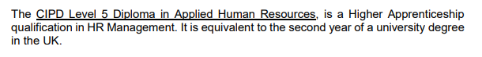
Doc1.1 – Taken from Programme of Study Handbook
Doc 1.2 – Snapshot of timetable sent via email
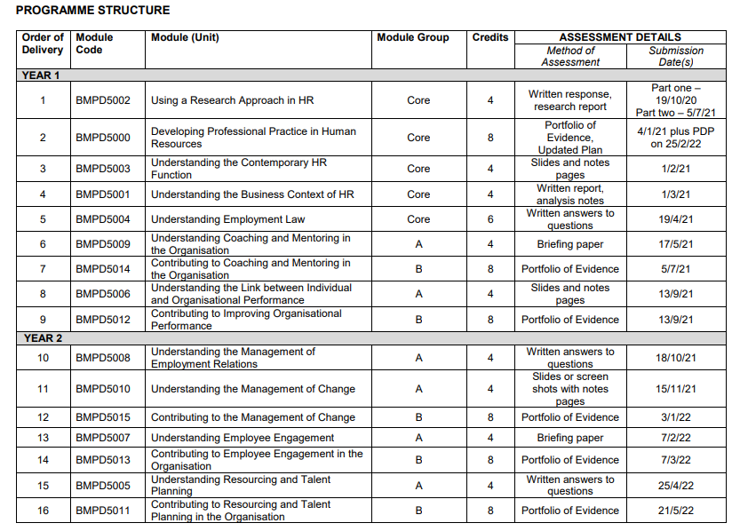

Doc1.3 - Taken from Programme of Study Handbook
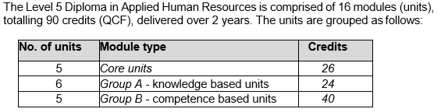
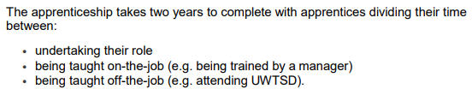
Doc1.4 Taken from Programme of Study Handbook

Doc1.5 Taken from Programme of Study Handbook
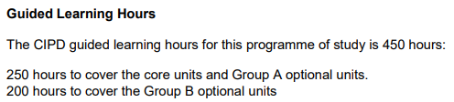
Doc1.6 Taken from Programme of Study Handbook
Doc1.7 Taken from Programme of Study Handbook
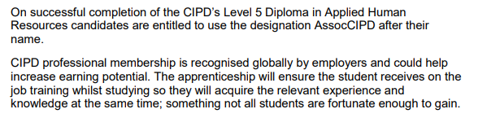

Doc 1.8 - Apprenticeship contract between employer and B-WBL
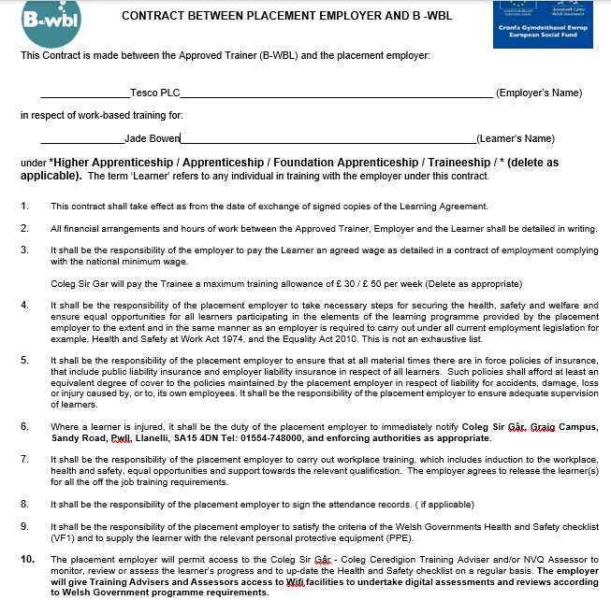

Doc 1.9 - Apprenticeship Learning Agreement 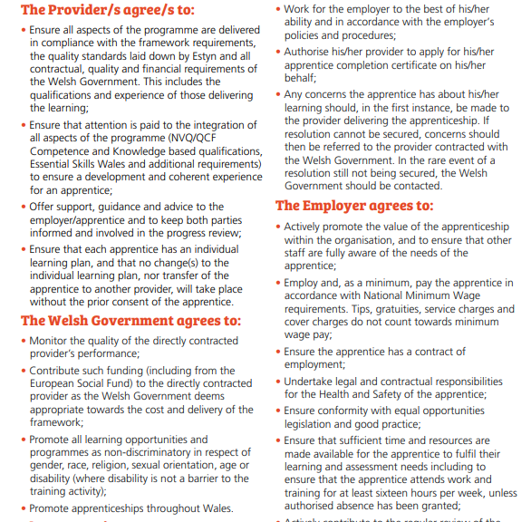


Doc1.10 – Screenshot taken from outlook diary invite

Doc 1.11 – Taken from CIPD website
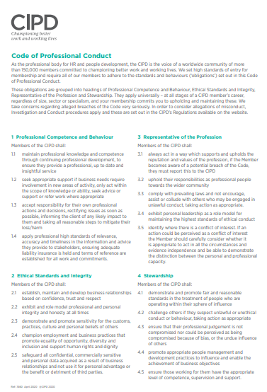

Doc 1.12 – Taken from UWTSD Student Code of Conduct
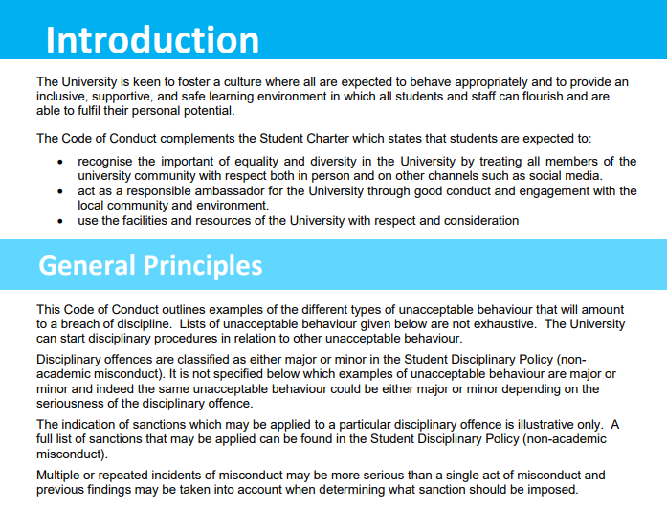

Doc 1.13 – Taken from Programme of Study Handbook

Doc1.14 – Taken from CIPD Student brochure
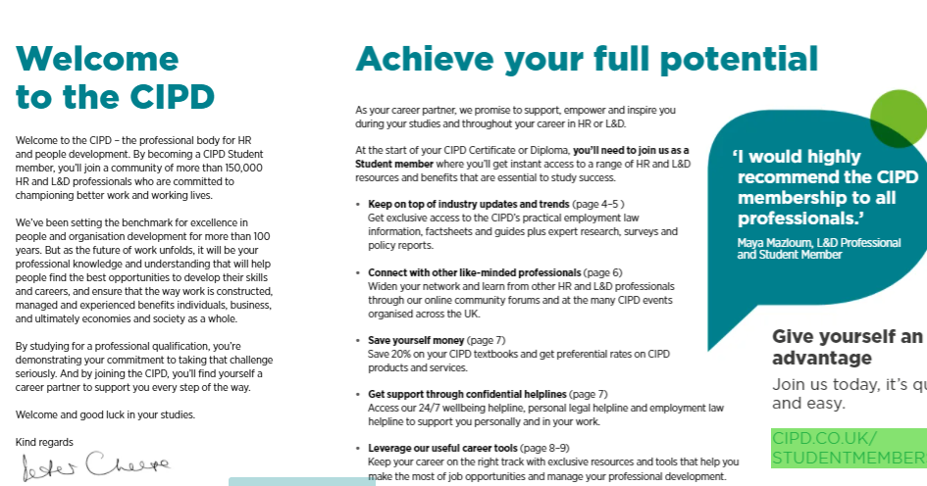

Doc 1.15 Taken from Moodle
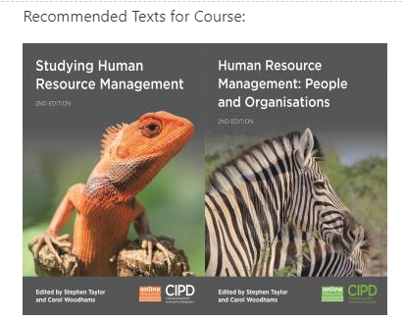
Doc 1.16 Taken from UWTSD homepage

Doc1.17 – Taken from Programme of Study Handbook
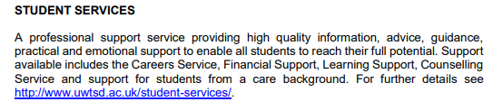

Doc 1.18
Induction Questionnaire
 | Question | Answer
1. | When, where and at what time will the course be delivered? | Once a month over 2 years at Coleg Sir Gar Carmarthen campus
2. | How many modules form part of the programme? | 16
3. | What are the term dates for this year? | 21/09/20 - 22/01/21
4. | What is Moodle? | The Uni’s virtual learning platform used for learning and teaching and can be accessed anywhere by enrolled students
5. | What is Eduroam? | A secure internet access for students when on campus
6. | What is Turnitin? | An online checking and plagiarism prevention platform analysing people’s written material
7. | Do you know when you are required to hand in work? | Yes
8. | What are the core texts for this programme? | Studying Human Resource Management  Human Resource Management: People and Organisations  Introduction to Employment Law
9. | Do you know how to access the library catalogue? | Yes
10. | Do you know who to go to if you have a question/concern about the course? | Yes
11. | What is the name of the Training Adviser? | Carola Platz
12. | What is the name of the course lecturer? | Julie Thomas/ Rachael Jones
13. | Will you be expected to complete work outside lessons? | Yes
14. | Do you need to be a member of the CIPD? | Yes
15. | What support is available for study skills? | Student Support services
16. | Do you know where the fire-exits and first aid points are for the building? | Yes
17. | How many credits is the programme? | 90
18. | What is the length of the programme? | 2 years
19. | Do you know where to find the student handbook and timetable? Where? | Under ‘course information’ on Moodle
20. | What academic level is this qualification? | Level 5 Diploma

Name: Jade Bowen
Signed: J.Bowen
CIPD Membership Number: 57385937
Signature of Lecturer: 
Date: 27/10/2020

Activity 2

How does the CIPD HRPM areas and bands define the HR profession and why the HRPM behaviours are essential to being an effective HR professional

Introduction
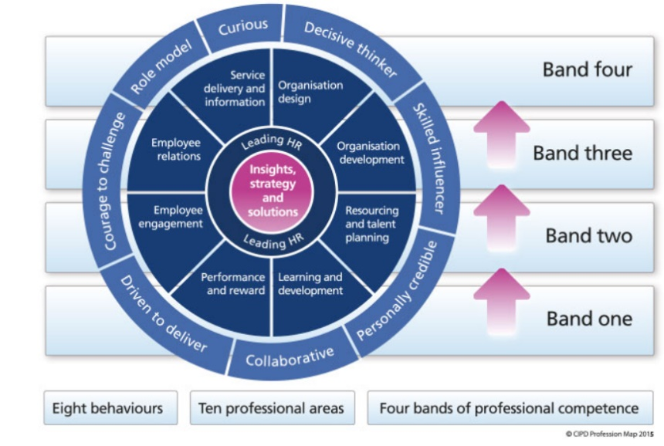
The CIPD Profession Map 2013 is a competency framework detailing the knowledge and behaviours needed to be an effective HR Professional. The Profession Map (below) consists of ten areas, eight behaviours and four bands; all of which together define the HR Profession.

The context of the map focuses on having a good understanding of business priorities to enhance sustainable performance, and the contribution needed from all HR Professionals (CIPD, 2013).
HR Professionals use specialist knowledge and skills to analyse and evaluate, in accordance with a code of conduct set by a governing body, i.e. CIPD (Lester, 2010). A HR Professional is someone who makes valuable and strategic contributions to an organisation (Farndale, 2005, cited in CIPD, 2020, People Profession Survey).
This report details how the areas and bands within the Profession Map define the HR Profession, and why the behaviours are essential to being an effective HR Professional.

For the purposes of this report, I will be referencing the 2013 Profession Map, as opposed to the new 2018 map.

Main: Areas and Bands
The CIPD 2013 Profession Map (PM) defines the HR Profession (HRP) through 10 key areas that all HR Professionals should practice, regardless of their role or level of responsibility.

The Profession Map emphasises on being a HR Leader by role modelling ‘what good looks like’ through own effort and developing and supporting others to add value and drive the business’ performance (CIPD, 2013).

Each area of the CIPD (2013) Profession Map is appropriate to all HR Professionals, but the importance of that area will vary dependent of the role. For example, Resource and Talent Planning will be more suited to someone who is responsible for ensuring there is adequate resourcing and continuous talent development, as oppose to someone who focuses on ensuring there are sufficient recognition and reward schemes available through Performance and Reward. This shows how diverse the HR role can be and the importance of being adaptable to change.

Accompanying each of the 10 areas within the CIPD (2013) Profession Map are 4 ‘bands of competence’. These bands define the level of input and responsibility for each activity such as ‘Organisational Development’ or ‘Employee Relations’. The level of detail provided varies depending on whether they are at the start of their HR career (Band 1) or within the most senior HR position (Band 4).

However, what remains a key focus throughout the Profession Map is having a deep understanding of the business strategies and being able to work with various stakeholders, regardless of level (CIPD, 2013).

The Profession Map also highlights what knowledge and skills are needed to progress to the next level. Madden and Mitchell (1993) states Continual Professional Development (CPD) is a lifelong journey and is key to being an effective HR Professional. Focusing on building skills, keeping knowledge up-to-date and developing behaviours, enhances personal capability as well as benefitting organisational performance. Keeping up to date with the forever-changing needs of the external world, for example, Employment Law changes, is crucial to support the business to help implement, lead and in-bed change. (CIPD, 2015)

Eight behaviours
The CIPD, 2013 Profession Map also includes 8 behaviours that distinguish how HR Professionals (HRP) should conduct themselves, in order to add value and enhance business success.

CIPD, (2012) research shows that having the courage to challenge, expressing curiosity, and gaining a deep understanding of the business to drive performance is key to being a successful ‘business savvy’ HRP.

Skilfully influencing, along with having the courage to challenge can only be effective once a genuine relationship has been made. Understanding concerns and worries of peers enables successful communication to influence effectively, achieving better results. (CIPD, 2018)

CIPD (2013) implies having the courage to challenge is important to being an effective HR Professional as it shows strength and confidence. Remaining calm, using evidence-based knowledge, and carefully selecting battles gives a bigger impact and generates valuable debates. An effective HRP will speak up when it is the right thing to do for customers, colleagues, and the business.

Identifying issues, analysing information, and making ethical decisions is key to being a decisive thinker. When done right adds great value to the business and enhances performance. Understanding business priorities is key to effective decision-making; an effective HR focuses on fixing the cause of the problem and develops structured solutions. (CIPD, 2020a)

Effective HR Professionals are curious to improve ways of working and are focussed on key priorities. They inspire and collaborate with others in and outside of the business to find ‘best practice’ and make ethical decisions (CIPD, 2013). Although, according to 2018 People Profession Survey, 28% of HR Professionals felt pressured from the business which hindered them from making ethical decisions. (CIPD, 2020b)

Collaborating with others in and outside of the business, identifying and supporting talent development, and inspiring others to deliver the business strategy enhances contributions and excels business performance. (CIPD 2013)

Underpinning the HR Profession is the CIPD Code of Conduct (CIPD, 2020d); a set of ethical principles detailing the importance of confidentiality, integrity, equality, and diversity, and CPD, demonstrating ethical practice and making ethical decisions (CIPD, 2020c). The Code of Conduct is essential in protecting the integrity of the profession, failure to do so shows lack of professionalism (CIPD, 2012).

Conclusion
In conclusion, the Professional Map provides a guiding framework of behaviours, skills and knowledge that enable the HR Professional to provide ethical, expert, and dedicated support that adds value to the business. Each area and band facilitate directed learning that supports continuous development, to ensure the effectiveness of HR Professionals.

References/ Bibliography

CIPD, (2012) Business savvy: giving HR the edge. Available at: https://www.cipd.co.uk/Images/business-savvy_2012-giving-hr-the-edge-sop_tcm18-8844.pdf (Accessed: 22/11/2020)

CIPD, (2013) CIPD HR 2013 Profession Map. Available at: https://www.cipd.co.uk/cipd-hr-profession/cipd-hr-profession-map/default.html (Accessed on: 6/11/2020)

CIPD, (2015a) CPD for HR Podcast. Available at: https://www.cipd.co.uk/podcasts/cpd-for-hr (Accessed on: 13/11/2020)

CIPD, (2018) Core behaviours: Professional courage and influence. Available at: https://peopleprofession.cipd.org/profession-map/core-behaviours/professional-courage-influence (Accessed: 20/11/2020)

CIPD, (2020a) People Profession Survey 2020. Available at: https://www.cipd.co.uk/Images/people-profession-uk-ireland-2020-report-1_tcm18-78597.pdf (Accessed on: 20/11/2020)

CIPD, (2020b) Coronavirus and the workforce: doing the right thing in a crisis. Available at:
https://www.cipd.co.uk/news-views/changing-work-views/future-work/thought-pieces/coronavirus-workforce-crisis (Accessed on: 18/11/2020)

CIPD, (2020c) Ethical practice and the role of HR. Available at: https://www.cipd.co.uk/knowledge/culture/ethics/role-hr-factsheet (Accessed on: 12/11/2020)

CIPD, (2020d) CIPD Code of Professional Conduct. Available at: https://www.cipd.co.uk/Images/code-of-professional-conduct-april-2020_tcm18-14510.pdf (Accessed on: 30/11/2020)

Activity 3 – Project Management
Plan, implement, monitor, and evaluate a work project
Introduction
HR Professionals must be able to manage projects, over a long period of time or relatively short period of time, following the five key stages to successful project management. These include initiation, planning and design, execution, monitoring and controlling and completion (John & Perkins, 2016).
A project I was recently involved in was the design and implementation of a training plan for over 200 colleagues who were all new to the business. This was a short-term project of 3 weeks. To monitor progress, I used a Gantt chart (Doc 3.1) , where some timelines altered over the duration of the project due to unforeseen circumstances.
For the purpose of this assignment and in-line with GDPR, I have removed/ altered some colleague details (name, employee number, email address, contact number).
Initiation
The usual process for training colleagues would be that they train in a neighbouring store. However, due to the store opening in a remote location the nearest neighbouring support store was over an hour away, and so the original training plan involved ‘classroom’ learning using textbooks, digital learning, and online resources.
However, due to the importance of having quality face-to-face training, I felt the training plan was not adequate and would not provide the best results. I spoke to my Store Manager (SM) with the idea of arranging on-the-job training with our neighbouring store’s, albeit this would be challenging to achieve this with the same budget. At first, my SM was not keen on the idea due to budget constraints however, I was able to provide a business case (Doc3.2) to persuade him otherwise and was hopeful of delivering it for no more than the original plan if I negotiated and planned effectively.
After a team meeting with my SM and the rest of the management team we come to the agreement that the training and capability of our colleagues was vital to the success of the store and business. We decided to devise a mix of classroom and on the job training, totalling 3 days ‘classroom’ and 10 days ‘on the job’ training. We believed by reducing the training plan to 13 days, colleagues would not be disadvantaged as on the job training would be more beneficial than 15 days in the classroom.
With only 4 weeks until store opening, myself and the People Manager took the lead in building and organising an effective training plan, collaborating with Store Manager’s from neighbouring stores, and working with head office for approval to increase the budget.
Planning and Design
Once everyone was on board with the new idea, we discussed the key factors that we would need to consider first. This included looking at transport options with the possibility of hiring cars for colleagues to drive, discussing the legalities and safety aspects. We also discussed costing, time (as we only had 3 weeks), and logistics.

For my planning and design, I broke it down into four subgroups as detailed below.
- Budgets and finance
- Transport
- Colleague training and resourcing
- Communication
Budgets and Finance
I had a meeting with my Store Manager to discuss the budgets. The original budget for 15 days ‘class-room’ training totalled to £318,000 which included the venue, colleague pay and training materials, and a £10,000 contingency budget (Doc 3.3).
However, due to the new training plan which now included hire cars and travel costs I needed to find ways to save money to ensure I did not overspend the budget. I contacted the venue to negotiate the cost as we were reducing the booking from 15 days to 3 days. They agreed we could now have the venue for free with the agreement they could advertise their venue in our store in return, a copy of the invoice was email to me (Doc 3.4)(Doc 3.5).
After finishing budgeting and negotiating pricing, I managed to reduce the total cost to £308,000 which was well received by the store manager as it allowed for an additional £10,000 to be spent on a colleague party which under the original training plan was not feasible (Doc 3.6)
Transport
On seeking advice from Head Office, due to legalities we had to use a specific car-hiring company as this also provides company insurance for colleagues to drive the vehicles. I contacted the car-hire company and they sent me a booking form to complete. I also looked at the cost to hire coaches, however this was more expensive and logistically would not work, so I decided against this option.
Colleague training and resourcing
I arranged a call with the New Stores Project Manager (Doc3.7) as I wanted to identify what previous benefits and drawbacks of training this way and use this information in my approach to ensure was efficient and beneficial as possible. I also spoke to the Learning Deployment Manager to understand what additional learning tools were available, such as, digital learning, online resources, textbooks etc. From this I found out the Counters team would need to attend a ‘Gold Level Butchery Skills’ course, as well as complete their ‘Gold Food Hygiene and Safety’ training and I was able to build this into the training plan.
Before building the training plan, I handed out ‘availability forms’ to all colleagues to understand what days, times and shifts everyone was available to work (Doc 3.8). Once I was in receipt of these, I was able to split everyone into groups, broken down by their department and plan what shift’s they would be doing (Doc 3.9).
Myself and my People Manager devised a training plan specific to departmental needs. Due to budget restraints, we established that colleagues would spend 3 days doing “classroom training” which would include their safe and legal training. They would commence their 10 days in-store training, this was also detailed in the plan (Doc 3.10)(Doc 3.11).
Through a manager’s meeting, we needed to feel confident colleagues were receiving all the training required before opening day. We came up with the idea of having a departmental sign-off sheet which would confirm colleagues understood their training and role requirements, the manager would then sign this off once training had been completed (Doc3.12). During in-store training, we discussed managers would check-in with colleagues and observe them in action.
Communication
- Management Team
As a collective, we felt communication between the team and supporting stores was vital to gain the most from the training plan.
We discussed having a rota of who would be leading the ‘classroom’ training and when, and who would be visiting the supporting stores to check-in with colleagues. We also discussed the importance of having a manager ‘on-call’ during the night when colleagues were still training in case of any emergencies etc.
We agreed due to the high number of colleagues, each manager would take responsibility for their own department and colleagues and update their training tracker to ensure everyone was on track.
I suggested we should have daily meetings every morning to discuss the plan for the day, any colleague absence, issues from the day before and feedback from the supporting stores.
- Colleagues
To stay in contact with colleagues, we would need a ‘contact details’ form listing their name, number and emergency contact details (Doc 3.13). It was also agreed all colleagues would receive a copy of their training plan.
Again, it was agreed managers would check-in with their team regularly, as well as visiting them in-store to keep communication up to date.
- Training stores/ SMs
After the initial call with supporting Store Manager’s to confirm supportance. I arranged various conference calls to keep them updated on the training plan and to confirm the number of colleagues attending on which days (Doc 3.14). Once training begun, the calls then increased to every Monday, Wednesday, and Friday to discuss progress, feedback, and any concerns (Doc 3.15).
Throughout the planning process I communicated and collaborated with a range of stakeholders of various levels, internal and external to my company. By seeking advice from subject experts I was able to adapt the training plan to be most effective.
Execution
Once the budgets had been confirmed by head office and my Store Manager had signed off the training plan I was able to confirm with the hire car company how many cars we needed, and arrange drop off/pick up dates, times and location (Doc 3.16).
Myself and the management team held a meeting to confirm roles and responsibilities, including who would be providing the training on which days, who would be “on-call” and who would be visiting the stores to check-in with the colleagues (Doc 3.17).
All colleagues’ were contacted confirming their training shifts for the 3 weeks, providing them with details of where and when they would be training (whether they’d be in-store training or classroom training) and what shifts they’d be doing. This was done by the colleagues’ line manager who I would provided the details to. Colleagues received a copy of this (Doc 3.18).
I also arranged for the Counter’s team to undergo a 3 day specialist training course which was required as part of their role. This was scheduled into their training plan for 19th-21st Novemeber (Doc 3.19).
Monitor and control
Throughout the duration, I attended calls with supporting Store Manager’s to gather feedback on how the training process was going, which sometimes was done via email if they were unable to attend a call (Doc 3.20). Any feedback, I would then discuss with the management team during our meetings.
Colleague attendance was monitored by their department manager which was not documented, however any sickness absence was recorded on an ‘Absence Tracker’ as per the Company’s Sickness and Absence policy and passed to the Admin clerk to update the payroll system (Doc 3.21).
To ensure manager’s were playing their part in checking-in on their colleagues as per our communication agreement, I visited stores speaking to various colleagues to understand the level of support they were receiving, how they were feeling, any concerns etc.
During the Management meetings, we discussed each department’s training tracker to understand progress and any concerns.
Completion
As this was a tight timescale to complete the training, there was no scope built into the plan for colleague absence or setbacks. Colleagues who did not complete their training in time needed to receive additional training post opening day. I arranged this with the supporting stores and confirmed via email (Doc 3.22).
Also, due to unforeseen circumstances the training course that the Counter’s team were due to parttake in was rescheduled at short notice, meaning their training plan needed to be reviewed and ammended quickly.
Upon store opening day, training completion totalled 96% and any training left outstanding was planned in post opening as per above.
According to my “communication effectiveness questionnaire” filled in by a colleague, only ‘occassionally’ I am open to feedback which I know I need to improve on (Doc 3.23)
So to understand the success of the project I issued all managers and colleagues with a ‘Training Feedback Survey’. This feedback provided me with insight as to how they felt I led the project, as well as the level of training and support the colleagues received, which fortunately everyone was happy with (Doc 3.24)(Doc 3.25).

Appendix
Doc 3.1 - Gantt chart
Training Plan Planner
 |  | PLANNING |  | CLASSROOM | ON JOB
Activity | Who | Wk 1 | Wk 2 | Wk 3 | Wk 4 | Wk 5
Compare current training plan with new idea | Jade
Discuss new idea with Store manager | Jade
Hold meeting with Management team to influence new training idea | Jade & SM
Meeting with SM - discuss and review budgets for new training plan | Jade & SM
Arrange call with supporting SMs | Jade
Contact venue - ammend booking & negiotiate cost | Jade
Contact car-hire and coach company - obtain quotes | P.M
Speak to Project Mgr | Jade
Speak to Learning Mgr | Jade
Find out colleague's availablity | Jade/ manager specific
Build dpt specific training plan | Jade and P.M
Discuss Mgr roles/responsibility rota | Jade, all mgrs, SM
Complete and submit car-hire request form | Jade
Confirm venue booking | Jade
Design mgr rota | all mgrs
Contact all colleagues - confirm their training shifts | Mgr specific
Book Counter's training course | PM
Classroom training begins | Mgrs
Hold daily mgr meetings to discuss classroom training progress | Jade, PM & all mgrs
Update supporting SM's of training plan | Jade
Confirm to colleagues their 10 day training plan | Mgr specific
Hold regular calls with SMs gather feedback | Jade
Feedback to mgrs of feedback from SMs | Jade
Visit stores - check in with colleagues | Jade & all mgrs
Hold mgr meetings discuss overall training progress | Jade & PM
Hold final training progress call with SMs | Jade
Feedback to my SM on overall progress achieved | Jade & PM
Plan for additional training for those who are not 100% | Jade
Reschedule Counter's training course | PM
Gather feedback from colleagues and managers on how I led the project | Jade
Submit all documents to Project Manager | Jade

Gantt Chart Key
Key
Initiation
Plan & Design
Execution
Monitor
Completion

Doc 3.2 – Comparing training options

Doc 3.3 – Taken from excel spreadsheet. Original budget sheet.
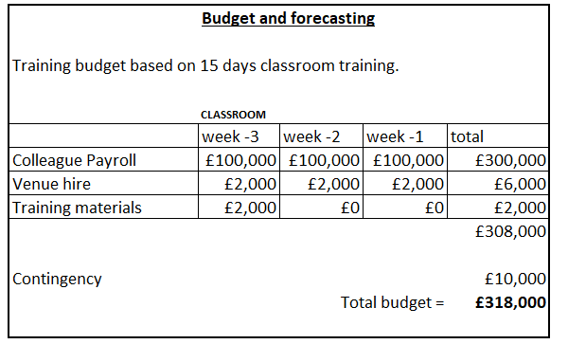
Doc 3.4 – Copy of confirmation of email
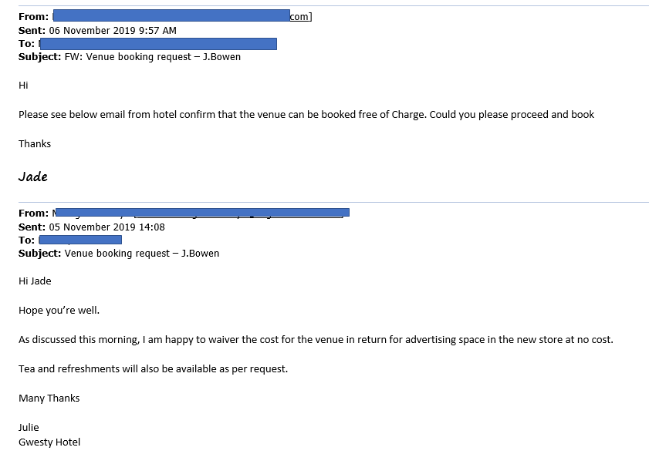
Doc 3.5 – Copy of training venue invoice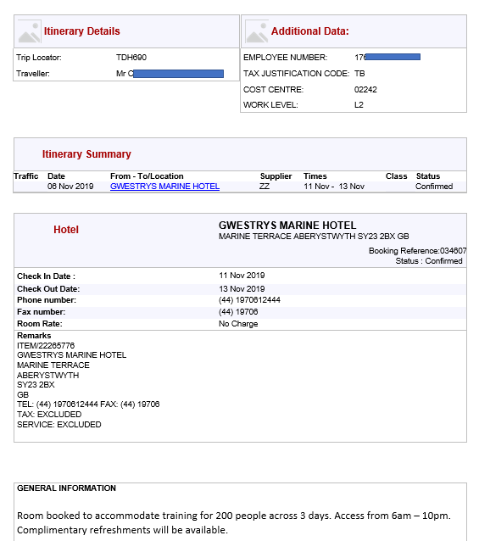
Doc 3.6 – Taken from excel spreadsheet. New budget plan
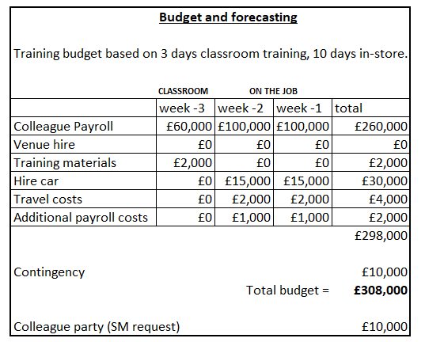
Doc 3.7 – Call with Project Manager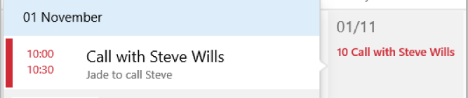

Doc 3.8 – Colleague Availability form
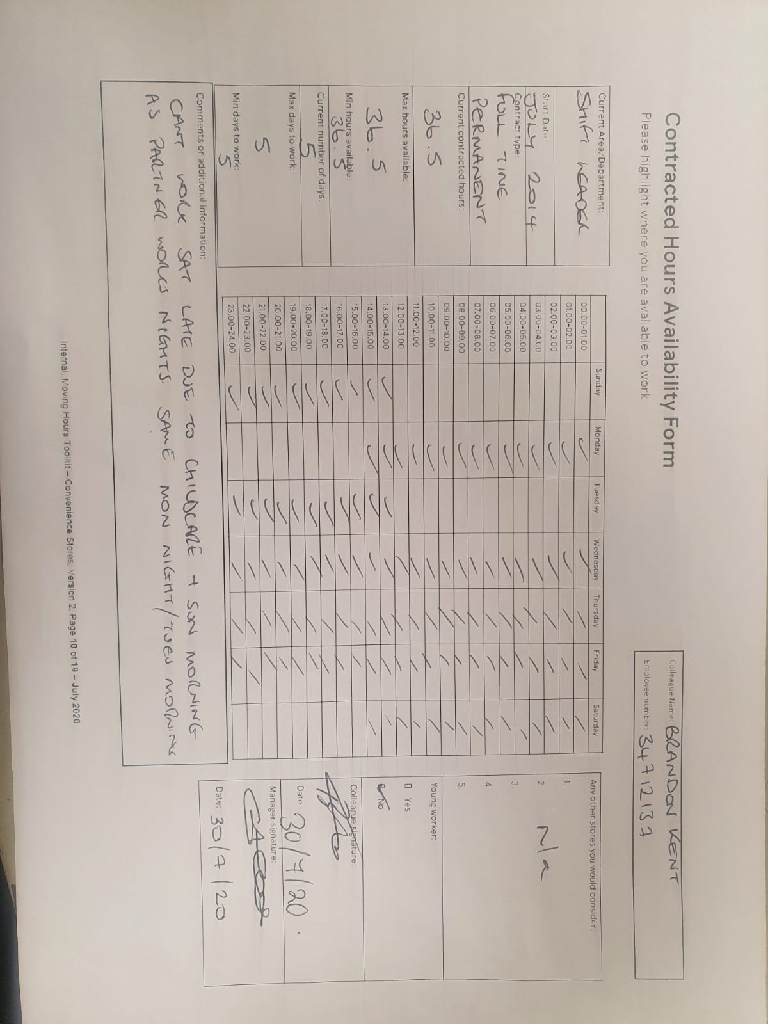
Doc 3.9 – Copy of training schedule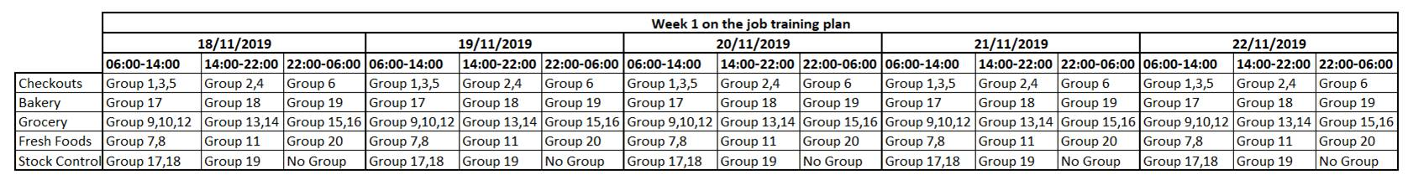

Doc 3.10 – Copy of department 3 day classroom training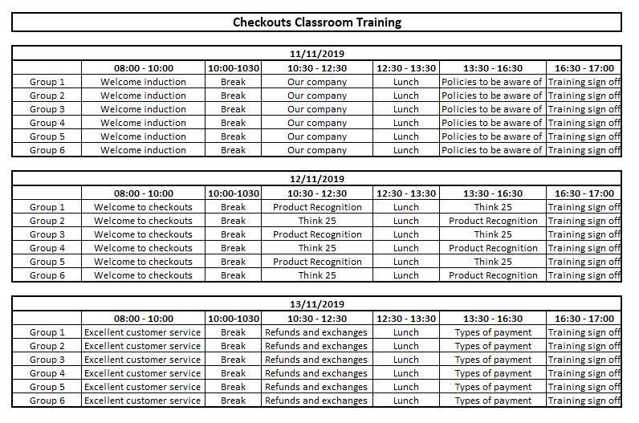

Doc 3.11 – Copy of department 10 day in-store training
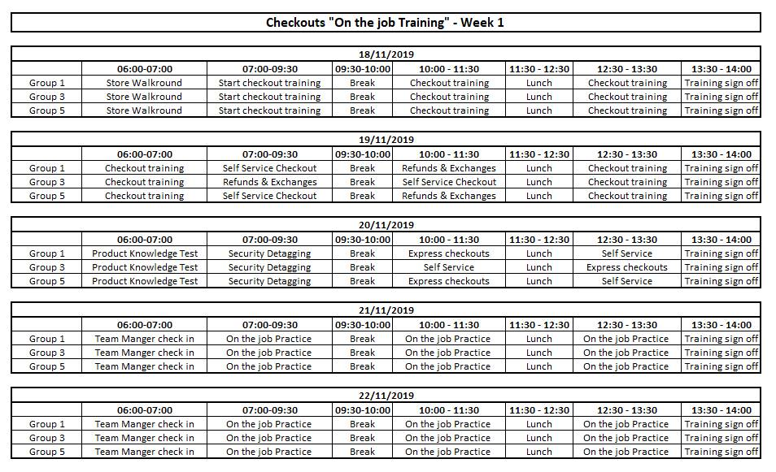
Doc 3.12 – Training sign-off card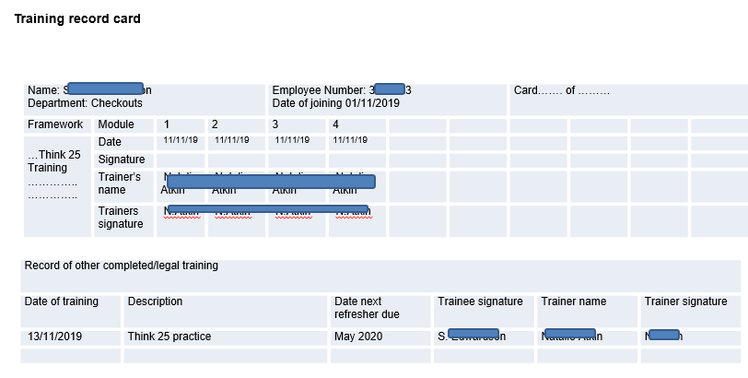
Doc 3.13 – Blank colleague contact form used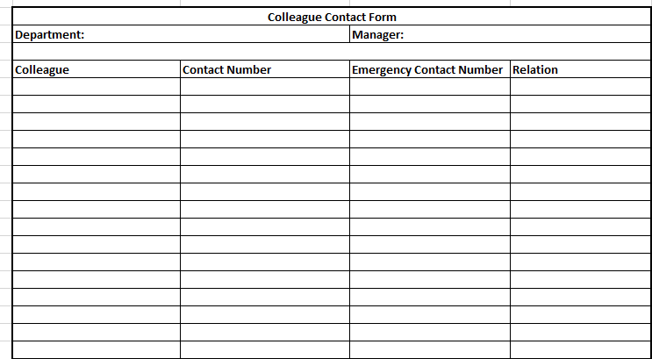
Doc 3.14 – Diary invites with SM to discuss training plan
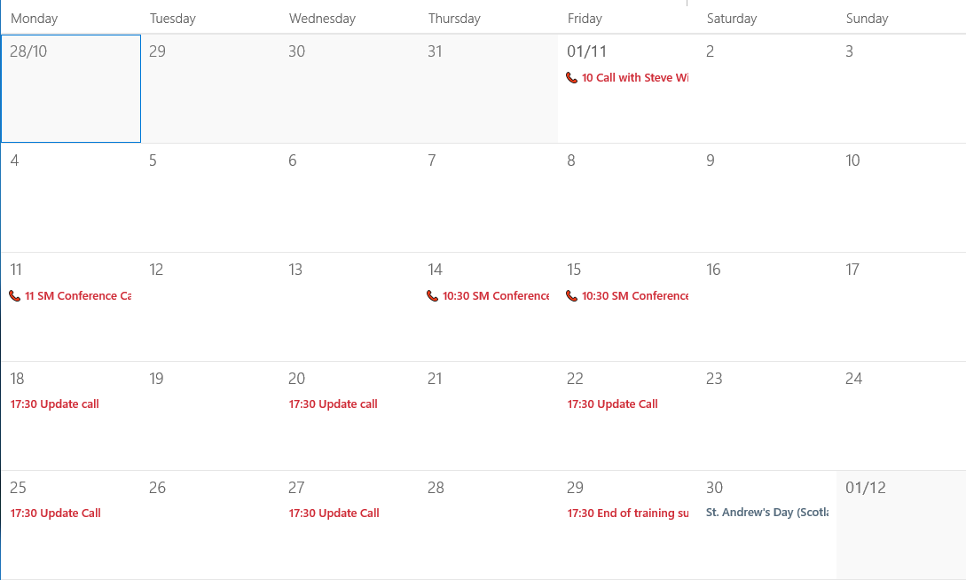
Doc 3.15 – Diary invites with SM to discuss training progress
Doc 3.16 – Copy of hire car booking form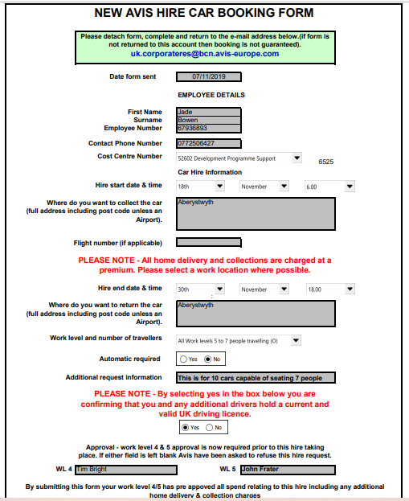
Doc 3.17 – Manager Roles/Responsibility Rota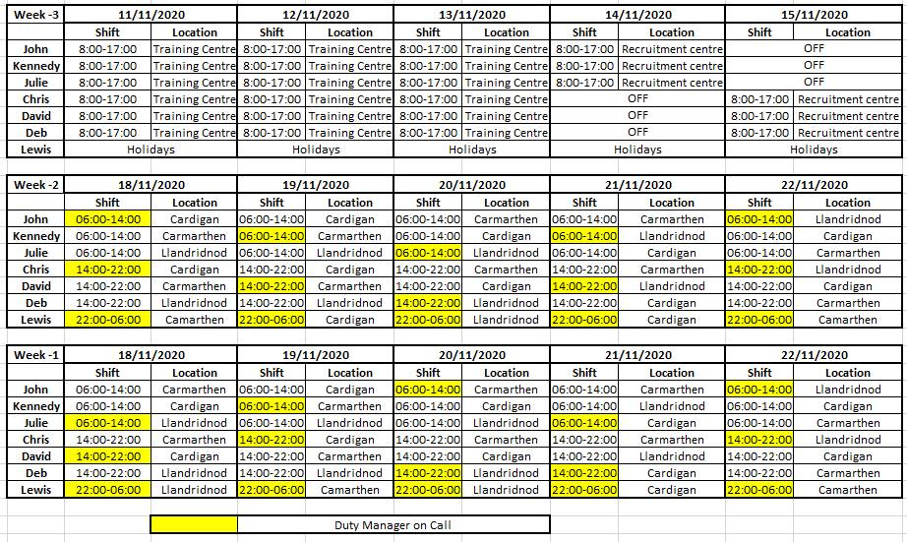

Doc 3.18 – Colleague training plan
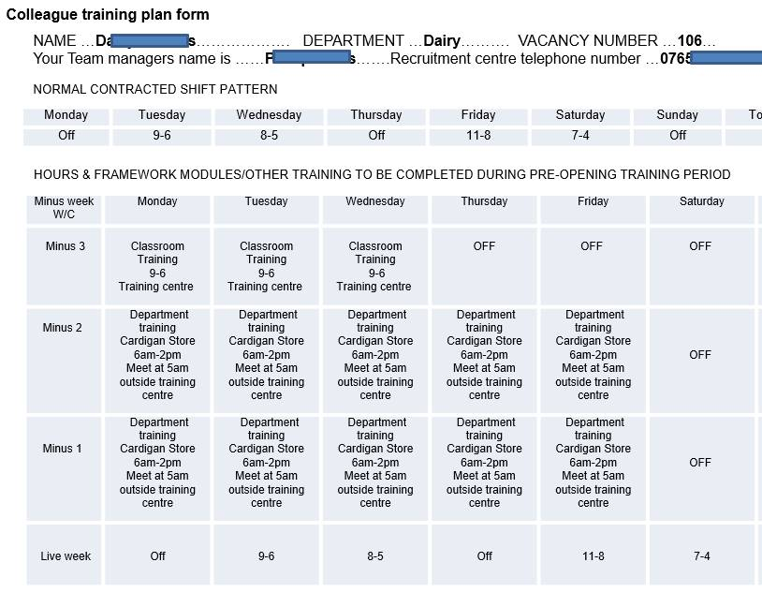
Doc 3.19 – Counter’s training plan showing specialist training course planned in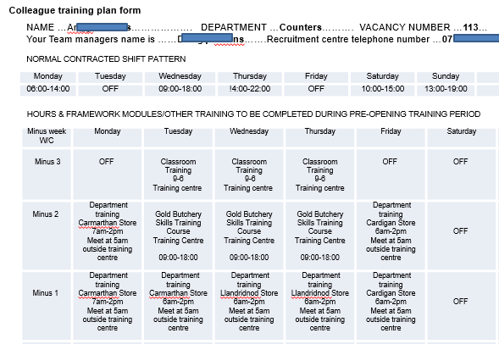
Doc 3.20 – trianing progress email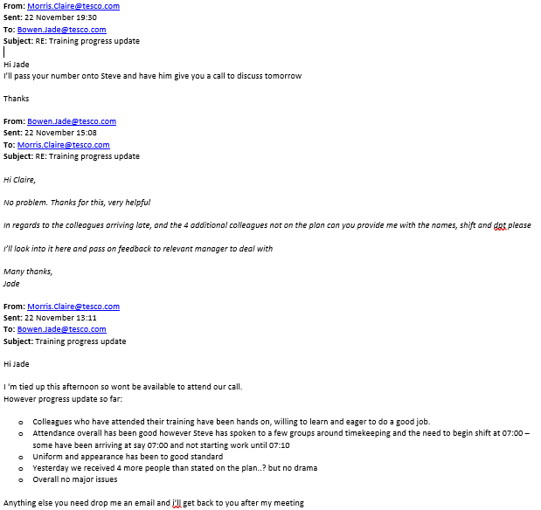

Doc 3.21 – Copy of Company absence tracker 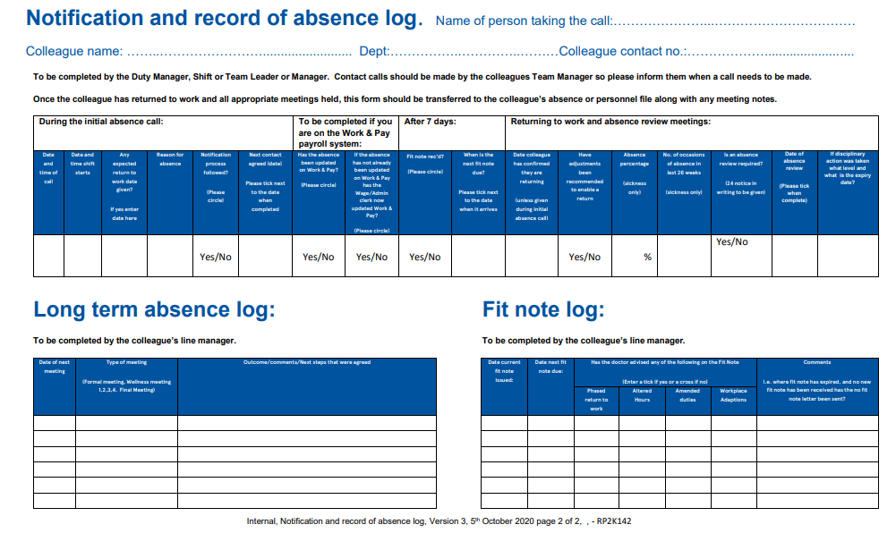

Doc 3.22 – Following up emails
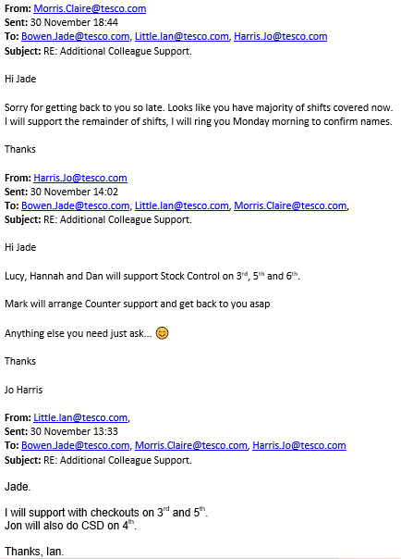
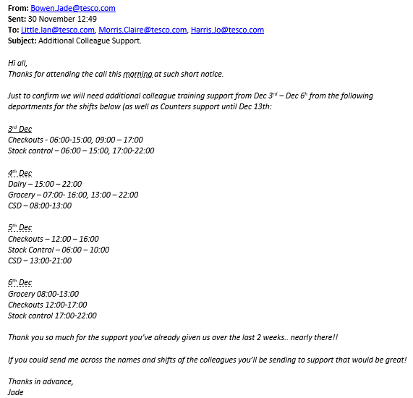

Doc 3.23 – Communication effectiveness questionnaire
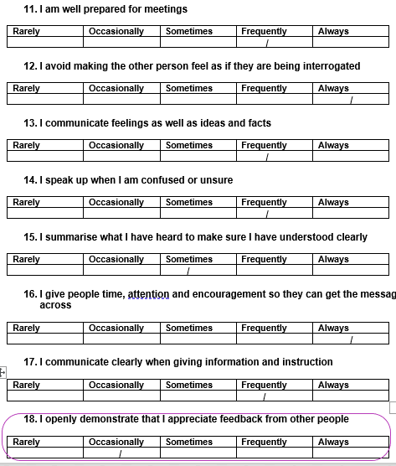

Doc 3.24 – Colleague training feedback survey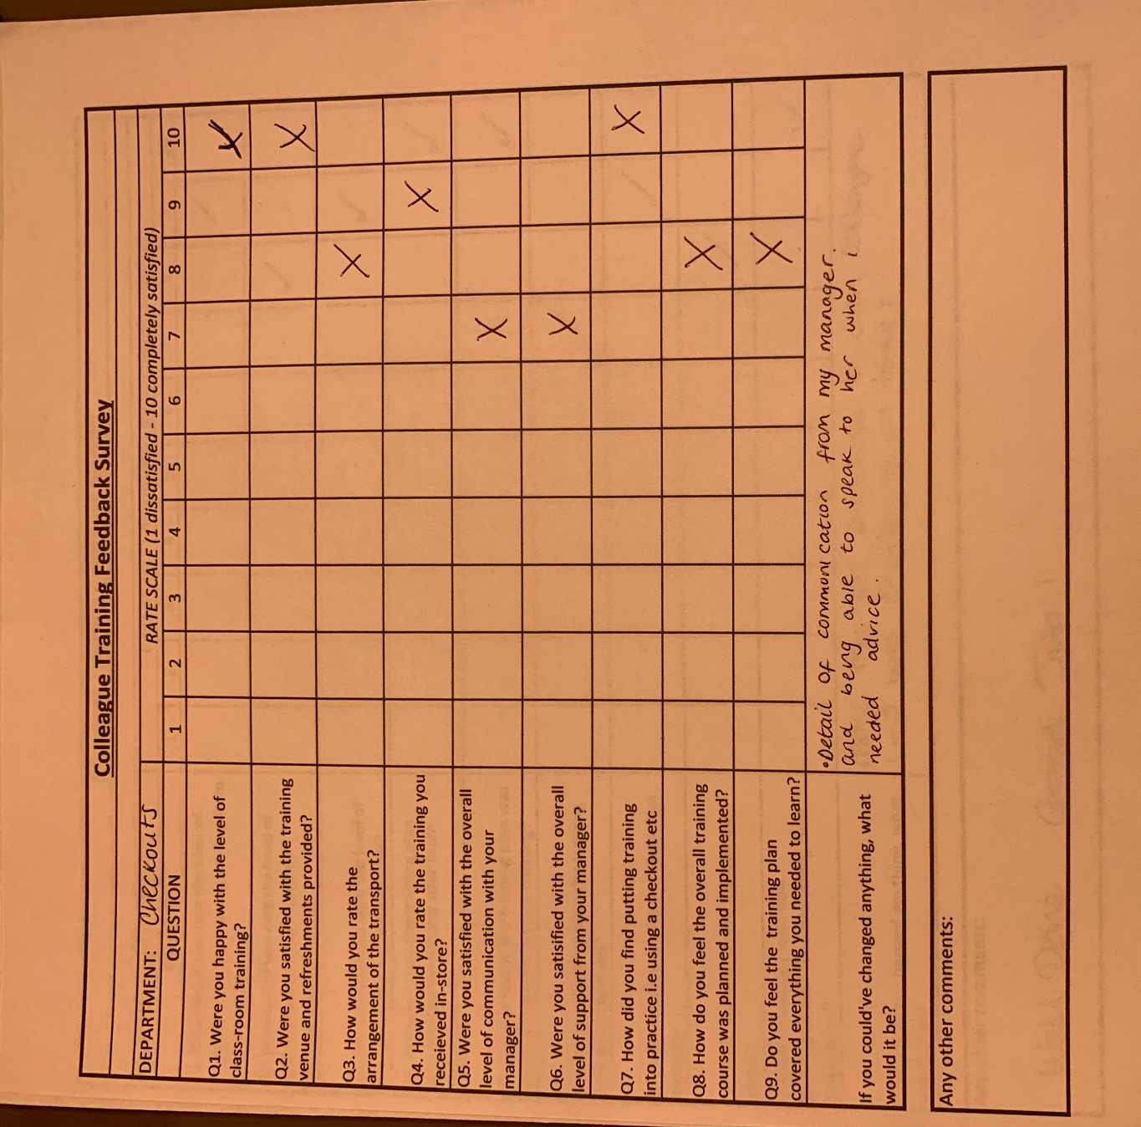
Doc 3.25 – Manager training feedback survey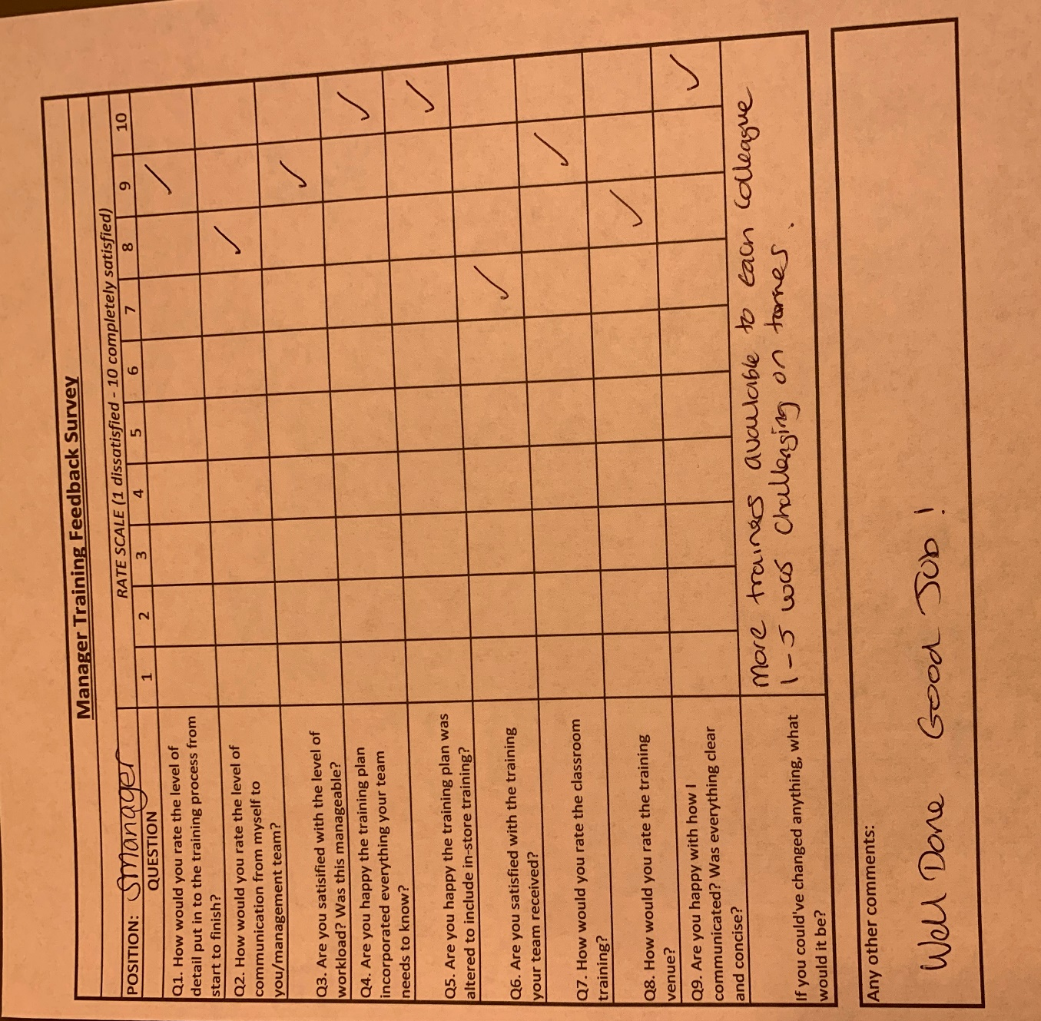

Activity 4

The concept of team dynamics and how political behaviour can impact the achievement of organisational objectives
Introduction
This report describes the meaning of team dynamics, and what is needed to become an effective and successful team. It will discuss Tuckman and Jensen (1977) five stage model to being an effective team, as well as looking at the different roles’ individuals play from Belbin’s model.
The report also investigates what is meant by ‘political behaviour’, and how individuals displaying these behaviours can have effect team-members as well as the achievement of organisational objectives; both positively and negatively.
Main: Team dynamics
A team is defined as two or more individuals focussed on achieving a shared goal. Team dynamics are the forces that drive the team’s behaviour to achieve the end result (Eckes, 2003).
These forces are influenced by personality, past experiences, knowledge, and skills influencing the team-effectiveness (Watson, 2014) and enhancing business performance (Jackson and Carter, 2000, cited in Watson and Reissner, 2014).
Core to being a successful HR Professional is having the attribute to work collaboratively, communicating effectively, and being adaptable to change, which is especially important in a crisis (CIPD, 2013). These behaviours are crucial when building an effective team under pressure. As well as focussing on the competencies of the individuals; particularly those who will motivate and support one another, as well as setting clear objectives, and continually reviewing progress (West, 2020).
Effective teams work better together once a good relationship has been formed and they feel confident to challenge ideas, ask questions and make mistakes. Using each other’s strengths, understanding their own purpose, and seeing positive results is encouraging for a team to strive forward, producing better results. (Re:work, n.d.)
Diversity of skills, knowledge and culture can contribute to team-effectiveness, as well as being the main cause of unnecessary conflict and disagreements (Watson, 2014). However, Lamb (2014) argues getting the balance of conflict right can be healthy, as too little conflict prevents ‘innovative thinking’, and too much conflict effects team moral and performance (Watson, 2014).
Research conducted by (Re:Work, n.d.) highlights the importance of how a team is formed as opposed to who is on the team. Team size can also be an arguable factor as (Katzenbach and Smith, 1993, cited in Re:work, n.d.) suggests a team less than 10 individuals produces higher quality of work than a larger team. For teams to succeed, individuals and group efforts are needed, with everyone taking responsibility and accountability for the outcome. (Clegg et all, 2005, cited in Watson and Reissner, 2014)
Building an effective team starts with the groundwork; firstly, identifying the key success factors of the project enables a team to be formed around what is needed (Jones, 2014).
Tuckman and Jensen (1977) suggest teams develop through five stages: forming, storming, norming, performing and adjourning. The model highlights how teams start off unsure and confused. They set roles and responsibilities, causing conflict and disagreements. As the team progress, they start to become more independent and settled, having a clear understanding of the objectives, and collectively achieving the end goal (Tuckman, 1965, cited in Watson and Reissner, 2014).
Belbin’s model identifies nine roles needed for an effective team. Research shows effective teams are made up of a range of diverse behaviours; coordinator, implementer, shaper, plant, resource-investigator, monitor/evaluator, team-worker, completer and specialist (Belbin, 2019). This model encourages teams to become high performing, avoiding being stuck at the earlier stages of Tuckman model (Miller, 2014).
However, as a team grows, so does their knowledge and performance, eventually outgrowing each other and can lead to lack of exertion (Clegg et al, 2005, cited in Watson and Reissner, 2014).
Political Behaviour
Political behaviour can be described as influencing others to your own beliefs when there is an unreliable authority (Kakabadse, 1983, cited in Armstrong 2009), to enhance personal and organisational objectives (Jarrett, 2017).
Organisational politicians believe by applying manipulative behaviours such as ‘wire-pulling’, ‘exerting pressure’, and using a ‘Machiavellian approach’ achieves the end goal and justifies their behaviour (Armstrong p.149, 2009). Although, such behaviours can stem from lack of resourcing, pressure to deliver and own motivations (Jarrett, 2017).
Individuals displaying these behaviours tend to be highly driven by their own opinions. They believe using political behaviour is the only way to get things done (Armstrong, 2009) but, when used appropriately; politics can be useful and effective to achieving own and organisational objectives (Jarrett, 2017).
However, some people will act unethically by withholding important information from their teammates, go behind their back, and target weaker members with the belief that knowledge is power (Armstrong, 2020). This over-controlling behaviour can affect the effectiveness and contribution from the team and become a barrier to achieving the objectives (Horn, 2009).
When dealing with organisational politics, managers need to be aware of them but avoid being part of them, as they can have an impact on the success of the end goal (Horn, 2009). Managers should ensure that any issues are discussed in full, differences in opinions are dealt with quickly, and ensure any disagreements do not become personal (Armstrong, 2009).
Conclusion
To summarise, the contribution of individuals’ knowledge, skills and experience plays a significant role in driving organisational objections.
The roles people play are pivotal in developing an inclusive culture, enabling team cohesion and confidence to challenge through the toing and froing of sharing ideas.
However, in spite of the fact that political behaviour can push forward the achievement of business goals, power tactics and manipulation can disrupt the integrity of team dynamics, undermine the inclusivity, and disengage team members.
Therefore, utilising the full potential of team dynamics is essential for achievement and sustainability of business objectives.

References
CIPD. (2013) The CIPD Profession Map. Available at: https://www.cipd.co.uk/learn/career/profession-map (Accessed: 3rd December 2020)
Re:work, n.d. Identify dynamics of effective teams. Available at: https://rework.withgoogle.com/guides/understanding-team-effectiveness/steps/introduction/ (Accessed: 5th December 2020)
Lamb, P. (2014) Building the best team. Available at: https://www.cipd.co.uk/podcasts/building-best-team (Accessed: 5th December 2020)
Jones, G. (2014) Building the best team. Available at: https://www.cipd.co.uk/podcasts/building-best-team (Accessed: 5th December 2020)
Eckes, G. (2003) Six Sigma Team Dynamics. Hudson, New Jersey, USA. John Wiley & Sons
Tuckman, B.W. & Jensen, M.A.C. (1977) Stages of Small-Group Development Revisited. Available at: http://faculty.wiu.edu/P-Schlag/articles/Stages_of_Small_Group_Development.pdf
(Accessed: 5th December 2020)
Belbin, M. (2019) Belbin team roles. Available at: https://www.belbin.com/about/belbin-team-roles/ (Accessed: 5th December 2020)
Watson, G. and Reissner, S. (2014) Developing skills for business leadership. 2nd ed. London: Chartered Institute of Personnel and Development.
Miller, T. (2014) When four worlds collide. Available at: https://www.belbin.com/media/1397/when-4-worlds-collide-tj-2014.pdf (Accessed: 6th December 2020)
West, M. (2020) The key components of effective teamworking during the covid-19 crisis. Available at: https://people.nhs.uk/teamworking/the-key-components-of-effective-teamworking-during-the-covid-19-crisis/ (Accessed: 4th December 2020)
Armstrong, M. (2009) Armstrong’s Handbook of Management and Leadership. 2nd Edition. London: Kogan Page
Armstrong, M. (2020) Armstrong's Handbook of Human Resource Management Practice. 15th Edn London: Kogan Page
Jarrett, M. (2017) The 4 types of organisational politics. Available at: https://hbr.org/2017/04/the-4-types-of-organizational-politics (Accessed: 6th December 2020).
Horn, R. (2009) The Business Skills Handbook. London: Chartered Institute of Personnel and Development.

Activity 5
Self-assessment of HR capabilities and Personal Development Plan

Introduction
CPD is a key aspect in keeping knowledge and skills up to date, focussing on personal growth and external contexts, benefiting individuals and the business (Taylor and Woodhams, 2016). CIPD provides a tool for assessing current knowledge and skills against the 2013 Profession Map in order to manage professional development.

In this activity, I will be undertaking a self-assessment using the 2013 CIPD HR Profession Map at Band 2 level. The self-assessment will highlight which areas of the Profession Map I am ‘emerging and ‘exceeding’ in. From this information, I will look at numerous ways to enhance my development needs and produce a Personal Development Plan.

I will be carrying out the student self-assessment against the whole of the Profession Map but only creating my development plan against two professional areas (one of which will be a core area) and two behaviours. I will then decide which two areas and two behaviours I will base my learning plan on which are more suited to the HR role I am interested in.

Findings

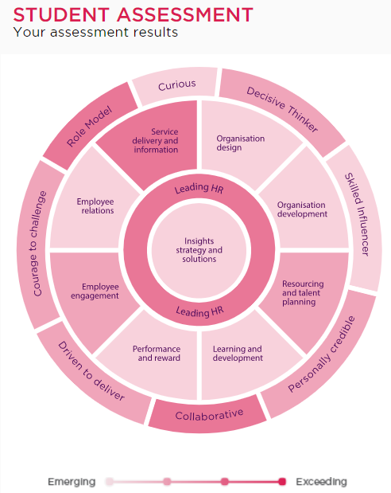

My self-assessment (see above/DOC 5.1) highlighted the areas I was ‘emerging’ and ‘exceeding’ in. The areas and behaviours identified as exceeding are what I currently practice in my job, therefore have greater knowledge on.

The self-assessment also highlighted the areas I needed to focus on, enabling me to create my development plan. Those two areas are:

Professional areas:
- Insights, Strategy and Solutions
- Employee Relations

Behaviours:
- Skilled influencer
- Curious

Once I had selected the areas that I needed to develop my knowledge in, I was able to build my Personal Development Plan (PDP) and look at ways I could start my learning whilst being on maternity leave. To enhance my learnings I will attend courses, tribunals, employment law updates, use books, journals, the internet and arrange meetings with specialised experts once I return to work.

However, before looking at how I would learn best, I used my learning styles questionnaire (DOC5.2) to identify my preferred learning style. This showed me as a reflector and I learn best by observing others first, process my findings and taking my own action.

I was then able to build my PDP, using the six steps to successful development planning:

- Personal Skills Audit
When writing my PDP, I considered the approaches that I could use to support my development. Most of my learning would be identified through the situational approach. However, using the benchmarking approach would be beneficial as I would gain a lot of knowledge from having a role model/mentor currently doing the job I aspire to do. The rest of my learnings I would gather through obtaining feedback.

- Setting Objectives
When setting objectives, I used SMART approach. This made sure my learnings would be specific and information gathered was measurable. I also had to make sure the learning outcomes were achievable whilst on maternity leave.

I looked at dates for CIPD courses, mock tribunals, and employment law updates to ensure my objectives were realistic.

- Selecting Opportunities
My objectives are set both in and outside of work, as these include self-studying, attending online courses/webinars as well as work with and shadowing others in work.

- Actions
When building my action plan, I made sure my objectives were detailed in what I needed to do, how I would do this, and where and when I would carry out my learnings.

- Implementation and Progress
As it is important to have support through my development, I will seek for a mentor with a CIPD HR status once I return to work. However, in the interim my line manager is aware of my development needs and will support me in arranging time to implement my learnings on my return.

The final stage is the assessment of my learning, which will be carried out as I work my way through my PDP.

Conclusion
On completion of my self-assessment, it does paint an accurate picture of my current knowledge and skills, and what I need to focus on to gain the expertise in the role I which to progress to.

As I am currently on maternity leave, some areas of the plan could be more detailed however, without knowing exact timescales for each objective I will continually make changes and updates to ensure I stay on track. I may need to adapt some objectives, so they remain achievable and realistic.

References/Appendix:

Taylor, S. and Woodhams, C. (2016). Studying Human Resource Management. 2nd Edn. London: CIPD

Doc 5.1 – Taken from CIPD My CPD Self Assessment

Doc 5.2 Taken from my learning style questionnaire
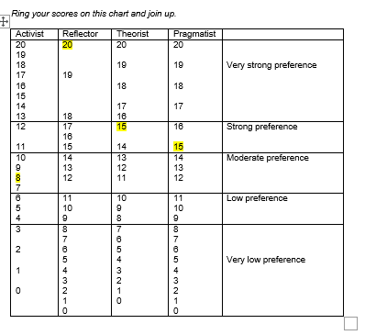

My Personal Development Plan

NAME: | Jade Bowen | MEMBERSHIP NUMBER: | 57385937
COVERING THE PERIOD FROM: | January 2021 | TO: | March 2022

This record sheet is for your guidance only – you may present your development plan in any other format.

Planned outcome

Where do I want to be by the end of this period? What do I want to be doing? (This may be evolutionary or “more of the same”.)

What do I want/need to learn? | What will I do to achieve this? | What resources or support will I need? | What will my success criteria be? | Target dates for review and completion
To gain a full understanding of organisation’s insights, strategies and solutions and HR can support these | Read and summarise most recent annual review report to understand organisation’s performance. | Tesco Annual Report 2020 | Detailed notes summarising content of report and having sound understanding of organisation’s latest performance | February 2021
 | Arrange meeting with HR Manager to understand what the strategic HR priorities organisation is focussing on | HRM to agree time/availability | Confidently discuss strategic HR priorities and how my role impacts the bigger picture | March 2021
 | Undertake CIPD Insights Focussed Course to understand the importance of being insights focussed | CIPD Insights Focussed course | On completion of the course, I will have sound understand of the importance of being insights focussed and how I can use it effectively within my role | March 2021
Gain a better understanding of the role of Employee Relations and what I need to do to specialise in this area (equivalent to) in my organisation (Colleague Relations Partner) | Read and summarise CIPD Employee Relations factsheet  Attend various Employee Tribunals/mock tribunals  Shadow Colleague Relations Partner to understand role and responsibility | CIPD ER factsheet  Dates and times of tribunals  Role pack  Time with CRP  Note take in meetings | I will have good understanding of ER role and what the role entails  Knowledge of the process of tribunals.  Understanding the importance of employment law applied in the workplace  I will have strong knowledge of the CRP/ER role and what I need to do to develop towards this role | January 2021  Ongoing throughout course  September 2021
Successfully influence stakeholders to achieve organisational goals | Read the head and heart at work: business case for soft skills’ research  Research influencing skills online  Speak to colleagues who are strong influencers to understand their approach to successful influencing | The head and heart at work: business case for soft skills’ Research  ‘Ted Talks’, online research, articles  Time with colleagues | I will understand what skills are needed to successfully influence colleagues and stakeholders  Feedback from colleagues confirms I can successfully influence others  Able to adapt my influencing style to accommodate individually | May 2021  April 2021  October 2021
To have more of a future-focused and open-minded approach, continually looking for new ways to enhance organisational performance | Network with HR Professionals external to my organisation (non-PLC) to understand the varying degrees of HR policies and practices  Attend external HR Networking events run by CIPD, including employment law updates to gain insights and provide solutions within my own organisation  Collaborate with external organisations (SME) to understand how SME’s operate in comparison to PLC’s | Time with external HR professional  Questions/notes  Dates & times of CIPD events  Time/availability with SME manager  Notes | I have broader knowledge of how HR policies are designed and implemented in non-PLC organisations  Continual up to date knowledge of employment law changes – able to ensure my organisation remains legal  I will understand how SME businesses function, including how HR policies are designed and implemented with no cooperate HR team | April 2021  Ongoing throughout course  April 2021

