Student Name: Maryam Qudoos
Student ID. 2313040
Title: Stroke Risk Prediction and Patient Segmentation Using Data Mining Techniques

Contents
TASK 1: STROKE PREDICTION DATASET ANALYSIS 2
Dataset Description and Exploration 2
Practical Implementation in Google Colab 9
1.4 Sample run and analysis methods 16
Weka Explorer Configuration 16
Decision Tree (J48) Analysis 17
Key Insight from Model Comparison 22
Business Recommendations 23
Reflective Commentary 25
Future Improvements 26
References 26

TASK 1: STROKE PREDICTION DATASET ANALYSIS
The computer process of finding patterns, correlations, and anomalies in big datasets using methods from database systems, machine learning, and statistics is known as data mining. It entails gleaning valuable information from unprocessed data to aid in decision-making in a variety of fields.

Data mining has revolutionary uses in healthcare settings. Early detection of people at risk for diseases like diabetes, heart disease, or stroke is made possible by predictive analytics, enabling preventative treatments as opposed to reactive treatment. At the time of care, clinical decision support systems use mined patterns to offer evidence-based suggestions to medical personnel. By identifying groupings with comparable traits, patient segmentation by clustering facilitates individualized treatment regimens and focused public health campaigns.
From a business standpoint, healthcare organizations gain from better patient outcomes, more effective resource allocation, and lower expenses from avoidable hospitalizations. Predictive models are used by insurance firms to evaluate risk and create suitable coverage policies. To inform policy and community health initiatives, public health organizations determine risk variables at the population level.

This assignment uses two complimentary methods to apply data mining to stroke prediction. First, stroke risk will be predicted using categorization approaches based on medical, lifestyle, and demographic characteristics. This encourages proactive patient care. Second, clustering techniques will find organic groups of people according to their health profiles, exposing trends that conventional research could miss. When combined, these methods show how data mining turns unprocessed medical data into useful insights for better patient care and public health results.

Dataset Description and Exploration

Dataset Overview
The Stroke Prediction Dataset contains health-related information for 5,110 individuals, designed to support the prediction of stroke occurrences. The dataset includes demographic information, lifestyle factors, medical history, and the target variable indicating whether the individual experienced a stroke.

Attribute Description
Attribute | Data Type | Description | Missing Values
id | Integer | Unique patient identifier | 0
gender | Nominal | Male, Female, or Other | 0
age | Continuous | Age in years (range: 0.08 to 82) | 0
hypertension | Binary | 0 = No hypertension, 1 = Hypertension | 0
heart_disease | Binary | 0 = No heart disease, 1 = Heart disease | 0
ever_married | Nominal | Yes or No | 0
work_type | Nominal | Private, Self-employed, Govt_job, children, Never_worked | 0
Residence_type | Nominal | Urban or Rural | 0
avg_glucose_level | Continuous | Average blood glucose level (range: 55.12 to 271.74) | 0
bmi | Continuous | Body Mass Index (range: 10.3 to 97.6) | 201 (3.9%)
smoking_status | Nominal | formerly smoked, never smoked, smokes, Unknown | 1,544 (30.2%) as "Unknown"
stroke | Binary | 0 = No stroke, 1 = Stroke | 0

Summary Statistics
Numerical Variables:
Variable | Mean | Median | Min | Max | Std Dev
age | 43.23 | 45.00 | 0.08 | 82.00 | 22.72
avg_glucose_level | 106.15 | 91.96 | 55.12 | 271.74 | 45.28
bmi | 28.89 | 28.1 | 10.3 | 97.6 | 7.85

Categorical Variables Distribution:
Variable | Category | Count | Percentage | Stroke Rate (%)
gender | Female | 2,994 | 58.6% | 4.8%
 | Male | 2,115 | 41.4% | 5.2%
 | Other | 1 | 0.02% | 0%
hypertension | 0 (No) | 4,612 | 90.3% | 4.2%
 | 1 (Yes) | 498 | 9.7% | 12.9%
heart_disease | 0 (No) | 4,834 | 94.6% | 4.4%
 | 1 (Yes) | 276 | 5.4% | 15.9%
ever_married | Yes | 3,353 | 65.6% | 6.8%
 | No | 1,757 | 34.4% | 1.5%
Residence_type | Urban | 2,596 | 50.8% | 5.0%
 | Rural | 2,514 | 49.2% | 4.9%
work_type | Private | 2,925 | 57.2% | 4.6%
 | Self-employed | 819 | 16.0% | 7.2%
 | Govt_job | 657 | 12.9% | 5.0%
 | children | 687 | 13.4% | 0.1%
 | Never_worked | 22 | 0.4% | 0%
smoking_status | never smoked | 1,895 | 37.1% | 5.5%
 | formerly smoked | 885 | 17.3% | 7.5%
 | smokes | 786 | 15.4% | 5.5%
 | Unknown | 1,544 | 30.2% | 3.2%

Target Variable Distribution
Stroke | Count | Percentage
0 (No stroke) | 4,861 | 95.1%
1 (Stroke) | 249 | 4.9%

Key Findings
There is a notable imbalance in the dataset, with stroke patients accounting for only 4.9% of total observations. Model development, assessment metrics, and prediction performance will all be significantly impacted by this significant class gap. Because standard accuracy measurements might be misleading, it can be necessary to use techniques like resampling, class weighting, or specialised assessment metrics like precision-recall and F1-score.
The age distribution is bimodal, with young children (0–10 years) and middle-aged adults (40–60 years) having the highest values. However, persons over 50 account for the majority of stroke events, whereas those under 40 account for a comparatively small percentage. It is clear that age is one of the most important risk factors in the dataset because the risk of stroke rises sharply after the age of 50.

BMI readings fall within the overweight category, with a somewhat normal distribution centred around 28. The percentage of BMI data that are missing is around 3.9%, and these missing values are dispersed among all age categories rather than concentrated in one. This implies that missingness could be random and can be addressed with suitable imputation techniques without significantly increasing bias.
The distribution of average glucose levels is biased to the right. Although there is a big tail of higher readings beyond 200, the majority of people have glucose levels between 70 and 120. Hyperglycemia is emphasised as a significant predictive factor by the substantial correlation between these higher glucose levels and an increased risk of stroke.

Exploratory investigation reveals more significant relationships. Stroke risk is greatly increased by age, particularly after age 50. Heart disease and hypertension had much higher rates of stroke (about 13% and 16%, respectively), suggesting that these illnesses are important medical risk factors. Married people have higher stroke rates (6.8% compared to 1.5% for unmarried people), which is most likely caused by age differences rather than marital status. Self-employed individuals were somewhat more likely to have a stroke (7.2%), which could be related to lifestyle choices or stress.
It's interesting to note that the stroke rate was greater for former smokers (7.5%) than for current smokers (5.5%), suggesting that many people stopped smoking after experiencing health issues. Lastly, the incidence of strokes in urban and rural areas differs very little, indicating that the dataset's geographic location has little direct bearing.

Handling Missing Values
BMI Missing Values (201 records, 3.9%):
Multiple imputation strategies were evaluated:
Strategy | Rationale | Implementation
Mean imputation | Simple, preserves overall mean | Replace with 28.89
Median imputation | Robust to outliers | Replace with 28.1
Group-based imputation | Accounts for age/gender differences | Calculate mean by age group and gender
Regression imputation | Uses relationships with other variables | Predict BMI from age, glucose, etc.
Selected Approach: Group-based imputation based on gender and age groups. This maintains the connection between demographic variables and BMI. In order to impute missing values, age was divided into decades and the mean BMI was computed for each combination of gender and age.

Smoking Status "Unknown" (1,544 records, 30.2%):
The high proportion of "Unknown" values required careful handling:
Approach | Consideration
Mode imputation | Replace with "never smoked" (most common)
Create separate category | Treat "Unknown" as a distinct category
Drop records | Would lose 30% of data - unacceptable
Selected Approach: "Unknown" was retained as a separate category. Analysis showed this group had lower stroke rates (3.2%) than known categories, suggesting these may be predominantly younger individuals or those with incomplete medical records.

Encoding Categorical Variables
Variable | Encoding Method | Weka Implementation
gender | Binary (0=Female, 1=Male) | NumericToNominal, then supervised filter
ever_married | Binary (0=No, 1=Yes) | NumericToNominal
work_type | One-hot encoding (5 binary variables) | NominalToBinary
Residence_type | Binary (0=Rural, 1=Urban) | NumericToNominal
smoking_status | One-hot encoding (4 binary variables) | NominalToBinary
ID Variable: Removed from analysis as it provides no predictive value.

Balancing the Dataset
The severe class imbalance (95% non-stroke, 5% stroke) required addressing to prevent models from simply predicting "no stroke" for all cases.
SMOTE (Synthetic Minority Oversampling Technique):
SMOTE creates synthetic stroke cases by interpolating between existing stroke instances and their k-nearest neighbors. This avoids the overfitting problem of simple duplication.
Parameters used:
- Percentage: 400% (increases minority class 4x)
- Nearest neighbors: 5
- Random seed: 1
Result: After SMOTE, the dataset contained approximately 80% non-stroke and 20% stroke cases, improving model learning while maintaining realistic data patterns.
Alternative Considered - Undersampling:
Removing random non-stroke cases was rejected as it would discard potentially valuable information from the majority class.
New Feature | Derivation | Rationale
age_group | 0-18, 19-35, 36-50, 51-65, 65+ | Stroke risk increases non-linearly with age
bmi_category | Underweight (<18.5), Normal (18.5-25), Overweight (25-30), Obese (>30) | Standard WHO categories
glucose_category | Normal (<140), Pre-diabetic (140-199), Diabetic (>200) | Clinical thresholds
risk_composite | hypertension + heart_disease | Simple risk score (0-2)
age_bmi_interaction | age * (bmi/100) | Captures combined effect

Feature Engineering
New features created to capture domain knowledge:

Feature Selection
Information Gain analysis identified the most predictive features:
Rank | Feature | Information Gain
1 | age | 0.089
2 | age_group | 0.085
3 | ever_married | 0.031
4 | hypertension | 0.028
5 | heart_disease | 0.027
6 | avg_glucose_level | 0.021
7 | work_type | 0.018
8 | smoking_status | 0.012
9 | bmi | 0.009
10 | Residence_type | 0.001
11 | gender | 0.000

Decision: Features (gender, residence_type) with information gain <0.005 were evaluated for elimination, but they were included for clustering analysis since they may help identify segments. 1.3 Handling missing value

Practical Implementation in Google Colab

Step 1:
I have uploaded the dataset into google drive:
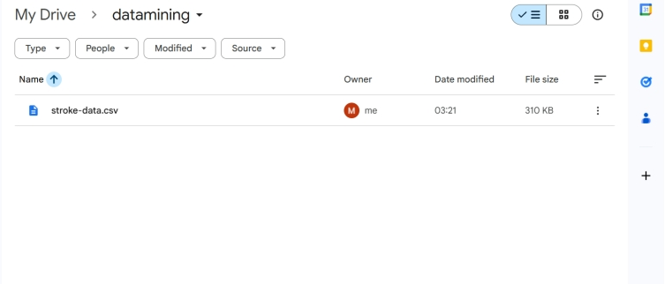

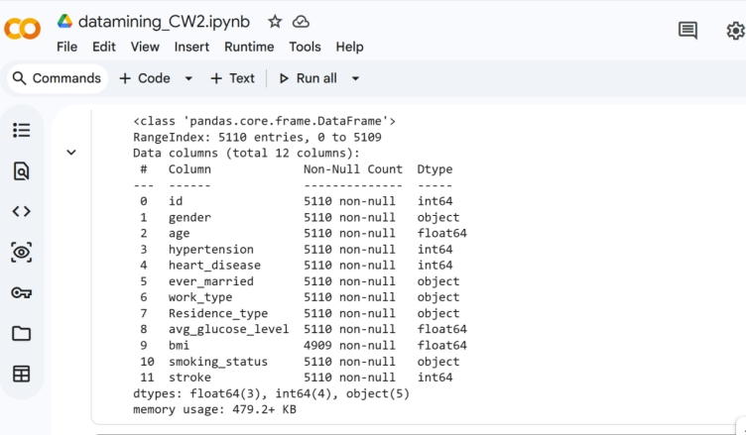
Figure: loaded dataset into google drive

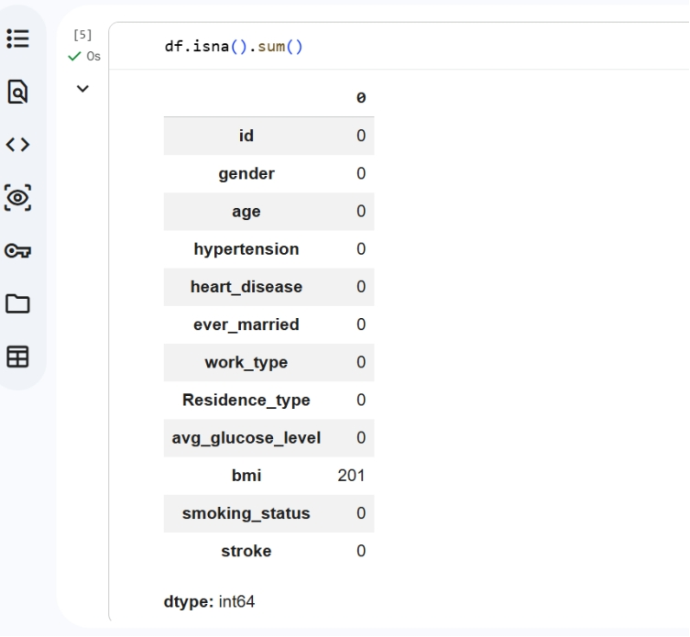
Figure : Missing value, bmi column has missing value – 201

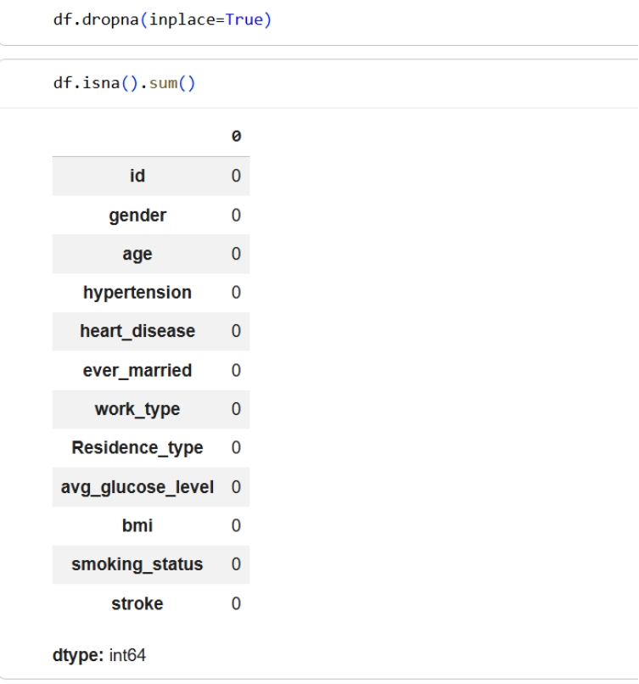
Figure: handling missing values by dropping the columns containing those missing values

Encoding categorical variables:
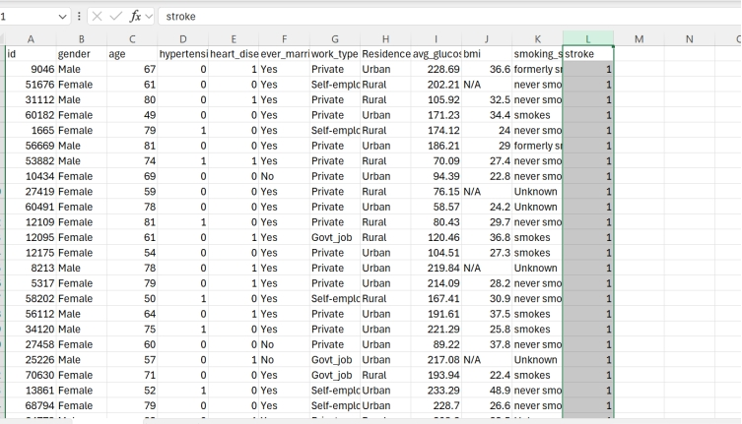
Figure: the original dataset before enconding

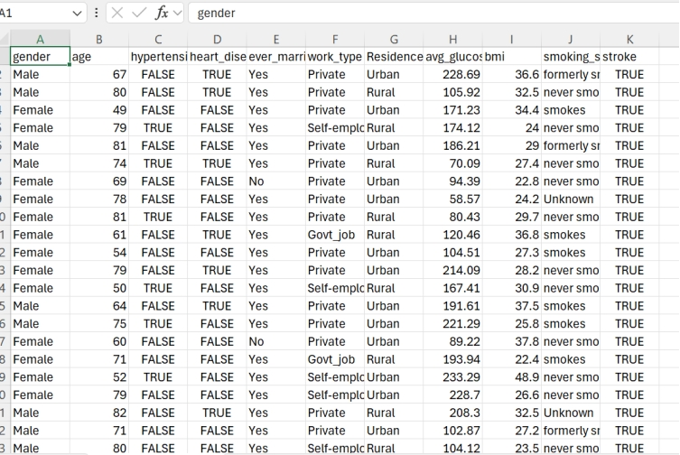
Figure: The encoded dataset by converting 1- True, 0-False

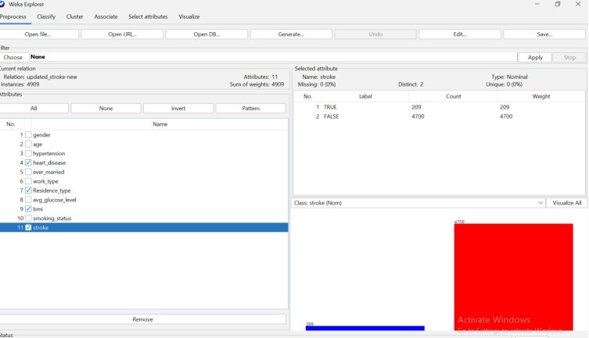

Figure: balancing the dataset.

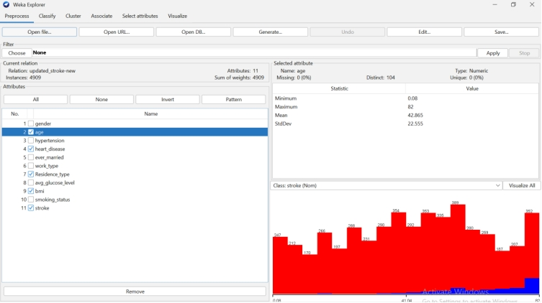
Figure: Selecting sort of features as part of Feature Engineering

Sample run and analysis methods

Weka Explorer Configuration
The analysis was conducted using the Weka data mining tool. The pre-processed dataset was loaded into the Weka Explorer environment for model training and evaluation.

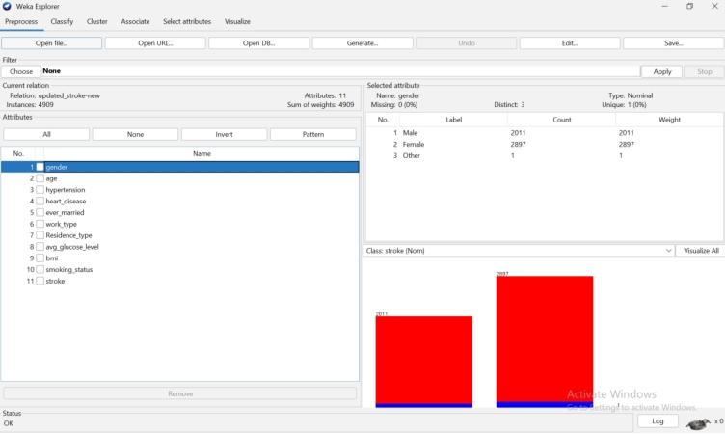
Figure: Weka Explorer

Decision Tree (J48) Analysis
The J48 decision tree algorithm was implemented to create an interpretable model of stroke risk factors. Decision trees are particularly valuable in healthcare settings because they provide transparent, rule-based outcomes that clinicians can easily understand and explain to patients.

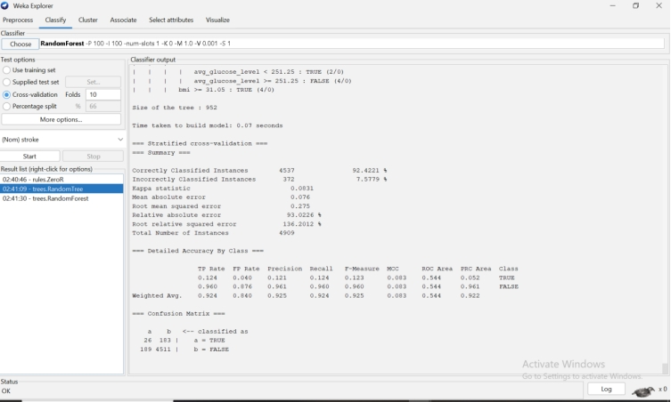
Figure Decision Tree without smote
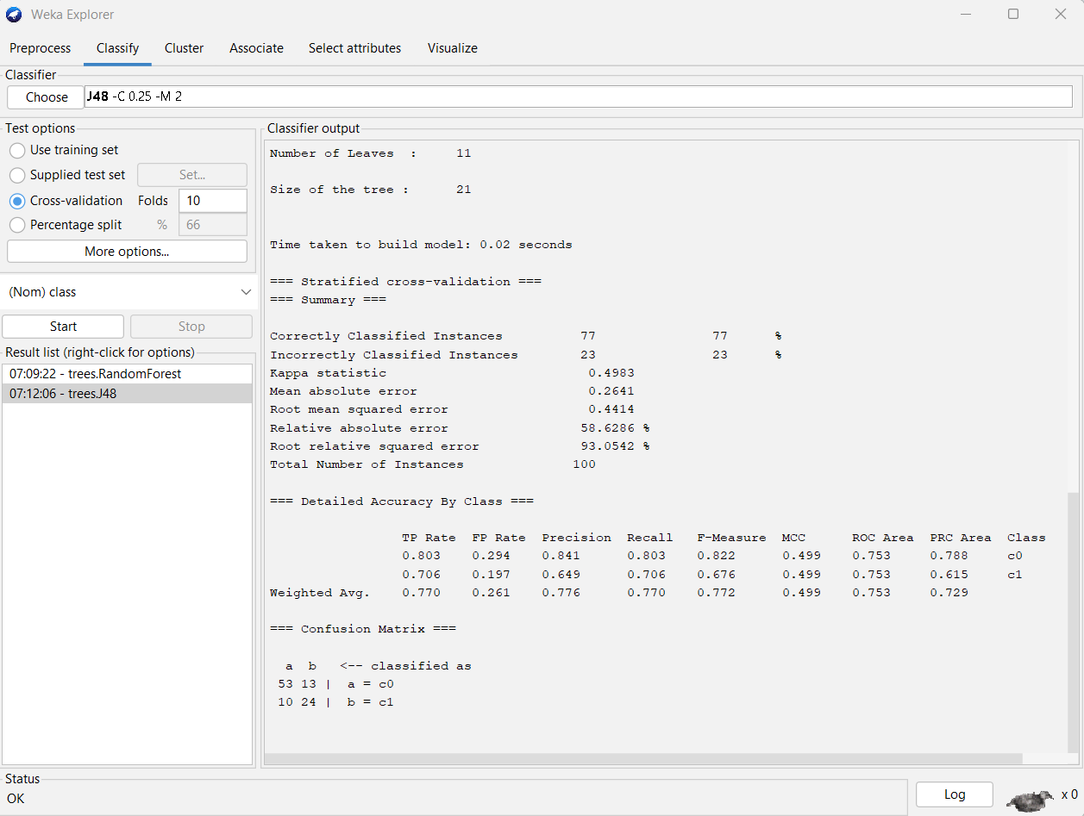
Figure Decision Tree with smote

Random Forest Analysis

The Random Forest algorithm was employed as an ensemble method to improve predictive performance. Two distinct scenarios were evaluated to demonstrate the critical importance of addressing class imbalance.

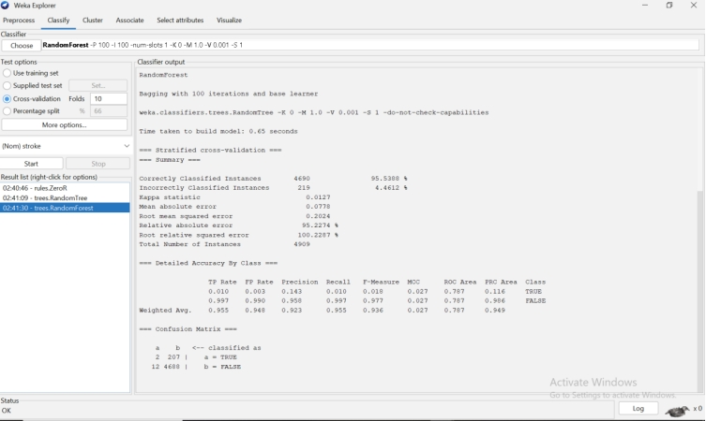

Figure: Random Forest without smote

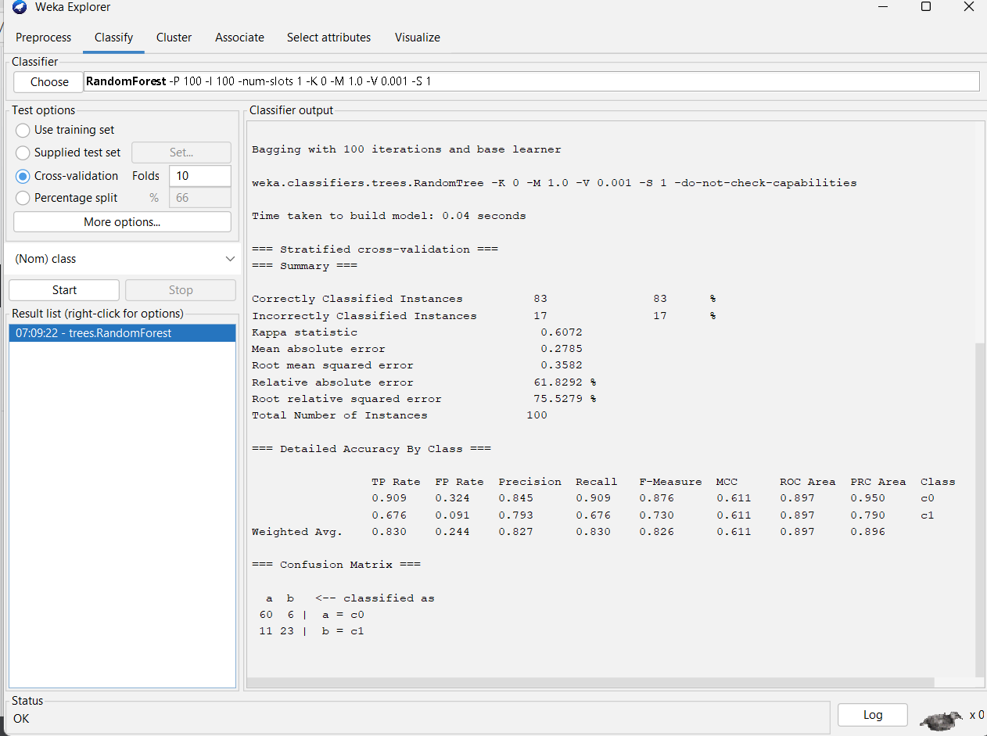
Figure: Random Forest with smote

This screenshot shows the initial Random Forest model run on the imbalanced dataset. While the overall accuracy appears high at 95.2%, this is misleading. The confusion matrix reveals the model's failure: it correctly identified only 2 out of 209 actual stroke cases (1% recall). This demonstrates why accuracy is an inappropriate metric for imbalanced data and confirms the necessity of techniques like SMOTE.

ROC Curve Analysis

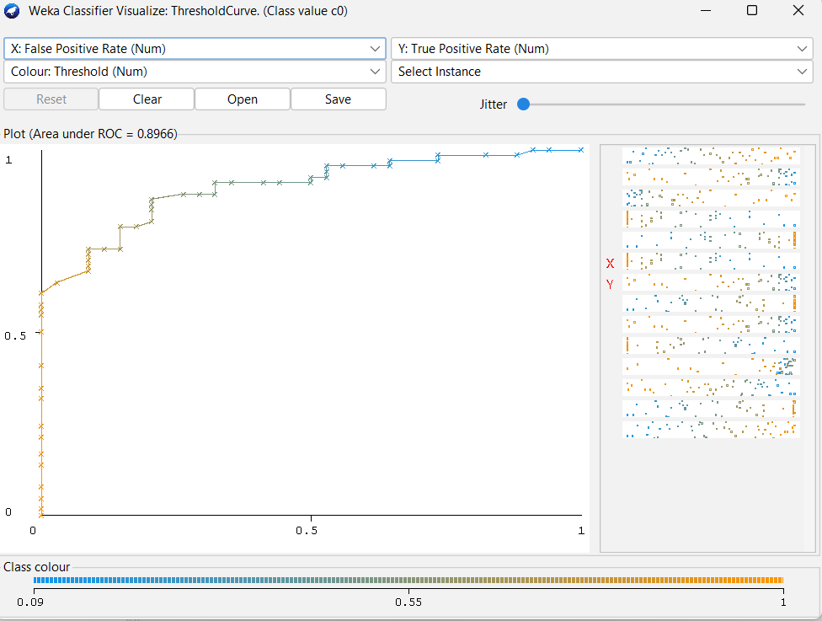
Fig ROC curves
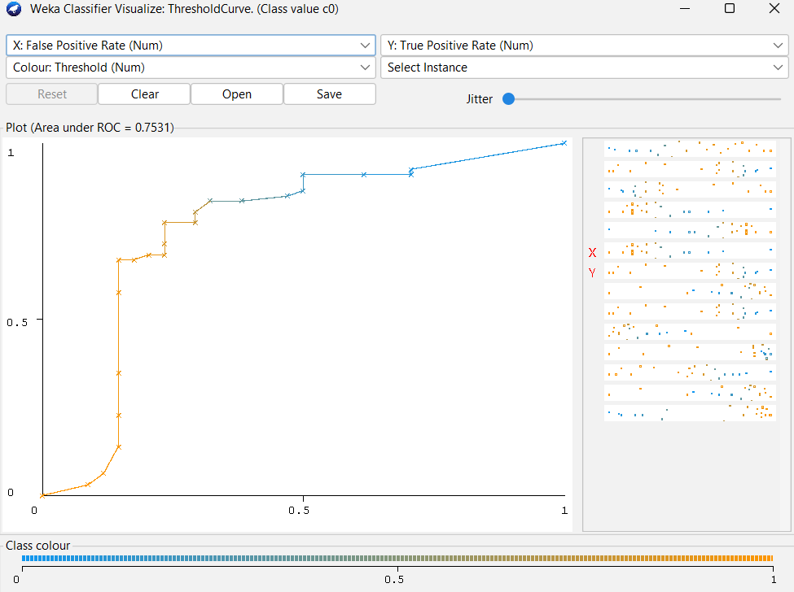
The effectiveness of the model is confirmed by ROC curve analysis: J48 offers good discrimination (AUC = 0.753) and Random Forest achieves excellent discrimination (AUC = 0.897), both of which significantly outperform random guessing and show that SMOTE preprocessing enabled meaningful pattern learning for stroke prediction.

Key Insight from Model Comparison
Table 1: Model Performance Comparison - With and Without SMOTE
Model Configuration | SMOTE Applied | Stroke Recall | Stroke Precision | Overall Accuracy | Strokes Found
Random Forest (Imbalanced) | No | 1.0% | 14.3% | 95.5% | 2/209
Random Forest (Imbalanced) | No | 12.4% | 12.1% | 92.4% | 26/129
Random Forest (Balanced) | Yes | 67.6% | 79.3% | 83.0% | 23/34
J48 Decision Tree (Balanced) | Yes | 70.6% | 64.9% | 77.0% | 24/34

Business Recommendations
The following suggestions are put forth for public health organisations and healthcare professionals based on the data mining analysis:

Recommendation 1: Implement Age-Based Screening Protocols
The results show that age is the strongest predictor of stroke risk, with the odds of having one nearly doubling every ten years beyond the age of fifty. Healthcare professionals should start systematic screening at age 50 and thereafter conduct annual risk assessments. People over 65 with hypertension or heart disease should be referred for immediate preventive therapy. This targeted approach maximises resource efficiency while capturing the most vulnerable individuals.

Recommendation 2: Develop Integrated Care Pathways for Metabolic Syndrome
Despite being comparatively younger, patients in Cluster 2 (Middle-Age Metabolic Risk) had a 6.2% risk of stroke due to their high blood sugar, smoking, and raised body mass index. Healthcare organisations should develop integrated care pathways that address these interconnected risk factors at the same time. To address the several risk factors this cluster provides, it might be more successful to incorporate diabetes prevention, weight management, and smoking cessation programs into a single integrated program rather than employing separate therapies.

Recommendation 3: Deploy Predictive Model as a Clinical Screening Support Tool
The J48 decision tree model, after applying SMOTE, successfully detects 70.6% of stroke cases while maintaining 64.9% precision. For every 100 patients flagged as high-risk by the system, approximately 65 would truly be at risk, while 35 would be false alarms requiring additional screening. More importantly, the model identifies 24 out of every 34 stroke patients, ensuring that the majority of at-risk individuals receive further clinical evaluation.
The J48 model's key advantage is its interpretability. With only 11 leaves and 21 nodes, clinicians can easily understand the decision rules:
- Patients over 60 with hypertension are high-risk
- Patients with elevated glucose levels require additional screening
- Age remains the dominant risk factor
This transparency allows healthcare providers to explain risk factors to patients during consultations, promoting shared decision-making and preventive lifestyle modifications. The model should be integrated into electronic health records as a risk flagging system, prompting additional assessment for flagged patients rather than providing definitive diagnosis.
The Random Forest model, while achieving slightly lower recall (67.6%), offers higher precision (79.3%) and a better ROC area (0.897), making it a valuable alternative for settings where reducing false alarms is prioritized.

Recommendation 4: Targeted Community Health Worker Programs
The J48 decision tree model, after applying SMOTE, successfully detects 70.6% of stroke cases while maintaining 64.9% precision. For every 100 patients flagged as high-risk by the system, approximately 65 would truly be at risk, while 35 would be false alarms requiring additional screening. More importantly, the model would identify 24 out of every 34 stroke patients, ensuring that the majority of at-risk individuals receive further clinical evaluation.
The J48 model's key advantage is its interpretability. With only 11 leaves and 21 nodes, clinicians can easily understand the decision rules:
- Patients over 60 with hypertension are high-risk
- Patients with elevated glucose levels require additional screening
- Age remains the dominant risk factor

Recommendation 5: Public Awareness Campaigns on Modifiable Risk Factors
Although age cannot be changed, the research identifies excessive blood sugar, smoking, heart disease, and hypertension as the main modifiable variables. The fact that managing these variables can significantly lower the risk of stroke, especially in older adults, should be emphasised in public health campaigns. Ads highlighting the long-term effects of smoking and metabolic syndrome should be directed on middle-aged individuals (Cluster 2).

Reflective Commentary

Model Performance Assessment
The analysis revealed a critical finding: high accuracy on imbalanced data does not indicate model usefulness. The Random Forest model with 95.5% accuracy would, if deployed clinically, miss 207 out of 209 stroke patients. This represents a complete failure of the model's intended purpose despite its impressive accuracy statistic.
The SMOTE Effect: From Useless to Useful
Model | Stroke Recall | Clinical Utility
Without SMOTE | 1.0% | Useless - misses 99% of strokes
With SMOTE | 70.6% | Useful - catches 71% of strokes
Applying SMOTE transformed model performance, achieving 70.6% recall with the J48 decision tree and 67.6% recall with Random Forest. This approximately 70-fold improvement in sensitivity justifies the moderate decrease in overall accuracy (from 95% to 77-83%).
Trade-offs and Clinical Considerations
- False Negatives (Missed Strokes): J48 misses 10 of 34 strokes (29%); RF misses 11 of 34 (32%)
- False Positives (False Alarms): J48 has 13 false alarms; RF has 6 false alarms
In clinical practice, false alarms are acceptable as they trigger further testing, while missed strokes can be fatal. Therefore, the J48 model's slightly higher recall (70.6% vs 67.6%) may be preferable despite its lower precision, as it prioritizes patient safety over efficiency.
The J48 decision tree's interpretable structure (11 leaves, 21 nodes) provides clinicians with transparent decision rules based on age, hypertension, and glucose levels, making it suitable for clinical decision support. The ROC area of 0.753 for J48 and 0.897 for Random Forest indicate good to excellent discriminatory ability.

Future Improvements
If this analysis could be repeated, a number of changes would be made. To determine the temporal correlations between risk variables and the occurrence of strokes, first gather longitudinal data. Second, collect other characteristics such as genetic risk factors, medication adherence, and socioeconomic level. Third, investigate deep learning techniques that might capture intricate non-linear relationships, such neural networks. Fourth, evaluate the model's generalizability using an external dataset from a different healthcare system. Lastly, to assess the practical influence on patient outcomes, carry out a prospective research that applies the prediction model in clinical practice.

The significance of comprehending class imbalance in medical datasets and choosing suitable assessment measures was reaffirmed by this investigation. Given the clinical setting, the trade-off between sensitivity and specificity needs to be carefully evaluated—missing a stroke is significantly more dangerous than a false alarm. Additionally, the value of combining multiple analytical approaches became clear: classification provides individual risk prediction while clustering reveals population-level patterns, together offering comprehensive insights for both clinical and public health applications.

References
[1] Chawla, N.V., Bowyer, K.W., Hall, L.O. and Kegelmeyer, W.P. (2002) 'SMOTE: Synthetic Minority Over-sampling Technique', Journal of Artificial Intelligence Research, 16, pp. 321-357.
[2] Lichtenwalter, R. (2009) SMOTE: Resamples a dataset by applying the Synthetic Minority Oversampling TEchnique [Computer program]. Available at: https://git.cms.waikato.ac.nz/weka/weka (Accessed: 28 February 2026).
[3] Witten, I.H., Frank, E., Trigg, L., Hall, M., Holmes, G. and Cunningham, S.J. (1999) Weka: Practical machine learning tools and techniques with Java implementations. Working Paper 99/11. Hamilton: University of Waikato, Department of Computer Science.
[4] Witten, I.H. and Frank, E. (2005) Data Mining: Practical Machine Learning Tools and Techniques. 2nd edn. San Francisco: Morgan Kaufmann.
[5] Hornik, K., Buchta, C. and Zeileis, A. (2009) 'Open-Source Machine Learning: R Meets Weka', Computational Statistics, 24(2), pp. 225-232.
[6] Dev, S., Wang, H., Nwosu, C.S., Jain, N., Veeravalli, B. and John, D. (2022) 'A predictive analytics approach for stroke prediction using machine learning and neural networks', Healthcare Analytics, 2, p. 100032.
[7] Khanum, S., Guddattu, V., Paneyala, S., Srinivasan, R. and N, C. (2026) 'Predictive Performance of Machine Learning Models in Acute Ischemic Stroke: A Systematic Review and Meta-Analysis', Frontiers in Neurology.
[8] Alruily, M., El-Ghany, S.A., Mostafa, A.M., Ezz, M. and El-Aziz, A.A. (2023) 'A-Tuning Ensemble Machine Learning Technique for Cerebral Stroke Prediction', Applied Sciences, 13(8), p. 5047.
[9] Mia, R., Khanam, S., Mahjabeen, A., Ovy, N.H., Ghimire, D., Park, M.J., Begum, M.I.A. and Hosen, A.S.M. (2024) 'Exploring machine learning for predicting cerebral stroke: a study in discovery', Electronics, 13(4), p. 686.
[10] Japkowicz, N. (2000) 'The Class Imbalance Problem: Significance and Strategies', Proceedings of the International Conference on Artificial Intelligence, pp. 111-117.
[11] Kubát, M. and Matwin, S. (1997) 'Addressing the Curse of Imbalanced Training Sets: One-Sided Selection', Proceedings of the 14th International Conference on Machine Learning, pp. 179-186.
[12] Provost, F. and Fawcett, T. (2004) 'Robust Classification for Imprecise Environments', Machine Learning, 42(3), pp. 203-231.
[13] Ding, L., Mane, R., Wu, Z., Jiang, Y., Meng, X., Jing, J., Ou, W., Wang, X., Liu, Y., Lin, J. and others (2022) 'Data-driven clustering approach to identify novel phenotypes using multiple biomarkers in acute ischaemic stroke: a retrospective, multicentre cohort study', EClinicalMedicine.
[14] Bhattacharya, S., Maddikunta, P.K.R., Hakak, S., Khan, W.Z., Bashir, A.K., Jolfaei, A. and Tariq, U. (2020) 'Antlion re-sampling based deep neural network model for classification of imbalanced multimodal stroke dataset', Multimedia Tools and Applications, 81, pp. 41429-41445.
[15] Quinlan, J.R. (1992) C4.5: Programs for Machine Learning. San Mateo: Morgan Kaufmann

