University of Wales Trinity Saint David
School of Engineering

Manufacturing Process and Material Selection

Rory Brown
1809110
11/01/2020

Intro
The component that has been selected for this assignment is a tool used for side trimming strip steel. This tool known as a circular side trimming knife, this allows the strip to be trimmed to customer width requirements during the cold rolling process. These trimming knives are used throughout the cold rolling process. During schedules where 80% of the product processed is side trimmed the side trimming knives are replaced often due to various reasons such as chips in the blades, serration on the strip and bad edge quality all undesirable defects for the customer. The current turn around time for new blades is around 2 weeks therefore finding an alternative production method would prove beneficial as the side trimming knives are often under stocked causing production problems as it is difficult to predict when they will become defective.
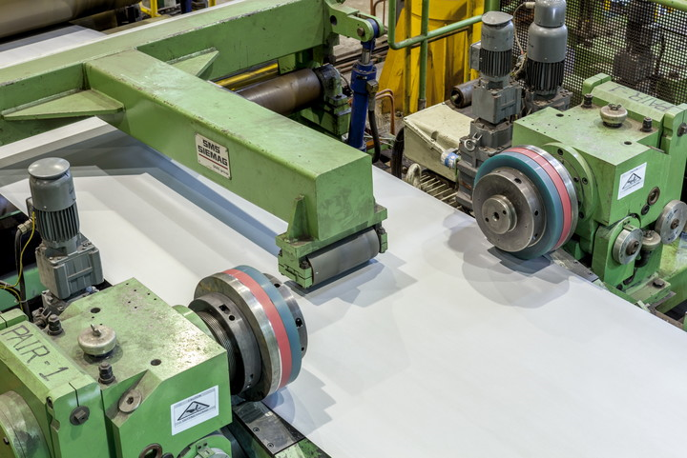
(figure 1, side trimming unit) (SMS-group, 2020)
Functional requirements
The functional requirements of side trimming knives are to cut the strip steel to customer width requirements, such as the deign of their processing line may only be suitable for certain width material. The side trimming knives must also provide a smooth finish free from serration. Serrated edges cause problems for later processes involving coatings with squeeze rolls are they pick up the serrated edges. The side trimming knives must also be incredibly durable as high strength steels are processed at speeds up to 100mpm while side trimming. Compressive strength is also an important factor for the side trimming blades. As the blades must also be able to withstand opposite forces as the machinery will push the knives towards the steel strip and the steel strip will apply force in the opposite direction. (corrosionpeadia, 2020) The side trimming knives must also be able to resist the high forces of shock applied by the strip steel. This is key as a material with high impact resistance will likely to be durable when tested and have high resistance to fatigue. (safeopeadia, 2020) The last key functional requirement of the side trimming knives is to be have high wear resistance more specifically high abrasive wear resistance as the strip steel and the knives will act as two surfaces in two body abrasive wear with the knives being the harder surface taking material away from the strip steel. (gordonengland, 2018)
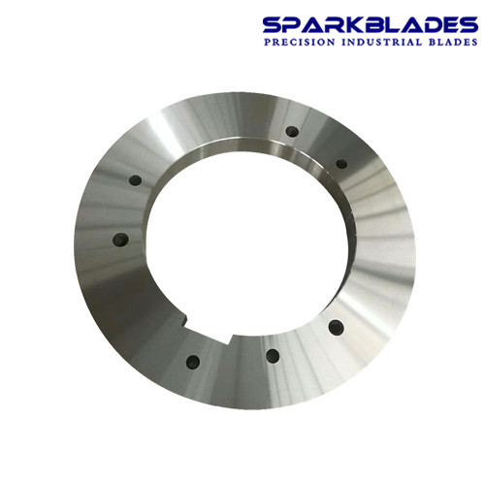
(figure 2, side trimming blade, (SparkBlades, 2019)
Material in use
The side trimmer knives are made from tungsten carbide. (Sparkblades, 2019) this material is a metal like material that break down at temperatures of 2,600 Celsius. It is primarily made up of two separate elements tungsten which is a strong, hard and high strength metal and carbon black which is highly resistant to wear and abrasion. In order to be shaped to the required shape it is heated to 1400-1600 Celsius where a powered metal is added such as cobalt. (Tikkanen, 2020)
Manufacturing process
There are 8 steps involved in the production of the side trimming knives each step adding value or a manufacturing feature to the final product. (Sparkblades, 2019)
- Raw material/Sawing
The first step is to acquire the raw material or the tungsten carbide alloy, it is cut to the desired size for the side trimming knife using a bandsaw.
- Forging
To forge the side trimming knives a seamless rolled ring forging process is used this is carried out by heating the alloy to the required temperature for plastic deformation to occur in this case 2600+ Celsius. It is then positioned between two dies and compressed until the required width is achieved. A mandrel is then inserted in the centre of the alloy to create a space where the arbour and idler roll will later be positioned. The component is then positioned on a driver roll with an idler roll positioned through the centre and axial rolls either side to control ring height. Pressure is applied to the inside and outside diameter of the component until the requirements are met. (Berman, 2016)
- Rough processing
The next stage is rough processing this is carried out to remove any imperfections created during the forging process. This is carried out in a milling machine.
- Heat Treatment
Heat treatment is carried to harden the side trimming knives and increase their strength. This is achieved by heating the component to temperatures between 480-620 Celsius in an air tight vicinity through induction hardening in a hardening furnace machine. (Johnsinit, 2020) The component will then be quenched and rapidly cooled, it is then aged by repeating the process of heating and rapidly cooling. Through hardening the component will undertake a loss of ductility and toughness as a result. (Wojes, 2019)
- Surface precise grinding/circular grinding.
This is carried out by grinding the surface to de burr and smooth the component. (thomasnet, 2020) this is vital as the blades need to be a certain size to ensure a secure fit on the side trimming mandrel.
- Testing
The last phase of production is the testing phase. This ensures the component has the correct dimensions and is suitable for use. This is carried out using a micrometre and measuring multiple points of the side trimming knives. (Sparkblades, 2019)
Addictive manufacturing process selected
The additive manufacturing processes that were considered for this were selective laser melting and binder jetting AD systems. Both offer precise reliable solutions to creating the side trimming knives, but binder jetting is a more capable process as it has multiple heads for printing and can produce parts quicker than binder jetting systems. (Leong, 2019)
Binder jetting
The process begins using a 3-D CAD model designed on a computer program which is then converted to an STL file and imported to the 3-D binder jetting software. (https://www.youtube.com/channel/UCZZMsXgV5_lEQ0FQlPZIAvQ, 2016) Binder jetting is carried using two materials, a material and a binder in the form of a liquid and powder. Multiple print heads will then move horizontally, and layers of material added along with layers of the binder. The component is eventually lowered onto a platform gradually as each layer is applied. The power is spread using a roller, as the component is encased in the surrounding power bed. The component is then removed from the machine and the excess power removed. (Loughborough University, 2020) For accurate finishes the droplet and power size need to be considered as well as the layer heights which will slow the process but provide a better finish. (3dsourced, 2020)
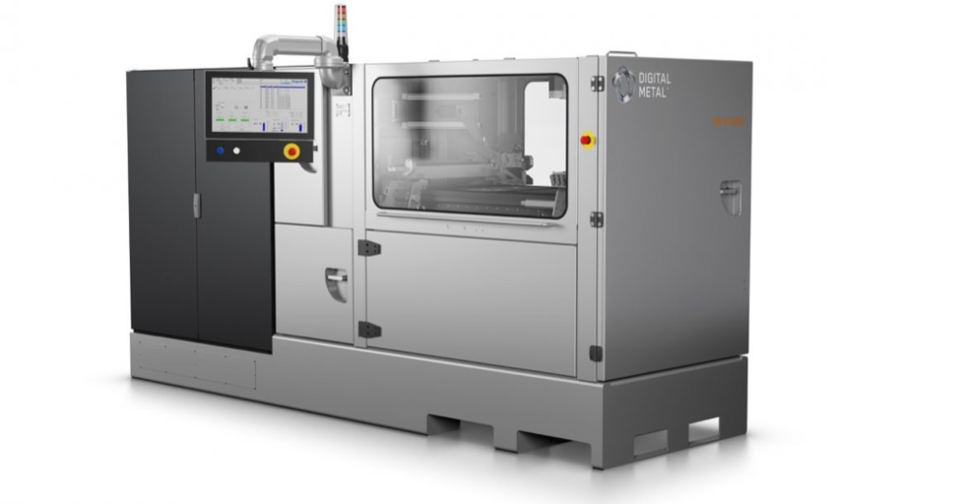
(Figure 3, binder jetting machine. (Leong, 2019)

New build material
As the current blades are made from tungsten carbide either this material would need to be processed in a power form or another material selected to aid the most suitable process. There is evidence of tungsten carbide being used in the selective laser melting process. (Powder Perfect, 2020) but the process is not as efficient as binder jetting. The new material that could be used is silicon carbide. There is widespread use of silicon carbide being used for binder jetting (ExOne, 2020). The material itself offers advantages over tungsten carbide. It is used for car breaks, grinding wheels, bullet proof vests and cutting tools designed to cut steel. ( Augustyn et al, 2008). It is an extremely hard material and can withstand higher amounts of friction than tungsten carbide when comparing hardness. (tungsten carbide 9Mohs, Silicon carbide 9.5 Mohs.) This is vital down to the nature of the use of the blade use mainly through abrasion therefore hardness plays a key role in withstanding the abrasion of the strip steel on the side trimming knives potentially lasting longer before a change is required. Silicon carbide is also a considerably lighter per cubic centimetre than tungsten carbide (3.21g cm-3 compared to 19.25g cm-3). This would allow blade changes to be carried out without the use of support from chains and hooks and lower the risk of injury whilst carrying out blade changes. Although tungsten carbide has higher crushing strength when compared to silicon carbide (up to 3900MPa compared to 4780Mpa) (MakeItFrom.com, 2018).
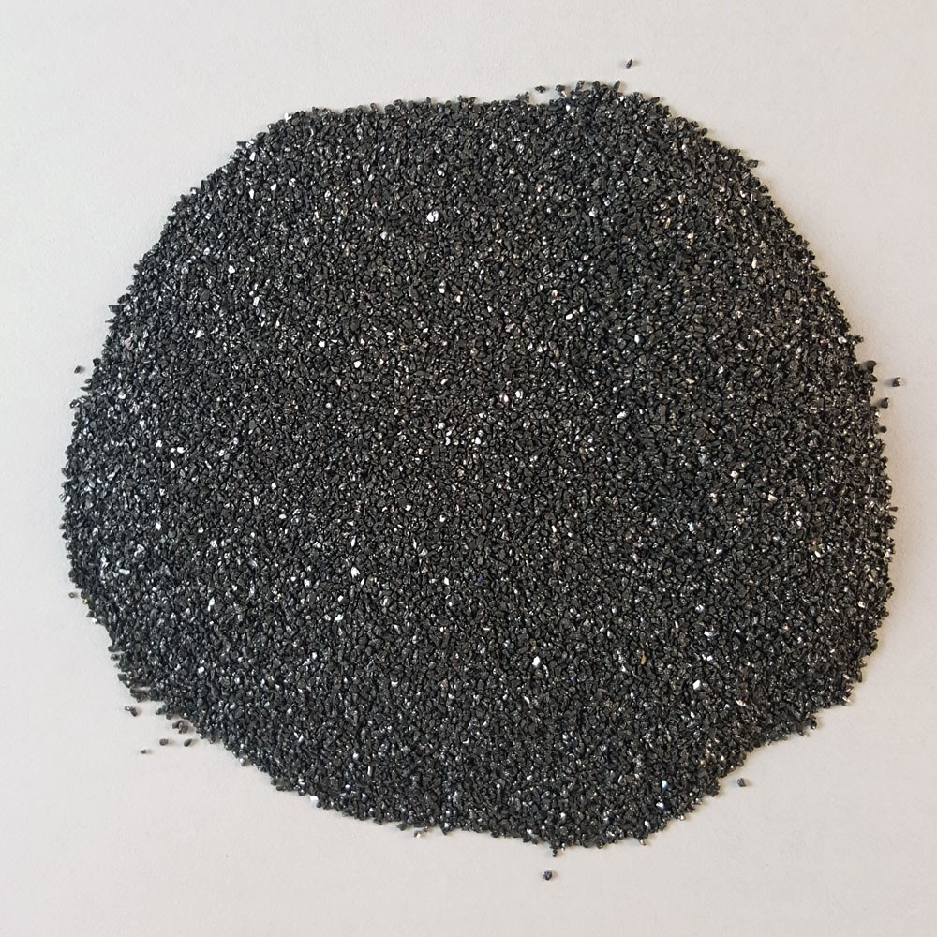
(figure 4, silicon carbide. (www.kramerindustriesonline.com, 2020)
Advantages of new additive production method
The primary benefit of the new additive process is removing the material cutting steps, forging and roughness treatment. With the new material silicon carbide purchased in its power form would remove the need to cut material and purchase bars of silicon carbide or transport tungsten carbide. The forging process seamless ring rolling could also be removed completely from the production method. Eliminating the cost of tooling. Given the level of finish achieved from the binder jetting process it would be possible to remove the roughness treatment phase, binder jetting can achieve a finish of around 50 microns, but this does make the process slower. (3dsourced, 2020) The process would still involve heat treatment to solidify the binder and harden the component. Other benefits are lowered inventory as parts can be made within a 24-hour turnaround time when compared to the current 2 weeks turnaround time for the side trimming knives. The need for storing parts is removed and production can be on pull production system and reduce the bullwhip effect and reduce levels of a stock that cannot be sold. (Jackson, 2018) Parts can be produced in 70% less of the time, with 95% less waste by using an additive manufacturing technique, this is down to the product being made in the correct specifications that can be controlled through additive manufacturing methods that cannot be as precise during the forging phases of ring roll production. This also results in lower labour costs as less production phases are needed. (Jackson, 2018). The removal of tools and less production phases ensures less components are damaged during the tooling phases. The new manufacturing process would consist of acquiring the power and binder, binder jetting, heat treatment to bind the layers, heat hardness treating surface and circular grinding followed by testing to ensure accuracy. The distribution of the product is also eased and improved as the product can be produced closer to the locations where the components are needed. Inventory management is minimalised as a digital file can be sent to multiple production locations. By having the product produced closer to the customer ensures faster delivery and just in time manufacturing resulting in lowering the inventory costs. (Jabil, 2020). By using an additive manufacturing system parts can be personalized with ease, allowing the centre to be adjusted for different sized mandrels, ensuring a solid fit and improving cutting. The size and width can be adjusted to ensure they are suitable for the design of each processing line using a computer programme sent directly to the binder jet software eliminated the need to adjust the forging methods and positions of the rolls used.

References
Augustyn et al. (2008, August 28). Silicon carbide. Retrieved January 19, 2020, from Encyclopædia Britannica: https://www.britannica.com/science/silicon-carbide
3dsourced. (2020, January 6). Binder Jetting 3D Printing: Everything You Need To Know. Retrieved January 20, 2020, from https://3dsourced.com/: https://3dsourced.com/guides/binder-jetting/
Berman, S. (2016, June 1). What is the Seamless Rolled Ring Forging Process? Retrieved January 13, 2020, from https://www.ferralloy.com/: https://www.ferralloy.com/seamless-rolled-ring-forging-process/
corrosionpeadia. (2020). Compressive Strength. Retrieved January 2020, 2020, from https://www.corrosionpedia.com/: https://www.corrosionpedia.com/definition/1620/compressive-strength-material-science
ExOne. (2020). Ceramic 3D Printing Materials & Binders. Retrieved January 19, 2020, from https://www.exone.com/en-US: https://www.exone.com/en-US/3d-printing-materials-and-binders/ceramic
gordonengland. (2018). Wear Resistance. Retrieved January 13, 2020, from https://www.gordonengland.co.uk/copyright.html: https://www.gordonengland.co.uk/copyright.html
https://www.youtube.com/channel/UCZZMsXgV5_lEQ0FQlPZIAvQ. (2016, July 20). https://www.youtube.com/watch?v=RNNxEoXuvuw. Retrieved January 19, 2020, from https://www.bing.com/videos/search?q=binder+jetting+full+process&&view=detail&mid=5009208F6331C609806C5009208F6331C609806C&&FORM=VRDGAR&ru=%2Fvideos%2Fsearch%3Fq%3Dbinder%2Bjetting%2Bfull%2Bprocess%26FORM%3DHDRSC3
Jabil. (2020). The Benefits of Additive Manufacturing. Retrieved January 20, 2020, from https://www.jabil.com/: https://www.jabil.com/solutions/additive-manufacturing/benefits-of-additive-manufacturing.html
Jackson, B. (2018, January 23). Mass production – is 3D printing up to the supply-chain challenge? Retrieved January 20, 2020, from https://3dprintingindustry.com/: https://3dprintingindustry.com/news/mass-production-3d-printing-supply-chain-challenge-127849/
Johnsinit. (2020). Heat Treatment of Steels & Metals. Retrieved January 2020, from http://brighthubengineering.com/: https://www.brighthubengineering.com/manufacturing-technology/30476-what-is-heat-treatment/
Leong, D. (2019). Types of 3D Printing in Metal. Retrieved January 19, 2020, from https://markforged.com/: https://markforged.com/learn/types-of-3d-printing-metal/
Loughborough University. (2020). Additive Manufacturing Research Group. Retrieved January 2020, 2020, from https://www.lboro.ac.uk/?external: https://www.lboro.ac.uk/research/amrg/about/the7categoriesofadditivemanufacturing/binderjetting/
MakeItFrom.com. (2018, August 08). Silicon Carbide vs. Tungsten Carbide. Retrieved January 20, 2020, from https://www.makeitfrom.com/: https://www.makeitfrom.com/compare/Silicon-Carbide-SiC/Tungsten-Carbide-WC/
Powder Perfect. (2020). Tungsten, Tungsten Carbide and Molybdenum Powders for Additive Manufacturin. Retrieved January 19, 2020, from https://www.globaltungsten.com/en.html: https://www-globaltungsten-com.azureedge.net/fileadmin/user_upload/home/Products/AM_Brochure_-_Draft__low_res_.pdf
safeopeadia. (2020). Impact Resistance. Retrieved January 13, 2020, from https://www.safeopedia.com/: https://www.safeopedia.com/definition/78/impact-resistance
SMS-group. (2020). https://www.google.co.uk/url?sa=i&rct=j&q=&esrc=s&source=images&cd=&ved=2ahUKEwi8sYPwpZLnAhWOsRQKHQCJDvQQjhx6BAgBEAI&url=https%3A%2F%2Fsteelguru.com%2Fsteel%2Fsms-group-to-supply-side-trimming-unit-to-severstal%2F454287&psig=AOvVaw2rt8UMHTN9YOEFnB_kV6GN&u. Retrieved January 20, 2020, from https://www.google.co.uk/search?q=side+trimming+steel&source=lnms&tbm=isch&sa=X&ved=2ahUKEwj8-s6DpZLnAhXTUBUIHS69BWkQ_AUoAnoECAsQBA&cshid=1579527329574710&biw=1366&bih=655#imgrc=eUhQ7rK9rkE0WM:
Sparkblades. (2019). 66mm circular carbide slitting knife blade. Retrieved January 13, 2020, from sparkblades.com: www.sparkblades.com/product/66m-circular-carbide-slitting-knife-blade/
SparkBlades. (2019). rotary side trimmer knives in steel plate edge trimming line. Retrieved January 20, 2020, from https://www.google.co.uk/search?q=side+trimming+steel&source=lnms&tbm=isch&sa=X&ved=2ahUKEwj8-s6DpZLnAhXTUBUIHS69BWkQ_AUoAnoECAsQBA&cshid=1579527329574710&biw=1366&bih=655#imgrc=j4spX1Toqp9ZoM:
Sparkblades. (2019). Workshop. Retrieved January 13, 2020, from http://www.sparkblades.com/: http://www.sparkblades.com/about-us/workshop/
thomasnet. (2020, January 16). Types of Metal Finishing. Retrieved January 16, 2020, from https://www.thomasnet.com/: https://www.thomasnet.com/articles/custom-manufacturing-fabricating/types-metal-finishing/
Tikkanen, A. (2020). Tungsten Carbide. Retrieved January 13, 2020, from https://www.britannica.com/: https://www.britannica.com/science/silicon-carbide
Wojes, R. (2019, January 25). Learn About Precipitation Hardening. Retrieved January 16, 2020, from https://www.thebalance.com/: https://www.thebalance.com/precipitation-hardening-2340019
www.kramerindustriesonline.com. (2020). https://www.kramerindustriesonline.com/product/silicon-carbide-grit/. Retrieved January 20, 2020, from https://www.bing.com/images/search?view=detailV2&id=373B4425B8B242EC00E77F17447C6B50E6C10977&thid=OIP.tOZdMmY2A3R7_eNDTHQHVQHaHa&mediaurl=https%3A%2F%2Fwww.kramerindustriesonline.com%2Fwp-content%2Fuploads%2Fproduct_silicon_carbide.jpg&exph=1000&expw=1000

Bibliography
ENGINEERING & SERVICES: HXT® Knives. (2020). Retrieved January 2020, 2020, from https://askoinc.com/engineering-services/knives-for-processing-ahss-hxt-technology/
Types of 3D Printing in Metal: https://markforged.com/ (2019). Retrieved January 19 2020, from https://markforged.com/learn/types-of-3d-printing-metal/
What is metal additive manufacturing?: Renishaw.com (2020). Retrieved January 19 2020, from https://www.renishaw.com/en/renishaw-enhancing-efficiency-in-manufacturing-and-healthcare--1030

