ACHA6013

Jack Bond
Design Philosophy
Design - My Realm of Philosophy

‘Why do I design the way I do?’



How to…
“Solve problems in an unproblematic way.” ~ Bjarke Ingles
Where does design come from?
Is design inherited?
Or is it something we breathe, as if an oxygen particle?
Let’s take a moment to look back at where design really started to fascinate me in particular, and how it has led me to this exact moment.
Following this I will discuss and show an understanding of how my philosophical design process operates as a whole, and how this may unfold in the future.
This is the beginning
My thesis begins when I was welcomed into the world’s most populous city in 2002, Tokyo. Japan’s capital city is considered to be an incredibly emerging civilization, with the second largest urban economy worldwide, and a diverse history of art and design culture. To be born in another country is a wonderful opportunity not given to many – and I am constantly using my good fortune to keep all things Japanese at the forefront of my thoughts. Respect for other people and politeness are embedded in Japanese society – and are two values I constantly aim to achieve myself. From a design point of view, I consider Japan synonymous with clean lines, cutting edge technology, and high quality – and again, I use this heritage to inspire my own work where possible.
This opening chapter in my life – albeit at a very young age – allowed me to get an inbuilt sense and curiosity of this extraordinary society, one that was far different to our home country. The experience kick-started my ‘global light switch’ and allowed me to appreciate and understand a new culture more effectively.
Our life in Japan was followed in quick succession with the opportunities to live in both Greece and Denmark. One is known and respected as one of the world’s greatest and most influential ancient civilisations, and the other has emerged as one of the leading cultures in recent decades to be at the forefront of modern, sleek design, and the utmost appreciation for quality of life.
These foreign opportunities have allowed me to recognise the impact we have on earth and has vastly widened my span of understanding how we populate the world in a patchwork of multiple cultures, which all contribute to the colours, tastes and senses of the global community.
How does this relate to design?
Whether it’s living in Japan, Greece or Denmark – or being given the opportunity to visit some wonderful countries in the world such as Mexico, Dubai, Germany, America and Croatia – I have increased my understanding of new environments and cultures, and I have realised the intense need to diversify designs to meet local criteria and tastes. Whilst I appreciate that innovation and change is of utmost importance in design work, my background has also allowed me to be ever conscious of cultural differences and the need for design differentiation depending on the audience. It is also the ability to know where to look for these cultural differences. Whether it be in local cuisine, religious customs, social influences, or economic conditions – I believe that designers need to take all the various factors into account.
Growing up and being educated in four different cities and having the inevitable local customs and habits influencing my lifestyle, there has been one constant that has stayed with me throughout – namely, cars and transport. My first recollection of being inspired was our visit to the Gumball 3000 rally line-up in Copenhagen in 2014. I remember being mesmerised by the various cars arriving in their colourful and stylish liveries – combined with the noise of their engines and the showmanship of their drivers. This ignited a desire to find out more and led me to more cars shows and supercar spotting events – even taking any opportunity to wander the streets of West London in order to find as many special cars as possible, many of which had been imported from the Middle East for the summer season.
Where does this passion for art crossover?
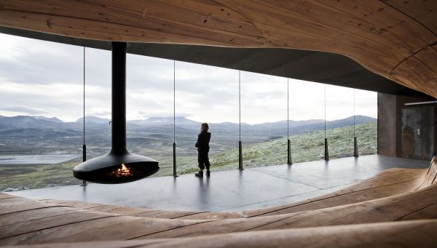
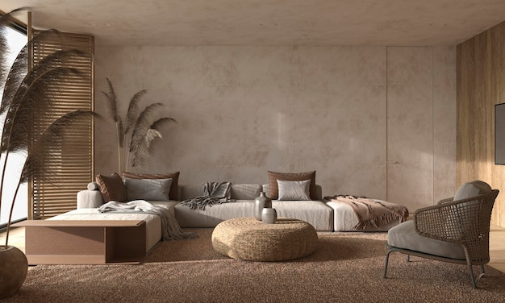
My school education has followed me through this life journey – and I have taken any opportunity given to get into an art studio or a design lab. In fact, it was during secondary school in the UK that I was able to select Art and Design Technology as subjects to learn and be examined in. It was then that I realised that careers can be forged in the fields of creativity. It was probably interior design that initially captured my fascination, and it was most likely my time living in Scandinavia that had influenced my ideas. Whether it is the mass-appeal of IKEA or an appreciation for Scandinavian design methods, I was quickly led into an appreciation for all things that were crafted in very modern yet effortless manners. To quote Leonardo Da Vinci – ‘Simplicity is the ultimate sophistication’ – and I feel this is a very appropriate way to describe Scandinavian architecture and interiors, and how this form of design will be playing a large role in my own creative philosophy.

With growth comes change, and realising the world has a large span of creativity, I was motivated to challenge my own design theories. One key impact I have recognised is how design is very subjective and personal, allowing you to venture into innovative ideas and judgements creating a large picture due to having this eye for design. An example of this would be learning about the avant-garde art movement – Cubism - and how this style of design has influenced the architecture, music and literature movements within the 20th century. Discovering this art style allowed me to appreciate how abstract design can provoke a wide spectrum of ideas and interpretations. This lesson has taught me how design lets visions be heard and seen from all distinct aspects, which help to grasp the bigger picture. In my opinion, this is something that has been very relevant to my understanding of art and to understand that some designs can either please or offend viewers.
How does this tie in with Automotive Design?
Once I realised that I could combine my love of art and design with my passion for all things car-related, the rest was history! If I am able in some way to influence car designs of the future and to inspire the next generation, just in the same way as I have been inspired by the current generation of car designers, then I would have fulfilled a life-dream.
This dream of mine became much more of a reality once I knew Automotive Design was a pathway I could select for my university education. It led me to have hope that my ideas and visions could also play their role in the future of this industry.
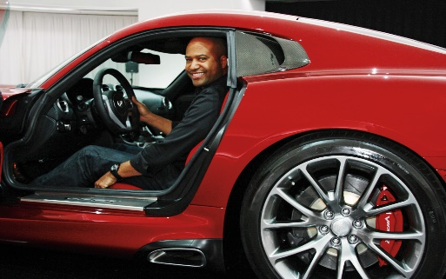
Everyone is inspired at some point; everyone can be motivated by someone; and I was no different in that respect. Whilst not with us today, I have grown up in a family who have drawn references between my love of art and design with those of my maternal grandfather. My grandfather attended art school, and went on to become a recognised graphic designer in the London commercial market – but it was his ability to pick up a pencil and a piece of paper, and make images and characters come alive for the delight of his children and grandchildren that I personally remember most. In more recent years, I have turned my attention to those artists and designers who are celebrated within the car industry. One of the earliest motivational moments occurred when I watched the ‘Art of Design’ documentary which covered the life of Ralph Gilles. I was struck by his passion from an early age to draw, to design, to be visionary – and his talents soon led him to become chief designer for Chrysler – and he subsequently went on to hold similar positions at Fiat and the Alfa Romeo group, FCA. This was my first insight into the mechanics of the car design industry and the process in which designers of various talents can be spotted.
In addition, seeing how monumental Gilles’ impact had been within the Dodge and Chrysler brands has really inspired me to follow in similar steps. The success of the Dodge Viper, and how this specific vehicle has defined an era is what pushes me to have a similar impact elsewhere. The feeling of seeing your design being loved and enjoyed by its audience is what motivates me to fulfil this passion of mine.
Of particular note to me was when Gilles mentions: ‘‘taste-making takes time. So if you get it wrong, you really get it wrong’’. This message conveys how as designers the goal is to strongly focus on the sole purpose of ensuring their delivery will be very successful and universally liked. If you get it wrong, then the damage to a brand can be quite substantial.
Who else has guided me along this path?
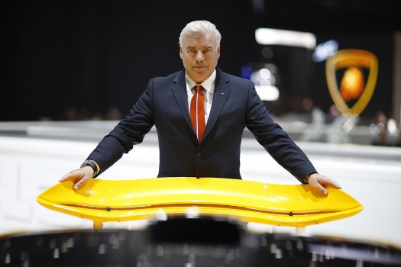
Another very successful automotive designer that has shaped my design philosophy is Frank Stephenson. ‘One of the world’s most renowned and influential designers of today’, not only has he designed a handful of my favourite cars but has allowed new interpretations within this design spectrum.
His strong work ethic and his innovative design within some of industry’s most iconic brands, and how this has led all his designs to become incredibly successful, and globally recognisable, is what motivates me the most. For instance, I find it incredible how he single-handedly saved the Mini brand with the re-design of the Mini Cooper, as well as brought the Fiat 500 model back into trend. This success has not only inspired me to want to be as successful in the future within the design industry but has focused my attention onto never disregarding an old brand for being out-dated, but knowing that as a designer we have the ability to renovate something back into a future-proof version of its former self. A successful car brand and model becomes part of our society, culture and history, and we as designers have an obligation to ensure such loved items are never left to demise.
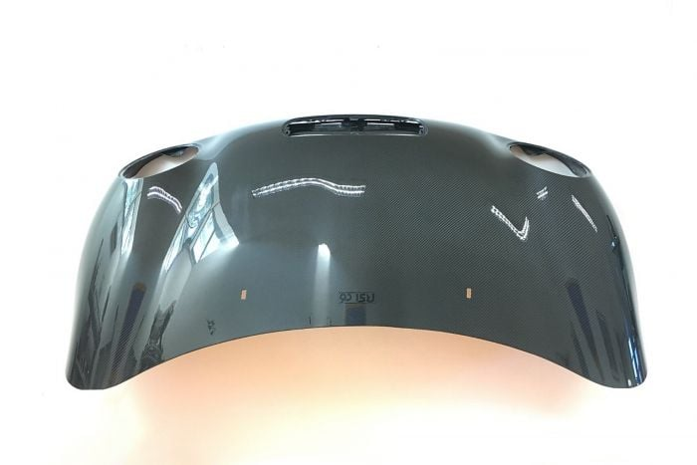
One of Frank Stephenson’s main characteristics, in my opinion, is how he conveys design inspiration through nature and natural objects. Essentially, bringing nature into design. This has shown me the importance of being informed of the natural environment around us, and letting it influence my creative ideas. Whether this can be found in modern architecture, landscapes or wildlife, I am learning to appreciate how we can align the two aspects of nature and design to help bring about positive change. I have used various animal shapes and forms in my initial sketches to take inspiration from their speed forms – and it was Frank who first gave me this idea. In fact, it was his use of the female hourglass figure which he integrated into the curvaceous bonnet surfaces of his new Mini Cooper design concept which first struck me as pure genius. Why create new shapes as a designer when there are perfectly good ones to be re-used right in front of us?
Mini Cooper Bonnet
Moving away from individual designers for a moment and how they have personally influenced myself, then I would also point out that the never-ending availability of top-class content on social media, television and in film has also influenced my educational choices. Not least, it has allowed me to discover techniques and pick up tips, that I might otherwise not have been able to learn. Such availability of content has in essence allowed me to be inspired by a wide selection of designers, compared to a previous generation who could only really be influenced by those they had immediately around them or within published documentation. I consider myself fortunate to have access to the likes of Frank Stephenson online, via his own channel, and I benefit enormously as a result.
‘’Art is not what you see, but what you make others see’’ ~ Edgar Degas
This quote from the French impressionist has emphasised the importance of team building and how we as a community grow from how we perceive others and how we want us to be perceived. Many designs are defined by opinion facilitating positive growth through honest judgements, which in turn will develop these ideas further. Being in the design studio supports group development, and having an alternate opinion broadens your feedback, and how to improve on your current work. Something we as humans need to work on better if we are to improve our togetherness as a community.

What else helps to inspire my desire for design?
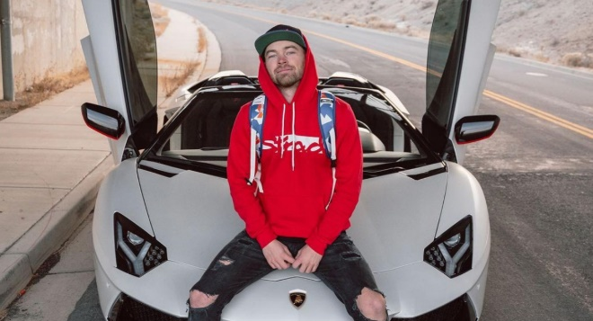
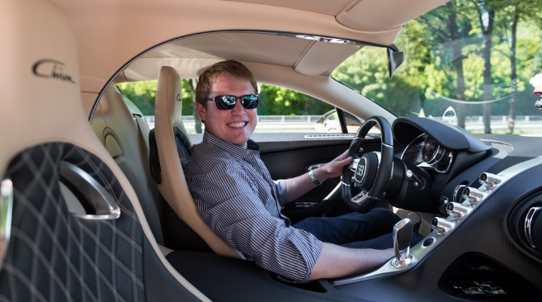
Aside from the design industry there are many other platforms that help to facilitate inspiration. Touching upon it earlier, YouTube is an excellent medium for this and is in fact how my passion for cars became ever-growing.


Content creators, such as Shmee150 and the Stradman, have deepened my passion immensely, especially due to their sheer excitement and enjoyment which shines through in their videos. The enthusiasm they display when seeing the various car designs on offer today gives me the motivation to be impactful with this industry. Aside from YouTube, mainstream television shows such as Top Gear also emphasise why we as designers can take pleasure in aspiring to be the best, so that our work one day will be shared across their media, highlighting to potential customers who might also want to enjoy our creations.
How is this design inspiration being applied to my current design study?
Design is all about how you can stand out, whether that is your personality, your ideas or your views on the world. With every project, I ask myself ‘What does this world not have which I can maybe produce?’, or ‘How can I bring change to this environment in a positive way?’.
By asking these initial questions it helps me to form an overall direction for the project so that I know what is achievable. Setting out goals guides me in knowing how I want the project to be planned and, therefore, executed. Completing this early will allow you to stay on track, so that we do not lose our train of thought mid-project.
For instance my third-year final project highlights the potential hassles, anxieties, and disruptions involved in everyday travel, whether by plane, train or car. With that in mind, I aim to design a travel concept for 2060 using Level 5 Autonomy which might alleviate many of these issues. With the story board finalised, I then start with the initial designs. For the early development, I gather images of other similar concepts in order to discover how my designs would compare to the current ideas in tomorrow’s world. It is important to me that my ideas are fresh and aligned closely with what I perceive to be the trends of the future. Remaining fresh and current is key, but I have also learnt along this educational pathway to push boundaries and ideas further – beyond what others might think is imaginable. Challenging stereotypes and questioning people’s expectations is essential in a designer’s thought process. In the case of my project – challenge the convention of spending hours in an airport, and instead question why holiday travellers do not load up their comfortable car on their driveways and let the vehicle drive them to their destination?
I enjoy the initial sketch phase of a project. It allows you to create lines, forms, shapes and concepts without restriction; to let the pencil flow across the paper and see what ideas come as a result. However, most importantly, I have learnt to use this phase to enable others to comment and react to my designs. I am of the opinion that being open to alternative viewpoints will inevitably allow your work to improve proportionate to the amount of feedback you are open to receive. At my very early stage in this design journey, I believe you will only develop your skills more once you have received sufficient advice and expertise from your surrounding audience. I am a great believer in using mentors, where possible – whether they be fellow students, former students or industry experts. Not only will they be able to guide you, supported by their experience, but also teach you to understand how the industry operates. In my case, my mentor has already helped to open doors to providing me with valuable experience in the commercial workplace and has also helped me learn techniques to self-promote my talents and ideas.
During our course, we have been fortunate enough to have industry specialists visit and present their ideas. An open mind is one of the greatest tools we own. Being open and willing to adopt new ideas and opinions allows us to grow in ourselves, and to expand our own portfolios of concepts.
What else do I strive for within my design philosophy?
Positive change.
We are living in a world, especially right now with increasing cost of living prices, and wars being fought on country boundaries not far from our own.
This is why, as a designer, I am very passionate about helping our community. Whether that is pushing for a lot more sustainable materials to be used or discovering cheaper solutions for alternative transport methods. Activating this mindset will allow us to empathise with the world around us, so that we are certain on how to deliver this promising transformation to our people and planet. I aspire one day to highlight my ideas for change and feel proud to have hopefully delivered this to the community, because I feel we are in debt to what this world is giving us.
My recent design projects have centred around the use of environmentally friendly materials, thereby reducing the harm we do to the planet. For instance, for my second third-year project, I have proposed to harness the power generated by the flow of the River Thames to power London’s taxi service. Thinking outside the box, whilst following current trends, allows our ideas to remain present but at the same time make the most of innovation. Our duty as designers of the future is to constantly innovate new ideas and concepts for the better of our society and its future.
Striving for focus and staying determined to uncover change within this ever-adapting world, are two especially important skills we must succeed at. However, displaying passion and enjoyment through our work, ultimately ensures we will be able to succeed to the highest level.
‘’People rarely succeed unless they have fun in what they are doing’’ ~ Dale Carnegie
‘’Live and work but do not forget to play, to have fun in life and really enjoy it’’ ~ Eileen Caddy
How can this then be applied to my design field?
I have been fortunate already to pursue an educational pathway which encapsulates my love of both art and cars. Going forward, I am a firm believer in humans becoming more successful in the tasks they set themselves if they live by the ethos of having fun at the same time. Agreeing with both Carnegie and Caddy (see above quotations) I have so far been able to apply my design philosophy to reflect my passion for this industry. Success through enjoyment is what I aspire to achieve within the industry, and I rely on this aspect to allow me to make my own footprint within it. Seeing how Ralph Gilles and Frank Stephenson applied their passion into their work is inspiration enough for myself.
The surface has been scratched
The automotive industry is far-reaching and combines a vast array of designs, for vehicles with a multitude of uses. Whilst I always have a preference in the type of vehicle design I am naturally drawn to, I also fully appreciate that I will seize upon whatever career opportunity presents itself down the line. As students, we are just starting to take our baby steps into the industry, and upon graduating from university, I will personally learn to grab any chance given without thinking twice. Gaining experience is key to our personal development and learning from those already in the industry is what will allow us to grow as design individuals.
Therefore, what specific designs influence my philosophy?
That said , if I was to be able to choose or define where my passion for design is best put into practice, then it would most definitely be within the SUV (Sport Utility Vehicle) sector of the industry. Being very much aware of the criticism directed toward these typically high fuel consumption and over-sized vehicles, I still feel an empathy towards their design, and I would be highly motivated to be part of their future. SUV’s account for 28% of all vehicles on our roads today and have traditionally been ever-present in my family’s choice of cars.
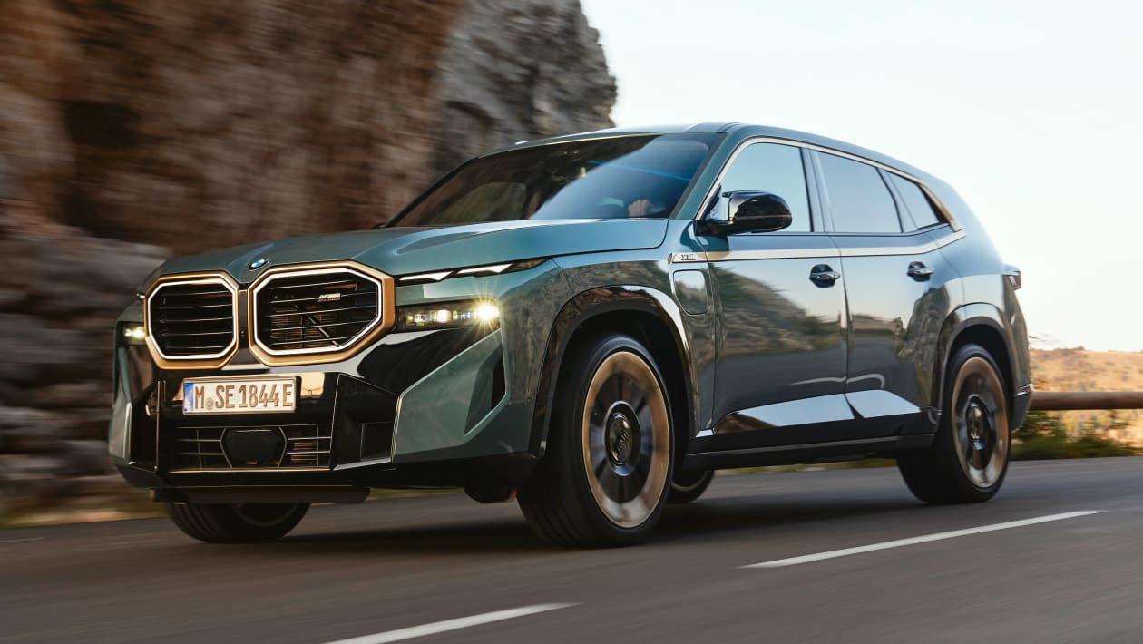
This year we saw the release of the BMW XM, a high-performance SUV combining a V8 engine and advanced battery technology. The XM carries the same ‘kidney-shaped’ grills as seen on the latest M4 and M3 models within the BMW range. From a design point, the notion of power is conveyed through the car’s frontal appearance. In fact, proportions are all important within the SUV sector. The need to design such a large vehicle with sleek lines, combining a sporty look, with elegant and luxury exteriors and interiors almost makes this sector of the car market more controversial. The entrance of hyper-luxury brands like Maserati, Rolls Royce, Lamborghini and Bentley (to name only a few) has antagonised the purists who believe that the SUV’s have deviated from their original purpose of combining off-road capability with on-road utility. However, I find it fascinating to see how this sector has found sufficient space for all levels of brand affordability to find its place within it. From the Santa Fe to the Cayenne, from the Cullinan to the CRV, from the Urus to the Land Rover Sport, they all have their loyal supporters, and they all have their own unique identities.
Relating this back to the XM, I am drawn to the boldness of its surfaces, in particular the captivating face, and its huge front grills. I see elegance on the road in its design, at the same time as the ability to envisage this car being powered around an offroad circuit. The XM is no exception - all of these brands are striving to stand out from the crowd, and I am keen to be part of this SUV movement. It is a growing market space, and I would be able to implement my passion through enjoyment into my work.
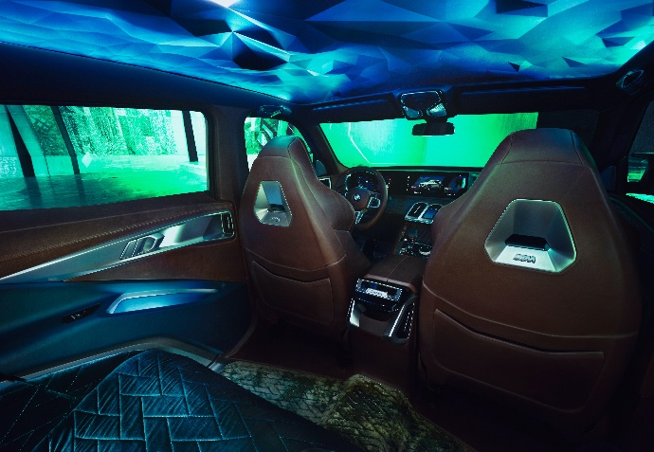
It is also important to point out that it is not all about the exterior designs of the cars. I believe that interiors will play an ever-increasingly important role in the future. If we pause for a moment and reflect on the BMW XM itself, then we can see (to the left) how the clever use of lighting transforms its passengers into a world of ‘distinctive ambient light’ which is complimented by the exclusive vintage leather. I have been able to use aspects from this design into my final year project, with the view of making an interior design that will offer utmost luxury and refinement to its users.
Not all designs always achieve mass appeal, or even mass-acceptance. The BMW XM is a prime example of such. The RAC reviewers described the design as ‘’extrovert’’, and the Top Gear presenters appeared shocked when they heard the prototypes were being put into production. This again teaches me that design is very subjective and this allows for a diverse range of opinions. Striving for provocative design is what I aim to achieve within this industry, as I believe that will be the only way for my work to ultimately stand out from the crowd, and to gather its fan-base.
How can I achieve this?
By being innovative.
Bringing change to an already mature market.
By capturing how my designs can be used productively.
How do you define success within design?:
- the accomplishment of an aim or a purpose
This can be calculated in two ways:
- How well a product sells in terms of number of purchases globally.
- Or to the extent it exceeded expectations, as well as increasing the recognition for the brand.
For example, Apple released the iPhone fifteen years ago, and at the time courted with controversy with its rather unique design and never seen before user interface. Since then, over 2.2 billion phones have been sold, thereby making it the most popular mobile brand ever. The Apple brand has grown to the highest level of global recognition as a result.
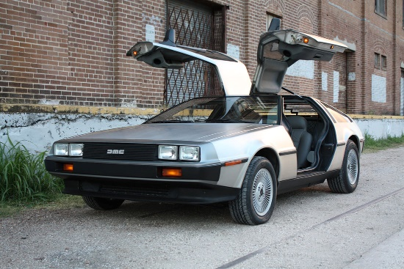
Sometimes within the industry, these large corporations fail to meet expectations and release a design which fails to succeed. The consequential impact is not only damage to the brand identity but also economic loss. Failure to meet sales expectation is a costly mistake and we have a few examples. For instance, DeLorean created and launched the DMC-12 model and ultimately sold less than 9000 cars worldwide – not only a design flop, but also had significant technical problems, in particular electrical system errors as well as an underpowered engine, among others.
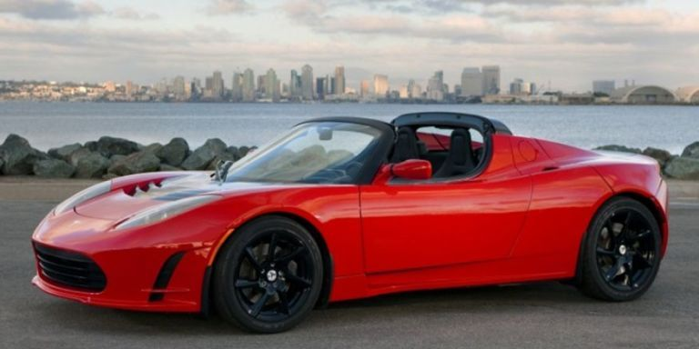
It is very interesting to see how these companies deal with such failures and try to leverage on them to achieve future success. For instance, when Tesla first released the Roadster in 2008, it featured a 248-horsepower engine. In addition, its design lacked sleekness and beauty compared to other models on the market at that time. However, due to its large price tag and dependability issues only 2,450 units were sold.
Roll forward a few years, and today Tesla is the world’s largest electric vehicle producer with over 3.2 million vehicles sold, and their models include one of the most reliable batteries within the industry. Their success shows how companies can gain popularity even after a tough period in their history. In my opinion their success has deepened further through Elon Musk’s entrepreneurial leadership and his visions for the brand.
Learning from your mistakes and being able to come back stronger inspires me in my future work ethic. Any criticism or dejection, regardless of the scale, are building blocks to improve on so that you come back stronger and succeed again. Accepting failure is a skill, but it allows for further creativity and a dedicated mindset – one that I hope will help me develop.
We are far from done

What will the future of design look like?
Who knows?
One thing we do know, however, is that our deadline to meet carbon zero levels is of paramount importance for the future survival of this planet. Therefore, having the environment and sustainability at the forefront of our minds in a design concept must be our obligation towards the next generations ahead of us.
Shifting transport norms on this planet will move into overdrive from this point onwards, but I also believe that there will be a further shift and that will be into the realm of space. The idea of inhabiting other planets in the not-too-distant future is a concept that the next generation of designers will surely tackle. This will prove to be a prime example of how complex problems require intense solutions and design will be of upmost importance allowing these opportunities to be solved. Adapting a growth mindset will enable us to motivationally bring change through our ideas.
"You have to really believe not only in yourself; you have to believe that the world is actually worth your sacrifices." ~ Zaha Hadid
We can only strive for change if we, as a community, want to bring change forward and are willing to invest so that our planet will be cleaner for us to live in, in the distant future.
Therefore we must
“Solve problems in an unproblematic way.”
Turning full circle to the beginning of this essay with the initial quote from the Danish architect, simplicity is what we as innovators strive to achieve with our designs for the future. Why over-complicate creations when this will cause immediate problems in the foreseeable future? Cutting costs through minimalism will enable the manufacturing process to be more efficient and facilitating the planet by increasing the use of renewable materials.
How can I interpret this for the automotive industry?
Studying the likes of Gilles and Stephenson has widened my spectrum of vision into how to interpret design and how we can become a bigger part within this design community. Striving for simplicity and energy effectiveness as well as innovative ideation processes will hopefully allow my designs to stand out from the crowd and allow me to become successful in the future. In addition, studying various design sources, whether that be from architecture or graphics background, will prepare us for being industry-ready, so that we can achieve ultimate success.
What is next?
Only time will tell.
Technology and how we use it will continue to change our lives dramatically. From an automotive perspective, I am a firm believer that we will soon travel in Level 5 autonomous vehicles, whether that be on the road, by water or by air. The day of a vehicle being something we drive will be replaced by a vehicle that drives us. Artificial Intelligence (AI) will play its part, and intuitive technology will replace a vast number of human decisions. Maybe one day, AI will remove the need for designers due to its advancements in technology. Let’s hope that won’t be the case just yet! I will leave the last word, however, to the environment – we need to live in a carbon negative world, where burning fossil fuels become a thing of the past. Improving our wildlife and eco systems within a community of joint responsibility, will be the main factors that will allow us to achieve our shared goals.
I very much look forward to contributing to this journey – and I sincerely hope that this thesis has gone some way to illustrate my passion for the opportunities that lay ahead.

References:
Wikipedia Contributors (2019). Cubism. Wikipedia. Available at: https://en.wikipedia.org/wiki/Cubism.

www.goodreads.com. (2022). A quote by Leonardo da Vinci. Available at: https://www.goodreads.com/quotes/9010638-simplicity-is-the-ultimate-sophistication-when-once-you-have-tasted.

Wikipedia. (2021). Ralph Gilles. Available at: https://en.wikipedia.org/wiki/Ralph_Gilles.

Netflix, Inc. (2019). Ralph Gilles: Automotive Design. Netflix. Available at: https://www.netflix.com/watch/80093806?trackId=255824129&tctx=0%2C0%2CNAPA%40%40%7Cb547767b-50a5-4953-9477-09a05cfbd693-33379762_titles%2F1%2F%2Fabstract%20%2F0%2F0%2CNAPA%40%40%7Cb547767b-50a5-4953-9477-09a05cfbd693-33379762_titles%2F1%2F%2Fabstract%20%2F0%2F0%2Cunknown%2C%2Cb547767b-50a5-4953-9477-09a05cfbd693-33379762%7C1%2CtitlesResults%2C80057883.

Wikipedia. (2022). Frank Stephenson. Available at: https://en.wikipedia.org/wiki/Frank_Stephenson

McRae, I. (2022). UK poverty: the facts, effects and solutions in a cost of living crisis. The Big Issue. Available at: https://www.bigissue.com/news/social-justice/uk-poverty-the-facts-figures-effects-solutions-cost-living-crisis/#:~:text=Around%2014.5%20million%20people%20are.

www.linkedin.com. (2019). ‘People rarely succeed unless they have fun in what they are doing.’ Dale Carnegie. Available at: https://www.linkedin.com/pulse/people-rarely-succeed-unless-have-fun-what-doing-dale-widley-marcelin/

Twitter. (2014). Available at: https://twitter.com/motivational/status/490394379589136384?lang=en-GB.

Car Throttle. (2017). 5 Reasons Why SUVs Suck. Available at: https://www.carthrottle.com/post/nxd5pv5/

www.rac.co.uk. (2022). BMW XM review | Car review | RAC Drive. Available at: https://www.rac.co.uk/drive/car-reviews/bmw/xm/xm/

www.bmw.co.uk. (2022). BMW XM (G09): Models, technical Data, Hybrid & Prices | BMW.UK. Available at: https://www.bmw.co.uk/en/all-models/m-models/xm/2022/bmw-xm-overview.html#cockpit-technologies

Top Gear. (2022). BMW XM prototype review: 634bhp hybrid mega-SUV driven Reviews 2022. Available at: https://www.topgear.com/car-reviews/bmw/first-drive

Ruby, D. (2022). 26+ iPhone User & Sales Statistics (Fresh Data 2022). demandsage. Available at: https://www.demandsage.com/iphone-user-statistics/#:~:text=It%20is%20estimated%20that%20more

Hadid, Z. (2018). 10 Unpredictable Facts You Never Knew About Zaha Hadid - Arch2O.com. Available at: https://www.arch2o.com/10-unpredictable-facts-never-knew-zaha-hadid/#:~:text=She%20designed%20almost%201000%20projects&text=The%20late%20architect%20is%20the.

Marketing Mind. (2019). Top 10 Best-Selling Products Of All Time. Available at: https://www.marketingmind.in/top-10-best-selling-products-of-all-time/.

www.whatcar.com. (2022). Tesla Model Y Review 2022. Available at: https://www.whatcar.com/tesla/model-y/hatchback/review/n23624/buying-owning

www.bloomberg.com. (2022). Bloomberg - Are you a robot? Available at: https://www.bloomberg.com/news/articles/2022-10-20/tesla-model-y-ranks-among-the-top-selling-vehicles-in-the-world?leadSource=uverify%20wall.

Weyer, M. (2020). These Are The Car Industry’s 10 Most Devastating Failures. HotCars. Available at: https://www.hotcars.com/these-are-the-car-industrys-10-most-devastating-failures/

Autocar. (n.d.). The biggest flops in automotive history. Available at: https://www.autocar.co.uk/slideshow/biggest-flops-automotive-history-1#49

‌Akgunduz, B. (2022). How Many Tesla Cars Have Been Sold? | Model 3/Y Sales By Year |Licarco. Licarco - Latest Electric Cars, E-Motors, Vehicle Comparisons. Available at: https://www.licarco.com/news/how-many-tesla-cars-have-been-sold.

‌

‌

