Technology and Environment M4X01974 Gabriella Abbott 2011608 History and Theory An Exemplar of Modern Architecture

The Design and History of Barcelona Pavilion
Introduction
Barcelona German State Pavilion is a unique example of modern Architecture. The elegant pavilion is a very popular tourist attraction however has a detailed historic background. This structure in particular interests me, not only because of the design but also because of the city its located in. Barcelona is a place I have visited multiple times and its distinct Architecture fascinates me.

Historical Background
The Barcelona Pavilion was built in 1929 by Mis van der Rohe, one of the most well-known architects of the 20th century. The pavilion was built in Montjuic, Barcelona near a popular village visited by many during the International Exhibition. The pavilion was designed to represent the new Germany after World War One. The ‘‘democratic, culturally progressive, prospering, and thoroughly pacifist’’ Germany stated Zimmerman (2006, p.39). The project was first used by King Alfonso XIII and German officials on the 19^{th of} May 1929, for an International Exposition, this being the purpose of the pavilion (Montaner, 1997, p.197). Mies committed to designing all the German exhibitions that would take place in the Barcelona Pavilion. Mies was instructed to leave the pavilion open and as it was designed to house the official opening of the German section of the exhibition fair. The idea

being that the Architecture was the exhibition, as trade exhibitions were not permitted. The visitors would use the exhibition pavilion in order to move into the next exhibition (Chambers,2016). Pavello Mies van der Rohe informed that the pavilion was put onto the market in 1929 by the German government and as a result of not having a buyer they made the decision to dismantle the structure and sell the materials (n.d). It was stated that “The building instantly became a masterpiece in van der Rohe’s career, a symbol for the twentieth century Modernism movement and an inspiration for generations of future architects, all over the globe”. A group of Spanish architects sets to replicate it in 1983 because it “became such an icon” and therefore it was rebuilt in the exact same location (Mid Century Home, 2016).
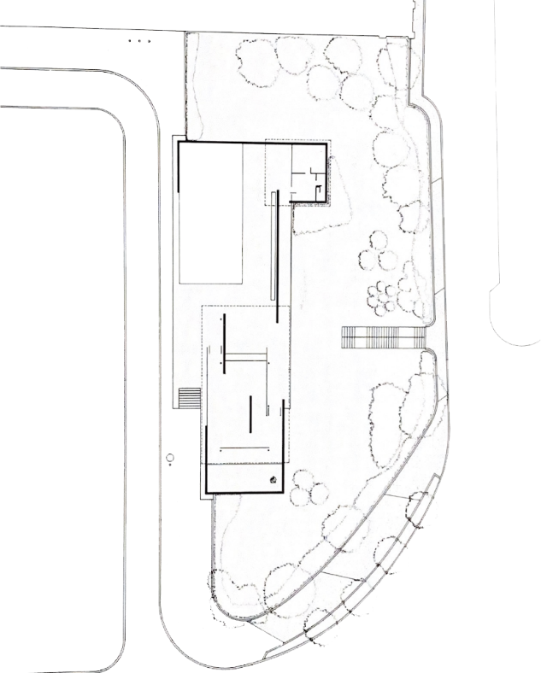
Plan and Section
The location plan of the pavilion shows that its only viewable from the east, directly from the street, as the landscaping of trees and greenery surrounds the structure. The location is peaceful and scenic compared to a large part of the rest of the city. The large amount of landscaping also softens the FIG 1 Location plan of the Barcelona Pavilion (Morales, view, both of these things enabling a Cirici and Ramos, 1993, p.29) calm atmosphere to be created.

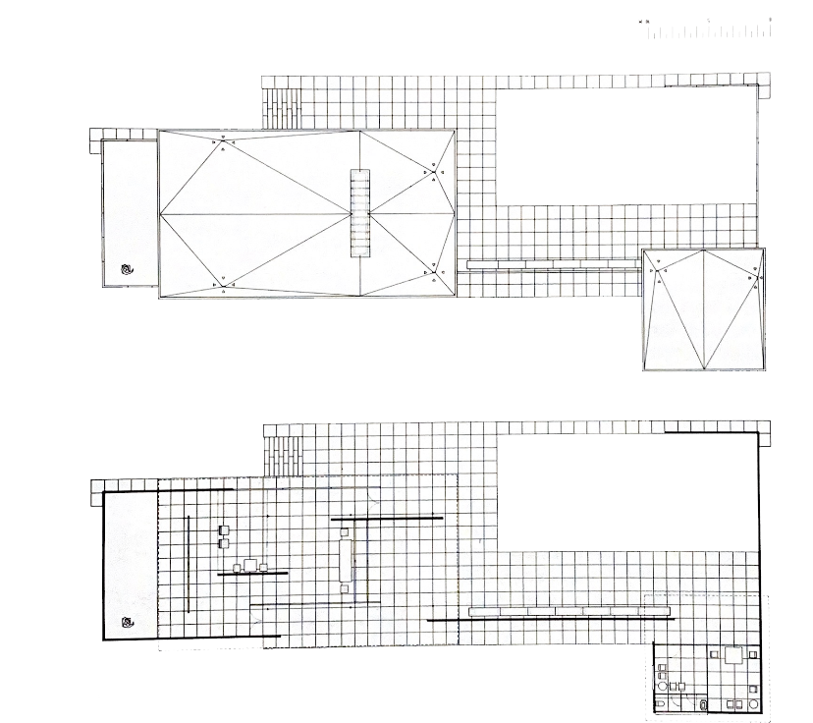
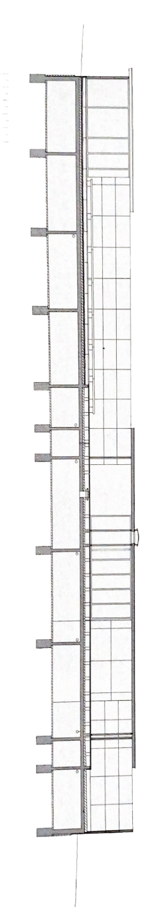
The plan is made up of many vertical and horizontal lines. The roof plan shows that two sections are undercover building structures, a larger and a smaller. The larger structure including limited furniture and walls positioned to create a free-flowing space for people to move around or gather. The larger space is not closed off from the outside area allowing people to move fluidly around FIG 2 Barcelona Pavilion Plan and Roof plan (Morales, the pavilion from outside to inside, as Cirici and Ramos, 1993, p.29) well as between the two structures.

The plan shows that Rohe created a clutter free space that was not over ridded with furniture and instead did achieve the purpose of it being an exhibition rather than housing one, therefore leaving the space open, as instructed.

FIG 3 Section of Barcelona Pavilion (Morales, Cirici and Ramos, 1993, p.37)
The section demonstrates how easy the pavilion flows from one side to the other without any part feeling shut off from the rest of the site. It clearly shows the change in material throughout the

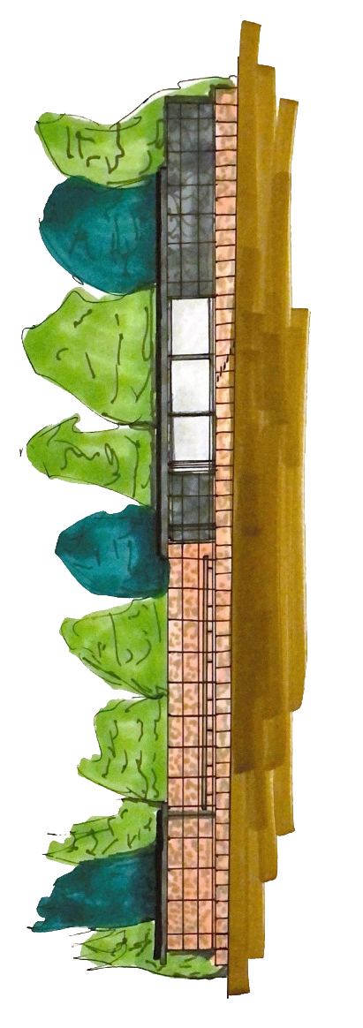
section by using different sized squares, indicating that there is a common material flowing throughout the site thus tying the different sections of the pavilion together. There is also a bench shown on the section for seating showing that the spaces inside and outside can flow together with some moving around as well as being seated, however do not feel separate. The bench also starts at the small annex on the left of the section all the way to the larger structure on the right, inter linking the two.
FIG 4 Colour Elevation of Barcelona Pavilion by Gabriella Abbott
The elevation in colour shows how the landscaping sits in respect to the pavilion and softens the image. The pavilion has large glass windows seen in this elevation again linking the outside to the inside parts of the space. The colours of the materials shown in this sketch shows the warmth created by the pavilion, the pavilion blends with the colours seen in the surrounding environment, giving more of a natural feel to the structure.

Materials and Light
A large part of the pavilion was made from stone; however, the partnered materials modernised the design. Rohe designed the pavilion to be made out marble, water, glass as well as stone, this allowed many of the materials to reflect and create the illusion of a larger space. Onyx dore stone

was used along the main wall of the pavilion connecting the two undercover structures. Two water basins, a larger and a smaller, sit in the pavilion creating a very scenic atmosphere. Roman travertine slabs of 1.1 metres by 1.1 metres were used to create a base for the pavilion, raising it above the ground level. The walls were also made from the same material however the slabs were larger, measuring 2.2 metres by 1.1 metres, giving the walls more of a sleek finish. Some walls were also made of green marble, two different types were incorporated into the pavilion, commonly known as Tinos and Alphine during the time of construction. The Alphine marble used for the wall that surrounded the small basin of water and the Tinos used for just one wall stood at the entrance of the larger annex. These walls were underlaid with a three-centimetre slab as well as a metal interior structure. The roof was made from a concrete slab, plastered, and painted. It was supported by eight steel columns and overhung the interior creating the illusion of a floating roof (Morales, Cirici and Ramos, 1993, p.13). The floor and the roof were connected by the marble walls as well as horizonal as well as vertical glass sheets in different colours, grey, green, and white, although were kept transparent. The large amount of glass lit up the pavilion and allowed the connection between the inside and outside to be taken further (Morales, Cirici and Ramos, 1993, p.14)

Idea and theories
Rohe designed the pavilion to be raised above ground level as many other buildings were in Germany during this time, for example House Auerbach. This allowed the beauty of the pavilion to be enhanced and distinguished very easily from surrounding structures. The modern materials used were chosen in light of the fact the pavilion was to represent the new Germany. The Barcelona chair was designed specifically for the pavilion and is a very accurate representation of Rohe’s abstract design process, although the Roman chair known as a Curule seat, was said to be the inspiration be

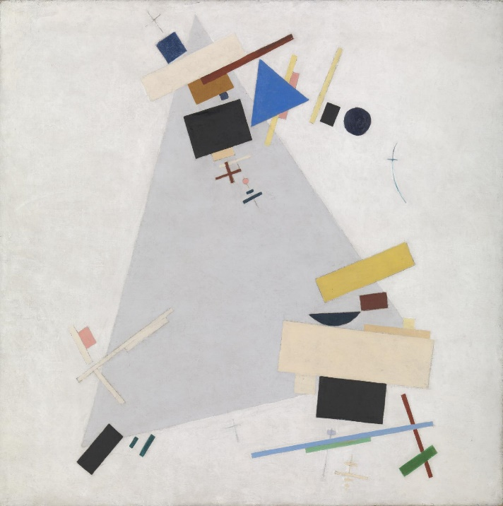
the architectural inspiration behind the Barcelona chair (Chambers,2016). Although not confirmed, the inspiration behind the pavilion could have come from artist such as Kasinir Malevich who created artistic pieces from horizontal lines, vertical lines as well as shapes much like the formations seen in the plans of the Barcelona pavilion.
FIG 5 Painting by Kazimir Malevich to represent the
types of works that could be behind the inspiration
of the Barcelona pavilion (Malevich, 1915 or 1916)

As previously mentioned, Rohe was instructed to create a pavilion that is an exhibition, rather than to house one. Taking inspiration from works such as these meant Rohe would have been able to do this whilst creating an artistic piece, linking art with architecture which was very popular during this period.

Conclusion
Mies van der Rohe succeeded in his task to create an exhibition to which inspires architects all over

the world, even today. His simplistic project was enough to leave people fascinated with the structure due to the modern and powerful choice of materials and unique furniture. Rohe designed a clutter free space for the German Government which turned out to be one of the most well-known projects throughout his career. Even though it was decided the pavilion would be sold after the exhibition and later torn down, the unique structure left such an impression on people that it was rebuilt by architects almost sixty years later. The pavilion succeeded in tying art and architecture together with this design due to the use of line, simplicity, and colour. The Barcelona pavilion is still often visited by tourists when going to Barcelona city.

References
Chambers, S. (2016) Mies Van de Rohe: 1929 Barcelona Pavilion. [Blog] Available at: Mies Van de Rohe: 1929 Barcelona Pavilion (chambersarchitects.com) (Accessed: 23rd March 2021)
Malevich, E. (1915 or 1916) Dynamic Suprematism. [Oil paint on canvas] Available at: ‘Dynamic Suprematism’, Kazimir Malevich, 1915 or 1916 | Tate (Accessed: 29th March 2021)
Mid-Century Home (2015) The Barcelona Pavilion by Mies van der Rohe. Available at: The Barcelona Pavilion by Mies van der Rohe (midcenturyhome.com) (Accessed: 23rd March 2021)
Montaner, J.M. (1997) BARCELONA A City and its Architecture. Cologne: Taschen
Morales, I.D.S., Cirici,C. and Ramos,F. Mies Van Der Rohe: Barcelona Pavilion. Barcelona: Editorial Gustavo Gili
Zimmerman,C. (2006) Mies van der Rohe. Cologne: Taschen

