

University of Wales
Trinity Saint David
LCBB5000

Tutor name: Gasso Wilson Mwaluseke

Data Handling and Business Intelligence
ASSIGNMENT 2

Teodora Georgieva
Student ID: 2111818
Date of submission: 05/05/2023
Word Count: 3292 words

Table of Contents

1. Introduction ………………………………………………………………………………...2
2. Pre-processing, analysing and visualising the data in Microsoft Exel – advantages and disadvantages………………………………………………………………………………….2
2.1.Pivot Table……….………………………………………………………………………..3 2.2.VLOOKUP and AVERAGE……………………………….……………………………..4
3. Practical application of SPSS and working with a database…………………………...…...5
3.1. Male and Female students……. ………………………………………………………….6
3.2. Qualifies and does not qualify students for free lunch……………………………………7
3.3. Mean and median of free lunch requirements…………………………………………….8
3.4. Mean and median differences of students' pre-test and post-test scores………………...13
3.5. Clustering………………………………………………………………………………..19
4. Data-mining and Text-mining methods in our business world……………………………20
5. SPSS and Microsoft Excel - analysis of the strengths and weaknesses of the software…..21
6. Conclusion………………………………………………………………………………...22
7. References…………………………………………………………………………………23

- Introduction
Data analysis and visualization are processes through which we extract in-depth information and identify facts and trends in an understandable way. In this report, we will mention the different stages of working with a database in Microsoft Excel and some of the features of the program. In addition, we will make graphs, charts and diagrams to show how to make findings more effective. Additionally using SPSS with its advantages will solve a task, analyse the information, and visualize the results and trends. Working with these programs individually gives us the opportunity to evaluate their strengths and weaknesses. We will provide an example of some data mining and text mining methods used successfully in the developing business world.
Part 1
- Pre-processing, analysing and visualising the data in Microsoft Excel – advantages and disadvantages
In this part, Microsoft Excel and its stages will be evaluated, and with some of the program's functions, we will analyse a set of hotel reservation data to track the change in average booking price from 2017 to 2021. We will use VLOOKUP and PIVOT tables functions to achieve in-depth and visualized results.
- Pre-processing the data
With minimal training, we can prepare data entry. There is no limit to the amount of information that can be recorded, so the software is widely used for data entry or analysis. The convenience comes from being able to enter many sheets with lots of information.
One of the disadvantages of the program is the need for a thorough knowledge of keyboard shortcuts, functions and formulas in order to use it to its full potential (JavaTpoint, n.d.)
Although these tables have the potential for teamwork, mistakes can be made when adding or removing information, which will be difficult to detect and recover from (Brudner, 2022). Also, it will be difficult to know who made this mistake, with unlimited access to the file. The lack of additional protection is a weak point of the program.

- Analysing the data
One of the advantages of MS Excel is that it is easy to find or restore data. Looking up information on paper takes time, but a spreadsheet doesn't have that problem. Here we can find and extract the data and store everything in just one MS Excel file (JavaTpoint, n.d.).
Spreadsheets make it easy to manipulate data with a good knowledge of the program. We can make pivot tables, use different functions, find duplicates, multiply, divide and add data sets. We can also search all rows and columns for a specific word or parameter (Brudner, 2022).
These spreadsheets are best suited when preparing financial records such as budgets, balance sheets, and cash flow statements. Income and asset information is easily exported to and from accounting programs.
The disadvantage - the presenter can, due to a lack of competence, choose only those data that he considers relevant and thus inadvertently influence important decisions (Natter, 2019).
- Visualising the data
Through the numerous functions and applications of this software, even with a large amount of data, easy-to-interpret visualizations are obtained in different variants. (Lesky, et al., 2014). It is used both by private users and to visualize statistical results in presentations and reports. There is easy and free access to guides and tutorials.
This requires practice and in-depth functional knowledge, which, however, takes time. The interpretation of the results is also not so clear and visible to some users.
2.1. Pivot Table
 | Data
Arrival year | Average price per year | decrease/increase | Five year average price
2017 | 90.0439238 |  | 103.42
2018 | 106.359883 | 16.31595924 | 103.42
2019 | 70.96333333 | -19.08059046 | 103.42
2020 | 81.4 | -8.643923798 | 103.42
2021 | 105.3333333 | 15.28940954 | 103.42
Grand Total | 103.4235391 |  | 103.42

From the analysis we find that there are no big fluctuations from the average price for these 5 years. 2019 and 2020 saw small dips from the average, likely due to Covid-19 and the associated restrictions and issues. Prices are slightly higher in 2018 and 2021, with the increase for the latter year a result of both the post-Covid situation and inflation.

  - VLOOKUP and AVERAGE
From the Hotel Reservation table, with 36276 rows and 19 columns, to show how the VLOOKUP function works we use the formula shown below, which actually shows us the first values, that the program finds for room price for the corresponding year. The results are set to appear in row 36281 for the 2017 year and then the formula is made to work in the same way for the remaining years
To find the average price of rented rooms for each year, we use the AVERAGE function, and the formula in our case is shown below as well.

 | 1st Value | Average
2017 | 65 | 90.05
2018 | 106.68 | 106.45
2019 | 94.5 | 101.78
2020 | 87.5 | 105.34
2021 | 115 | 101.23

=VLOOKUP(A36281,$J$1:$Q$36276,8,FALSE) – for 1st Value
=AVERAGEIF($J$2:$J$36276,A36281,$Q$2:$Q$36276) – for Average

When analysing the average prices for each year, we observe small deviations over the years, which indicates a stable policy and a successfully developing business.

Part 2
- Practical application of SPSS and working with a database
Understanding the relationships between students' pre-and post-test scores, gender, and reduced or free lunch eligibility is the goal of outcome measurement research. Through the capabilities of SPSS, we will trace whether dependencies exist between the mentioned indicators and give guidance in making decisions about the allocation of resources, intervention strategies and student support initiatives. The use of this software will allow us to obtain an accurate statistical analysis, through its numerous algorithms for numerical and graphical results (IBM, n.d.).

3.1. Male and Female students

Frequencies

Statistics
Gender
N | Valid | 2133
N | Missing | 0

Gender
 |  | Frequency | Percent | Valid Percent | Cumulative Percent
Valid | Female | 1056 | 49.5 | 49.5 | 49.5
Valid | Male | 1077 | 50.5 | 50.5 | 100.0
Valid | Total | 2133 | 100.0 | 100.0

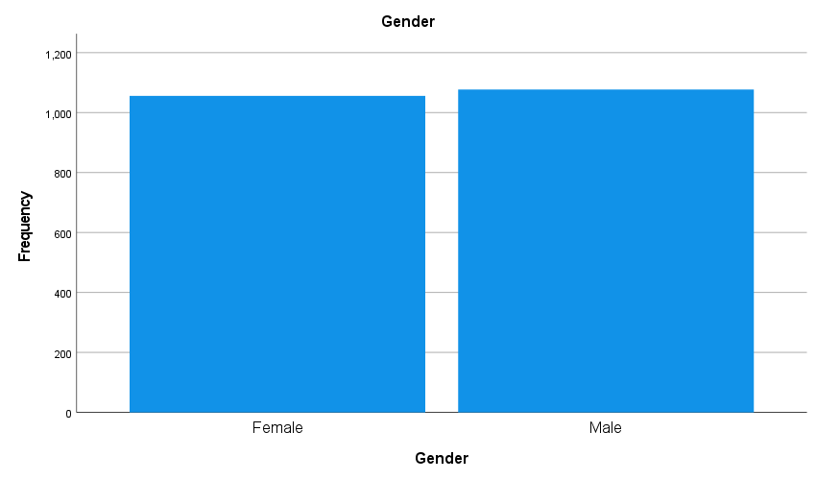

According to the results, the gender distribution shows almost equal proportions of students, with women making up 49.5% and men making up 50%. These prove that the representation of both sexes, in this case, is balanced.

3.2. Qualifies and does not qualify students for free lunch

Frequencies

Statistics
Lunch
N | Valid | 2133
N | Missing | 0

Lunch
 |  | Frequency | Percent | Valid Percent | Cumulative Percent
Valid | Does not | 1215 | 57.0 | 57.0 | 57.0
Valid | Qualifie | 918 | 43.0 | 43.0 | 100.0
Valid | Total | 2133 | 100.0 | 100.0

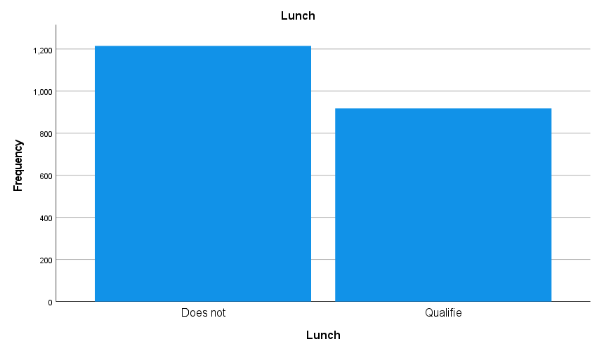

By studying the eligibility for free lunch, we can find out about the social status and problems of the students and take further action to alleviate them. The research shows that 43.0% of students in the data set qualify for reduced or free lunch, and the remaining 57.0% do not qualify.

3.3. Mean and median of free lunch requirements

Statistics
 |  | Pretest | Posttest
N | Valid | 2133 | 2133
N | Missing | 0 | 0
Mean |  | 54.9559 | 67.1022
Median |  | 56.0000 | 68.0000

Pretest
 |  | Frequency | Percent | Valid Percent | Cumulative Percent
Valid | 22.00 | 1 | .0 | .0 | .0
Valid | 23.00 | 1 | .0 | .0 | .1
Valid | 25.00 | 1 | .0 | .0 | .1
Valid | 26.00 | 3 | .1 | .1 | .3
Valid | 27.00 | 5 | .2 | .2 | .5
Valid | 28.00 | 9 | .4 | .4 | .9
Valid | 29.00 | 17 | .8 | .8 | 1.7
Valid | 30.00 | 27 | 1.3 | 1.3 | 3.0
Valid | 31.00 | 19 | .9 | .9 | 3.9
Valid | 32.00 | 23 | 1.1 | 1.1 | 5.0
Valid | 33.00 | 26 | 1.2 | 1.2 | 6.2
Valid | 34.00 | 24 | 1.1 | 1.1 | 7.3
Valid | 35.00 | 18 | .8 | .8 | 8.2
Valid | 36.00 | 36 | 1.7 | 1.7 | 9.8
Valid | 37.00 | 29 | 1.4 | 1.4 | 11.2
Valid | 38.00 | 38 | 1.8 | 1.8 | 13.0
Valid | 39.00 | 46 | 2.2 | 2.2 | 15.1
Valid | 40.00 | 45 | 2.1 | 2.1 | 17.3
Valid | 41.00 | 42 | 2.0 | 2.0 | 19.2
Valid | 42.00 | 42 | 2.0 | 2.0 | 21.2
Valid | 43.00 | 49 | 2.3 | 2.3 | 23.5
Valid | 44.00 | 43 | 2.0 | 2.0 | 25.5
Valid | 45.00 | 48 | 2.3 | 2.3 | 27.8
Valid | 46.00 | 37 | 1.7 | 1.7 | 29.5
Valid | 47.00 | 42 | 2.0 | 2.0 | 31.5
Valid | 48.00 | 44 | 2.1 | 2.1 | 33.5
Valid | 49.00 | 43 | 2.0 | 2.0 | 35.5
Valid | 50.00 | 44 | 2.1 | 2.1 | 37.6
Valid | 51.00 | 40 | 1.9 | 1.9 | 39.5
Valid | 52.00 | 54 | 2.5 | 2.5 | 42.0
Valid | 53.00 | 59 | 2.8 | 2.8 | 44.8
Valid | 54.00 | 52 | 2.4 | 2.4 | 47.2
Valid | 55.00 | 59 | 2.8 | 2.8 | 50.0
Valid | 56.00 | 56 | 2.6 | 2.6 | 52.6
Valid | 57.00 | 45 | 2.1 | 2.1 | 54.7
Valid | 58.00 | 63 | 3.0 | 3.0 | 57.7
Valid | 59.00 | 61 | 2.9 | 2.9 | 60.5
Valid | 60.00 | 73 | 3.4 | 3.4 | 63.9
Valid | 61.00 | 56 | 2.6 | 2.6 | 66.6
Valid | 62.00 | 60 | 2.8 | 2.8 | 69.4
Valid | 63.00 | 64 | 3.0 | 3.0 | 72.4
Valid | 64.00 | 48 | 2.3 | 2.3 | 74.6
Valid | 65.00 | 59 | 2.8 | 2.8 | 77.4
Valid | 66.00 | 51 | 2.4 | 2.4 | 79.8
Valid | 67.00 | 46 | 2.2 | 2.2 | 82.0
Valid | 68.00 | 47 | 2.2 | 2.2 | 84.2
Valid | 69.00 | 28 | 1.3 | 1.3 | 85.5
Valid | 70.00 | 30 | 1.4 | 1.4 | 86.9
Valid | 71.00 | 31 | 1.5 | 1.5 | 88.3
Valid | 72.00 | 34 | 1.6 | 1.6 | 89.9
Valid | 73.00 | 27 | 1.3 | 1.3 | 91.2
Valid | 74.00 | 28 | 1.3 | 1.3 | 92.5
Valid | 75.00 | 23 | 1.1 | 1.1 | 93.6
Valid | 76.00 | 18 | .8 | .8 | 94.4
Valid | 77.00 | 15 | .7 | .7 | 95.1
Valid | 78.00 | 15 | .7 | .7 | 95.8
Valid | 79.00 | 13 | .6 | .6 | 96.4
Valid | 80.00 | 7 | .3 | .3 | 96.8
Valid | 81.00 | 12 | .6 | .6 | 97.3
Valid | 82.00 | 11 | .5 | .5 | 97.8
Valid | 83.00 | 11 | .5 | .5 | 98.4
Valid | 84.00 | 10 | .5 | .5 | 98.8
Valid | 85.00 | 6 | .3 | .3 | 99.1
Valid | 86.00 | 8 | .4 | .4 | 99.5
Valid | 87.00 | 6 | .3 | .3 | 99.8
Valid | 88.00 | 1 | .0 | .0 | 99.8
Valid | 89.00 | 2 | .1 | .1 | 99.9
Valid | 91.00 | 1 | .0 | .0 | 100.0
Valid | 93.00 | 1 | .0 | .0 | 100.0
Valid | Total | 2133 | 100.0 | 100.0

Frequency Table

Posttest
 |  | Frequency | Percent | Valid Percent | Cumulative Percent
Valid | 32.00 | 1 | .0 | .0 | .0
Valid | 34.00 | 1 | .0 | .0 | .1
Valid | 35.00 | 1 | .0 | .0 | .1
Valid | 36.00 | 2 | .1 | .1 | .2
Valid | 37.00 | 3 | .1 | .1 | .4
Valid | 38.00 | 4 | .2 | .2 | .6
Valid | 39.00 | 9 | .4 | .4 | 1.0
Valid | 40.00 | 9 | .4 | .4 | 1.4
Valid | 41.00 | 11 | .5 | .5 | 1.9
Valid | 42.00 | 15 | .7 | .7 | 2.6
Valid | 43.00 | 23 | 1.1 | 1.1 | 3.7
Valid | 44.00 | 19 | .9 | .9 | 4.6
Valid | 45.00 | 26 | 1.2 | 1.2 | 5.8
Valid | 46.00 | 21 | 1.0 | 1.0 | 6.8
Valid | 47.00 | 30 | 1.4 | 1.4 | 8.2
Valid | 48.00 | 39 | 1.8 | 1.8 | 10.0
Valid | 49.00 | 39 | 1.8 | 1.8 | 11.9
Valid | 50.00 | 35 | 1.6 | 1.6 | 13.5
Valid | 51.00 | 42 | 2.0 | 2.0 | 15.5
Valid | 52.00 | 38 | 1.8 | 1.8 | 17.3
Valid | 53.00 | 45 | 2.1 | 2.1 | 19.4
Valid | 54.00 | 45 | 2.1 | 2.1 | 21.5
Valid | 55.00 | 48 | 2.3 | 2.3 | 23.7
Valid | 56.00 | 46 | 2.2 | 2.2 | 25.9
Valid | 57.00 | 49 | 2.3 | 2.3 | 28.2
Valid | 58.00 | 48 | 2.3 | 2.3 | 30.4
Valid | 59.00 | 57 | 2.7 | 2.7 | 33.1
Valid | 60.00 | 44 | 2.1 | 2.1 | 35.2
Valid | 61.00 | 48 | 2.3 | 2.3 | 37.4
Valid | 62.00 | 53 | 2.5 | 2.5 | 39.9
Valid | 63.00 | 40 | 1.9 | 1.9 | 41.8
Valid | 64.00 | 39 | 1.8 | 1.8 | 43.6
Valid | 65.00 | 37 | 1.7 | 1.7 | 45.3
Valid | 66.00 | 37 | 1.7 | 1.7 | 47.1
Valid | 67.00 | 49 | 2.3 | 2.3 | 49.4
Valid | 68.00 | 58 | 2.7 | 2.7 | 52.1
Valid | 69.00 | 65 | 3.0 | 3.0 | 55.1
Valid | 70.00 | 62 | 2.9 | 2.9 | 58.0
Valid | 71.00 | 51 | 2.4 | 2.4 | 60.4
Valid | 72.00 | 60 | 2.8 | 2.8 | 63.2
Valid | 73.00 | 54 | 2.5 | 2.5 | 65.8
Valid | 74.00 | 57 | 2.7 | 2.7 | 68.4
Valid | 75.00 | 45 | 2.1 | 2.1 | 70.6
Valid | 76.00 | 50 | 2.3 | 2.3 | 72.9
Valid | 77.00 | 47 | 2.2 | 2.2 | 75.1
Valid | 78.00 | 54 | 2.5 | 2.5 | 77.6
Valid | 79.00 | 57 | 2.7 | 2.7 | 80.3
Valid | 80.00 | 43 | 2.0 | 2.0 | 82.3
Valid | 81.00 | 39 | 1.8 | 1.8 | 84.2
Valid | 82.00 | 39 | 1.8 | 1.8 | 86.0
Valid | 83.00 | 31 | 1.5 | 1.5 | 87.4
Valid | 84.00 | 21 | 1.0 | 1.0 | 88.4
Valid | 85.00 | 29 | 1.4 | 1.4 | 89.8
Valid | 86.00 | 16 | .8 | .8 | 90.5
Valid | 87.00 | 23 | 1.1 | 1.1 | 91.6
Valid | 88.00 | 19 | .9 | .9 | 92.5
Valid | 89.00 | 15 | .7 | .7 | 93.2
Valid | 90.00 | 23 | 1.1 | 1.1 | 94.3
Valid | 91.00 | 22 | 1.0 | 1.0 | 95.3
Valid | 92.00 | 15 | .7 | .7 | 96.0
Valid | 93.00 | 23 | 1.1 | 1.1 | 97.1
Valid | 94.00 | 19 | .9 | .9 | 98.0
Valid | 95.00 | 15 | .7 | .7 | 98.7
Valid | 96.00 | 8 | .4 | .4 | 99.1
Valid | 97.00 | 3 | .1 | .1 | 99.2
Valid | 98.00 | 6 | .3 | .3 | 99.5
Valid | 99.00 | 3 | .1 | .1 | 99.6
Valid | 100.00 | 8 | .4 | .4 | 100.0
Valid | Total | 2133 | 100.0 | 100.0

Bar Chart

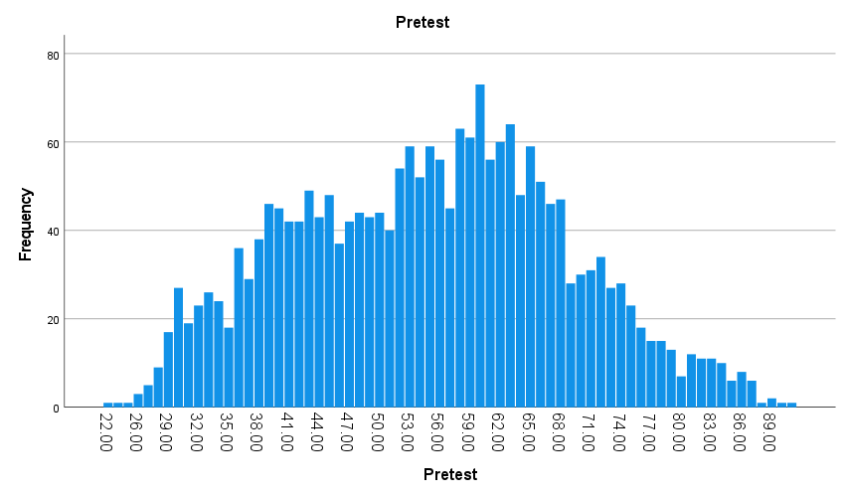

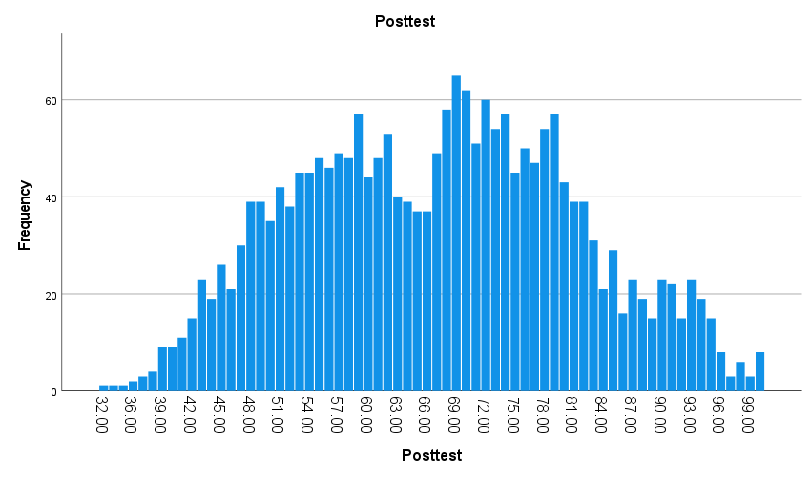

The averages show how many students are eligible for lunch. These children have a lower grade point average, so they are more likely to qualify for free lunch. Ineligible students have a higher mean, indicating a lower prevalence of lunch eligibility.

3.4. Mean and median differences of students' pre-test and post-test scores

Statistics
 |  | Pretest | Posttest
N | Valid | 2133 | 2133
N | Missing | 0 | 0
Mean |  | 54.9559 | 67.1022
Median |  | 56.0000 | 68.0000

Pretest
 |  | Frequency | Percent | Valid Percent | Cumulative Percent
Valid | 22.00 | 1 | .0 | .0 | .0
Valid | 23.00 | 1 | .0 | .0 | .1
Valid | 25.00 | 1 | .0 | .0 | .1
Valid | 26.00 | 3 | .1 | .1 | .3
Valid | 27.00 | 5 | .2 | .2 | .5
Valid | 28.00 | 9 | .4 | .4 | .9
Valid | 29.00 | 17 | .8 | .8 | 1.7
Valid | 30.00 | 27 | 1.3 | 1.3 | 3.0
Valid | 31.00 | 19 | .9 | .9 | 3.9
Valid | 32.00 | 23 | 1.1 | 1.1 | 5.0
Valid | 33.00 | 26 | 1.2 | 1.2 | 6.2
Valid | 34.00 | 24 | 1.1 | 1.1 | 7.3
Valid | 35.00 | 18 | .8 | .8 | 8.2
Valid | 36.00 | 36 | 1.7 | 1.7 | 9.8
Valid | 37.00 | 29 | 1.4 | 1.4 | 11.2
Valid | 38.00 | 38 | 1.8 | 1.8 | 13.0
Valid | 39.00 | 46 | 2.2 | 2.2 | 15.1
Valid | 40.00 | 45 | 2.1 | 2.1 | 17.3
Valid | 41.00 | 42 | 2.0 | 2.0 | 19.2
Valid | 42.00 | 42 | 2.0 | 2.0 | 21.2
Valid | 43.00 | 49 | 2.3 | 2.3 | 23.5
Valid | 44.00 | 43 | 2.0 | 2.0 | 25.5
Valid | 45.00 | 48 | 2.3 | 2.3 | 27.8
Valid | 46.00 | 37 | 1.7 | 1.7 | 29.5
Valid | 47.00 | 42 | 2.0 | 2.0 | 31.5
Valid | 48.00 | 44 | 2.1 | 2.1 | 33.5
Valid | 49.00 | 43 | 2.0 | 2.0 | 35.5
Valid | 50.00 | 44 | 2.1 | 2.1 | 37.6
Valid | 51.00 | 40 | 1.9 | 1.9 | 39.5
Valid | 52.00 | 54 | 2.5 | 2.5 | 42.0
Valid | 53.00 | 59 | 2.8 | 2.8 | 44.8
Valid | 54.00 | 52 | 2.4 | 2.4 | 47.2
Valid | 55.00 | 59 | 2.8 | 2.8 | 50.0
Valid | 56.00 | 56 | 2.6 | 2.6 | 52.6
Valid | 57.00 | 45 | 2.1 | 2.1 | 54.7
Valid | 58.00 | 63 | 3.0 | 3.0 | 57.7
Valid | 59.00 | 61 | 2.9 | 2.9 | 60.5
Valid | 60.00 | 73 | 3.4 | 3.4 | 63.9
Valid | 61.00 | 56 | 2.6 | 2.6 | 66.6
Valid | 62.00 | 60 | 2.8 | 2.8 | 69.4
Valid | 63.00 | 64 | 3.0 | 3.0 | 72.4
Valid | 64.00 | 48 | 2.3 | 2.3 | 74.6
Valid | 65.00 | 59 | 2.8 | 2.8 | 77.4
Valid | 66.00 | 51 | 2.4 | 2.4 | 79.8
Valid | 67.00 | 46 | 2.2 | 2.2 | 82.0
Valid | 68.00 | 47 | 2.2 | 2.2 | 84.2
Valid | 69.00 | 28 | 1.3 | 1.3 | 85.5
Valid | 70.00 | 30 | 1.4 | 1.4 | 86.9
Valid | 71.00 | 31 | 1.5 | 1.5 | 88.3
Valid | 72.00 | 34 | 1.6 | 1.6 | 89.9
Valid | 73.00 | 27 | 1.3 | 1.3 | 91.2
Valid | 74.00 | 28 | 1.3 | 1.3 | 92.5
Valid | 75.00 | 23 | 1.1 | 1.1 | 93.6
Valid | 76.00 | 18 | .8 | .8 | 94.4
Valid | 77.00 | 15 | .7 | .7 | 95.1
Valid | 78.00 | 15 | .7 | .7 | 95.8
Valid | 79.00 | 13 | .6 | .6 | 96.4
Valid | 80.00 | 7 | .3 | .3 | 96.8
Valid | 81.00 | 12 | .6 | .6 | 97.3
Valid | 82.00 | 11 | .5 | .5 | 97.8
Valid | 83.00 | 11 | .5 | .5 | 98.4
Valid | 84.00 | 10 | .5 | .5 | 98.8
Valid | 85.00 | 6 | .3 | .3 | 99.1
Valid | 86.00 | 8 | .4 | .4 | 99.5
Valid | 87.00 | 6 | .3 | .3 | 99.8
Valid | 88.00 | 1 | .0 | .0 | 99.8
Valid | 89.00 | 2 | .1 | .1 | 99.9
Valid | 91.00 | 1 | .0 | .0 | 100.0
Valid | 93.00 | 1 | .0 | .0 | 100.0
Valid | Total | 2133 | 100.0 | 100.0

Frequency Table

Posttest
 |  | Frequency | Percent | Valid Percent | Cumulative Percent
Valid | 32.00 | 1 | .0 | .0 | .0
Valid | 34.00 | 1 | .0 | .0 | .1
Valid | 35.00 | 1 | .0 | .0 | .1
Valid | 36.00 | 2 | .1 | .1 | .2
Valid | 37.00 | 3 | .1 | .1 | .4
Valid | 38.00 | 4 | .2 | .2 | .6
Valid | 39.00 | 9 | .4 | .4 | 1.0
Valid | 40.00 | 9 | .4 | .4 | 1.4
Valid | 41.00 | 11 | .5 | .5 | 1.9
Valid | 42.00 | 15 | .7 | .7 | 2.6
Valid | 43.00 | 23 | 1.1 | 1.1 | 3.7
Valid | 44.00 | 19 | .9 | .9 | 4.6
Valid | 45.00 | 26 | 1.2 | 1.2 | 5.8
Valid | 46.00 | 21 | 1.0 | 1.0 | 6.8
Valid | 47.00 | 30 | 1.4 | 1.4 | 8.2
Valid | 48.00 | 39 | 1.8 | 1.8 | 10.0
Valid | 49.00 | 39 | 1.8 | 1.8 | 11.9
Valid | 50.00 | 35 | 1.6 | 1.6 | 13.5
Valid | 51.00 | 42 | 2.0 | 2.0 | 15.5
Valid | 52.00 | 38 | 1.8 | 1.8 | 17.3
Valid | 53.00 | 45 | 2.1 | 2.1 | 19.4
Valid | 54.00 | 45 | 2.1 | 2.1 | 21.5
Valid | 55.00 | 48 | 2.3 | 2.3 | 23.7
Valid | 56.00 | 46 | 2.2 | 2.2 | 25.9
Valid | 57.00 | 49 | 2.3 | 2.3 | 28.2
Valid | 58.00 | 48 | 2.3 | 2.3 | 30.4
Valid | 59.00 | 57 | 2.7 | 2.7 | 33.1
Valid | 60.00 | 44 | 2.1 | 2.1 | 35.2
Valid | 61.00 | 48 | 2.3 | 2.3 | 37.4
Valid | 62.00 | 53 | 2.5 | 2.5 | 39.9
Valid | 63.00 | 40 | 1.9 | 1.9 | 41.8
Valid | 64.00 | 39 | 1.8 | 1.8 | 43.6
Valid | 65.00 | 37 | 1.7 | 1.7 | 45.3
Valid | 66.00 | 37 | 1.7 | 1.7 | 47.1
Valid | 67.00 | 49 | 2.3 | 2.3 | 49.4
Valid | 68.00 | 58 | 2.7 | 2.7 | 52.1
Valid | 69.00 | 65 | 3.0 | 3.0 | 55.1
Valid | 70.00 | 62 | 2.9 | 2.9 | 58.0
Valid | 71.00 | 51 | 2.4 | 2.4 | 60.4
Valid | 72.00 | 60 | 2.8 | 2.8 | 63.2
Valid | 73.00 | 54 | 2.5 | 2.5 | 65.8
Valid | 74.00 | 57 | 2.7 | 2.7 | 68.4
Valid | 75.00 | 45 | 2.1 | 2.1 | 70.6
Valid | 76.00 | 50 | 2.3 | 2.3 | 72.9
Valid | 77.00 | 47 | 2.2 | 2.2 | 75.1
Valid | 78.00 | 54 | 2.5 | 2.5 | 77.6
Valid | 79.00 | 57 | 2.7 | 2.7 | 80.3
Valid | 80.00 | 43 | 2.0 | 2.0 | 82.3
Valid | 81.00 | 39 | 1.8 | 1.8 | 84.2
Valid | 82.00 | 39 | 1.8 | 1.8 | 86.0
Valid | 83.00 | 31 | 1.5 | 1.5 | 87.4
Valid | 84.00 | 21 | 1.0 | 1.0 | 88.4
Valid | 85.00 | 29 | 1.4 | 1.4 | 89.8
Valid | 86.00 | 16 | .8 | .8 | 90.5
Valid | 87.00 | 23 | 1.1 | 1.1 | 91.6
Valid | 88.00 | 19 | .9 | .9 | 92.5
Valid | 89.00 | 15 | .7 | .7 | 93.2
Valid | 90.00 | 23 | 1.1 | 1.1 | 94.3
Valid | 91.00 | 22 | 1.0 | 1.0 | 95.3
Valid | 92.00 | 15 | .7 | .7 | 96.0
Valid | 93.00 | 23 | 1.1 | 1.1 | 97.1
Valid | 94.00 | 19 | .9 | .9 | 98.0
Valid | 95.00 | 15 | .7 | .7 | 98.7
Valid | 96.00 | 8 | .4 | .4 | 99.1
Valid | 97.00 | 3 | .1 | .1 | 99.2
Valid | 98.00 | 6 | .3 | .3 | 99.5
Valid | 99.00 | 3 | .1 | .1 | 99.6
Valid | 100.00 | 8 | .4 | .4 | 100.0
Valid | Total | 2133 | 100.0 | 100.0

Bar Chart

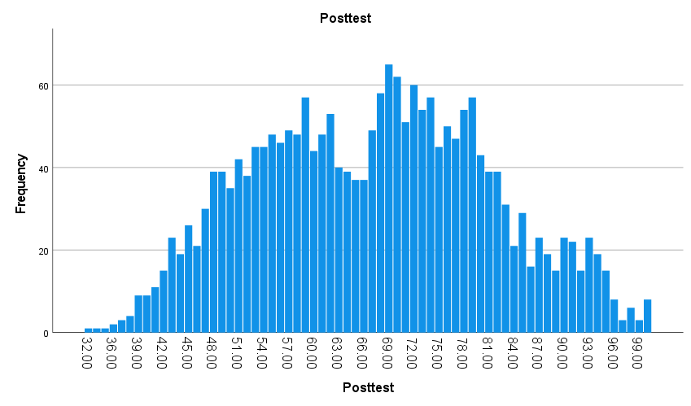

These data can be compared to find trends in their growth and performance over time. The average scores and central tendency of the data are shown, respectively, by the mean and median values. In the case analysed by us, the growth of both variables in the post-test period is visible.

3.5. Clustering

Quick Cluster

Initial Cluster Centers

 | Cluster
 | 1 | 2 | 3 | 4
Pretest | 23.00 | 93.00 | 50.00 | 59.00
Posttest | 35.00 | 100.00 | 53.00 | 85.00

Iteration Historyª

Iteration | Change in Cluster Centers
Iteration | 1 | 2 | 3 | 4
1 | 11.678 | 12.811 | 6.007 | 9.261
2 | 4.059 | 4.351 | 1.513 | 2.421
3 | 1.711 | 1.888 | .817 | 1.185
4 | .797 | 1.338 | .598 | .582
5 | .573 | .679 | .448 | .305
6 | .162 | .381 | .126 | .174
7 | .115 | .063 | .094 | .030
8 | .000 | .000 | .000 | .000
a. Convergence achieved due to no or small change in cluster centers. The maximum absolute coordinate change for any center is .000. The current iteration is 8. The minimum distance between initial centers is 32.450.

Final Cluster Centers

 | Cluster
 | 1 | 2 | 3 | 4
Pretest | 36.55 | 75.19 | 49.07 | 61.52
Posttest | 48.41 | 88.20 | 60.64 | 73.89

Number of Cases in Each Cluster
Cluster | 1 | 459.000
Cluster | 2 | 340.000
Cluster | 3 | 577.000
Cluster | 4 | 757.000
Valid |  | 2133.000
Missing |  | .000

We used K-means cluster analysis, which divides the data into K groups based on similarity using Pre-test and Post-test scores. Thus, we look for trends in identifying groups with distinctive characteristics and learning more about their performance in the school process.

- Data-mining and Text-mining methods in our business word
Data mining is the process of discovering important and accurate information in massive amounts of data (Kantardzic, 2011).
- Classification – through purchase history data, demographics and behavioural patterns, businesses can identify their most valuable customers. It is also used to detect fraudulent transactions as well as to assess risk.
- Regression - we use it in the credit and operational sectors and in supply chains, analysing historical data. This is how we optimize resource allocation, such as workforce and inventory levels, and production capacity.
- Mining Association Rules- analysing pages visited, customer comments and purchase data, direct searches for patterns of similar services and items. The practical application of this model is both in sales and in distribution and advertising.
- Clustering - uses the grouping together of related data items. Clustering techniques, which place data points into groups based on how similar they are, can be used for product recommendations and image identification.
- The decision tree used to predict service quality based on various factors, user opinion, number of sales and loyal customers.

Text-mining techniques are methods for analysing the text database and extracting insights (Rai, 2022). Some of the most commonly used are:

- Information extraction - by collecting relevant and related words or phrases used by the user, which are tracked and then the relevant data is found. The two most famous applications that use this analysis are Google and Yahoo.
- Summarization - can be helpful for tasks such as document summarization for legal or medical purposes, and a different social analysis.
- Categorization - this method serves to distribute personalized ads, detect spam, and classify web pages.
- Named entity recognition - we add an additional description to the client's wishes or some specific information about him.
- Sentiment analysis is the technique of examining the feelings or emotions conveyed in a text message and is implemented in machine learning for example.

- SPSS and Microsoft Excel - analysis of the strengths and weaknesses of the software

Spreadsheet software | Statistical analysis software
Can perform some statistical analysis | Advanced analytics, like regression, logistics, factor analysis, cluster analysis
Used in businesses were managing sensitive data on a broad scale | Used by many large companies and industries
Microsoft program for working and saving information through formulas and functions. | An IBM product for statistical analysis and information manipulation
Individual rows and columns are not considered variables (Domo, 2022) | Each individual column is a variable quantity (Domo, 2022)
- Conclusion
In conclusion, data analysis and visualization are crucial steps in any project. They help us make decisions and analyse large databases to see what our strategy should be. In this report, we used Microsoft Excel and SPSS with their tools and features and demonstrated how they can be useful in creating clear and visually understandable analyses for the user.

- References

Brudner, E., 2022. 22 Advantages & Disadvantages of Using Spreadsheets for Business. (Online)
Available at: https://blog.hubspot.com/sales/dangers-of-using-spreadsheets-for-sales
(Accessed 28 04 2023).
Domo, 2022. Real-time dashboards for real-time insights. (Online)
Available at: https://www.domo.com/solution/business-dashboards?utm_source=google&utm_medium=paidsearch&campid=7015w000000vnmAAAQ&gcreative=628072273132&gdevice=c&gnetwork=g&gkeyword=analysing%20data&gplacement=&gmatchtype=b&gtarget=&gadposition=&s_kwcid=AL!5964!3!6280
(Accessed 04 05 2023).
IBM, n.d. IBM SPSS software. (Online)
Available at: https://www.ibm.com/spss
(Accessed 30 04 2023).
JavaTpoint, n.d. Advantages and Disadvantages of MS Excel. (Online)
Available at: https://www.javatpoint.com/advantages-and-disadvantages-of-ms-excel
(Accessed 28 04 2023).
Kantardzic, M., 2011. Data Mining-Concepts, Models, Methods and Algorithms. 2nd ed. Hoboken, New Jersey: John Wiley & Sons.
Lesky, J., Osmic, M. & Simon, S., 2014. Data Visualisation in Spreadsheets, Graz: Institute for Information Systems and Computer Media (IICM).
Natter, E., 2019. The Advantages & Disadvantages of Spreadsheets. (Online)
Available at: https://smallbusiness.chron.com/advantages-disadvantages-spreadsheets-26551.html
(Accessed 29 04 2023).
Rai, A., 2022. What is Text Mining: Techniques and Applications. (Online)
Available at: Text mining techniques are methods for analyzing the text database and extracting insights. Some of the most commonly used are:
(Accessed 01 05 2023).

