STRATEGIC MANAGEMENT: A CASE STUDY "NETFLIX COMES TO BOLLYWOOD

STUDENT NAME: ALISHA SANGHANI
STUDENT ID:2122542
LECTURER NAME: GLADIUS KOLUTHUNGAN

Table of Contents
Introduction 3
Section 1 3
Background of the company 3
Strategy of the company 4
Success factors of the company 5
Section 2 6
Strategic analysis of the internal and external issues faced by Netflix 6
PESTLE Analysis 6
Porter's five forces 9
SOSTAC Model 11
Section 3 12
Analysis of Internal Environment 12
General Model of Business in Netflix 12
Figure 3: Business Model of Netflix 13
Financial factors in Netflix 14
Usage of VRIO framework 15
Table 1: VRIO analysis 15
Value chain analysis 18
Swot Analysis 19
Figure 4: SWOT analysis 20
Conclusion 22
Recommendation 22
References 24

Introduction
The following discussion is going to shed light on the strategic management of the OTT (Over the Top) giant Netflix. Strategic management generally depicts the planning of a company or an organization to meet its ultimate goal (Rêgo et al. 2021). Though there are several other areas that also come under strategic management. Monitoring the progress, analysis of the data and at the end to know about the necessaries that the organization needs. All the mentioned areas have been designed to reach a company or organization to achieve the goal that they have set and at the same time to meet the objectives of them also. Netflix is known as a famous OTT platform over the globe. On 29th August 1997 Netflix was founded, and from that time to the present time it has made a landmark in the OTT business (de Oliveira Dias and Duzert 2021).
The entire study is going to discuss the entry of Netflix to Bollywood and also how they manage their business in India. Though India has a huge viewer base, it will always have to remember that this market is also price sensitive. In the following discussion it will also be discussed how Netflix applied several strategies to grasp the market and at the same time how they reduced their competition. It is being needed to focus on the purpose of Netflix and at the same time it will also have to discuss how Netflix makes a higher amount of profit using several business strategies to grow in the large and price-sensitive market of India.

Section 1

Background of the company
According to the case study, the part of entertainment has been captured by television for several years. Hence after the growth of time there have been several changes that allow OTT platforms to enter in the field. After the revolution over the area mobile phone and laptops OTT platforms also started to come to the board. In the year 1997 Netflix had started their journey and from that time they were serving seamless services to their consumers (de Oliveira Dias and Duzert 2021). There are 190 countries where Netflix provides their service. It will have to admit that this is very big in numbers and at the same time the numbers also talk about their efficiency while providing their service. Starting from California this OTT platform reached every corner of the maximum country.
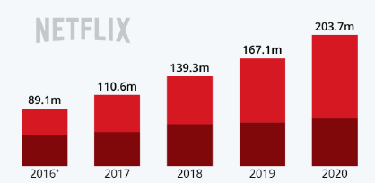
Figure 1: Revenue growth of Netflix
(Source: Statista, 2022 )
Marc Randolph and Reed Hastings are the owners of this company (Hurst 2019). They both worked for Pure Software and then decided to move on and started their new business. In the time of the rapidly growing television age, they thought of a streaming platform which can provide entertainment at any place. With this thought they gave birth to Netflix. Netflix is a streaming app which provides the customers a seamless streaming experience on behalf of a subscription. Starting with a single screen this company is now making a large amount of money from it and it is growing big day by day. Netflix is now a company worth 44 BIllion dollars and they are accruing the top position in terms of generating revenue (Lozic 2021). With the seamless service they are making things easy for the people and with several actions and planning they have made a revolution over the entertainment industry.

Strategy of the company
In order to grow in a rapid way there is a need for a solid and proper strategy along with planning. Netflix is a type of company who first thought of relaxing DVDs and then made a march throughout the world. Though India does not have a very economically stable audience base, they came to India and delivered several introductory plans. With this they started making a habit in between the people so that there can be a revolution with the help of the people's habit (Kumar et al. 2020). With this type of strategy Netflix always believed to retain their best employees and at the same time they also believe that it is their employees who work hard to deliver the best services to the consumers. Therefore, it becomes their duty to deliver them the best as well (Dillon 2020). Netflix was also aware that there will be so many competitions in the Indian market and for this reason they started to pick the popular web series and movies released in India and with the time people started to lean towards Netflix.

Success factors of the company
Being a huge name in the OTT platform, it was not an advantage for Netflix to spread their business in India. All the portions were different in case of India and at the same time a fresh strategy to grow. There can be mentioned several factors which helped Netflix to become a large brand in India. From the very beginning it was obvious that if there will not be an entry to Bollywood, then it will be tough to grab the market. Netflix strategically did this and with several popular picks they made a mark in the section (Khanna and Malviya 2020).
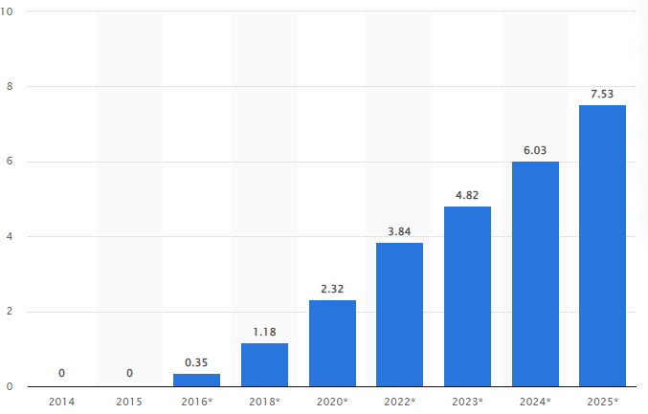
Figure 2: Viewer’s growth graph (Netflix India)
(Source: Statista, 2022)
Moreover, they became successful in creating a Netflix culture among the people and though their subscription price was higher than the other OTT platform, they managed to get 5 million consumers of their application in India. Though the economically Indian audience was not that able to afford the plan of Netflix, there was a will to grab the subscription to Netflix as well.

Section 2

Strategic analysis of the internal and external issues faced by Netflix
Strategic analysis generally means to a particular process through which a company goes and throughout this process, the company or the organization come to know about the business environment that they are having. In this particular discussion, the strategic analysis of the internal and external issues that are faced by Netflix is going to be discussed. In order to conduct the entire process, there are going to use several models like PESTLE, and Porter's five forces model. All these models are going to help to know about the internal and external issues faced by Netflix and at the same time with all the analysis it is going to be a proper discussion of the issues faced by Netflix in the Indian market.

PESTLE Analysis
Political Factors  - The issue of censorship has become a concern in India  - Due to some political mismatch their content has been banned in many parts of India  - Several restricted access in India to spread | Economical Factors  - The rising trend of Indian GDP  - Increasing competition in the OTT business in India  - Privacy protection and piracy  - The household and their savings strategy | Social Factors  - The blend of different cultures in India  - The growing birth rate of India  - The difference in social norms in India
Technological Factors  - User can access the high-quality video  - Data privacy of the customers  - Use of the advance software to maintain the application | Environmental Factors  - Trend of reusable energy  - Trend of using less papers  - Prioritizing the environment in more acceptable way | Legal Factors  - The high price for the subscription becomes a cause of conflict  - Rising claim of copyright makes according to the Copyright Act 1957  - Ethical correction while providing service

Though in the Indian context it becomes so much difficult to make the business in a very proper way. The subscription plan that Netflix recently has in the Indian context is comparatively high. Though according to the case study, Netflix is going to hit 100 million subscribers in the context of the Indian market, it is going to be a tough task for them. The main competition that Netflix has in the context of the Indian market is Disney Hotstar. The price of their introductory plan is 99, where the user can stream 1080p videos on a single screen. In order to make a competition, Netflix introduced their one-month plan at rupees 199 (Kumar et al. 2020). Though their price was higher, the other problem with this plan was the user can only stream 480p videos with it. At the same time, cultural communication has always been a tough journey for Netflix in India. Hindi is the language that may count as the most said language in India. Hence there are several contents in the house of Netflix where it has been a serious concern for Netflix.
Political factors
In case of discussing political factors, it will always have to keep in mind that it will be judged in the Indian context. Being a US-based brand Netflix first faced issues with censorship (Chattopadhyay 2020). There were several contents on Netflix at that time which were not appropriate for the Indian audience. Hence the brand faced many issues regarding this as well. India has a vast cultural environment. Here you can see several cultures. Therefore, this diversity of culture makes things difficult for them because it can act like a threat that there can be a ban on any content to hurt the sentiment of other communities.
Economic factors
The economic factors can become the most crucial one and at the same time, there are several issues that can affect Netflix to growth in the Indian market. This economical factor, there is needed to draw attention to several points like the growth of GDP. At the same time, there can be seen a higher growth of competition among the OTT platforms in India (Sundaravel and Elangovan 2020). It was a disadvantage for Netflix because its subscription fees were much higher than the other OTT platforms. It becomes a disadvantage for them and at the same time in case of competition, it becomes a big issue for them. According to the case study, India does not have a large number of viewers who will buy a subscription plan with a handsome amount of money.
Social factors
Social factor is a kind of factor where it can be complicated for Netflix. Though Hindi is the most used language in India, there are several cultures out there (Lobato and Lotz 2020). People of other cultures love to view the content in their own language. There are also several regional languages which are also very much popular in India as well. Netflix will have to make the balance in between these two and at the same time, there will have to control over the content and will have to maintain the rate of the content so that any community should not be hurt. Hence if they become unsuccessful to do this, it can become a massive issue for them in the future to spread over the Indian market.
Technological factors
It needs to be technologically correct and at the same time, if an OTT platform becomes successful to provide privacy to their user, there cannot be anything better (Kulkarni and Bedekar, 2022). At the same time if they made it easier for the audience with the introduction of high-quality video. The use of better technology to maintain the application can be very effective because if the application is optimized there can be a large gathering audience. The user interface should be optimized. If Netflix in the Indian market is thinking of making a revolution or thinking of going to the top, they are needed to focus on the technology as well.
Environmental factors
There is a common policy that if someone wants to enter any new region then there is a need to accept the minimal things of that region. Though it is pretty clear that there will be several obstacles for Netflix and at the same time they will have to think about it with a critical mind and there is a need to accept the environmental orders and should also participate in the programmes that connect with the environment as well. Also, if they made a series or a short movie regarding environmental awareness in the context of India, then it will be more acceptable to them and at the same time, it will reflect goodwill for them as well.
Legal factors
Legal factors can be considered the most important and the main factor that can affect Netflix in a very negative way while spreading its business in India. First, the subscription fees of Netflix are really high and there are several more platforms that offer content at less price (Sundaravel and Elangovan 2020). Though Netflix should look into it and should fix the issue as early as possible if they want to grow in the Indian market. They will always have to keep in mind that if they begin to raise the subscription price there will be a conflict with the consumers and at the same time, this will affect them negatively. They should also be needed to be ethically correct while providing by keeping private the data of their customers.

Porter's five forces
Porter's five forces generally reveal the power that the company or the organisation have. It mainly studies several areas like rivals, the potential of the new market entrants, the quality of the suppliers, amount of the audience base and in the end suitability of the product that the company. All these factors decide how this company or organization will perform during the economic growth. This particular model is really very descriptive and with the help of this model, several areas will be very easy to understand. Hence this model helps to know about the areas where the company or the organization should work and also at the same time which area is pretty strong for the company as well.
Rivalry between competitors (High): In the case of competition there can be stated that in the Indian market context there are several strong competitors like Disney Hotstar and Amazon Prime Video. All the competitors are the best in their area and making things better day by day (Sundaravel and Elangovan 2020). There it will always be a threat for Netflix because Amazon Prime and Holster provide service at a lower cost and there are many consumers who will directly lean towards those platforms. At the same time, there are several extra benefits of using those platforms, where there are no added advantages from Netflix's side after paying a higher amount.
Threat of entry (Low): In recent times there are several OTT platforms available in India. Netflix is one of them. All the competitors of Netflix are also very well known in this particular field. Therefore, it can be stated that there is not that much threat of new entry in the market for Netflix. Hence if they do not want to make them an option for the Indian audience, Netflix is being needed to change their subscription rate as early as possible. It will make the graph high for them and at the same time, there is also a need of making several changes to their policies of them (Lotz et al. 2022). If they become unsuccessful in doing this, their competitors will take the place that they have been in recent times.
Threat of substitutes (Low): Netflix is a brand that is already spreading its business worldwide. They have already accrued a brand name. Also, they have a good audience base over the globe and also many people are leaning towards them in recent times. Hence it can be stated that the threat of substitutes is low for Netflix. In the end, it will always have to state that if they really want to grow high in the Indian market and avoid the threat of substitutes, it will have to change its policy.
Power of Buyers (Low): If it comes to the power of buyers, it is clear that this index will show a lower graph. Netflix has a pretty high subscription rate and this is not acceptable or affordable to many consumers and the consumers switch or avoid Netflix from the very first day (Singh 2019).
Power of Suppliers (High): Being a global brand it will have to state that the range of supply will be always high from the side of Netflix. They are ruling here in this area and they are going to rule the area in the future as well (Mukherjee 2019). It will have to admit that the delivery of contents is top notch and they always dapat the best system. Hence looking at the Indian market it cannot be considered and if they want to make a mark on the Indian market of OTT, then they need to be more popular when making their policy and while deciding their subscription fees.

SOSTAC Model
P.R Smith in 1990 created the SOSTAC model (Mentari et al. 2022). Sostac Model generally helps in marketing planning and this model works with the help of several stages following Situation, Objectives, Strategy, Tactics, Action and Control.
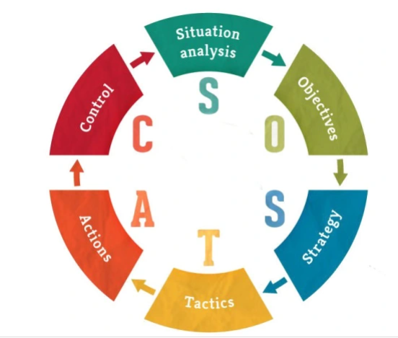
Figure : SOSTAC model
(Source : digitalmarketingvtos, 2019 )
Situation
The current position of Netflix in the world is stable and they are expanding its business in many countries. India is one of those countries and with the slogan of ‘ Netflix comes to Bollywood’, they are trying to make their grip on India with the help of several plans.
Objectives
The objectives of Netflix in the context of India are:
- To expand their brand largely in India
- To grasp the high consumer base that India has
Strategy
In order to meet the objectives Netflix has been thinking of an introductory plan and at the same time to be in competition with the other brands they have introduced several options regarding the plan, keeping in mind the economic unstable market of India.
Tactics
If it is necessary for Netflix to make several changes in their plans keeping in mind about the market and the customer base of India, they want a successful expansion of their business in India.
Action
With the yearly plans, Netflix also has launched monthly plans so that they become successful in capturing large numbers of customers. These plans will help them to be in the market with a stable p[osition as well.
Control
The successful implementation of every plan can help Netflix to achieve the place that they are expecting in the context of the Indian market and audience. They will have to be proper while making a step and all the steps should have been taken carefully.

Section 3

Analysis of Internal Environment

General Model of Business in Netflix
According to Aversa et al., (2019), the attribute which is followed within the internal sphere of business in Netflix mainly comprise the policies that aim to curtail the prevalence of piracy of contents which is sought after by the population in India as well as other nations. Therefore, when it comes to the profitable matters in the company the entire facility regarding the logistics is associated with the formation of a network across Europe which has led to the formation of a base of audience in countries namely India. According to Iordache et al., (2022), there have been negotiations regarding trade that allowed Netflix to make an entry within India. This caused the company to create a market connected to the phenomenon of cross-cultural factors as a result of which the company has been able to make an entrance within the segments of Bollywood. Apart from this, there also has been a number of measures that led to the creation of the quintessential infrastructures across India from the end of Netflix, thereby, enabling the company to aid supplemental distribution of content that incorporates both audio and visual elements (Lotz, 2021).
The range of innovation exercised by Netflix in areas of India can be correlated with the matters of the desire among the audience to have access to those kinds of content which are often deemed to hold qualities that are premium. Therefore, the CEO of Netflix always strove to an aim to ensure the provision of those content which are going to break the boundaries as well as the expectation of culture within India. All the episodes which are provided from the end of a premium form of shows are aimed to be provided to the audience using a service based on subscription. This service entwined with the subscription is often maintained through an interface that is simplified as well as convenient for the respective users (Netflix, 2022). As mentioned by Minzheong (2020), Netflix has been able to promote provisions of a model of business which is not heavily reliant on building partnerships with other operators of the services comprising audio or visual forms of content.
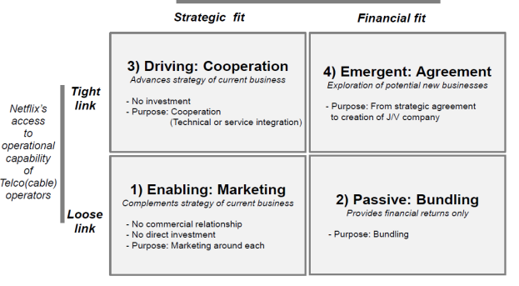

Figure 3: Business Model of Netflix
(Source: Song, 2021)
Figure 3. which has been formulated by Song (2021) shows the overall elements which are incorporated by Netflix to aid business in countries outside Europe, namely India. Cherla et al., (2021) opined that Netflix incorporates one such form of licensing which has the facility for using a fixed form of cost. This phenomenon enables the company to show content from the sphere of Bollywood without having to go through the borrowers enforced by any specified culture in India. In addition to this, Netflix also has the facility to leverage the purchases made from its end that allowing the company to maintain a reasonable amount of profitability thereby aiding the elimination of unwarranted advertisements or any kind of interruption towards the audience. According to Song (2021), the outsourcing of infrastructure along with services also enabled Netflix to provide content which is considered to be premium to the viewers across every area in India. This facilitates the company to ensure that the content associated with Bollywood remains accessible at a rate which is affordable among every stratum of the viewers.

Financial factors in Netflix
When it comes to the structure in the realm of finances, Netflix enhances the scope of reaching a wonder base of income by providing content which is often exclusive or completely original in its sphere of activity (Bouquillion, 2020). Therefore, whenever it decides to make an entry into every segment of Bollywood, it is able to incorporate the same tactic it uses in the areas that are pan-European. This causes the company to change the policy with regard to subscriptions and eliminate any form of discount. In spite of doing all this, the audience is still willing to pay the prerequisite amount associated with the subscription thereby enhancing the policy of income within NetFlix. According to Putri and Paksi (2021), Netflix is also able to maintain its base of customers by incorporating a system that enables the company to aid the reception of feedback from the users on the basis of loops. This in turn allows the company to maintain relationships with its audience across India who are avid consumers of content related to Bollywood.
As per Panda et al., (2021) Netflix divides its segments for revenue based on the section of the content in India. Therefore, when it comes to the revenue gained from movies, it will be different from those gained from the provision of services of other kinds such as web series. Apart from that, the content which is provided from the end of Netflix is not only inclusive of mere content from Bollywood but also enables the audience to experience content in a way which is completely catered for the mentality of the viewers and market within India. It has been mentioned by Maksyshko and Vasylieva (2021) that Netflix is also able to establish a scenario of monopoly when it comes to the services of streaming in India. This has been achieved by the company through the purchase of rights which are specific to the contents and production in the realm of Bollywood.
In addition to this, the company has also established a circumstance of exclusivity which keeps its customers glued to its services even if the rate provided for subscription is outside the purview of income of the audience (Chelliah et al., 2021). According to Meng et al., (2022), the sphere of profitability in Netflix is deemed to show steadiness in the upcoming future. This is mainly due to the fact that there is a steady rise in the utilisation of services for streaming content which are web-based. As a result of this, the phenomenon is also becoming more prevalent in the Indian sphere of consumption of entertainment. Sul and Turconi (2021) opined that Netflix conducts meetings to aid discussion about the failure in the field regarding finances that caused setbacks to the company. Now that the company is operating within India and has made a mark in a specific industry of this country namely Bollywood, the company adopts the same framework for carrying out business through successful means. The main element that provides competitiveness to Netflix in relation to Bollywood is that most of its content is curated through algorithms that are at par with the preferences of the customers.

Usage of VRIO framework

Valuable | Rare | Inimitable | Organisation
- Reckoned brand  - Brand image, innovation, and supplier relationships  - Capability of raising funds | - Risk taking capacity  - Adaptability | - Market communication  - Product quality  - Customer experience  - Competitive pricing | - Human resource  - Organisation culture  - Distribution network  - Production capacity  - Employee training  - Research and development

Table 1: VRIO analysis
(Source: Created by Author)
Valuable
Netflix's steady expansion over the years has shown that it has achieved a significant competitive edge over its rivals, even beating some of them. According to Rataul et al. (2018), innovation, Netflix's ability to manage internet streaming even with the obstacles, and other reasons would all contribute to this aim being realised. In recent months, Netflix has taken matters into its own hands and started producing original programming under its own brand. Participation in CSR activities helps Netflix to acquire a unique set of skills that cannot be replicated by any other company. This is because CSR activities are strategically integrated into Netflix's overall business objectives. Annual reports and the company's website inform all stakeholders of the company's operations and social responsibility efforts. Therefore, as mentioned by Fleischman et al. (2021), Netflix's strong reputation for brand integrity and positive equity, the Netflix brand is widely recognised. This strong brand awareness is critical for both sales and corporate value. In nations where operational units are not present, the firm has been able to effectively deliver items and make them incredibly accessible. This was made successful because to the company's worldwide supply chain's extremely efficient distribution structure. This is a vital resource for the corporation since it helps Netflix to take advantage of new markets and areas throughout the world by adhering to stringent rules and criteria in its dealings with distributors and suppliers.
As opined by Huang et al. (2021), Netflix is able to cut its operating expenses and gain economies of scale because of its extremely inventive product offerings and services. Since the company's innovation propensity has helped it manage environmental concerns and take advantage of environmental opportunities, it has been a useful resource. However, the company's anticipated development and diversification will need the capacity to acquire funds internally. Rare
Despite its global reach, Netflix also has a presence in the Hindi-speaking world. As a result of its global reach, as Seo and Park (2020) stated that Netflix has been able to attract new customers and generate income in several countries. As a result, the corporation has gained not just more financial power but also more cultural exposure and worldwide acclaim. Due to this, Netflix's worldwide background and experience is a rare resource. Many organisations do not have the capabilities that are unusual in nature, but Netflix has, and this gives Netflix a competitive edge in the Indian market. As Madewa (2018) suggested that Netflix encourages its workers and management to engage in collaborative problem-solving as part of the company's corporate culture. This makes it possible for the firm to have better levels of cooperation, creativity, and innovation in Bollywood, all of which contribute to higher competitiveness. Higher competitiveness, in turn, leads to competitive advantage and benefits for the organisation in the marketplace in both the short run and the long run. Therefore, the organisation has a unique capability that gives it the ability to avoid potentially dangerous situations and capitalise on favourable ones.
Inimitable
Netflix has taken a systematic approach to the usage of marketing messages in an effort to encourage increased use. According to Sull and Turconi (2021), the organisational culture and the business vision, both of which are shaped by the strategic leadership of the company, encapsulate the strategic emphasis of the company, making it something that cannot be replicated. Therefore, the marketing communications for the firm are inimitable resources, which has enabled the brand to retain a long-term edge in terms of competitiveness on an international level. As a result, customers in India and the other locations where Netflix does business are able to acquire its offers and products with relative ease. Conversely, as Hermawan and Tjendrasa (2020) argued that Netflix providing customers with items of a high standard has been a major contributor to the brand's popularity. Since of the high quality and consistency, customers are more likely to make repeat purchases and consume more of Netflix's goods, which is an incomparable resource for the firm because the high quality and specifics of prediction are only known to the highest management of the company.
For Bollywood users, Netflix offers a one-of-a-kind experience. Furthermore, Sull and Turconi (2021) stated that the organisation provides customers with a high level of brand connection via unique and relevant experiences. Using many touch points, the organisation provides a comprehensive experience that inspires consumers to return for more transactions. Therefore, the Netflix customer engagement and brand experience have gone beyond the basic product providing to include offering and interacting with customers with the creation of relevant content that helps the brand enhance its equity. As a result, this is a non-sustainable advantage. Organisation
As Netflix (2022) argued that Netflix's financial strength enables the corporation to analyse prospective mergers and acquisitions for getting a competitive edge by exploring new product innovations and releases in Bollywood. Furthermore, the company's financial strength has helped it concentrate on product innovation and quality control across India, where it operates. The company's broad and well-managed distribution network benefits greatly from its financial stability. As a result, the corporation can manage its worldwide operations more efficiently because of technological innovation and integration. Nafees et al. (2021) stated that to remain competitive and make the most of other resources, the Coca-Cola Company has made significant investments in R&D that are clear and targeted. The firm's supply chain consists of a variety of distinct distribution networks, including those owned and operated by the company, as well as those that are agency and dealer based.

Value chain analysis
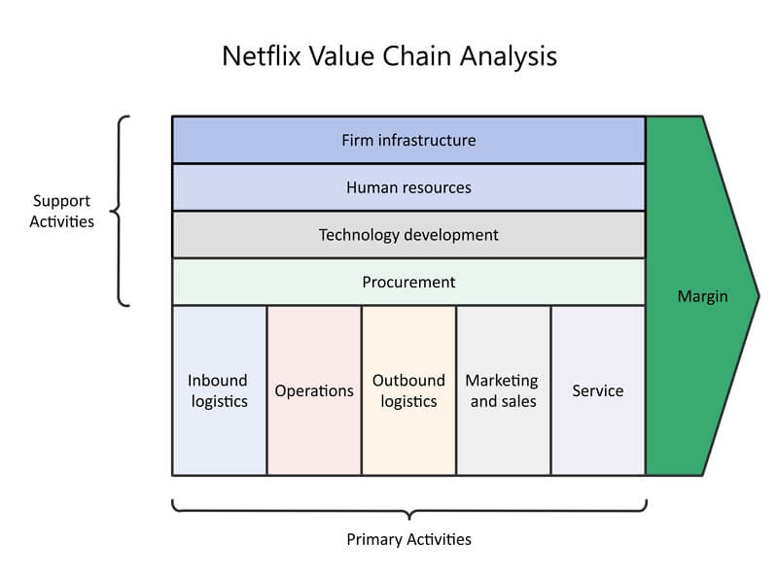
Figure 4 : value chain analysis
(Source : Salvador et al., 2019)
Inbound logistics
The processes of collecting, maintaining, and dispersing the inputs of the items are known as inbound logistics in the Netflix value chain. According to Salvador et al. (2019), in the current Netflix value chain, digital media constitutes the information commodity. Netflix has great connections to content creators such as Warner Bros. and others.
Operations
A company's operations are the activities and processes it does in order to transform incoming materials into finished goods for sale. The operations are where Netflix increases productivity and optimises efficiency. Hence, management and the underlying platforms are at the heart of the company's operations for entry into Bollywood.
Outbound logistics
Company items are sent to clients via a procedure known as "outbound logistics." Netflix's websites and applications are part of the company's outbound logistics since that is where the company's viewers will be seeing the content (Chalaby, 2019). Customers provide the material on both Android and iOS. Thus, customers would enjoy uninterrupted streaming thanks to the seamless integration of cloud infrastructure with outbound logistics.
Marketing and sales
Netflix's advertising expenditure has grown substantially over the last couple of years. The annual budget for advertising at this firm was $2.60 billion in 2019 (Linkedin, 2022). Marketing and advertising are integrated into the platform in an effort to draw users there. Along with this, the corporation spent $2.57 billion on advertising in 2018, which resulted in an increase in clientele. Therefore, Netflix's advertising strategies have consistently been open and honest with its audience.
Services
According to Chalaby (2019), Netflix's economic strategy relies on a number of different types of client contributions. One of the most popular features, according to corporations. Most of Netflix's value creation occurs after subscribers have already paid for the service. Consequently, offering these services and delighting customers in Bollywood is an essential element of the company's value chain.

Swot Analysis

Strengths  - Strong online presence  - Financial position  - High-quality product  - Geographical presence | Weaknesses  - Poor waste management practices  - Poor inventory management  - Organisational culture  - Lack of efficiency  - Customer dissatisfaction
Opportunities  - Exponential growth  - Adjacent market  - Increasing standardisation  - Reducing the cost of market entry | Threats  - Threats of new enters  - Culture of sticky prices in the industry  - Average brand image

Figure 4: SWOT analysis
(Source: Created by Author)
Strengths
- The impact of good e-WOM and the development of strong ties with Bollywood consumers may be amplified by a strong online presence on various social networking sites and excellent social media management.
- As mentioned by binged (2022), Netflix in India, The Way Ahead's success in a competitive market is enhanced by high product quality. In terms of Indian original shows, Netflix has mostly focused on Hindi-language productions. There is a reasonable but not very amazing 6.7/10 average rating for Hindi series on IMDb. Despite the fact that Netflix's success comes from its sporadic selection of titles with a focus on quality content. For example, the selection of programs like 'Sacred Games’ and 'Delhi Crime' alone merits plaudits from Netflix's senior executives.
- Moreover, according to Rostika and Kunkurat (2019), Netflix has a solid track record of discovering new and interesting shows that were previously available on other streaming services. Indian examples include TVF's highly praised shows "Kota Factory" and "Little Things," both of which have won several awards and nominations. While 'Cobra Kai,' an internationally popular cartoon originally streamed on YouTube, has found a home on Netflix. According to the choices made by Netflix, we believe they are on the correct track in this regard and should continue to take advantage of these shows.

Weaknesses
- There is a lack of efficiency in Netflix subscription video on demand’s (Svod) inventory and cash flow management.
- A company's capacity to grow its existing customers and drive repeat purchases is harmed when promotions and marketing initiatives are underfunded (Tyagi and Krishna, 2019).
- Netflix's marketing techniques, price, and lack of brand image were its main flaws. It had a difficult time gaining traction in India. They ran into issues due to a lack of local production and research on what customers desired (Moneycontrol, 2022). Only 7.5% of Netflix was specifically designed for Indian viewers. To advertise an American product in the Indian market is comparable. Due to the absence of brand image, many Bollywood consumers stayed with rivals who offered free services or services specialised in certain areas.
Opportunities
- The size of the market has increased rapidly during the previous half-decade. Consumer tastes and preferences have changed as a result of the entry of new clients. Netflix Svod has a major issue as a result of this: how to keep existing subscribers happy while also attracting new ones (Sull and Turconi, 2021). With the help of numerous brands and a variety of features, Netflix Svod has attempted to diversify.
- Technology advancements in the manufacturing and delivery processes would be used to incorporate innovation into company practices.
- According to Rostika and Kunkurat (2019), the risks of entering and marketing in the Indian market have been greatly decreased as a result of globalisation and the explosion of digital marketing and social media.
Threats
- Inflation raises manufacturing costs, which has an effect on the profitability of the Bollywood industry (Moneycontrol, 2022).
- It would be difficult for Netflix to overtake well-established rivals like Eros Now and Hot Star in the Indian market.
- When supplied items or services are not environmentally sustainable, the rising environmental sustainability trends pose a serious danger. In a competitive market, it attracts attention from environmentalists, which may harm a company's brand image (binged, 2022).
- A lack of cultural intelligence would have a negative influence on Netflix's ability to operate beyond national borders and cope with cultural diversity.

Conclusion
With the use of several analytical methods and frameworks, this study was able to explore and analyse Netflix's strategic intentions and fundamental challenges in Bollywood. To begin, it was critical to have a general understanding of Netflix's inner workings by studying the company's goal, vision, and purpose. The report's focus was on the firm's strategic goals and how Netflix's performance as an innovative organisation contributed to its success. With the use of PESTEL analysis, the external environment study was given and provided an insight into the environmental aspects impacting the firm. A Porter's Five Forces, Value chain and a VRIO framework study of the industry are then performed, as is a comprehensive industry analysis. As a result of these findings, a SWOT analysis was conducted to better understand Netflix's relative strengths and weaknesses, potential opportunities and threats, and more.

Recommendation
- To reach its goal of 100 million customers, Netflix will have to expand into the Indian market basically for Bollywood. Netflix's largest threat comes from the growing number of rivals, who are posing an increasing amount of competition.
- The company's strategy, which includes premium pricing, no add streaming services, and a concentration on streaming services, will remain unchanged.
- Netflix must include advertisements in its streaming service in order to boost its profitability and reach its goal of 100 million Indian subscribers. This would allow the corporation to provide cheaper streaming that affects the price-sensitive populace, which will benefit the company's bottom line.
- As Netflix attempts to stabilise and establish itself in Bollywood, the company's primary goal should be to improve its margin relative to its rivals. Pricing should be their final alternative if they want to reach this goal and keep it steady.

References
Attaran, M. and Deb, P., 2018. Machine learning: the new big thing for competitive advantage. International Journal of Knowledge Engineering and Data Mining, 5(4), pp.277-305.
Aversa, P., Hervas-Drane, A. and Evenou, M., 2019. Business model responses to digital piracy. California Management Review, 61(2), pp.30-58.
binged. 2022. [online] Available at: <https://www.binged.com/news/swot-analysis-netflix-india-original-series-portfolio/> [Accessed 6 August 2022].
Bouquillion, P., 2020. Industrial and Financial Structures of Over-the-Tops (OTTs) in India. In Platform Capitalism in India (pp. 129-149). Palgrave Macmillan, Cham.
Chalaby, J.K., 2019. Understanding Media Globalization: 373A Global Value Chain Analysis. In The Routledge Companion to Global Television (pp. 373-384). Routledge.
Chattopadhyay, A., 2020. Web Series and Web Movies and their psycho-sociological impact on netizens in India. A Quarterly Bilingual Peer-Reviewed Journal for Social Sciences and Humanities.
Chelliah, B.J., Barik, S.K., Sunan, S. and OR, N.K., 2021. A Context Aware and Adaptive Methodology for Robust Netflix Recommendation framework. Turkish Journal of Computer and Mathematics Education (TURCOMAT), 12(6), pp.4790-4799.
Cherla, A., Howard, N. and Mossialos, E., 2021. The ‘Netflix plus model’: can subscription financing improve access to medicines in low-and middle-income countries? Health Economics, Policy and Law, 16(2), pp.113-123.
de Oliveira Dias, M. and Duzert, Y., 2021. The Evolution of Netflix in Brazil: The First Decade. GSJ, 9(12).
Dillon, J.D., 2020. More than netflix: The real potential of personalised learning. Training & Development, 47(2), pp.20-23.
Fleischman, B., Ondracek, J., Saeed, M. and Bertsch, A., 2021. Netflix: Strategizing Corporate Resources and Capabilities.
Hermawan, W. and Tjendrasa, K., 2020. Evaluation Of Investment In IoT Startup at PT TMI. Jurnal Ilmu Sosial Politik Dan Humaniora, 3(2), pp.22-31.
Huang, Y., Lv, Z. and Sui, Z., 2021, October. Where Should Existing Video Streaming Platforms Improve: A Comparative Analysis of Netflix and IQiyi. In 2021 International Conference on Public Relations and Social Sciences (ICPRSS 2021) (pp. 585-592). Atlantis Press.
Hurst, B.K., 2019. The Devil is in the Trademark: A Discussion of the Satanic Temple v. Netflix. Rutgers JL & Religion, 20, p.319.
Iordache, C., Raats, T. and Donders, K., 2022. Trends and Perspectives on Digital Platforms and Digital Television in Europe| The “Netflix Tax”: An Analysis of Investment Obligations for On-Demand Audiovisual Services in the European Union. International Journal of Communication, 16, p.21.
Khanna, P. and Malviya, M., 2020. Identification of Success Factors for Mirzapur Web Series. Management, 8(2), pp.21-27.
Kulkarni, S. and Bedekar, M., 2022. Perception of privacy in a data driven world.
Kumar, J., Gupta, A. and Dixit, S., 2020. Netflix: SVoD entertainment of next gen. Emerald Emerging Markets Case Studies.
Linkedin. 2022. Netflix. [online] Available at: <https://www.linkedin.com/pulse/netflix-ritwik-sharma> [Accessed 11 August 2022].
Lobato, R. and Lotz, A.D., 2020. Imagining global video: The challenge of Netflix. JCMS: Journal of Cinema and Media Studies, 59(3), pp.132-136.
Lotz, A., Eklund, O. and Soroka, S., 2022. Netflix, Library Analysis, and Globalization: Rethinking Global Flows. Journal of Communication.
Lotz, A.D., 2021. In between the global and the local: Mapping the geographies of Netflix as a multinational service. International Journal of Cultural Studies, 24(2), pp.195-215.
Lozic, J., 2021. Media industry transformation: Comparison management in Comcast and Netflix. Economic and Social Development: Book of Proceedings, pp.107-116.
Madewa, C.R., 2018. ANALYSIS ON NETFLIX’S COMPETITIVE ADVANTAGE AND CHALLENGES AND ITS FUTURE PROSPECT (Doctoral dissertation, UAJY).
Maksyshko, N.K. and Vasylieva, O.V., 2021. Comparative analysis of the stock quotes dynamics for IT and the entertainment industry companies based on the characteristics of memory depth. In M3E2-MLPEED (pp. 16-30).
Meng, H., Zhang, J., Zhang, Y. and Zhou, W., 2022, July. An Assessment about the Business and Profitability Analysis for Netflix. In 2022 2nd International Conference on Enterprise Management and Economic Development (ICEMED 2022) (pp. 467-477). Atlantis Press.
Mentari, B.N.N.E., Herawati, H., Jennifer, J., Leonardi, F.N., Kurniawan, C., Salsabila, N. and Tunjungsari, H.K., 2022, April. Analysis of e-Branding Strategic on Indomie Instant Noodles Before and During the Pandemic. In 3rd Tarumanagara International Conference on the Applications of Social Sciences and Humanities (TICASH 2021) (pp. 1852-1856). Atlantis Press.
Minzheong, S., 2020. A Case Study on Partnership Types between Network Operators & Netflix: Based on Corporate Investment Model. International Journal of Internet, Broadcasting and Communication, 12(1), pp.14-26.
Moneycontrol. 2022. Here are the reasons why Netflix hasn't been able to crack the Indian streaming market. [online] Available at: <https://www.moneycontrol.com/news/trends/here-are-the-reasons-why-netflix-hasnt-been-able-to-crack-the-indian-streaming-market-7973201.html> [Accessed 6 August 2022].
Mukherjee, R., 2019. Jio sparks Disruption 2.0: infrastructural imaginaries and platform ecosystems in ‘Digital India’. Media, Culture & Society, 41(2), pp.175-195.
Nafees, L., Mehdi, M., Gupta, R., Kalia, S., Banerjee, S. and Kapoor, S., 2021. Netflix in India: expanding to success. Emerald Emerging Markets Case Studies.
Netflix, 2022. Netflix – Watch TV Programmes Online, Watch Films Online. [online] Netflix.com. Available at: <https://www.netflix.com/> [Accessed 6 August 2022].
Panda, B.N.P., Satpathy, S. and Sharma, I., 2021. Binge Watching to Binge Serving in India: Revolution, Regulation and Restriction of Over-the-Top (OTT) Platform. Rupkatha Journal on Interdisciplinary Studies in Humanities, 13(4).
Putri, A.R.F. and Paksi, A.K., 2021. The Strategy Of Netflix To Dominate The Entertainment Media Market In Indonesia 2016-2021. Jurnal Ilmiah Dinamika Sosial, 5(1), pp.110-134.
Rataul, P., Tisch, D.G. and Zámborský, P., 2018. Netflix: Dynamic capabilities for global success. In SAGE Business Cases. SAGE Publications: SAGE Business Cases Originals.
Rêgo, B.S., Jayantilal, S., Ferreira, J.J. and Carayannis, E.G., 2021. Digital transformation and strategic management: A systematic review of the literature. Journal of the Knowledge Economy, pp.1-28.
Rostika, A. and Kunkurat, K., 2019, August. OPPORTUNITIES FOR THE ASIA’S FILM INDUSTRY AS AN ECONOMIC ENHANCER IN ASIAN COUNTRY. In International Conference of One Asia Community (Vol. 1, No. 1, pp. 70-72).
Salvador, E., Simon, J.P. and Benghozi, P.J., 2019. Facing disruption: The cinema value chain in the digital age. International Journal of Arts Management.
Seo, J.W. and Park, H., 2020. A Study on the Strengths of Cultural Content Company in the Long-Tail Market: Case of Kakao-Page. Journal of Convergence for Information Technology, 10(11), pp.117-130.
Singh, P., 2019. New Media as a Change Agent of Indian Television and Cinema: A study of over-the-top Platforms. Journal of Content, Community and Communication, 9(1), pp.131-137.
Song, M., 2021. A Comparative Study on Over-The-Tops, Netflix & Amazon Prime Video: Based on the Success Factors of Innovation. International journal of advanced smart convergence, 10(1), pp.62-74.
Sull, D. and Turconi, S., 2021. Netflix Goes to Bollywood.
Sundaravel, E. and Elangovan, N., 2020. Emergence and future of Over-the-top (OTT) video services in India: an analytical research. International Journal of Business, Management and Social Research, 8(2), pp.489-499.
Sundaravel, E. and Elangovan, N., 2020. Emergence and future of Over-the-top (OTT) video services in India: an analytical research. International Journal of Business, Management and Social Research, 8(2), pp.489-499.
Tyagi, V. and Krishna, H., 2019. A Strategic Analysis of Online Movie and Event Ticketing Platform: Bookmyshow. The Journal of Gujurath Research Society, 21(13), pp.320-325.

