Name: Sophie Foyle

Student Number: 2506396
__________________________________________________________

WORKSHEET 1 – TESTING (Using Variables)

- Original code:
print ("Please enter your surname")
userSurname = input()
print ("Please enter your national insurance number")
userNIN = input()
print ("Please enter your age")
userAge = int(input())
while userAge < 16:
print ("Invalid age, please try again")
userAge = int(input())
print ("Please enter your weekly working hours")
userWorkHours = int(input())
while userWorkHours <= 0:
print ("Invalid working hours, please try again")
userWorkHours = int(input())
print ("Information successfully input, thank you")

- Code Testing

For each test below, run your code and enter the values provided. Present a screenshot of the programme running. Did the programme behave correctly or did it do something unexpected, and if so, why?

Surname:
- Enter JONES
- Leave blank
- Enter A
- Enter 123

National Insurance Number:
- Enter PE534121B
- Leave blank
- Enter AB11223344556677 (ie too long for National Insurance number format)
- Enter 22PE4088A (ie wrong format)

Age
- Enter 34
- Enter 150
- Enter -4
- Enter a letter

Number of working hours per week:
- Enter 37.5
- Enter 150
- Enter 0
- Enter -2

Fill in a box for each test above. You should present 16 separate boxes, 1 for each test. (Note: the first two boxes are provided as a template)

Test:
Surname i. Enter JONES

Screenshot(s) of output:
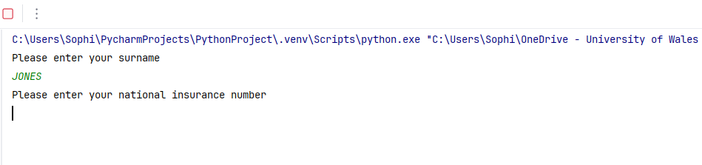
Result: Did the programme behave as expected ie syntactically and logically correct?
Yes. It allowed the user to enter their surname, and there were no errors as result. The programme correctly moved on to allow the user to then input their National Insurance Number.

Test:
Surname ii Leave blank

Screenshot(s) of output:
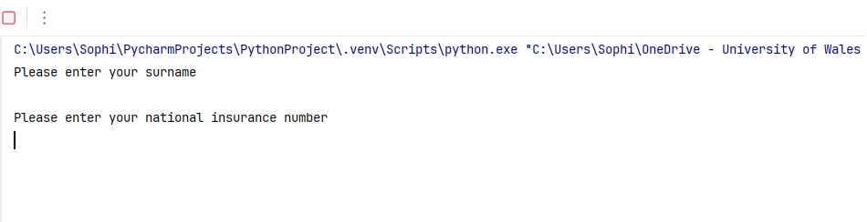
Result: Did the programme behave as expected ie syntactically and logically correct?
No. In a real-world scenario, this programme would likely be used to retrieve payroll information, employee information, or possibly to verify identity. For all these scenarios, a surname would be required to identify the correct person. Without a surname being entered the data could retrieve information on the wrong person or fail to complete the search correctly. There should have been validation in place that does not allow this field to be blank.

Continue the rest of the tests below. (Copy and paste a box for each one)

Test: Surname iii Enter A

Screenshot(s) of output:
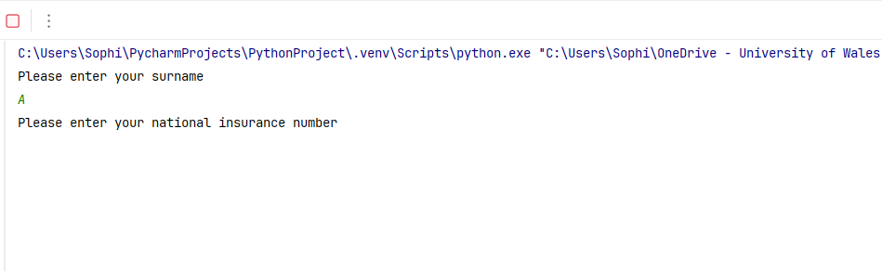
Result: Did the programme behave as expected ie syntactically and logically correct?
Yes. Initially on testing, it was assumed there should be some validation that requires surnames to be at least two letters. With this mind, research was done to establish how many letters the shortest surname contained. Whilst it is mostly common within Asian surnames, there are multiple records of just one-letters surnames [1]. This is further supported by a record held within the Guiness World Records, where the most common single letter surname is ‘O’, largely in Korea [2]. Whilst generally there should be some validation requiring this entry to be longer, it could cause issues should a person only have a one letter surname.

Test: Surname iv Enter 123

Screenshot(s) of output:
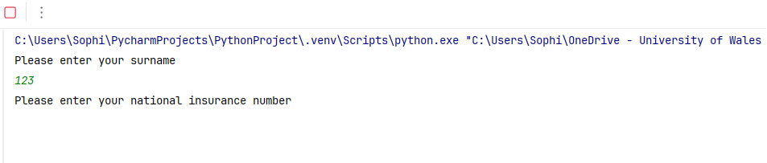
Result: Did the programme behave as expected ie syntactically and logically correct?
No. Numbers are an invalid entry for surname. There would need to be validation in place that requires the user to enter letters only. The programme should have responded asking the user to try again, using letters only.

Test: National Insurance Number i. Enter PE534121B

Screenshot(s) of output:
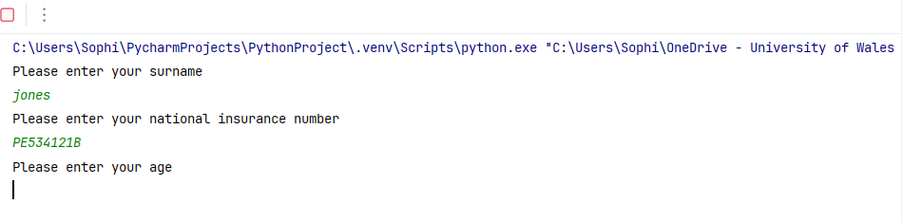
Result: Did the programme behave as expected ie syntactically and logically correct?
Yes. The National Insurance Number entered is the correct length, and the letters and numbers are formatted correctly and in the correct order. This entry would be valid and therefore it is correct that programme proceeds to request the user to enter the next piece of information.

Test: National Insurance Number ii Leave Blank

Screenshot(s) of output:
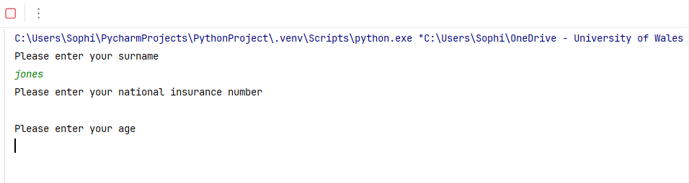
Result: Did the programme behave as expected ie syntactically and logically correct?
No. As with the surname, this information would be required to locate the record of the correct person, particularly as this is the main identifier of all the variables. There could be more than one person with the same surname, who are the same age and work the same hours, therefore this information would be essential to locate the correct person and their data. Again, there should have been validation in place that does not allow this field to be blank.

Test: National Insurance Number iii Enter AB11223344556677

Screenshot(s) of output:
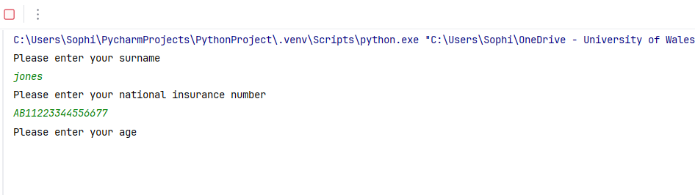
Result: Did the programme behave as expected ie syntactically and logically correct?
No. The National Insurance Number is too long therefore would be an invalid entry and would result in a failed search. There would need to be validation in place to ensure it is 9 characters long. The same would apply if someone missed a character and entered a number that is too short.

Test: National Insurance Number iv Enter 22PE4088A

Screenshot(s) of output:
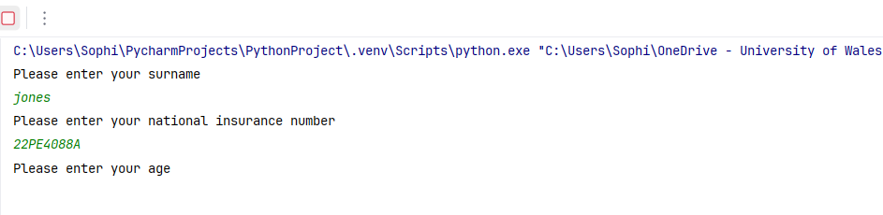
Result: Did the programme behave as expected ie syntactically and logically correct?
No. The National Insurance Number is in the incorrect format. The first two characters should be letters, not numbers. This would again result in a failed search and there should be validation in place to ensure the format is correct to maintain the integrity of the data being retrieved.

Test: Age i. Enter 34

Screenshot(s) of output:
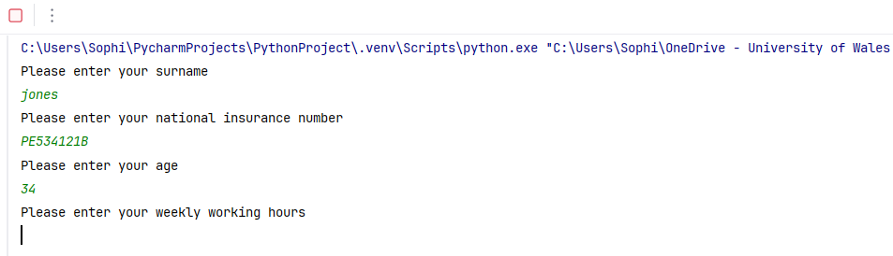
Result: Did the programme behave as expected ie syntactically and logically correct?
Yes. The age is valid and within a reasonable range to hold a National Insurance Number and the system correctly moves on to allow the user to enter the next piece of data.

Test: Age ii. Enter 150

Screenshot(s) of output:
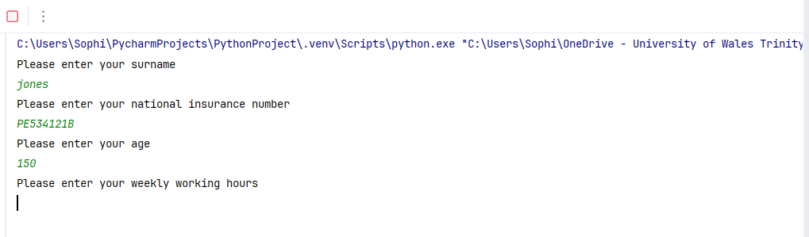
Result: Did the programme behave as expected ie syntactically and logically correct?
No. Whilst technically someone who is 150 years old would still have a valid National Insurance Number, this entry would almost certainly be an error, given nobody has lived to this age. Although users of around 100 years old would be uncommon, this is a more realistic upper limit than 150 years old. Setting the maximum age to a more plausible limit would ensure the data of older users can be retrieved but would prevent data which is clearly incorrect being entered. Therefore, validation should have been in place to limit the age to around 100 years old.

Test: Age iii. Enter -4

Screenshot(s) of output:
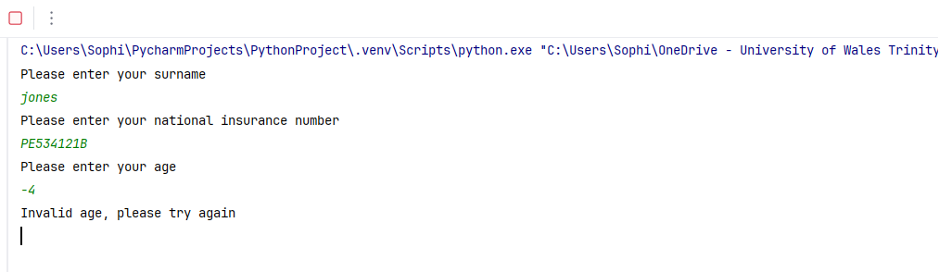
Result: Did the programme behave as expected ie syntactically and logically correct?
Yes. The age of -4 years old is invalid, and the programme has correctly identified this and requests the user to enter a valid age. This prevents the search failing or retrieving incorrect data due to an invalid data entry and maintains data integrity.

Test: Age iv. Enter a letter

Screenshot(s) of output:
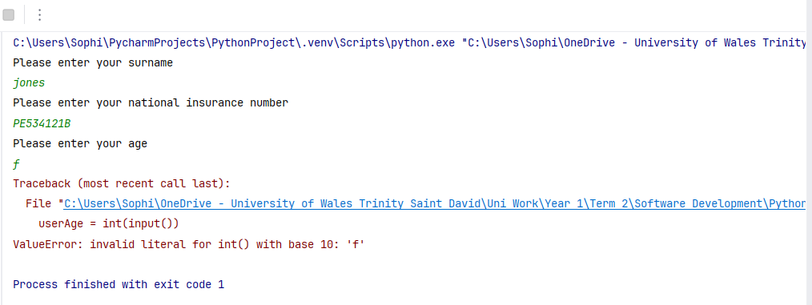
Result: Did the programme behave as expected ie syntactically and logically correct?
No. This is a programme error rather than a user-facing error message. The programme cannot complete the function, causing it to crash. The error message is only visible to the programmer but provides no meaningful feedback to the user and does not prompt them to re-enter their age using a number. Validation should be implemented so the user receives a clear error message and is given the opportunity to re-enter the data correctly.

Test: Working hours i. Enter 37.5

Screenshot(s) of output:
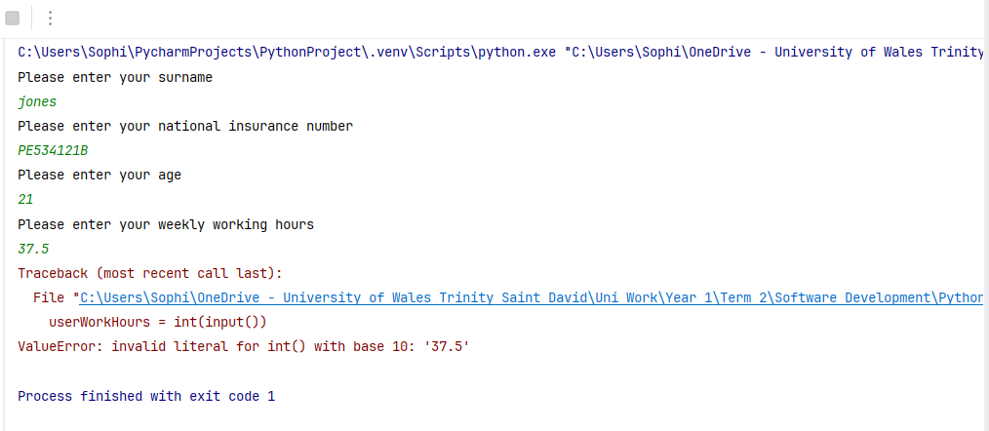
Result: Did the programme behave as expected ie syntactically and logically correct?
No. Because ‘int’ was used, the data entered must be a whole number. This would not be suitable for a data entry of working hours, as these are not always whole hours. This has again generated a programme error with no meaningful feedback for the user, but the issue is with the code/programming itself, as ‘float’ should have been used.
Test: Working hours ii. Enter 150

Screenshot(s) of output:
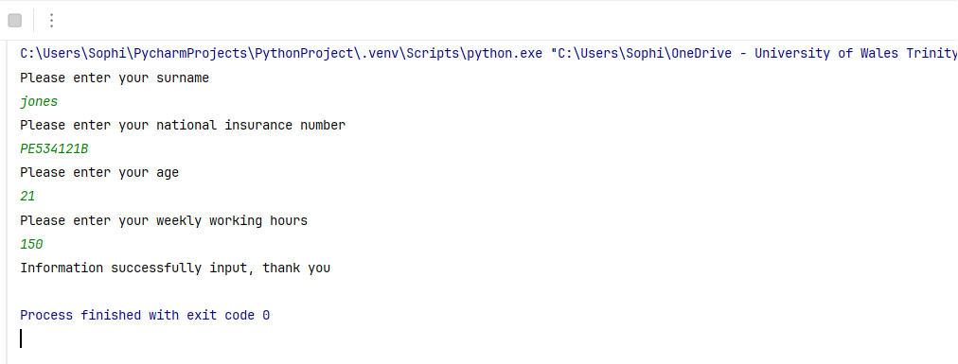
Result: Did the programme behave as expected ie syntactically and logically correct?
No. Whilst the code did work, 150 hours is an unrealistic data-entry in terms of how many hours someone would work in one week and this would likely indicate an error. Even in extreme circumstances, working more than 60-70 hours per week would be highly unlikely. To account for rare cases, validation should be implemented to limit the entry to around 80 hours.

Test: Working hours iii. Enter 0

Screenshot(s) of output:
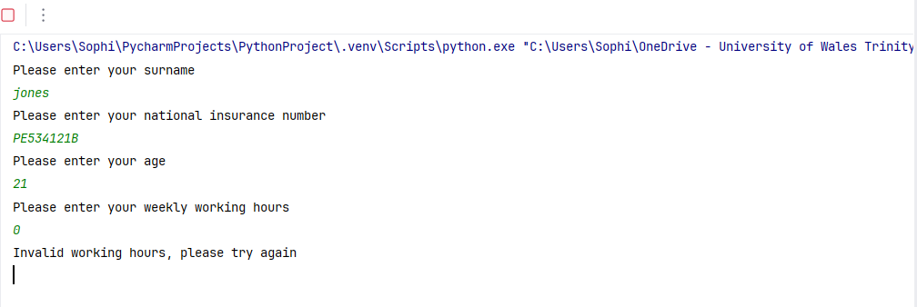
Result: Did the programme behave as expected ie syntactically and logically correct?
Yes. The programme has identified that no hours have been entered and has requested the user re-enter the data. It is unrealistic that an employee has no working hours per week and it has been treated as an invalid input and given the user the opportunity to enter the correct data.

Test: Working hours iv. Enter -2

Screenshot(s) of output:
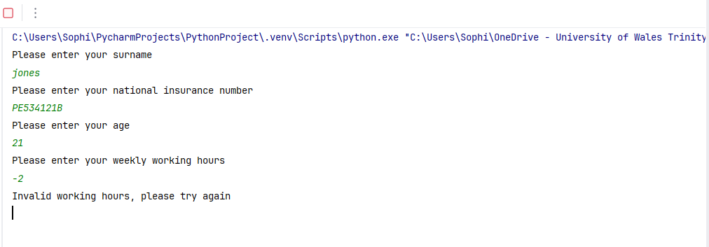
Result: Did the programme behave as expected ie syntactically and logically correct?
Yes. It is impossible for an employee to work -2 hours. The programme has correctly identified this as an input error and has again given the user the opportunity to input the correct, valid data.

- Consider the results of the above tests and revisit your code in order to solve the problems. (Note: you may not be able to solve all of them, but solve as many as you can.)

Paste your revised code here:
print ("Please enter your surname")
userSurname = input().strip()
while userSurname == "":
print ("Input cannot be blank, please try again")
userSurname = input().strip()
while not userSurname.isalpha():
print ("Entry must be letters only, please try again")
userSurname = input().strip()
print ("Please enter your national insurance number")
userNIN = input().strip()
while userNIN == "":
print ("Input cannot be blank, please try again")
userNIN = input().strip()
while len (userNIN) != 9:
print ("Entry must be 9 digits, please try again")
userNIN = input().strip()
print ("Please enter your age")
userAge = input()
while not userAge.isdigit():
print ("Entry must be a number, please try again")
userAge = input()
userAge = int(userAge)
while userAge < 16 or userAge > 100:
print ("Invalid age, please try again")
userAge = int(input())
print ("Please enter your weekly working hours")
userWorkHours = float(input())
while userWorkHours <= 0 or userWorkHours > 80:
print ("Invalid working hours, please try again")
userWorkHours = float(input())
print ("Information successfully input, thank you")

No validation was in place to prevent blank entries for the users surname or National Insurance Number. Using .strip() removes any whitespace at the start and end of the input, meaning that blank entries, single spaces, or multiple spaces are all treated as empty. A while loop was then used to prompt users to re-enter their surname or National Insurance Number if a blank entry was detected [3].

Once a non-blank entry had been provided, the .isalpha() method was used to ensure that only letters were entered, resulting in a valid input [4].

A National Insurance Number must be 9 characters long. Using len() allows the validation to check the length of the input, and if it is not exactly 9 characters, the program displays an error message and prompts the user to re-enter the data. This loops until a 9-character entry is input [5].

Initially there was only validation entered for the age requiring the input to be over 16. Additional validation was entered to set an upper limit of 100, so the range was more realistic.

Given that .isalpha() was used to ensure characters of the surname were letters only, it was logical that similar validation, such as .isdigit() would be used to ensure the age entry was numbers only. [6]
After this loop, there was some difficulty with converting the entry to be identified as an integer for the section after this loop. Copilot was used for this aspect, and by entering userAge = int(userAge), it converted the userAge entry to an integer for the remaining part of the code. [7]

Validating the code for the input of working hours highlighted that int() was used instead of float(). This was an oversight in the initial development of the code, as int() would require whole number entries only, however partial hours can be worked, requiring the use of float().
Similar to the age data entry, additional validation was entered to set an upper limit of working hours to 80, allowing for a more realistic range.

REFERENCES:
[1] T. Miller. “The World's Shortest Personal Names.” JSTOR. Accessed 02/03/2026. [Online]. Available: https://www.jstor.org/stable/community.34574528?seq=1

[2] Guinness World Records. “Commonest surname of one letter.” Guinness World Records. Accessed 02/03/2026. [Online]. Available: https://www.guinnessworldrecords.com/world-records/67277-commonest-surname-of-one-letter#:~:text=The%20commonest%20single%2Dletter%20surname,a%20single%20character%20is%205%2C327.

[3] w3schools. “Python String strip() Method”. w3schools. Accessed: 19/03/2026. [Online]. Available: https://www.w3schools.com/python/ref_string_strip.asp

[4]w3schools. “Python String isalpha() Method”. w3schools. Accessed: 19/03/2026. [Online]. Available: https://www.w3schools.com/python/ref_string_isalpha.asp

[5] CodeRivers. “Python len() of a String: A Comprehensive Guide”. CodeRivers. Accessed 19/03/2026. [Online]. Available: https://coderivers.org/blog/python-len-of-a-string/

[6] A. Saxena. “Python String isdigit() Method”. geeksforgeeks. Accessed 19/03/2026. [Online] Available: https://www.geeksforgeeks.org/python/python-string-isdigit-method/

[7] Microsoft Copilot. Version 1.25121.84.0. Microsoft. Accessed: 19/03/2026 [Mobile App] Available: https://apps.microsoft.com/detail/9WZDNCRD29V9?hl=en-gb&gl=GB&ocid=pdpshare

