

University of Wales Trinity Saint David
School of Engineering

AWD Torque Vectoring

Steven Wilkinson
P149872
Beng Motorsport Engineering
19/05/20
Advanced Vehicle Dynamics
M6X00407

Contents
1 Abstract 6
2 Introduction 7
3 Vehicle specification and data. 8
3.1 Vehicle data of Ferrari FF 8
3.2 Vehicle assumptions. 9
4 Vehicle Dynamics of the Ferrari FF. 10
4.1 Mass model of the Ferrari FF 10
4.2 Slip curves 11
4.3 Friction Circle. 11
4.4 Dynamic Index. 13
4.4.1 Dynamic index is subjective 13
Dynamic index of the Ferrari FF 14
4.5 Centre of gravity position 15
4.6 Centre of percussion 16
5 Torque vectoring 17
5.1 What is Torque vectoring 17
5.2 Torque Vectoring by Braking 18
5.3 Torque path within the Ferrari FF 19
5.4 Ferrari FF Gearbox calculations 20
5.5 Improving cornering ability by Torque vectoring. 21
6 Sensors and control 26
6.1 Integration to the driver. 26
7 Conclusion 27
8 Bibliography 28

Figure 1: Lumped Mass Model. 10
Figure 2: Friction circle. 12
Figure 3: Torque vectoring. 17
Figure 4: Ferrari FF Engine and transmission. 19

Table 1: Vehicle Specifications. 7
Table 2:Gear ratios 8
Table 3:Vehicle assumptions. 8
Table 4: Dynamic index of the Ferrari FF. 12
Table 5: Centre of gravity of the Ferrari FF. 13
Table 6: Gearbox calculations. 17

Equation 1:Lateral Forces. 10
Equation 2:Resultant Force 11
Equation 3: Dynamic index 12
Equation 4: Centre of Gravity position. 14
Equation 5:Centre of percussion. 14
Equation 6:Centripetal Acceleration. 19
Equation 7:Yaw rate in steady state. 19
Equation 8: Mass on each wheel. 19
Equation 9: Weight transfer across axle. 19
Equation 10: Each wheel Weight transfer. 20
Equation 11: Rolling resistance. 20
Equation 12:Aerodynamic drag. 20
Equation 13:Lateral force on axle. 20
Equation 14: Total force. 20
Equation 15:Front Loading percentage. 20
Equation 16: Rear Loading percentage. 21
Equation 17: Lateral force resistance. 21
Equation 18: Front Longitudinal drive force grip. 21
Equation 19:Rear Longitudinal drive force grip. 21
Equation 20:Drive force. 21
Equation 21:Yaw moment. 22
Equation 22: Driver handwheel angle. 22
Equation 23: Torque vectoring. 22
Equation 24: Drive force. 23
Equation 25:Yaw moment. 23

Abstract

In March 2011 Ferrari launched their first 4WD vehicle the FF “Ferrari Four” the report will conduct background research into how this new vehicle utilises its four wheel drive system and by the use of vehicle dynamic calculations and mass models theoretically calculate the moments and forces generated at the tyres contact patch as the vehicle operates.

Introduction

Within this report research to be conducted on the concept of Torque vectoring and specifically how Ferrari engineered and launched their first four-wheel drive vehicle.
Background research into Torque vectoring to gain an understanding of the principles and workings which will allow for calculations to be made into how the FF operates.
Using limited real-world data made available on public sources and some reasonable assumption calculations into the torque generated and how Ferrari utilise the type of new system.
Upon calculating it is hope that conclusions can be made in the reasons why Ferrari adopted to engineer a 4WD system in this particular way and the benefits it beings rather than conventional methods of an all-wheel drive vehicle.

Vehicle specification.

Vehicle data of Ferrari FF

Length (mm) | 4907
Width (mm) | 1953
Height (mm) | 1379
Wheelbase (mm) | 2990
Front track (Mm) | 1676
Rear Track (mm) | 1660
Mass (Kg) | 1880
Weight Distribution % | Front - 47  Rear - 53
Front Tyre size (m) | 0.245
Rear Tyre size (m) | 0.295
Rollin coefficient (Tarmac) | 0.02
Rolling resistance (N) | 401
Aerodynamic Coefficient of Drag | 0.32
Steering ratio | 15.1:1
Table 1: Vehicle Specifications.
Gear Ratios
1st Gear | 3.40
2nd Gear | 2.19
3rd Gear | 1.63
4th Gear | 1.29
5th Gear | 1.03
6th Gear | 0.84
7th Gear | 0.63
Final Drive | 4.38
Table 2:Gear ratios

Vehicle assumptions.

Mass of driver (Kg) | 100
Gravity (m/s) | 9.81
Tyre Cornering stiffness per degree (N) | 1500
Clutch Material Carbon/Kevlar  Friction coefficient | 0.05 -0.1
Clutch plate pressure (Mpa) | 3
Table 3:Vehicle assumptions.

The above tables show the vehicle data used in calculating performance characterises of the Ferrari FF.
Assumptions that have been made when no data can be found have been taken from generic values which could be assumed to be true for example values taken from lecture material in (Sandford, 2017 ).

Vehicle Dynamics of the Ferrari FF.

Mass model of the Ferrari FF

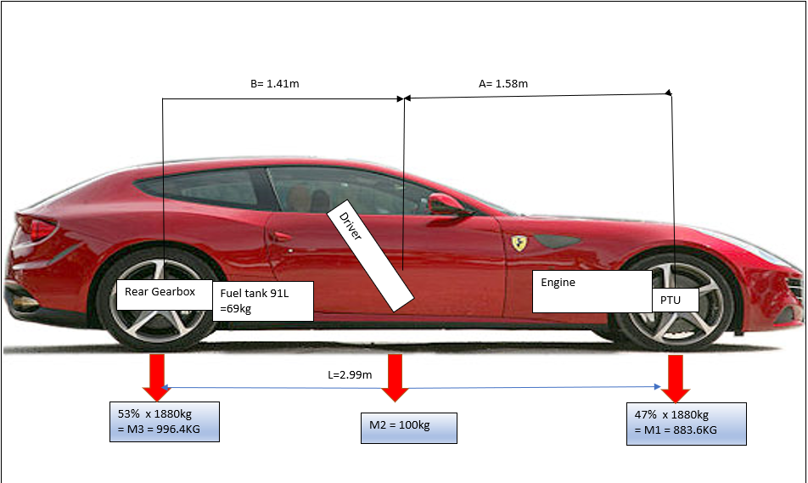
Figure 1: Lumped Mass Model.

The Ferrari FF has a weight distribution of 47/53% this has been achieved to keep the same ethos as the other Ferraris in the range such as the F458 which has similar mass distribution. In doing this also allows the vehicle to feel like a mid-engine vehicle this has been achieved by the positioning of mass corresponding to the centre of gravity.

Slip curves
To allow a pneumatic tyre to change direction and the driver to be able to operate the vehicle around an intended path the tyre must first slip from its straight-ahead position. This angle difference of the tyre rotating heading and the vehicles heading is called the slip angle.
When observing a slip curve of lateral force VS drive force it shows that once a prescribed amount of force from the road wheels is achieved then tyres can no longer increase linearly the very top of the curve is the peak level of adhesion, afterwards the tyre will lose lateral forces for any additional drive force. An example of this is a rear tyre that is loaded with excessive drive and lateral forces during hard cornering This leads to the contact patch of the tyre to be saturated, this can be felt by the driver through the steering wheel as it feeling light when oversteering as now the rear tyres has a larger slip angle than the front tyres.
$$Fy=C xα$$
Equation 1:Lateral Forces.

Friction Circle.

A tyre produces its maximum lateral force when neither drive nor braking forces are being undertaken at the same time. In doing so can quickly over saturate the tyres contact patch during excessive cornering /steering inputs are occurring which increases the lateral load onto the tyre through weight transfer. (Santos, 2014)
$$Force resultant= \sqrt{{Lateral force }^{2}}+{Drive force }^{2}$$
Equation 2:Resultant Force
The equations above shows that by having a combination of both Lateral and drive force will affect the maximum overall forces through the contact patch.

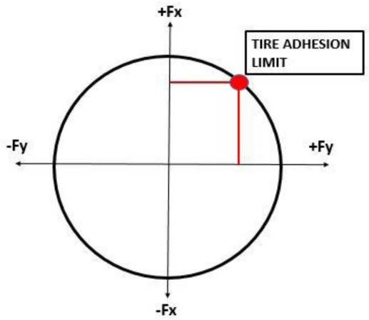
Figure 2: Friction circle.

Construction of the tyre will have an impact on how the friction circle will look as some vehicle tyres tolerate more Drive force than they can withstand lateral force and this will impact on how the driver will need to react between different tyre manufacturers and how they construct their tyres.

Dynamic Index.

The Dynamic index is a calculated figure that represents the potential agility of a vehicle. This gives an indication of how a vehicle will behave in a cornering situation as it influences the vehicle within the centre of rotation in yaw.
The Dynamic index is the output of inertial match theory which is the relationship between the centre of gravity position and the vehicles wheelbase.

Having a DI greater than 1 lead to a vehicle which will feel sluggish in cornering and not very responsive to steering inputs. This is because its ability to generate lateral acceleration is reduced. This can cause the vehicle to have an increase in understeering tendencies.
If the DI is below 1 this results to an increase in lateral acceleration in the rear if the car and the rear tyres will generate more slip angle faster, this will increase the oversteer characteristics of the vehicle. (Dynamics, 2004)
$$Dynamic Index=\frac{Inertia}{Total mass x a }$$
Equation 3: Dynamic index

Dynamic index is subjective

The feel to the driver of a vehicles dynamic index is subjective to the individual and driving preference or style of that driver for example, a DI of under one would promote a lively and responsive vehicle to handle however, if the driver were proficient in handling vehicles of this nature then they would not be troubled by the potential sharpness of the handling. On the other hand, a driver who has had little to no previous experience of this would think the Vehicle is unfavourable and difficult to drive.

Dynamic index of the Ferrari FF
The dynamic index of the Ferrari FF varies depending on the masses within it, which it is calculated.
The base vehicle its DI is taken as exactly 1.03 which means the vehicle is mostly balanced but leaning to some understeer which is ideal for driver comfort and confidence when negotiating a corner. As the vehicle is not going to suddenly lurch into a corner and catch out the driver.
Ferrari have achieved this by its wheelbase dimensions, having the distance ‘a’ of 1.58m to the Centre of gravity but a smaller front mass means this is balanced by distance “b” of 1.41m but a larger distribution set towards the rear.

However, when considering additional mass of the driver and fuel the Dynamic index changes to 0.95 and 0.98, respectively. As the driver (Of mass 100kg) was calculated near to the centre of gravity this had a small effect on the additional rotational inertia as the distance was small thus meaning it did not generate a large inertia force.
Additional mass of adding also fuel to the vehicle meant the Dynamic index was increased to 0.98. This would mean the vehicle is with the additional 168kg has more oversteer and lively characteristics which would be more a-kin to the driving philosophy of a Ferrari.

Base Vehicle Mass. (Kg) | Base Vehicle + Driver (Kg) | Base Vehicle +Driver+ Fuel Tank
1.00 | 0.95 | 0.98
Table 4: Dynamic index of the Ferrari FF.

The Ferrari FF shares a similar Dynamic index value to another Ferrari’s such as the F458 even though the two are vastly different. This shows that Ferrari have a trend in which they design all their vehicles to handle like irrespective on where the engine and drivetrain is located.
The F458 has a Dynamic index between 0.98 and 1.02 depending on additional masses applied such as driver and fuel.
This is interesting because this vehicle has different wheelbase dimensions and masses. With its weight distribution 58% in comparison to the FF’s 53% however the Centre of gravity distances between front and rear are identical to the FF.
This means that the FF will share similar handling characteristics to the F458 when using 100% rear wheel drive.

Centre of gravity position

Centre of gravity or centre of mass is critically important in evaluating vehicle performance. It is the point on a vehicle in which the masses are balance against each other, this could not be directly in the middle of the vehicle if the mass distributions are not equal going through the front/rear axle.
Centre of gravity directly relates to the dynamic index of a vehicle as a CofG trending towards the front would have a lower DI and will have potentially more oversteer tendences.

$$CofG position=Wheelbase x Mass distbution \%$$
Equation 4: Centre of Gravity position.

Table 5: Centre of gravity of the Ferrari FF.
Centre of gravity | Front | Rear
C of G (mm) | 1584.70 | 1405.30
C of G (m) | 1.58 | 1.41

The centre of gravity on the FF is 1.58m behind the front axle and 1.41m in front of the rear axle. This means the CofG position would be somewhere near to the driver and other additional masses this will create the least amount of extra rotation inertia as the distance is the smallest it can be.

Centre of percussion
Centre of percussion or inertial conjugate is the point on which an object has no translation about its axis.
If a load impacts this point, then no rotation is felt at the top of the body. (Dynamics, 2004)
Typically, this is found around 2/3 of the length of the body. This is the case for the Ferrari FF as its Centre of percussion is found 3.52m from the front of the vehicle which with a total length of 4.9m is around 2/3. (Miller, 2012) This puts the Centre of percussion just ahead of the rear gearbox and axle making the vehicle more stable.
$$Centre of percussion=\frac{Inertia}{Vehicle mass x CofG distance to front axle }$$
Equation 5:Centre of percussion.

Torque vectoring

What is Torque vectoring

A torque vectoring differential directs the flow of torque a required amount on each wheel on a axle depending on cornering application. This means during a corner it assists the vehicle by creating addition yaw rotation by directing torque to individual wheels and this aids stability within the turn.
To achieve this an electronically controlled clutch pack is used after the torque has passed through a conventional differential. These clutch packs on both sides of the differential limit and restrict the flow of torque and are attached to a set of planetary gear sets which transfer the torque through to the road wheels.
The figure below shows the path in which torque is transferred from the input shaft through the differential and onto the axles/road wheels.
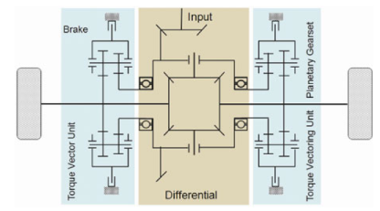

Figure 3: Torque vectoring.

Torque Vectoring by Braking
Another variation on Torque Vectoring is its use by braking method, this is mostly installed on high end performance vehicles and controls the yaw rate during cornering. This is achieved by applying a small amount of braking force to each wheel independently to reduce potential wheel slip before it occurs. This allows the vehicle to be subjected to highest lateral acceleration possible and have the tyre not over saturated with load, leading to a breakaway.
Using this system will “keep the vehicle in line” and on the requested path desired by the driver, this method is aided by control systems such as Traction control and ESP which monitor wheel speed for potential slip.
Applies the braking for:
- High speed wheel slip which shows tyre adhesion has been exceeded.

- High speed slip angle when exceeding lateral acceleration for a given steering input.

Torque path within the Ferrari FF

Within the Ferrari FF the torque from the engine is distributed between two independent gearboxes up to 20% of the torque capacity is allocated to the front wheels. Under normal road conditions power the rear wheels would be allocated 100%. This is electronically controlled by the ‘4RM’ and is used to maintain the same driving characteristics to other Ferrari’s across the range. (ADCOCK, 2016)
At the rear of the vehicle a rear differential utilising torque vectoring splits up drive torque independently across the rear axle. The front wheels are only used for transmitting torque when necessary such as when more drive force is requested by the driver than the rear wheels can provide such as poor road conditions which reduce friction coefficient.
To provide the front wheels with torque it is transferred straight front the engine to a second gearbox inline with the front axle.
This PTU (Power transfer unit) again splits torque independently across the axle by the use of electronically controlled clutches these limit or allow the transfer of torque by the use of a percentage slip to deliver the correct amount of drive force requested by the driver.

Benefits to this system are a lighter and smaller packaged gearbox used at the front without the need for excessive driveshafts navigating the length of the vehicle to transmit power. This reduces the rotation inertia and lowers the centre of gravity of the vehicle.

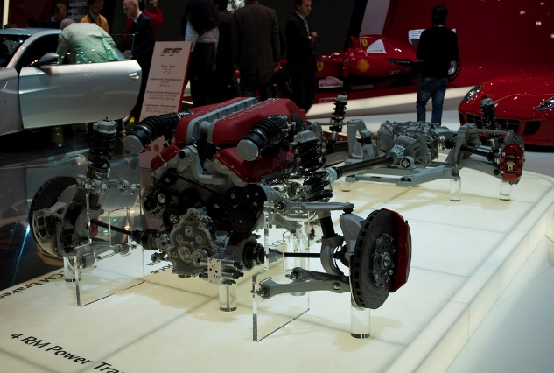
Figure 4: Ferrari FF Engine and transmission.

Ferrari FF Gearbox calculations

Table 6: Gearbox calculations.
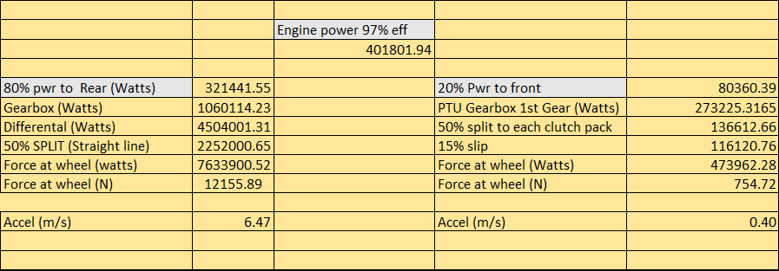

The above table shows the transfer of power between the engine and the road wheels during an 80/20% Split of power at 6000RPM in 1st gear.
It shows that if needed the front wheels can assists the vehicle in accelerating the vehicle if the situation arise that the rear wheels were not transferring adequate drive force.

Improving cornering ability by Torque vectoring.

To theoretically calculate the forces and moments which would be affecting the vehicle in the X and Y plane a scenario was chosen to evaluate this. This was the vehicle navigating a 50M radius corner at 60kph.
This allowed the observation of how weight transfer affected the vehicle and how torque vectoring could benefit the cornering ability of the vehicle and a beneficial tool for the driver.

$Centripetal acceleration=Meters per second ÷corner radius$
$$\frac{{16.6}^{2}}{50}=5.51m/ss$$
Equation 6:Centripetal Acceleration.

$$Steady state yaw rate= π×100=314m \\ \frac{314}{16.6}=18.9seconds per lap \\ \frac{360}{18.9}=19.04degrees per second$$
Equation 7:Yaw rate in steady state.

$$Front Mass on each wheel=\frac{883x9.81}{2}=4331N \\ Rear Mass on each wheel=\frac{996x9.81}{2}=4885N$$
Equation 8: Mass on each wheel.
$$Front WT on axle=\frac{\frac{0.5x883}{2x5.51}}{1.670}=726N$$
$$Rear WT on axle=\frac{\frac{\frac{0.5}{996}}{2x5.51}}{1.660}=826N$$

Equation 9: Weight transfer across axle.

WT Front Outer wheel 4331+726=5056N
WT Front Inner wheel 4331-725N
WT Rear outer wheel 4885+826=5711N
WT Rear inner wheel 4885-826=4059N
Equation 10: Each wheel Weight transfer.

$$Rolling risistance=Total vehicle mass x gravity xFriction coeffient \\ 2049x9.81x0.02=369N$$
Equation 11: Rolling resistance.

$$Areodynamic Drag=0.5 x CD x Frontal area x Air density x{Velocity }^{2} \\ 0.5x 0.32 x 2.79 x 1.279 x {16.6}^{2}=145N$$
Equation 12:Aerodynamic drag.
Total = 514N

$$Front Lateral Force on each axle=883 x 5.51=4865N$$
$$Rear Lateral Force on each axle=996 x 5.51=5487N$$
Equation 13:Lateral force on axle.

$$Front Total force=883 x 9.81=8662N$$
$$Rear Total Force=996 x 9.81=9770N$$
Equation 14: Total force.

$$Front outer loading percentage=\frac{5056}{8662}=58\%$$
$$Front inner loading percentage=\frac{3606}{8662}=42\%$$
Equation 15:Front Loading percentage.
$$Rear outer loading percentage=\frac{5711}{9770}=58\%$$
$$Rear inner loading percentage=\frac{4059}{9770}=41\%$$
Equation 16: Rear Loading percentage.

$$Front outer lateral force risitance=58\%x 8662=5023N$$
$$Front inner Lateral force risistance=41\%x 8662=3551N$$
$$Rear outer lateral force risitance=58\% x 9770=5666N$$
$$Rear inner lateral force risitance=41\% x 9770=4005N$$
Equation 17: Lateral force resistance.

$$Inner front Longitudinal drive force grip=\sqrt{{3606}^{2}}-{3551}^{2}= 627N-359=258N \\ Outer front Longitudinal drive force grip= \sqrt{{5056}^{2}}-{5023}^{2}=576N-359=217N$$
Equation 18: Front Longitudinal drive force grip.
$$Inner Rear Longitudinal drive force grip= \sqrt{{4059}^{2}}-{4005}^{2}=682N-359=313N \\ Outer Rear Longitudinal drive force grip= \sqrt{{5711}^{2}}-{5666}^{2}=715N-359=356N$$
Equation 19:Rear Longitudinal drive force grip.

The drive force across the four tyres is not evenly distributed.
$$Outside front=576-276=300N \\ Outside rear=715-276=439N$$
$$Total tractive effort=739N$$
$$Acceleration=\frac{739}{2049}=0.36 meters per second.$$
Equation 20:Drive force.

Yaw Moment
$$Front yaw moment=\frac{300}{0.834}=361Nm$$
$$Rear yaw moment=\frac{479}{0.83}=577nm$$
Total Moment = 938Nm
Equation 21:Yaw moment.

Hand wheel Steering angle required to counter the Yaw moment.
$\frac{938}{1500}=0.62 \frac{0.62}{90}=0.068 0.068x1260=85.6 degrees.$
Equation 22: Driver handwheel angle.

Additional Torque vectoring.

The total force reached was up to 58% on the outer tyres and 42% on the inner tyres this means there is the ability to increase the drive force and ultimately the tractive effort on each the tyres before tyre saturation occurs. With the ability to use torque vectoring different additional torque can be applied to individual wheels to reduce or increase the yaw moment and increase the acceleration of the vehicle via the use of the electro servo motors clamping the clutch packs on each side of the axle.
As this scenario is taken at a transient phase of the corner more torque should be placed on the front outside wheel to further speed up its rotation and allow the vehicle to have an even contribution of yaw moments front/rear. This will make the vehicle easier to operate for the driver and more predictable as the rear is no longer rotating faster than the front.
$$Torque vecotring Front=441x9.81x 0.245=1277N \\ Torque vectoring Rear=498x9.81x0.295=1441N$$
Equation 23: Torque vectoring.

Applying this additional force generated from the engine to any of the wheels will increase both Yaw and acceleration of the vehicle. This will help turn the vehicle into the corner and use all available forces that the axle is capable of transferring.

$$New Drive force front=300+1277=1577N \\ New Drive force rear=439+1441=1880N$$
$$Total tractive effort=3457N \\ New Acceleration=\frac{3457}{2049}=1.68 Meters per second.$$
Equation 24: Drive force.
$$Yaw Moment front=\frac{1577}{0.834}=1890Nm \\ Yaw Moment rear=\frac{1880}{0.83}=2265Nm$$
Total yaw moment =4155Nm.
Equation 25:Yaw moment.

Sensors and control

Integration to the driver.

Traction control systems
Integrating a traction control system within the use of torque vectoring is essential for maintaining high vehicle safety. The TSC system will monitor potential wheel slip and this will aid torque vectoring by providing a more efficient feedback loop of information to best apply the correct amount of additional torque for the tyres to remain at the peak lateral force and not go over it and cause the tyres to breakaway. (Day, 2014)

Yaw/ pitch sensors
With the Ferrari FF using electromagnetic dampers to alter the damping ratio this can be used in conjunction with yaw/pitch sensors to monitor the roll the body of the vehicle has in a corner or during acceleration/braking. This means less weight transfer can occur through the body of the vehicle and it will remain more stable under changes of direction. Using this alongside steering sensors will also allow the torque vectoring system to apply more drive force sooner and make necessary adjustments to benefit the driver’s requirements.

Monitoring Driver inputs.
Having the driver’s inputs monitored such as Steered angle and the magnitude of these changes will allow the ECU to correctly implement the torque vectoring system. This will carefully apply drive force to individual wheels or for example the driver was performing an emergency manoeuvre then the need to direct torque to individual wheels to tighten cornering arcs and return the vehicle to neutral steered state. (Maharun, 2014) This will improve safety of the vehicle and make the vehicle more predictable even in high risk situations.

Conclusion

From conducting the investigation, it is found that torque vectoring is a useful tool to aid the driver and improve vehicle safety. The ability it has to direct the flow of torque to individual wheels without over saturating the contact patch means the tyre can remain at peak lateral load but maintain the most acceleration through a turn.
Since Ferrari released the FF other manufacturers have now developed their own form of torque vectoring. For example, Porsche for the Cayanne model have developed PTV plus this system encompasses steering, yaw rate and vehicle speed to determine if torque vectoring is needed at a given situation. It is achieved by the use of applying a small amount of brake force to the inside wheel this creates a speed difference and inducing a yaw moment.
Manufactures have also been developing four-wheel steer systems along with torque vectoring this further increases the systems complexity but allows for a more efficient method to apply torque to the road wheels.

Bibliography
ADCOCK, I., 2016. Ferrari's CTO details patented torque-vectoring AWD with rear-wheel steer. [Online]
Available at: https://www.sae.org/news/2016/03/ferraris-cto-details-patented-torque-vectoring-awd-with-rear-wheel-steer
[Accessed 19 May 2020].
Bonnington, P., 2012. Ferrari FF. [Art] (Flickr ).
Day, A., 2014. Braking of road Vehicles. 1st ed. US: British Library .
Dynamics, M. s. a. t. V., 2004. M Blundel D Harthy. 1st ed. s.l.:British Libary .
handbook, C., 2011. Torque Vectoring. [Art] (MercedesDruck).
Heißing, B., 2011. Chassis Handbook. 1st ed. Berlin: MercediesDruck.
Kolte, S. U., 2016. Tire Friction circle. [Art] (University of Michigan ).
Maharun, M., 2014. A Study of Torque Vectoring and Traction Control for an AllWheel Drive Electric Vehicle , Malaysia : EDP Sciences.
Metcalfe, H., 2014. Ferrari FF 2000 mile road trip, UK : Metcalfe .
Miller, P. J. S., 2012. Center of Percussion, US: LiteScience .
Sandford, M., 2017 . Notes on clutches , Swansea : School of Engineering .
Santos, R., 2014. Racing car dynamics. [Online]
Available at: http://racingcardynamics.com/racing-tires-lateral-force/
[Accessed 18 May 2020].
secrets, S., 2018. Suspension secrets. [Online]
Available at: https://suspensionsecrets.co.uk/lateral-and-longitudinal-load-transfer/
[Accessed 18 May 2020].
specification, E. P., 2008. ptionally connectable four wheel drive vehicle , Modena : EPO.

