
Skills for the Workplace
Module Assignment Submission
Student Name: | Vanya Petrova
Student Number: | 1817743
Module No: | (BMSW4001_LON)
Module Title: | Academic and Employability Skills
Lecturer: | Shao Yuen

Statement of Confirmation of Authenticity
By the act of making this submission, the student declares that this is the work of the student named above. The work has not, in whole or in part, been knowingly presented elsewhere for assessment, or where assessment has been built on a previous assessment, this has been identified. Where materials have been used from other sources it has been properly acknowledged. If this statement is untrue, the student acknowledges that an assessment offence has been committed.
Attention is drawn to the plagiarism and unfair practice policies of the University.

Table of Contents
Introduction ………………………………………………………………………………………………………………………3
Chapter 1 CV Writing…………………………………………………………………………………………………………..3
Chapter 2 Cover Letter Writing……………………………………………………………………………………………..5
Chapter 3 Presentation…………………………………………………………………………………………………………..6
Benefits of using the learned methods and techniques from the module ………………………………7
Conclusion…………………………………………………………………………………………………………………………….8
References…………………………………………………………………………………………………………………………….8
Appendix A………………………………………………………………………………………………………………………….10/11
Appendix B…………………………………………………………………………………………………………………………..13

Introduction

This report will be focused on the employability skills that I developed in the first two terms, how I improved my CV and cover letter writing and how the making and leading of presentation helped me during my working process as a Team Manager.
In Chapter 1 I will analyse the steps of writing structured and successful CV and what I achieved by learning how to use them properly.
Chapter 2 will be focused on how I learned to write proper Cover letter which is also a significantly important attachment
to the CV.
In Chapter 3 I will share my experience of making presentation and how the process was improved by the new skills I developed during the course.

Chapter 1 CV Writing

In my experience with applying for jobs I always asked myself „Why not more than 20% of the applications got me the ticket to the job interview?”. Even that I spend hours to prepare myself and rewriting my CV repeatedly I always ended up disappointed with the question “Where i am wrong?” spinning around in my head. Additionally, I am working as a Team Manager in cleaning agency and one of my responsibilities is to select candidates each week and organize their job interview- something that I found very hard to deal with. This Is just one of the many reasons I applied for the program “Certificate of Higher Education in Skills for the Workplace”.

Where I was wrong?

My first CV was simple and ineffective – containing only personal information such as: names, telephone number, address, email, education and work experience. After weeks of waiting for any response by the employers I thought something was wrong with the CV and decided to improve it by making a research for a successful CV. Unfortunately, the information in google is very confusing as every author is giving a personal thought of what is wrong and what is right. However, I took some tips from here and there and added some extra lines in the CV such as: personal and professional skills, but still the result was not what I was expecting.
After finishing the second term of the module “Academic and Employability skills” I can strongly agree with the fact that I learned how to make a successful CV by following some simple steps:
- Every CV must be in A4 format and up to 2 pages
- Must contain 4-6 personal skills
- The answers from employers that every CV needs to respond: “Do you understand me?”; “Can you Help me?”
- The CV must be made for the employer not for myself
- It is recommended to use a words such as: implemented, developed, researched, managed.

With those 5 basic rules I not only learned how to impress the employers, but also how to effectively review the candidate’s CV’s and choose the successful one’s only. I can be more productive with less time which is a “win -win” for both me and my employer. I have used the Kolb’s reflective model to improve my skills rather than Gibb’s reflective method as I found it more suitable and easier to follow.

Chapter 2 Cover Letter Writing

The writing of a Cover Letter was on of the challenges I had during this module as I don’t have any background experience with.
I have learned that cover letter is important addition to the CV, which is predictable in form and content. The letter gives and opportunity to present our strengths convincingly by the content, facts and arguments we describe, as well as by the way and form which they are presented. To make a compelling we should follow a few steps:
Attract the attention of the employer; Arouse interest; Inspire desire and motivation ;Encourage a response (invitation for interview appointment);The cover letter should add value to the CV in term of content ;It should not repeat what is already described in the CV.
We should be creative when presenting information about our accomplishments, motivation and ambitions. An additional information about our contacts in the sector can be provided if necessary, projects and etc. The cover letter should represent our overall preferences and expectations such as: creativity; independence; initiative; relative independence.
Wage requirements can only be written if we are professionals with proven experience and knowledge.
Overall, the cover letter should be guided through the following statements:
How I can help the company/ or the manager it is addressed to;
Show that I can remove the stress, save time and money;
Make them feel safe and excited

Following the stated steps and guides above I have made my first cover letter in class exercise (see appendix A). The feedback I received was very good- clear and well organized with few things I should work a bit more to improve such as: to include more examples to support my points and be more clearer about the idea why I want to work for this company.
Using the feedback, I will work with Kolb’s reflective method to improve my cover letter writing moving forward.

Chapter 3 Presentation

A computer presentation is a way to easily and conveniently present information to an audience. Its ability to combine contrasting text with multimedia tools such as images, sounds, videos and more make it interesting and comprehensible for the listeners. Using computer presentations helps a lot to capture and retain the attention of the audience, as it engages not only their hearing but also their gaze.
Every presentation can be made by many ways starting from the font, to the color and finishing with the slide styles. It is up to the presenter’s imagination to create any style of presentation if it is engaging the audience.

Since I started the program the program “Certificate of Higher Education in Skills for the Workplace” I had the chance to work on couple of presentations – group and individual ones.
The first presentation I had the chance to lead was successful with small exclusions. The graphic style and slides I used were good and clear without any extra effects which can distract the whole picture. I had to work more on my leading skills such as the tone of my voice, the eye contact with the audience and be more confident while speaking.
Given that feedback I decided to make a strict plan which I can follow for my next presentation and prepare myself better in order to achieve even higher results.
The first step of creating a better presentation was to give an answer some basic questions which will helped to structure the content according to the audience interest, such as: Who sits in this audience? What training have they received, how much information they can already know about my topic? What is the purpose of the presentation? To inspire people to make them think, or are they looking for specific and practical information? Do they need more concepts and theory than advice?
I decided to use 8 slides each with neutral blue tone and white oval Gothic font as it is proven than oval shapes are accepted better from human’s brain.
The text was structured and framed only to give an idea for the interesting facts so I can have more attention to myself rather than the screen and engage the audience with chat and body language. I have included pictures and graphics which were illustrating the topic of every slide.
After the presentation was done, I decided to practice my voice tone and body language Infront of friends and family member so I can be more confident with my lead.
The feedback I received was excellent (See appendix B) 96 points out of 100, which can only prove that in the base of every good job is hidden a very organized and structured plan to follow.

Benefits of using the learned methods and techniques from the module.

Since I’ve been promoted as a Team Manager and HR assistant, I was always struggling to find the right way to do my daily duties. I don’t have any degree in this field, so it was really challenging to have such a responsibility with the lack of specific education. On our team meetings I always tried to be observer rather than be active in any kind of conversations related to the monthly and annual recruitment problems. There were big gaps which I was in need to fill before I gain the confidence to lead our future meetings.
After I passed the Academic and Employability skills module, I had the chance to learn many specific things about the process of recruiting new employees and how to more efficiently select them through many candidates. I am well organized and confident in my recruitment skills and believe that it is also can be proven by the fact that our 5-star feedbacks from the clients have gained with 15%.
I am very confident to lead our team meeting and be active in every discussion regarding recruitment and managing the conflicts in our company.

Conclusion
This report was focused on how the gained knowledge has influenced my success both at university and professionally.
The reflective method used to improve the result of the activity was also disclosed, namely the Kolb’s method (1984), whose steps are well known: Concrete experience- Reflective Observation-Abstract Conceptualization-Active Experimentation.
In conclusion I can say I am more confident of leading presentation Infront of audience, I know exactly what the employers are looking from the candidates and how to select the best of them when becomes to my professional duties.

References
Adair, J. (2009) Effective Teambuilding, London: Pan Books.
Tracy, B. (2004) Eat That Frog, Great Britain: Hodder & Stoughton An Hachette UK Company.
Kolb, D. A. (1984) Experiential Learning: Experience as the source of Learning and Development. Englewood Cliffs, NJ: Prentice Hall.
Adair, J. (1973) Action-Centered Leadership. New York: McGraw-Hill.
Blanchard, K. (1990) The One Minute Manager meets the Monkey. UK: Fontana
Blanchard, K. & Johnson, S. (2015) The New One Minute Manager. UK: Thorsons

Appendix A
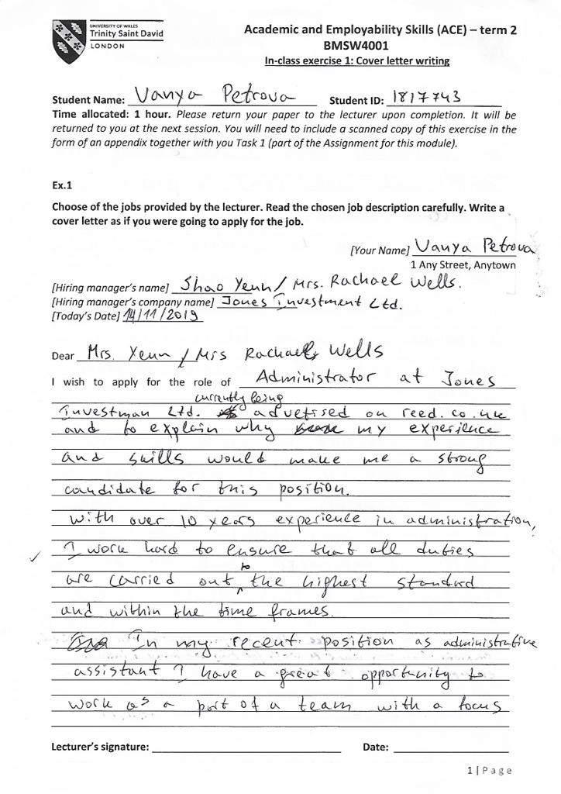
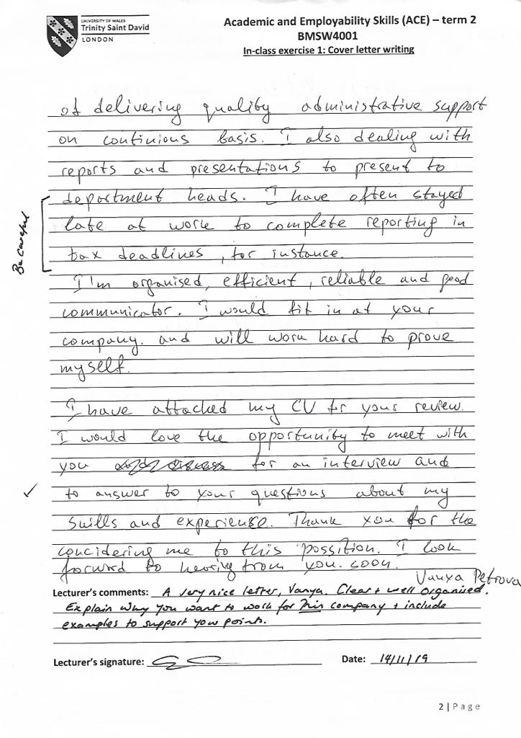
Appendix B



