AI statement

I did not use AI in my work

Part 2A - Business Plan - Farm & Forest Nursery, Aberaeron
This business plan outlines the proposal to establish an innovative early year setting in Aberaeron, Ceredigion: a farm-inspired nursery incorporating regular forest school provision. The setting will combine high-quality childcare with outdoor, experiential and nature-based learning. The aim is to create an environment where young children can develop holistically through meaningful engagement with the natural world while also addressing a recognised lack of local childcare services.

Entrepreneurship within early years provision requires identifying both a social need and a viable business opportunity. This concept responds directly to both. It seeks to meet the developmental needs of young children while providing a financially sustainable service for families within the local community. By integrating farming, outdoor education and early childhood pedagogy, the nursery offers a distinctive model that differs from traditional indoor settings and reflects the rural context of Ceredigion (Welsh Government, 2022)

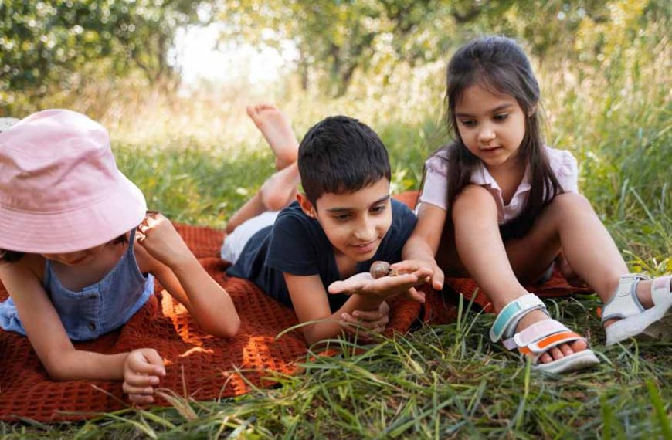
(EuroKids, 2024)
The idea for a farm and forest nursery was chosen for both educational and community reasons.

Firstly, there is currently limited nursery provision in Aberaeron, meaning many parents must travel to neighbouring towns to access childcare. This creates inconvenience, additional transport costs and potential barriers to employment. Establishing a local nursery therefore addresses a clear gap in the market and supports working families.

Secondly, research highlights growing concerns about children’s reduced time outdoors. Contemporary childhood is increasingly characterised by indoor play, structured activities and screen use. Studies suggest this can contribute to lower physical activity levels, reduced creativity and increased stress (Leonhardt, Danielsen and Andersen, 2025). Nature-based environments have been shown to improve children’s wellbeing, confidence and engagement in learning.

Finally, the rural landscape of Ceredigion provides a unique opportunity to create a setting that makes use of local resources such as farmland, woodland and open spaces. Rather than replicating a conventional classroom model, the nursery will use the surrounding environment as a learning space (Ceredigion Council, 2022). This place-based approach adds authenticity and relevance to children’s experiences.

For these reasons, the idea is both socially purposeful and entrepreneurially sound.

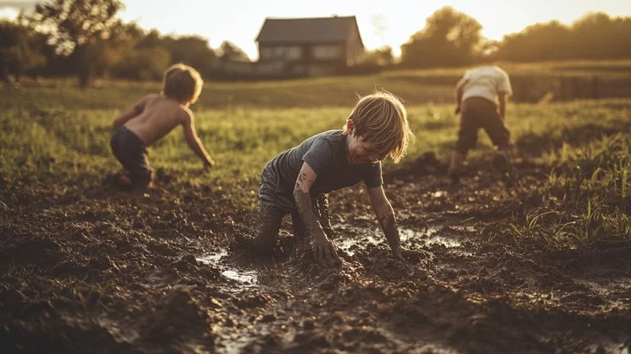
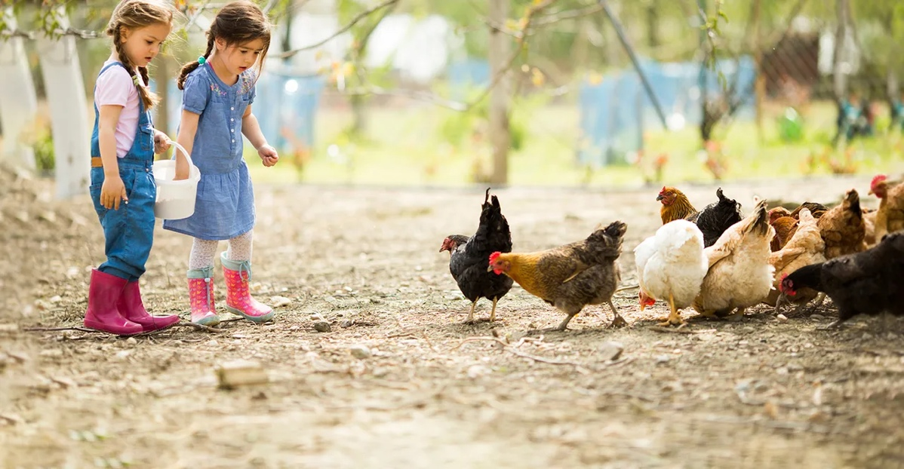
The proposed nursery will provide full-day childcare for children aged 6 months to four years and operate during standard working hours. The service will follow the Curriculum for Wales and Foundation Phase principles, emphasising play-based, child-led learning.

Key features will include:

- Daily outdoor play in a purpose-built natural garden
- Weekly visits to a neighbouring working farm
- Opportunities to care for animals such as chickens, lambs and goats
- Gardening and food-growing projects
- Regular forest school sessions in woodland areas
- Small group sizes to ensure personalised support
- A strong focus on wellbeing and independence

The physical environment will prioritise natural materials, open-ended resources and sustainable practices. Risk assessments and staff training will ensure that outdoor learning remains safe while still allowing children to experience appropriate challenge (Craig et al., 2024).

(StockCake, 2025)
(FarmProgress, 2018)
A major strength of this concept is its foundation in established child development theory and research. The farm and forest approach supports children across all areas of learning and development.

Physical Development

Outdoor environments encourage active movement such as climbing, balancing, running and digging. These activities develop gross motor skills, coordination and strength. Fine motor skills are also enhanced through tasks such as planting seeds, collecting eggs or handling tools. The Forest School Association reports that regular outdoor learning contributes to improved fitness and reduced sedentary behaviour. Providing daily access to outdoor play therefore supports children’s health more effectively than predominantly indoor settings (Forest School Association, 2021).

Cognitive Development

Piaget emphasised that children construct knowledge through direct interaction with their environment. Hands-on experiences allow children to test ideas, explore cause and effect and solve problems. Farm-based activities provide natural opportunities for learning mathematics and science (Hargraves, 2021). For example, children may count eggs, measure animal feed or observe seasonal changes in crops. These real-life contexts make abstract concepts meaningful and memorable. Experiential learning also supports curiosity and critical thinking, which are key foundations for later academic success.

Creativity and Imagination

Natural spaces stimulate imagination in ways that fixed toys often cannot. Nicholson’s Loose Parts Theory suggests that environments rich in open-ended materials promote creativity because children can manipulate them freely. Sticks, stones, mud and leaves can become anything children imagine, encouraging divergent thinking and storytelling (Westmorland & Furness Council, no date). Vygotsky also argued that imaginative play supports language development and social understanding. A forest school environment therefore nurtures creative expression alongside cognitive growth (Hauck and Gomez, 2025).

Social and Emotional Development

Social interaction is enhanced through collaborative outdoor play and shared tasks such as caring for animals or building shelters. These activities require cooperation, communication and negotiation. Additionally, caring for living creatures promotes empathy and responsibility. Research indicates that contact with animals can reduce anxiety and increase emotional regulation. Forest school programmes are also associated with improved confidence, resilience and independence, as children learn to manage risks and overcome challenges (Harding, 2024). Such experiences support secure attachments and positive self-esteem.

Environmental Awareness

Early exposure to farming and sustainability encourages children to develop respect for the natural world. Learning where food comes from and understanding ecological processes fosters environmental responsibility from a young age. This aligns closely with the Curriculum for Wales, which promotes ethical and informed citizens (Education Wales, 2020). Therefore, the nursery contributes not only to individual development but also to broader social values.

Start-up Costs for the first year
- Premises rent/ renovation
- Outdoor equipment
- Insurance and registration
- Staffing and training
- Learning resources
Estimated start-up costs: £60,000–£80,000

Income Sources
- Daily nursery fees
- Welsh Government funded childcare hours
- Holiday clubs
- Special workshops and community events
For example, with 20 children attending at £60 per day, five days per week, potential daily income could reach approximately £1200, demonstrating strong sustainability.

Staffing Costs
If each staff member worked approximately 40 hours per week and was paid above minimum wage £13.50 per hour, the weekly wage cost per staff member would be around £540. For five staff members, this would total approximately £2,700 per week.
Staffing cost yearly:
£135,000

Annual Overheads
• Rent: £24,000 a year
• Utilities: £8,000
• Insurance: £3,000
• Food & consumables: £15,000
• Resources & maintenance: £10,000 (Hewitt, 2019)
• Loan repayment: £10,000
Total annual overheads: £70,000

Total Costs
Staff wages: £135,000 a year
Other costs: £70,000
Total costs: £205,000



Beyond financial considerations, the nursery will contribute positively to the wider community. It will create employment opportunities, support local farms and reduce the need for families to travel long distances. Strengthening local services may also encourage young families to remain in the area.
This reflects the principles of social entrepreneurship, where businesses aim to create both economic and social value (Rivna and Gress, 2022). The nursery therefore supports community wellbeing alongside profitability.

The primary target market consists of parents and carers of children aged six months to four living in Aberaeron and surrounding rural communities. Informal local research and community feedback suggest strong demand for accessible childcare within the town. Families currently travelling elsewhere may prefer a closer, more convenient option (Welsh Liberal Democrats, 2023).
There is also increasing parental interest in outdoor and holistic education. Forest schools and nature-based settings are growing in popularity across the UK, reflecting a shift towards child-centred and wellbeing-focused approaches.
The nursery’s unique selling point will be its integration of farm experiences and forest school provision. As no similar setting exists locally, competition is minimal. This differentiation provides a clear competitive advantage and strengthens the business case.

Effective marketing will focus on building trust and visibility within the local community. Strategies will include social media promotion, local advertising, open days and partnerships with health visitors and primary schools. Word-of-mouth recommendations are particularly influential in rural areas and will be encouraged through positive relationships with families.

Branding will emphasise the nursery’s nature-based philosophy and unique farm experiences. Imagery of outdoor play and animal care will communicate the setting’s distinctive identity. Offering trial sessions may also help families experience the benefits first-hand.

In conclusion, the proposed farm and forest nursery in Aberaeron represents an innovative and sustainable approach to early years provision. By combining outdoor education, farming experiences and established developmental theory, the setting supports children’s physical, cognitive, social, emotional and creative growth.
At the same time, the business addresses a clear gap in local childcare services and demonstrates strong financial feasibility. Through effective marketing, funding opportunities and community partnerships, the nursery has the potential to become both a successful enterprise and a valuable local resource.
Ultimately, this concept shows how entrepreneurship in early childhood education can create meaningful learning experiences while meeting the practical needs of families and communities.

Part 2 B –

The proposed farm-inspired nursery with integrated forest school provision offers a new approach to early years education by moving learning beyond traditional indoor settings. While Part One focused on the business and practical planning of the idea, this section critically examines how the concept could influence young children’s development. It explores the ways the model may support early learning, compares it with existing early years provision, and considers the wider social, economic and educational challenges that may affect its implementation. The discussion draws on current research, early years theories, relevant policies and the concept of VUCA (volatility, uncertainty, complexity and ambiguity), which reflects the changing and unpredictable nature of modern education.

Early childhood development is commonly viewed as holistic, including physical, cognitive, social, emotional and creative areas of growth (Welsh Government, 2024). The farm and forest nursery model reflects this holistic approach by placing nature and hands-on learning at the centre of its teaching practice.
Jean Piaget suggested that children build knowledge through active interaction with their environment rather than through passive teaching. Farm-based learning creates real opportunities for experiential learning, allowing children to understand cause and effect through activities such as feeding animals, planting crops and observing seasonal changes (Scott and Cogburn, 2023). These experiences help turn abstract ideas into meaningful learning, supporting deeper cognitive development.
In comparison with many traditional nursery settings, where learning often takes place indoors using structured resources, experiential environments promote curiosity, questioning and problem-solving. Research shows that outdoor learning can improve concentration and engagement, especially for young children who learn best through sensory exploration (Kiviranta et al., 2024). As a result, the proposed nursery could help develop strong foundations for lifelong learning.
However, Outdoor play and adventure activities involve elements of exploration, challenge and risk, which research suggests have developmental value when they are meaningfully structured rather than unregulated free play. This highlights the importance of skilled practitioners who can guide, scaffold and support children’s learning experiences in outdoor settings (Gray et al., 2025).

Lev Vygotsky stressed that social interaction and collaborative play are key for both cognitive and emotional development. Forest school activities promote teamwork and problem-solving through shared tasks such as den building or caring for animals, helping children develop communication skills and peer relationships (London School of Childcare Studies, 2021).
Working with animals can also support emotional growth. Research shows that human–animal interaction can increase empathy, improve emotional regulation and reduce anxiety in young children (Beetz et al., 2012). Traditional indoor nurseries may provide fewer opportunities for these experiences or sustained responsibility for living beings.
Nonetheless, ethical and safety considerations are essential. Ensuring animal welfare, managing risk and maintaining children’s safety requires clear policies and trained staff. If these are not addressed, the developmental benefits could be compromised and safeguarding concerns may arise (Brelsford et al., 2020).

Declining physical activity in young children is an increasing concern in modern childhood. Greater screen time and indoor lifestyles are linked to reduced motor skills and overall wellbeing. Outdoor learning naturally encourages movement, coordination and balance through activities such as climbing, digging and exploring (Gao et al., 2018).
According to the Forest School Association regular outdoor learning also supports resilience and confidence, as children learn to manage risks for themselves. This approach aligns with the Curriculum for Wales, which emphasises the development of healthy, confident individuals (Welsh Government, 2023).
Nevertheless, accessibility issues need to be considered. Outdoor learning can be affected by weather, the cost of suitable clothing, and parents’ perceptions of safety. Families facing financial challenges may struggle to provide appropriate outdoor attire, potentially creating inequalities unless inclusive strategies are implemented.

Simon Nicholson proposed the Loose Parts Theory, which suggests that creativity thrives in environments with open-ended materials. Natural spaces offer a wide variety of resources that promote imaginative play, storytelling and symbolic thinking. Unlike toys with fixed purposes, these materials allow children to direct their own learning experiences (Cankaya et al., 2023).
This differs from many commercial early years settings, where structured activities often dominate because of curriculum demands or concerns about risk. The proposed nursery could therefore support greater creative independence, a skill increasingly recognised as important in 21st-century education.

Although outdoor learning is increasingly valued in early years practice, many nurseries still operate mainly indoors due to limited space, staffing pressures or regulatory requirements. Urban settings in particular often lack access to natural environments, which can limit outdoor learning time (Traynor et al., 2025).
The proposed nursery differs by making outdoor learning central to its approach rather than treating it as an extra activity. This reflects a wider international interest in nature-based education but is still relatively rare in rural Welsh childcare.
However, innovation alone does not guarantee better outcomes. Research shows that the quality of adult–child interaction remains the strongest influence on development, regardless of setting (Howard et al., 2024) The success of the nursery therefore depends not only on its environment but also on skilled practitioners and reflective teaching practices.

The concept is strongly supported by several policy frameworks. The Curriculum for Wales encourages experiential, play-based learning and promotes connection with local environments, which the nursery’s place-based approach directly supports (Welsh Government, 2024). The United Nations Convention on the Rights of the Child (UNCRC) highlights children’s rights to play, participation and development (United Nations, 1989). Outdoor learning helps fulfil Article 31, which recognises children’s right to play and recreation. Furthermore, the National Minimum Standards for Regulated Childcare, which inform Care Inspectorate Wales’ inspection and regulatory framework emphasise wellbeing, active learning and child-centred practice (Welsh government , 2025). The proposed nursery aligns with these requirements but would need thorough risk assessments to ensure full compliance.

Modern early years provision operates in a VUCA environment, defined by volatility, uncertainty, complexity and ambiguity. Volatility is seen in economic instability and the cost-of-living crisis, which can impact childcare businesses. Rising energy bills, food costs and staff salaries may threaten financial stability, while families under financial pressure may reduce childcare use, affecting occupancy (Leader, 2017).
Uncertainty was highlighted by the COVID-19 pandemic, which showed how quickly operational requirements can change. Ongoing hygiene expectations affect resource use, shared materials and outdoor activities, and future public health issues could disrupt farm visits or group learning sessions (Leader, 2017).
Complexity arises from balancing educational quality, safeguarding, animal welfare, environmental sustainability and financial viability. Practitioners must manage regulatory requirements while delivering innovative pedagogy (Leader, 2017).
Ambiguity exists in debates about risk-taking in play. Although research supports managed risk for development, parental concerns and inspection pressures can encourage overly cautious approaches, limiting the benefits of forest school methods (Leader, 2017).
Considering these factors, the VUCA framework demonstrates that entrepreneurial early years initiatives must remain flexible and adaptable rather than rigidly fixed.

Several factors could affect the implementation of the nursery:
- Financial pressures: high start-up costs and staff wages remain significant.
- Cost-of-living crisis: families’ ability to afford childcare may reduce enrolment.
- Staff recruitment: there is a national shortage of qualified early years practitioners.
- Weather dependency: outdoor learning requires flexible planning to maintain consistency.
- Insurance and regulation: working with animals adds administrative and compliance complexity.
Educational settings also often struggle to adopt innovative outdoor models or specialised equipment due to funding constraints, raising questions about scalability across the wider early years sector (Traynor et al., 2025).
Despite these challenges, the concept offers opportunities for broader adoption. Nature-based learning aligns with policy priorities on wellbeing and sustainability.
Future developments could include:
- Partnerships with local schools to extend outdoor learning into primary education.
- Inclusion programmes for children with additional learning needs.
- Community workshops to promote environmental awareness.
- Research collaborations to evaluate developmental outcomes.
If successful, this model could influence early years practice more widely, showing how rural environments can enhance learning rather than restrict it.

This analysis shows that the proposed farm and forest nursery could strongly support young children’s holistic development through hands-on learning, outdoor play, and connection with nature. Backed by developmental theory, policy guidance, and current research, the model aligns well with modern educational priorities.
However, implementation occurs in a VUCA context, influenced by economic pressures, uncertainty, and regulatory demands. Its success depends on skilled practitioners, financial stability, and the ability to adapt to changing circumstances.
Although it would start as a small local initiative, the model has potential for wider use across the early years sector, as the benefits of nature-based learning gain recognition. Ongoing research and evaluation would be needed to assess long-term outcomes and guide future developments in early childhood education.

References

Beetz, A. et al. (2012) ‘Psychosocial and Psychophysiological Effects of Human-Animal Interactions: The Possible Role of Oxytocin’, Frontiers in Psychology, 3(234). Available at: https://doi.org/10.3389/fpsyg.2012.00234.

Brelsford, V.L. et al. (2020) ‘Best Practice Standards in Animal-Assisted Interventions: How the LEAD Risk Assessment Tool Can Help’, Animals, 10(6), p. 974. Available at: https://doi.org/10.3390/ani10060974.

Cankaya, O. et al. (2023) ‘Preschool Children’s Loose Parts Play and the Relationship to Cognitive Development: A Review of the Literature’, Journal of Intelligence, 11(8), p. 151. Available at: https://doi.org/10.3390/jintelligence11080151.

Ceredigion Council (2022) CEREDIGION Ceredigion Public Services Board ASSESSMENT OF LOCAL WELL-BEING 2022. Available at: https://www.ceredigion.gov.uk/media/ailh1mpt/ceredigion-assessment-of-local-well-being-2022.pdf (Accessed: 26th February 2026).

Craig, D. et al. (2024) ‘Effective Nature-Based Outdoor Play and Learning Environments for below-3 Children: A Literature-Based Summary’, International Journal of Environmental Research and Public Health, 21(9), pp. 1247–1247. Available at: https://doi.org/10.3390/ijerph21091247.

Education Wales (2020) Curriculum for Wales guidance. Available at: https://hwb.gov.wales/api/storage/18d0d2f1-0563-4945-a889-d1548ae24c4e/curriculum-for-wales-guidance.pdf (Accessed: 26th February 2026).

EuroKids (2024) Farm Activities for Preschoolers: Engaging Education in Nature, EuroKids. Available at: https://www.eurokidsindia.com/blog/farm-related-engaging-activities-for-preschoolers-and-toddlers.php (Accessed: 1 March 2026).

FarmProgress (2018) Keep farm kids safe this summer, Farm Progress. Available at: https://www.farmprogress.com/farm-life/keep-farm-kids-safe-this-summer (Accessed: 1 March 2026).

Forest School Association (2021) What Is Forest School?, Forest School Association. Available at: https://forestschoolassociation.org/what-is-forest-school/ (Accessed|: 24th February 2026).

Gao, Z. et al. (2018) ‘Physical Activity in Children’s Health and Cognition’, BioMed Research International, 2018(1), pp. 1–4. Available at: https://doi.org/10.1155/2018/8542403.

Gray, T. et al. (2025) ‘Risky Outdoor Play and Adventure Education in Nature for Child and Adolescent Wellbeing: A Scoping Review’, Behavioral Sciences, 16(1), pp. 5–5. Available at: https://doi.org/10.3390/bs16010005.

Harding, N. (2024) Nurturing Emotional Resilience in Forest School Settings: Research Insights | Forest School Association, forestschoolassociation.org. Available at: https://forestschoolassociation.org/nurturing-emotional-resilience-in-forest-school-settings-research-insights/ (Accessed: 28th February 2026).

Hargraves, V. (2021) Piaget’s theory of education, The Education Hub. Available at: https://theeducationhub.org.nz/piagets-theory-of-education/ (Accessed: 1st March 2026).

Hauck, J. and Gomez, K. (2025) Social and Cultural Influences on Child Development: Lev Vygotsky and Urie Bronfenbrenner, Springer Nature. Available at: https://doi.org/10.1007/978-3-031-98319-1_4.

Hewitt, C. (2019) Take control of your personal finances, Medium. Available at: https://medium.com/@colinhewitt/take-control-of-your-personal-finances-d27341d54eb5 (Accessed: 28th February 2026).

Howard, S.J. et al. (2024) ‘Measuring the Quality of Adult–Child Interactions in the Context of ECEC: a Systematic Review on the Relationship with Developmental and Educational Outcomes’, Educational Psychology Review, 36(1). Available at: https://doi.org/10.1007/s10648-023-09832-3.

Hwb (2024) View - Hwb, Gov.wales. Available at: https://hwb.gov.wales/playlists/view/1d966d4e-a1c7-4b1e-b29f-6090a3a926c7/en/34 (Accessed: 27th February 2026).

Kiviranta, L. et al. (2024) ‘Outdoor Learning in Early Childhood education: Exploring Benefits and Challenges’, Educational Research, 66(1), pp. 1–18. Available at: https://doi.org/10.1080/00131881.2023.2285762.

Leader, C.C. (2017) Children’s Centres Systems Leadership — VUCA contexts, Children’s Centre. Available at: https://medium.com/children-s-centre/childrens-centres-systems-leadership-vuca-contexts-fffed3fceb64 (Accessed: 27th February 2026).

Leonhardt, C., Danielsen, D. and Andersen, S. (2025) ‘Associations between screen use, learning and concentration among children and young people in western countries: a scoping review’, Children and Youth Services Review, 177, p. 108508. Available at: https://doi.org/10.1016/j.childyouth.2025.108508.

London School of Childcare Studies (2021) The Lev Vygotsky Education Approach - London School of Childcare Studies, London School of Childcare Studies. Available at: https://childcarestudies.co.uk/blog/the-lev-vygotsky-education-approach/ (Accessed: 26th February 2026).

McLeod, S. (2025a) Piaget cognitive stages of development, Simply Psychology. Available at: https://www.simplypsychology.org/piaget.html (Accessed 16th February 2026).

McLeod, S. (2025b) Vygotsky’s sociocultural theory of cognitive development, Simply Psychology. Available at: https://www.simplypsychology.org/vygotsky.html (Accessed: 16th February 2026).

Patel, S. (2023) The benefits of playing outside for kids, Electric Ride On Cars. Available at: https://electricrideoncars.co.uk/blogs/blog/benefits-of-playing-outdoors-for-kids (Accessed: 23rd February 2026).

Rivna, A. and Gress, M. (2022) ‘Social entrepreneurship as a new business model. The case of refugee integration’, Economic Research-Ekonomska Istraživanja, pp. 1–19. Available at: https://doi.org/10.1080/1331677x.2022.2120044.

Schools, F. (2024) The Difference Between Outdoor Learning and Forest Schools, Forest Schools Education. Available at: https://www.forestschools.com/blogs/forest-school-blog/the-difference-between-outdoor-learning-and-forest-schools?srsltid=AfmBOooYt7Q1KOzICxI9hfb-7TljwFSexLOTkZfriKcoA7nrVP8HcNGr (Accessed: 18 February 2026).

Scott, H.K. and Cogburn, M. (2023) Piaget, National Library of Medicine. StatPearls Publishing. Available at: https://www.ncbi.nlm.nih.gov/books/NBK448206/ (Accessed: 26th February 2026).

StockCake (2025) Free Kids playing outdoors Image | Download at StockCake, Stockcake.com. StockCake. Available at: https://stockcake.com/i/kids-playing-outdoors_1456533_197645 (Accessed: 1st March 2026).

The Early Years Network Team (2023) Embracing Nature & The Benefits of Outdoor Learning, The Early Years Network. Available at: https://theearlyyearsnetwork.co.uk/knowledge-hub/embracing-nature-the-benefits-of-outdoor-learning (Accessed: 25th February 2026).

Traynor, O. et al. (2025) ‘The feasibility of evaluating outdoor nature-based early childhood education and care provision: a pilot quasi-experimental design’, Pilot and Feasibility Studies, 11(1). Available at: https://doi.org/10.1186/s40814-025-01721-6.

United Nations (1989) Convention on the Rights of the Child, OHCHR. United Nations. Available at: https://www.ohchr.org/en/instruments-mechanisms/instruments/convention-rights-child (Accessed: 1st March 2026).

Welsh Government (2022) A curriculum for funded non-maintained nursery settings. Available at: https://hwb.gov.wales/api/storage/b1801d78-38c3-4320-9818-d9996c21aef8/220914-a-curriculum-for-funded-non-maintained-nursery-settings.pdf (Accessed: 1st March 2026).

Welsh Government (2023) Teaching and Learning in the outdoors: the Current State of Outdoor Learning in Schools in Wales Research. Available at: https://hwb.gov.wales/api/storage/177a33a6-7c70-4843-bb63-903e70a04154/teaching-and-learning-in-the-outdoors-the-current-state-of-outdoor-learning-in-schools-in-wales.pdf (Accessed: 1st March 2026).

Welsh Government (2024) Early Childhood Play, Learning and Care Plan in Wales (Detailed version) 2 Early Childhood Play, Learning and Care Plan in Wales. Available at: https://www.gov.wales/sites/default/files/publications/2024-03/early-childhood-play-learning-care-plan.pdf (AccessedL=: 27th February 2026).

Welsh Government (2025) CHILDCARE AND EARLY YEARS CAPITAL PROGRAMME SMALL GRANTS GUIDANCE 2025-28. Available at: https://www.gov.wales/sites/default/files/publications/2025-09/childcare-and-early-years-capital-programme-small-grants-scheme-guidance-2025-2028.pdf (Accessed: 24th February 2026).

Welsh government (2025) National Minimum Standards (NMS) for Regulated Childcare: proposed changes 2025 [HTML] | GOV.WALES, GOV.WALES. Available at: https://www.gov.wales/national-minimum-standards-nms-regulated-childcare-proposed-changes-2025-html (Accessed: 27th February 2026).

Welsh Liberal Democrats (2023) Closing the Gap: Childcare in Wales. Available at: https://www.libdems.wales/fileadmin/groups/512/Images/Campaign_Images/Closing_the_Gap_FINAL.pdf (Accessed: 1 March 2026).

Westmorland & Furness Council (no date) Loose Parts Play. Available at: https://www.cumbria.gov.uk/elibrary/Content/Internet/537/1459/7037/38477/38494/45121133841.pdf (Accessed: 1 March 2026).

