University of Wales Trinity Saint David

Wales Institute of Science & Art

Application of Computer Aided Engineering Processes

Structural Design & Fluid Analysis
ACHA6010

John Forster
2004393

12/2023

Table of Contents

- – Introduction
- – Methodology
  - – Validation Study
  - – Mesh Study
  - – Piston Study
- – Results & Analysis
  - – Piston Analysis
4.0 – Conclusion
5.0 – References
6.0 – Appendix

Table of Figures
Figure 1: Bimetallic Strip Diagram (Dub, 2017) 4
Figure 2: Bimetallic Strip Specification (Dub, 2017) 4
Figure 3: Bimetallic Strip Design 5
Figure 4: Mesh Analysis Values 5
Figure 5: How Maximum Total Deformation of Bimetallic Strip varies with Mesh Element Size 6
Figure 6: Crankshaft, Connecting Rod, Gudgeon pin and Piston model. 7
Figure 7: Rigid Dynamics Force Time Graph 7
Figure 8: Steady State Thermal Temperature Analysis of Piston 9
Figure 9: Total Piston Deformation 9
Figure 10: Equivalent Stress of the Piston 10
Figure 11: Piston System Data 13
Figure 12: Fully Linked System Ansys Workbench R1 2021 13

- – Introduction
This report will outline how the use of computer aided design and finite element analysis can be used to improve vehicle components in terms of structural design as well as mass reduction. The computer aided design (CAD) software that is shown to be used in this report is Solidworks 2023 and the finite element analysis (FEA) used in this report is Ansys R1 2021. This report will also outline how this will be undertaken regarding what methods shall be used so that this could be replicated or improved.

Computer-aided design (CAD) is a way to digitally create and model 2D drawings and 3D models of new or existing products before they’re ever manufactured. (PTC Digital Transforms Physical, 2023). This is done so that models can be more accurately designed and tested before ever being manufactured.

Finite element analysis (FEA) is used to digitally model how a real 3D model would react under real world condition. These conditions can include load, deformation or effects under high temperatures. The aim of FEA is to reduce the number of physical models used when testing components. (Simscale, 2023). FEA is also used to calculate simulations that would be otherwise too complicated to calculate mathematically.

2.0 – Methodology
2.1 – Validation Study

Firstly, to test what I will be investigating a validation study must be undertaken. For this investigation the validation study will be a load test of a bimetallic strip. The bimetallic strip will consist of 2 different metals: the invar and copper. (Dub, 2017)
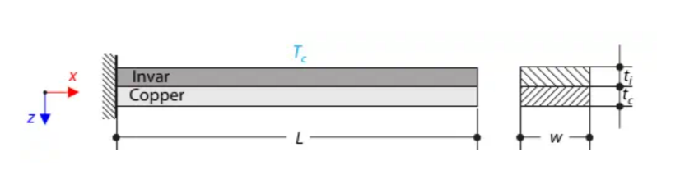
Figure 1: Bimetallic Strip Diagram (Dub, 2017)

The left end of the bimetallic strip is fixed, and the right end is free as shown in figure 1. The free end of the bimetallic strip is loaded by a thermal loading of 100 degrees Celsius at the free end of the strip. This is done to find the total deflection of the strip.

To start the validation study firstly the CAD model of the bimetallic strip must be created. For this report it was designed in Solidworks 2023. The model must be designed in line with the same specification shown below in figure 2 and should be like the design in figure 3.
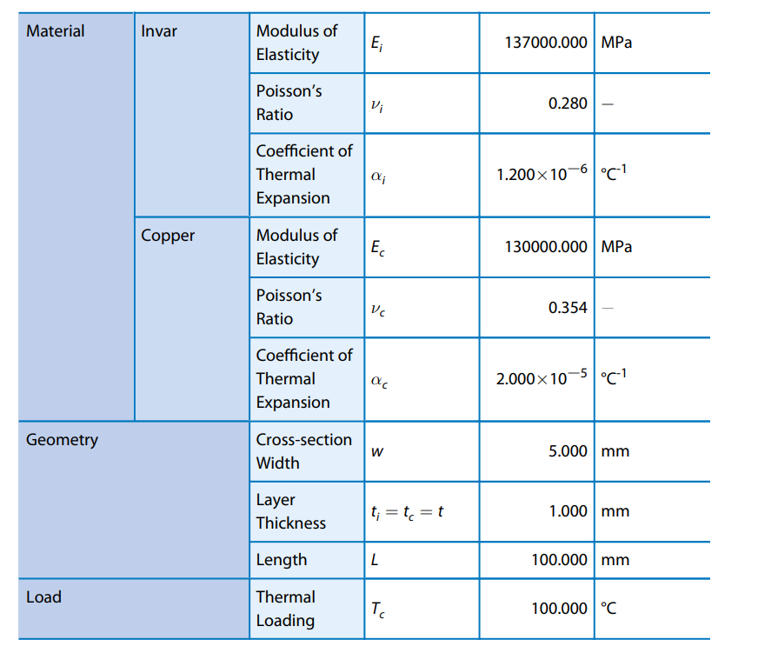
Figure 2: Bimetallic Strip Specification (Dub, 2017)

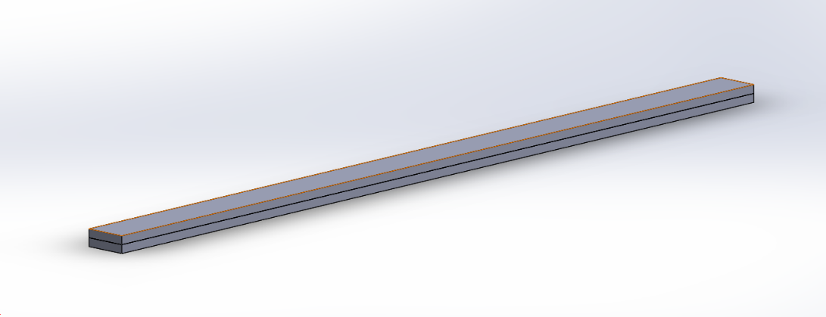
Figure 3: Bimetallic Strip Design

Once the bimetallic strip is designed as shown in figure 3, it must be saved as a STEP file so that the design can then be imported as a geometry in Ansys R1 2021.

However, before the geometry is imported the two layers must be assigned to the correct material with the correct the modulus of elasticity, Poisson’s ratio and coefficient of thermal expansion. These values may have to manually added so that the values are the same as shown in figure 2.

After this is done the geometry can be imported so that the design can be modelled using an appropriate mesh size. The mesh size used for this analysis was 0.0009 metres. An analysis on the correct mesh size will be shown in section 2.2. Following completion of the mesh sizing the model can be run in Ansys R1 2021.

2.2 – Mesh Analysis

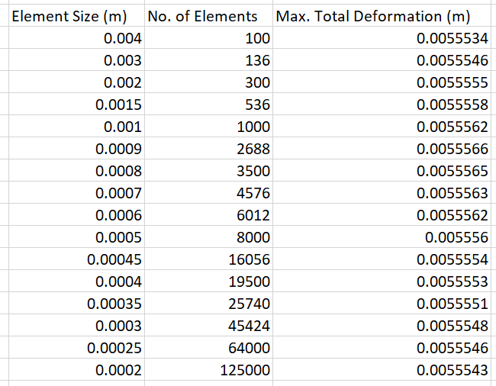
Whilst the validation model was conducted an analysis of the mesh size was also conducted. This was conducted to find the most accurate mesh to use for the piston analysis. Depending on the mesh size the value being investigated can be significantly different.
Figure 4: Mesh Analysis Values

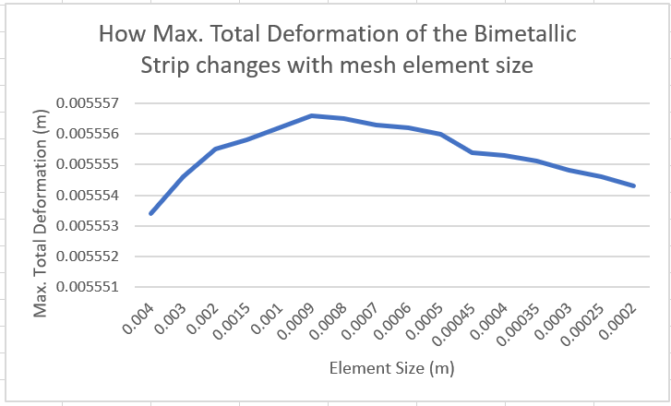
Figure 5: How Maximum Total Deformation of Bimetallic Strip varies with Mesh Element Size
Figure 5 shows how the total deformation changes with element size. However, there does not appear to be a vast difference between the values that were found but, the highest maximum total deformation appeared at an element size of 0.0009 metres therefore, this provides the most accurate mesh size that will be used for further study of the piston.

2.3 – Piston Study

The main study of this report is the study of the piston. This was completed after conducting both the validation study and the mesh analysis. The overall methodology for this piston analysis is like the validation study but with some additional steps.
The first step for the piston analysis is the same as the validation study: to create a CAD design so that the design can be used as the geometry model in FEA (Ansys R1 2021). Once the CAD model has been designed in Solidworks and converted to a STEP file the engineering data can be inputted into Ansys R1 2021. This data shall be shown in the appendix. This will provide the data for the fully linked system.

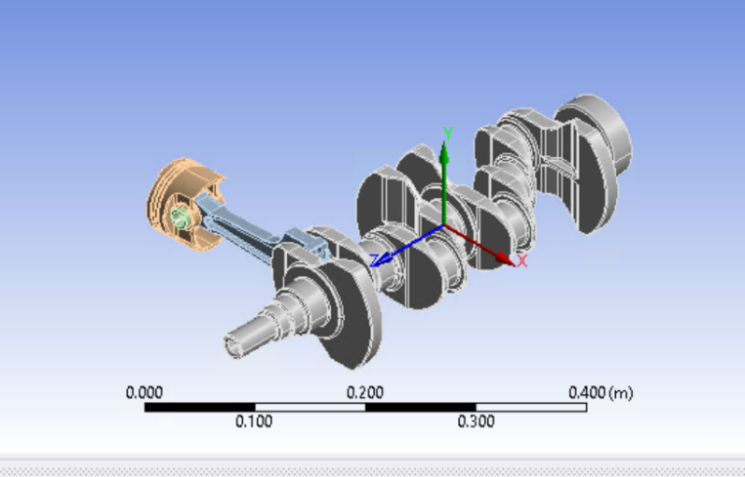

Figure 6: Crankshaft, Connecting Rod, Gudgeon pin and Piston model.

The next section of the system is rigid dynamics. In this section the aluminium 6061 (the metal used in this study) must be applied to all components and revolute joints must be created to make sure the system runs as it would in the real world. The joints can be made in the connections section of Ansys R1 2021. A ‘mesh’ must be created for the model to be simulated; however, no actual mesh needs to be created at this stage as the system is rigid. Next, the time duration for the rigid dynamics must be inputted. For this model the time duration is 0.05 seconds as the system runs around 4000 revolutions per minute (RPM) meaning any higher time duration will provide excess data. The time step is then set to 0.0001 seconds and the rotational velocity is set to 4000 RPM. Finally, a joint probe must be created between the gudgeon pin and the piston so that the result of this can be imported to the static structural section of the system. For rigid dynamics only 1 result is needed to move forward so the largest value is used for this system that is 2386.2 N. This can be found from the graph in figure 7 below.
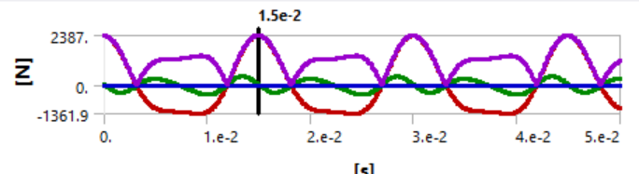
Figure 7: Rigid Dynamics Force Time Graph
For the static structural sections, the same data, geometry and model is used so it does not need to be re-created. However, before further work is conducted in the static structural section the steady state thermal section must be created to account for thermal deformation. The steady state thermal section also uses the same engineering data and geometry as the rigid dynamics. A mesh for the thermal steady state is then created. The mesh used in this report will be 0.0009 metres as this is the most accurate mesh as found in figure 5. The convection inputs for all regions of the piston are then inputted into Ansys these inputs are shown in the appendix. The solution of this thermal stage is needed to then input into the static structural section as it is used as a boundary condition for the static structural section of the system. In the static structural section, the mesh needs to be recreated as 0.0009 metres so it’s the same as the thermal study. Lastly, in the analysis settings in static structural the model has to have weak springs selected as on and a pressure must be selected in the static structural section acting down on top of the piston. Once this is done the fully linked system can be solved as a static structural body.

3.0 – Results & Analysis
3.1 – Piston Analysis

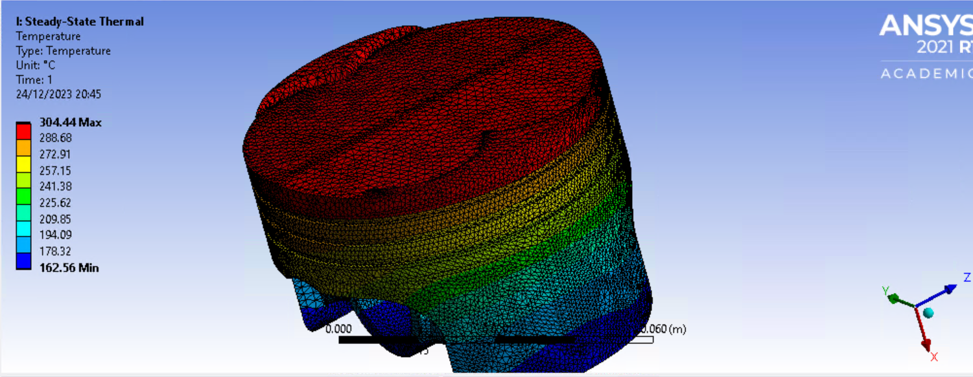
Figure 8: Steady State Thermal Temperature Analysis of Piston

Figure 8 shows the thermal temperature map that the piston experiences when under load. The max temperature shown occurs at the top of the piston due to this is the region where the fuel mix burn occurs. The maximum temperature found from this simulation is 304.44 degrees Celsius. This is a typical maximum piston temperature as shown by (MAHLE, 2012).

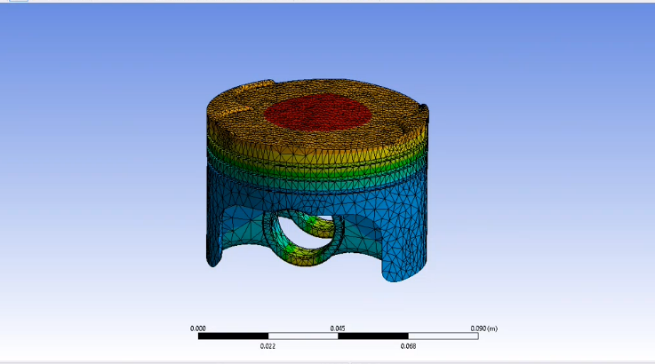
Figure 9: Total Piston Deformation
The total piston deformation in figure 9 is shown to appear around the top middle section of the piston crown. This is expected as around her is where the spark originates from causing more deformation. However, the total deformation of this piston is very low at 0.0003 metres as a maximum therefore suggesting that the 6061-aluminium used is a suitable material to be used in pistons. However, there is an anomaly where there are higher deformation values around the section where the piston encounters the gudgeon pin. This could be due to the stresses encountered between the piston and gudgeon pin and could be further improved by further constraining that area of the piston.
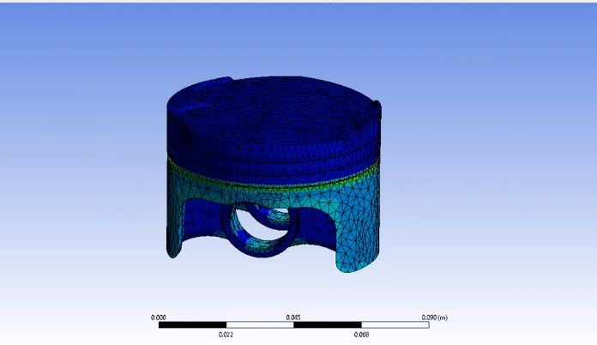
Figure 10: Equivalent Stress of the Piston
Figure 10 shows the equivalent stress of the piston. It shows that the highest stresses can be found around the piston rings and are reasonably high at 2.23 GPa. This is reasonable however, as these areas are smaller and therefore are more susceptible to higher stress levels. Despite this the rest of the piston has much lower values for equivalent stress making the aluminium material suitable to be used.

4.0 – Conclusion
In conclusion, this report shows how engineering software can be used to analyse the material used. It also shows how CAD and FEA can be used to design a suitable model without having to manually test the model. Further constraining the piston in some areas such as around the gudgeon pin could however be useful to acquire more accurate results.

5.0 - References
Dub, M. (2017, October 12). Verification Example. Retrieved October 15, 2023, from Bimetallic Strip: https://www.dlubal.com/en/downloads-and-information/examples-and-tutorials/verification-examples/000078#:~:text=A%20bimetallic%20strip%20is%20composed,bimetallic%20strip%20(free%20end).
MAHLE. (2012). Pistons and Engine Testing. In MAHLE. MAHLE GMBH. Retrieved December 16, 2023, from https://dieselnet.com/tech/combustion_piston-cool.php#:~:text=Some%20typical%20temperature%20values%20for,injection)%20350%E2%80%93400%C2%B0C
PTC Digital Transforms Physical. (2023). What is CAD? Retrieved December 11, 2023, from CAD Software Solutions: https://www.ptc.com/en/technologies/cad
Simscale. (2023). What Is FEA | Finite Element Analysis? Retrieved December 12, 2023, from What Is FEA | Finite Element Analysis?: https://www.simscale.com/docs/simwiki/fea-finite-element-analysis/what-is-fea-finite-element-analysis/

6.0 – Appendix
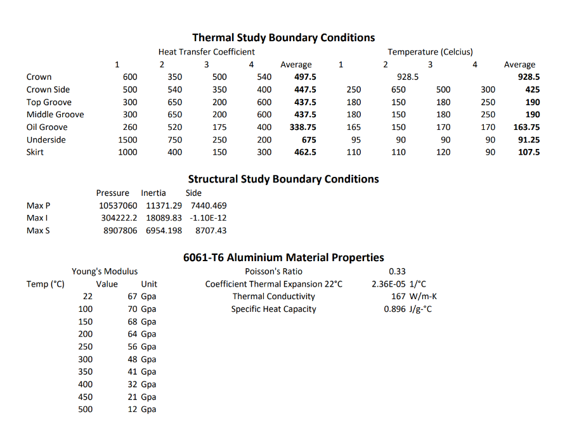
Figure 11: Piston System Data
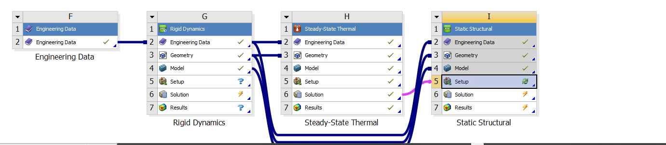
Figure 12: Fully Linked System Ansys Workbench R1 2021

