Activity : Build models using ANN and CNN for MNIST Handwritten digit classificaiton.
MNIST Handwritten Digit classificaiton using CNN
- Objective of this activity is to
  - Introduciton to MNIST (Modified National Institute of Standards and Technologies) data set and its importnace in computer vision
  - Building a baseline classificaiton model using ANN and CNN
  - Evaluate the both models
  - Building an improved CNN
  - Finalizing the improved model for the prediction in MNIST dataset
  - Part of the code is given and complete the sections highlighted in red font.

Importing Libraries
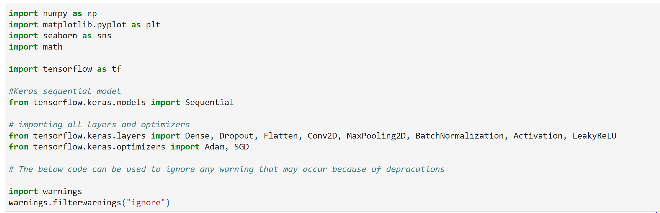
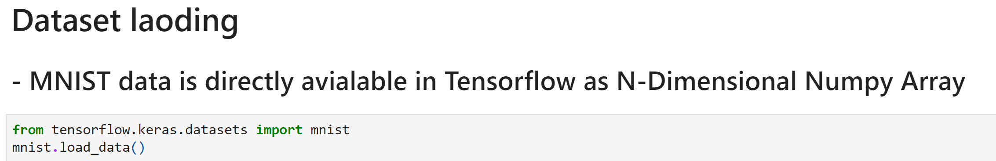

Data is assigned to both train and test sets
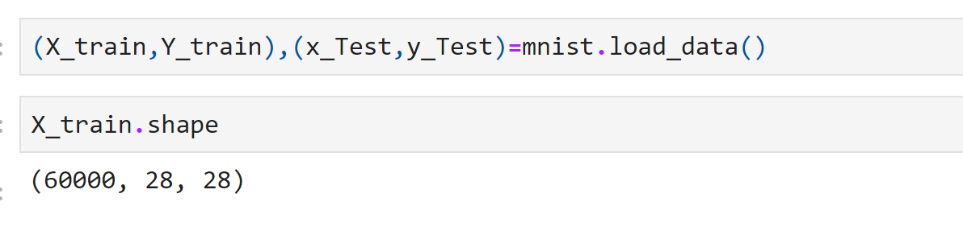
The shape function provided the shape of the data i.e there are 10000 images with dimensions 28x28
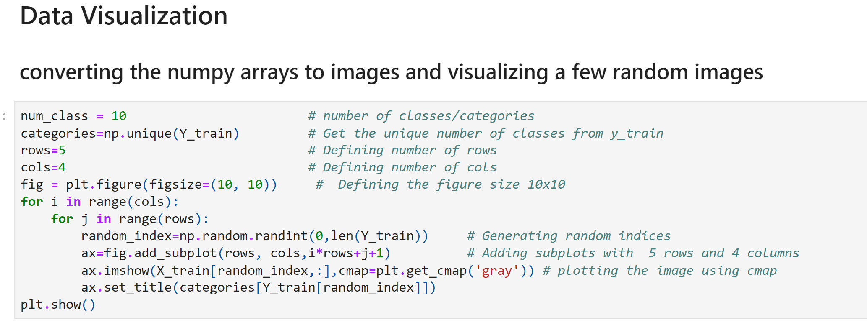
Output of the above code is as follows
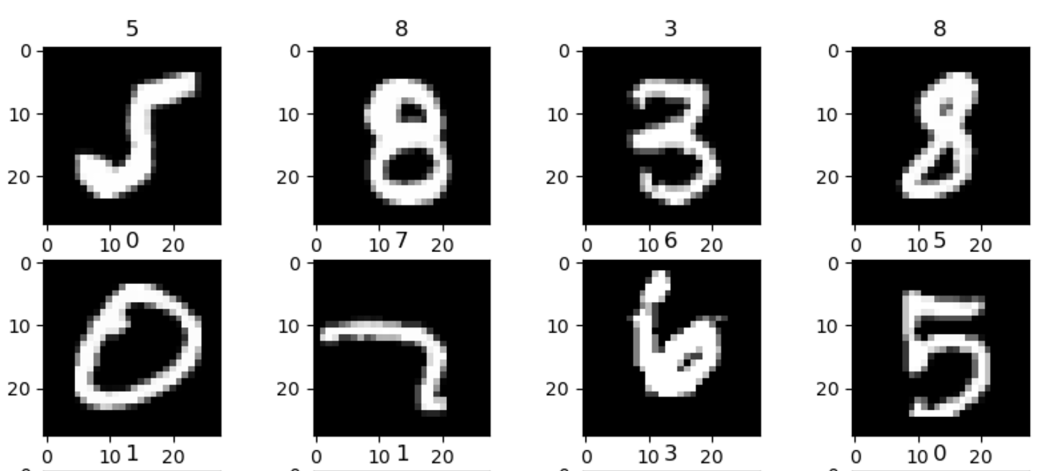

Present the distribution of each class (digits 0-9 in this case) to understand the status of the data imbalance/balance.
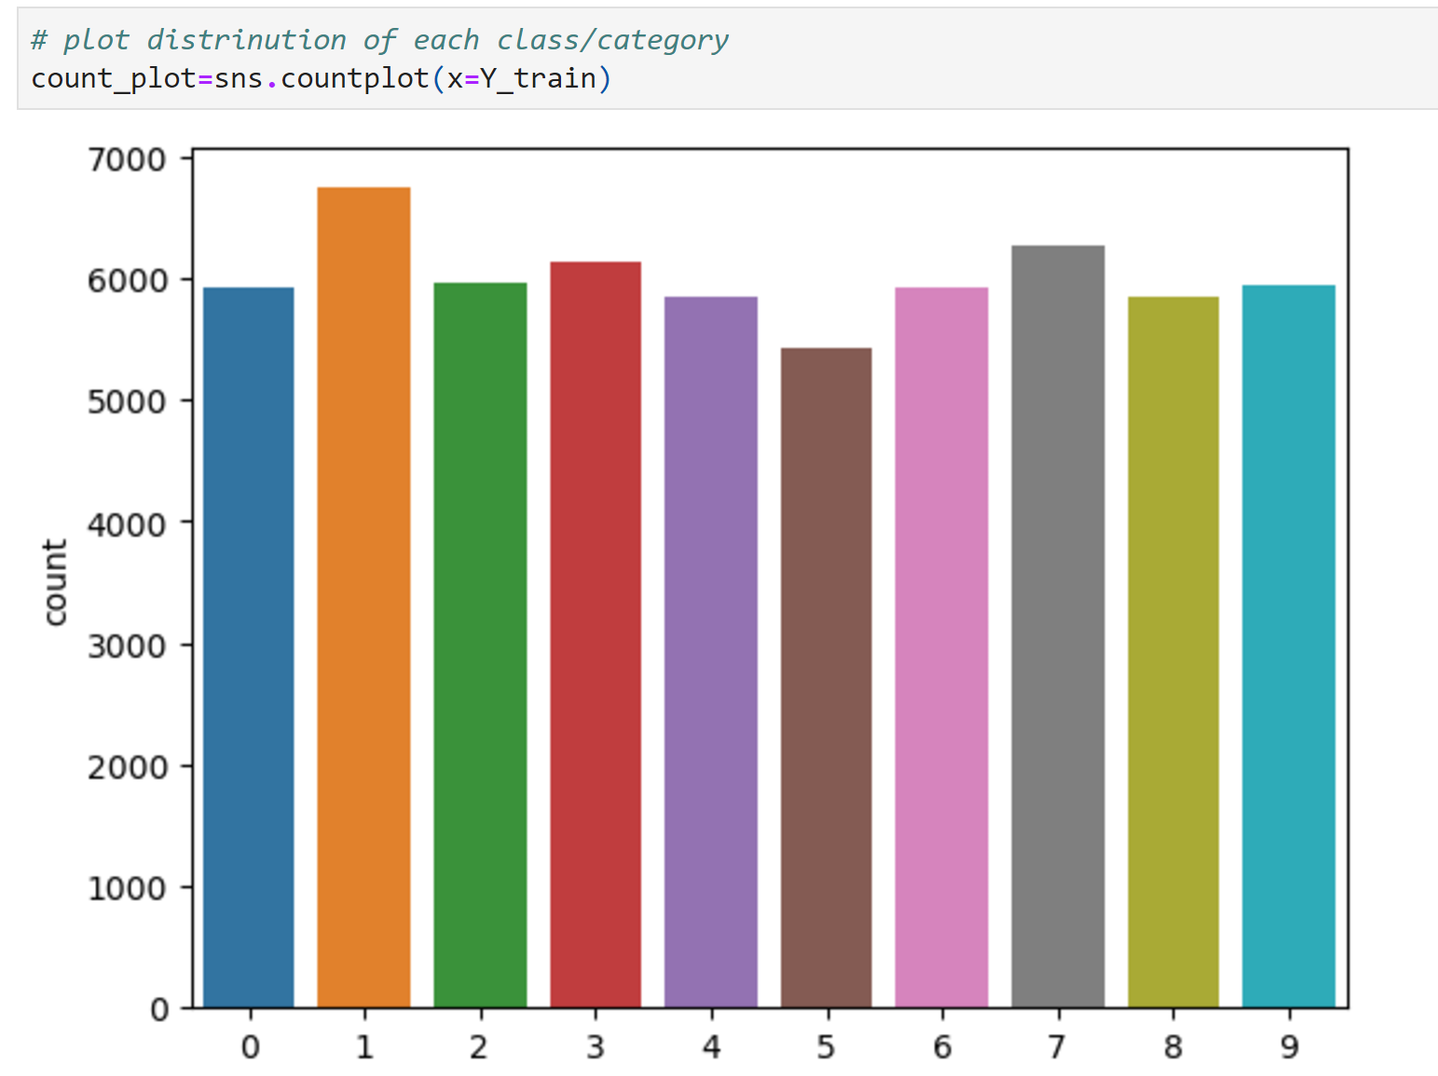

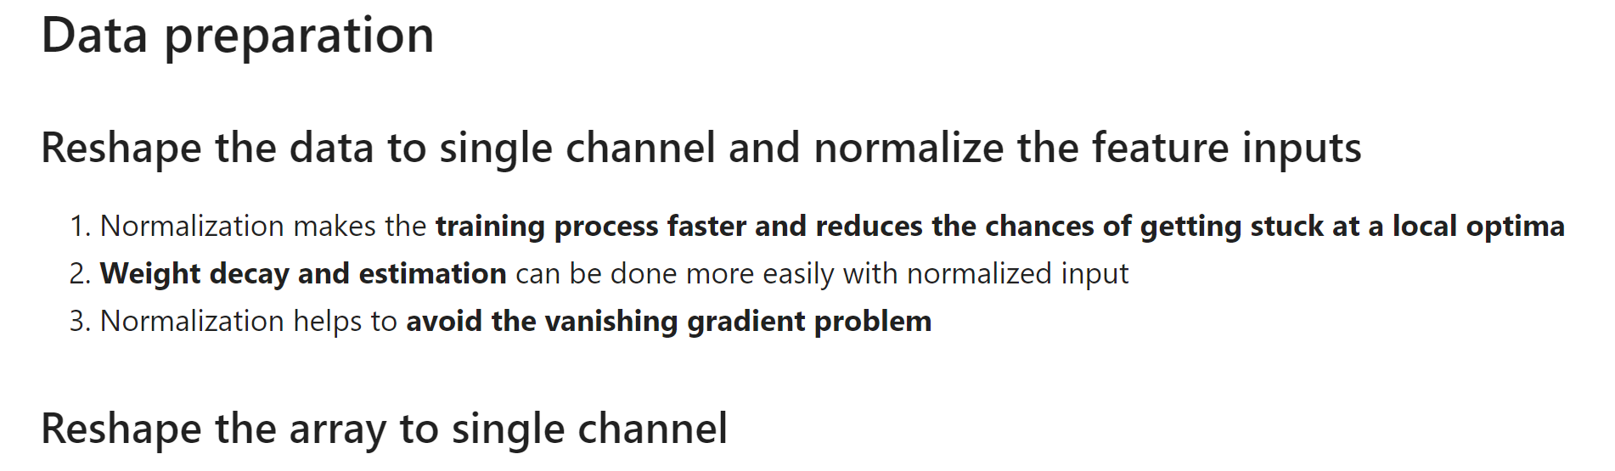
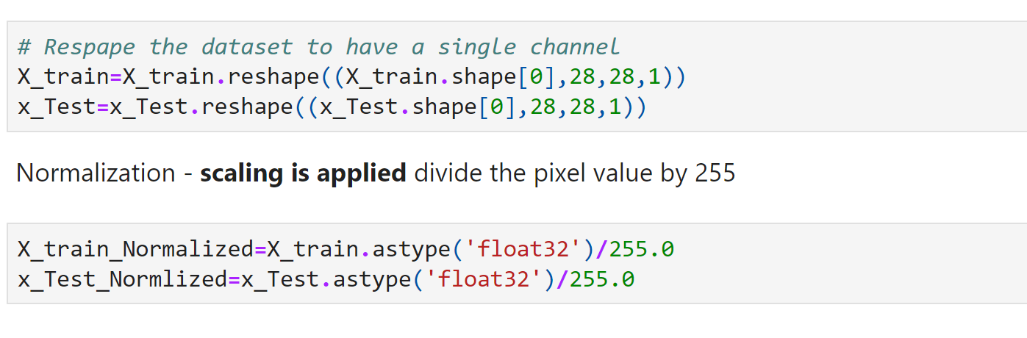
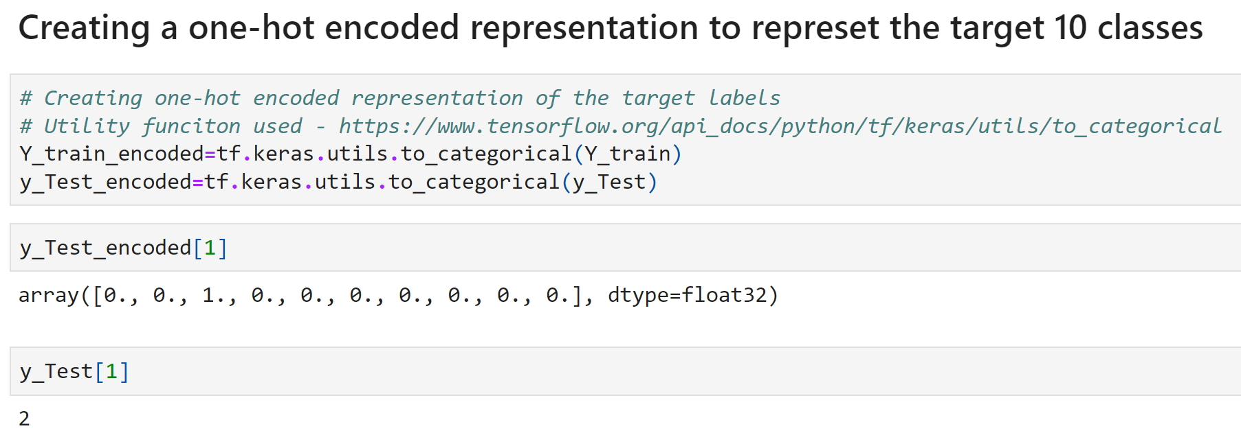
Here * The tf.keras.utils.to_categorical function converts a class vector (integers representing class labels) into a one-hot encoded format.
One-Hot Encoding:
- If you have a label, for example, 2, in one-hot encoding it is represented as [0, 0, 1, 0, 0, 0, 0, 0, 0, 0].

Model building using ANN
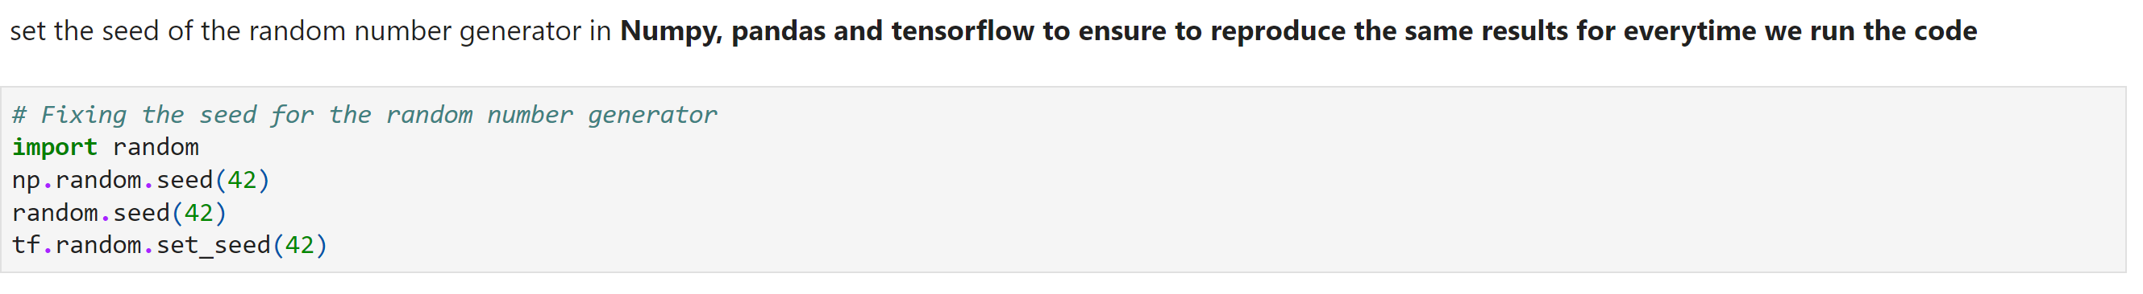

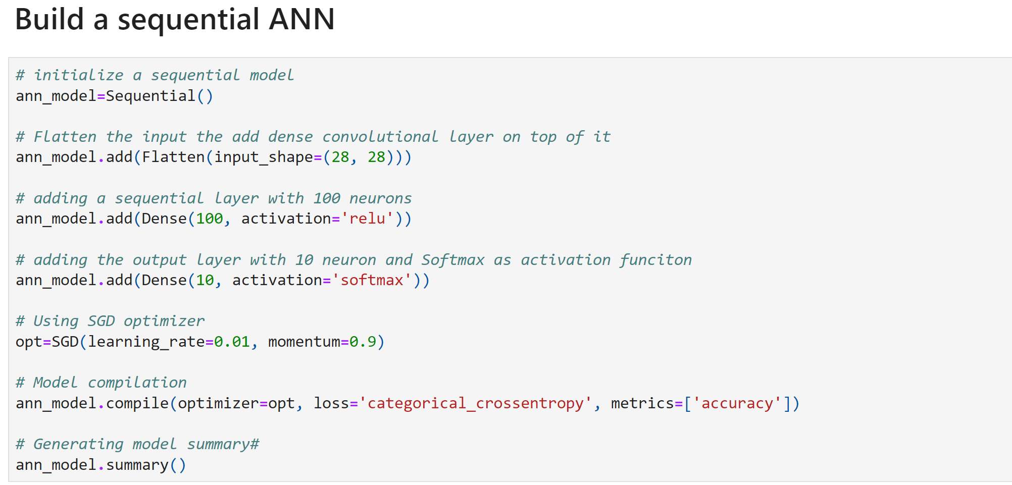
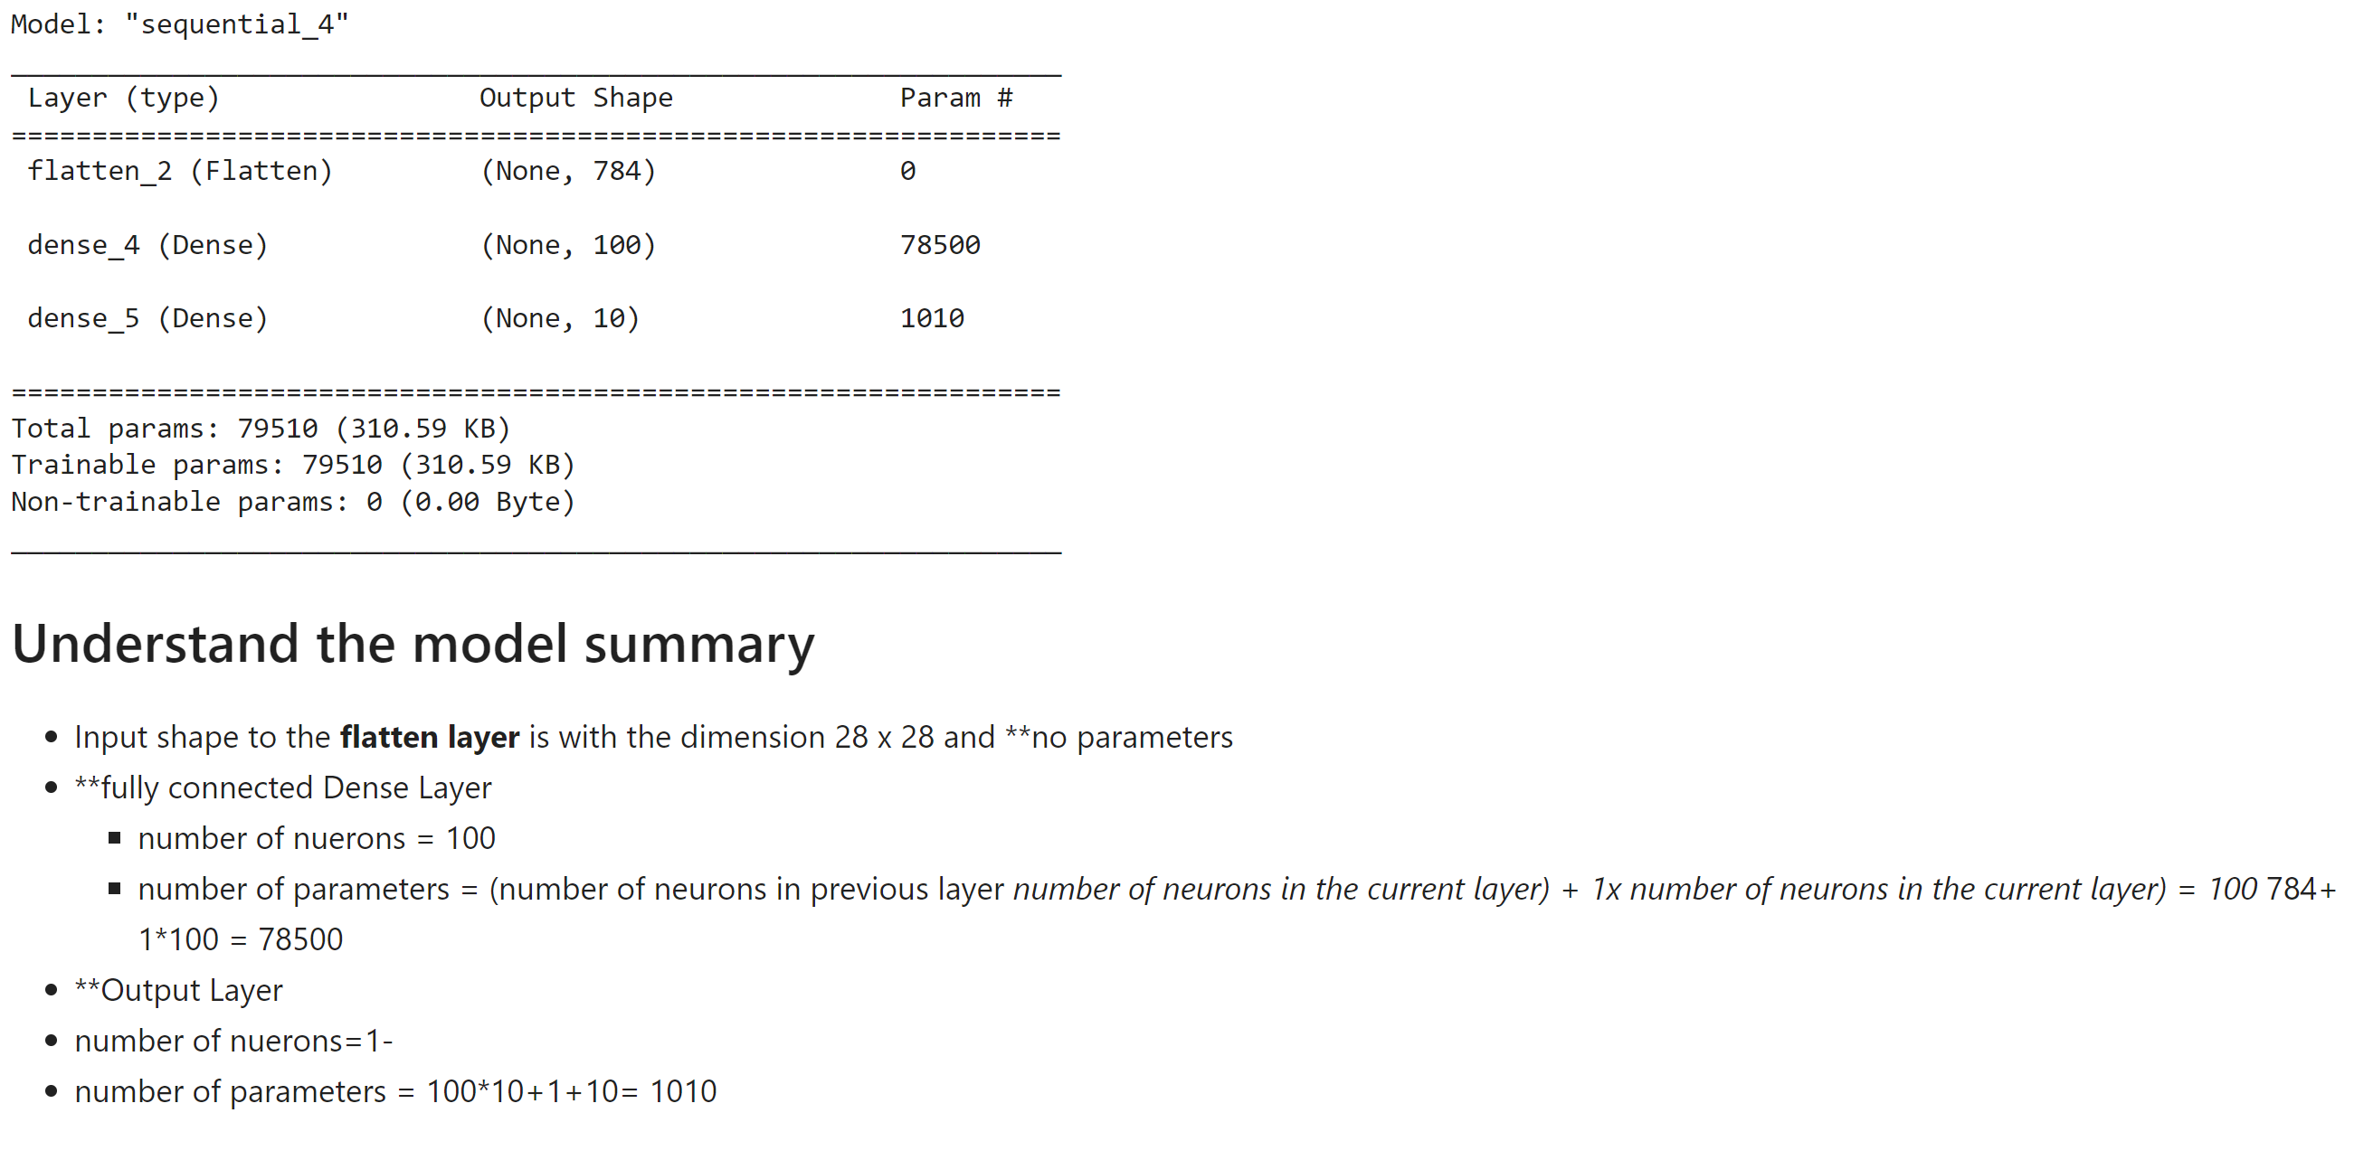

Evaluation of the model using Accuracy and Epoch
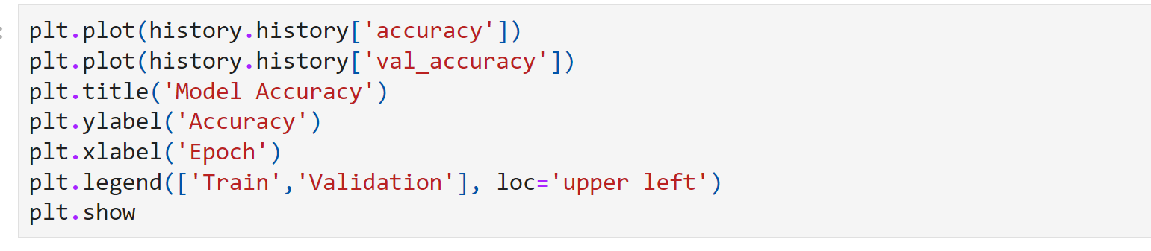

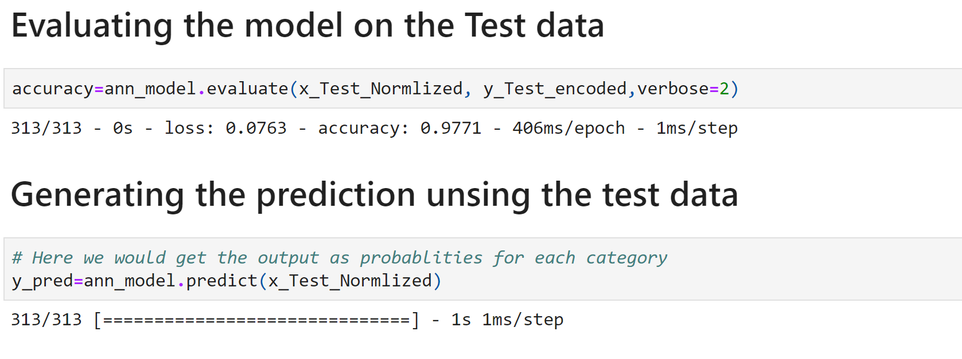

Plotting the confusion matrix
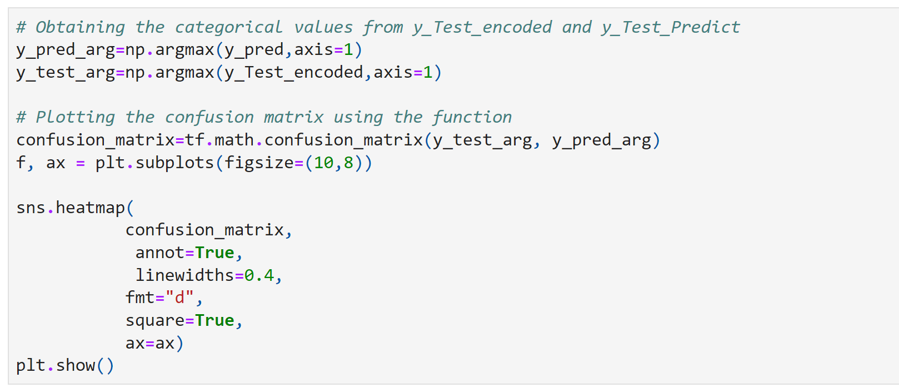
And observe the confusion matrix and analyse that there any digits are misclassified ?

Building another model using CNN and also set the seeds for random generation to reproduce same results for every time
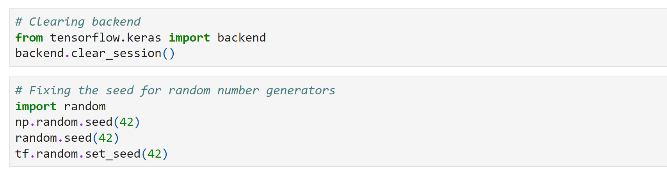
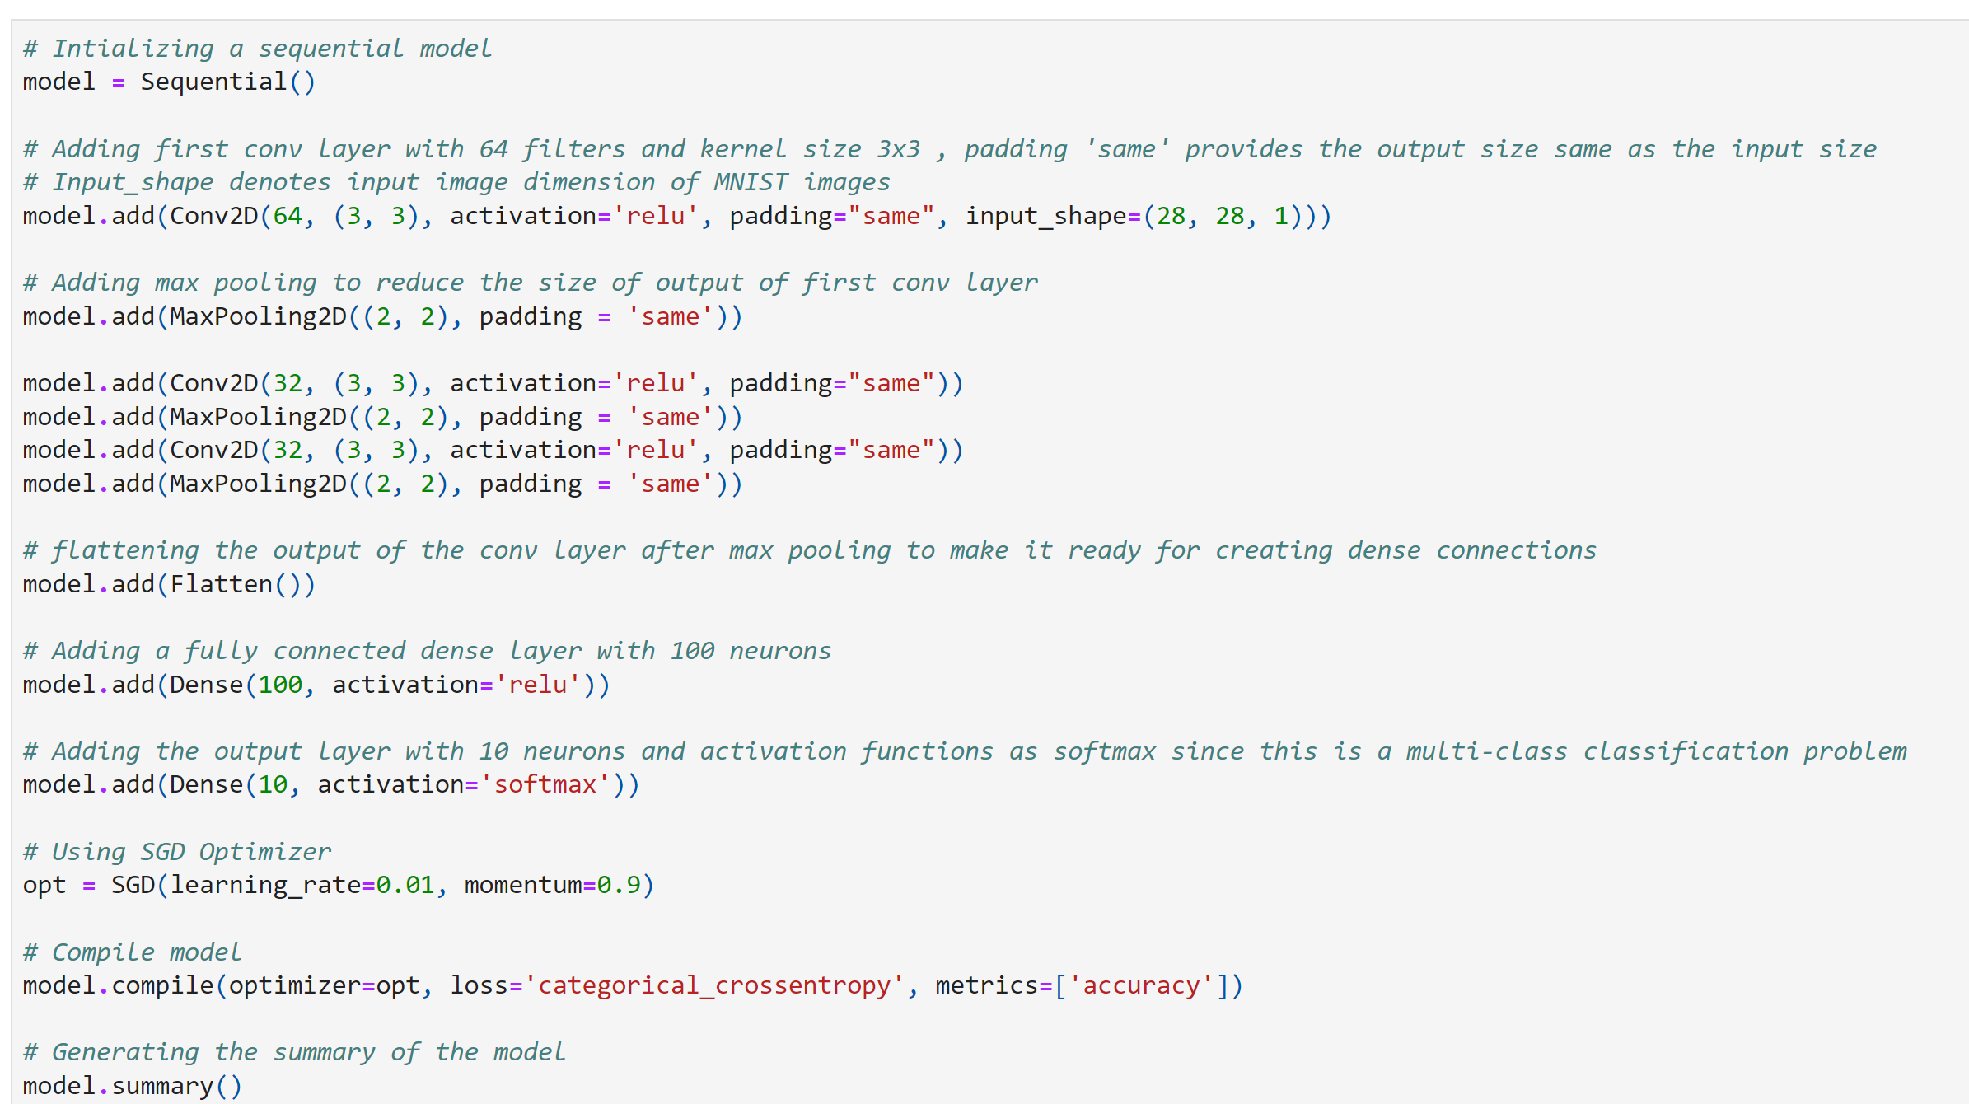
Understand the model… how many convolutional layer, how many filters, and what’s the size of the filter ? Understand the pooling layer, pooling technique ?
Also analyse the results returned by the model.summary() function.
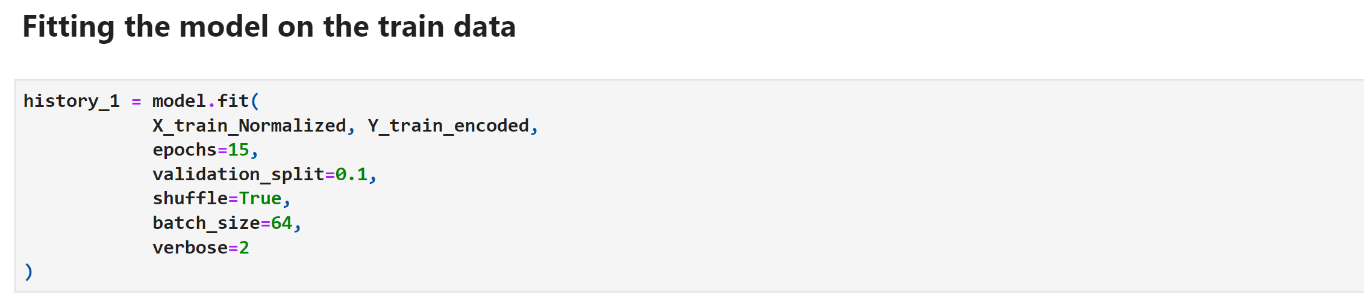

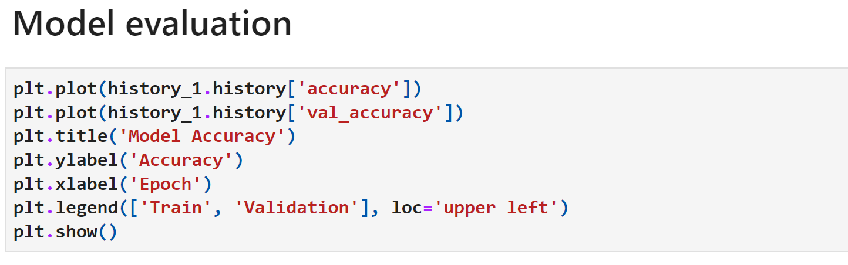
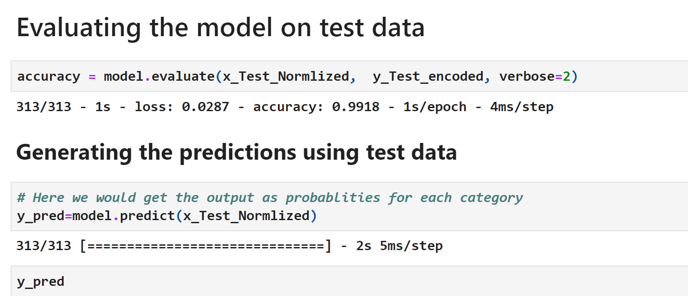

Plotting the confusion matrix
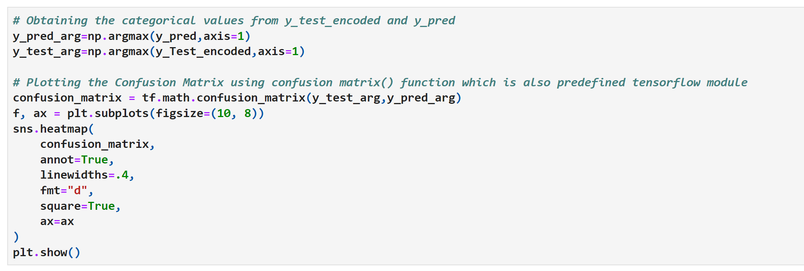

Compare the performance of the ANN and CNN also the number pf parameters used for each model.

And build an improved version of CNN.

