Strategic Management and Sustainability

  - (LCBB6015)

  - Automotive Industry Trends and Strategy

Student Name: Ungureanu Daniel Valentin
Student ID: 2125720

Table of Contents
Introduction 4
Overview/Background of Tesla 4
Products/Services 4
Industry 5
Location 5
Strategic Intent 5
Vision 5
Mission 5
Objectives 5
Tesla's Current Performance 6
Financial and Market Performance 6
Competitive Positioning 6
Strategy Analysis 7
External Environmental Audit 7
PESTEL Analysis: 7
Porter’s 5 Forces 8
Internal Environmental Audit 8
SWOT Analysis: 8
VRIO Analysis 9
Value Chain Analysis 9
Strategy Formulation 9
Strategic Choices 9
New Strategy Proposal 10
Conclusion and Recommendations 10
Summary 10
Recommendations 10
References 11

Table of Figures
Figure 1: EV transition (Tesla) 4
Figure 2: Tesla 5
Figure 3: Tesla Vehicle Production 8
Figure 4: PESTEL Analysis Framework 9
Figure 5: Porter’s 5 Forces Framework 10
Figure 6: SWOT Analysis Framework 11
Figure 7: VRIO Analysis Framework 12
Figure 8: BCG Matrix Analysis Framework 13
Figure 9: Tesla Value Chain Analysis Framework 14
Figure 10: proposed strategy idea visually 15

Introduction
Strategic management is a process which entails a process of formulation, implementation and evaluation of strategies that achieve organizational goals. In the example of Tesla, it implies being adaptive to the dynamism of the field of automobiles such as electrification, sustainability, and technology. Tesla needs strategic management since the automotive industry is going through a significant transformation, to continue being the leader in the electric vehicles (EV) and in clean energy solutions. A good strategic management can assist Tesla to manage the competition forces, regulatory and market pressure in the troubling of achieving long-term sustainability (Brem and Nylund, 2024).
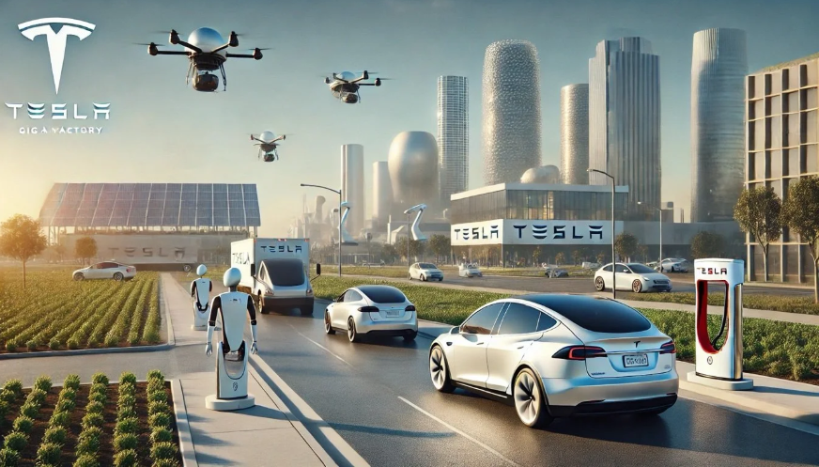
Figure 1: EV transition (Tesla)
Source: (the, 2024)
This report will discuss strategic response of Tesla to the trend of electrification and sustainability. It evaluates the strategic intent, company competitiveness and company performance. Based on this discussion, this report provides strategic recommendations which have the potential to market Tesla with regard to market position and sustainability efforts. The report shall be structured as follows, company overview, strategic intent, performance analysis, strategy formulation as well as recommendations.

Overview/Background of Tesla
Company Name: Tesla, Inc.
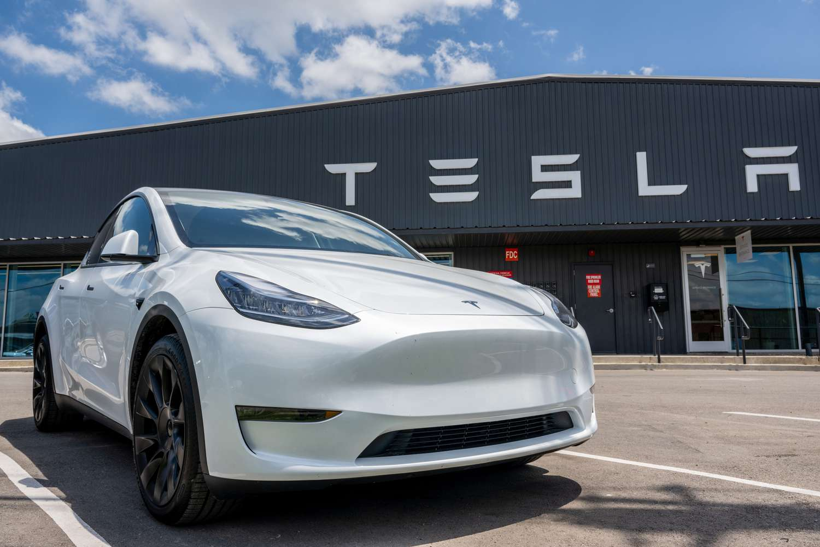
Figure 2: Tesla
source: (Zucchi, 2025)

Products/Services
Tesla is perhaps an innovator when it comes to manufacturing electric automobiles (EVs), energy storage and solar-powered products. Its portfolio of electric cars consists of the Model S, Model 3, Model X and Model Y that target different market segments, luxury cars and mass-market cars. The Powerwall and Powerpack is another energy storing product produced by Tesla; it is to store renewable energy to be utilized within residences, businesses and utility. Moreover, Tesla also designs solar-powered devices and energy, such as solar panels and Solar Roof to facilitate the usage of environmentally friendly energy (Wu et al., 2022).

Industry
Tesla is a company involved in a clean energy and automobile business. It is a significant force in the electric cars market and is playing a significant role in ensuring that the world is more sustainable by providing renewable energy products.

Location
Tesla is found in the global level and the key plants are the United States, China, and Europe. The Tesla electric factories including the Tesla Gigafactories of Nevada, Shanghai and Berlin can facilitate Tesla in responding to the increasing demands of the Tesla cars and energy products in different markets around the world (Khaleel et al., 2024).

Strategic Intent

Vision
The vision of Tesla is to have a sustainable energy future by hastening the transition between fossil to renewable energy. This can be observed in its interest in electric vehicles (EVs), energy storage, and solar solutions. The vision goes in line with the international trends of decarbonization and eco-friendliness, which allows distinguishing Tesla among other traditional car manufacturing companies. This picture is a competitive advantage, as Tesla can be regarded as a car and energy company, and it will be more appropriate positioning to gain more importance in the market in the long term (Rita, 2022).

Mission
Tesla has the mission of leading the transition of the world to sustainable energy as EVs, renewable technologies and batteries. Approaching the tendencies in the industry, such as electrification or digitalization, Tesla becomes easier to reach through the creation of electric vehicles and integration of the latest technologies, such as AI and automation. This mission uplifts its competitive edge because it helps in vertical integration, minimizes reliance on suppliers as well as quicker innovation compared to the competition (Mahmoud et al., 2023).

Objectives
Tesla has established a few major strategic goals in its quest to electrify and be sustainable:
- Mass Adoption of Electric Vehicles: Add more inexpensive electric vehicles to the market, to enable many more to adopt EVs with the aim of EVs becoming an ordinary mode of transport.
- Expansion of Energy Products: Increase utilization of energy sources like solar and energy storage products so as to have a sustainable life.
- Global Presence: Increase its manufacturing capabilities in different parts of the world in new Gigafactories in response to increasing EVs and renewable energy products demand.
- Innovation and Technological Leadership: To keep pace with the pack, continue to improve the performance of cars, battery technology and self-driving systems.

Tesla's Current Performance

Financial and Market Performance
In Tesla there has been high financial growth in the past years with the following figures being accomplished in year 2022; the revenue of 53.8 billion and net income of 12.6 billion. The growth is fueled mostly by growing demand in the electric vehicles (EVs) and energy storage solutions. In the year 2022, the company manufactured 1.3 million vehicles and this is an indicator that it has the capacity to produce more vehicles (Kozlovskyi et al., 2026). Nevertheless, this growth is substantial enough that the inference of this growth to an attainable sustainable long-run business will be how Tesla will deal with the excessive production cost, shocked logistic, and competition in the market. Tesla possesses larger margins than conventional car producers, which the competitors are bridging with an investor-strength in EVs. Moreover, Tesla has made the diversification to such markets like China and Europe that has allowed Tesla to expand but instead brings it down in terms of both geopolitical and regulatory risks.
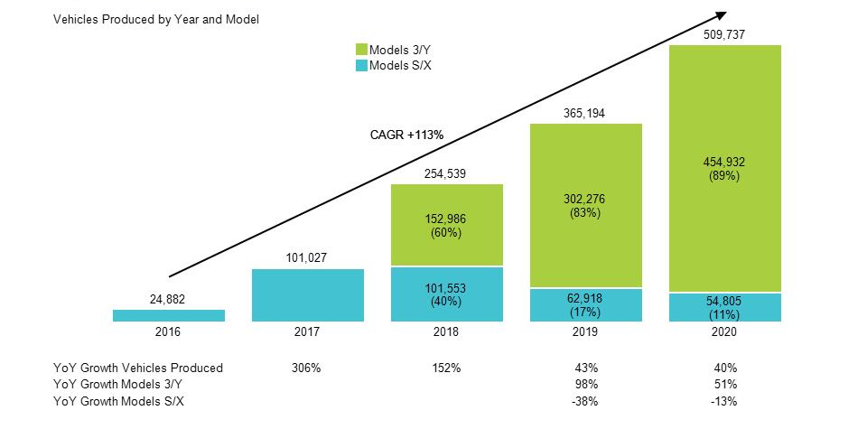
Figure 3: Tesla Vehicle Production
source: (Goldstein, 2021)

Competitive Positioning
Tesla has a well-established presence in the EV market worldwide with an approximate market share of about 20% this is due to its first mover and high brand name. Its extensive network of Supercharges and unrelenting pursuits of battery and autotomizing technologies are also an impetus towards competitive advantage. However, competition is also on the upswing as both long-established automakers Volkswagen and General Motors are expanding their EV capabilities with new entrants coming in to challenge them in the form of Rivian and Lucid Motors. One such area that Tesla has led ahead of its competition is innovation, which is possible because of verticalization and embedded energy ecosystem yet the rising competition can cost super companies market share and price power in the long-term (ALBERTO, 2023).

Strategy Analysis

External Environmental Audit

PESTEL Analysis:
- Political: The government is offering incentives to use EVs and Tesla will be able to continue growing, even though trades tension (e.g., US-China) is also a cause of the rising job insecurity. This dictates a need to localize (Gigafactory’s) by Tesla in order to mitigate geopolitical risk.
- Economic: An increase in the inflation levels, an increase in the cost of lithium (as a raw material) can decrease the profit margins of Tesla. Hence, vertical integration strategy and the economies of scale in Tesla is vital in ensuring cost competitiveness (Mitropetros, 2024).
- Social: Tesla stands an opportunity to advantage since people are becoming more and more concerned about the environment and, therefore, EVs. This positions Tesla to be in an enhanced brand equity of a sustainability innovator, and improves market growth in future.
- Technological: AI, batteries, self-driving have quickly developed, and R and D funds must be invested. The ability of Tesla to be more innovative than other companies is essential in sustenance of its competitive advantage.
- Environmental: Although Tesla is an environmental-sustainable company, environmental issues arise when it comes to the production of batteries. This puts Tesla on the strain to invest on battery recycling and sustainable sourcing strategies.
- Legal: The rigidity as far as the safety and autonomous driving is concerned increases compliance costs. Legal-related effects (e.g., lawsuits) on the reputation of Tesla will be the risks that it will have to deal with more effectively.
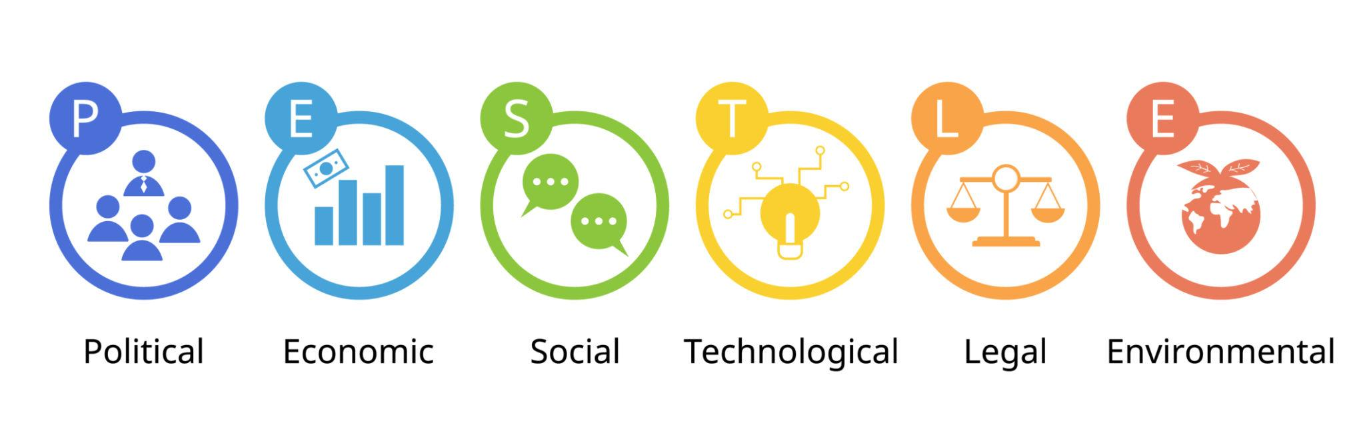
Figure 4: PESTEL Analysis Framework

Porter’s 5 Forces
- Threat of Substitutes: Low. Despite an attractive EV market, barriers to entry are high in terms of capital investment, there are technology barriers and the well-established brand of Tesla that presents a strong competitor to the industry.
- Supplier Power: Low integrity supplier is also a threat to Tesla due to its dependence on special materials like lithium. The strategy of vertical integration of Tesla decreases this risk, and enhances control of the supply chain (Thulin and Povlsen, 2024).
- Bargaining Power of Buyers: Strong. It is going to increase the buyer power due to the increased amount of EVs and Tesla will be compelled to become innovative and branded to remain close to consumers.
- Risk of Substitutes: Moderate. Substitute threats can be attributed to the traditional vehicles and emerging technologies including hydrogen powered vehicles. Nonetheless, there is substantial differentiation in the technological life of EVs and charging infrastructure by Tesla.
- Industry Rivalry: Intense. The Tesla rivals of Volkswagen and Ford make the industry very competitive, reducing the market share of Tesla. This demands that Tesla keeps innovating and going worldwide in order to maintain a leading status.
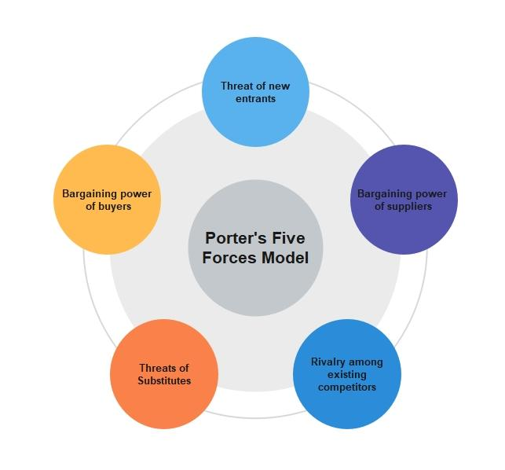
Figure 5: Porter’s 5 Forces Framework
source: (EdrawMind, 2020)

Internal Environmental Audit

SWOT Analysis:
- Strengths: There are good brand recognition, leadership in technologies in the EV and energy storage, and the global network of production, which include Gigafactories.
- Weaknesses: It is overpriced to produce, there are issues in quality control, and they use limited suppliers of significant components.
- Opportunities: Upcoming ventures in new markets, further development of battery and solar technologies and an increasing clean energy market.
- Threats: An increase in competition with the current car manufacturers and new EV start-ups, regulatory challenges, and environmental challenges with battery production.
These aspects show that Tesla should use its technological advantages and global growth potential and confront the cost issues and rising competition to maintain the long-term leadership (Maria, 2022).
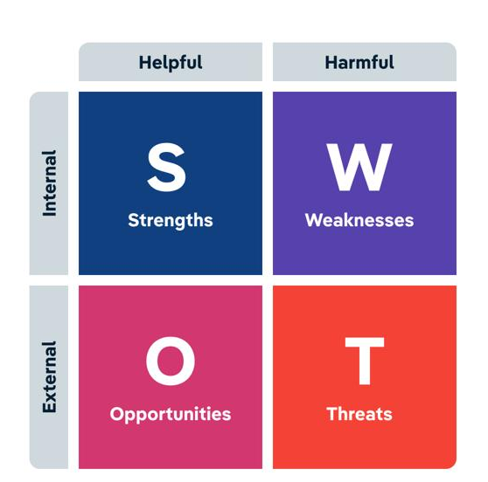
Figure 6: SWOT Analysis Framework
source: (IBISWorld, 2024)

VRIO Analysis
- Value: Tesla has the advantage of first mover in EVs as well as cutting edge technology which will add great value to the industry.
- Rarity: Tesla of the vertical integration, battery technologies innovation are rather rare.
- Imitability: Tesla has technologies which are difficult to replicate but the rivals are catching up in EV and autonomous driving technologies.
- Strategic placement: Tesla enjoys the strong organizational strength of having the ability to leverage the technological resources it has and generate quickly with the Gigafactories.
In general, the resources of Tesla offer a sustainable competitive advantage, but an ever-growing threat of competitors will erode this competitive advantage eventually and thus necessitate more innovation (Louhichi and Dissertation, 2025).
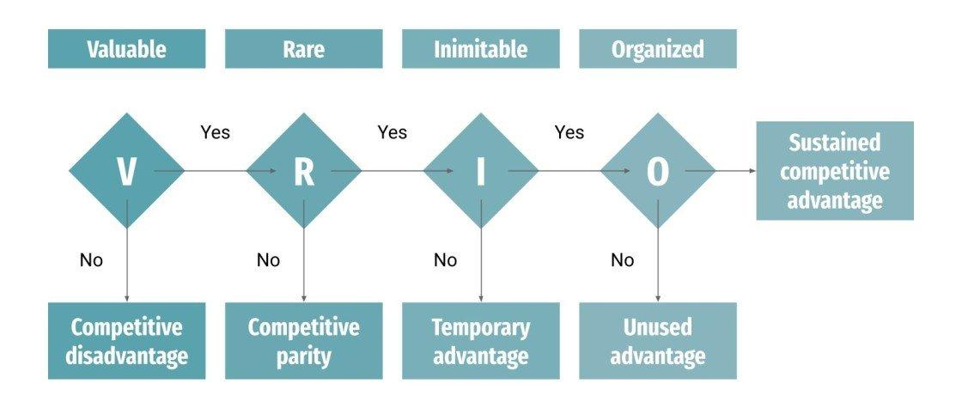
Figure 7: VRIO Analysis Framework

BCG Matrix Analysis
Tesla products may be analysed with the help of the BCG Matrix:
- Stars: Model 3 and Model Y - Good market share in a growing EV market, past and future revenue streams and probability of growth.
- Cash Cows: Model S and Model X - Relatively stable in demand experienced models, which offer great cash flows, however, with less growth.
- Question Marks: Powerwall and Solar Roof- Energy Products-High growth potential, but lesser market share and would still require further investment.
- Dogs: Scant references as Tesla keeps on eliminating products which are not performing well.
This implies that Tesla successively increase investments in high-growth areas (EVs and energy solutions) and leverage cash flow of already existing products to fund innovation and growth (Purnawan, 2025).
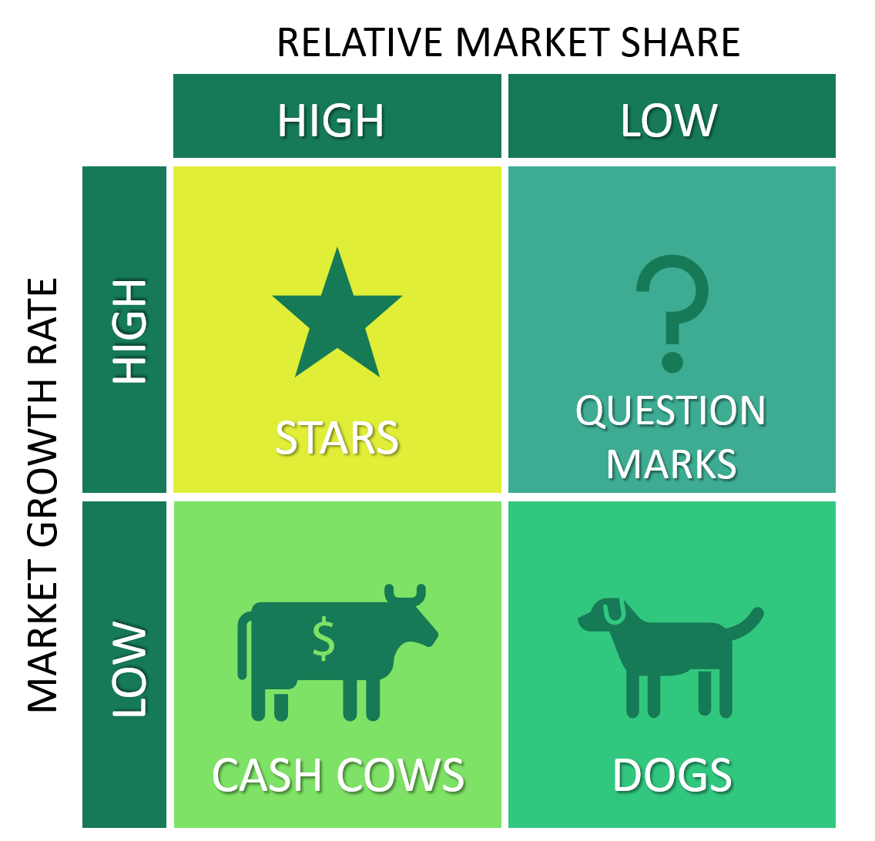
Figure 8: BCG Matrix Analysis Framework
source: (Lars de Bruin, 2017)

Value Chain Analysis
Among the major Tesla value chain activities are vertical integration, cutting-edge technologies in production, and direct sales to consumers. The company enjoys the merit of making its own production of batteries along with innovative manufacturing process, which boosts its competitive advantage in its operation. Tesla also offers after sales amenities like software enhancement and Electric chargers that also enhance its value proposition as a way of developing a convenient customer experience. The operations are conducive to Tesla on the market, enhancing efficiency, brand loyalty and overpower technology (Basile, 2025). Tesla explains that this effective value chain can distinguish its strategy since it assists it in reducing costs, innovation and customer experience, which can make the company enhance its competitiveness.
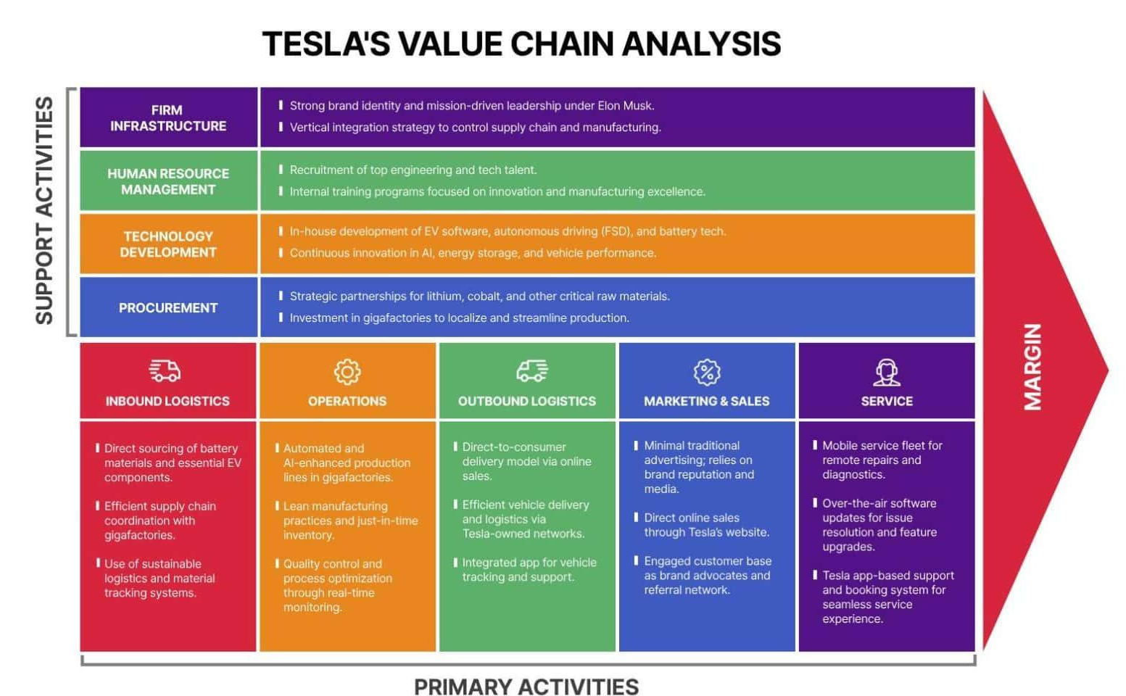
Figure 9: Tesla Value Chain Analysis Framework
source: (Daniel Pereira, 2025)

Strategy Formulation

Strategic Choices
The strategy of Tesla rests on its leadership in the market of electric car (EV) with the support of the innovation, vertical integration, and sustainability. These decisions can be linked to external forces like environmental protection policies and rising demand on clean energy (PESTEL), and its good brand and technological strengths (SWOT/VRIO) can be considered its competitive advantage. Direct sales, Supercharger system and the autonomous driving innovations of Tesla enhance differentiation. Nevertheless, growing competition among traditional car manufacturers and new EV producers is stimulating competition in the industry, and Tesla must constantly innovate and become cost-effective to retain its market share (Islam and Islam, 2025).

New Strategy Proposal
To enhance its vertical integration Tesla ought to invest in green battery production and sourcing of raw materials so as to mitigate risks in supply chain as well as control the cost. Furthermore, the differentiation and long-term value can be further promoted through the creation of an integrated ecosystem uniting EVs, autonomous systems powered by AI, and energy solutions. Entering into high-growth markets (e.g., India and Southeast Asia) will enable mass utilization of EVs. More effective innovation could occur due to strategic alliances with technology companies that will ensure that Tesla continues to be a competitive company (Ibrahim Abugarayesh, 2025).
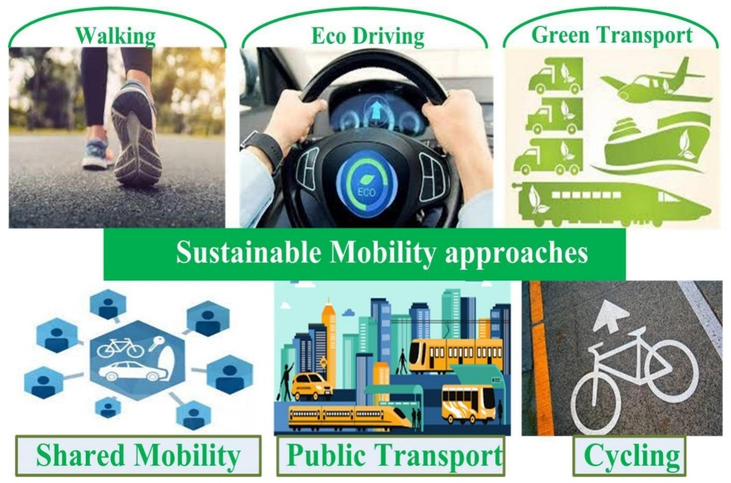
Figure 10: proposed strategy idea visually
source: (Chakraborty et al., 2021)

Conclusion and Recommendations

Summary
Through innovation, vertical integration and sustainability Tesla has managed to become a champion brand in electric vehicle and clean energy industry. Its long-term reaction to the movement of electrifying things, such as enhanced battery and energy stations, has also determined its market leader position. However, it is faced by an issue of growing competitiveness and market dynamics.

Recommendations
To become even more competitive, Tesla should invest in vertical integration, particularly in battery manufacturing, and sourcing of raw materials in order to guarantee the security in Tesla supply chain. Also, Tesla will stay on the lead in electrification and sustainability by entering into new markets like Southeast Asia and India and establishing strategic relationships in AI and autonomous driving.

References
ALBERTO, C. (2023). Valuing a Disruptor Innovator: Tesla’s Impact on the Electric Vehicle Market. [online] thesis.unipd.it. Available at: https://thesis.unipd.it/handle/20.500.12608/59488.
Basile, V. (2025). Strategy and Competitive Advantages. Future of Business and Finance, pp.5–81. doi:https://doi.org/10.1007/978-3-032-02766-5_2.
Brem, A. and Nylund, P.A. (2024). Incumbents Inertia in the Automotive Industry: Technological, Market, and Societal Drivers of Electric Vehicle Standardization. IEEE Transactions on Engineering Management, 71, pp.1683–1689. doi:https://doi.org/10.1109/tem.2023.3336004.
Chakraborty, S., Kumar, N.M., Jayakumar, A., Dash, S.K. and Elangovan, D. (2021). Selected Aspects of Sustainable Mobility Reveals Implementable Approaches and Conceivable Actions. Sustainability, 13(22), p.12918. doi:https://doi.org/10.3390/su132212918.
Daniel Pereira (2025). Tesla Value Chain Analysis. [online] Business Model Analyst. Available at: https://businessmodelanalyst.com/tesla-value-chain-analysis/?.
EdrawMind (2020). Porter’s Five Forces: Definition & Examples | EdrawMind. [online] EdrawMind. Available at: https://edrawmind.wondershare.com/examples/porters-five-forces-analysis-definition-and-examples.html.
Goldstein, D. (2021). Tesla Vehicle Production. [online] Mekko Graphics. Available at: https://www.mekkographics.com/tesla-vehicle-production/.
IBISWorld (2024). How To Do a SWOT Analysis. [online] Ibisworld.com. Available at: https://www.ibisworld.com/blog/how-to-do-a-swot-analysis/1/1127/? [Accessed 19 Apr. 2026].
Ibrahim Abugarayesh, O. (2025). Tesla EV Vehicles Scenario Planning . doi:https://doi.org/10.2139/ssrn.5876762.
Islam, Q.T. and Islam, Q.T. (2025). Strategic Leap: BYD’s Forward Vertical Integration Into the EV Market. [online] SAGE Publications: SAGE Business Cases Originals eBooks. SAGE Publishing. doi:https://doi.org/10.4135/9781071968819.
Khaleel, M., Nassar, Y., El-Khozondar, H.J., Elmnifi, M., Rajab, Z., Yaghoubi, E. and Yaghoubi, E. (2024). Electric Vehicles in China, Europe, and the United States: Current Trend and Market Comparison. Int. J. Electr. Eng. and Sustain., [online] 2(1), pp.1–20. Available at: https://ijees.org/index.php/ijees/article/view/70.
Kozlovskyi, S., Khadzhynov, I., Bolhov, V., Akhnovska, I., Kabachii, V., Kozlovskyi, V. and Kozlovskyi, O. (2026). Prospects for Development of the Global Automotive Industry in Context of Digitalization and Achievement of the Sustainable Development Goals. Problemy Ekorozwoju, [online] 21(1), pp.326–341. doi:https://doi.org/10.35784/preko.8646.
Lars de Bruin (2017). BCG Matrix EXPLAINED with EXAMPLES | B2U | Business-to-you.com. [online] B2U - Business-to-you.com. Available at: https://www.business-to-you.com/bcg-matrix/#google_vignette.
Louhichi, C. and Dissertation, A. (2025). Is Green technology Really the Answer to Sustainability or Just Shifting the Problem? [online] Available at: https://uniselinus.education/sites/default/files/2025-10/CAMILLE%20LOUHICHI.pdf.
Mahmoud, A., Mahmoud, R., Masoud, R. and Abdelaziz, A. (2023). Assessing the Transformative Impact of Tesla’s Strategic Change Interventions and Technology... ResearchGate. [online] doi:https://doi.org/10.13140/RG.2.2.14984.39684.
Maria, R. (2022). Tesla´s international expansion - the impact of sustainability on competitive advantage. [online] Run.unl.pt. Available at: https://run.unl.pt/entities/publication/6275ee1b-af3c-4035-8007-5dbd02907735.
Mitropetros, A. (2024). The Role of Electric Vehicles in the Geopolitics of Energy. Unipi.gr. doi:https://dione.lib.unipi.gr/xmlui/handle/unipi/17852.
Purnawan, B. (2025). Report Accelerating the Future: An In-depth Analysis of Tesla’s Market Strategy and Growth Opportunities. doi:https://doi.org/10.6084/m9.figshare.29897357.
Rita, J. (2022). Tesla´s technological shift - the world-s transition to sustainable energy. [online] Run.unl.pt. Available at: https://run.unl.pt/entities/publication/4a0062a3-e219-4953-a970-50c9bf93697d.
the, I. (2024). Torres Marketing. [online] Torres Marketing. Available at: https://www.torresmarketinginc.com/blog/what-is-the-future-of-tesla [Accessed 19 Apr. 2026].
Thulin, C.K. and Povlsen, S.B. (2024). Navigating the Road Ahead: Tesla’s Resilience in the Face of Emerging Rivals. [online] Available at: https://research-api.cbs.dk/ws/portalfiles/portal/108049434/1850915_MASTERS_THESIS_FINAL_TESLA_.pdf.
Wu, Z.-Q., Nguyen, P.-Q., Phankasemsan, I. and Wolf, E. (2022). Driving Sustainability and Electric Vehicles Evolution: Tesla Company’s Success Strategies. dspace.fcu.edu.tw.
Zucchi, K. (2025). What Makes Tesla’s Business Model Different? [online] Investopedia. Available at: https://www.investopedia.com/articles/active-trading/072115/what-makes-teslas-business-model-different.asp.

