July 14, 2019
Farzana Hussen (1709301)
uwtsd
Tutor: Julie Thomas
Workplace CULTURE AND its impact on organisational efficency
BMSK5005
Academic essay on workplace culture and context
Introduction
This essay has been assigned to investigate the workplace culture of UWTSD and how organisational culture impact the efficiency. The researcher will be using management framework PESTLE analysis, Johnson and Scholes Cultural Web to analysis the organisational culture and the impact of external environment. Implications of the internal context, size, sector and structure. The researcher will analyse the ethical stance of UWTSD and the commitments. The researcher will analyse whether individual and organisational values and beliefs are aligned. How this can influence the individual’s performance. the researcher will conclude make recommendations to the management to further enhance the organisational culture.
Abbreviation:
OC – Organisational culture
(Task 1) PESTLE Analysis
PESTLE is an acronym for; political, economic, social, technological, legal and environment elements. The researcher defines pestle as a framework and a diagnostic tool to support organisations to understand the external environmental factors that can impact the organisation in a positive or negative way (CIPD 2018). Organisations can use the framework to maximise opportunities and minimise threats at the earliest. Organisation performance is dependent on the success of the management who are able to remove threats and risk through analysis (Mullins, 2005). CIPD (2018) view Pestle as understanding the broader environment and the challenge the organisation will encounter. The analysis come with disadvantages; Pestle analysis needs to be undertaken more regularly due to the continuous change and demands of the external environment. The analysis can identify many factors which may not be significant. Buchanan & Huczynski (2010) praise the framework however state that Pestle cannot identify or anticipate economic collapse of political or financial upheaval.

(Task 1) UWTSD Pestle Analysis

 | External Factors | Impact on UWTSD
Political | - Changes to government policy – tuition fees capped  - Brexit – uncertainty of negotiation  - New regulations Office for Student | - UWTSD non-profitable organisation is dependent on funding’s  - European staff employment under threat  - High turnover of EU student  - EU funding for research and innovation  - Uwtsd need to ensure adequate, value for money education opportunities to avoid investigations by OfS regulators
Economic | - Tuition fee announced to be decreased  - Wage rate  - Inflation  - Government/ Public funding reduced in higher education | - Do Uwtsd enough capital, reliable income, long-term funding or financial security  - are staff receiving the right level of income  - implement budget change – financial performance maybe affected  - difficult to get funding to meet staff and student demands
Social | - Education for all ages  - Organisations demand for graduates  - Flipped classroom  - Online and Distance learning  - LBGT campaign | - benefits Uwtsd – tuition fees utilised as innovating and creating facilities for students  - changing the way tutors teach  - high student number  - Maintaining inclusive and diverse culture
Technology | - Advances in technology  - Automation  - Artificial intelligence  - Security  - Internet speed  - Free online learning and training  - The fourth industrial revolution | - new technology requires staff adequate training  - costly  - support the redundancy strategy replace humans with technology  - online training – reduces student numbers  - supercomputing, intelligent robots,
Legal | - employment laws, common law, educational law, health and wellbeing  - Third party contracts | - staff require knowledge of rules and regulation  - avoid litigation  - Staff and student rights  - Copyright breach – online library  - Mental health awareness for staff and student
Environmental | - Climate change  - Carbon emission  - Waste and recycling | - Sustainability pledge  - Green  - Climate resilience  - Waste prevention strategy

(Task 1) UWTSD Pestle analysis implication summary
Political – BREXIT has caused uncertainty of rules and regulations; research funding from EU may be limited for UWTSD to innovate and be creative (Universities UK 2016). New regulators that will monitor universities to ensure they provide value for money service to student, Uwtsd will need to ensure they are compliant and offering students the best learning and development experience and support (Gov.uk 2018).

Economic – Tuition fee plans indicated reduction from £9,000 to £7,500 (BBC, 2019a). Government funding has reduced which puts pressure on Universities to find innovate ways to minimise financial strain. This has impacted on the staff numbers leading to redundancy for Uwtsd (BBC NEWS 2019b).

Social - The Guardian (2018) has published article that emphasises that UK economy could benefit from recruiting students of age, businesses are demanded people with higher education, they want knowledgeable people. This is beneficial for UWTSD it will improve student numbers, increase the financial aspects and support the community by enrolling students from poorer backgrounds. Flipped classroom has become pervasive internationally, according to Wanner and Palmer (2015) in higher education there has been progress of the change towards student centred and self-directed learning. Students feel empowered by being the central of learning by universities providing learning materials to students in advance and utilising class time to actively discuss key aspects of the online materials.

Technological – Technology advance is an opportunity and threat for Uwtsd by having software that can automatically update information can be effective than being done manually which can be time consuming for staff, these artificial intelligences can contribute to balancing the redundancy strategy. external online course and training have implications of people moving away from studying in universities and want independent flexible learning. Uwtsd do currently practice online and distance learning, although it is flexible and the university have been ranked for the student support, they will need to frequently monitor the resources and limitations for students’ access (UWTSD, 2019a).

Environmental - CSR examines how an organisation affects its environment, CSR analyses the organisations impact on stakeholders, environment and society. It takes interest in the value of ethics in an organisation (Weber & Gerard 2014). Uwtsd (2019b) have been encouraging and promoting waste prevention strategy throughout the campuses to support sustainability.

(Task 2) Organisational Culture
Culture is general concept is the way of life and how things are done. Sinclair (1993) argues that culture is a metaphor that aids in conceptualising organisations. Management have inclined towards OC to explain what happens in the workplace and how to construct improvements to achieve goals. The researcher defines OC is about shared values, beliefs, attitudes, norms and opinions which influence management and its people to be motivated, think, feel and actions towards their work and others in the workplace (French 2007). OC is perceived as the personality of the Organisation. It is about how things are practiced on a daily basis. OC impacts many aspects of the organisation, such as task issues, individual and organisational performance (Buchanan & Huczynski 2010). Mullins (2005) cited on his publication that Atkinson believed OC is about reflecting the assumptions of how and the way work is performed, what is deemed acceptable and what behaviour is encouraged. French (2007) & Barrett (2018) argue that there is no single definition to culture. OC has become an essential tool for management that supports in promoting ethical practices amongst the workers (Sinclair 1993).

(Task 2) The Cultural Web
Johnson and Scholes present Cultural web, the model is used by organisations to assess the environment and the impact it has on employees and customers (Mossop et al, 2013). McDonald & Foster (2013) explain the culture lies within the paradigm which are the assumptions that are taken for granted in an organisation. The web gives a broader and balanced perspective. The paradigm has six elements that are interrelated and interdependent on each other. It can be used to collect data for strategic planning by management. It is a simplistic framework that perceives different views of the culture and is effective as a research theory.
The six elements consist of; Symbols – brand, logo, shorthand of words used to describe, the layout of the office, mission and visions statements that represent the organisation. Stories – positive and negative stories told about the organisation from internal and external sources. Rituals and routine – the daily behaviour and the acceptable actions of the people and the way things are done. Organisational Structure – what is the structure according to chart, hierarchical, autocratic or flat. Control System – measurements of the financial, quality, operational, performance systems. Power Structure – who has the power in the organisation, based on position and seniority that influences decision making. The paradigm expresses through the elements of the most important facts of the way organisations practice (Mullins, 2005 & 2016).

(Task 2) UWTSD Cultural Web
Symbols – UWTSD logo and branding (see appendix A) consist of blue and yellow colours, yellow signifies joy, happiness, hope and philosophy. Dark blue and blue symbolises integrity, knowledge, power, stability, trust, technology and confidence (Incredible art, 2019). The logo of the shield indicates protection and safety. Symbolising protection and safety may indicate the protection of the staff’s physical and moral integrity (Jovanovic & Bozicic, 2017). At the Swansea campus two staff share an office, large dining and social open plan area that can be used by staff and students. Library have multiple seating sections. Physical environment such as layout can support staff and students to be motivated help with being creative, collaborative, inspire and unite the people and efficient through ethical behaviour, (CMI workplace, 2018).

Stories – Founded in 1853, UWTSD was formed in 2010 (merger) with three main campuses in South Wales and learning centres in London, Cardiff and Birmingham. UWTSD have a reputation for its innovative industry-led and career focus programmes (The Independent, 2014 & UWTSD, 2019c). This indicates how rapidly the institute is growing by offering variety of courses. Received national awards ratings and ranking in the Top 10 University of the year for excellence, winner of WHATUNI Student choice awards 2019 (WHATUNI, 2019). These stories reflect the mission, vision and priority to provide the best educational programme for students and emphasise on the office for student regulations. The institute is a successful organisation providing value for money education (OFS, 2019).

Rituals and Routines – at the beginning of each session students are required to sign the register. It is the responsibility of the programme director to monitor attendance and progress, as part of regulations UWTSD have responsibility to report poor attendance to awarding authorities (UWTSD, 2018). This can support tutors to analyse the behaviours of students. According to research by Al-Shammari (2016) it has been found that student attendance has high correlation with their achievements if they have been present during sessions.

Organisational structure – The university is a private sector, large institution with tall hierarchical structure (UWTSD, 2019d) (see appendix B&C). This type of structure has longer decision making and formal lines of authority. The structure is centralised and formalised, where the senior management have power and influence on decision-making, through rules and procedures (Nwachukwu & Chladkova 2018; Johnson 2016 & Tajeddini, 2014). Longer process can have a positive impact where thorough checks made, non-compliant, reduces risk, and more effective decisions. Poor designed structure can have negative implications of illogical issues and inefficiency, conflict, lack of co-ordination, late and incompetent decisions. Iasmina & Gabriela & Alexandra (2019) believe the structure has benefits such as organisation is reliable at maintaining the status quo. Sinha (2017) argues that decentralisation and sharing information in the organisation can lead to high levels of psychological empowerment. Increased control over work will allow staff to see their work meaningful.

Control Structure - each department are controlled by senior management, the university is tightly controlled, annual report reviews to assess efficiencies, productivities and budgets for faculties. Staff receive recognition and appreciating for commitment. Moshtari & Ghaemi (2016) believe control structures can help organisation to problem-solve, by applying control systems can support to implement strategic goals effectively through environment, quality, information system. The structure resembles bureaucracy and is influenced by the organisational structure.

Power Structure – The governance council members influence the activity, through high quality information and resources to make decisions (UWTSD, 2019e). Power is with the top senior management; the management of the University is led by the Vice-Chancellor, supported by a Senior Directorate comprising three Deputy Vice-Chancellors and two Pro Vice-Chancellors.

(Task 3) Analysis of UWTSD ethical stance
The UWTSD (2017a) has committed to maintaining high ethical standards in the research undertaken by staff and students. Obliged to Concordat to support research integrity, where research conducted is appropriate standards of the ethical principles and practices. To protect staff, students and participants. To prevent negligence claims made of the university that can impact the reputation. The core aspects of research integrity are; honesty, rigour, transparency, open communication, care and respect. Ethics committee membership is reviewed annually where research ethics officer requires to ensure colleagues aware of the roles and duties of the ethical standard the university upholds.

Sustainability is one of Uwtsd values - to deliver meaningful and relevant educational pathways that promotes learning and social responsibilities (UWTSD, 2019f). It is the central focus of the university’s operations, curriculum, campuses and culture (UWTSD, 2017b). It has been found that UWTSD (2019b) affirm that they are committed to sustainable approach to waste and disposable management and will continuously make improvements of the environmental practice. Media, environmentalist and activist pressures and influences organisations to recognise the social duties and obligations that reaches beyond shareholders (Weber & Gerard, 2014).

As part of induction day for new students the campuses hand out reusable bags and infuser water bottle, The Independent (2019) published article of the best way to keep plastic bottles from landfill by replacing with reusable bottles. Waste and recycling are monitored and measured, the university has embedded a culture in the workforce of waste prevention and reuse (UWTSD, 2019b). Every corridor in the campuses have recycling bins, working closely with contractors to ensure the university upholds its legal duties of care of the TBL (see appendix D). Weber & Gerard (2014) believe management are responsible to create and maintain an ethical culture in organisation, which can be done through compliance measures of wrongdoing of ethical behaviour or CSR.

Hayat, Nadeem & Jan (2018) expressed how improving the environment and going green has been a major issue for the government, the current generation Y & Z concern is to innovate ways of becoming eco-friendly for societies. The Lampeter campus food waste is collected by Anaerobic Digestion facility, to generate electricity and heat, or into renewable natural gas and transportation fuels (UWTSD 2019b). It has been found that Eilert, Walker & Dogan (2017) hypothesized that the size of the organisation is the driver to successful embedding of the ethical culture towards CSR. Stakeholders have high expectations; this motivates the organisation to influence behaviours towards SR.

It has been found that the university received seven awards in 2017, recognition in 2015 by Green Gown Awards for best leadership winner, Sustainability champion (Sustainability Exchange 2015). To add to the list; bronze, silver and gold ratings (UWTSD, 2017c).

(Task 4) Values, Beliefs and Attitudes
The researcher has found according to Strategic Finance (2018) article; that employee and organisation values should be aligned; this will lead to success more easily when individuals’ beliefs and attitudes is influenced by values will shape how they perform. HR Magazine (2019) believe that for an organisation to be successful they need to ensure if they have the right people, and whether their values aligned, is the individual inspired by mission and vision, as values are the foundation of culture, values direct decision making.

It has been found that the individual values (see appendix) is aligned with UWTSD values. UWTSD characteristic offer well defined curriculum, the individual values achievement and personal growth. The university is committed to sustainability, the individual is self-disciplined and committed. University is pioneering to ideas of work-based learning and professional practice; the individual is ambitious and enthusiastic towards initiating ideas and creativity. It has been found that OV and individual values are aligned, this influences the individual to be motivated, dedicated and use discretionary effort to achieve common goal. Where leaders are able to encourage of personal accountability behaviour towards being responsibly, ownership and empowerment (Strategic Finance, 2018). In order to have the best fit, organisations need to satisfy and support the worker’s needs, desires and preferences to be successful. Individuals are choosing employment in accordance to organisations values, culture and sense of belongingness (Agarwal, 2012 & Barrett, 2018).

HBR (2018) article has defined the importance aspects of the organisation, that prospective employee must pay attention to, these dimensions to confirm if the if the organisation is the best fit for the individual. Individuals need to analyse how company cultivate relationship, how the communicate and informal or formal decision makings. Do individuals receive recognition for effort, it has been found that Jaguar believe their success is due to recognition which is a powerful motivator for workers to do their best and use discretionary effort (Engage for Success, 2016). Dyer (2018) states that top companies are using books, articles, case studies and webinars to share their culture publicly and how they do things such as Netflix or Google. this builds brand credibility attracting talented people. The openness helps job candidates to know what the company is all about.

(Task 5) Conclusion
The researcher concludes that Pestle analysis is effective and has identified external factors that influence Uwtsd strategies and efficiency. Pestle is used by HRM to understand trends, to support strategic planning. It helps to anticipate future impacts on business, each element can be interrelated to each other.

The cultural web is effective, the web is assisting in identifying of hidden assumptions in an organisation. The framework is promising for analysing perspective and can be used to implement other business environments, the framework can be used to compare different organisations, highlight obstructions that prevent workers from being productive (Mossop et al 2013).

There is no best or better organisational structure, individual organisations have their own structure that may or not work effectively. It has been found the structure does not affect the communication between staff and senior management or student, using technological communication has embedded positive rapport, staff are able to use email to engage with student relating to the modules. The staff use discretionary effort to support student; such as programme directors amended submission dates to ensure the students are fully competent in their assignments.

UWTSD have a strong OC which influences staff, students and communities towards CSR, and this reflects the culture, values, strong ethical morals and integrity practice. UWTSD have a positive financial health, although there has been redundancy announcement, this has not impacted the staff in the workforce, staff feel positive of the future of UWTSD. The university has opportunities to further enhance to maintain the efficiencies to compete with leading universities and provide the best for its staff and students.

(Task 5) Recommendations
The researcher recommends for organisation to further enhance by being adaptive to these practices:
- Dyer (2018) suggests that individuals looking to join company should look at business review websites such as; Yelp or Glassdoor. This can also support organisations to get an insight of what their workers think and say and reflect on their practices.

- HR Zone (2014) & Prospect (2019) have favoured the benefit of video interviews, it gives participant the ability to showcase their potential whatever the distance, this supports the growth of distributed workforce by attracting the best talent from around the world. University of Oxford is amongst the top five in the world, Oxford is one of the prestigious universities who employ staff from 100 different countries (THE, 2018).

- HBR (2015) developed ToMo (see appendix E) framework, it has direct and indirect motives that distinguish why people work, organisation should use this framework as HBR have found high-performing culture maximise the first three motives by its people and minimise the lower three.

- Buchanan & Huczynski (2010) & Costanza et al (2015) believe that organisations that are value focus orientated are likely to be more successful by hiring like-minded people, by recruiting people who fit and blend with the organisation culture will lead to efficiency and consistency.

- Agile engagement; Karanges et al (2015) state the benefits of employee engagement is; increase in productivity, improves image and reputation and increase in ROI.

- Organisations should have different policy and procedures, because different generations of employee have different needs and requirements, employees will make further efforts towards the success of the organisations if they are engaged and satisfied (Stoyanova & Iliev, 2017).

Appendices

- Uwtsd Logo:


- Uwtsd Organisation chart:

C. Extension from Library and Learning Resources Executive Head:
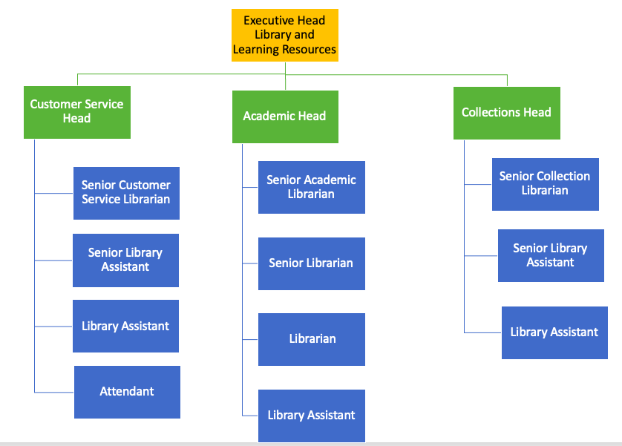

D. John Elkington Triple Bottom Line to support sustainability:
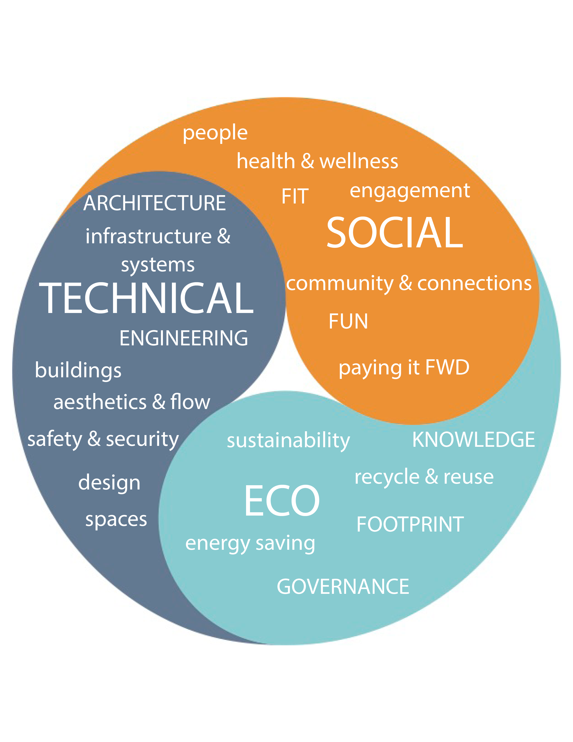

E. HBR ToMo framework:
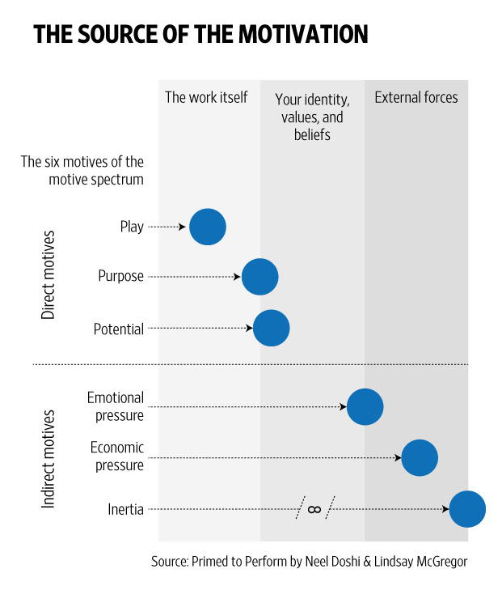

Reference List

Al-Shammari, Z.N. (2016) Enhancing Higher Education Student Attendance Through classroom management. Cogent Education, 3(1), p.11
DOI: 10.1080/2331186X.2016.1210488

Agarwal, P. (2012) Aligning Person-Organization Fit with the Practice of Human Resource Management, International Journal of Management Prudence, 4(1), pp.13–21.

Barrett, R. (2018) Everything I have learned about values. LULU

BBC NEWS (2019a) £7,500 tuition fees plan face BREXIT delay (online)
Available on: https://www.bbc.co.uk/news/education-47405054
Accessed: 24/6/19

BBC NEWS (2019b) University of Wales Trinity St David face ‘financial uncertainties’ (online)
Available at: https://www.bbc.com/news/uk-wales-48609280
Accessed: 17/6/19

Buchanan, D.A. and Huczynski, A.A. (2010) Organizational Behaviour. 7th ED. Harlow: Pearson Education Ltd

CIPD (2018) Pestle Analysis (online)
Available at: https://www.cipd.co.uk/knowledge/strategy/organisational-development/pestle-analysis-factsheet
Accessed: 12/6/19

Costanza, D.P and et al (2015) Journal of Business & Psychology. ‘The effective of adaptive Organizational Culture on long-term Survival’. Springer, 31, pp. 361-381
DO1 10.1007/s10869-015-9420-y
Accessed: 11/6/19

CMI Workplace (2018) How workplace design can affect office values and company culture (online)
Available at: https://www.cmiworkplace.co.uk/how-workplace-design-can-affect-office-values-and-company-culture/
Accessed: 2/7/19

Dyer, C. (2018) The Power of Company Culture: How any business can build a culture that improves productivity, performance and profits. London: Kogan Page Limited

Eilert, M. Walker, K. & Dogan, J. (2017) Can Ivory Towers be Green? The Impact of Organization Size on Organizational Social Performance. Journal of Business Ethics, 140(3), pp.537–549.
DOI:10.1007/s10551-015-2667-4
Engage for Success (2016) How 5 Companies Bring Their Values to Life (online)
Available at: https://engageforsuccess.org/how5companiesbringtheirvaluestolife
Accessed: 6/7/19

French, R. (2007) Cross-Cultural Management in Work Organisation. London: CIPD

Gov.UK (2018) New universities regulator comes into force (online)
Available at: https://www.gov.uk/government/news/new-universities-regulator-comes-into-force
Accessed: 18/6/19

Hayat, K. Nadeem, A. & Jan, S. (2018) The impact of environmental consciousness, green proce sensitivity and green product, on green purchase intention (A case of Peshawar market), City University Research Journal, 8(1), pp.103–116.

Harvard Business Review (2015) How Company Culture Shapes Employee Motivation (online)
Available at: https://hbr.org/2015/11/how-company-culture-shapes-employee-motivation
Accessed: 6/7/19

Harvard Business Review (2018) When you start a new job, pay attention to these 5 aspects of company culture (online)
Available at: https://hbr.org/2018/03/when-you-start-a-new-job-pay-attention-to-these-5-aspects-of-company-culture
Accessed: 11/4/19

HR Magazine (2019) Company culture is critical to your success (online)
Available at: http://www.hrmagazine.co.uk/article-details/company-culture-is-critical-to-your-success
Accessed: 11/6/19

HR Zone (2014) The impact of video technology on employment interviews (online)
Available at: https://www.hrzone.com/talent/acquisition/the-impact-of-video-technology-on-employment-interviews
Accessed: 6/7/19

Iasmina, I. Gabriela, P. & Alexandra, V. (2019) Communication and Management in Hierarchical Structures: Agricultural Management/ Lucrari Stiintfice Seria I, Management Agricol, 21(1), pp.33-41

Independent (2019) 13 best reusable water bottles (online)
Available at: https://www.independent.co.uk/extras/indybest/outdoor-activity/sports-equipment-accessories/best-reusable-water-bottles-a6717726.html
Accessed: 3/7/19

Independent (2014) Trinity St David, University of Wales (online)
Available at: https://www.independent.co.uk/student/into-university/az-uni-colleges/trinity-saint-david-university-of-wales-1767202.html
Accessed: 25/6/19

Johnson, M.C. (2016) From tall to matrix: redefining organisational structure. Change, 48(4), pp.55-62 DOI: 10.1080100091383.2016.1198189

Jovanovic, P. & Bozicic, D.M. (2017) Legal framework for employee’s moral integrity protection. Zbornik Radova: Fakulket U Novom Sadu, 51(4), pp.1229- 1249

Karanges et al. (2015) The influence of internal communication on employee engagement: A pilot study. Public Relations Review, 41(1), pp.129–131.

Mullins, L.J. (2005) Management and Organisational Behaviour. 7th ED. Harlow: Pearson Education Limited

Mullins, L.J. with Christy, G. (2016) Management & Organisational Behaviour. 11th ED. Harlow: Pearson Education Limited

Mossop, L. et al (2013) ‘Medical Education’, Analysing the hidden curriculum: use of a cultural web, 47 (2), pp. 134 – 143. DOI: 10.1111/medu.12072

McDonald, S. and Foster, R.A. (2013) International journal of management. The use of Johnson’s Cultural Web to Improve Understanding of Organisation Culture: A Critical View, 30 (4) 340-354

Moshtari, M. & Ghaemi, A.A. (2016) A Framework for auditing management control systems and its application in a public organisation. Journal of Applied management accounting research, 14(2), pp.57-64

Nwachckwu, C. & Chladkova, H. (2018) Firm Resources, Strategic analysis. Capability and strategic performance: Organisational Structure as moderator. International Journal for Quality Research. 13(1), pp 75-94
DOI: 10.24874/IJQR13.01-05

Office for Students (2019) What universities and colleges should do for students (online)
Available at: https://www.officeforstudents.org.uk/for-students/what-universities-and-colleges-should-do-for-students/
Accessed: 18/6/19

Prospects (2019) Video interview tips (online)
Available at: https://www.prospects.ac.uk/careers-advice/interview-tips/video-interview-tips
Accessed: 6/7/19

Sinclair, A. (1993) Approaches to organisational culture and ethics, Journal of Business Ethics, 12 (1). P 63.

Sinha, S. (2017) Organisational structure and work-related attitude: Mediating role of Psychological empowerment, Journal of Organisation and human behaviour. 6(3) pp.46 - 55

Strategic Finance (2018) Success through strong leadership (online)
Available at: https://moodle.uwtsd.ac.uk/pluginfile.php/244076/mod_resource/content/1/SUCCESS_THROUGH_STRONG_CULTURE.pdf
Accessed on 11/6/19

Sustainability Exchange (2015) Green Gown Awards 2015
Available at: http://www.sustainabilityexchange.ac.uk/green_gown_awards_2015_leadership_award_dr_jane
Accessed: 7/7/19

Stoyanova, T. & Iliev, I. (2017) Employee Engagement Factor for Organizational Excellence. International Journal of Business and Economic Sciences Applied Research, 10(1), pp.23–29.

Tajeddini, K. (2014) The effect of organisational structure and hoteliers. Risk Proclivity on innovativeness. Asia-Pacific Journal of Management Research and Innovation. 10(1) pp.1-12
DOI: 10.1177/2319510X14529487

The Guardian (2018) Economy ‘could benefit from more going to university’. (online)
Available at: http://www.theguardian.com/education/2018/aug/06/uk-economy-could-benefit-from-more-going-to-university
Accessed: 18/6/19

The Higher Education (2018) Best Universities in the world 2019
Available at: https://www.timeshighereducation.com/student/best-universities/best-universities-world
Accessed: 8/7/19

UWTSD (2019b) Sustainability Delivery Team (online)
Available at: https://www.uwtsd.ac.uk/sustainability/waste-management/
Accessed: 18/6/19

Uwtsd (2017c) Green Impact Awards 2017 (online)
Available at: https://www.uwtsd.ac.uk/sustainability/news-and-events/green-impact-awards-2017.html
Accessed: 3/7/19

Uwtsd (2019c) Go Far in Swansea
Available at: https://www.uwtsd.ac.uk/swansea/
Accessed: 6/7/19
Uwtsd (2019b) University: transforming education, transforming lives
Available at: https://uwtsd.ac.uk/about/
Accessed: 4/7/19

Uwtsd (2019f) Mission and Vision
Available at: https://uwtsd.ac.uk/mission/
Accessed: 6/7/19

Uwtsd (2017b) Sustainability Delivery Team: A culture of sustainability (online)
Available at: https://www.uwtsd.ac.uk/sustainability/a-culture-of-sustainability/
Accessed: 1/7/19

Uwtsd (2017a) Research Ethics & Integrity Code of Practice (online)
Available at: https://www.uwtsd.ac.uk/media/uwtsd-website/content-assets/documents/research/research-ethics-integrity-code-practice.pdf
Accessed: 6/7/19

Uwtsd (2018) Admission Policy
Available at: http://www.uwtsd.ac.uk/media/uwtsd-website/content-assets/documents/registry/admissions-policy-and-related/uwtsd-admissions-policy-september-2018-2.0-final.pdf
accessed: 4/7/19

UWTSD (2019d) Organisational Chart (online)
Available on: https://www.uwtsd.ac.uk/media/uwtsd-website/content-assets/documents/governance/uwtsd-organisational-chart.pdf
Accessed on: 12/06/19

UWTSD (2019e) Governance and Management (online)
Available on: https://www.uwtsd.ac.uk/governance-management/management/senior-management-team/
Accessed on: 12/06/19

Uwtsd (2019a) Online and Distance learning (online)
Available at: https://www.uwtsd.ac.uk/online/
Accessed: 4/7/19

Wanner, T. & Palmer, E. (2015) Personalising learning: Exploring student and teacher perceptions about flexible learning and assessment in a flipped university course. Computers & Education, 88, pp.354–369. DOI: 10.1016/j.compedu.2015.07.008

Weber, C. & Gerard, J. (2014) Reconfiguring Compliance for Social Corporate Responsibility. Journal of Economics Development, IT, Finance, and Marketing, 6(2), pp.32-47

WHATUNI? (2019) Whatuni student choice awards 2019 (online)Available at: https://www.whatuni.com/student-awards-winners/course-and-lecturers/
Accessed: 1/7/19

