

University of Wales
Trinity Saint David

Application of CAE Processes

2205290
Jake Davies

12/2025

Contents
Introduction 3
Modelling and Assembly 4
Kinematic Simulation and Structural analysis 5
Kinematic analysis 5
Chosen Component 6
Thermal Analysis 7
Thermal Results Analysis 8
Static Structural Analysis 9
Structural Analysis 10
Optimization and Improvement 11
Base line material – Aluminium alloy 11
Titanium Alloy thermal analysis 12
Titanium alloy structural analysis 13
Titanium Alloy Structural analysis 14
Failed material 15
Validation Testing 16
Simplified Test Case 16
Analytical and Software Comparison 17
Mesh Independent Study 18
Mesh Refinement 2 19
Mesh Refinement 3 20
Conclusion 21
References 22

Introduction

Computer aided engineering (CAE) tools have become an essential part of modern engineering, they allow rapid virtual testing which leads to a large decrease in development time and cost. CAE does have its own limitations though, so the accuracy of these virtual tests is strongly dependent on the model assumptions and boundary conditions.
In this study a simplified internal combustion engine was selected as the desired project, this system is suitable as it has a well-defined kinematic behaviour.
The main aim of this report is to demonstrate the application of CAE processes to the improvement and analysis of a component within a dynamic assembly. The report also will show the limitations within CAE by comparing results from a real test against a simplified analytical model, this will clearly show the accuracy of results.

Modelling and Assembly
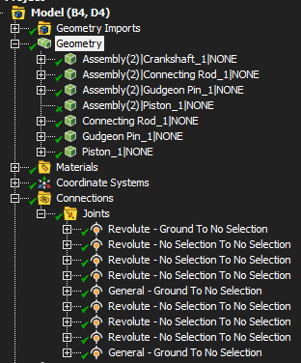
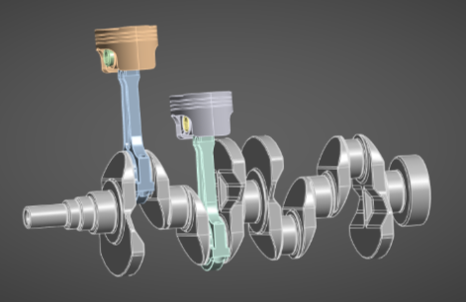(Figure 1) (Figure 2)
The mechanical system modelled in this study is a simplified internal combustion engine as shown in figure 1, the assembly consists of 1 crankshaft, 2 connecting rods, 2 gudeon pins and 2 piston heads. The model represents a realistic system to ensure accuracy within the results.
To accurately represent the real physical limitations within an engine, the appropriate joints were applied to the model within Ansys. Revolute joints were used for the crank to the connecting rod as well as between the connecting rod and the gudeon pins. This allowed for the correct rotational motion without allowing for unrealistic lateral translation. To accurately represent the piston within the cylinder bore, a general to ground joint was applied. This meant that I could define which axis become free and which is fixed, as I wanted the piston to move up and down simulating it within a real engine, I chose to fix axis X and Y and allow free translation up and down the Z axis.
The assembly was driven by applying a forced rotational velocity to the joint that connects the crank to ground. The force applied was a constant 2000rpm, this was chosen as it is a low-mid engine speed which limited computational cost which meant I had a clear representation of inertial loading effects. By applying a constant rotational velocity, a steady and repeatable kinematic behaviour was achieved.
The setup of this assembly formed a strong foundation for the rigid dynamics test, then I exported the results from this test when the simulation was at top dead centre (TDC) and used these in the upcoming thermal and structural assessment of the selected component.

Kinematic Simulation and Structural analysis

Kinematic analysis
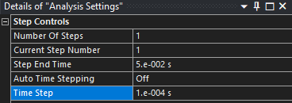

(Figure 3)
The rigid dynamics settings for the kinematic simulation are shown in figure 3. A step end time of 0.05s and a time step of 0.0001s were used to create the results for rotational velocity. This setup allowed for 2 full crank revolutions to be captured at the forced 2000rpm, which was sufficient to analyse the kinematic behaviour and extract the representative loading conditions. A short test was conducted as there was no gain from having more crank revolutions as the data would be the same as the conditions would not be changing.
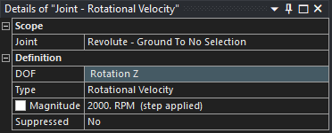
(Figure 4)
Here we can see the joint settings for the crank to ground joint with degrees of freedom only being rotation around the z axis. I set the rotational velocity to 2000rpm. The joint reaction forces were monitored during the test and peak loading conditions were identified to the corresponding position of top dead centre (TDC). This motion load was exported and used for the thermal and structural analysis.

Chosen Component

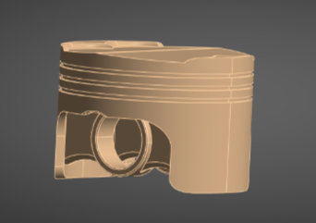
(Figure 5)
The chosen component for the thermal and structural analysis was the piston as shown in figure 5. This was chosen due the to importance of the piston within the engine assembly and exposure to significant thermal and inertial loading during it operation, in particular the crown undergoes extreme thermal conditions during combustion and then the arear around the gudeon pins undergo high stress concentrations due to the forces transmitted through the connecting rod.
The piston operates in a thermally demanding environment which make it an ideal subject for evaluating the influence of temperature on material behaviour and structural performance.

Thermal Analysis

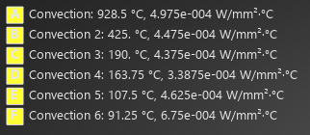
(Figure 6)
A steady state thermal analysis was conducted on the piston to account for the intense operating temperatures experienced by the piston during operation. Thermal loading was applied using the convection boundary conditions within Ansys as shown in figure 5. The convection tool allows heat transfer between the piston surfaces and surrounding environment to be modelled by forcing and external temperature and heat coefficient to the selected faces. I broke this down into 6 different sections, 5 of them being the top and outer sides of the piston and the 6th being the entire underside of the piston.
Different temperatures were applied to specific regions to accurately represent the non-uniform thermal environment within the piston chamber. Higher temperatures were applied to the surfaces exposed to the combustion chamber whilst the lower temperatures were applied to areas around the skirt and away from the combustion zone. This allowed for a representative thermal zone around the component.
The limitation to this is it is a steady state thermal system so there are uniform heat coefficients for the selected faces, this model does not consider combustion gases or oil flow, therefore this is a clear limitation. Despite these simplifications the results are accurate, so it allows for cost affective analysis on material property and structural performance under intense thermal conditions.

Thermal Results Analysis
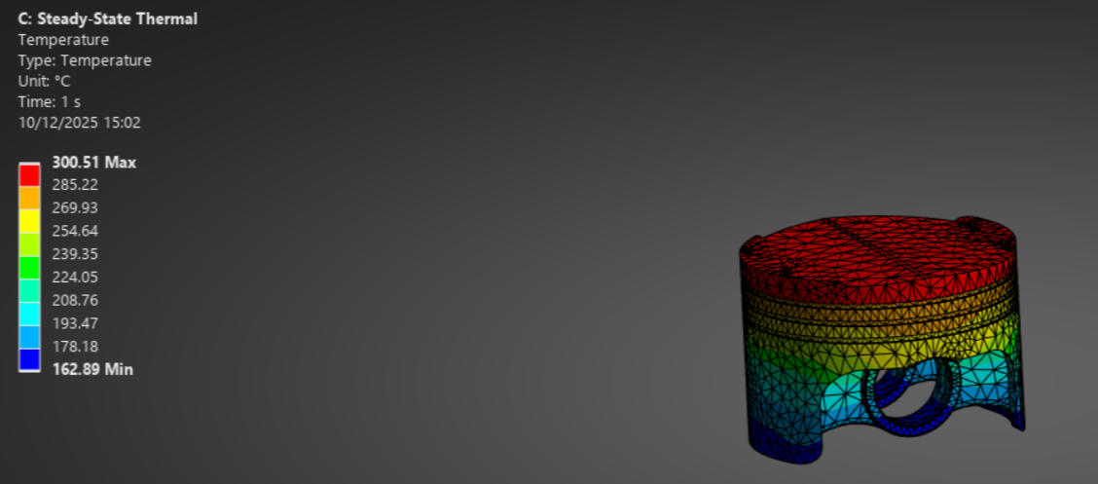
(Figure 7)
The steady state temperature distribution for the aluminium alloy piston is shown in figure 7. The maximum temperature recorded was approximately 300.5 degrees, occurring at the pistons crown, which is directly exposed to the elevated combustion chamber temperatures. The minimum temperature recorded was 162.89 degrees, this occurred around the piston skirts and gudeon pins where the temperature gets distributed to the chamber walls and lubricated areas.
A clear thermal gradient is visible adown the axis of the piston with the highest temperatures at the crown and the lowest at the skirt, this is representative to real engine operation, where heat is introduced at the crown and dispersed to surrounding components within the combustion chamber. Achieving a low temp around the gudeon pins is important due to the intense mechanical load the withstand, this load makes them sensitive to material property changes therefore a low temperature in this region is good as it reduces chance of material deformation under stress.
The non uniform temperature field results in differential thermal expansion and contributes to the development of thermal stresses within the piston. The high operating temperatures lead to a reduced material stiffness and strength. This must be taken into consideration during the structural testing.

Static Structural Analysis

The structural analysis was performed using mechanical loads extracted from the kinematic simulation at top dead centre (TDC), combined with the temperature field obtained from the steady-state thermal analysis.

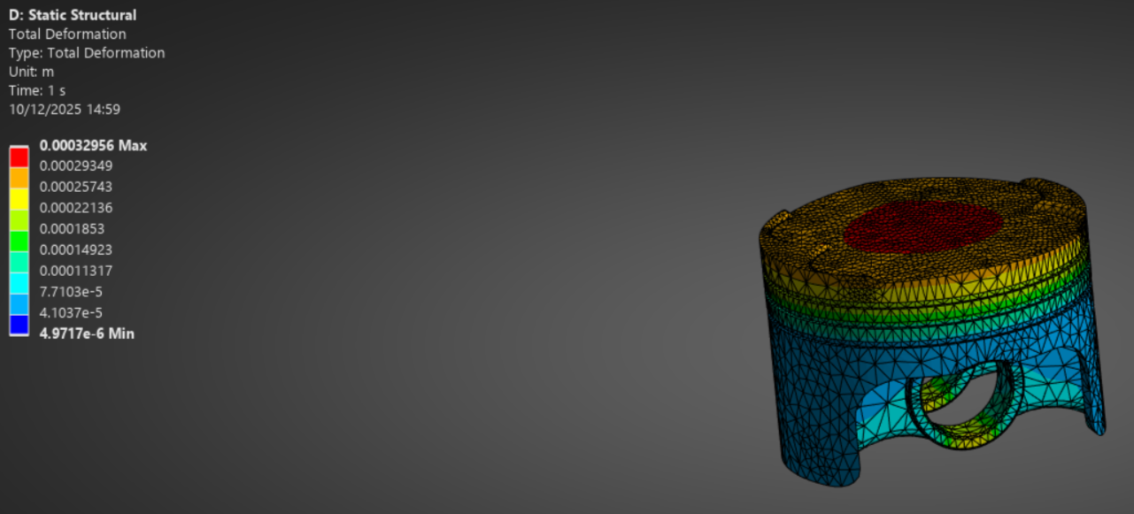
(Figure 8)
The total deformation result for the aluminium alloy under the applied loading conditions is shown above in figure 8. The maximum deformation recorded was 0.33mm which occurred at the crown region, this is expected as the crown is relatively unsupported when compared to the constrained gudgeon pin region, therefore it undergoes much greater compliance under load. Lower deformation is seen around the skirt area which is also to be expected as there isn’t a lot of applied loads at this region.
The deformation results indicate that that the applied boundary conditions and loading will produce realistic structural behaviour.

Structural Analysis

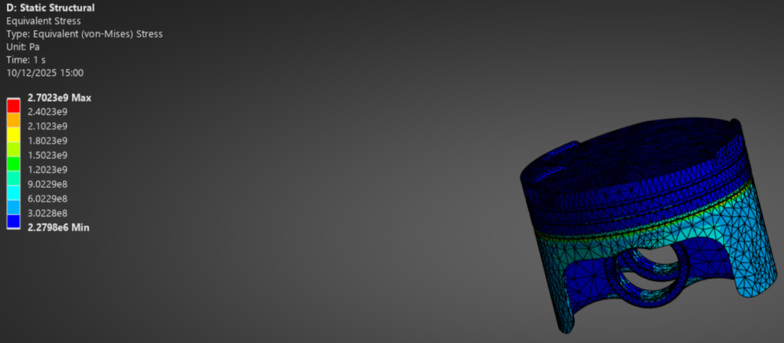
(Figure 9)
The equivalent Stress distribution for the aluminium alloy under the applied thermos mechanical loading conditions is shown in figure 9. The results show that majority of the piston is experiencing very low stress, there are some areas of elevated stress, and these are localised around the load transfer points. These regions around the gudeon pins are expected to be increased stress regions as there is the transfer of inertial forces from the connecting rod.
The maximum equivalent stress recorded was 2.7GPA. while this value significantly exceeds the yield strength of an aluminium alloy, it is important to know that this happens over a very small, localised region, the low stress levels across most of the piston, represented by the blue contour covering the piston, suggest that this extreme value of peak stress is not globalised across the entire region of the component.
Extreme values like this are likely caused by idealised boundary conditions, highly constrained regions. These values will increase with mesh refinement and generally do not correspond to the overall material behaviour. Due to these reasonings less focus should be placed on the values and more on the overall product of the results, which in this case majority of the piston experiences very low stress values.
These results highlight the importance of CAE limitations and reinforce the need for mesh independent studies and careful consideration when applying boundary conditions. The stress results provide a basis for improvement and material choice refinement rather than an overall component failure.

Optimization and Improvement

Base line material – Aluminium alloy

The aluminium alloy piston which was analysed in the previous section was used as the baseline material for the iterative improvement study. This material represents a common choice for pistons due to its low density and favourable thermal conductivity. The thermo mechanical analysis of the aluminium provided the reference point for other materials I have tested.

Titanium Alloy thermal analysis

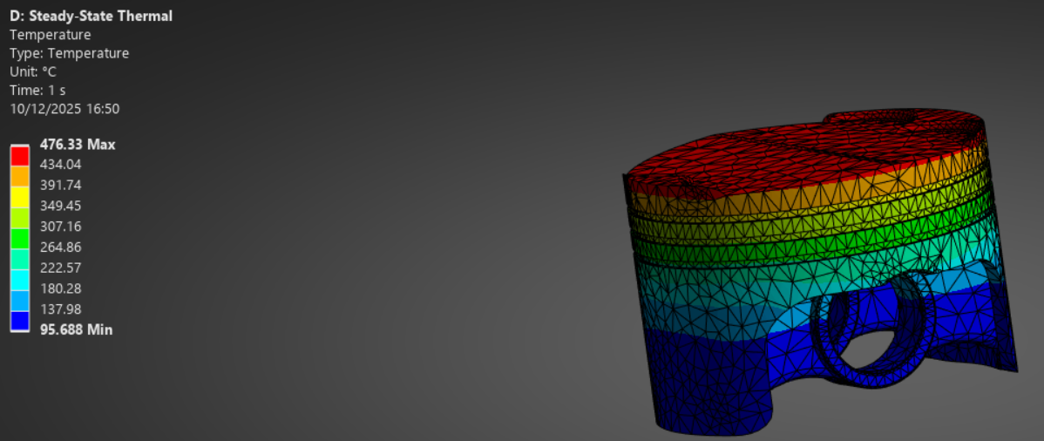
(Figure 10) steady state temperature distribution for titanium alloy

An alternative material study was conducted using a titanium alloy piston, this was to test if improved performance could be achieved under the same thermal load compared to the aluminium alloy piston. Titanium alloy is commonly used in high performance engineering due to the high strength to weight ratio and superior mechanical capabilities at high temperatures.
A maximum temperature of 476 degrees was observed at the crown of the piston, with minimum temperatures of 96 degrees occurring in the lower skirt and gudeon pin regions. This aligns with the similar reaction from the aluminium with the peak temperature appearing at the crown and the temperature decreasing further down the piston, this also aligns with real world engine operation.
Compared to the baseline aluminium alloy the titanium alloy operates at a much higher temperature due to the lower thermal conductivity, which reduces heat dissipation away from the crown. However, titanium alloys maintain their stiffness and strength at elevated temperatures making them more suitable for high temperature applications.

Titanium alloy structural analysis

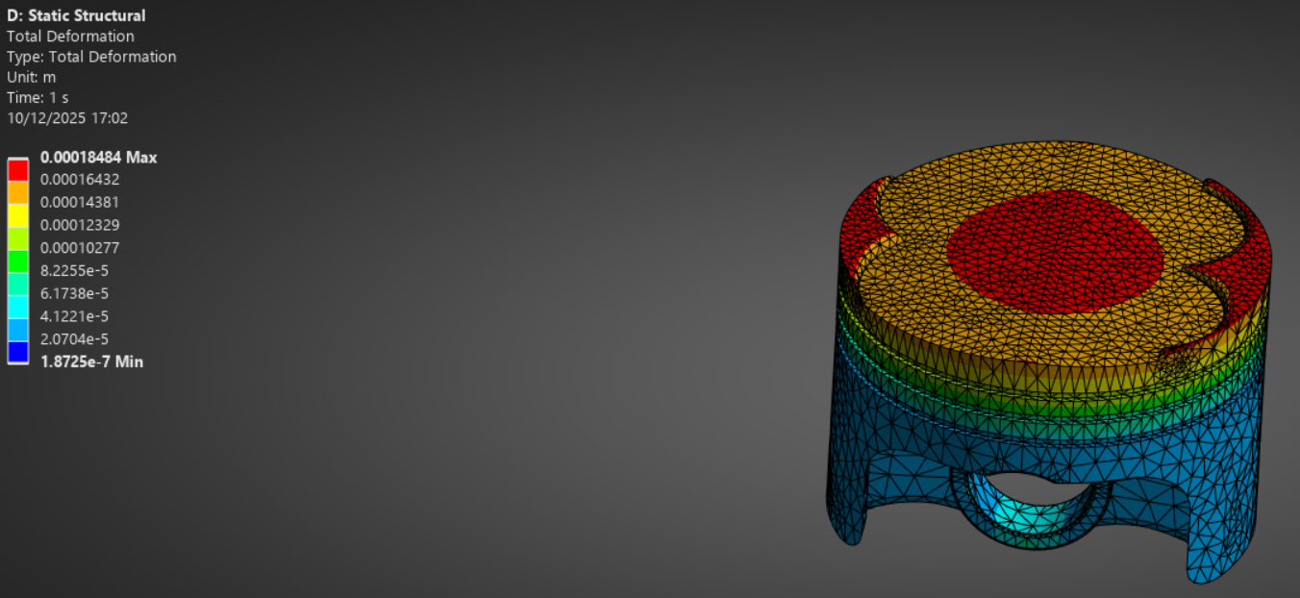
(Figure 11) Titanium alloy Total deformation

The total deformation results for the titanium alloy piston under thermos mechanical load conditions are shown in figure 11. The maximum deformation was 0.185mm, this is a significant reduction when compared to the aluminium alloy which had a total deformation of 0.33mm.
This reduction in deformation is due to the much greater stiffness and the improved high temperature mechanical properties of the titanium alloy. As with the aluminium alloy lower deformation values are observed at the skirt gudeon pin region due to increased constraint and load transfer within these sections.
This reduction in deformation represents and improvement to structural rigidity and performance when using a titanium alloy, particularly under high thermal conditions.

Titanium Alloy Structural analysis

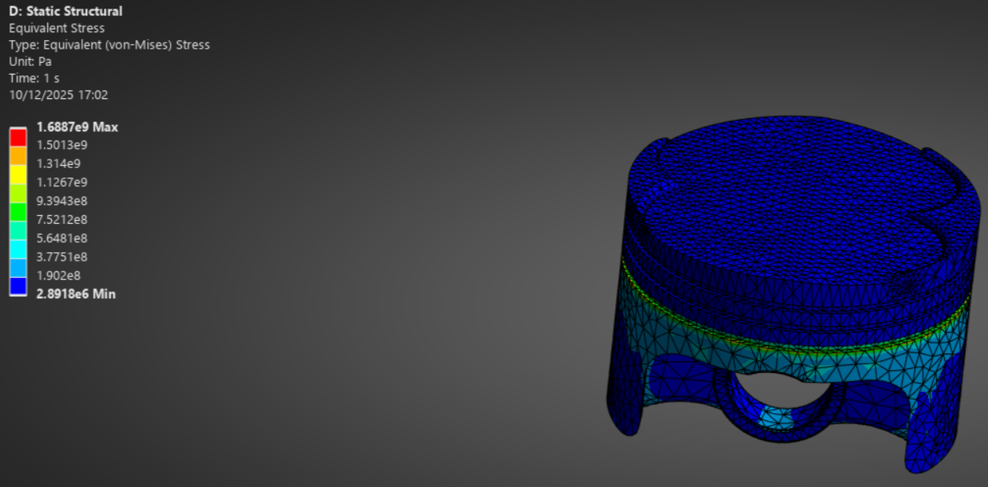
(Figure 12) Equivalent Stress (Von Mises) of the titanium alloy

The equivalent stress distribution for the titanium alloy is shown above in figure 12. As with the aluminium alloy elevated stress regions are local to the gudeon pin region, where inertial forces from the connecting rod are introduced to the piston. Therefore, these regions are expected to experience higher stress levels due to the load concentration.
The maximum equivalent tress recorded for the titanium alloy piston was approximately 1.69GPa, while this peak remains very high it still shows a noticeable reduction when compared to the aluminium alloy which had a peak stress of 2.7GPa. the stress distribution across most of the piston is lower and more uniform, indicated by the low stress contour regions.
As with the aluminium alloy the peak stress is localised and likely influenced by ideal boundary conditions and constraint effects, rather than representing a component failure. However, the reduction in peak stress alongside the improved high temperature mechanical properties of the titanium alloy indicate an enhanced structural performance under elevated operating conditions.
This demonstrates changing the material is an effective strategy for reducing deformation and stress without altering geometry of the component.

Failed material

An additional material study was conducted using stainless steel; however, this was not carried forward for this optimization. The stainless-steel piston exhibited higher operating temperatures, increased deformation and significantly higher localised stresses compared to both aluminium and titanium. These results indicated that it was not suitable for furthering the discussion of optimizing against aluminium.

Validation Testing

Simplified Test Case

To validate the accuracy of Ansys thermo mechanical modelling and mesh behaviour, a simplified benchmark problem based on a published analytical verification case. The chosen test case is a bimetallic strip which is composed of two materials with two significantly different coefficients of thermal expansion. This strip was subject to a uniform temperature increase. This test case is suitable as it contains well defined analytical data, so I can accurately test Ansys and mesh behaviour.
The bimetallic strip consists of two bonded layers, one being copper and another being invar. Each of these materials are 1mm thick, have a length of 100mm and a width of 5mm. one end of the beam is fully fixed in place, and the other end is left freely to deform. A uniform temperature of 100 degrees was applied to the beam; this induces differential thermal expansion resulting in bending deformation.
This test case is suitable for validation as it isolates thermo-elastic behaviour, minimises complex geometry, and allows for mesh refinement to assess solution accuracy.

Analytical and Software Comparison

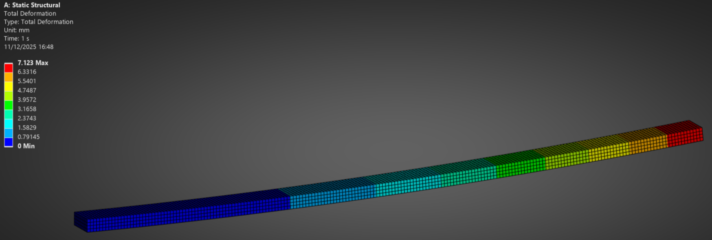
(Figure 13) Bimetallic strip total deformation

For the bimetallic strip benchmark subject to the uniform temperature increase of 100 degrees, the analytical solution predicts a maximum free end deflection of 7.049mm. the corresponding Ansys result obtained for the initial mesh 0f 0.5mm produced a maximum total deformation of 7.123mm at the free end of the beam, as shown in figure 13.
This represents a total percentage error of 1.05% relative to the analytical solution. The deformation profile shows 0 bending at the fixed end with smooth bending behaviour throughout the beam; this is consistent with the expected physical result of a bimetallic strip under thermal loading. This close results indicates that the Ansys model is capable of accurately reproducing the analytical thermos-elastic result for this benchmark problem.
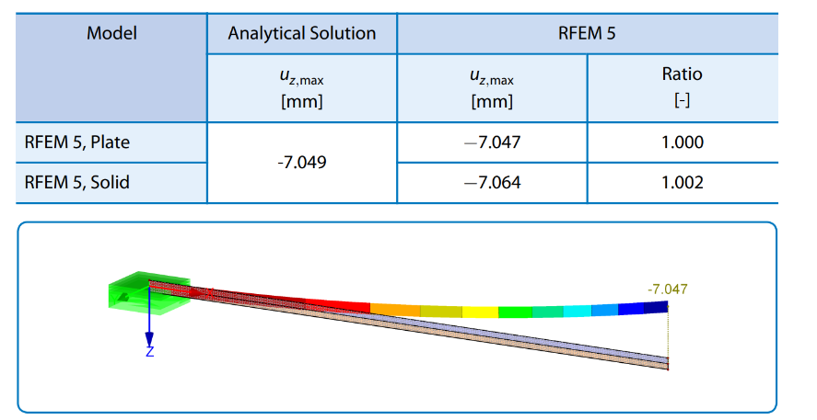
(Figure 14) Analytical solution for bimetallic strip

Mesh Independent Study

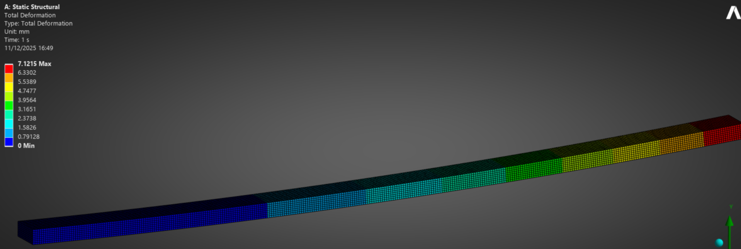
(Figure 15) Mesh Refinement at 0.3mm

The first mesh refinement case used an element size of 0.3mm, with the total deformation distribution shown in figure 15. The maximum free end deformation was 7.1215mm, whilst the fixed end deformation stayed the same at 0mm, this confirms that the boundary conditions were applied correctly. When comparing to the reference analytical deflection of 7.049mm, the result corresponds to an error percentage of 1.03%. the smooth gradient along the beam indicates stable thermos-elastic behaviour.

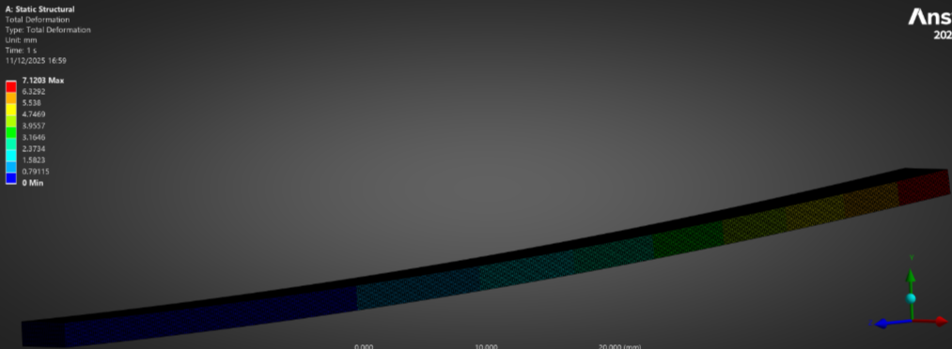
Mesh Refinement 2

(Figure 16) Mesh refinement of 0.1mm

The second mesh refinement was even smaller at 0.1mm, with the total deformation result shown in figure 16. The maximum deformation on the free end was 7.1203mm, further consistency with the fixed end staying at 0mm deformation. When compared with the analytical solution of 7.049, it corresponds to a total percentage error of 1.01%. the close agreement with the 0.3mm mesh shows that extreme mesh refinement only produces marginal gains to accuracy.

Mesh Refinement 3

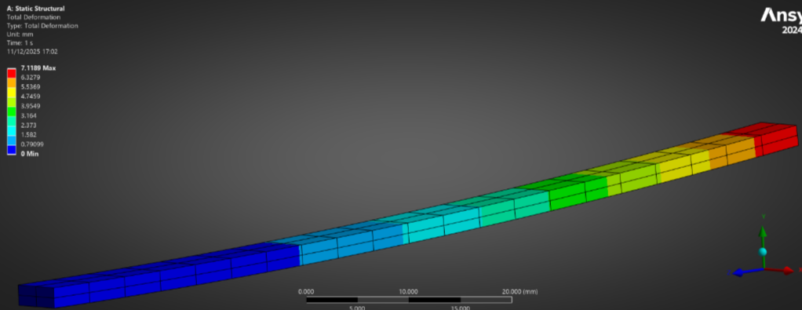
(Figure 17) Mesh refinement of 4.9mm

A third mesh sizing was analysed using a much coarser element size of 4.9mm, the resulting total deformation is displayed in figure 17. The maximum deformation at the free end was 7.1189mm. when compared to the analytical reference of 7.049mm, this corresponds a total percentage error of 0.99%. despite the substantially reduced mesh density, the prediction remains in close similarity with that of the analytical results and the much finer mesh sizing. This indicates that the global thermos-elasticity of the beam is not highly sensitive to mesh refinement.

Conclusion

This study demonstrated the application of computer aided engineering (CAE) tools to analyse, compare, and improve component performance within a mechanically and thermally loaded system. The results highlighted the importance of appropriate modelling assumptions, realistic boundary conditions, and critical interpretation of numerical outputs when assessing structural behaviour.
Material substitution proved to be an effective optimisation strategy, with the titanium alloy offering improved structural performance without the requirement for geometric modification. A benchmark validation study further confirmed the reliability of Ansys modelling approach, showing good agreements with an analytical solution.
Overall, this work demonstrates that CAE is most effective when combined with validation and informed engineering judgement, enabling reliable design decisions whilst still acknowledging the theoretical limitations of numerical simulation.

References

Dlubal Software (2018) Verification Example 0078: Bimetallic Strip. RFEM 5 Verification Manual. Dlubal Software GmbH.
ANSYS (2025) ANSYS Mechanical User’s Guide. ANSYS Inc.

