

LOCATION: Swansea | LLEOLIAD: abertawe
LEVEL 6 | LEFEL 6
EXAMINATION PERIOD | CYFNOD ARHOLIADAU
January 2024 | Ionawr 2024
MODULE CODE: ACCA6022
Switching ROUTING, and WIRELESS

TIME: 2 HOURS
answer all questions

This is an individual practical lab-test, held under examination conditions. You will be assigned One Router, Two Switches and two PCS. configure these devices based on the following specifications.
The router is R1, the switches s1, s2 , PCs PC-A, PC-B

This paper contributes 75 % to overall module ASSESSMENT.

Equipment or materials required. Please select from the following:
Adnoddau neu ddefnyddiau sydd eu hangen.

Cyfrifiannell/Calculator

Llyfr Agored/Open Book

Arall/Other Nodwch/Please Note ……………………….

Task 1: IN-CLASS ASSESSMENT (20 %)
1.Inter-VLAN Routing Challenge (5%)
2.EtherChannel Additional Activity (5%)
3.WLAN Additional Activity 5 %)
4. EIGRP Challenge (5% )

Task 2: Practical Lab Test on real devices (80 %)
Actual Total Marks [60 marks]

  - When completing the task,
    - wherever you find the below table, you must call the examiner to check your task before moving to the next task.
Examiner Comments and Signature:
Signature:


    - wherever you find the below symbol, you must take a screenshot and paste them in a word document and submit.

  - After completing all the parts of the assessment, copy the configuration as per the requirement stated below and submit both the word document and text file electronically via Moodle Submission.

Topology

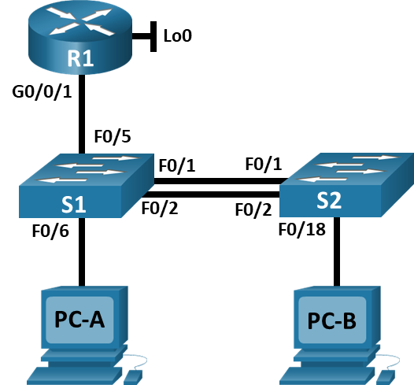

Addressing Table

VLAN Table
VLAN | VLAN Name
2 | Bikes
3 | Trikes
4 | Management
5 | Parking
6 | Native

Addressing Table
Device / Interface | IP Address / Prefix | Default Gateway
R1 G0/0/1.2 | 10.20.8.1 /26 | N/A
R1 G0/0/1.2 | 10.20.8.1 /26 | N/A
R1 G0/0/1.3 | 10.20.8.65 /27 | N/A
R1 G0/0/1.3 | 10.20.8.65 /27 | N/A
R1 G0/0/1.4 | 10.20.8.97 /29 | N/A
R1 G0/0/1.4 | 10.20.8.97 /29 | N/A
R1 G0/0/1.6 | N/A | N/A
R1 Loopback0 | 209.165.201.1 /27 | N/A
R1 Loopback0 | 209.165.201.1 /27 | N/A
S1 VLAN 4 | 10.20.8.98 /29 | 10.20.8.97
S1 VLAN 4 | 10.20.8.98 /29 | 10.20.8.97
S1 VLAN 4 | 10.20.8.98 /29 | 10.20.8.97
S2 VLAN 4 | 10.20.8.99 /29 | 10.20.8.97
S2 VLAN 4 | 10.20.8.99 /29 | 10.20.8.97
S2 VLAN 4 | 10.20.8.99 /29 | 10.20.8.97
PC-A NIC | DHCP for IPv4 address | DHCP for IPv4 default gateway
PC-A NIC | DHCP for IPv4 address | DHCP for IPv4 default gateway
PC-B NIC | DHCP for IPv4 address | DHCP for IPv4 default gateway
PC-B NIC | DHCP for IPv4 address | DHCP for IPv4 default gateway
Note: There is no interface on the router supporting VLAN 5.

Task 1 – Network Cabling (8 marks )

- Physically cable the network as shown in the topology diagram. (4 marks)

- Disable DNS lookup and configure hostnames on all devices as per the Addressing table (4marks)

Examiner Comments and Signature:
Signature:

Task 2 – Configure Basic Settings on R1, S1 and S2 ( 15 marks)

- Domain name:swre-lab.com, Privileged Exec password:cisco123, Console access password: cisco123.
-Create an administrative user in the local database
Username: cisco
Password: cisco123
-Set login on VTY lines to use local database.
-Set VTY lines to accept SSH connectivity
-Encrypt the cleartext password
-Generate the RSA crypto Key : 1024 bits modulas.
4. Configure router interfaces and sub-interfaces, including the Loopback0 with IP addresses.
NB: Use the Router Interface names applicable to your Chosen type e.g G0/0, G0/0/0

5.Configure the Management Interface (SVI) with IP addresses.

Examiner Comments and Signature:
Signature:

Task 3 – Configure Network Infrastructure Settings (VLANs, Trunking, EtherChannel) (15 marks )
- Create VLANs on S1 and S2 as per the VLAN Table.
- Create 802.1Q trunks that use the native VLAN 6 on S1 and S2
- Create a Layer 2 EtherChannel port group that uses interfaces F0/1 and F0/2 on S1 and S2
- On S1 Configure host access port for VLAN 2 (Interface F0/6)
- On S2 Configure host access port for VLAN 3 (Interface F0/18)
- ON S1 and S2 Configure port-security on access ports, to allow 3 MAC addresses.
- On S1 and S2 assign all the unused interfaces into VLAN 5 and shut them down.

Examiner Comments and Signature:
Signature:

Task 4 – Configure IPV4 DHCP (14 marks)

- ( 10 marks)

Task | Specification
Configure Default Routing | Create a default route for IPv4 that direct traffic to interface Loopback 0
Configure IPv4 DHCP for VLAN 2 | Create a DHCP pool for VLAN 2, consisting of the last 10 addresses in the subnet only. Specify the default gateway address as the router interface address for the subnet involved
Configure IPv4 DHCP for VLAN 3 | Create a DHCP pool for VLAN 3, consisting of the last 10 addresses in the subnet only. Specify the default gateway address as the router interface address for the subnet involved

13. Configure the host computers PC-A and PC-B to use DHCP for IPv4. After configuring each host computer, record the host network settings with the ipconfig /all command.

PC-A Network Configuration (2 marks)
Physical Address | blank
IP Address | blank
Subnet Mask | blank
Default Gateway | blank

PC-B Network Configuration (2 marks)
Physical Address | blank
IP Address | blank
Subnet Mask | blank
Default Gateway | blank

Task 5 – Part 4: Test and Verify End-to-End Connectivity (8 marks)

Use the ping command to test IPv4 connectivity between all network devices. NB: If pings to host computers fail, temporarily disable the computer firewall and retest.
NB: Please use that actual router interfaces for your Router type.

PINGs

From and To | Ping Results (Success: Yes/ No)
PC-A to R1 G0/0/1.2
PC-A to R1 G0/0/1.3
PC-A to S1 (VLAN 4)
PC-A to PC-B
PC-B to R1 Loopback 0
PC-B to R1 G0/0/1.3
PC-B to S2 (VLAN 4)
PC-B to S1 (VLAN4 )

Submission Requirement:
Note: Your electronic submission will be accepted only after getting signature from the Examiner on completing the above tasks.
1. A word document with screenshot of Tasks with symbol
2. A txt file containing running configurations, for each Router and Switch, with all appropriate show commands to justify your command execution. The file name should be Surname_Sno_devicename.txt

All documentation for your solution should be submitted electronically on Moodle. It is your responsibility that you copy all the files correctly.

Diwedd/End

